Supplementary Information:
Aberration-free multiphoton super-resolution imaging via dual deconvolution of the incoherent response matrix
Sumin Lim^{1,2}, Sungsam Kang^{1,2}, Jin-Hee Hong^{1,2}, Youngho Jin¹, Kalpak Gupta^{1,2}, Moonseok Kim³, Suhyun Kim⁴, Wonshik Choi^{1,2*}, Seokchan Yoon^{5*}
¹Center for Molecular Spectroscopy and Dynamics, Institute for Basic Science, Seoul 02841, Korea
²Department of Physics, Korea University, Seoul 02855, Korea
³Department of Medical Life Sciences, College of Medicine, The Catholic University of Korea, Seoul, 06591, Korea
⁴Department of Biomedical Sciences, Korea University, Ansan, Republic of Korea
⁵School of Biomedical Convergence Engineering, Pusan National University, Yangsan 50612, Korea
*Corresponding author(s). E-mail(s): wonshik@korea.ac.kr; sc.yoon@pusan.ac.kr

Table of contents
1. Comparison of dual deconvolution and conventional blind deconvolution 2
2. Experimental Setup 3
3. Two-photon imaging of Zebrafish hindbrain 4

1. Comparison of dual deconvolution and conventional blind deconvolution
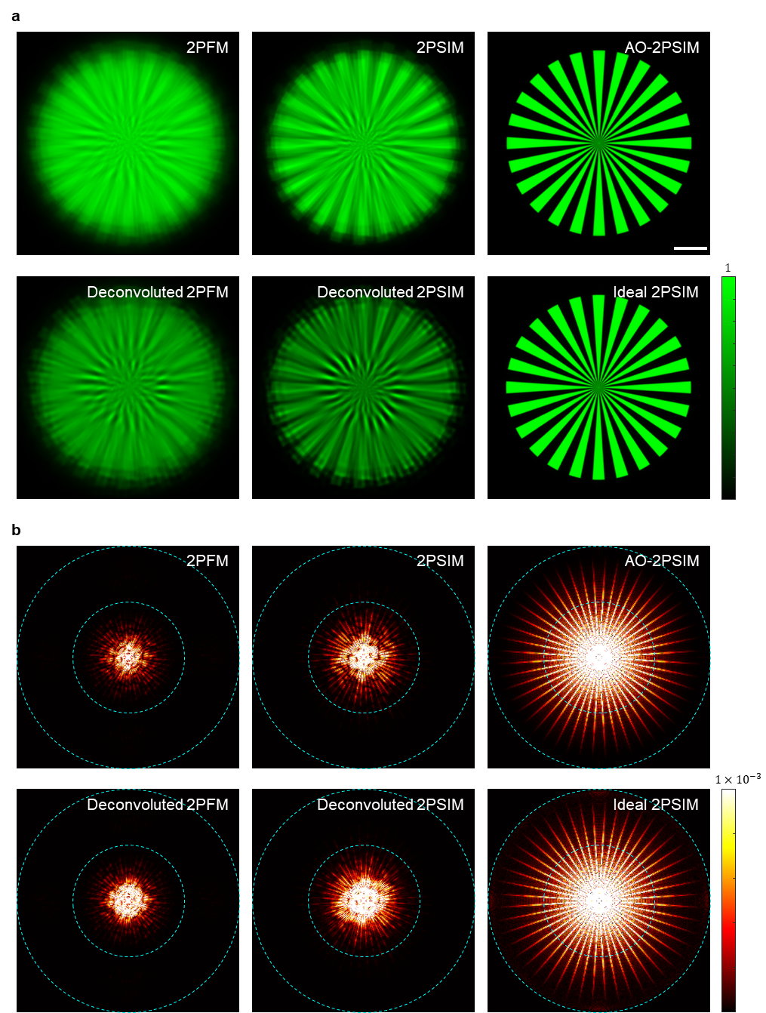
Fig. S1 | Comparison of dual deconvolution and conventional blind deconvolution. a, 2PFM, 2PSIM, and AO-2PSIM images obtained from simulated data (top row). Blind deconvolution of the 2PFM (bottom left) and 2PSIM (bottom center) images. An ideal 2PSIM image (bottom right) was also obtained for the case of no aberration. b, Power spectral densities of the corresponding images in (a). The two dashed circles indicate bandwidths with radii of $2αk_{em}$ and $4αk_{em}$, respectively, where $α$ is the numerical aperture and $k_{em}$ is the wavenumber for the emission wavelength.

2. Experimental Setup
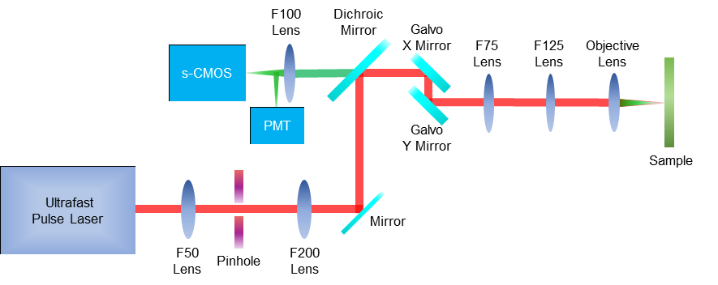
Fig. S2 | The schematic of the customized two-photon microscopy setup.

We used a tunable femtosecond pulsed laser (INSIGHT X3, Spectra Physics) as an excitation laser for two-photon fluorescence imaging. The center wavelength of 900 nm was employed for the demonstrations with Alexa 488 and GFP fluorescence family dyes, and the center wavelength of 850 nm is employed for the demonstrations with Rhodamine B fluorescence dye. A pinhole was placed between a lens with a focal length of 50 mm and a lens of a focal length of 200 mm for spatial filtering. A short-pass dichroic mirror (DMSP680B, Thorlabs) was used to separate the shorter wavelength fluorescence from the two-photon excitation laser. After reflection by the dichroic mirror, the excitation beam passed through two Galvo mirrors (GVS002, Thorlabs) for 2D raster-scanning on the sample. An objective (N60X-NIR, Nikon, ×60, 1.0 NA) was employed. Two relay lenses with focal lengths of 75 mm and 125 mm are introduced in between the Galvo mirror system and the objective. The emitted fluorescence was de-scanned by the Galvano mirror system, followed by the dichroic mirror and optical emission band-pass filters. Fluorescence signals are then recorded by s-CMOS camera (pco.edge 4.2, PCO AG). The magnification of the imaging system was 45. The camera’s pixel pitch was 6.5 μm, corresponds to 145 nm at the sample plane. Additionally, we utilized a photo-multiplier tube (PMT, H13543-20, Hamamatsu) for conventional two-photon fluorescence imaging.

3. Two-photon imaging of Zebrafish hindbrain
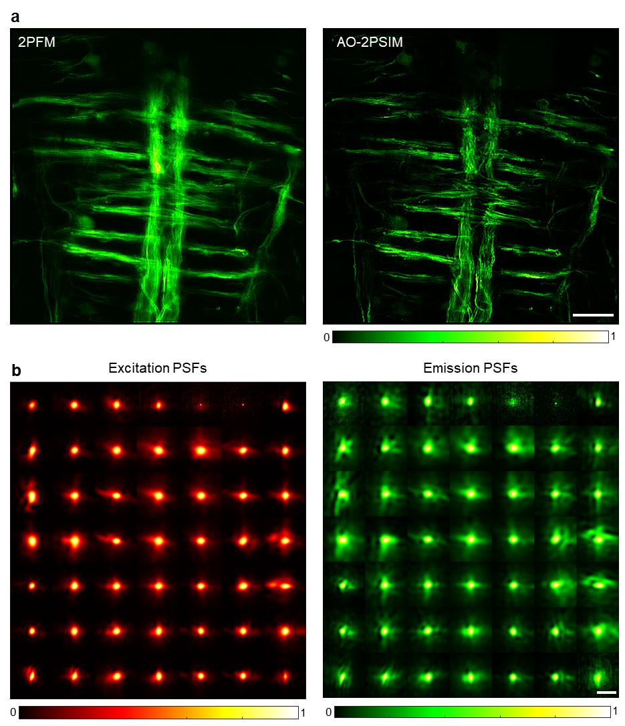
Fig. S3 | Two-photon imaging of Zebrafish hindbrain. a, 2PFM (left) and AO-2PSIM (right) images of oligodendrocytes in 10 d.p.f. zebrafish. b, Excitation (left) and emission (right) PSFs identified by the dual-deconvolution algorithm for each isoplanatic patch. Scale bars in (a), 20 μm. Scale bars in (b), 3 μm.

We obtained two-photon fluorescence images of a 10 days-post-fertilization (d.p.f.) zebrafish hindbrain at a depth of 180 μm and applied the dual-deconvolution algorithm for aberration correction. Figure S3a shows the reconstructed 2PFM and AO-2PSIM images, visualizing the fine structures of zebrafish oligodendrocyte membranes. To correct spatially varying aberrations, the whole ROI of 145×145 μm² was divided into 7×7 subregions (20×20 ${\text{μm}}^{2}$), and each subregion was analyzed separately. Some of the identified PSFs show multiple foci that induce ghost artifacts and cause a significant loss of resolution. The AO-2PSIM image (the right panel in Fig. 3Sa) revealed commissural tracts within the caudal hindbrain, along with additional commissural tracts connected to anterior medial projections at the peripheries, showing the myelination in early development stage of neuron system. In contrast, the 2PFM image (the left panel in Fig. 3Sa) failed to depict discernible central nervous structures.
For the whole zebrafish imaging study, embryos from the Tg (claudinK:gal4vp16;uas:megfp) (#FRZCC1013) line were cultivated at a temperature of 28 °C in E3 embryo medium. The E3 medium composition consisted of 5 mM NaCl (7548-4405, Daejung), 0.17 mM KCl (6566-4400, Daejung), 0.33 mM CaCl2 (2507-1400, Daejung), and 0.33 mM MgSO4 (21032, Daejung). After hatching, the embryos were transferred to E3 medium supplemented with N-phenylthiourea (P7629, Sigma Aldrich) to inhibit pigmentation. At 10 days post-fertilization, in the early stage of zebrafish larvae, the larvae were anesthetized using tricaine (E10521, Sigma-Aldrich) within the E3 medium. Subsequently, the larvae were fixed in a 4% paraformaldehyde solution for 1 hour at room temperature. This entire experimental procedure received approval from the Committee of Animal Research Policy at Korea University (approval number KOREA2021-0037).

