Supplemental Material
Contents
Supplemental Material 1
Figure S1 2
Figure S2 3
Result S1 4
Result S2 5
Table S1 7
Table S2 8

Figure S1: ROC curves of five-fold cross-validation of the 3D radiomics model
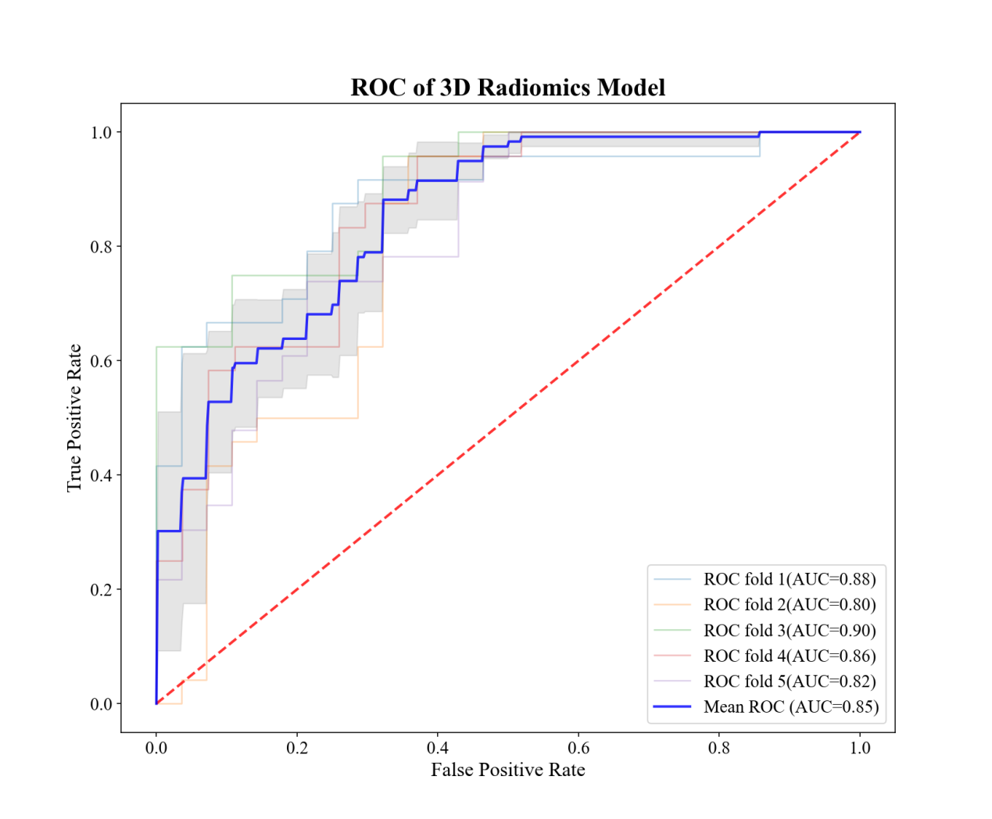

Figure S2: ROC curves of five-fold cross-validation of the 3D fused model
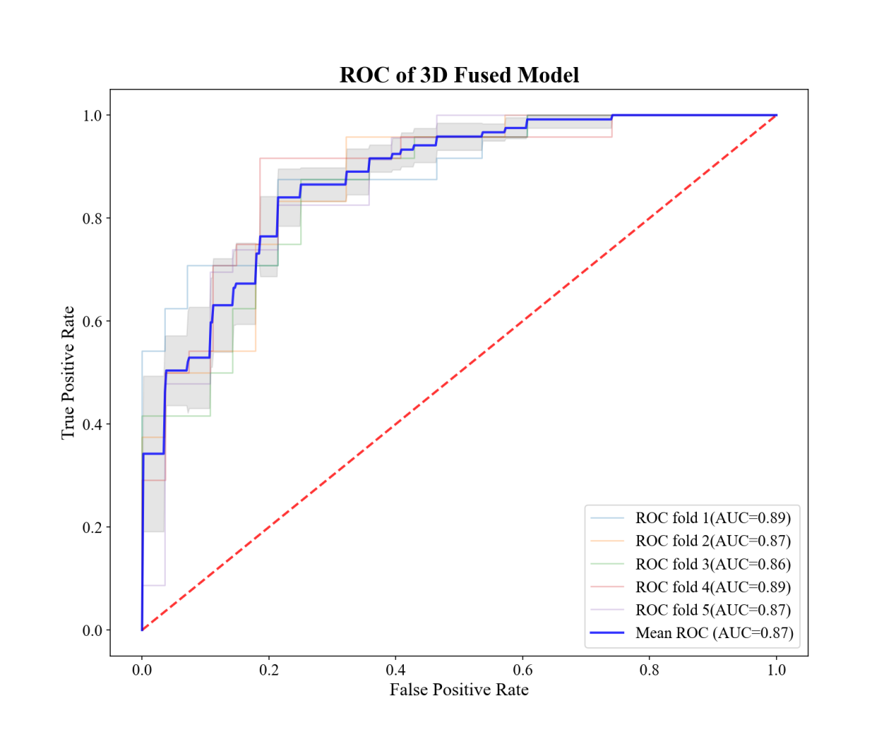

Result S1:
The key feature set of the radiomics model contains 35 features, including 2 local binary pattern features, 14 from Haar wavelet transform, 16 from sym8 wavelet transform, and 3 new features generated through the symbolic regression method. The calculation formula for the radiomics signature we constructed is as follows:
Radiomics Signature = -0.1504 + (2.7636 * haar_LL_1_GLCM_Difference_variance) + (-1.6224 * haar_LL_1_GLRLM_LRE) + (-1.9128 * haar_LL_1_GLRLM_LRLGE) + (2.2141 * haar_LL_2_NGTDM_Strength) + (1.9388 * haar_HL_1_GLCM_Inverse_difference) + (-2.2719 * haar_HL_1_GLCM_Information_measures_of_correlation_1) + (-1.6228 * haar_LH_1_GLCM_Difference_entropy) + (-0.7898 * haar_LH_2_GLCM_Cluster_Shade) + (-1.7493 * haar_LH_2_GLCM_Difference_variance) + (-0.8006 * haar_LH_2_NGTDM_Complexity) + (1.0091 * haar_HH_2_GLCM_Entropy) + (0.8678 * haar_HH_2_GLCM_Inverse_difference) + (1.0091 * haar_HH_2_GLCM_Difference_entropy) + (1.3080 * haar_HH_2_NGTDM_Complexity) + (-1.8805 * sym8_LL_1_NGTDM_Complexity) + (-1.6308 * sym8_LL_2_GLCM_Inverse_difference) + (-3.0274 * sym8_LL_2_NGTDM_Strength) + (1.1862 * sym8_HL_1_GLSZM_LZE) + (1.2089 * sym8_HL_1_NGTDM_Strength) + (0.7775 * sym8_LH_1_GLCM_Cluster_Shade) + (0.5313 * sym8_LH_1_GLCM_Information_measures_of_correlation_1) + (2.0159 * sym8_HL_2_GLCM_Information_measures_of_correlation_1) + (2.8375 * sym8_HL_2_GLSZM_LZHGE) + (-1.4984 * sym8_LH_2_GLCM_Entropy) + (-2.8910 * sym8_LH_2_GLCM_Inverse_difference) + (-1.4984 * sym8_LH_2_GLCM_Difference_entropy) + (-1.4713 * sym8_LH_2_GLRLM_LRE) + (-3.1764 * sym8_LH_2_GLSZM_LZE) + (0.3069 * sym8_LH_2_NGTDM_Complexity) + (2.5003 * sym8_HH_2_NGTDM_Strength) + (0.8643 * LBP_GLRLM_HGRE_u2) + (1.5310 * LBP_GLSZM_HGZE_u2) + (0.6407 * 3V) + (-0.9045 * 4V) + (-1.1686 * 18V)

Result S2:
A total of 1,131 radiomics features based on 3D segmentation were extracted, of which 365 remained after feature selection. Additionally, thirty synthetic features were created through symbolic regression. Using RFECV, the 43 most valuable features were identified, including
'original_firstorder_Mean', 'original_glcm_ClusterTendency', 'original_gldm_DependenceEntropy', 'original_glszm_GrayLevelNonUniformity', 'lbp-3D-m1_firstorder_RootMeanSquared', 'lbp-3D-m1_glrlm_ShortRunHighGrayLevelEmphasis', 'lbp-3D-m2_firstorder_MeanAbsoluteDeviation', 'lbp-3D-m2_firstorder_Variance', 'lbp-3D-m2_ngtdm_Busyness', 'lbp-3D-k_gldm_DependenceVariance', 'lbp-3D-k_glszm_ZoneEntropy', 'wavelet-LLH_firstorder_Minimum', 'wavelet-LHH_glszm_GrayLevelNonUniformity', 'wavelet-HLL_firstorder_InterquartileRange', 'wavelet-HLL_glrlm_RunVariance', 'wavelet-HHL_firstorder_Kurtosis', 'wavelet-HHH_firstorder_90Percentile', 'wavelet-HHH_glcm_ClusterProminence', 'wavelet-LLL_firstorder_10Percentile', 'wavelet-LLL_firstorder_90Percentile', 'wavelet-LLL_firstorder_RootMeanSquared', 'wavelet-LLL_glrlm_LongRunEmphasis', '1V', '2V', '3V', '4V', '5V', '6V', '7V', '8V', '10V', '11V', '12V', '14V', '15V', '16V', '17V', '18V', '23V', '24V', '25V', '26V', and '28V'. A 3D radiomics model was constructed using RF and five-fold cross validation with stratified sampling based on these features. The best parameters for the random forest algorithm of the 3D radiomics model were: 'criterion': 'entropy', 'max_depth': 8, 'max_features': 'log2', 'min_samples_leaf': 6, 'n_estimators': 60. The 3D radiomics model achieved a mean AUC of 0.850, an accuracy of 70.1%, a sensitivity of 69.8%, and a specificity of 70.5%.
The 3D fused feature set selected by RFECV consisted of 15 features, which included male gender, chronic HBV infection, cirrhosis, clinical symptoms, AFP, right lobe, irregular shape, ill-defined, intra-tumoral hemorrhage, intra-tumoral necrosis, arterial phase rim enhancement, pseudo-capsule, non-peripheral washout, intrahepatic metastasis, and the radiomics score. The best parameters of the 3D fused model based on RF were: 'criterion': 'gini', 'max_depth': 7, 'max_features': 'auto', 'min_samples_leaf': 2, 'n_estimators': 70. The mean AUC of the 3D fused model was 0.875, the accuracy was 76.8%, the sensitivity was 74.0%, and the specificity was 79.2%.

Table S1: Comparison of the clinical characteristics between the dual-phenotype hepatocellular carcinoma (DPHCC) group and the non-DPHCC group from the training set
Clinical characteristics | DPHCC  (n = 119) | Non-DPHCC  (n = 139) | p values
Age (years) | 52.0 ± 10.4 | 59.0 ± 11.4 | <0.001
Male | 91 (76.5%) | 118 (84.9%) | 0.086
Chronic HBV infection | 100 (84.0%) | 122 (87.8%) | 0.388
Cirrhosis | 86 (72.3%) | 83 (59.7%) | 0.034
Clinical symptom | 36 (30.3%) | 47 (33.8%) | 0.542
AFP (ng/ml) | 9929.3 ± 20370.6 | 2564.8 ± 9537.3 | <0.001

Table S2: Comparison of the radiologic characteristics between the dual-phenotype hepatocellular carcinoma (DPHCC) group and the non-DPHCC group from the training set
Radiologic characteristics | DPHCC  (n = 119) | Non-DPHCC  (n = 139) | p values
Right lobe | 76 (63.9%) | 98 (70.5%) | 0.257
Tumor size (cm) | 4.6 ± 2.8 | 5.6 ± 3.0 | 0.009
Irregular | 57 (47.9%) | 55 (39.6%) | 0.178
Ill-defined | 65 (54.6%) | 35 (25.2%) | <0.001
Intra-tumoral fat | 3 (2.5%) | 8 (5.8%) | 0.200
Intra-tumoral hemorrhage | 6 (5.0%) | 28 (20.1%) | <0.001
Intra-tumoral necrosis | 62 (52.1%) | 39 (28.1%) | <0.001
Arterial phase rim enhancement | 11 (9.2%) | 6 (4.3%) | 0.112
Pseudo-capsule | 16 (13.4%) | 55 (39.6%) | <0.001
Non-peripheral washout | 104 (87.4%) | 122 (87.8%) | 0.927
Progressive enhancement | 7 (5.9%) | 9 (6.5%) | 0.844
Intrahepatic metastasis | 18 (15.1%) | 16 (11.5%) | 0.392
Lymphadenopathy | 11 (9.2%) | 14 (10.1%) | 0.823

