Vacuum ultraviolet second-harmonic generation in NH₄B₄O₆F crystal
Fangfang Zhang^{1,2}†, Zilong Chen¹†, Chen Cui¹†, Zhihua Yang^{1,2}, Miriding Mutailipu^{1,2}, Fuming Li¹, Xueling Hou¹, Xifa Long¹, Shilie Pan^{1,2}*
¹CAS Key Laboratory of Functional Materials and Devices for Special Environmental Conditions; Xinjiang Key Laboratory of Functional Crystal Materials; Xinjiang Technical Institute of Physics and Chemistry, Chinese Academy of Sciences, Urumqi 830011, China.
²Center of Materials Science and Optoelectronics Engineering, University of Chinese Academy of Sciences, Beijing 100049, China.
*Corresponding author. Email: slpan@ms.xjb.ac.cn.
†These authors contributed equally to this work.

Extended Data Fig. 1. Schematic diagram of the enhancement of interlayer coupling through the insertion of atoms with spatially extended s-orbitals between neighboring layers. It illustrates the modified hopping parameter and the resulting increase in bonding strength, which enables the growth of crystals with reduced layered tendency.
Extended Data Fig. 2. Comparison of the effective NLO coefficients (d_{eff}) between ABF and KBBF at fundamental wavelength range of 310-400 nm. For type I phase-matching, d_{eff} (ABF) = d₃₂cosφ, where d₃₂ = 1.09 pm V^{–1} based on the Maker fringe technique, and d_{eff} (KBBF) = d₁₁cosθcos3φ, where d₁₁ = 0.49 pm V^{–1} (32). The phase-matching angle (θ) and azimuthal angle (φ) were calculated based on the Sellmeier equations for ABF and KBBF, respectively. The weak dependence of d_{ij} on wavelength where far from cut-off edge was ignored. d_{eff} at 386→193 nm and 355→177.3 nm is highlighted by dot lines.
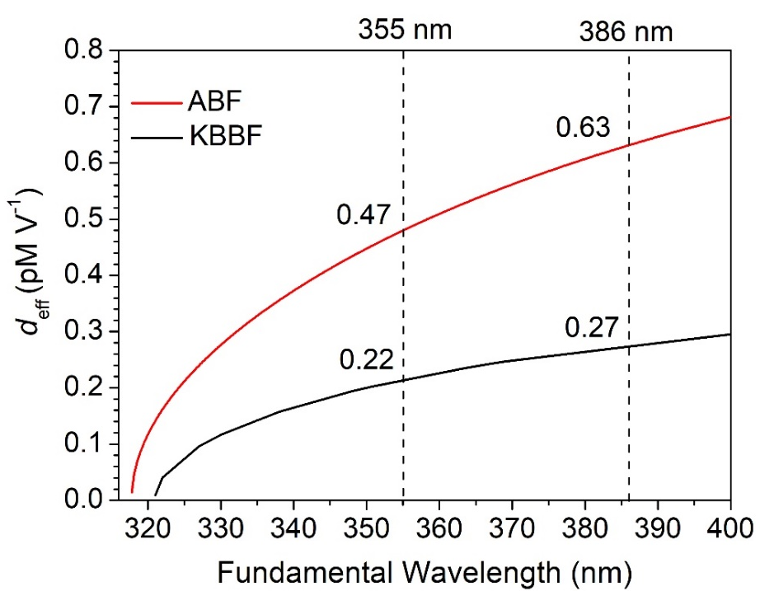

Extended Data Fig. 3. Raw data of frequency doubling light for 158.9-188.0 nm using the ABF device with (θ, φ) = (0 °, 70 °).

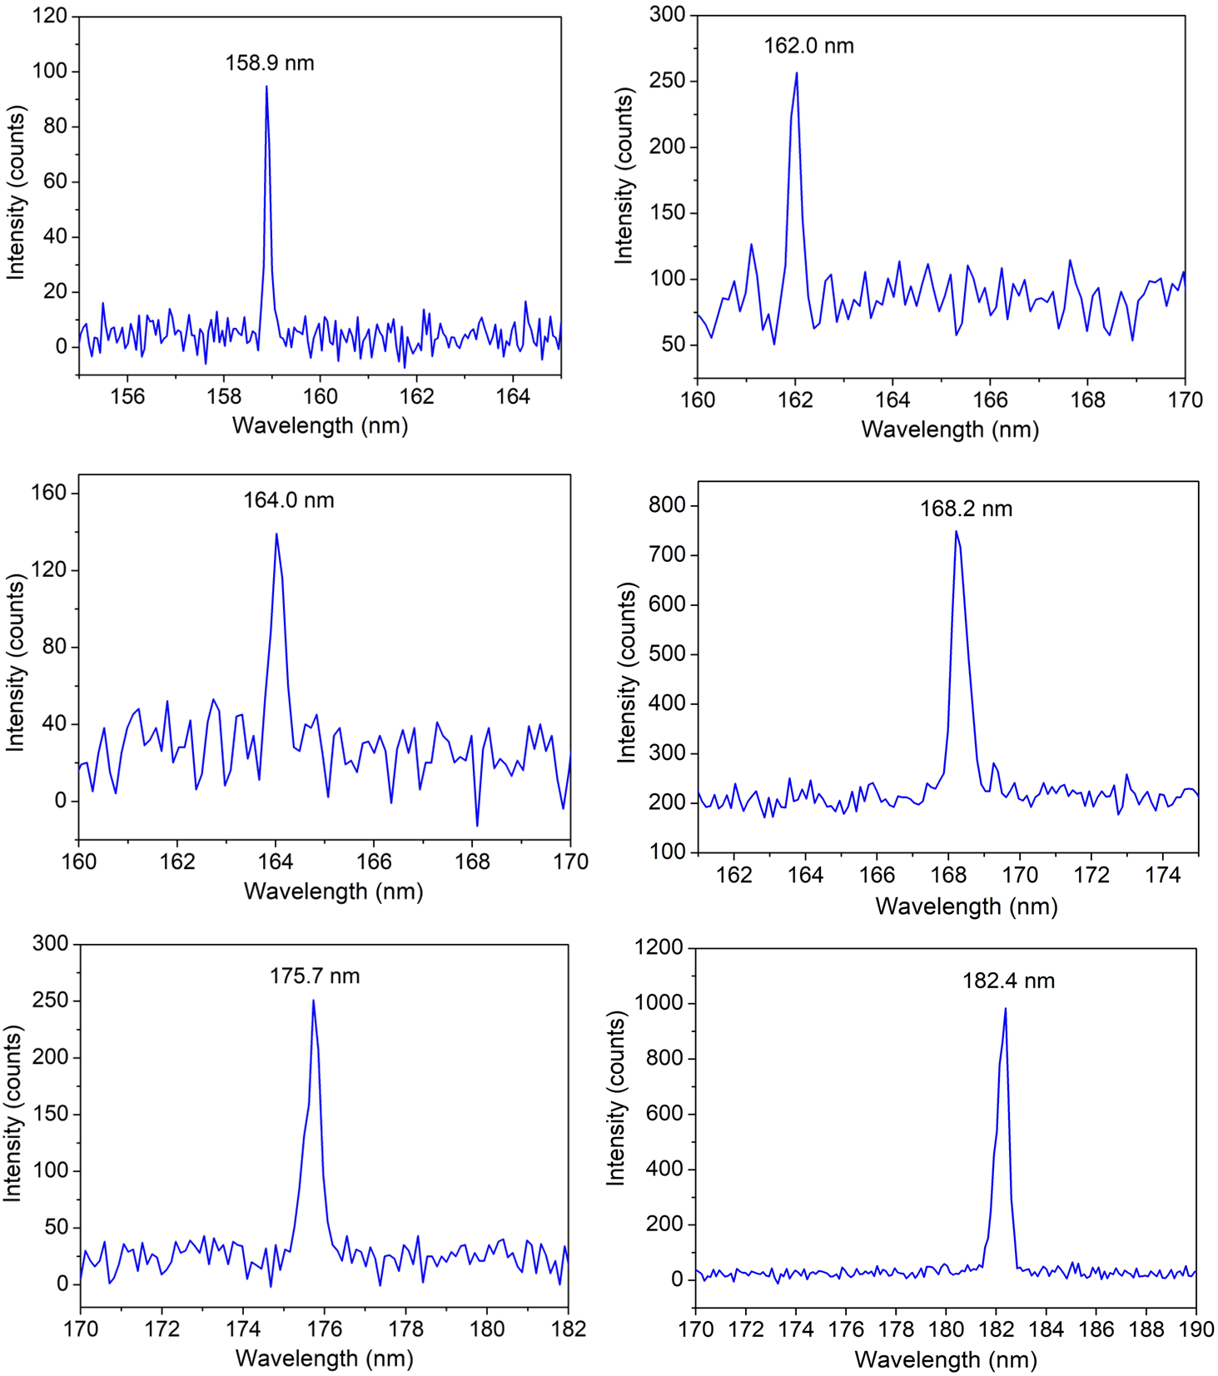

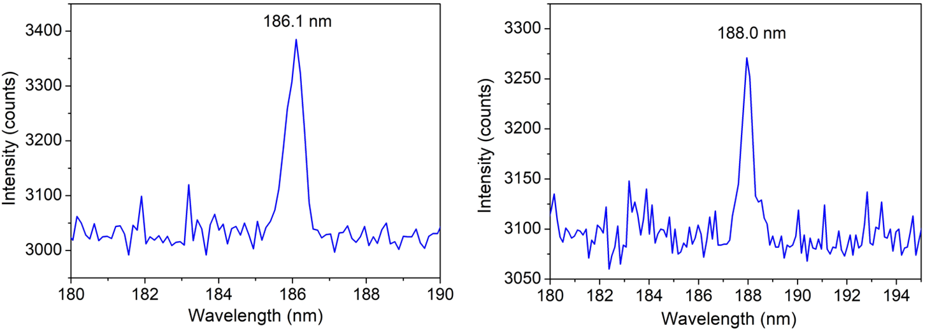
Extended Data Fig. 4. Observation of frequency doubling light for 190.4-230.5 nm using the ABF device with (θ, φ) = (0 °, 40 °). The red dotted line highlights breaking through the "200nm wall". Note that the SHG intensity is normalized for a better version and the raw data are available in Extended Data Fig. 5.
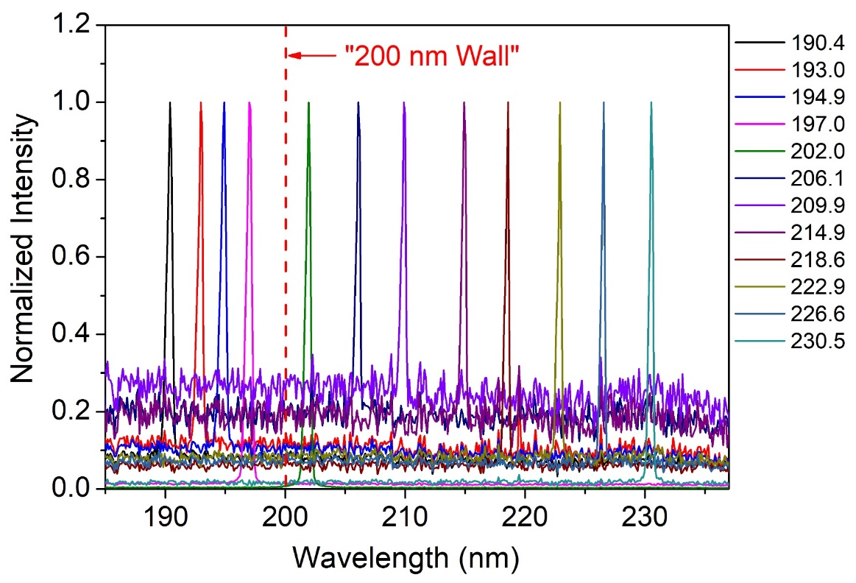

Extended Data Fig. S5. Raw data of frequency doubling light for 190.4-230.5 nm using the ABF device with (θ, φ) = (0 °, 40 °).

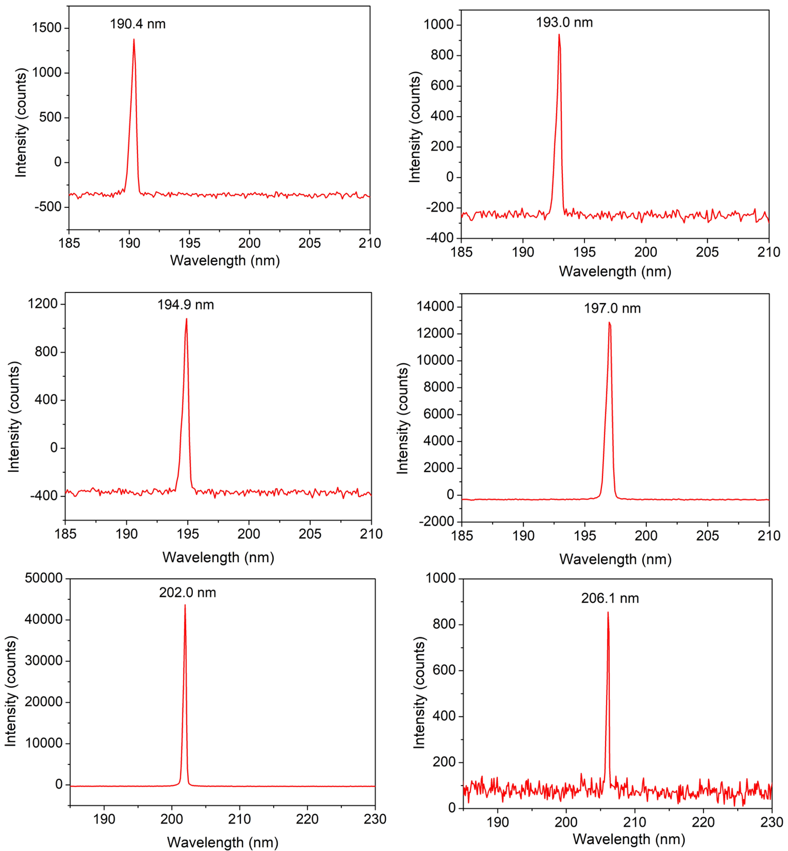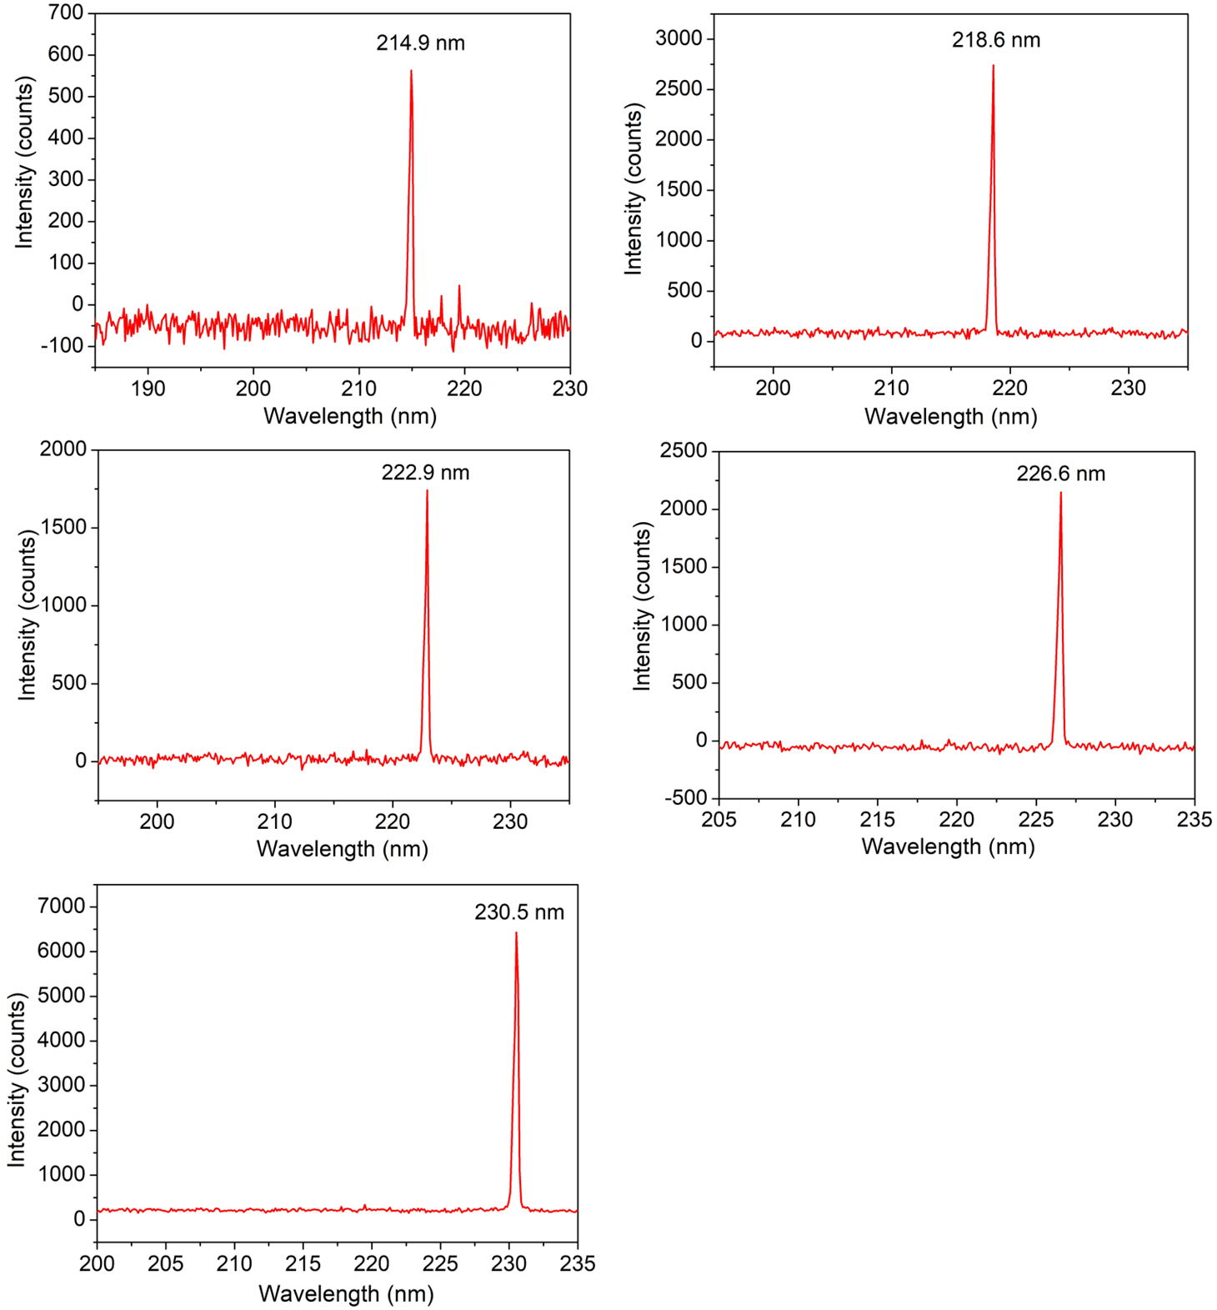
Extended Data Fig. 6 Observation of frequency doubling light from 255.1-340.2 nm using the ABF device with (θ, φ) = (0 °, 90 °). Note that the SHG intensity is normalized for a better version and the raw data are available in Fig. S7. Both fundamental and SHG lights are shown.
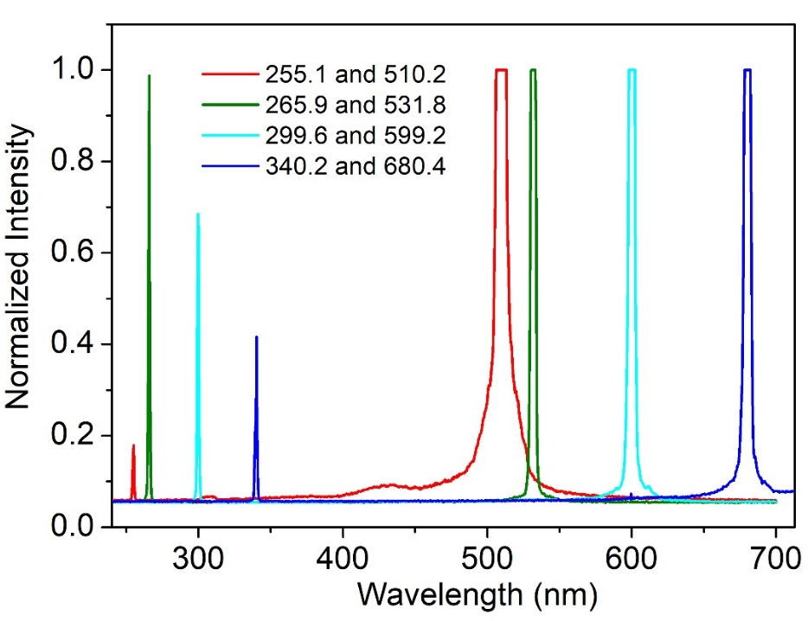

Extended Data Fig. 7. Raw data of frequency doubling light for 255.1-340.2 nm using the ABF device with (θ, φ) = (0 °, 90 °). Both fundamental and SHG lights are highlighted by dot lines in the figures.

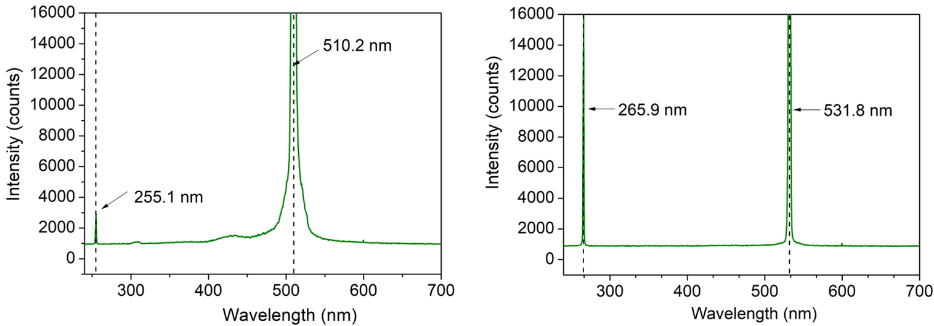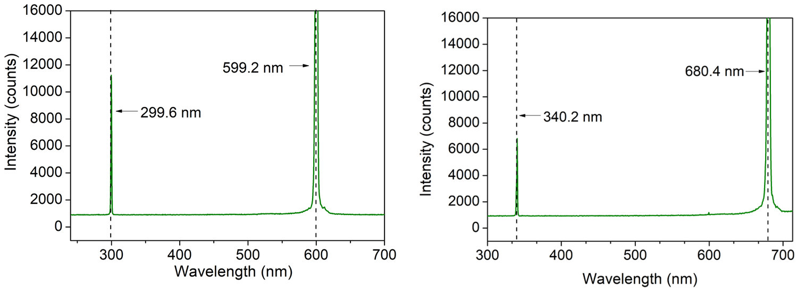

Extended Data Table. 1. Calculated effective SHG coefficients tensor (pm V^{–1}) and contribution of orbitals in the SHG coefficient d₃₂ of ABF.
Interaction orbitals | Contribution
NH₄-related orbitals (including hydrogen bond interaction orbital) | – 0.229 pm V^{–1}  (23 %)
Boron and oxygen/fluorine related orbitals | – 0.773 pm V^{–1}  (77 %)
Sum | – 1.002 pm V^{–1}

