Table S1. Mann-Whitney U test between genders and age groups in CTRL and obese subjects. Obese and CTRL groups have been stratified for gender and, on the bases of the age median value (13 years) in age≥13 years and age<13 years and compared by Mann-Whitney U test. In bold, p values ≤0.05.
 | CTRL F vs CTRL M |  | Obese F vs Obese M |  | CTRL+ vs CTRL- |  | Obese+ vs Obese-
Microbiota features | Mann-Whitney U | Monte Carlo Sig. (2-tailed) | Mann-Whitney U | Monte Carlo Sig. (2-tailed) | Mann-Whitney U | Monte Carlo Sig. (2-tailed) | Mann-Whitney U | Monte Carlo Sig. (2-tailed)
Shannon index | 135.00 | 0.27 | 402.00 | 0.10 | 141.00 | 0.65 | 292.00 | 0.49
Chao1 index | 165.00 | 0.84 | 491.00 | 0.64 | 121.00 | 0.28 | 293.00 | 0.50
Ruminococcaceae | 113.00 | 0.08 | 476.00 | 0.51 | 66.00 | 0.00 | 306.00 | 0.64
Faecalibacterium prausnitzii | 164.00 | 0.81 | 525.50 | 0.98 | 116.00 | 0.22 | 308.00 | 0.67
Bacteroides | 107.00 | 0.05 | 463.00 | 0.41 | 148.00 | 0.82 | 288.00 | 0.45
Lachnospiraceae | 163.00 | 0.79 | 490.00 | 0.63 | 143.00 | 0.70 | 314.00 | 0.73
Dialister | 141.50 | 0.36 | 515.00 | 0.87 | 116.50 | 0.22 | 231.00 | 0.09
Ruminococcus | 170.00 | 0.95 | 441.00 | 0.27 | 153.00 | 0.94 | 262.00 | 0.24
Rikenellaceae | 159.00 | 0.70 | 436.50 | 0.25 | 155.00 | 0.99 | 257.00 | 0.21
Enterobacteriaceae | 130.00 | 0.21 | 409.00 | 0.12 | 149.50 | 0.84 | 277.00 | 0.35
Bacteroidaceae | 132.00 | 0.24 | 477.00 | 0.51 | 155.00 | 0.99 | 271.00 | 0.30
Barnesiellaceae | 161.00 | 0.75 | 526.00 | 0.98 | 134.00 | 0.51 | 287.00 | 0.43
Oscillospira | 153.00 | 0.58 | 435.00 | 0.23 | 89.00 | 0.05 | 241.00 | 0.13
Prevotella copri | 167.00 | 0.88 | 425.50 | 0.13 | 143.00 | 0.70 | 286.50 | 0.38
Prevotella | 108.00 | 0.06 | 453.50 | 0.26 | 138.00 | 0.59 | 276.00 | 0.27
Bacteroides ovatus | 156.00 | 0.64 | 400.50 | 0.09 | 97.00 | 0.07 | 262.00 | 0.23
Parabacteroides | 165.00 | 0.84 | 455.00 | 0.32 | 130.00 | 0.43 | 328.00 | 0.90
Bacteroides fragilis | 147.50 | 0.46 | 356.00 | 0.01 | 102.00 | 0.09 | 244.00 | 0.10
Erysipelotrichaceae | 155.50 | 0.62 | 453.00 | 0.34 | 132.00 | 0.47 | 301.00 | 0.59
Akkermansia muciniphila | 148.00 | 0.48 | 497.00 | 0.65 | 131.00 | 0.45 | 312.50 | 0.67
Roseburia | 165.00 | 0.84 | 521.00 | 0.93 | 145.50 | 0.75 | 315.00 | 0.74
Blautia | 121.50 | 0.13 | 515.00 | 0.87 | 134.50 | 0.51 | 254.00 | 0.19
Sutterella | 138.00 | 0.31 | 523.50 | 0.96 | 127.00 | 0.38 | 249.00 | 0.14
Streptococcus | 143.00 | 0.39 | 518.50 | 0.91 | 144.50 | 0.72 | 270.50 | 0.30
Phascolarctobacterium | 156.50 | 0.64 | 388.00 | 0.04 | 112.50 | 0.17 | 268.00 | 0.22
Clostridiaceae | 157.00 | 0.66 | 401.00 | 0.10 | 116.00 | 0.22 | 242.00 | 0.13
Bacteroides caccae | 158.00 | 0.68 | 487.00 | 0.57 | 125.00 | 0.34 | 285.00 | 0.37
Moraxellaceae | 148.50 | 0.48 | 507.00 | 0.75 | 146.50 | 0.77 | 318.00 | 0.73
Collinsella aerofaciens | 152.50 | 0.56 | 480.00 | 0.48 | 114.00 | 0.20 | 329.50 | 0.91
Clostridium | 124.00 | 0.15 | 481.50 | 0.55 | 140.50 | 0.63 | 296.50 | 0.53
Dorea | 150.00 | 0.52 | 489.00 | 0.61 | 148.00 | 0.82 | 305.00 | 0.63
Anaerostipes | 146.00 | 0.44 | 364.00 | 0.03 | 118.00 | 0.24 | 205.50 | 0.03
Coprococcus | 154.00 | 0.60 | 522.00 | 0.94 | 140.00 | 0.63 | 294.00 | 0.51
Lachnospira | 148.00 | 0.48 | 498.00 | 0.69 | 116.00 | 0.22 | 310.00 | 0.68
Christensenellaceae | 151.00 | 0.54 | 527.00 | 0.99 | 140.00 | 0.63 | 262.00 | 0.19
Mogibacteriaceae | 149.00 | 0.50 | 444.00 | 0.29 | 154.00 | 0.96 | 327.00 | 0.89
Haemophilus parainfluenzae | 168.00 | 0.91 | 521.00 | 0.94 | 133.00 | 0.49 | 247.50 | 0.06
Ruminococcus gnavus | 136.50 | 0.29 | 454.50 | 0.30 | 152.50 | 0.91 | 321.00 | 0.80
Veillonella dispar | 149.00 | 0.50 | 454.50 | 0.24 | 89.00 | 0.04 | 294.00 | 0.43
Coriobacteriaceae | 168.00 | 0.91 | 439.00 | 0.22 | 127.50 | 0.38 | 312.00 | 0.69
Parabacteroides distasonis | 155.50 | 0.62 | 442.50 | 0.24 | 144.50 | 0.72 | 261.00 | 0.21
Butyricimonas | 146.00 | 0.44 | 421.00 | 0.08 | 107.00 | 0.13 | 312.00 | 0.64
Granulicatella | 171.00 | 0.98 | 496.00 | 0.64 | 130.50 | 0.43 | 249.00 | 0.10
Turicibacter | 149.00 | 0.50 | 523.00 | 0.95 | 149.50 | 0.84 | 263.00 | 0.20
Odoribacter | 142.00 | 0.38 | 492.00 | 0.60 | 154.00 | 0.96 | 286.50 | 0.38
Actinomyces | 154.00 | 0.60 | 485.00 | 0.52 | 147.00 | 0.79 | 312.00 | 0.65
Eubacterium dolichum | 150.00 | 0.52 | 422.00 | 0.10 | 138.00 | 0.59 | 280.00 | 0.30
Bacteroides uniformis | 124.00 | 0.15 | 446.00 | 0.17 | 132.00 | 0.47 | 240.00 | 0.05
Holdemania | 168.00 | 0.91 | 472.50 | 0.41 | 129.50 | 0.41 | 334.00 | 0.98

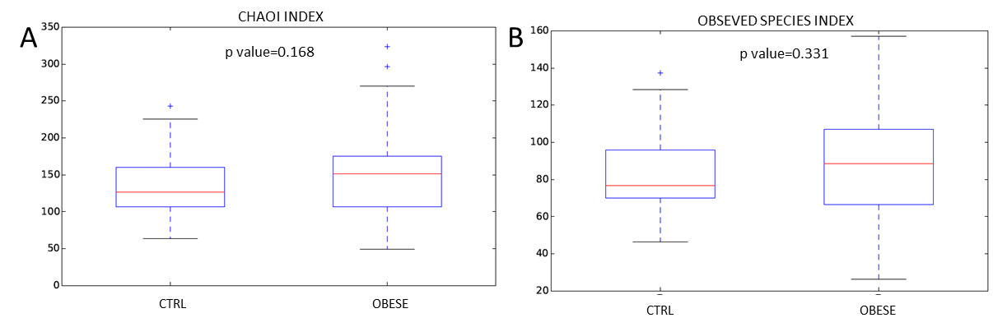

Supplementary Figure 1. Boxplots representing α-diversity indices. Panel A and B represent the Chao1 and Observed species indexes for obese and CTRL samples. The interquartile range is represented by the box and the line in the box is the median. The whiskers indicate the largest and the lowest data points, respectively, while the dots symbolize outliers.

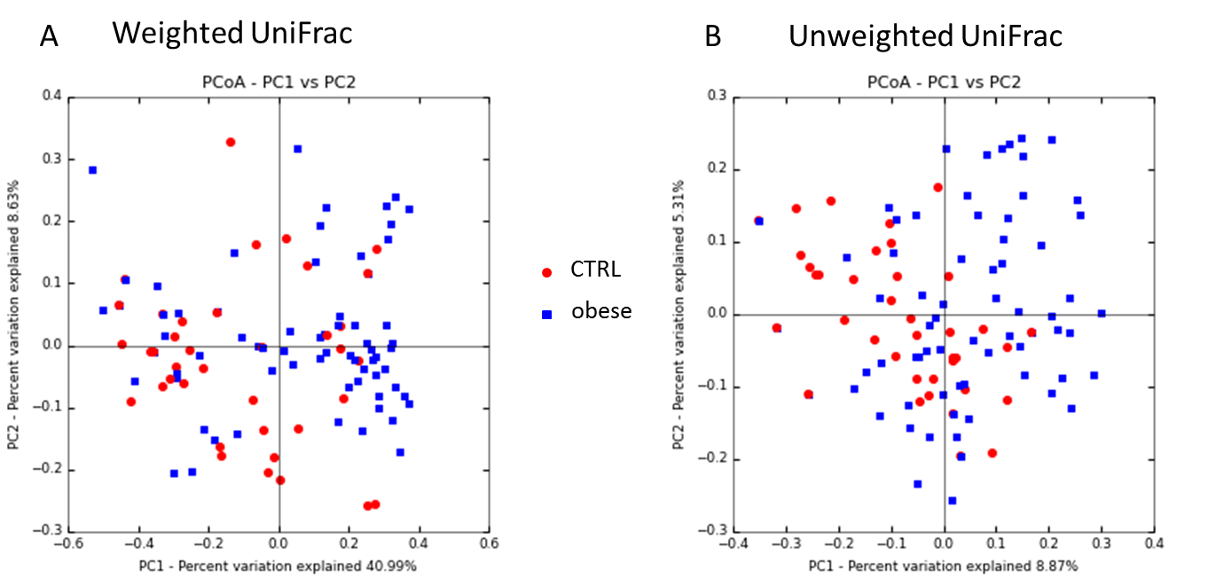
Supplementary Figure 2. Principal component analysis plot (PCA) of the bacterial communities using UniFrac algorithm. Axes represent the first 2 components from principal coordinate (PCo) analysis based on the phylogenetic distance between Operational Taxonomic Units (OTU) representative sequences. Panel A, UniFrac weighted PCoA plots of CTRL and obese groups. Panel B, unweighted UniFrac PCoA plots of CTRL and obese groups.

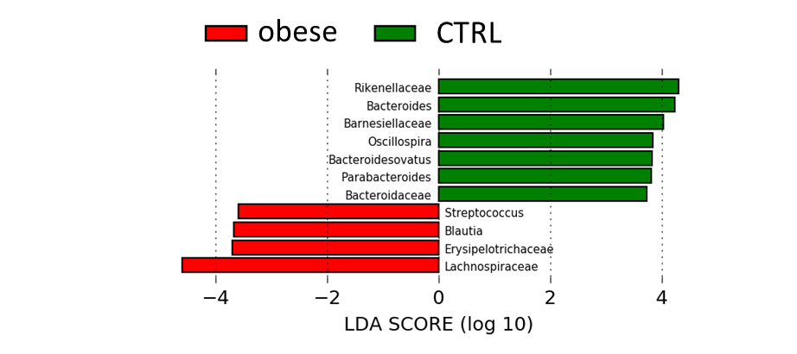
Supplementary Figure 3. Linear discriminative analysis (LDA) effect size (LEfSe) analysis between healthy CTRL (green) and obese patients (red).

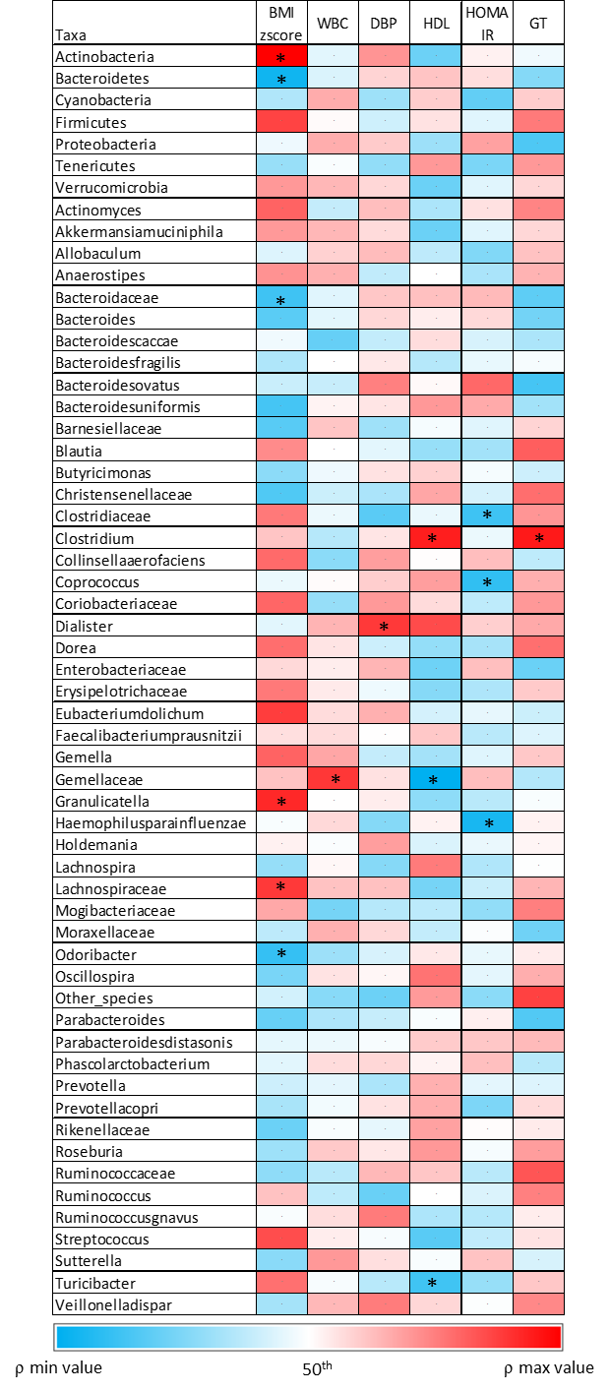
Supplementary Figure 4. Heat map representing Spearman’s correlation analysis between metabolic abnormalities and gut microbiota OTUs. Stars indicate the correlation values statistically significant.

