Supplementary Table
Supplementary Table 1. Baseline Cohort Characteristics and Neuroimaging Data in the UK Biobank Study Population
Group | Baseline Participants | Baseline % | Total Scans | Scan %
Healthy Controls (CN) | 6036 | 15.5 | 6036 | 15.5
Non-brain Disease | 25416 | 65.2 | 25416 | 65.2
Brain Disorder | 7515 | 19.3 | 7515 | 19.3
Total | 38967 | 100 | 38967 | 100
UKB = UK Biobank; CN = Healthy Controls (no G00–G99/F00–F99/I60-I63 diagnoses); Non-brain Disease = Exclusively non-neurological comorbidities; Brain Disorder = Neurological/neuropsychiatric diagnoses (ICD-10 G00–G99, F00–F99, I60-I63); Scans represent baseline T1-weighted MRI acquisitions

Supplementary Table 2. Distribution of Neurodegenerative, Psychiatric, and Neurological Disorders with Pathophysiological Classification in the Brain Disorder Group of UK Biobank Cohort (N=7,515)
Disease Name | Abbreviation | ICD-10 Code | Number of Cases | Category
Alzheimer's Disease | AD | G30 | 63 | Neurodegenerative Disorders
Vascular Dementia | VaD | F01 | 293 | Neurodegenerative Disorders
Parkinson's Disease | PD | G20 | 79 | Neurodegenerative Disorders
Stroke | - | I63 | 743 | Neurological Disorders
Anorexia Nervosa | AN | F50.0 | 48 | Psychiatric Disorders
Anxiety Disorder | ANX | F41 | 2390 | Psychiatric Disorders
Bipolar Disorder | BD | F31 | 72 | Psychiatric Disorders
Major Depressive Disorder | MDD | F32 | 4490 | Psychiatric Disorders
Epilepsy | - | G40 | 340 | Neurological Disorders
Multiple Sclerosis | MS | G35 | 151 | Neurological Disorders
Obsessive-Compulsive Disorder | OCD | F42 | 33 | Psychiatric Disorders
Post-Traumatic Stress Disorder | PTSD | F43.1 | 76 | Psychiatric Disorders
Schizophrenia | SCZ | F20 | 26 | Psychiatric Disorders
Sleep Disorders | SD | G47 | 679 | Neurological Disorders

Supplementary Table 3. Baseline Cohort Characteristics and Longitudinal Monitoring in the ADNI Study Population
Group | Baseline Participants | Baseline % | Total Scans | Scan %
Cognitively Normal (CN) | 332 | 23.7 | 1,480 | 29.3
Mild Cognitive Impairment (MCI) | 785 | 56.0 | 2,836 | 56.1
Alzheimer's Disease (AD) | 285 | 20.3 | 742 | 14.7
Total | 1,402 | 100 | 5,058 | 100
ADNI = Alzheimer's Disease Neuroimaging Initiative; CN = Cognitively Normal; MCI = Mild Cognitive Impairment

Supplementary Table 4. Baseline Cohort Characteristics and Longitudinal Monitoring in the PPMI Study Population
Group | Baseline Participants | Baseline % | Total Scans | Scan %
Healthy Controls (CN) | 185 | 15.7 | 279 | 9.6
Prodromal Parkinson's (prodPD) | 381 | 32.2 | 1,326 | 45.6
Parkinson's Disease (PD) | 616 | 52.1 | 1,303 | 44.8
Total | 1,182 | 100 | 2,907 | 100
PPMI = Parkinson's Progression Markers Initiative; HC = Healthy Controls; Scans include clinical assessments, biomarker collections and neuroimaging sessions

Supplementary Table 5. High-Resolution 3D Voxel Reconstruction via Transformer-Based Encoder with Multi-Head Attention and Optimized Learning Strategies
Component | Parameters
Input | 128³ voxels (16³ patches)
Encoder layers | 12 transformer blocks
Attention heads | 8-head multi-head attention
Hidden layers | MLP with 512→256 dimensions
Optimization | Adam (β₁=0.9, β₂=0.999)
Learning rate | 2×10⁻⁵ with cosine decay
Regularization | Early stopping (10 &epochs patience)

Supplementary Table 6. Performance of the 3D-ViT Model in Brain Age Estimation Across Cohorts and Subgroups
Group | N | MAE (years) | MSE (years) | R2 | Pearson r
Healthy Control Group Performance
UKB Training | 25,162 | 2.627 | 10.988 | 0.81 | 0.901
UKB Cross-validation (Mean) | 5,032 | 2.61 | 10.999 | 0.808 | 0.899
UKB Testing | 6,290 | 2.684 | 11.398 | 0.805 | 0.898
Subgroup Analysis
UKB Female | 16,159 | 2.567 | 10.456 | 0.811 | 0.902
UKB Male | 15,293 | 2.714 | 11.719 | 0.804 | 0.897
UKB Age < 65 | 15,211 | 2.609 | 10.867 | 0.455 | 0.76
UKB Age >=65 | 16,241 | 2.666 | 11.261 | 0.233 | 0.687
External Validation
ADNI, CN | 1,480 | 2.998 | 16 | 0.568 | 0.758
PPMI, CN | 279 | 3.205 | 17.64 | 0.858 | 0.936
Disease Group Performance
UKB Patient Group | 7,515 | 2.773 | 12.566 | 0.793 | 0.895
ADNI, MCI | 2,836 | 4.773 | 36.26 | 0.37 | 0.675
ADNI, AD | 742 | 6.08 | 57.55 | 0.068 | 0.51
PPMI, ProdPD | 1,326 | 3.913 | 23.97 | 0.601 | 0.854
PPMI, PD | 1,302 | 3.483 | 19.64 | 0.778 | 0.96

Supplementary Table 7. Descriptive Statistics of Neuropsychological Tests by Cognitive Domain
Cognitive Domain | Test Name | Sample Size | Age Mean (SD) | Sex (% Female)
Short-term memory | Numeric Memory Test (NMT) | 25,617 | 64.48 (7.56) | 52.30%
Visual reasoning | Matrix Pattern Completion (MPC) | 24,872 | 64.51 (7.49) | 52.15%
Abstract reasoning | Fluid Intelligence Test (FIT) | 24,901 | 64.53 (7.48) | 52.10%
Processing speed | Reaction Time Test (RTT) | 25,617 | 64.48 (7.56) | 52.30%
Associative learning | Paired Associate Learning (PAL) | 24,872 | 64.50 (7.51) | 52.20%
Executive function | Tower Rearranging (TR) | 24,945 | 64.49 (7.50) | 52.20%
Cognitive flexibility | Symbol Digit Substitution (SDS) | 25,617 | 64.48 (7.56) | 52.30%
Visual memory | Pairs Matching Test (PMT) | 25,617 | 64.48 (7.56) | 52.30%

Supplementary Table 8. Cognitive Performance Stratified by Brain Age Gap Quartiles in the UKB Cohort
Variables (Mean ± SD) | Total (n = 25617) | Q1 (n = 6408) | Q2 (n = 6834) | Q3 (n = 6750) | Q4 (n = 5625) | Statistic | P
Numeric memory | 6.79 ± 1.25 | 6.80 ± 1.26 | 6.78 ± 1.26 | 6.78 ± 1.24 | 6.77 ± 1.25 | F=0.52 | 0.671
Matrix pattern completion | 8.03 ± 2.10 | 8.10 ± 2.10 | 8.12 ± 2.07 | 7.95 ± 2.11 | 7.95 ± 2.12 | F=12.40 | <0.001
Fluid intelligence | 6.59 ± 2.01 | 6.57 ± 2.03 | 6.64 ± 2.01 | 6.57 ± 1.99 | 6.57 ± 2.02 | F=1.93 | 0.122
Reaction time/ms | 597.52 ± 109.30 | 591.74 ± 106.26 | 593.68 ± 109.47 | 599.79 ± 108.11 | 604.88 ± 112.78 | F=19.27 | <0.001
Paired associate learning | 7.03 ± 2.51 | 7.14 ± 2.52 | 7.15 ± 2.47 | 6.99 ± 2.51 | 6.85 ± 2.52 | F=19.82 | <0.001
Tower rearranging | 9.96 ± 3.20 | 9.99 ± 3.22 | 10.07 ± 3.17 | 9.86 ± 3.22 | 9.91 ± 3.20 | F=5.20 | 0.001
Symbol digit substitution | 18.95 ± 5.22 | 19.29 ± 5.15 | 19.30 ± 5.17 | 18.77 ± 5.31 | 18.45 ± 5.21 | F=40.67 | <0.001
Pairs Matching | 2.52 ± 1.38 | 2.51 ± 1.35 | 2.46 ± 1.34 | 2.53 ± 1.39 | 2.57 ± 1.44 | F=6.68 | <0.001

Supplementary Table 9. Associations Between Biological Aging Quartiles and Cognitive Performance Across Multiple Domains (UK Biobank Cohort)
Cognitive Domain | Comparison | Beta | 95% CI | P value | P_{FDR} | Significance
Numeric memory | Q2 vs Q1 | -0.02 | -0.06 to 0.03 | 0.43896 | 0.43896
Numeric memory | Q3 vs Q1 | -0.02 | -0.06 to 0.03 | 0.40904 | 0.43896
Numeric memory | Q4 vs Q1 | -0.03 | -0.07 to 0.02 | 0.2253 | 0.43896
Matrix pattern completion | Q2 vs Q1 | 0.02 | -0.05 to 0.09 | 0.5784 | 0.5784
Matrix pattern completion | Q3 vs Q1 | -0.15 | -0.22 to -0.08 | <0.001 | <0.001 | ***
Matrix pattern completion | Q4 vs Q1 | -0.15 | -0.22 to -0.08 | <0.001 | <0.001 | ***
Fluid intelligence | Q2 vs Q1 | 0.07 | 0.00 to 0.14 | 0.04872 | 0.14615
Fluid intelligence | Q3 vs Q1 | 0 | -0.07 to 0.07 | 0.89522 | 0.92806
Fluid intelligence | Q4 vs Q1 | 0 | -0.07 to 0.07 | 0.92806 | 0.92806
Reaction time | Q2 vs Q1 | 1.94 | -1.84 to 5.73 | 0.31355 | 0.31355
Reaction time | Q3 vs Q1 | 8.06 | 4.28 to 11.84 | <0.001 | <0.001 | ***
Reaction time | Q4 vs Q1 | 13.15 | 9.37 to 16.93 | <0.001 | <0.001 | ***
Paired associate learning | Q2 vs Q1 | 0.01 | -0.07 to 0.10 | 0.75344 | 0.75344
Paired associate learning | Q3 vs Q1 | -0.14 | -0.23 to -0.06 | 0.00124 | 0.00186 | **
Paired associate learning | Q4 vs Q1 | -0.28 | -0.37 to -0.20 | <0.001 | <0.001 | ***
Tower rearranging | Q2 vs Q1 | 0.08 | -0.03 to 0.19 | 0.16328 | 0.16586
Tower rearranging | Q3 vs Q1 | -0.13 | -0.24 to -0.02 | 0.02211 | 0.06633
Tower rearranging | Q4 vs Q1 | -0.08 | -0.19 to 0.03 | 0.16586 | 0.16586
Symbol digit substitution | Q2 vs Q1 | 0.01 | -0.17 to 0.19 | 0.93782 | 0.93782
Symbol digit substitution | Q3 vs Q1 | -0.52 | -0.70 to -0.34 | <0.001 | <0.001 | ***
Symbol digit substitution | Q4 vs Q1 | -0.84 | -1.02 to -0.66 | <0.001 | <0.001 | ***
Pairs Matching | Q2 vs Q1 | -0.05 | -0.09 to 0.00 | 0.05414 | 0.08121
Pairs Matching | Q3 vs Q1 | 0.02 | -0.03 to 0.07 | 0.43507 | 0.43507
Pairs Matching | Q4 vs Q1 | 0.06 | 0.01 to 0.11 | 0.01319 | 0.03956 | *
Linear regression models were used to assess the associations between biological aging quartiles (independent variable, with Q1 as the reference group) and cognitive domain measures (dependent variables). β coefficients with 95% confidence intervals (CIs) were estimated using ordinary least squares. To account for multiple comparisons across eight cognitive domains, we applied the Benjamini-Hochberg procedure to control the false discovery rate (FDR). Significance thresholds were defined as: P < 0.001***, P < 0.01**, and P< 0.05*.

Supplementary Table 10. Optimal Knots, Inflection Points, and Maximum Effects of Brain Age Gap on Cognitive Domains
Cognitive Domain | Optimal Knots | Inflection Point | Max Effect
Numeric Memory | 1 | -0.06 | 3.17
Matrix Pattern Completion | 1 | 0.1 | 3.29
Fluid Intelligence | 1 | 0.01 | 3.46
Reaction Time | 1 | -1.75 | 3.13
Paired Associate Learning | 1 | 0.01 | 3.11
Tower Rearranging | 1 | -0.03 | 3.24
Symbol Digit Substitution | 1 | 0.1 | 3.21
Pairs Matching | 1 | 0.1 | 3.26

Supplementary Table 11. Cohort Characteristics and Follow-up Duration Stratified by BAG Quartiles in the UKB Dataset
Disorder Category | BAG Quartile | Cohort Size, n | Incident Cases, n | Censored Cases, n | Follow-up Duration, years  Mean (SD) | Person-Years  median [min-max]
Alzheimer's Disease | Q1 | 9,529 | 11 | 9,518 | 9.04 | 9.96 [0.03-26.75]
Alzheimer's Disease | Q2 | 10,265 | 6 | 10,259 | 9.07 | 10.00 [0-26.70]
Alzheimer's Disease | Q3 | 10,268 | 17 | 10,251 | 8.97 | 9.88 [0-26.32]
Alzheimer's Disease | Q4 | 8,905 | 29 | 8,876 | 9.05 | 9.93 [0.01-26.97]
 | Total | 38,967 | 63 | 38,904 | 9.03 | 9.94 [0-26.97]
Vascular Dementia | Q1 | 9,529 | 64 | 9,465 | 9.04 | 9.96 [0.03-26.75]
Vascular Dementia | Q2 | 10,265 | 82 | 10,183 | 9.07 | 10.00 [0-26.70]
Vascular Dementia | Q3 | 10,268 | 68 | 10,200 | 8.98 | 9.88 [0-26.32]
Vascular Dementia | Q4 | 8,905 | 79 | 8,826 | 9.05 | 9.93 [0.01-26.97]
 | Total | 38,967 | 293 | 38,674 | 9.03 | 9.94 [0-26.97]
Parkinson's Disease | Q1 | 9,529 | 14 | 9,515 | 9.03 | 9.96 [0.03-26.75]
Parkinson's Disease | Q2 | 10,265 | 18 | 10,247 | 9.06 | 10.00 [0-26.70]
Parkinson's Disease | Q3 | 10,268 | 23 | 10,245 | 8.97 | 9.87 [0-26.32]
Parkinson's Disease | Q4 | 8,905 | 24 | 8,881 | 9.05 | 9.92 [0.01-26.97]
 | Total | 38,967 | 79 | 38,888 | 9.03 | 9.94 [0-26.97]
Stroke | Q1 | 9,529 | 166 | 9,363 | 9.01 | 9.93 [0.03-26.75]
Stroke | Q2 | 10,265 | 153 | 10,112 | 9.04 | 9.98 [0-26.70]
Stroke | Q3 | 10,268 | 198 | 10,070 | 8.95 | 9.83 [0-26.32]
Stroke | Q4 | 8,905 | 226 | 8,679 | 9.01 | 9.86 [0.01-26.97]
 | Total | 38,967 | 743 | 38,224 | 9.00 | 9.90 [0-26.97]
Anorexia Nervosa | Q1 | 9,529 | 11 | 9,518 | 9.04 | 9.97 [0.03-26.75]
Anorexia Nervosa | Q2 | 10,265 | 9 | 10,256 | 9.07 | 10.00 [0-26.70]
Anorexia Nervosa | Q3 | 10,268 | 14 | 10,254 | 8.98 | 9.88 [0-26.32]
Anorexia Nervosa | Q4 | 8,905 | 14 | 8,891 | 9.05 | 9.93 [0.01-26.97]
 | Total | 38,967 | 48 | 38,919 | 9.03 | 9.94 [0-26.97]
Anxiety Disorder | Q1 | 9,529 | 472 | 9,057 | 8.97 | 9.86 [0.03-26.75]
Anxiety Disorder | Q2 | 10,265 | 588 | 9,677 | 8.99 | 9.91 [0-26.70]
Anxiety Disorder | Q3 | 10,268 | 697 | 9,571 | 8.88 | 9.74 [0-26.32]
Anxiety Disorder | Q4 | 8,905 | 633 | 8,272 | 8.93 | 9.74 [0.01-26.97]
 | Total | 38,967 | 2,390 | 36,577 | 8.94 | 9.81 [0-26.97]
Bipolar Disorder | Q1 | 9,529 | 11 | 9,518 | 9.03 | 9.96 [0.03-26.75]
Bipolar Disorder | Q2 | 10,265 | 10 | 10,255 | 9.07 | 10.00 [0-26.70]
Bipolar Disorder | Q3 | 10,268 | 26 | 10,242 | 8.97 | 9.87 [0-26.32]
Bipolar Disorder | Q4 | 8,905 | 25 | 8,880 | 9.04 | 9.91 [0.01-26.97]
 | Total | 38,967 | 72 | 38,895 | 9.03 | 9.94 [0-26.97]
Depression | Q1 | 9,529 | 905 | 8,624 | 8.94 | 9.84 [0.03-26.75]
Depression | Q2 | 10,265 | 1,126 | 9,139 | 8.93 | 9.86 [0-26.70]
Depression | Q3 | 10,268 | 1,235 | 9,033 | 8.82 | 9.69 [0-26.32]
Depression | Q4 | 8,905 | 1,224 | 7,681 | 8.85 | 9.68 [0.01-26.97]
 | Total | 38,967 | 4,490 | 34,477 | 8.88 | 9.77 [0-26.97]
Epilepsy | Q1 | 9,529 | 57 | 9,472 | 9.03 | 9.96 [0.03-26.75]
Epilepsy | Q2 | 10,265 | 84 | 10,181 | 9.05 | 9.99 [0-26.70]
Epilepsy | Q3 | 10,268 | 82 | 10,186 | 8.96 | 9.87 [0-26.32]
Epilepsy | Q4 | 8,905 | 117 | 8,788 | 9.03 | 9.90 [0.01-26.97]
 | Total | 38,967 | 340 | 38,627 | 9.02 | 9.93 [0-26.97]
Multiple Sclerosis | Q1 | 9,529 | 14 | 9,515 | 9.04 | 9.97 [0.03-26.75]
Multiple Sclerosis | Q2 | 10,265 | 20 | 10,245 | 9.07 | 10.00 [0-26.70]
Multiple Sclerosis | Q3 | 10,268 | 33 | 10,235 | 8.97 | 9.87 [0-26.32]
Multiple Sclerosis | Q4 | 8,905 | 84 | 8,821 | 9.04 | 9.91 [0.01-26.97]
 | Total | 38,967 | 151 | 38,816 | 9.03 | 9.94 [0-26.97]
Obsessive-Compulsive Disorder | Q1 | 9,529 | 5 | 9,524 | 9.04 | 9.96 [0.03-26.75]
Obsessive-Compulsive Disorder | Q2 | 10,265 | 8 | 10,257 | 9.07 | 10.00 [0-26.70]
Obsessive-Compulsive Disorder | Q3 | 10,268 | 10 | 10,258 | 8.97 | 9.87 [0-26.32]
Obsessive-Compulsive Disorder | Q4 | 8,905 | 10 | 8,895 | 9.05 | 9.93 [0.01-26.97]
 | Total | 38,967 | 33 | 38,934 | 9.03 | 9.94 [0-26.97]
Post-Traumatic Stress Disorder | Q1 | 9,529 | 15 | 9,514 | 9.04 | 9.96 [0.03-26.75]
Post-Traumatic Stress Disorder | Q2 | 10,265 | 20 | 10,245 | 9.07 | 10.00 [0-26.70]
Post-Traumatic Stress Disorder | Q3 | 10,268 | 26 | 10,242 | 8.97 | 9.87 [0-26.32]
Post-Traumatic Stress Disorder | Q4 | 8,905 | 15 | 8,890 | 9.05 | 9.93 [0.01-26.97]
 | Total | 38,967 | 76 | 38,891 | 9.03 | 9.94 [0-26.97]
Schizophrenia | Q1 | 9,529 | 2 | 9,527 | 9.04 | 9.97 [0.03-26.75]
Schizophrenia | Q2 | 10,265 | 6 | 10,259 | 9.07 | 10.00 [0-26.70]
Schizophrenia | Q3 | 10,268 | 4 | 10,264 | 8.98 | 9.88 [0-26.32]
Schizophrenia | Q4 | 8,905 | 14 | 8,891 | 9.05 | 9.92 [0.01-26.97]
 | Total | 38,967 | 26 | 38,941 | 9.03 | 9.94 [0-26.97]
Sleep Disorder | Q1 | 9,529 | 134 | 9,395 | 9.01 | 9.92 [0.03-26.75]
Sleep Disorder | Q2 | 10,265 | 159 | 10,106 | 9.04 | 9.97 [0-26.70]
Sleep Disorder | Q3 | 10,268 | 184 | 10,084 | 8.94 | 9.83 [0-26.32]
Sleep Disorder | Q4 | 8,905 | 202 | 8,703 | 9.01 | 9.88 [0.01-26.97]
 | Total | 38,967 | 679 | 38,288 | 9.00 | 9.90 [0-26.97]

Supplementary Table 12. Cohort Characteristics and Follow-up Duration Stratified by BAG Quartiles in the ADNI Dataset
Disorder Category | BAG Quartile | Cohort Size, n | Incident Cases, n | Censored Cases, n | Follow-up Duration, years  Mean (SD) | Person-Years  median [min-max]
Mild Cognitive Impairment | Q1 | 1,156 | 611 | 545 | 3.04 | 2 [0-10.5]
Mild Cognitive Impairment | Q2 | 865 | 404 | 461 | 2.79 | 2 [0-10]
Mild Cognitive Impairment | Q3 | 941 | 471 | 470 | 2.48 | 2 [0-8]
Mild Cognitive Impairment | Q4 | 2,096 | 1350 | 746 | 1.91 | 2 [0-10]
 | Total | 5,058 | 2,836 | 2,222 | 2.44 | 2 [0-10.5]
Alzheimer's Disease | Q1 | 1,156 | 161 | 995 | 3.04 | 2 [0-10.5]
Alzheimer's Disease | Q2 | 865 | 75 | 790 | 2.79 | 2 [0-10]
Alzheimer's Disease | Q3 | 941 | 106 | 835 | 2.48 | 2 [0-8]
Alzheimer's Disease | Q4 | 2,096 | 400 | 1,696 | 1.91 | 2 [0-10]
 | Total | 5,058 | 742 | 4,316 | 2.44 | 2 [0-10.5]

Supplementary Table 13. Cohort Characteristics and Follow-up Duration Stratified by BAG Quartiles in the PPMI Dataset
Disorder Category | BAG Quartile | Cohort Size, n | Incident Cases, n | Censored Cases, n | Follow-up Duration, years | Person-Years
 |  |  |  |  | Mean (SD) | median [min-max]
Prodromal Parkinson's | Q1 | 727 | 400 | 327 | 2.59 | 2 [1-2]
Prodromal Parkinson's | Q2 | 725 | 344 | 381 | 2.51 | 2 [1-2]
Prodromal Parkinson's | Q3 | 728 | 300 | 428 | 2.43 | 2 [1-2]
Prodromal Parkinson's | Q4 | 727 | 282 | 445 | 2.46 | 2 [1-2]
Prodromal Parkinson's | Total | 2,907 | 1,326 | 1,581 | 2.50 | 2 [1-2]
Parkinson's Disease | Q1 | 727 | 278 | 449 | 2.59 | 2 [1-2]
Parkinson's Disease | Q2 | 725 | 305 | 420 | 2.51 | 2 [1-2]
Parkinson's Disease | Q3 | 728 | 347 | 381 | 2.43 | 2 [1-2]
Parkinson's Disease | Q4 | 727 | 372 | 355 | 2.46 | 2 [1-2]
 | Total | 2,907 | 1,302 | 1,605 | 2.50 | 2 [1-2]

Supplementary Table 14. Comparison of BAG Levels Across Various Disease Groups Compared to Healthy Controls (CN)
 |  | BAG
Disease Group | Sample Size | Mean ± SD | P-value
CN | 9,274 | 0.122 ± 3.039 | Reference
AD | 805 | 3.242 ± 6.635 | <0.001***
MCI | 2,836 | 2.063 ± 5.619 | <0.001***
VaD | 293 | 0.279 ± 3.463 | 0.442
ProdPD | 1,326 | -1.441 ± 4.880 | <0.001***
PD | 1,381 | -0.003 ± 4.463 | 0.321
Stroke | 743 | 0.631 ± 3.585 | <0.001***
AN | 48 | 0.369 ± 3.547 | 0.631
ANX | 2,390 | 0.525 ± 3.425 | <0.001***
BD | 72 | 1.913 ± 4.051 | <0.001***
MDD | 4,490 | 0.516 ± 3.409 | <0.001***
Epilepsy | 340 | 1.059 ± 3.478 | <0.001***
MS | 151 | 4.069 ± 5.328 | <0.001***
OCD | 33 | 1.161 ± 3.231 | 0.074
PTSD | 76 | 0.310 ± 3.539 | 0.645
SCZ | 26 | 2.068 ± 3.341 | 0.007**
SD | 679 | 0.641 ± 3.379 | <0.001***
Data presented as mean ± standard deviation. P-values calculated using two-sample t-test compared to CN group.

Supplementary Table 15. Association of Biological Aging (BAG) with Neurological and Psychiatric Disorders: Hazard Ratios (HR) and 95% Confidence Intervals (CI) Stratified by BAG Quartiles
Disease | BAG | HR [95% CI] | FDR P-value
Alzheimers disease | BAG per year | 1.165 [1.086-1.249] | 7.368e-05***
Alzheimers disease | Q2 vs Q1 | 0.496 [0.183-1.340] | 0.278
Alzheimers disease | Q3 vs Q1 | 1.450 [0.679-3.095] | 0.469
Alzheimers disease | Q4 vs Q1 | 2.801 [1.399-5.608] | 0.011*
Mild cognitive impairment | BAG per year | 1.040 [1.030-1.050] | 3.201e-04***
Mild cognitive impairment | Q2 vs Q1 | 0.956 [0.856-1.067] | 0.421
Mild cognitive impairment | Q3 vs Q1 | 1.449 [1.307-1.607] | 2.206e-04***
Mild cognitive impairment | Q4 vs Q1 | 1.691[1.526-1.874] | 5.606e-05***
Vascular dementia | BAG per year | 1.022 [0.988-1.058] | 0.323
Vascular dementia | Q2 vs Q1 | 1.169 [0.843-1.621] | 0.476
Vascular dementia | Q3 vs Q1 | 0.990 [0.704-1.393] | 0.969
Vascular dementia | Q4 vs Q1 | 1.311 [0.943-1.823] | 0.202
 | BAG per year | 0.993 [0.992-1.001] | 0.199
Prodromal Parkinson’s | Q2 vs Q1 | 0.903 [0.811-0.994] | 0.056
 | Q3 vs Q1 | 1.112 [0.991-1.245] | 0.076
 | Q4 vs Q1 | 0.925 [0.833-1.023] | 0.105
 | BAG per year | 1.038 [0.972-1.108] | 0.385
Parkinsons disease | Q2 vs Q1 | 1.176 [0.585-2.365] | 0.716
 | Q3 vs Q1 | 1.532 [0.788-2.977] | 0.325
 | Q4 vs Q1 | 1.830 [0.947-3.538] | 0.154
 | BAG per year | 1.055 [1.033-1.077] | 4.447e-06***
Stroke | Q2 vs Q1 | 0.843 [0.677-1.050] | 0.234
 | Q3 vs Q1 | 1.114 [0.907-1.369] | 0.433
 | Q4 vs Q1 | 1.456 [1.191-1.779] | 9.012e-04***
 | BAG per year | 1.030 [0.947-1.120] | 0.580
Anorexia nervosa | Q2 vs Q1 | 0.733 [0.304-1.769] | 0.580
 | Q3 vs Q1 | 1.183 [0.537-2.605] | 0.735
 | Q4 vs Q1 | 1.335 [0.606-2.941] | 0.580
 | BAG per year | 1.046 [1.034-1.058] | 1.630e-12***
Anxiety disorder | Q2 vs Q1 | 1.141 [1.011-1.288] | 0.077
 | Q3 vs Q1 | 1.385 [1.233-1.557] | 3.221e-07***
 | Q4 vs Q1 | 1.442 [1.280-1.625] | 1.820e-08***
 | BAG per year | 1.174 [1.100-1.253] | 7.383e-06***
Bipolar disorder | Q2 vs Q1 | 0.840 [0.357-1.977] | 0.735
 | Q3 vs Q1 | 2.207 [1.09-4.466] | 0.070
 | Q4 vs Q1 | 2.431 [1.196-4.941] | 0.038*
 | BAG per year | 1.046 [1.037-1.055] | 5.046e-23***
Depression | Q2 vs Q1 | 1.147 [1.051-1.252] | 0.007**
 | Q3 vs Q1 | 1.286 [1.180-1.401] | 8.535e-08***
 | Q4 vs Q1 | 1.466 [1.345-1.598] | 5.686e-17***
 | BAG per year | 1.094 [1.061-1.128] | 1.023e-07***
Epilepsy | Q2 vs Q1 | 1.350 [0.964-1.889] | 0.166
 | Q3 vs Q1 | 1.345 [0.960-1.886] | 0.171
 | Q4 vs Q1 | 2.189 [1.595-3.005] | 6.561e-06***
 | BAG per year | 1.363 [1.312-1.416] | 5.096e-55***
Multiple sclerosis | Q2 vs Q1 | 1.308 [0.660-2.589] | 0.580
 | Q3 vs Q1 | 2.209 [1.182-4.128] | 0.036*
 | Q4 vs Q1 | 6.417 [3.644-11.299] | 1.536e-09***
 | BAG per year | 1.103 [0.999-1.218] | 0.117
Obsessive compulsive disorder | Q2 vs Q1 | 1.449 [0.474-4.429] | 0.600
 | Q3 vs Q1 | 1.868 [0.638-5.464] | 0.378
 | Q4 vs Q1 | 2.123 [0.726-6.212] | 0.278
 | BAG per year | 1.025 [0.959-1.096] | 0.580
Post traumatic stress disorder | Q2 vs Q1 | 1.227 [0.628-2.397] | 0.616
 | Q3 vs Q1 | 1.621 [0.859-3.060] | 0.242
 | Q4 vs Q1 | 1.069 [0.522-2.186] | 0.898
 | BAG per year | 1.189 [1.067-1.324] | 0.006**
Schizophrenia | Q2 vs Q1 | 2.755 [0.556-13.649] | 0.327
 | Q3 vs Q1 | 1.868 [0.342-10.198] | 0.580
 | Q4 vs Q1 | 7.504 [1.705-33.018] | 0.022*
 | BAG per year | 1.055 [1.032-1.079] | 8.570e-06***
Sleep disorder | Q2 vs Q1 | 1.092 [0.868-1.374] | 0.580
 | Q3 vs Q1 | 1.283 [1.027-1.603] | 0.070
 | Q4 vs Q1 | 1.612 [1.295-2.005] | 7.368e-05***

Supplementary Table 16. Follow-up Characteristics of the Cohort
Parameter | Value
Total participants | 38,967
Deaths (%) | 469 (1.2%)
Censored (%) | 38,498 (98.8%)
Median follow-up (IQR) | 3.4 years (1.8-5.1)
Total person-years | 148,774
Follow-up range | 0-7.5 years

Supplementary Table 17. Censoring Distribution Across BAG Quartiles of Death
BAG Quartile | Total | Deaths | Censored | Death Rate (%) | Censoring Rate (%)
Q1 | 9,740 | 77 | 9,663 | 0.8 | 99.2
Q2 | 9,740 | 91 | 9,649 | 0.9 | 99.1
Q3 | 9,740 | 121 | 9,619 | 1.2 | 98.8
Q4 | 9,741 | 180 | 9,561 | 1.8 | 98.2

Supplementary Table 18. Proportional Hazards Assumption Testing
Covariate | χ² | df | p-value
Age | 0.078 | 1 | 0.78
Sex | 0.159 | 1 | 0.69
BMI | 0.12 | 1 | 0.73
Smoking status | 0.09 | 1 | 0.76
Alcohol consumption | 0.14 | 1 | 0.71
Global test | 0.26 | 5 | 0.88
Statistical significance was evaluated using Schoenfeld residuals test. All covariates satisfied the proportional hazards assumption (p > 0.05).

Supplementary Table 19. Distribution of Lifestyle Behavior Scores Across BAG Groups: Comparative Analysis of Risk and Protective Factors (Total N=35,687)
Variable | BAG | No (mean ± sd, n) | Yes (mean ± sd, n) | P-value
Never Smoking | Q1 | -3.77 ± 1.50 (n=3082) | -3.80 ± 1.53 (n=3082) | 0.43
 | Q2 | -0.87 ± 0.58 (n=3432) | -0.89 ± 0.59 (n=3432) | 0.042*
 | Q3 | 1.15 ± 0.61 (n=3683) | 1.12 ± 0.61 (n=3683) | 0.040*
 | Q4 | 4.27 ± 1.69 (n=4172) | 4.16 ± 1.65 (n=4172) | 0.002**
Low-to-Moderate Sedentary Behavior | Q1 | -3.77 ± 1.55 (n=2433) | -3.80 ± 1.51 (n=2433) | 0.046*
 | Q2 | -0.88 ± 0.59 (n=2432) | -0.88 ± 0.59 (n=2432) | 0.95
 | Q3 | 1.14 ± 0.60 (n=2582) | 1.13 ± 0.61 (n=2582) | 0.56
 | Q4 | 4.22 ± 1.66 (n=2676) | 4.20 ± 1.67 (n=2676) | 0.35
Frequent Social Connection | Q1 | -3.72 ± 1.51 (n=1134) | -3.80 ± 1.52 (n=1134) | 0.06
 | Q2 | -0.88 ± 0.59 (n=1127) | -0.89 ± 0.59 (n=1127) | 0.75
 | Q3 | 1.15 ± 0.62 (n=1097) | 1.13 ± 0.61 (n=1097) | 0.32
 | Q4 | 4.24 ± 1.70 (n=1164) | 4.20 ± 1.67 (n=1164) | 0.66
Healthy Sleep | Q1 | -3.72 ± 1.48 (n=1932) | -3.81 ± 1.53 (n=1932) | 0.030*
 | Q2 | -0.86 ± 0.58 (n=1924) | -0.89 ± 0.59 (n=1924) | 0.020*
 | Q3 | 1.13 ± 0.60 (n=2082) | 1.14 ± 0.61 (n=2082) | 0.67
 | Q4 | 4.25 ± 1.71 (n=2140) | 4.20 ± 1.66 (n=2140) | 0.35
Regular Physical Activity | Q1 | -3.77 ± 1.50 (n=1744) | -3.80 ± 1.52 (n=1744) | 0.62
 | Q2 | -0.90 ± 0.59 (n=1635) | -0.88 ± 0.59 (n=1635) | 0.36
 | Q3 | 1.13 ± 0.61 (n=1595) | 1.14 ± 0.61 (n=1595) | 0.58
 | Q4 | 4.32 ± 1.77 (n=1701) | 4.18 ± 1.64 (n=1701) | 0.030*
Moderate Alcohol Consumption | Q1 | -3.70 ± 1.49 (n=2263) | -3.82 ± 1.53 (n=2263) | <0.001***
 | Q2 | -0.86 ± 0.58 (n=2488) | -0.89 ± 0.59 (n=2488) | 0.030*
 | Q3 | 1.16 ± 0.61 (n=2787) | 1.13 ± 0.61 (n=2787) | 0.040*
 | Q4 | 4.34 ± 1.75 (n=3175) | 4.14 ± 1.62 (n=3175) | <0.001***
Healthy Diet | Q1 | -3.77 ± 1.48 (n=3140) | -3.80 ± 1.54 (n=3140) | 0.77
 | Q2 | -0.89 ± 0.59 (n=3194) | -0.88 ± 0.59 (n=3194) | 0.62
 | Q3 | 1.13 ± 0.61 (n=3255) | 1.14 ± 0.61 (n=3255) | 0.41
 | Q4 | 4.26 ± 1.73 (n=3281) | 4.18 ±1.63 (n=3281) | 0.27
Data presented as mean ± standard deviation (sample size). *Significance levels: *p<0.05, **p<0.01, **p<0.001 (Between-group: Student's t-test (healthy vs. unhealthy)). Quartile interpretation: Q1 (lowest age correlation) to Q4 (highest age correlation).

Supplementary Table 20. Quantitative Stratification of Lifestyle Class Effects on BAG Quartile Groups
BAG | Lifestyle class | Mean ± SD (N) | p-value
Q1 | Unfavorable [0-1] | -3.88 ± 1.63 (24) | 0.180
 | Intermediate [2-4] | -3.71 ± 1.47 (2502)
 | Favorable [5-7] | -3.82 ± 1.54 (7213)
Q2 | Unfavorable [0-1] | -0.56 ± 0.52 (26) | 0.013*
 | Intermediate [2-4] | -0.88 ± 0.59 (2738)
 | Favorable [5-7] | -0.89 ± 0.59 (6976)
Q3 | Unfavorable [0-1] | 1.27 ± 0.62 (49) | 0.012*
 | Intermediate [2-4] | 1.14 ± 0.61 (2882)
 | Favorable [5-7] | 1.13 ± 0.61 (6809)
Q4 | Unfavorable [0-1] | 4.50 ± 1.81 (87) | <0.001***
 | Intermediate [2-4] | 4.33 ± 1.76 (3289)
 | Favorable [5-7] | 4.15 ± 1.63 (6363)
Data presented as mean ± standard deviation (sample size). *Significance levels: *p<0.05, **p<0.01, **p<0.001 (Kruskal-Wallis test with Dunn's post-hoc adjustment). Quartile interpretation: Q1 (lowest age correlation) to Q4 (highest age correlation).

Supplementary figure
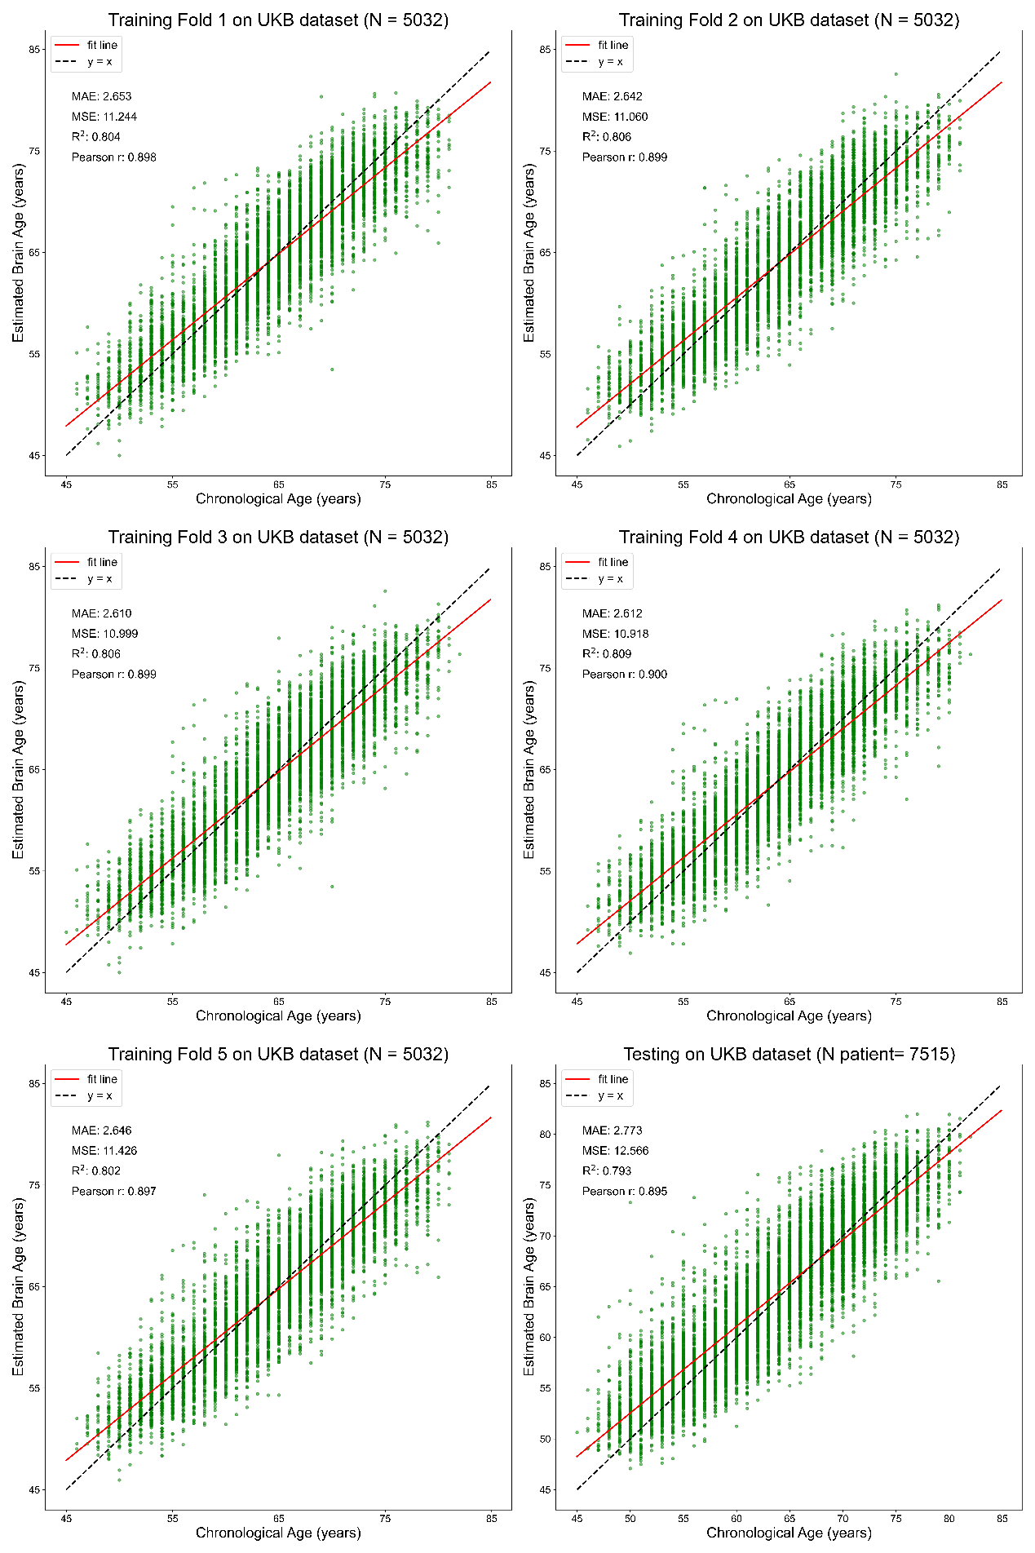
Supplementary figure 1. Brain age estimation on each fold across the 5-fold cross validation from the UK Biobank. Brain age estimation on the testing data of 7,515 subjects with brain disorders in the UKB dataset.
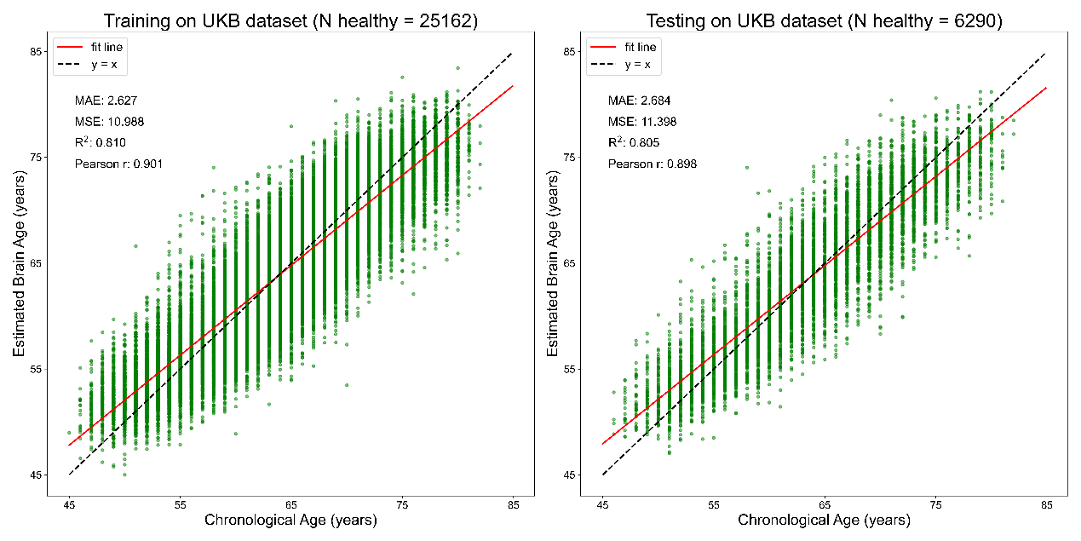
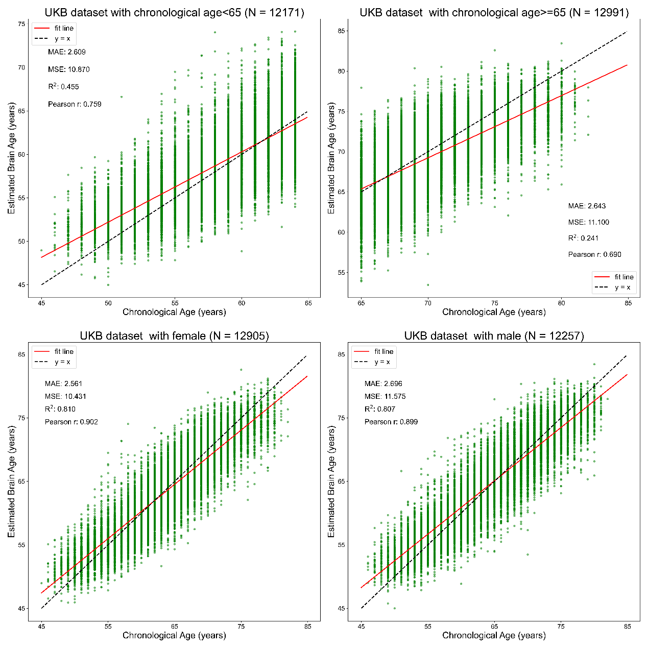
Supplementary Figure 2. Brain age estimation based on sex-separated training and testing datasets in the UKB dataset.

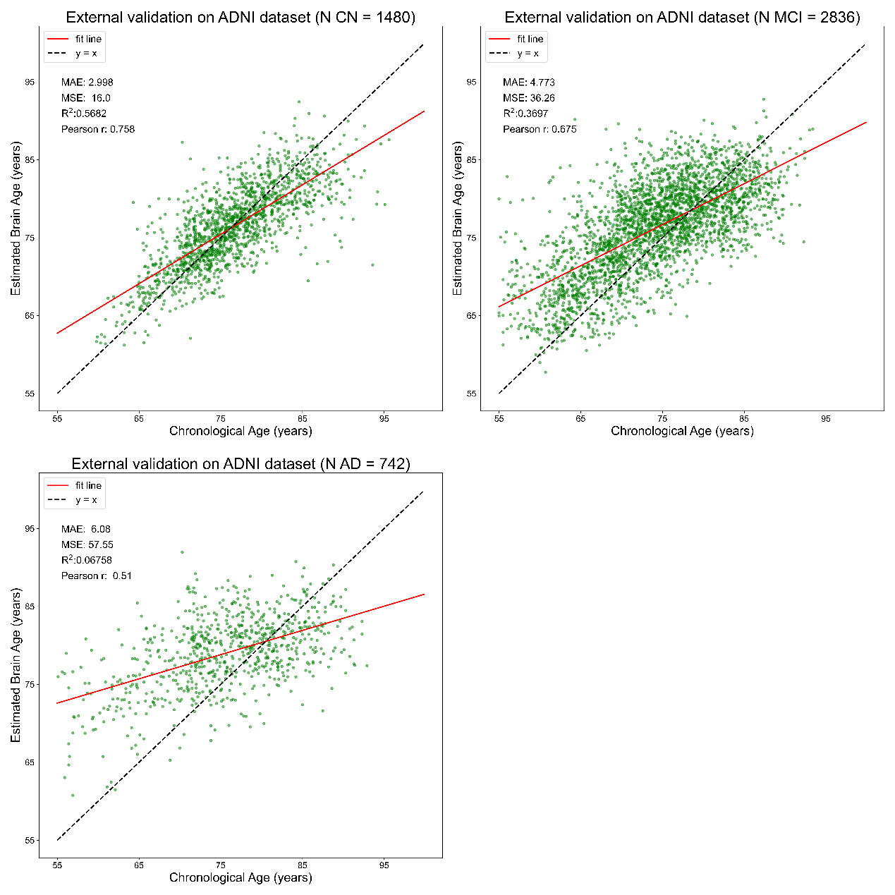
Supplementary Figure 3 Brain age estimation on the ADNI dataset. CN, cognitively normal; MCI, mild cognitive impairment; AD, Alzheimer’s disease.

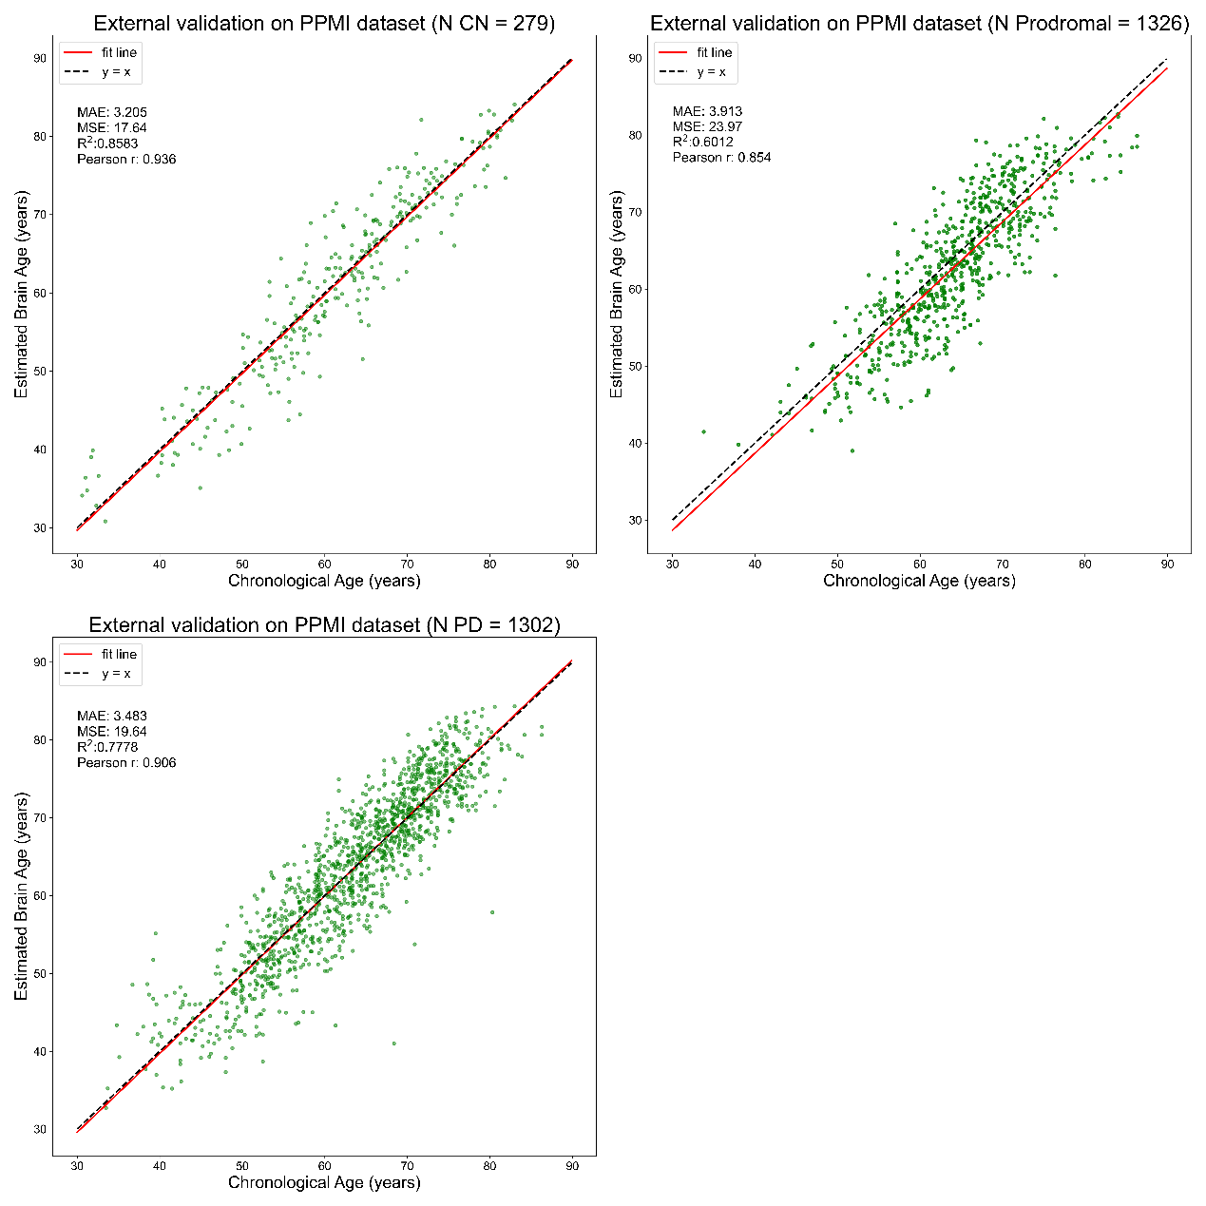

Supplementary Figure 4 Brain age estimation on the PPMI dataset. HC, healthy control; PD, Parkinson’s disease.

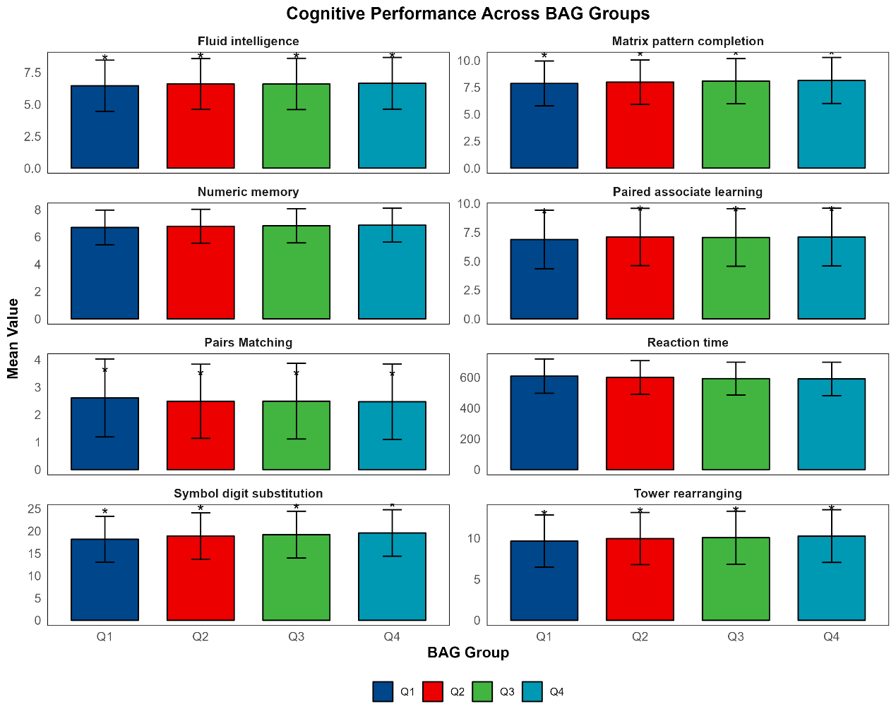
Supplementary Figure 5. Cognitive Performance Stratified by Brain Age Gap Quartiles in the UK Biobank Cohort

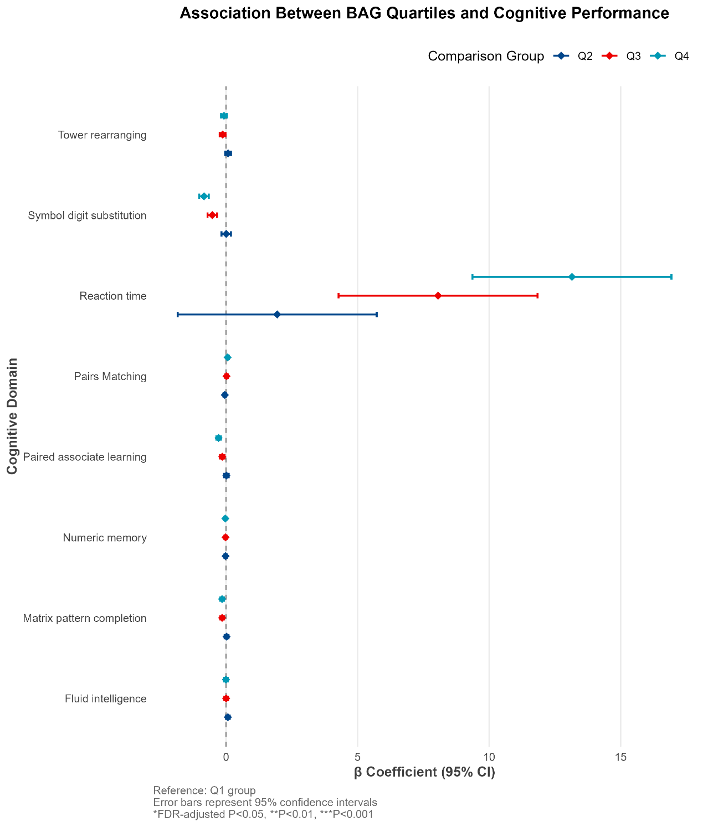
Supplementary Figure 6. Dose-Response Gradient of Biological Aging Quartiles on Cognitive Domain Performance
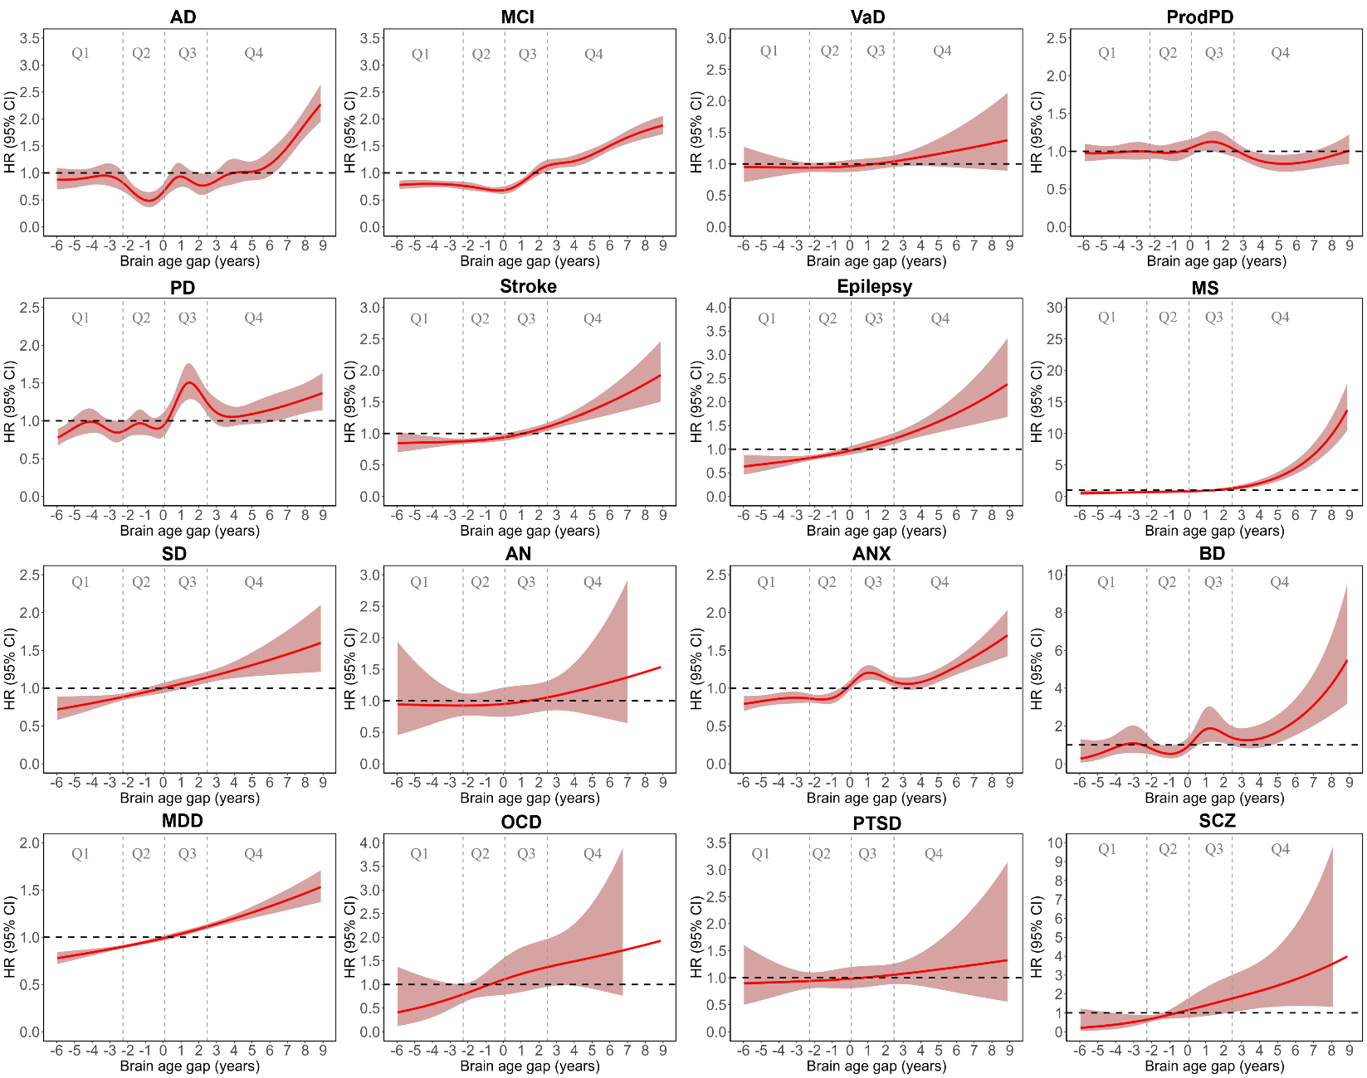
Supplementary Figure 7. Hazard Ratios (HR) for Various Brain Disorders Across BAG Quartiles

