Supplementary Materials for

Depletion of CD8⁺ CAR T-cells leads to superior anti-tumor efficacy of pure CD4⁺ CAR T-cells against Acute Leukemias

Qian Chen^{1,2}, Hao Yao¹, Lianghao Mao³, Dominic Depke¹, Lei Wang¹, David Sedloev¹, Marina Scheller¹, Bailin He⁴, Yi Liu¹, Julia M. Unglaub¹, Anita Schmitt¹, Ashok Kumar Jayavelu^{3,5}, Carsten Müller‐Tidow¹, Michael Schmitt¹ and Tim Sauer¹*

Correspondence to: tim.sauer@med.uni-heidelberg.de

This PDF file includes:

Figures. S1 to S14
Table S1

Figure. S1.
Supplementary Figure 1. Structural composition of CAR constructs and experimental set-up of the co-culture assay.
(A) Schematic representation of the structural composition of the CD70.CAR, CD19.CAR, EphA2.CAR and GD2.CAR. (B) Schematic outline of the retroviral vectors used for the generation of CD70.CART, CD19.CART, EphA2.CART and GD2.CART cells. (C) Schematic representation of the experimental design of the serial co-culture assay. CART cells were co-cultured with tumor cells at appropriate Effector-to-Target (E:T) ratios in plates without the addition of external cytokines. A single well was harvested on the pre-specified day of the co-culture and the absolute tumor and T cell numbers at the end of each co-culture were determined by flow cytometry using CountBright® counting beads. The same number of fresh tumor cells as in co-culture #1 were repeatedly added to the co-culture until CARTs failed to kill the tumor cells or failed to persist after tumor cell killing.

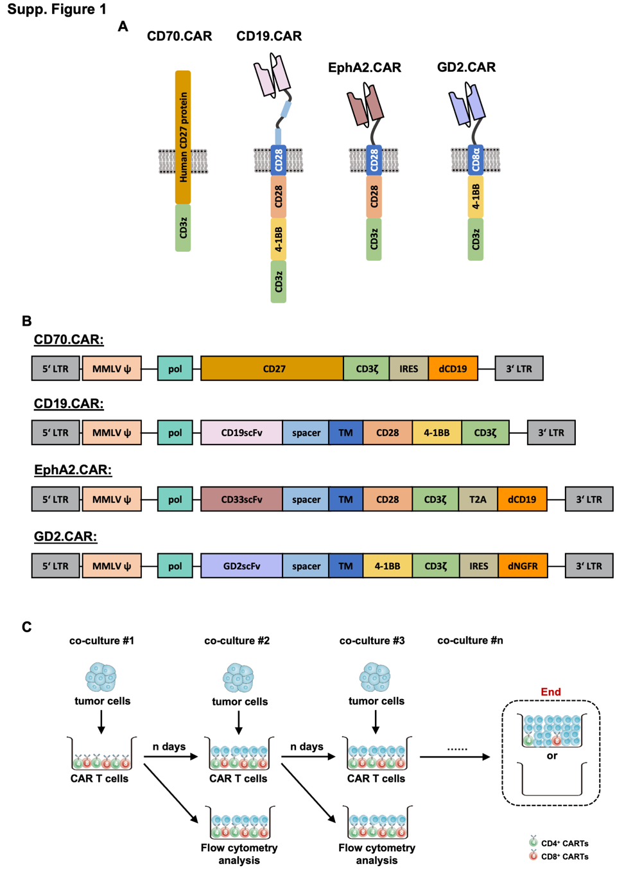

Figure. S2.
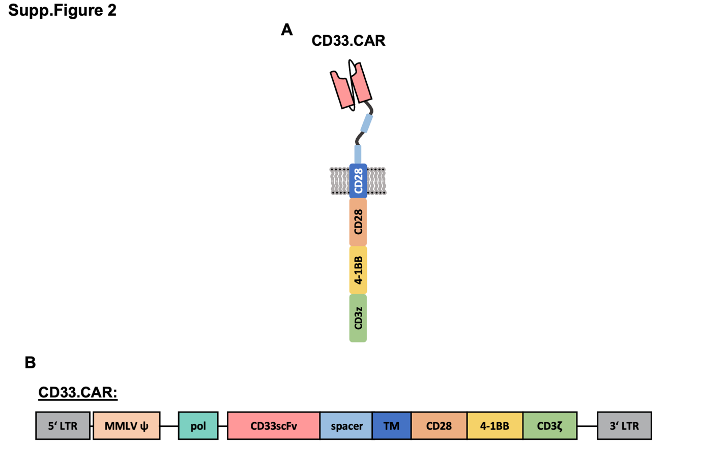

Supplementary Figure 2. Structural composition of CD33.CART construct.
(A) Schematic outline of the structural composition of CD33.CAR. (B) Schematic outline of the retroviral vectors used for the generation of CD33.CART cells.

Figure. S3.
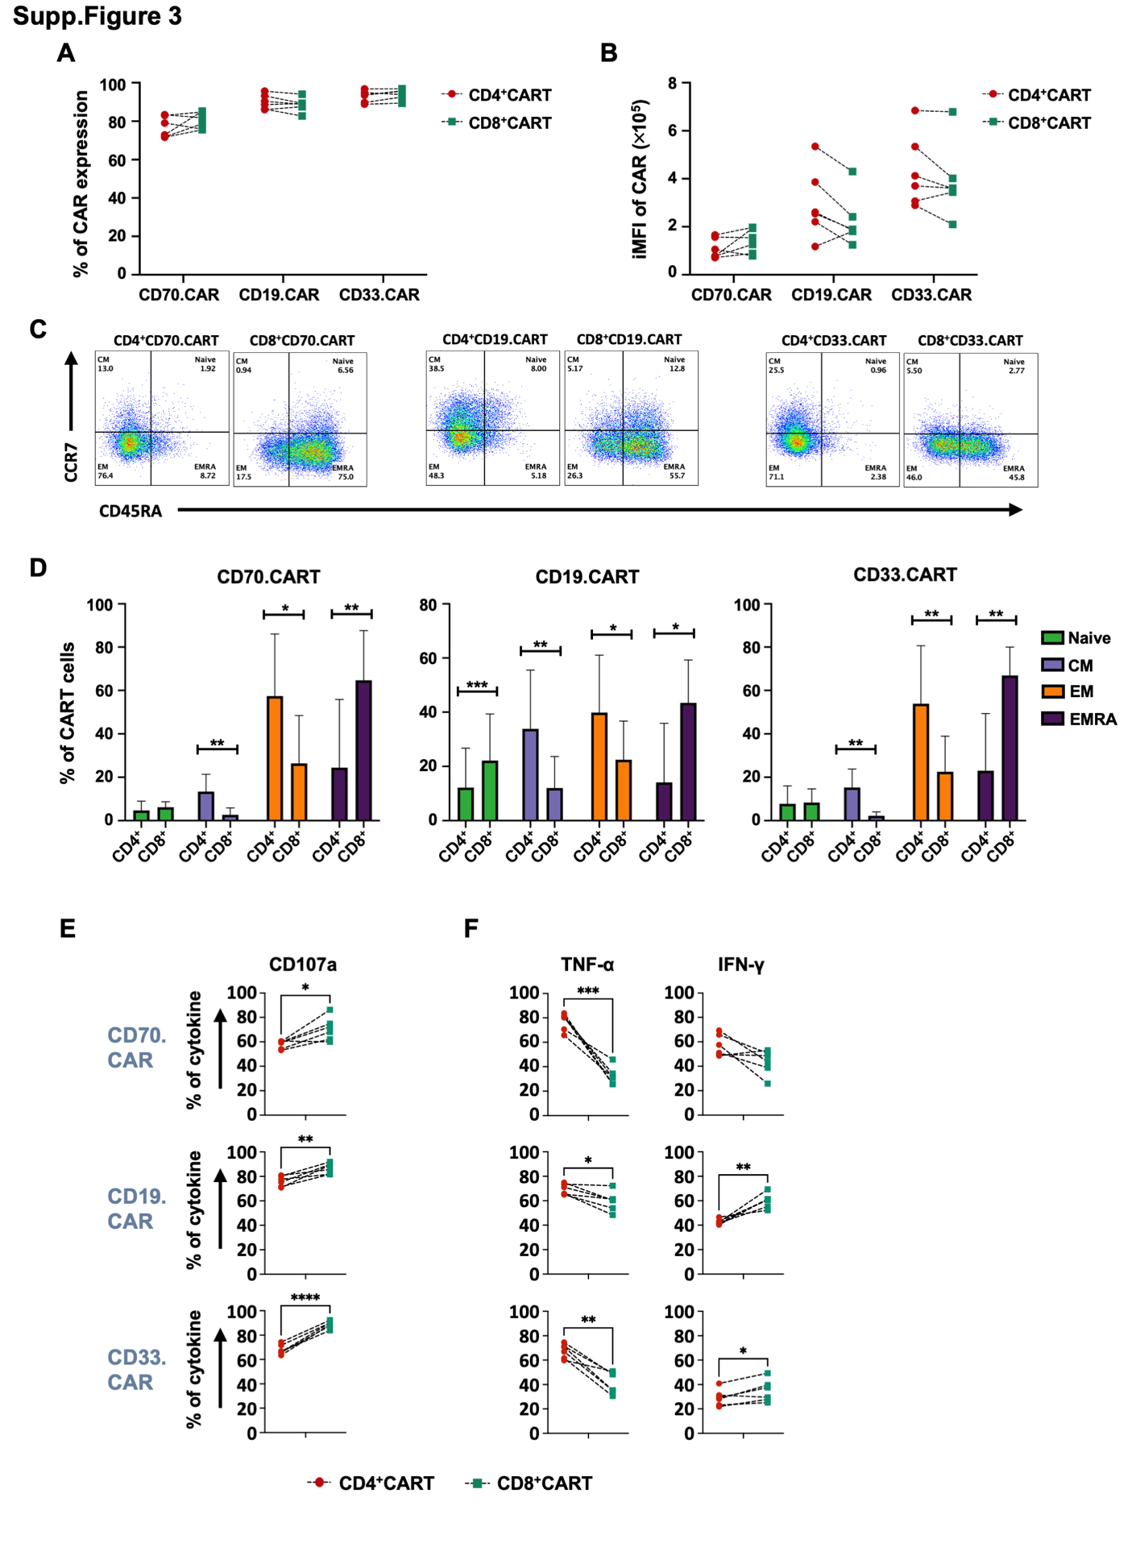

Supplementary Figure 3. Phenotypical characterization of CD4+ and CD8+ CART cells.
(A-B) Expression of the CD70 CAR, the CD19 CAR and the CD33 CAR. (A) Percentage of CAR expressing CD4+ and CD8+ CARTs and (B) the integrated mean fluorescence intensity of CAR expression (iMFI) as determined by flow cytometry on day 12 after T-cell activation: CD3+CD4+CAR+ vs CD3+CD8+CAR+ (N=6, P=ns (not significant), paired t test). The expression of CD70.CAR was determined by detection of a truncated CD19 using an APC-conjugated CD19 specific antibody. The CD19.CAR and the CD33.CAR were detected by staining with biotin-labeled protein L followed by subsequent staining with APC-conjugated streptavidin. (C) Representative dot plots depicting the immunophenotype of CD70.CART, CD19.CART and CD33.CART on day 16 after T-cell activationof T-cell transduction by flow cytometry. (D) Immunophenotypic analysis of CD4+ and CD8+ CART cells on day 16 after T-cell activation (CD4 vs CD8, naive: CD45RA+CCR7+; central memory [CM]: CD45RA–CCR7+; effector memory [EM]: CD45RA−CCR7−; EM T cells re-express CD45RA [EMRA]: CD45RA+CCR7−) (N = 6, paired t test, *P < 0.05; **P < 0.01; ***P < 0.001). (E) CD107a expression and (F) TNF-α and IFN-γ secretion 4 hours after stimulation with antigen positive tumor cells (E:T ratio 1:1) as determined by intracellular staining followed by flow cytometry. (N = 6, paired t test, *P < 0.05; **P < 0.01; ***P < 0.001; ****P < 0.0001).

Figure. S4.
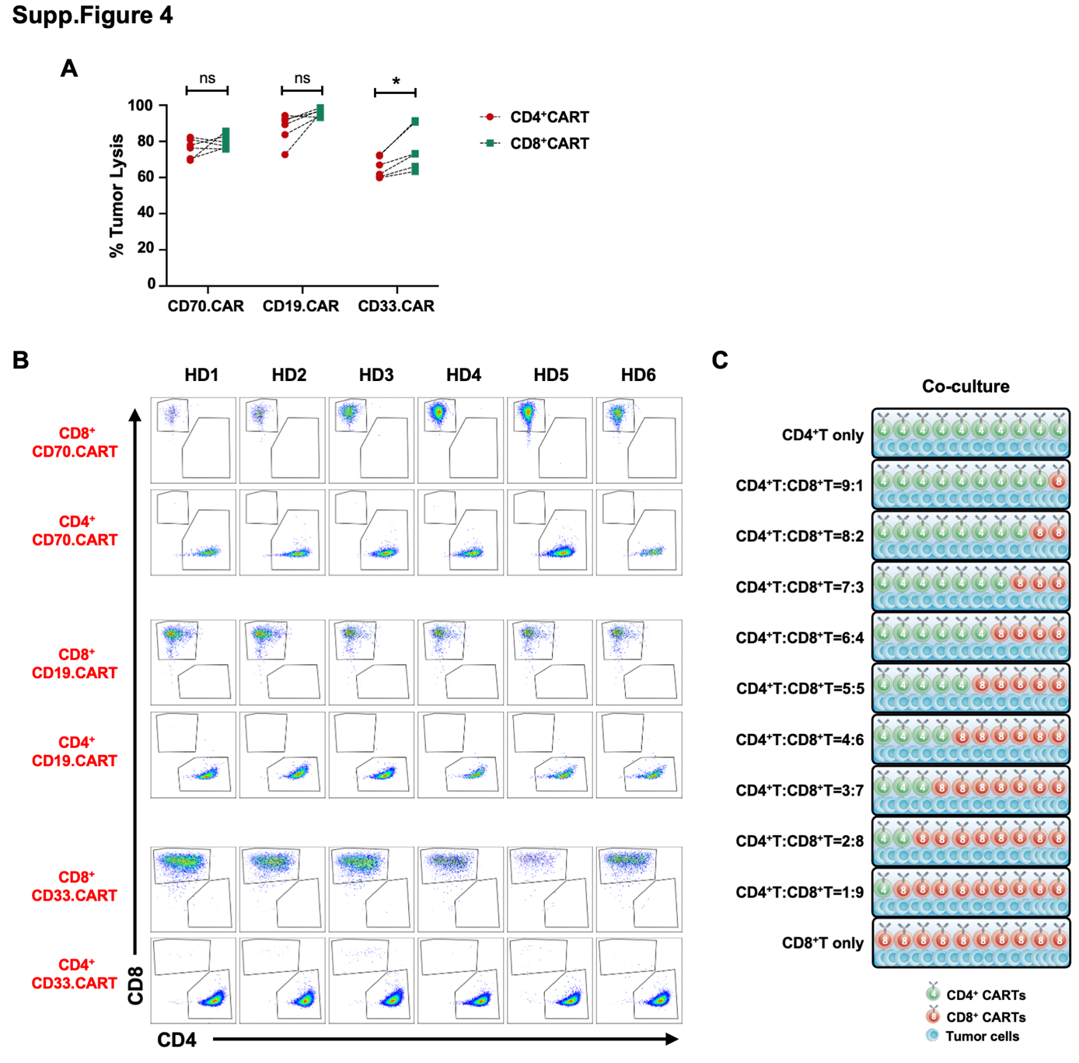

Supplementary Figure 4. Short-term cytotoxicity of CD4+ and CD8+ CART cells and generation of CART products with distinct CD4+/CD8+ T-cell ratios to be used in serial co-culture assays
(A) Short-term cytotoxicity of CARTs was determined after co-culturing CD70.CARTs, CD19.CARTs and CD33.CARTs for 24 hours with Molm-13, Nalm-6, HL-60 cells, respectively, at an E:T ratio of 1:2. The absolute number of residual tumor numbers were determined by flow cytometry using CountBright counting beads (N = 6, paired t test, *P < .05; ns, not significant). (B) Representative dot plots of CD4+ and CD8+ CD70.CARTs, CD19.CARTs and CD33.CARTs from 6 healthy donors (HD) after fluorescence-activated cell sorting (FACS) on day 12 of T-cell transduction. (C) These CARTs were then used to set-up serial co-culture assays with target antigen expressing tumor cells at the displayed CD4+/CD8+ CART ratios.

Figure. S5.
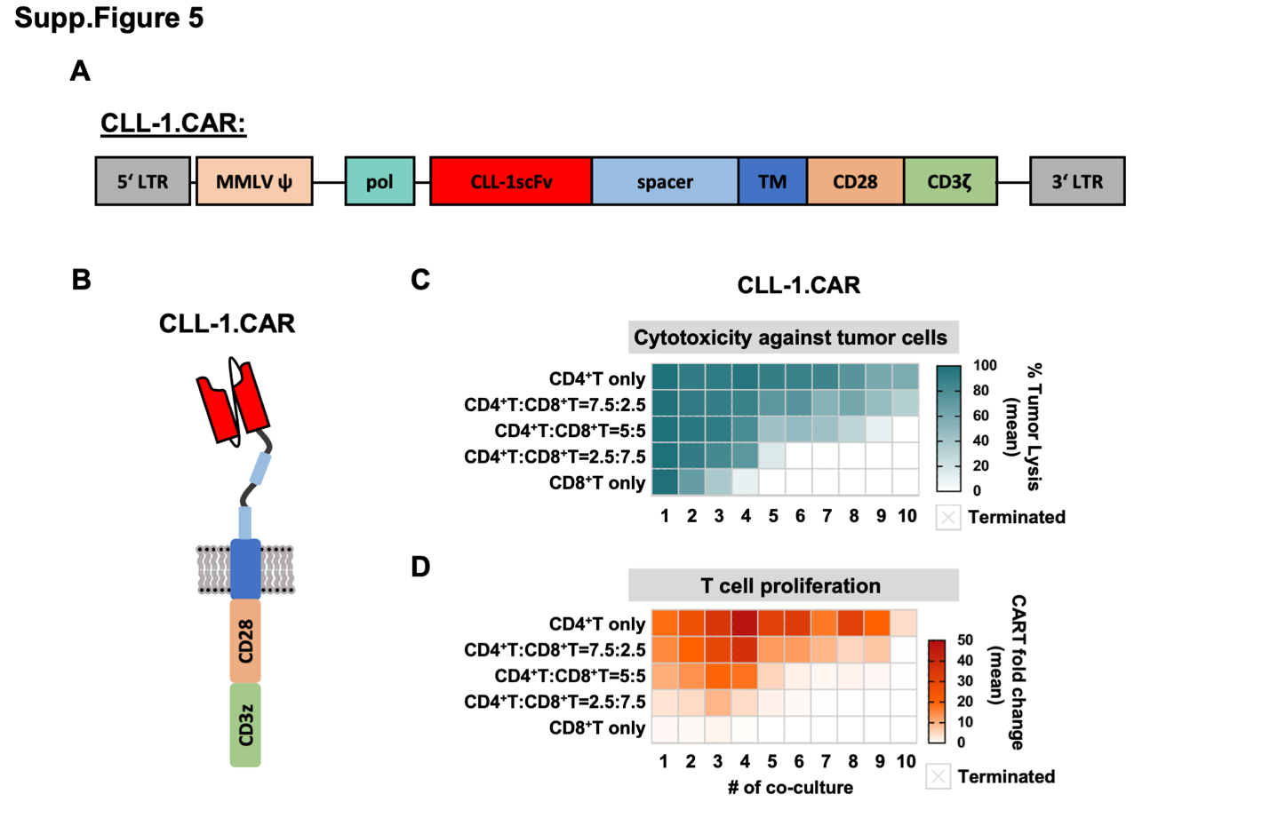

Supplementary Figure 5. Structural composition and functional demonstration of the second-generation CLL-1.CAR containing the CD28 co-stimulatory domain
(A-B) Schematic outline of the structural composition of a second-generation CLL-1.CAR containing the CD28 co-stimulatory domain. (C-D) CLL-1.CARTs and HL-60 cells expressing CLL-1 were cocultured at an E:T ratio of 1:3 and fresh tumor cells were added every 3 days. The absolute tumor and T cell numbers at the end of each co-culture were determined by flow cytometry using CountBright counting beads (N=6). (C) Double-gradient heat map of tumor cell killing (blue, 100% target cell lysis; white, 0% target cell lysis); (D) Double-gradient heat map of T cell proliferation (red, highest proliferation value; orange, baseline proliferation value; white, no proliferation).

Figure. S6.
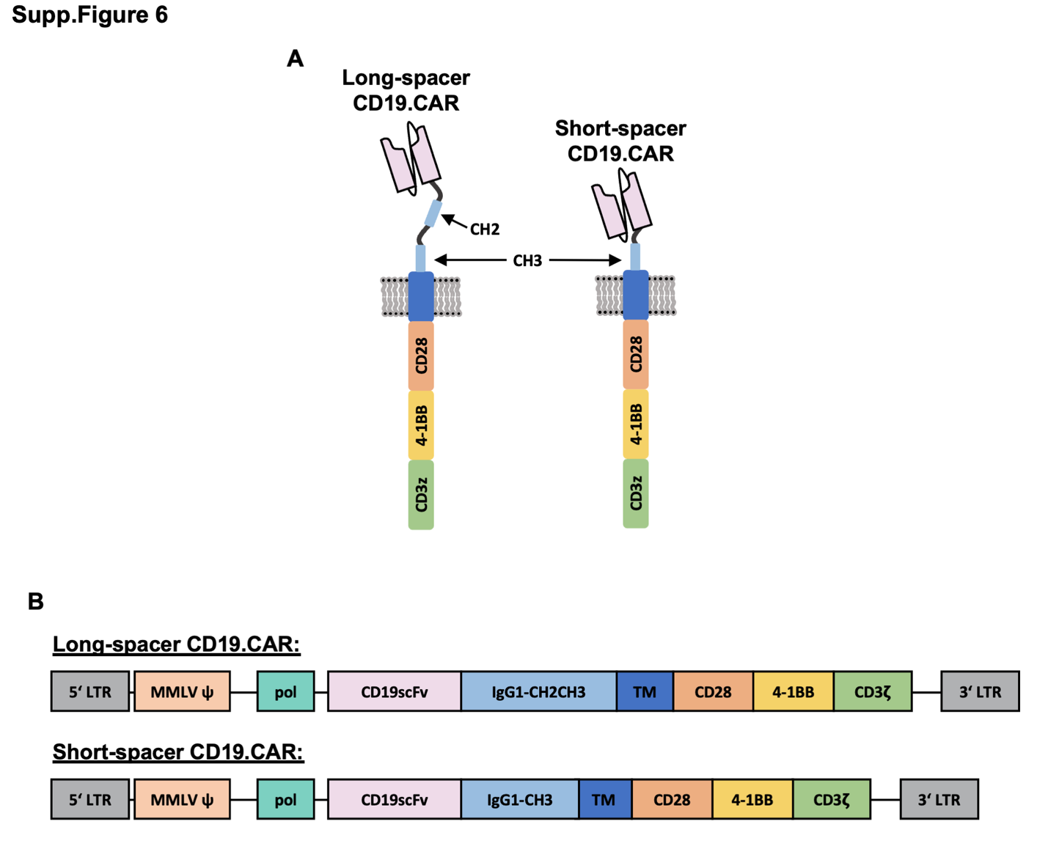

Supplementary Figure 6. Structural comparison of long-spacer and short-spacer CD19.CART constructs.
(A) Schematic representation of the structural composition of the CD19.CAR with a long-spacer and a short-spacer. (B) Schematic representation of the retroviral vectors used for the generation of long-spacer and short-spacer CD19.CARTs.

Figure. S7.
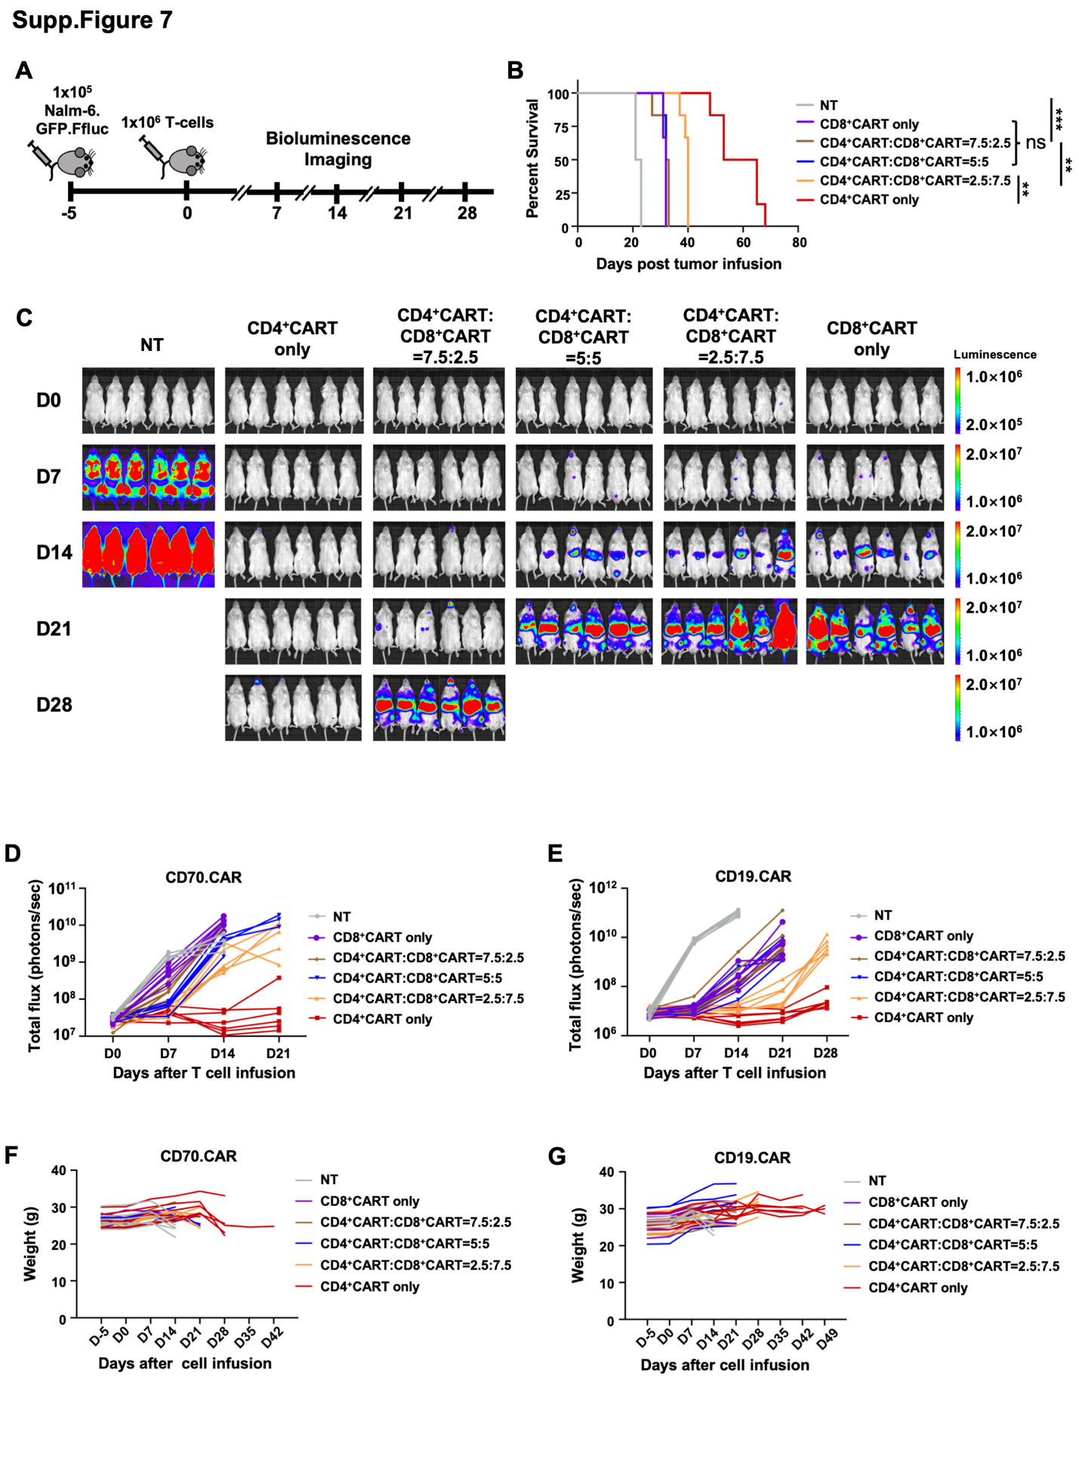

Supplementary Figure 7. Superior antileukemic activity of CD4⁺ CARTs cells in murine xenograft models.
(A) Experimental setup of the Nalm-6 xenograft model. Short-spacer CD19.CART cells (1 × 10⁶), depicted in Supplementary Figure 6, and non-transduced (NT) T cells (1 × 10⁶) were administered 5 days after injection of GFP firefly luciferase (Ffluc)-labeled Nalm-6 cells (1 × 10⁵). Bioluminescence imaging (BLI) was performed prior to T cell injection on day 0 to confirm tumor cell engraftment and continued weekly thereafter (N = 6 for each treatment group). (B) Kaplan-Meier survival graph of mice treated with either short spacer CD19.CART or NT T cells. The statistical analysis of survival between the treatment groups was performed using the log-rank (Mantel-Cox) test (N=6, **P < .01; ***P < .001; ns, not significant). (C) Images depicting the BLI signal derived from Nalm-6 cells on the specified days in mice treated with either NT T cells or short-spacer CD19.CARTs at various CD4⁺/CD8⁺ CART ratios. (D-E) Evolution of total flux measured by BLI for each individual mouse in every treatment group for the CD70.CART model (D) and CD19.CART model (E). (F-G) The body weight of treated mice in the CD70.CART (F) and CD19.CART (G) models was measured as an indicator of their overall condition.

Figure. S8.
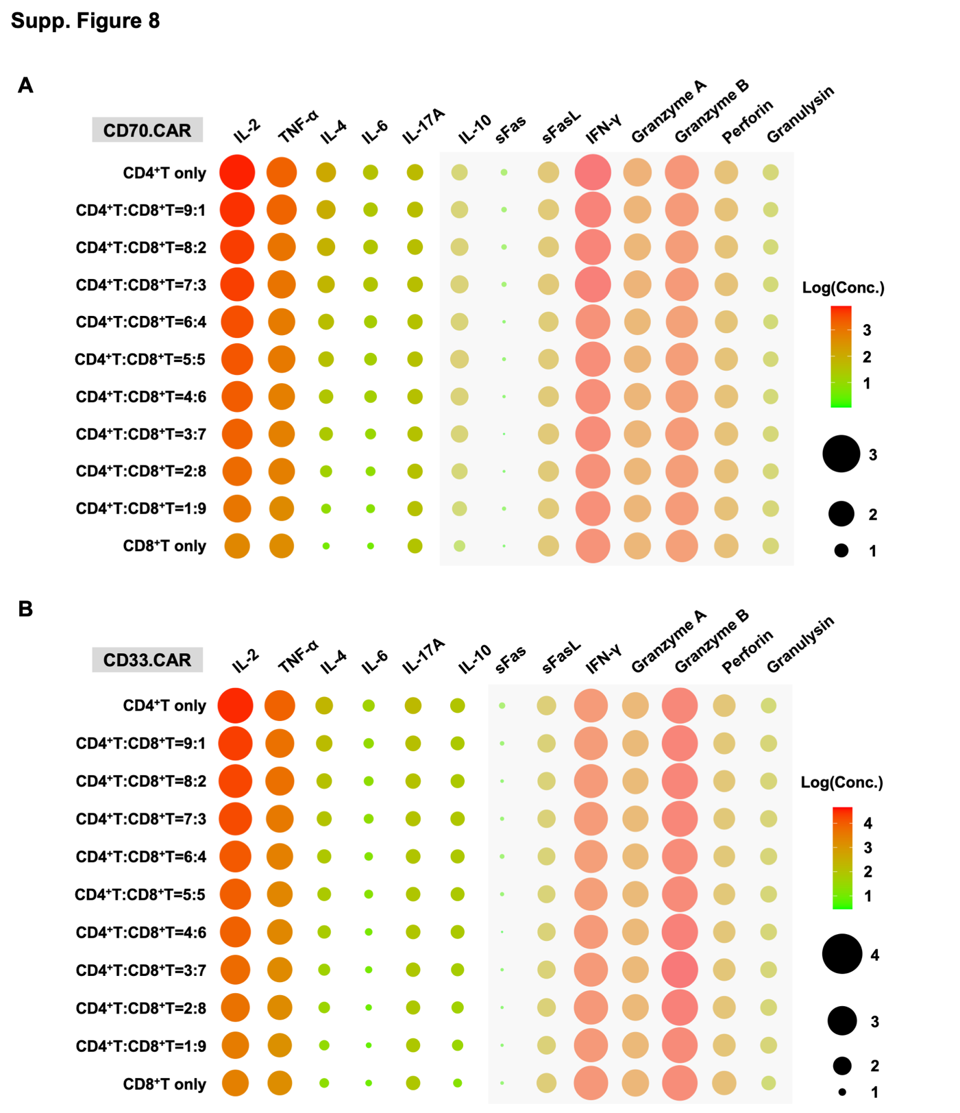

Supplementary Figure 8. Cytokine release profile of CD70.CART and CD33.CART products.
(A-B) Multiplex analysis of cytokine production by CD70.CART (A) and CD33.CART products (B) from 6 healthy donors at indicated CD4⁺/CD8⁺ ratios after 24-hour co-culture with Molm-13 and HL-60 cells respectively at an E:T ratio of 1:3. The mean value of concentrations are shown.

Figure. S9.
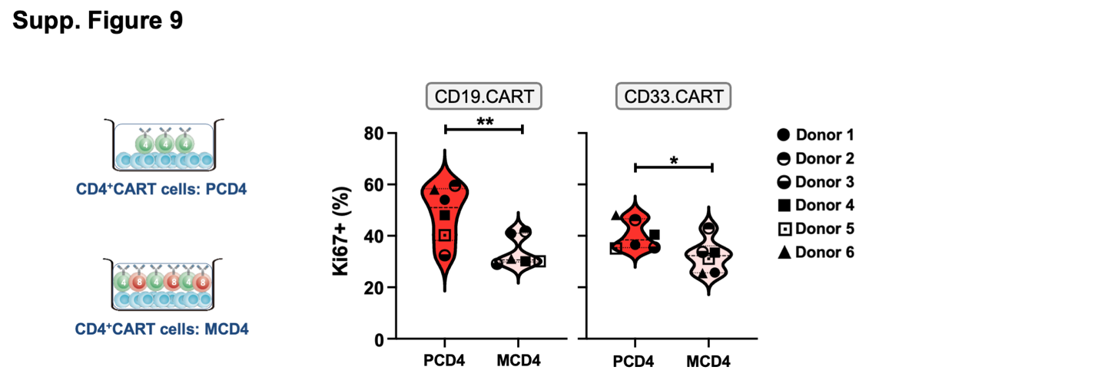

Supplementary Figure 9. Assessment of Ki67 expression in PCD4 and MCD4 cells.
CD19.CARTs and CD33.CARTs were co-cultured with Nalm-6 and HL-60 cells respectively every 3 days at an E:T ratio of 1:3. Ki67 expression on PCD4 and MCD4 CARTs was determined by flow cytometry on day 9 of co-culture (N = 6, paired t test, *P < 0.05; **P < 0.001).

Figure. S10.
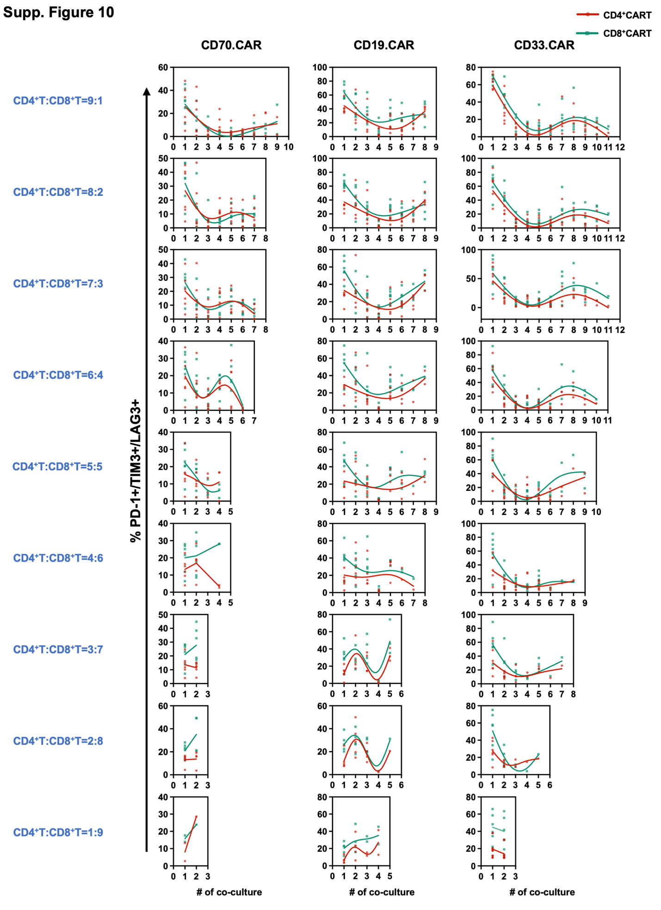

Supplementary Figure 10. Expression of surface molecules associated with T-cell exhaustion on CD4⁺ and CD8⁺ CART cells during long-term coculture assays.
Expression of inhibitory receptors (PD-1+/TIM-3+/LAG-3+) on CD70.CAR, CD19.CAR and CD33.CAR CD4⁺ and CD8⁺ CARTs from 6 different healthy donors at the end of each co-culture with their respective target cells as determined by flow cytometry. CARTs were added to the co-culture at the indicated CD4⁺/CD8⁺ ratios. Every data point displays the percentage of CD4⁺ and CD8⁺ CART cells expressing PD-1, TIM-3 and LAG-3 from every donor at each time point. The non-linear fit curve represents the fit value.

Figure. S11.
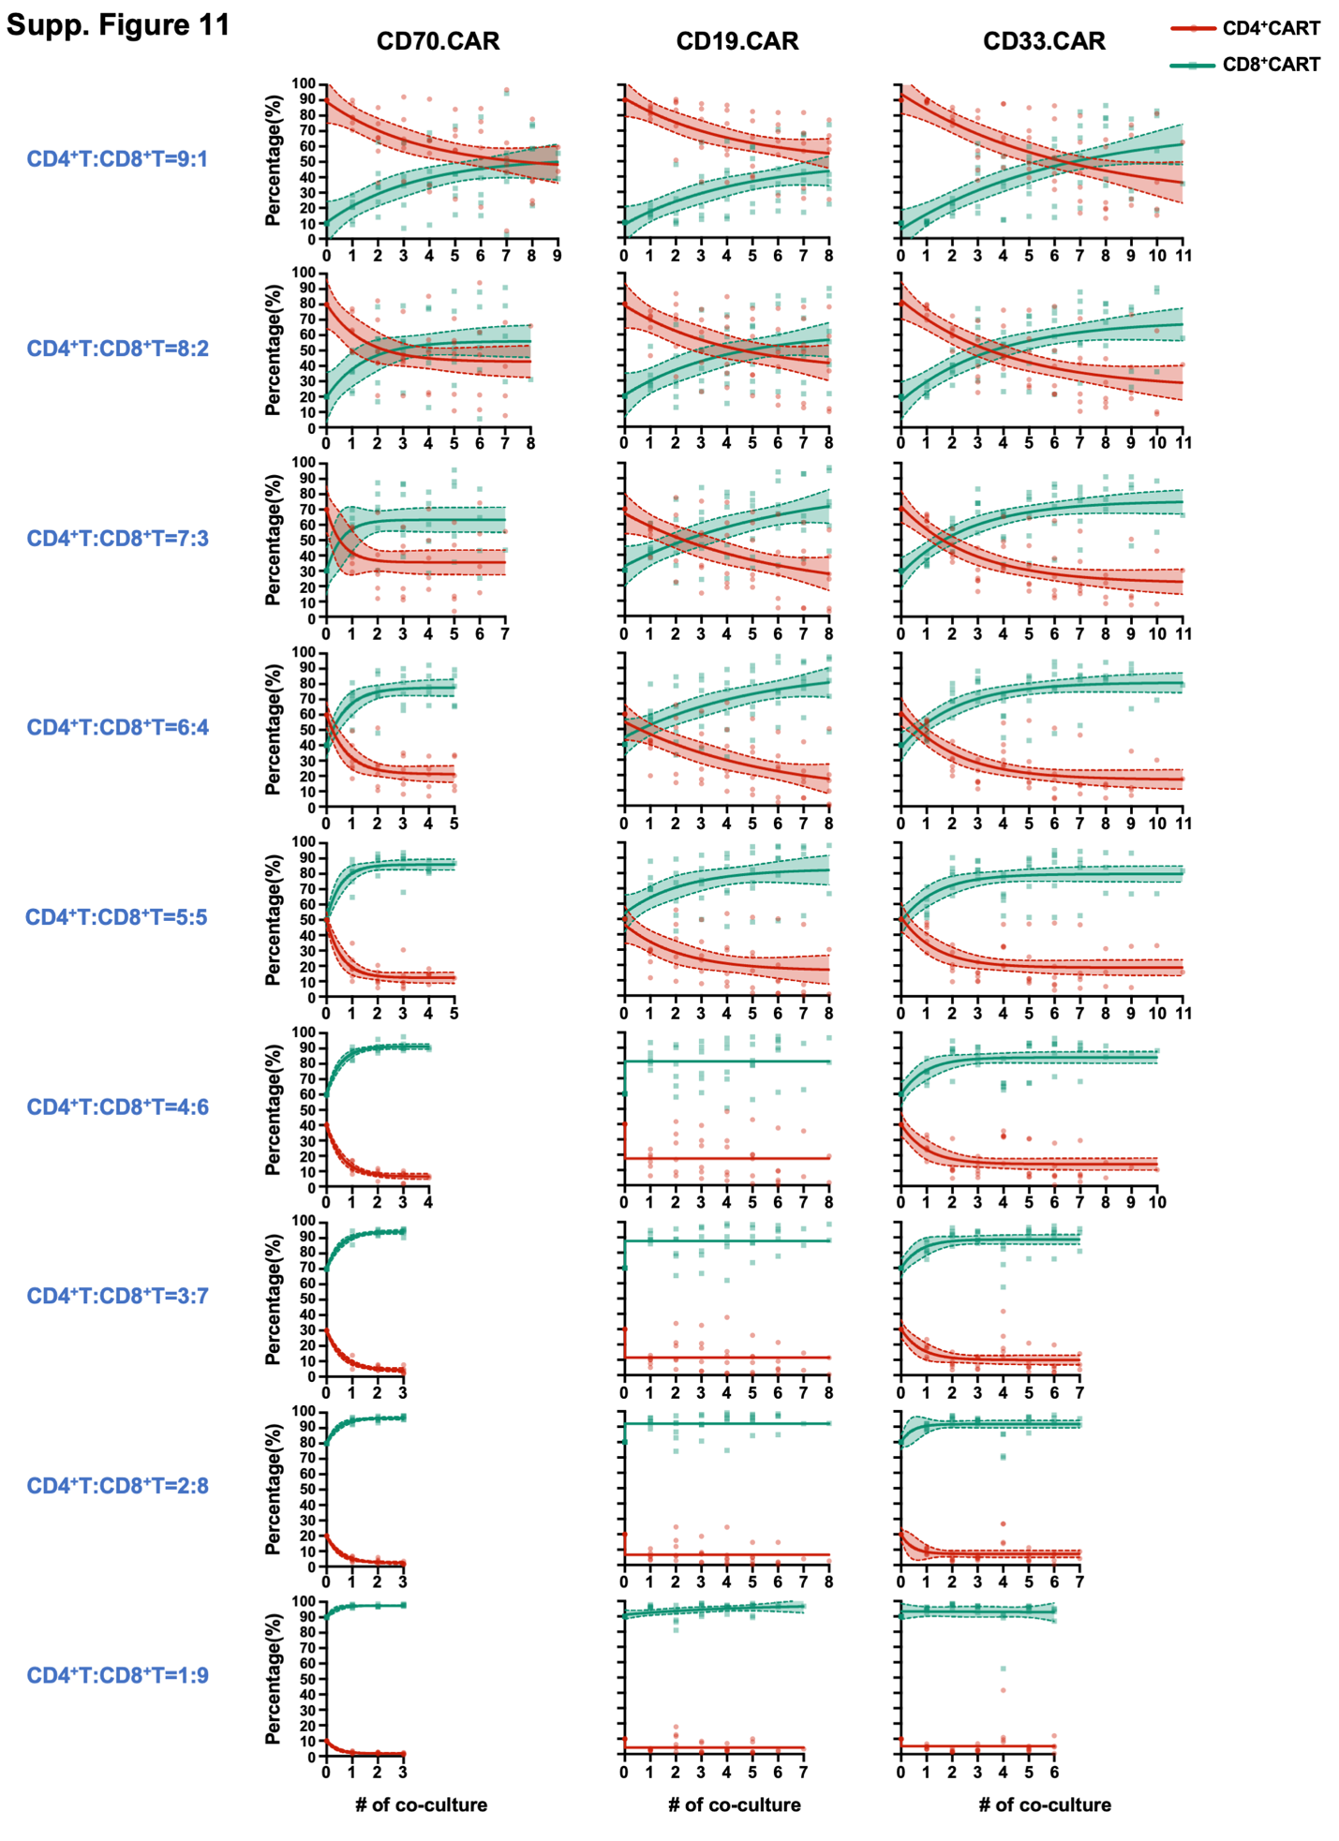

Supplementary Figure 11. Changes of the CD4⁺/CD8⁺ T-cell composition of CART products during serial coculture assays.
CD70.CART, CD19.CART and CD33.CART products from 6 healthy donors containing the indicated ratios of CD4⁺ and CD8⁺ CARTs were co-cultured with their appropriate target cells and the percentage of CD4⁺ and CD8⁺ CARTs for each donor was determined at the end of each co-culture by flow cytometry. Each individual datapoint displays the percentage of CD4⁺ and CD8⁺ CART cells of every donor at each time point. The non-linear fit curve represents the fit value and the dotted line represents the 95% confidence interval (CI).

Figure. S12.
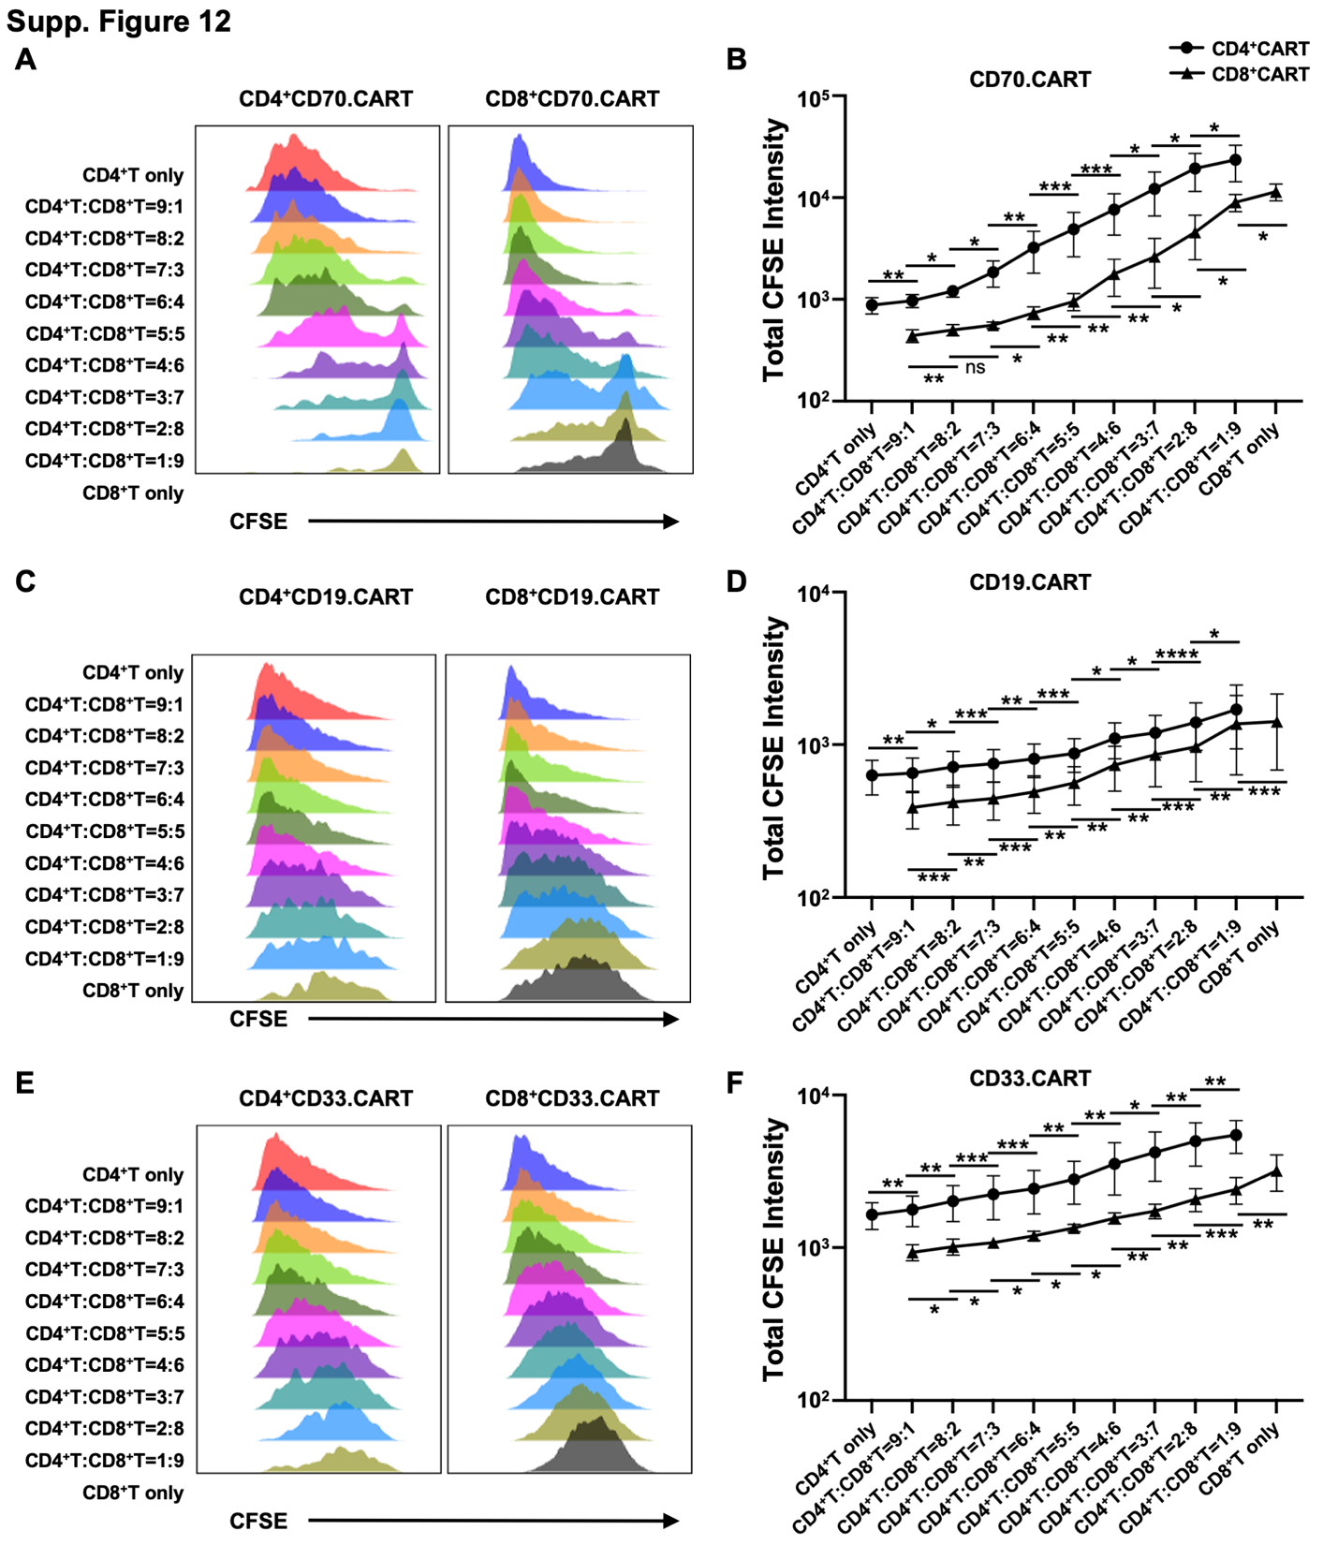

Supplementary Figure 12. Proliferation rates of CD4⁺ and CD8⁺ CART cells depending on the CD4+/CD8+ composition upon antigen stimulation.
(A-B) Representative histograms (A) and statistical analysis (B) of the proliferation rate of CD4⁺ and CD8⁺ CD70.CART products containing the indicated CD4+/CD8+ ratios after a 5-day stimulation with irradiated Molm-13 cells as determined by CSFE staining. (C-D) Representative histograms (C) and statistical analysis (D) of the proliferation rate of CD4⁺ and CD8⁺ CD19.CART products containing the indicated CD4+/CD8+ ratios after a 5-day stimulation with irradiated Nalm-6 cells as determined by CSFE staining. (E-F) Representative histograms (E) and statistical analysis (F) of the proliferation rate of CD4⁺ and CD8⁺ CD33.CART products containing the indicated CD4+/CD8+ ratios after a 5-day stimulation with irradiated HL-60 cells as determined by CSFE staining. (N = 4, paired t test, *P < 0.05; **P < 0.01; ***P < 0.001; ns, not significant).

Figure. S13.
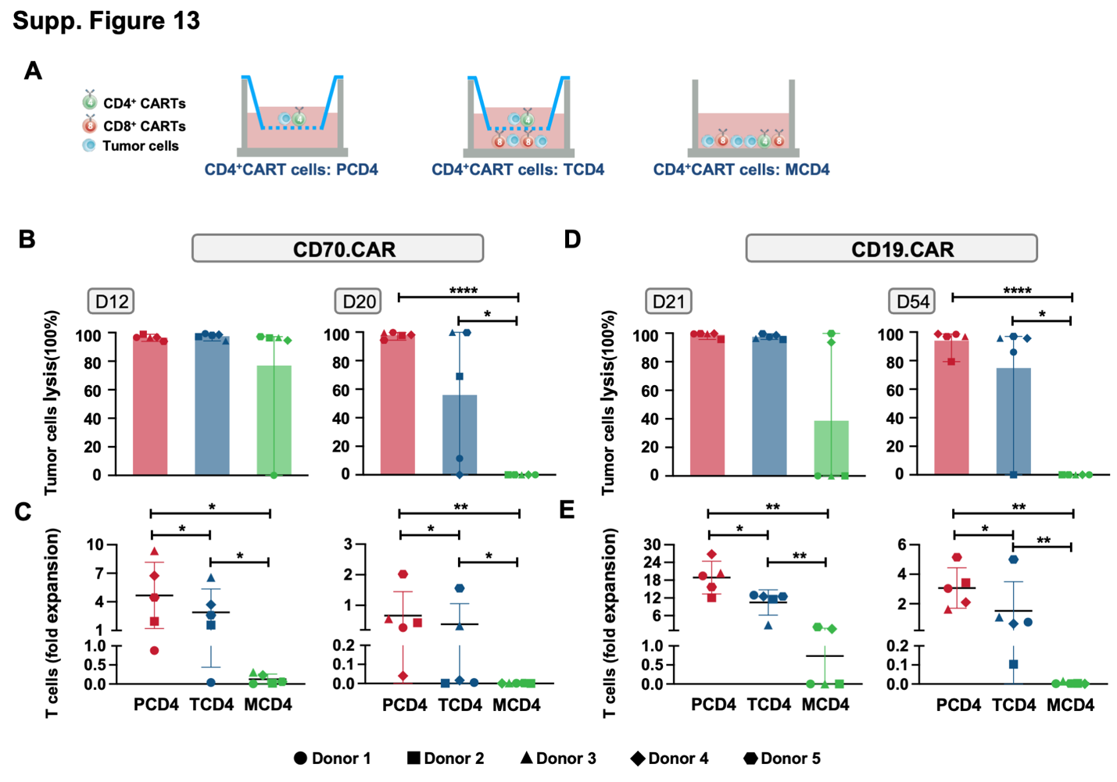

Supplementary Figure 13. CD4⁺ CART cell functionality is impaired by cell-to-cell interaction with CD8⁺ CART cells.
Experimental setup of the serial co-culture assay in the transwell cell-culture device. CD70.CARTs and CD19.CARTs were cocultured with Molm-13 or Nalm-6 cells at a E:T ratio of 1:1 and fresh tumor cells were added every 3 (CD19.CARTs) or every 4 days (CD70.CARTs). CD4⁺ CARTs (in the upper chamber) separated from CD8⁺ CARTs by the semipermeable membrane are indicated as TCD4, CD4⁺ CARTs cultured in the upper chamber without any CD8⁺ CARTs are indicated as PCD4 and CD4⁺ CARTs that were co-cultured in the presence of CD8⁺ CARTs are indicated as MCD4. The absolute tumor and T cell numbers at the end of each coculture were determined by flow cytometry using CountBright® counting beads. (D) Tumor cell killing and (E) T-cell proliferation of CD70.CARTs on day 12 and day 20 of co-culture. (F) Tumor cell killing and (G) T-cell proliferation of CD19.CARTs on day 33 and day 54 of co-culture. (N = 5, paired t test, *P < 0.05; **P < 0.01; ****P < .0001).

Figure. S14.
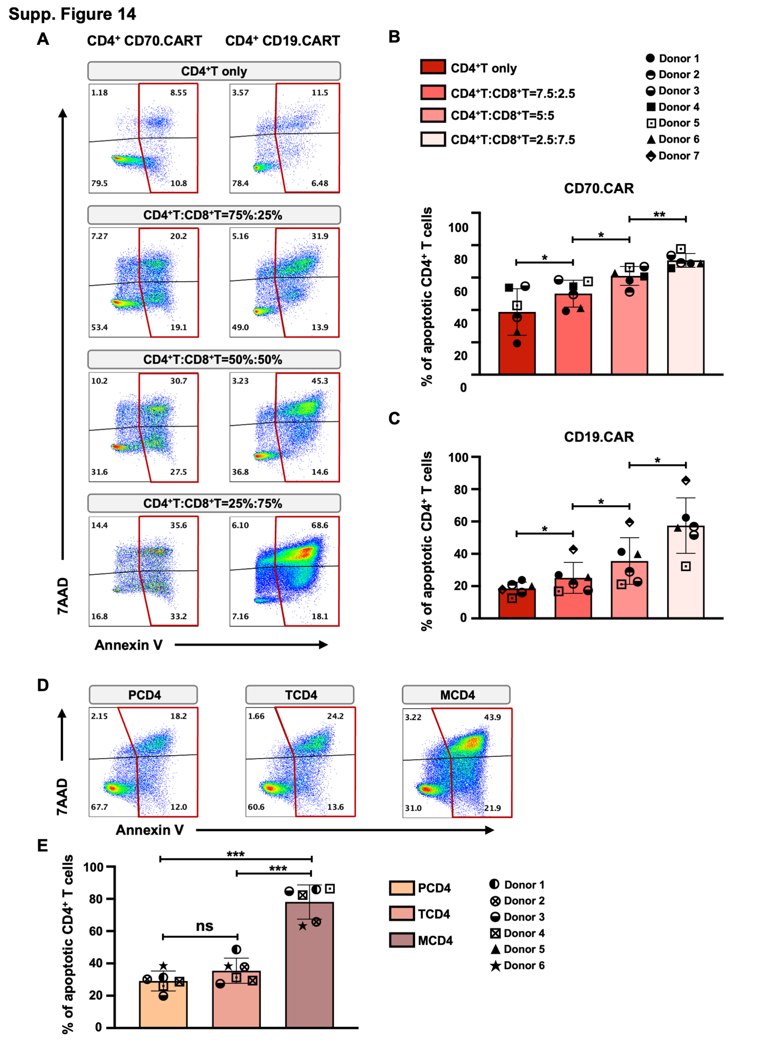

Supplementary Figure 14. Induction of apoptosis in CD4⁺ CARTs upon interaction with CD8⁺ CART cells.
(A) Representative dot plots illustrating the percentage of apoptotic CD4⁺ CD70.CARTs and CD19.CARTs of CART products containing the indicated CD4⁺/CD8⁺ ratios upon antigen stimulation in coculture assays as determined by Annexin V/7-AAD staining on day 8 for the CD70-CART model and day 12 for the CD19.CART model. CD70.CARTs and CD19.CARTs were cocultured with Molm-13 and Nalm-6 cells, respectively, at an E:T ratio of 1:3 and fresh tumor cells were added every 4 days (CD70.CARTs) and 3 days (CD19.CARTs) respectively. Apoptotic cells were identified as Annexin V+. (B) Quantitative analysis of apoptotic CD4⁺ CD70.CARTs upon antigen stimulation. (C) Quantitative analysis of apoptotic CD4⁺ CD19.CARTs upon antigen stimulation. (D) Representative dot plots illustrating the percentage of apoptotic CD4⁺ CD19.CARTs harvested from the Transwell co-culture assay upon repetitive antigen stimulation with Nalm-6 cells every three days as determined by Annexin V/7-AAD staining on day 15. CD4⁺ CARTs (in the lower chamber) separated from CD8⁺ CARTs by the semipermeable membrane are indicated as TCD4, CD4⁺ CARTs cultured in the lower chamber without any CD8⁺ CARTs are indicated as PCD4 and CD4⁺ CARTs that were co-culture in the presence of CD8⁺ CARTs are indicated as MCD4. (E) Bar graphs illustrating the percentage of apoptotic CD4⁺ CARTs cell harvested from the Transwell co-culture assay. (N = 6, paired t test, *P < .05; **P < 0.01; ***P < 0.001).

Table S1.
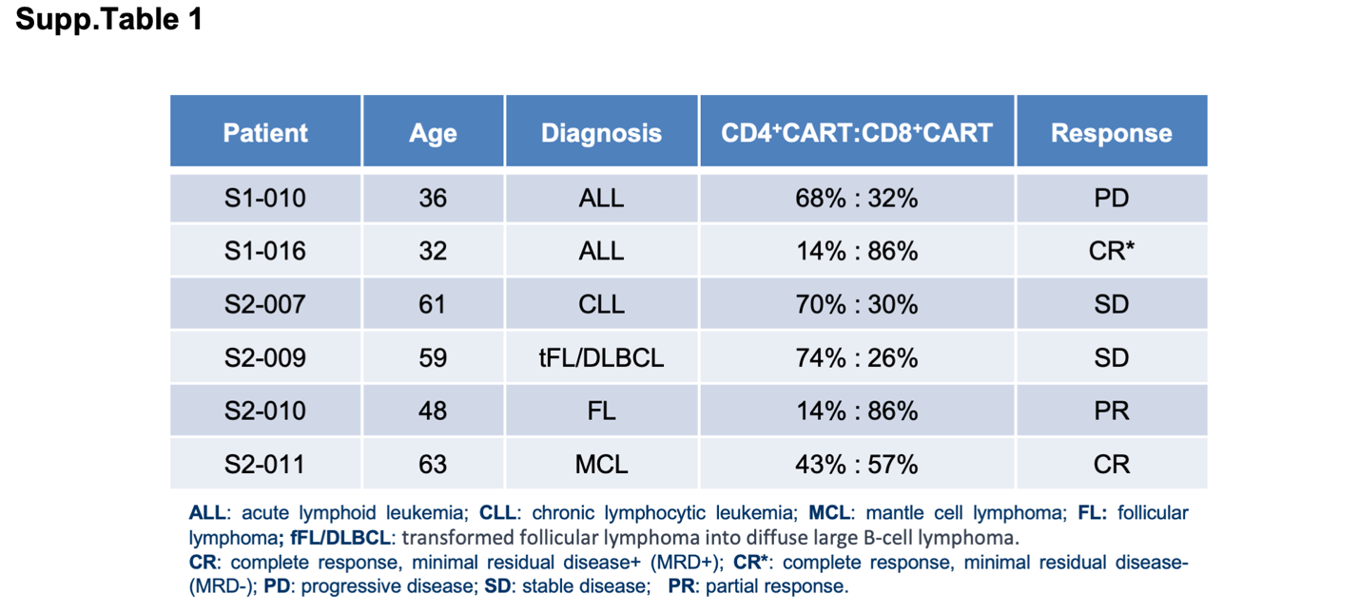

Supplementary Table 1. The baseline information and treatment characteristics of patients from HD-CAR1 clinical trial.

