Integrating soft robotics and computational models to study left atrial hemodynamics and device testing in sinus rhythm and atrial fibrillation
Authors: Manisha Singh^{1#}, Keegan Mendez^{1#}, Brian Ayers², Sophie X Wang^{1,3}, Atsushi Takahashi⁴, Debbie L Teodorescu^{5,6}, Jordi Mill⁷, Carlos Albors⁷, Andreas Escher¹, Yiling Fan¹, Caglar Ozturk¹, Eve Sheridan⁸, Emma Rutherford⁸, Oscar Camara⁷, Tarun Chakravarty⁵, Ellen T Roche^{1,8*}
Affiliations
¹Institute for Medical Engineering and Science, Massachusetts Institute of Technology, Cambridge, MA, USA
²Department of Surgery, Massachusetts General Hospital, Boston, MA, USA
³Department of Surgery, Beth Israel Deaconess Medical Center, Boston, MA, USA
⁴Department of Brain and Cognitive Sciences, McGovern Institute for Brain Research, Massachusetts Institute of Technology, Cambridge, MA, USA
⁵Department of Cardiology, Smidt Heart Institute, Cedars-Sinai Medical Center, Los Angeles, CA, USA
⁶Pulse Heart Institute, Tacoma, WA, USA
⁷Physense, BCN Medtech, Department of Engineering, Universitat Pompeu Fabra, Barcelona, Spain
⁸Department of Mechanical Engineering, Massachusetts Institute of Technology, Cambridge, MA, USA.
#These authors contributed equally to this work
*Corresponding author: Ellen T. Roche, email: etr@mit.edu

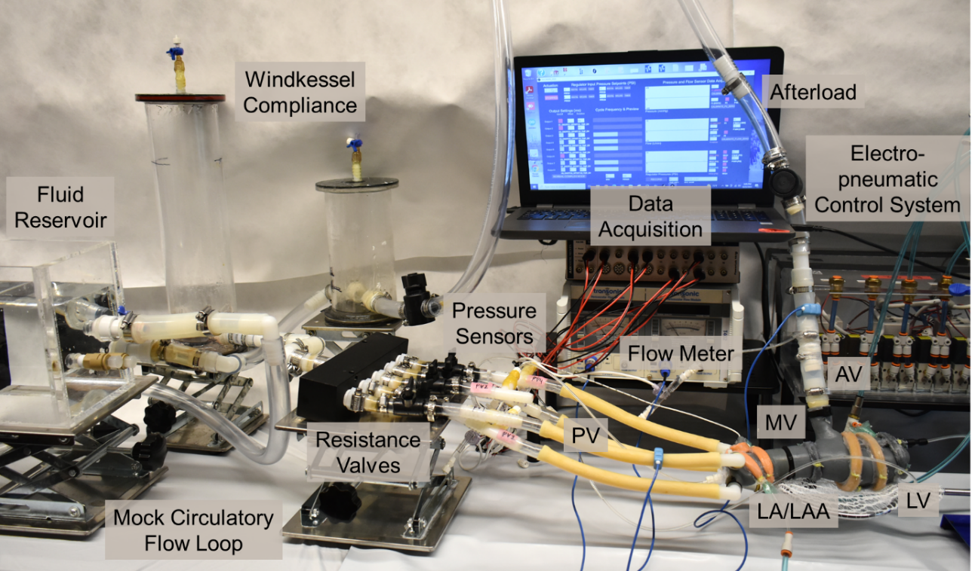
Figure S1: Mock circulatory flow loop driven by soft robotic left atrium and atrial appendage (LA/LAA) and left ventricle (LV). MV; mitral valve, AV; aortic valve, PV; pulmonary vein.

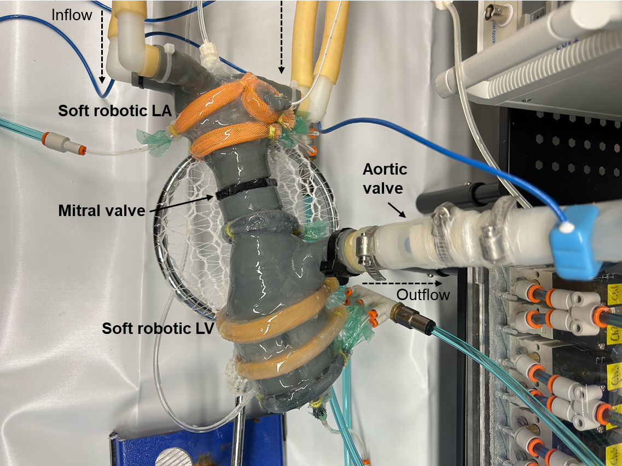
Figure S2: Soft robotic, patient-specific 3D-printed left atrium (LA) and left ventricle (LV) integrated with the mock circulatory flow loop.
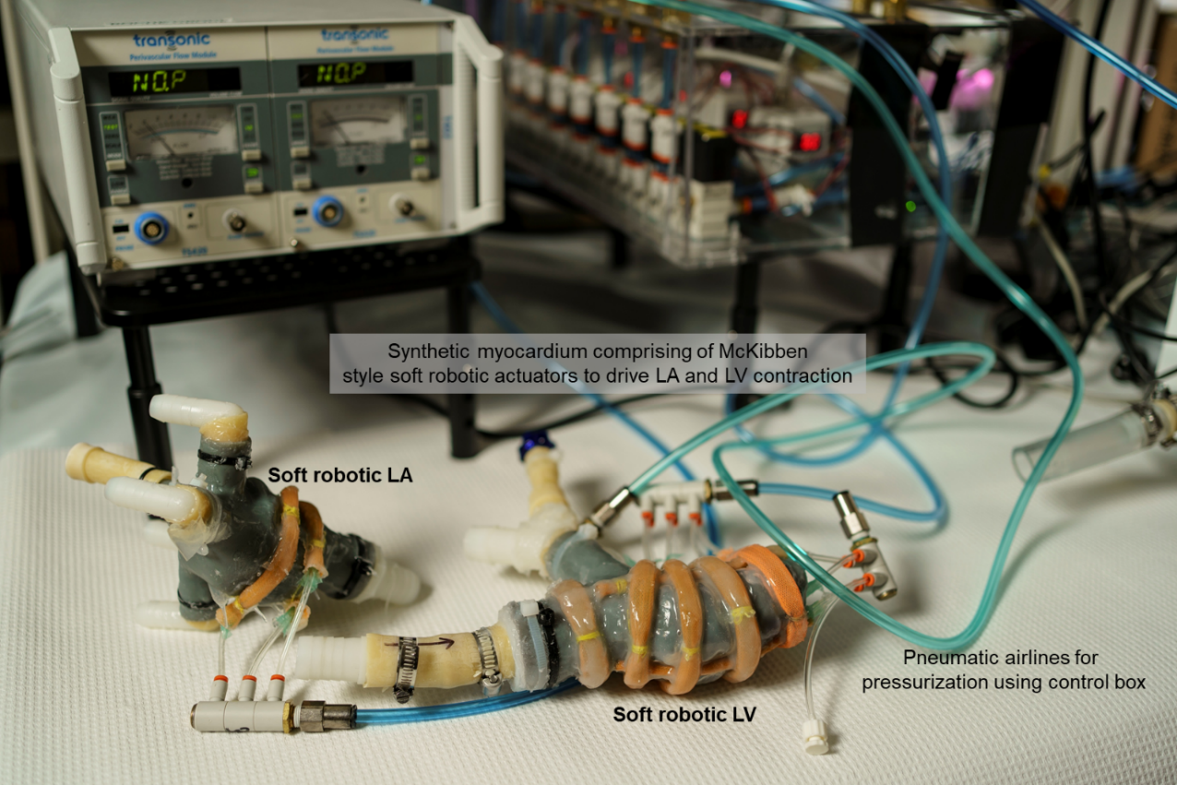
Figure S3: Patient-specific 3D-printed left atrium (LA) and left ventricle (LV) integrated with soft robotic synthetic myocardium, comprising of McKibben-type actuators to drive atrial and ventricular wall mechanics during systole. Photo credit: Jodi Hilton.

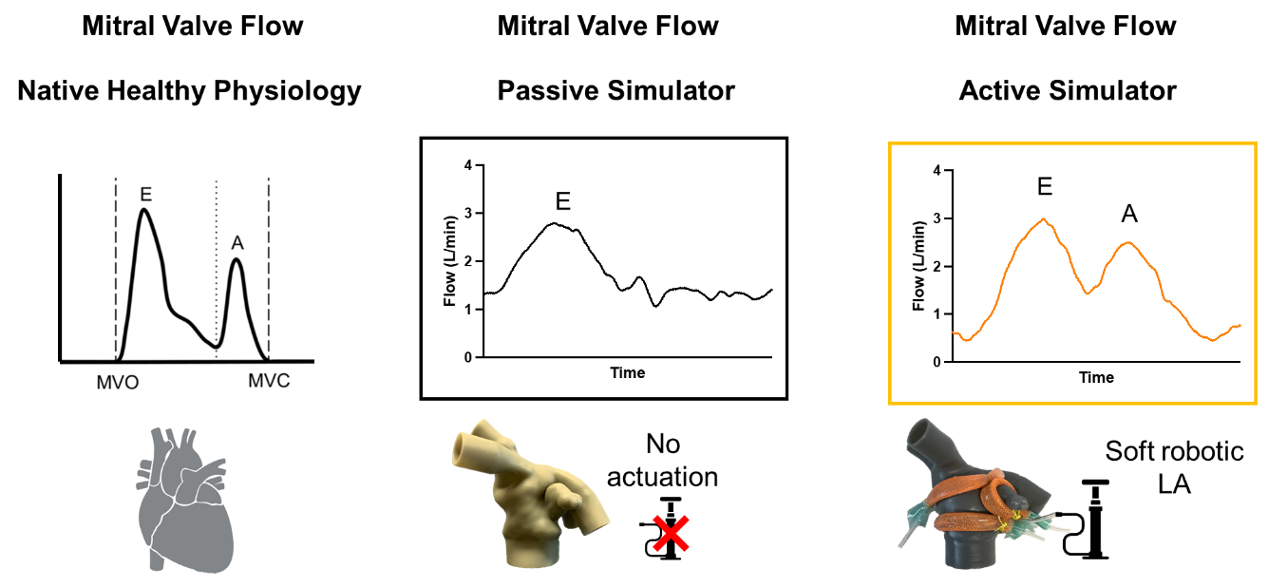
Figure S4: Comparison of flow waveforms illustrating physiological and simulated cardiac dynamics. Left: Healthy physiological flow. Middle: Flow waveform generated by a passive simulator, lacking the left atrial (LA) kick and A wave. Right: Flow waveform recreated using soft robotics in our simulator, successfully replicating the atrial kick for a more physiological profile. MVO; mitral valve open, MVC; mitral valve closed.

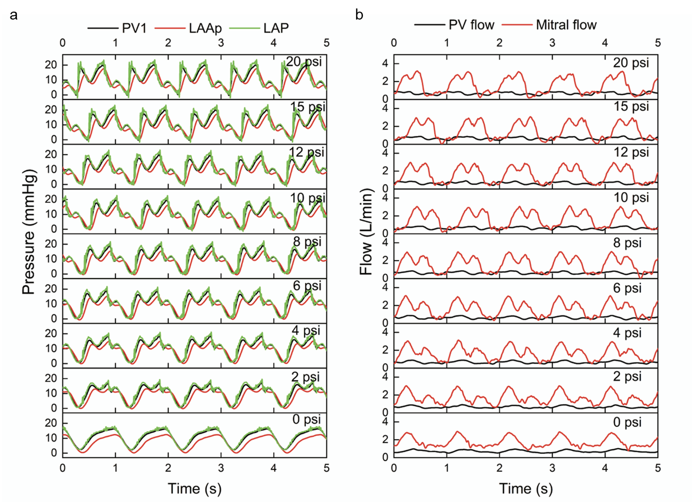
Figure S5: Flow and pressure profiles within the circulatory loop. (a) Pressure waveforms at increasing actuation pressures (0 to 20 psi), showing pulmonary vein (PV1) pressure, LAA pressure (LAAp), and left atrial pressure (LAP) over time. Each trace illustrates pressure changes with increasing actuation, capturing physiological variations in atrial pressures and showcasing the model's ability to recreate conditions relevant to various cardiac states. (b) Flow measurements from the pulmonary vein (PV flow) and mitral valve flow under the same range of pressures (0 to 20 psi). Flow profiles demonstrate cyclic patterns consistent with physiological conditions, with higher actuation pressures producing increased flow amplitudes. LAA; left atrial appendage.
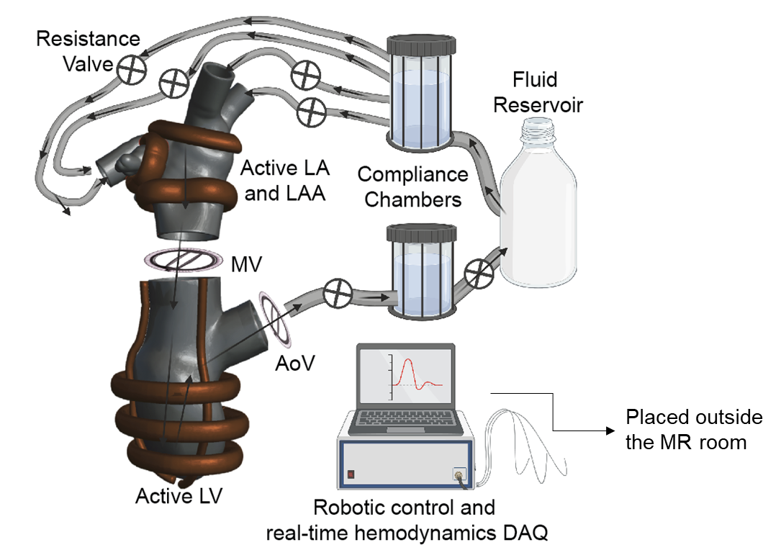
Figure S6: Schematic of a portable and compact magnetic resonance imaging (MRI) compatible mock circulatory flow loop setup. LA; left atrium, LV; left ventricle, LAA; left atrial appendage, MV; mitral valve, AoV; aortic valve, DAQ; data acquisition.

Movie S1: Atrial fibrillation, characterized by an irregular and rapid heartbeat due to uncoordinated atrial signals, compared to the organized and steady contraction of sinus rhythm in a live porcine model.
Movie S2: Fully integrated soft robotic cardiovascular model, combining the left atrium and left ventricle replicates left-sided cardiovascular hemodynamics, highlighting synchronized motion in a mock circulatory flow loop reflective of physiological conditions.
Movie S3: 3D-printed soft robotic heart model faithfully replicates the anatomical and physiological motion of the left atrium, left atrial appendage, and left ventricle, along with the functionality of the mechanical heart valves.

