Supporting Information

Quinoline-5,8-Dione CDC25 Inhibitors: Potent Anti-Cancer Agents in Leukemia and Patient-Derived Colorectal Organoids

Iin Narwanti^{a,b,1}, Zih-Yao Yu^{c,1}, Bidyadhar Sethyª, Pei-Ling Zheng^{c}, Li-Hsin Cheng^{d,e}, Kelvin K. Tsai^{d,e}, Sung-Bau Lee^{c,f}*, Jing-Ping Liou ^{a,c,f}*

ª School of Pharmacy, College of Pharmacy, Taipei Medical University, Taipei, Taiwan.
^{b} Faculty of Pharmacy, Universitas Ahmad Dahlan, Yogyakarta, Indonesia.
^{c} Ph.D. Program in Drug Discovery and Development Industry, College of Pharmacy, Taipei Medical University, Taipei, Taiwan.
^{d}Laboratory of Advanced Molecular Therapeutics, Graduate Institute of Clinical Medicine, College of Medicine, Taipei Medical University, Taipei 110, Taiwan
^{e}Core Laboratory of Organoids Technology, Office of R&D, Taipei Medical University, Taiwan
^{f} TMU Research Center for Drug Discovery, Taipei Medical University, Taipei, Taiwan.

Address correspondence to:
* Jing-Ping Liou, School of Pharmacy, College of Pharmacy, Taipei Medical University, 250 Wu-Hsing Street, Taipei 110, Taiwan. E-mail: jpl@tmu.edu.tw
*Sung-Bau Lee, Ph.D. Program in Drug Discovery and Development Industry, College of Pharmacy, Taipei Medical University, 250 Wu-Hsing Street, Taipei 110, Taiwan. E-mail: sbl@tmu.edu.tw

¹ These authors contributed equally to this work.
Contents
List of tables

Table S1. Cytotoxicity of synthesized compounds in colorectal cancer cancer cells (%) 3
Table S2. IC₅₀ values against CRC cell lines (HCT116 and DLD-1 cell lines) 4
Table S3. Physicochemical properties, pharmacokinetic properties, and drug-likeness of compounds 6a, 6b, D1b, D3a, D3b, D11a, and D11b calculated using the web-based SwissADME tool 60

List of Figures
Figure S1. D1b and D11b treatment triggers significant apoptosis in HCT116 cells. 5
Figure S2. D3a and D11a impede CDK1 dephosphorylation and mitosis progression in HL-60 cells. 6
Figure S3. D1b, D3b, and D11b prevent dephosphorylation of CDK1 and activation of mitotic signaling in HCT116 cells. 7
Figure S4. Treatment of selected compounds leads to cell cycle arrest or delay in HCT116 cells. 8
Figure S5. D3a and D11a suppress H4K20 methylation in HL-60 cells. 9
Figure S6. D11b treatment suppresses H4K20 methylation in HCT116 cells. 10
Figure S7. D11b induces a high level of DNA damage in K-562 and HCT116 cells. 11
Figure S8. ¹H-NMR, ¹³C-NMR, HRMS spectra,3 and HPLC profile of Final Compounds 12

Table S1. Cytotoxicity of synthesized compounds in colorectal cancer cancer cells (%)

Compounds | Cell viability (%)
Compounds | CRC cell lines
Compounds | HCT116 | DLD-1
6a | 79.9±5 | 98±3.2
D1a | 78.5±2 | 89.4±5.5
D1b | 2.1±0.8 | 0.25±0.33
D2a | 2.1±1.3 | 1.6±1.1
D2b | 2.5±0.7 | 8.9±1.3
D3a | 5.7±2.7 | 0.78±0.51
D3b | 2.5±0.3 | 0.87±0.35
D4a | 71.9±0.9 | 84.5±3
D4b | 93±9.1 | 93.4±7.4
D5a | 74.7±3.9 | 86.6±4.6
D5b | 4.5±0.9 | 3.4±1.3
D6a | 89.4±2 | 104.2±3.3
D6b | 96±7.5 | 97.8±4.2
D7a | 85±3.1 | 106.2±5
D7b | 3.3±0.46 | 36.8±5.1
D8a | 82.9±4.2 | 95.7±4.5
D8b | 31.6±7 | 7.8±1.8
D9a | 58.2±3.7 | 35.3±8.7
D9b | 25.9±2.4 | 67.9±3.5
D10a | 69.2±2.9 | 66.6±7.3
D10a | 91.7±4.2 | 94.2±4.7
D11a | 1.2±0.5 | 0.57±0.66
D11b | 0.98±0.63 | BDL
D12a | 84.3±2.1 | 102.1±6.8
D12b | 92±2.1 | 98.4±7.3
DMSO | 100±1.1 | 100±4.3
HCT116 and DLD-1 were treated with 2 μM of indicated compounds for 72h, and the percentages of surviving cells were determined by MTS assay. Results are shown as means with SDs from at least two independent experiments (n ≥ 5). BDL: Below detection limit.

Table S2. IC₅₀ values against CRC cell lines (HCT116 and DLD-1 cell lines)
Compounds | IC₅₀ (μM)
Compounds | HCT116 | DLD-1
D1b | 0.48±0.1 | 0.38±0.004
D2a | 1.43±0.16 | 0.76±0.1
D2b | 0.88±0.11 | 1.29±0.02
D3a | 1.5±0.09 | 0.74±0.03
D3b | 1.13±0.12 | 0.65±0.008
D5b | 0.83±0.12 | 0.84±0.08
D7b | 0.83±0.11 | 1.77±0.15
D11a | 1.14±0.1 | 0.56±0.02
D11b | 0.17±0.02 | 0.13±0.006

HCT116 and DLD-1 were treated with indicated compounds for 72 h, and the half maximal inhibitory concentration (IC₅₀) values were determined by MTS assay. Results are shown as means with SDs from at least two independent experiments (n ≥ 6).

Figure S1. D1b and D11b treatment triggers significant apoptosis in HCT116 cells.

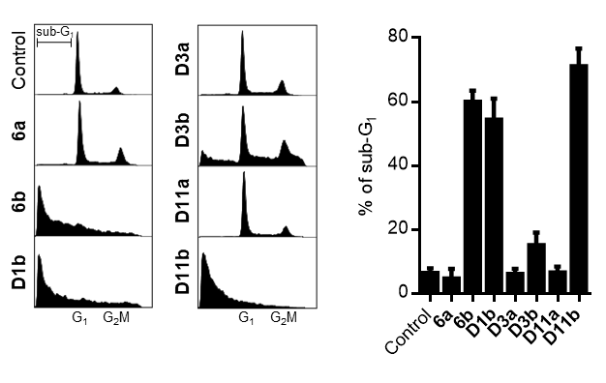
Analysis of cell cycle profiles of HCT116 cells treated with 2 μM of indicated compounds for 72 h. Representative profiles (left) and percentages of the sub-G1 population from at least three biological replicates (right) are shown and displayed with means and SDs (n = 3).

Figure S2. D3a and D11a impede CDK1 dephosphorylation and mitosis progression in HL-60 cells.

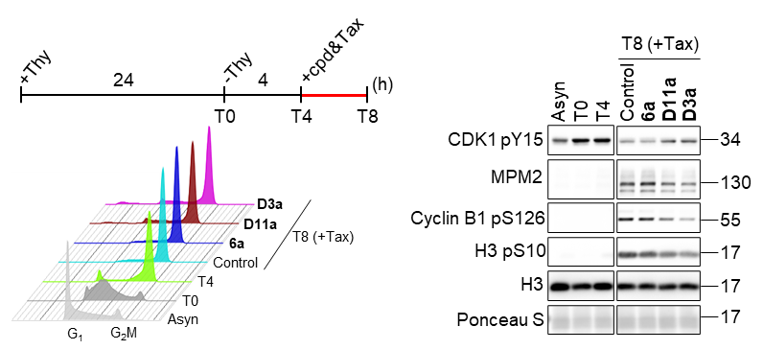
Analysis of cell cycle progression and mitotic signaling of thymidine-synchronized HL-60 cells co-treated with 0.2 μM of Taxol and 0.75 μM of indicated compounds. Experimental design (left upper) and representative results of FACS (left lower) and Western blot (right) from one of two biological replicates are shown. Asyn: Asynchronous; cpd: Compound; Tax: Taxol; Thy: Thymidine.

Figure S3. D1b, D3b, and D11b prevent dephosphorylation of CDK1 and activation of mitotic signaling in HCT116 cells.

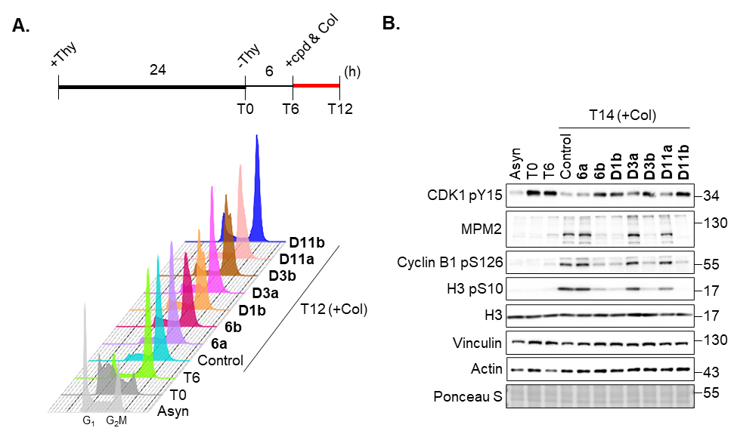
(A) Analysis of cell cycle progression of thymidine-synchronized HCT116 cells co-treated with 0.2 μM of colchicine and 2 μM of indicated compounds. Experimental design (upper) and representative results from one of two biological replicates (lower) are shown. (B) Analysis of mitotic signaling in HCT116 cells treated as (A). Representative results from one of two biological replicates are shown. Asyn: Asynchronous; Cpd: Compound; Col: Colchicine; Thy: Thymidine.

Figure S4. Treatment of selected compounds leads to cell cycle arrest or delay in HCT116 cells.

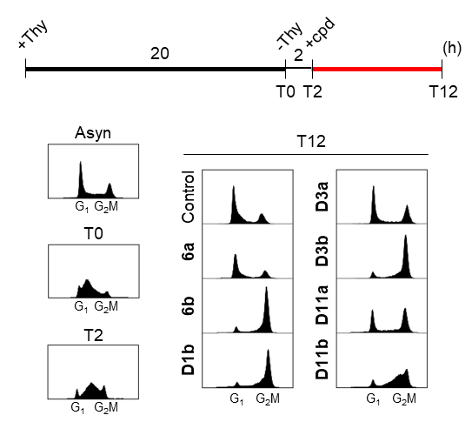
Analysis of cell cycle progression of thymidine-synchronized HCT116 cells treated with 2 μM. Experimental design (upper) and representative results from one of two biological replicates (lower) are shown. Asyn: Asynchronous; Cpd: Compound; Thy: Thymidine.

Figure S5. D3a and D11a suppress H4K20 methylation in HL-60 cells.

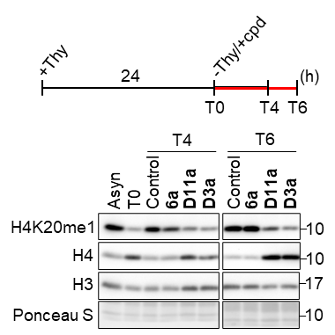
Analysis of H4K20 mono-methylation in thymidine-synchronized HL-60 cells treated with 2 μM of indicated compounds. Experimental design (upper) and representative results from one of two biological replicates (lower) are shown. The unequal staining of total histone H4 was potentially due to the interference from the unstripped H4K20me1 antibody remaining on the membrane. Asyn: Asynchronous; Cpd: Compound; Thy: Thymidine.

Figure S6. D11b treatment suppresses H4K20 methylation in HCT116 cells.

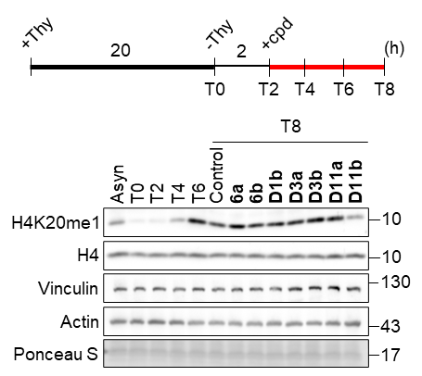
Analysis of H4K20 mono-methylation in thymidine-synchronized HCT116 cells treated with 2 μM of indicated compounds. Experimental design (upper) and representative results from one of two biological replicates (lower) are shown. Data were collected from different sets of gel electrophoresis with equal loading of the same samples. Asyn: Asynchronous; Cpd: Compound; Thy: Thymidine.

Figure S7. D11b induces a high level of DNA damage in K-562 and HCT116 cells.

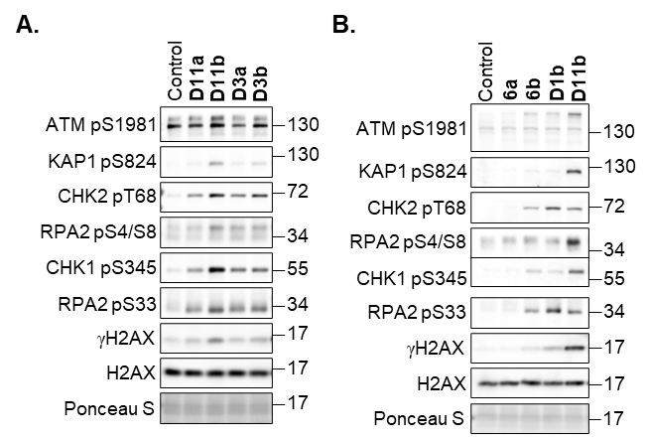
Analysis of DNA damage signaling in K-562 (A) and HCT116 (B) cells treated with 1 μM of indicated compounds for 4 h (A) or 2 μM for 8 h (B) . Representative results from one of two biological replicates are shown.

Figure S8. ¹H-NMR, ¹³C-NMR, HRMS spectra,3 and HPLC profile of Final Compounds
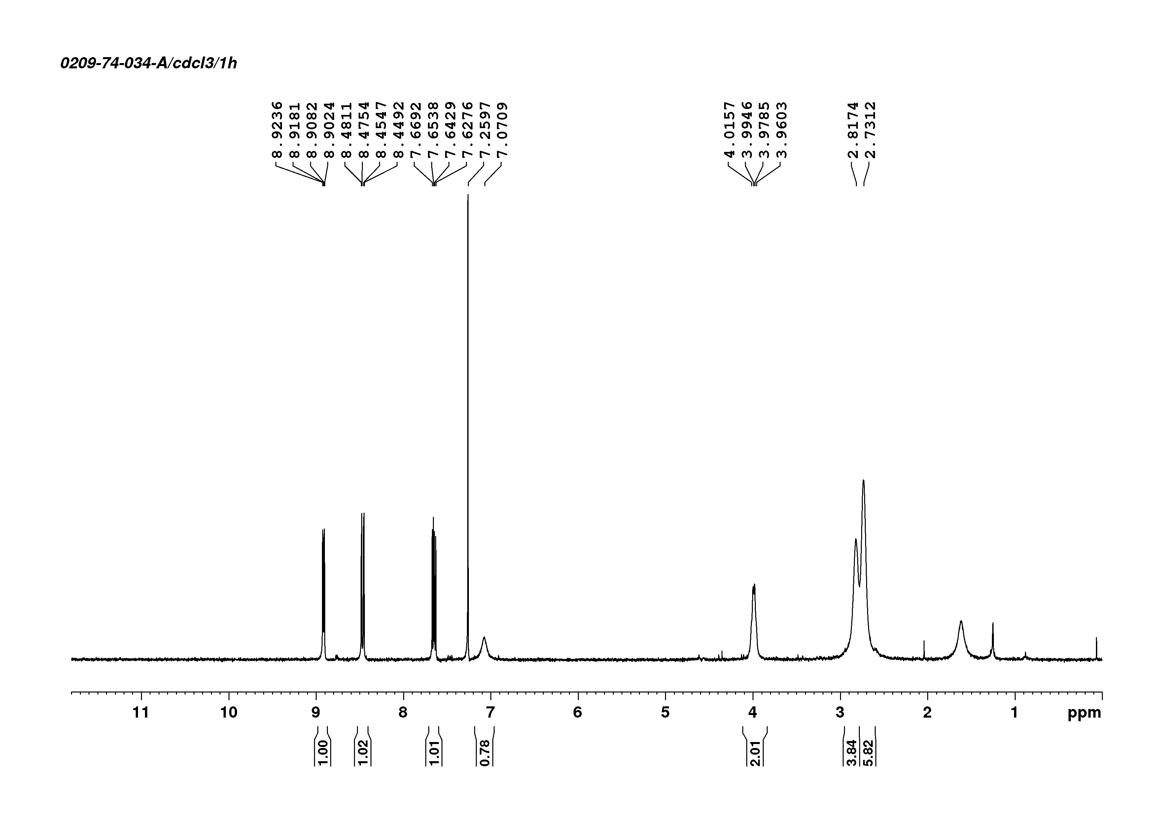
¹H-NMR spectrum of compound D1a

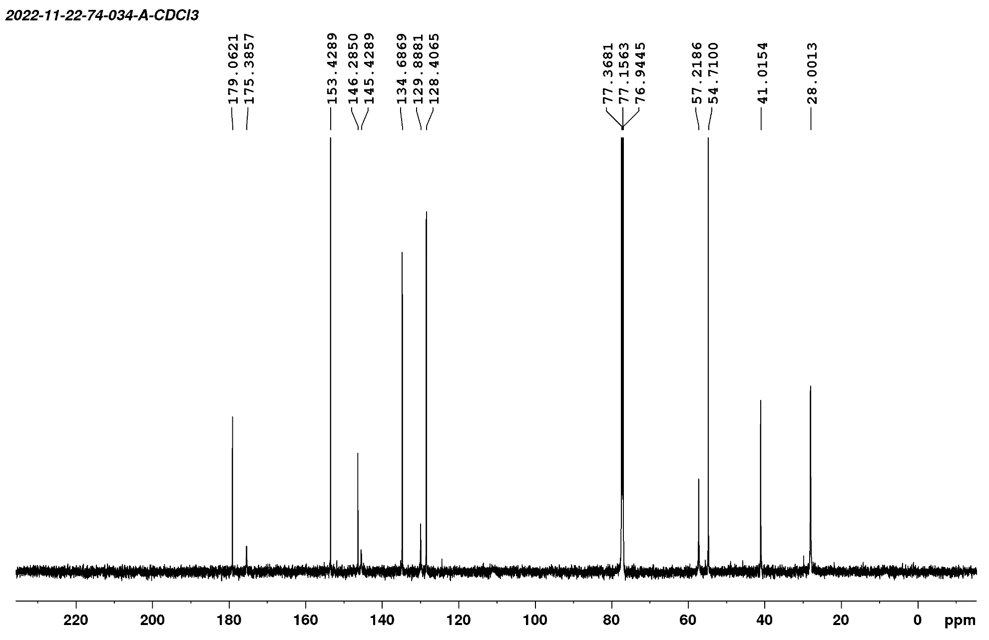
¹³C-NMR spectrum of compound D1a
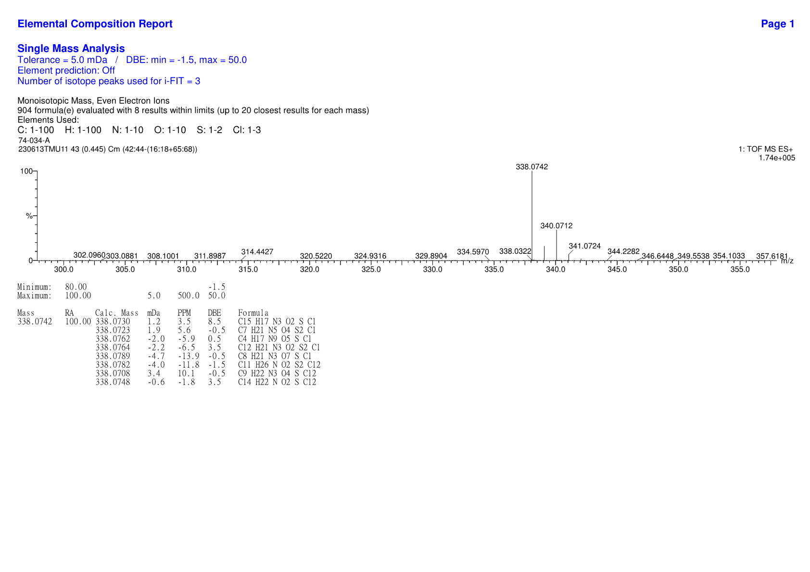
HRMS spectrum of compound D1a

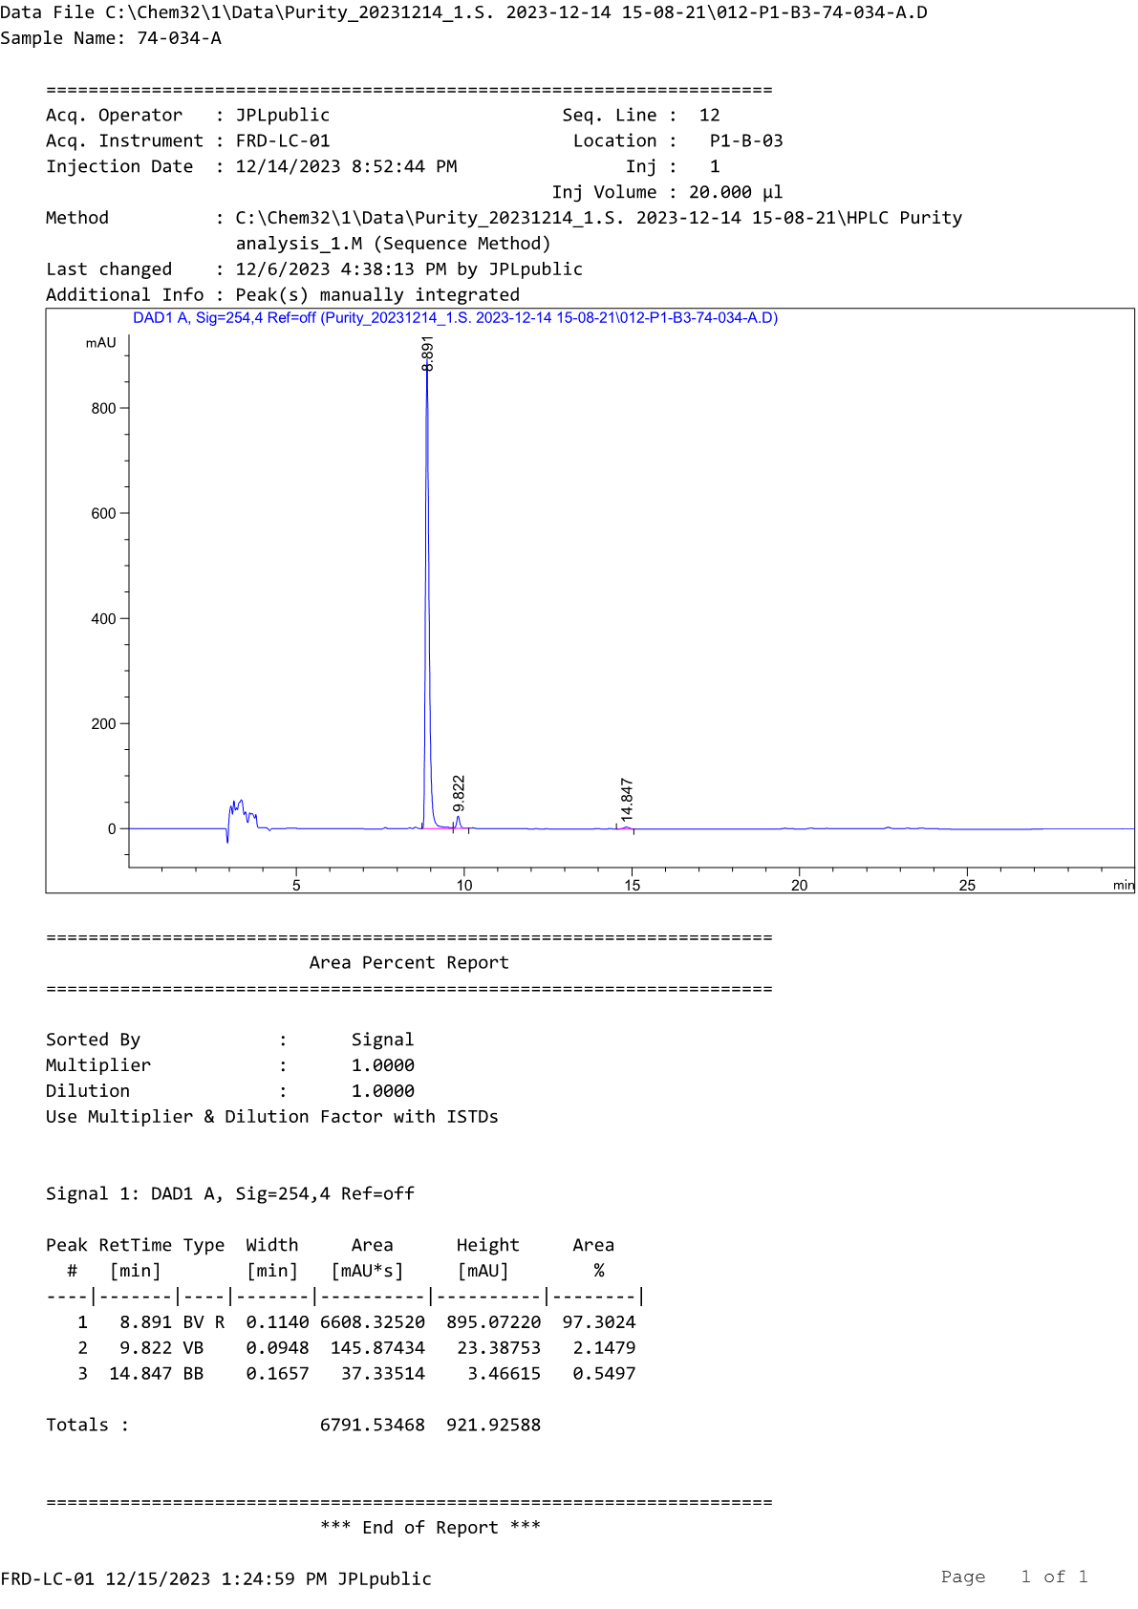
HPLC profile of compound D1a
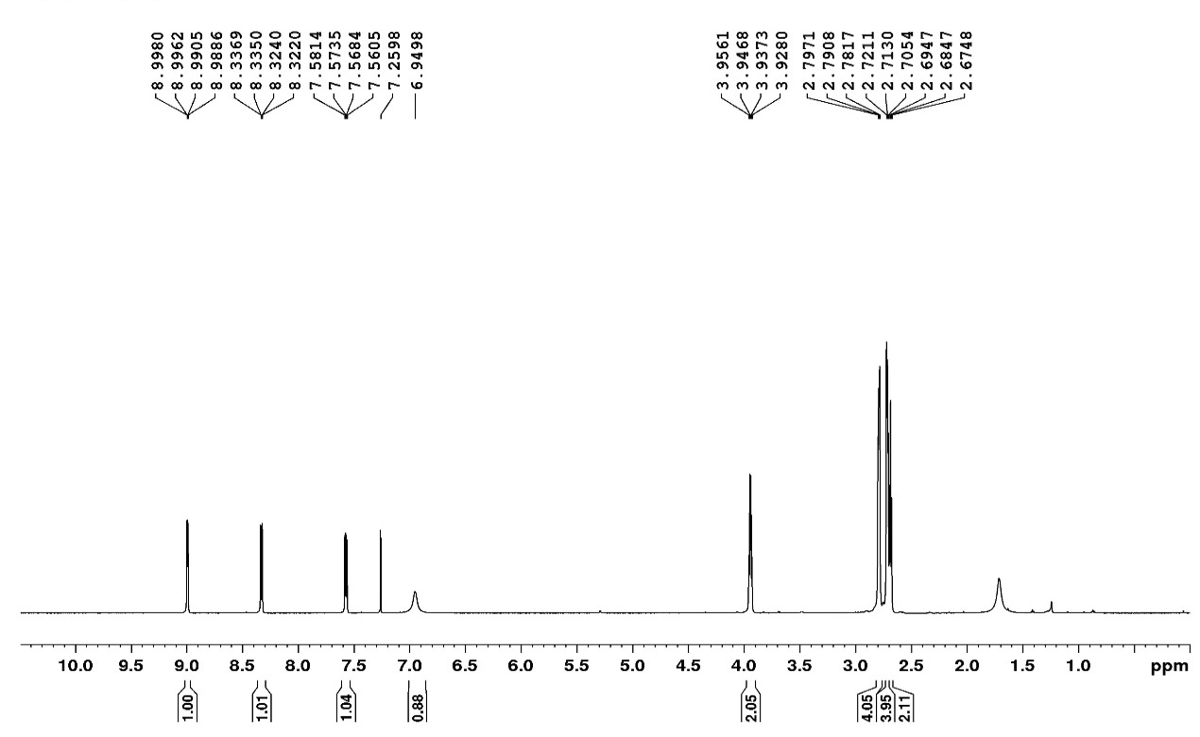
¹H-NMR spectrum of compound D1b

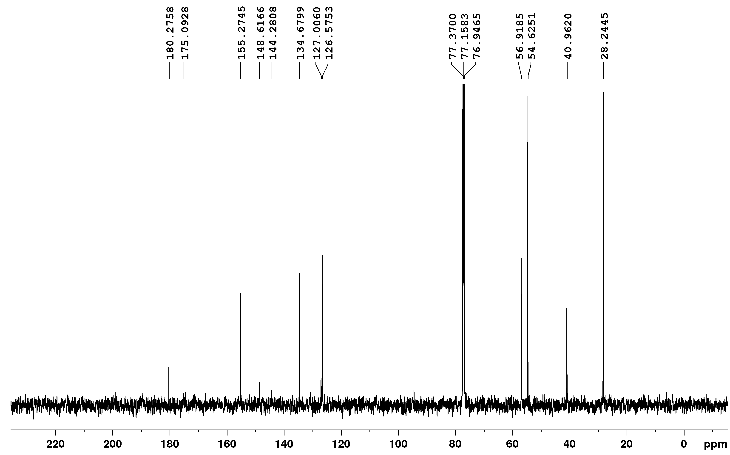
¹³C-NMR spectrum of compound D1b
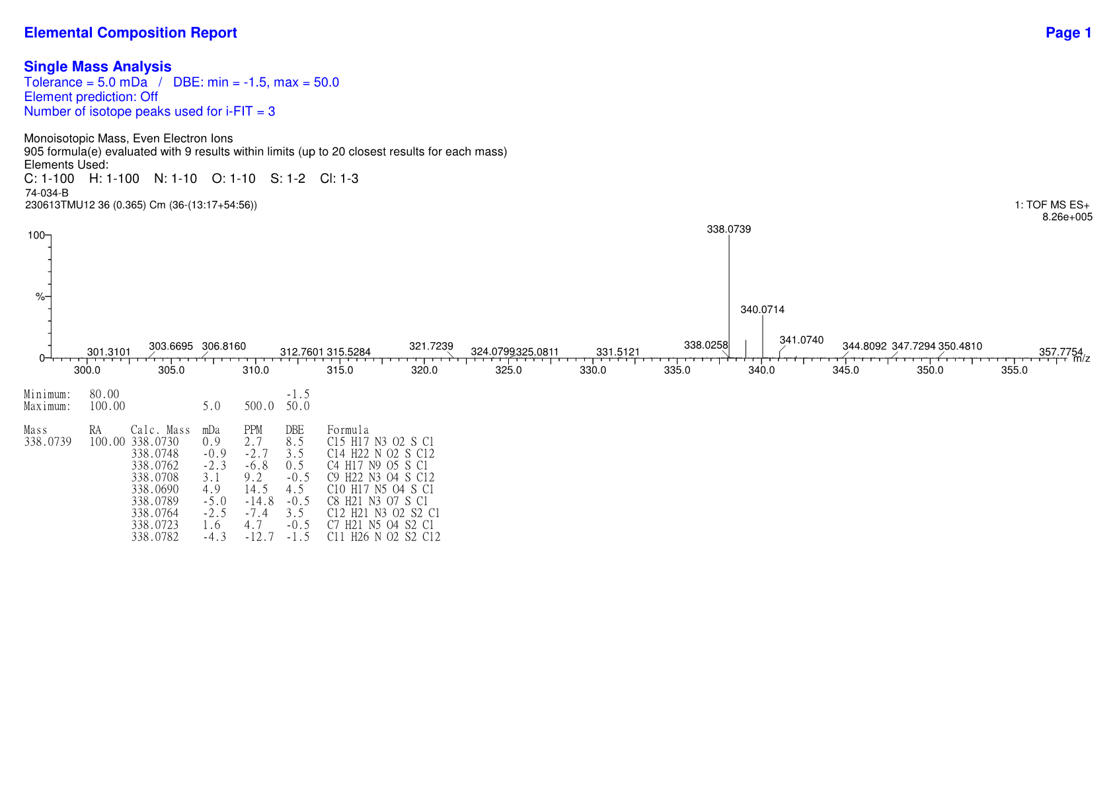
HRMS spectrum of compound D1b

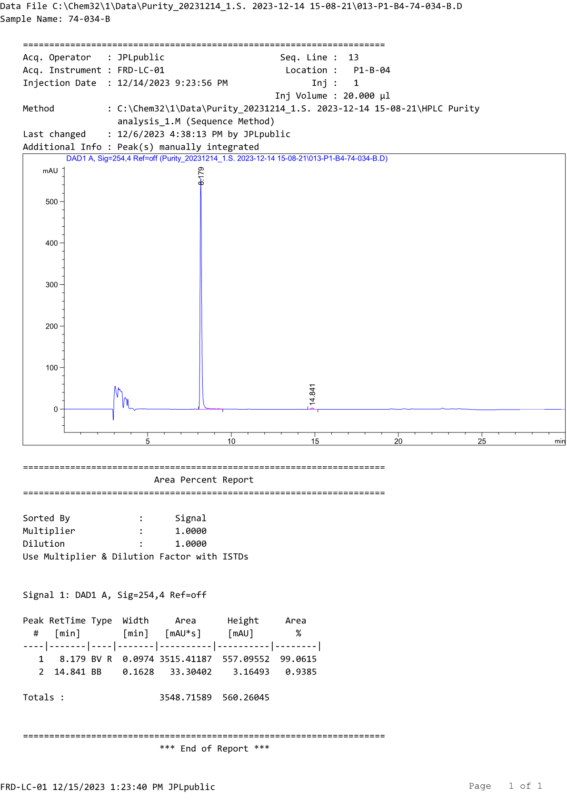
HPLC profile of compound D1b
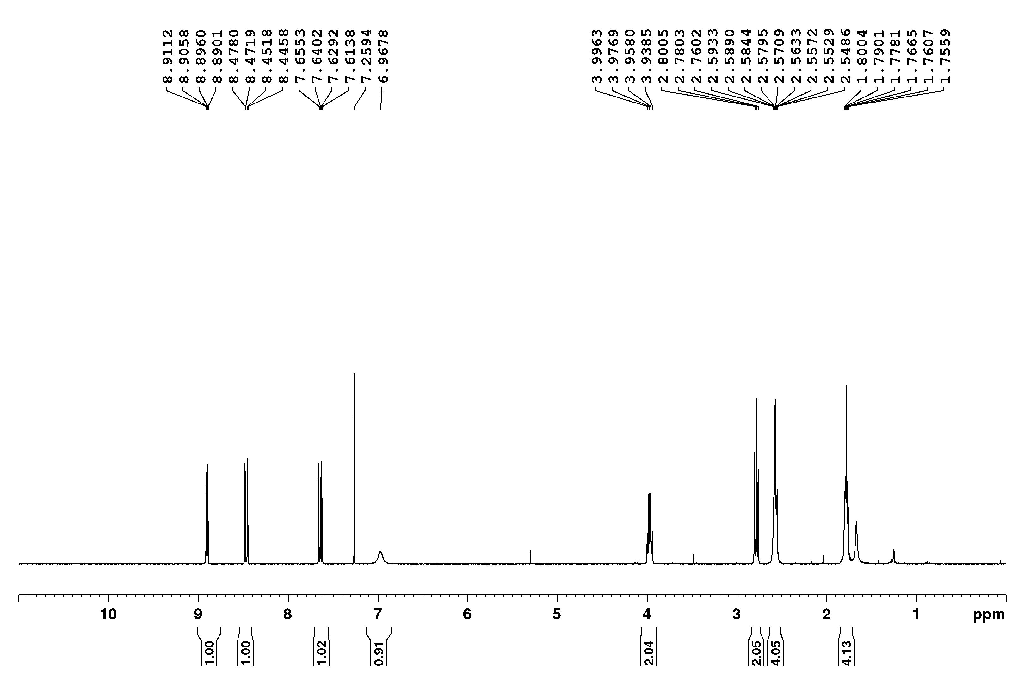
¹H-NMR spectrum of compound D2a

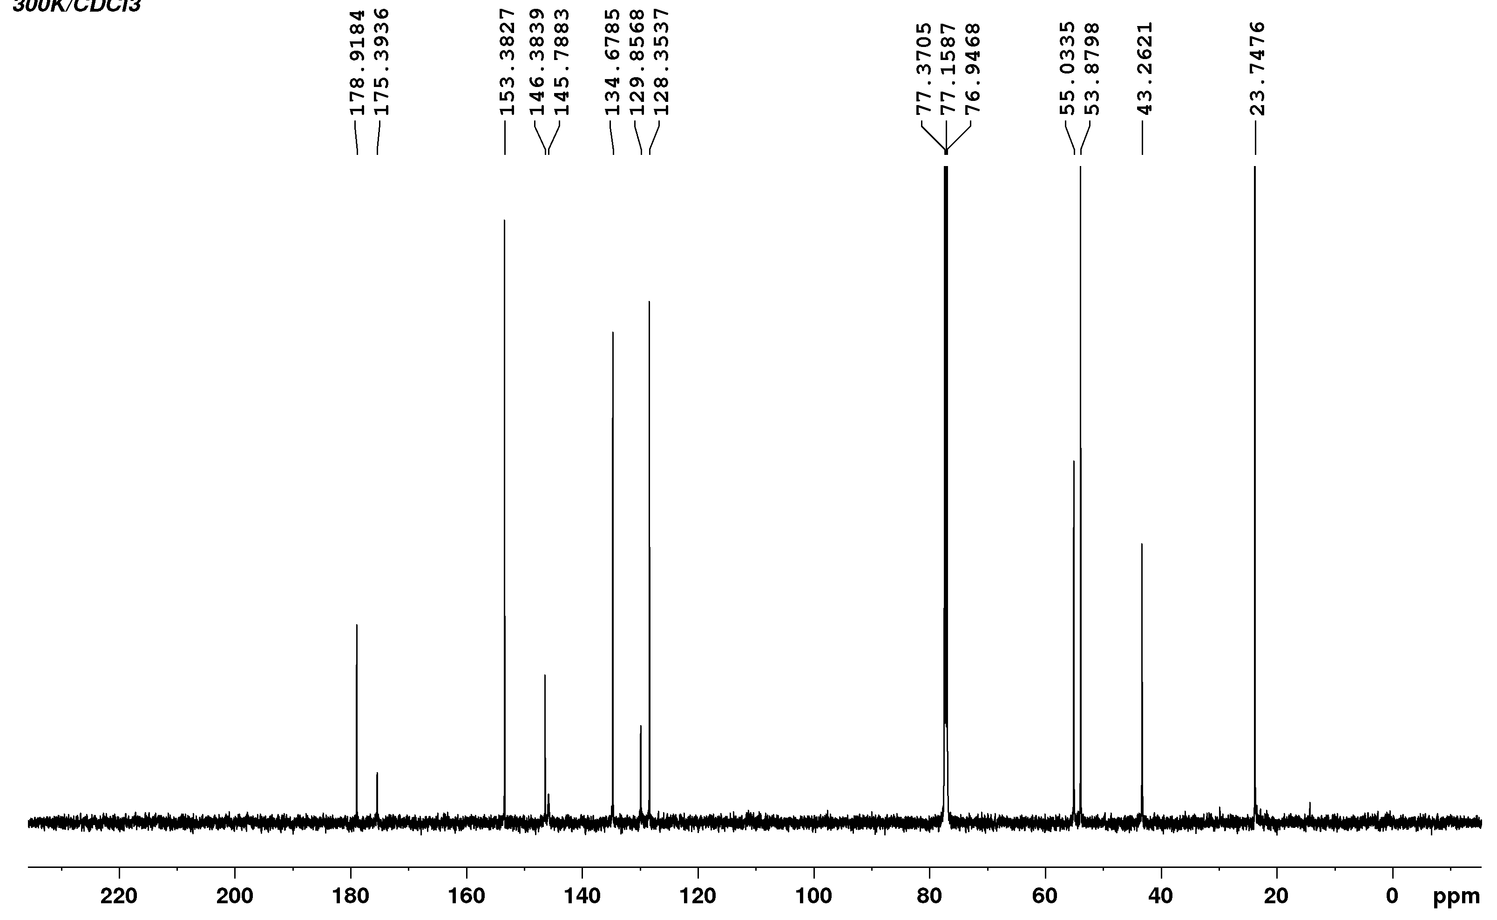
¹³C-NMR spectrum of compound D2a
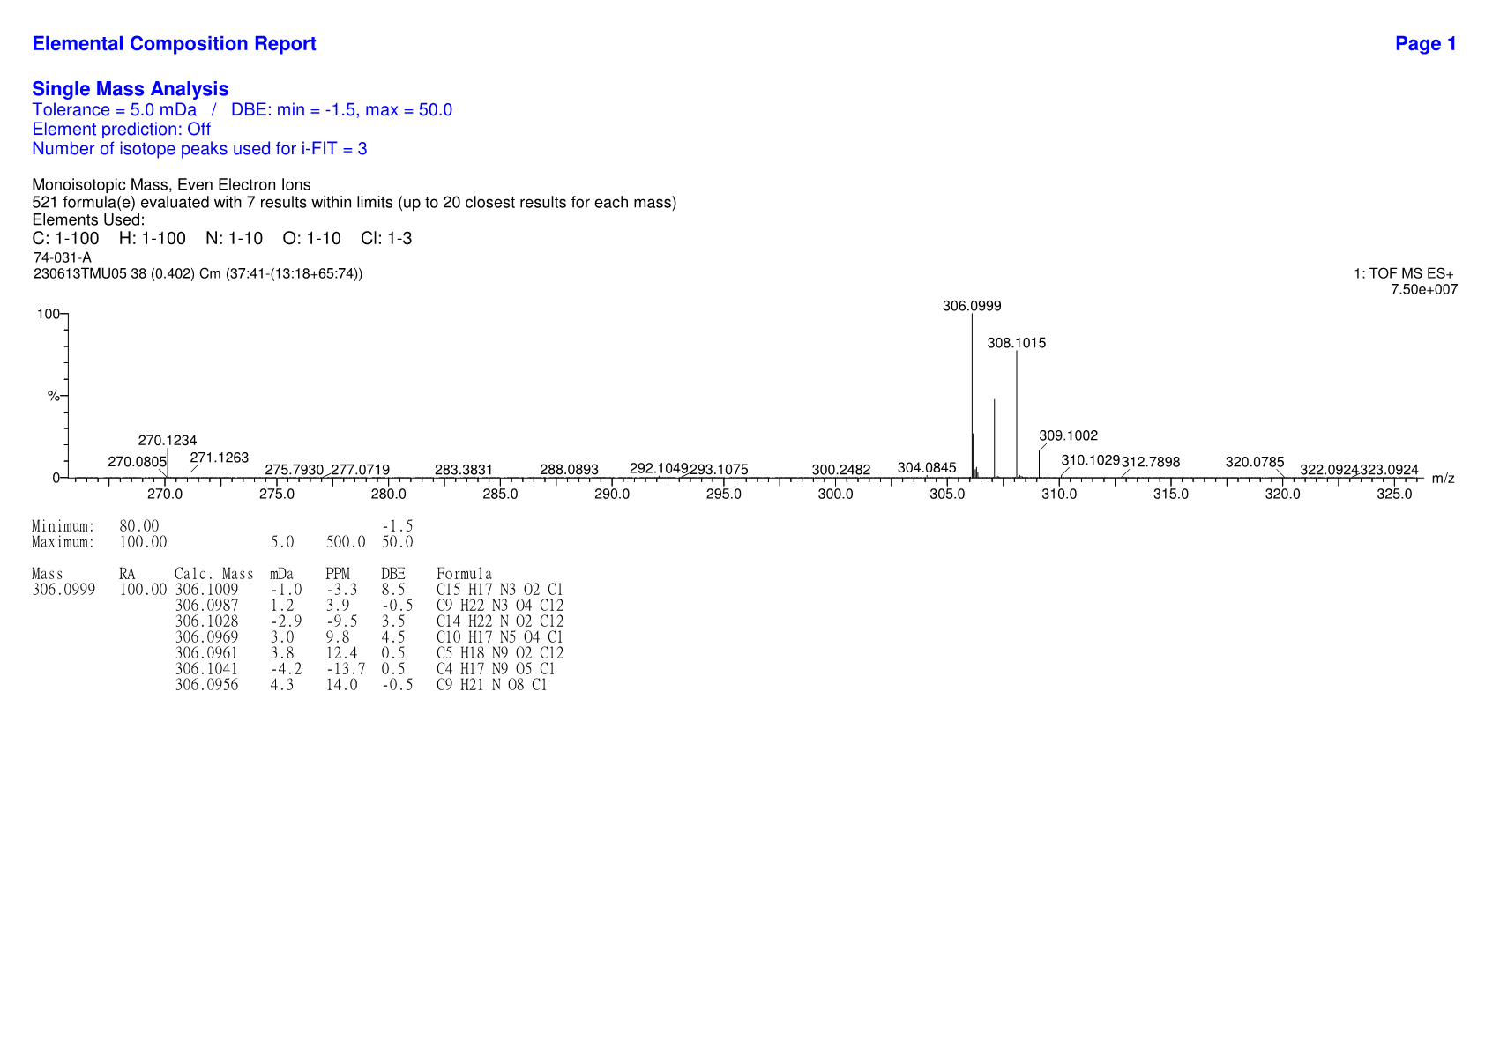
HRMS spectrum of compound D2a

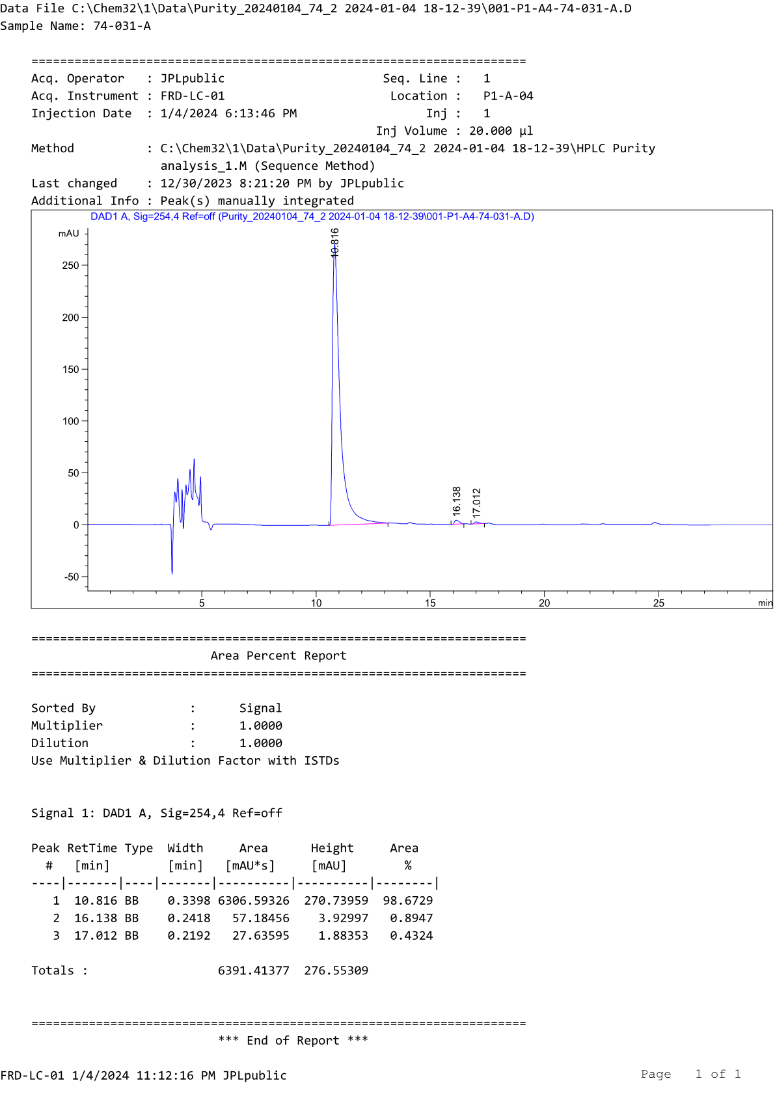
HPLC profile of compound D2a
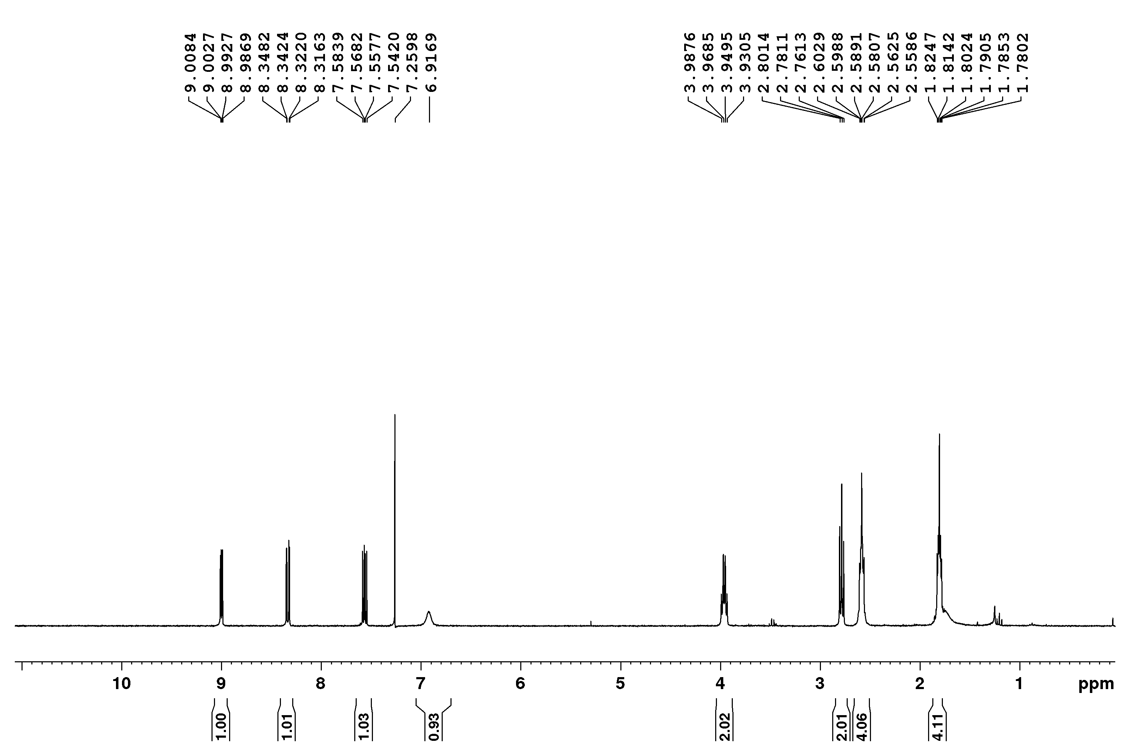
¹H-NMR spectrum of compound D2b

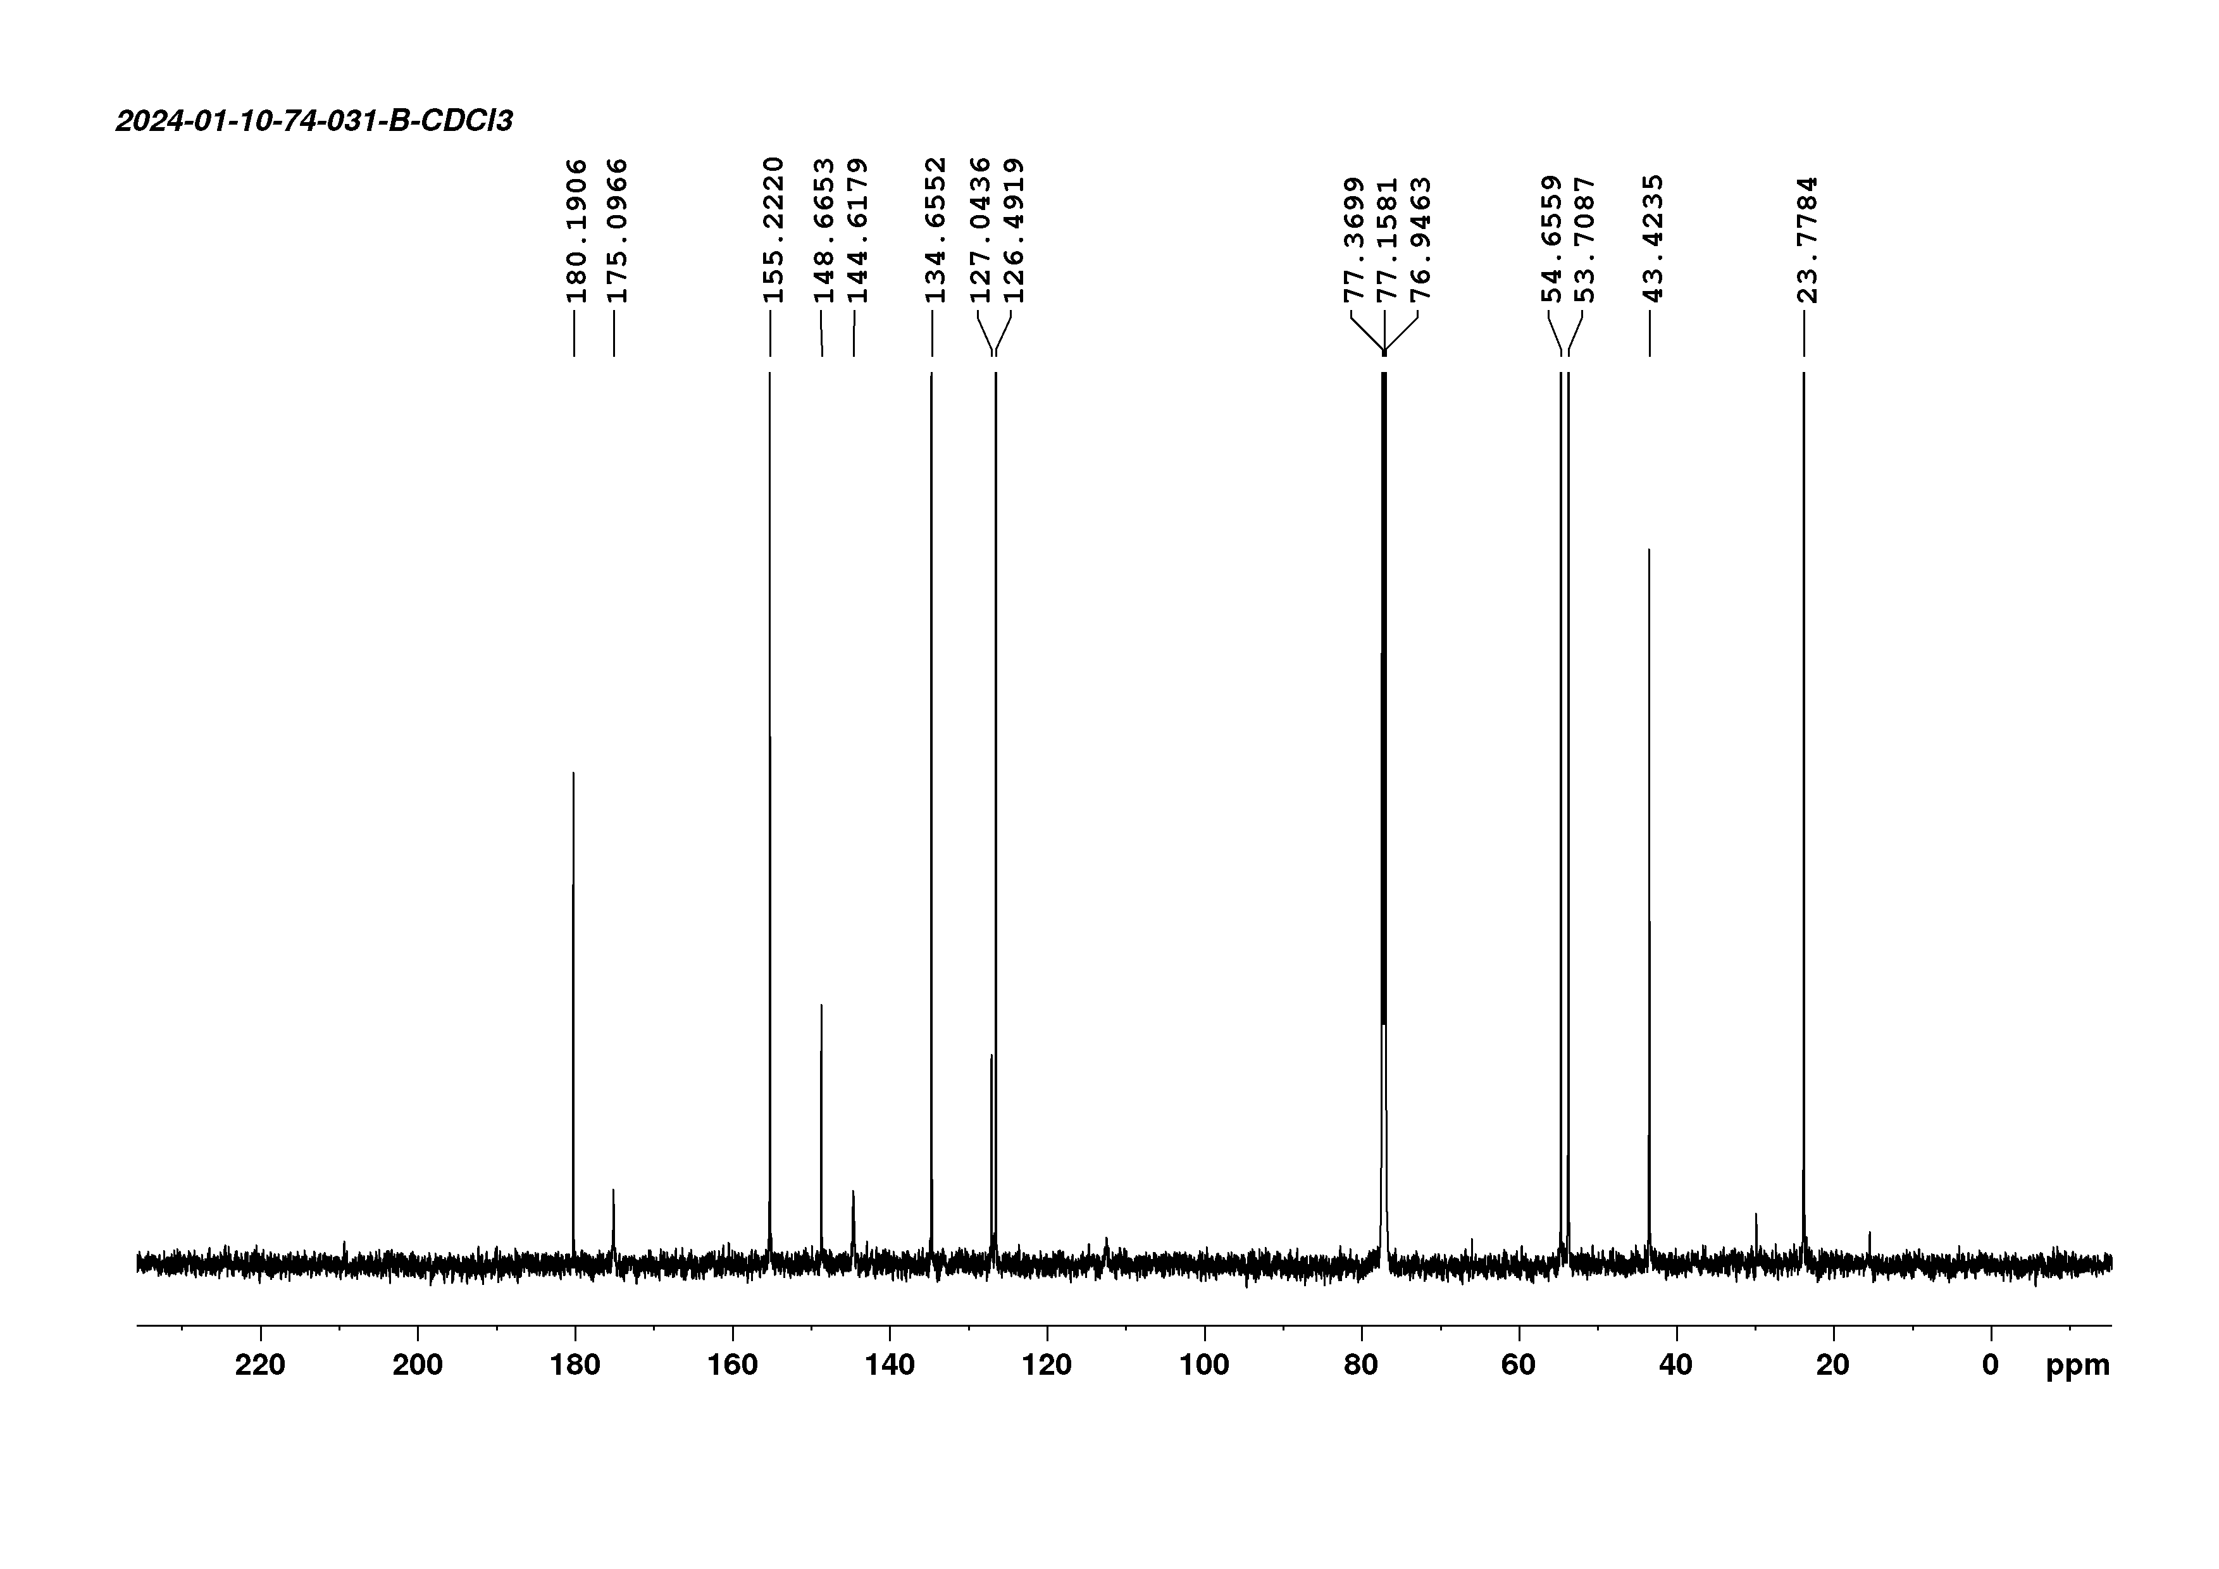
¹³C-NMR spectrum of compound D2b
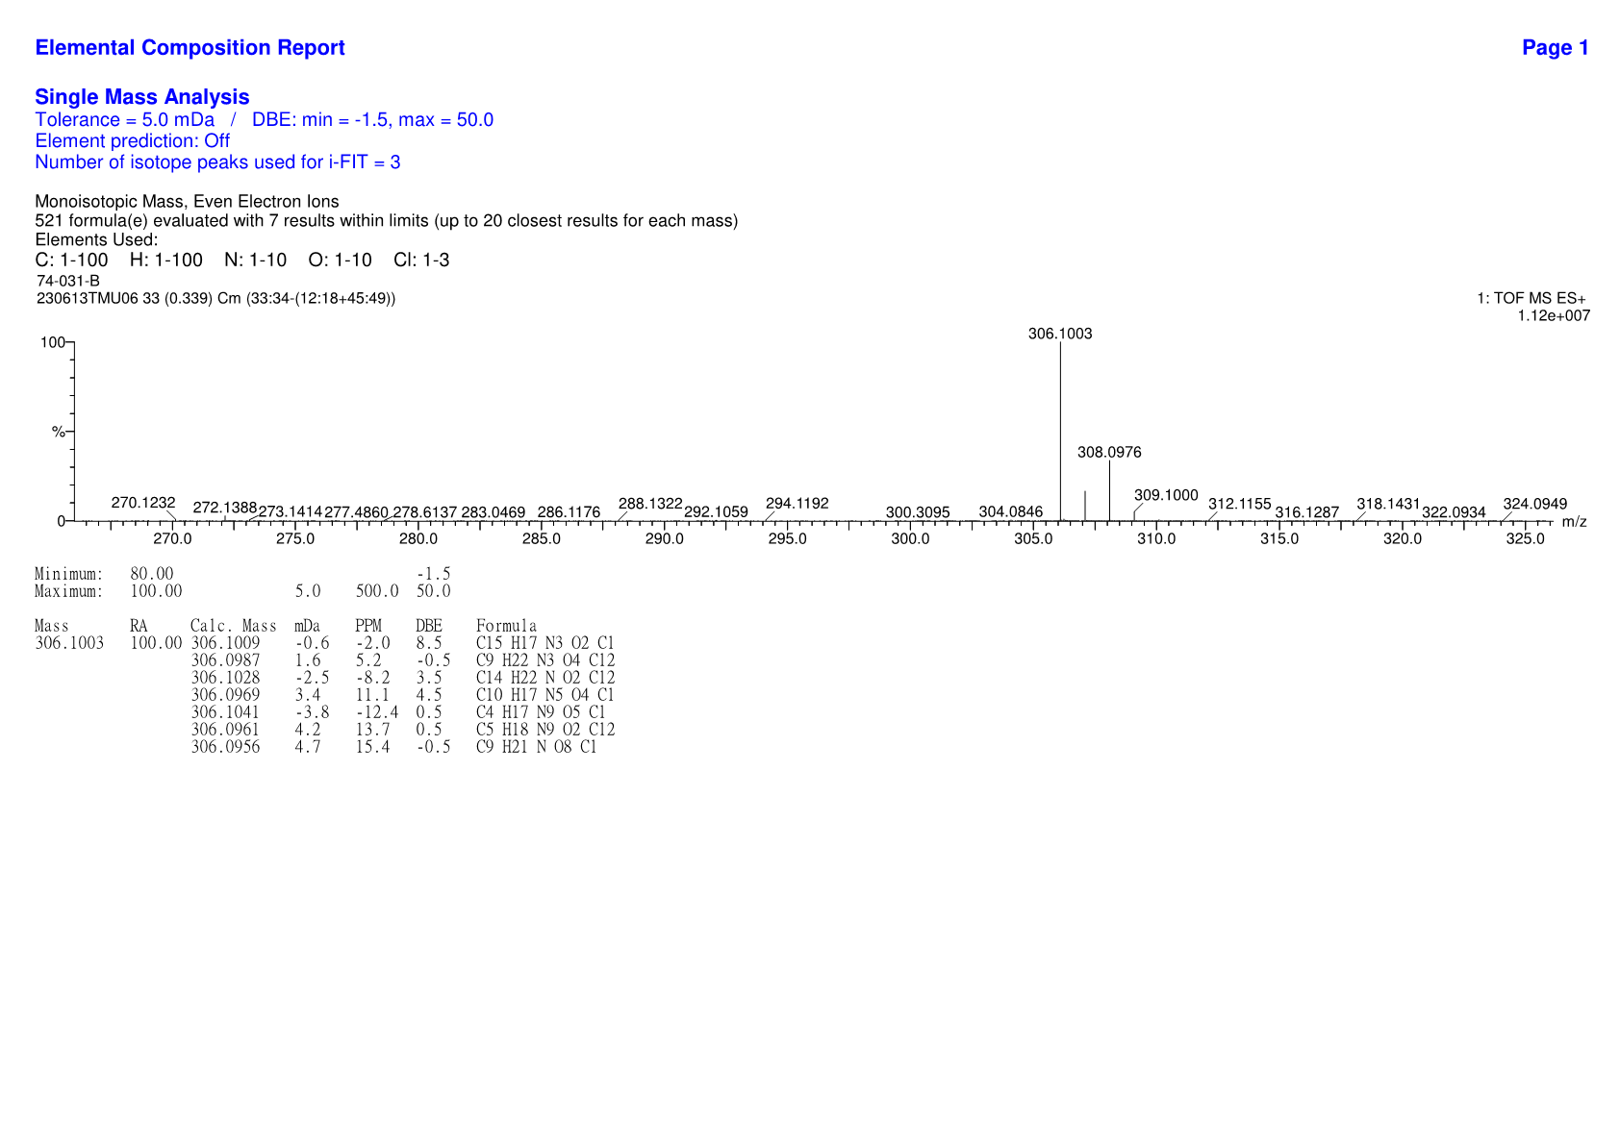
HRMS spectrum of compound Db

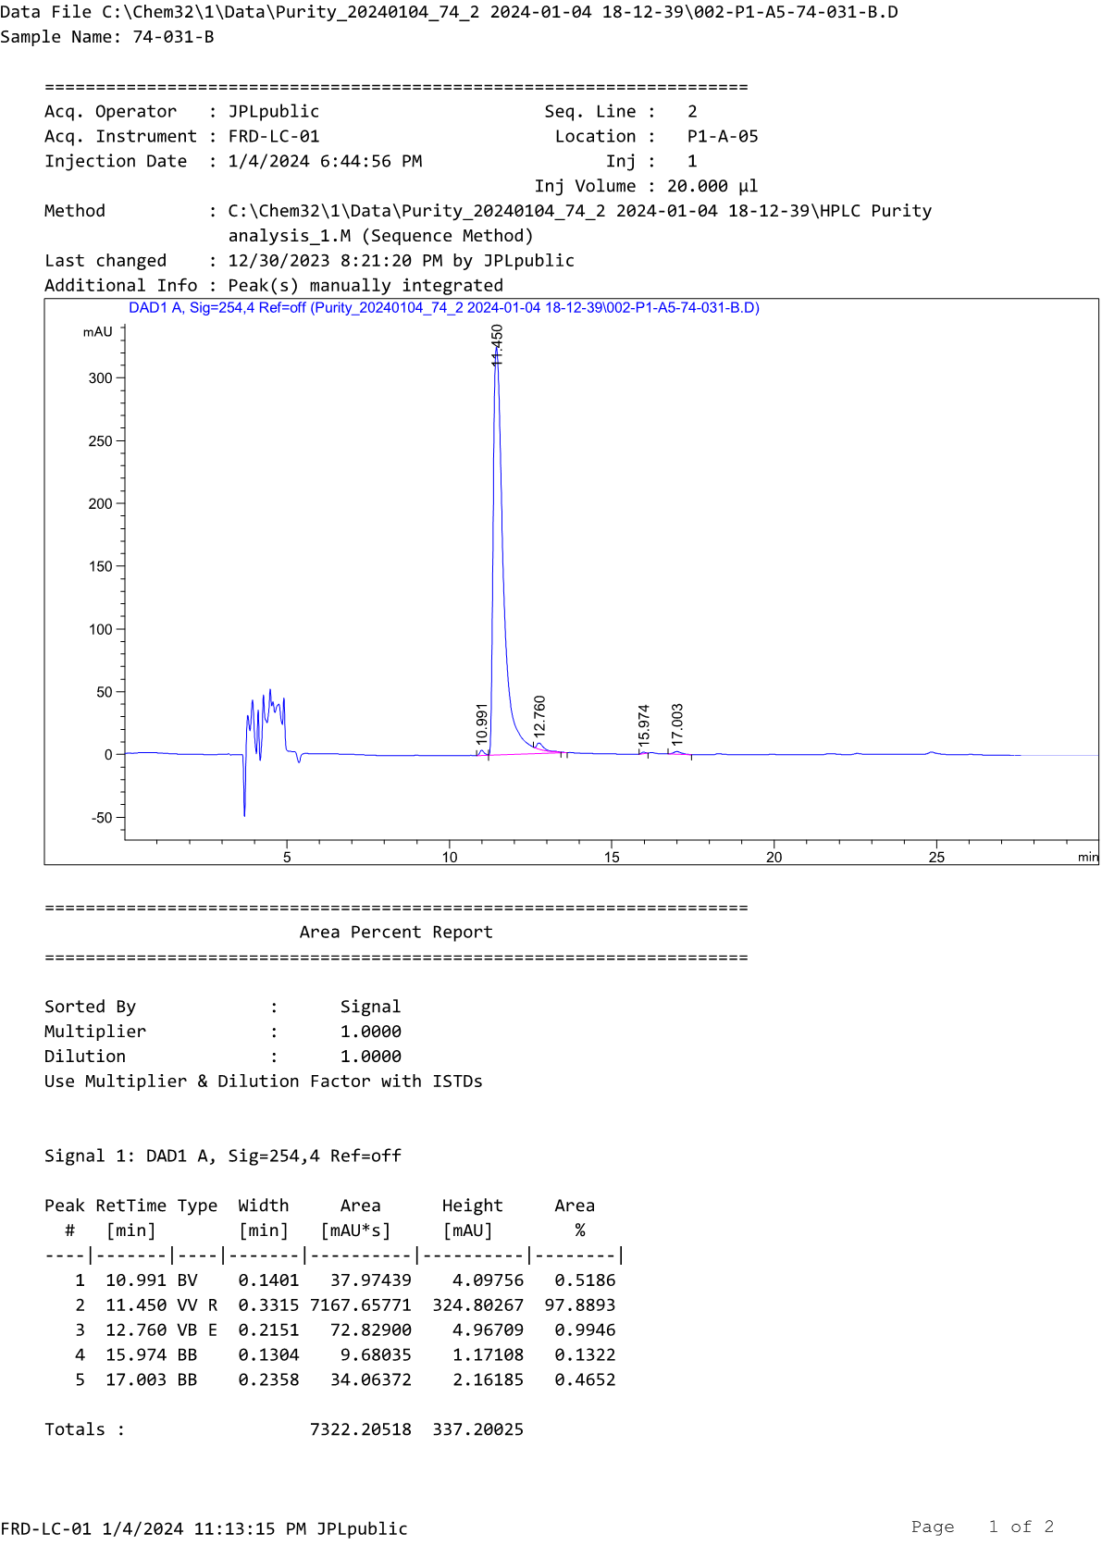
HPLC profile of compound D2b
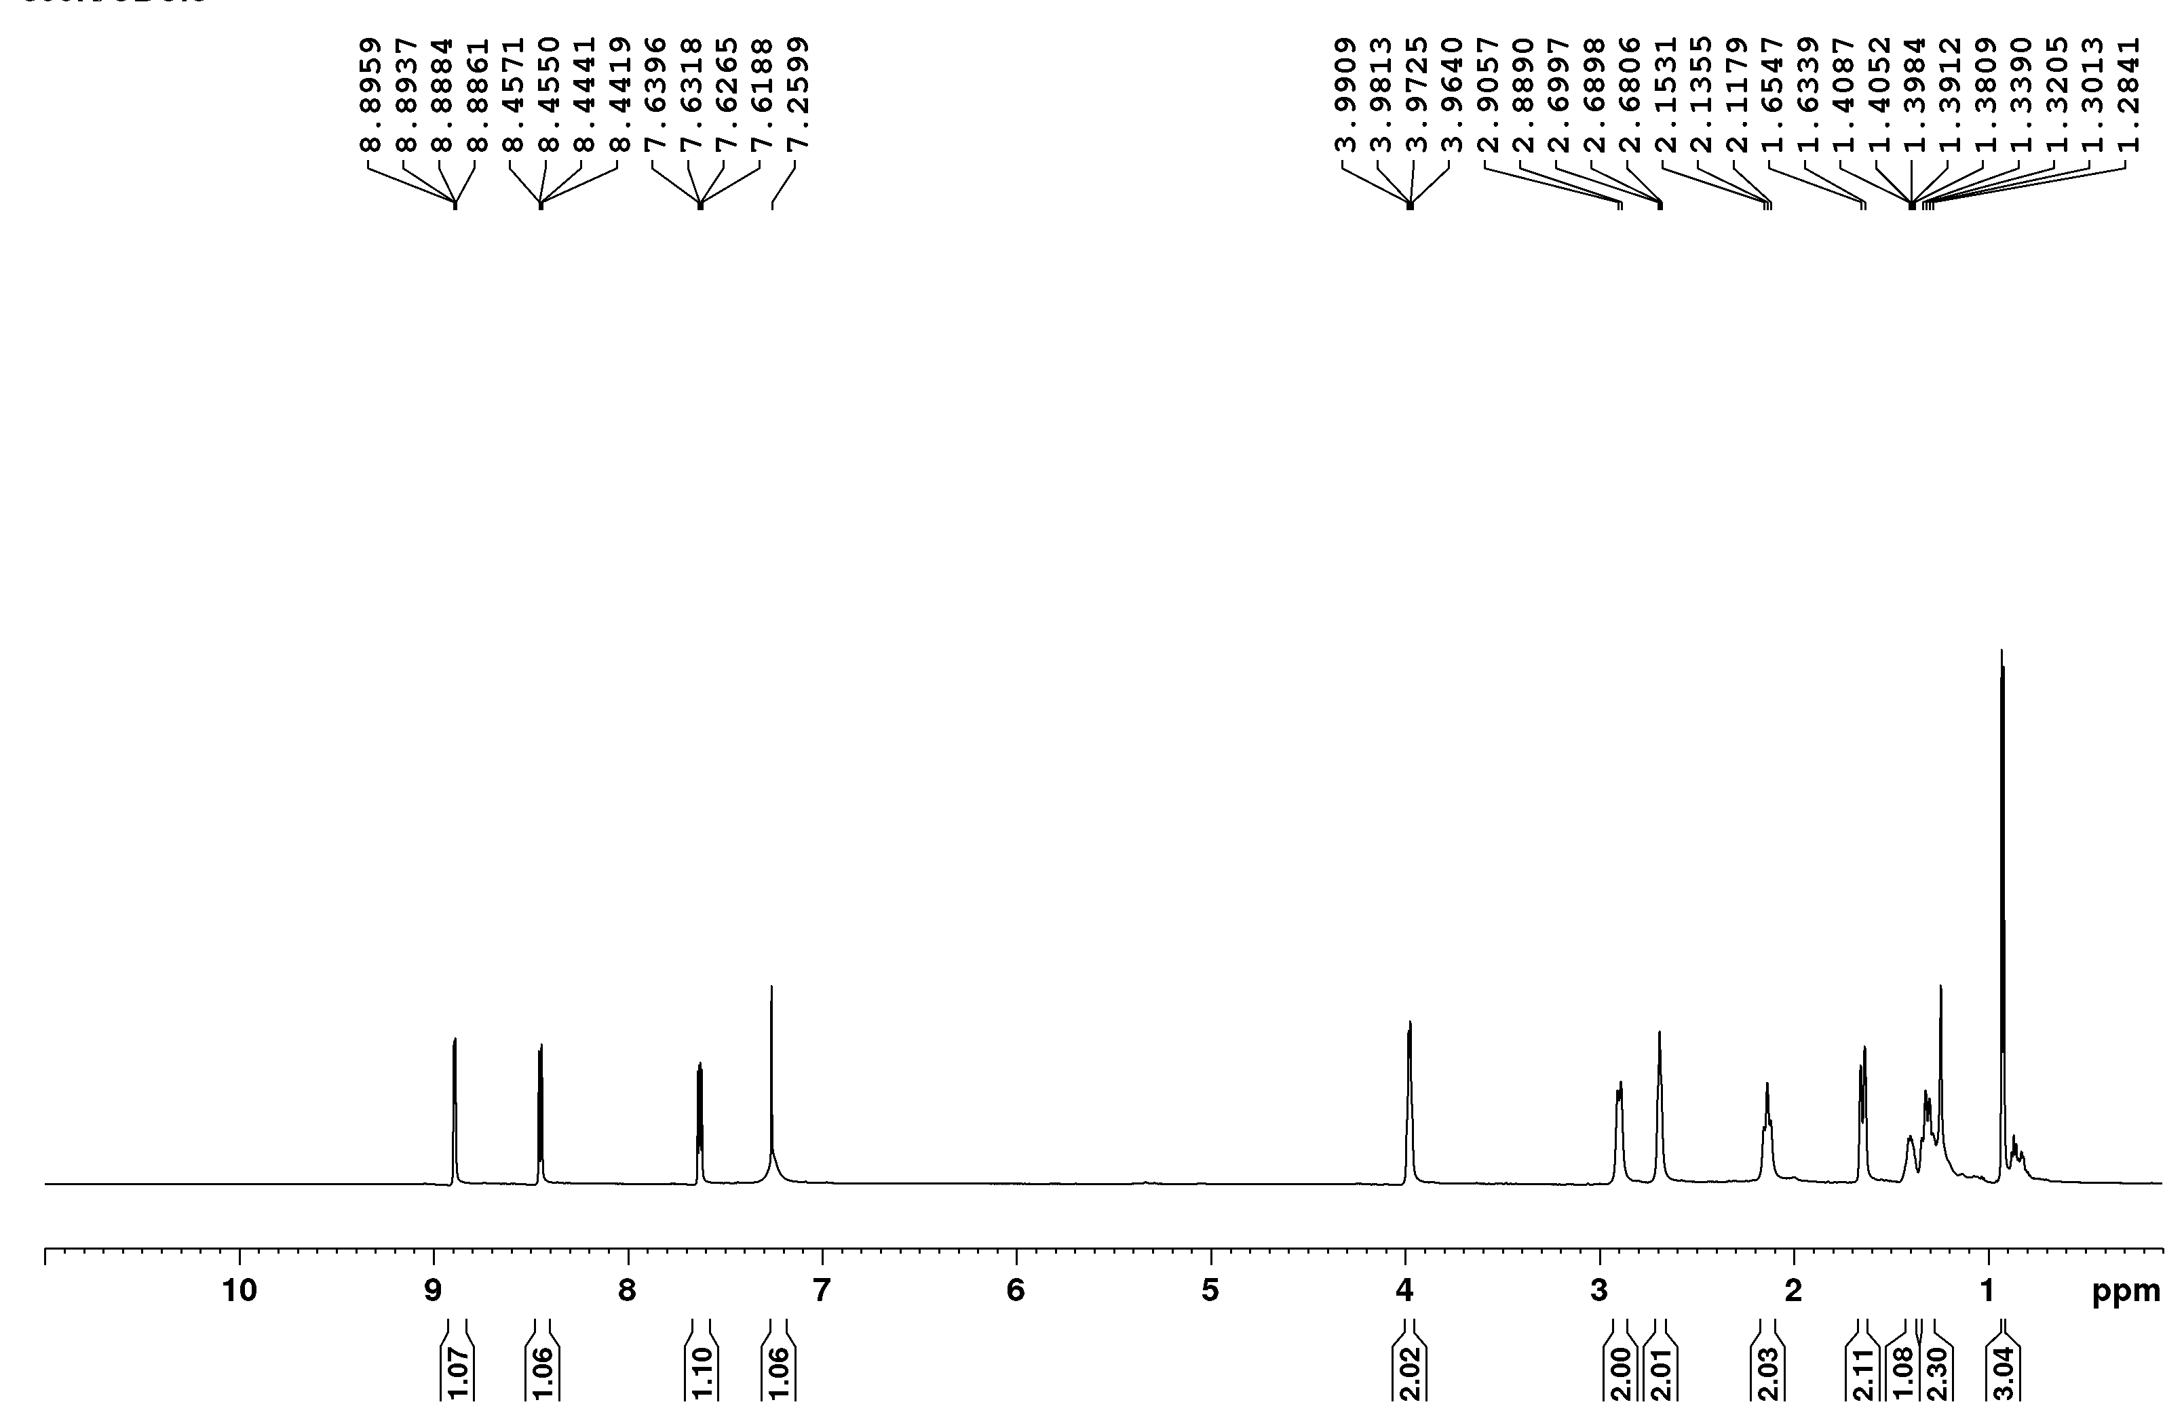
¹H-NMR spectrum of compound D3a

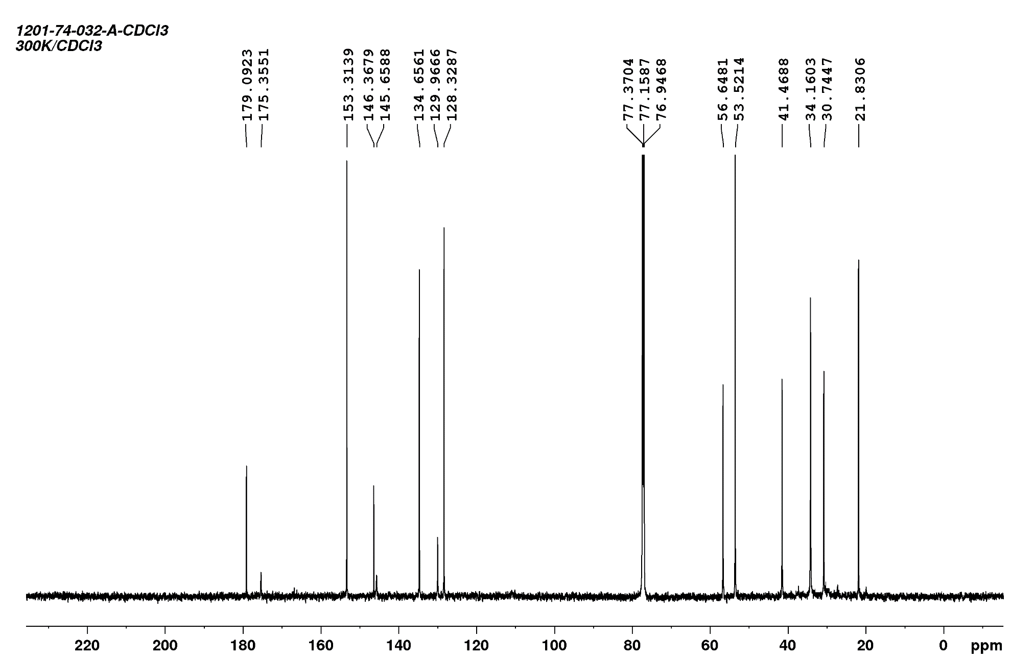
¹³C-NMR spectrum of compound D3a
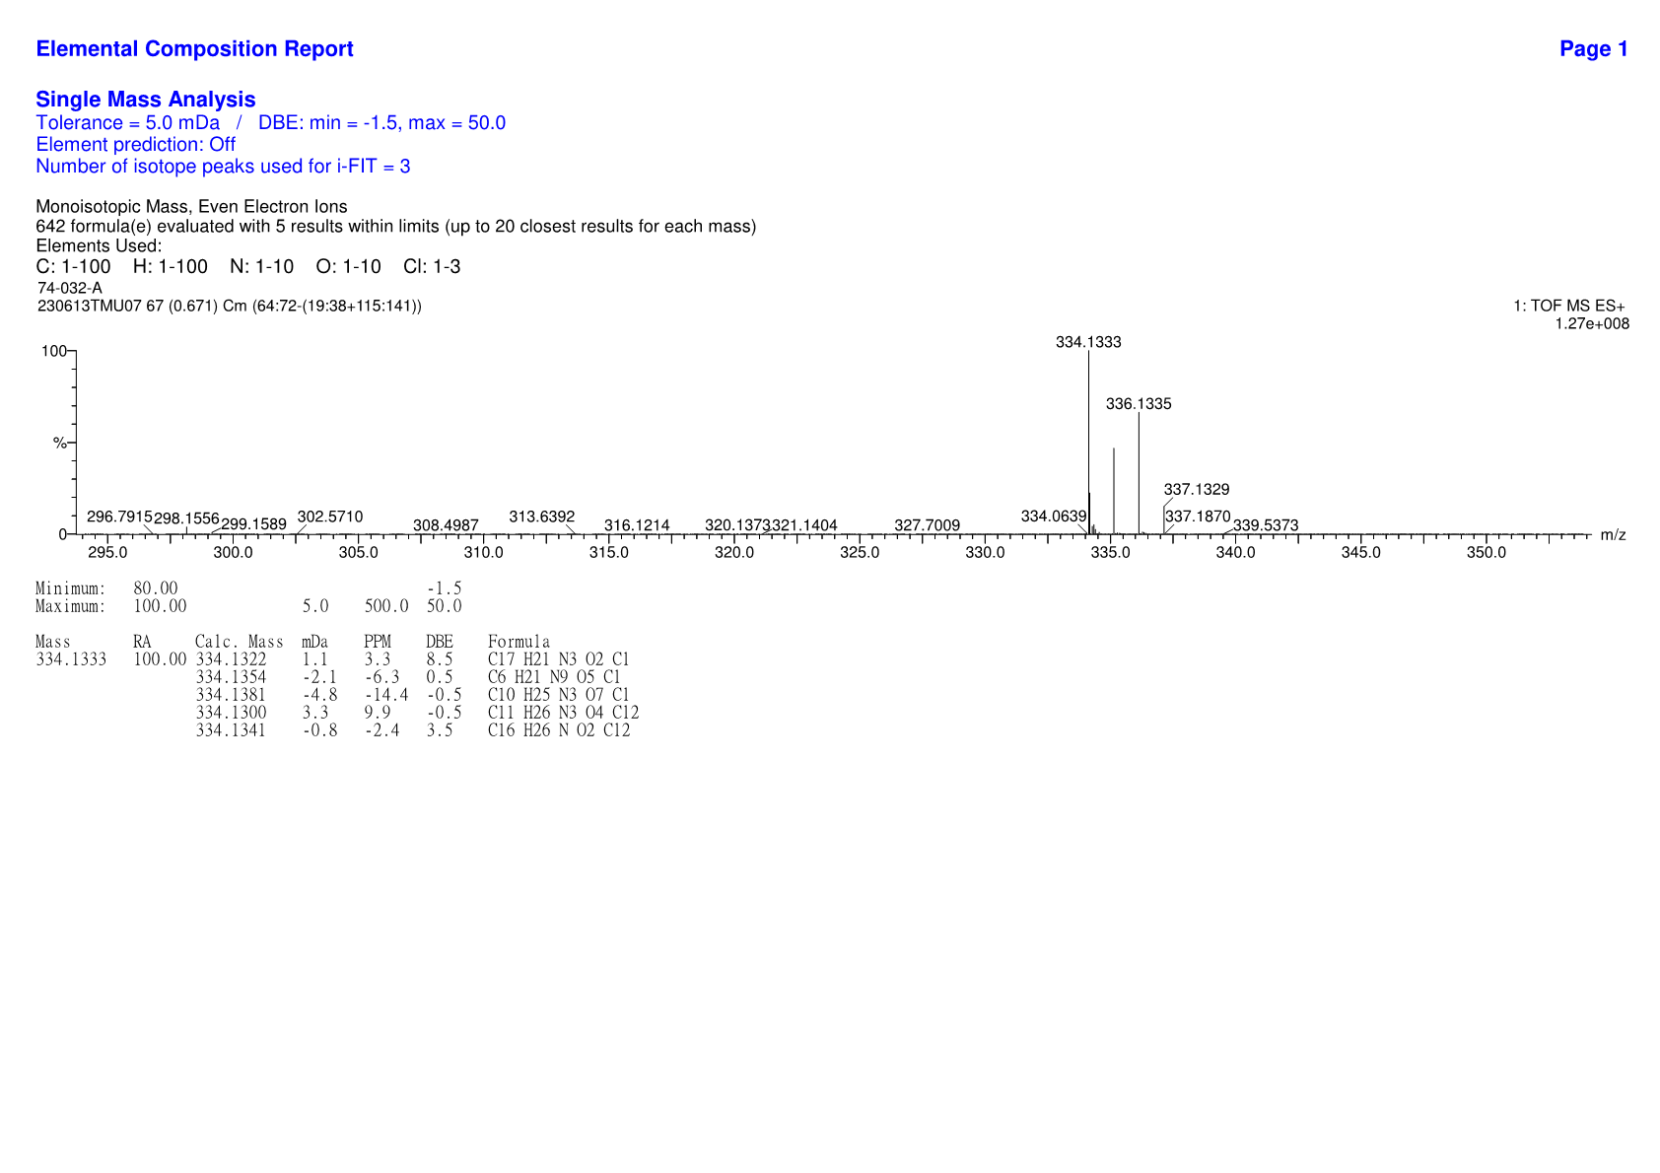
HRMS spectrum of compound D3a

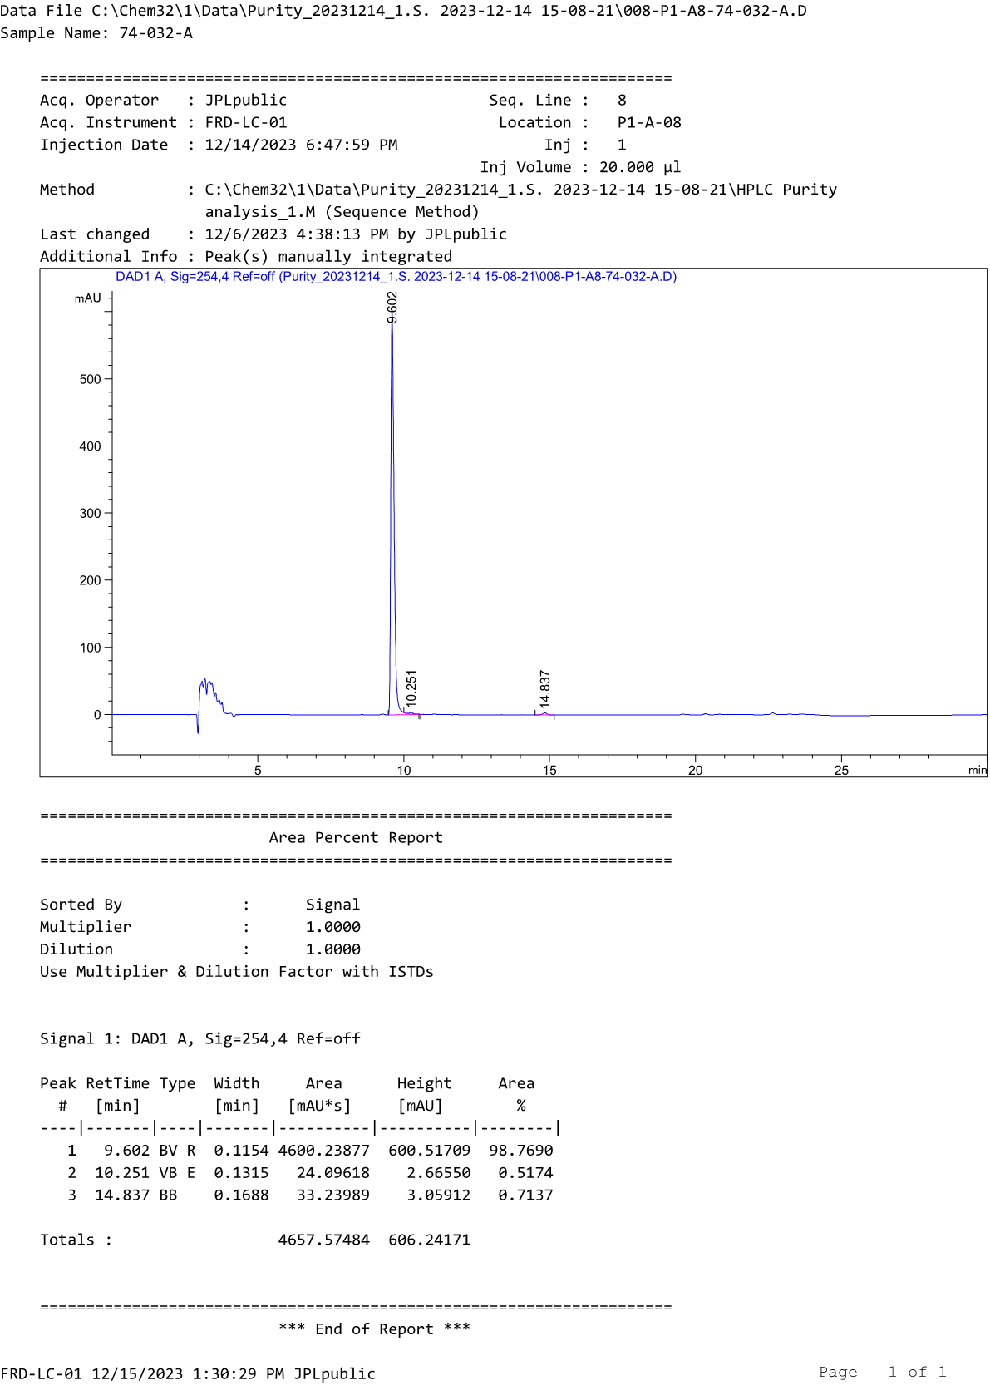
HPLC profile of compound D3a
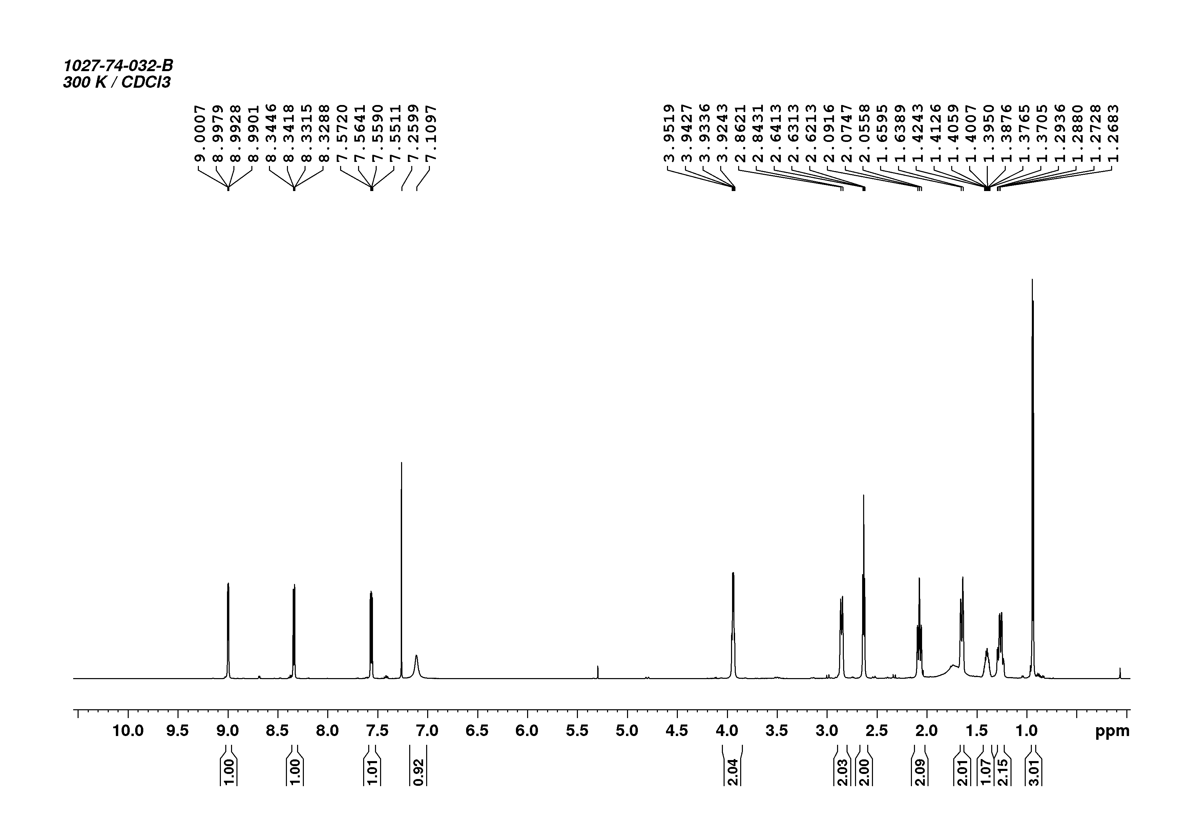
¹H-NMR spectrum of compound D3b

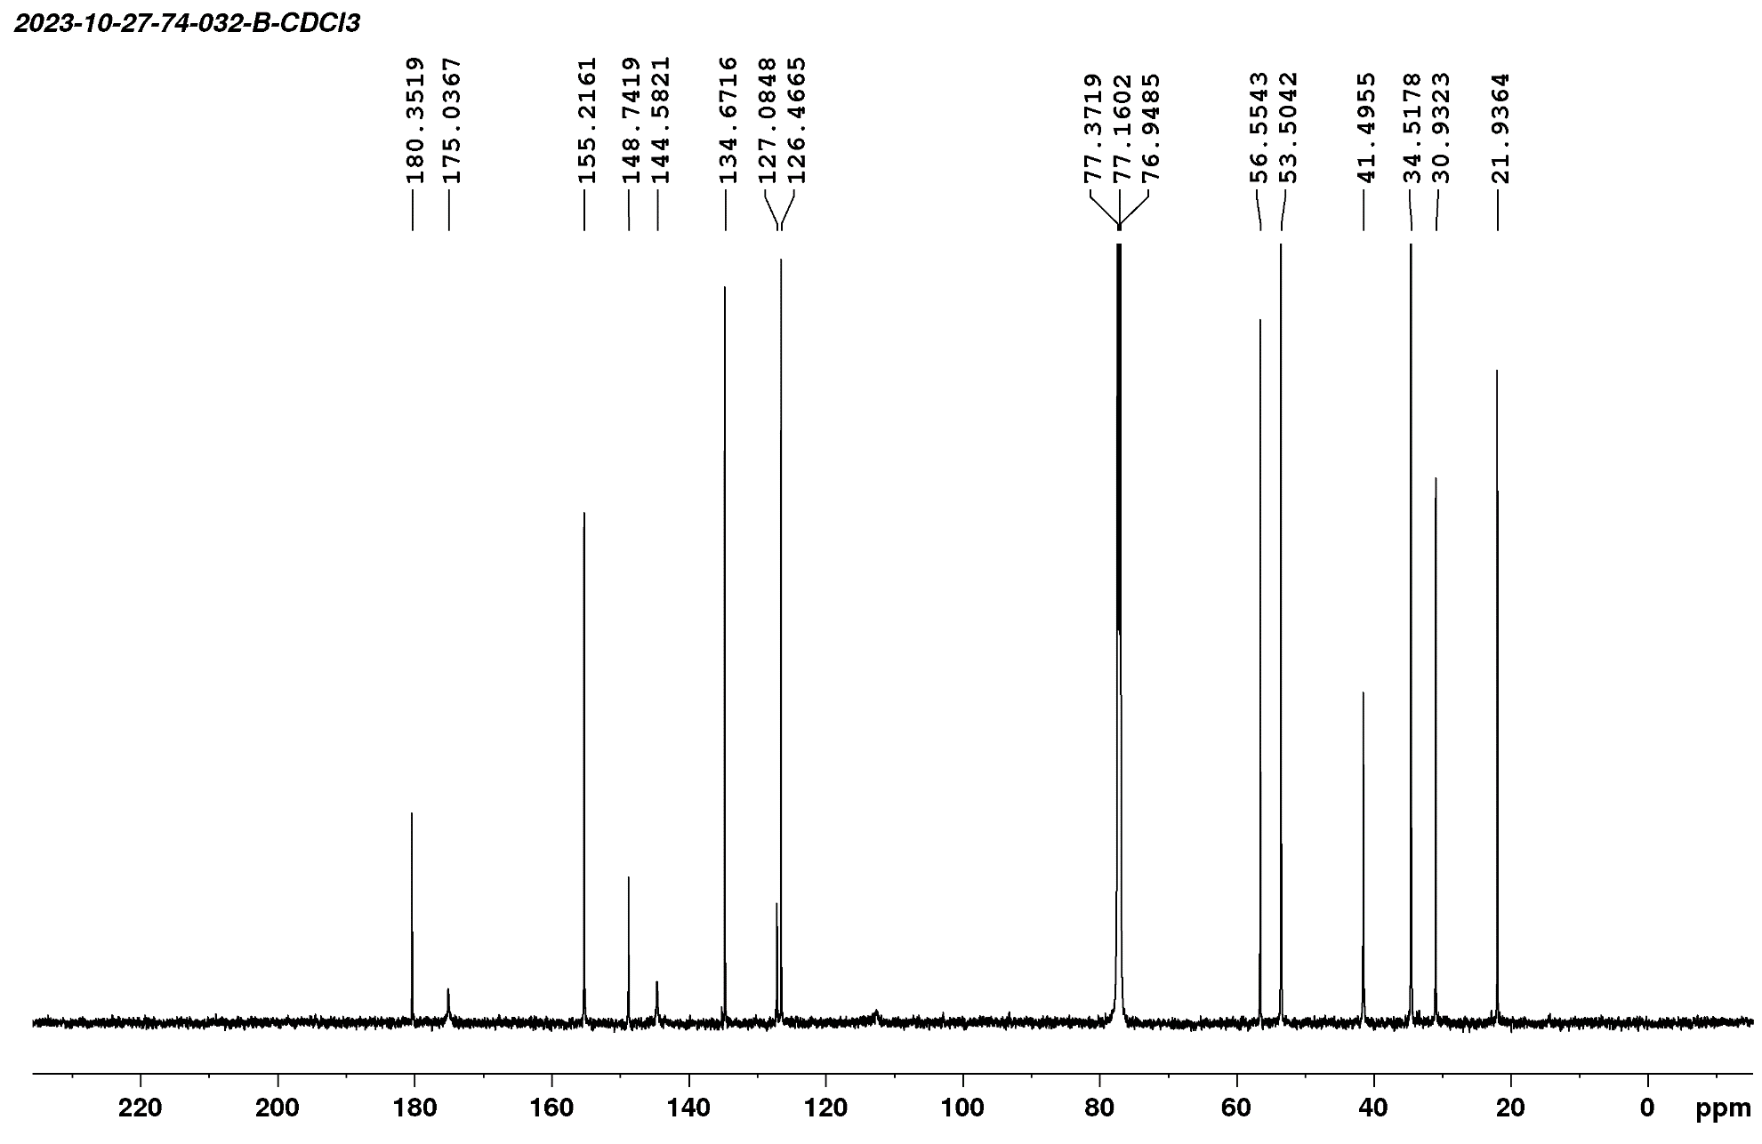
¹³C-NMR spectrum of compound D3b
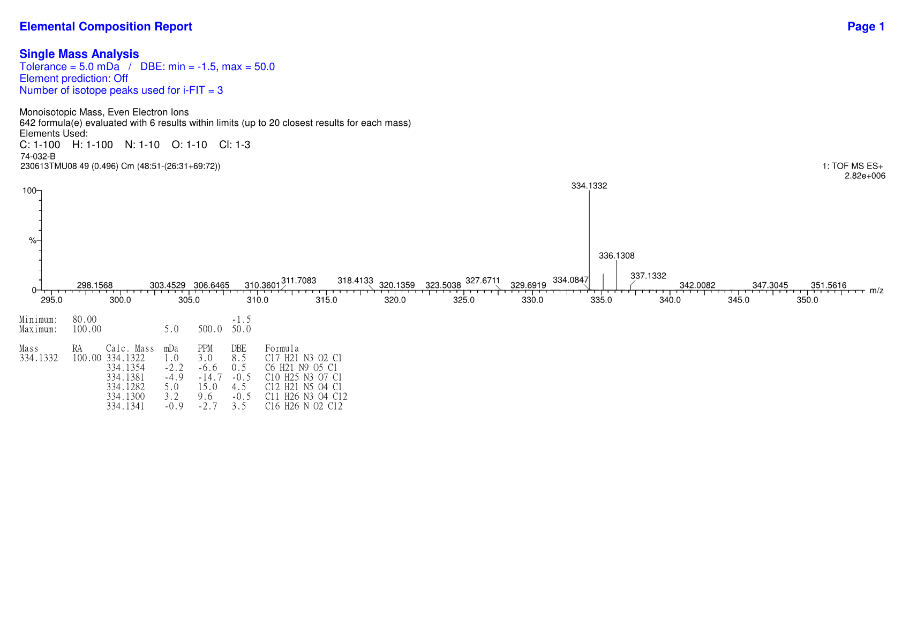
HRMS spectrum of compound D3b

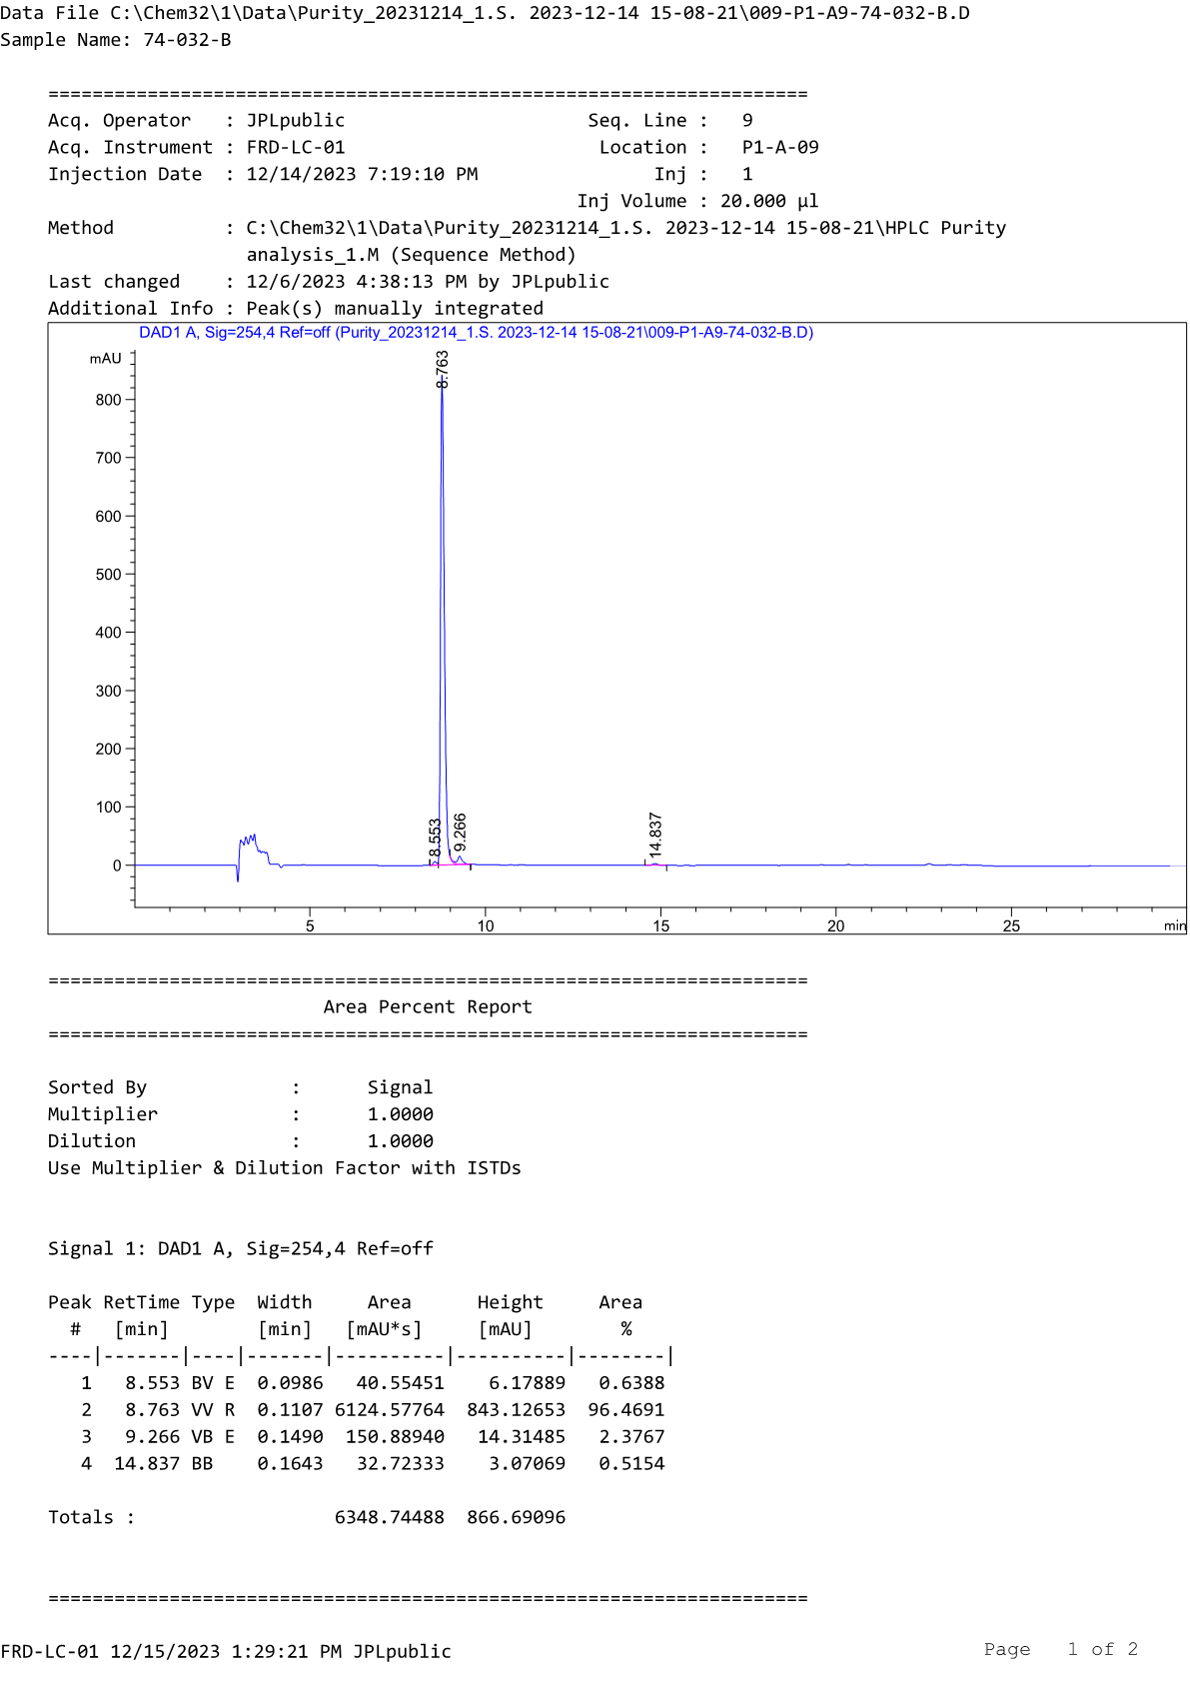
HPLC profile of compound D3b
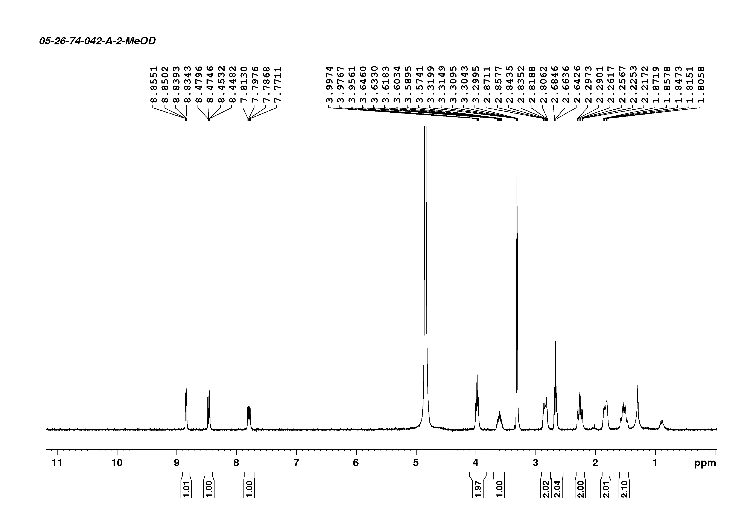
¹H-NMR spectrum of compound D4a

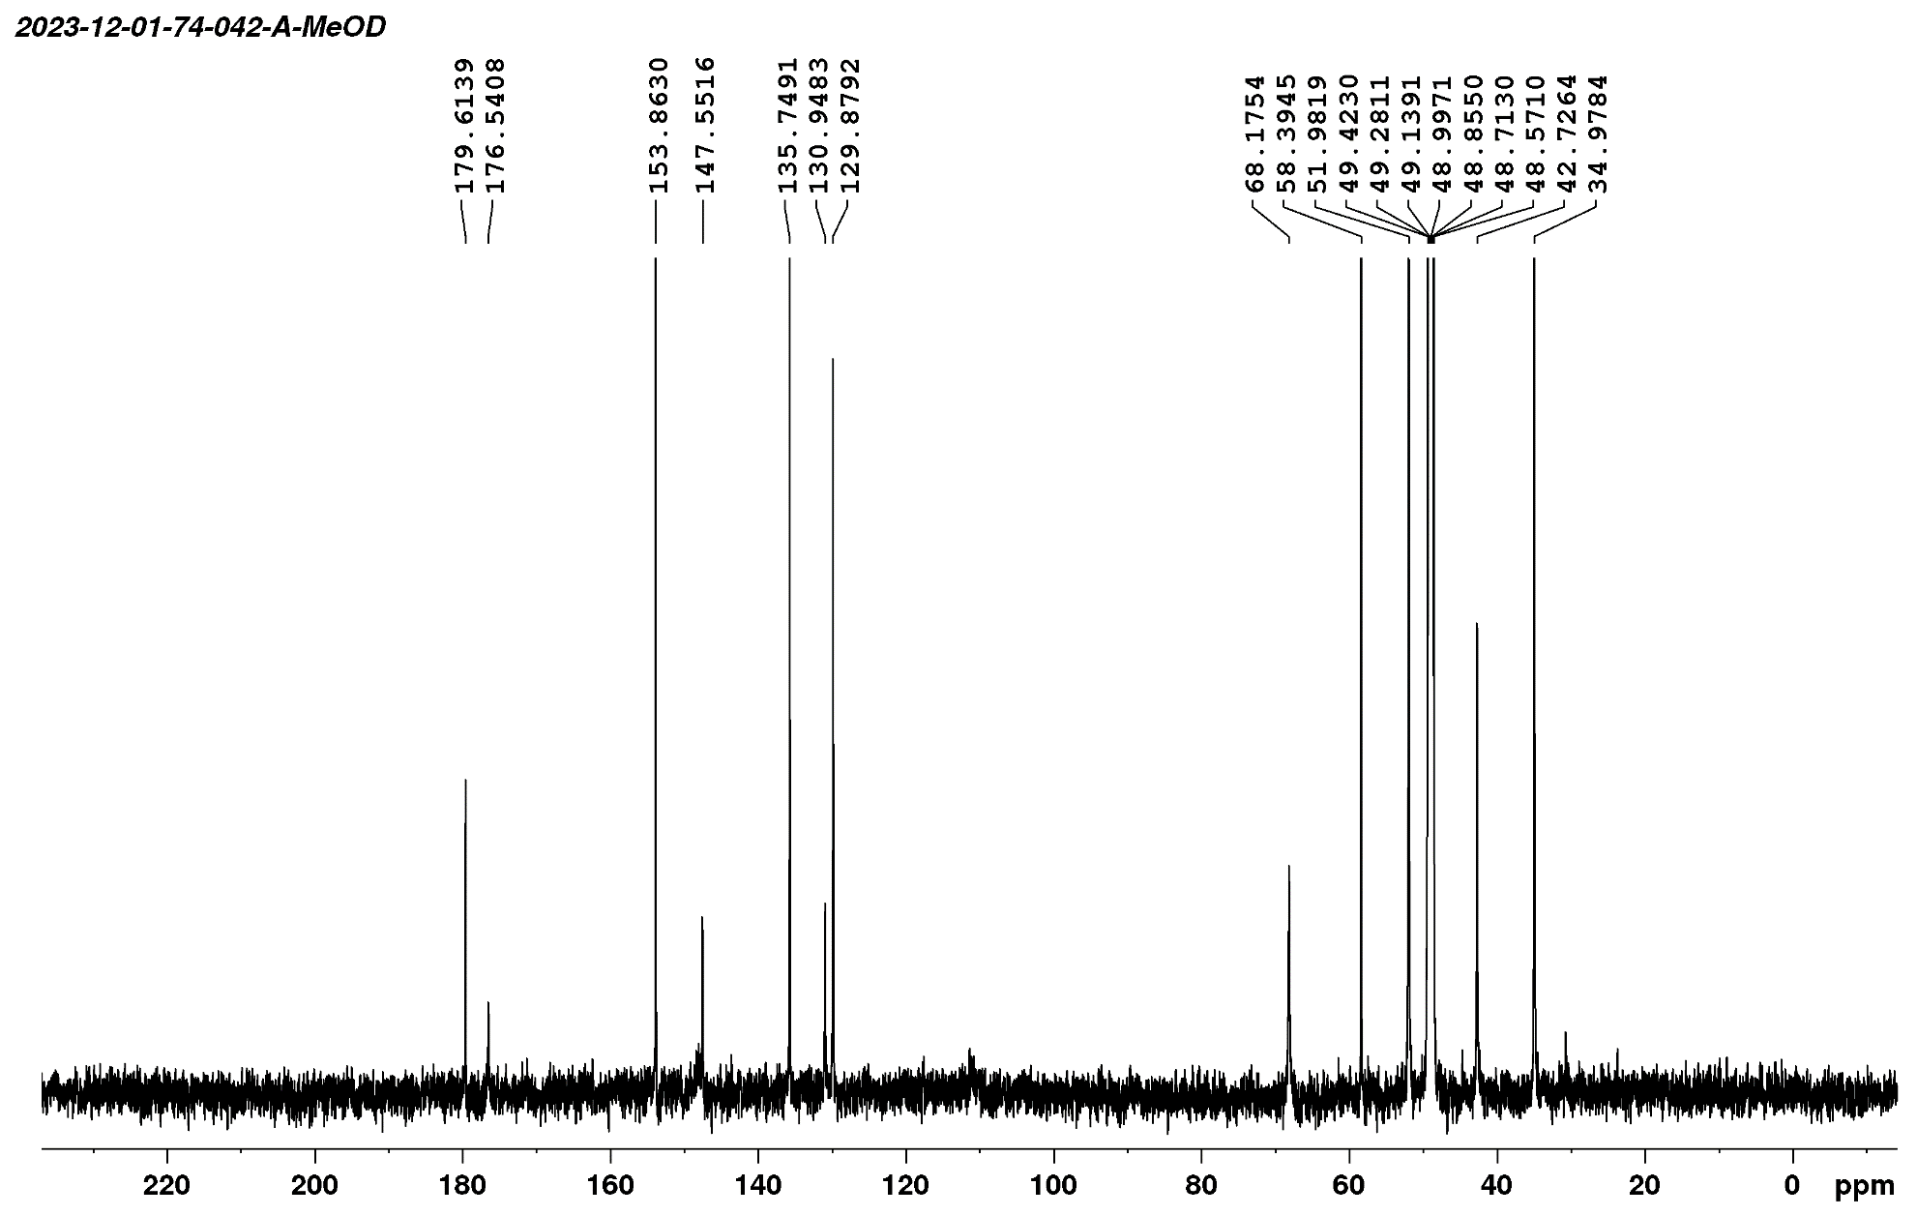
¹³C-NMR spectrum of compound D4a
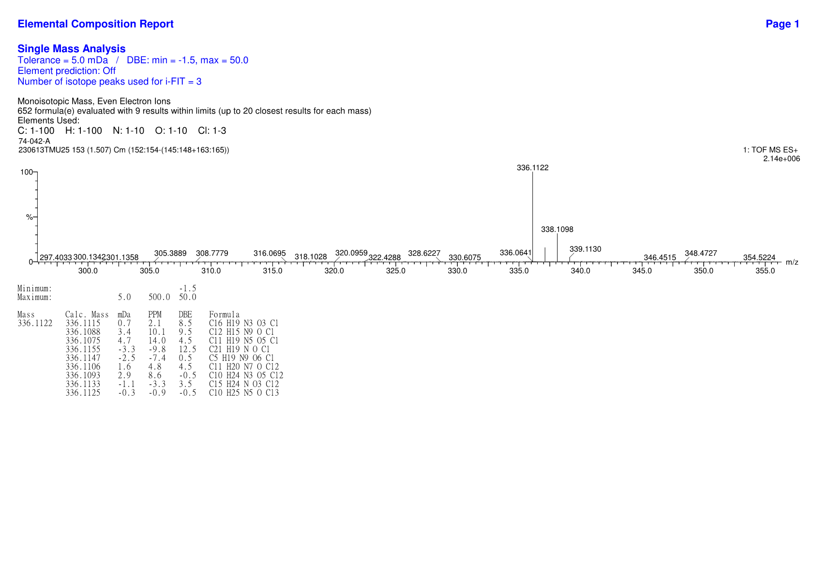
HRMS spectrum of compound D4a

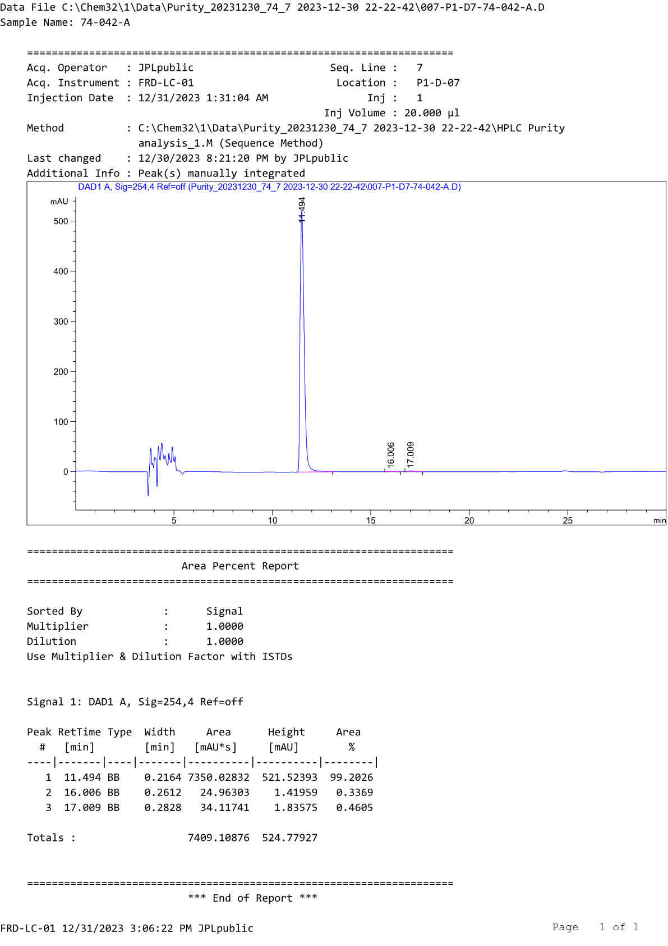
HPLC profile of compound D4a
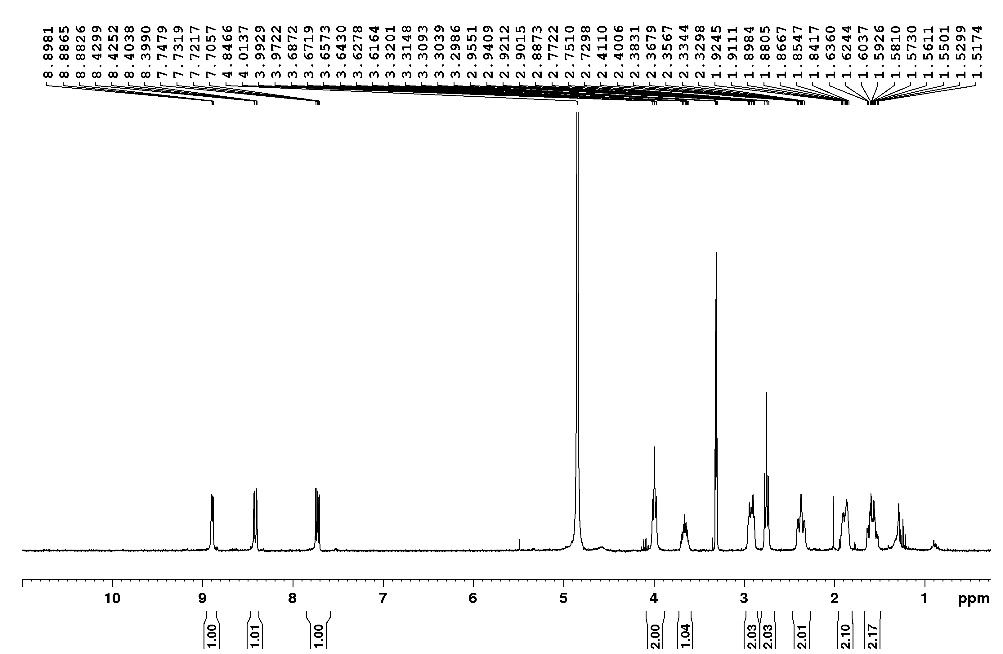
¹H-NMR spectrum of compound D4b

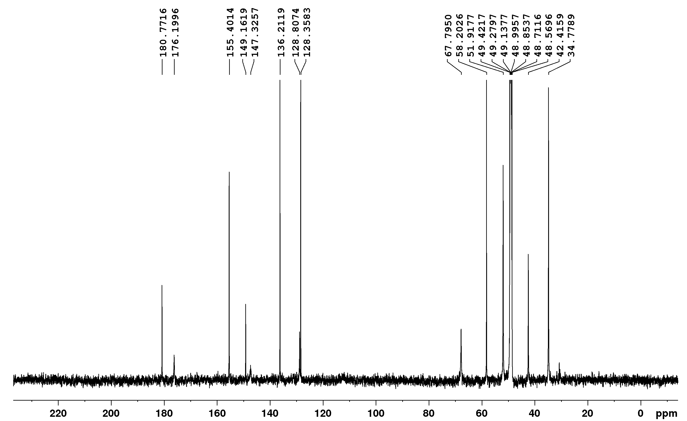
¹³C-NMR spectrum of compound D4b
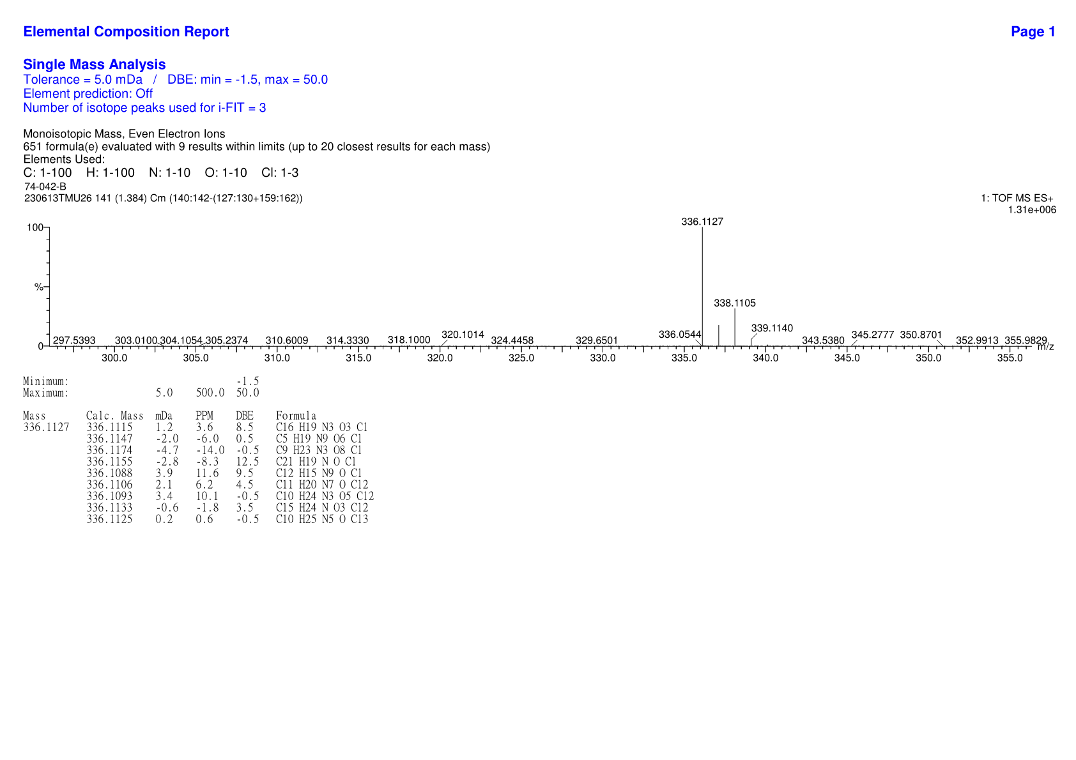
HRMS spectrum of compound D4b

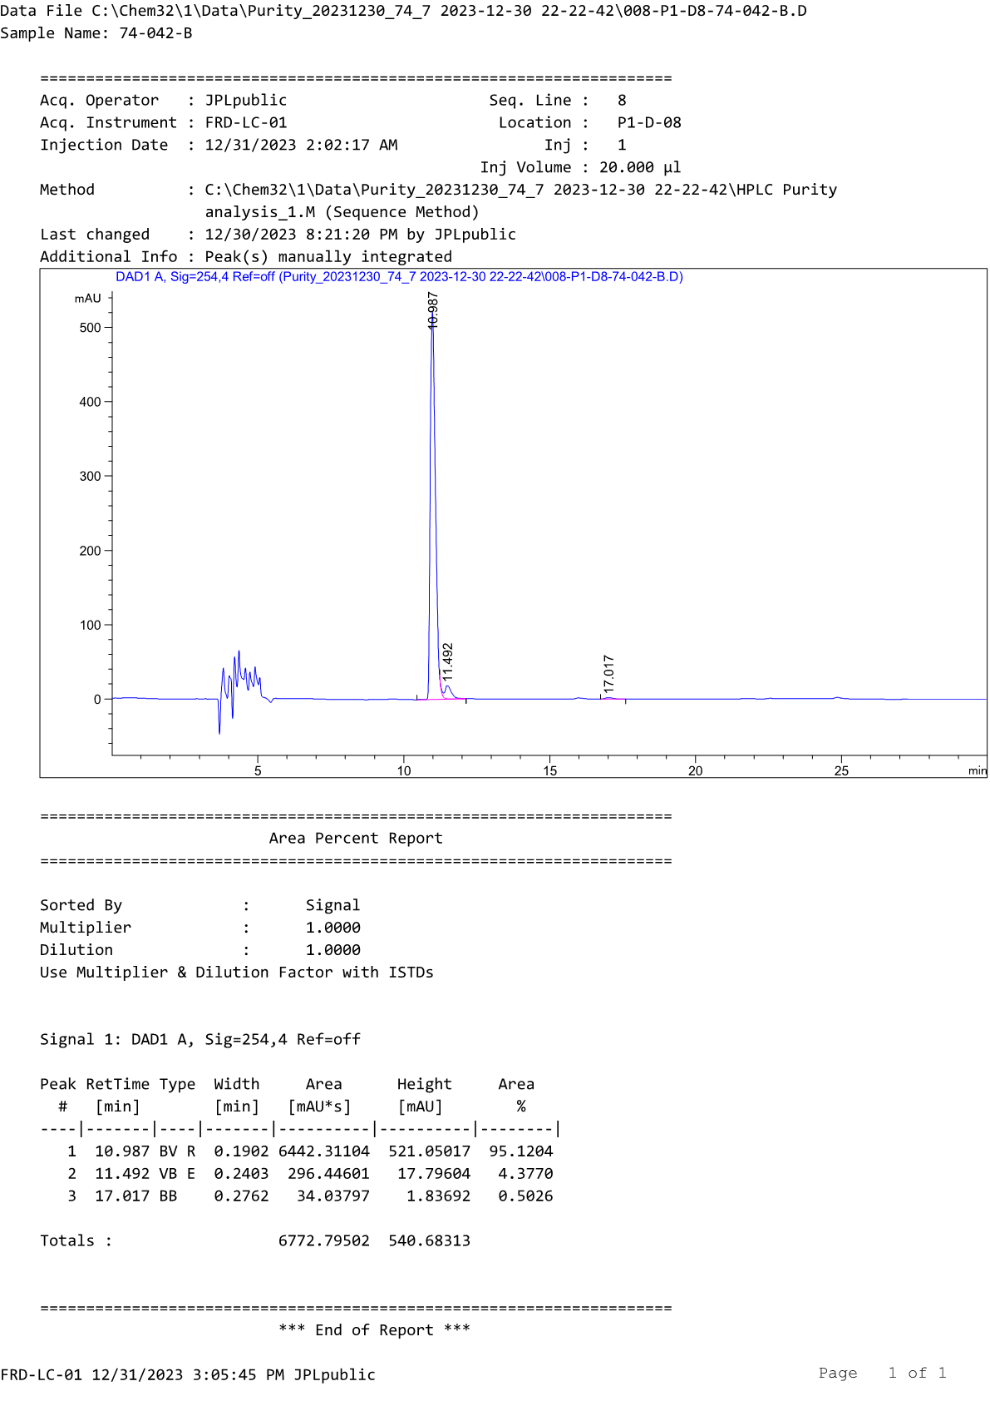
HPLC profile of compound D4b
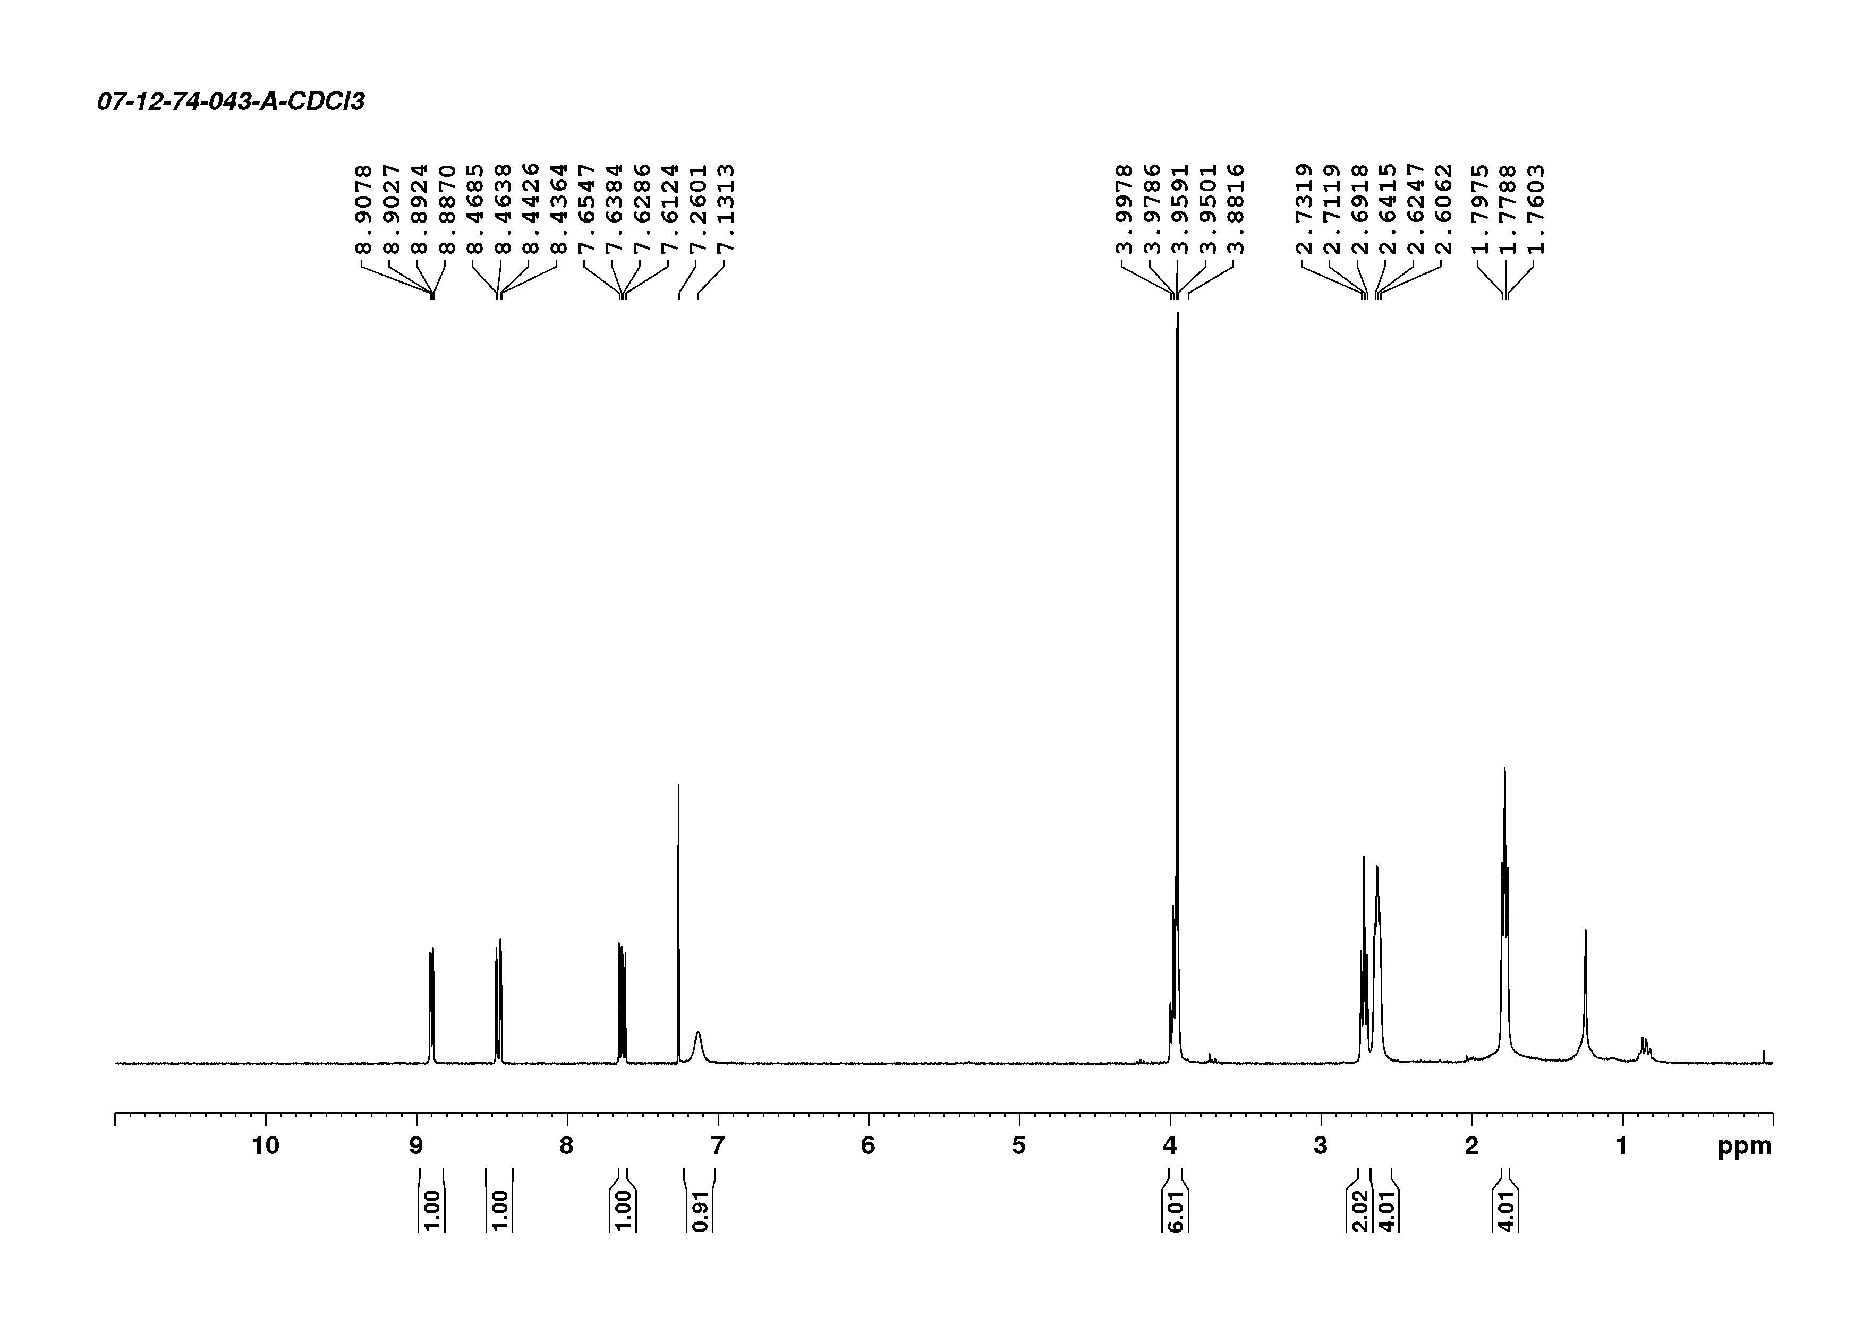
¹H-NMR spectrum of compound D5a

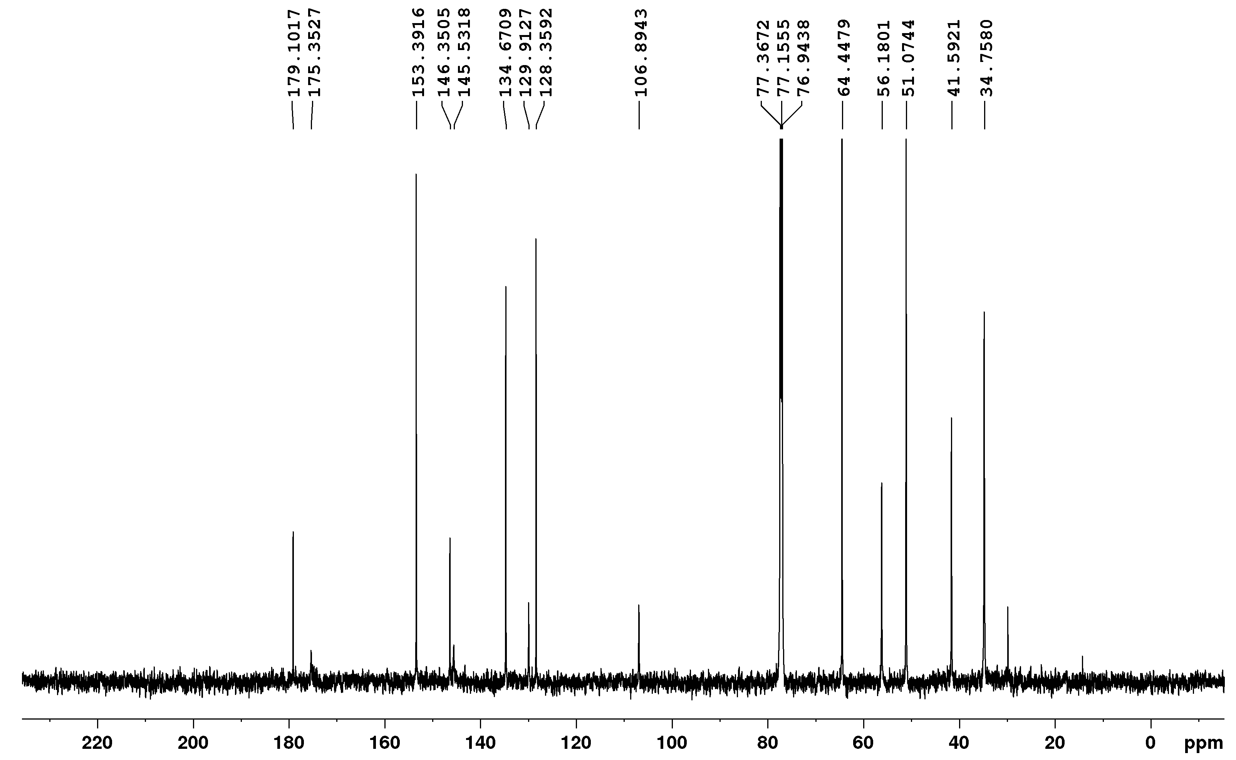
¹³C-NMR spectrum of compound D5a
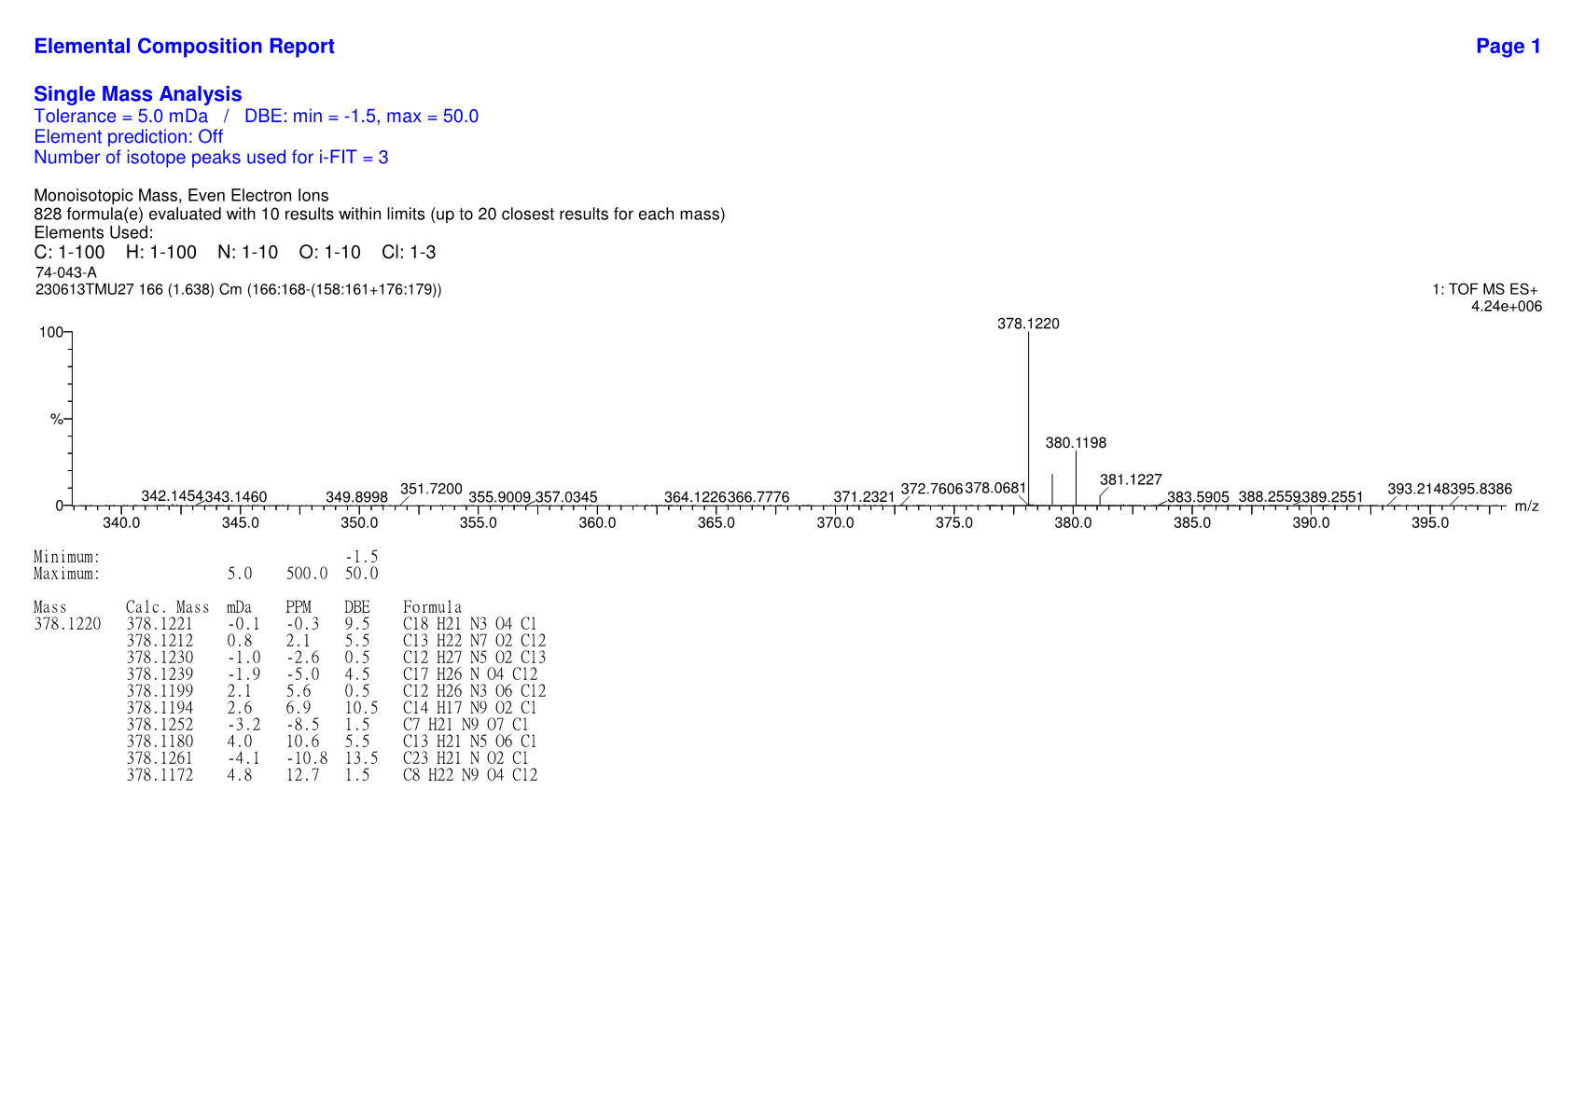
HRMS spectrum of compound D5a

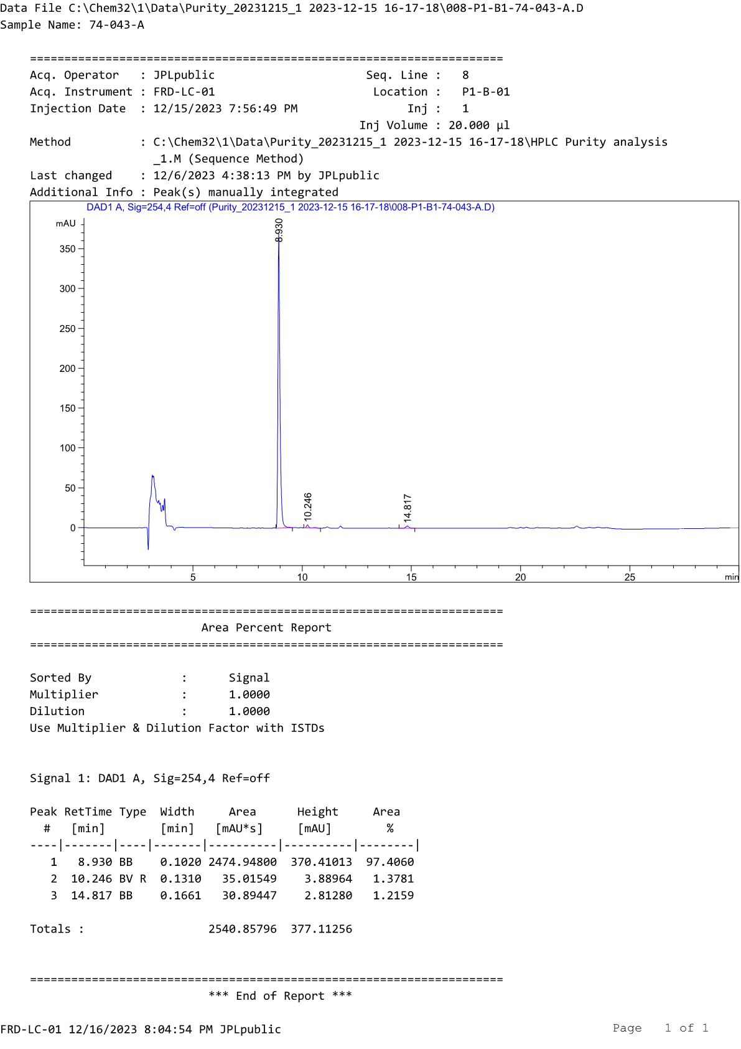
HPLC profile of compound D5a
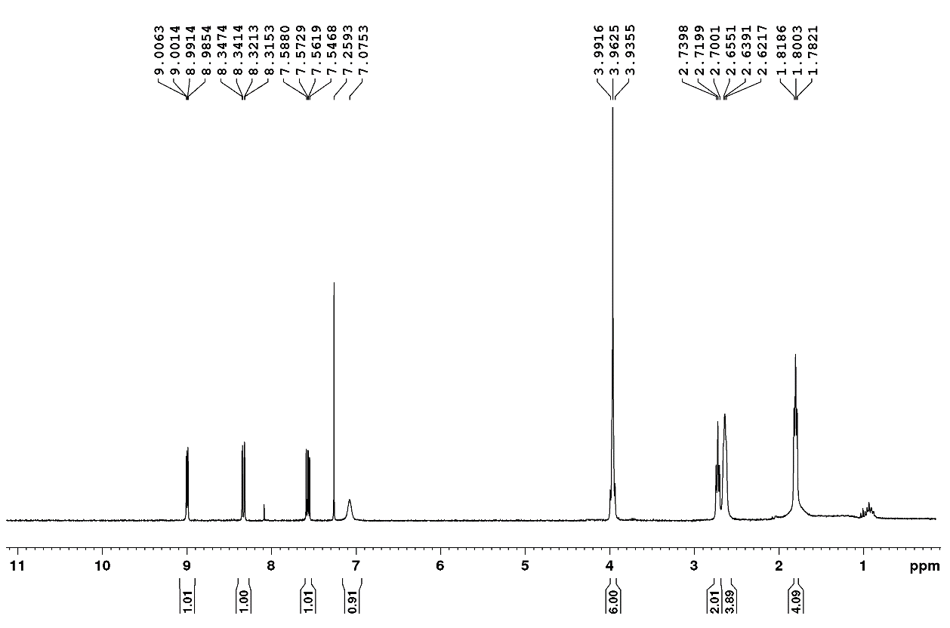
¹H-NMR spectrum of compound D5b

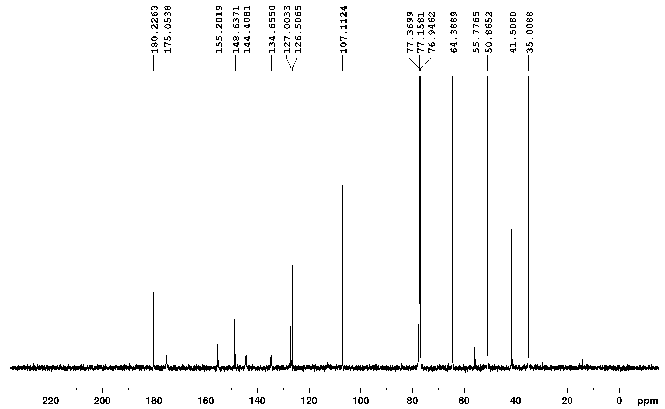
¹³C-NMR spectrum of compound D5b
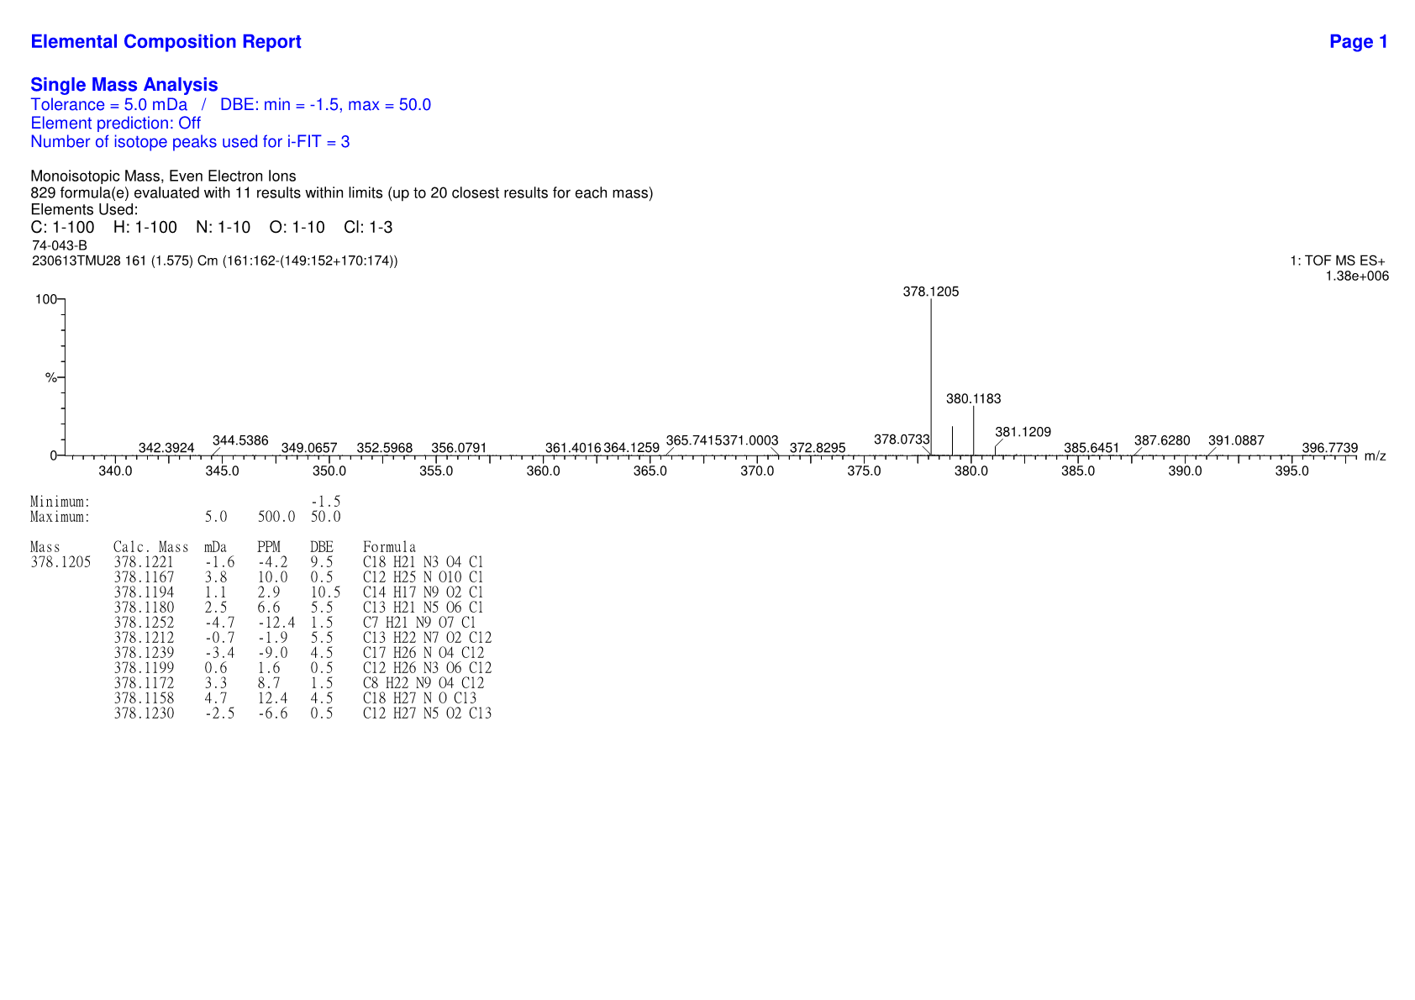
HRMS spectrum of compound D5b

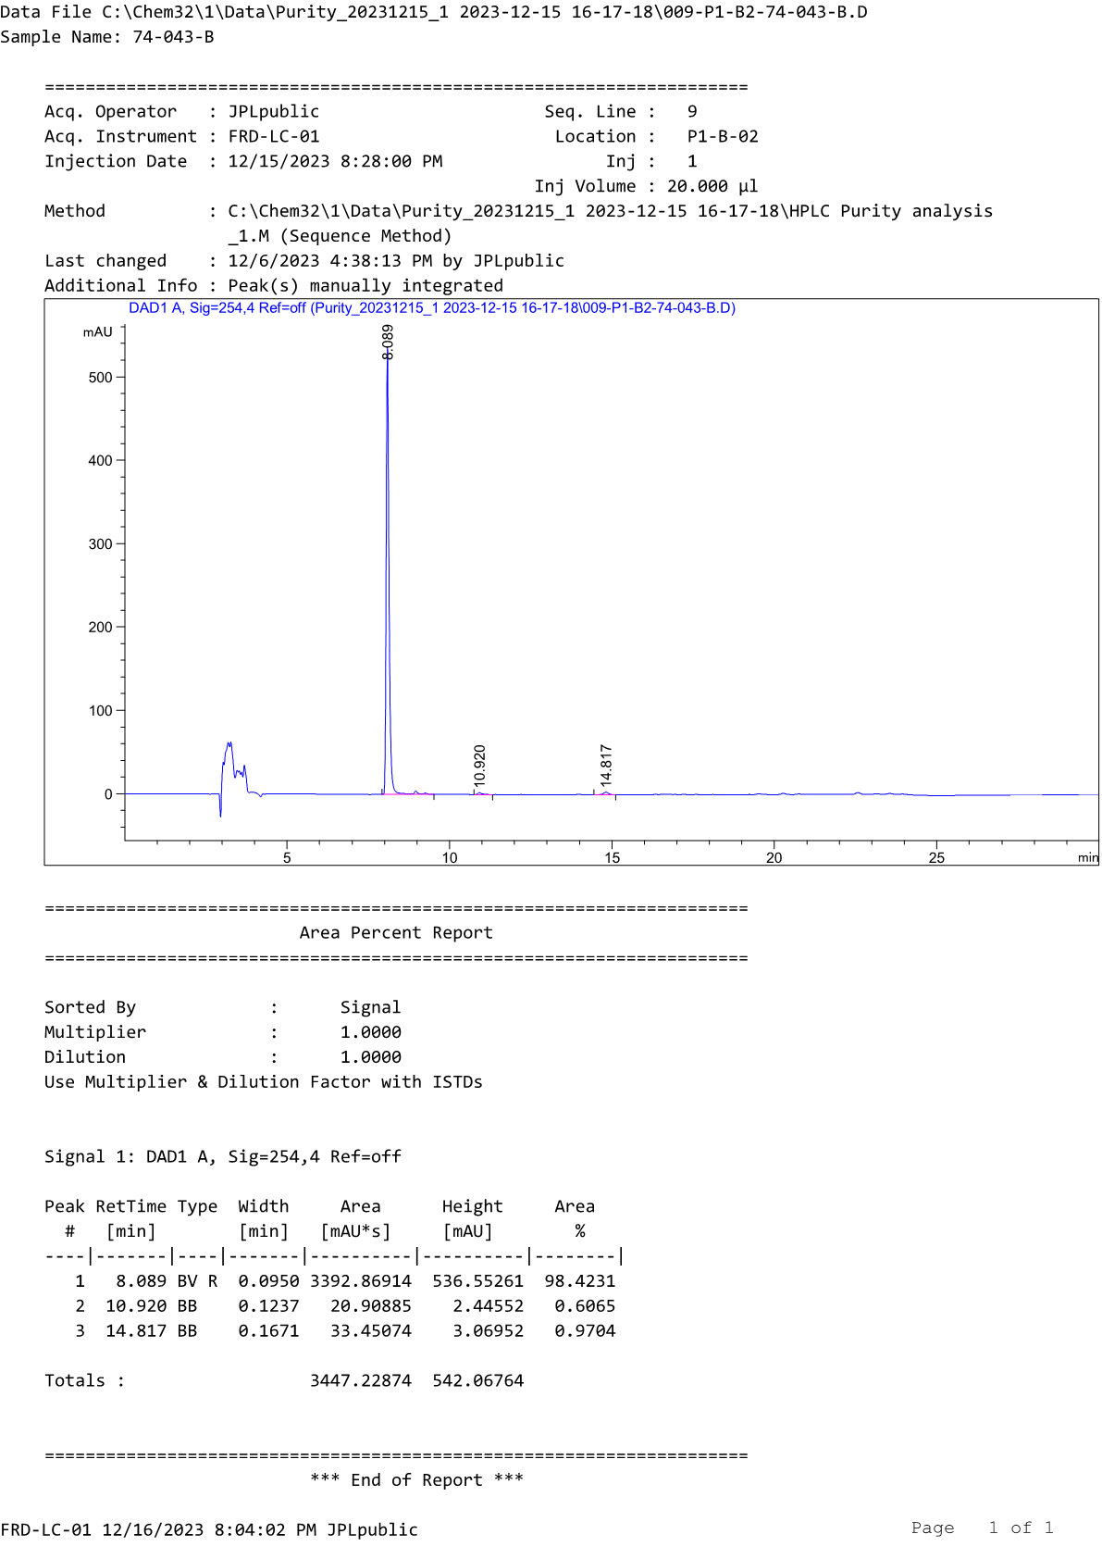
HPLC profile of compound D5b
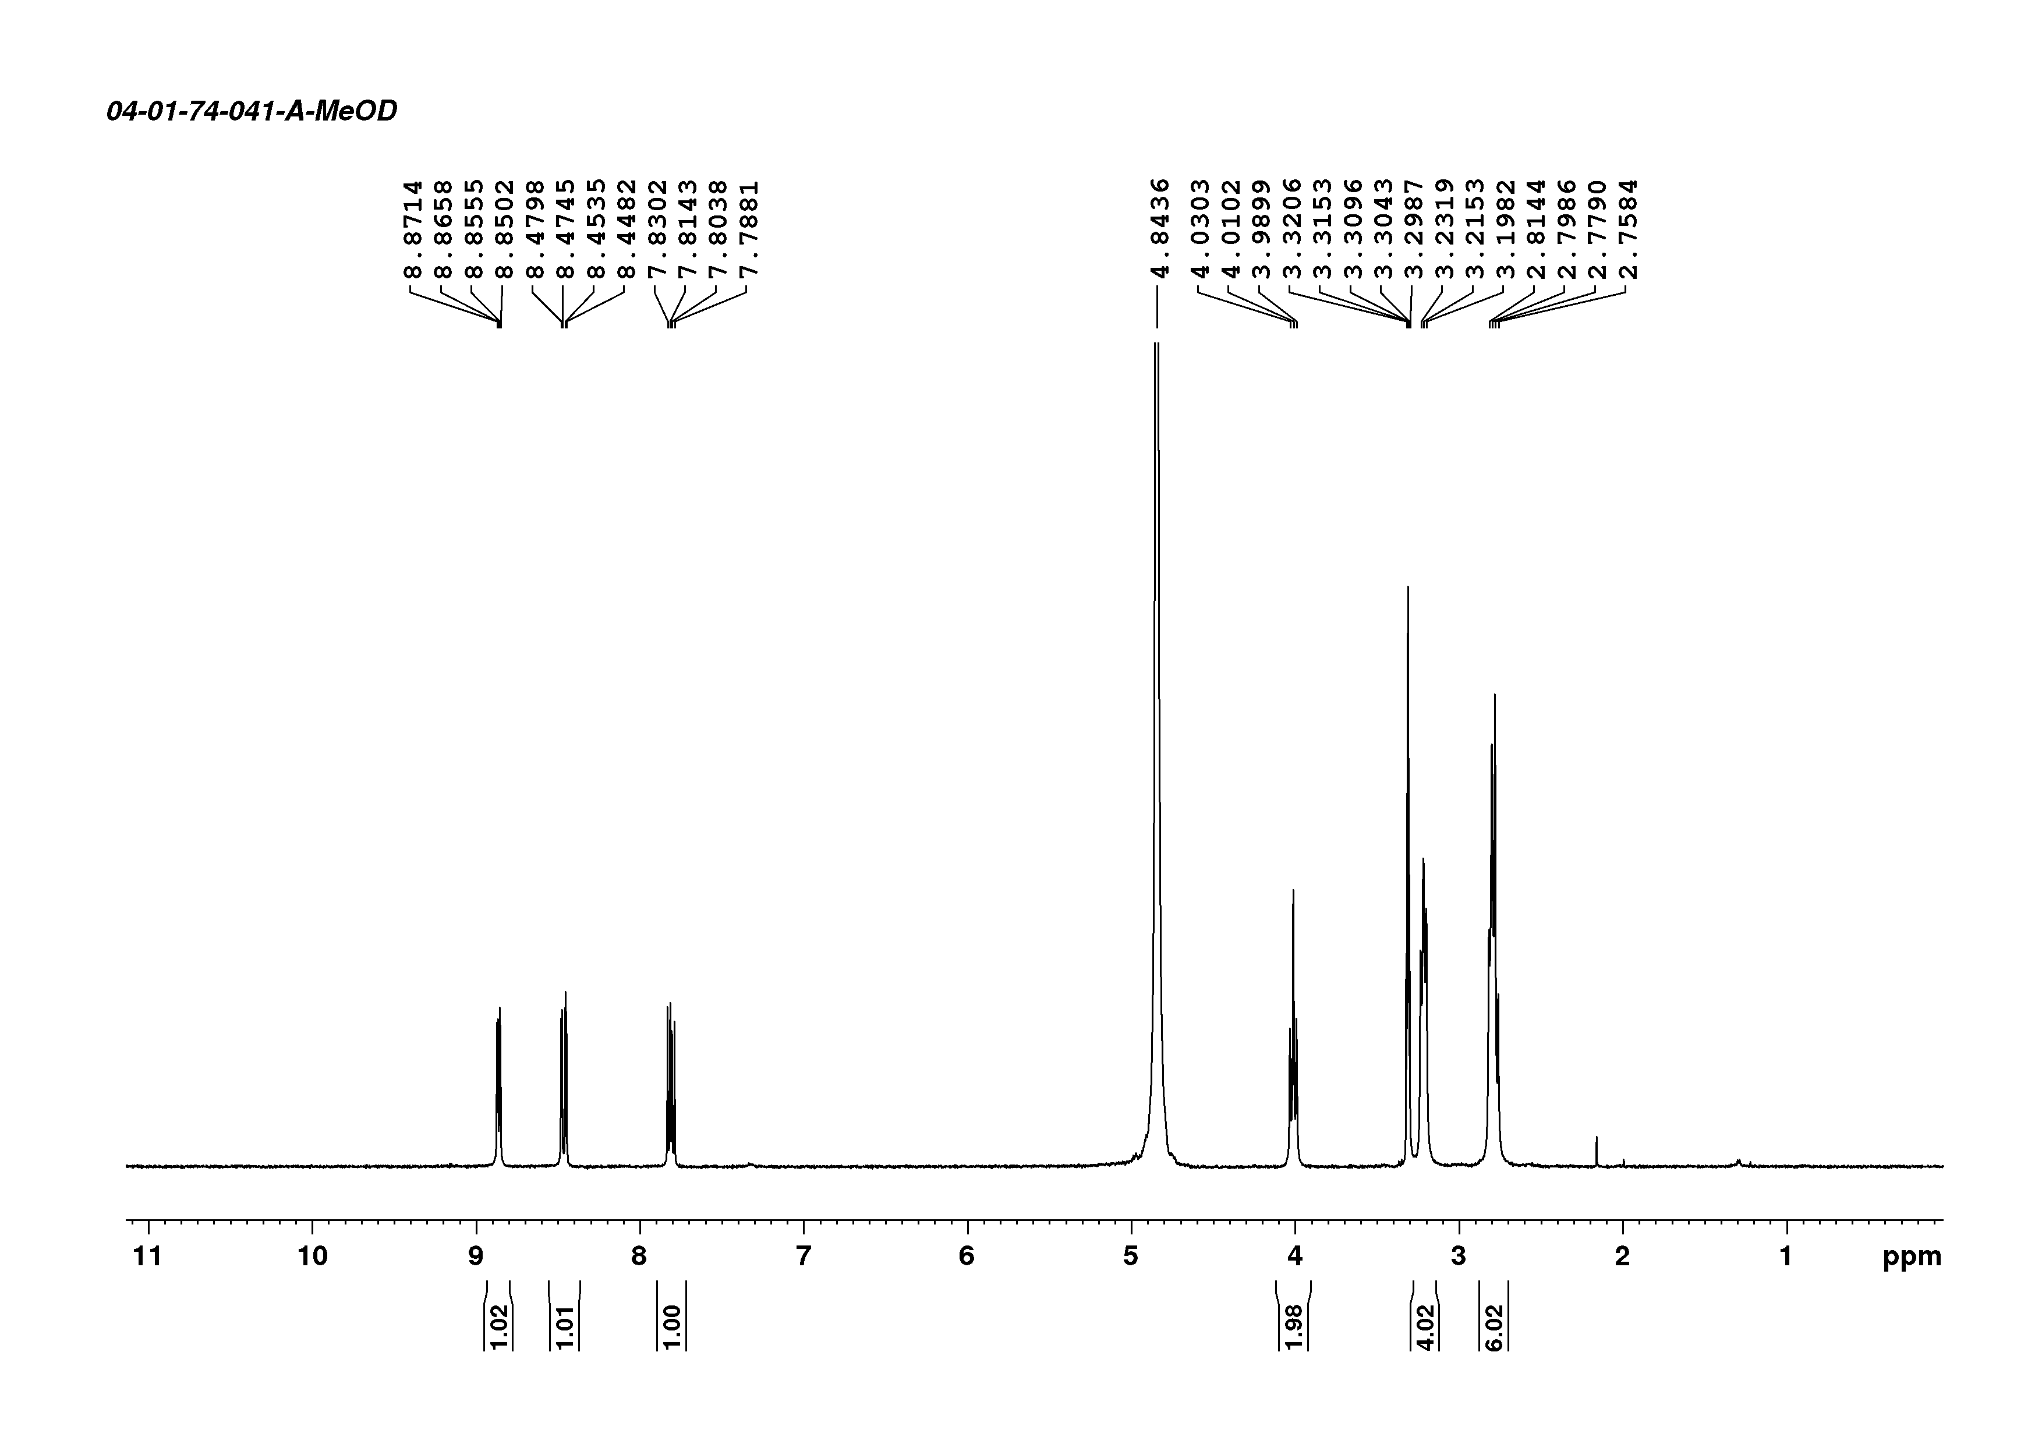
¹H-NMR spectrum of compound D6a

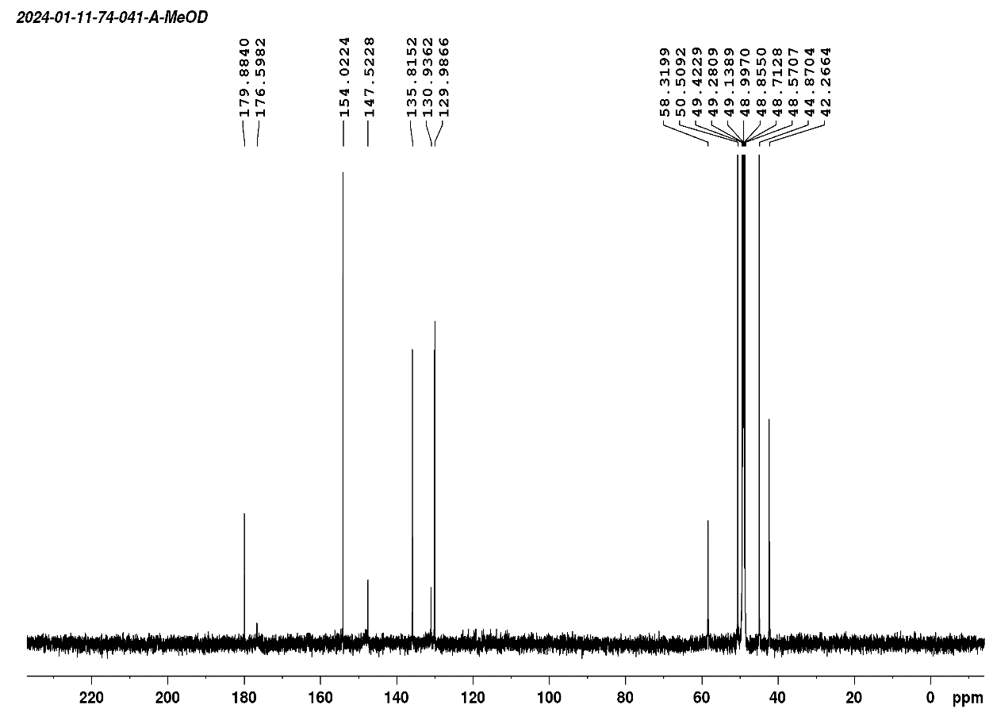
¹³C-NMR spectrum of compound D6a
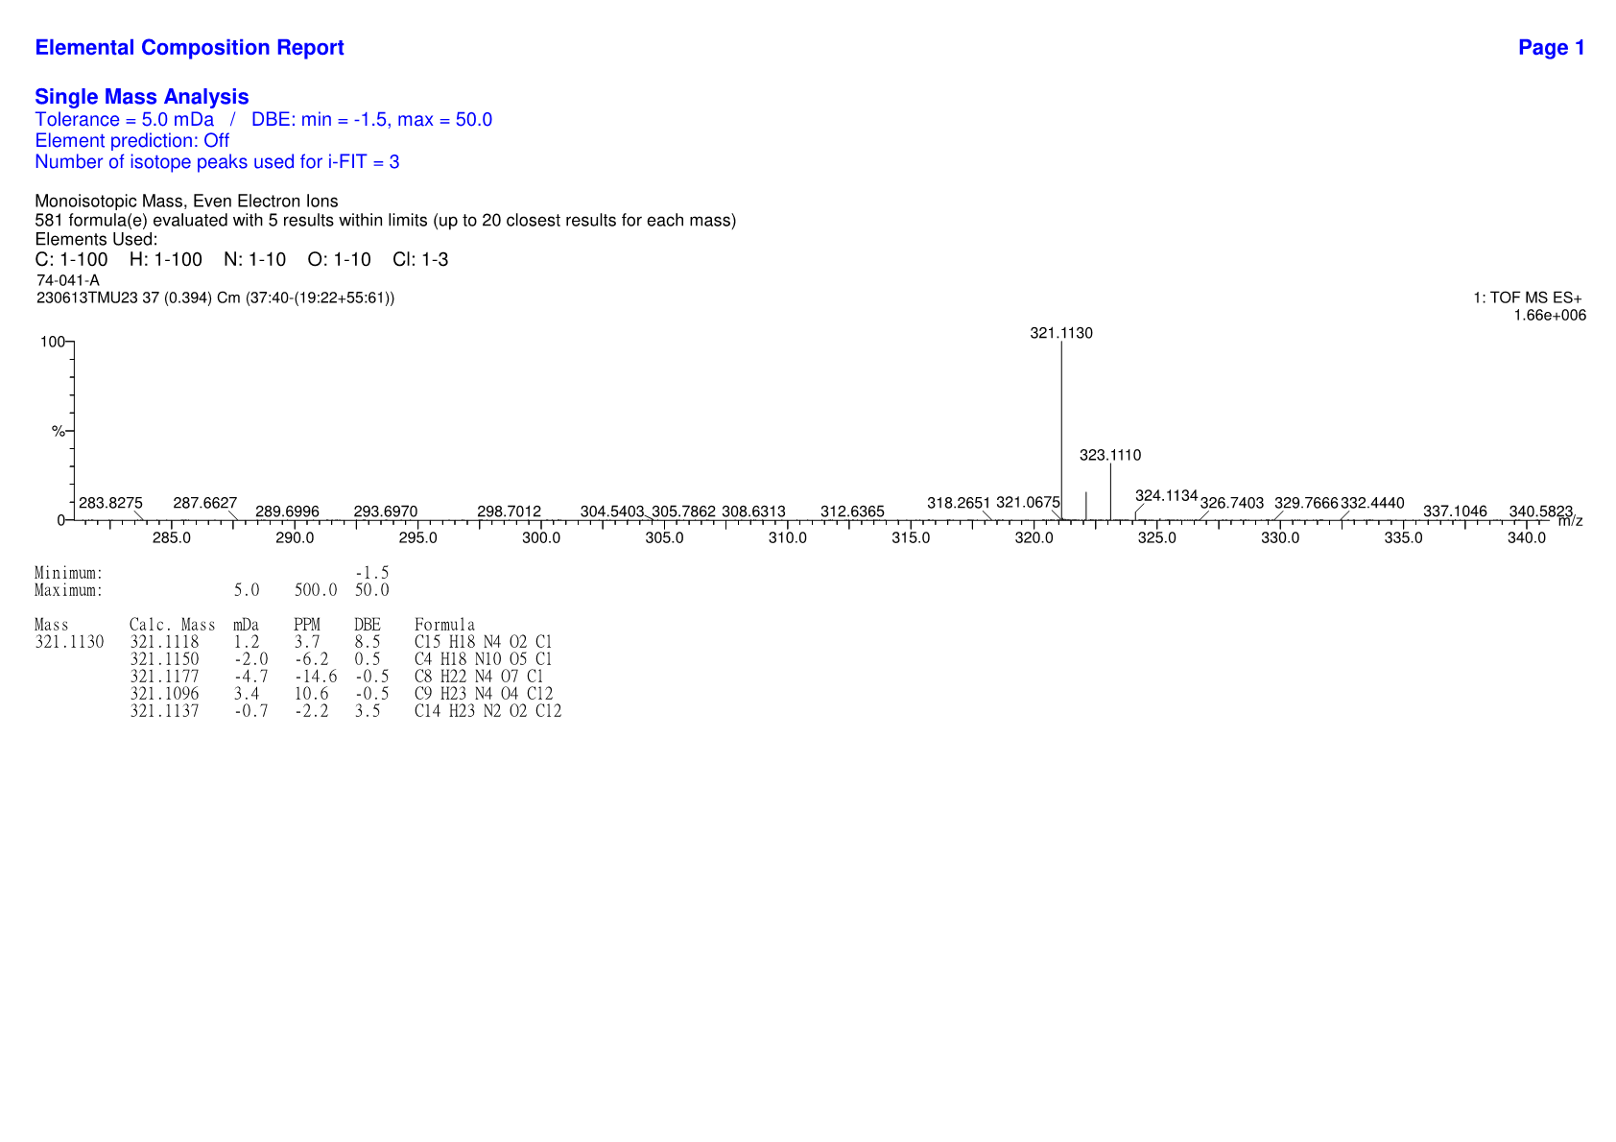
HRMS spectrum of compound D6a

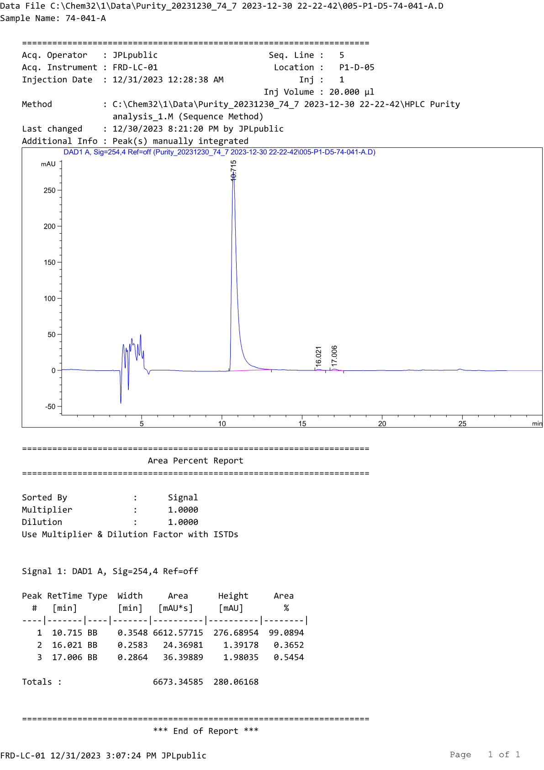
HPLC profile of compound D6a
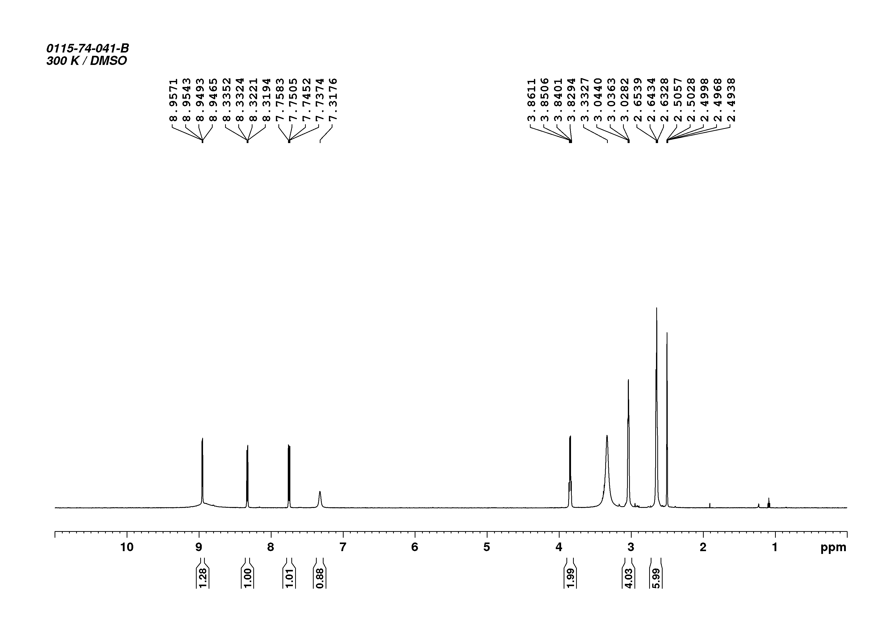
¹H-NMR spectrum of compound D6b

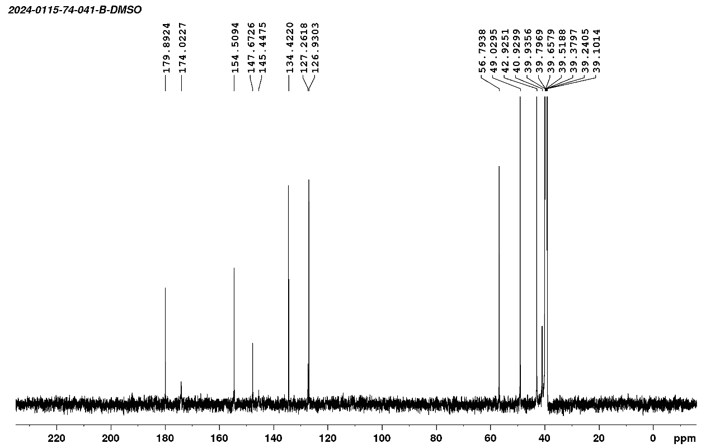
¹³C-NMR spectrum of compound D6b
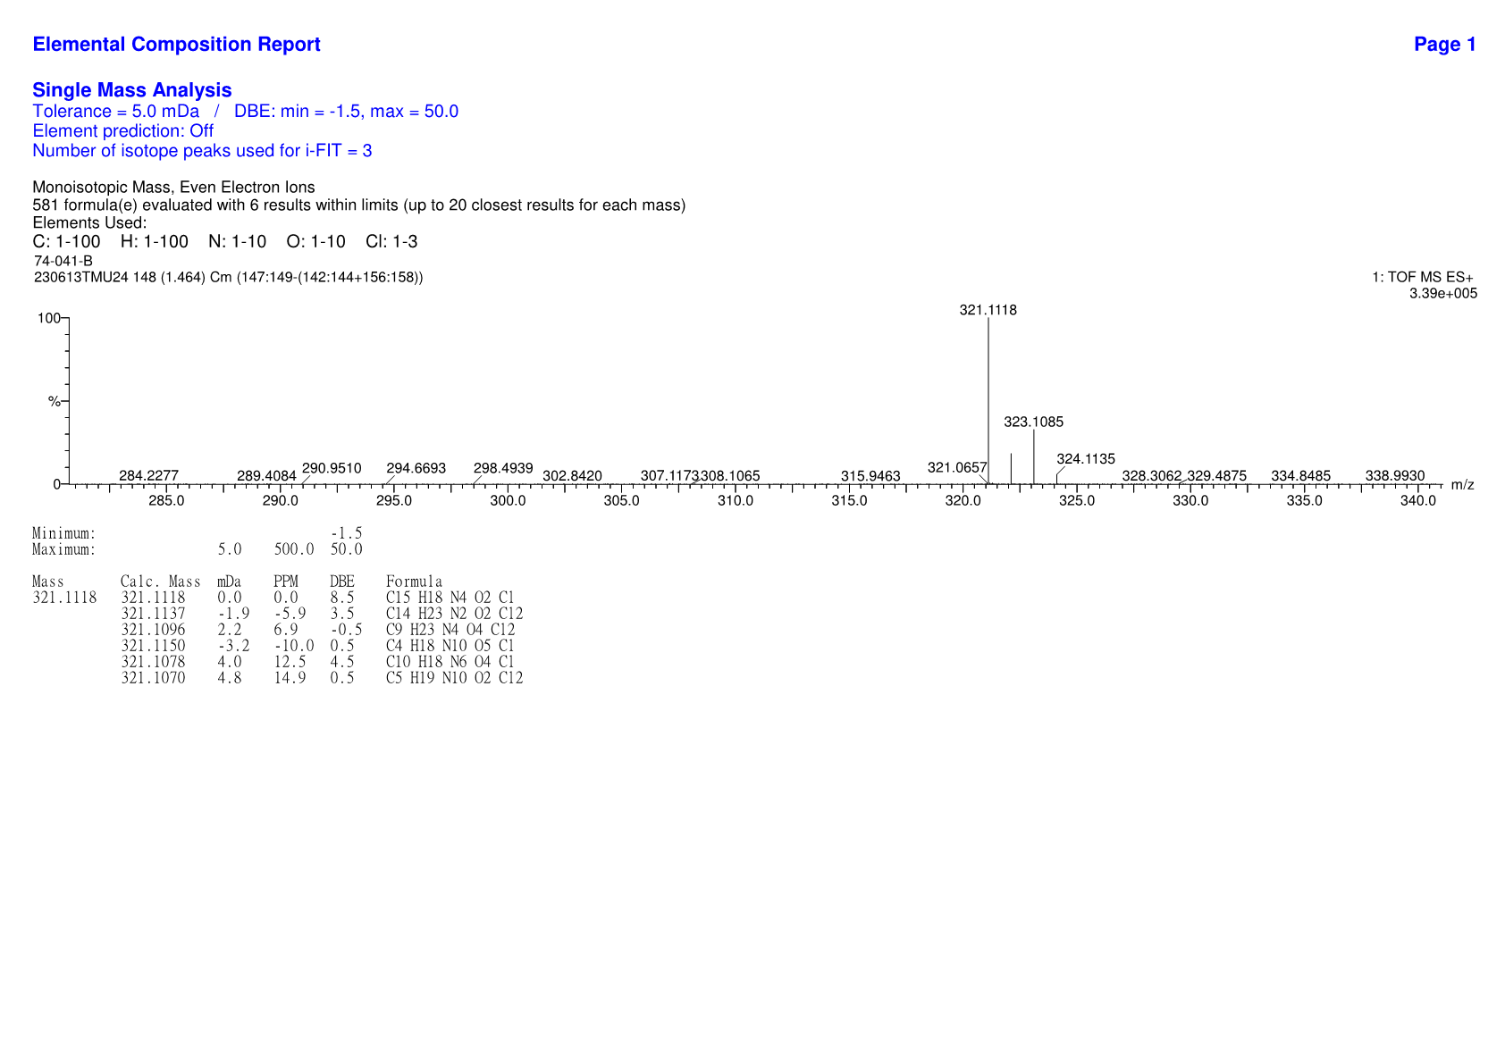
HRMS spectrum of compound D6b

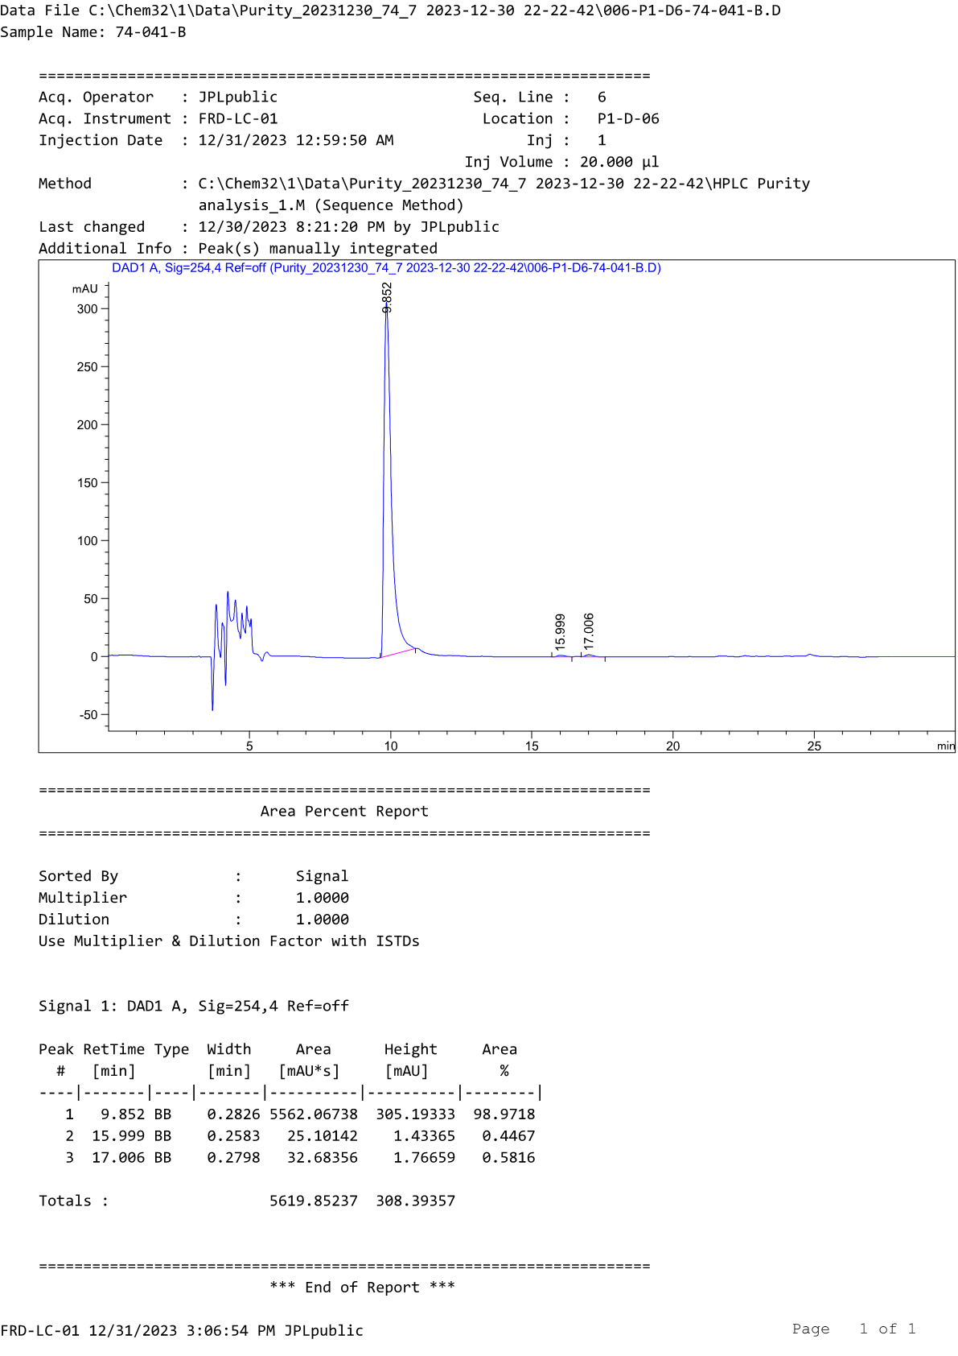
HPLC profile of compound D6b
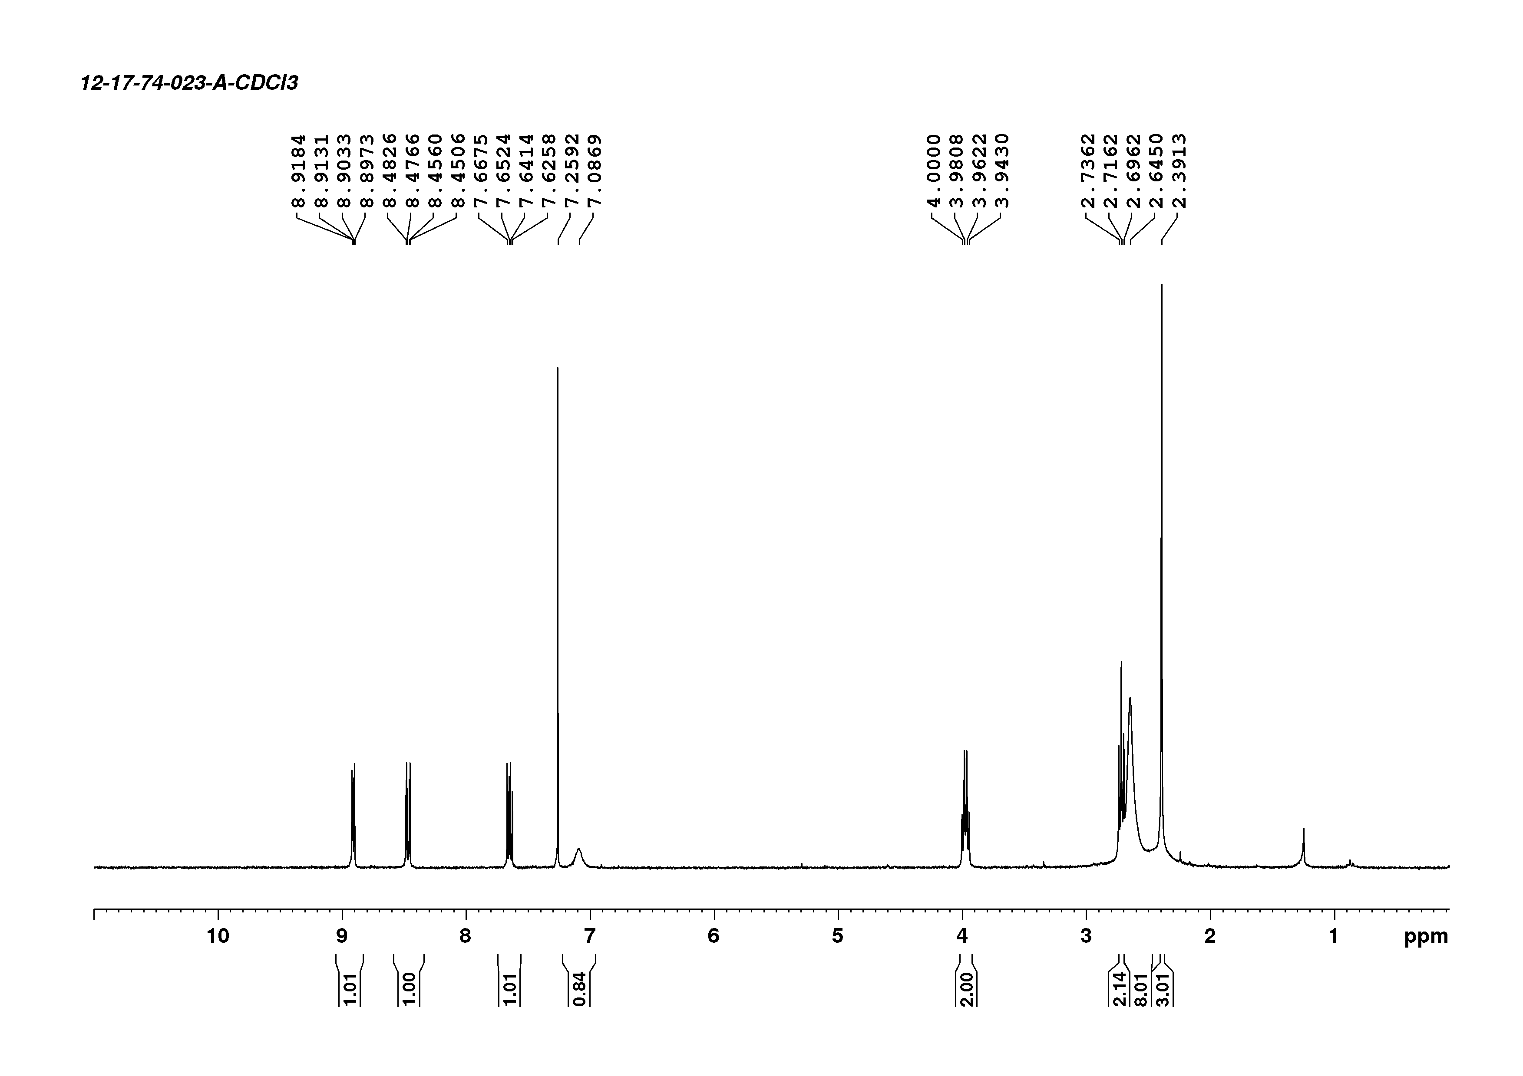
¹H-NMR spectrum of compound D7a

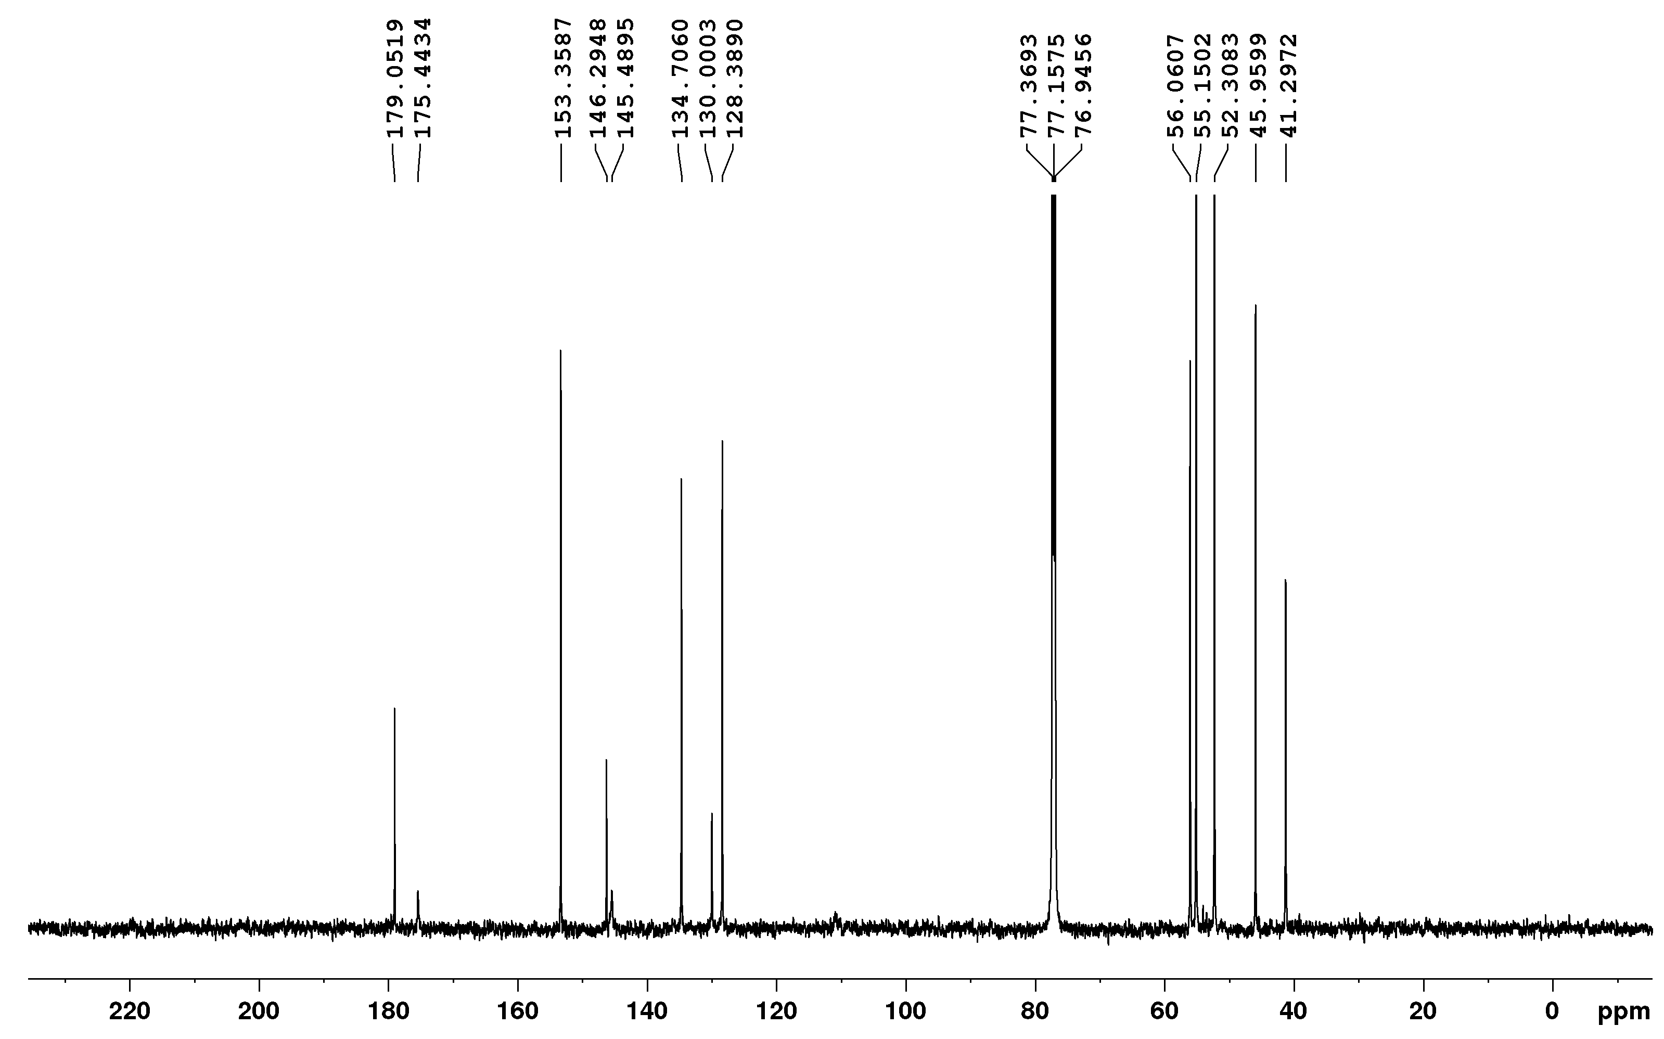
¹³C-NMR spectrum of compound D7a
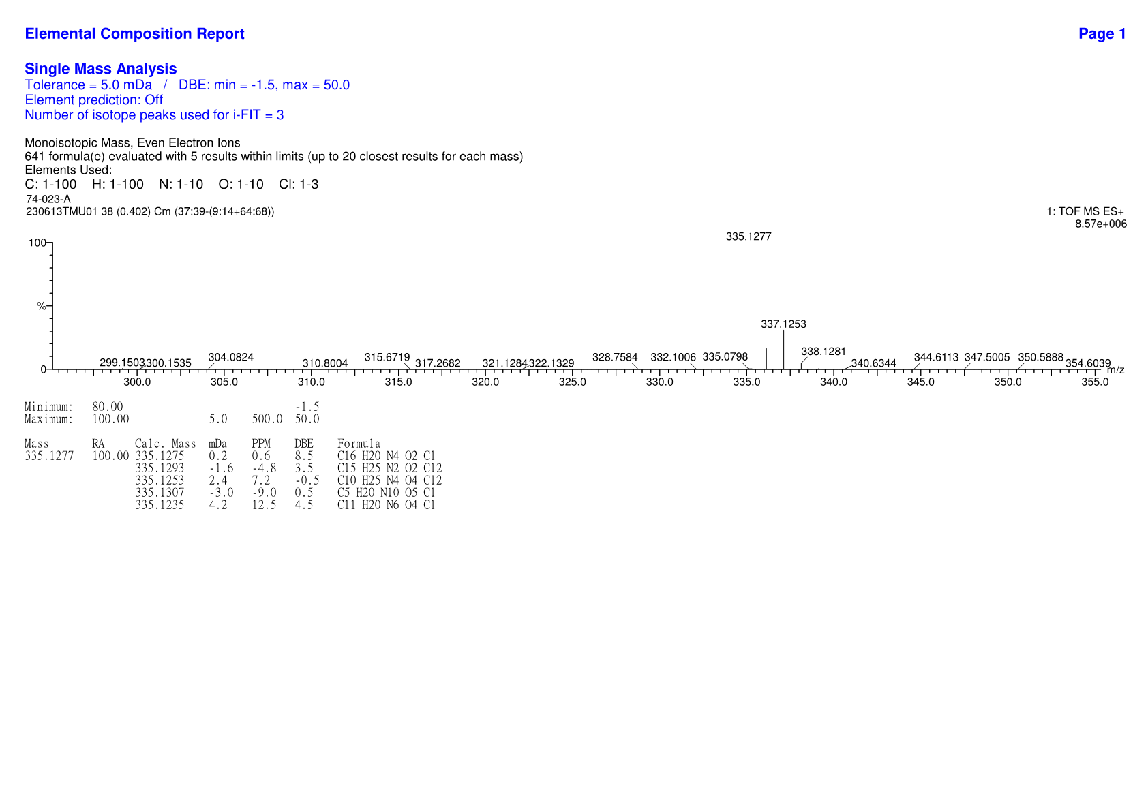
HRMS spectrum of compound D7a

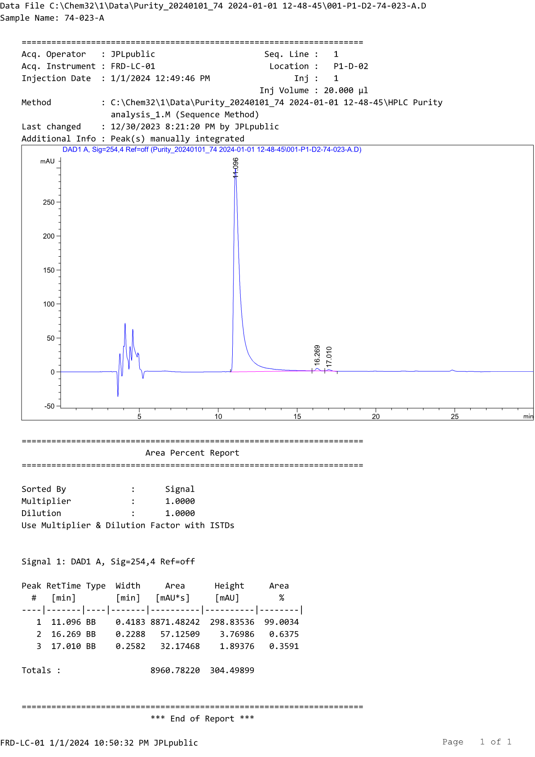
HPLC profile of compound D7a
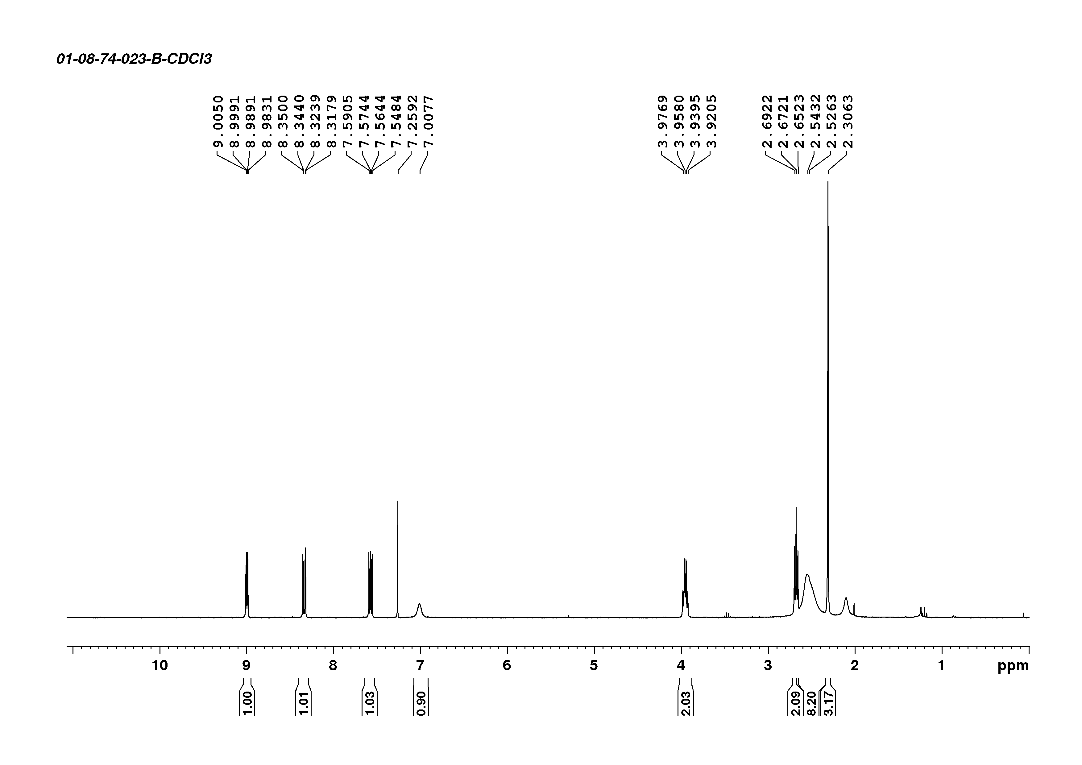
¹H-NMR spectrum of compound D7b

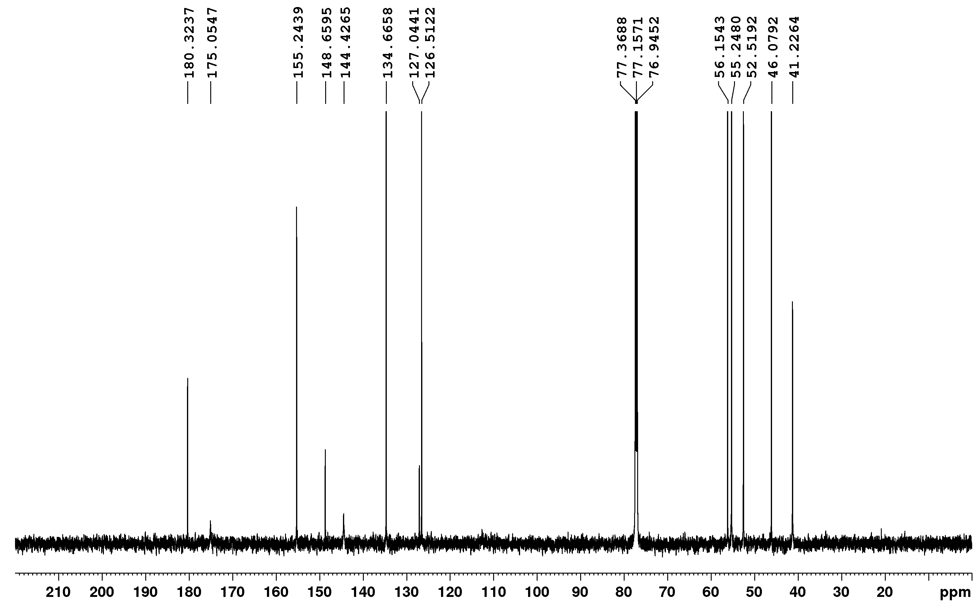
¹³C-NMR spectrum of compound D7b
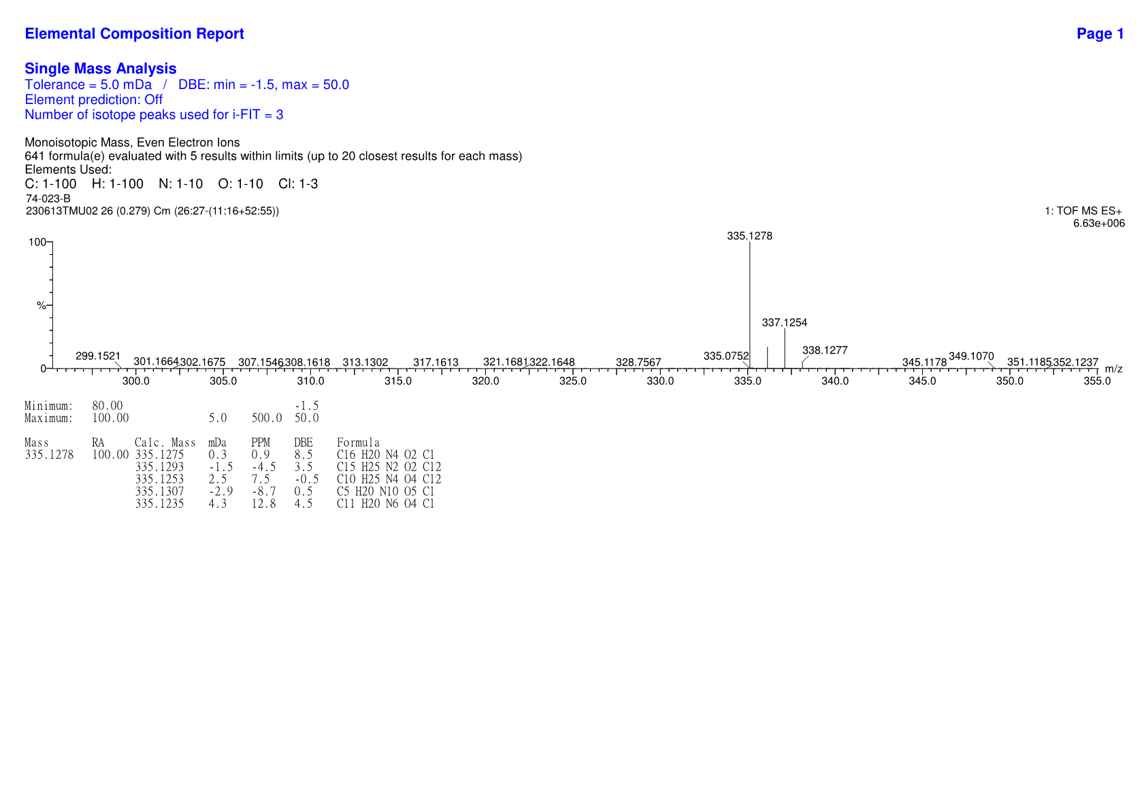
HRMS spectrum of compound D7b

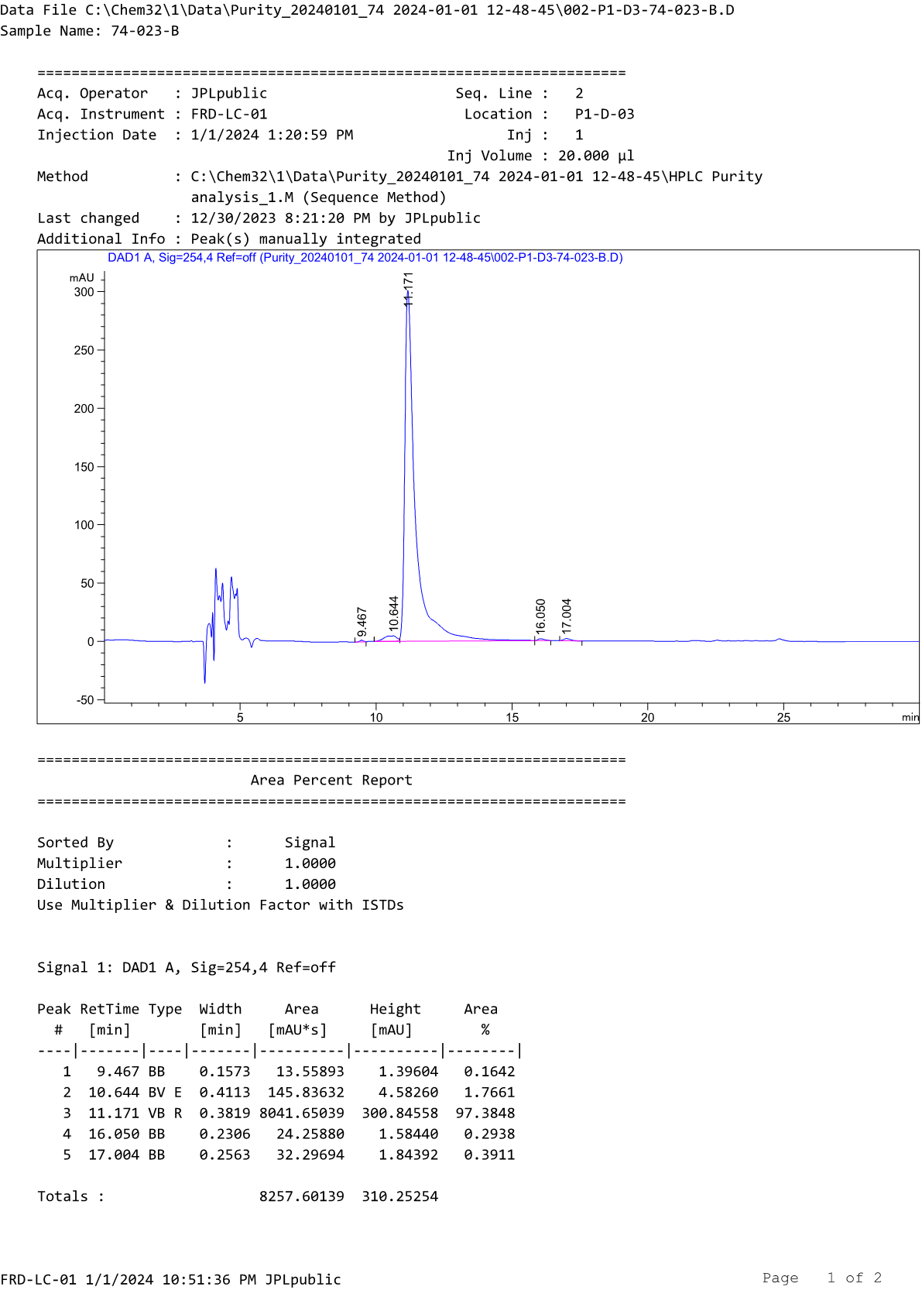
HPLC profile of compound D7b
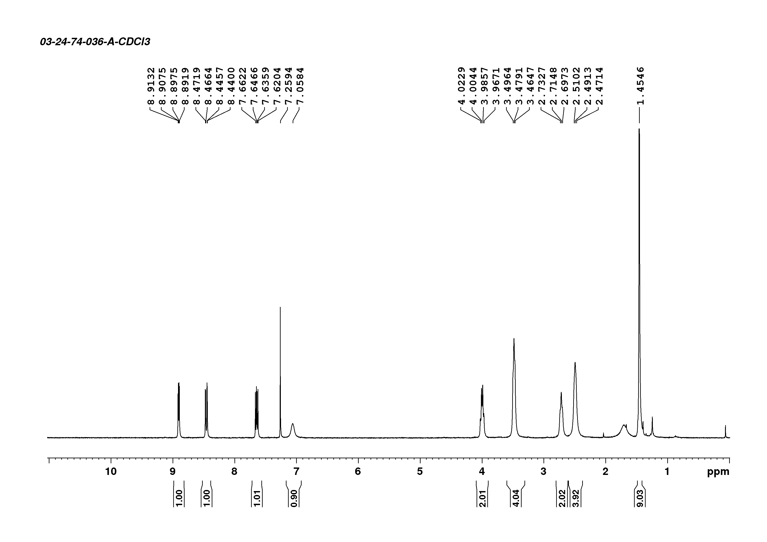
¹H-NMR spectrum of compound D8a

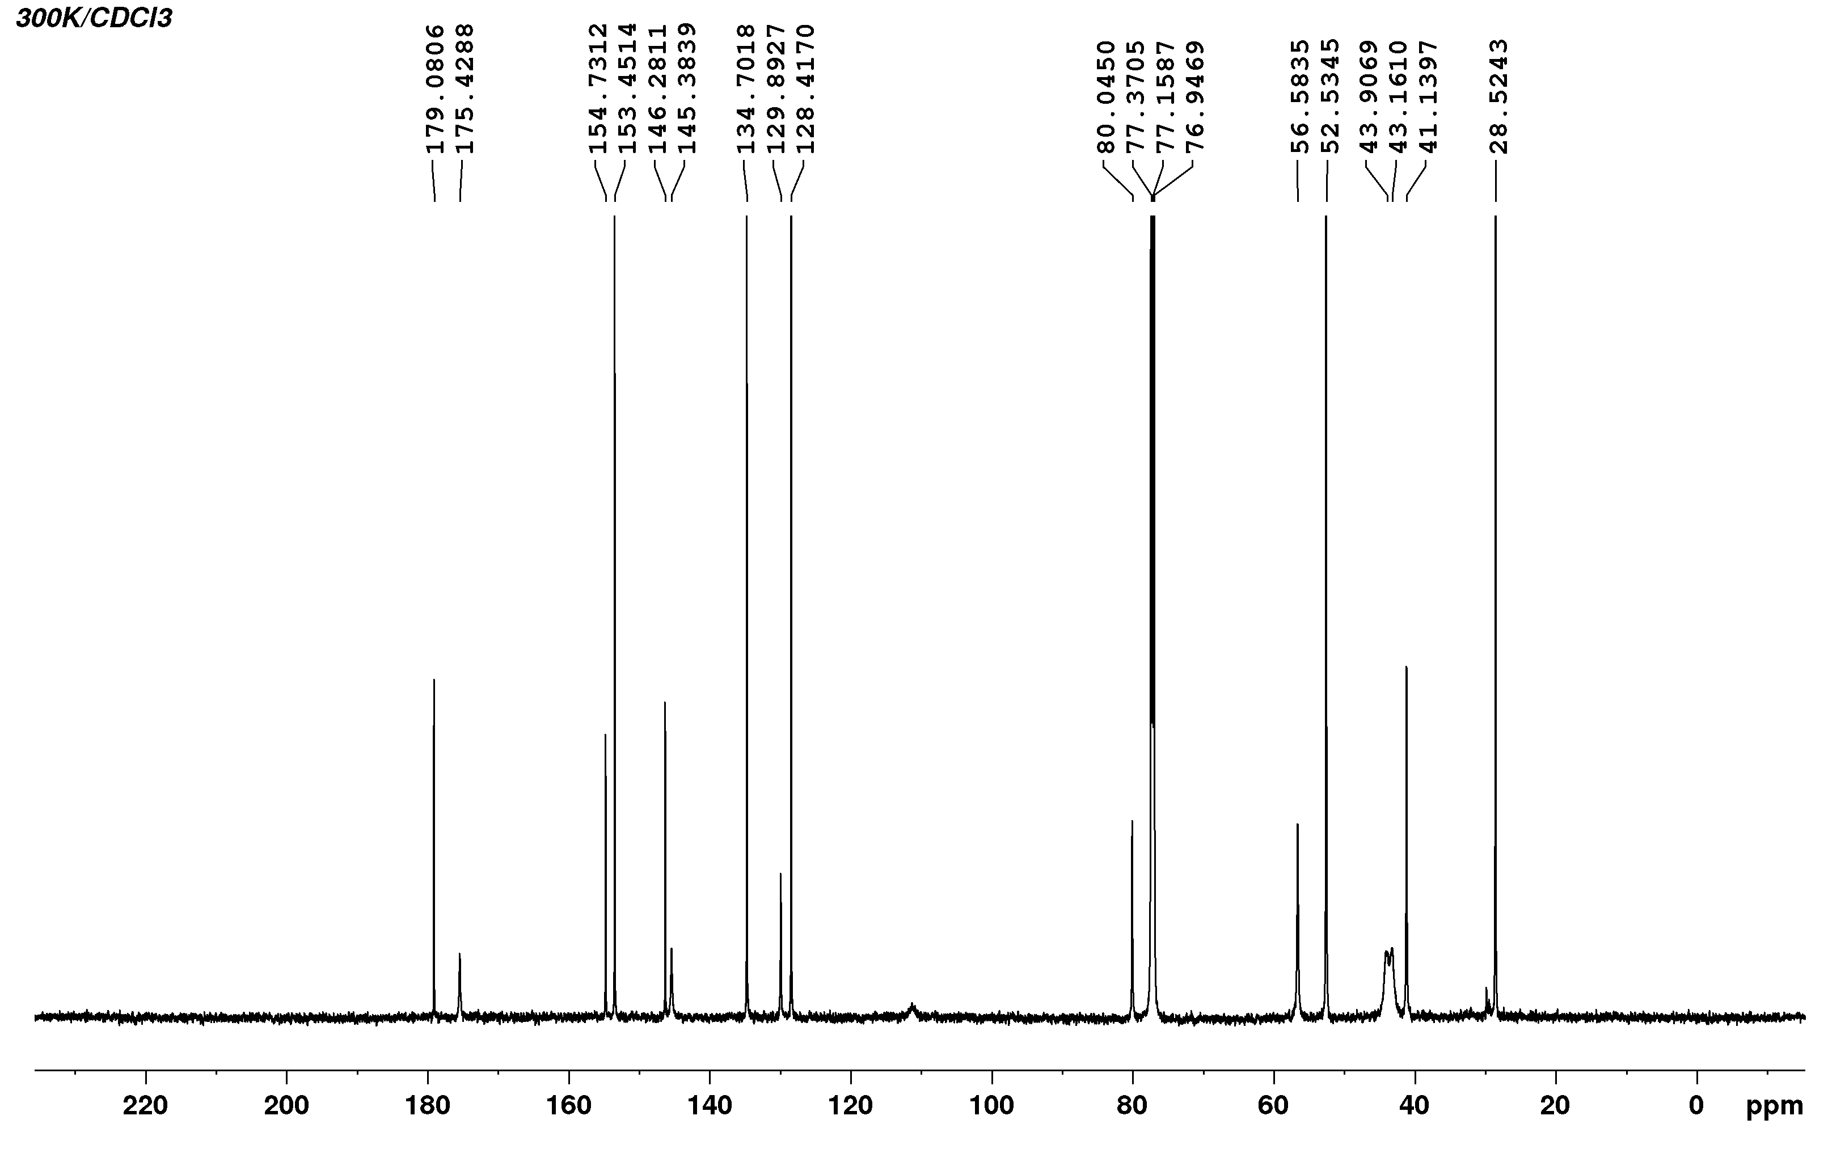
¹³C-NMR spectrum of compound D8a
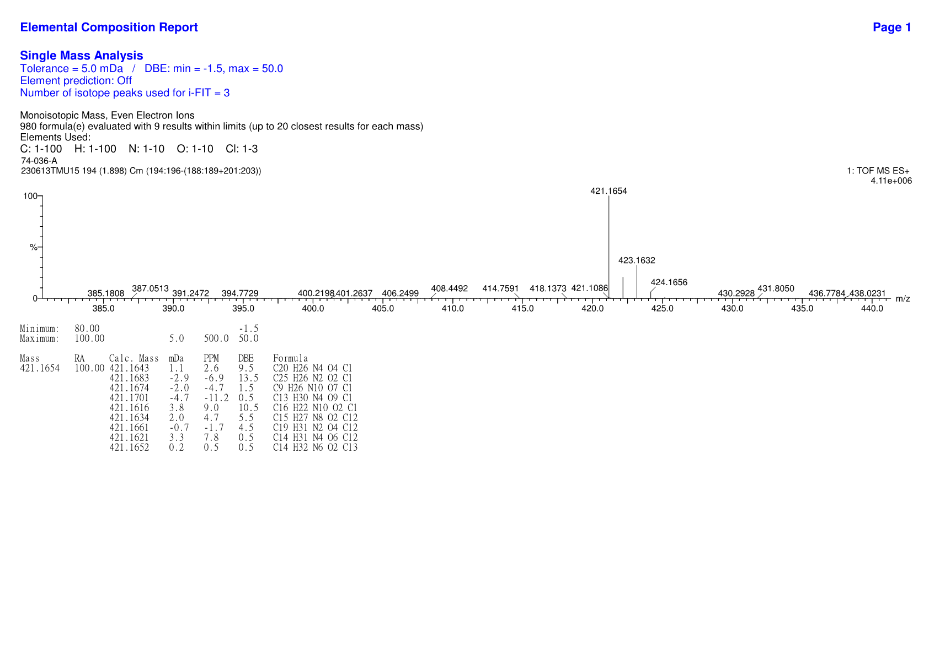
HRMS spectrum of compound D8a

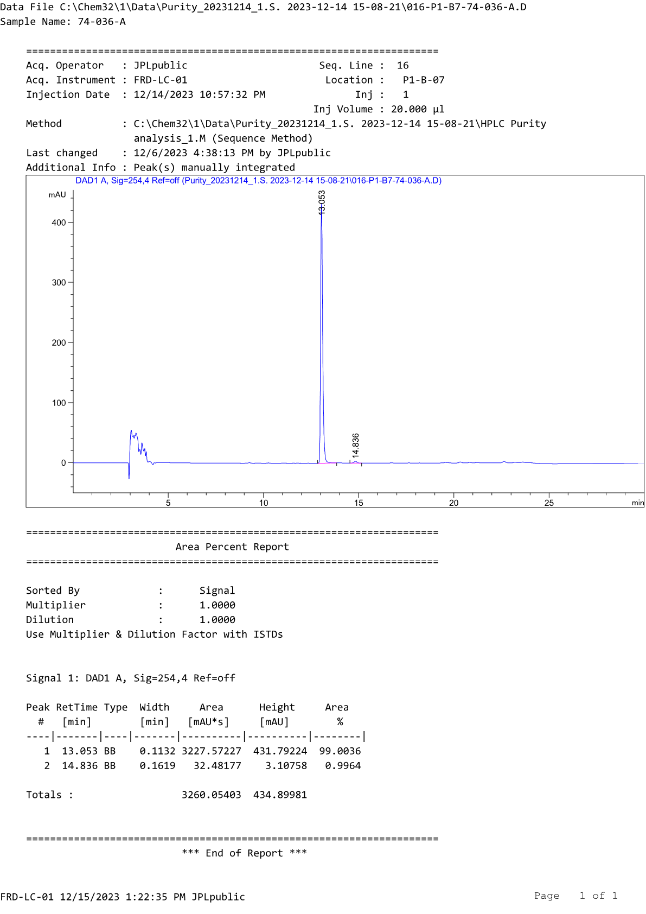
HPLC profile of compound D8a
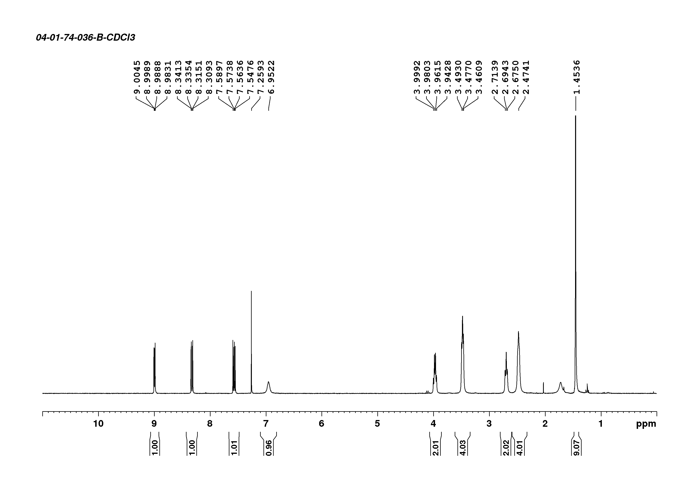
¹H-NMR spectrum of compound D8b

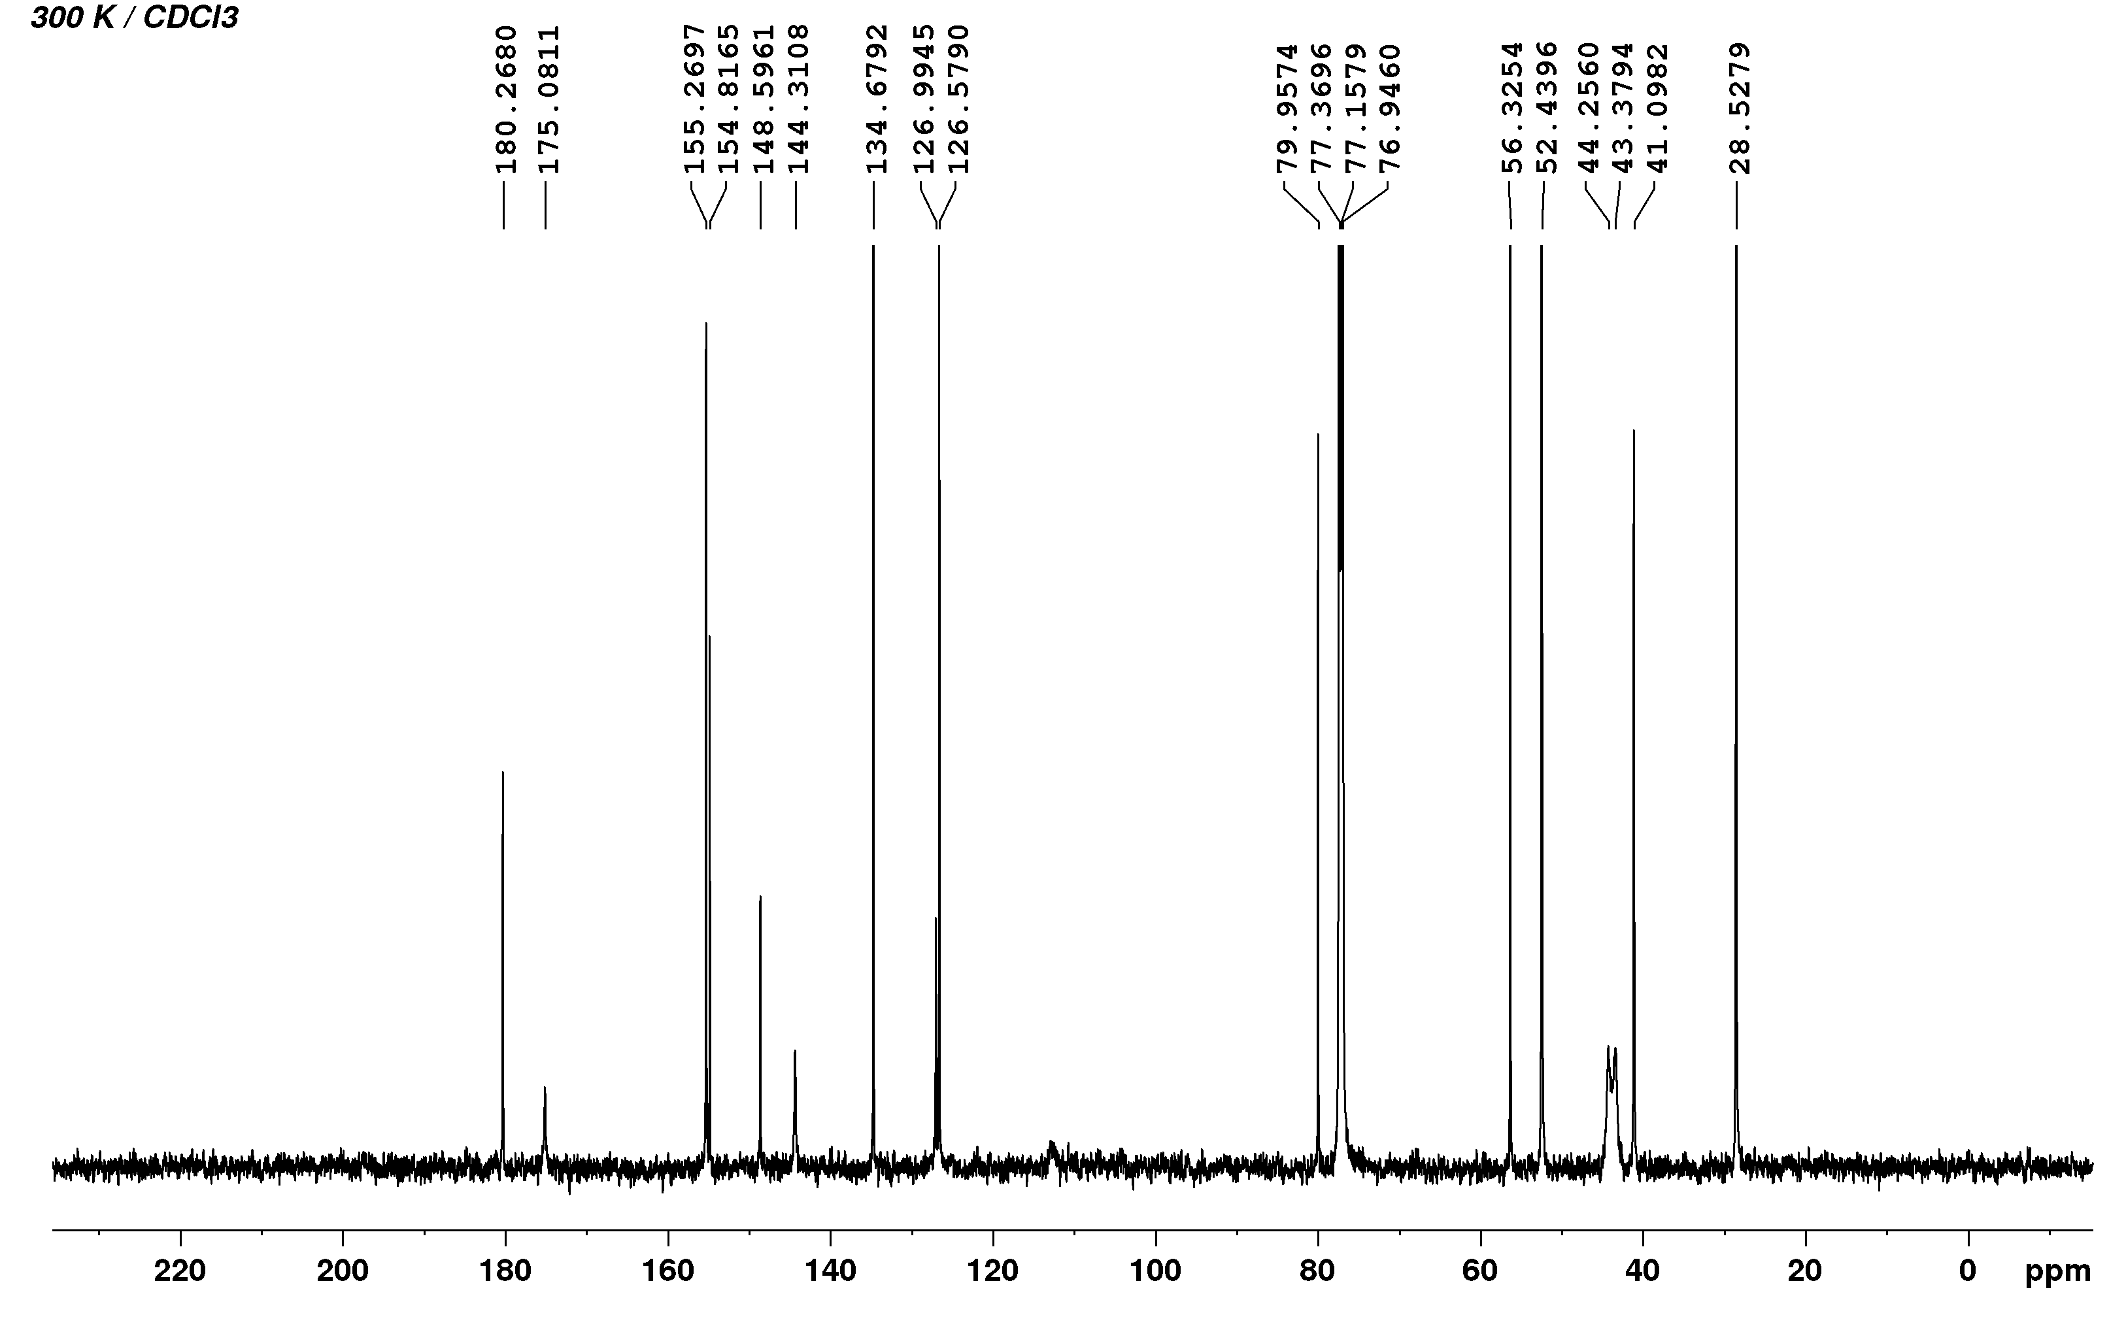
³C-NMR spectrum of compound D8b
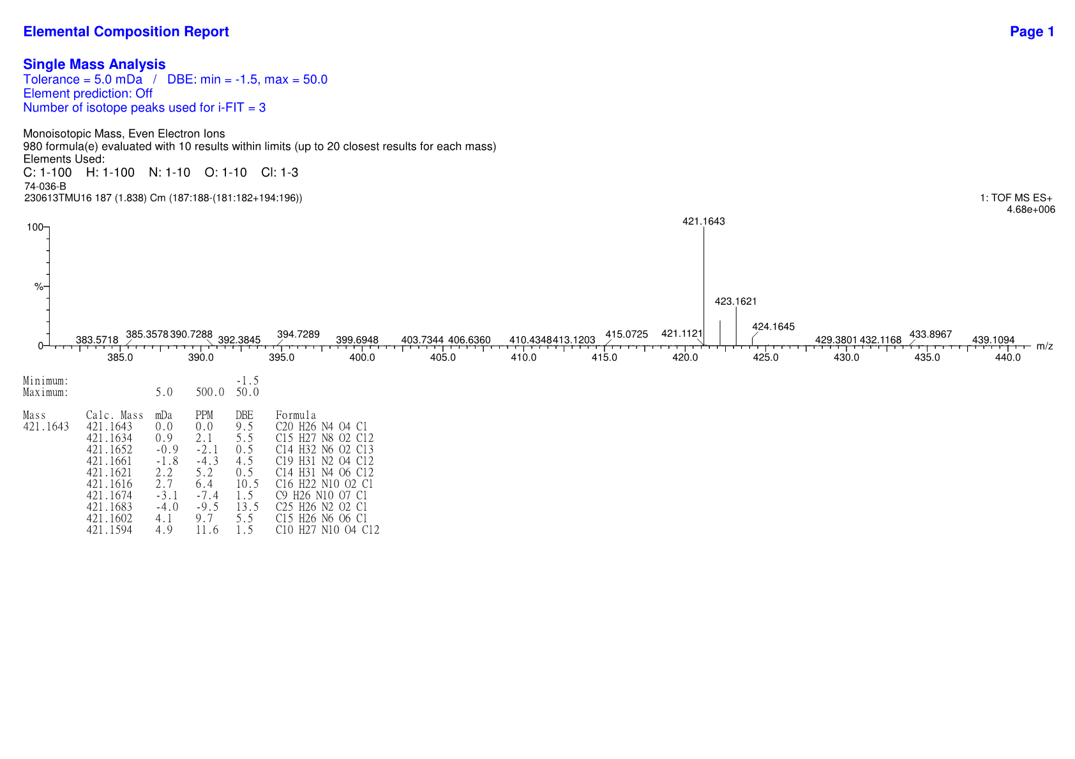
HRMS spectrum of compound D8b

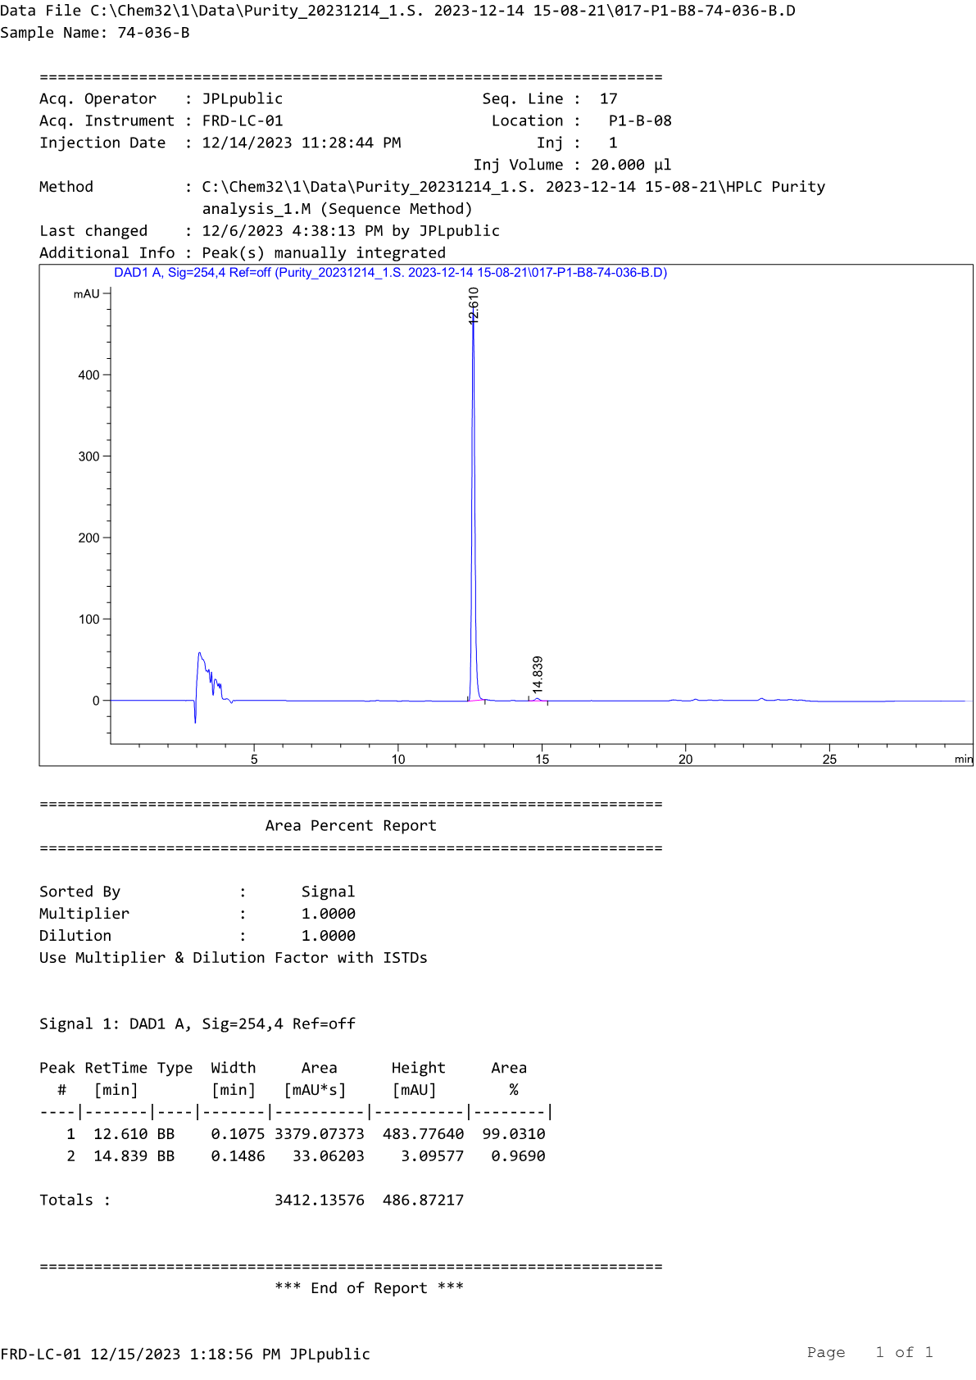
HPLC profile of compound D8b
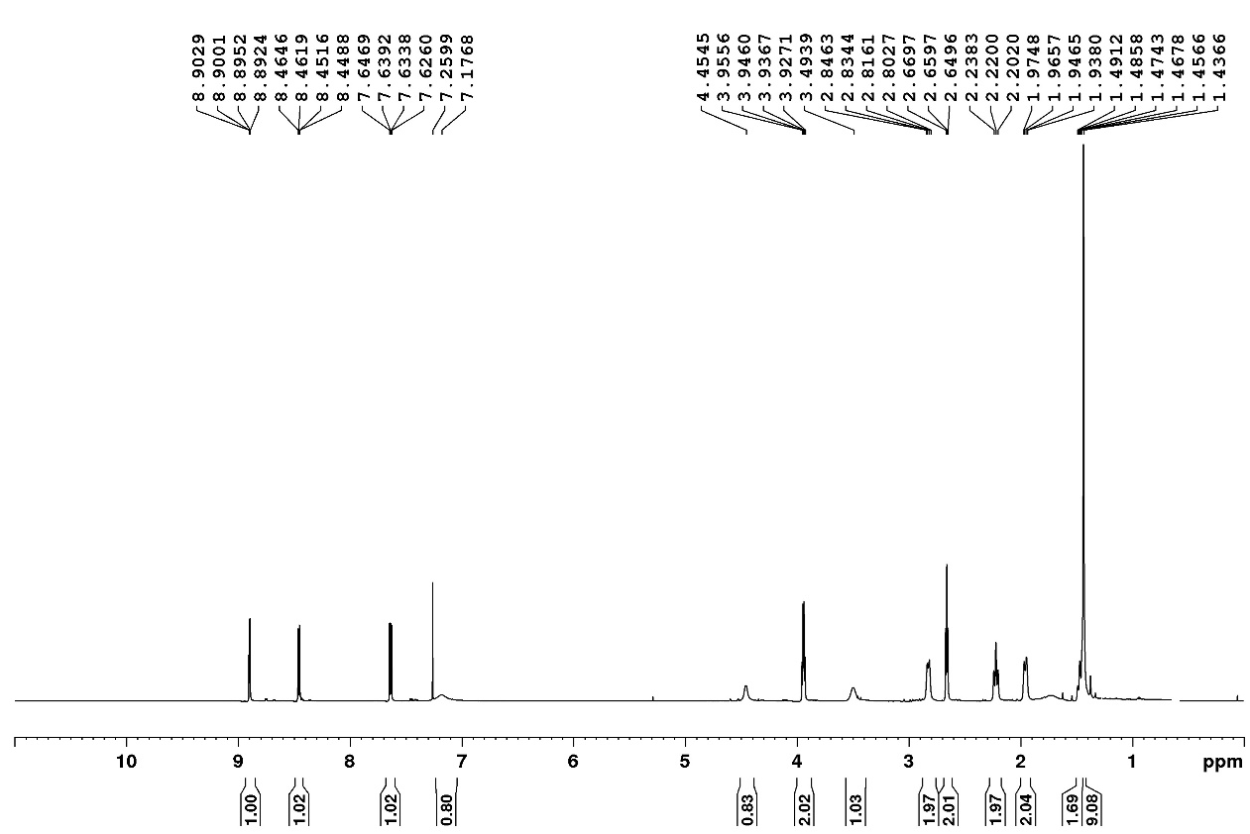
¹H-NMR spectrum of compound D9a

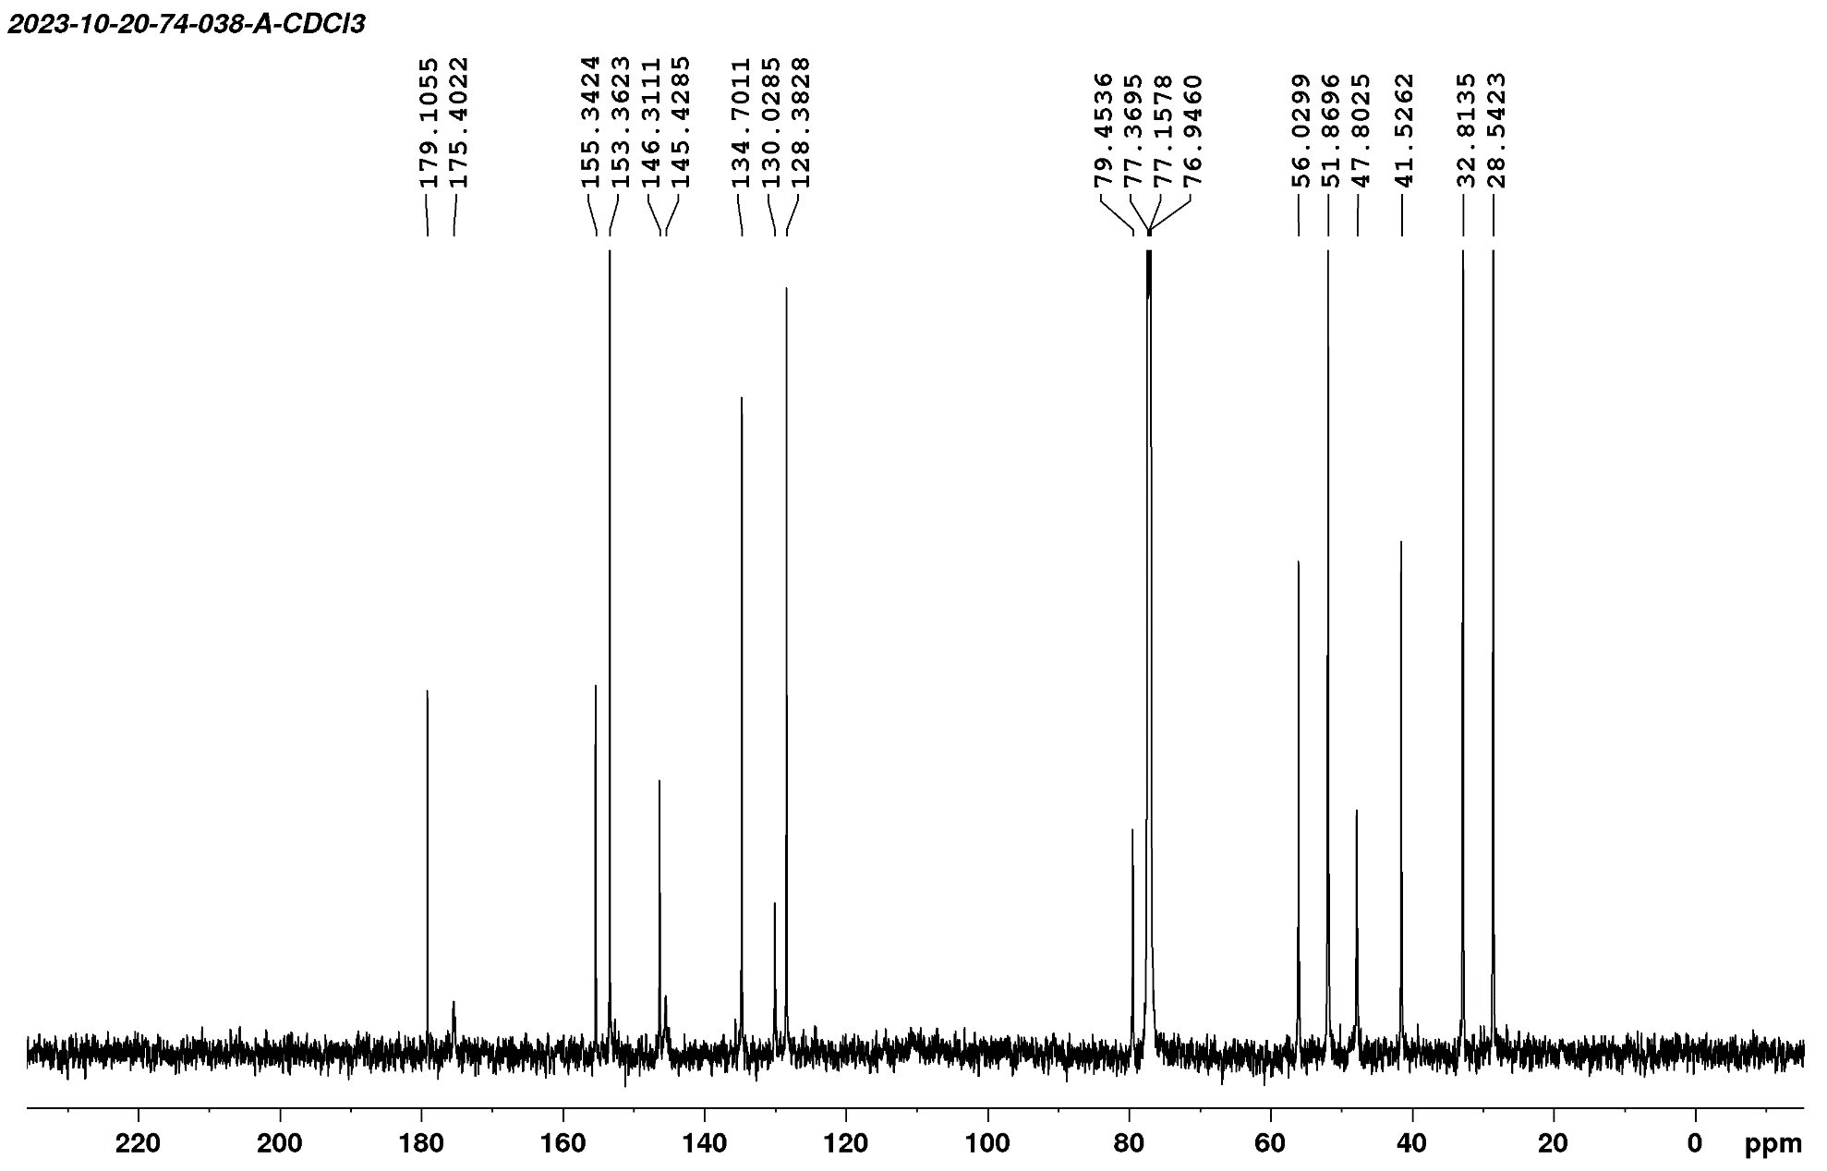
¹³C-NMR spectrum of compound D9a
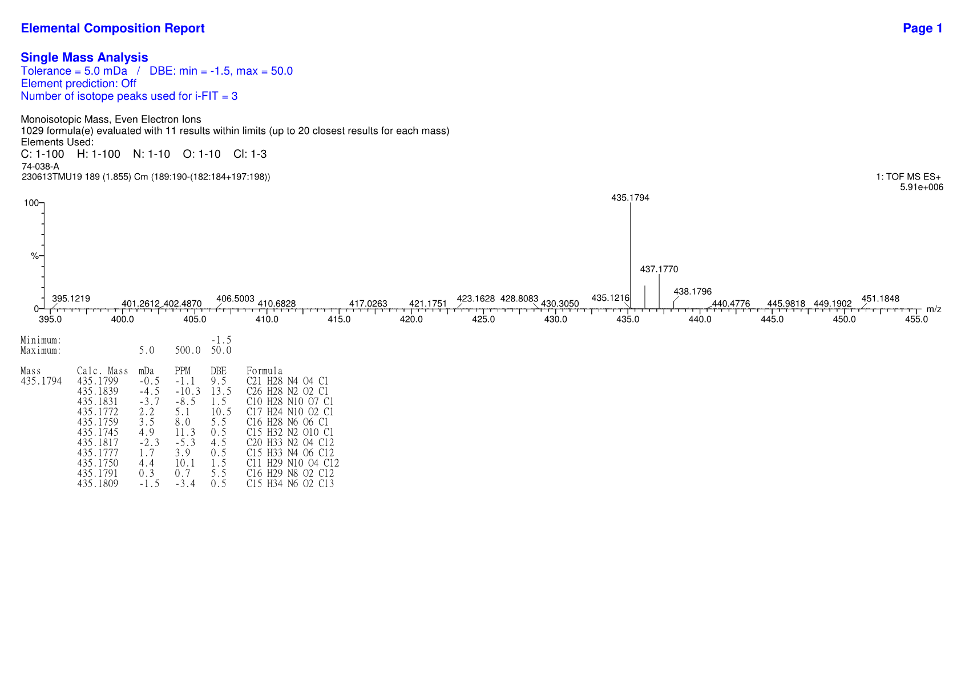
HRMS spectrum of compound D9a

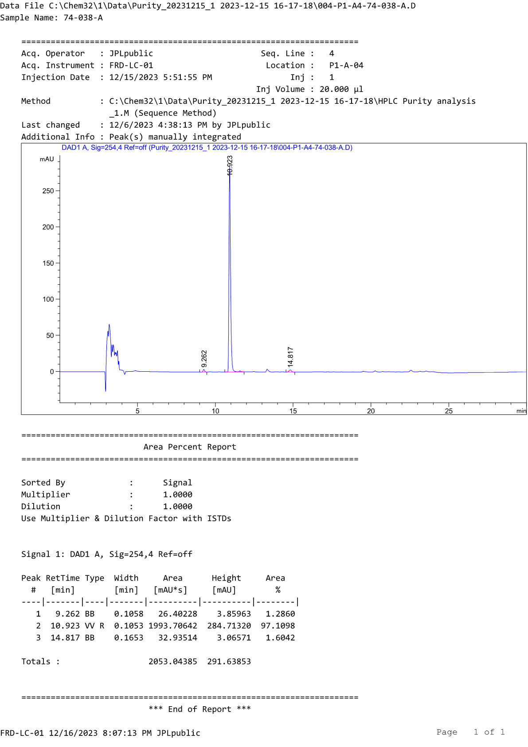
HPLC profile of compound D9a
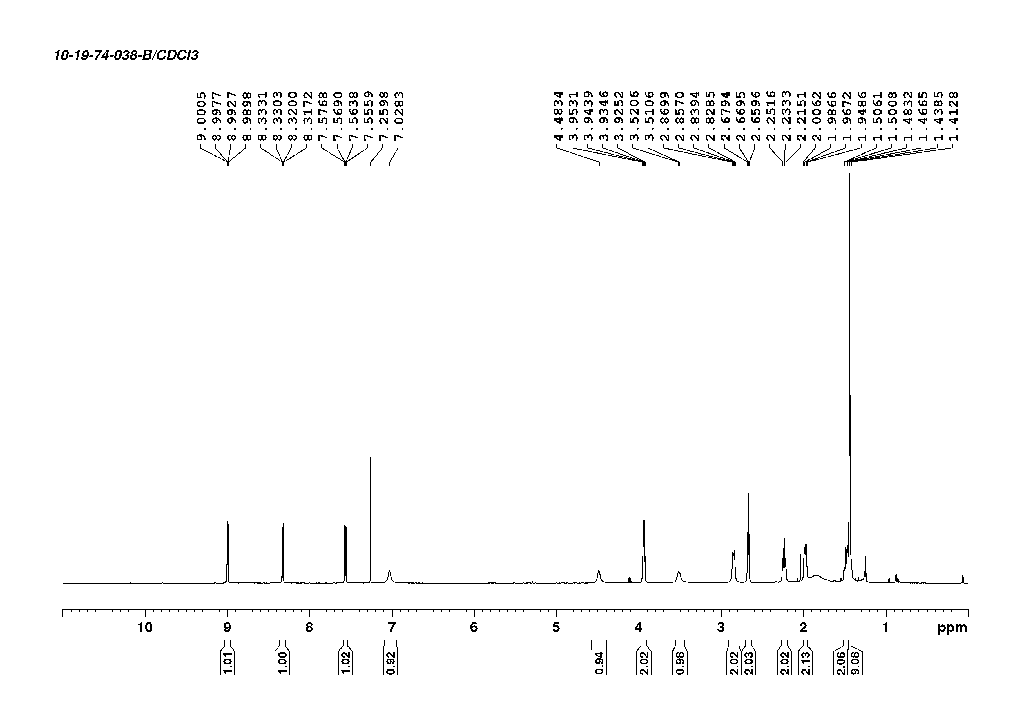
¹H-NMR spectrum of compound D9b

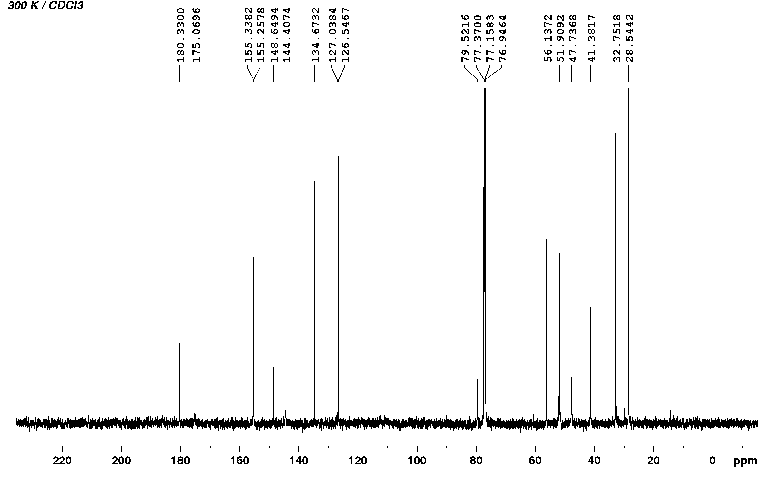
¹³C-NMR spectrum of compound D9b
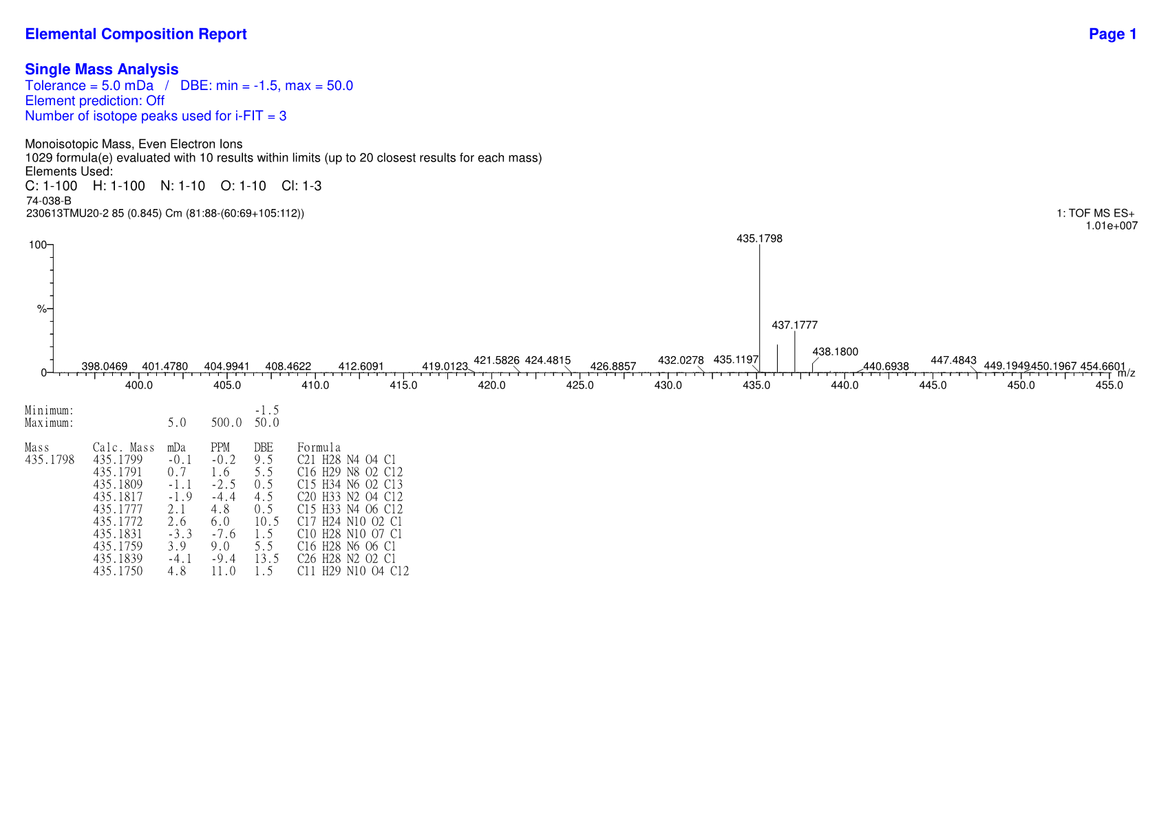
HRMS spectrum of compound D9b

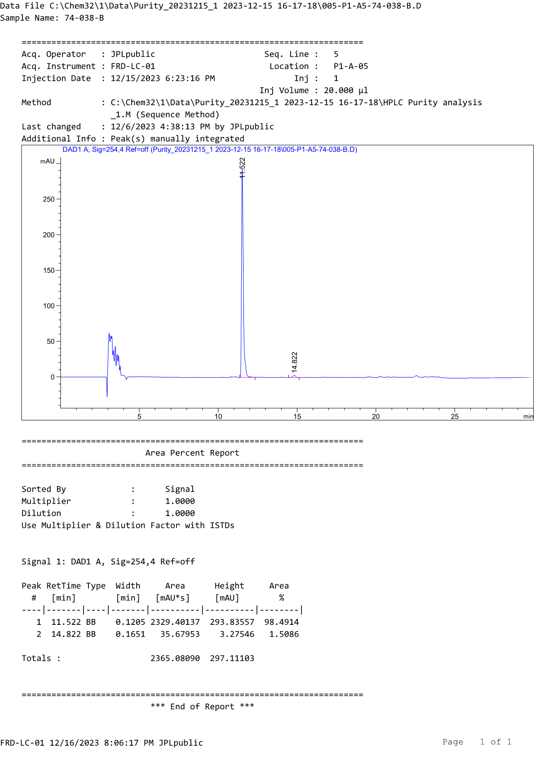
HPLC profile of compound D9b
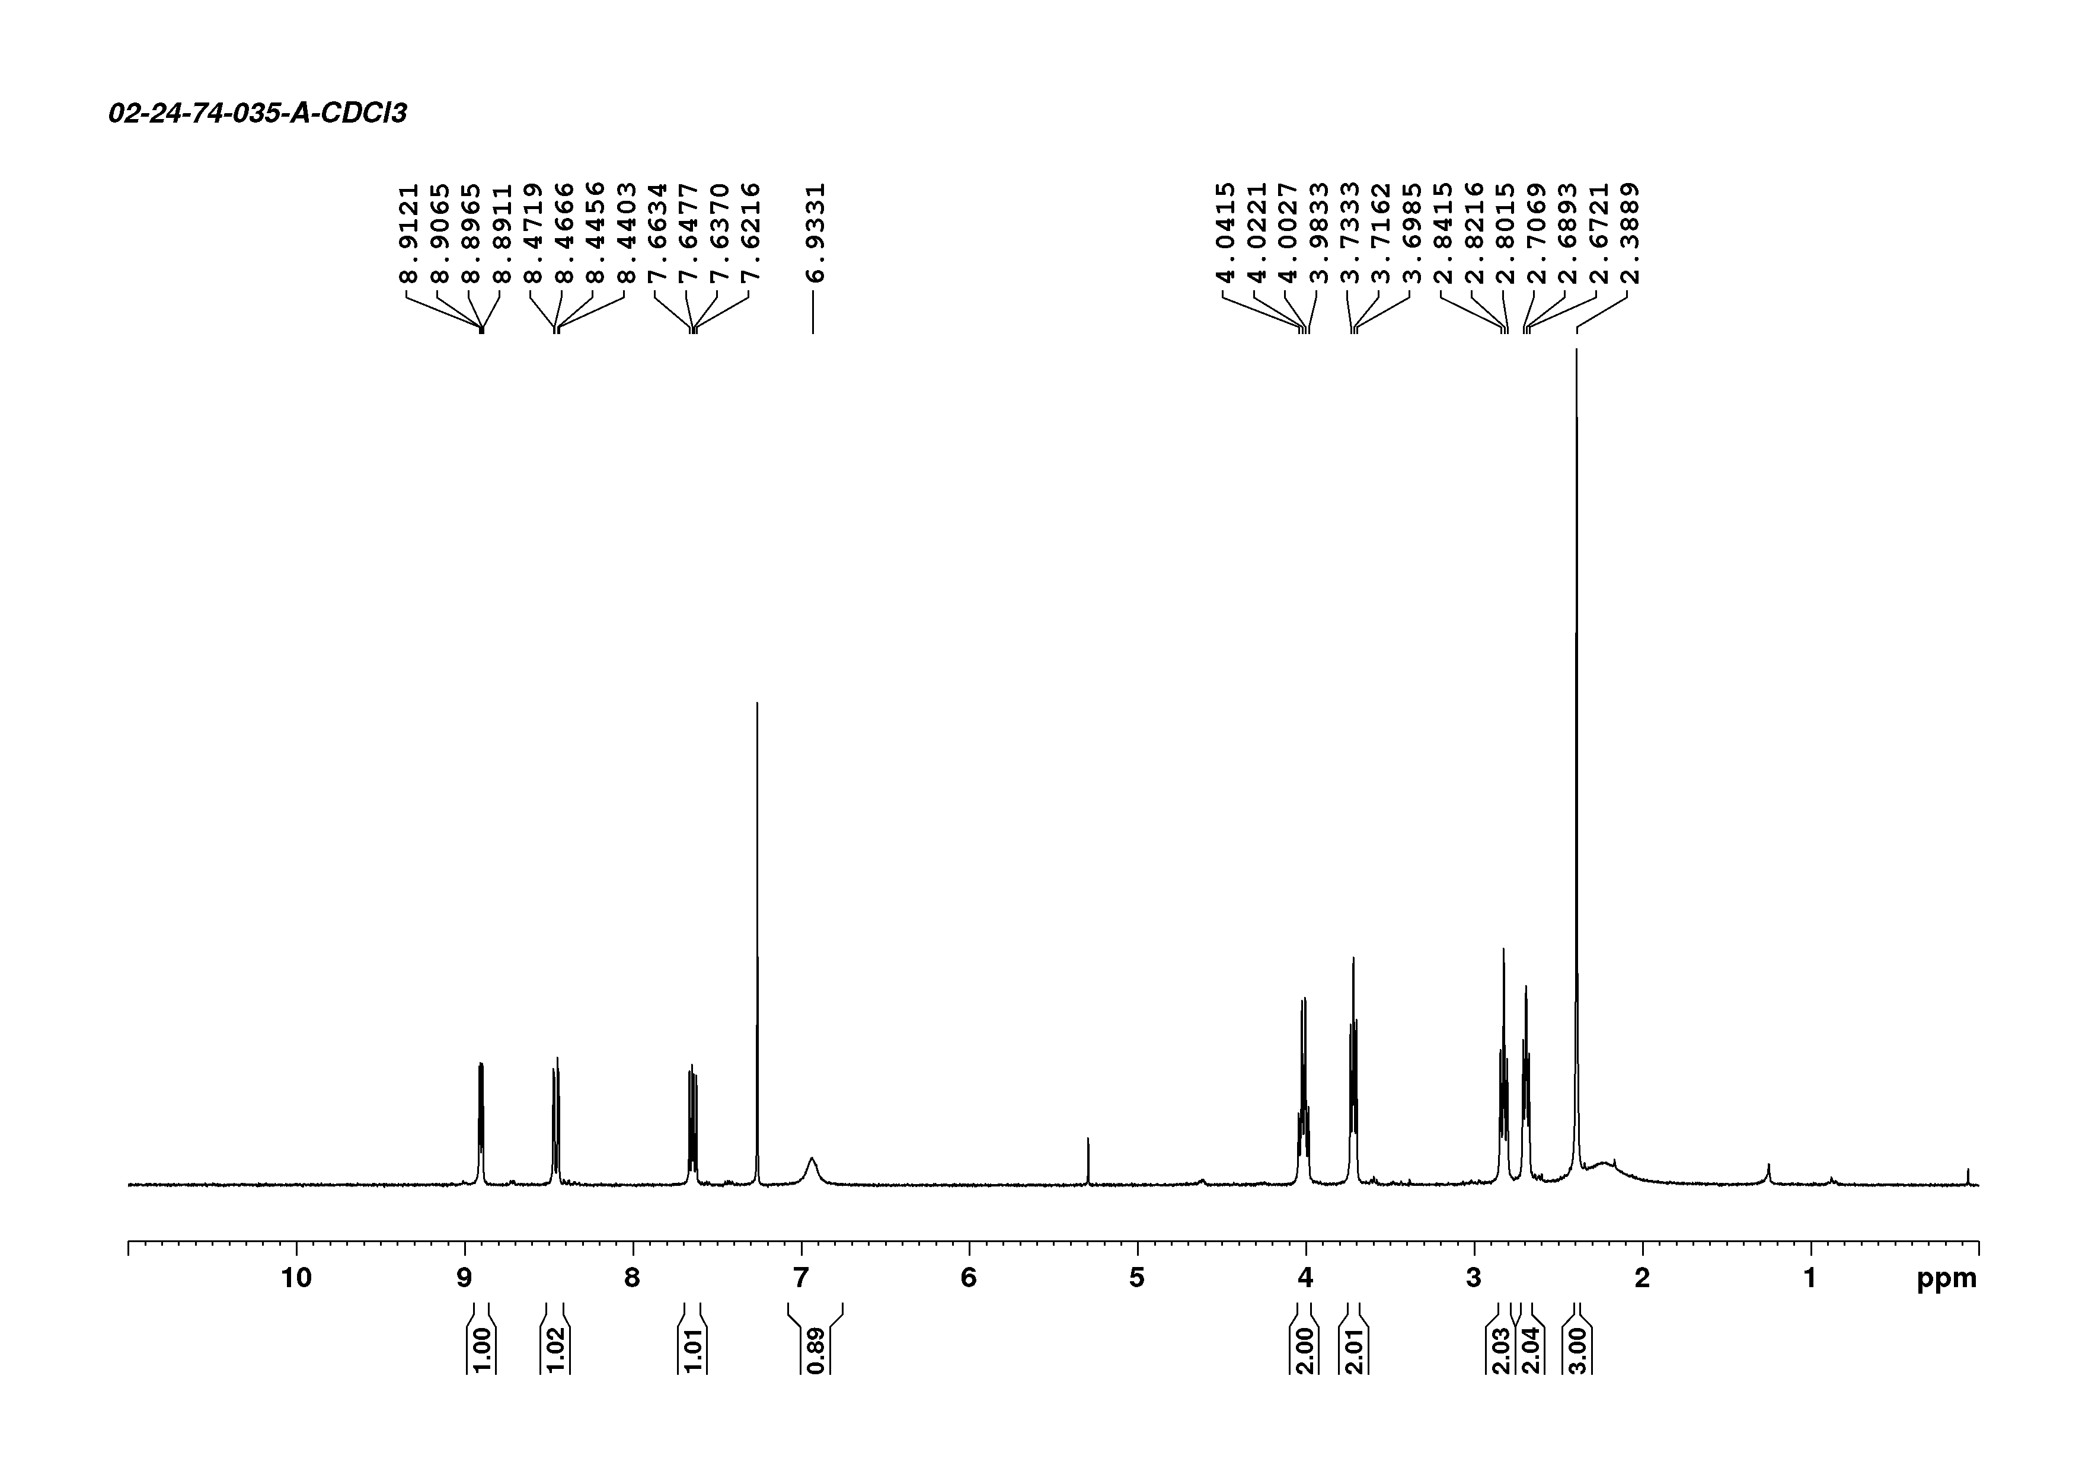
¹H-NMR spectrum of compound D10a

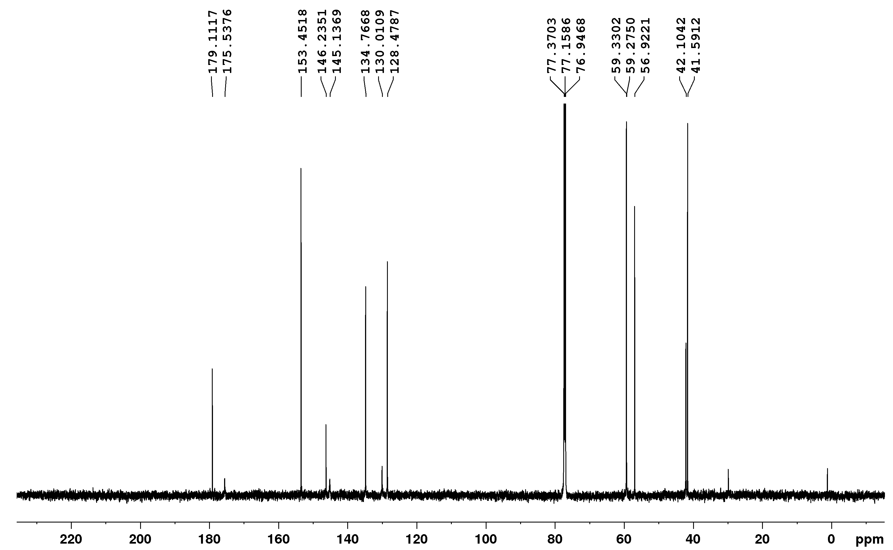
¹³C-NMR spectrum of compound D10a
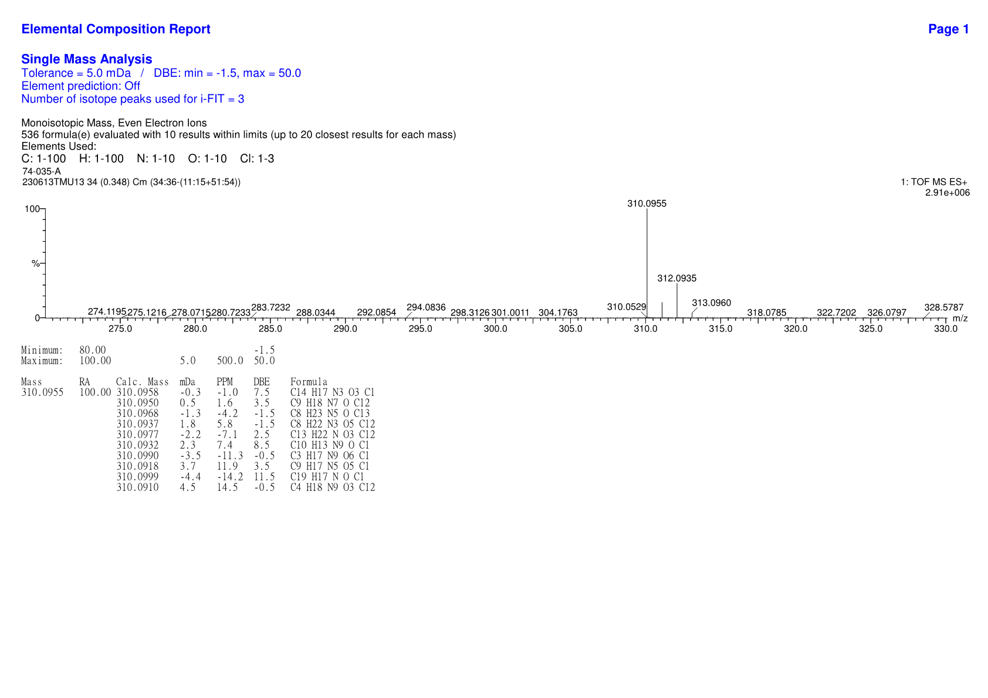
HRMS spectrum of compound D10a

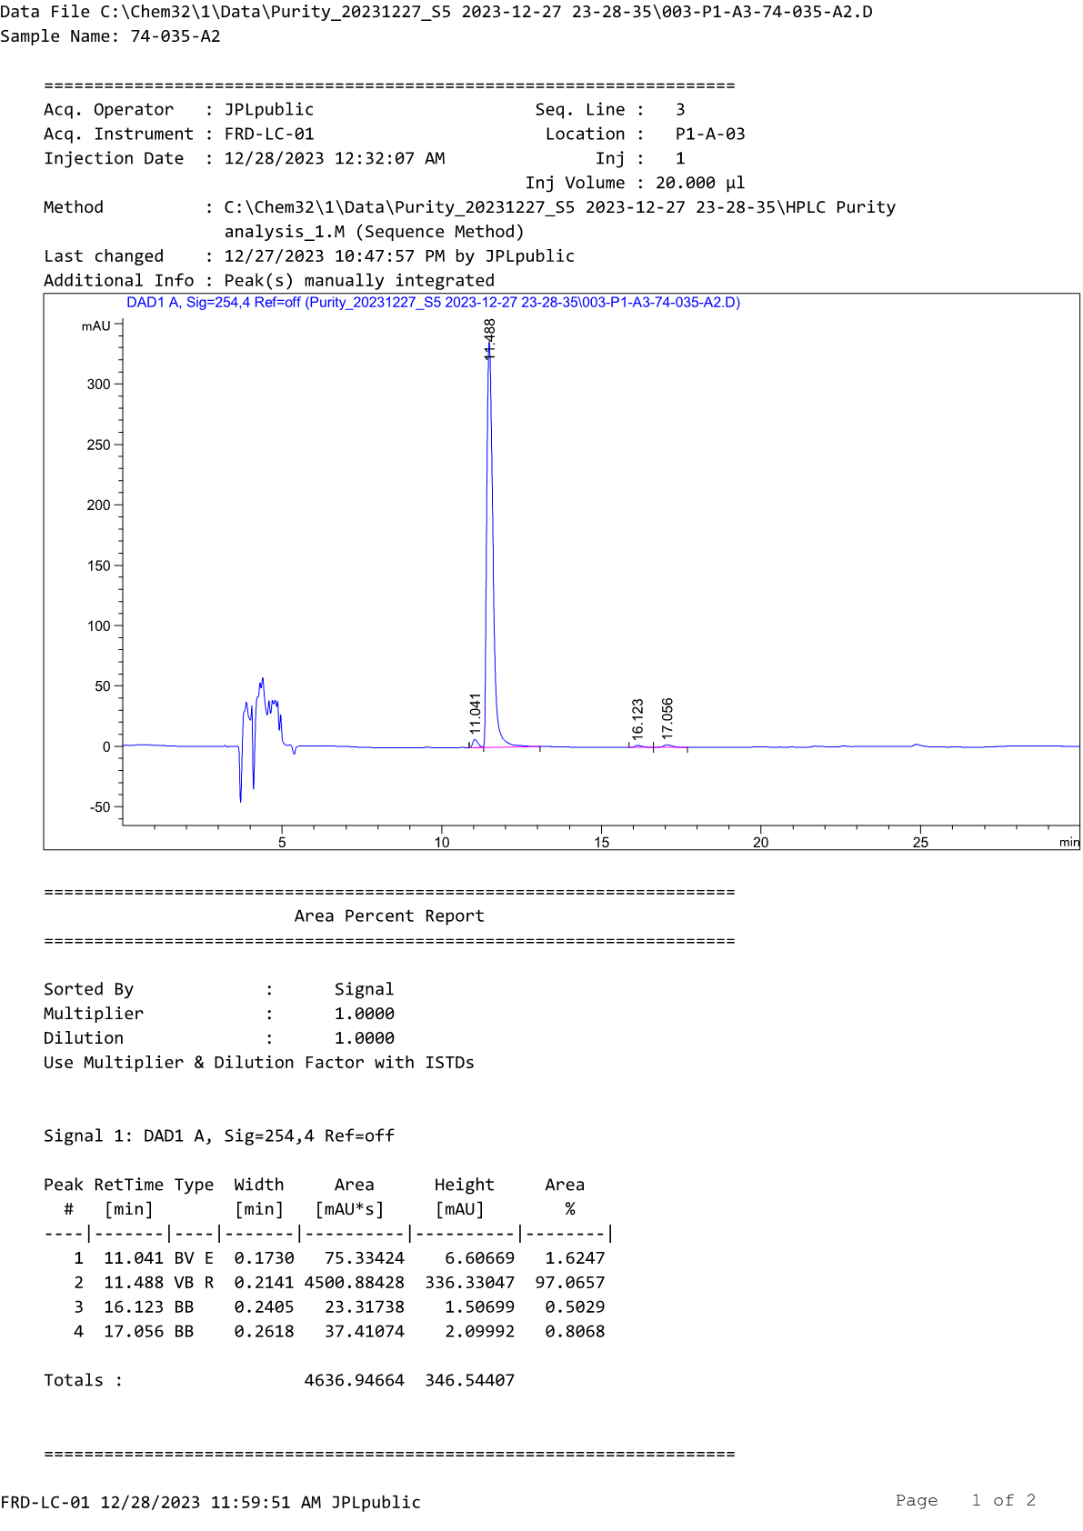
HPLC profile of compound D10a
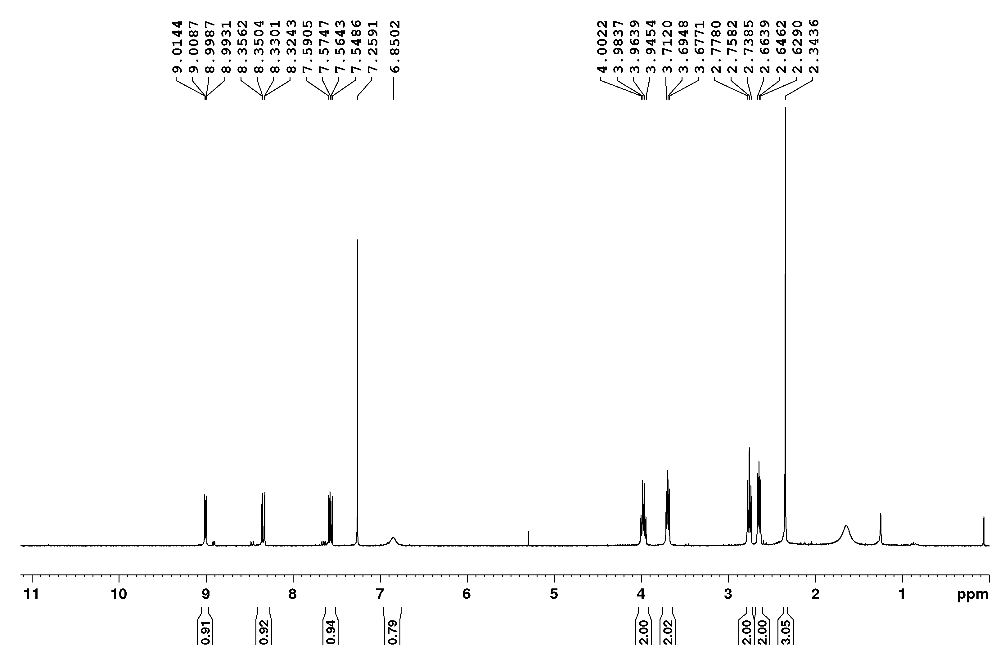
¹H-NMR spectrum of compound D10b

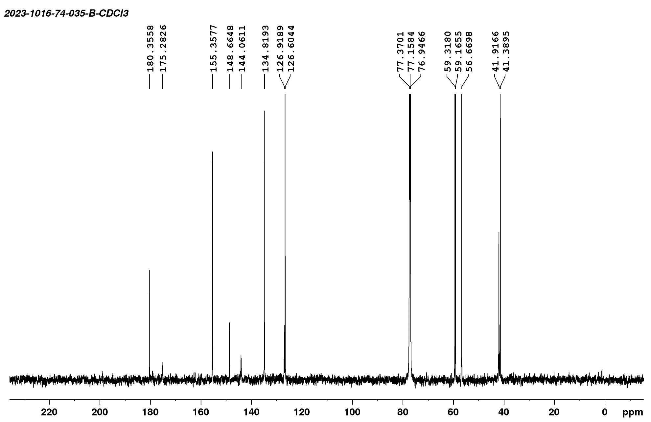
¹³C-NMR spectrum of compound D10b
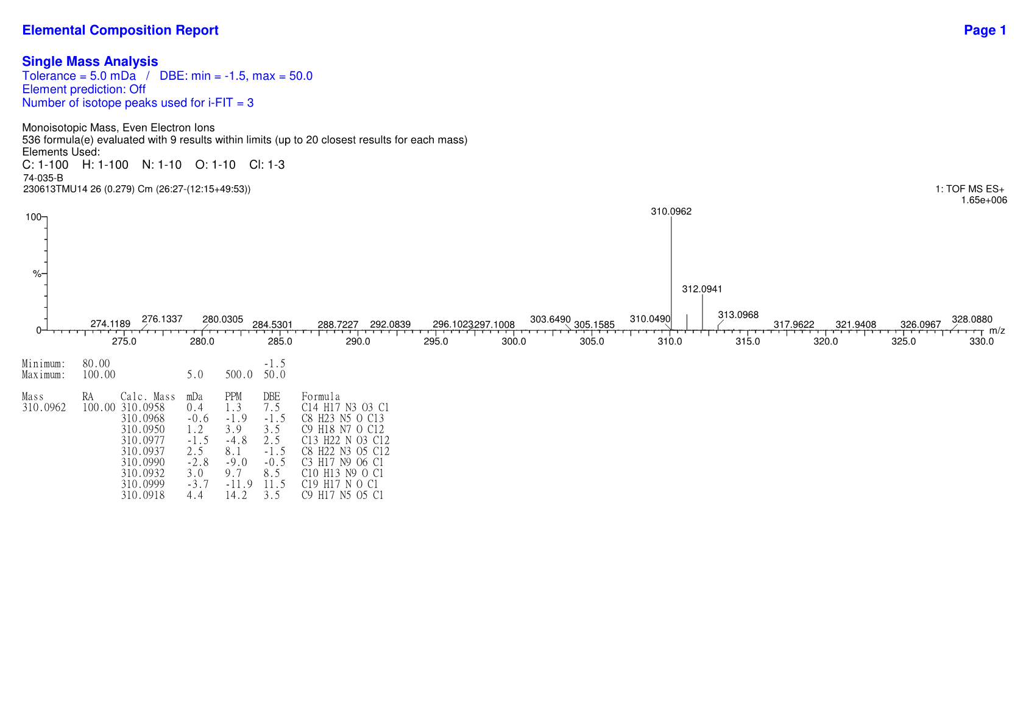
HRMS spectrum of compound D10b

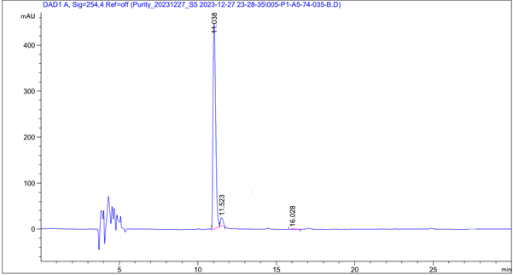
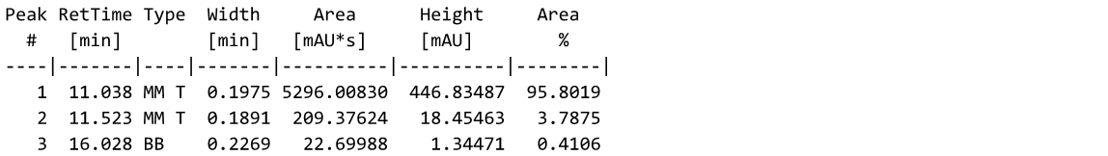
HPLC profile of compound D10b
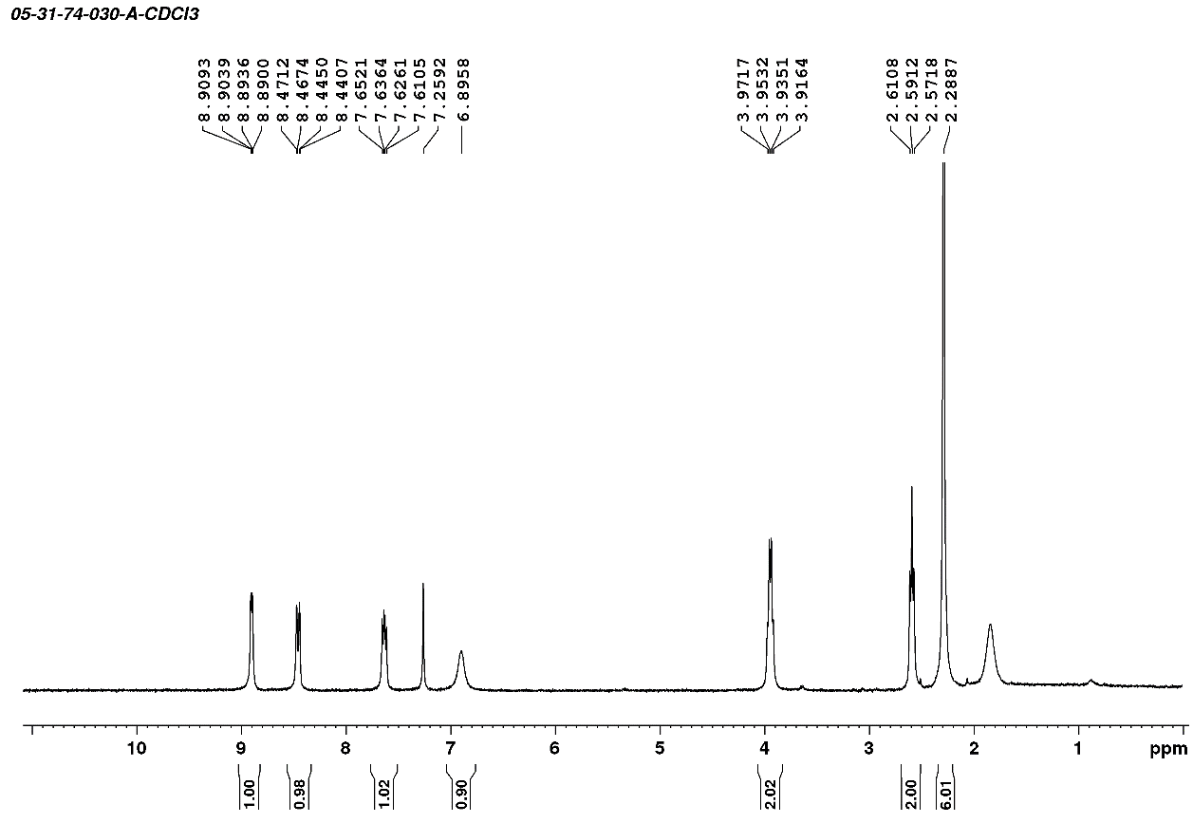
¹H-NMR spectrum of compound D11a

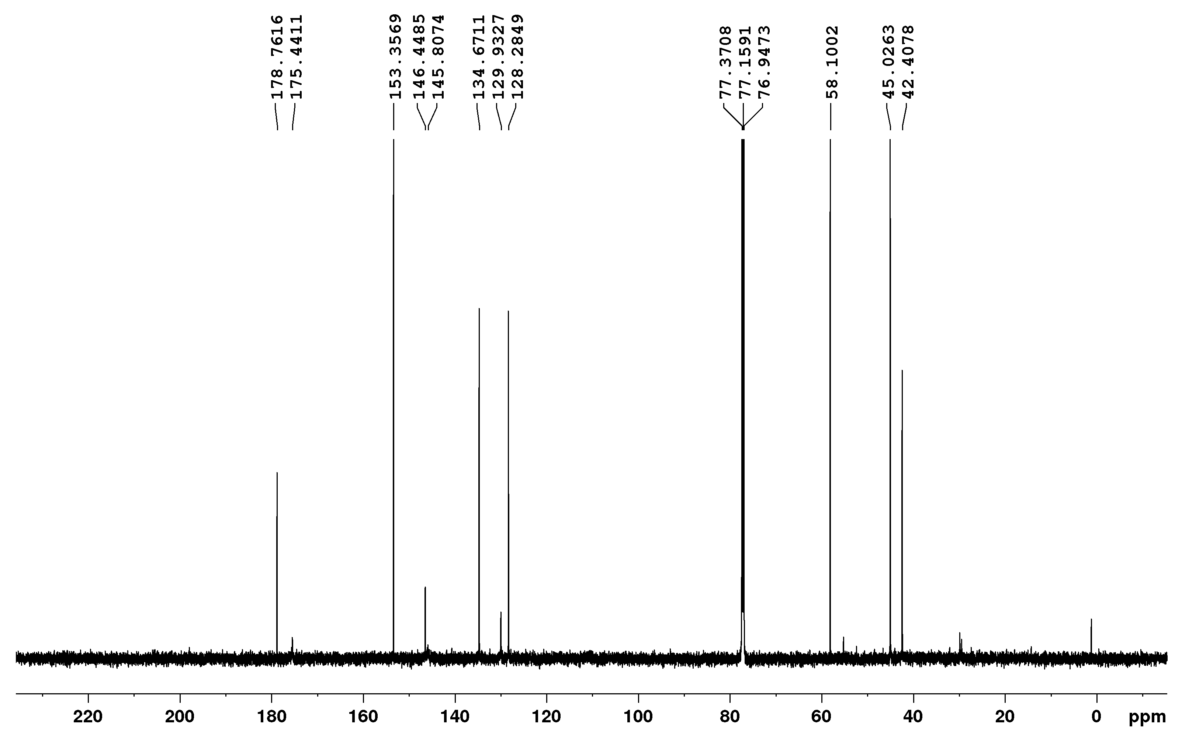
¹³C-NMR spectrum of compound D11a
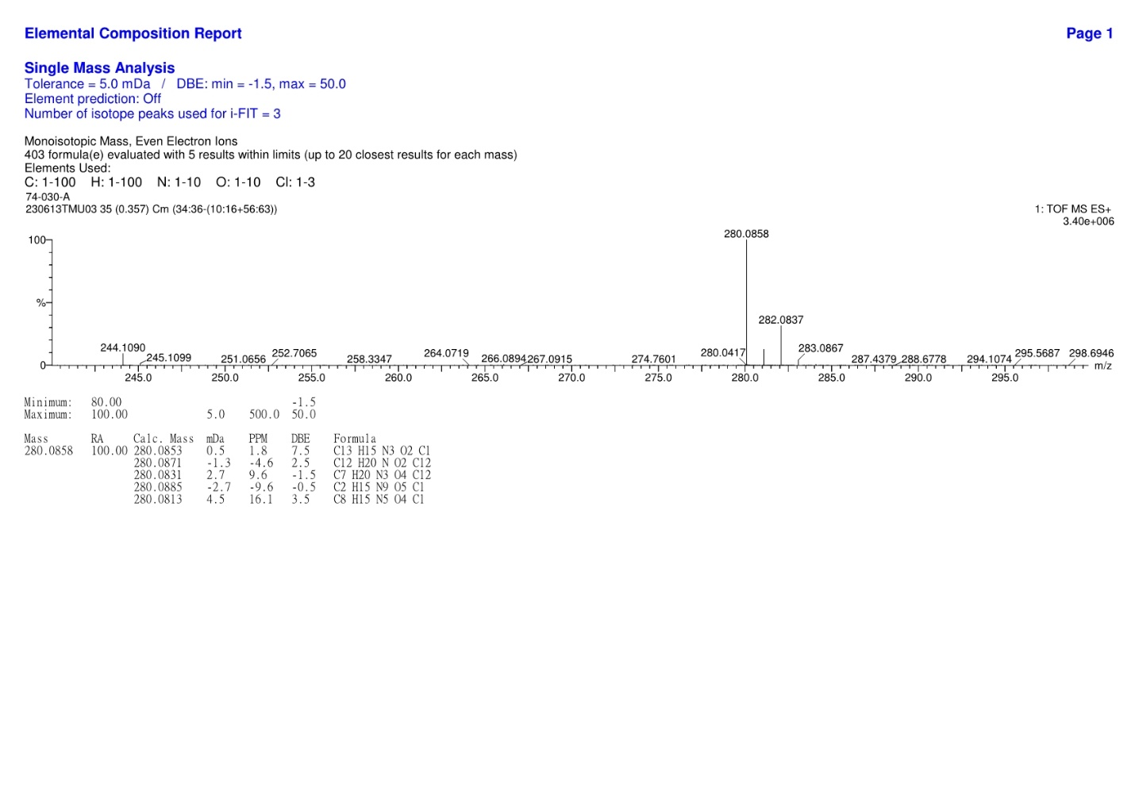
HRMS spectrum of compound D11a

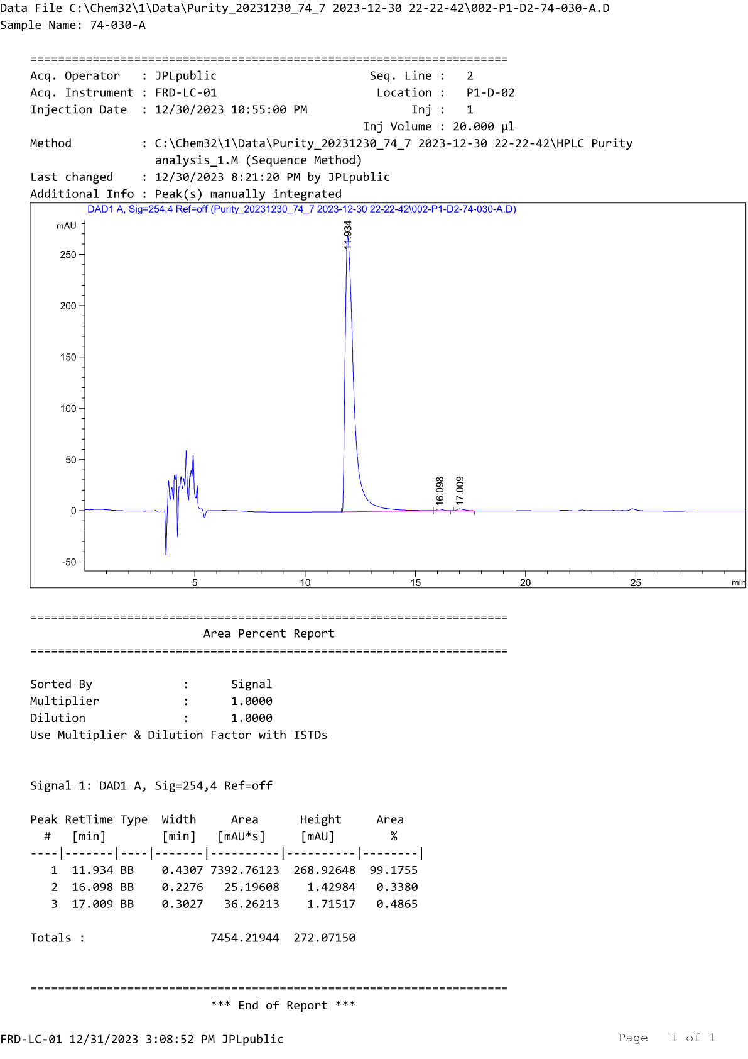
HPLC profile of compound D11a
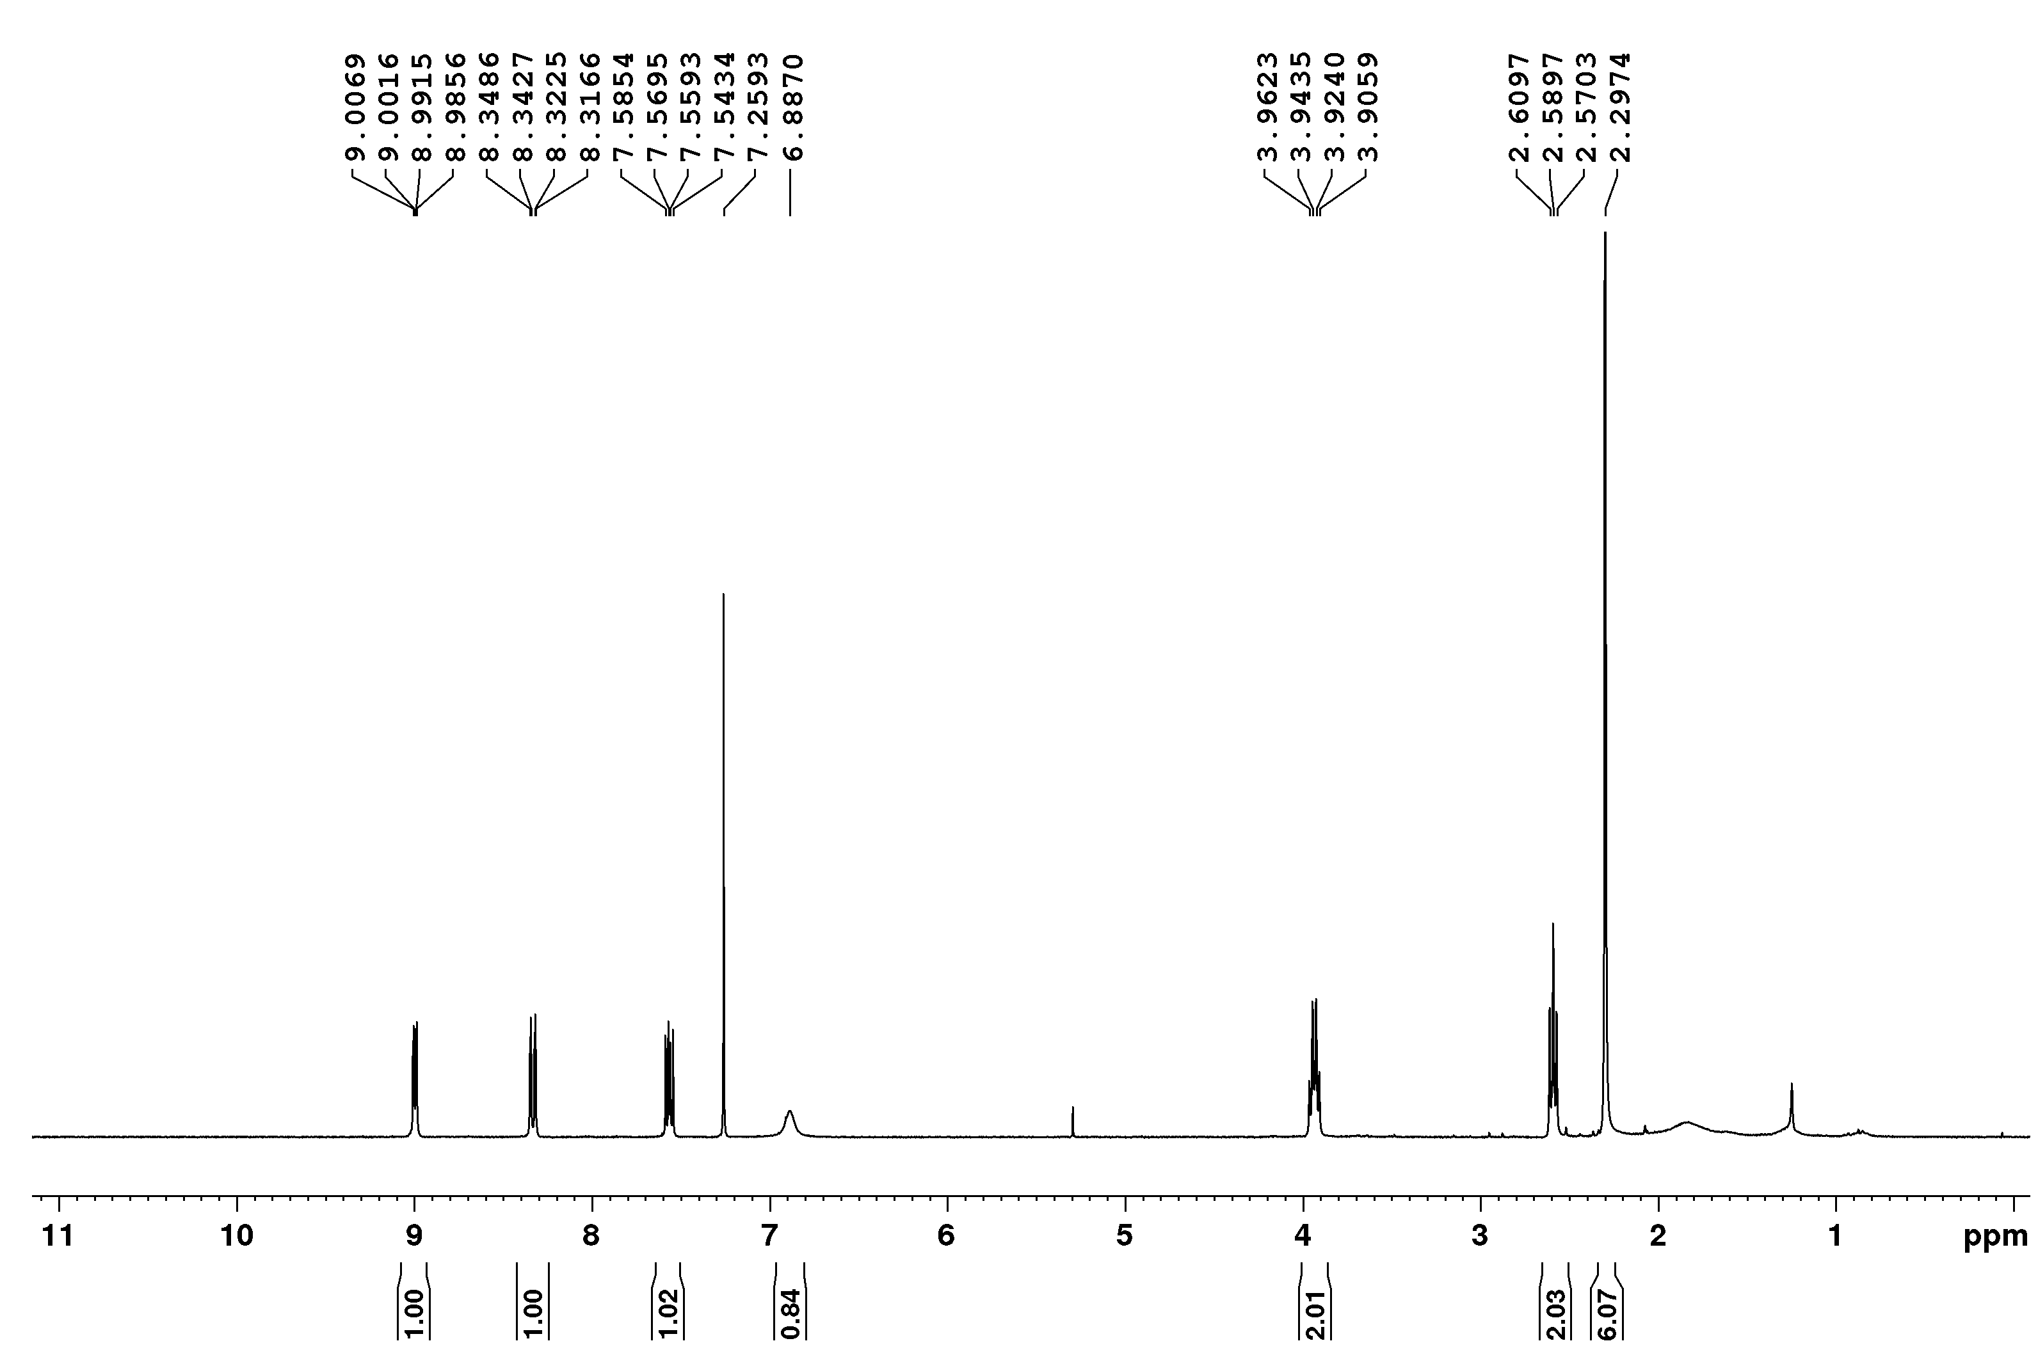
¹H-NMR spectrum of compound D11b

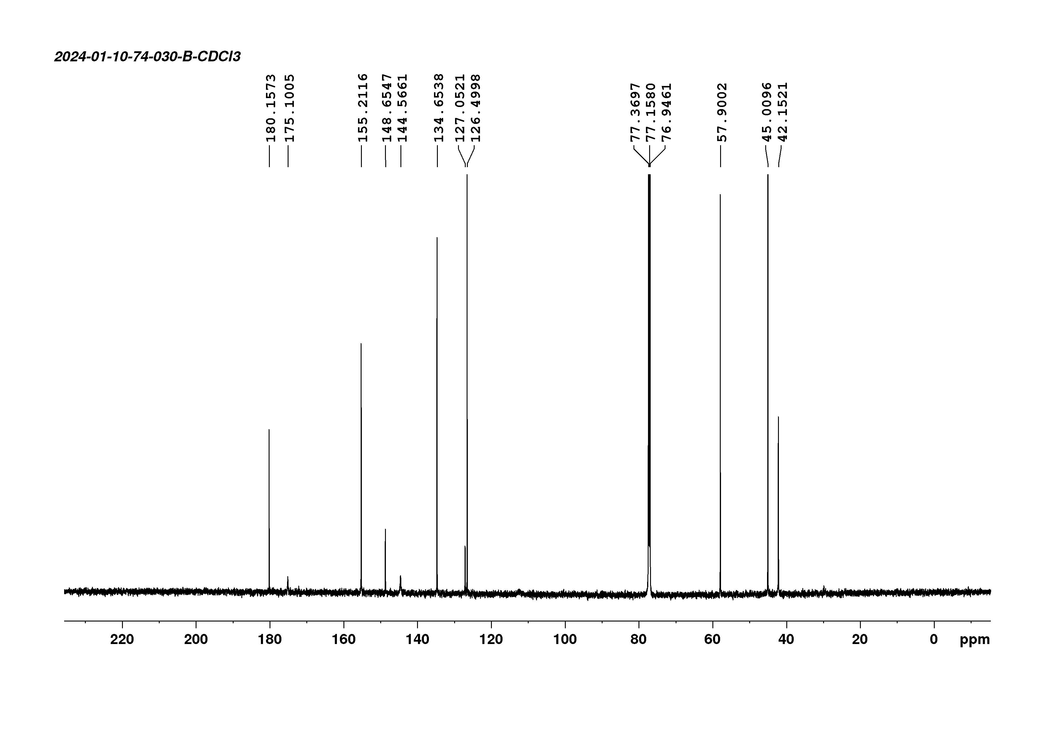
¹³C-NMR spectrum of compound D11b
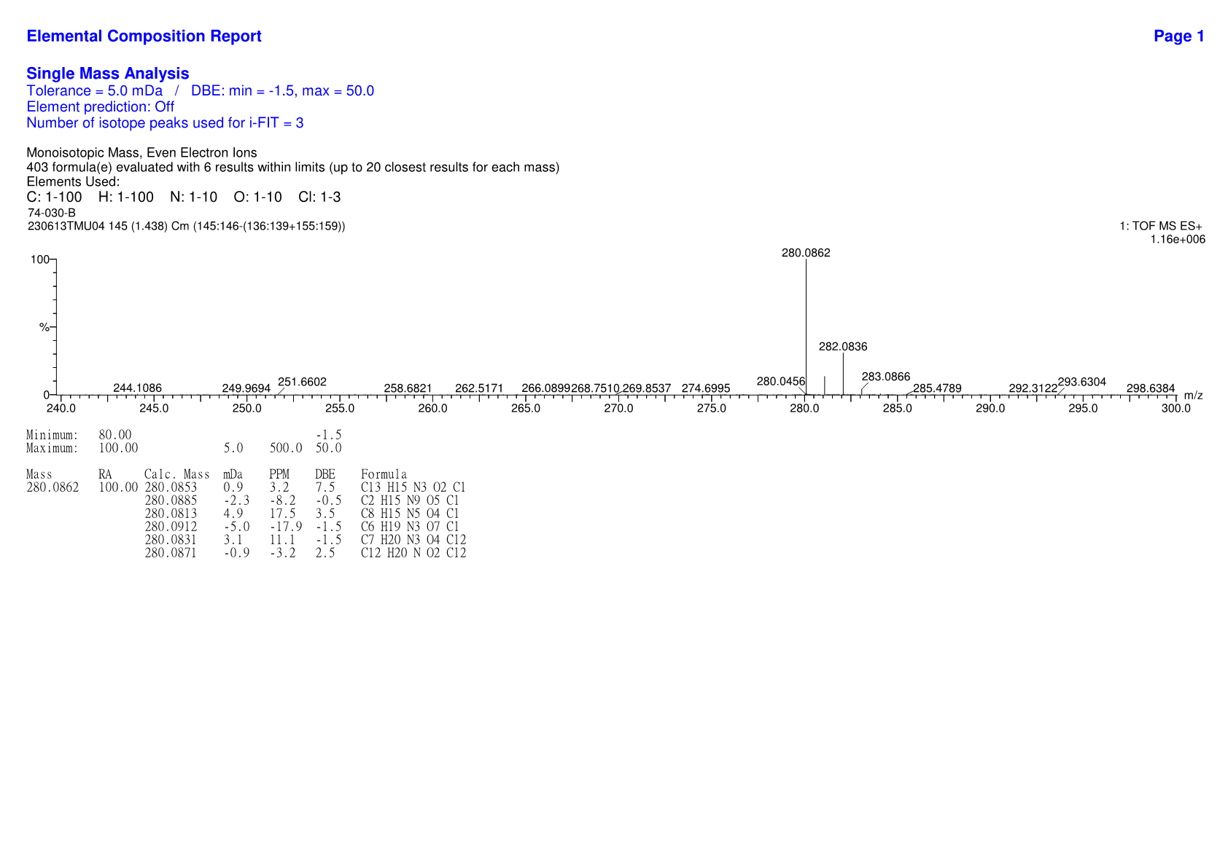
HRMS spectrum of compound D11b

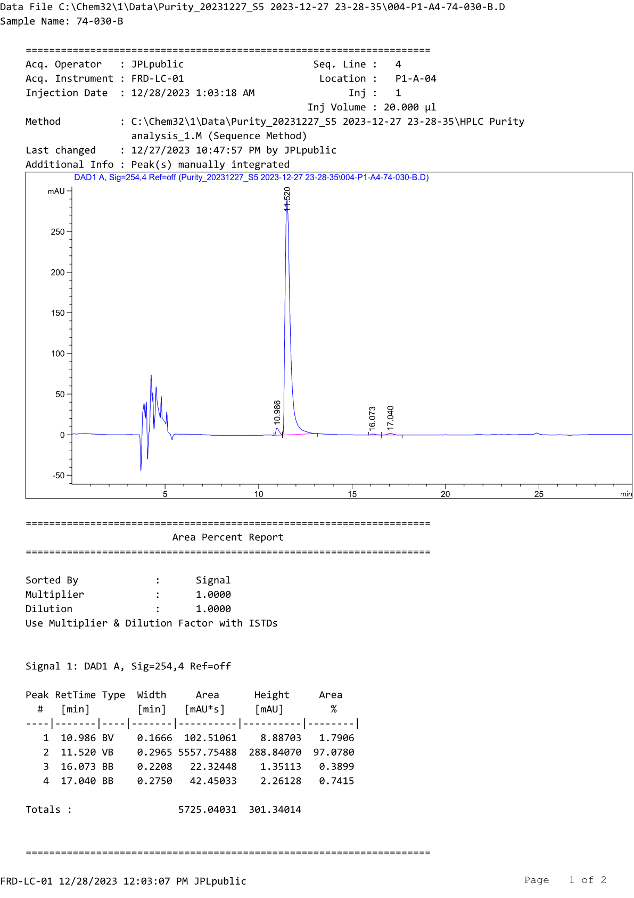
HPLC profile of compound D11b
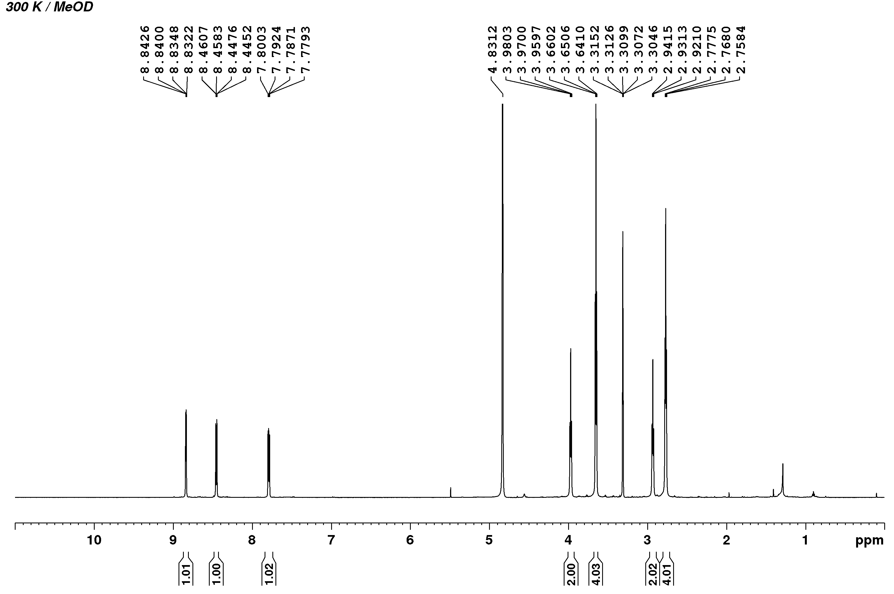
¹H-NMR spectrum of compound D12a

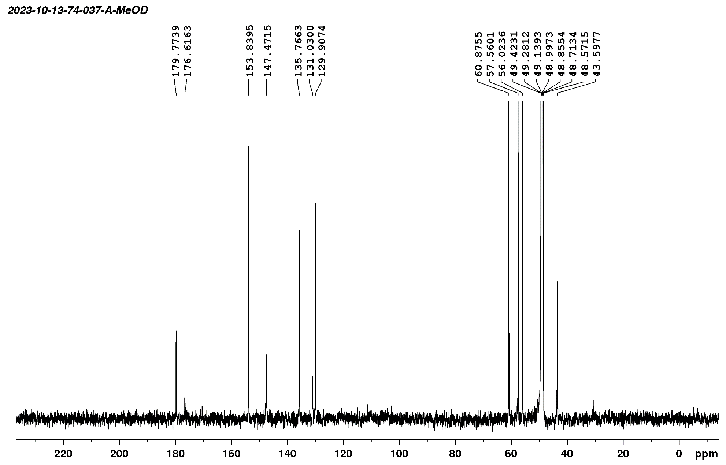
¹³C-NMR spectrum of compound D12a
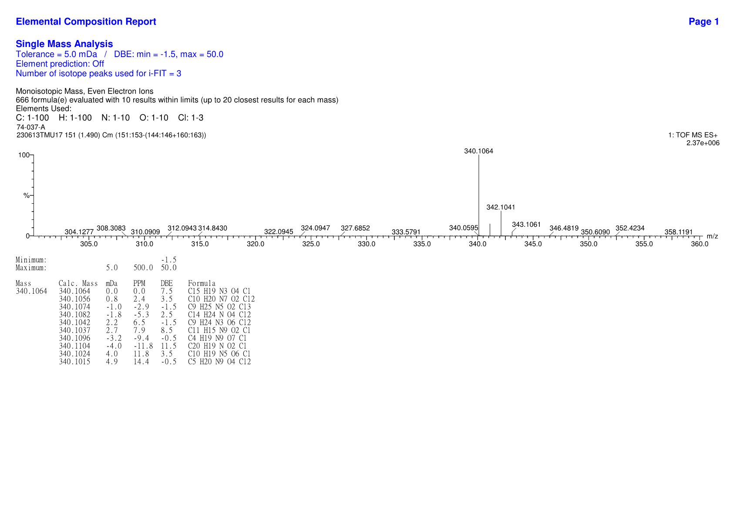
HRMS spectrum of compound D12a

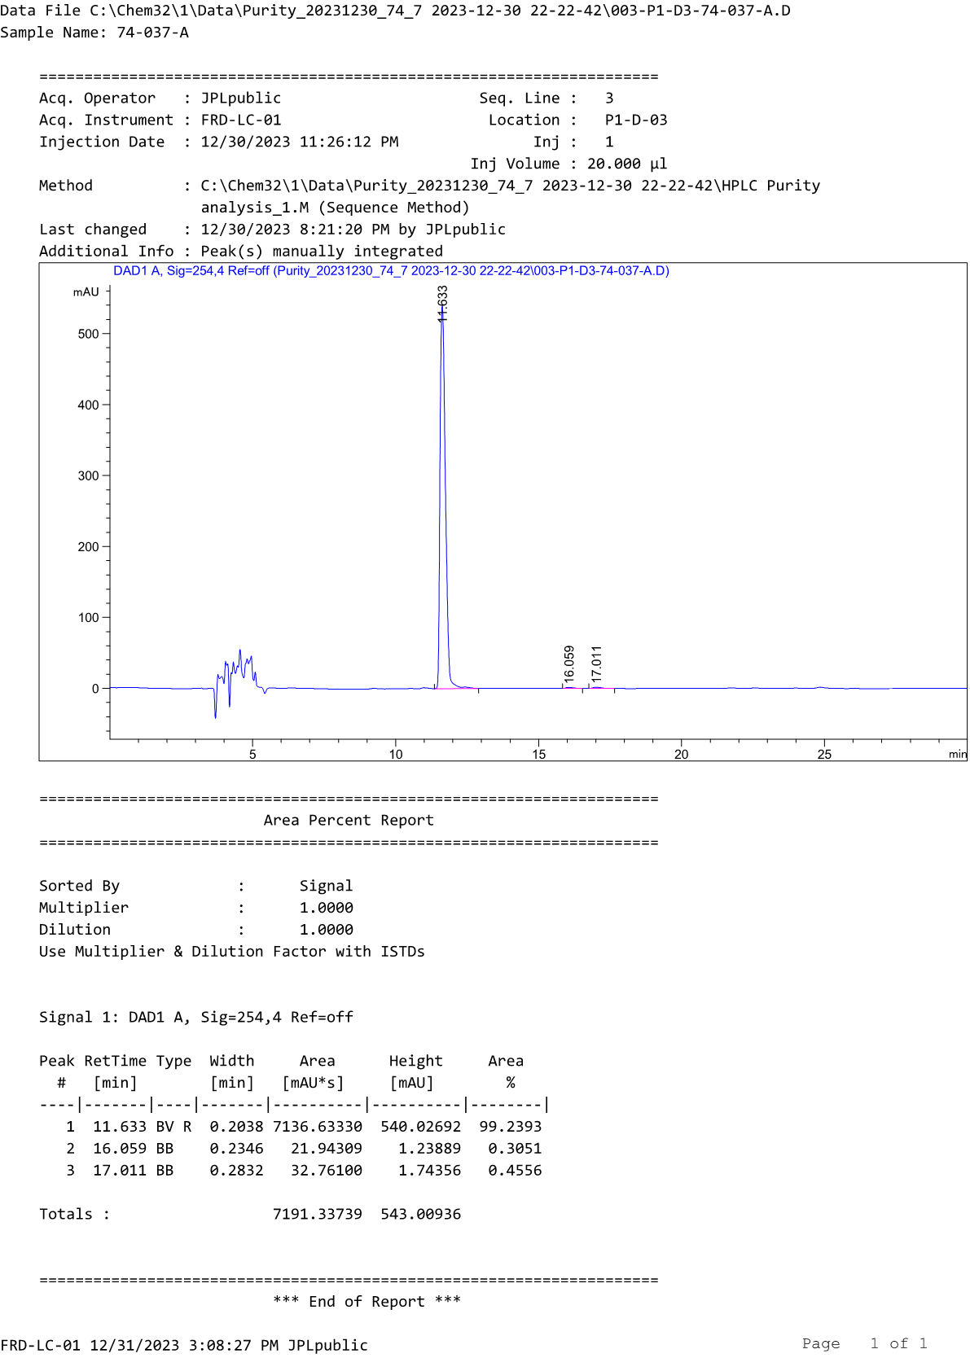
HPLC profile of compound D12a
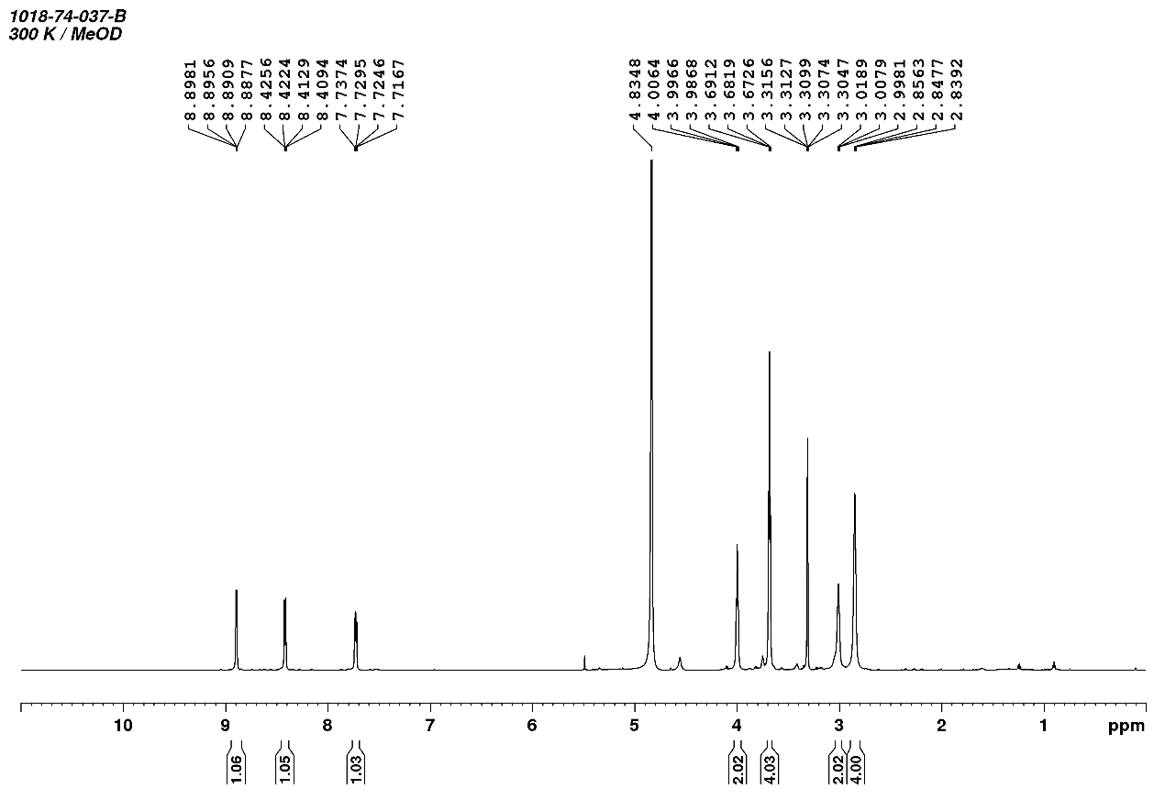
¹H-NMR spectrum of compound D12b

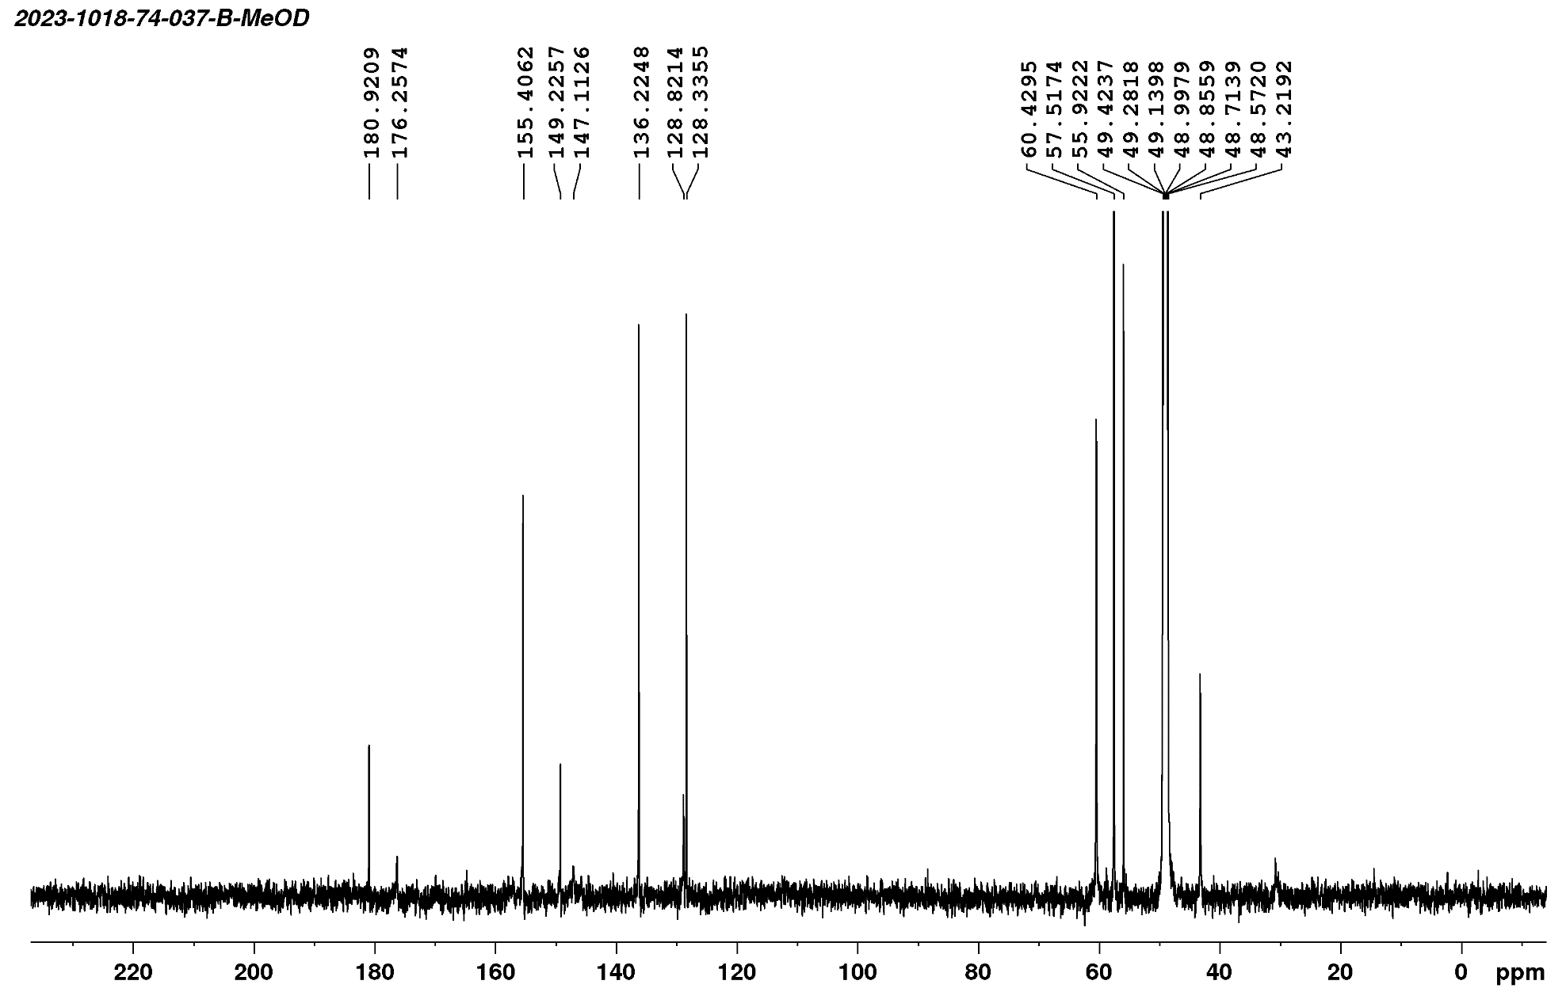
¹³C-NMR spectrum of compound D12b
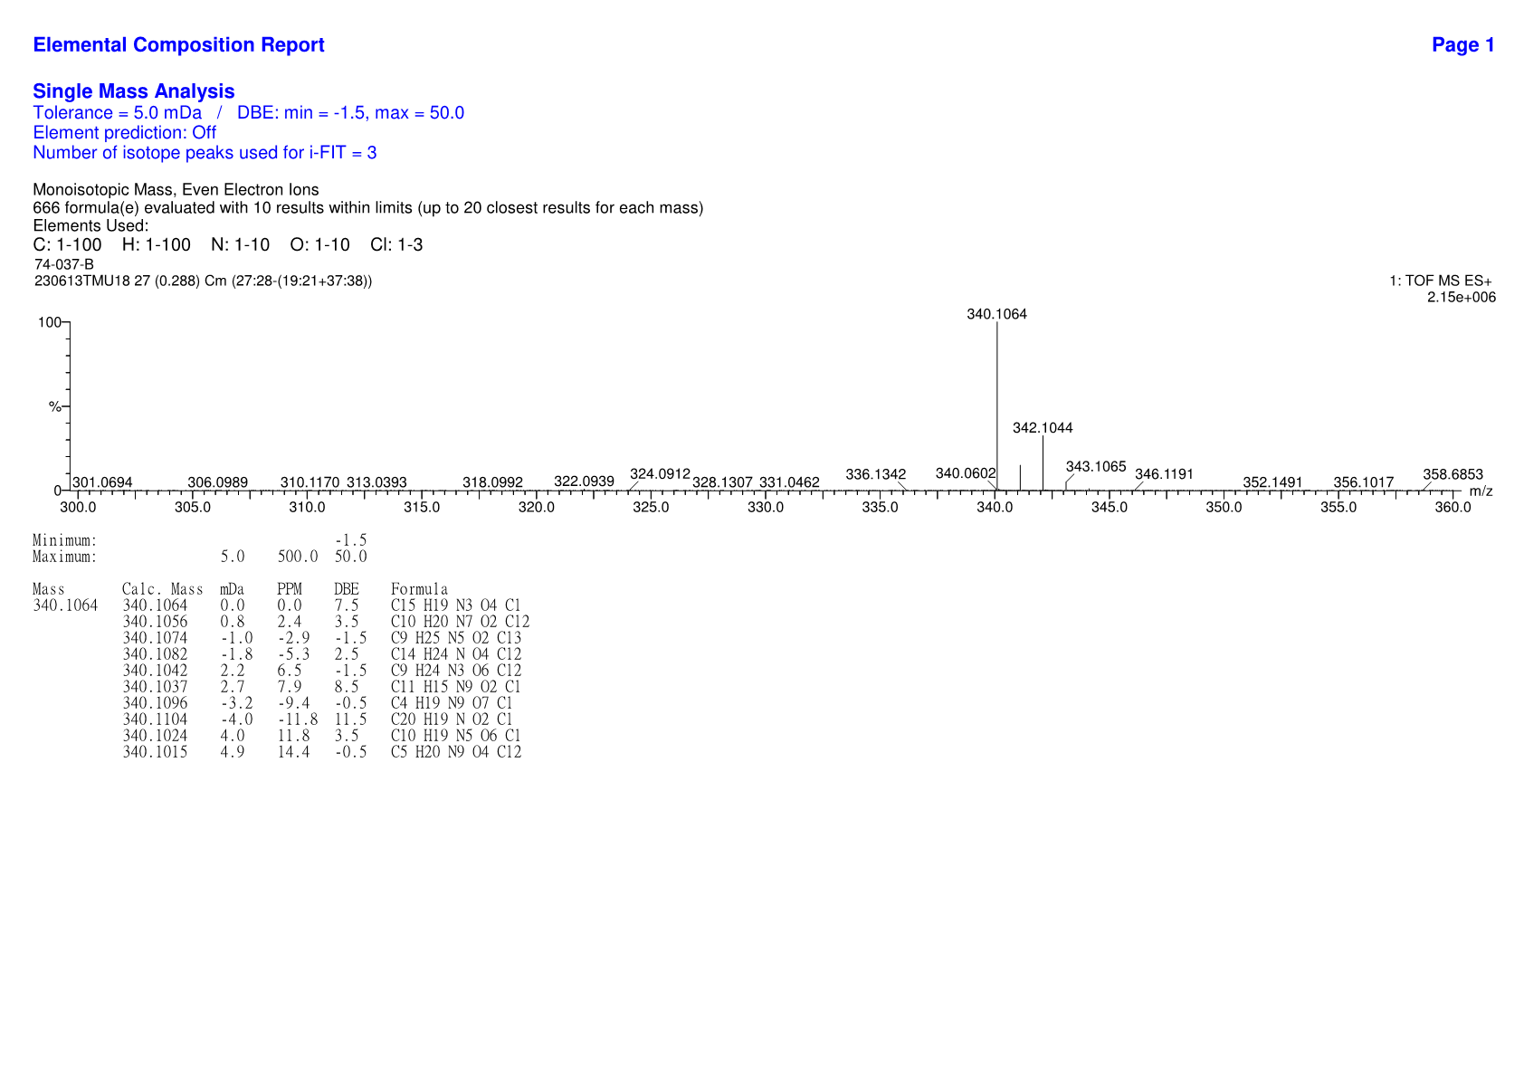
HRMS spectrum of compound D12b

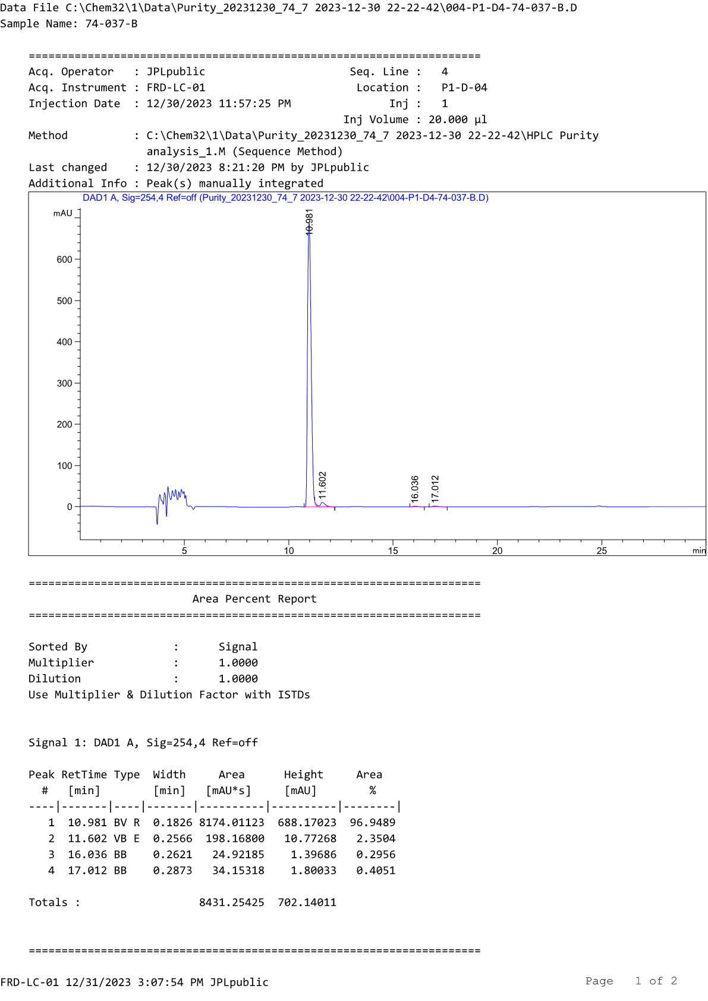
HPLC profile of compound D12b
Table S3. Physicochemical properties, pharmacokinetic properties, and drug-likeness of compounds 6a, 6b, D1b, D3a, D3b, D11a, and D11b calculated using the web-based SwissADME tool
Compounds | Molecular Formula | MW | HBDª | HBA^{b} | RB^{c} | TPSA^{d} (Å²) | ClogP^{e} | SClass^{f} | GIA^{g} | BBBP^{h} | Drug-likeness (#violation)^{i} | Bioavailability Score
6a | C₁₅H₁₆ClN₃O₃ | 321.76 | 1 | 5 | 4 | 71.53 | 1.03 | S | High | No | Yes (0) | 0.55
6b | C₁₅H₁₆ClN₃O₃ | 321.76 | 1 | 5 | 4 | 71.53 | 1.04 | S | High | No | Yes (0) | 0.55
D1b | C₁₅H₁₆ClN₃O₂S | 337.82 | 1 | 4 | 4 | 87.60 | 1.61 | S | High | No | Yes (0) | 0.55
D3a | C₁₇H₂₀ClN₃O₂ | 333.81 | 1 | 4 | 4 | 62.30 | 2.18 | S | High | Yes | Yes (0) | 0.55
D3b | C₁₇H₂₀ClN₃O₂ | 333.81 | 1 | 4 | 4 | 62.30 | 2.16 | S | High | Yes | Yes (0) | 0.55
D11a | C₁₃H₁₄ClN₃O₂ | 279.72 | 1 | 4 | 4 | 62.30 | 1.18 | S | High | Yes | Yes (0) | 0.55
D11b | C₁₃H₁₄ClN₃O₂ | 279.72 | 1 | 4 | 4 | 62.30 | 1.2 | S | High | Yes | Yes (0) | 0.55
ª HBD : number of H-bond donors
^{b} HBA : number of H-bond acceptors
^{c} RB : number of rotatable bonds
^{d} TPSA : topological polar surface area
^{e} CLogP : consensus Log P (average of iLOGP, XLOGP3, WLOGP, MLOGP, and Silicos-IT Log P)
^{f} Sclass : ESOL solubility class, S means soluble
^{g} GIA : gastrointestinal absorption
^{h} BBBP : blood-brain barrier permeability.
^{i} Drug-like : drug-likeness indices (bioavailability) from Lipinski, Ghose, Veber, Egan, and Muegge filters.
#Violation : number of violations of the 5 filters.

