Repurposing the Combination Drug of Favipiravir, Hydroxychloroquine and Oseltamivir as a Potential Inhibitor against SARS-CoV-2:A Computational Study
Pooja¹ and Papia Chowdhury ^{1*}
Department of Physics and Materials Science & Engineering, Jaypee Institute of Information Technology, Noida 201309, Uttar Pradesh, India
*Corresponding author:papia.chowdhury@jiit.ac.in

SD1:Various parameters like binding affinity, Hydrogen bonded interaction, dipole moment, dreiding energy, Inhibition constant for the docked structure of F, Hand O with receptor protein 6LU7. Drug Favipiravir represented as F, Hydroxychloroquine represented as H and Oseltamivir represented as O.

Ligand | Binding affinity  (kcal/mol) | Hydrogen bonded interaction (donor - acceptor, distance in Å) (A:6LU7, drug:ligand) | Dreiding energy  (ligand) | Dipole moment of ligand  (Debye) | Inhibition  Constant  (M)  K_{i}=$e^{∆G/KT}$
F | -4.4 | (A:THR24:HN -:F:O, 2.00099)  (A:THR24:HG1 -:F:O,2.30365)  (A:THR25:HN-:F:O,2.82701)  (:F:H -:A:CYS22:O,2.76702)  (:F:H -:A:THR25:OG1, 2.39306)  (:F:H -:A:VAL42:O, 2.80565)  (:F:H -:A:CYS44:O, 2.54365)  (:F:H -:A:ILE43:O,2.72896) | 53.0 | 2.437 | 5.9×10⁻⁴
H | -4.8 | (:H:N -:A:GLU166:O, 3.23748)  (:H:O -:A:MET165:SD, 3.61818)  (:H:O -:A:ARG188:O, 3.29008)  (:H:C -:A:THR190:O, 3.59348) | 332.8 | 2.461 | 3×10⁻⁴
O | -5.1 | (A:SER144:HG -:O:O, 2.34364)  (:O:N -:A:GLN189:OE1 , 3.27562  (:O:O -:A:LEU141:O, 3.23335)  (:O:O -:A:CYS145:SG,3.47153) | 327.4 | 1.308 | 1.8×10⁻⁴

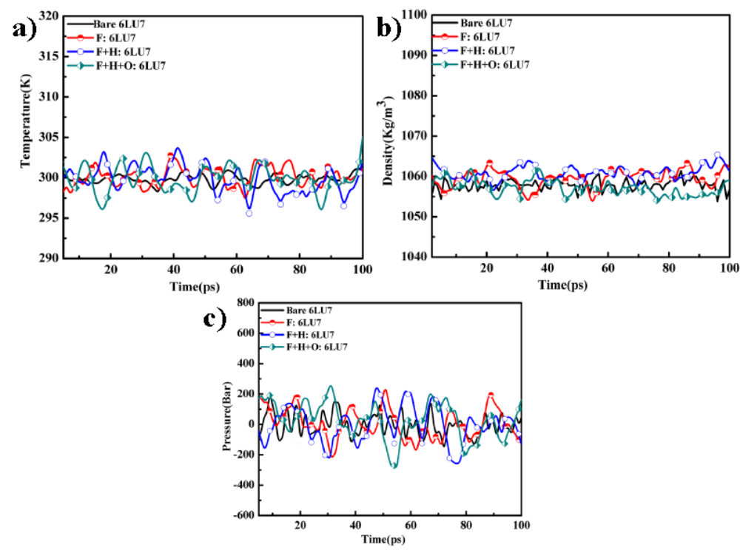
SD: 2a), b), c) Temperature, Density and Pressure computed data for protein 6LU7in its bare state, F:6LU7, F+H:6LU7, F+H+O:6LU7 complex.

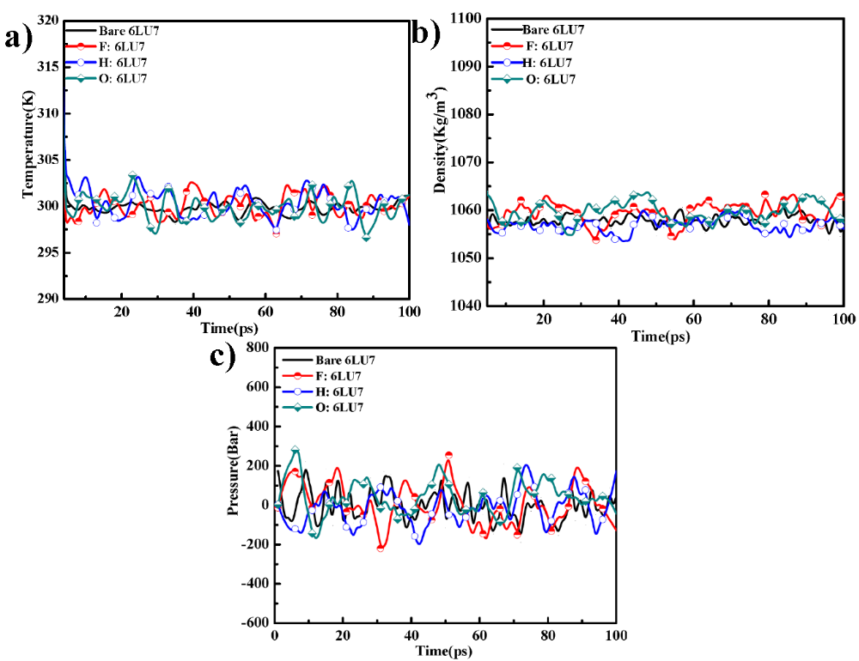

SD3:a), b), c) Temperature, Density and Pressure computed data for protein 6LU7 in its bare state and F:6LU7, H:6LU7, O:6LU7 complex.

SD 4:Data obtained by MD simulations for protein 6LU7 in its bare state and for theF:6LU7, H:6LU7 and O:6LU7 complex structure.
S. No. | Parameter | Bare 3CLpro protease (6LU7) |  | F:6LU7 |  | H:6LU7 |  | O:6LU7
S. No. | Parameter | Mean | Range | Mean | Range | Mean | Range | Mean | Range
MD Simulation Result
1. | SR Columbic Interaction Energy (Kcal /mol) | NA | NA | -11.6 | 0--30 | -10.4 | 0- -40 | -2.6 | 0- -40
2. | SR LJ Interaction Energy (Kcal/ mol) | NA | NA | -20.3 | 0- -30 | -53.6 | 0 - -70 | -20.4 | 0- -40
3. | RMSD (nm) | 0.22 | 0.13-0.32 | 0.25 | 0.10-0.40 | 0.23 | 0.23-0.24 | 0.23 | 0.09-0.48
4. | Inter H-Bonds | NA | NA | 5 | 0-9 | 3 | 0-5 | 2 | 0-3
5. | Radius of gyration | 2.18 | 2.13-2.24 | 2.21 | 2.20-2.21 | 2.21 | 2.20-2.22 | 2.2 | 2.16-2.4
6. | SASA (nm²) | 30-35 | 33 | 7-9 | 8 | 7.3-9 | 8.2 | 6.5-9 | 8
MM/PBSA Results
7. | Potential Energy (kcal/mol) | -0.30×10⁶$±$8.8 | -7.0×10⁵ - -1.3×10⁶ | -0.1×10⁶$±$4.94 | -3.4×10⁴ - -2.8×10⁵ | -0.1×10⁶$±$4.94 | -3.4×10⁴ - -2.8×10⁵ | -0.1×10⁶$±$4.94 | -3.4×10⁴ - -2.8×10⁵
8 | Total energy(Kcal/mol) | -- | -- | -0.47×10⁵ | -- | -0.47×10⁵ | -- | -0.48×10⁵ | --
9 | Enthalpy(Kcal/mol) | -- | -- | -0.47×10⁵ | -- | -0.47×10⁵ | -- | -0.59×10⁵ | --
10. | Binding energy(∆G)(Kcal/mol) | NA | NA | -4.1 | NA | -49.4 | NA | -6.2 | NA
11. | Van der Waal Energy(∆E_{vdw}) (Kcal/mol) | NA | NA | -0.0026 | NA | -58.95 | NA | -5.1 | NA
12. | Electrostatic Energy(∆E_{elec})(Kcal/mol) | NA | NA | -0.003 | NA | -5.00 | NA | -0.48 | NA

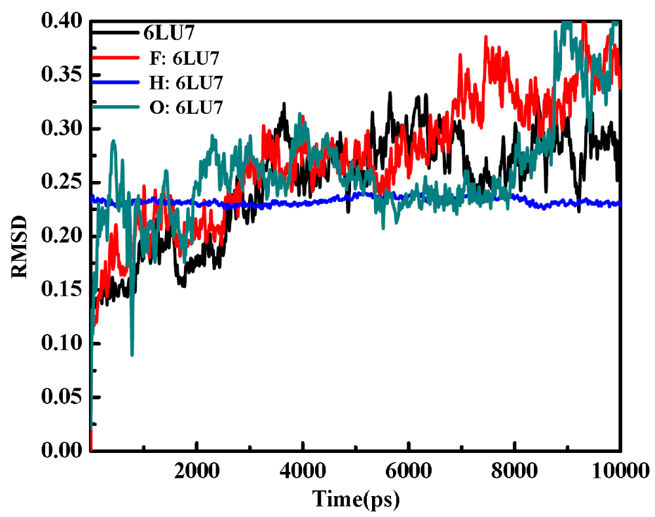
SD 5:Root mean square deviation (RMSD) graphs of receptor protein 6LU7 in its bare state and in F:6LU7, H:6LU7 and O:6LU7complex structure in the full time trajectory up to 10000ps.

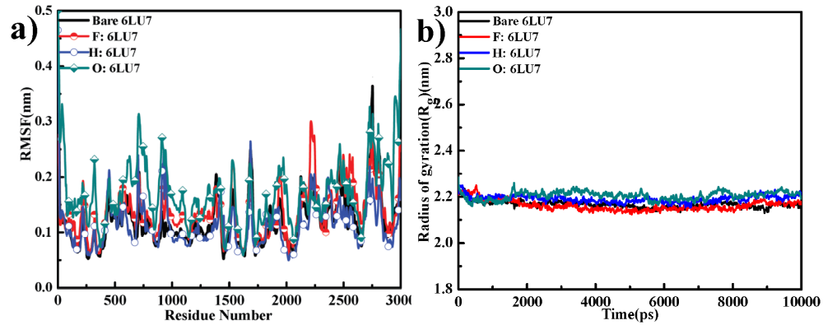
SD 6:RMSF of 6LU7 in its bare state and of complex (F:6LU7, H:6LU7 and O:6LU7) structure, b) R_{g} of 6LU7 in its bare state and of complex (F:6LU7, H:6LU7 and O:6LU7) structure.

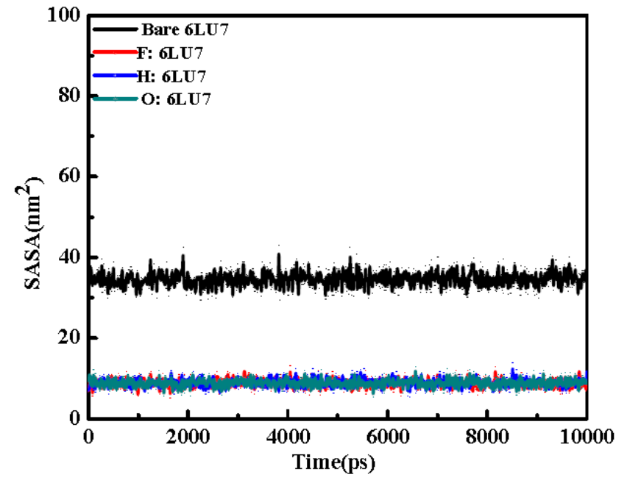
SD 7:SASA area for protein 6LU7 in its bare state and for complex (F:6LU7, H:6LU7, O:6LU7) structure.

