Supplementary Information

Remote-controllable bone-targeted delivery of estradiol for the treatment of ovariectomy-induced osteoporosis in rats
Yuanyuan Guo, Yongwei Liu, Chen Shi, Tingting Wu, Yongzhi Cui, Siyuan Wang, Ping Liu, Xiaobo Feng, Yu He& Dehao Fu
Table S1. Encapsulation efficiency (EE%) and drug loading efficiency (DLE%) of estradiol in PLGA@E₂ NPs, AL-PLGA@E₂ NPs, PEG-PLGA@E₂ NPs and PEG-PLGA-AL@E₂ NPs; data represent the mean and standard deviation (n = 3).
Groups | PLGA@E₂ NPs | AL-PLGA@E₂ NPs | PEG-PLGA@E₂ NPs | PEG-PLGA-AL@E₂ NPs
EE% | 72.01 ± 2.61 | 62.64 ± 7.13 | 64.74 ± 16.55 | 58.31 ± 9.17
DLE% | 1.43 ± 0.05 | 1.24 ± 0.14 | 1.24 ± 0.31 | 1.15 ± 0.18

Table S2. EE% and DLE% of estradiol in PEG-PLGA-AL@E₂ NPs.
Ratio of PLGA and E₂ | 25:0.5 | 25:1 | 25:1.5
EE% | 58.34 ± 9.21 | 40.41 ± 6.82 | 46.41 ± 1.39
DLE% | 1.15 ± 0.18 | 1.72 ± 0.28 | 2.66 ± 0.08

Table S3. The characteristics of PEG-PLGA-AL@ Fe₃O₄/E₂ NPs.
Ratio of PLGA and Fe₃O₄ | 25:0.25 | 25:0.5 | 25:0.75
Diameter/nm | 180.01 ± 3.1 | 181.42 ± 1.2 | 182.03 ± 2.0
PDI | 0.25 ± 0.04 | 0.24 ± 0.01 | 0.25 ± 0.02
Zeta potential/mv | -4.68 ± 0.20 | -4.18 ± 0.80 | -4.66 ± 0.30
E₂ EE% | 67.39 ± 4.41 | 65.78 ± 8.42 | 51.44 ± 9.41
E₂ DLE% | 1.30 ± 0.08 | 1.27 ± 0.16 | 1.00 ± 0.18
Fe₃O₄ EE% | 56.10 ± 6.11 | 57.81 ± 4.63 | 57.42 ± 4.64
Fe₃O₄ DLE% | 0.55 ± 0.06 | 1.12 ± 0.09 | 1.66 ± 0.13

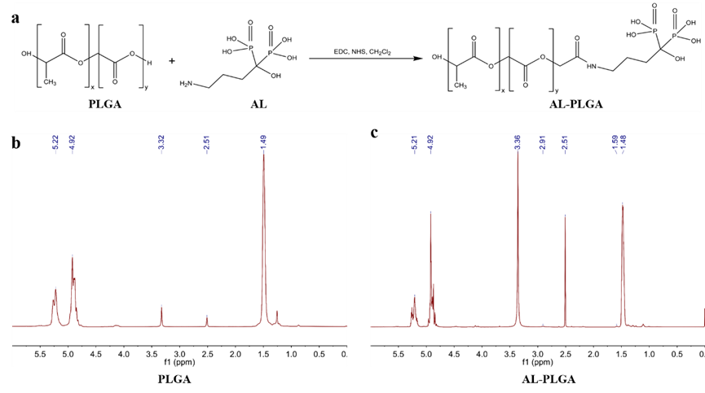
Figure S1. Synthesis of AL-PLGA. Synthetic scheme (a) and associated ¹H-NMR spectra of PLGA (b) and AL-PLGA (c) (600 MHz, DMSO-d6).
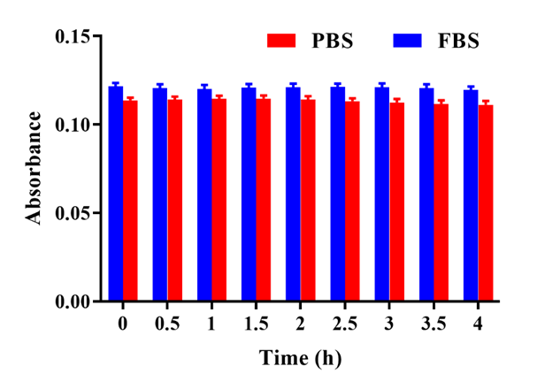
Figure S2. In vitro particle stability assay of PEG-PLGA-AL@Fe₃O₄/E₂ NPs in 1×PBS or FBS (n = 3).

Figure S3. The effect of NPs on WBC, RBC, HGB and PLT at end of study (week 13). No significant differences were found between treatment groups (P > 0.05, n = 8). Treatment groups TG1: OVX, TG2: free E₂, TG3: PLGA@E₂ NPs, TG4: AL-PLGA@E₂ NPs, TG5: PEG-PLGA@E₂ NPs, TG6: PEG-PLGA-AL@E₂ NPs, TG7: PEG-PLGA-AL@Fe₃O₄ NPs, TG8: PEG-PLGA-AL@Fe₃O₄/E₂ NPs, TG9: PEG-PLGA-AL@Fe₃O₄/E₂ NPs +MF.
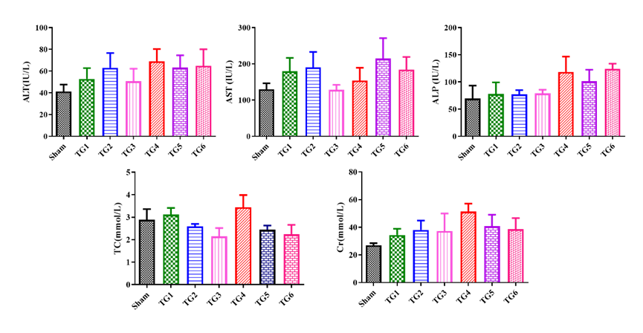
Figure S4. The effect of NPs on ALT, AST, ALP, Cr and TC in sham and OVX rats at end of study (week 13). No significant differences were found between treatment groups (P > 0.05, n = 8). ALT: alanine aminotransferase, AST: aspartate aminotransferase, ALP: alkaline phosphatase, Cr: creatinine, TC: total cholesterol. Treatment groups TG1: OVX, TG2: free E₂, TG3: PLGA@ E₂ NPs, TG4: PEG-PLGA@E₂ NPs, TG5: PEG-PLGA-AL@E₂ NPs, TG6: PEG-PLGA-AL@Fe₃O₄/E₂ NPs.

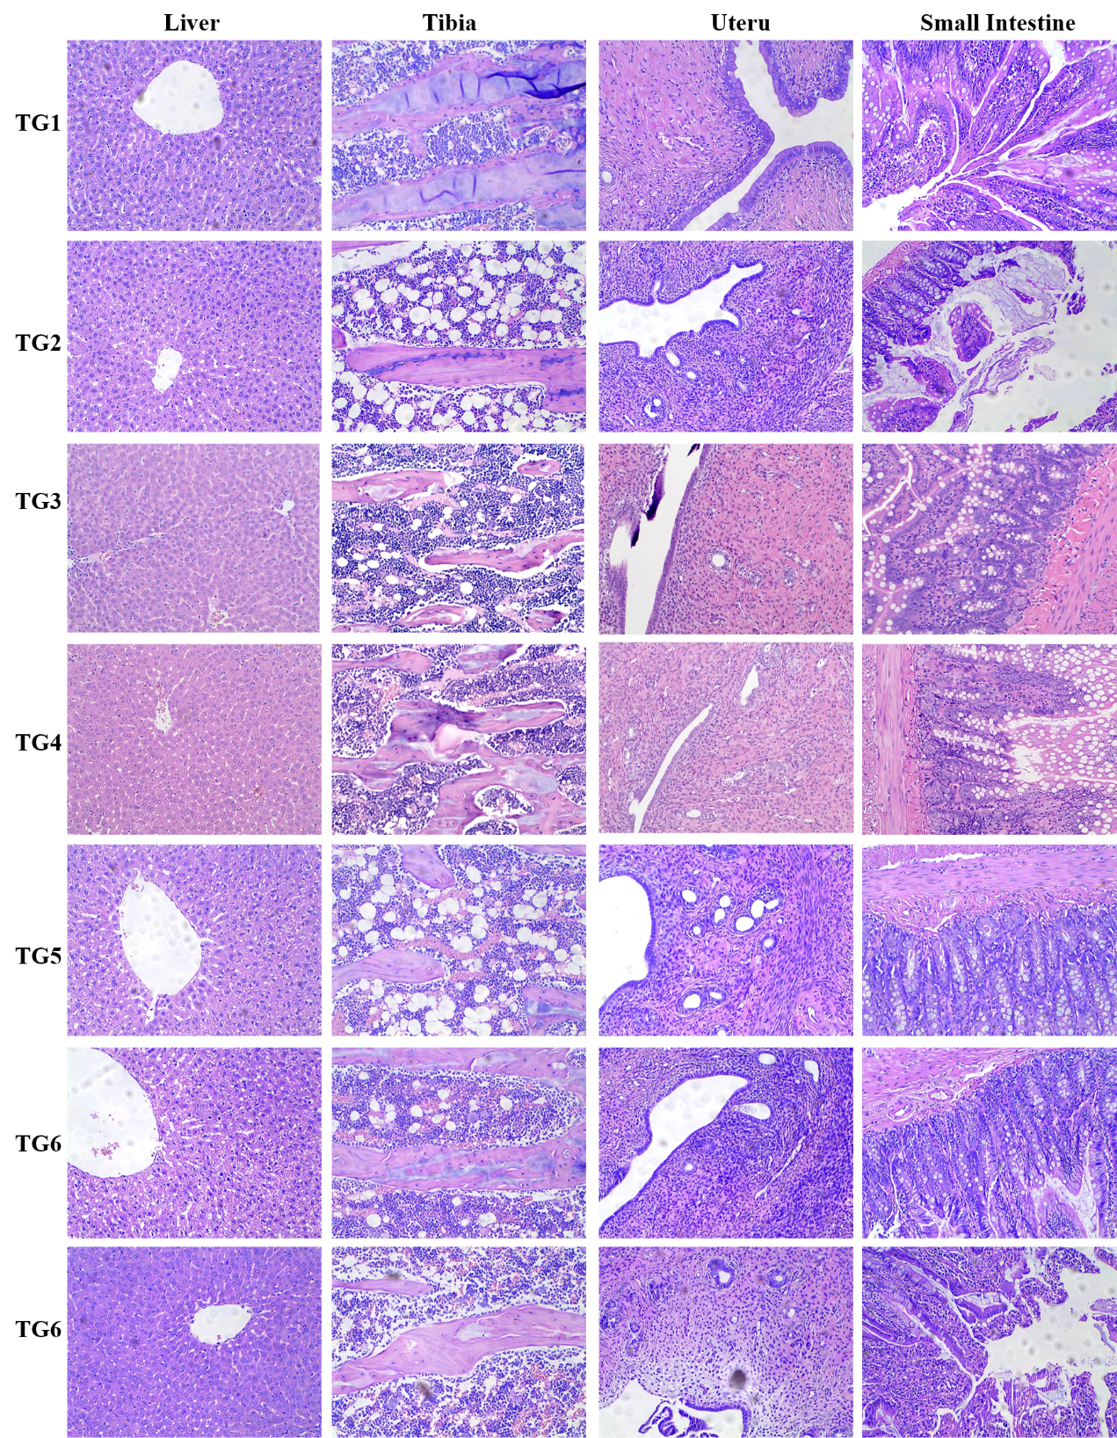
Figure S5. Sections of main organs were obtained and stained with H&E. Treatment groups TG1: OVX, TG2: free E₂, TG3: PLGA@ E₂ NPs, TG4: PEG-PLGA @ E₂ NPs, TG5: PEG-PLGA-AL@E₂ NPs, TG6: PEG-PLGA-AL@Fe₃O₄/ E₂ NPs.

