Supplementary Data
Design and evaluation of fast-release glucose granules for self-management of hypoglycemia
Nabeel Ahmed* ª, Muhammad Arslan Liaqat ª, Fasih-ur-Rehman ª, Ibrar Afzal ª, Jawaria Jabeen ª Dr. Mulazim Hussain Asim ^{b}
ª College of Pharmacy, University of Sargodha, Pakistan.
^{b} Lecturer, College of Pharmacy, University of Sargodha, Pakistan
* Corresponding author

Table S1. Flow properties of granules
Sr No. | Bulk Vol.  (ml) | Tapped Vol.  (ml) | Bulk Density(g/cm3) | Tapped Density (g/cm3 | CI | HR | Angle of Repose
 |  |  |  |  |  |  | d | H | Angle
 |  |  |  |  |  |  | cm | cm | Degree
F1 | 23 | 22 | 0.411 | 0.43 | 4.62 | 1.05 | 8.56 | 1.7 | 21.66
F2 | 28 | 27 | 0.42 | 0.44 | 4.76 | 1.04 | 8.26 | 1.9 | 24.98
F3 | 37 | 36 | 0.38 | 0.39 | 2.63 | 1.02 | 8.70 | 1.9 | 23.59

Figure S1. Comparisons of linear Vs non-linear models for standard curve. A) linear fit, B) asymmetrical sigmoid fit with least square method (reported in the study), and C) asymmetrical sigmoid fit with robustness
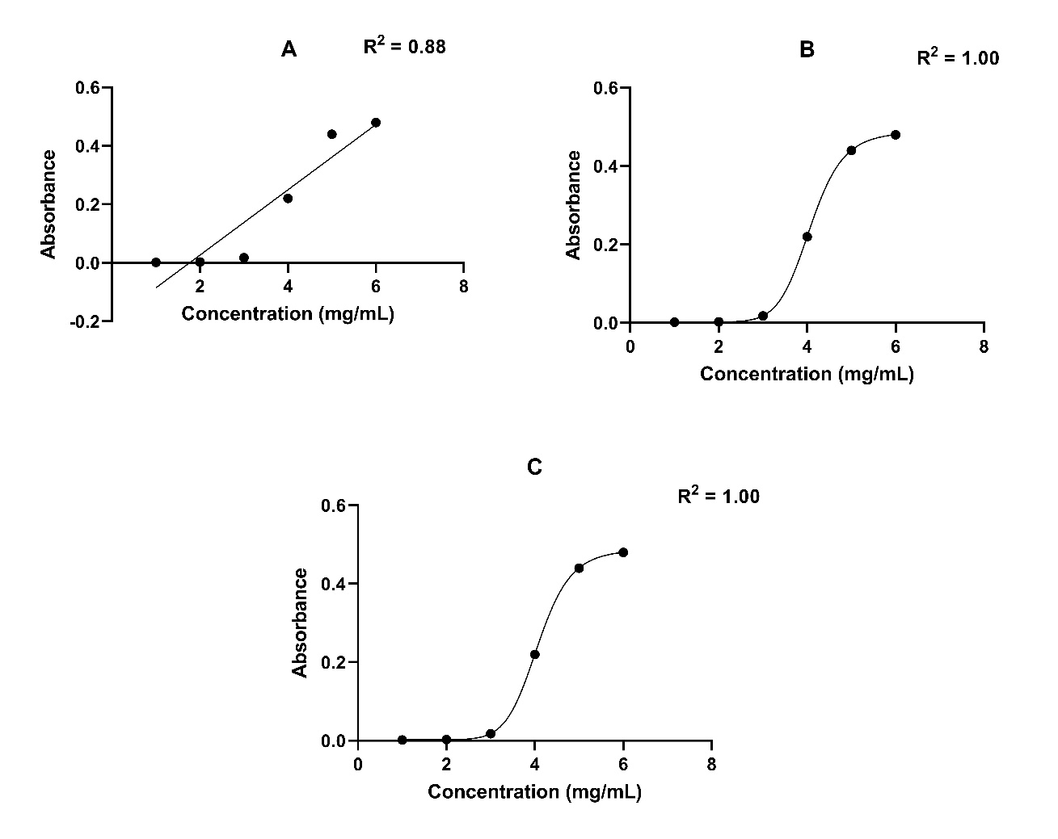

Figure S2. UV-Visible Spectra (A) and peak absorbance of glucose (B)
A  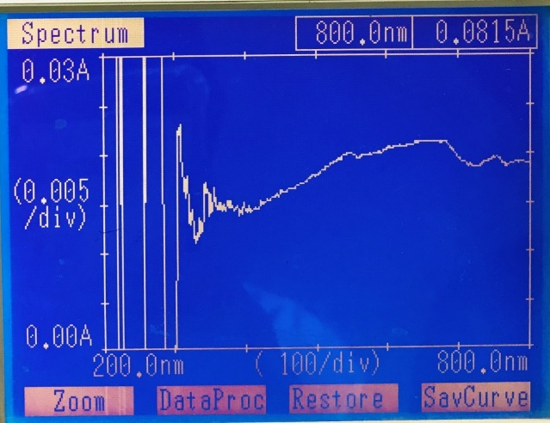 | B  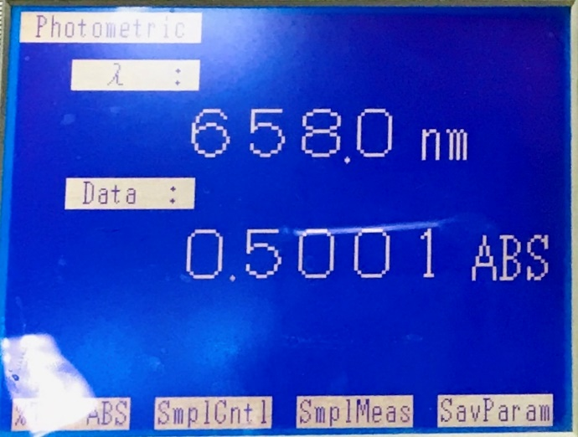

Figure S3. Physical appearance of formulations

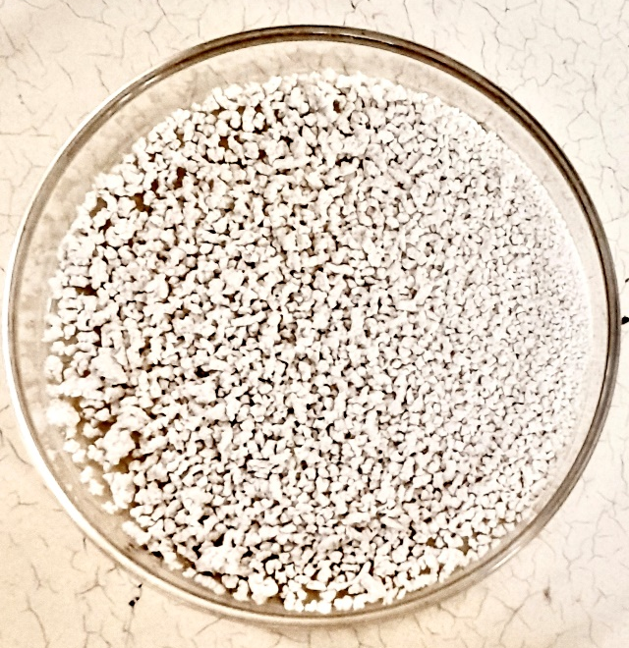Formulation 1 | 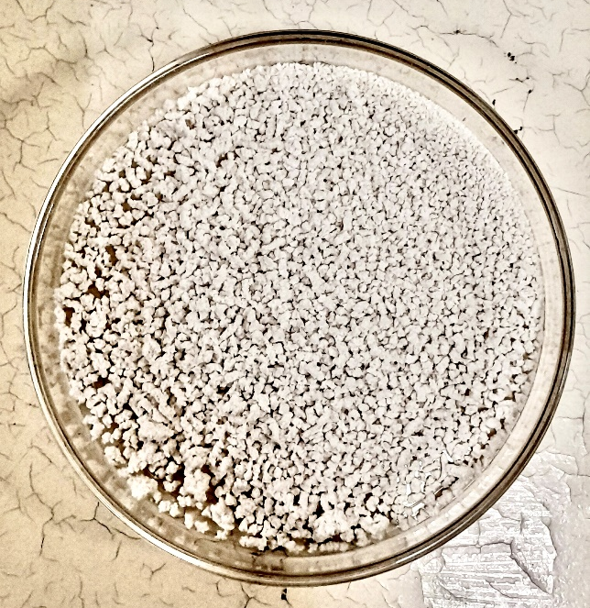Formulation 2
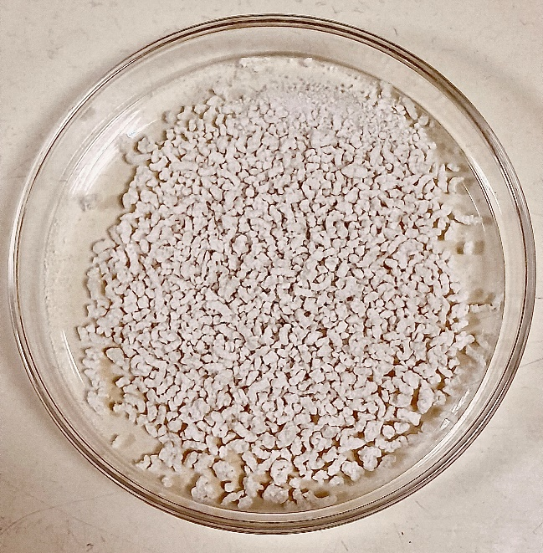

Formulation 3

