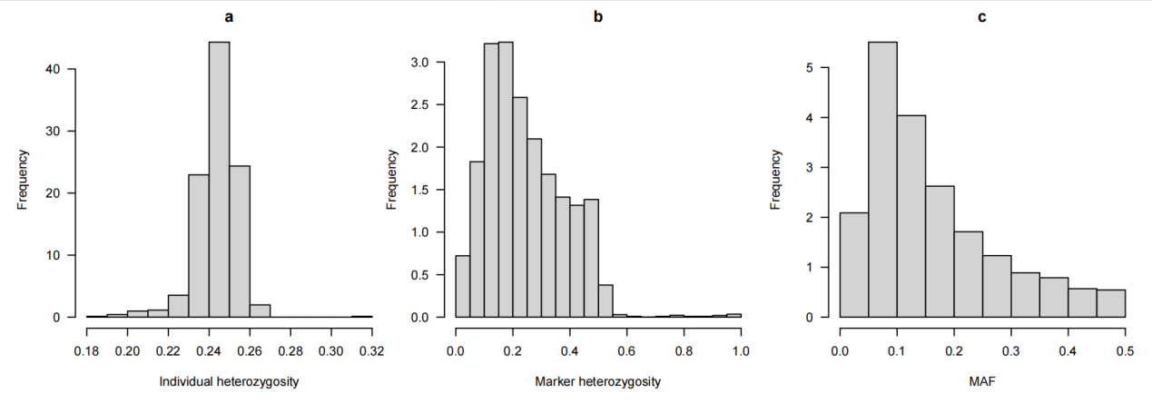
Figure S1. Heterozygosity and Minor Allele Frequency.
This figure shows the frequency distribution of heterozygosity and minor allele frequency (MAF) for yak individuals and genomic markers.
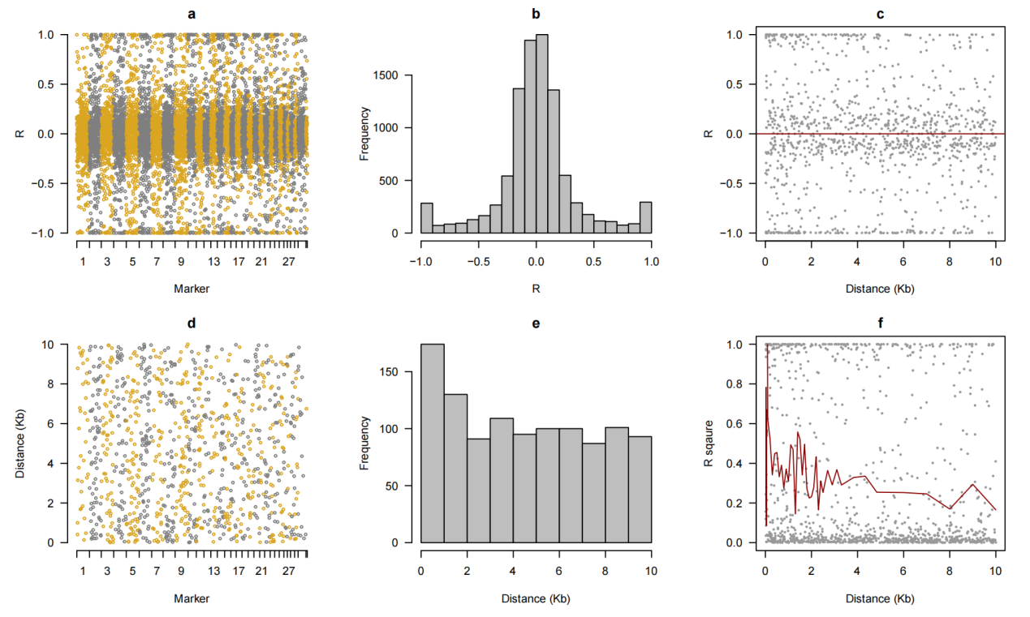
Figure S2.Statistical Analysis of Genomic Marker.
This figure presents a comprehensive statistical analysis of genomic markers, focusing primarily on the correlation between markers and the physical distance between them. It also visualizes the relationship between correlation and distance, with the red curve illustrating the decay trend of R
square with increasing distance.

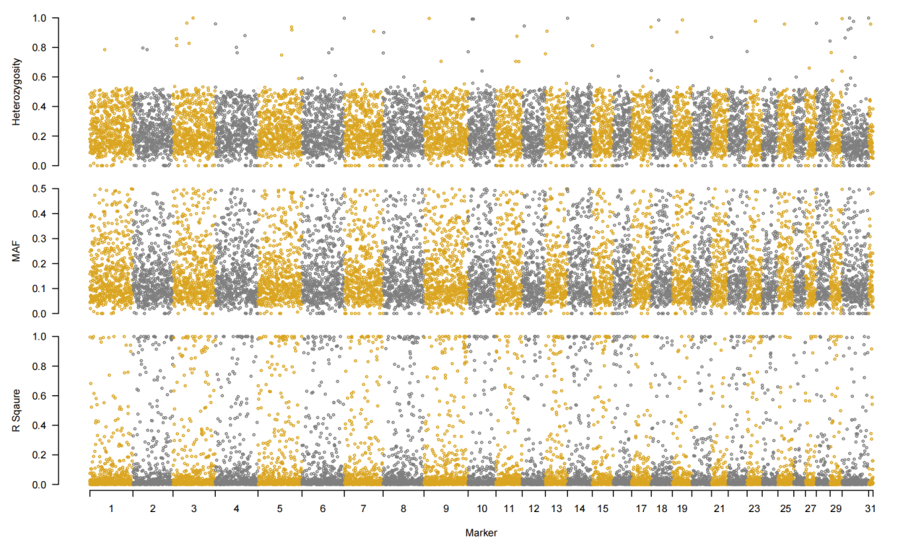
Figure S3. Distribution of Heterozygosity, Minor Allele Frequency, and R² across Marker Loci on the Genome.
This figure shows the distribution of heterozygosity, minor allele frequency (MAF), and R Square across different marker loci in the yak genome. The X-axis represents genomic markers, ranging from Chromosome 1 to Chromosome 31. Each point indicates the value of a genomic marker for a specific characteristic.

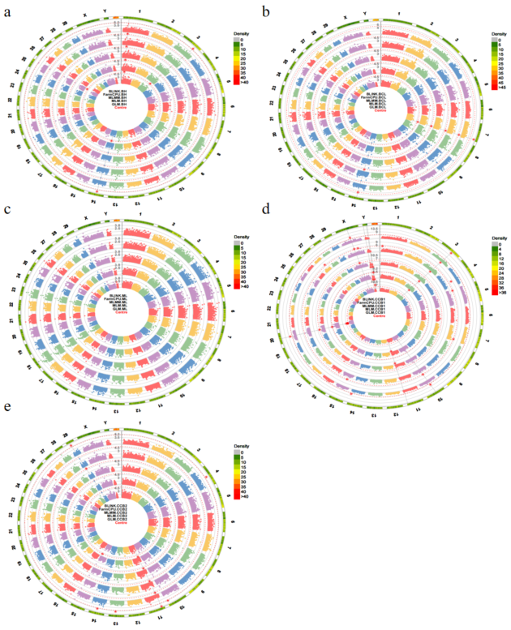
Figure S4. Manhattan plots for the other five body size traits in yaks.
The circular Manhattan plots based on five models identified significant loci associated with the other body size traits in yaks, with the five Manhattan plots corresponding to the body size traits BH, BCL, ML, CC, and CCB2.

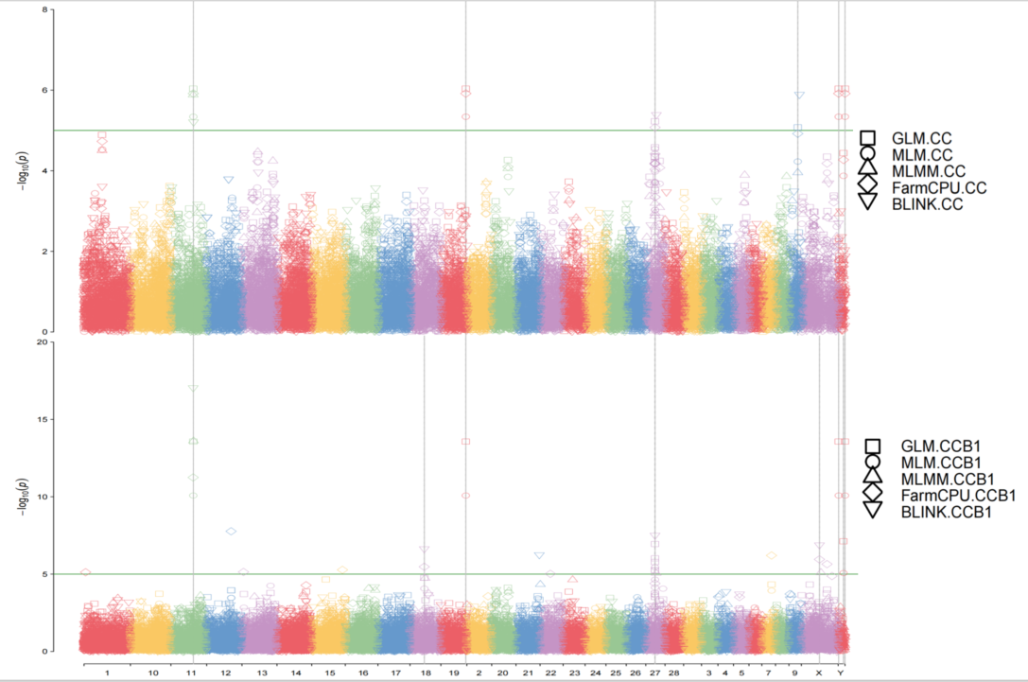
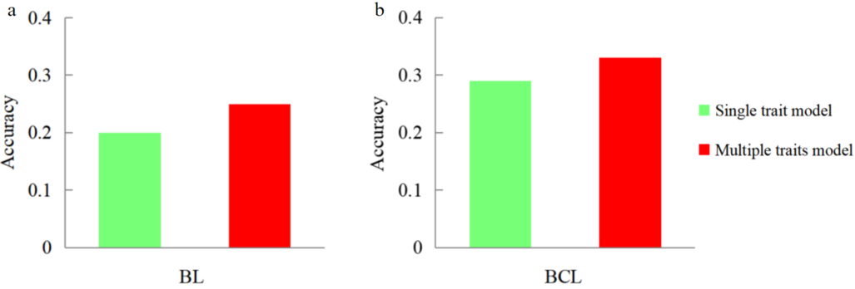
Figure S5. Single and Multiple Trait Model Accuracy for Body Length and Body Canted Length in Yaks.
For single-trait genomic selection, it is consistent with the manuscript. For multi-trait genomic selection, one-fifth of the relative traits will be omitted, and four-fifths of the relative traits will be used to predict the interesting trait.

Table S1. Mean and Standard Deviation of Body Size Traits in Yaks by Age
 | BL | BH | ML | BCL | CCB1 | CC | CCB2
≤2 | 0.738±0.188 | 0.820±0.111 | 0.172±0.028 | 0.784±0.143 | 0.043±0.017 | 0.241±0.056 | 0.047±0.012
3 | 0.734±0.101 | 0.835±0.100 | 0.170±0.030 | 0.801±0.102 | 0.053±0.012 | 0.262±0.052 | 0.045±0.011
4 | 0.764±0.112 | 0.872±0.085 | 0.183±0.040 | 0.832±0.110 | 0.049±0.015 | 0.266±0.049 | 0.047±0.013
5 | 0.763±0.104 | 0.859±0.118 | 0.172±0.028 | 0.830±0.104 | 0.046±0.017 | 0.261±0.055 | 0.045±0.011
6 | 0.802±0.086 | 0.882±0.091 | 0.195±0.036 | 0.876±0.086 | 0.047±0.018 | 0.271±0.073 | 0.045±0.010
7 | 0.785±0.106 | 0.881±0.105 | 0.197±0.037 | 0.860±0.115 | 0.045±0.018 | 0.258±0.059 | 0.046±0.012
8 | 0.798±0.103 | 0.907±0.086 | 0.201±0.029 | 0.886±0.104 | 0.053±0.015 | 0.282±0.054 | 0.043±0.010
9 | 0.811±0.087 | 0.900±0.080 | 0.200±0.032 | 0.887±0.084 | 0.048±0.017 | 0.269±0.057 | 0.044±0.011

This table presents the mean and standard deviation (SD) for various body size traits of yaks at different ages, from 2 to 9 years old. These data provide insights into the development of yak body size traits as they age.

This table presents the mean and standard deviation (SD) for various body size traits of yaks at different ages, from 2 to 9 years old. These data provide insights into the development of yak body size traits as they age.

Age（years）  Trait | BL | BH | ML | BCL | CCB1 | CC | CCB2
2 | 0.738±0.188 | 0.820±0.111 | 0.172±0.028 | 0.784±0.143 | 0.043±0.017 | 0.241±0.056 | 0.047±0.012
3 | 0.734±0.101 | 0.835±0.100 | 0.170±0.030 | 0.801±0.102 | 0.053±0.012 | 0.262±0.052 | 0.045±0.011
4 | 0.764±0.112 | 0.872±0.085 | 0.183±0.040 | 0.832±0.110 | 0.049±0.015 | 0.266±0.049 | 0.047±0.013
5 | 0.763±0.104 | 0.859±0.118 | 0.172±0.028 | 0.830±0.104 | 0.046±0.017 | 0.261±0.055 | 0.045±0.011
6 | 0.802±0.086 | 0.882±0.091 | 0.195±0.036 | 0.876±0.086 | 0.047±0.018 | 0.271±0.073 | 0.045±0.010
7 | 0.785±0.106 | 0.881±0.105 | 0.197±0.037 | 0.860±0.115 | 0.045±0.018 | 0.258±0.059 | 0.046±0.012
8 | 0.798±0.103 | 0.907±0.086 | 0.201±0.029 | 0.886±0.104 | 0.053±0.015 | 0.282±0.054 | 0.043±0.010
9 | 0.811±0.087 | 0.900±0.080 | 0.200±0.032 | 0.887±0.084 | 0.048±0.017 | 0.269±0.057 | 0.044±0.011

Table S1. Mean and Standard Deviation of Body Size Traits in Yaks by Age

Table S2. Estimated Heritability for Body Size Traits in Yaks
Trait | Heritability (%)
BL | 6.5
BH | 14
BCL | 4.1
ML | 2.5
CCB1 | 47.8
CC | 23.5
CCB2 | 22.4
This table summarizes the heritability estimates (expressed as a percentage) for various body size traits in yaks. The heritability values indicate the proportion of phenotypic variance that can be caused by genetic variance, providing the possibility of obtaining desirable traits during selection in breeding.
Table S3. Significant SNP and candidate gene information
SNP No. * | Chr | Position (bp) | Gene ID | Gene Name
S1_32191242 | 1 | 32191242 | ENSBGRG00000000082 | GRIK1
S3_97322275 | 3 | 97322275 | ENSBGRG00000000593 | PRKAA2
S4_65614224 | 4 | 65614224 | ENSBGRG00000001001 | ELMO1
S4_91144655 | 4 | 91144655 | ENSBGRG00000021923 | SEMA3E
S5_6249370 | 5 | 6249370 | ENSBGRG00000001184 | GRIN2B
S6_28171330 | 6 | 28171330 | ENSBGRG00000012752 | CNOT6L
S6_64894237 | 6 | 64894237 | ENSBGRG00000003070 | SMIM14
S7_114182165 | 7 | 114182165 | ENSBGRG00000002267 | MSRA
S7_114275665 | 7 | 114275665 | ENSBGRG00000002267 | MSRA
S10_106316722 | 10 | 106316722 | ENSBGRG00000026688 | SNX9
S11_15246495 | 11 | 15246495 | ENSBGRG00000005875 | LHFPL2
S11_92286727 | 11 | 92286727 | ENSBGRG00000004582 | PTPN21
S13_51683778 | 13 | 51683778 | ENSBGRG00000009791 | ABCC8
S14_43229824 | 14 | 43229824 | ENSBGRG00000013922 | CAMTA1
S20_34062188* | 20 | 34062188 | ENSBGRG00000021795 | gene_source ensembl
S20_34082808* | 20 | 34082808 | ENSBGRG00000022357 | gene_source ensembl
S20_34180196 | 20 | 34180196 | ENSBGRG00000024966 | TCF25
S20_34180196 | 20 | 34180196 | ENSBGRG00000025749 | SPIRE2
S20_34237476 | 20 | 34237476 | ENSBGRG00000024966 | TCF25
S20_34237476 | 20 | 34237476 | ENSBGRG00000026229 | FANCA
S25_48455758 | 25 | 48455758 | ENSBGRG00000007473 | EEF1AKMT2
SX_61170346 * | X | 61170346 | ENSBGRG00000020130 | gene_source ensembl
SX_94995867 | X | 94995867 | ENSBGRG00000021471 | CACNA1F

* SNP No. indicates the sequence number in the entire tag list. Chromosomes and locations refer to physical location information in genomic data. The gene names are annotated from the GTF file of the Bosgru_v3.0 reference genome. The significant loci marked with an asterisk (*) in the upper right corner were not annotated with gene names in yak, but were annotated with gene names in species such as Orcinus orca and Ovis aries.

