Supplementary Figures:
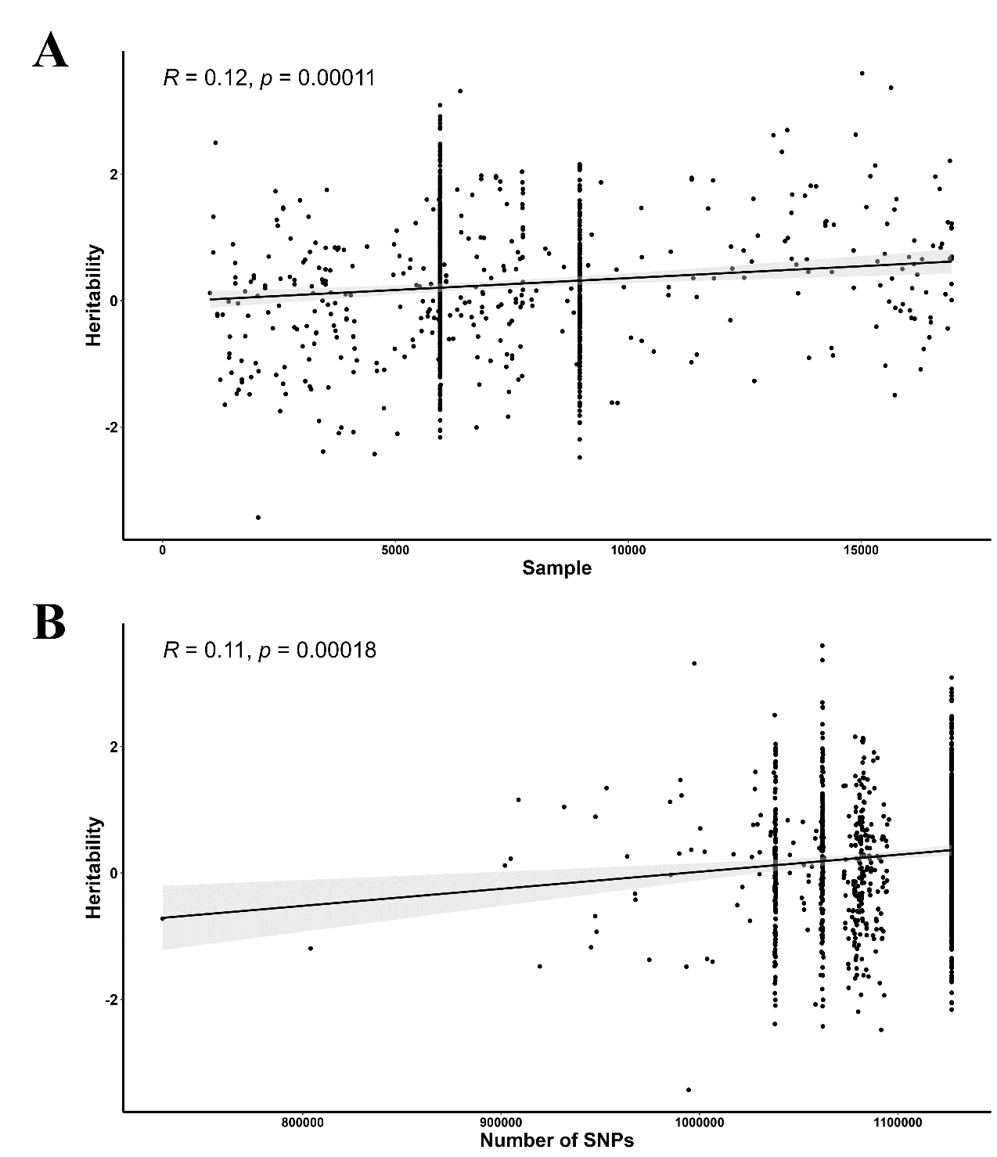
Supplementary Figures 1. The relationship between the GM heritability and traits of the GWAS data. A. The scatter plot with linear regression line showing the relationship between the bacterium estimated heritability and sample size. B. The scatter plot with linear regression line showing the relationship between the bacterium estimated heritability and the number of detected SNPs.

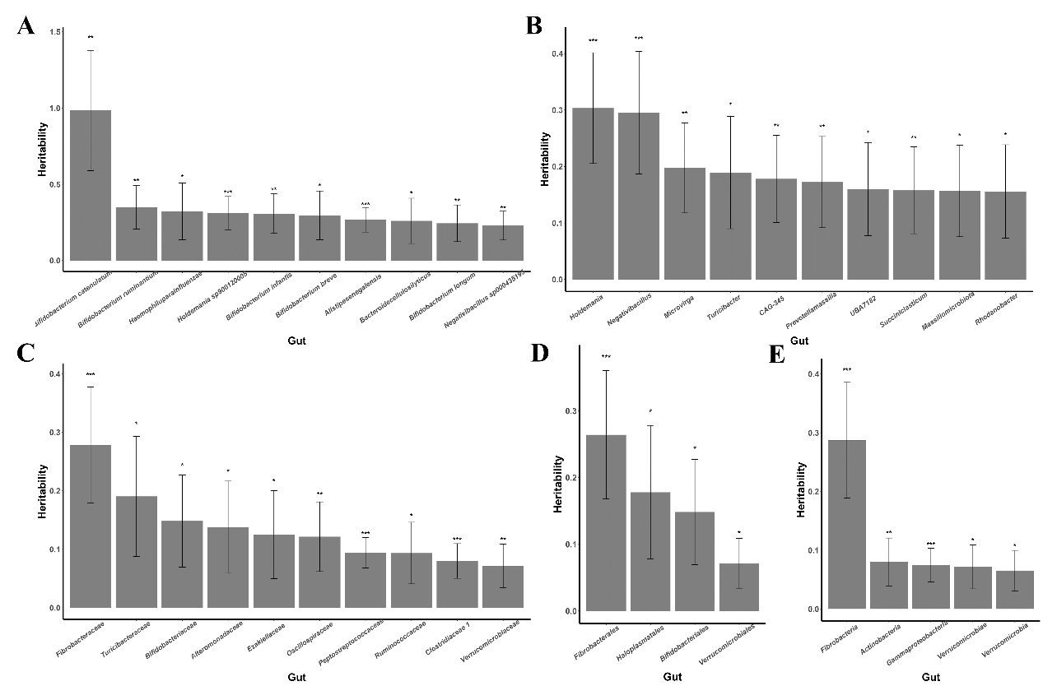
Supplementary Figures 2 The highest estimated heritability of GM taxa in six different classification levels. A. The bar chart showing the top 10 GM in 97 selected GM taxa with the highest heritability at the Species taxonomic level. B. The bar chart showing the top 10 GM in 97 selected GM taxa with the highest heritability at the Genus taxonomic level. C. The bar chart showing the top 10 GM in 97 selected GM taxa at the Family taxonomic level. D. The bar chart showing the selected GM taxa at the Order taxonomic level. E. The bar chart showing the selected GM taxa at the Class and
Phylum taxonomic level. ***: Z score of estimated the SNP heritability ≥ 2.58 ($P_{h_{SNP}^{2}}$<0.01; two-side); **: Z score of estimated the SNP heritability ≥ 1.96 ($P_{h_{SNP}^{2}}$<0.05; two-side); *: Z score of estimated the SNP heritability ≥ 1.64 ($P_{h_{SNP}^{2}}$<0.05; one-side)

