Supplementary materials

eFigure 1. Flowchart Showing the Patient Enrollment Criteria.

eFigure 2. KM curve according to subgroups

eTable 1. Incidence of Treatment-Related Adverse Events

eFigure 1. Flowchart Showing the Patient Enrollment Criteria.
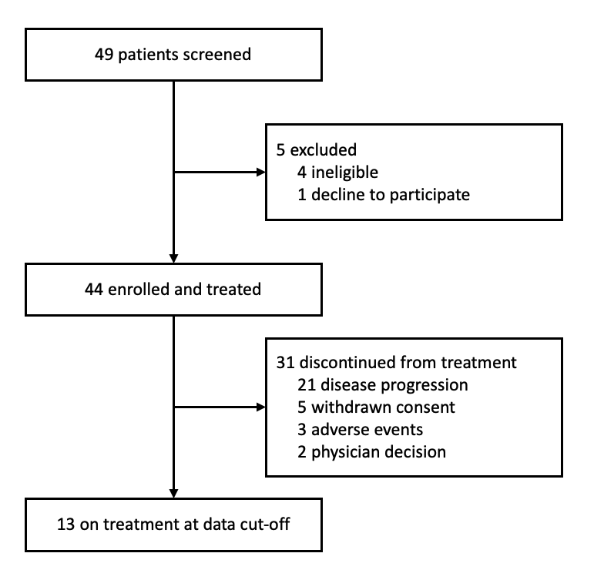

eFigure 2. KM curve according to subgroups

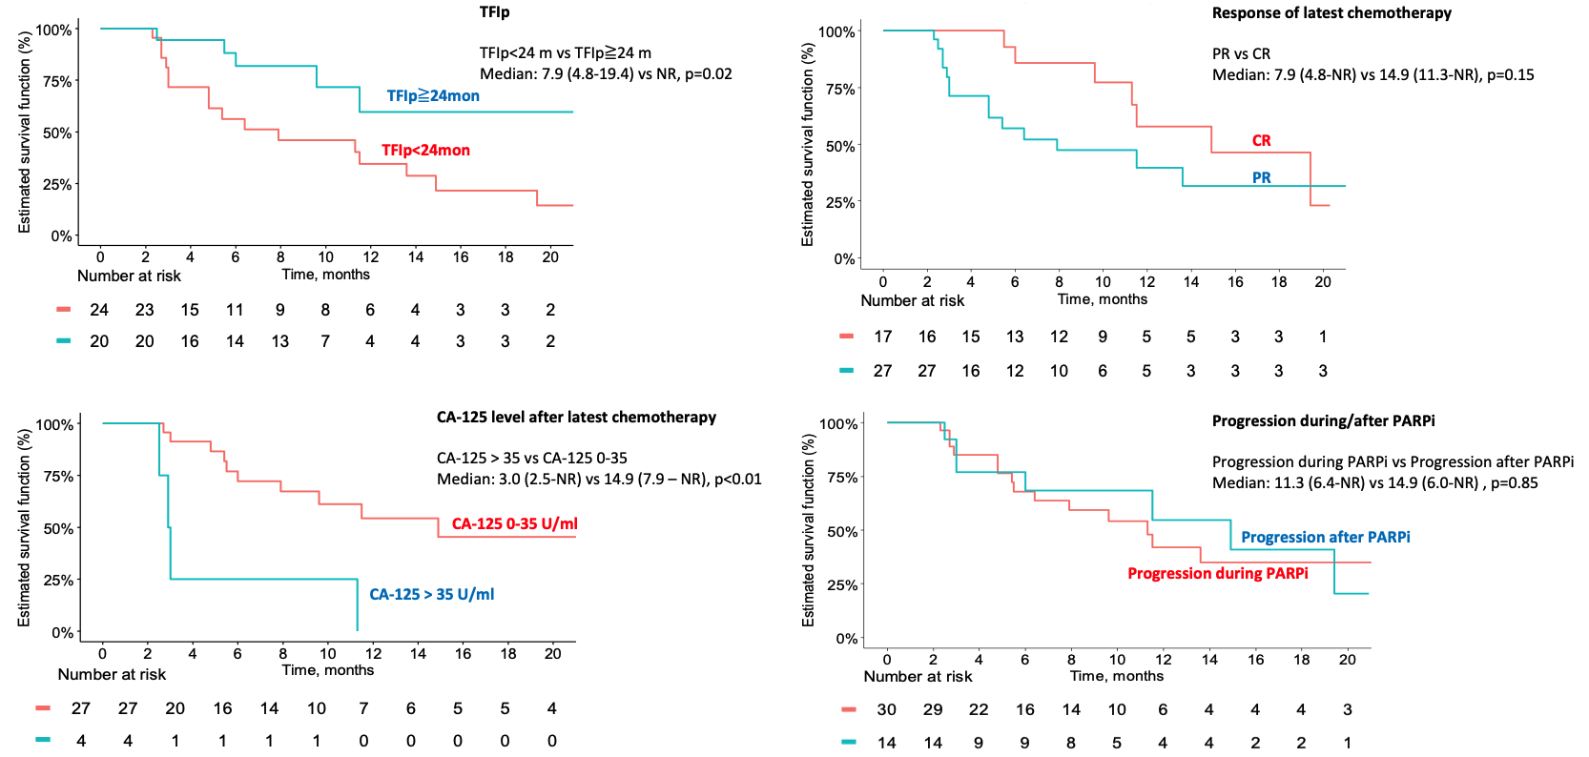

eTable 1. Incidence of Treatment-Related Adverse Events

 | TRAE in overall population (N=40)
 | Any TRAE |  |  | Related to niraparib |  |  | Related to bevacizumab
 | Any | Grade ≧ 3 |  | Any | Grade ≧ 3 |  | Any | Grade ≧ 3
Any | 40 (90·9%) | 12 (27·3%) |  | 36 (81·8%) | 12 (27·3%) |  | 29 (65·9%) | 6 (13·6%)
Anemia | 8 (18·2%) | 6 (13·6%) |  | 8 (18·2%) | 6 (13·6%) |  | 5 (11·4%) | 2 (4·6%)
Thrombocytopenia | 13 (29·6%) | 2 (4·6%) |  | 12 (27·3%) | 1 (2·3%) |  | 8 (18·1%) | 1 (2·3%)
Neutropenia | 8 (18·2%) | 6 (13·6%) |  | 7 (15·9%) | 6 (13·6%) |  | 2 (4·6%) | 2 (4·6%)
Hypertension | 9 (20·5%) | 1 (2·3%) |  | 3 (6·8%) | 0 |  | 9 (20·5%) | 1 (2·3%)
Proteinuria | 5 (11·4%) | 0 |  | 0 | 0 |  | 5 (11·4%) | 0
Fatigue | 5 (11·4%) | 0 |  | 5 (11·4%) | 0 |  | 4 (9·1%) | 0
Headache | 3 (6·8%) | 0 |  | 0 | 0 |  | 3 (6·8%) | 0
Nausea | 4 (9·1%) | 0 |  | 4 (9·2%) | 0 |  | 1 (2·3%) | 0
Vomiting | 1 (2·3%) | 0 |  | 1 (2·3%) | 0 |  | 1 (2·3%) | 0
Diarrhea | 1 (2·3%) | 0 |  | 1 (2·3%) | 0 |  | 0 | 0
Elevated AST/ALT | 5 (11·4%) | 0 |  | 5 (11·4%) | 0 |  | 4 (9·1%) | 0
Acute kidney injury | 2 (4·6%) | 0 |  | 1 (2·3%) | 0 |  | 2 (4·6%) | 0
Hyperkalemia | 2 (4·6%) | 0 |  | 2 (4·6%) | 0 |  | 2 (4·6%) | 0
UTI | 2 (4·6%) | 0 |  | 2 (4·6%) | 0 |  | 2 (4·6%) | 0
Arthralgia | 3 (6·8%) | 0 |  | 1 (2·3%) | 0 |  | 3 (6·8%) | 0
Insomnia | 3 (6·8%) | 0 |  | 3 (6·8%) | 0 |  | 1 (2·3%) | 0
TRAE=Treatment-Related Adverse Event. AST=Aspartate Aminotransferase. ALT=Alanine Aminotransferase. UTI=Urinary Tract Infectio

