Supplementary Material

Model Equation.

Full Model

Total Aedes ∼ Surface water + Built environment + Elevation + Precipitation + Average Temperature +s(longitude,latitude) + s(Day of the year) + s(year) + ti(Day of the year* Average Temperature)

where s() indicates a spline function, ti() indicates tensor product interaction

Figure S1. Example meteorological patterns during the study time from a weather station at Ontario International Airport, located near the study location. The top panel indicates monthly high and low (max and min) ambient temperatures. The lower panel indicates total precipitation by month during the study period.

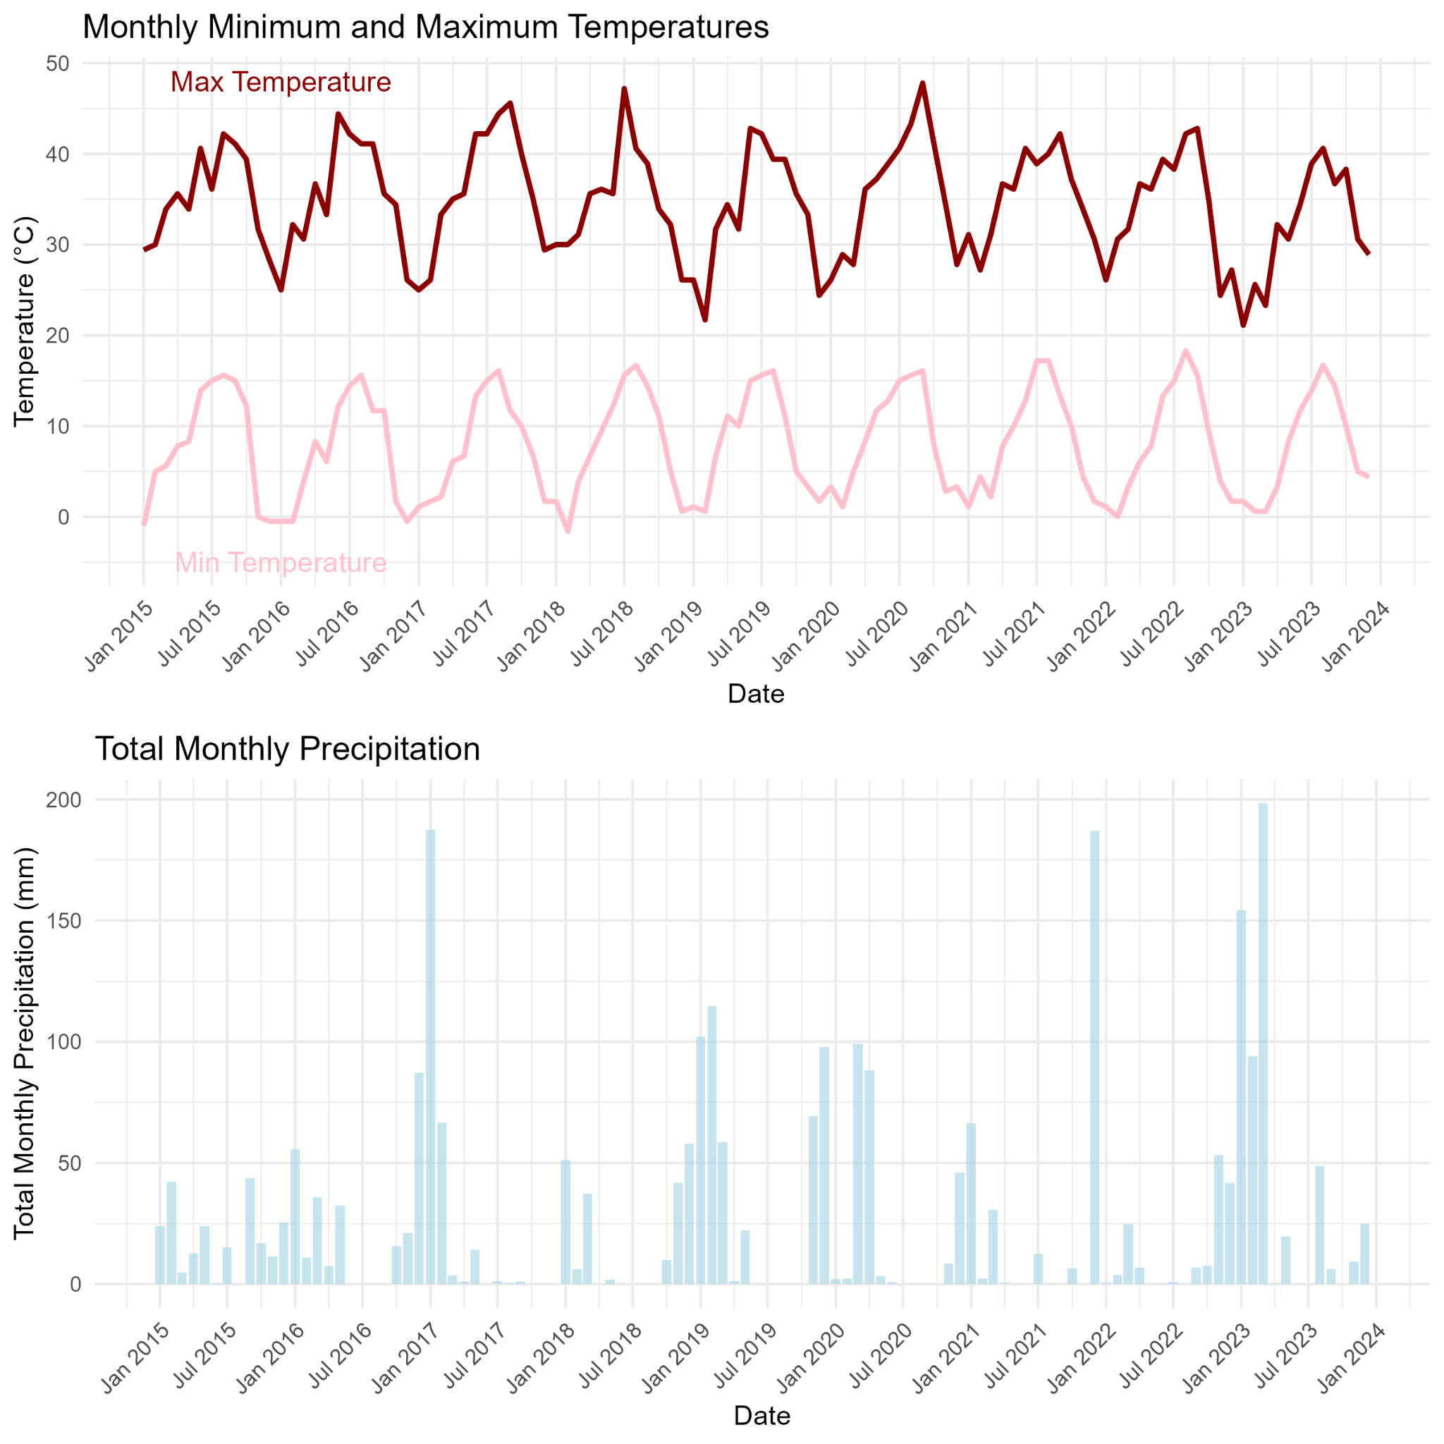

Figure S2. General meteorological patterns by month during the study period. The top panel indicates mean maximum and minimum temperatures for each month during the 2015 - 2023 study period. The middle panel indicates the mean total precipitation by month during the study period. The lower panel indicates the mean number of adult Ae. aegypti captured per trap across the study time period (see Table 3 for details).

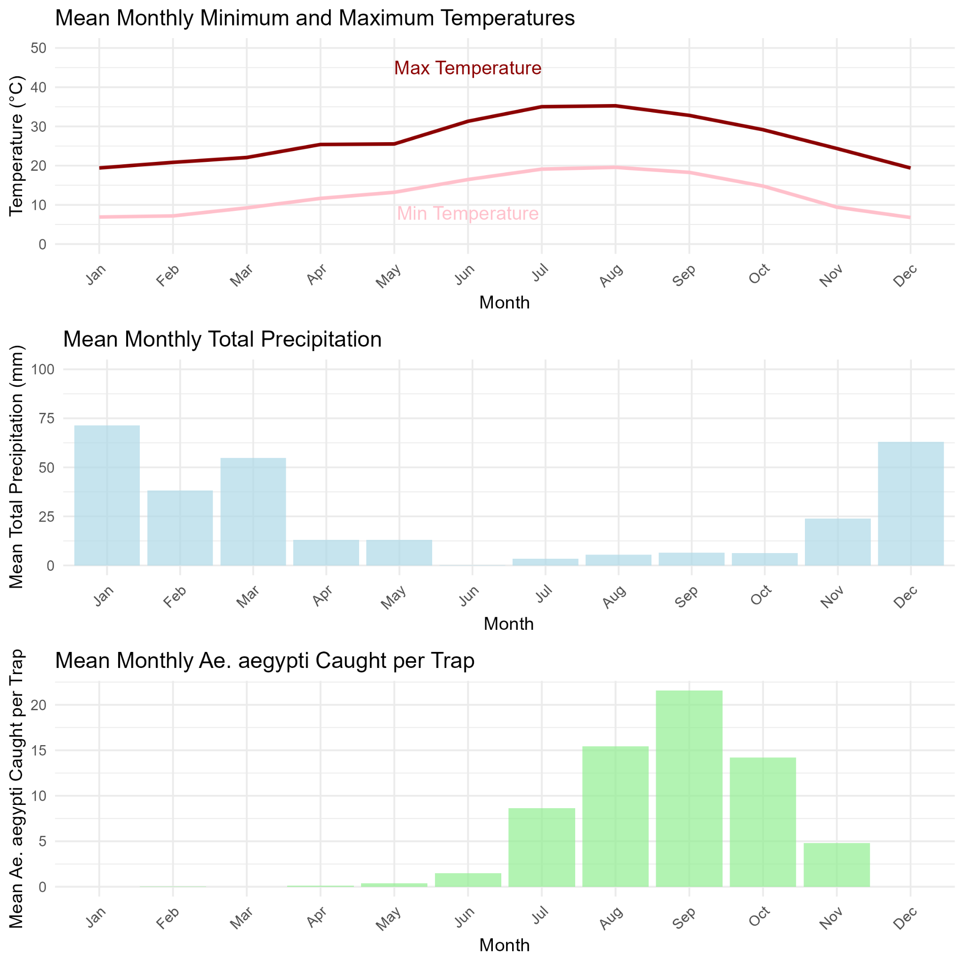

Table S1. Summary statistics for trapped adult Ae. aegypti and traps by month (pooled across years).
Month | total Ae. aegypti caught | mean per trap | sd per trap | median per trap | IQR per trap | total number of traps | proportion of traps with no mosquitoes
01 | 0 | 0.00 | 0.00 | 0 | 0 | 10 | 1.00
02 | 3 | 0.03 | 0.16 | 0 | 0 | 111 | 0.97
03 | 1 | 0.00 | 0.06 | 0 | 0 | 266 | 1.00
04 | 61 | 0.13 | 0.70 | 0 | 0 | 484 | 0.93
05 | 283 | 0.37 | 1.14 | 0 | 0 | 755 | 0.82
06 | 1277 | 1.48 | 4.12 | 0 | 2 | 860 | 0.58
07 | 7185 | 8.63 | 38.35 | 3 | 7 | 833 | 0.30
08 | 18528 | 15.44 | 21.79 | 8 | 18 | 1200 | 0.18
09 | 23937 | 21.56 | 35.12 | 11 | 24 | 1110 | 0.17
10 | 13287 | 14.21 | 23.79 | 6 | 16 | 935 | 0.18
11 | 1071 | 4.80 | 13.71 | 1 | 3 | 223 | 0.45
12 | 0 | 0.00 | 0.00 | 0 | 0 | 44 | 1.00

Table S2. Summary table of Generalized Additive Model with a Negative Binomial Distribution for 14 days lags.

Smooth Term | edf | Ref.df | Chi.sq | p-value
Longitude*Latitude | 31.66 | 49 | 461.009 | <0.001 ***
Surface water | 6.575 | 9 | 71.717 | <0.001 ***
Elevation | 3.396 | 4 | 38.194 | <0.001 ***
Urban area | 0.0005813 | 9 | 0.0 | 0.816
Precipitation | 0.003566 | 9 | 0.008 | 0.141
Temperature | 4.711 | 9 | 38.874 | <0.001 ***
DOY (Day of Year) | 6.072 | 9 | 1561.065 | <0.001 ***
Year | 1.992 | 2 | 2551.518 | <0.001 ***
DOY * Temperature | 3.268 | 4 | 53.637 | <0.001 ***

Deviance explained = 66.4

Table S3. Summary table of Generalized Additive Model with a Negative Binomial Distribution for 28 days lags.

Smooth Term | edf | Ref.df | Chi.sq | p-value
Longitude*Latitude | 31.75 | 49 | 463.72 | <0.001 ***
Surface water | 5.388 | 9 | 65.7 | <0.001 ***
Elevation | 3.44 | 4 | 38.87 | <0.001 ***
Urban area | 0.000385 | 9 | 0.0 | 0.636
Precipitation | 0.0006935 | 9 | 0.0 | 0.991
Temperature | 0.0007131 | 9 | 0.0 | 0.468
DOY (Day of Year) | 6.56 | 9 | 4486.77 | <0.001 ***
Year | 1.993 | 2 | 2543.35 | <0.001 ***
DOY * Temperature | 2.564 | 4 | 25.34 | <0.001 ***

Deviance explained = 66

Figure S3. Spline function results from the GAM (generalized additive model) for Ae. aegypti abundance from 2017 - 2023 with 28 days lags.

(A) Geographic Coordinates; (B) NDWI (Normalized Difference Water Index); (C) Elevation (DEM); (D) Built Environment; (E) Precipitation; (F) Average Temperature; (G) Day of the Year (DOY, Seasonality); (H) Year; (I) Interaction between Day of Year and Average Temperature.

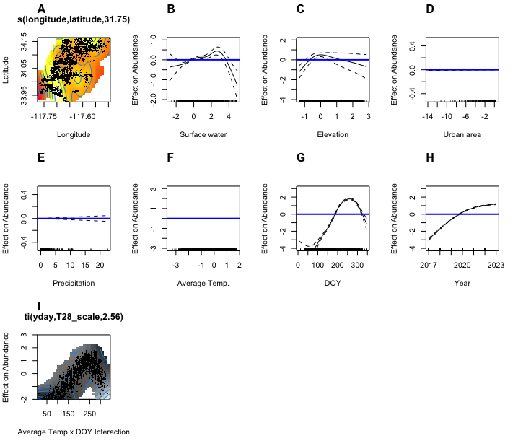

Spatial Analysis
Figure S4. Spatial correlogram for Aedes Mosquitoes from 2017 - 2023 with 250m interval
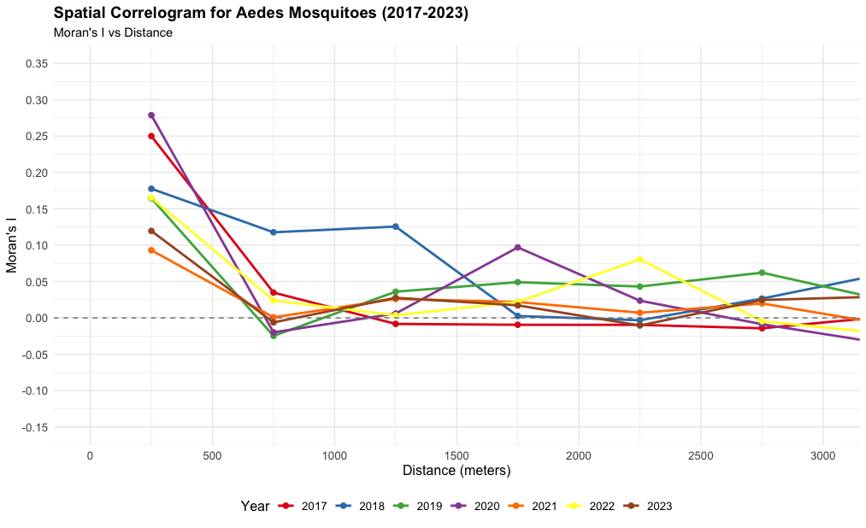

Figure S5. Hotspot Analysis of Ae. aegypti Abundance (2017–2023) with 250m threshold.
These results show year-to-year differences in the spatial distribution of Ae. aegypti abundance across the study area.

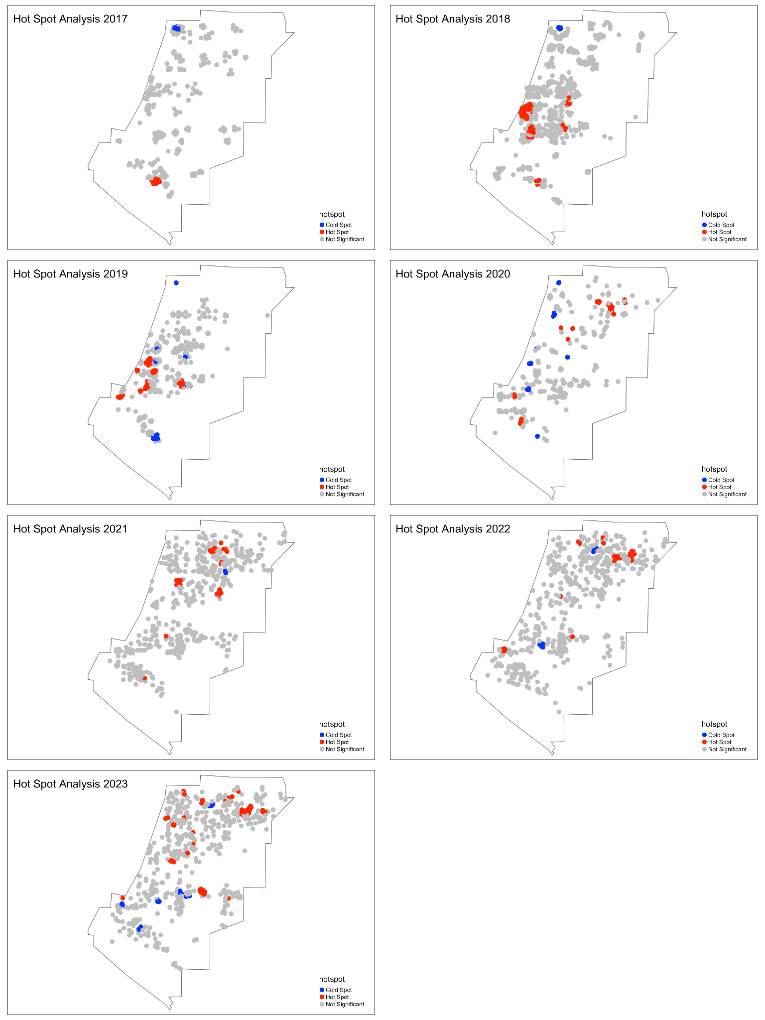

Figure S6. Directed Acyclic Graph (DAG) for Mosquito Abundance in San Bernardino.
This Directed Acyclic Graph (DAG) illustrates the complex relationships affecting mosquito abundance through various environmental and urban factors. Mosquito abundance is directly impacted by surface water, precipitation, average temperature, and elevation. Surface water, in turn, is influenced by precipitation and built area. Average temperatures are shaped by seasonal changes and elevation. Precipitation is affected by seasonal patterns, while built area is determined by elevation and the passage of time. In this DAG, surface water and precipitation act as mediators, explaining how environmental changes influence mosquito abundance. Elevation and seasons are confounders, impacting both the primary variables and mosquito abundance.

