 | Diagnose
 | BCC | SCC | Others
Pre-diagnosis
BCC | 110 | 21 | 32
SCC | 8 | 22 | 9
Other | 3 | 0 | 4

TABLE-2 GENDER OF PATIENTS
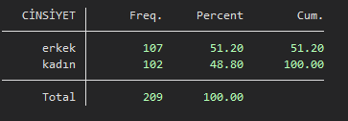
TABLE 3:AGE RANGE OF PATIENTS
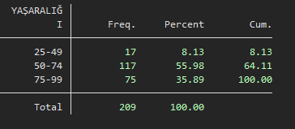
TABLE 4: LESION LOCATIONS
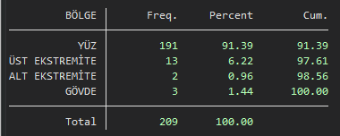

TABLE 5: SURGICAL MARGIN POSITIVITY
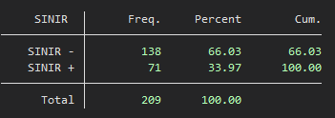
TABLE 6: LOCAL RECURRENCE STATUS
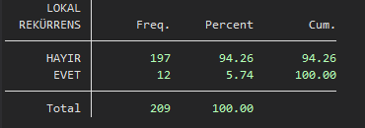
TABLE 7: AVERAGE NUMBER OF SURGERIES
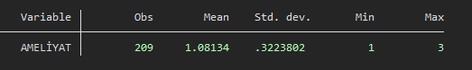
TABLE 8: AVERAGE AGE OF PATIENTS
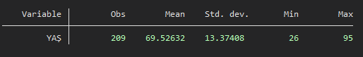

TABLE 9: PRE-DIAGNOSIS – DIAGNOSIS
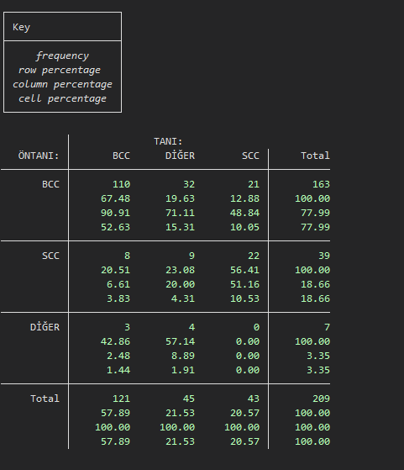

TABLE 10: DIAGNOSIS – GENDER
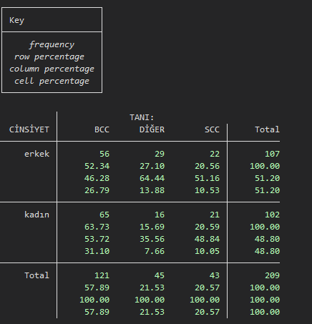

TABLE 11: DIAGNOSIS – MARGIN POSITIVITY
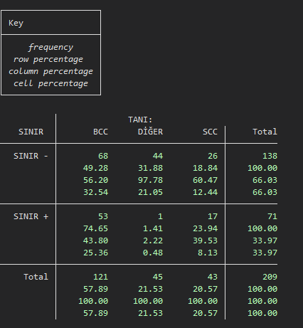

TABLE 12: DIAGNOSIS – NUMBER OF SURGERIES
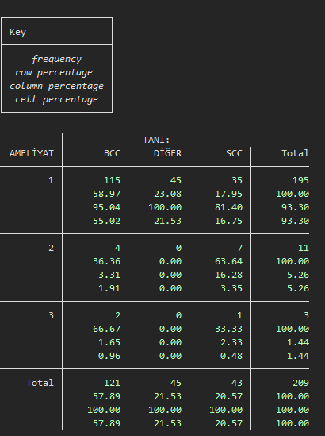

TABLE 13: DIAGNOSIS – LESION LOCATIONS
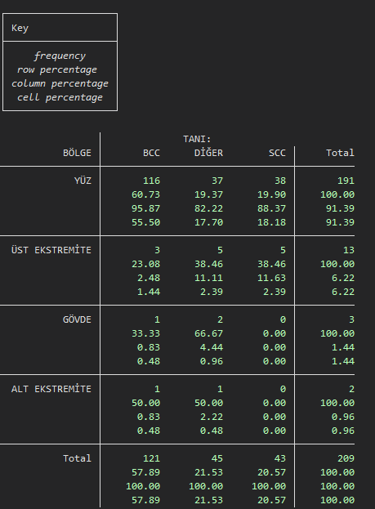

TABLE 14: DIAGNOSIS – LOCAL RECURRENCE STATUS
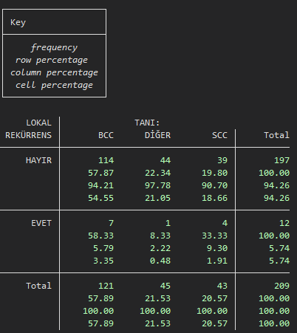

TABLE 15: DIAGNOSIS – AGE RANGE
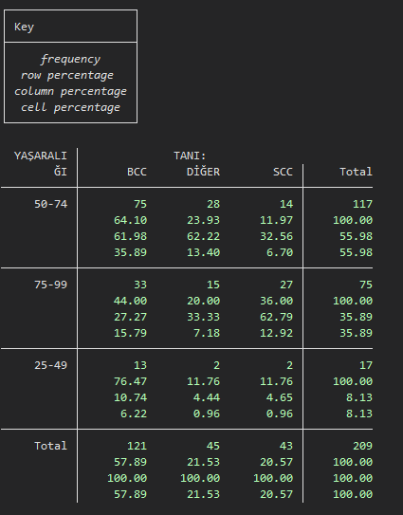

16. , n=209
 | BCC | SCC | DİĞER | TOPLAM
N (%) | 120(57.89) | 43(20.57) | 46(21.53) | 209
Age, mean (range) | 67.3 (26-95) | 12.7 (31-95) | 68.2 (41-90)
, n (%) | 65 (%31,10) | 21 (%10.05) | 16 (%7,66) | 102
(YÜZ), n (%) | 116(55.5) | 38(17.7) | 37(18.1) | 191
(BCC OLAN), n (%) | 110(52.63) | 21(10.05) | 32(15.31) | 163
, mean (SD) | 1.06 (0.3) | 1.20(0.46) | 1 (0)
, n (%) | 68 (32.5) | 26 (12.44) | 44 (21.05) | 138
, n (%) | 7 (3.35) | 4 (1.91) | 1 (0.48) | 12

TABLE 17: LOCAL RECURRENCE STATUS – AGE RANGE
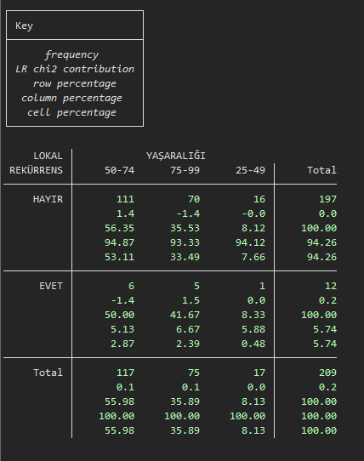

TABLE 18: LOCAL RECURRENCE STATUS – LESION LOCATIONS
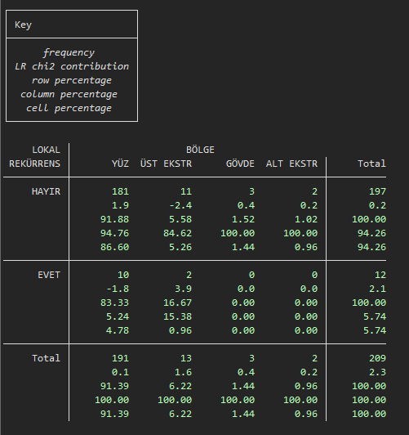

TABLE 19: MARGIN POSITIVITY – DIAGNOSIS
