Annex 1. Data Collected on the Nyan River Estuary Mangrove System/Area
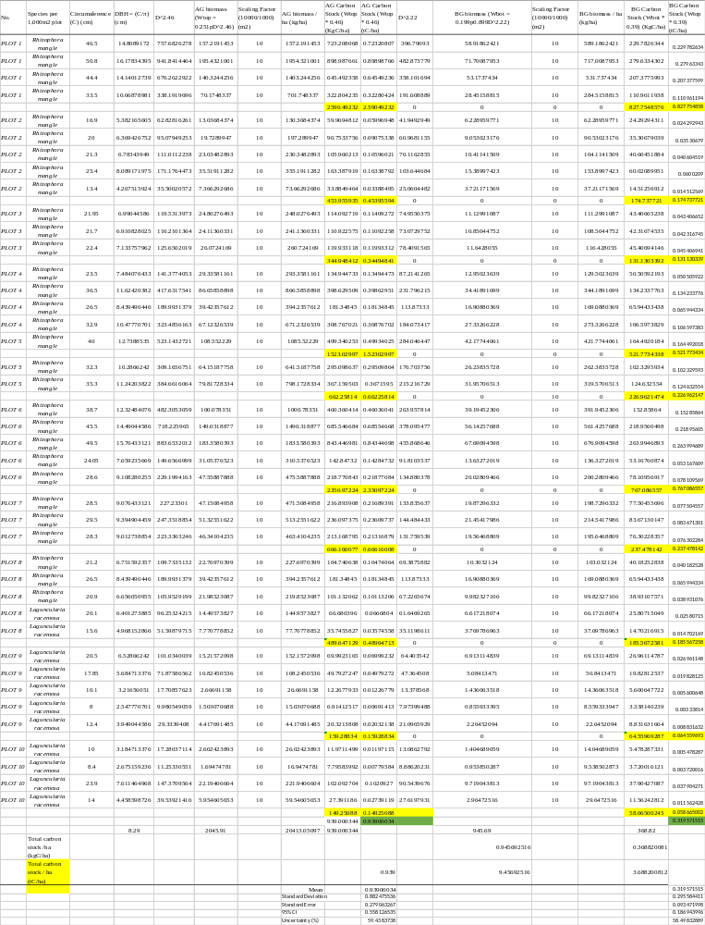
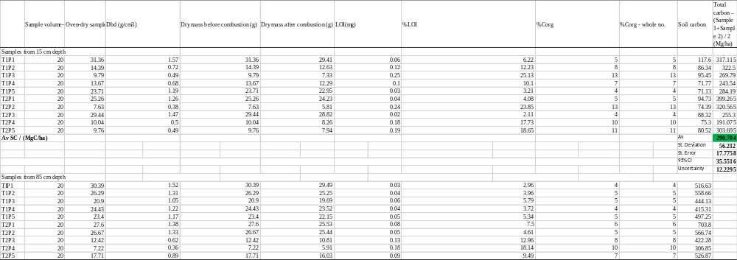
Annex 2. Data Collected on the Ehunli Lagoon Mangrove System/Area
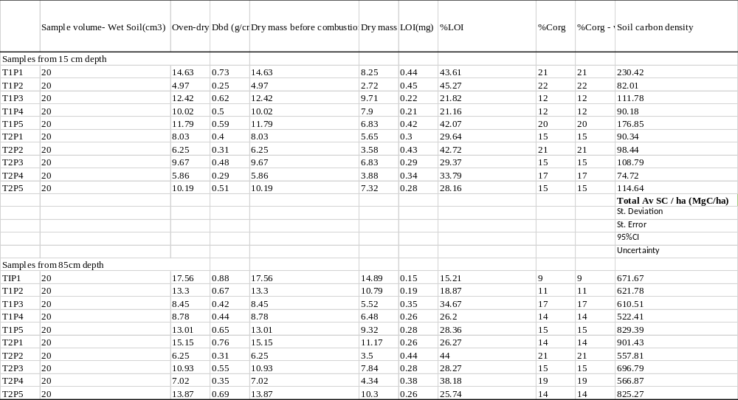
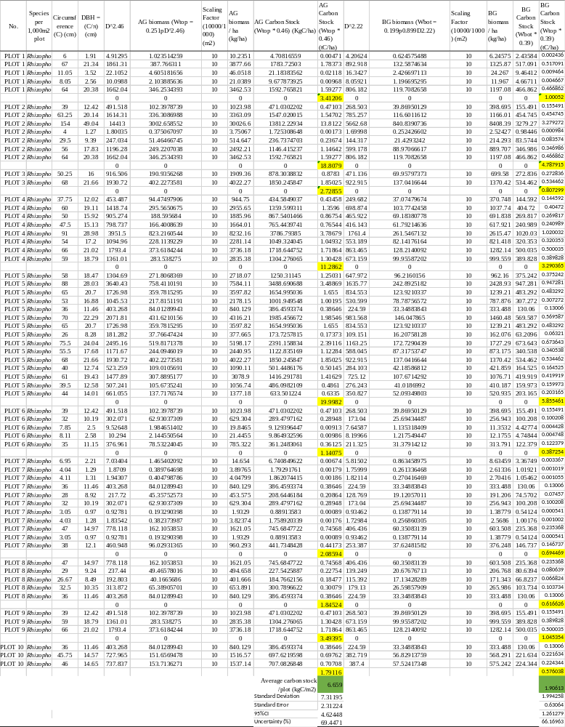
Annex 3. Data Collected on the Rocky Bay Mangrove System/Area
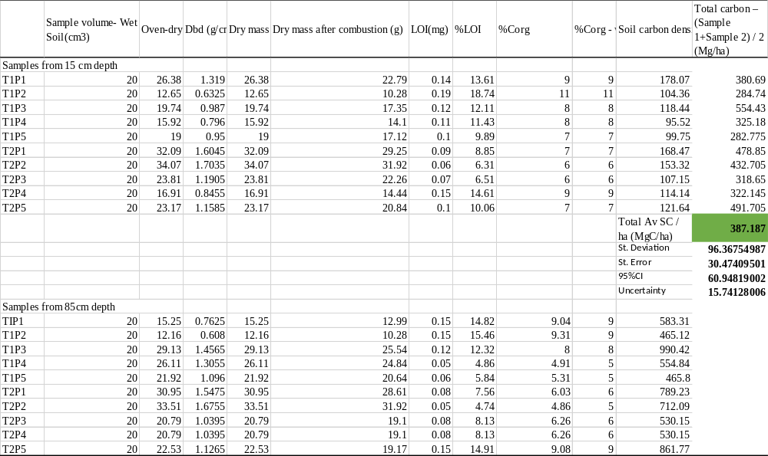

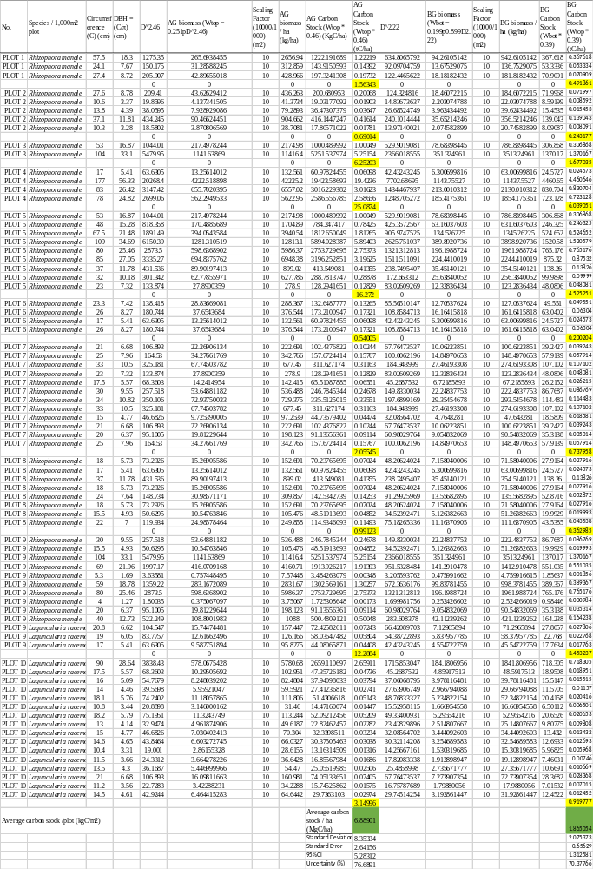
Annex 4. Total Carbon Stocks in all Systems
