Methodology for Optimal Dose Selection in Pilot Study
In this pilot study, the cytotoxicity of various free silymarin and liposomal silymarin concentrations was evaluated on adipose-derived mesenchymal stem cells (AMSCs) to determine the optimal dose for further experiments. AMSCs were cultured and treated with different concentrations of free silymarin and liposomal silymarin. At the same time, a control group without any drug treatment was included to establish baseline cell viability. The cells were seeded at a density of 1 × 10⁴ cells per plate and incubated in a humidified environment at 37 °C with 5% CO₂. After 24 hours of cell culture, 20 µL of MTT reagent was added to each well containing the scaffolds, and the plates were incubated at 37 °C for 4 hours. Subsequently, DMSO was added to each well as a solvent, and the plates were placed on a shaker for 30 minutes to enhance dissolution. The absorbance was then measured at a wavelength of 570 nm using a microplate reader spectrophotometer (SPECTROstar Nano, BMG LABTECH, Germany).
A wide range of concentrations was tested to assess the dose-response relationship, including concentrations of 1, 5, 10, 15, 20, 25, 30, 40, 50, and 100 µg/mL for both free silymarin and liposomal silymarin. Each concentration was tested in five independent replicates to ensure statistical reliability. The percentage of cell viability was calculated relative to the control group (untreated cells), and a dose-response curve was plotted to determine the relationship between drug concentration and cell viability. The half-maximal inhibitory concentration (IC50) was calculated for both free silymarin and liposomal silymarin using nonlinear regression analysis. The mean and standard deviation (SD) of cell viability were calculated for each concentration, and the correlation between drug concentration and cell viability was determined using Pearson’s correlation coefficient (r).
At lower concentrations (1–10 µg/mL), free silymarin exhibited minimal cytotoxicity, with cell viability ranging from 94.37% to 100%. However, as the concentration increased, a significant reduction in cell viability was observed. At 25 µg/mL, cell viability dropped to 53.14 ± 2.34%, and at 100 µg/mL, it further decreased to 7.40 ± 2.68%, indicating substantial cytotoxicity (Figure S1).
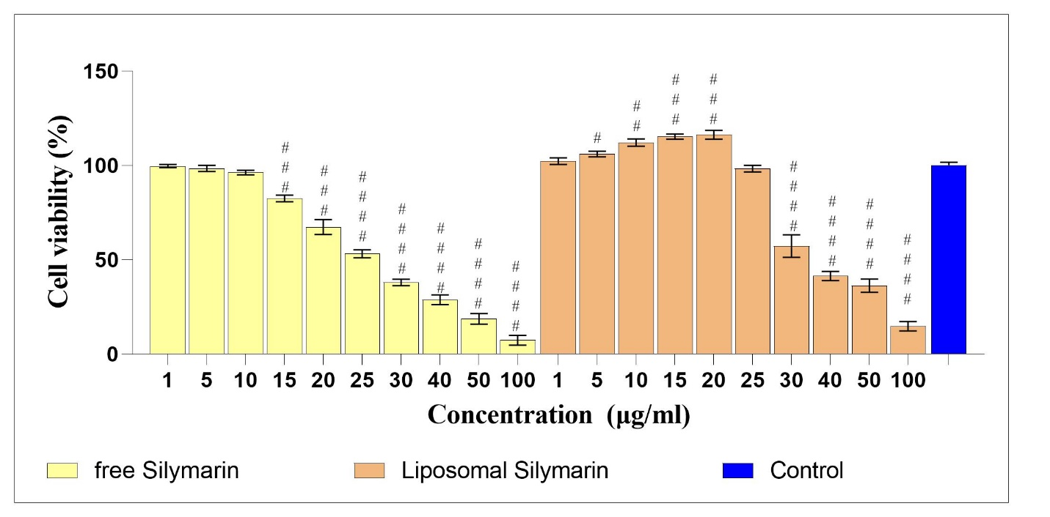
Figure S1. Effect of different concentrations (1–100 µg/mL) of free silymarin and liposomal silymarin on the viability of adipose-derived mesenchymal stem cells (AMSCs) compared to the untreated control group. Data are presented as mean ± SD (n = 5). The hashtag (#) indicates significant changes compared to the control group (p < 0.05).
In contrast, liposomal silymarin demonstrated significantly higher biocompatibility (Figure S1). At concentrations up to 20 µg/mL, cell viability remained above 110%, indicating enhanced cell proliferation compared to the control group. Even at higher concentrations, such as 50 µg/mL, cell viability was maintained at 36.36 ± 3.47%, which was significantly higher than that observed with free silymarin at the same concentration (Figure S2). At 100 µg/mL, cell viability was 14.80 ± 2.68%, still showing reduced cytotoxicity compared to free silymarin.
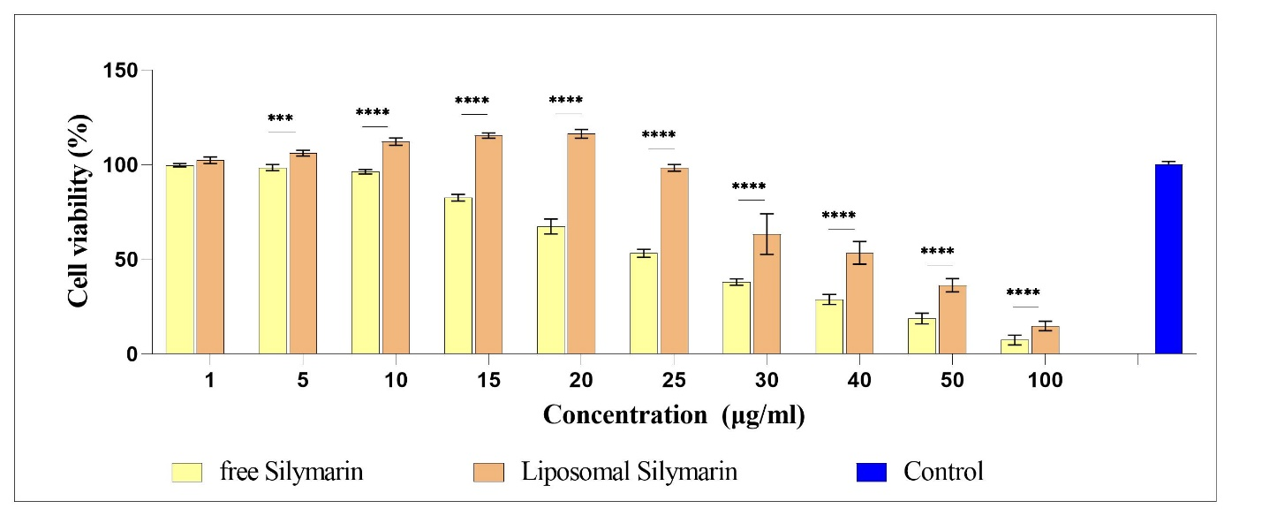
Figure S2. Effect of different concentrations (1–100 µg/mL) of free silymarin and liposomal silymarin on the viability of adipose-derived mesenchymal stem cells (AMSCs). Data are presented as mean ± standard deviation (SD) (n = 5). The control group represents untreated cells. Asterisks (*) indicate significant changes compared to the control group (p < 0.05). The results demonstrate the dose-dependent cytotoxicity of free silymarin and the enhanced biocompatibility of liposomal silymarin.
The Pearson’s correlation coefficient (r) was calculated to evaluate the relationship between the concentration of free silymarin and liposomal silymarin and the percentage of cell viability. The strong negative correlation (r = -0.98) indicates a highly significant inverse relationship between the concentration of free silymarin and cell viability. As the concentration of free silymarin increases, cell viability decreases sharply (Table S1). This suggests that free silymarin exhibits dose-dependent cytotoxicity, with higher concentrations leading to significant reductions in cell survival.
Table S1. Comparison of Pearson’s correlation coefficient (r) and IC50 values between free silymarin and liposomal silymarin.
Parameter | Free Silymarin | Liposomal Silymarin
Correlation (r) | -0.98 | -0.92
IC50 (µg/mL) | 25.0 ± 1.5 | 38.2 ± 3.5

The negative correlation (r = -0.92) also indicates an inverse relationship between the concentration of liposomal silymarin and cell viability (Table S1). However, the correlation is slightly weaker compared to free silymarin, suggesting that liposomal silymarin has a less pronounced cytotoxic effect. This is consistent with the observed higher biocompatibility and controlled release properties of the liposomal formulation, which result in reduced toxicity even at higher concentrations. This difference underscores the advantage of the liposomal formulation in maintaining cell viability across a wider range of concentrations. The results align with the dose-response curves, where liposomal silymarin demonstrated higher cell viability at all tested concentrations compared to free silymarin.
Both correlation coefficients are statistically significant (p < 0.05), confirming that the observed relationships between concentration and cell viability are not due to random chance. The high absolute values of the correlation coefficients (close to -1) indicate a strong and consistent trend in the data.
The IC50 was calculated for both free silymarin and liposomal silymarin to determine the concentration at which cell viability is reduced to 50% (Table S1). The IC50 value of 25.0 µg/mL indicates that free silymarin significantly reduces cell viability at relatively low concentrations. The higher IC50 value of 38.2 µg/mL for liposomal silymarin indicates that this formulation is less cytotoxic compared to free silymarin. The liposomal encapsulation of silymarin appears to mitigate its cytotoxic effects, allowing for higher concentrations to be used without significantly compromising cell viability. The higher IC50 of liposomal silymarin suggests that it can be used at higher concentrations without causing significant toxicity, making it a more suitable candidate for tissue engineering applications.
Additionally, the concentration of 25 µg/mL of liposomal silymarin was chosen as the optimal dose because it showed no significant toxicity compared to the control group. This pilot study provided critical insights into the optimal dose of silymarin for subsequent experiments, ensuring minimal cytotoxicity and maximum therapeutic efficacy.

