MER57E3 transposable element subfamily co-opted for gene regulation in human early neural development
Michelle Almeida da Paz ^{1, 2}
Umut Yildiz ²
Minyoung Kim ^{2, 3}
Víctor Campos-Fornés ^{2, 4}
Marina Pinkasz ^{2, 5, 6}
Thomas Dahlet ^{2, 7}
Kyung-Min Noh ^{2, 8}
Leila Taher ¹

¹ Institute of Biomedical Informatics, Graz University of Technology, Graz, Austria
² European Molecular Biology Laboratory (EMBL), Genome Biology Unit, Heidelberg, Germany
³ Faculty of Biosciences, Molecular Biosciences: Neuroscience Major, Heidelberg University, 69120, Heidelberg, Germany
⁴ Faculty of Biosciences, Collaboration for Joint PhD Degree between EMBL and Heidelberg
⁵ Departamento de Fisiología, Biología Molecular y Celular, Facultad de Ciencias Exactas y Naturales, Universidad de Buenos Aires, Buenos Aires, Argentina
⁶ Instituto de Fisiología, Biología Molecular y Neurociencias, Universidad de Buenos Aires, CONICET, Buenos Aires, Argentina
⁷ Molecular Systems Biology Unit, European Molecular Biology Laboratory (EMBL), Heidelberg, Germany
⁸ Department of Biomedicine, Aarhus University, Denmark

SUPPLEMENTARY FIGURES
Suppl. Fig. 1. Gene ontology (GO) enrichment analysis of the genes whose TSS resides within 2kbp of MER57E3 copies. Gene ratio (x-axis) represents the the ratio between the number of genes in the given GO term and the number of genes annotated in each category. Dot size indicates the gene count. Dot colour indicates the P-value adjusted by Benjamini-Hochberg (BH, “p-adjust”). Genes near MER57E3 copies are associated with activities related to DNA-binding transcription repressor and activator.
Suppl. Fig. 2. Transcription factor regulatory motifs found within MER57E3 copies compared to their expected frequency in the entire human genome used as background (threshold adjusted P-value < 0.000001). MER57E3 elements embed serveral motifs for brain-specific transcription factors.

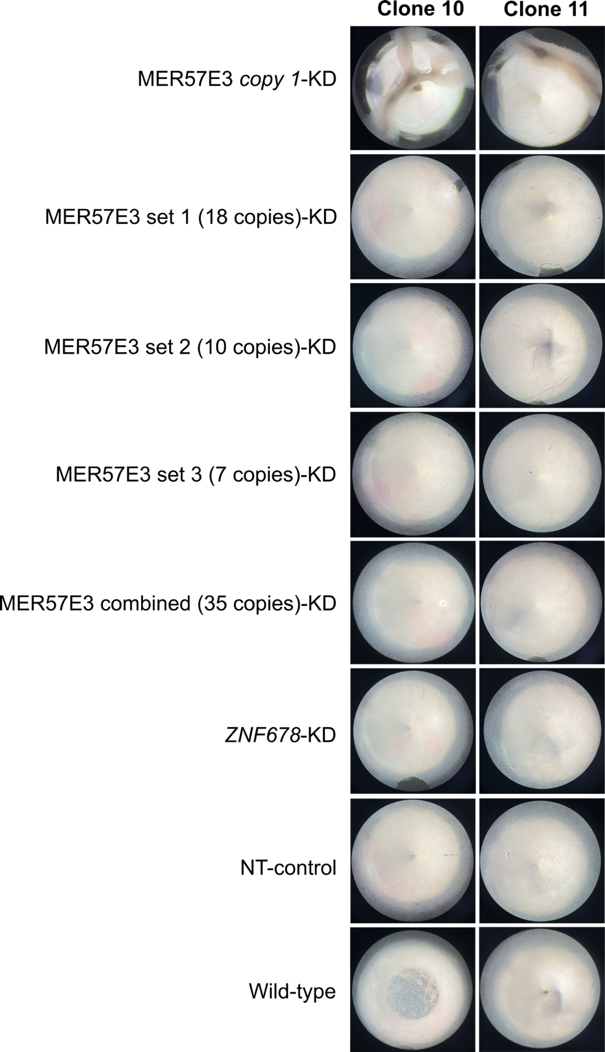
Suppl. Fig. 3. Two biological replicates (clones 10 and 11) of the differentiated neural progenitor cells (NPCs), CRISPRi-mediated knockdown of the MER57E3 copy 1 (MER copy 1-KD), MER57E3 multi-copies (MER57E3 sets 1–3-KD, targeting 18, 10 and 7 copies, respectively), MER57E3 combined-KD (targeting a total of 35 copies), and ZNF678 promoter (ZNF678-KD). A lacZ-targeting sgRNA (non-targeting control, NT-control) and wild-type were used as controls. CRISPRi mediated knockdown of MER57E3 copy 1 shows reduced proliferation and cell adhesion.
Suppl. Fig. 4. Volcano plot shows differentially expressed genes for the CRISPRi-mediated knockdown of ZNF678 compared to the NT control. ZNF678 promoter knockdown disrupts the regulation of a total of 39 genes.

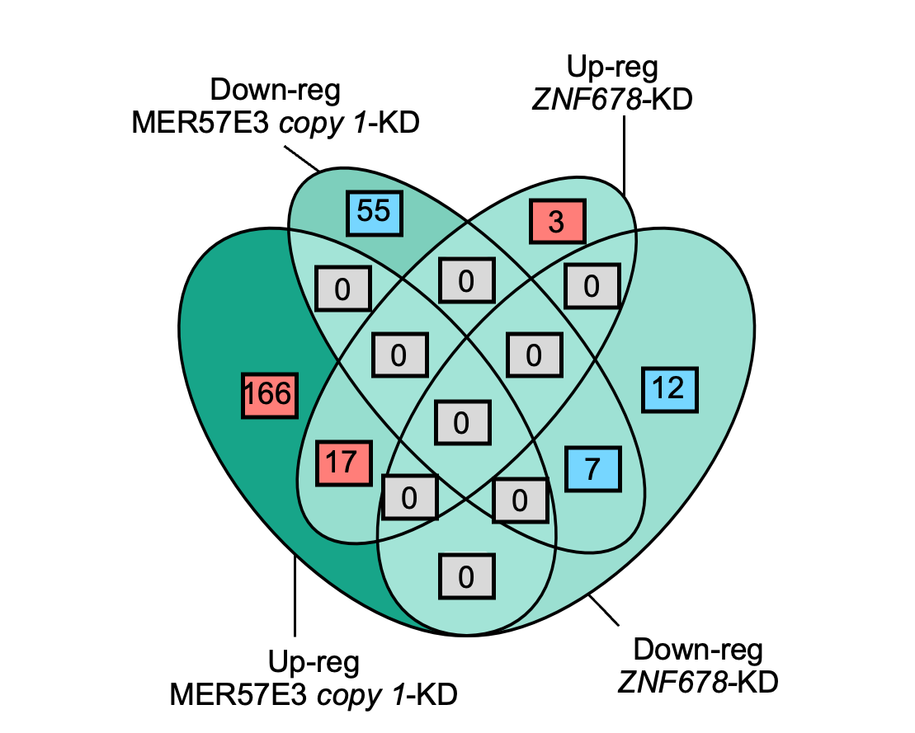
Suppl. Fig. 5. Overlapping among differentially expressed genes (DEGs) upon perturbation (knockdown, KD) of MER57E3 copy 1 and ZNF678. DEGs were separated in down-regulated (down-reg) and up-regulated (up-reg) genes.

