SUPPLEMENTARY MATERIAL
QUANTITATIVE ANALYSIS OF THE INTRACELLULAR miRNA CONTENT USING GOLD NANOPROBES AND SINGLE PARTICLE ICP-MS WITH ToF AND TQ MASS ANALYZERS.
Sara González Morales,¹ Elena Añón Álvarez,³ David Clases,² Mario Corte-Rodriguez^{1,3}* and Maria Montes-Bayón^{1,3}*.
¹Department of Physical and Analytical Chemistry, Faculty of Chemistry, University of Oviedo, Julián Clavería 8, 33006 Oviedo, Spain.
²Department of Chemistry. University of Graz.
³Health Research Institute of the Principality of Asturias (ISPA), Av. Hospital Universitario s/n, 33011 Oviedo, Spain.
*montesmaria@uniovi.es; *cortemario@uniovi.es


Biotinylated oligonucleotides

40 nm Streptavidin coated Au NP
Sera-Mag™ SpeedBead Streptavidin (1 µm)

Figure S1. Schematic diagram of the developed assay

A)
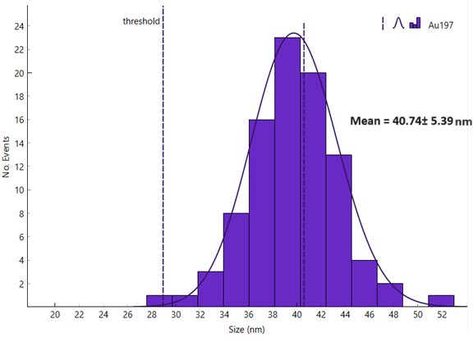

B)
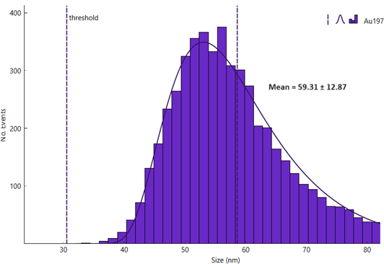

Figure S2. Histograms corresponding to the analysis of the two Au NPs used in the assay by SP-ICP-ToF-MS. A) 40 nm and B) 60 nm.

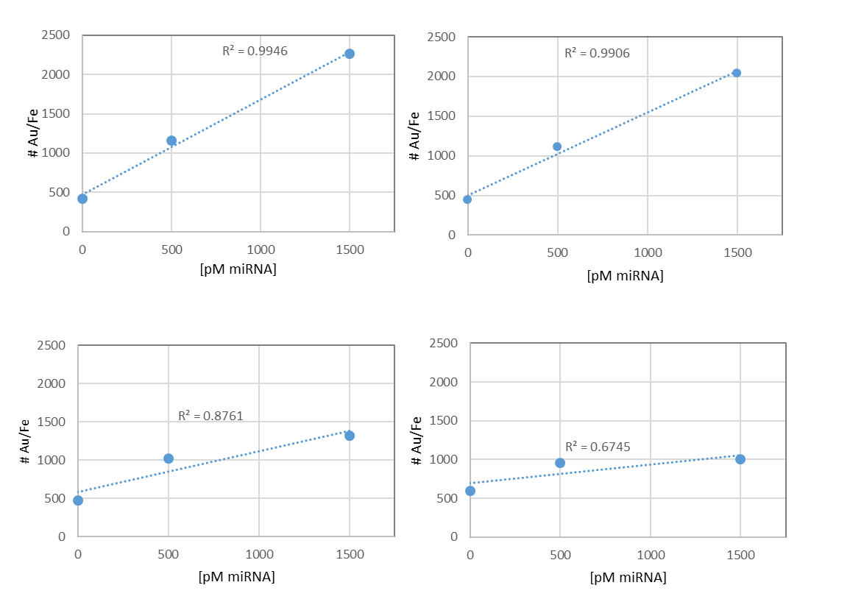
Figure S3. Response of the assay to increasing concentrations of the analyte while decreasing the concentration of the detection probe. A) 858 pmol, B) 424, C) 255 and D) 170 pmol.
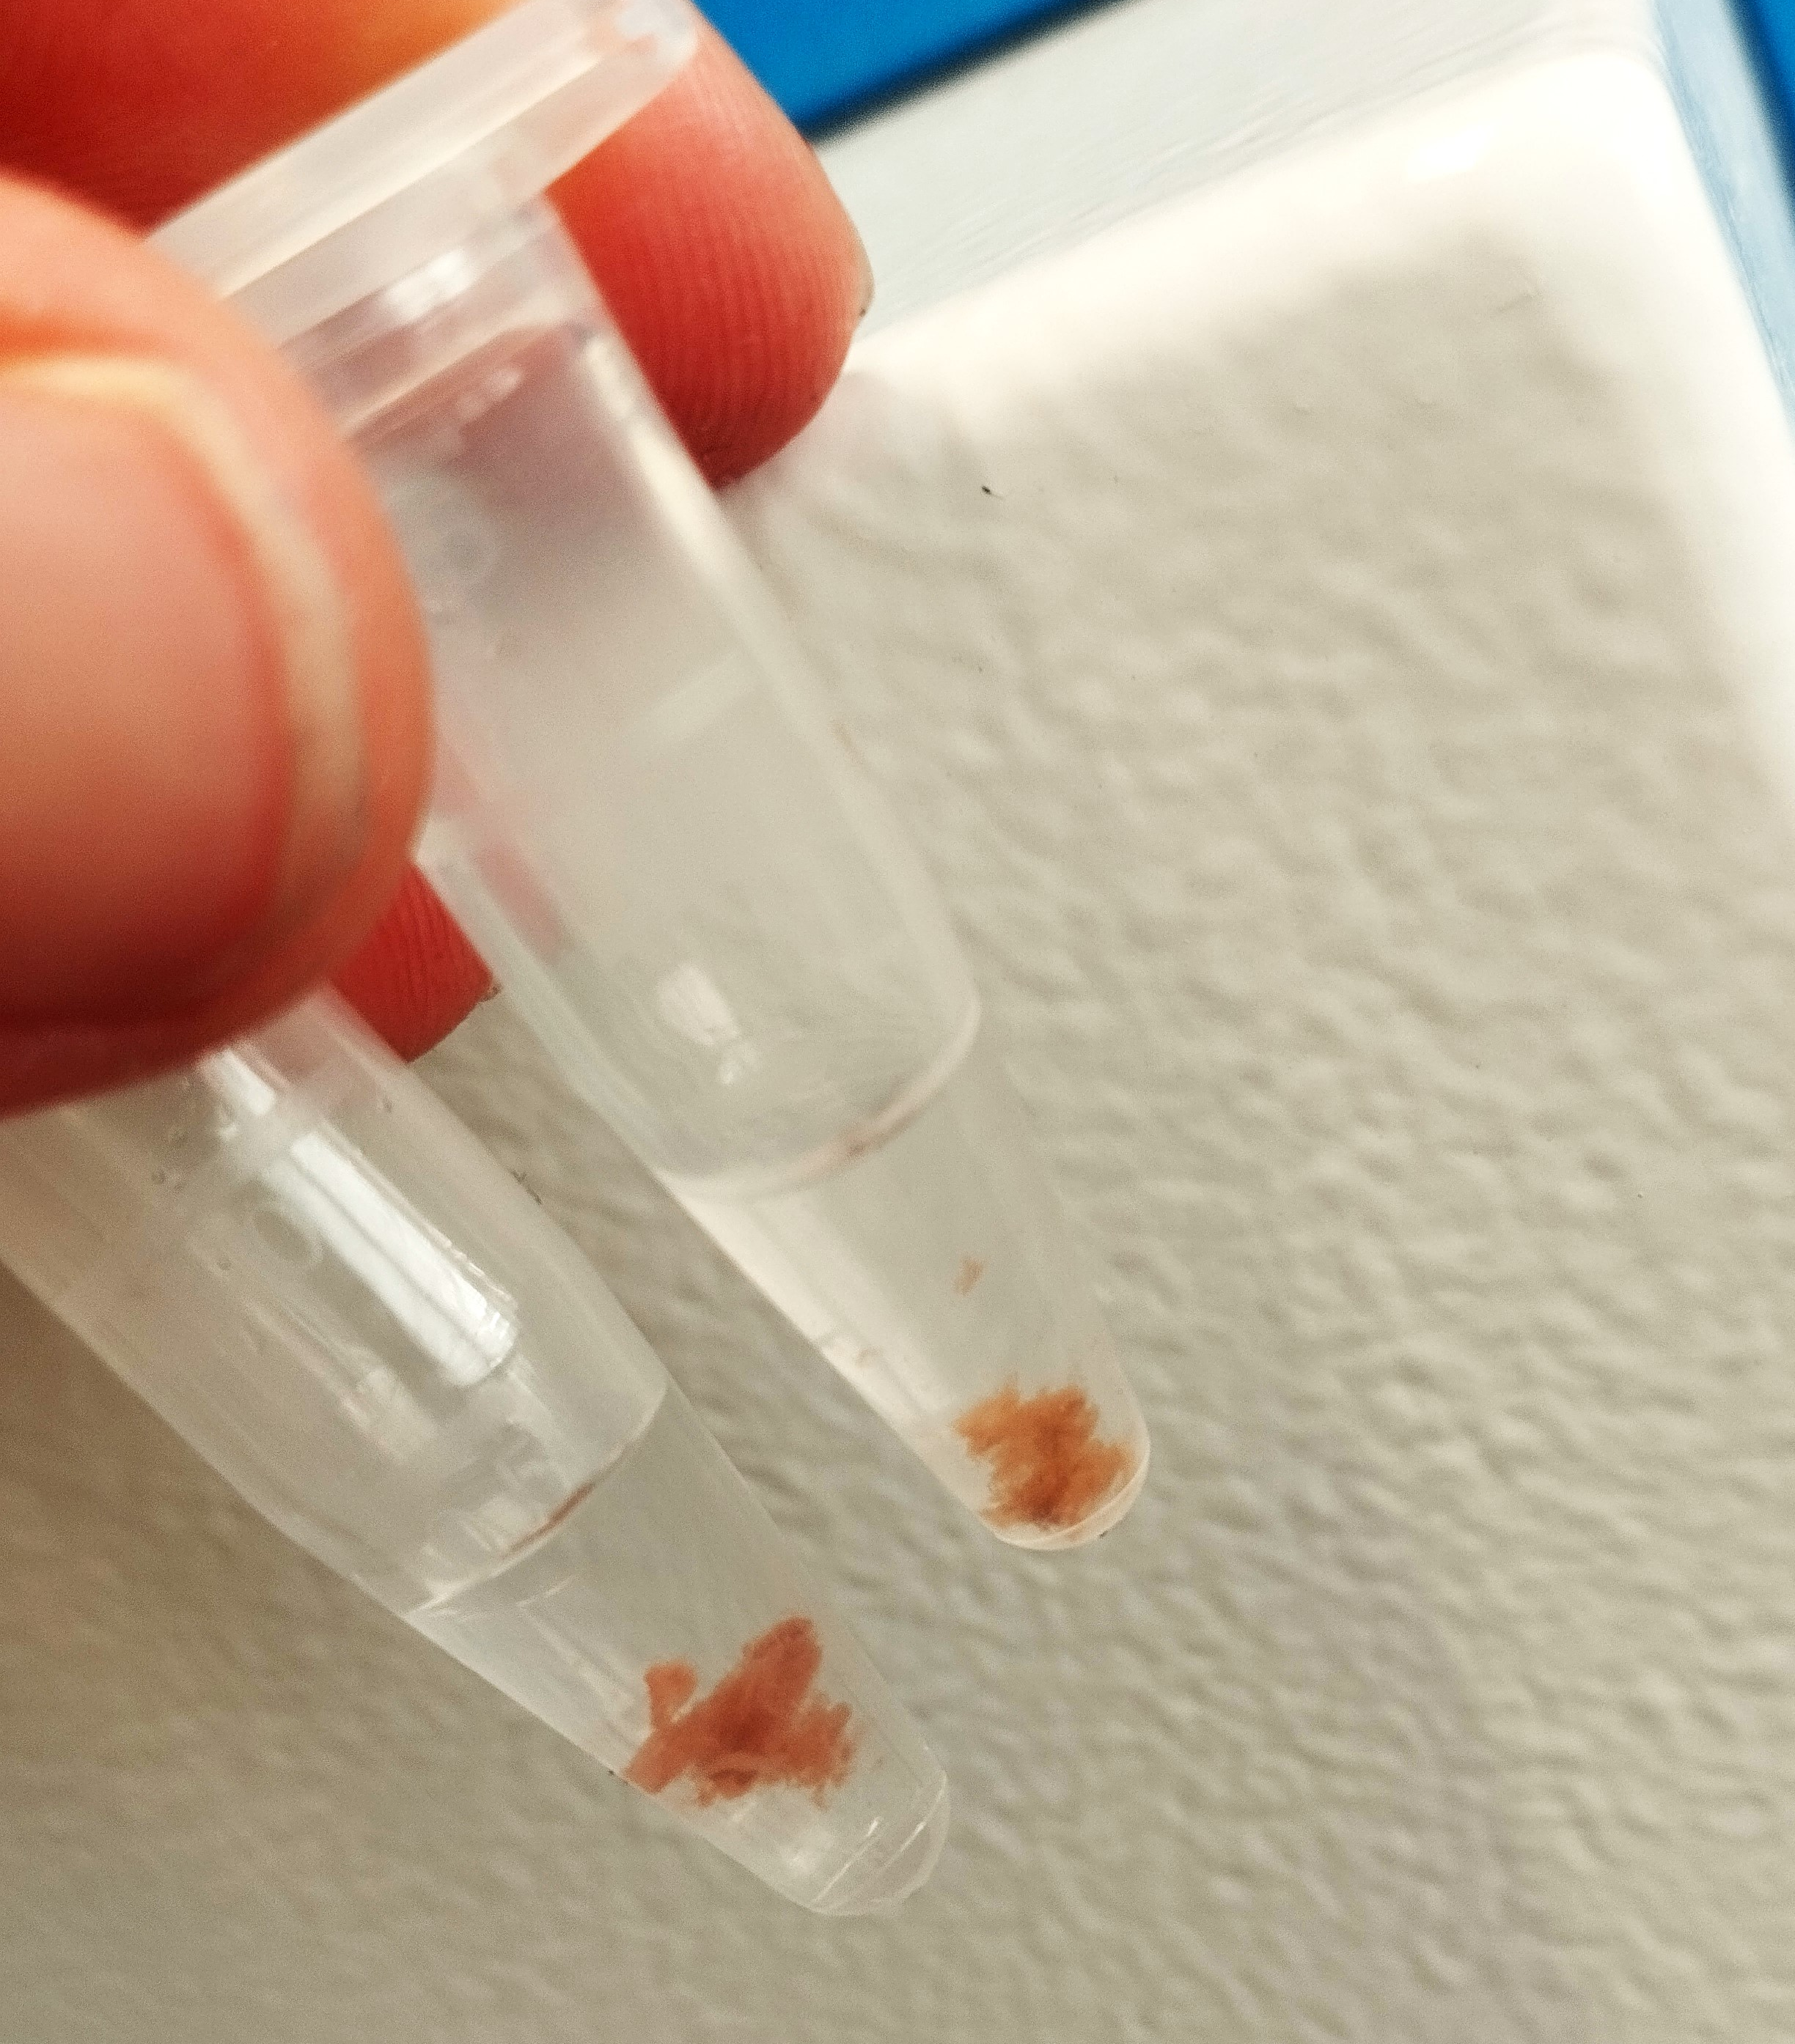
Figure S4. Aggregates observed after conducting the assay directly on the cell lysate before ultrafiltration.

