Supplementary Material for Research Paper „Comparative analysis of small WEEE pre-treatment options: An economic and environmental assessment“ by Stephani, P.; Li, C.; Mack, T.; Vogelgesang, M.; Ionescu, E. (2025)

Inventory Lists for the Life cycle inventories

Table 1: Manual Dismantling
Name | Comment | Value | Unit | Reference
sWEEE |  | 1 | kg
Manual Dismantling Facility |  | 1.60E-08 | piece | manual treatment facility construction, waste electric and electronic equipment | manual treatment facility, waste electric and electronic equipment | Consequential, U
Electric tool | Assumption: Tool has life span of 2500h, includes electrical and non-electrical tools | 6.52E-06 | piece | power saw production, with catalytic converter | power saw, with catalytic converter | Consequential, U
Electricity, low voltage | Assumption: electrical tools are used for 30% of time | 3.42E-03 | kWh | Literature values for the power of electric drills
Labour | ps = person*second |  | ps | Dismantling time dependant on device

Table 2: Initial Crushing, Handpicking
Name | Description | Value | Unit | Reference
sWEEE |  | 1 | kg
Manual Dismantling Facility |  | 1.60E-08 | piece | manual treatment facility construction, waste electric and electronic equipment | manual treatment facility, waste electric and electronic equipment | Consequential, U
Hammer mill | Assumption: corresponds to a quarter of machinery of the comminution and sorting process | 5.00E-10 | piece
Labour |  | 8,106666667 | ps
Strom |  | 0.024259259 | kWh | Calculated based on power and duration

Table 3: Pollutant Removal
Name | Description | Value | Unit | Reference
sWEEE |  | 1 | kg
Manual Dismantling Facility |  | 1.60E-08 | piece | manual treatment facility construction, waste electric and electronic equipment | manual treatment facility, waste electric and electronic equipment | Consequential, U
Labour |  |  | ps | Pollutant removal duration dependant on device

Table 4: Comminution and Sorting
Name | Description | Value | Unit | Reference
sWEEE |  | 1 | kg
Manual Dismantling Facility |  | 8.00E-10 | piece | treatment of waste electric and electronic equipment, shredding | waste electric and electronic equipment | Consequential, U
Labour | Assumptions: Five workers are involved over whole process, two-shift-operation | 2.2 | ps
Electricity, medium voltage |  | 0.07 | kWh | treatment of waste electric and electronic equipment, shredding | waste electric and electronic equipment | Consequential, U

Metallurgy:
The pyrometallurgical copper smelting process was modelled based on the process chain of
- “treatment of electronics scrap, metals recovery in copper smelter | electronics scrap | Consequential, U” (SE)
- “treatment of metal part of electronics scrap, in copper, anode, by electrolytic refining | metal part of electronics scrap, in copper, anode | Consequential, U” (SE)
- “treatment of precious metal from electronics scrap, in anode slime, precious metal extraction | precious metal from electronics scrap, in anode slime | Consequential, U” (SE)
from the ecoinvent v3.8 consequential background database. The resulting process chain is a grave-to-cradle process which takes electronics scrap (reference product) and other inputs and yields precious metals (modelled via substitution) and wastes.
Values for labour and throughput were estimated based on Brown, T.: Engineering Economics and Economic Design for Chemical Engineers, CRC Press (2007) and the business reports of enterprises which run integrated copper smelters suited for electronics scrap.

MPPM
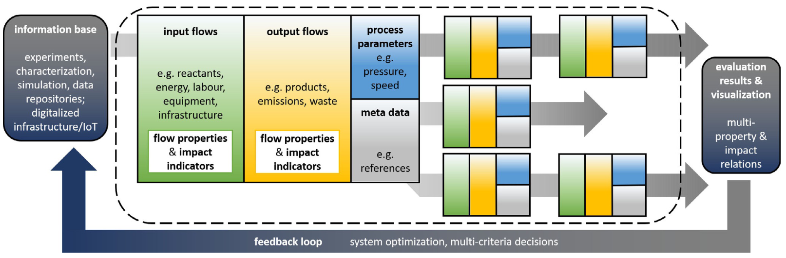
Figure 1: schematic illustration of the multi-property process modelling procedure
Source: Klemenz, S.; Stegmüller, A.; Yoon, S.; Felser, C.; Tüysüz, H.; Weidenkaff, A. Holistic View on Materials Development: Water Electrolysis as a Case Study. Angewandte Chemie International Edition 2021, 60, 20094–2010, https://doi.org/10.1002/anie.202105324

Transfer Coefficients
Fraction | Manual Dismantling | Pollutant removal | Crushing, Hand Picking | Comminution, Sorting
Battery | 1 | 1 | 1 | 0
PCB | 1 | 0 | 1 | 0
Cable | 1 | 0 | 1 | 0
Display | 1 | 0 | 0 | 0
Electronic components | 1 | 0 | 1 | 0
Aluminium | 0.98 | 0 | 0.98 | 0.75
Copper | 0.98 | 0 | 0.98 | 0.69
Fe-Metals | 0.96 | 0 | 0.98 | 0.64
Other metals | 0.99 | 0 | 0.98 | 0.7
Plastics | 0.9 | 0 | 0.98 | 0.84
Glass | 1 | 0 | 0 | 0.9
Others | 1 | 0 | 0.98 | 1

The values describe the share of the fraction contained in the device which is cleanly liberated. E. g. a value of 0.9 means that 90% of the fraction are liberated while the remaining 10% cannot. The share of a fraction that is not liberated at all is treated as generic waste. Values of 0 indicate that this fraction cannot be recovered at all in this process step. Some values are based on assumptions and simplifications.
Reference:
Stephani, P. Expert Interview of Wladislaw Benner at Fraunhofer IWKS regarding material recovery rates in several process technology steps. Date: 26.10.2021

