The structure of scale lens and inner reflector in the photophore of the deep-sea fish Neoscopelus (Myctophiformes: Neoscopelidae): insight into the light projection mechanisms for counterillumination
José Paitio
Daichi Yano
Hironori Asada
Masakazu Iwasaka
Shiro Takei
Yuichi Oba

Supplementary Information
FIGURE S1
a) Lateral view of fresh specimen of D. watasei (black arrow indicates Vn photophore). b) Ventral surface D. watasei showing ventral photophores. c) Lateral view of defrosted specimen of N. microchir. d) Ventral surface N. microchir showing ventral photophores. Scale bars: 1cm.

FIGURE S2
Transverse sections of N. microchir ventral photophore (dotted bracket) with scale lens (white arrowhead) and regular scale (black arrowhead) (a) and regular scale isolated from ventral body (b). Insets show the whole view of the scales. The dotted lines represent the section position. Dotted circle shows the photophore area. Arrows indicate the positions for morphometric measurements (see Table 1). The two-tone grayscale of the lens structure in panel a (near the white arrowhead) is a staining artifact. The regular scale in panel b is highly curled when isolated. The section position of regular scale in panel a is out of the center. V= Ventral; L= Lateral; Pt= Photophore; PAM= Photophore area middle; PAE= Photophore area edge; CM= Center middle; CE= Center edge; SE=Scale edge. Scale bars: 500 µm.

FIGURE S3
Semi-thin transverse sections of scales observed under SEM microscopy. a) Layers of collagen fibers of regular scale of D. watasei (left), the photophore scale of D. watasei (center left), the photophore scale of N. microchir (center right), and the scale cup of D. watasei (right). b) Thicker areas of photophore scales of N. microchir (upper) and D. watasei (lower) showing fusion of collagen layers (dotted outlined rectangles, white arrow indicating the direction from the lateral to the area covering the photophore). c) Boundary between two layers showing collagen fibers perpendicular (black arrowhead) and parallel (white arrowhead) to the section axis in the scale from the D. watasei ventral photophore. V=Ventral; L= Lateral. Scale bars: 200 a) 5 µm; b) 10 µm; c) 1 µm.

FIGURE S4
FTIR spectra of accessory tissues in the N. microchir photophore: a) Inner reflector (solid line) and authentic anhydrous guanine (dashed line); b) Scales of N. microchir (solid line) and tilapia (dashed line, adapted from Shalaby et al., 2020).

FIGURE S5
Morphometric distribution of iridophores from reflective tissues in photophores of D. watasei and N. microchir. Inner reflector of D. watasei Vn photophore; Inner reflector of N. microchir body photophore; Inner reflector of D. watasei body photophore; Lens scale reflector of N. microchir body photophore; Lens scale reflector of D. watasei body photophore.

FIGURE S6
a) Transversal semi-thin section of D. watasei skin showing a single layer of diffusive iridophores. b) Transversal semi-thin section of the inner reflector of D. watasei Vn photophore. c) Transversal thin section of Vn head photophore of D. watasei. V=Ventral; L= Lateral; D= Ventral; C= Connective tissue; I= Iridophores; IR= Inner reflector; Ph= Photocytes; PL= Pigmented layer. Scale bars: a-b) 10 µm; c) 200 µm.
- 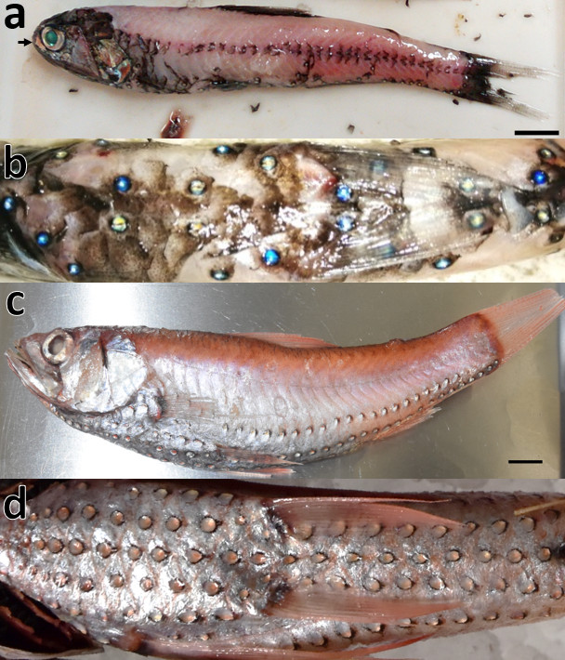
FIGURE S1. Tiff

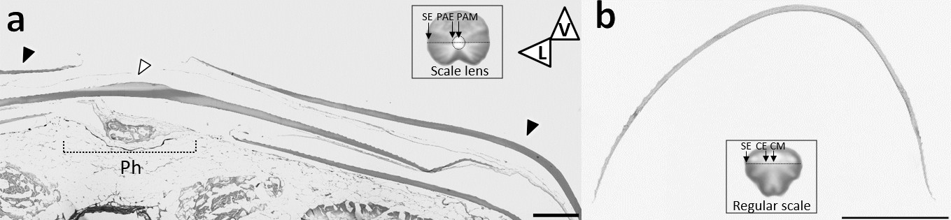
FIGURE S2. Tiff

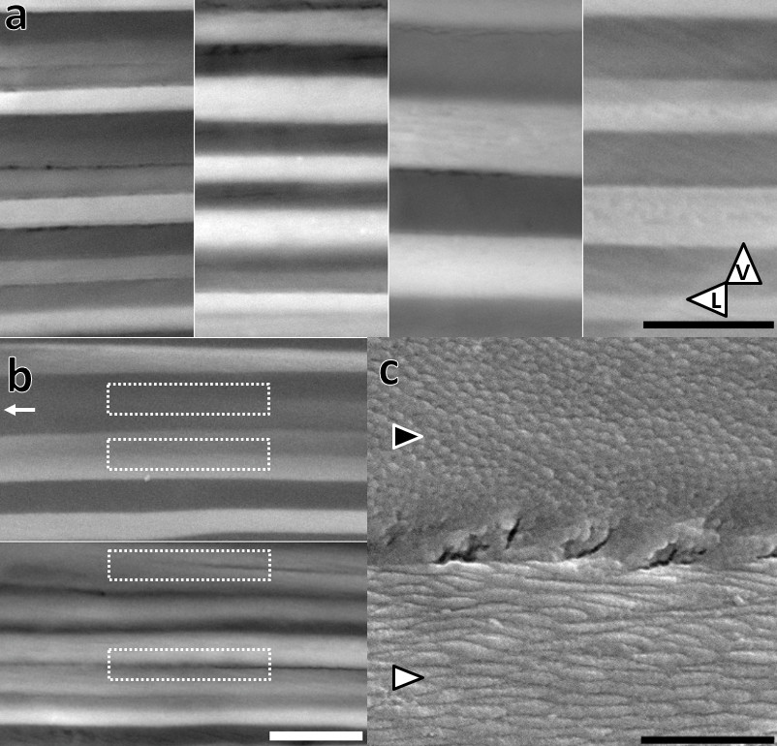
FIGURE S3. Tiff
FIGURE S4. Tiff
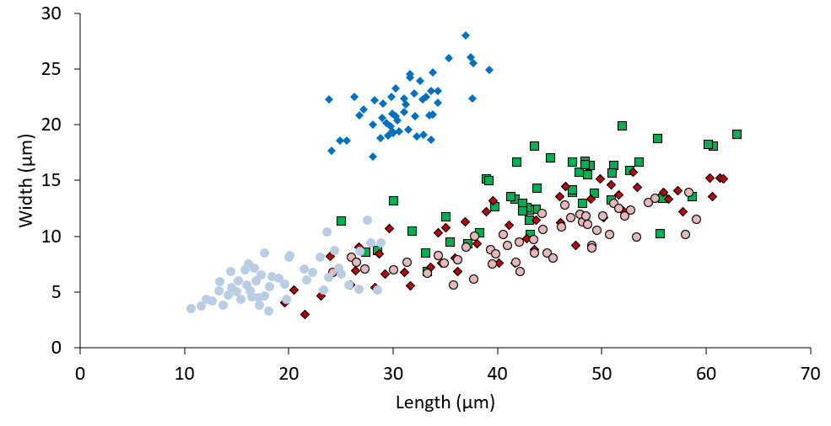
Figure S5. Tiff

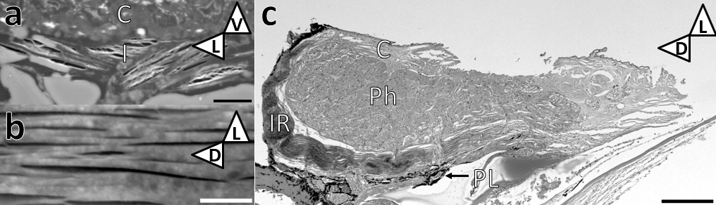
Figure S6. Tiff

