Refining Schizophrenia Risk Assessment: Machine Learning Delineates a Brain Signature of Cognitive Basic Symptoms
Koutsouleris et al.
SUPPLEMENTARY INFORMATION

Table of Contents
Supplementary Introduction 4
Short introduction into the basic symptom concept and Cognitive Disturbances (COGDIS) 4
Supplementary Methods 7
Participant recruitment and evaluation of prodromal symptoms 7
Processing of the structural magnetic resonance images 8
Computation of polygenic risk scores 9
Implementation of a flexible machine learning strategy for the optimal detection of sparse brain patterns for diagnostic classification 10
Testing each model’s performance significance using a permutation analysis with 1000 label permutations 12
Assessing neuroanatomical overlaps between COGDIS, MIXED and Formal Thought Disorder 12
Supplementary Results 13
Sociodemographic and clinical differences between study groups 13
Pairwise brain expression score correlations 14
References 14
Supplementary Tables 18
Table S1: The Transparent Reporting of a multivariable prediction model for Individual Prognosis Or Diagnosis using artificial intelligence (TRIPOD+AI) checklist 18
Table S2: Study group abbreviations and sample sizes. 21
Table S3: Inclusion and exclusion criteria of the PRONIA study. 22
Table S4: Antipsychotic medication thresholds used as exclusion criteria in the PRONIA study based on the previous version of the S3 guidelines of the German Association for Psychiatry, Psychotherapy and Psychosomatics. 23
Table S5: Group inclusion and exclusion criteria of the ZInEP study. 24
Table S6: Diagnostic breakdown of the recent-onset psychosis (ROP) group. 25
Table S7: Biopsychosocial variables used for predicting diagnostic brain pattern expression using machine learning. 26
Table S8: Study-related, sociodemographic, physical, functional and clinical differences in the PRONIA patient groups. 31
Table S9: Study-related, sociodemographic, physical, functional and clinical differences between the MUC patient groups. 33
Table S10: Study-related, sociodemographic, functional and clinical differences in the ZInEP sample. 34
Table S11: MR scanner systems and structural MRI sequence parameters used at the 9 PRONIA sites, in Munich and in the ZInEP studies. 35
Table S12: Performance of FThD classifiers in model development and validation samples. 36
Table S13: Subgroup analysis of pairwise correlations between the brain expression scores and BrainAGE. 37
Table S14: Prognostic stratification of GAF disability/impairment- and symptom-based outcome trajectories. 38
Supplementary Figures 39
Figure S1: Geographic location of recruitment sites and observational study protocol of the PRONIA study. 39
Figure S2: Strategy for sampling patients and HC for training and validating CHR-P classifiers. 40
Figure S3: Evaluation of site calibration strategy. 41
Figure S4: Voxel-level BrainAGE effects. 42
Figure S5: Voxel-level COGDIS brain pattern effects. 43
Figure S6: Voxel-level schizophrenia brain pattern effects. 44
Figure S7: Voxel-level MIXED brain pattern effects. 45
Figure S8: Voxel-level UHR brain pattern effects. 46
Figure S9: Neuroanatomical comparison between COGDIS and FThD+ classifiers. 47
Figure S10: Neuroanatomical comparison between COGDIS and FThD− classifiers. 48
Figure S11: Neuroanatomical comparison between MIXED and FThD+ classifiers. 49
Figure S12: Neuroanatomical comparison between MIXED and FThD− classifiers. 50
Figure S13: Performance of biopsychosocial brain score prediction models in the entire PRONIA cohort. 51
Figure S14: Quade test comparing the performances of biopsychosocial models predicting brain expression scores. 52
Figure S15: Performance of biopsychosocial brain score prediction models in patients vs. healthy controls 53
Figure S16: Permutation and label generalization analysis of biopsychosocial brain expression prediction models. 54
Figure S17: Relevance of genetic (left), neurocognitive (middle) and phenotypic (right) domains for the multimodal and transdiagnostic prediction of COGDIS brain pattern expression in the PRONIA cohort. 55
Figure S18: Relevance of genetic (left), neurocognitive (middle) and phenotypic (right) variables for the multimodal and transdiagnostic prediction of schizophrenia brain pattern expression in the PRONIA cohort. 56
Figure S19: Relevance of genetic (left), neurocognitive (middle) and phenotypic (right) variables for the multimodal and transdiagnostic prediction of BrainAGE pattern expression in the PRONIA cohort. 57
Figure S20: Relevance of genetic (left), neurocognitive (middle) and phenotypic (right) variables for the multimodal and transdiagnostic prediction of MIXED brain pattern expression in the PRONIA cohort. 58
Figure S21: Raw and z-transformed GAF-Disability/Impairment and GAF-Symptom trajectories from baseline to the T2 time points in the PRONIA clinical study participants. 59
Figure S22: Prognostic relevance of brain expression scores and GAF baseline features in the prediction of GAF-D/I outcome trajectories. 60

Supplementary Introduction

Short introduction into the basic symptom concept and Cognitive Disturbances (COGDIS)
Inspired by the early work of Wilhelm Mayer-Gross¹ on the onset of schizophrenia and its symptoms, the basic symptom concept was gradually developed by Gerd Huber from the 1950s until the 1980s.^{2,3} In anticipation of two essential aspects of the basic symptom concept, Mayer-Gross¹ already distinguished between initial uncharacteristic precursors (including disturbances of central vegetative processes, affects, drive and stress tolerance as well as anxiety and obsessive-compulsive symptoms) from the characteristic preliminary stages that occur later (including thought and activity disturbances), which ultimately lead to the manifest psychotic symptoms. In addition, he already assumed that these early disorders were not part of the premorbid personality, but would ‘impressively’ break into the ‘healthy personality’,¹ whereby they – like the basic symptoms – were ‘already prepsychotic, but not premorbid’.^{2,3}
In the face of these assumptions, Huber later coined the term ‘substrate-close basic symptoms’^{2,3} to express his conviction that these subjective complaints, which occur early in the course of the disease, are the basis of the final psychotic phenomena, whereby they are more closely linked to the assumed somatic substrate than psychotic positive or negative symptoms. Basic symptoms would thus represent “positive symptoms in statu nascendi that are already quasi ‘microproductive’”.³ The frequently observed fluctuation in the occurrence of basic symptoms, which could also remit completely in the meantime and in this case should be seen in the context of an outpost syndrome and not a prodrome, is caused both endogenously and situationally, for example by everyday stress or minimal affective triggers.^{3,4} Inadequate attempts to cope with self-perceived basic symptoms could also further increase psychological stress and appear as attenuated negative symptoms, such as social withdrawal or avolition.⁵
An obligatory characteristic of basic symptoms is their self-perception as disorders that are experienced and described as novel and/or different compared to normal complaints and that did not occur at all or occurred significantly less frequently and always with a link to particular situations/triggers in the premorbid phase.^{5,6} With a fully preserved reality testing and insight, these complaints are also regarded as a disturbance of the patient's own processes or experiences and are not projected into the environment for even a split second. Despite their conception as a direct expression of the underlying central disorder, the occurrence of such phenomena in the context of a diagnosed neurological and somatic disease as well as a connection with psychotropic substances, in particular ketamine and cannabis,⁷ are among the general exclusion criteria in the assessment of basic symptoms. Their sole occurrence in hypnagogic or hypnopompic states also exclude their rating.⁸
COGDIS requires the presence of at least two of the following basic cognitive symptoms, which occur even with otherwise good concentration/attention and at least once in a week within the past three months:^{5,6,8}
  - ‘Thought interference’ with the interjection of completely irrelevant and banal contents of consciousness that briefly enter the mind but do not result in losing the thread of the intended thought.
  - ‘Thought blockages’ resulting in at least temporarily losing the thread of thought either by an unintentional interruption of the thought, an unintentional replacement of the thought by another clearly more irrelevant/uninteresting thought, or by losing the thread through other ideas associated with aspects of the thought.
  - ‘Thought pressure’ in terms of a pushing of thematically unrelated thoughts that are difficult to stop
  - ‘Disturbance of receptive speech’ in terms of difficulties in the immediate comprehension of the native language, even in everyday conversations/reading
  - ‘Disturbance of expressive speech’ experienced as unusual word-finding disorders in the mother tongue in everyday life or a reduction in vocabulary
  - ‘Disturbance of abstract thinking’ in the sense of a falsely concrete understanding of abstract, metaphorical or symbolic content
  - ‘Inability to divide attention’ in tasks that do not in themselves require full attention and primarily involve different senses with at least one task that normally would require very little attention, such as washing up and having a conversation
  - ‘Captivation of attention by details of the visual field’ in terms of banal, uninteresting stimuli, so that the deliberate shifting of attention to more relevant stimuli is hindered
  - ‘Unstable ideas of reference’ in which the feeling that something might be especially related to the patient or that he is the centre of attention is not related to the surrounding and immediately recognized as inappropriate, i.e., as a ‘misperception’, even before a more concrete idea arises and is consciously considered before being dismissed (as in attenuated ideas of reference that are part of the UHR symptoms)
At this, from a phenomenological point of view, some of the cognitive basic symptoms included in COGDIS can be perceived as the subjective counterpart of observable formal thought disorder (FThD).^{9–11} For example, ‘loss of goal’ and ‘derailment’ (i.e., ’loosening of associations’, ‘flight of ideas’), ‘distractible speech’, ‘pressured speech’ as well as ‘incoherence’ that are commonly part of the disorganized/positive FThD factor^{9,10} can be regarded the as the observable counterpart of the subjectively experienced ‘losing the thread’ and ‘unintentional replacement of the thought’ subtypes of ‘thought blockages’, ‘thought pressure’ and ‘thought interference’ of COGDIS. While ‘blocking’ and ‘poverty of speech’ of the negative FThD dimension^{9,10} can be regarded as the observable counterpart of the ‘interruption’ subtype of ‘thought blockage’ and ‘disturbance in expressive speech’; the latter also resembling the negative symptom ‘alogia’.⁵ ‘Disturbance of abstract thinking’, on the other hand, that can be regarded as the subjective counterpart of ‘concretism’ is framed in the broader construct of FThD,^{9,10} while ‘disturbance in receptive speech’ mainly resembles the subjective counterpart of observed language comprehension problems as part of the cognitive dimension of psychoses. Finally, the self-experienced ‘captivation of attention by details of the visual field’ and ‘inability to divide attention’ are phenomenologically most similar to an observable ‘attentional impairment’ or ‘avolition’ in terms of negative symptoms.⁵

Supplementary Methods

Participant recruitment and evaluation of prodromal symptoms
The PRONIA sample investigated in the current study was recruited from the following 9 European sites:
PRONIA Site | Institution Name | Country | Type of Service | Catchment Population | Screening population / year
Munich | Department of Psychiatry and Psychotherapy, Ludwig-Maximilian-University Munich | DE | Academic outpatient services including specialized service for early recognition of psychosis; tertiary care academic hospital | 1,200,000 | 700
Basel | Department of Psychiatry and Psychotherapy, University of Basel | CH | Academic inpatient and outpatient services including specialized service for early recognition and intervention of psychosis; tertiary care academic hospital | 500,000 | 200
Milan Niguarda | Department of Pathophysiology and Transplantation, University of Milan. Four recruitment hospitals: Niguarda, Policlinico, San Paolo, Villa San Benedetto Menni in Albese con Cassano | IT | Psychiatric outpatient services including specialized services for early recognition of psychosis and persons at high risk; Academic hospital, providing psychiatric inpatient services, psychiatric outpatient services and local services; | 600,000 | 1,000
Cologne | Department of Psychiatry and Psychotherapy, University of Cologne | DE | Academic outpatient services including specialized service for early recognition of psychosis; tertiary care academic hospital | 1,000,000 | 600
Birmingham | The University of Birmingham | UK | Academic specialised Early Intervention Service for Psychosis covering Birmingham and Solihull. Community and Inpatient | 1,200,000 | 800
Turku | Department of Psychiatry, University of Turku | FI | Psychiatric outpatient and hospital services responsible for treatment of psychiatric patients in their catchment areas in the South-Western Finland. | 284,000 | 2,300
Udine | Department of Psychiatry, University of Udine | IT | Psychiatic outpatient services, academic hospital and local services. Tertiary care neuropsychiatric service | 600,000 | 500
Münster | Department of Psychiatry, University of Münster | DE | Academic outpatient services including specialized service for early recognition of psychosis; tertiary care academic hospital | 500,000 | 200
Bari | Department of Psychiatry, University of Bari | IT | Psychiatric outpatient services including specialized services for early recognition of psychosis and persons at high risk; Academic hospital, providing psychiatric inpatient services, psychiatric outpatient services and local services; | 1,500,000 | 600
Patients were recruited between February 1st, 2014, and January 31st, 2019. Details on the study protocol are provided in the Supplementary Material of ¹².
Clinical raters received training in the assessment of clinical high-risk criteria for psychosis (CHR-P), including both UHR and COGDIS symptom assessment instruments^{13,14} through workshops provided by Frauke Schultze-Lutter, the developer of the Schizophrenia Proneness Instrument. CHR-P criteria of each study candidate were assessed before study inclusion in regular case conferences led by Frauke Schultze-Lutter and re-evaluated during the follow-up period if a transition to psychosis was suspected.

Processing of the structural magnetic resonance images
The T1-weighted MR images were processed with the CAT12 toolbox (version 1207, https://neuro-jena.github.io/cat/).¹⁵ In summary, the preprocessing involved the following sequence of steps:
- Denoising based on Spatially Adaptive Non-Local Means filtering.
- Adaptive Maximum A Posteriori (AMAP) segmentation, which models local variations of intensity distributions as slowly varying spatial functions and thus achieves a homogeneous segmentation across cortical and subcortical structures.
- Additional denoising using a Markov Random Field approach, which incorporates spatial prior information of adjacent voxels into the segmentation estimation generated by AMAP.
- Local Adaptive Segmentation (LAS), which adjusts the images for white matter (WM) and grey matter (GM) inhomogeneities caused by differing iron content in e.g. (sub)cortical structures.
- Final AMAP segmentation by a partial volume segmentation algorithm that is capable of modelling tissues with intensities between GM and WM, as well as GM and cerebrospinal fluid and is applied to the AMAP-generated tissue segments.
- High-dimensional registration of the images to a template in Montreal Neurological Institute space generated from the MRI data of 555 healthy controls (HC) in the IXI database (http://www.braindevelopment.org). The registered GM images were multiplied with the Jacobian determinants obtained during registration to produce GM volume (GMV) maps. GMV maps were resliced to 2 mm isotropic voxel resolution without further Gaussian smoothing to retain fine-grained morphometric variation in the data. The Quality Assurance framework of CAT12 was used to quantitatively check the quality of the GMV maps. This procedure produced a weighted quality score which classified image quality into excellent [A], good [B], satisfactory [C], sufficient [D], critical [E], and failed [F]) categories.
The images analysed in the current work were categorized between B+ (44.2% of images), B (50.5%), B- (4.8%) and C+ (0.3%).

Computation of polygenic risk scores
In the PRONIA cohort with sMRI data (Figure 1; n=1441), 1118 (77.6%) participants had provided whole-blood samples and consented to genetic testing. DNA was genotyped using Illumina’s Infinium Global Screening (GSA) Array-24 BeadChip version 2 + Psych content (GSA). The GSA includes > 650,000 markers and comprises 50,000 variants associated with common psychiatric disorders such as schizophrenia, bipolar disorders and autism spectrum disorders. After standard, stringent quality control using PLINK (e.g., sample call rate > 0.98; variant call rate > 0.98; Minor Allele Frequency > 0.01; removal of variants deviating from Hardy-Weinberg equilibrium, p < 10E-6; sex check and heterozygosity outlier analysis), a total of 505,687 variants remained in the dataset.
The post-QC genotype data were then phased with eagle v2.4.1 (https://alkesgroup.broadinstitute.org/Eagle/) and imputed with minimac 4 v1.0.2 (https://genome.sph.umich.edu/wiki/Minimac4) using 1000 genome phase 3 data as reference haplotypes panel (https://www.internationalgenome.org/home). To include reliable variants for polygenic risk score (PRS) analysis we excluded imputed variants with lower imputation accuracy (i.e., R²<0.8, n=10,962,225). Finally, we computed PRS for the traits in the study by means of the “clumping plus threshold” method. The PRS computation was run using PRSise v2 tool (https://choishingwan.github.io/PRSice/) with the default parameters for clumping (i.e., R²<0.1 considering 250kb flanking regions for each variant included in the PRS) while 10 P-value thresholds for variants selection were tested (i.e., 5.00e-08, 1.00e-06, 1.00e-04, 0.001, 0.01, 0.05, 0.1, 0.2, 0.5, 1.0).
For PRS computations, we employed the summary statistics of neuropsychiatric, cognitive and behavioral traits provided by the references listed in Table S7. PRS were computed as the sum of the risk alleles weighed by the association estimates for the three disorders (beta of respective disorders) including all common variants (i.e., with Minor Allele Frequency > 1%) in the clumped dataset at a given P value threshold. PRS were standardized to have a direct comparison across sample PRS values considering variable P value thresholds. Moreover, since PRS values can also be influenced by population structure, we extracted the first 5 Principal Components (PC) from the post QC genotype data. Pruning of genotyping data was applied prior to computing the PC to limit the effect of Linkage Disequilibrium (LD) across markers and, consequently, to better represent the population structure in the eigenvectors. Genome-wide pruning was performed with PLINK considering window sizes of 50 variants and steps of 5 variants, while a threshold of 0.5 in the R² correlation across paired variants was considered. The PRS were corrected for population structure effects by computing beta coefficients measuring the shared variance between the population-structure PCs and the PRS features in the HC individuals and then applying the obtained coefficients to the respective patient data. The adjusted patient PRS scores were standardized using the adjusted HC data and included in the downstream analysis steps.

Implementation of a flexible machine learning strategy for the optimal detection of sparse brain patterns for diagnostic classification
For the implementation of a flexible machine learning strategy that detects optimally sparse brain patterns for diagnostic classification while minimizing residual site effects in the data, the following three steps were performed:
- Calculation of discriminative, site-effect insensitive weights: For each voxel, a weight was computed based on its diagnostic value and its site effects variability, scaled to the range [0,1]. Specifically, in each training data partition, we generated a discriminative weight image ($W$) by computing for each voxel the product of the min-max transformed F-Score (diagnostic separability) and the min-max transformed, inverted F statistic (site separability), as provided by one-way analysis of variance (ANOVA), using the following formula:
$$v_{w}=F_{\text{score, scaled}}^{λ_{1}}×\left(1-F_{\text{statistic, scaled}}^{λ_{2}}\right)$$
Where:
- $v_{W}$ is a voxel weight in the $W$map,
- $F_{\text{score, scaled}}= \frac{F_{\text{score}}-min⁡(F_{\text{score}})}{\max\left(F_{\text{score}}\right)-min⁡(F_{\text{score}})}$ , where: $F_{\text{score}}=\frac{{(M_{\text{PAT}}-M_{\text{HC}})}^{2}}{{SD}_{\text{PAT}}+{SD}_{\text{HC}}}$ measures diagnostic separability between the given patient class (PAT) and the healthy control class (HC) with $M$ being the mean value and $SD$ the standard deviation of the given voxel value in the respective class.
- $F_{\text{statistic, scaled}}=\frac{F_{\text{statistic}}-min⁡(F_{\text{statistic}})}{\max\left(F_{\text{statistic}}\right)-min⁡(F_{\text{statistic}})}$, where: $F_{\text{statistic}}=\frac{{MS}_{\text{sites}}}{{MS}_{\text{error}}}$ measures the site effects in the given voxel with $MS$ being the mean squares of sites or errors.
- $λ_{1}$ and $λ_{2}$ introduce separate weight exponentiation factors which allowed us to investigate how increasing or decreasing the emphasis on certain voxels (by making the weights more extreme or more moderate) affected the sparsity of the diagnostic and residual site-effects pattern and, in turn, the classification performance. We exponentiated voxel weights within the range $λ∈ \left[1, 3, 5\right]$ to vary the degree of sparsity systematically, from no additional emphasis [1] to moderate [3] and high emphasis [5] on relevant voxels.
Each voxel in a training partition’s GMV maps was then multiplied by its corresponding $v_{W}$ before entering the next preprocessing step​.
- Spatially informed dimensionality reduction: Principal Component Analysis (PCA) was applied to the weighted images to transform the data into a set of linearly uncorrelated discriminative eigenvariates (principal components). The pre-weighting step biased PCA towards finding principal components that did not just capture most of the variance in the data but encoded the most relevant variance to the classification task at hand while mitigating residual site-related variance in the data. We optimized the number of eigenvariates (N_{PC}) within a range of [5, 10, 15, 20, 25, 30, 40, 50, 60, 70, 80] to focus on the most discriminative variation in the data and thus reduce the potential impact of noise of higher cardinality eigenvariates on the subsequent analysis steps. The study participants’ eigenscores were standardized using the eigenscores’ median and standard deviations before entering the machine learning step.
- Maximum-margin classification: $L_{2}$-regularized, $L_{1}$-loss linear support-vector classification (SVC) as implemented in the LIBLINEAR library¹⁶ was trained to separate patients from HC using the discriminative eigenvariates generated in the previous step. We employed a cost-sensitive, soft-margin SVC formulation to automatically account for the unbalanced class distributions in our classification analyses. The SVC algorithm’s slack hyperparameter C, which controls the misclassification cost, was optimized in the range of $2^{[-7\overset{→}{∈Z}0]}$.
For each parameter combination $h$ in this 3 (λ₁) x 3 (λ₂) x 11 (N_{PC}) x 8 (C) hyperparameter space $H$ (=792 hyperparameter combinations) we measured the SVC models’ CV₁ test data performance at each partition of the CV₁ cycle. We chose the optimal parameter combination $h^{*}$ by finding the maximum average Balanced Accuracy (BAC) in $H$, defined as:
$$h^{*}=\arg{\max_{h_{i}∈H}}\left({\overline{\text{BAC}}}_{ij}=\frac{1}{k}\sum_{j=1}^{k=10}{({\text{Sensitivity}}_{ij}+{\text{Specificity}}_{ij})/2}\right)$$
Where $h_{i}$ is the parameter combination at position $i$ in $H$, and $j$ is the current partition in the $k$ test data partitions of the CV₁ level.

Testing each model’s performance significance using a permutation analysis with 1000 label permutations
In addition to testing the statistical significance of the single model’s performance, the permutation analyses also tested whether a given model’s predictions generalized to other brain expression scores. To this end, Pearson correlation coefficients ($r_{perm})$were computed between permuted model predictions and the unseen scores. We evaluated how many times $r_{perm}$equaled or exceeded the correlation coefficient obtained from the observed model’s predictions ($r_{obs}$) and derived a P value for the generalization of the given biopsychosocial model to each of the other four scores, defined as:
$$p=\frac{\sum_{i=1}^{n}{I\left({|r}_{perm}|≥{|r}_{obs}|\right)}}{n}$$
where:
- $I\left({|r}_{perm}|≥{|r}_{obs}|\right)$is an indicator function that equals 1 if the absolute value of the permuted correlation $r_{perm}$ is greater than or equal to the absolute value of $r_{obs}$​, and 0 otherwise.
- $n$ is the total number of permutations.

Assessing neuroanatomical overlaps between COGDIS, MIXED and Formal Thought Disorder
Patients from the PRONIA and MUC cohorts diagnosed with psychotic disorders (total n=459; ROP-SCZ: n=102, NONSCZ-ROP: n=214, FE-SCZ: n=60, RE-SCZ: n=79) and available imaging, PANSS and SANS data were stratified based on Formal Thought Disorder (FThD) severity into high (FThD+) and low (FThD−) subgroups. FThD severity was approximated using specific items from PANSS and SANS questionnaires that capture aspects of positive and negative FThD symptoms: ‘Conceptual disorganization’ (PANSS-P2), ‘Difficulty in abstract thinking’ (PANSS-N5), ‘Poor attention’ (PANSS-G11), ‘Poverty of speech’ (SANS-09), ‘Poverty of content of speech’ (SANS-10), ‘Blocking’ (SANS-11), ‘Increased latency of response’ (SANS-12), and ‘Global rating of attention’ (SANS-25). PANSS and SANS data were scaled to the range [0, 1], and missing entries were imputed using sequential kNN-based methods.¹⁷ An FThD score was computed for each patient by summing the respective PANSS and SANS variable scores. To remove the impact of general psychopathology on the subsequent analysis, these FThD sum scores were adjusted for the sum of the PANSS and SANS variables not included in the FThD construct via partial correlation analysis.
Patients were then ranked according to their adjusted FThD scores, with the upper and lower 75 patients assigned to the FThD+ and FThD− groups, respectively, aligning with the patient sample size available for COGDIS classifier training. Following the methodology described in the methods section of the main paper, HC groups matched by site, age, and sex were assembled for each FThD subgroup using the identical sampling strategy applied in the CHR-P analyses. Machine learning models were trained to distinguish each patient subgroup from their corresponding matched HC group, following the same analytical procedures used in developing and validating CHR-P classifiers. The ZInEP cohort as well as all PRONIA patients and HC not included in the development of the two FThD models were used for model validation. Validation results including classification performance metrics and permutation-based P values for balanced accuracies in each group comparison are detailed in Table S12.
Then, the univariate spatial colocalization analysis described in the main paper was repeated after replacing the schizophrenia brain score regressor with the decision scores produced by the FThD+ and FThD− classifiers. Conjunction and masked contrasts were applied to the COGDIS, FThD+ and FThD− regressors, and MIXED, FThD and FThD− regressors to investigate shared and unique components among the respective brain signatures (Figures S9-S12). Statistical significance was determined at α=0.05, FWE-corrected.

Supplementary Results

Sociodemographic and clinical differences between study groups
Pronounced differences in age and sex distributions were observed at the cohort and study-group levels (Tables S8-S10), representing the wide range of disease stages and phenotypes under study. As expected, we found overall symptom severity increases from CHR-P states, over first-episode to established schizophrenia, as reflected by patients’ PANSS total scores (Tables S8, S9). Negative symptoms were more pronounced in schizophrenia compared to non-schizophrenic psychotic disorders or BOR (Tables S8, S9), and in COGDIS, UHR, or MIXED risk syndromes compared to COPER or HR-BIP groups (Table S10). COGDIS symptoms were more severe in schizophrenic compared to non-schizophrenic psychoses, and in MIXED compared to COGDIS groups (Tables S8, S10). The majority of patients with COGDIS, UHR or MIXED had a depressive comorbidity, while the prevalence of depression was lower in patients with COPER or HR-BIP (Tables S8, S10). Depressive and bipolar diagnoses were three times more frequent in ROP-NONSCZ compared to ROP-SCZ (Table S8). We also observed higher prevalence of PTSD in UHR or MIXED syndromes compared to other CHR-P criteria (Tables S8, S10). Further differences were found between HC and patients in alcohol, nicotine, or cannabis consumption but not between patient groups (Tables S8-S10). Similarly, patients had higher Body-Mass-Index (BMI), childhood trauma scores and more educational problems compared to HC (Tables S8-S10).

Pairwise brain expression score correlations
When testing the pairwise group-level associations between brain expression scores (Table S13), a weak positive correlation of COGDIS with MIXED, and strong positive correlations of COGDIS with BrainAGE and SCZ were observed, with only COGDIS-SCZ associations surviving BrainAGE adjustment with a moderate positive correlation. UHR was not correlated with COGDIS but showed a weak positive association with MIXED, which, in turn was weakly positively correlated with SCZ (Table S13). SCZ was strongly positively correlated with BrainAGE (Table S13). For each of these at least weak correlations, subgroup analyses were conducted, which showed that the associations observed between COGDIS, SCZ, and BrainAGE were not attributable to a specific subgroup but at least moderately correlated in most groups but COPER and HR-BIP (Table S13). Like in the analyses of group-level differences (Table 2), the correction for BrainAGE reduced effects and showed weak to medium global effects only for correlations between UHR and MIXED and between COGDIS and SCZ (Table S13). Subgroup analyses of BrainAGE-corrected associations showed correlations between COGDIS and SCZ in FE-SCZ, ROP-SCZ and RE-SCZ that were reduced to below-moderate levels, while respective correlations where of moderate strength in the other samples, except for COPER and HR-BIP (Table S13).

References
1. Mayer-Gross, W. Die Klinik. in Spezieller Teil: Fünfter Teil die Schizophrenie (eds. Beringer, K. et al.) 293–578 (Springer, Berlin, Heidelberg, 1932). doi:10.1007/978-3-642-92501-6_4.
2. Huber, G. Das Konzept substratnaher Basissymptome und seine Bedeutung für Theorie und Therapie schizophrener Erkrankungen. [The concept of basic deficits in schizophrenia and its significance for theory and treatment.]. Nervenarzt 54, 23–32 (1983).
3. Huber, G. [Prodromal symptoms in schizophrenia]. Fortschr Neurol Psychiatr 63, 131–138 (1995).
4. Schultze-Lutter, F. Basic symptoms in deficit states and their relation to negative symptoms. in Managing negative symptoms of schizophrenia 19–37 (Oxford University Press, New York, NY, US, 2020). doi:10.1093/med/9780198840121.003.0002.
5. Schultze-Lutter, F. Subjective symptoms of schizophrenia in research and the clinic: the basic symptom concept. Schizophr. Bull. 35, 5–8 (2009).
6. Schultze-Lutter, F. et al. Basic symptoms and the prediction of first-episode psychosis. Curr. Pharm. Des. 18, 351–357 (2012).
7. Morgan, C. J. A. et al. Neurocognitive Function and Schizophrenia-Proneness in Individuals Dependent on Ketamine, on High Potency Cannabis (‘Skunk’) or on Cocaine. Pharmacopsychiatry 45, 269–274 (2012).
8. Schultze-Lutter, F., Addington, J., Ruhrmann, S. & Klosterkötter, J. Schizophrenia Proneness Instrument, Adult Version (SPI-A). (Rome, 2007).
9. Kircher, T., Bröhl, H., Meier, F. & Engelen, J. Formal thought disorders: from phenomenology to neurobiology. Lancet Psychiatry 5, 515–526 (2018).
10. Zamperoni, G., Tan, E. J., Rossell, S. L., Meyer, D. & Sumner, P. J. Evidence for the factor structure of formal thought disorder: A systematic review. Schizophr. Res. 264, 424–434 (2024).
11. Andreasen, N. C. Scale for the assessment of thought, language, and communication (TLC). Schizophr. Bull. 12, 473–482 (1986).
12. Koutsouleris, N. et al. Prediction Models of Functional Outcomes for Individuals in the Clinical High-Risk State for Psychosis or With Recent-Onset Depression: A Multimodal, Multisite Machine Learning Analysis. JAMA Psychiatry 75, 1156–1172 (2018).
13. Schultze-Lutter, F., Addington, J., Ruhrmann, S. & Klosterkötter, J. Schizophrenia Proneness Instrument, Adult Version (SPI-A). (Rome, 2007).
14. McGlashan, T. H., Miller, T. J., Woods, S. W., Hoffman, R. E. & Davidson, L. Instrument for the assessment of prodromal symptoms and states. in Early intervention in psychiatric disorders (eds. Miller, T., Madnick, S. A., McGlashan, T. H., Libiger, J. & Johannessen, J. O.) 135–149 (Kluwer Academic, Dordrecht, 2001).
15. Gaser, C. et al. CAT: a computational anatomy toolbox for the analysis of structural MRI data. GigaScience 13, giae049 (2024).
16. Fan, R.-E., Chang, K.-W., Hsieh, C.-J., Wang, X.-R. & Lin, C.-J. LIBLINEAR: A Library for Large Linear Classification. J. Mach. Learn. Res. 9, 1871–1874 (2008).
17. Kim, K.-Y., Kim, B.-J. & Yi, G.-S. Reuse of imputed data in microarray analysis increases imputation efficiency. BMC Bioinformatics 5, 160 (2004).
18. Angst, J. et al. The HCL-32: Towards a self-assessment tool for hypomanic symptoms in outpatients. J. Affect. Disord. 88, 217–233 (2005).
19. Sheehan, D. V. et al. The Mini-International Neuropsychiatric Interview (M.I.N.I.): the development and validation of a structured diagnostic psychiatric interview for DSM-IV and ICD-10. J. Clin. Psychiatry 59 Suppl 20, 22-33;quiz 34-57 (1998).
20. Demontis, D. et al. Discovery of the first genome-wide significant risk loci for attention deficit/hyperactivity disorder. Nat. Genet. 51, 63–75 (2019).
21. Watson, H. J. et al. Genome-wide association study identifies eight risk loci and implicates metabo-psychiatric origins for anorexia nervosa. Nat. Genet. 51, 1207–1214 (2019).
22. Grove, J. et al. Identification of common genetic risk variants for autism spectrum disorder. Nat. Genet. 51, 431–444 (2019).
23. Mullins, N. et al. Genome-wide association study of more than 40,000 bipolar disorder cases provides new insights into the underlying biology. Nat. Genet. 53, 817–829 (2021).
24. Stahl, E. A. et al. Genome-wide association study identifies 30 loci associated with bipolar disorder. Nat. Genet. 51, 793–803 (2019).
25. Lee, J. J. et al. Gene discovery and polygenic prediction from a genome-wide association study of educational attainment in 1.1 million individuals. Nat. Genet. 50, 1112–1121 (2018).
26. Lee, J. J. et al. Gene discovery and polygenic prediction from a genome-wide association study of educational attainment in 1.1 million individuals. Nat. Genet. 50, 1112–1121 (2018).
27. Okbay, A. et al. Genome-wide association study identifies 74 loci associated with educational attainment. Nature 533, 539–542 (2016).
28. Savage, J. E. et al. Genome-wide association meta-analysis in 269,867 individuals identifies new genetic and functional links to intelligence. Nat. Genet. 50, 912–919 (2018).
29. Wray, N. R. et al. Genome-wide association analyses identify 44 risk variants and refine the genetic architecture of major depression. Nat. Genet. 50, 668–681 (2018).
30. Luciano, M. et al. Association analysis in over 329,000 individuals identifies 116 independent variants influencing neuroticism. Nat. Genet. 50, 6–11 (2018).
31. Ripke, S. et al. Biological insights from 108 schizophrenia-associated genetic loci. Nature 511, 421 (2014).
32. Trubetskoy, V. et al. Mapping genomic loci implicates genes and synaptic biology in schizophrenia. Nature 604, 502–508 (2022).
33. Baselmans, B. M. L. & Bartels, M. A genetic perspective on the relationship between eudaimonic -and hedonic well-being. Sci. Rep. 8, 14610 (2018).
34. Identification of risk loci with shared effects on five major psychiatric disorders: a genome-wide analysis. The Lancet 381, 1371–1379 (2013).
35. van den Berg, S. M. et al. Meta-analysis of Genome-Wide Association Studies for Extraversion: Findings from the Genetics of Personality Consortium. Behav. Genet. 46, 170–182 (2016).
36. Kunkle, B. W. et al. Genetic meta-analysis of diagnosed Alzheimer’s disease identifies new risk loci and implicates Aβ, tau, immunity and lipid processing. Nat. Genet. 51, 414–430 (2019).
37. Ferrari, R. et al. Frontotemporal dementia and its subtypes: a genome-wide association study. Lancet Neurol. 13, 686–699 (2014).
38. Bernstein, D. & Fink, L. CTQ: Childhood Trauma Questionnaire: a retrospective self-report. San Antonio TX Psychol. Corp (1998).
39. Winterstein, B. P. et al. Brief assessment of schizotypy: Developing short forms of the Wisconsin Schizotypy Scales. Personal. Individ. Differ. 51, 920–924 (2011).
40. Betz, L. T. et al. General psychopathology links burden of recent life events and psychotic symptoms in a network approach. Npj Schizophr. 6, 1–8 (2020).
41. Cannon-Spoor, H. E., Potkin, S. G. & Wyatt, R. J. Measurement of premorbid adjustment in chronic schizophrenia. Schizophr. Bull. 8, 470–484 (1982).
42. Endler, N. S. & Parker, J. D. A. Coping Inventory for Stressful Situations--Short Form. https://doi.org/10.1037/t67919-000 (2021).
43. Zimet, G. D., Dahlem, N. W., Zimet, S. G. & Farley, G. K. The Multidimensional Scale of Perceived Social Support. J. Pers. Assess. 52, 30–41 (1988).
44. Costa, P. T., Jr. & McCrae, R. R. The revised NEO personality inventory (NEO-PI-R). in The SAGE Handbook of Personality Theory and Assessment: Volume 2 - Personality Measurement and Testing 179–198 (2008). doi:10.4135/9781849200479.n9.
45. Friborg, O., Hjemdal, O., Rosenvinge, J. H. & Martinussen, M. A new rating scale for adult resilience: what are the central protective resources behind healthy adjustment? Int. J. Methods Psychiatr. Res. 12, 65–76 (2003).
46. WHO. WHOQOL-BREF : Introduction, Administration, Scoring and Generic Version of the Assessment : Field Trial Version. (WHO Division of Mental Health, Geneva, Switzerland, 1996).
47. Cole, J. D. & Kazarian, S. S. The level of expressed emotion scale: A new measure of expressed emotion. J. Clin. Psychol. 44, 392–397 (1988).
48. Cornblatt, B. A. et al. Preliminary findings for two new measures of social and role functioning in the prodromal phase of schizophrenia. Schizophr. Bull. 33, 688–702 (2007).
49. Pedersen, G., Hagtvet, K. A. & Karterud, S. Generalizability studies of the Global Assessment of Functioning–Split version. Compr. Psychiatry 48, 88–94 (2007).
50. Keefe, R. S. et al. The Brief Assessment of Cognition in Schizophrenia: reliability, sensitivity, and comparison with a standard neurocognitive battery. Schizophr. Res. 68, 283–297 (2004).
51. Petrides, M. Impairments on nonspatial self-ordered and externally ordered working memory tasks after lesions of the mid-dorsal part of the lateral frontal cortex in the monkey. J. Neurosci. 15, 359–375 (1995).
52. Rey, André. L’examen clinique en psychologie. (Presses universitaires de France, Paris, 1958).
53. Cornblatt, B. A., Risch, N. J., Faris, G., Friedman, D. & Erlenmeyer-Kimling, L. The Continuous Performance Test, identical pairs version (CPT-IP): I. New findings about sustained attention in normal families. Psychiatry Res. 26, 223–238 (1988).
54. Wechsler, D. Wechsler Adult Intelligence Scale. (Psychological Coorperation, San Antonio, TX, 1997).
55. Reitan, R. M. TMT, Trail Making Test A & B. (South Tucson, AR, 1992).

Supplementary Tables

Table S1: The Transparent Reporting of a multivariable prediction model for Individual Prognosis Or Diagnosis using artificial intelligence (TRIPOD+AI) checklist
Section/Topic Item Development Checklist item/ evaluation¹ |  |  |  | Reported on page
TITLE
Title | 1 | D;E | Identify the study as developing or evaluating the performance of a multivariable prediction model, the target population, and the outcome to be predicted | 1
ABSTRACT
Abstract | 2 | D;E | See TRIPOD+AI for Abstracts checklist below | 2
INTRODUCTION
Background | 3a | D;E | Explain the healthcare context (including whether diagnostic or prognostic) and rationale for developing or evaluating the prediction model, including references to existing models | 3/4
Background | 3b | D;E | Describe the target population and the intended purpose of the prediction model in the context of the care pathway, including its intended users (e.g., healthcare professionals, patients, public) | 3/4
Background | 3c | D;E | Describe any known health inequalities between sociodemographic groups | NA
Objectives | 4 | D;E | Specify the study objectives, including whether the study describes the development or validation of a prediction model (or both) | 4/5
METHODS
Data | 5a | D;E | Describe the sources of data separately for the development and evaluation datasets (e.g., randomised trial, cohort, routine care or registry data), the rationale for using these data, and representativeness of the data | 5/6
Data | 5b | D;E | Specify the dates of the collected participant data, including start and end of participant accrual; and, if applicable, end of follow-up | Supplement (p. 7)
Participants | 6a | D;E | Specify key elements of the study setting (e.g., primary care, secondary care, general population) including the number and location of centres | 5/6, Supplement (p. 7)
Participants | 6b | D;E | Describe the eligibility criteria for study participants | Tables S3-S5
Participants | 6c | D;E | Give details of any treatments received, and how they were handled during model development or evaluation, if relevant | Supplement, Tables S8-S10
Data preparation | 7 | D;E | Describe any data pre-processing and quality checking, including whether this was similar across relevant sociodemographic groups | 6/7
Outcome | 8a | D;E | Clearly define the outcome that is being predicted and the time horizon, including how and when assessed, the rationale for choosing this outcome, and whether the method of outcome assessment is consistent across sociodemographic groups | 7/ Table S1
Outcome | 8b | D;E | If outcome assessment requires subjective interpretation, describe the qualifications and demographic characteristics of the outcome assessors | Supplement (p. 7/8)
Outcome | 8c | D;E | Report any actions to blind assessment of the outcome to be predicted | Not applicable
Predictors | 9a | D | Describe the choice of initial predictors (e.g., literature, previous models, all available predictors) and any pre-selection of predictors before model building | 6/7, Table S7
Predictors | 9b | D;E | Clearly define all predictors, including how and when they were measured (and any actions to blind assessment of predictors for the outcome and other predictors) | 6/7
Predictors | 9c | D;E | If predictor measurement requires subjective interpretation, describe the qualifications and demographic characteristics of the predictor assessors | Not applicable for MRI, Supplement (p. 7)
Sample size | 10 | D;E | Explain how the study size was arrived at (separately for development and evaluation), and justify that the study size was sufficient to answer the research question. Include details of any sample size calculation | Figure 1
Missing data | 11 | D;E | Describe how missing data were handled. Provide reasons for omitting any data | 6/ Supplement
Analytical methods | 12a | D | Describe how the data were used (e.g., for development and evaluation of model performance) in the analysis, including whether the data were partitioned, considering any sample size requirements | 7/8/9
Analytical methods | 12b | D | Depending on the type of model, describe how predictors were handled in the analyses (functional form, rescaling, transformation, or any standardisation). | 7/8/9
Analytical methods | 12c | D | Specify the type of model, rationale², all model-building steps, including any hyperparameter tuning, and method for internal validation | 7/8/9
Analytical methods | 12d | D;E | Describe if and how any heterogeneity in estimates of model parameter values and model performance was handled and quantified across clusters (e.g., hospitals, countries). See TRIPOD-Cluster for additional considerations³ | 6/7
Analytical methods | 12e | D;E | Specify all measures and plots used (and their rationale) to evaluate model performance (e.g., discrimination, calibration, clinical utility) and, if relevant, to compare multiple models | 9
Analytical methods | 12f | E | Describe any model updating (e.g., recalibration) arising from the model evaluation, either overall or for particular sociodemographic groups or settings | 7/8/9
Analytical methods | 12g | E | For model evaluation, describe how the model predictions were calculated (e.g., formula, code, object, application programming interface) | 9/10
Class imbalance | 13 | D;E | If class imbalance methods were used, state why and how this was done, and any subsequent methods to recalibrate the model or the model predictions | 7
Fairness | 14 | D;E | Describe any approaches that were used to address model fairness and their rationale | 6/7/10
Model output | 15 | D | Specify the output of the prediction model (e.g., probabilities, classification). Provide details and rationale for any classification and how the thresholds were identified | 9/10
Training versus evaluation | 16 | D;E | Identify any differences between the development and evaluation data in healthcare setting, eligibility criteria, outcome, and predictors | 5/6/ Supplement
Ethical approval | 17 | D;E | Name the institutional research board or ethics committee that approved the study and describe the participant-informed consent or the ethics committee waiver of informed consent | 5
OPEN SCIENCE
Funding | 18a | D;E | Give the source of funding and the role of the funders for the present study | Acknowledgments
Coflicts of interest | 18b | D;E | Declare any conflicts of interest and financial disclosures for all authors | Acknowledgments
Protocol | 18c | D;E | Indicate where the study protocol can be accessed or state that a protocol was not prepared | Acknowledgments
Registration | 18d | D;E | Provide registration information for the study, including register name and registration number, or state that the study was not registered | Supplement
Data sharing | 18e | D;E | Provide details of the availability of the study data | Acknowledgments
Code sharing | 18f | D;E | Provide details of the availability of the analytical code⁴ | Analysis parameters to be provided alongside the paper
PATIENT & PUBLIC INVOLVEMENT
Patient & Public Involvement | 19 | D;E | Provide details of any patient and public involvement during the design, conduct, reporting, interpretation, or dissemination of the study or state no involvement. | Not available
RESULTS
Participants | 20a | D;E | Describe the flow of participants through the study, including the number of participants with and without the outcome and, if applicable, a summary of the follow-up time. A diagram may be helpful. | 6/ Figure 1
Participants | 20b | D;E | Report the characteristics overall and, where applicable, for each data source or setting, including the key dates, key predictors (including demographics), treatments received, sample size, number of outcome events, follow-up time, and amount of missing data. A table may be helpful. Report any differences across key demographic groups. | Supplementary Results / Tables S8-S10
Participants | 20c | E | For model evaluation, show a comparison with the development data of the distribution of important predictors (demographics, predictors, and outcome). | Supplementary Results / Tables S8-S10
Model development | 21 | D;E | Specify the number of participants and outcome events in each analysis (e.g., for model development, hyperparameter tuning, model evaluation) | 6/ Figure 1, Table S2
Model specification | 22 | D | Provide details of the full prediction model (e.g., formula, code, object, application programming interface) to allow predictions in new individuals and to enable third-party evaluation and implementation, including any restrictions to access or re-use (e.g., freely available, proprietary)⁵ | 7-12
Model performance | 23a | D;E | Report model performance estimates with confidence intervals, including for any key subgroups (e.g., sociodemographic). Consider plots to aid presentation. | Table 1
Model performance | 23b | D;E | If examined, report results of any heterogeneity in model performance across clusters. See TRIPOD Cluster for additional details³. | Tables 1/2/S12/S13
Model updating | 24 | E | Report the results from any model updating, including the updated model and subsequent performance | NA
DISCUSSION
Interpretation | 25 | D;E | Give an overall interpretation of the main results, including issues of fairness in the context of the objectives and previous studies | 26-27
Limitations | 26 | D;E | Discuss any limitations of the study (such as a non-representative sample, sample size, overfitting, missing data) and their effects on any biases, statistical uncertainty, and generalizability | 27
Usability of the model in the context of current care | 27a | D | Describe how poor quality or unavailable input data (e.g., predictor values) should be assessed and handled when implementing the prediction model | NA
Usability of the model in the context of current care | 27b | D | Specify whether users will be required to interact in the handling of the input data or use of the model, and what level of expertise is required of users | NA
Usability of the model in the context of current care | 27c | D;E | Discuss any next steps for future research, with a specific view to applicability and generalizability of the model | 27-28
From: Collins GS, Moons KGM, Dhiman P, et al. BMJ 2024;385:e078378. doi:10.1136/bmj-2023-078378
D=items relevant only to the development of a prediction model
E=items relating solely to the evaluation of a prediction model
D;E=items applicable to both the development and evaluation of a prediction model
† Separately for all model building approaches.
‡ TRIPOD-Cluster is a checklist of reporting recommendations for studies developing or validating models that explicitly account for clustering or explore heterogeneity in model performance (e.g., at different hospitals or centers).
§ Relates to the analysis code, for example, any data cleaning, feature engineering, model building, and evaluation.
¶ Relates to the code to implement the model to get estimates of risk for a new individual.
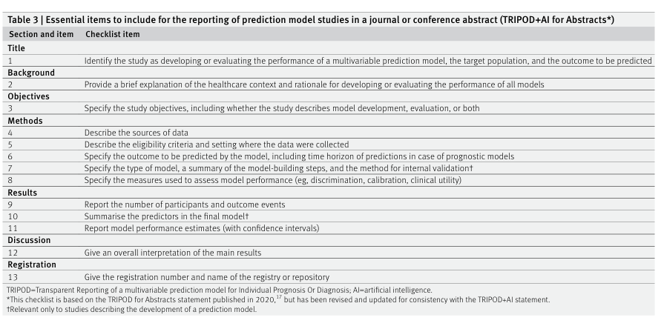

Table S2: Study group abbreviations and sample sizes.
Short | Long | N_{total} | PRONIA | MUC | ZInEP
CHR-P | Clinical High-Risk State for Psychosis defined by COGDIS and/or UHR criteria | 425 | 312 |  | 113
uCHR-P | Unspecified CHR-P state defined by the presence of UHR symptoms with or without COGDIS | 304 | 237 |  | 67
COGDIS | CHR-P state defined using COGnitive DISturbance criteria but not UHR criteria | 121 | 75 |  | 46
UHR | CHR-P state defined only by Ultra-High-Risk criteria | 151 | 127 |  | 24
MIXED | CHR-P state defined by both UHR and COGDIS criteria | 153 | 110 |  | 43
COPER | Psychosis risk state defined by COgnitive PERceptual abnormalities | 23 |  |  | 23
HR-BIP | High-risk state for bipolar disorders | 20 |  |  | 20
SCZ | Schizophrenia defined by DSM-IV-TR criteria | 257 | 103 | 154
RE-SCZ | Recurrent schizophrenia (DSM-IV-TR) | 88 |  | 88
FE-SCZ | First-episode schizophrenia (DSM-IV-TR) | 66 |  | 66
ROP-SCZ | Recent-onset psychosis (see Table S3), DSM-IV-TR criteria for schizophrenia met | 107 | 107
ROP-NONSCZ | Recent-onset psychosis (see Table S3), DSM-IV-TR criteria for schizophrenia not met | 222 | 222
ROD | Recent-onset major depression (see Table S3) | 278 | 278
BIP | Bipolar disorders (DSM-IV-TR, currently euthymic) | 35 |  | 35
MDD | Major depressive disorder (DSM-IV-TR) | 104 |  | 104
BOR | Borderline personality disorder (DSM-IV-TR) | 57 |  | 57
HC | Healthy controls | 907 | 522 | 335 | 50

Table S3: Inclusion and exclusion criteria of the PRONIA study.
Group Inclusion Criteria | Group Exclusion Criteria | General Inclusion / Exclusion / Drop-out Criteria
Clinical High-Risk Group (CHR) |  | Inclusion Criteria:  - Age 15 to 40 years  - Language skills sufficient for participation  - Able to provide consent / assent  Exclusion Criteria:  1. IQ below 70  2. Hearing is not sufficient for neuro-cognitive testing  3. Current or past head trauma with loss of consciousness (> 5 min)  4. Current or past known neurological disorder of the brain  5. Current or past known somatic disorder potentially affecting the structure or functioning of the brain  6. Current or past alcohol dependence  - Current poly-substance dependence or within the past six months (Note: any combination with E.6. led to exclusion)  - Any contra-indication for MRI  Exclusion criteria for healthy controls:  - Any life-time CHR-P criteria,  - Any current or past DSM-IV axis disorder,  A positive familial history (1st degree relatives) for affective or non-affective psychoses or major affective disorders (Major Depressive Disorder, Bipolar Disorder) as defined by treatment or diagnosis, if not due to a secondary medical condition including dementia.  - An intake of psychotropic medications or drugs more than 5 times/year and in the month before study inclusion.  Drop-out criteria:  - No follow-up examination after the 6-month follow-up examination (IV6)  - Withdrawn consent / assent
Psychosis-risk syndrome alternatively defined by:  Attenuated Positive Symptoms (APS), as measured by the SIPS (requires 1 of 5 of the following: unusual thought content/ delusional ideas, suspicious-ness/persecutory ideas, grandiosity, perceptual abnormalities/hallucinations, and disorganized communication) with a moderate to severe, but not psychotic, severity (SIPS score 3-5) that (1) began with-in the past year or was rated one or more scale points higher compared to 12 month ago, AND (2) occurred at an average frequency of at least once per week for at least several minutes per event in the past month, AND (3) was not better explained by another mental disorder. | - Any intake of antipsychotic medication for more than 30 cumulative days at or above the minimum dosage defined by the DGPPN S3 Guidelines for the treatment of first-episode psychosis (Table S2),  - Any intake of antipsychotic drugs within the past 3 months before psychopathological baseline assessments at or above the minimum dosage threshold.  - Occurrence of the CHR syndrome is better explained by other DSM-IV disorder
Brief Intermittent Psychotic Symptoms (BLIPS), as measured by the SIPS (requires score of 6 of any of the symptoms listed above) that; type 1: (1a) has a severity of '6' in each of the past 3 months (regardless of when they first reached this severity), AND (1b) was present for at least a few minutes a day with an average frequency of at least once a month, OR type 2: (2a) has a severity of '6' in the past month (regardless of when they first reached this severity) AND (2b) was present for at least a few minutes at an average frequency of at least once a week OR (2c) at a cumulative frequency of at least 1 hour; AND for both types (3) remitted spontaneously within one week (i.e. without antipsychotic medication) AND (4) was not better explained by another mental disorder.
Genetic Risk and Functional Decline (GRFD) defined by a current 30% or greater reduction in the functional disability score of the split version of the Global Assessment of Functioning Scale (GAF) compared with the highest lifetime level of functioning, AND (having a first-degree relative with a history of any psychotic disorder OR having a DSM-IV-TR schizotypal personality disorder).
Cognitive Disturbances (COGDIS) as measured by the SPI-A (requires at least 2 of 9 cognitive basic symptoms with at least weekly occurrence (score ≥3) during the last 3 months): inability to divide attention, captivation of attention by details of the visual field, disturbance of expressive speech, disturbance of receptive speech, disturbances of abstract thinking, thought interference, thought blockages, thought pressure, unstable ideas of reference
Recent-Onset Depression (ROD)
Major Depressive Disorder as defined by DSM-IV-TR + ALL of the following criteria:  - First life-time depressive episode,  - Duration of current depressive episode no longer than 24 months,  - Diagnostic criteria fulfilled within past three months | - Occurrence of the major depressive episode is better explained by other DSM-IV disorders  - See CHR exclusion criteria
Recent-Onset Psychosis (ROP)
- Criteria for a DSM-IV-TR Psychotic Episode fulfilled within the last three months,  - First diagnosis of psychosis made within the past 12 months (reference date: screening visit) | Antipsychotic medication for longer than 3 months  (= dosage in or above the 'first-episode psychosis' range of DGPPN S3 Guidelines; Table S2)

Table S4: Antipsychotic medication thresholds used as exclusion criteria in the PRONIA study based on the previous version of the S3 guidelines of the German Association for Psychiatry, Psychotherapy and Psychosomatics.
Candidate CHR and ROD patients were excluded if they had received antipsychotic medication (1) for more than 30 cumulative days at or above the minimum target dosage threshold for the treatment of first-episode psychosis, or (2) within the past 3 months before psychopathological baseline assessments at or above the minimum target dosage threshold for the treatment of first-episode psychosis.
Substance | Recommended | DI' | Target dosage | Target dosage | Maximum dosage
 | starting dosage |  | first-episode | relapsing | recommended
 | (mg/d) |  | psychosis | schizophrenia
 |  |  | (mg/d) | (mg/d) | (mg/d)²
Atypical Antipsychotics
Amisulpride | 200 | (1)-2 | 100-300 | 400-800 |  | 1200
Aripiprazole | (10)-15 | 1 | 15-(30) | 15-30 |  | 30
Olanzapine | 5-10 | 1 | 5-15 | 5-20 |  | 20
Quetiapine | 50 | 2 | 300-600 | 400-750 |  | 750
Risperidone | 2 | 1-2 | 1-4 | 3-6-(10) |  | 16
Ziprasidone | 40 | 2 | 40-80 | 80-160 |  | 160
Typical Antipsychotics
Fluphenazine | 0.4-10 | 2-3 | 2.4-10 | 10-20 |  | 20-(40)
Flupentixole | 2-10 | 1-3 | 2-10 | 10-60 |  | 60
Haloperidole | 1-10 | (1)-2 | 1-4 | 3-15 |  | 100
Perazine | 50-150 | 1-2 | 100-300 | 200-600 |  | 1000
Perphenazine | 4-24 | 1-3 | 6-36 | 12-42 |  | 56
Pimozide | 1-4 | 2 | 1-4 | 2-12 |  | 16
Zotepine | 25-50 | 2-(4) | 50-150 | 75-150 |  | 450
Zuclopenthixole | 2-50 | 1-3 | 2-10 | 25-50 |  | 75
Abbreviations: DI dosage interval, ²maximum recommended dosage according to prescribing information.

Table S5: Group inclusion and exclusion criteria of the ZInEP study.
Inclusion criteria
High-risk for psychosis (COGDIS/COPER)
COPER | at least one cognitive–perceptive basic symptom in the SPI-A/-CY¹³
COGDIS | at least two cognitive disturbances symptoms in the SPI-A/-CY¹³
Ultra-high-risk (UHR) for psychosis (UHR)
APS | at least one attenuated psychotic symptom, or
BLIPS | at least one brief limited intermittent psychotic symptom, or
State-trait group | reduction in global assessment of functioning of >30% in the past year plus either schizotypal personality disorder or a first degree relative with psychosis
High risk for bipolar disorder (HR-BIP)
HR-BIP | A score ≥14 in the Hypomania Checklist¹⁸
Exclusion criteria
Diagnosed schizophrenic, substance-induced or organic psychosis, other symptomatic organic mental disorders, manifest bipolar disorder, current substance, or alcohol dependence, age below 13 or above 35 years, incapacity to consent, e.g., due to an acute and severe psychopathological state or low intellectual abilities with IQ <80. Axis-I diagnoses were assessed using the Mini-International Neuropsychiatric Interview for DSM-IV.¹⁹

Table S6: Diagnostic breakdown of the recent-onset psychosis (ROP) group.
The table indicates the number (N) and percentage (%) of ROP-SCZ and ROP-NONSCZ patients meeting criteria for given lifetime diagnoses at study inclusion.
Diagnoses | ROP-SCZ [N (%)] | ROP-NONSCZ [N (%)]
N | 107 | 222
Schizophrenia (SCZ) | 94 (87.9) | 0 (0.0)
Schizophreniform disorder | 0 (0.0) | 40 (18.0)
Schizoaffective disorder | 0 (0.0) | 15 (6.8)
Delusional disorder | 1 (0.9) | 17 (7.7)
Brief psychotic disorder | 0 (0.0) | 27 (12.2)
Psychosis due to a general medical condition | 0 (0.0) | 0 (0.0)
Substance-induced psychotic disorder | 2 (1.9) | 11 (5.0)
Psychosis not otherwise specified | 0 (0.0) | 36 (16.2)
Bipolar disorders with psychotic features | 0 (0.0) | 1 (0.5)
Major depressive disorder with psychotic features | 2 (1.9) | 12 (5.4)

Table S7: Biopsychosocial variables used for predicting diagnostic brain pattern expression using machine learning.
Variables | Scale
Polygenic scores [Genome-wide P thresholds: P<10⁻⁸, <10⁻⁶, <10⁻⁵, <10⁻⁴, <.001, <.005, <.1, <.2, <.5, <1]
Attention Deficit Hyperactivity Disorder²⁰ | Continuous
Anorexia²¹ | Continuous
Autism-spectrum disorders²² | Continuous
Bipolar disorders (Mullins)²³ | Continuous
Bipolar disorders (Stahl)²⁴ | Continuous
Cognitive Performance²⁵ | Continuous
Educational Attainment²⁶ | Continuous
Educational Years²⁷ | Continuous
IQ²⁸ | Continuous
Major-depressive disorder²⁹ | Continuous
Neuroticism³⁰ | Continuous
Schizophrenia (Ripke)³¹ | Continuous
Schizophrenia (PGC 2021)³² | Continuous
Wellbeing Eudaimonic³³ | Continuous
Wellbeing Hedonistic³³ | Continuous
Cross-Disorder³⁴ | Continuous
Extraversion³⁵ | Continuous
Alzheimer’s Disease (ADIGAP)³⁶ | Continuous
Frontotemporal dementia³⁷ | Continuous
Sociodemographic
Age | Continuous
Sex [Male, Female] | Categorical
Ethnicity [Dummy-coded: White, Black, Asian, Mixed, Other] | Categorical
Mother: Graduation qualifiying for higher education degree: [Dummy-coded: No, Yes, Unknown] | Categorical
Participant: Graduation qualifying for higher education degree [No, Yes] | Categorical
Participant: Other Graduation [No, Yes] | Categorical
Participant: Without Graduation: [No, Yes] | Categorical
Participant: Higher education degree [No, Yes] | Categorical
Participant: Education years of schooling and higher education | Continuous
Participant: Education years due to repetition of school years | Continuous
Mother: Other graduation [Dummy-coded: No, Yes, Unknown] | Categorical
Mother: Without graduation [Dummy-coded: No, yes, Unknown] | Categorical
Mother: Higher education degree [No, Yes] | Categorical
Father: Graduation qualifying for higher education degree: [Dummy-coded: No, Yes, Unknown] | Categorical
Father: Other graduation [Dummy-coded: No, Yes, Unknown] | Categorical
Father: Without graduation [Dummy-coded: No, yes, Unknown] | Categorical
Father: Higher education degree [No, Yes] | Categorical
Population at place of living: [1: >500K, 2: 100K-500K, 3: 10K-100K, 4: <10K] | Categorical
Population density at place of living [inhabitants / km²] | Continuous
Having a partner within the last 12 months [No, Yes] | Categorical
Medical / Anthropometric
Pregnancy or birth complications [No, Yes] | Categorical
Current somatic health [0: no illness, 1: symptoms, no diagnosis, 2: diagnosed illness] | Ordinal
Current or past neurological conditions [No, Yes] | Categorical
Head trauma without loss of consciousness [No, Yes] | Categorical
Current treatment for somatic disorder [No, Yes] | Categorical
Alcohol consumption [0: none; 1: irregularly; 2: regularly] | Ordinal
Average alcohol units per day | Continuous
Average number of cigarettes per day | Categorical
Body-Mass Index [kg/m²] | Continuous
Abdominal circumference [cm] | Continuous
Psychosocial / Behavioural / Environmental
CTQ (Childhood Trauma Questionnaire)³⁸: Emotional abuse score | Continuous
CTQ (Childhood Trauma Questionnaire)³⁸: Physical abuse score | Continuous
CTQ (Childhood Trauma Questionnaire)³⁸: Sexual abuse score | Continuous
CTQ (Childhood Trauma Questionnaire)³⁸: Emotional neglect score | Continuous
CTQ (Childhood Trauma Questionnaire)³⁸: Physical neglect score | Continuous
WSS (Wisconsin Schizotypy Scales, short version)³⁹: Magical ideation score | Continuous
WSS (Wisconsin Schizotypy Scales, short version)³⁹: Perceptual aberration score | Continuous
WSS (Wisconsin Schizotypy Scales, short version)³⁹: Social Anhedonia score | Continuous
WSS (Wisconsin Schizotypy Scales, short version)³⁹: Physical anhedonia score | Continuous
CoLE (Cologne Chart of Life Events)⁴⁰: Burden due to events with effects on mental health | Continuous
CoLE (Cologne Chart of Life Events)⁴⁰: Burden due to events without effects on mental health | Continuous
PAS (Premorbid Adjustment Scale, Childhood)⁴¹: sociability and withdrawal [ 0: “Not withdrawn, actively and frequently seeks out social contacts” to 6: “unrelated to others, withdrawn and isolated. Avoid contacts”] | Ordinal
PAS (Premorbid Adjustment Scale, Childhood)⁴¹: peer relationships [ 0: “Many friends, close relationships with several” to 6 “Social isolate, no friends, not even superficial relationships” ] | Ordinal
PAS (Premorbid Adjustment Scale, Childhood)⁴¹: scholastic performance [ 0: “Excellent student” to 6: “Failing all classes” ] | Ordinal
PAS (Premorbid Adjustment Scale, Childhood)⁴¹: adaptation to school [ 0: “Good adaptation, enjoys school, no or rare discipline problems, has friends at school, likes most teachers” to 6: “Refuses to have anything to do with school - delinquency or vandalism directed against school” ] | Ordinal
PAS (Premorbid Adjustment Scale, Early adolescence)⁴¹: sociability and withdrawal [ 0 to 6] | Ordinal
PAS (Premorbid Adjustment Scale, Early adolescence)⁴¹: peer relationships [ 0 to 6 ] | Ordinal
PAS (Premorbid Adjustment Scale, Early adolescence)⁴¹: scholastic performance [ 0 to 6 ] | Ordinal
PAS (Premorbid Adjustment Scale, Early adolescence)⁴¹: adaptation to school [ 0 to 6 ] | Ordinal
PAS (Premorbid Adjustment Scale, Early adolescence)⁴¹: Social-sexual aspects [ 0: “Started dating, showed a clear interest in the opposite or same sex, may have gone “steady,” may include some sexual activity” to 6: “A loner, no or rare contacts with either boys or girls” ] | Ordinal
PAS (Premorbid Adjustment Scale, Late adolescence)⁴¹: sociability and withdrawal [ 0 to 6 ] | Ordinal
PAS (Premorbid Adjustment Scale, Late adolescence)⁴¹: peer relationships [ 0 to 6 ] | Ordinal
PAS (Premorbid Adjustment Scale, Late adolescence)⁴¹: scholastic performance [ 0 to 6 ] | Ordinal
PAS (Premorbid Adjustment Scale, Late adolescence)⁴¹: adaptation to school [ 0 to 6 ] | Ordinal
PAS (Premorbid Adjustment Scale, Late adolescence)⁴¹: Social-sexual aspects [ 0: “Always showed a clear interest in the opposite or same sex, dating, has gone “steady,” engaged in some sexual activity (not necessarily intercourse)” to 6: “No desire to be with boys and girls, never went out with opposite or same sex” ] | Ordinal
PAS (Premorbid Adjustment Scale, General)⁴¹: Education [ 0: “Completed college and/or graduate school, or professional school (e.g., law)” to 6: “Did not get beyond fifth grade” ] | Ordinal
PAS (Premorbid Adjustment Scale, General)⁴¹: Continuous employment or school functioning [3 yrs-6 months prior inclusion/health system contact] [ 0: “All the time” to 6: “Never” ] | Ordinal
PAS (Premorbid Adjustment Scale, General)⁴¹: Change in work or school performance [1 yr-6 months prior inclusion/health system contact] [ 0: “Abruptly” to 6: “Imperceptibly, difficult to not possible to determine onset of deterioration” ] | Ordinal
PAS (Premorbid Adjustment Scale, General)⁴¹: Frequency of job change or schooling interruptions [3 yr-6 months prior inclusion/health system contact] [ 0: “Same job held or remained in school” to 6: “Less than 2 weeks at a job or in school” ] | Ordinal
PAS (Premorbid Adjustment Scale, General)⁴¹: Establishment of independence [ 0: “Successfully established residence away from family home, financially independent of parents” to 6: “Made no attempt to leave home or be financially independent” ] | Ordinal
PAS (Premorbid Adjustment Scale, General)⁴¹: Global assessment of highest level of functioning achieved in respondent’s life [ 0: “Fully able to function successfully in and take pleasure from (1) school or job; (2) friends; intimate sexual relationships; (4) church, hobbies, etc. Enjoys life and copes with it well” to 6: “Unable to function in or enjoy any aspect of life” ] | Ordinal
PAS (Premorbid Adjustment Scale, General)⁴¹: Social-personal adjustment [ 0: “A leader or officer in formally designated groups, clubs, organisations, or athletic teams in senior high school, vocational school, college, or young adulthood. Involved in intimate, close relationship with others” to 6: “No desire to be with peers or others. Either asocial or antisocial” ] | Ordinal
PAS (Premorbid Adjustment Scale, General)⁴¹: Degree of interest in life [ 0: “Keen, ambitious interest in some of the following: home, family, friends, work, sports, art, pets, gardening, social activities, music, and drama“ to 6: “Withdrawn and indifferent toward life interests of average individual. No deep interests of any sort” ] | Ordinal
PAS (Premorbid Adjustment Scale, General)⁴¹: Energy level [ 0: “Strong drive, keen, active, alert interest in life. Liked life and had energy enough to enjoy it” to 6: “Submissive, inadequate, passive reactions. Weak grasp on life, does not go out to meet life’s problems, does not participate actively, but passively accepts his lot without having the energy to help self” ] | Ordinal
CISS (Coping Inventory for Stressful Situations)⁴²: Task-oriented coping style score | Continuous
CISS (Coping Inventory for Stressful Situations)⁴²: Emotion-oriented coping style score | Continuous
CISS (Coping Inventory for Stressful Situations)⁴²: Distraction-oriented coping style score | Continuous
CISS (Coping Inventory for Stressful Situations)⁴²: Social-diversion oriented coping style score | Continuous
CISS (Coping Inventory for Stressful Situations)⁴²: Avoidance-diversion oriented coping style score | Continuous
MSPSS (Multidimensional Scale of Perceived Social Support)⁴³: Total score of perceived social support | Continuous
MSPSS (Multidimensional Scale of Perceived Social Support)⁴³: Perceived social support by family members | Continuous
MSPSS (Multidimensional Scale of Perceived Social Support)⁴³: Perceived social support by friends | Continuous
MSPSS (Multidimensional Scale of Perceived Social Support)⁴³: Perceived social support by significant others | Continuous
NEO-FFI (NEO Five-Factor Inventory)⁴⁴: Neuroticism score | Continuous
NEO-FFI (NEO Five-Factor Inventory)⁴⁴: Extraversion score | Continuous
NEO-FFI (NEO Five-Factor Inventory)⁴⁴: Openness score | Continuous
NEO-FFI (NEO Five-Factor Inventory)⁴⁴: Agreeableness score | Continuous
NEO-FFI (NEO Five-Factor Inventory)⁴⁴: Conscientiousness score | Continuous
RSA (Resilience Scale for Adults)⁴⁵: Perception of self score | Continuous
RSA (Resilience Scale for Adults)⁴⁵: Planned future score | Continuous
RSA (Resilience Scale for Adults)⁴⁵: Social competence score | Continuous
RSA (Resilience Scale for Adults)⁴⁵: Family coherence score | Continuous
RSA (Resilience Scale for Adults)⁴⁵: Social support score | Continuous
RSA (Resilience Scale for Adults)⁴⁵: Personal structure score | Continuous
WHOQoL-BREF (WHO Quality of Life, brief version)⁴⁶: Overall quality of life score | Continuous
WHOQoL-BREF (WHO Quality of Life, brief version)⁴⁶: Overall quality of health score | Continuous
WHOQoL-BREF (WHO Quality of Life, brief version)⁴⁶: Somatic health score | Continuous
WHOQoL-BREF (WHO Quality of Life, brief version)⁴⁶: Psychological health score | Continuous
WHOQoL-BREF (WHO Quality of Life, brief version)⁴⁶: Interpersonal relationships score | Continuous
WHOQoL-BREF (WHO Quality of Life, brief version)⁴⁶: Environmental factors score | Continuous
LEE (Level of Expressed Emotions)⁴⁷: Lack of emotional support by significant other(s) | Continuous
LEE (Level of Expressed Emotions)⁴⁷: Intrusiveness of significant other(s) | Continuous
LEE (Level of Expressed Emotions)⁴⁷: Irritability of significant other(s) | Continuous
LEE (Level of Expressed Emotions)⁴⁷: Criticism by significant other(s) | Continuous
GF-S (Global Functioning - Social Functioning)⁴⁸: Highest lifetime score [ 1: “Extreme social isolation” to 10: “Superior social/inter-personal functioning” ] | Ordinal
GF-R (Global Functioning – Role Functioning)⁴⁸: Highest lifetime score [ 1: “Extreme role dysfunction” to 10: “Superior role functioning” ] | Ordinal
GAF-S (Global Assessment of Functioning - Symptoms)⁴⁹: Highest lifetime score [ 1-10: “Persistent danger of severely hurting self or others (e.g. recurrent violence) OR serious suicidal act with danger of death” to 91-100: “No symptoms” ] | Ordinal
GAF-DI (Global Assessment of Functioning - Disability)⁴⁹: Highest lifetime score [ 1-10: “Persistent inability to maintain personal hygiene” to 91-100: “Superior functioning in a wide range of activities, life’s problems never seem to get out of hand, is sought out by other because of his or her many positive qualities.” ] | Ordinal
Neurocognitive testing
FDS (Auditory Digit Span, forward): Maximum digits string length correctly reminded at least once | Continuous
BDS (Auditory Digit Span, backward): Maximum digits string length correctly reminded at least once | Continuous
FDS/BDS Ratio | Continuous
DSST (Digit Symbol Substitution Test)⁵⁰: Score symbol matchings | Continuous
DSST (Digit Symbol Substitution Test)⁵⁰: Correct number symbol matchings | Continuous
DSST (Digit Symbol Substitution Test)⁵⁰: Error number symbol matchings | Continuous
SOPT (Self-Ordered Pointing Task)⁵¹: Errors, 10 elements, trial 1 | Continuous
SOPT (Self-Ordered Pointing Task)⁵¹: Errors, 10 elements, trial 2 | Continuous
SOPT (Self-Ordered Pointing Task)⁵¹: Errors, 10 elements, trial 3 | Continuous
SOPT (Self-Ordered Pointing Task)⁵¹: Perseveration Errors, 10 elements, trial 1 | Continuous
SOPT (Self-Ordered Pointing Task)⁵¹: Perseveration Errors, 10 elements, trial 2 | Continuous
SOPT (Self-Ordered Pointing Task)⁵¹: Perseveration Errors, 10 elements, trial 3 | Continuous
SOPT (Self-Ordered Pointing Task)⁵¹: Maximum correct responses before error, 10 elements, trial 1 | Continuous
SOPT (Self-Ordered Pointing Task)⁵¹: Maximum correct responses before error, 10 elements, trial 2 | Continuous
SOPT (Self-Ordered Pointing Task)⁵¹: Maximum correct responses before error, 10 elements, trial 3 | Continuous
SOPT (Self-Ordered Pointing Task)⁵¹: Errors, 4 elements, trial 1 | Continuous
SOPT (Self-Ordered Pointing Task)⁵¹: Errors, 4 elements, trial 2 | Continuous
SOPT (Self-Ordered Pointing Task)⁵¹: Errors, 4 elements, trial 3 | Continuous
SOPT (Self-Ordered Pointing Task)⁵¹: Perseveration errors, 4 elements, trial 1 | Continuous
SOPT (Self-Ordered Pointing Task)⁵¹: Perseveration errors, 4 elements, trial 2 | Continuous
SOPT (Self-Ordered Pointing Task)⁵¹: Perseveration errors, 4 elements, trial 3 | Continuous
SOPT (Self-Ordered Pointing Task)⁵¹: Maximum correct responses before error, 4 elements, trial 1 | Continuous
SOPT (Self-Ordered Pointing Task)⁵¹: Maximum correct responses before error, 4 elements, trial 2 | Continuous
SOPT (Self-Ordered Pointing Task)⁵¹: Maximum correct responses before error, 4 elements, trial 3 | Continuous
SOPT (Self-Ordered Pointing Task)⁵¹: Ratio errors | Continuous
SOPT (Self-Ordered Pointing Task)⁵¹: Ratio perseveration errors | Continuous
SOPT (Self-Ordered Pointing Task)⁵¹: Ratio maximum correct responses before error | Continuous
RAVLT (Rey Auditory Verbal Learning Test)⁵²: Immediate recall, trial 1, repetition list A | Continuous
RAVLT (Rey Auditory Verbal Learning Test)⁵²: Immediate recall, trial 5, repetition list A | Continuous
RAVLT (Rey Auditory Verbal Learning Test)⁵²: Immediate recall, out of list words, trial 1, repetition list A | Continuous
RAVLT (Rey Auditory Verbal Learning Test)⁵²: Immediate recall, out of list words, trial 5, repetition list A | Continuous
RAVLT (Rey Auditory Verbal Learning Test)⁵²: Immediate recall, repeated words, trial 1, repetition list A | Continuous
RAVLT (Auditory Verbal Learning Test)⁵²: Immediate recall, repeated words, trial 5, repetition list A | Continuous
RAVLT (Auditory Verbal Learning Test)⁵²: Interference, immediate recall, repetition list B | Continuous
RAVLT (Auditory Verbal Learning Test)⁵²: Interference, immediate recall, words from list A repetition list B | Continuous
RAVLT (Auditory Verbal Learning Test)⁵²: Interference, immediate recall, out of list words repetition list B | Continuous
RAVLT (Auditory Verbal Learning Test)⁵²: Interference, immediate recall, repeated words repetition list B | Continuous
RAVLT (Auditory Verbal Learning Test)⁵²: Interference, immediate recall, 6 repetition list A | Continuous
RAVLT (Auditory Verbal Learning Test)⁵²: Interference Immediate recall, out of list words 6 repetition list A | Continuous
RAVLT (Auditory Verbal Learning Test)⁵²: Interference Immediate recall, repeated words 6 repetition list A | Continuous
RAVLT (Auditory Verbal Learning Test)⁵²: Interference Immediate recall, words from list B 6 repetition list A | Continuous
RAVLT (Auditory Verbal Learning Test)⁵²: Delayed recall, repetition list A | Continuous
RAVLT (Auditory Verbal Learning Test)⁵²: Delayed recall, repetition out of list words list A | Continuous
RAVLT (Auditory Verbal Learning Test)⁵²: Delayed recall, repetition repeated words list A | Continuous
RAVLT (Auditory Verbal Learning Test)⁵²: Delayed recall, repetition words from list B list A | Continuous
RAVLT (Auditory Verbal Learning Test)⁵²: Recognition words from list A | Continuous
CPT-IP (Continuous Performance Test, Identical Pairs version)⁵³: Number correct whole test | Continuous
CPT-IP (Continuous Performance Test, Identical Pairs version)⁵³: Number error distracting stimuli whole test | Continuous
CPT-IP (Continuous Performance Test, Identical Pairs version)⁵³: Number error filler stimuli whole test | Continuous
CPT-IP (Continuous Performance Test, Identical Pairs version)⁵³: Number omissions whole test | Continuous
CPT-IP (Continuous Performance Test, Identical Pairs version)⁵³: Reaction times correct whole test | Continuous
CPT-IP (Continuous Performance Test, Identical Pairs version)⁵³: Reaction times error distracting whole test | Continuous
CPT-IP (Continuous Performance Test, Identical Pairs version)⁵³: Reaction times error filler whole test | Continuous
SVF (Verbal Fluency, semantic)⁵⁰: Correct words, 0-60 sec, category | Continuous
SVF (Verbal Fluency, semantic)⁵⁰: Errors words, 0-60 sec, category | Continuous
SVF (Verbal Fluency, semantic)⁵⁰: Repetitions, 0-60 sec, category | Continuous
PVF (Verbal Fluency, phonetic)⁵⁰: Correct, 0-60 sec, letter | Continuous
PVF (Verbal Fluency, phonetic)⁵⁰: Errors, 0-60 sec, letter | Continuous
PVF (Verbal Fluency, phonetic)⁵⁰: Repetitions, 0-60 sec, letter | Continuous
Total Word Generation Score | Continuous
Semantic to Phonetic Verbal Fluency Ratio | Continuous
ROCF (Rey-Osterreith Complex Figure)⁵²: Accuracy whole | Continuous
ROCF (Rey-Osterreith Complex Figure)⁵²: Accuracy whole, immediate recall | Continuous
ROCF (Rey-Osterreith Complex Figure)⁵²: Accuracy whole, delayed recall | Continuous
ROCF (Rey-Osterreith Complex Figure)⁵²: Placeme whole | Continuous
ROCF (Rey-Osterreith Complex Figure)⁵²: Placeme whole, immediate recall | Continuous
ROCF (Rey-Osterreith Complex Figure)⁵²: Placeme whole, delayed recall | Continuous
ROCF (Rey-Osterreith Complex Figure)⁵²: Score whole | Continuous
ROCF (Rey-Osterreith Complex Figure)⁵²: Score whole, immediate recall | Continuous
ROCF (Rey-Osterreith Complex Figure)⁵²: Score whole, delayed recall | Continuous
ROCF (Rey-Osterreith Complex Figure)⁵²: Time | Continuous
ROCF (Rey-Osterreith Complex Figure)⁵²: Time, immediate recall | Continuous
ROCF (Rey-Osterreith Complex Figure)⁵²: Time, delayed recall | Continuous
WAIS (Wechsel Adult Intelligence Scale, version III/IV)⁵⁴: Vocabulary test [Raw score] | Continuous
WAIS (Wechsel Adult Intelligence Scale, version III/IV)⁵⁴: Matrix test [Raw score] | Continuous
TMT-A (Trail-Making Test, part A)⁵⁵: Time of execution | Continuous
TMT-A (Trail-Making Test, part A)⁵⁵: Errors | Continuous
TMT-A (Trail-Making Test, part A)⁵⁵: Violations | Continuous
TMT-B (Trail-Making Test, part B)⁵⁵: Time of execution | Continuous
TMT-B (Trail-Making Test, part B)⁵⁵: Errors | Continuous
TMT-B (Trail-Making Test, part B)⁵⁵: Violations | Continuous
TMT (B-A) | Continuous
TMT (B/A) | Continuous

Table S8: Study-related, sociodemographic, physical, functional and clinical differences in the PRONIA patient groups.
Samples and variables | Study groups |  |  |  |  |  |  | df | F/W/χ² | η² / V | P
PRONIA | COGDIS (n=75) | UHR (n=127) | MIXED (n=110) | ROP-SCZ (n=107) | ROP-NONSCZ (n=222) | ROD (n=278) | HC (n=522)
Sociodemographic data
Sites [N (%)]
Bari | 7 (9.3) | 3 (2.4) | 1 (0.9) | 1 (0.9) | 8 (3.6) | 9 (3.2) | 19 (3.6) | 48 | 237.21† | .166 | <.001
Basel | 11 (14.7) | 12 (9.4) | 7 (6.4) | 16 (15.0) | 11 (5.0) | 16 (5.8) | 69 (13.2)
Birmingham | 10 (13.3) | 4 (3.1) | 6 (5.5) | 1 (0.9) | 20 (9.0) | 20 (7.2) | 54 (10.3)
Cologne | 12 (16) | 15 (11.8) | 11 (10) | 38 (35.5) | 10 (4.5) | 56 (20.1) | 75 (14.4)
Munich | 13 (17.3) | 43 (33.9) | 56 (50.9) | 41 (38.3) | 81 (36.5) | 101 (36.3) | 125 (23.9)
Milan | 1 (1.3) | 24 (18.9) | 6 (5.5) | 0 (0.0) | 32 (14.4) | 21 (7.6) | 36 (6.9)
Muenster | 6 (8.0) | 6 (4.7) | 4 (3.6) | 4 (3.7) | 7 (3.2) | 13 (4.7) | 15 (2.9)
Turku | 11 (14.7) | 8 (6.3) | 13 (11.8) | 4 (3.7) | 39 (17.6) | 19 (6.8) | 53 (10.2)
Udine | 4 (5.3) | 12 (9.4) | 6 (5.5) | 2 (1.9) | 14 (6.3) | 23 (8.3) | 76 (14.6)
Age [mean (SD) years] | 25.2 (5.6) | 23.7 (5.2) | 23.2 (5.9) | 25.2 (5.6) | 25.9 (6.0) | 25.2 (6.2) | 25.6 (6.0) | 6 | 4.40‡ | .018 | <.001
Sex [Female (%)] | 39 (52.0) | 64 (50.4) | 61 (55.5) | 35 (32.7) | 106 (47.7) | 138 (49.6) | 306 (58.6) | 6 | 28.00† | .139 | <.001
Body Mass Index [mean kg/m² (SD)] | 23.7 (4.6) | 22.7 (4.1) | 23.3 (4.3) | 23.7 (4.3) | 23.7 (4.3) | 23.7 (4.7) | 22.8 (3.5) | 6 | 2.31‡ | .010 | .032
Being in a relationship within the past year [yes (%)] | 44 (60.3) | 65 (52.4) | 47 (43.5) | 57 (53.3) | 111 (51.4) | 150 (54.5) | 344 (66.9) | 6 | 33.95† | .155 | <.001
Educational years [mean (SD)] | 14.1 (2.8) | 13.4 (3.0) | 13.0 (2.7) | 13.7 (3.3) | 13.8 (3.3) | 14.3 (3.2) | 15.9 (3.2) | 6 | 26.32‡ | .101 | <.001
Educational years repeated [mean (SD)] | 0.32 (0.69) | 0.54 (1.09) | 0.49 (1.34) | 0.37 (0.63) | 0.36 (0.90) | 0.33 (1.09) | 0.12 (0.37) | 6 | 26.35‡ | .029 | <.001
Substance use
Alcohol consumption [mean (SD) mg/day] | 3.64 (6.59) | 2.42 (3.78) | 3.10 (4.49) | 2.44 (2.79) | 3.73 (10.1) | 3.16 (6.73) | 2.60 (2.79) | 6 | 1.46‡ | .007 | .189
Nicotine consumption [mean (SD) cig/day] | 5.32 (7.51) | 3.64 (6.57) | 3.98 (6.46) | 5.58 (8.28) | 5.22 (7.20) | 4.37 (7.14) | 1.25 (3.59) | 6 | 17.08‡ | .070 | <.001
Cannabis use lifetime [SCID; yes (%)] | 7 (9.6) | 21 (16.8) | 11 (10.1) | 37 (34.6) | 51 (23.1) | 21 (7.6) | 15 (3.2) | 6 | 121.55† | .297 | <.001
Cannabis use past month [SCID; yes (%)] | 2 (2.7) | 6 (4.8) | 2 (1.8) | 12 (11.2) | 11 (5.0) | 4 (1.4) | 0 (0.0) | 6 | 51.20† | .193 | <.001
Functioning (mean (SD), Global Assessment of Functioning (GAF), Mean of Disability/Impairment and Symptoms Scales)
Highest GAF in the year before study inclusion | 67.4 (10.7) | 65.7 (13.3) | 63.7 (11.9) | 58.8 (14.1) | 63.4 (14.6) | 69.4 (11.3) | 86.6 (5.9) | 6 | 228.95‡ | .491 | <.001
Highest GAF in the month before study inclusion | 56.1 (9.7) | 53.4 (10.8) | 49.4 (10.8) | 40.5 (11.1) | 43.7 (13.3) | 55.1 (11.9) | 86.2 (6.2) | 6 | 763.07‡ | .763 | <.001
Psychopathology [mean (SD)]
Schizophrenia Proneness Instrument for Adults/Children (SPI-A/-CY) – COGDIS syndrome items
Inability to divide attention | 2.05 (2.21) | 0.28 (0.81) | 1.94 (2.26) | 1.59 (2.34) | 1.02 (1.92) | 0.26 (1.01) | 0.02 (0.20) | 6 | 295.77^{K} | .208 | <.001
Thought interference | 1.15 (1.86) | 0.13 (0.59) | 1.32 (1.94) | 0.92 (1.84) | 0.77 (1.69) | 0.11 (0.46) | 0.03 (0.24) | 6 | 182.86^{K} | .127 | <.001
Thought blockages | 2.75 (1.95) | 0.73 (1.46) | 2.93 (2.07) | 1.91 (2.34) | 1.39 (2.00) | 0.53 (1.24) | 0.08 (0.41) | 6 | 401.77^{K} | .283 | <.001
Dist. of receptive speech | 0.86 (1.74) | 0.05 (0.38) | 0.90 (1.65) | 0.99 (1.95) | 0.45 (1.31) | 0.11 (0.49) | 0.01 (0.08) | 6 | 157.60^{K} | .107 | <.001
Dist. of expressive speech | 2.33 (2.15) | 0.49 (1.26) | 2.67 (2.20) | 1.40 (2.16) | 1.00 (1.76) | 0.43 (1.15) | 0.05 (0.35) | 6 | 349.48^{K} | .247 | <.001
Thought pressure | 1.47 (2.04) | 0.22 (0.86) | 1.57 (2.12) | 1.76 (2.39) | 1.36 (2.14) | 0.30 (1.00) | 0.02 (0.21) | 6 | 261.23^{K} | .181 | <.001
Unstable ideas of reference | 0.58 (1.24) | 0.31 (1.07) | 0.78 (1.64) | 1.83 (2.46) | 0.97 (1.91) | 0.22 (0.81) | 0.03 (0.22) | 6 | 175.71^{K} | .122 | <.001
Dist. of abstract thinking | 0.19 (0.94) | 0.07 (0.57) | 0.25 (0.99) | 0.69 (1.63) | 0.36 (1.23) | 0.02 (0.19) | 0.00 (0.04) | 6 | 96.69^{K} | .065 | <.001
Captivation of attention by details in the visual field | 0.51 (1.42) | 0.07 (0.48) | 0.64 (1.45) | 0.38 (1.29) | 0.43 (1.27) | 0.08 (0.52) | 0.02 (0.23) | 6 | 90.21^{K} | .060 | <.001
SPI-A/-CY COGDIS sum score | 12.77 (5.58) | 3.75 (5.55) | 13.43 (6.19) | 12.39 (10.99) | 8.09 (8.13) | 3.31 (5.54) | 0.36 (1.26) | 6 | 163.90^{K} | .513 | <.001
Structured Interview for Psychosis Risk Syndromes (SIPS)
SIPS positive sum score | 3.73 (3.38) | 8.82 (3.93) | 9.98 (4.11) | 16.30 (5.75) | 16.06 (5.61) | 2.03 (2.15) | 0.47 (1.10) | 6 | 1057.87^{K} | .772 | <.001
SIPS negative sum score | 3.24 (1.56) | 3.14 (1.86) | 3.87 (1.75) | 3.89 (1.61) | 3.16 (1.88) | 3.39 (2.17) | 0.16 (0.54) | 6 | 811.05^{K} | .595 | <.001
SIPS disorganized sum score | 1.12 (0.74) | 1.51 (1.66) | 1.57 (1.03) | 1.92 (1.01) | 1.59 (1.54) | 1.02 (1.04) | 0.08 (0.60) | 6 | 660.86^{K} | .484 | <.001
SIPS general sum score | 2.64 (1.60) | 2.37 (2.47) | 2.81 (1.25) | 2.58 (1.36) | 2.19 (1.72) | 2.59 (2.23) | 0.24 (0.91) | 6 | 786.7^{K} | .577 | <.001
Positive and Negative Symptoms Scale (PANSS)
PANSS total score | 47.6 (12.2) | 54.2 (14.1) | 60.0 (15.6) | 74.2 (21.2) | 67.5 (19.8) | 49.5 (11.6) | — | 5 | 225.07^{K} | .250 | <.001
PANSS positive score | 9.3 (2.6) | 12.5 (3.8) | 12.7 (3.1) | 19.8 (6.1) | 19.2 (56.0) | 8.3 (1.7) | — | 5 | 553.82^{K} | .617 | <.001
PANSS negative score | 12.0 (5.4) | 12.7 (6.2) | 15.6 (7.4) | 17.9 (7.6) | 14.7 (7.2) | 12.9 (5.2) | — | 5 | 59.62^{K} | .061 | <.001
PANSS general score | 26.2 (6.5) | 29.0 (7.5) | 31.6 (8.5) | 36.4 (10.9) | 33.6 (10.8) | 28.3 (7.4) | — | 5 | 93.84^{K} | .101 | <.001
Beck Depression Inventory (BDI)-2
BDI-2 sum score | 25.6 (10.1) | 20.5 (11.0) | 29.6 (10.9) | 21.7 (11.0) | 19.3 (12.9) | 25.2 (12.0) | 3.4 (4.9) | 6 | 692.49^{K} | .568 | <.001
Disease course [mean (SD) years] and diagnoses [yes (%)] based on the Structured Clinical Interview for DSM-IV
Age of onset of index disease | — | — | — | 24.6 (5.73) | 25.8 (6.10) | 24.3 (6.24) | — | 2 | 3.56‡ | .013 | .029
Illness duration | — | — | — | 0.7 (0.9) | 0.5 (0.5) | 1.1 (1.1) | — | 2 | 30.95‡ | .100 | <.001
Bipolar disorder | 4 (5.3) | 2 (1.6) | 2 (1.9) | 0 (0.0) | 21 (9.5) | 0 (0.0) | — | 5 | 44.20† | .220 | <.001
Major depressive disorder | 43 (57.3) | 61 (49.2) | 81 (75.7) | 9 (8.4) | 68 (30.9) | —ª | — | 4 | 120.83† | .437 | <.001
Social phobia | 7 (9.3) | 13 (10.5) | 15 (14.0) | 0 (0.0) | 21 (9.5) | 20 (7.2) | — | 5 | 15.84† | .132 | .007
Obsessive-compulsive disorder | 0 (0.0) | 5 (4.0) | 6 (5.6) | 0 (0.0) | 10 (4.5) | 8 (2.9) | — | 5 | 9.66† | .103 | .085
Post-traumatic stress disorder | 1 (1.3) | 13 (10.5) | 11 (10.4) | 2 (1.9) | 6 (2.7) | 11 (4.0) | — | 5 | 22.20† | .156 | <.001
Environmental risk factors
Childhood trauma questionnaire sum score [mean (SD)] | 27.8 (10.6) | 29.5 (11.6) | 29.7 (11.5) | 28.9 (10.2) | 27.6 (11.8) | 27.6 (11.5) | 20.0 (6.4) | 6 | 221.08^{K} | .182 | <.001
Treatments prior to MRI
Antipsychotics [N (%)] |  |  |  |  |  |  |  | 5 | 152.19^{K} | .161 | <.001
No antipsychotic | 67 (89.3) | 109 (85.8) | 91 (82.7) | 55 (51.4) | 125 (56.3) | 259 (93.2) | —
1 antipsychotic | 6 (8.0) | 13 (10.2) | 18 (16.4) | 35 (32.7) | 65 (29.3) | 17 (6.1) | —
2 antipsychotics | 2 (2.7) | 4 (3.1) | 1 (0.9) | 12 (11.2) | 27 (12.2) | 2 (0.7) | —
3 antipsychotics | 0 (0.0) | 1 (0.8) | 0 (0.0) | 4 (3.7) | 4 (1.8) | 0 (0.0) | —
4 antipsychotics | 0 (0.0) | 0 (0.0) | 0 (0.0) | 1 (0.9) | 1 (0.5) | 0 (0.0) | —
Treated with FGA [yes (%)] | 0 (0.0) | 4 (3.1) | 0 (0.0) | 10 (9.3) | 24 (10.8) | 4 (1.4) | — | 5 | 41.12† | .212 | <.001
Treated with SGA [yes (%)] | 8 (0.0) | 17 (13.4) | 19 (17.3) | 50 (46.7) | 90 (40.5) | 17 (6.1) | — | 5 | 136.58† | .386 | <.001
Antidepressants [N (%)]
No antidepressant | 49 (65.3) | 92 (72.4) | 77 (70.0) | 99 (92.5) | 190 (85.6) | 155 (55.8) | — | 5 | 82.19^{K} | .085 | <.001
1 antidepressant | 16 (21.3) | 25 (19.7) | 25 (22.7) | 8 (7.5) | 23 (10.4) | 85 (30.6) | —
2 antidepressants | 8 (10.7) | 9 (7.1) | 8 (7.3) | 0 (0.0) | 8 (3.6) | 31 (11.2) | —
3 antidepressants | 0 (0.0) | 0 (0.0) | 0 (0.0) | 0 (0.0) | 1 (0.5) | 6 (2.2) | —
>3 antidepressants | 2 (2.6) | 1 (0.8) | 0 (0.0) | 0 (0.0) | 0 (0.0) | 1 (0.4) | —
Hospitalized prior to study inclusion [yes (%)] | 29 (39.2) | 56 (44.4) | 54 (49.1) | 77 (73.3) | 151 (69.3) | 149 (53.8) | — | 5 | 46.35† | .226 | <.001
Symbols and abbreviations:
† χ² test, ‡ Univariate analysis of variance (ANOVA), ^{K} Kruskal-Wallis test, ªnot analyzed because all individuals fulfilled MDD criteria for study inclusion, η² effect size for ANOVA or Kruskal-Wallis-Test, V Cramer’s V (effect size for χ² test), df degrees of freedom, Dist. Disturbance, FGA first-generation antipsychotics, F test statistic of ANOVA, P P value of statistical test, SCID Structured Clinical Interview for Diagnostic and Statistical Manual for Mental Disorders, 4th edition, SD standard deviation, SGA Second-generation antipsychotics, W test statistic of the Kruskal-Wallis test, χ² test statistic of the χ² test.

Table S9: Study-related, sociodemographic, physical, functional and clinical differences between the MUC patient groups.
Variables | RE-SCZ | FE-SCZ | BIP | MDD | BOR | HC | df | F/Z/χ² | η²/r/V | P
 | (n=88) | (n=66) | (n=35) | (n=104) | (n=57) | (n=335)
Sociodemographic data
Age [mean (SD) years] | 32.3 (10.3) | 28.6 (9.3) | 39.9 (9.6) | 42.3 (12.0) | 25.6 (6.7) | 33.0 (11.1) | 5 | 26.40‡ | .163 | <.001
Sex [Female (%)] | 22 (25.0) | 19 (28.8) | 17 (48.6) | 52 (50.0) | 57 (100.0) | 171 (51.0) | 5 | 90.95† | .364 | <.001
Educational years [mean (SD) years] | 10.6 (2.0) | 10.6 (1.8) | 11.6 (1.6) | 10.8 (1.7) | 11.2 (1.7) | 12.2 (1.3) | 5 | 26.00‡ | .168 | <.001
Body-Mass-Index [mean (SD) kg/m²] | 24.9 (4.2) | 25.1 (4.3) | 25.6 (3.6) | 24.7 (4.6) | 24.2 (5.0) | 23.2 (3.3) | 5 | 5.75‡ | .043 | <.001
Substance Use [mean (SD)]
No. cigarettes / day | 12.9 (13.0) | 12.9 (11.7) | NA | 9.71 (13.4) | NA | 5.2 (8.8) | 2 | 9.10‡ | .073 | <.001
Alcohol consumption [g/day] | 8.8 (13.4) | 12.2 (19.4) | 5.7 (20.9) | 11.2 (21.1) | NA | 10.5 (11.6) | 4 | 1.02‡ | .011 | .395
Disease course [mean (SD) years]
Age of disease onset | 23.5 (7.2) | 27.9 (8.6) | 26.1 (9.1) | 36.6 (12.1) | NA | — | 3 | 30.87‡ | .247 | <.001
Illness duration | 7.8 (8.1) | 0.4 (0.5) | 13.9 (9.2) | 5.8 (7.8) | NA | — | 3 | 29.33‡ | .237 | <.001
Psychopathology [mean (SD)]
Positive and Negative Symptoms Scale (PANSS)
PANSS total score | 83.1 (24.5) | 77.1 (31.6) | NA | NA | 70.0 (18.4) | — | 2 | 10.32^{K} | .043 | .006
PANSS positive score | 17.1 (7.5) | 20.0 (7.8) | NA | NA | 12.8 (5.1) | — | 2 | 26.37^{K} | .126 | <.001
PANSS negative score | 23.8 (9.2) | 18.9 (9.9) | NA | NA | 13.8 (6.0) | — | 2 | 33.01^{K} | .161 | <.001
PANSS general score | 42.2 (14.3) | 38.3 (17.5) | NA | NA | 43.4 (10.7) | — | 2 | 9.39^{K} | .038 | .009
Young Mania Rating Scale (YMRS)
YMRS total score | 11.0 (12.0) | NA | NA | NA | NA | — | — | — | — | —
Hamilton Depression Rating Scale (HDRS)
HDRS sum score | NA | NA | 9.7 (9.8) | 21.3 (9.5) | 24.0 (9.4) | — | 2 | 32.48^{K} | .173 | <.001
Scale for the Assessment of Negative Symptoms (SANS)
SANS Affective Flattening score | 13.9 (9.7) | 9.2 (8.9) | NA | NA | NA | — | 1 | 2.91^{W} | .243 | .004
SANS Alogia score | 7.4 (5.9) | 5.9 (6.7) | NA | NA | NA | — | 1 | 1.75^{W} | .147 | .080
SANS Avolition score | 9.2 (5.3) | 6.2 (5.4) | NA | NA | NA | — | 1 | 3.21^{W} | .269 | .001
SANS Anhedonia score | 14.3 (7.0) | 9.8 (8.2) | NA | NA | NA | — | 1 | 3.18^{W} | .266 | .001
SANS Attention score | 5.6 (3.7) | 5.6 (4.4) | NA | NA | NA | — | 1 | .001^{W} | .001 | .992
Medications [yes (%)]
Treated with FGA | 24 (29.3) | 24 (36.9) | 0 (0.0) | 10 (9.6) | 9 (17.3) | — | 4 | 30.64† | .303 | <.001
Treated with SGA | 61 (74.4) | 35 (53.8) | 12 (40.0) | 9 (8.7) | 12 (40.0) | — | 4 | 95.23† | .535 | <.001
Treated with antidepressant | 10 (11.9) | 1 (1.5) | 5 (16.7) | 76 (73.1) | 38 (67.9) | — | 4 | 141.74† | .647 | <.001

Symbols and abbreviations: † χ² test, ‡ Univariate analysis of variance (ANOVA), df degrees of freedom, F test statistic of ANOVA, FGA first-generation antipsychotic, K Kruskal-Wallis test, NA not available, P P value of statistical test, r rank-biserial correlation coefficient (effect size of the Mann-Whitney U test), SD standard deviation, SGA second-generation antipsychotic, V Cramer’s V (effect size for χ² test), W Mann-Whitney U test, Z standardized test statistic of the Mann-Whitney U test, χ² test statistic of the χ² test, η² effect size for ANOVA or Kruskal-Wallis test.

Table S10: Study-related, sociodemographic, functional and clinical differences in the ZInEP sample.
Variables | COGDIS | UHR | MIXED | COPER | HR-BIP | HC | df | F/W/χ² | η²/V | P
 | (n=46) | (n=24) | (n=43) | (n=23) | (n=20) | (n=50)
Sociodemographic data
Age [mean (SD) years] | 24.0 (5.34) | 17.5 (3.0) | 20.1 (5.7) | 24.7 (6.5) | 24.6 (5.3) | 22.3 (5.8) | 5 | 7.79‡ | .163 | <.001
Sex [Female (%)] | 19 (41.3) | 8 (33.3) | 16 (37.2) | 12 (52.2) | 8 (40) | 24 (48) | 5 | 2.89† | .119 | .716
Education [yes (%)]
Still in school | 2 (4.4) | 11 (45.8) | 14 (34.1) | 4 (18.2) | 2 (10.0) | — |  | 33.64† | .235 | .091
Primary class | 2 (4.4) | 0 (.0) | 3 (7.3) | 0 (.0) | 0 (.0) | — |  | 33.64† | .235 | .091
Secondary/Lower secondary school | 24 (53.3) | 10 (41.7) | 16 (39.0) | 12 (54.5) | 10 (50.0) | — |  | 33.64† | .235 | .091
Diploma secondary school | 2 (4.4) | 1 (4.2) | 0 (.0) | 1 (4.5) | 0 (.0) | — |  | 33.64† | .235 | .091
Grammar school without graduation | 2 (4.4) | 0 (.0) | 1 (2.4) | 1 (4.5) | 1 (5.0) | — |  | 33.64† | .235 | .091
University entrance qualification | 12 (26.7) | 2 (8.3) | 6 (14.6) | 4 (18.2) | 7 (35.0) | — |  | 33.64† | .235 | .091
Other qualification | 1 (2.2) | 0 (.0) | 1 (2.4) | 0 (.0) | 0 (.0) | — |  | 33.64† | .235 | .091
School year repeated [yes (%)] | 15 (33.3) | 8 (34.8) | 11 (27.5) | 6 (27.3) | 7 (35.0) | — | 4 | 0.78† | .072 | .941
Relationship ever [yes (%)] | 32 (72.7) | 15 (62.5) | 26 (65.0) | 14 (73.7) | 13 (68.4) | — | 4 | 1.29† | .092 | .873
Substance Use (MINI) [yes (%)]
Alcohol use
Current use | 25 (55.6) | 8 (33.3) | 19 (44.2) | 15 (65.2) | 15 (75.0) | — |  | 20.52† | .182 | .198
Use within the last year | 7 (15.6) | 4 (16.7) | 8 (18.6) | 2 (8.7) | 1 (5.0) | — |  | 20.52† | .182 | .198
Abuse | 0 (.0) | 1 (4.2) | 0 (.0) | 0 (.0) | 0 (.0) | — |  | 20.52† | .182 | .198
Dependency | 0 (.0) | 1 (4.2) | 2 (4.7) | 2 (8.7) | 0 (.0) | — |  | 20.52† | .182 | .198
Denied any use | 13 (28.9) | 10 (41.7) | 14 (32.6) | 4 (17.4) | 4 (20.0) | — |  | 20.52† | .182 | .198
Cannabis use
Current use | 7 (15.9) | 1 (4.2) | 7 (16.3) | 7 (30.4) | 6 (31.6) | — |  | 17.24† | .168 | .370
Use within the last year | 13 (29.5) | 6 (25.0) | 11 (25.6) | 3 (13.0) | 7 (36.8) | — |  | 17.24† | .168 | .370
Abuse | 1 (2.3) | 1 (4.2) | 3 (7.0) | 1 (4.3) | 0 (.0) | — |  | 17.24† | .168 | .370
Dependency | 2 (4.5) | 0 (.0) | 2 (4.7) | 2 (8.7) | 0 (.0) | — |  | 17.24† | .168 | .370
Denied any use | 21 (47.7) | 16 (66.7) | 20 (46.5) | 10 (43.5) | 7 (31.6) | — |  | 17.24† | .168 | .370
Functioning [mean (SD) Global Assessment of Functioning, GAF]
Highest GAF in the year before study inclusion | 71.3 (14.2) | 69.6 (10.8) | 71.7 (15.5) | 74.5 (16.1) | 74.4 (11.3) | — | 4 | 0.51‡ | .014 | .727
GAF at study inclusion | 58.3 (14.3) | 52.7 (10.7) | 51.9 (13.5) | 58.6 (17.5) | 66.2 (11.4) | — | 4 | 4.46‡ | .109 | .002
Psychopathology [mean (SD)]
Schizophrenia Proneness Instrument for Adults/Children (SPI-A/-CY) – COGDIS syndrome items
Inability to divide attention | 1.50 (1.94) | 0.26 (1.15) | 2.21 (2.43) | 0.43 (1.31) | 0.26 (0.65) | — | 4 | 23.25^{K} | .138 | <.001
Thought interference | 1.27 (1.96) | 0.50 (1.45) | 2.18 (2.33) | 0.36 (0.73) | 0.16 (0.50) | — | 4 | 19.84^{K} | .110 | <.001
Thought blockages | 2.44 (1.87) | 1.05 (1.86) | 3.07 (2.10) | 0.68 (1.43) | 0.82 (1.13) | — | 4 | 35.13^{K} | .218 | <.001
Dist. of receptive speech | 0.80 (1.50) | 0.09 (0.21) | 1.42 (2.03) | 0.48 (1.12) | 0.26 (0.56) | — | 4 | 14.64^{K} | .073 | .006
Dist. of expressive speech | 2.31 (2.05) | 0.55 (1.05) | 2.10 (2.27) | 0.57 (1.17) | 0.71 (1.36) | — | 4 | 20.27^{K} | .120 | <.001
Thought pressure | 1.52 (1.80) | 1.09 (1.85) | 3.26 (2.08) | 0.82 (1.68) | 0.65 (0.86) | — | 4 | 33.95^{K} | .211 | <.001
Unstable ideas of reference | 1.16 (1.68) | 1.30 (2.06) | 2.51 (2.18) | 1.43 (2.06) | 0.33 (0.69) | — | 4 | 15.61^{K} | .082 | .004
Dist. of abstract thinking | 1.62 (1.80) | 0.65 (2.08) | 1.14 (1.79) | 0.91 (0.52) | 1.40 (2.04) | — | 4 | 28.45^{K} | .164 | <.001
Captivation of attention by details in the visual field | 1.36 (1.12) | 0.64 (1.29) | 1.98 (2.08) | 0.95 (0.61) | 1.10 (0.55) | — | 4 | 16.75^{K} | .090 | .002
SPI-A/-CY COGDIS sum score | 13.39 (5.50) | 5.54 (6.90) | 19.07 (8.72) | 6.22 (3.90) | 5.30 (2.94) | — | 4 | 81.25^{K} | .512 | <.001
Structured Interview for Psychosis Risk Syndromes (SIPS)
SIPS positive sum score | 4.67 (2.89) | 11.21 (3.44) | 10.77 (4.07) | 4.23 (2.78) | 3.35 (3.01) | — | 4 | 84.27^{K} | .532 | <.001
SIPS negative sum score | 11.59 (5.42) | 13.71 (5.43) | 13.63 (5.96) | 8.91 (6.27) | 7.95 (5.93) | — | 4 | 20.79^{K} | .111 | <.001
SIPS disorganized sum score | 2.98 (1.87) | 6.71 (3.01) | 5.37 (2.94) | 2.70 (2.32) | 1.90 (1.92) | — | 4 | 52.52^{K} | .321 | <.001
SIPS general sum score | 7.78 (3.45) | 8.79 (3.59) | 9.12 (3.61) | 6.22 (3.53) | 5.50 (3.74) | — | 4 | 18.74^{K} | .098 | <.001
Positive and Negative Symptoms Scale (PANSS)
PANSS total score | 50.6 (11.2) | 70.3 (14.5) | 65.2 (15.1) | 51.0 (12.4) | 46.6 (9.8) | — | 4 | 44.94^{K} | .317 | <.001
PANSS positive score | 10.2 (3.2) | 15.7 (3.7) | 14.9 (4.3) | 10.3 (3.1) | 9.3 (2.2) | — | 4 | 61.73^{K} | .407 | <.001
PANSS negative score | 12.1 (4.3) | 17.6 (5.8) | 15.9 (5.7) | 11.7 (5.1) | 11.2 (4.7) | — | 4 | 28.00^{K} | .163 | <.001
PANSS general score | 27.3 (6.2) | 36.9 (6.7) | 34.3 (8.1) | 27.7 (6.6) | 25.8 (5.5) | — | 4 | 41.54^{K} | .268 | <.001
Symptom Checklist (SCL)-90R
SCL-90R depression subscore | 8.54 (3.77) | 6.92 (4.20) | 8.44 (3.63) | 7.57 (4.47) | 9.20 (3.02) | — | 4 | 4.57^{K} | .004 | .335
Diagnoses [yes [%)] based on the Mini-International Neuropsychiatric Interview (MINI)
Bipolar disorder | 11 (23.9) | 7 (29.2) | 12 (27.9) | 5 (21.7) | 0 (0.0) | — | 4 | 7.24† | .215 | .125
Major depressive disorder | 25 (54.3) | 14 (58.3) | 27 (62.8) | 7 (30.4) | 8 (40.0) | — | 4 | 7.93† | .225 | .094
Social phobia | 14 (30.4) | 6 (25.0) | 6 (14.0) | 6 (26.1) | 6 (30.0) | — | 4 | 3.84† | .157 | .429
Obsessive-compulsive disorder | 6 (13.0) | 4 (16.7) | 7 (16.3) | 1 (4.3) | 3 (15.0) | — | 4 | 2.19† | .119 | .700
Post-traumatic stress disorder | 1 (2.2) | 6 (25.0) | 3 (7.0) | 0 (.0) | 0 (.0) | — | 4 | 18.17† | .341 | .001
Symbols and abbreviations: † χ² test, ‡ Univariate analysis of variance (ANOVA), K Kruskal-Wallis test, P P value of statistical test, SD standard deviation, V Cramer’s V (effect size for χ² test), χ² test statistic of the χ² test, η² effect size for ANOVA or Kruskal-Wallis test.

Table S11: MR scanner systems and structural MRI sequence parameters used at the 9 PRONIA sites, in Munich and in the ZInEP studies.
Site | Model | Field Strength | Coil Channels | Flip Angle | TR [ms] | TE [ms] | Voxel Size [mm] | FOV | Slice Number
PRONIA: Bari | Philips Ingenia | 3T | 32 | 8 | Shortest (8.0) | Shortest (3.7) | 1.0 x 1.0 x 1.0 | 256 x 256 | 180
PRONIA: Basel | SIEMENS Verio | 3T | 12 | 8 | 2000 | 3.4 | 1.0 x 1.0 x 1.0 | 256 x 256 | 176
PRONIA: Birmingham | Philips Achieva | 3T | 32 | 8 | 8.4 | 3.8 | 1.0 x 1.0 x 1.0 | 288 x 288 | 175
PRONIA: Cologne | Philips Achieva | 3T | 8 | 8 | 9.5 | 5.5 | 0.97 x 0.97 x 1.0 | 250 x 250 | 190
PRONIA: Milan | Philips Achieva Intera | 1.5T | 8 | 12 | Shortest (8.1) | Shortest (3.7) | 0.93 x 0.93 x 1.0 | 240 x 240 | 170
PRONIA: Munich | Philips Ingenia | 3T | 32 | 8 | 9.5 | 5.5 | 0.97 x 0.97 x 1.0 | 250 x 250 | 190
PRONIA: Münster | Siemens MAGNETOM Prisma | 3T | 32 | 8 | 2130 | 2.3 | 1.0 x 1.0 x 1.0 | 256 x 256 | 192
PRONIA: Turku | Philips Ingenuity | 3T | 32 | 7 | 8.1 | 3.7 | 1.0 x 1.0 x 1.0 | 256 x 256 | 176
PRONIA: Udine | Philips Achieva | 3T | 8 | 12 | Shortest (8.1) | Shortest (3.7) | 0.93 x 0.93 x 1.0 | 240 x 240 | 170
MUC | Siemens MAGNETOM | 1.5T | 8 | 12 | 11.6 | 4.9 | 0.45 x 0.45 x 1.5 | 230 x 230 | 126
ZInEP | Philips Achieva TX | 3T | 8 | 8 | 8.3 | 3.8 | 0.94 x 0.94 x 1.0 | 240 x 240 | 160

Table S12: Performance of FThD classifiers in model development and validation samples.
Two sMRI-based machine learning models were trained to separate FThD+ or FThD- patients from matched HC (see Supplementary Methods). Classification performance was measured in the model development samples using repeated nested cross-validation. Models were validated by evaluating their performance in separating patients with different CHR-P, affective and psychotic conditions from HC. Validation samples did not include patients and HC used for model development. Models’ diagnostic performance was tested for significance using 1000 label permutations during cross-validation and independent validation steps.
Classifier | TP | TN | FP | FN | Sens [%] | Spec [%] | BAC [%] | AUC (95% CI) | DOR | P
FThD classifiers
FThD+ vs. HC | 52 | 130 | 95 | 23 | 69.3 | 57.8 | 63.6 | 0.70 (0.63-0.78) | 2.70 | <.001
FThD- vs HC | 42 | 123 | 102 | 33 | 56.0 | 54.7 | 55.3 | 0.60 (0.52-0.67) | 1.53 | 0.052
FThD+ classifier applied to patient and HC groups sampled from the PRONIA and ZInEP cohorts
COGDIS vs. HC | 69 | 284 | 159 | 52 | 57.0 | 64.1 | 60.6 | 0.61 (0.55-0.67) | 2.52 | .001
COPER vs. HC | 6 | 284 | 159 | 17 | 26.1 | 64.1 | 45.1 | 0.45 (0.34-0.57) | 0.53 | .775
UHR vs. HC | 65 | 284 | 159 | 85 | 43.3 | 64.1 | 53.7 | 0.53 (0.47-0.58) | 1.46 | .043
MIXED vs. HC | 66 | 284 | 159 | 87 | 43.1 | 64.1 | 53.6 | 0.57 (0.51-0.62) | 1.44 | .106
HR-BIP vs. HC | 8 | 284 | 159 | 12 | 40.0 | 64.1 | 52.1 | 0.53 (0.39-0.66) | 1.25 | .385
ROD vs. HC | 136 | 284 | 159 | 142 | 48.9 | 64.1 | 56.5 | 0.57 (0.53-0.61) | 1.86 | .002
ROP-NONSCZ vs. HC | 129 | 284 | 159 | 66 | 66.2 | 64.1 | 65.1 | 0.70 (0.65-0.75) | 3.40 | <.001
ROP-SCZ vs. HC | 68 | 284 | 159 | 24 | 73.9 | 64.1 | 69.0 | 0.71 (0.65-0.77) | 4.24 | <.001
FThD‒ classifier applied to patient and HC groups sampled from the PRONIA and ZInEP cohorts
COGDIS vs. HC | 58 | 242 | 153 | 63 | 47.9 | 61.3 | 54.6 | 0.61 (0.55-0.67) | 1.53 | .076
COPER vs. HC | 8 | 242 | 153 | 15 | 34.8 | 61.3 | 48.0 | 0.51 (0.38-0.63) | 0.81 | .677
UHR vs. HC | 57 | 242 | 153 | 94 | 37.7 | 61.3 | 49.5 | 0.50 (0.45-0.56) | 0.95 | .411
MIXED vs. HC | 59 | 242 | 153 | 94 | 38.6 | 61.3 | 49.9 | 0.54 (0.48-0.59) | 0.99 | .399
HR-BIP vs. HC | 8 | 242 | 153 | 12 | 40.0 | 61.3 | 50.6 | 0.54 (0.41-0.68) | 1.07 | .610
ROD vs. HC | 129 | 242 | 153 | 149 | 46.4 | 61.3 | 53.8 | 0.57 (0.53-0.62) | 1.44 | .011
ROP-NONSCZ vs. HC | 102 | 242 | 153 | 79 | 56.4 | 61.3 | 58.8 | 0.66 (0.61-0.71) | 2.12 | .002
ROP-SCZ vs. HC | 67 | 242 | 153 | 23 | 74.4 | 61.3 | 67.9 | 0.70 (0.64-0.77) | 3.69 | <.001
Abbreviations: Performance metrics: TP number of true positives, TN number of true negatives, FP number of false positives, FN number of false negatives, Sens Sensitivity, Spec Specificity, BAC Balanced Accuracy, AUC Area-under-the Curve with 95% Confidence Intervals, DOR Diagnostic Odds Ratio

Table S13: Subgroup analysis of pairwise correlations between the brain expression scores and BrainAGE.
For each at least weak correlation (|r|≥0.1) at the transdiagnostic level the Pearson correlation coefficients between the respective brain expression scores or BrainAGE were computed for all study groups. The significance of the correlation was assessed using two-sided P values, corrected for multiple comparisons per study group using the false-discovery rate. At least moderate correlations (|r|≥0.3) were considered relevant at the level of single study groups.
Study group | COGDIS w/ MIXED | COGDIS w/ UHR | COGDIS w/ SCZ | UHR w/ MIXED | UHR w/ SCZ | MIXED w/ SCZ | COGDIS w/ BrainAGE | UHR w/ BrainAGE | MIXED w/ BrainAGE | SCZ w/ BrainAGE
Study group | r (P_{FDR}) | r (P_{FDR}) | r (P_{FDR}) | r (P_{FDR}) | r (P_{FDR}) | r (P_{FDR}) | r (P_{FDR}) | r (P_{FDR}) | r (P_{FDR}) | r (P_{FDR})
 | Without BrainAGE correction
Whole sample | .110 (<.001) | -.005 (.825) | .596 (<.001) | .130 (<.001) | -.047 (.024) | .113 (<.001) | .512 (<.001) | -.050 (.018) | .084 (<.001) | .688 (<.001)
HC | .100 (.004) | — | .561 (<.001) | .146 (<.001) | — | .142 (<.001) | .421 (<.001) | — | — | .640 (<.001)
RE-SCZ | .031 (.772) | — | .490 (<.001) | .079 (.772) | — | .041 (.772) | .587 (<.001) | — | — | .682 (<.001)
FE-SCZ | .101 (.591) | — | .529 (<.001) | -.221 (.187) | — | .367 (.014) | .486 (<.001) | — | — | .751 (<.001)
BIP | .134 (.989) | — | .645 (<.001) | .083 (.989) | — | .019 (.989) | .644 (<.001) | — | — | .790 (<.001)
ROP-SCZ | .175 (.274) | — | .520 (<.001) | -.051 (.609) | — | .226 (.123) | .610 (<.001) | — | — | .562 (<.001)
ROP-NONSCZ | -.011 (.929) | — | .581 (<.001) | -.037 (.929) | — | .089 (.929) | .519 (<.001) | — | — | .718 (<.001)
MDD | .137 (.416) | — | .701 (<.001) | -.084 (.632) | — | .227 (.075) | .615 (<.001) | — | — | .807 (<.001)
ROD | .086 (.553) | — | .544 (<.001) | -.031 (.999) | — | .153 (.061) | .493 (<.001) | — | — | .698 (<.001)
BOR | -.159 (.960) | — | .682 (<.001) | .080 (.960) | — | .024 (.960) | .549 (<.001) | — | — | .807 (<.001)
MIXED | .169 (.092) | — | .551 (<.001) | .011 (.991) | — | .201 (.073) | .579 (<.001) | — | — | .639 (<.001)
UHR | .095 (.310) | — | .562 (<.001) | .326 (<.001) | — | .128 (.199) | .503 (<.001) | — | — | .539 (<.001)
COGDIS | .156 (.149) | — | .531 (<.001) | .184 (.110) | — | .192 (.110) | .476 (<.001) | — | — | .596 (<.001)
COPER | .398 (.417) | — | .210 (.680) | .153 (.680) | — | .463 (.417) | .380 (.417) | — | — | .542 (.417)
HR-BIP | -.096 (.992) | — | .143 (.992) | .003 (.992) | — | -.266 (.920) | .383 (.920) | — | — | .268 (.920)
 | With BrainAGE correction
Whole sample | .078 (<.001) | .025 (.235) | .390 (<.001) | .135 (<.001) | -.017 (.414) | .075 (<.001)
HC | — | — | .460 (<.001) | .158 (<.001) | — | — | — | — | — | —
RE-SCZ | — | — | .166 (.545) | .067 (.545) | — | — | — | — | — | —
FE-SCZ | — | — | .267 (.196) | -.218 (.209) | — | — | — | — | — | —
BIP | — | — | .409 (.050) | .061 (.684) | — | — | — | — | — | —
ROP-SCZ | — | — | .237 (.251) | -.054 (.585) | — | — | — | — | — | —
ROP-NONSCZ | — | — | .365 (<.001) | -.030 (.756) | — | — | — | — | — | —
MDD | — | — | .494 (<.001) | -.062 (.823) | — | — | — | — | — | —
ROD | — | — | .321 (<.001) | -.026 (.796) | — | — | — | — | — | —
BOR | — | — | .483 (.004) | .067 (.745) | — | — | — | — | — | —
MIXED | — | — | .308 (.003) | .021 (.954) | — | — | — | — | — | —
UHR | — | — | .450 (<.001) | .336 (<.001) | — | — | — | — | — | —
COGDIS | — | — | .347 (.003) | .211 (.124) | — | — | — | — | — | —
COPER | — | — | .055 (.802) | .189 (.773) | — | — | — | — | — | —
HR-BIP | — | — | .203 (.982) | .017 (.982) | — | — | — | — | — | —

Table S14: Prognostic stratification of GAF disability/impairment- and symptom-based outcome trajectories.
The table lists the out-of-training performance of prognostic classifiers trained to predict increasingly severe outcome trajectories using the PRONIA patients’ (CHR-P, ROD, ROP) brain expression scores, their six GAF baseline variables (‘highest lifetime’, ‘highest past year’, ‘highest past month’ functioning scores for both GAF-DI and GAF-S) or a combination of brain expression scores and GAF baseline data. Poor vs. good outcome trajectories were determined by evaluating patients’ Z-transformed GAF-DI and GAF-S scores at both the T1 and T2 time points using increasingly severe GAF cutoffs. Performance was quantified using Balanced Accuracy (BAC), sensitivity and specificity. Models’ significance was measured using 1000 label permutations and corrected for multiple comparisons using false-discovery rate (q=0.05). At each GAF cutoff, the BAC of significant models was compared using Quade test followed by post-hoc pairwise classifier comparisons if omnibus test results were significant at q=0.05. Omnibus P values were corrected for multiple comparisons across GAF cutoffs and post-hoc P values across pairwise tests using FDR. Significant model BAC or BAC comparisons were highlighted with bold font.
Classifiers | Sample sizes |  | Model Performance in % (BAC [Sensitivity, Specificity]) |  |  |  |  |  |  | Quade test results |  |  | Post-hoc between-classifier comparisons: P_{FDR}
GAF-DI threshold | N (poor) | N (good) | Brain expression scores | P_{FDR} | GAF baseline  variables | P_{FDR} | Fusion | P_{FDR} |  | W | P_{FDR} |  |  | Brain Scores vs GAF | Brain Scores vs Fusion | GAF vs Fusion
Z=-2 | 183 | 154 | 55.5 [58.5; 52.6] | .026 | 70.5 [65.0; 76.0] | <.001 | 68.8 [66.1; 71.4] |  | <.001 | 135.2 |  | <.001 |  | <.001 | <.001 | 0.001
Z=-3 | 155 | 182 | 56.1 [59.4; 52.7] | .028 | 70.7 [68.4; 73.1] | <.001 | 72.2 [72.9; 71.4] |  | <.001 | 121.6 |  | <.001 |  | <.001 | <.001 | 0.465
Z=-4 | 116 | 221 | 55.8 [57.8; 53.8] | .026 | 68.8 [71.6; 66.1] | <.001 | 67.7 [70.7; 64.7] |  | <.001 | 84.4 |  | <.001 |  | <.001 | <.001 | 0.033
Z=-5 | 87 | 250 | 56.0 [55.2; 56.8] | .048 | 65.7 [67.8; 63.6] | <.001 | 67.8 [73.6; 62.0] |  | <.001 | 58.9 |  | <.001 |  | <.001 | <.001 | 0.493
Z=-6 | 65 | 272 | 61.2 [64.6; 57.7] | .009 | 63.8 [69.2; 58.5] | <.001 | 67.5 [75.4; 59.6] |  | <.001 | 20.2 |  | <.001 |  | 0.003 | <.001 | 0.001
Z=-7 | 49 | 288 | 60.5 [63.3; 57.6] | .028 | 62.0 [67.3; 56.6] | .005 | 67.3 [75.5; 59.0] |  | <.001 | 11.4 |  | <.001 |  | 0.033 | <.001 | 0.004
Z=-8 | 40 | 297 | 62.8 [70.0; 55.6] | .008 | 63.5 [70.0; 56.9] | .002 | 67.9 [77.5; 58.2] |  | <.001 | 8.8 |  | <.001 |  | 0.081 | <.001 | 0.005
Z=-9 | 30 | 307 | 61.0 [66.7; 55.4] | .019 | 60.5 [66.7; 54.4] | .026 | 71.0 [83.3; 58.6] |  | <.001 | 13.4 |  | <.001 |  | 0.060 | <.001 | 0.001
GAF-S threshold | N (poor) | N (good) | Brain expression scores | P_{FDR} | GAF baseline  variables | P_{FDR} | Fusion | P_{FDR} |  | W | P_{FDR} |  |  | Brain Scores vs GAF | Brain Scores vs Fusion | GAF vs Fusion
Z=-2 | 209 | 128 | 52.3 [56.9; 47.7] | .242 | 66.4 [59.3; 73.4] | <.001 | 66.0 [61.7; 70.3] | <.001 |  | 130.0 |  | <.001 |  | <.001 | <.001 | .004
Z=-3 | 139 | 198 | 53.5 [54.0; 53.0] | .172 | 65.8 [66.9; 64.6] | <.001 | 64.4 [64.7; 64.1] | <.001 |  | 75.5 |  | <.001 |  | <.001 | <.001 | .009
Z=-4 | 96 | 241 | 57.7 [59.4; 56.0] | .014 | 64.8 [69.8; 59.8] | <.001 | 64.9 [68.8; 61.0] | <.001 |  | 25.6 |  | <.001 |  | <.001 | <.001 | .363
Z=-5 | 51 | 286 | 58.2 [60.8; 55.6] | .012 | 61.8 [68.6; 54.9] | <.001 | 63.6 [70.6; 56.6] | .002 |  | 6.0 | .003 |  |  | .004 | .003 | .363
Z=-6 | 39 | 298 | 58.3 [61.5; 55.0] | .038 | 65.5 [76.9; 54.0] | <.001 | 60.0 [66.7; 53.4] | .007 |  | 14.7 |  | <.001 |  | <.001 | .012 | .002
Z=-7 | 28 | 309 | 51.7 [50.0; 53.4] | .464 | 64.2 [75.0; 53.4] | .021 | 65.2 [75.0; 55.3] | .004 |  | 23.1 |  | <.001 |  | <.001 | <.001 | .026
Z=-8 | 20 | 317 | 50.9 [50.0; 51.7] | .536 | 61.0 [70.0; 52.1] | .020 | 63.5 [70.0; 57.1] | .007 |  | 27.0 |  | <.001 |  | <.001 | <.001 | .050
Abbreviations: BAC Balanced Accuracy, GAF-DI, GAF Disability/Impairment score, GAF-S GAF Symptom score

Supplementary Figures

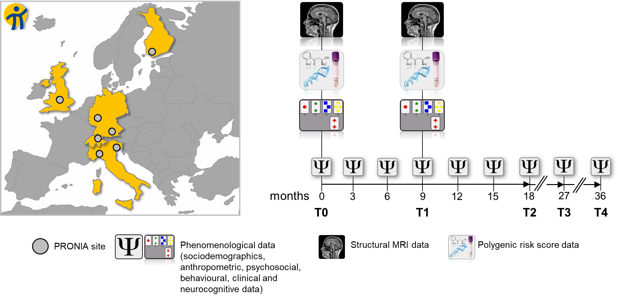

Figure S1: Geographic location of recruitment sites and observational study protocol of the PRONIA study.
Short interval assessments were conducted every 3 months in the three clinical groups (CHR-P, ROD, ROP). Extended clinical and neurocognitive phenotyping and biological data acquisition occurred at baseline and the 9-month follow-up visit in all study participants. For the detailed examination matrix, please see the Supplementary Material of ¹².

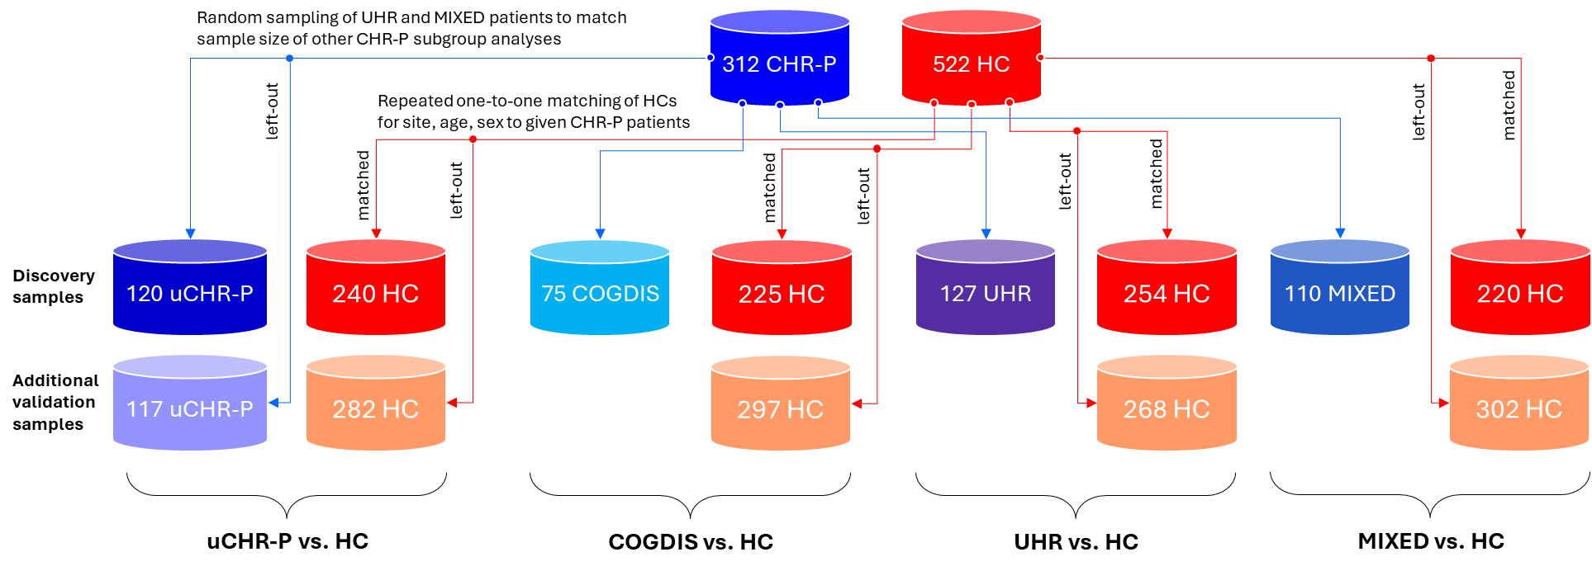

Figure S2: Strategy for sampling patients and HC for training and validating CHR-P classifiers.
HC individuals were by repeatedly matched one-to-one for site, age and sex to the respective CHR-P patients until diagnostic classes started diverging with respect to these covariates. The remaining HC individuals were held-back as CV₂ validation individuals. For the unspecified CHR-P (uCHR-P) classifier training we randomly sampled 120 CHR-P patients from the PRONIA database, who met UHR or MIXED criteria, and used the remaining UHR and MIXED patients as CV₂ validation subjects.

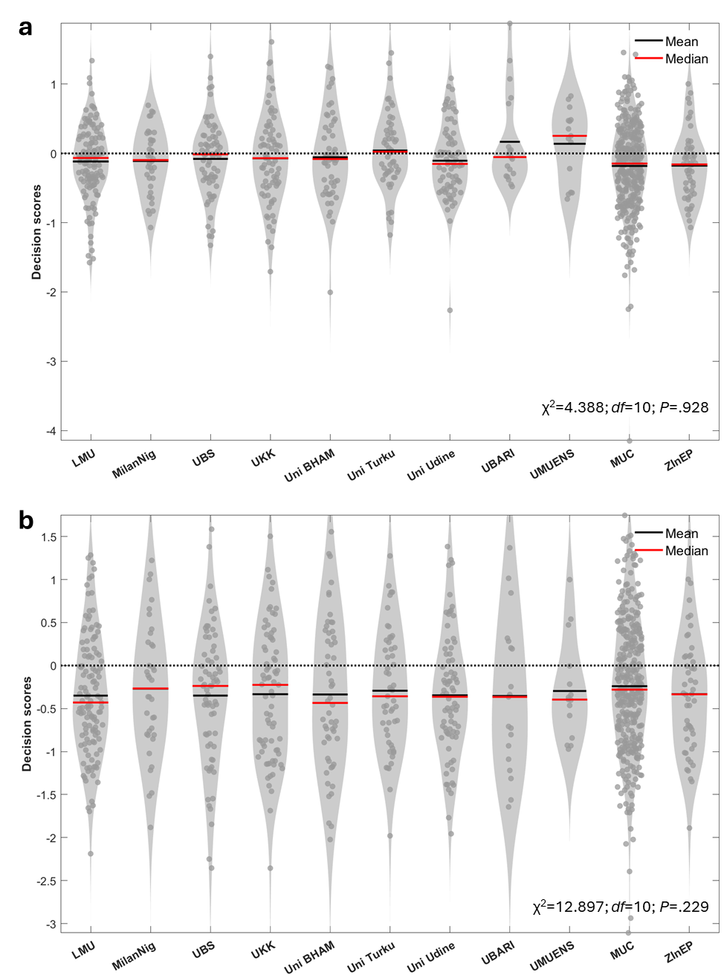

Figure S3: Evaluation of site calibration strategy.
Analysis of of site/scanner effects on out-of-training or out-of-cross validation decision scores produced for the healthy participants by the COGDIS (a) or Schizophrenia (b) classifiers. Significance of site effects was assessed using Kruskal-Wallis tests.

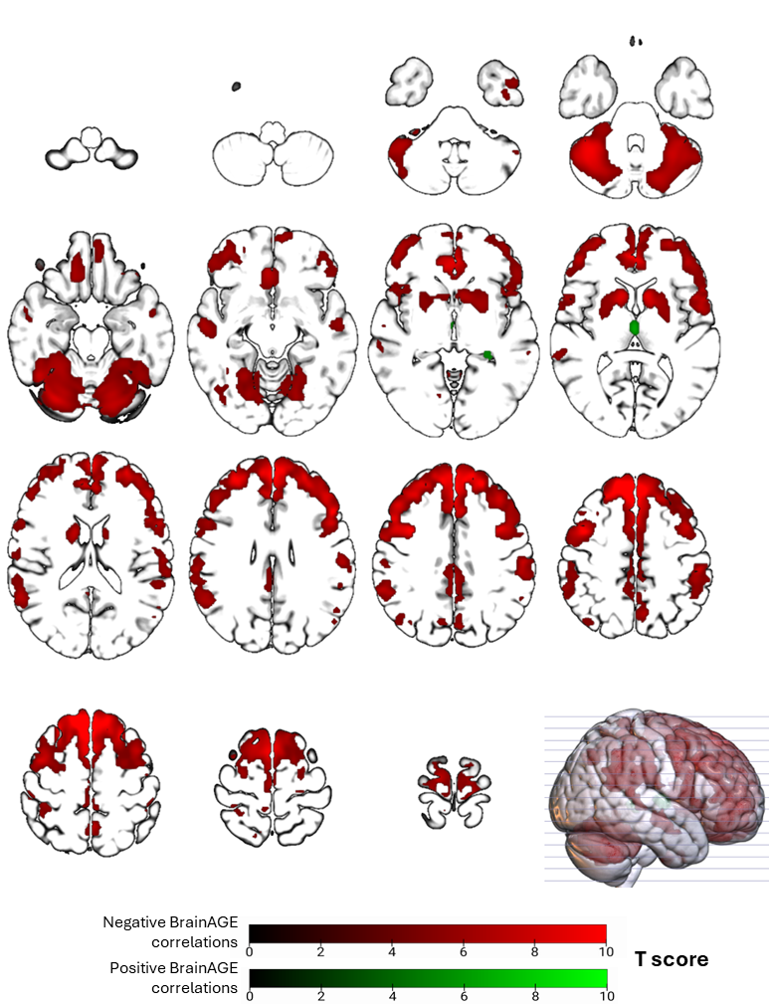

Figure S4: Voxel-level BrainAGE effects.
The figure shows voxels with negative correlations between GMV and BrainAGE scores across all PRONIA study participants at P<0.05, family-wise error rate-corrected, after controlling for the effects of COGDIS, UHR, MIXED and schizophrenia brain expression scores in the statistical design matrix. Voxels with positive BrainAGE correlations were detected in the thalamus and posterior parts of the hippocampus bilaterally at P<0.05, family-wise error rate -corrected.

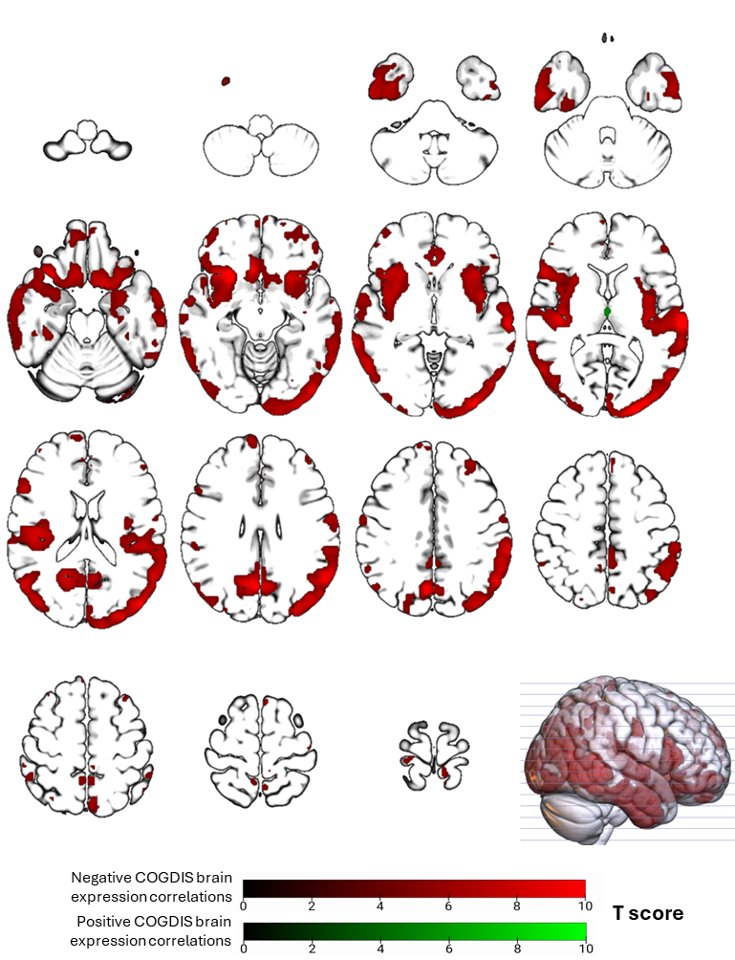

Figure S5: Voxel-level COGDIS brain pattern effects.
The figure shows voxels with negative correlations between GMV and COGDIS brain expression scores across all PRONIA study participants at P<0.05, family-wise error rate corrected, after controlling for the effects of BrainAGE, UHR, MIXED and schizophrenia brain expression scores in the statistical design matrix. Voxels with positive COGDIS brain expression correlations were detected in the thalamus at P<0.05, family-wise error rate -corrected.

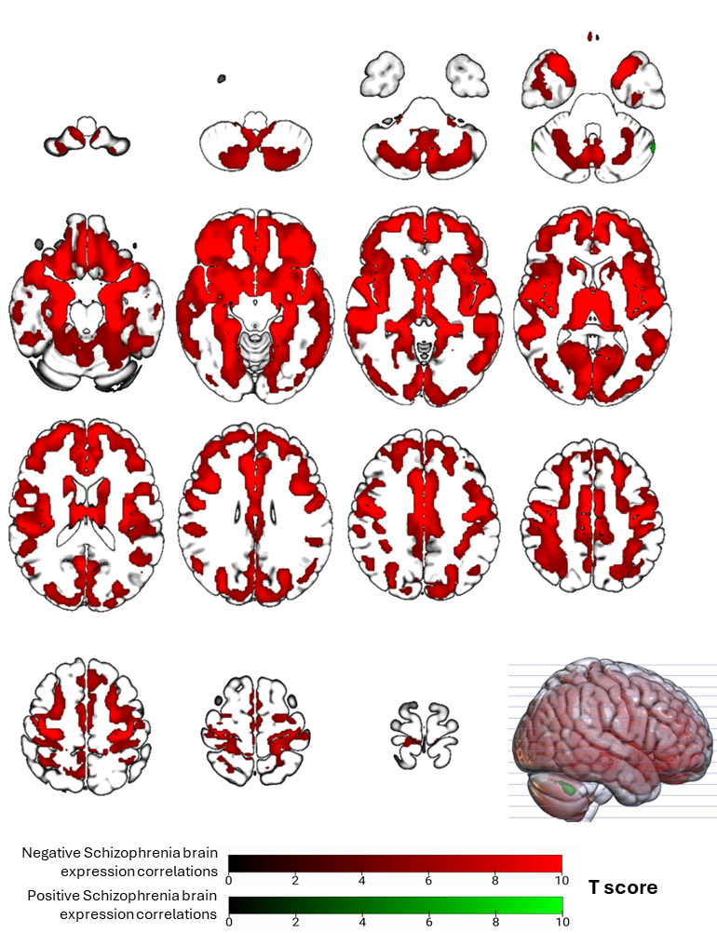

Figure S6: Voxel-level schizophrenia brain pattern effects.
The figure shows voxels with positive and negative correlations between GMV and schizophrenia brain expression scores across all PRONIA participants at P<0.05, family-wise error rate-corrected, after controlling for the effects of BrainAGE, COGDIS, UHR, and MIXED brain expression scores in the statistical design matrix. Voxels with positive schizophrenia brain expression correlations were detected bilaterally in the cerebellar hemispheres at P<0.05, family-wise error rate-corrected.
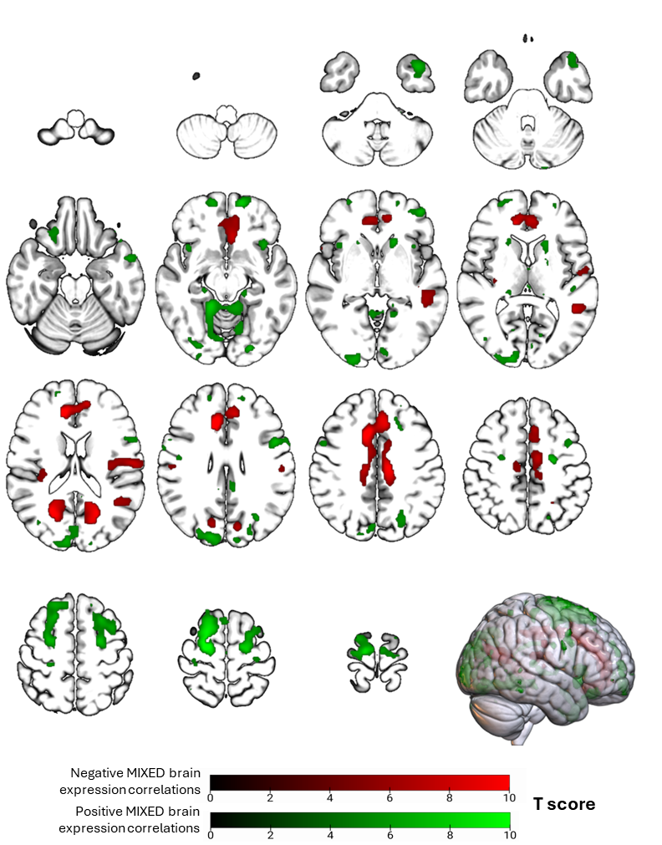

Figure S7: Voxel-level MIXED brain pattern effects.
The figure shows voxels with positive and negative correlations between GMV and MIXED brain expression scores across all PRONIA participants at P<0.05, family-wise error rate-corrected, after controlling for the effects of BrainAGE, COGDIS, UHR, and schizophrenia brain expression scores in the statistical design matrix.

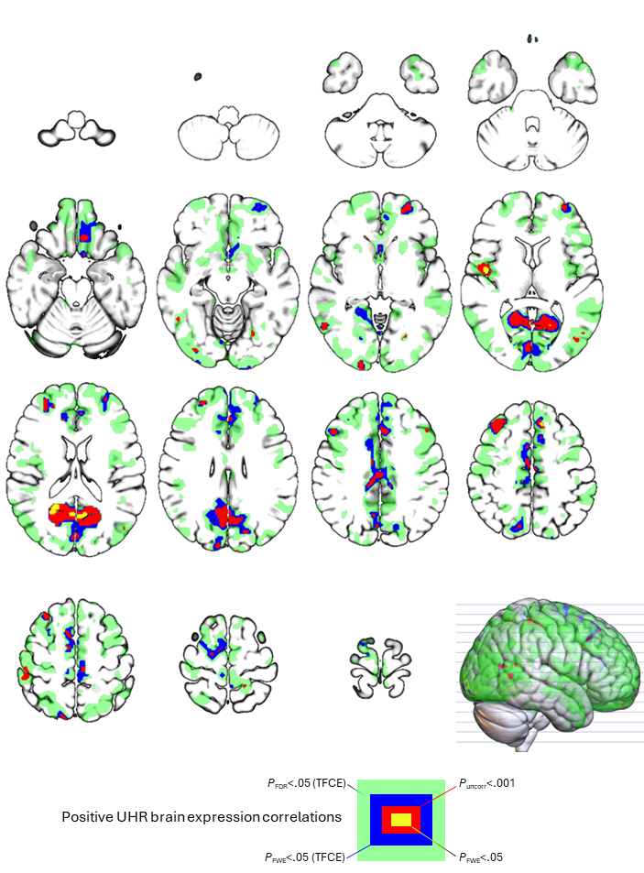

Figure S8: Voxel-level UHR brain pattern effects.
The figure shows voxels with positive correlations between GMV and UHR brain expression scores across all PRONIA study participants after controlling for the effects of BrainAGE, COGDIS, MIXED and schizophrenia brain expression scores in the statistical design matrix. The primary significance threshold was set to P<0.05, family-wise error rate -corrected as in the other analyses to identify strong voxel-level effects. In addition, an uncorrected threshold at P<.001 and two threshold-free-cluster enhancement (TFCE) thresholds were applied at P<0.05, FDR-corrected, and P<0.05, family-wise error rate -corrected, to detect more subtle but spatially contiguous effects associated with brain volume increases in persons with higher UHR brain expression scores. None of these thresholds produced voxels with negative UHR brain expression correlations.
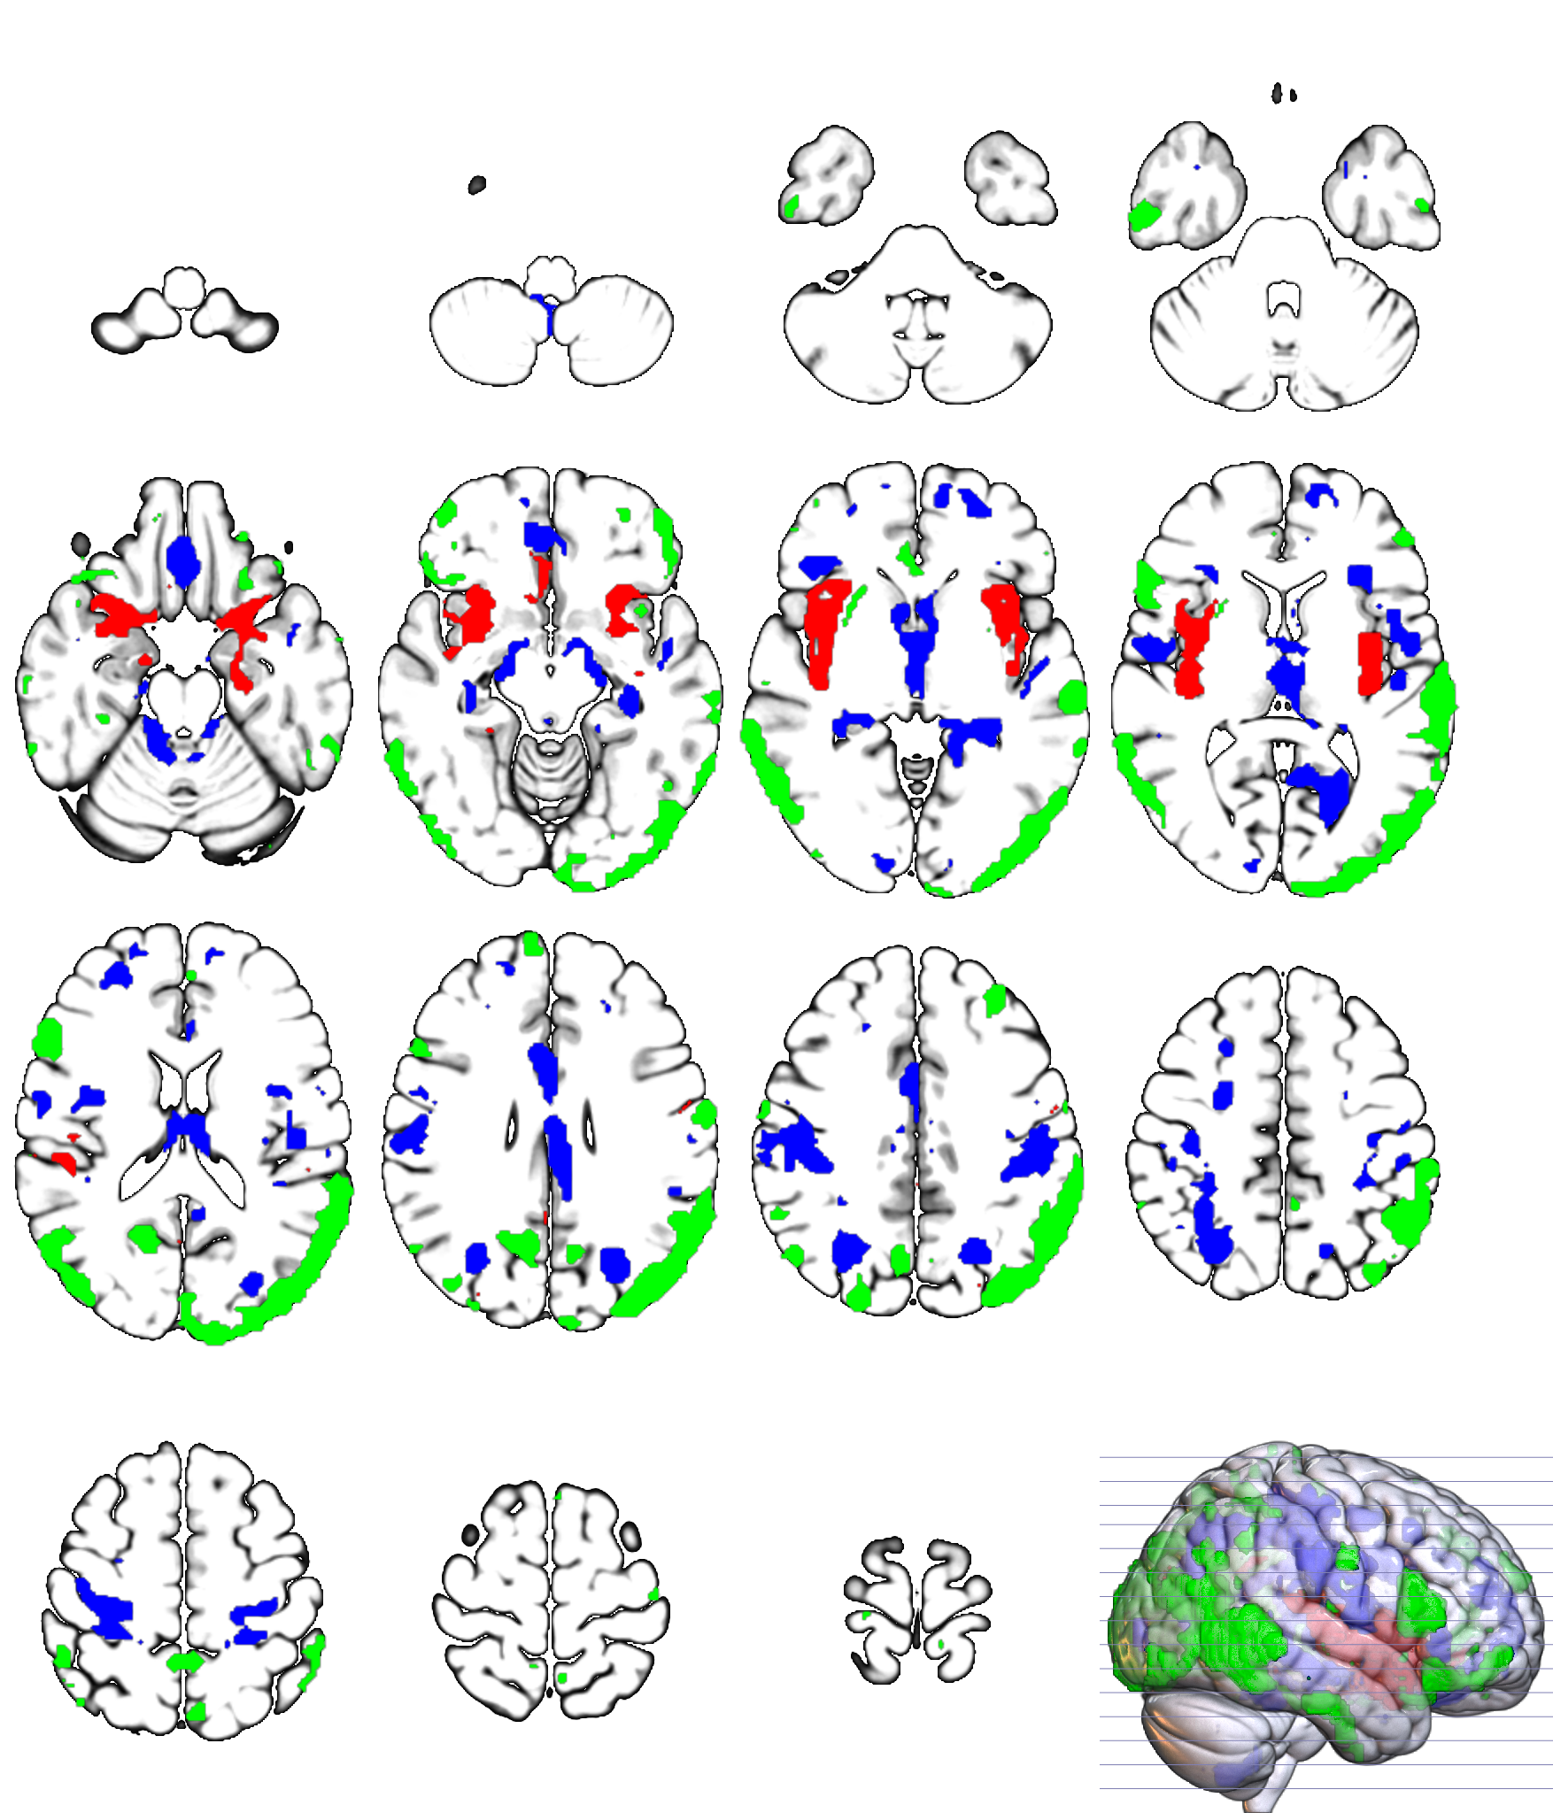

Figure S9: Neuroanatomical comparison between COGDIS and FThD+ classifiers.
The figure shows an overlay of three voxel-level contrasts at P<0.05, family-wise error rate-corrected: (1) green: voxels with negative correlations between GMV and COGDIS brain scores after excluding negative correlations of FThD+ brain scores at P<.05, uncorrected; (2) blue: voxels with negative correlations between GMV and FThD+ brain scores after excluding negative correlations of COGDIS brain scores at P<.05, uncorrected; (3) red: conjunction contrast showing voxels where GMV was negatively correlated with COGDIS and FThD+ brain scores at P<.05, FWE-corrected.

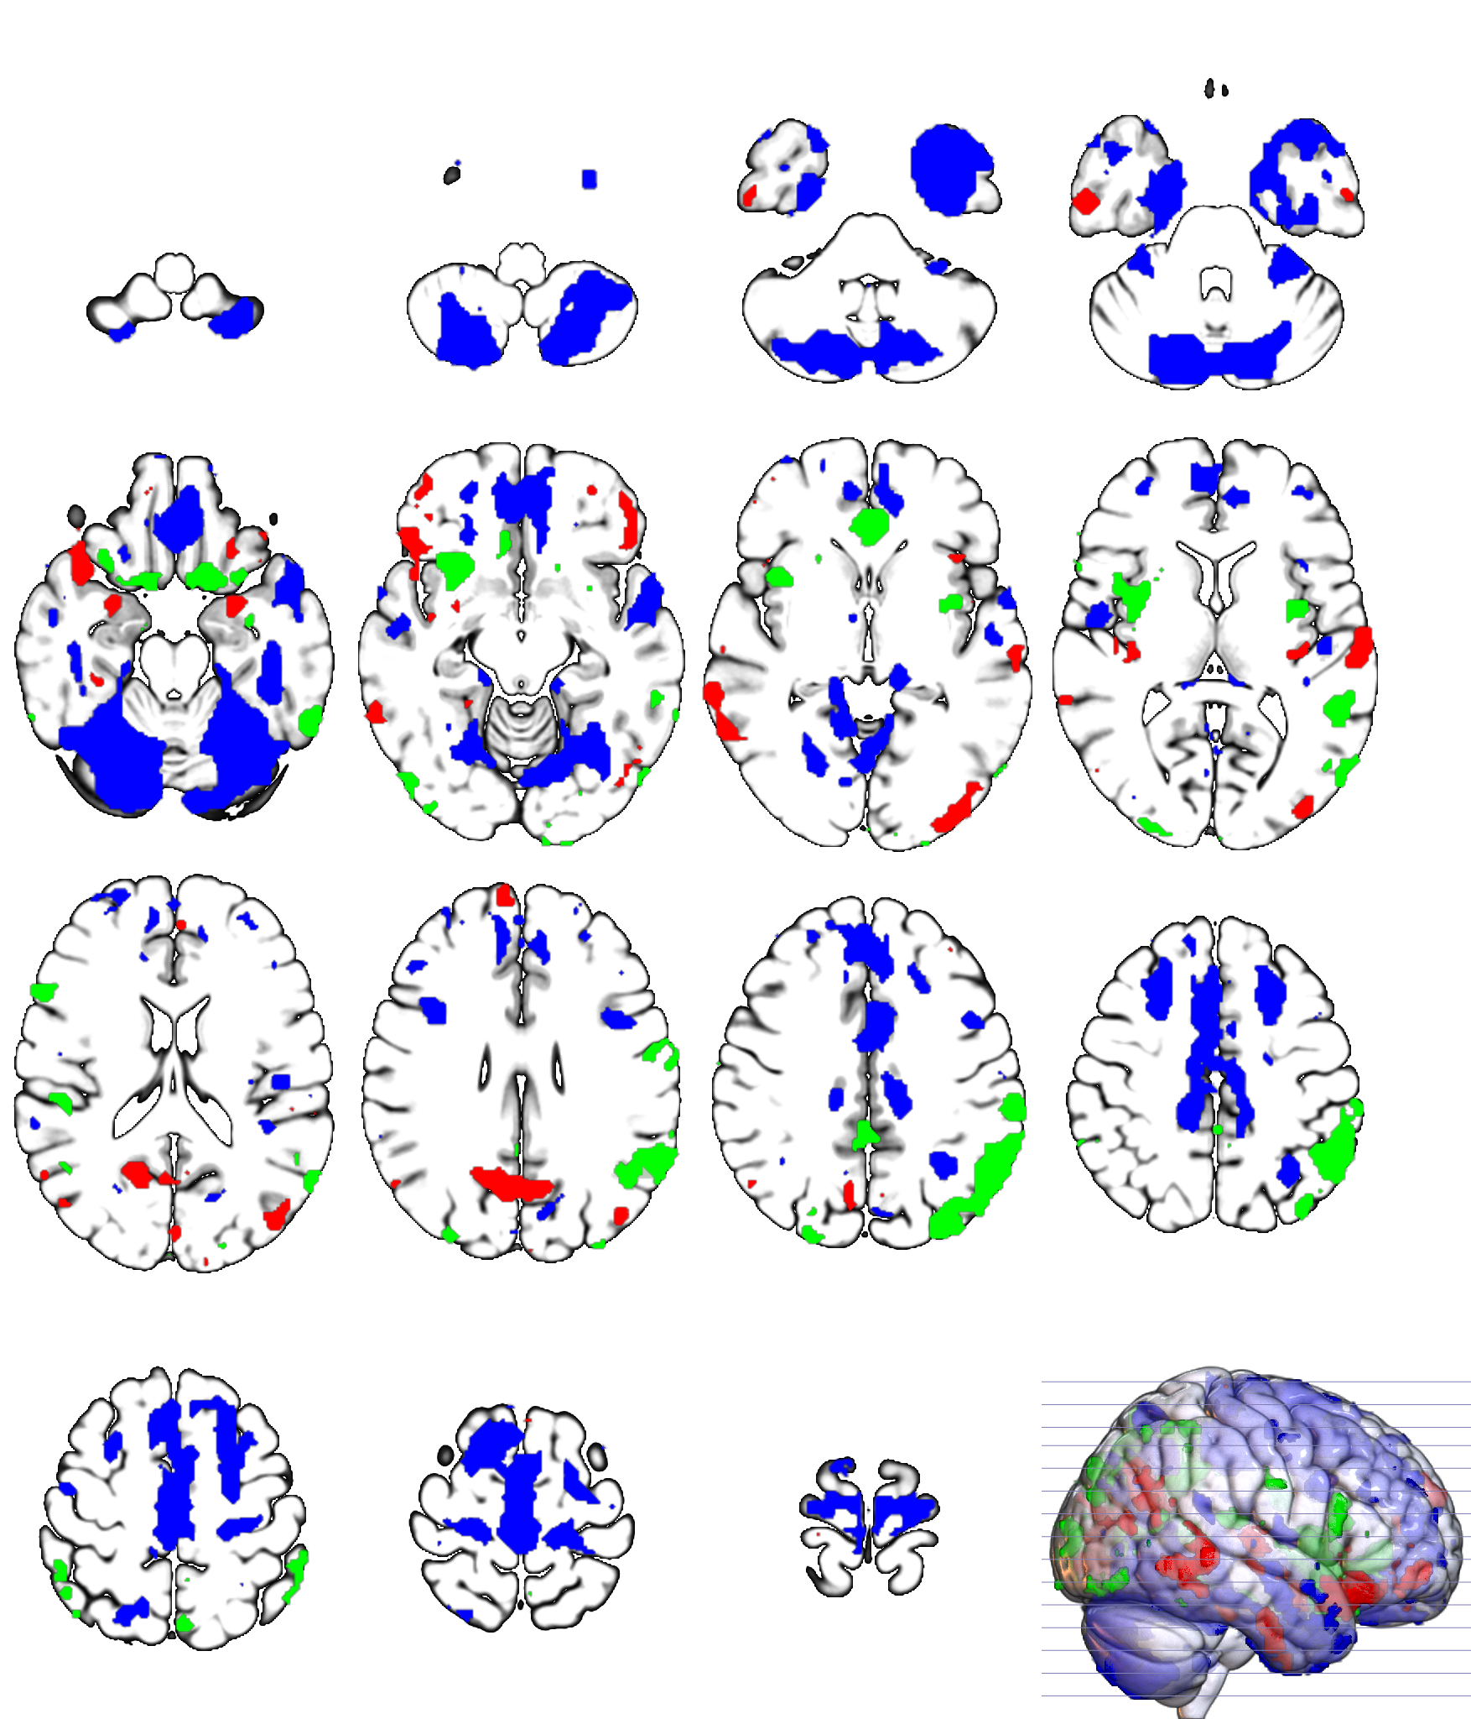

Figure S10: Neuroanatomical comparison between COGDIS and FThD− classifiers.
The figure shows an overlay of three voxel-level contrasts at P<0.05, family-wise error rate-corrected: (1) green: voxels with negative correlations between GMV and COGDIS brain scores after excluding negative correlations of FThD− brain scores at P<.05, uncorrected; (2) blue: voxels with negative correlations between GMV and FThD− brain scores after excluding negative correlations of COGDIS brain scores at P<.05, uncorrected; (3) red: conjunction contrast showing voxels where GMV was negatively correlated with COGDIS and FThD− brain scores at P<.05, FWE-corrected.

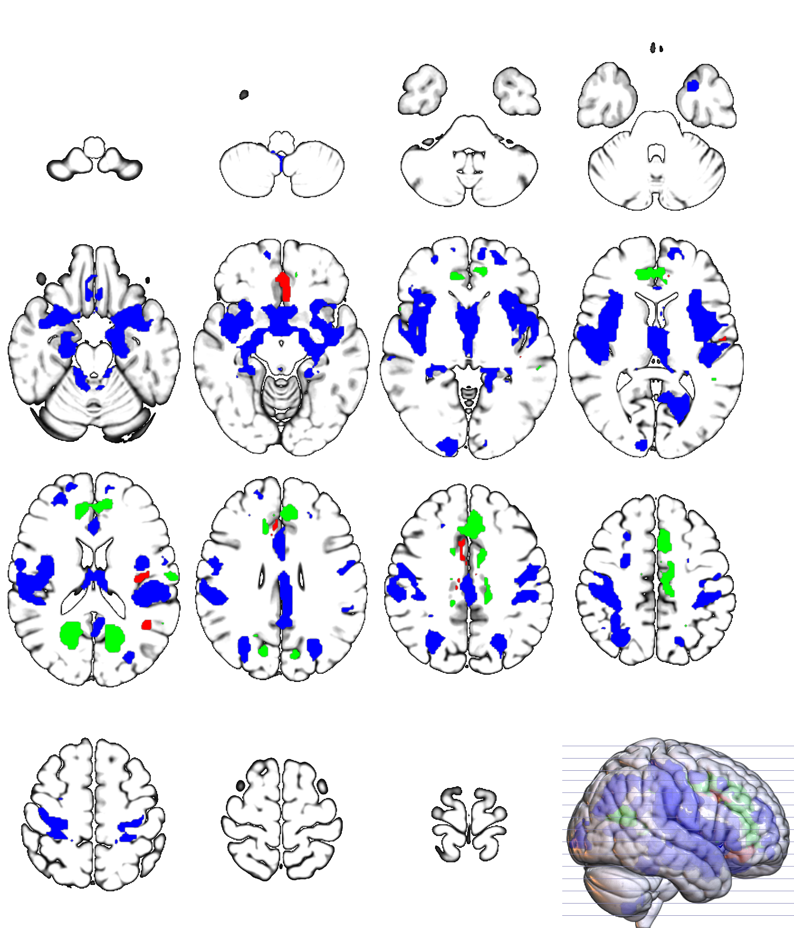

Figure S11: Neuroanatomical comparison between MIXED and FThD+ classifiers.
The figure shows an overlay of three voxel-level contrasts at P<0.05, family-wise error rate-corrected: (1) green: voxels with negative correlations between GMV and MIXED brain scores after excluding negative correlations of FThD+ brain scores at P<.05, uncorrected; (2) blue: voxels with negative correlations between GMV and FThD+ brain scores after excluding negative correlations of MIXED brain scores at P<.05, uncorrected; (3) red: conjunction contrast showing voxels where GMV was negatively correlated with MIXED and FThD+ brain scores at P<.05, FWE-corrected.

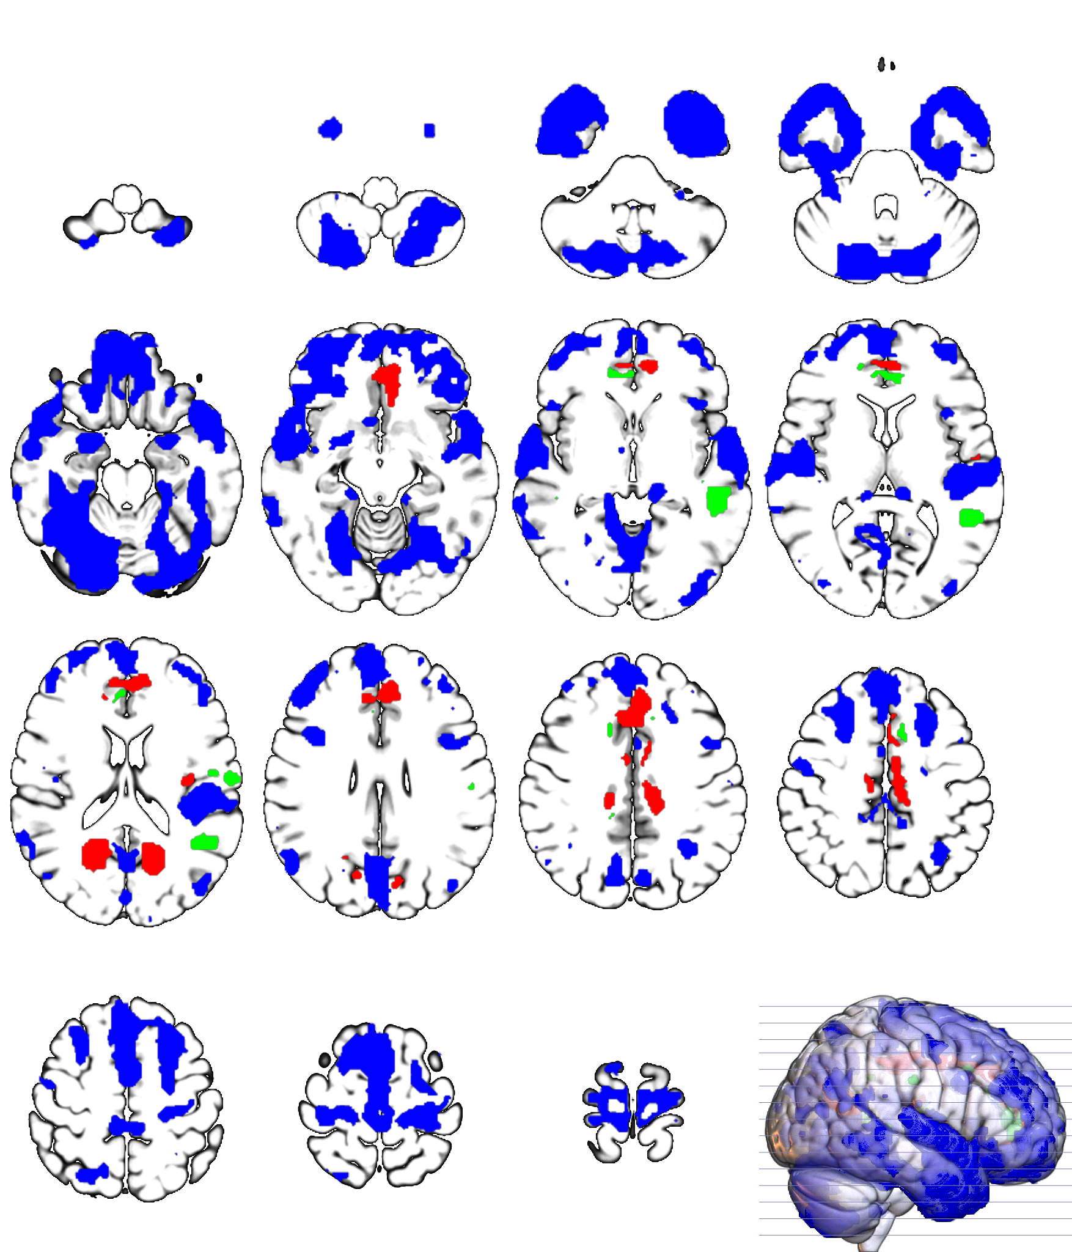

Figure S12: Neuroanatomical comparison between MIXED and FThD− classifiers.
The figure shows an overlay of three voxel-level contrasts at P<0.05, family-wise error rate-corrected: (1) green: voxels with negative correlations between GMV and MIXED brain scores after excluding negative correlations of FThD− brain scores at P<.05, uncorrected; (2) blue: voxels with negative correlations between GMV and FThD− brain scores after excluding negative correlations of MIXED brain scores at P<.05, uncorrected; (3) red: conjunction contrast showing voxels where GMV was negatively correlated with MIXED and FThD− brain scores at P<.05, FWE-corrected.

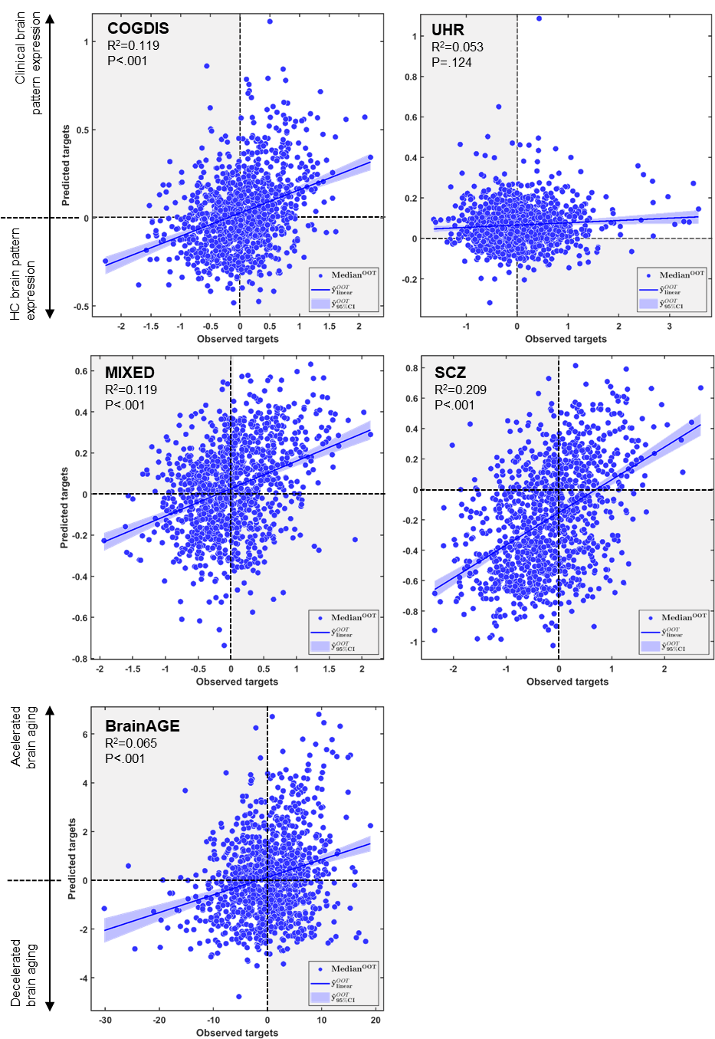

Figure S13: Performance of biopsychosocial brain score prediction models in the entire PRONIA cohort.
Predicted brain scores of the COGDIS, UHR, MIXED, Schizophrenia, and BrainAGE models were plotted against observed brain expression scores. Dashed lines in the scatter plots indicate the boundaries between observed/predicted patient and HC classes, or observed/predicted accelerated or decelerated brain aging.
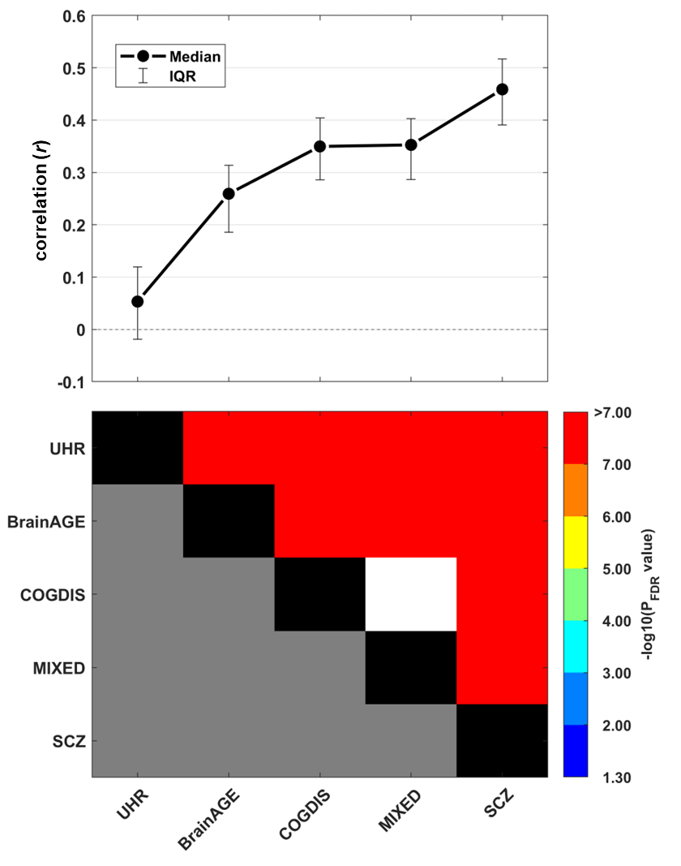

Figure S14: Quade test comparing the performances of biopsychosocial models predicting brain expression scores.
Top panel: Medians (error bars: interquartile ranges, IQR) of Pearson correlations between observed and predicted brain expressions scores computed at the CV₂ level. Models were sorted from the model with weakest (UHR) to the model with the strongest prediction performance (Schizophrenia, SCZ). The Quade test metric measured W_{4,396} = 145.6 and was significant with P<.001. Bottom panel: Following the significant omnibus test, pairwise post-hoc comparisons with FDR correction for multiple testing were conducted to compare model performances. All models except for the COGDIS and MIXED brain expression score predictors differed significantly from each other at P<.001.

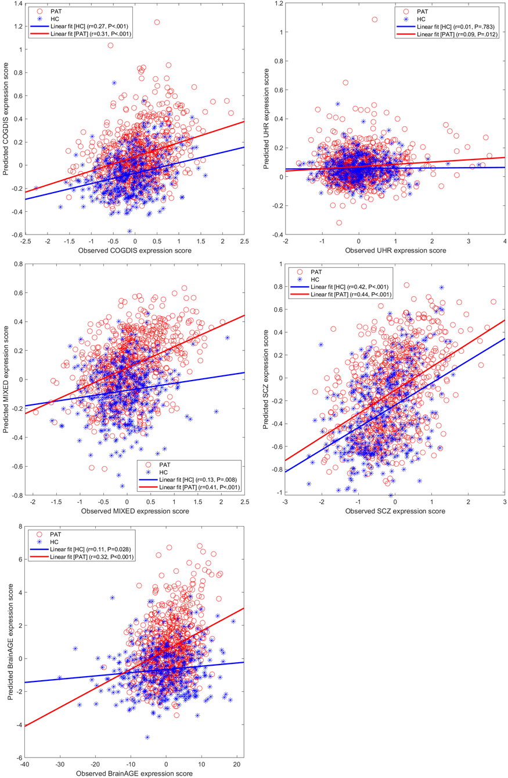

Figure S15: Performance of biopsychosocial brain score prediction models in patients vs. healthy controls
Predicted brain expression scores of the COGDIS, UHR, MIXED, schizophrenia, and BrainAGE models were plotted separately against observed brain expression scores for HC and patient groups (PAT). Linear fits illustrate the generalizability of brain signatures’ predictability to healthy controls. See also Table 4 in the main manuscript for interaction analysis results.

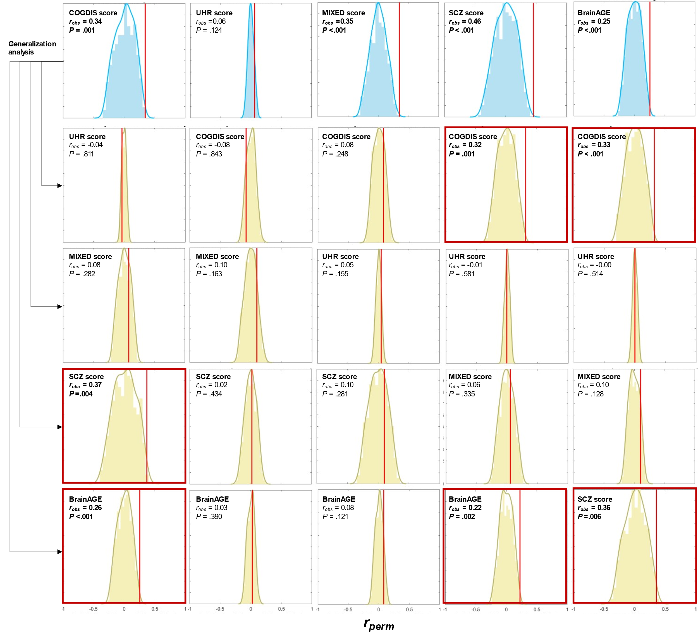

Figure S16: Permutation and label generalization analysis of biopsychosocial brain expression prediction models.
The performance of support-vector regression models trained to predict one of the four brain pattern expression scores or BrainAGE was tested for significance using 1000 label permutations (top row, blue-colored null distribution of permuted model performance as measured by r_{perm}). The model’s generalization capacity to the other four unseen scores was measured by correlating the model’s predictions with the respective observed brain expression score (r_{obs}, red vertical lines). In each label permutation, the correlation was re-computed between the respective brain expression score and the permuted model’s predictions, generating a null distribution (yellow) of the respective r_{perm} coefficient, which was used to determine the significance of model’s generalization capacity to the given brain expression score at α=0.05. Red rectangles indicate significant label generalization effects.

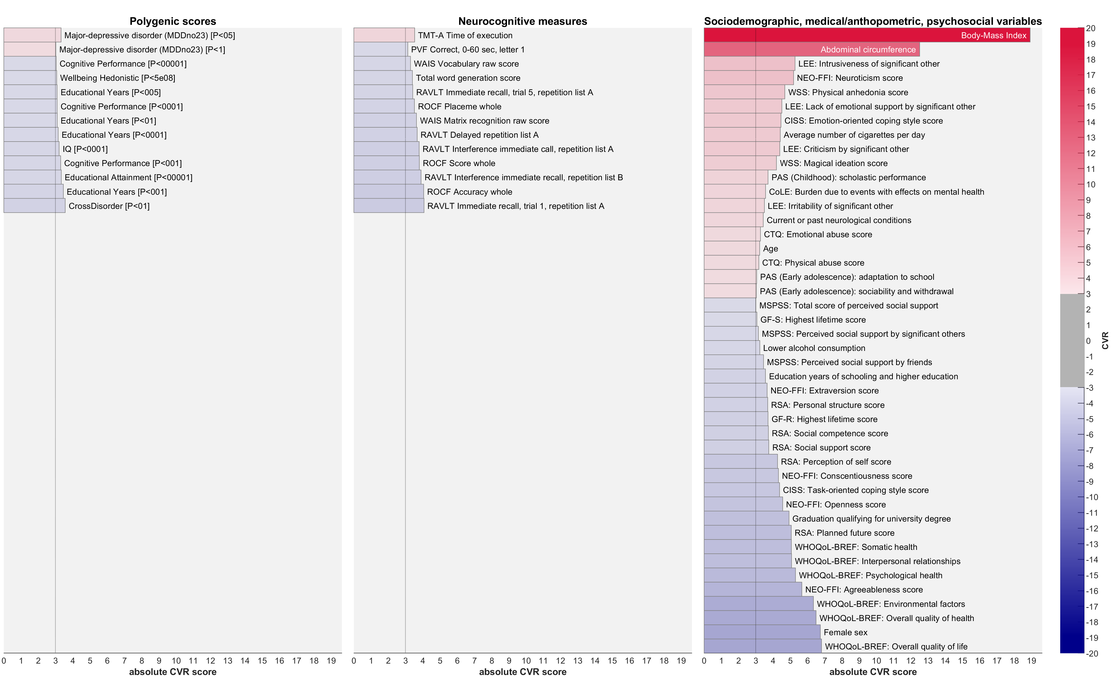
Figure S17: Relevance of genetic (left), neurocognitive (middle) and phenotypic (right) domains for the multimodal and transdiagnostic prediction of COGDIS brain pattern expression in the PRONIA cohort.
Only variables with an absolute CVR > 3 were depicted. For an explanation of the feature abbreviation please see Table S7. Variables predictive of the neuroanatomical COGDIS class were colored in red, variables predictive of the neuroanatomical HC class were colored in blue.
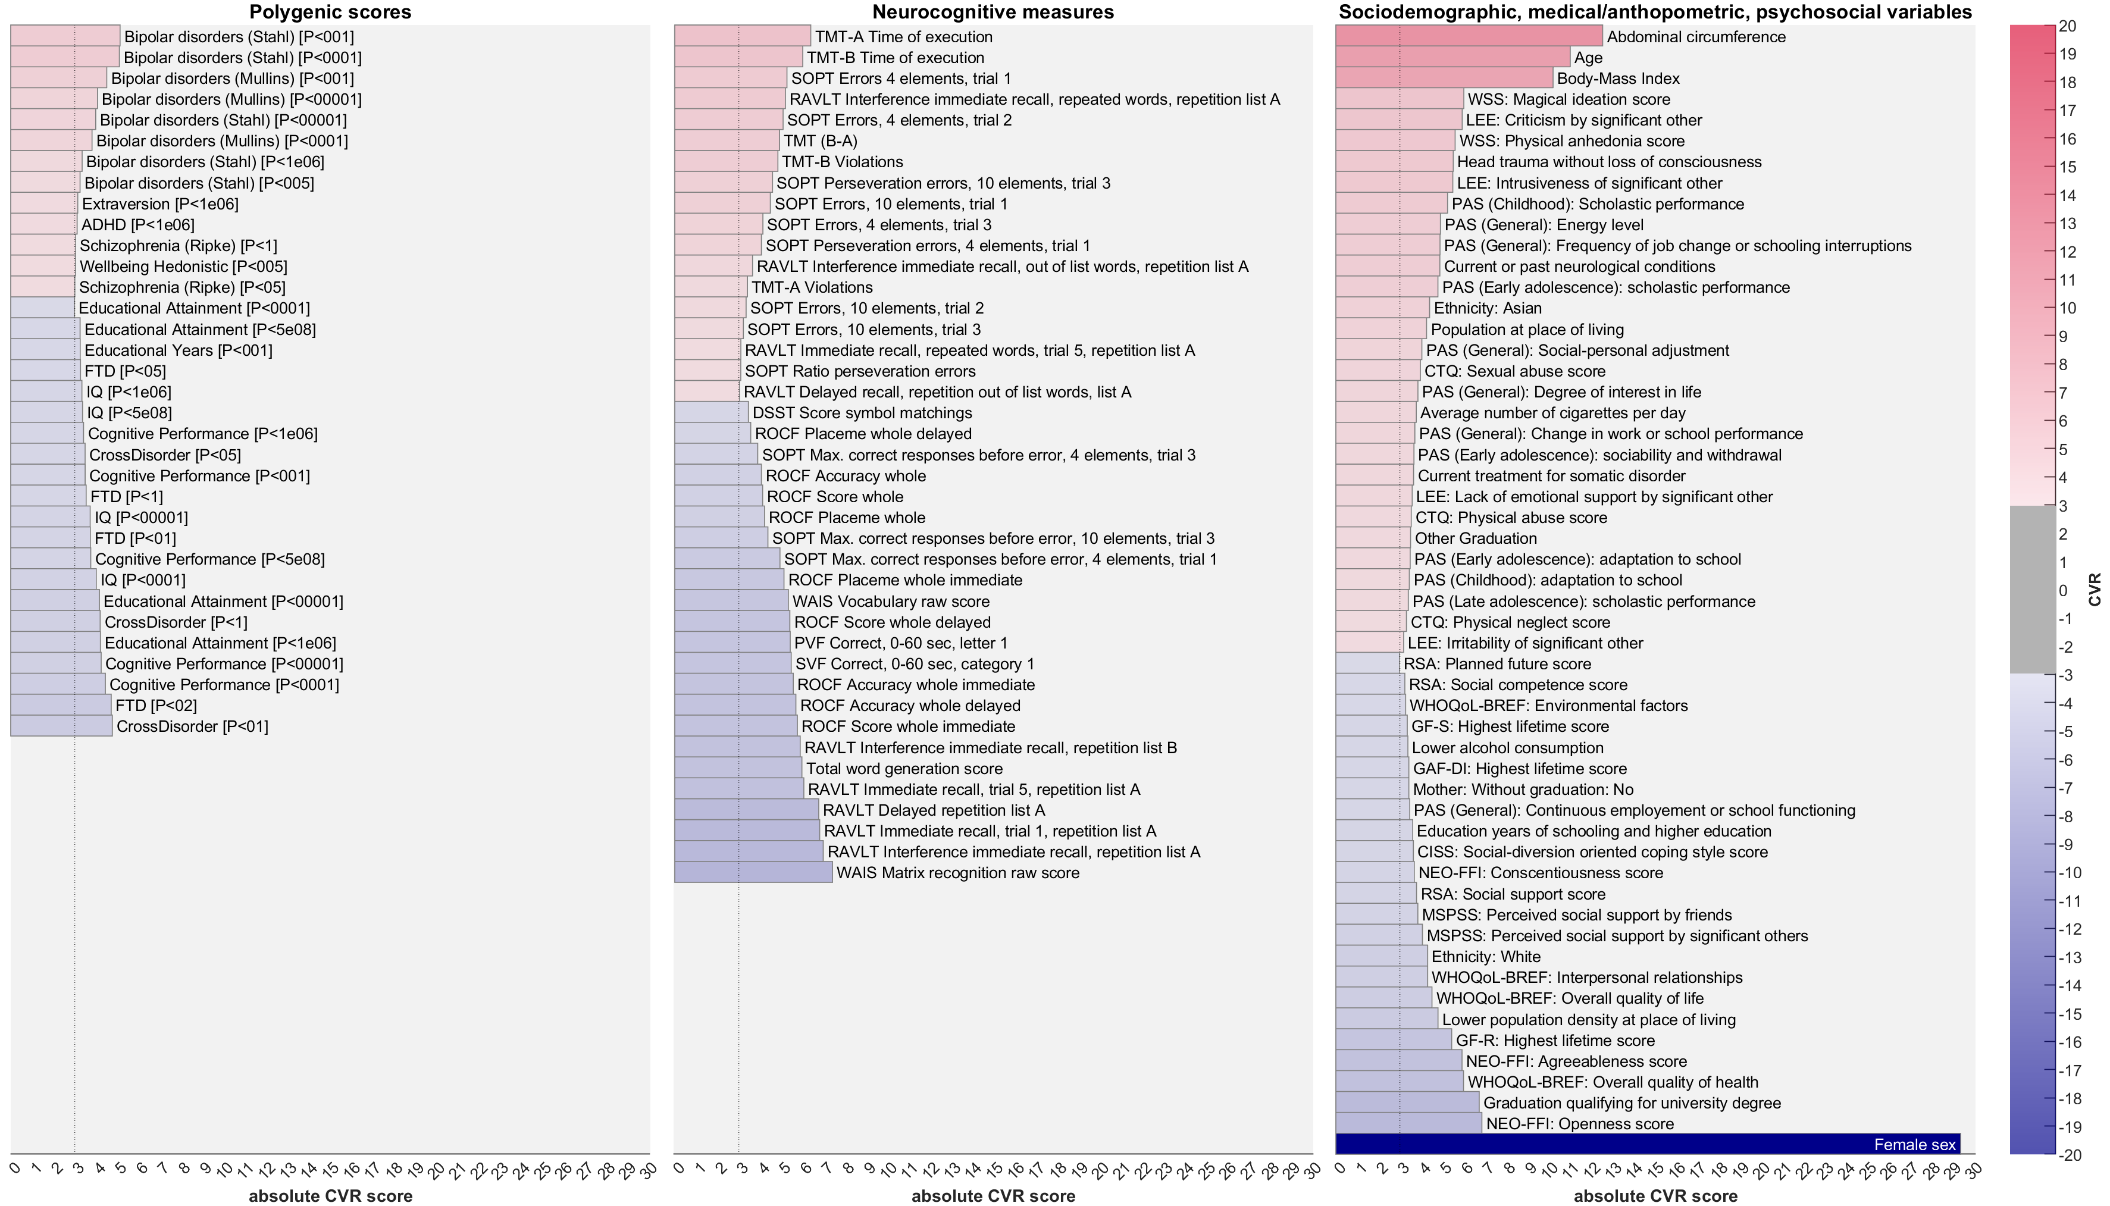

Figure S18: Relevance of genetic (left), neurocognitive (middle) and phenotypic (right) variables for the multimodal and transdiagnostic prediction of schizophrenia brain pattern expression in the PRONIA cohort.
Only variables with an absolute CVR > 3 were depicted. For an explanation of the feature abbreviation please see Table S7. Variables predictive of the neuroanatomical schizophrenia class were colored in red, variables predictive of the neuroanatomical HC class were colored in blue.

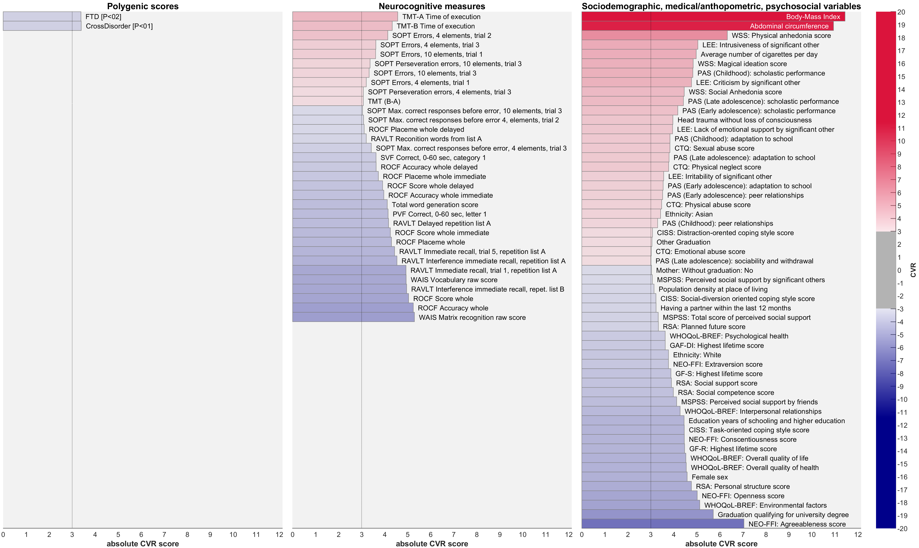

Figure S19: Relevance of genetic (left), neurocognitive (middle) and phenotypic (right) variables for the multimodal and transdiagnostic prediction of BrainAGE pattern expression in the PRONIA cohort.
Only variables with an absolute CVR > 3 were depicted. For an explanation of the feature abbreviation please Table S7. Variables predictive of accelerated brain aging were colored in red, variables predictive of decelerated brain aging were colored in blue.
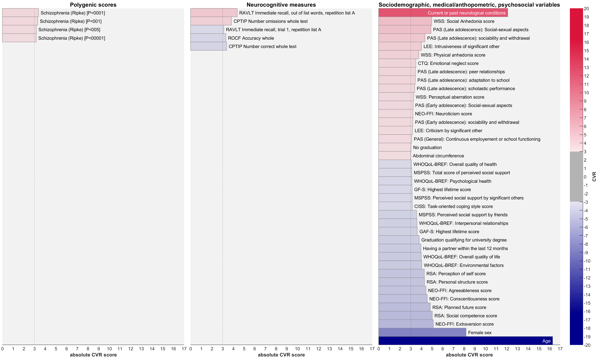

Figure S20: Relevance of genetic (left), neurocognitive (middle) and phenotypic (right) variables for the multimodal and transdiagnostic prediction of MIXED brain pattern expression in the PRONIA cohort.
Only variables with an absolute CVR > 3 were depicted. For an explanation of the feature abbreviation please see Table S7. Variables predictive of the neuroanatomical MIXED class were colored in red, variables predictive of the neuroanatomical HC class were colored in blue.

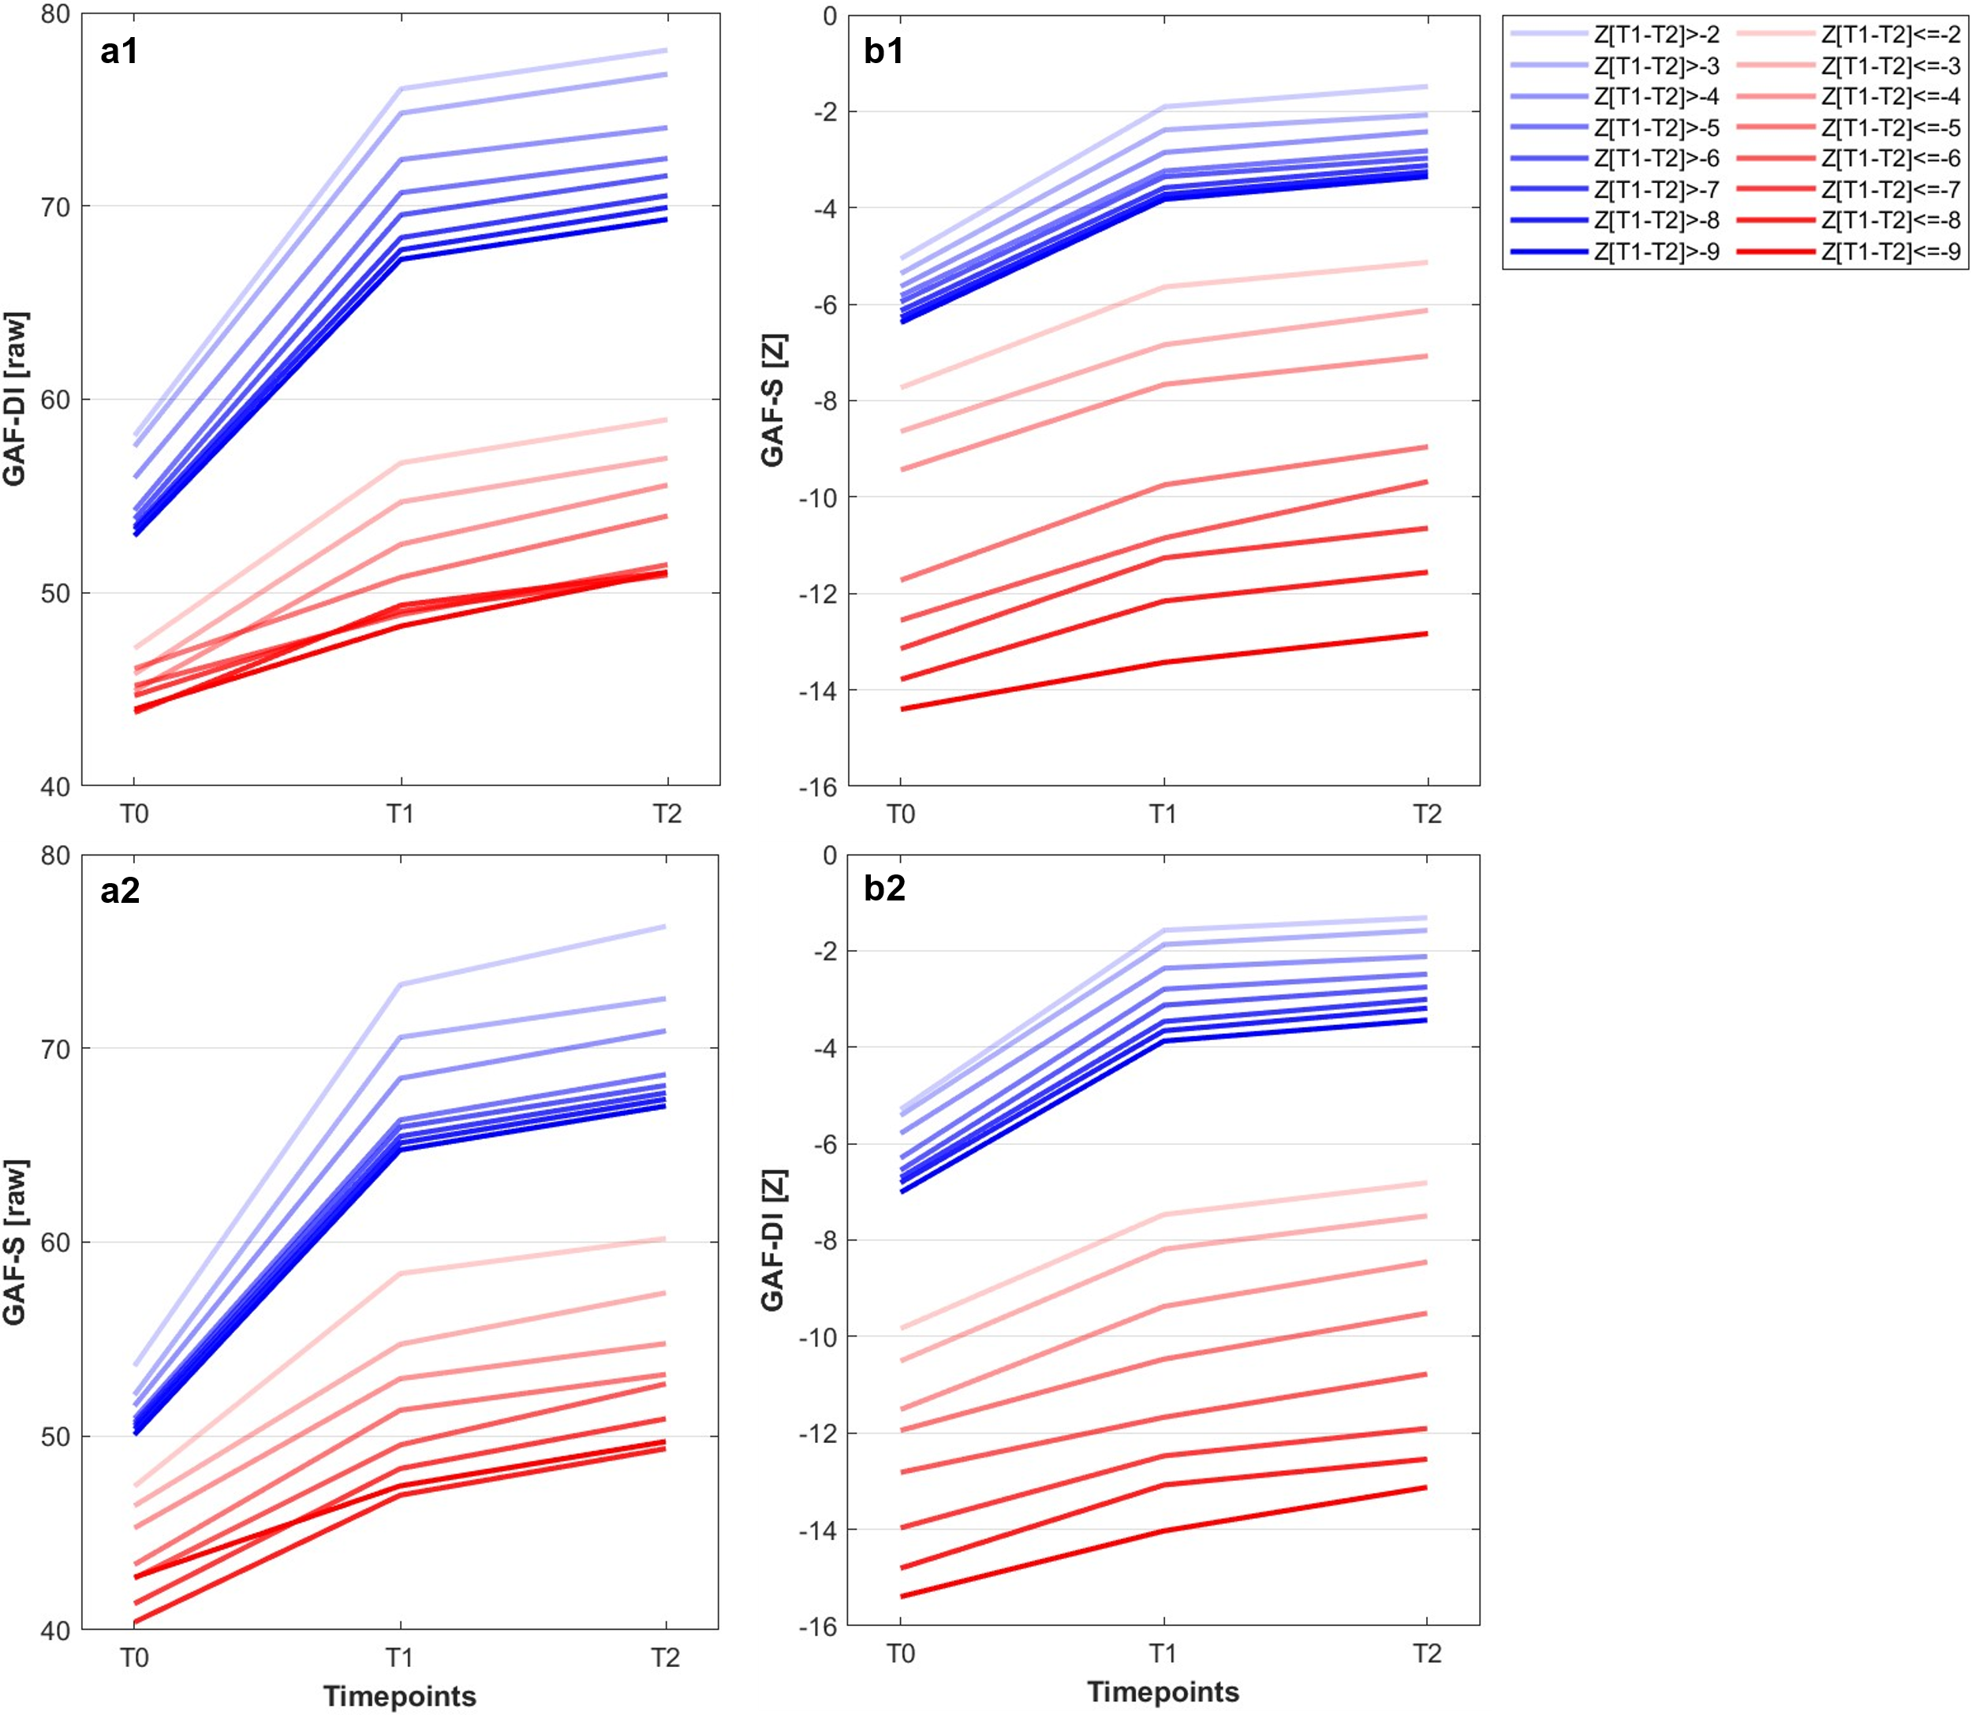

Figure S21: Raw and z-transformed GAF-Disability/Impairment and GAF-Symptom trajectories from baseline to the T2 time points in the PRONIA clinical study participants.
The longitudinal data of 537 healthy controls was used to dynamically standardize the GAF-DI and GAF-S data of 337 clinical study participants thus mitigating site and age effects in the GAF data. Patients were labeled with a ‘poor’ functioning trajectory if their z-transformed GAF data was below the respective Z threshold (-2 to -9) at both the T1 and T2 time points. Otherwise, they were labeled with a good functioning trajectory. Mean Z score trajectories were computed for the ‘poor’ (red) vs. ‘good’ outcome (blue) groups at each Z score cutoff and depicted with increasing color intensities for lower Z cutoffs in GAF-DI (b1) and GAF-S domains (b2). Original GAF trajectories were compared to the Z-transformed data by replacing Z scores in the respective ‘poor’ and ‘good’ outcome groups with the original GAF data and re-computing the mean trajectories (a1 and a2).

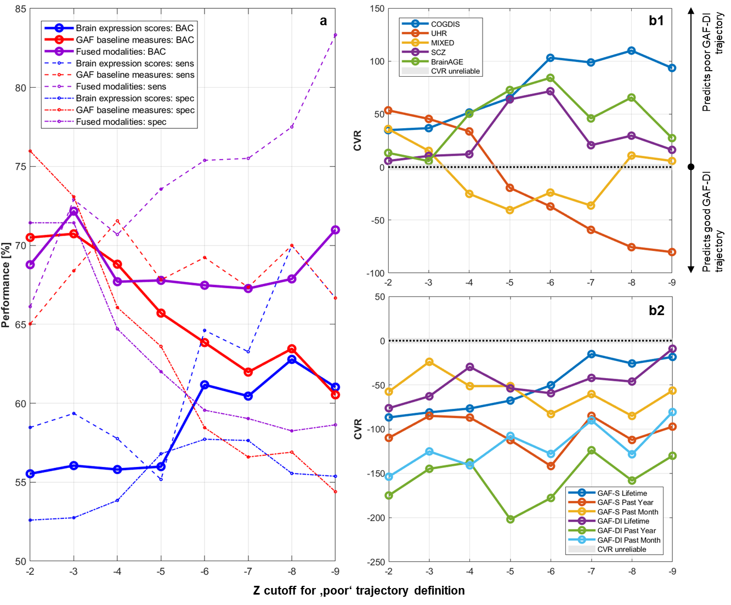

Figure S22: Prognostic relevance of brain expression scores and GAF baseline features in the prediction of GAF-D/I outcome trajectories.
(a) Prognostic performance (Balanced Accuracy [BAC], Sensitivity [Sens], Specificity [Spec]) of the brain expression, GAF baseline and fused-modalities classifiers as a function of ‘poor’ trajectory cutoff.
(b1) CVR of brain expression scores in the fused-modalities classifier as a function of ‘poor’ trajectory cutoff.
(b2) CVR of GAF baseline variables in the fused-modalities classifier as a function of ‘poor’ trajectory cutoff.

