Supporting Information
Integrated and sustainable preparation of functional nanocellulose via formic acid/choline chloride solvents pretreatment
Meiyan Wu • Keyu Liao • Chao Liu • Guang Yu • Mehdi Rahmaninia • Haiming Li • Bin Li

Meiyan Wu • Keyu Liao • Chao Liu • Guang Yu • Bin Li ()
CAS Key Laboratory of Biofuels, Qingdao Institute of Bioenergy and Bioprocess Technology, Chinese Academy of Sciences, Qingdao, Shandong, 266101, China
Tel: +86-532-80662725, Fax: +86-532-80662725, Postal address: No. 189 Songling Road, Qingdao, Shandong 266101, China. E-mail: libin@qibebt.ac.cn (B. Li)

Keyu Liao • Haiming Li ()
School of Light Industry and Chemical Engineering, Dalian Polytechnic University, Dalian, Liaoning, 116034, China
E-mail: charley1114@163.com (H. Li)

Meiyan Wu • Chao Liu
Key Laboratory of Pulp and Paper Science & Technology of Ministry of Education/Shandong Province, Qilu University of Technology (Shandong Academy of Sciences), Jinan, Shandong, 250353, China

Mehdi Rahmaninia
Wood and Paper Science and Technology Department, Faculty of Natural Resources, Tarbiat Modares University, Noor 46417-76489, Iran

# The first two authors contributed equally.

Including Pages S1-S9, Tables S1 and S2, Figures S1-S13, References.

Tab. S1 Summary of the preparation method of NC using DES pretreatment
Raw materials | Composition of the DES | Mechanical treatment | Products
Cotton (Ling et al. 2018; Liu et al. 2017) | ChCl/oxalic acid | Ultrasonication | CNCs
Softwood dissolving pulp (Laitinen et al. 2017a) | ChCl/oxalic acid | Microfluidization | CNCs
Beached eucalyptus kraft pulp (Yang et al. 2019) | FeCl3-catalyzed ChCl/oxalic acid | - | CNCs
Spruce groundwood pulp (Sirvio 2018) | Imidazole/triethylmethylammonium chloride | Homogenization | CNFs
Softwood dissolving pulp (Sirvio et al. 2016) | ChCl/oxalic acid, p-toluenesulfonic acid, levulinic acid | Homogenization | CNCs
Waste-board/fluting/waste container board (Laitinen et al. 2017b; Suopajarvi et al. 2017) | ChCl/urea | Microfluidization | CNFs
Bleached birch pulp (Sirviö et al. 2015) | ChCl/urea | Microfluidization | CNFs
Groundwood pulp (Sirviö and Visanko 2017) | Triethylmethylammonium chloride/imidazole | Homogenization | CNFs
Bleached kraft birch pulp (Li et al. 2018) | Aminoguanidine hydrochloride/glycerol | Microfluidization | CNFs
Bleached kraft birch pulp (Li et al. 2017) | Ammonium thiocyanate/urea or guanidine hydrochloride/urea | Microfluidization | CNFs
Softwood dissolving pulp (Sirviö et al. 2019) | Sulfamic acid/urea | Microfluidization | CNFs
Softwood dissolving pulp (Selkala et al. 2016) | Urea/LiCl | Microfluidization | CNFs
Poplar kraft Pulp (Ma et al. 2019) | ChCl/oxalic acid | Ultrasonication | CNCs/CNFs
Ramie fiber (Yu et al. 2019) | ChCl/oxalic acid or ChCl/urea | Ball milling | CNFs
Note: ChCl-Choline chloride, CNCs-cellulose nanocrystals, CNFs-cellulose nanofibrils.

Tab. S2 List of abbreviations
Abbreviation | Definition
F-DES | Formic acid/choline chloride
U-DES | Urea/choline chloride
MCC | Microcrystalline cellulose
U-MCC | Pretreated microcrystalline cellulose with U-DES
F-MCC | Pretreated microcrystalline cellulose with F-DES
NC | Nanocellulose
F-NC | Nanocellulose prepared via F-DES pretreatment plus ball-milling
U-NC | Nanocellulose prepared via U-DES pretreatment plus ball-milling
CNCs | Cellulose nanocrystals
CNFs | Cellulose nanofibrils
B-CNCs1/B-CNFs1 | CNCs or CNFs prepared via direct ball-milling for 8 h
B-CNCs2/B-CNFs2 | CNCs or CNFs prepared via direct ball-milling for 16 h
F-CNCs1/F-CNFs1 | CNCs or CNFs prepared via F-DES pretreatment plus ball-milling for 8 h
F-CNCs2/ F-CNFs2 | CNCs or CNFs prepared via F-DES pretreatment plus ball-milling for 16 h
U-CNCs1/U-CNFs1 | CNCs or CNFs prepared via U-DES pretreatment plus ball-milling for 8 h
U-CNCs2/U-CNFs2 | CNCs or CNFs prepared via U-DES pretreatment plus ball-milling for 16 h
U-DES (R1/R2/R3) | Recycled U-DES after the first/second/third cycle
F-DES (R1/R2/R3) | Recycled F-DES after the first/second/third cycle

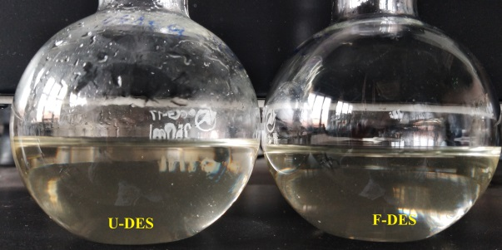
Fig. S1 Digital images of the prepared U-DES and F-DES

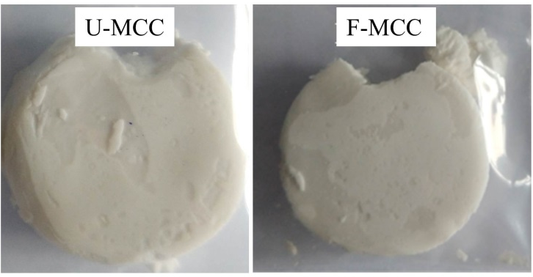
Fig. S2 Digital images of U-MCC and F-MCC after DES pretreatment for 2 h
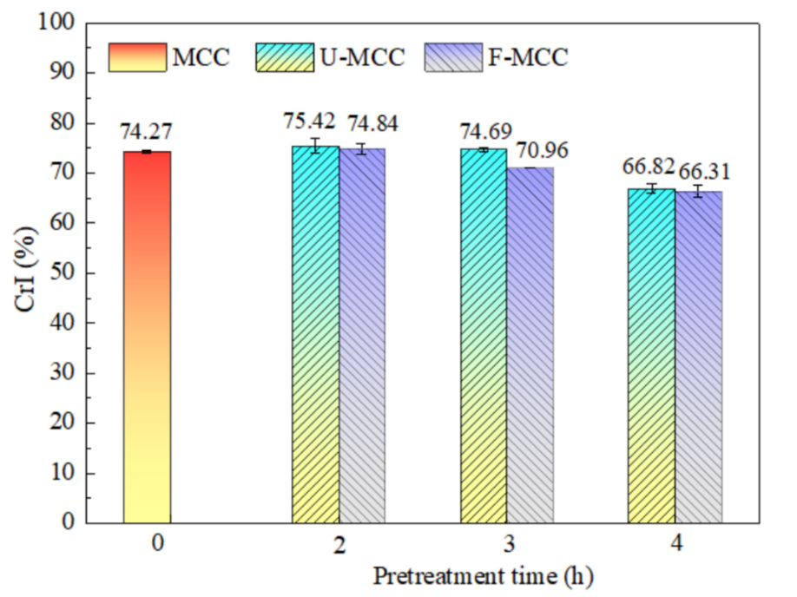
Fig. S3 Crystallinity index of MCC and the pretreated MCC samples

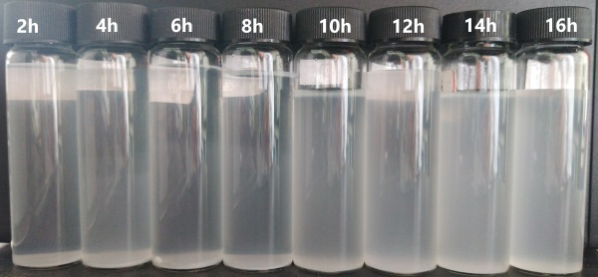
Fig. S4 The dispersion of MCC after ball milling with different milling time (0.1 wt% in water, standing for 2 h)

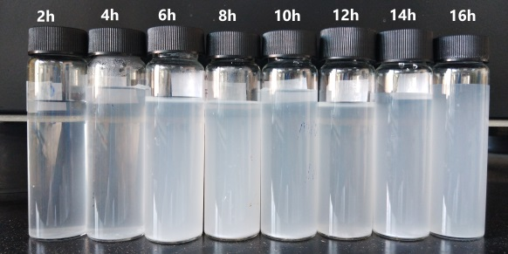
Fig. S5 The dispersion of U-MCC after ball milling with different milling time (0.1 wt% in water, standing for 2 h)
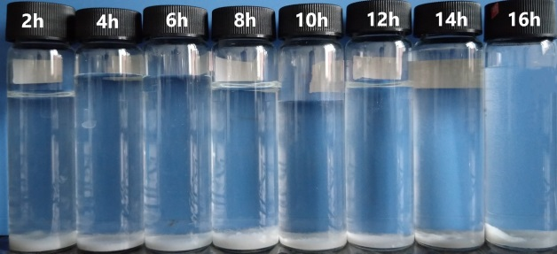
Fig. S6 The dispersion of F-MCC after ball milling with different milling time (0.1 wt% in water, standing for 2 h)

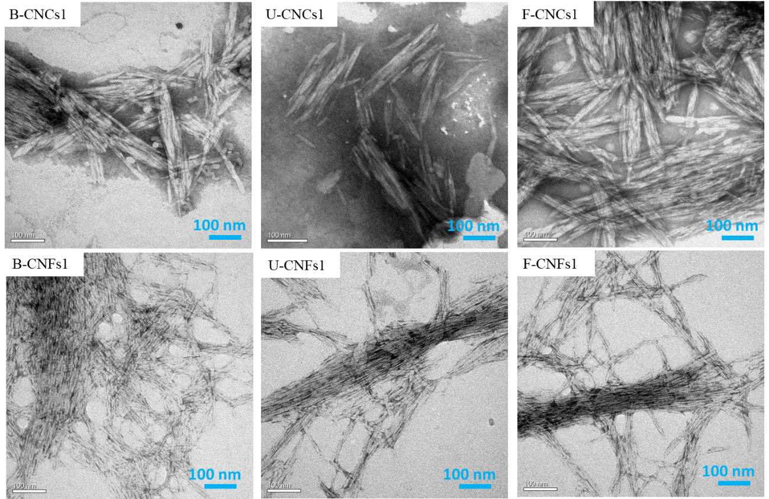
Fig. S7 TEM images of the CNCs and CNFs separated from B-NC1, U-NC1 and F-NC1 after ball milling for 8 h

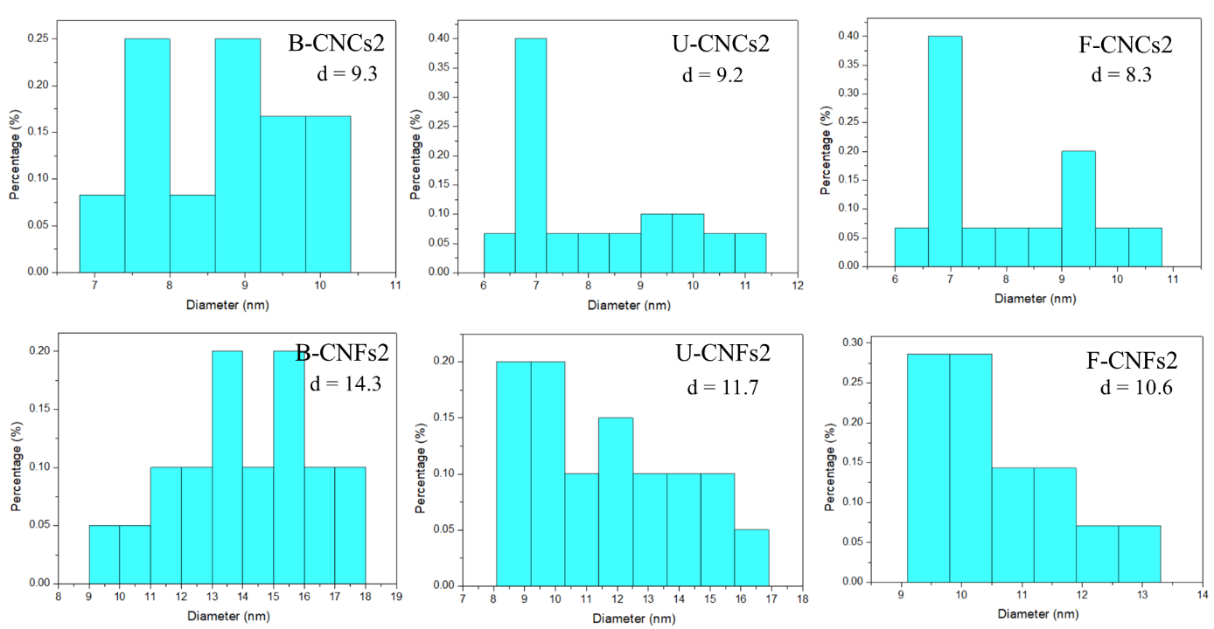
Fig. S8 Diameter distribution and mean diameter (d) of CNCs and CNFs separated from B-NC2, U-NC2 and F-NC2 samples after ball milling for 16 h

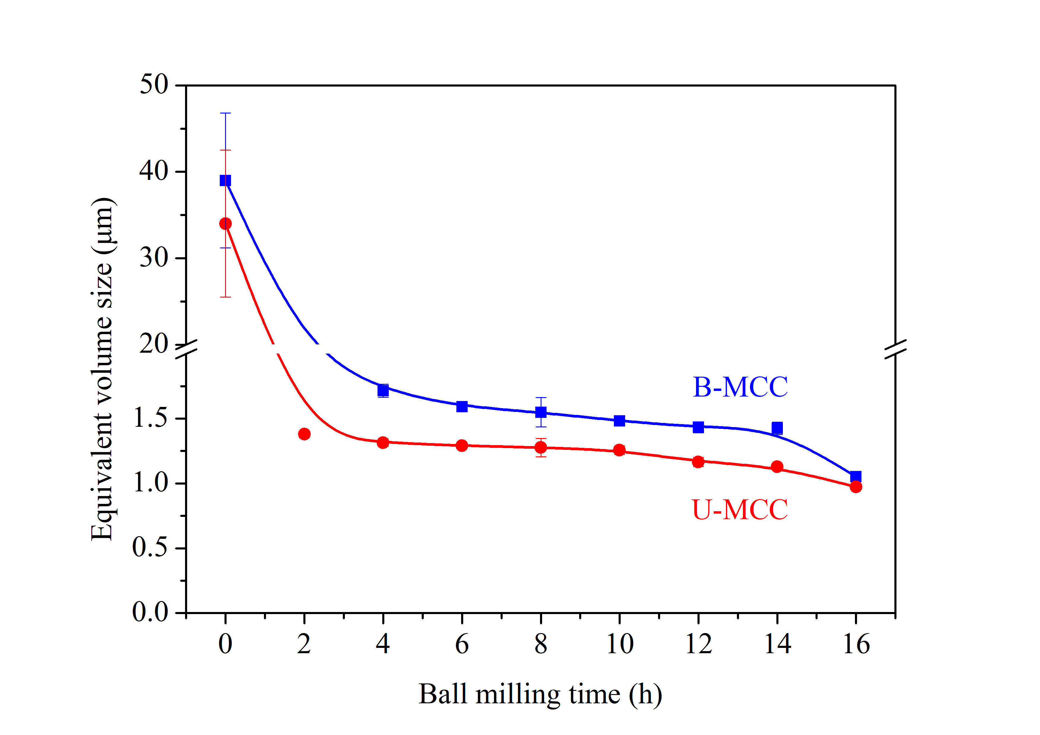
Fig. S9 Equivalent volume size of MCC and U-MCC samples after ball milling for different milling time

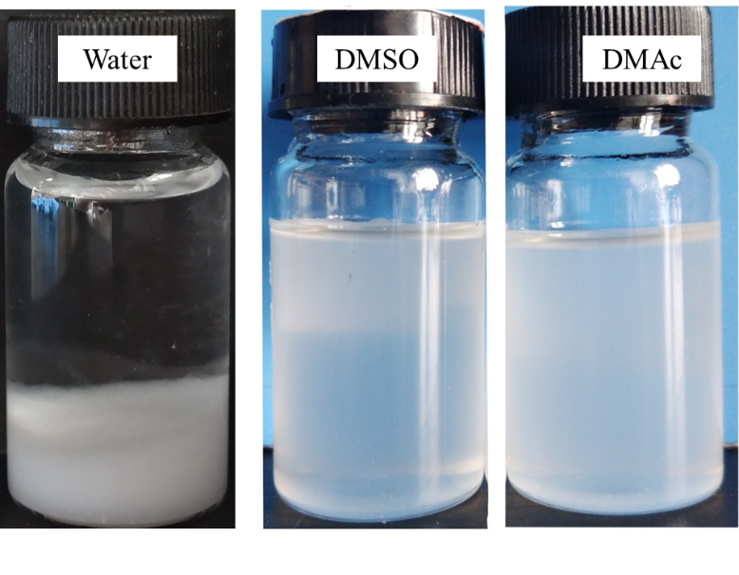
Fig. S10 Dispersibility of F-NC2 suspension (0.1 wt%) in various solvents (after standing for 3 months)

Fig. S11 DTG curves of MCC and NC samples after ball milling for 16 h
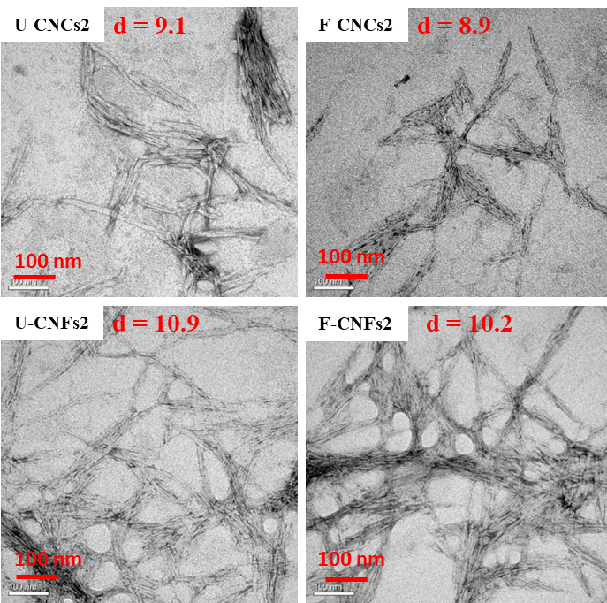
Fig. S12 TEM images and mean diameter (d) of the CNCs and CNFs prepared using the recycled U-DES (R3) and F-DES (R3)
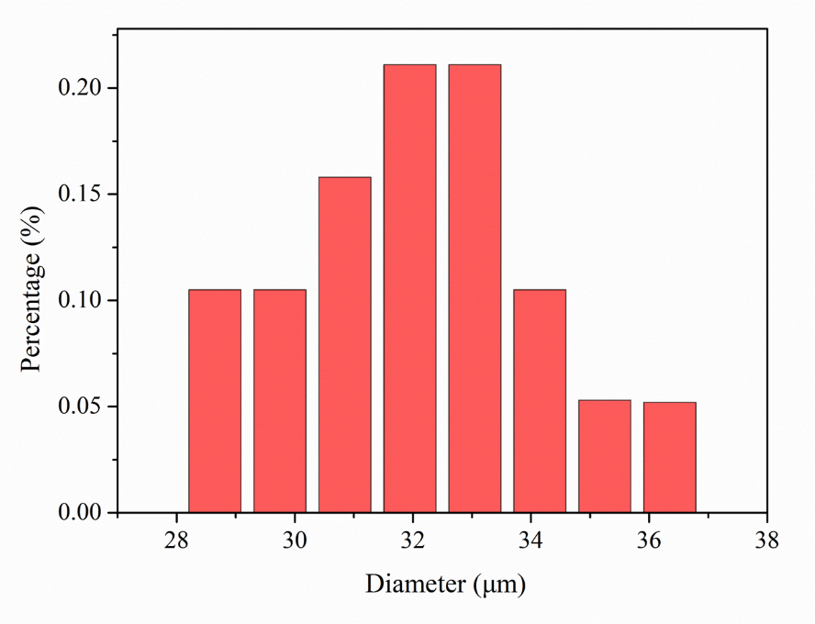
Fig. S13 Diameter distribution of droplets in F-CNCs2 stabilized Pickering emulsions
References
Laitinen O, Ojala J, Sirviö JA, Liimatainen H (2017a) Sustainable stabilization of oil in water emulsions by cellulose nanocrystals synthesized from deep eutectic solvents Cellulose 24:1679-1689 https://doi:10.1007/s10570-017-1226-9
Laitinen O, Suopajarvi T, Osterberg M, Liimatainen H (2017b) Hydrophobic, superabsorbing aerogels from choline chloride-based deep eutectic solvent pretreated and silylated cellulose nanofibrils for selective oil removal ACS Appl Mater Interfaces 9:25029-25037 https://doi:10.1021/acsami.7b06304
Li P, Sirvio JA, Asante B, Liimatainen H (2018) Recyclable deep eutectic solvent for the production of cationic nanocelluloses Carbohydr Polym 199:219-227 https://doi:10.1016/j.carbpol.2018.07.024
Li P, Sirvio JA, Haapala A, Liimatainen H (2017) Cellulose nanofibrils from nonderivatizing urea-based deep eutectic solvent pretreatments ACS Appl Mater Interfaces 9:2846-2855 https://doi:10.1021/acsami.6b13625
Ling Z, Edwards JV, Guo Z, Prevost NT, Nam S, Wu Q, French AD, Xu F (2018) Structural variations of cotton cellulose nanocrystals from deep eutectic solvent treatment: Micro and nano scale Cellulose 26:861-876 https://doi:10.1007/s10570-018-2092-9
Liu Y, Guo B, Xia Q, Meng J, Chen W, Liu S, Wang Q, Liu Y, Li J, Yu H (2017) Efficient cleavage of strong hydrogen bonds in cotton by deep eutectic solvents and facile fabrication of cellulose nanocrystals in high yields ACS Sustain Chem Eng 5:7623-7631 https://doi:10.1021/acssuschemeng.7b00954
Ma Y, Xia Q, Liu Y, Chen W, Liu S, Wang Q, Liu Y, Li J, Yu H (2019) Production of nanocellulose using hydrated deep eutectic solvent combined with ultrasonic treatment ACS omega 4:8539-8547 https://doi:10.1021/acsomega.9b00519
Selkala T, Sirvio JA, Lorite GS, Liimatainen H (2016) Anionically stabilized cellulose nanofibrils through succinylation pretreatment in urea-lithium chloride deep eutectic solvent ChemSusChem 9:3074-3083 https://doi:10.1002/cssc.201600903
Sirviö JA, Ukkola J, Liimatainen H (2019) Direct sulfation of cellulose fibers using a reactive deep eutectic solvent to produce highly charged cellulose nanofibers Cellulose 26:2303-2316 https://doi:10.1007/s10570-019-02257-8
Sirviö JA, Visanko M (2017) Anionic wood nanofibers produced from unbleached mechanical pulp by highly efficient chemical modification J Mater Chem A 5:21828-21835 https://doi:10.1039/c7ta05668k
Sirviö JA, Visanko M, Liimatainen H (2015) Deep eutectic solvent system based on choline chloride-urea as a pre-treatment for nanofibrillation of wood cellulose Green Chemistry 17:3401-3406 https://doi:10.1039/c5gc00398a
Sirvio JA (2018) Cationization of lignocellulosic fibers with betaine in deep eutectic solvent: Facile route to charge stabilized cellulose and wood nanofibers Carbohydr Polym 198:34-40 https://doi:10.1016/j.carbpol.2018.06.051
Sirvio JA, Visanko M, Liimatainen H (2016) Acidic deep eutectic solvents as hydrolytic media for cellulose nanocrystal production Biomacromolecules 17:3025-3032 https://doi:10.1021/acs.biomac.6b00910
Suopajarvi T, Sirvio JA, Liimatainen H (2017) Nanofibrillation of deep eutectic solvent-treated paper and board cellulose pulps Carbohydr Polym 169:167-175 https://doi:10.1016/j.carbpol.2017.04.009
Yang X, Xie H, Du H, Zhang X, Zou Z, Zou Y, Liu W, Lan H, Zhang X, Si C (2019) Facile extraction of thermally stable and dispersible cellulose nanocrystals with high yield via a green and recyclable FeCl3-catalyzed deep eutectic solvent system ACS Sustain Chem Eng 7:7200-7208 https://doi:10.1021/acssuschemeng.9b00209
Yu W, Wang C, Yi Y, Zhou W, Wang H, Yang Y, Tan Z (2019) Choline chloride-based deep eutectic solvent systems as a pretreatment for nanofibrillation of ramie fibers Cellulose 26:3069-3082 https://doi:10.1007/s10570-019-02290-7

