Supplementary Information

Dual-mode electrochemiluminescence and fluorescence aptasensing platform based on resonance energy transfer for sensitive detection of estradiol

Waner Hou¹ • Zhimin Liu*¹ • Xuanxuan Hao¹ • Xun Lei¹ • Jintao Cheng¹ • Yaxin Li¹ • Leqian Hu¹ • Peng Li*²

¹ College of Chemistry and Chemical Engineering, Henan University of Technology, Zhengzhou 450001, People’s Republic of China
² Institute for Complexity Science, Henan University of Technology, Zhengzhou 450001, People’s Republic of China

* Corresponding authors:
E-mail: zhimin@haut.edu.cn (Z. Liu), lipeng@haut.edu.cn (P. Li).

Characterization of the nanomaterials
As displayed in Fig. S1A, XPS survey spectrum of RuMOFNSs showed the characteristic peaks of C 1s, O 1s, N 1s, Ru 3p and Zn 2p elements. Particularly, the high-resolution spectrum of Ru 3p (Fig. S1B) displayed the characteristic peaks of Ru 3p_{1/2} (484.5 eV) and Ru 3p_{3/2} (462.4 eV), while the Zn 2p region (Fig. S1C) showed two peaks located at 1021.3 eV (Zn 2p_{3/2}) and 1044.5 eV (Zn 2p_{1/2}). The auger electron peak of Zn inserted into the Ru 3p region ascribed to the co-existing of Zn and Ru elements. The high˗resolution XPS spectra of C 1s, N 1s and O 1s were also presented in Fig. S1(D-F), implying the successful preparation of RuMOFNSs [1].
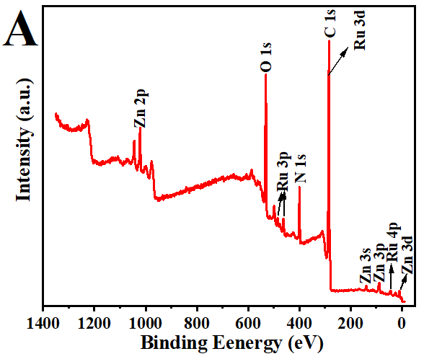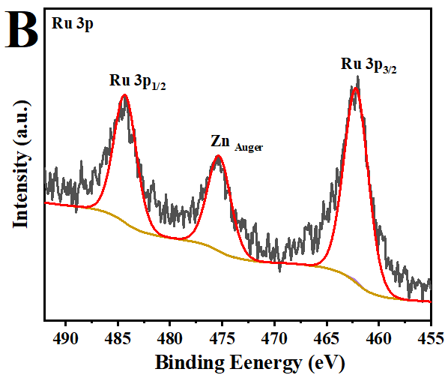
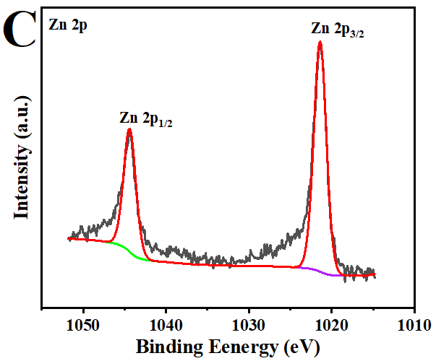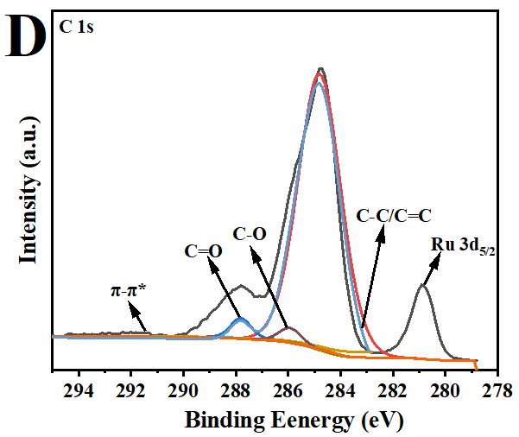
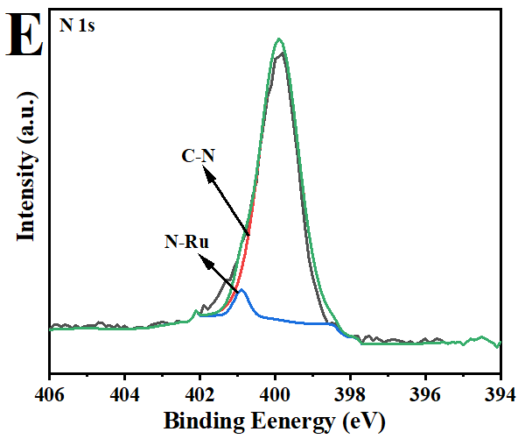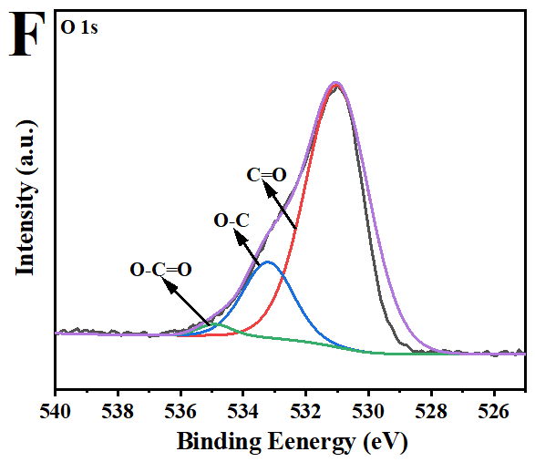
Fig. S1. XPS survey spectrum of RuMOFNSs (A): Ru 3p (B), Zn 2p (C), C 1s (D), N 1s (E) and O 1s (f).
Condition optimization for double-mode analysis
Fig. S2(A-C) showed the relationships between pH of PBS, concentration of RuMOFNSs, incubation time of AuNCs-Apt and ECL intensity. The highest ECL response was reached at pH 7.0, suggesting that acidic or basic environment inhibits the attachment efficiency of RuMOFNSs to cDNA, the immobilized AuNCs-Apt was decreased, leading to the decreased ECL-RET efficiency. Similarly, the concentration of RuMOFNSs and incubation time of AuNCs-Apt were also optimized, 0.4 mg/mL RuMOFNSs and 40 min incubation time were selected in ECL experiments.
Meanwhile, the effects of the concentration of RuMOFNSs and the incubation time of AuNCs-Apt on FL intensity were also investigated, it could be seen from Fig. S2D and Fig. S2E that 0.4 mg/mL RuMOFNSs and 50 min incubation time were selected in FL tests.

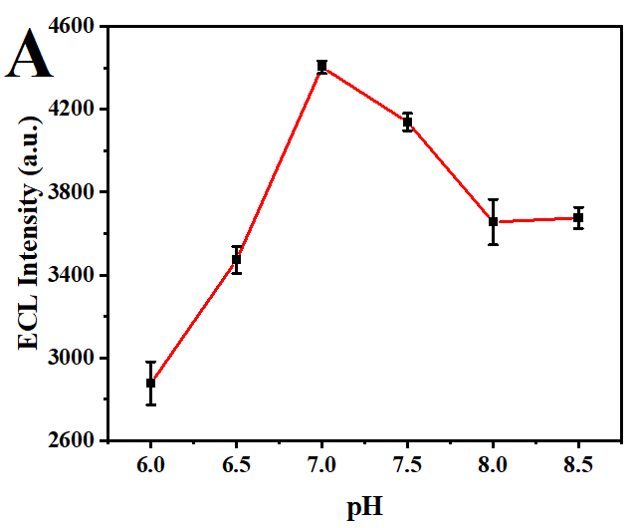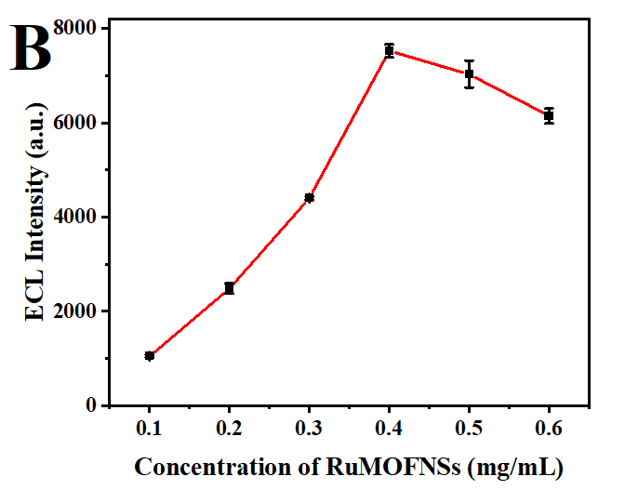
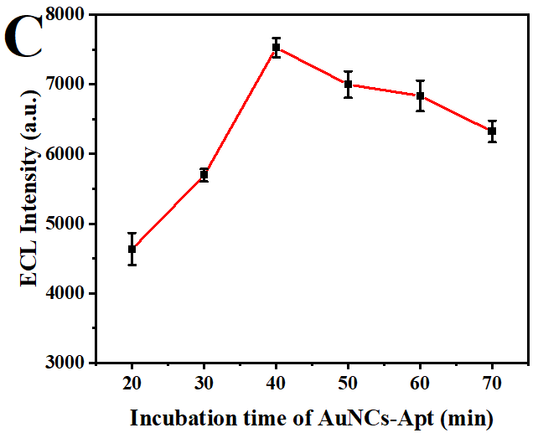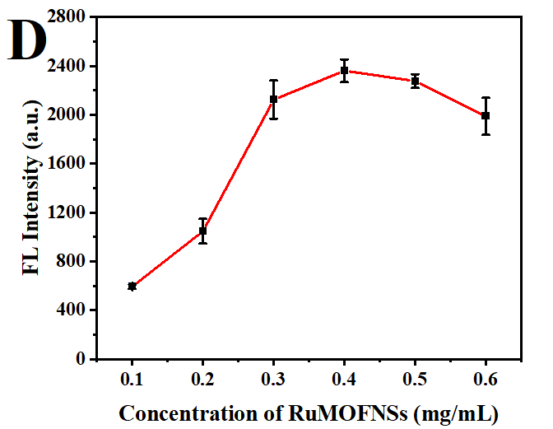
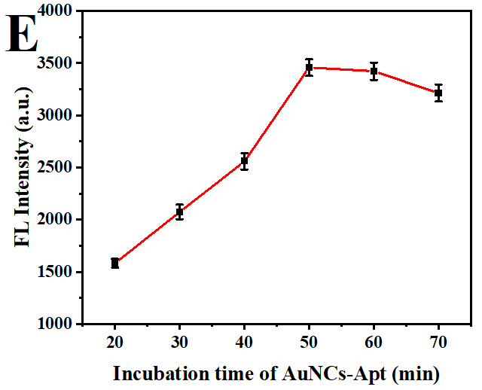
Fig. S2. Effects of pH of PBS (A), concentration of RuMOFNSs (B) and incubation time of AuNCs-Apt (C) on ECL response. Concentration of RuMOFNSs (D) and incubation time of AuNCs-Apt (E) on FL response.

ECL and FL performance evaluation of dual-mode sensors
Table S1 Comparison of different methods for detection of estradiol.
Techniques | Detection range | Detection limit | References
Colorimetric aptasensor  SERs  HP LC | 0.25~10 μg/mL  0.1~4 ng/mL  0.3~300 μg/kg | 0.265 μg/mL  0.073 ng/mL  0.1 μg/kg | [2]  [3]  [4]
Phosphorescence aptasensor | 0.5~1200 ng/mL | 0.29 ng/mL | [5]
Fluorescence aptasensor  Photoelectrochemical aptasensor  ECL | 0.025~1 ng/mL  1.0~250 nmol/L  0.00001~200 ng/mL | 0.025 ng/mL  0.37 nmol/L  3.7 fg/mL | [6]  [7]  [8]
ECL | 0.00005~100 nmol/L | 20 fmol/L | This work
FL | 0.1 ~10000 nmol/L | 97 pmol/L | This work

Real sample analysis
Table S2 Recovery analysis of the dual-mode aptasensor for estradiol detection in lake water and milk sample (n=3).
Samples | Method | Added (nmol/L) | Found (nmol/L) | Recovery (%) | RSD (%)
Lake Water | ECL  Aptamer Sensor | 0 | - | - | -
Lake Water | ECL  Aptamer Sensor | 0.1 | 0.105 | 104.52 | 3.61
Lake Water | ECL  Aptamer Sensor | 1 | 1.025 | 102.50 | 2.25
Lake Water | ECL  Aptamer Sensor | 10 | 9.924 | 99.24 | 3.25
Lake Water | FL  Aptamer Sensor | 0 | - | - | -
Lake Water | FL  Aptamer Sensor | 1 | 0.95 | 94.72 | 1.33
Lake Water | FL  Aptamer Sensor | 10 | 9.53 | 95.29 | 2.00
Lake Water | FL  Aptamer Sensor | 100 | 101.96 | 101.96 | 1.52
Milk | ECL  Aptamer Sensor | 0 | - | - | -
Milk | ECL  Aptamer Sensor | 0.1 | 0.096 | 95.52 | 1.20
Milk | ECL  Aptamer Sensor | 1 | 0.983 | 98.34 | 2.74
Milk | ECL  Aptamer Sensor | 10 | 10.094 | 100.94 | 2.09
Milk | FL  Aptamer Sensor | 0 | - | - | -
Milk | FL  Aptamer Sensor | 1 | 1.032 | 103.21 | 4.49
Milk | FL  Aptamer Sensor | 10 | 10.376 | 103.76 | 2.17
Milk | FL  Aptamer Sensor | 100 | 98.94 | 98.94 | 1.04

References
- Yan MX, Ye J, Zhu QJ, Zhu LP, Huang JS, Yang XR (2019) Ultrasensitive immunosensor for cardiac troponin I detection based on the electrochemiluminescence of 2D Ru-MOF nanosheets. Anal Chem 91: 10156-10163.
2. H. B. Jiang, Y. J. Liu, C. H. Tang, Z. Wei, M. L. Chen, X. L. Lu, J. Yang, P. Yu, Development of an E2 colorimetric sensor based on truncation optimization strategy of 17β-estradiol aptamer, Microchem. J. 199 (2024) 109968.
3. S. M. Mugo, W. H. Lu, Determination of β-estradiol by surface-enhance raman spectroscopy (SERS) using a surface imprinted methacrylate polymer on nanoporous biogenic silica, Anal. Lett. 55 (2021) 378-387.
4. H. Lu, X. Z. Wu, Y. P. Yang, H. X. Chen, X. P. Dang, X. L. Liu, Preparation, characterization and application of double yolk-shell structure magnetic molecularly imprinted polymers for extraction of 17β-estradiol, New J. Chem. 46 (2022) 11927-11933.
5. Y. Zhang, J. Zhou, X. X. Zhang, W. L. Wang, C. Yang, X. L. Shi, Y. W. Feng, R. Abdurahman, NIR persistent luminescence nanoparticles based turn-on aptasensor for autofluorescence-free determination of 17β-estradiol in milk, Food Chem. 373 (2022) 131432.
6. Z. J. Cheng, J. Ling, W. Q. Zhang, Y. J. Ding, Rapid detection of 17β-estradiol based on shaddock peel derived fluorescent aptasensor for forensic examination, Forensic Sci. Int. 331 (2022) 111153.
7. L. H. Tu, J. H. Zhu, A. P. Tanjung, M. Wang, J. W. Kang, A. J. Wang, L. P. Mei, Y. D. Xue, P. Song, A signal-off photoelectrochemical aptasensor for ultrasensitive 17β-estradiol detection based on rose-like CdS@C nanostructure and enzymatic amplification, Microchim. Acta 189 (2022) 56.
8. X. Dong, G. H. Zhao, Y. Y. Li, Q. Z. Zeng, H. M. Ma, D. Wu, X. Ren, Q. Wei, H. X. Ju, Dual-mechanism quenching of electrochemiluminescence immunosensor based on a novel ECL emitter polyoxomolybdate-zirconia for 17β-estradiol detection, Anal. Chem. 94 (2022) 12742-12749.

