Microbes isolated from Saline-Alkali Soil of Northern Ningxia：insight on microbial diversity and antibacterial activity

Xiao-li Ma^{*1,2} Jing-jing Tian¹ Fan-fan Ding¹ Zhi-bo Jiang¹

1 School of Chemistry and Chemical Engineering, North Minzu University, Yinchuan 750021, China
2 School of Pharmaceutical Sciences, Peking University, Beijing 100191, China

*Correspondence:
Dr. Xiao-li Ma, Key Laboratory of Chemical Engineering and Technology of State Ethnic Affairs Commission, School of Chemistry and Chemical Engineering, North Minzu University, Yinchuan 750021, P.R., China; Email: mxl@nmu.edu.cn Tel: +86 951 2066204.
Figure S1 Fungal plate growth status of soil sample
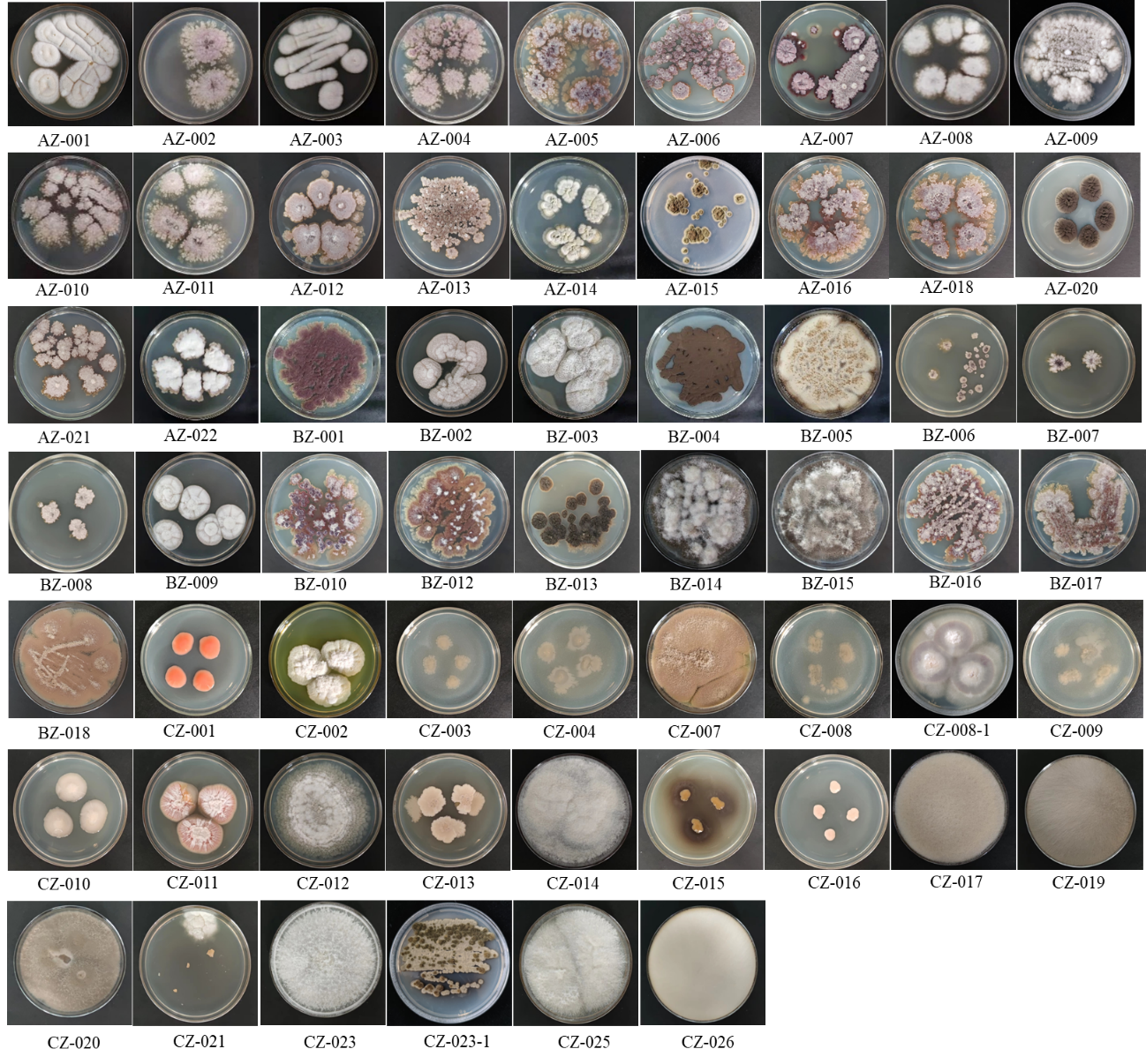
Figure S2 Proportion of fungi by genus

Figure S3 Phylogenetic tree of 38 strains of fungal
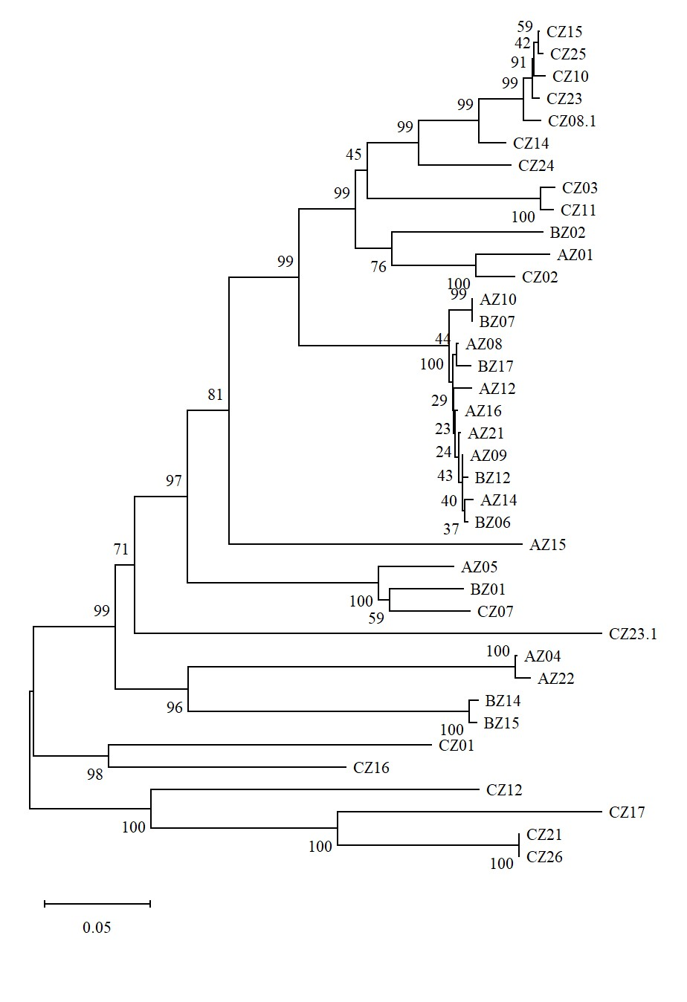
Figure S4 Inhibitory activity of 20 strains of Actinomycetes against S. aureus
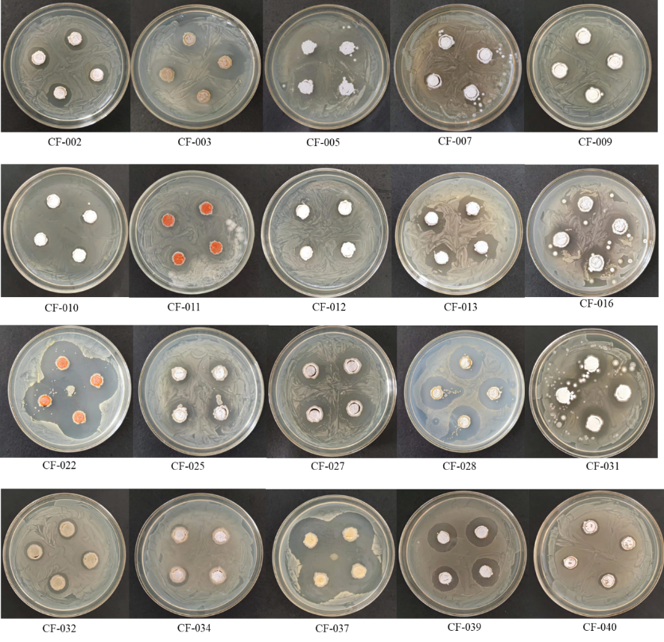

Figure S5 Inhibitory activity of 35 strains of Actinomycetes against P. vulgaris

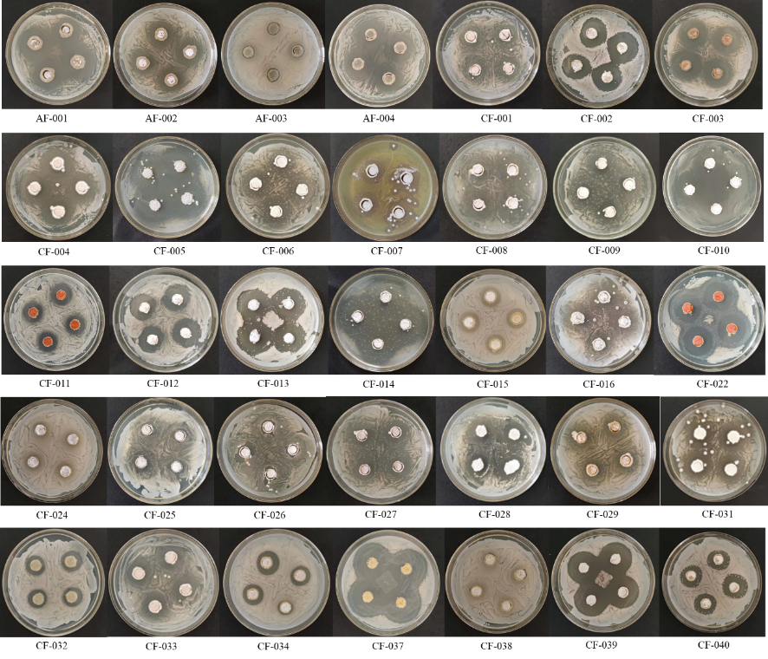

Figure S6 Inhibitory activity of 14 strains of Actinomycetes on C. albicans.

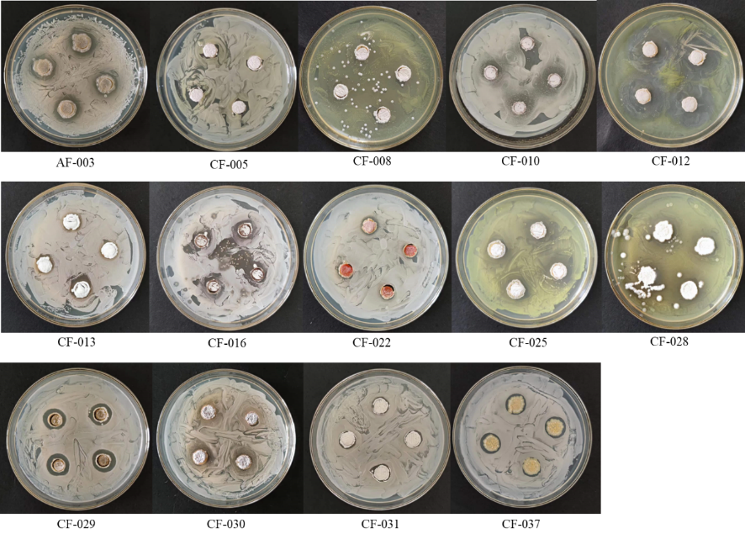

Table S1 NCBI comparison of Fungal ITS sequence
Strain No. | DNA identification results | Query  Coverage | Identities | Sequence ID
AZ-001 | Nigrosabulum globosum | 96% | 95.46% | MH860723.1
AZ-004 | uncultured Ascomycota | 33% | 99.36% | OW842641.1
AZ-005 | Penicillium oxalicum | 98% | 99.64% | ON712135.1
AZ-008 | Chaetomium sp. | 96% | 99.25% | MK361147.1
AZ-009 | Chaetomium sp.. | 95% | 99.25% | MK361147.1
AZ-010 | Chaetomium sp. | 97% | 99.08% | MK361147.1
AZ-012 | Chaetomium sp. | 95% | 99.62% | MK361147.1
AZ-014 | Chaetomium sp. | 96% | 99.25% | MK361147.1
AZ-015 | Cladosporium limoniforme | 98% | 99.60% | OR673657.1
AZ-016 | Chaetomium sp. | 95% | 99.44% | MK361147.1
AZ-021 | Chaetomium sp. | 95% | 99.44% | MK361147.1
AZ-022 | uncultured A. | 28% | 99.66% | OW842641.1
BZ-001 | Aspergillus fumigatus | 97% | 99.47% | OP681417.1
BZ-002 | Acremonium sp. | 94% | 96.47% | MF189903.1
BZ-006 | Chaetomium sp.. | 95% | 99.62% | MK361147.1
BZ-007 | Chaetomium sp. | 98% | 98.91% | MK361147.1
BZ-012 | Chaetomium sp. | 96% | 99.62% | MK361147.1
BZ-014 | Alternaria chlamydosporigena | 97% | 99.47% | KC466540.1
BZ-015 | Alternaria chlamydosporigena | 96% | 99.28% | KC466540.1
BZ-017 | Chaetomium sp. | 94% | 99.62% | MK361147.1
CZ-001 | Rhodotorula mucilaginosa | 98% | 99.32% | JO425393.1
CZ-002 | A. chrysogenum | 96% | 99.63% | MH858636.1
CZ-003 | Sarocladium strictum | 95% | 100.00% | MK361137.1
CZ-007 | Aspergillus terreus | 98% | 99.13% | MF972904.1
CZ-008-1 | Fusarium andiyazi | 97% | 99.41% | OQ818159.1
CZ-010 | Fusarium andiyazi | 96% | 99.42% | OQ818159.1
CZ-011 | S.strictum | 98% | 99.11% | EU520182.1
CZ-012 | Mortierella alpina | 95% | 99.84% | KU738456.1
CZ-014 | Fusarium proliferatum | 99% | 99.25% | ON527495.1
CZ-015 | Fusarium andiyazi | 98% | 99.03% | OQ818159.1
CZ-016 | Vishniacozyma tephrensis | 96% | 99.58% | MN128859.1
CZ-017 | Actinomucor elegans | 96% | 99.69% | FJ176396.1
CZ-021 | Sarocladium strictum | 95% | 99.63% | MK361137.1
CZ-023 | F. fujikuroi | 98% | 96.60% | MH084746.1
CZ-023-1 | Scolecobasidium tshawytschae | 97% | 99.06% | MZ503737.1
CZ-024 | Fusarium solani | 97% | 99.44% | OQ818125.1
CZ-025 | Fusarium verticillioides | 98% | 99.42% | ON712507.1
CZ-026 | Mucor sp. | 95% | 99.66% | MT365973.1

Table S2 Inhibitory effect of different concentrations of standards on S. aureus, P. vulgaris and C. albicans
Antibiotics/（μg/mL） | Bacteriostatic diameter/cm
Antibiotics/（μg/mL） | 1 000 | 800 | 600 | 400 | 200 | 100 | 20 | 10 | 5 | 2.5
vancomycin hydrochloride | 1.25 | 1.2 | 1.1 | 1 | 0.9 | 0.95 | 0.9 | 0.85 | 0 | 0
ofloxacin | 3.3 | 3.1 | 3.3 | 3.3 | 3 | 1.8 | 1.5 | 1.4 | 1.3 | 1.1
amphotericin B | 1.3 | 1.3 | 1.3 | 1.3 | 1.2 | 1.8 | 1.5 | 1.3 | 1.2 | 1
Note: The diameter of the Oxford cup is 0.8 cm. The blank control are sterile water and dimethyl sulfoxide.

