Appendices
Appendix 1- Interview Guide
Interview Guide
Introduction
Good morning/afternoon,
First of all, we would like to thank you for participating in this study. Your contribution will assist in developing a tool to support decision-making in the prevention of fractures in postmenopausal women.
Please note that your participation is voluntary and confidential. Feel free to answer or skip any questions as you wish. The more information you provide, the richer the study will be. You may withdraw from the interview at any time without any consequence.
I will now ask you a series of questions. I will take notes as you respond and may ask for clarification or elaboration if necessary. If you have any doubts about a question, please don’t hesitate to ask before answering.

Questionnaire: Health Professional Profile
Personal: Description of the health professional’s background
To begin, I would like to ask you a few questions to better understand your background as a primary care professional.
- How old are you?
☐ [Enter age]
☐ Prefer not to say / Don’t know
- What gender do you identify with?
☐ Male
☐ Female
☐ Other
☐ Prefer not to say / Don’t know
- What is your nationality? How long have you been practising in Spain?
- How many years have you been working in primary care?
☐ [Enter number of years]
- In addition to working in primary care, do you also work as:
☐ Hospital specialist
☐ Private practice
☐ Other
☐ None
☐ Prefer not to say / Don’t know

- How many hours per week do you dedicate to primary care consultations?
(Please provide estimates for both before and during the COVID-19 pandemic)

- How many patients do you typically see per day in primary care consultations?
(Please answer separately for before and during the COVID-19 pandemic)

Time Period <20 20–30 30–40 >40 Don’t know
Before COVID-19 ☐ ☐ ☐ ☐ ☐
During COVID-19 ☐ ☐ ☐ ☐ ☐

7.b. Of these, how many are over the age of 50?

7.c. Currently, what proportion of your consultations are conducted by phone versus in person?

- What is the estimated average annual income per person in the neighbourhood where your primary care centre is located?
☐ High (> €20,000)
☐ Upper-middle (€16,000–€20,000)
☐ Lower-middle (€12,000–€16,000)
☐ Low (< €12,000)
☐ Don’t know / No answer

- On a scale from 0 to 10, how satisfied are you with your work in primary care?

INTERVIEW
DOMAIN ONE – Representation of the Usual Clinical Profile
Personal: Description of the clinical profile of postmenopausal women at risk of fracture

- Could you describe a typical consultation in your daily practice where the assessment of primary fracture risk due to osteoporosis is addressed?
(Please describe the average patient profile, reason for consultation, length of session, treatment requested, etc.)

- How often do you encounter a woman with the profile you just described in a typical month, before and during the pandemic?

Never (1)
Rarely (2)
About as frequently as other conditions (3)
Quite often (4)
Very often (5)

Annex questions: How often did you encounter such a woman before the pandemic? - How often did you encounter such a woman during the pandemic?

- In your opinion, what do you attribute this frequency to? (What factors might influence this positively or negatively?)

- What protocol or clinical practice guideline do you use (or have used) in managing these patients?

Now, we will ask for some characteristics of the diagnostic process:
Characteristics of Diagnosis
- Do you use FRAX to calculate fracture risk?
☐ Yes
☐ No
If not, which tool do you use?

- Are the data on risk factors retrievable from the electronic primary care medical record?
☐ Yes
☐ No
- What risk threshold (or range of thresholds) do you consider when prescribing pharmacological treatment?

- From what age do you usually recommend diagnostic testing?

- If women arrive with a previous diagnosis, do you maintain that diagnosis or conduct further assessments?

- What is the usual origin of the diagnostic tests women bring to consultations? (Ask whether they come from the private sector or from specialist referrals)

- Do you follow any questionnaire to help determine whether a bone density scan is necessary?
☐ Yes
☐ No
If yes, which one?

- What difficulties and obstacles do you encounter in diagnosis?

- What are your expectations for improvement? (select an option)
Very low (1)
Low (2)
Moderate (3)
High (4)
Very high (5)

Therapeutic Management of These Women
- What steps do you follow in therapeutic management?

- If the women already have a prescribed treatment, do you change it?

- What treatment do you offer them? For what purpose?

- What is the objective of this treatment?

Fracture Prevention
- Do you consider treatment to be useful for fracture prevention?
☐ Yes
☐ No
If yes, for whom?

- How would you improve treatment for fracture prevention?

Knowledge Among Women
- What do you think women know about their risk of osteoporotic fracture?

- What level of basic knowledge do patients typically have about osteoporosis and fractures? ( Select an option
None
Low
Moderate
High
Expert
- What myths or misconceptions are commonly found among women?

- What adverse effects or complications are most frequently reported by women?

- Where do women usually obtain their information from? (e.g., health professionals, the internet...)

- What are women’s expectations regarding the prevention and care of osteoporotic fractures? (select an option)
Very low (1)
Low (2)
Moderate (3)
High (4)
Very high (5)

Impact of COVID-19
- What impact has the COVID-19 pandemic had on the management of these women?

Additional Considerations
- Is there any important consideration that you believe we have not covered? (This can also be a good moment to elaborate on any additional issues, such as barriers or facilitators in the management of these patients)

DOMAIN TWO – Shared Decision-Making
Knowledge about Shared Decision-Making`

- What is your experience regarding women’s participation in decision-making for primary fracture prevention? (How would you like it to be, and how is it in reality? Have patients ever made it easier or more difficult for you to manage their care?)

- Do women usually express any criteria that would make them willing to start treatment?
☐ Yes
☐ No
If yes, what criteria do they usually mention or what would need to happen for them to agree to treatment?

- Do women typically express preferences regarding fracture prevention treatment in relation to:

3.1. Taking or not taking treatment?
☐ Yes
☐ No

3.2. Undergoing diagnostic testing (e.g. bone density scan)?
☐ Yes
☐ No

3.3. Lifestyle modifications (e.g. increasing dietary calcium)?
☐ Yes
☐ No

- Do you take these preferences into account in your clinical decision-making?
☐ Yes
☐ No
If yes, how? Why?

- Are women’s preferences recorded in the medical history?

- Are you familiar with the concept of shared decision-making?
☐ Yes
☐ No
How would you define it in your own words?

- Are you aware of decision aids (DAs)?
☐ Yes
☐ No
Which ones do you know? Please list them.

7.1. Do you know how to use these decision aids?

7.2. Have you received any specific training, or where did you obtain this information?

- Have you used or do you currently use any tool or other method to explain the benefits and risks of primary fracture prevention treatment to postmenopausal women?
☐ Yes
☐ No
If yes, which one?

8.1. If yes: What has your experience been? (Explore advantages and disadvantages.)

8.2. If no: Is there any reason why you haven’t used them?

Usefulness of Shared Decision-Making in Clinical Practice
Next, I will show you an example of a decision aid (DA) designed for use with postmenopausal women at risk of primary fracture. (See Annex 1). Please take a few minutes to review the image, after which I will ask you some questions.

Questions
- Do you consider the information included in this tool sufficient for a woman to make an informed decision?
☐ Yes
☐ No
If not, why? What is missing? What is unnecessary?

- How would you improve this decision aid?

- How feasible do you think it would be to implement this decision aid in your daily clinical practice? (select one option)
Very easy
Easy
Neither easy nor difficult
Difficult
Very difficult

- For the following items, what level of difficulty from 0 to 10 (0 = not at all, 10 = extremely difficult) do you think each would pose for the implementation of this tool in clinical practice?

Type of Difficulty Score (0–10)
Lack of time ☐
Lack of knowledge on how to use it ☐
Difficulty using it with patients ☐
Lack of available decision aids ☐
Lack of practical experience/examples ☐
Lack of personnel to help develop DAs ☐
Low willingness for clinical collaboration ☐
Inability to meet patient preferences or expectations ☐
Insufficient health information system resources ☐
Lack of high-quality/certain evidence in clinical practice ☐
Inapplicability to specific patient conditions ☐
Lack of support from supervisors ☐
Other (please specify and rate) ☐

- What are your intentions to use decision aids in your routine clinical practice?( Select one option)
Very low (1)
Low (2)
Moderate (3)
High (4)
Very high (5)

VIDEO
Next, I will show you a brief five-minute video about a shared decision-making aid designed for postmenopausal women at risk of primary fracture. (See Annex 2). Afterwards, I will ask you a few brief questions about your impressions.

Questions

- What advantages and disadvantages do you see in adding a decision analysis model to the decision aid?

- What are your intentions to use shared decision aids in your routine clinical practice? (Select one option)
Very low (1)
Low (2)

Moderate (3)
High (4)
Very high (5)

ANNEX 1 - GRAPHIC INFORMATION

(The participant will now be shown an example of a decision aid.)
Please take a moment to review the image.
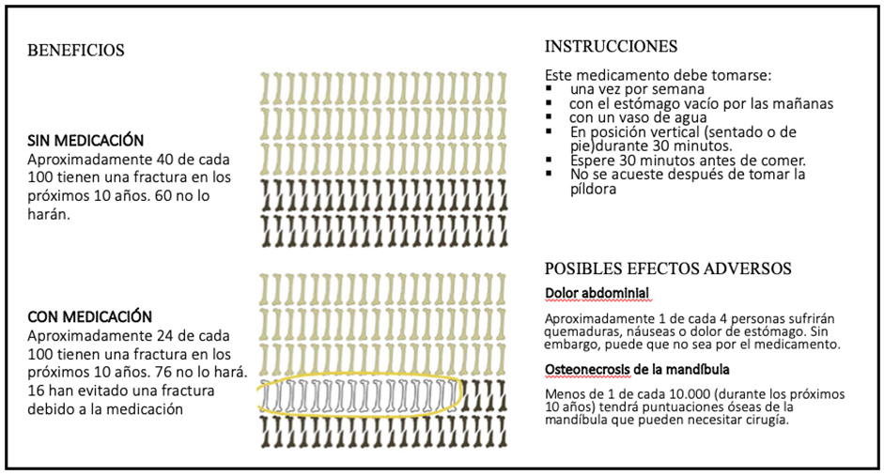
Translated text of the image:
BENEFITS |  | INSTRUCTIONS
WITHOUT MEDICATION  Approximately 40 out of every 100 women will have a fracture in the next 10 years. 60 will not. |  | This medication should be taken:  - once a week  - on an empty stomach in the morning  - with a glass of water  - in an upright position (sitting or standing) for 30 minutes  - wait 30 minutes before eating  - do not lie down after taking the pill
WITH MEDICATION  Approximately 24 out of every 100 women will have a fracture in the next 10 years. 76 will not.  16 have avoided a fracture due to the medication. |  | POSSIBLE SIDE EFFECTS  Abdominal pain  Approximately 1 in 4 people will experience heartburn, nausea, or stomach pain. However, this may not be caused by the medication.  Jaw osteonecrosis  Fewer than 1 in 10,000 (over the next 10 years) will develop jaw bone damage that may require surgery.

[Supporting explanation – not to be read aloud to the participant]
In this image, you can see an example of a decision aid tool. It contains information on treatment efficacy. For example, it shows that a woman with osteoporosis has a 40% risk of fracture—meaning that in a population of 100 similar women, 40 will experience a fracture without taking medication, while 16 fractures can be prevented with medication.
The decision aid also includes information on how the medication should be taken and on potential side effects.

ANNEX 2 – VIDEO

The decision analysis model is often used to support decision-making outside clinical encounters (e.g. in health programme evaluations or cost-effectiveness studies). Some authors have proposed using this model as a tool to support patient participation in clinical decisions, promoting dialogue between the healthcare professional and the patient during shared decision-making.

Decision analysis involves structuring a decision within an analytical framework that includes all important outcomes associated with each alternative (e.g. pharmacological treatment vs. no treatment), their likelihood of occurrence, and the patient’s preferences. Using these probabilities and preferences, the expected value (e.g. in terms of quality of life) of each option is calculated.
The treatment with the highest expected value is considered to yield the best outcome. This information, when shared with the patient, may enhance shared decision-making.

Let me show you an example:

In this image, we see a decision tree representing the different options: taking or not taking bisphosphonates, and the associated probability of experiencing a primary fracture.

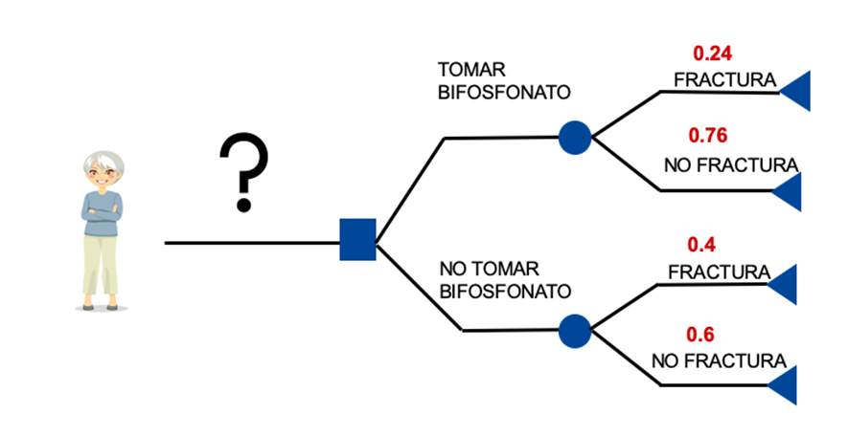
Translated image text:
TAKE BISPHOSPHONATE | Fracture: 0.24  No fracture: 0.76
DO NOT TAKE BISPHOSPHONATE | Fracture: 0.40  No fracture: 0.60

In this case, the probability of having a primary fracture is 24% when taking bisphosphonates. Without treatment, the risk rises to nearly double—40%.

The next step is to weigh the benefits and risks of each alternative:

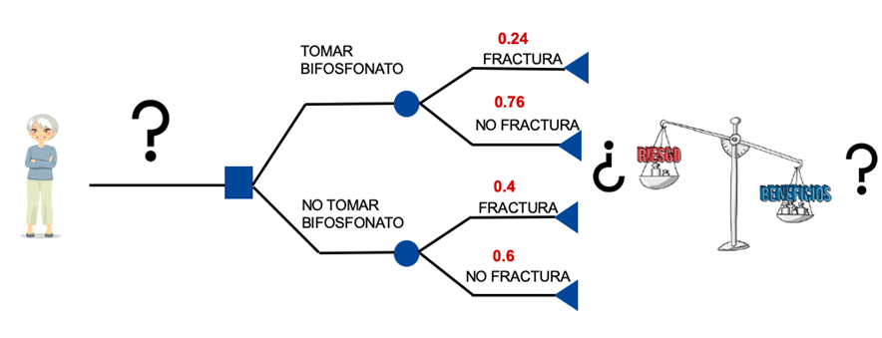

Translated image text:
TAKE BISPHOSPHONATE | Fracture: 0.24  No fracture: 0.76 | ¿Risk / Benefits?
DO NOT  TAKE BISPHOSPHONATE | Fracture: 0.40  No fracture: 0.60 | ¿Risk / Benefits?

To do this, we use the patient’s values and preferences, which are gathered through value clarification exercises. These exercises help women to weigh the pros and cons of taking medication—in this case, bisphosphonates.

One example of such exercises is the use of visual analogue scales, as shown in this image:

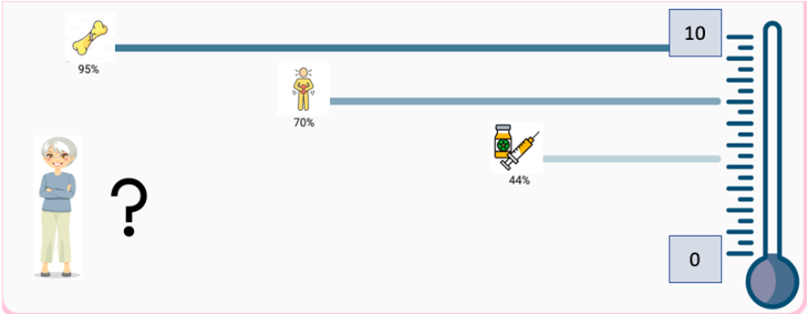

With the aid of graphic tools such as feeling thermometers, we ask questions like:
"From 0 to 100, how important is it for you to avoid a fracture?"
"From 0 to 100, how important is it to avoid abdominal pain caused by medication?"
"From 0 to 100, how important is it to avoid weekly injections?"

In this case, the woman assigns the following values (on a 0–100 scale):

Importance of avoiding a fracture: 95
Importance of avoiding abdominal pain: 70
Importance of avoiding weekly injections: 44
These values are then incorporated into the decision tree.

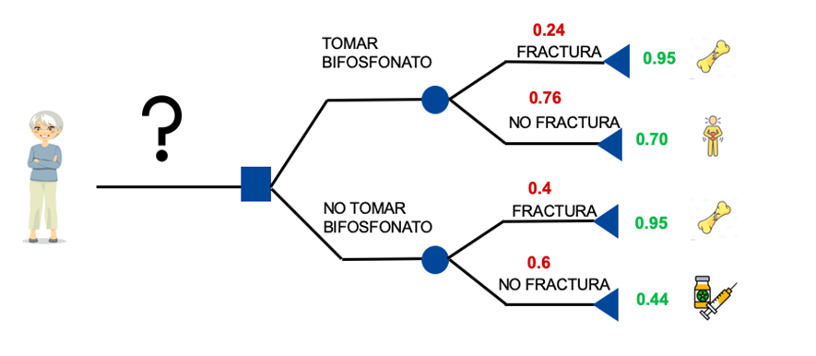

Translated image text:
TAKE BISPHOSPHONATE | Fracture: 0.24  No fracture: 0.76 | Patient Value: 0.95  Patient Value: 0.70
DO NOT  TAKE BISPHOSPHONATE | Fracture: 0.40  No fracture: 0.60 | Patient Value: 0.95  Patient Value: 0.44

Combining the probabilities for each outcome with the woman’s preferences, the model calculates the expected quality of life for each alternative.

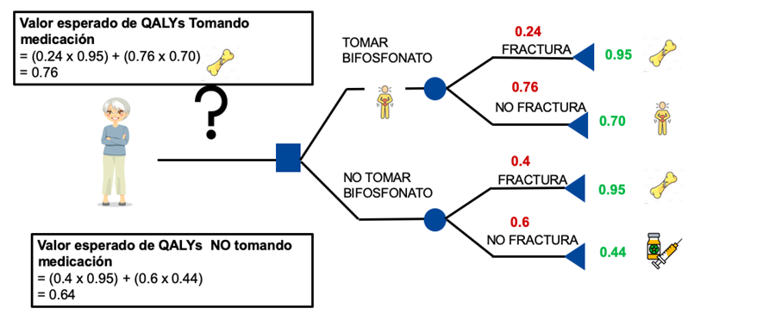

Translated image text:
Expected QALYs value when taking medication  = (0.24 × 0.95) + (0.76 × 0.70)  = 0.76 | TAKE  BISPHOSPHONATE | Fracture: 0.24  No fracture: 0.76 | Patient Value: 0.95  Patient Value: 0.70
Expected QALYs value when NOT taking medication  = (0.40 × 0.95) + (0.60 × 0.44)  = 0.64 | DO NOT  TAKE BISPHOSPHONATE | Fracture: 0.40  No fracture: 0.60 | Patient Value: 0.95  Patient Value: 0.44

--

In this case, expected quality of life with bisphosphonates is 0.76, while without treatment it is slightly lower at 0.64.

Therefore, for this particular woman, the model indicates that taking bisphosphonates would improve her quality of life.

In conclusion, the decision analysis model is intended to facilitate the shared decision-making process between doctor and patient.

Appendix 2. Considerations for bias mitigation
Aspect | Consideration | Mitigation Strategy
Team composition | Team composed of family physicians and public health research’s with experience in primary care and fracture prevention | Regular team discussions to challenge assumptions and interpretations
Prior influences | Previous experience in clinical guideline implementation and osteoporosis management | Use of multiple coders for data analysis
Evaluation of perspectives | Possible changes in viewpoints during the course of the research | Maintenance of a reflexive journal to document ideas and decisions
Seeking diversity | Risk of focusing on perspectives that confirm preconceived ideas | Active search for discrepant cases or alternative perspectives in the data

Appendix 3. Quotes from family physicians regarding fracture prevention in postmenopausal women

Theme | Number of QUOTE | FPs Participant ID | Quote
Fracture risk assessment | Q1 | B010 | "One thing is biological age and another thing is chronological age, and in the end what I look at is the chronological age, not the biological age of the person. Some people are 80 years old and are stronger than a person who is 60 years old and already has osteoporosis or has a fracture"
 | Q2 | B011 | "Above all, it is more the lack of clinical guidelines and protocols."
 | Q3 | M005 | "I think we fail a little bit in the active search for... or at least I fail a little bit in the active search if the woman doesn't ask me. Just as I measure blood pressure as a preventive activity, or I ask them if they smoke, I do not address the issue of osteoporosis in consultation as part of the preventive activities, although it should be done anyway"
Impact of COVID-19 | Q4 | B004 | "As obstacles, perhaps the delay that we have suffered for a while to order complementary tests. During the pandemic, all these complementary tests were blocked and we could not order any densitometry; it has been a year without ordering some complementary tests that were left in a second level because they were not urgent"
Pharmacological treatment | Q5 | M006 | "Sometimes I read an article in a journal, and you read it because, deep down, the whole topic of osteoporosis has been somewhat murky for a long time, always leaving you with a sense of doubt... but is it really like that, or not? That's why the guidelines are appreciated because they set boundaries, within what the guidelines are, which you know you follow, but always with caution."
 | Q6 | B004 | "Well, calcium and vitamin D are considered prophylactic treatment. Bisphosphonates I don't understand them as prophylactic treatment."
 | Q7 | B009 | "Medications have an expiration date, at least bisphosphonates do; they cannot be used indefinitely. Therefore, I'm not sure if they are being avoided during the most critical period of life, which is from the age of 70 or 80 when people are more likely to suffer fractures."
Non-pharmacological treatment | Q8 | B011 | "All that is to prevent falls, yes, all the recommendations in the home environment to prevent falls. I think that's very important"
 | Q9 | B010 | "But to start instructing people that... of a lot of things that they already know, right? Give them a sheet accompanied by information about non-pharmacological interventions that are as potent or more potent than pharmacological interventions in many cases. One thing is not a substitute for the other."
 | Q10 | C003 | "That [the sheet] had some written recommendations that could be given to the patient, apart from explaining it to her. We should not have time to make more consultations, but we should have the possibility of carrying out group activities, for different people with similar or even different risk levels, explaining some details such as fall apprehension and diet and physical activity. But that is not an activity that we usually do."
Role of private sector | Q11 | M006 | "But if it comes from the private specialist I do get very critical and do the whole procedure, the whole process."
 | Q12 | M020 | "Above all, if they have performed a test, a densitometry, and I can see it, I already have the diagnosis, even if it is, let's say, densitometric, and I can establish the diagnosis."
 | Q13 | B002 | "Many times, they come to you from the gynaecologist or the rheumatologist, ... all these that come with a densitometry, obviously come with the treatment. I don't say "Now I'm going to take this out". Well, I do it and that's it, I assume it, I assume it as a diagnosis."
Role of nurses | Q14 | B005 | "And then the role of nursing is also important. Primary care nurses, if they have time or if they are good and trained, with initiative, they can do a lot in that sense as well"
Patient misconceptions | Q15 | M001 | "Confusing osteoarthritis with osteoporosis is a common occurrence"
 | Q16 | M001 | "Look, they fail to understand that densitometry is a risk factor, not a diagnosis."
 | Q17 | M001 | "... they understand that the densitometry is requested every year, and they are asking for it because if you don't do a densitometry, you are not preventing something that could happen in the future"
Patient preferences | Q18 | B005 | "... and then, there is another profile of patients who want a pharmacological solution and who believe that this should be sufficient"
 | Q19 | B009 | “But, in general, if the treatment is indicated, all treatments are preventive to try to reduce the risk of fracture. There are practically no curative treatments. And everything is preventive. So, if it is indicated, then let it continue and go ahead. I explain it to the patient”
 | Q20 | B004 | “Because you have to remedy it when you are very young, you worry when you are in middle age and you suffer the consequences later on […]”
Patient Education | Q21 | M006 | “By taking a calcium pill they will never have osteoporosis, they come looking for the calcium prescription to not have osteoporosis"
 | Q22 | C003 | "I have seen because they are usually... they are having a cytology, they say "well, the age of menopause has arrived, and now the next thing is to monitor osteoporosis". So, within the portfolio, let's say within the agenda to be attended to, now we are also going to attend to osteoporosis"
 | Q23 | M001 | "Is that they do not know what they have to do to prevent, what benefits them; that they have to do exercise, or they do not understand it or do not want to put it in their heads; that they do not have to smoke or consume toxic substances, that is what they do not understand"
Patient self-care | Q24 | M001 | "The woman is the one who worries about the whole family, sometimes even the problem is that she worries so much about the rest that she does not worry about herself when she should, and when she does worry, we are already talking that maybe it is because the children are already gone, she is already 70 years old, she already has ailments, and she should have taken care of herself 10 or 15 years before"
Patient pressure | Q25 | B009 | "I do a risk assessment; it is true that if the woman insists and insists and insists, then I can ask for a BMD. But I as a physician would not indicate densitometry as a criterion"
Influence of private practice | Q26 | B002 | "The way some colleagues act or proceed in private practice creates expectations that later when it comes to Social Security, are not affordable and are also inappropriate. I believe this also causes a certain level of iatrogenesis, even though it's true that it's minimal, but it doesn't make sense."
Patient understanding | Q27 | B010 | "People have a poor understanding of the disease, I believe, because many patients come to you asking for densitometry when there are no criteria for it, or people say their bones hurt and, therefore, they have osteoporosis. In other words, people have a poor understanding of the disease and the tests"
Shared decision-making | Q28 | B010 | "It is a dialogue between two people, between two experts, who faced with a situation, an event, a clinical problem, tries to deliberate to seek what makes the most sense cognitively, emotionally and behaviorally for the patient"
 | Q29 | B007 | "It is a discussion between experts, the patient as an expert on her life and values and you as a healthcare professional relying on guidelines, on evidence-based medicine"
 | Q30 | B010 | "Because there are people who want to do nothing, and you have to wait and see, and I have to respect that"
 | Q31 | B004 | "It is explaining the benefits of a treatment, side effects, and lifestyle changes, in which they can participate"
 | Q32 | B005 | "When a person enters the consultation and sees that there is a professional who listens, who listens attentively, who is curious, curious in the broad sense of the word, who does not judge, who is interested, who is respectful of the reason for the consultation, at that moment the person opens up in a short time, bonds are generated, he/she opens up to wanting to collaborate with that professional, starts to look in some pocket, starts to look for solutions... what solutions, what possibilities and solutions are there"
 | Q33 | M020 | "... when you make a decision, especially when you make a decision and make a recommendation, normally I do record it: "information is given, it is explained to her, but the patient decides not to....". Not because of a penalty, but because I think that the situation, the clinical judgment, the therapeutic decision has to be recorded in the electronic medical record"
Use of decision aids | Q34 | B010 | "No, I have read some clinical practice guidelines from SEMFYC or the Spanish Rheumatology Society that I can remember, and then I use them very sporadically"
 | Q35 | C002 | "To use these tools, you should have a face-to-face consultation. Because of course, we have telephone consultations, but for example, we do not have consultations via video call. So, if you have to explain to a patient, we need to at least see them. If you give them an informative document alone, it is not enough. I think we should explain it to the patient, not give him an informative document, coldly"

Appendix 4. Difficulties to implement SDM support tools in clinical practice
ID | FPs location of PHC center | FPs gender | SE level neighborhood | Lack of time | Lack of experience with decision aids | Patients experience with decision aid | Lack of interest by health professionals in the use of decision aids | Insatisfaction with expectations | Lack of resources | Lack of evidence | Lack of support from higher positions
B004 | Barcelona | Women | Low | 7 | 8 | 8 | 1 | 2 | 1 | 5 | 7
B005 | Barcelona | Women | Medium low | 7 | 2 | 6 | 6 | 1 | 1 | 1 | 1
B002 | Barcelona | Women | Medium low | 1 | 1 | 3 | 3 | 1 | 2 | 1 | 1
B009 | Barcelona | Women | Medium high | 10 | 7 | 7 | 10 | 3 | 3 | 5 | 5
B011 | Barcelona | Women | Low | 4 | 3 | 4 | 1 | 6 | 3 | 7 | 3
B007 | Barcelona | Women | High | 5 | 1 | 3 | 1 | 5 | 6 | 7 | 9
B010 | Barcelona | Men | Medium high | 10 | 7 | 3 | 7 | 2 | 9 | 2 | 8
PB001 | Barcelona | Men | Medium high | 10 | 7 | 1 | 9 | 5 | 9 | 5 | 9
C002 | Tenerife | Men | Medium high | 8 | 9 | 8 | 10 | 5 | 10 | 10 | 9
C003 | Tenerife | Men | Medium low | 5 | 2 | 2 | 7 | 5 | 6 | 1 | 2
M001 | Madrid | Men | Medium low | 9 | 5 | 4 | 7 | NR | 8 | 9 | 3
M005 | Madrid | Women | Low | 8 | 7 | 5 | 7 | 3 | 9 | 7 | 8
M006 | Madrid | Women | Low | 10 | 4 | 3 | 8 | 1 | 3 | 9 | 5
M015 | Madrid | Men | Medium high | 8 | 2 | 1 | 1 | 5 | 1 | 10 | 8
M019 | Madrid | Men | Low | 4 | 6 | 6 | 3 | NR | 1 | 1 | 10
M020 | Madrid | Men | Medium low | 3 | 3 | 4 | 5 | 2 | 1 | 1 | 7
Mean |  |  |  | 6 | 4 | 4 | 4 | 3 | 3 | 4 | 5
NR: Not reported
Note: The rating scale ranges from 1 to 10, where 1 represents the lowest level of difficulty and 10 represents the highest level of difficulty.

