Supplementary Figure 1
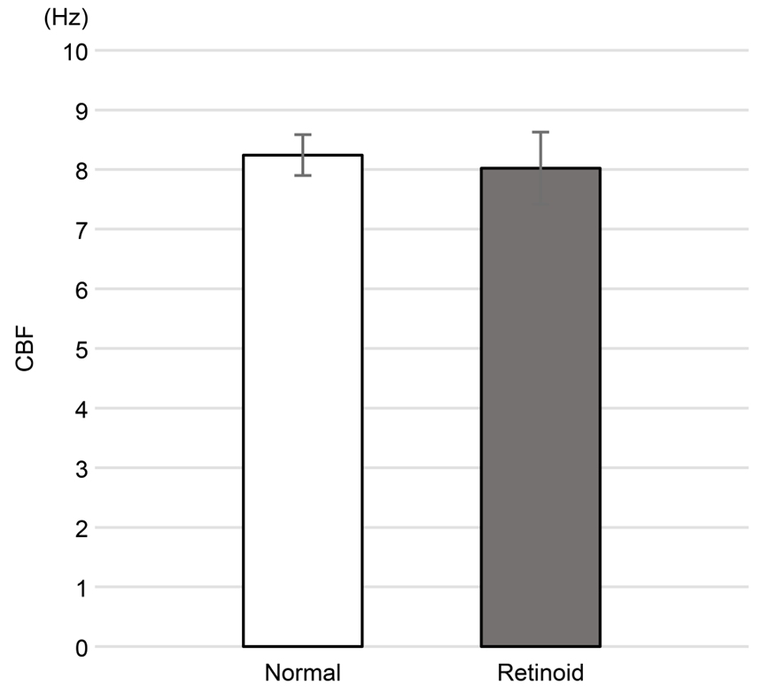
Supplementary Fig. 1. CBF values in the retinoid and control groups.
The mean CBF was 8.02 ± 0.60 Hz in the retinoid group and 8.24 ± 0.34 Hz in the control group, with no significant difference between two groups.
error bar: ± standard error of the mean
CBF, ciliary beat frequency

Supplementary Figure 2
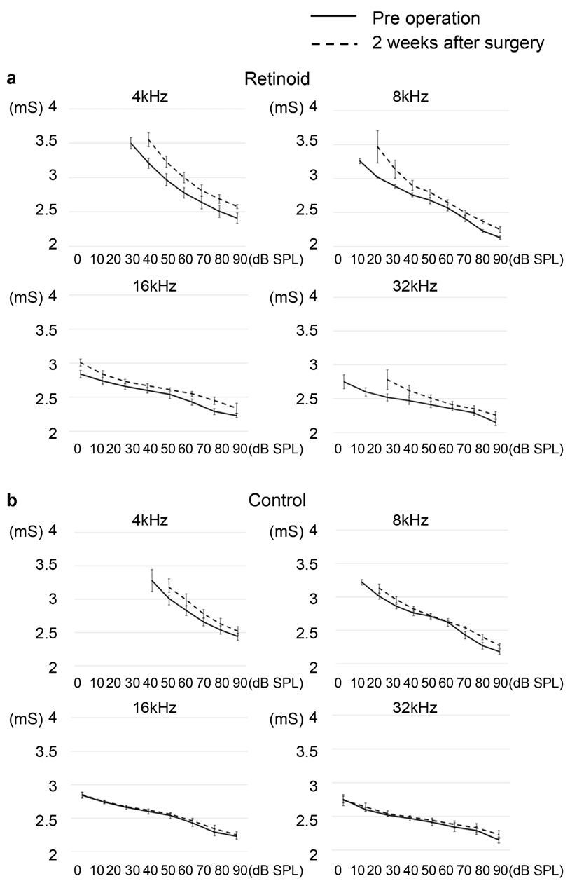
Supplementary Fig. 2. L–I curves in the retinoid and control groups.
The L–I curves in the retinoid group showed a prolonged latency at 2 weeks postoperatively compared with preoperatively at all frequencies, regardless of sound pressure. On the other hand, the L–I curves in the control group showed a prolonged latency at 2 weeks postoperatively at 4 kHz and 8 kHz only, but not at 16 kHz or 32 kHz.
error bar: ± standard error of the mean

Supplementary Figure 3
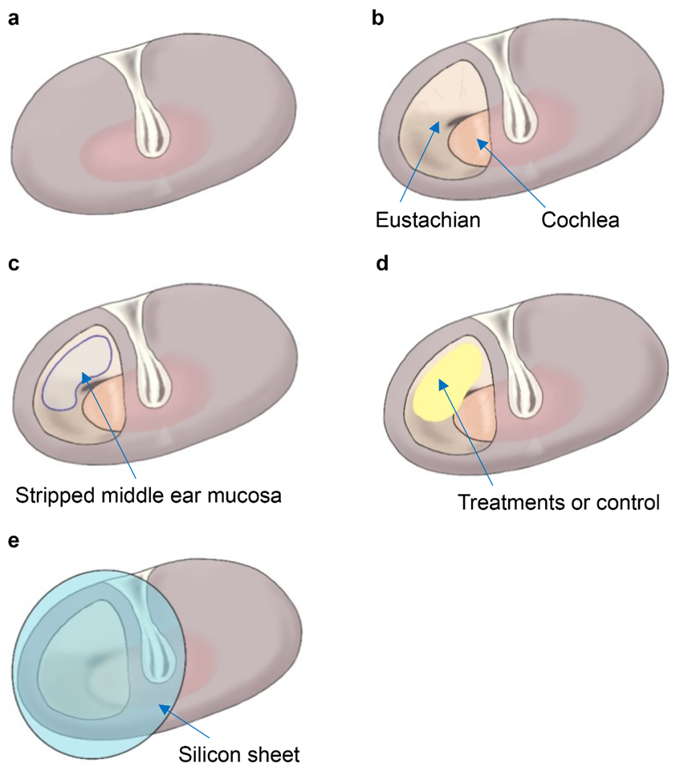
Supplementary Fig. 3 Topical administration of drugs to guinea pig models (in the left ear)
a Normal tympanic membrane.
b Cochlea and Eustachian tube after opening the tympanic membrane.
c Stripping of the middle ear mucosa around the Eustachian tube using a pick.
d Injection of drugs.
e Placement of a silicone sheet on the tympanic membrane.

Supplementary Video

Supplementary Video. Ciliary motility in the control and retinoid groups
Both groups showed beating of cilia.

