Supplemental Data
Electrocatalytic hydrogen evolution performance of RuO₂ nanorods grown on top of WO₃ nanotube arrays
Man Zhang,^{a, b} Kefeng Wang,^{a*} Jingxiao Ren,^{c} Yong-hua Li,^{d} Heng Jiang,^{b*} Wei Wei^{a*}
ª ª School of Petrochemical Engineering, Liaoning Petrochemical University, Fushun, Liaoning 113001, China
^{b} Henan Engineering Center of New Energy Battery Materials, College of Chemistry and Chemical Engineering, Shangqiu Normal University, Shangqiu 476000, Henan, China
^{c} School of Surveying and Planning, Shangqiu Normal University, Shangqiu 476000, China
^{d} North Huajin Chemical Industries Group Corporation, Panjin 124000, P. R. China

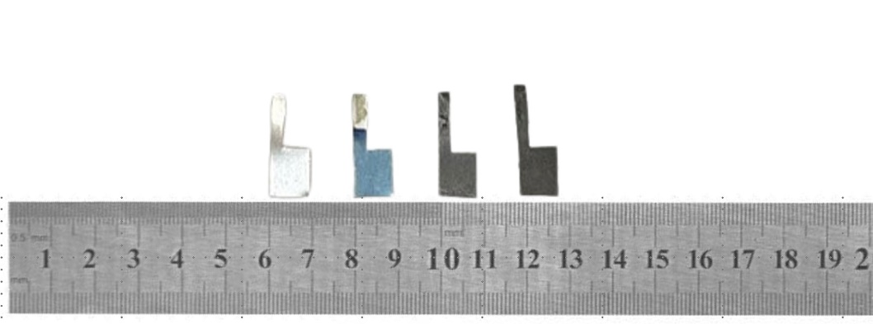
Figure S1 Photographs of blank W foil, anodized W foil (WO₃ NTA), Ru(OH)₃/WO₃ NTA and RuO₂ NRs/WO₃ NTA.

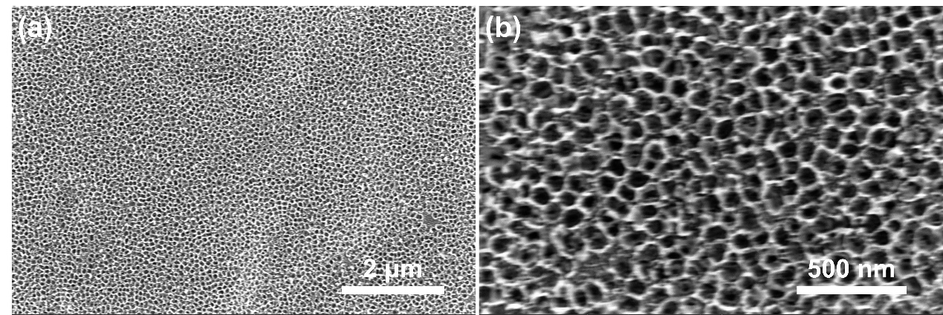
Figure S2 SEM images of WO₃ NTA fabricated through an anodization process using a piece of W foil as the substrate.

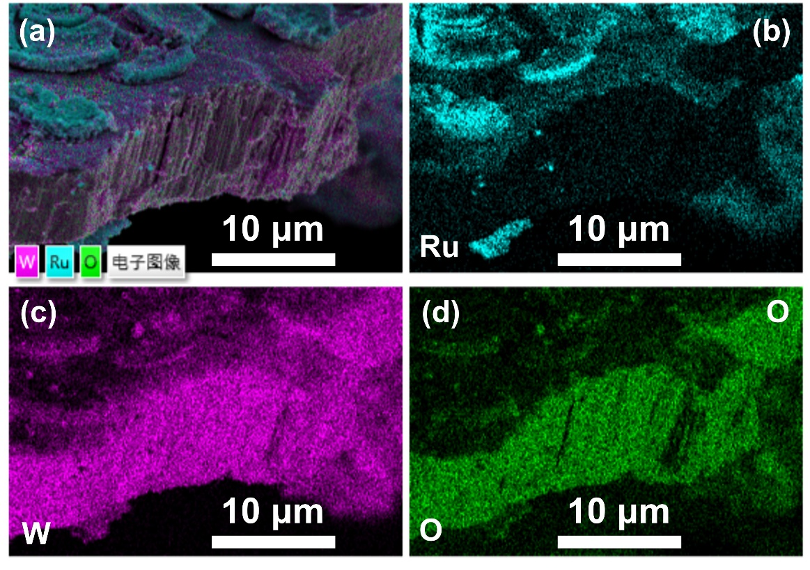
Figure S3 EDS elemental mapping images for RuO₂ NRs/WO₃ NTA: (a) overlay, (b) Ru, (c) W and (d) O
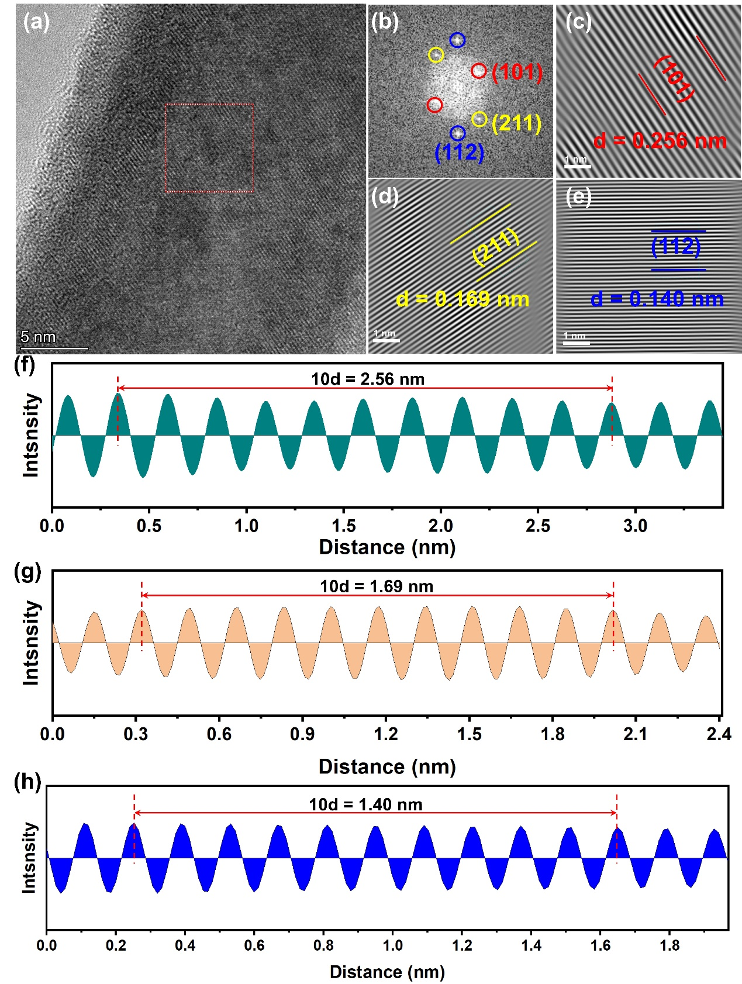
Figure S4 (a) HRTEM image of RuO₂ nanorod in RuO₂ NRs/WO₃ NTA. (b) The fast Fourier transform (FFT) pattern of the selected area in (a). (c~e) Inverse FFT images taken from the square labeled in (b) correspond to the interplanar crystal spacings of (101), (211) and (112) planes of RuO₂. (f-h) The corresponding interplanar spacings.
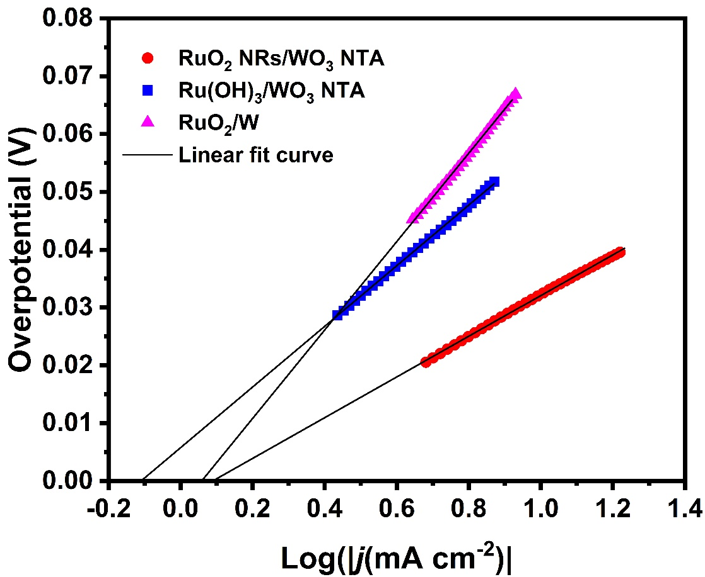
Figure S5 Calculation of the exchange current densities of different catalysts by extrapolating the linear fit of the Tafel plot to its interception.

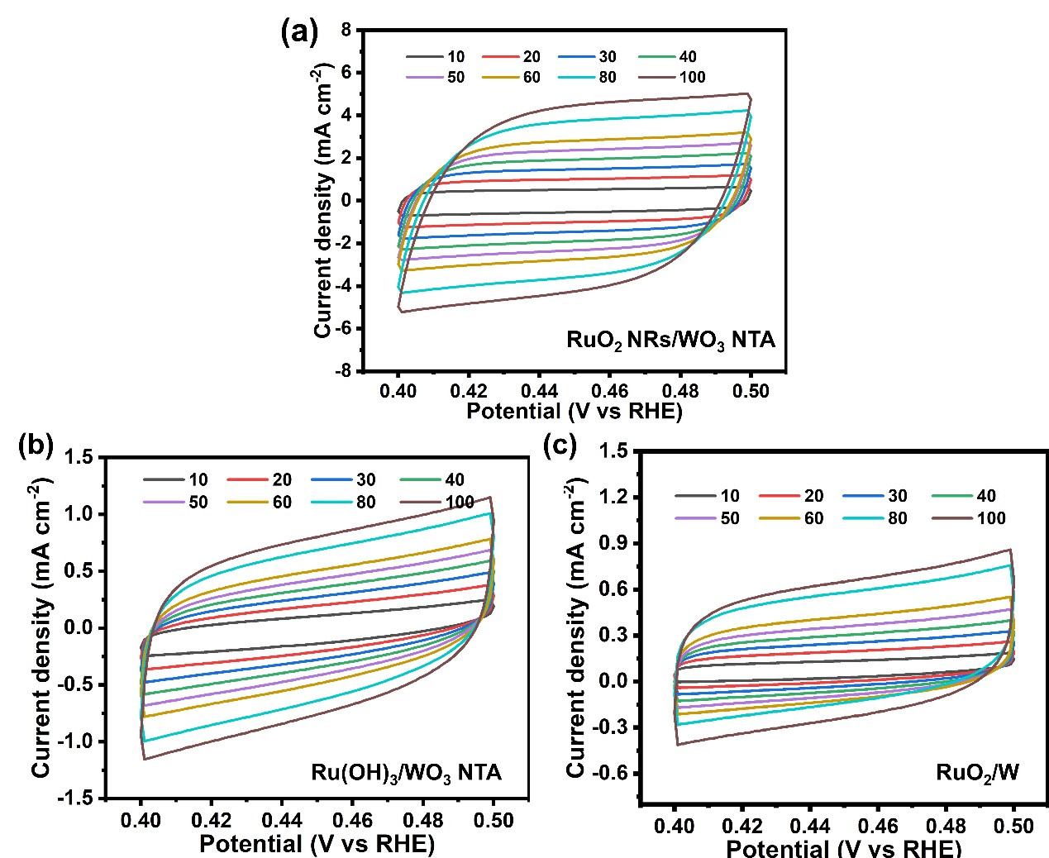
Figure S6 Cyclic voltammetry (CV) curves with different scan rates of (a) RuO₂ NRs/WO₃ NRA, (b) Ru(OH)₃/WO₃ NRA, and (c) RuO₂/W in the non-Faradaic regions in 1 M KOH.

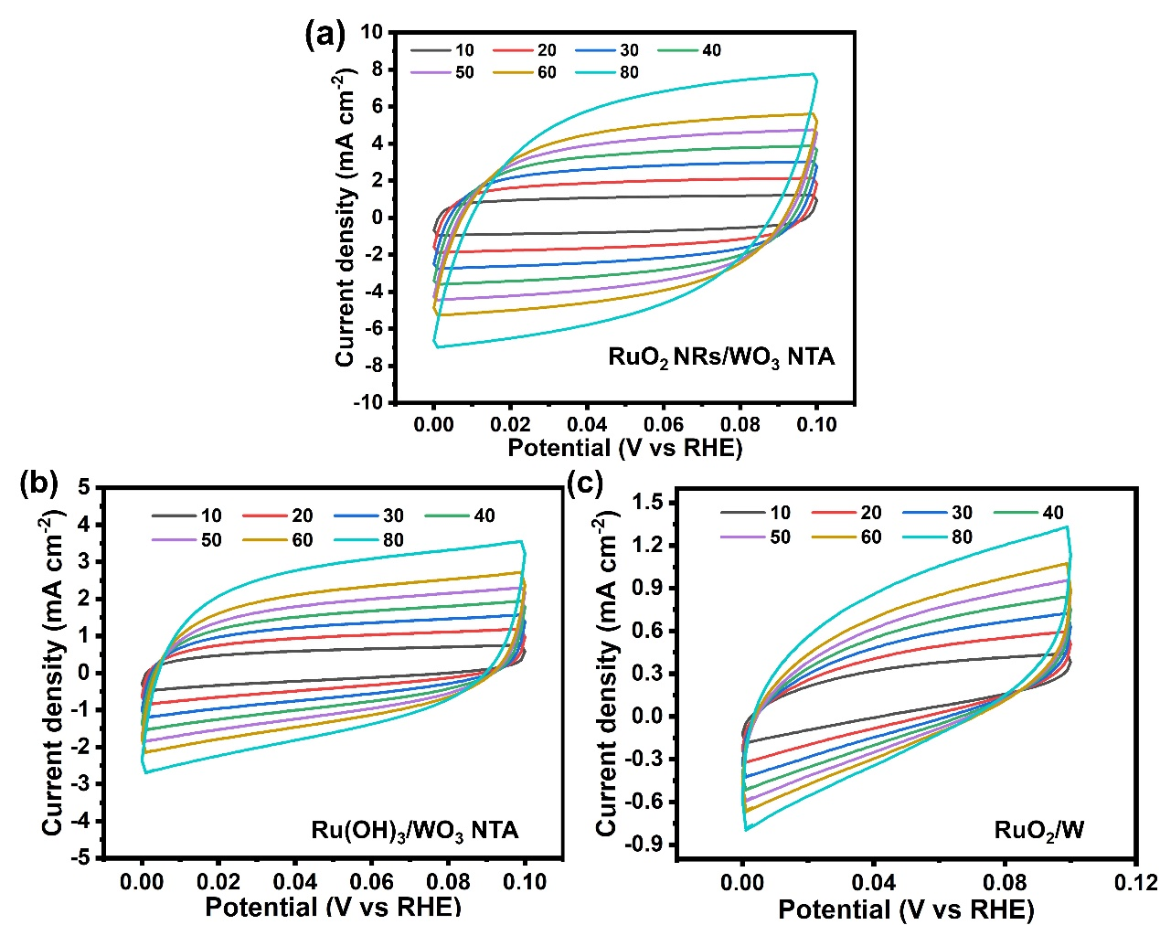
Figure S7 Cyclic voltammetry (CV) curves with different scan rates of (a) RuO₂ NRs/WO₃ NRA, (b) Ru(OH)₃/WO₃ NRA, and (c) RuO₂/W in the non-Faradaic regions in 0.5 M H₂SO4.

Table S1 Comparison of alkaline HER performance of RuO₂ NRs/WO₃ NTA with other reported RuO₂-based and Ru-based electrocatalysts
Catalysts | η₁₀ mV | η₁₀₀ mV | Tafel slope (mV dec⁻¹) | Reference
RuO₂ NRs/WO₃ NTA | 33 | 83 | 35.2 | This work
RuO₂@Ni-MWCNTs | 20.21 | 159 | 26.26 | J. Colloid Interface Sci., 2025, 679: 100-108
Ru-RuO₂/C-300A | 31 | >100 | 85.4 | Advanced science, 2025, 2414534.
Ru/NdOCl | 20 | >100 | 36 | Adv. Mater., 2025, 2417621.
RuO₂@MoS₂ | 114 | >400 | 62.9 | Appl. Surf. Sci., 2021, 538: 148019
RuO₂@Fe₂O₃/HrGO NSs | 239 | >300 | 97 | Int. J. Hydrogen Energy, 2023, 48: 1813-1830
RuO₂–Fe₂O₃ | 148 |  | 43 | Dalton Transactions, 2022, 51: 6314-6331.
Mn-RuO₂ | 37 | >100 | 40.8 | Chin. Chem. Lett., 2024, 35: 109863.
RuO₂@TiO₂/TP | ~34 | 143 | 94 | Inorg. Chem. Frontiers, 2022, 9: 6602-6607
Ni/Co(OH)₂-Ru@NF | 28 | >100 | 23.81 | Small, 2025, 2410086.
Ru-RuO₂@NPC | ~79 |  | 73 | Appl Catal B: Environ., 2022, 302, 120838.
Co-SAC/RuO₂ | 45 |  | 58 | Angew Chem Int Ed, 2022, 61, e202114951
Ru@RuO₂ | 32 | 84 | 21.7 | Chem Eng J 2023, 460, 141672
nanoporous RuO₂ | 87 |  | 45.8 | J. Electroanal. Chem., 2021, 881: 114955
ZIF-8/SnO₂@RuO₂ | ~198 |  | 55.6 | Mater. Today Commun., 2025, 43: 111769
Ru-mCNFs-300 | 19 | 121 | 39 | Vacuum, 2024, 225: 113258.
Ru-RuO₂/ MXene@CC | 43 | ~146 | 52.1 | Colloids Surf. Physicochem. Eng. Aspects, 2023, 679: 132638.
CoFe₂O₄/RuO₂ | 58 | ~158 | 73.1 | Electrochim. Acta, 2024, 503, 144930
h-RuO₂/CNT | ~37 | ~125 | 43.5 | Appl Catal B: Environ., 2024, 365, 124220
NiRuO_{2−x} | 51 |  | 34.4 | J. Colloid Interface Sci., 2023, 630: 940-950.
Al doped Ru_{x}/RuO₂ | 43.97 | 47.1 | 120.04 | J. Mater. Chem. A, 2025, 13: 5091-5105
Ru/CeO₂/C | 30 |  | 55.9 | ChemistrySelect, 2024, 9, e202404254
Ir SA/RuO₂ | 37 | 88 | 22.6 | Chem. Sci., 2024, 15, 16796–16803
fcc Ru–RuO₂/C | 30 | >150 | 21 | J. Mater. Chem. A, 2024, 12, 27540–27548

Table S2 Comparison of acidic HER performance of RuO₂ NRs/WO₃ NTA with other reported RuO₂-based and Ru-based electrocatalysts
Catalysts | η₁₀ mV | Tafel slope (mV dec⁻¹) | Reference
RuO₂ NRs/WO₃ NTA | 62 | 35.4 | This work
RuO₂@Ni-MWCNTs | 73.7 | 48.86 | J. Colloid Interface Sci., 2025, 679: 100-108
Ru-RuO₂@NPC | 68 | 56 | Appl Catal B: Environ 2022, 302, 120838.
Al doped Ru_{x}/RuO₂ | >100 | 57.9 | J. Mater. Chem. A, 2025, 13: 5091-5105
Mn(SAs)-Ru/RuO₂ | 39 | 14.31 | Adv. Funct. Mater., 2024, 2422166
Ru NPs/Fe₅Ni₄S₈ | 54 | 57 | Small, 2023, e2301721.
Mo₂C-Ru/C | 64 | 67 | Adv. Funct. Mater., 2023, 2301925
Ru_{1+NPs}/N−C | 75 | 42.7 | ACS Appl. Mater. Interfaces, 2022, 14: 15250-15258.
RuFeP-NCs/CNF | 65.8 | 43.4 | Appl. Catal., B, 2021, 283: 119583
Ru@Co/N-CNTs | 92 | 45 | ACS Sustainable Chem. Eng. 2020, 8, 9136−9144
La-doped RuO₂ | 71 | 49.3 | Chem. Eng. J., 2022, 439: 135699
RuNi/CQDs | 58 | 55 | Angew. Chem. Int. Ed., 2020, 59: 1718-1726
RuP₃–CoP NS | 60 | 56 | Mater. Today Sustainability 2021, 13, 100074
Ru-RuO₂-NC | 112 |  | J. Alloys Compd., 2022, 902: 163787.
Ru-Ru₂P | 48 | 41.2 | InfoMat, 2022, 4: e12287.
RuTe₂/Graphene | 72 | 33 | Chem. Asian J. 2020, 15, 2886
Ru/ZnRuO₂ | 97 | 51.5 | Adv. Funct. Mater. 2024, 34, 2409306
FeCoNiCrTi-RuO₂ | ~50 | 69.1 | Small, 2024, 20: 2404019.
RuO₂/CeO₂@C | 120 | 83.1 | Chem. Eng. J., 2024, 479: 147939
RuO₂/Co₃O₄ | 100 | 85.1 | Adv. Energy Sustainability Res., 2023, 4: 2300057
RuO₂/C₃N₄ | 109 | 70.8 | Dalton Trans., 2023, 52, 10515–10521
Pt-RuO₂/Ti mesh | 49 | 51.2 | J. Electroanal. Chem., 2023, 932: 117221.
Ru@MoO(S)₃ | 63 | 32 | Nano Energy, 2022, 100: 107445
RuO₂-WC NPs | 58 | 66 | Angew. Chem. 2022, 134, e202202519
Ru/WO3-W2N/NC | 110 | 70 | J. Colloid Interface Sci., 2023, 636, 618–626

