<Chinese Medicine>
Additional file 1

ML-Driven Metabolomics Predicts Anti-Inflammatory and Antioxidant Activities in D. officinale Leaves
Guoliang Zhang¹, Yuying Zhao¹, Chenlei Ru¹, Guangxin Luo¹, Jihong Yang^{1,2,3,}*, Zhenhao Li^{1,2,3,}*
* These authors contributed equally to this work
1 Zhejiang ShouXianGu Botanical Drug Institute, Hangzhou, Zhejiang, China
2 BoYu Intelligent Health Innovation Laboratory, Hangzhou, Zhejiang, China
3 Zhejiang Key Laboratory of Biological Breeding and Exploitation of Edible and Medicinal Mushrooms, Wuyi, China

* Correspondence:
Zhenhao Li:
Affiliation: Zhejiang Key Laboratory of Biological Breeding and Exploitation of Edible and Medicinal Mushrooms, Wuyi
E-mail: zhenhao6@126.com

Jihong Yang:
Affiliation: Zhejiang ShouXianGu Botanical Drug Institute, Hangzhou
E-mail: 11219021@zju.edu.cn

Contents

Table S1 Samples information of D. officinale leaves.
Table S2 Precursor/Product ion pairs and parameters for MRM of compounds used in this study.
Table S3 Identification list of secondary metabolites of D. officinale.
Table S4 Relative content of secondary metabolites in leaves of D. officinale (n=2).
Table S5 Linear regression data, precision, and repeatability for 17 amino acids.
Table S6 The content of 17 kinds of amino acids in 60 batches of D. officinale leaves (mg·g⁻¹, n=2).
Table S7 Vitamin content of 60 batches of D. officinale leaves (μg·g⁻¹, n=2).
Figure S1 Amino acid determination chromatogram (1: Asp; 2: Ser; 3: Glu; 4: Gly; 5: His; 6: Arg; 7: Thr; 8: Ala; 9: Pro; 10: Cys; 11: Tyr; 12: Val; 13: Met; 14: Lys; 15: Ile; 16: Leu; 17: Phe).
Figure S2 In vitro validation results of anti-inflammatory activity.
Figure S3 Effect of variety 630 on the activity of HEK-293T-NFkB cells.
Figure S4 Effect of variety Y2 on the activity of HEK-293T-NFkB cells.
Figure S5 Effect of variety Y3 on the activity of HEK-293T-NFkB cells.
Figure S6 Effect of variety B1 on the activity of HEK-293T-NFkB cells.
Figure S7 Effect of variety B3 on the activity of HEK-293T-NFkB cells.

Table S1 Samples information of D. officinale leaves
NO. | Sample number | Month | Varity
1 | Y2Y-10 | 10 | Y2 D123  (Y2)
2 | Y2Y-11 | 11 | Y2 D123  (Y2)
3 | Y2Y-12 | 12 | Y2 D123  (Y2)
4 | Y2Y-1 | 1 | Y2 D123  (Y2)
5 | Y2Y-2 | 2 | Y2 D123  (Y2)
6 | Y2Y-3 | 3 | Y2 D123  (Y2)
7 | Y2Y-4 | 4 | Y2 D123  (Y2)
8 | Y2Y-5 | 5 | Y2 D123  (Y2)
9 | Y2Y-6 | 6 | Y2 D123  (Y2)
10 | Y2Y-7 | 7 | Y2 D123  (Y2)
11 | Y2Y-8 | 8 | Y2 D123  (Y2)
12 | Y2Y-9 | 9 | Y2 D123  (Y2)
13 | B1Y-10 | 10 | Black 1 A037  (B1)
14 | B1Y-11 | 11 | Black 1 A037  (B1)
15 | B1Y-12 | 12 | Black 1 A037  (B1)
16 | B1Y-1 | 1 | Black 1 A037  (B1)
17 | B1Y-2 | 2 | Black 1 A037  (B1)
18 | B1Y-3 | 3 | Black 1 A037  (B1)
19 | B1Y-4 | 4 | Black 1 A037  (B1)
20 | B1Y-5 | 5 | Black 1 A037  (B1)
21 | B1Y-6 | 6 | Black 1 A037  (B1)
22 | B1Y-7 | 7 | Black 1 A037  (B1)
23 | B1Y-8 | 8 | Black 1 A037  (B1)
24 | B1Y-9 | 9 | Black 1 A037  (B1)
25 | B3Y-10 | 10 | Black 3 A039  (B3)
26 | B3Y-11 | 11 | Black 3 A039  (B3)
27 | B3Y-12 | 12 | Black 3 A039  (B3)
28 | B3Y-1 | 1 | Black 3 A039  (B3)
29 | B3Y-2 | 2 | Black 3 A039  (B3)
30 | B3Y-3 | 3 | Black 3 A039  (B3)
31 | B3Y-4 | 4 | Black 3 A039  (B3)
32 | B3Y-5 | 5 | Black 3 A039  (B3)
33 | B3Y-6 | 6 | Black 3 A039  (B3)
34 | B3Y-7 | 7 | Black 3 A039  (B3)
35 | B3Y-8 | 8 | Black 3 A039  (B3)
36 | B3Y-9 | 9 | Black 3 A039  (B3)
37 | 630Y-10 | 10 | 630 A039  (630)
38 | 630Y-11 | 11 | 630 A039  (630)
39 | 630Y-12 | 12 | 630 A039  (630)
40 | 630Y-1 | 1 | 630 A039  (630)
41 | 630Y-2 | 2 | 630 A039  (630)
42 | 630Y-3 | 3 | 630 A039  (630)
43 | 630Y-4 | 4 | 630 A039  (630)
44 | 630Y-5 | 5 | 630 A039  (630)
45 | 630Y-6 | 6 | 630 A039  (630)
46 | 630Y-7 | 7 | 630 A039  (630)
47 | 630Y-8 | 8 | 630 A039  (630)
48 | 630Y-9 | 9 | 630 A039  (630)
49 | Y3Y-10 | 10 | Y3 C102  (Y3)
50 | Y3Y-11 | 11 | Y3 C102  (Y3)
51 | Y3Y-12 | 12 | Y3 C102  (Y3)
52 | Y3Y-1 | 1 | Y3 C102  (Y3)
53 | Y3Y-2 | 2 | Y3 C102  (Y3)
54 | Y3Y-3 | 3 | Y3 C102  (Y3)
55 | Y3Y-4 | 4 | Y3 C102  (Y3)
56 | Y3Y-5 | 5 | Y3 C102  (Y3)
57 | Y3Y-6 | 6 | Y3 C102  (Y3)
58 | Y3Y-7 | 7 | Y3 C102  (Y3)
59 | Y3Y-8 | 8 | Y3 C102  (Y3)
60 | Y3Y-9 | 9 | Y3 C102  (Y3)

Table S2 Precursor/Product ion pairs and parameters for MRM of compounds used in this study
Compound | RT（min） | ion pairs (m/z) | Cone (V) | Collision (V) | Start (min) | End (min)
Vitamin B₅ | 6.45 | 220.0788＞72.1457 | 8 | 18 | 6.2 | 7
Vitamin B₅ | 6.45 | 220.0788＞90.0621* | 8 | 14 | 6.2 | 7
Vitamin B₁ | 0.90 | 265.1364＞122.1015* | 28 | 14 | 0.7 | 1.3
Vitamin B₁ | 0.90 | 265.1364＞144.0434 | 28 | 12 | 0.7 | 1.3
NMN | 1.22 | 335.0885＞97.0161 | 28 | 26 | 1.0 | 1.8
NMN | 1.22 | 335.0885＞123.0596* | 28 | 12 | 1.0 | 1.8
Vitamin B₂ | 7.80 | 377.1702＞172.0859 | 28 | 36 | 7.6 | 8.2
Vitamin B₂ | 7.80 | 377.1702＞243.0935* | 28 | 22 | 7.6 | 8.2
Folic acid | 7.43 | 442.1716＞176.0528 | 28 | 40 | 7.2 | 8.0
Folic acid | 7.43 | 442.1716＞295.1421* | 28 | 20 | 7.2 | 8.0
*: Quantitative ion pairs
Table S3 Identification list of secondary metabolites of D. officinale
Classification | Numbers | t_{R} (min) | Identification | Formula | m/z | ppm | MS/MS Fragments
Phenols | A-1 | 2.44 | koaburaside | C₁₄H₂₀O₉ | 331.1034 | -2.2 | 168.0433,153.0194,125.0242
Phenols | A-2 | 2.52 | Vanillic acid 4-β-D-glucoside | C₁₄H₁₈O₉ | 329.0882 | 0.7 | 152.0115
Phenols | A-3 | 3.06 | Glucosyringic acid | C₁₅H₂₀O₁₀ | 359.0984 | -0.8 | 197.0456,182.0219
Phenols | A-4 | 4.08 | darendoside A | C₁₉H₂₈O₁₁ | 431.156 | -1.8 | 235.1174,99.0085
Phenols | A-5 | 4.24 | (2S)-1-O-(4-hydroxy-3-methoxybenzoyl)-3-(O-α-D-glucuronosyl)glycerol | C₁₇H₂₂O₁₂ | 417.1034 | -2.5 | 152.0107
Phenols | A-6 | 4.42 | (7S,8S)-guaiacylglycerol 8-O-β-Dglucopyranoside | C₁₆H₂₄O₁₁ | 391.1244 | -3.2 | 315.0712,153.0193
Phenols | A-7 | 4.56 | kelampayoside A | C₂₀H₃₀O₁₃ | 477.1669 | -1.8 | 125.0242
Phenols | A-8 | 5.04 | icariside F2 | C₁₈H₂₆O₁₀ | 401.1451 | -1.0 | 347.1138,269.1030,161.0462
Phenols | A-9 | 5.13 | lucidumoside C | C₂₇H₃₆O₁₄ | 583.2036 | -1.0 | 419.171,329.1231
Phenols | A-10 | 5.27 | 1-O-[α-L-arabinofuranosyl(1→6)-β-D-glucopyranosyl]-erythro-1,2-bis(4-hydroxy-3-methoxyphenyl)propan | C₂₈H₃₈O₁₅ | 613.214 | 0.0 | 567.2087,383.0772,195.0657
Phenols | A-11 | 5.35 | 4-(β-D-glucopyranosyloxy)-3,5-dimethoxyphenyl 6-O-(4-hydroxy-3-methoxybenzoyl)-β-D-glucopyranoside | C₂₈H₃₆O₁₇ | 644.187 | -1.4 | 597.2176,481.1335,341.0861
Phenols | A-12 | 5.58 | 3-methoxybenzoic acid methyl ester 4-O-α-L-rhamnopyranosyl-(1''->2')-β-D-allopyranoside | C₂₁H₃₀O₁₃ | 489.1608 | 1.5 | 327.1084,236.1038,165.0560
Phenols | A-13 | 5.85 | periclymenoside | C₃₃H₄₄O₁₈ | 727.2459 | 0.8 | 501.1777,339.1235,179.0540
Phenols | A-14 | 6.02 | dilatioside B | C₃₄H₄₆O₁₉ | 757.2564 | 0.1 | 531.1870,369.1351,339.1241
Phenols | A-15 | 7.03 | 5-O-caffeoyl-4-O-syringoylquinic acid | C₂₅H₂₆O₁₃ | 533.1304 | -0.2 | 431.0972,283.0617,165.0552
Phenols | A-16 | 7.39 | lyoniresinol 9′α-O-β-D-xylopyranoside | C₂₇H₃₆O₁₂ | 551.2137 | -0.8 | 359.1500,344.1260,208.0742
Phenols | A-17 | 9.12 | geoside | C₂₁H₃₀O₁₁ | 457.1717 | 0.8 | 163.0767,148.0530
Phenols | A-18 | 9.37 | paeonolide | C₂₀H₂₈O₁₂ | 459.151 | 0.8 | 327.1096,165.0558,164.0471
Phenols | A-19 | 9.73 | alangisesquin A | C₃₇H₄₆O₁₆ | 745.2716 | 1.5 | 697.2714,535.1975,433.1513
Phenols | A-20 | 13.43 | 10a,14b-methylene-ditritin | C₃₁H₃₂O₈ | 531.2025 | 0.7 | 391.1554,257.0805
Flavonoids | B-1 | 5.30 | vicenin-2 | C₂₇H₃₀O₁₅ | 593.1514 | -0.1 | 473.1088, 353.0667，163.0400
Flavonoids | B-2 | 5.75 | neoisoschaftoside | C₂₆H₂₈O₁₄ | 563.1405 | -0.8 | 383.0768,353.0658
Flavonoids | B-3 | 5.95 | schaftoside | C₂₆H₂₈O₁₄ | 563.1405 | -0.4 | 383.0781,353.0674
Flavonoids | B-4 | 6.38 | isoschaftoside | C₂₆H₂₈O₁₄ | 563.1408 | -0.6 | 353.0670,325.0704
Flavonoids | B-5 | 6.46 | glucosyl-vitexin | C₂₇H₃₀O₁₅ | 593.1515 | -1.0 | 413.0882,293.0456
Flavonoids | B-6 | 6.95 | rutin | C₂₇H₃₀O₁₆ | 609.1463 | 0.1 | 300.0276,151.0039
Flavonoids | B-7 | 7.90 | apigenin 6-C-alpha-L-arabinopyranosyl-8-C-beta-D-xylopyranoside | C₂₅H₂₆O₁₃ | 533.1302 | -0.7 | 443.0984,353.0674,325.0725
Flavonoids | B-8 | 8.59 | ambocin | C₂₆H₂₈O₁₄ | 563.1403 | -0.6 | 383.0764,293.0457
Flavonoids | B-9 | 8.79 | apioside | C₂₆H₂₈O₁₄ | 563.1408 | 0.6 | 383.0768,293.0457
Flavonoids | B-10 | 11.75 | naringenin | C₁₅H₁₂O₅ | 271.061 | 0.3 | 151.0032,119.0500
Lignan | C-1 | 6.18 | 5,5'-dimethoxylariciresinol 4-O-β-D-glucopyranoside | C₂₈H₃₈O₁₃ | 581.2239 | -0.8 | 516.1298,179.0553,113.0246
Lignan | C-2 | 6.22 | liriodendrin | C₃₄H₄₆O₁₈ | 787.2671 | -0.6 | 579.2094,417.1555,181.0505
Lignan | C-3 | 7.31 | hydroxysyringaresinol 9-O-β-D-glucopyranoside | C₂₈H₃₆O₁₄ | 595.2034 | 0.0 | 357.1352
Lignan | C-4 | 8.72 | acanthoside B | C₂₈H₃₆O₁₃ | 579.2084 | 0.3 | 417.1558,402.1321,181.0510
Lignan | C-5 | 9.91 | Reaxys ID 32411403 | C₃₇H₄₆O₁₆ | 745.2716 | 1.0 | 643.2400,595.2175,367.1032,
Lignan | C-6 | 13.11 | dendrocandin U | C₂₆H₂₈O₈ | 468.2089 | 0.3 | 209.0820,151.0404,137.0253
Glycolipids | D-1 | 16.91 | 1-O-linoloyl-3-O-β-D-galactopyranosyl-sn-glycerol | C₂₇H₄₈O₉ | 561.3282 | -0.9 | 281.2482,279.2326
Glycolipids | D-2 | 15.09 | 3-{[6-O-(beta-D-Galactopyranosyl)-beta-D-galactopyranosyl]oxy}-2-hydroxypropyl (12Z,15Z)-12,15-octadecadienoate | C₃₃H₅₈O₁₄ | 723.3812 | 3.3 | 397.1349,281.2483
Glycolipids | D-3 | 15.39 | gingerglycolipid B | C₃₃H₅₈O₁₄ | 723.3813 | -0.1 | 415.1443,397.1345
Glycolipids | D-4 | 15.84 | 3-O-β-D-galactopyranosyl-1-O-[(9Z,12Z,15Z)-octadeca-9,12,15-trienoyl]-sn-glycerol | C₂₇H₄₆O₉ | 559.3121 | -1.3 | 480.3078,277.2171,253.0923
Glycolipids | D-5 | 16.58 | 3-(beta-D-Galactopyranosyloxy)-2-hydroxypropyl (9Z,12Z)-9,12-octadecadienoate | C₂₇H₄₈O₉ | 566.374 | -1.5 | 353.1998,279.2329
Terpenes | E-1 | 2.95 | eleganoside-C | C₁₈H₂₈O₁₂ | 435.1515 | 0.1 | 315.0717,152.0116,109.0292
Terpenes | E-2 | 4.32 | sweroside | C₁₆H₂₂O₉ | 357.1187 | -0.5 | 162.0304
Terpenes | E-3 | 4.65 | geniposide | C₁₇H₂₄O₁₀ | 387.1299 | 0.5 | 207.0670,192.0392,177.0190
Terpenes | E-4 | 4.92 | yadanzioside D | C₂₉H₄₀O₁₆ | 643.2252 | -1.7 | 405.1552,357.1335,266.0117
Terpenes | E-5 | 6.07 | genipin 1-O-β-D-gentiobioside | C₂₃H₃₄O₁₅ | 549.1816 | -1.0 | 323.0970,195.0659,179.0717,
Terpenes | E-6 | 6.09 | asaolaside | C₂₈H₃₈O₁₅ | 613.214 | -0.2 | 357.1340,195.0659,179.0717,
Terpenes | E-7 | 6.17 | hedyoiridoidside B | C₂₂H₃₈O₁₃ | 509.2242 | 1.1 | 463.2187,149.0463,89.0243
Terpenes | E-8 | 8.93 | 7-O-acetyllaciniatoside IV | C₂₉H₄₀O₁₅ | 627.2293 | 0.2 | 209.0824
Terpenes | E-9 | 10.77 | 4-hydroxy-3,7-dimethyl-2,6-octadienyl-?-D-glucopyranosyl(1→3)-?-D-glucopyranoside | C₂₂H₃₈O₁₂ | 493.2292 | 0.4 | 447.2246
Terpenes | E-10 | 11.04 | acuminoside | C₂₁H₃₆O₁₀ | 447.2238 | -0.3 | 315.1809,101.0247
phospholipid | F-1 | 15.59 | 1-(9Z,12Z)-octadecadienoyl-2-hydroxy-sn-glycero-3-phosphocholine | C₂₆H₅₀NO₇P | 564.3301 | -0.3 | 504.3094,279.2330,277.2172
phospholipid | F-2 | 16.75 | 1-oleoyl-3-lysophosphatidylcholine | C₂₆H₅₂NO₇P | 566.3462 | -1.0 | 281.2483
Anthraquinone | G | 6.73 | ruberythric acid | C₂₅H₂₆O₁₃ | 533.1304 | -0.4 | 443.0984,353.0663,325.0706
Organic acid | H | 4.24 | γ-methyl-δ-hydroxy-pentanoic acid β-D-glucopyranoside | C₁₂H₂₂O₈ | 293.124 | 0.3 | 182.0574,99.0086
Oligosaccharide | I | 5.59 | shimaurinoside B | C₁₆H₃₀O₁₀ | 381.1765 | -0.9 | 165.056

Table S4 Relative content of secondary metabolites in leaves of D. officinale (n=2)
Varity | Month | A-1 | A-2 | A-3 | A-4 | A-5 | A-6 | A-7 | A-8 | A9 | A-10 | A-11 | A-12 | A13 | A-14
Y2 | 10 | 5.316 | 1.013 | 4.405 | 7.032 | 55.986 | - | 4.358 | 136.998 | 0.508 | 0.453 | - | 7.475 | - | 0.650
Y2 | 11 | 5.767 | 1.334 | 3.245 | 2.992 | 13.955 | - | 4.666 | 45.328 | 1.249 | 0.842 | - | 2.476 | 0.489 | 0.564
Y2 | 12 | 1.632 | 1.055 | 2.191 | 2.477 | 13.234 | - | 2.822 | 45.062 | 0.715 | - | - | 1.973 | - | -
Y2 | 1 | 0.835 | 1.030 | 1.802 | 2.463 | - | - | 2.642 | 35.204 | - | - | - | 1.843 | - | -
Y2 | 2 | 2.208 | 0.806 | 1.354 | 2.735 | 11.816 | - | 1.801 | 36.512 | - | - | - | 1.756 | - | -
Y2 | 3 | 2.201 | - | 1.554 | 2.451 | 6.926 | - | 2.006 | 23.040 | - | - | - | 1.902 | - | -
Y2 | 4 | 2.252 | - | 1.791 | 2.740 | 9.111 | - | 1.973 | 32.612 | - | - | - | 3.001 | - | -
Y2 | 5 | 1.784 | - | 1.589 | 2.560 | 9.812 | - | 1.474 | 32.195 | - | - | - | 2.643 | - | -
Y2 | 6 | 4.131 | 0.944 | 2.313 | 2.567 | 10.550 | - | 1.901 | 30.631 | 0.851 | - | - | 3.669 | - | -
Y2 | 7 | 4.493 | 1.442 | 2.754 | 1.012 | 38.060 | - | 1.182 | 34.482 | - | - | - | 0.455 | - | -
Y2 | 8 | 3.945 | - | 3.435 | 4.386 | 17.750 | - | 2.491 | 60.358 | - | - | - | - | - | -
Y2 | 9 | 2.330 | - | 2.300 | 3.839 | - | - | 1.754 | 44.135 | - | - | - | - | - | -
B1 | 10 | 3.045 | 7.409 | 4.881 | 3.049 | 46.234 | - | 1.971 | 59.993 | - | - | - | 4.389 | - | -
B1 | 11 | 2.459 | 5.304 | 2.974 | 2.340 | 21.539 | - | 1.105 | 32.805 | - | - | - | 2.026 | - | -
B1 | 12 | 1.151 | 5.031 | 3.143 | 2.844 | 23.673 | - | 1.084 | 39.524 | - | - | - | 1.958 | - | -
B1 | 1 | 0.686 | 5.010 | 2.426 | 2.484 | 22.832 | - | 0.996 | 33.943 | - | - | - | 1.935 | - | -
B1 | 2 | 1.989 | 3.826 | 2.194 | 2.619 | 20.813 | - | 0.793 | 30.497 | - | - | - | 1.702 | - | -
B1 | 3 | 2.425 | 3.372 | 2.631 | 4.008 | 26.686 | - | 0.882 | 33.185 | - | - | - | 2.178 | - | -
B1 | 4 | 2.206 | 3.420 | 3.262 | 4.396 | 35.967 | - | 1.142 | 44.359 | - | - | - | 3.760 | 6.008 | 0.458
B1 | 5 | 1.130 | 2.763 | 2.653 | 3.425 | 29.115 | - | 0.821 | 39.846 | - | - | - | 4.385 | - | -
B1 | 6 | 3.914 | 3.650 | 4.423 | 4.877 | 27.074 | - | 1.333 | 37.297 | - | - | - | 4.174 | - | -
B1 | 7 | 4.419 | - | 7.247 | 2.119 | 38.136 | - | 1.509 | 5.306 | - | - | - | 0.648 | - | -
B1 | 8 | 4.970 | - | 6.331 | 4.230 | 37.400 | - | 1.548 | 6.061 | - | - | - | 1.060 | - | -
B1 | 9 | 2.252 | 2.523 | 4.141 | 2.209 | - | - | 0.876 | 43.018 | - | - | - | - | - | -
B3 | 10 | 3.048 | 1.120 | 2.026 | 2.109 | 18.193 | - | 1.145 | 54.009 | - | - | - | 3.449 | - | -
B3 | 11 | 2.211 | 1.083 | 1.409 | 3.258 | 9.940 | - | 3.655 | 50.538 | - | - | - | 2.071 | - | -
B3 | 12 | 1.118 | 1.192 | 1.659 | 4.924 | 12.166 | - | 4.444 | 68.948 | - | - | - | 2.485 | - | -
B3 | 1 | 0.731 | 0.972 | 1.225 | 3.985 | 12.972 | - | 3.751 | 55.893 | - | - | - | 2.468 | - | -
B3 | 2 | 1.573 | 0.944 | 1.012 | 4.086 | 15.414 | - | 3.307 | 55.512 | - | - | - | 2.065 | - | -
B3 | 3 | 2.002 | 0.378 | 1.405 | 4.741 | 20.580 | - | 2.797 | 48.758 | - | - | - | 3.053 | - | -
B3 | 4 | 1.345 | - | 1.023 | 4.057 | 12.231 | - | 2.492 | 45.637 | - | - | - | 2.434 | - | -
B3 | 5 | 1.065 | -0 | 0.900 | 3.120 | 11.749 | - | 2.256 | 46.684 | - | - | - | 2.679 | - | -
B3 | 6 | 7.081 | 2.319 | 3.071 | 5.531 | 18.773 | - | 4.265 | 65.744 | - | - | - | 4.849 | 0.433 | 0.121
B3 | 7 | 4.167 | 1.022 | 3.436 | 6.086 | 20.941 | - | 5.275 | 5.143 | - | - | - | - | 0.128 | -
B3 | 8 | 5.695 | 1.082 | 4.220 | 6.788 | 21.249 | - | 5.515 | 92.304 | - | - | - | - | - | -
B3 | 9 | 1.075 | 1.354 | 1.534 | 1.678 | - | - | 2.431 | 32.475 | - | - | - | 1.801 | - | -
630 | 10 | 2.981 | 1.003 | 2.535 | 1.788 | 23.343 | - | 2.182 | 48.914 | - | - | - | 3.700 | - | -
630 | 11 | 2.216 | 0.653 | 1.171 | 1.192 | 9.779 | - | 1.117 | 22.581 | - | - | - | 1.796 | - | -
630 | 12 | 2.241 | 1.109 | 2.339 | 3.268 | 17.860 | - | 2.395 | 47.050 | - | - | - | 3.553 | - | -
630 | 1 | 0.851 | 0.866 | 1.493 | 2.348 | 16.946 | - | 1.732 | 35.721 | - | - | - | 2.859 | - | -
630 | 2 | 2.506 | 0.810 | 1.364 | 2.675 | 17.366 | - | 1.557 | 32.372 | - | - | - | 1.840 | - | -
630 | 3 | 1.327 | - | 0.827 | 2.736 | 10.819 | - | 1.562 | 30.708 | - | - | - | 1.747 | - | -
630 | 4 | 1.890 | - | 1.394 | 3.053 | 13.156 | - | 1.194 | 29.041 | - | - | - | 2.716 | - | -
630 | 5 | 1.477 | - | 1.898 | 4.282 | 15.269 | - | 1.358 | 34.634 | - | - | - | 5.073 | - | -
630 | 6 | 5.050 | 0.986 | 2.883 | 5.486 | 21.882 | - | 1.682 | 43.193 | - | - | - | 5.964 | - | -
630 | 7 | 5.066 | - | 4.158 | 8.063 | 24.735 | - | 2.420 | 4.550 | - | - | - | - | - | -
630 | 8 | 4.670 | 0.859 | 3.635 | 7.125 | 16.815 | - | 2.366 | 42.779 | - | - | - | - | - | -
630 | 9 | 0.875 | 0.976 | 1.687 | 0.974 | - | - | 0.837 | 18.754 | - | - | - | - | - | -
Y3 | 10 | 3.412 | 1.472 | 3.097 | 5.318 | 18.754 | - | 6.235 | 106.613 | 0.641 | - | - | 7.493 | - | -
Y3 | 11 | 3.708 | 1.887 | 2.093 | 2.423 | 32.560 | - | 1.549 | 56.866 | - | - | 0.493 | 2.596 | - | -
Y3 | 12 | 2.461 | 2.298 | 3.136 | 3.473 | 28.996 | - | 1.420 | 58.692 | 0.659 | - | - | 1.966 | - | -
Y3 | 1 | 0.994 | 1.378 | 1.424 | 1.870 | 21.305 | - | 0.975 | 42.824 | - | - | - | 1.657 | - | -
Y3 | 2 | 3.114 | 1.592 | 1.259 | 2.423 | - | - | 0.985 | 38.238 | - | - | - | 1.416 | - | -
Y3 | 3 | 1.920 | 0.812 | 1.472 | 3.825 | 25.303 | - | 0.855 | 39.365 | - | - | - | 2.335 | - | -
Y3 | 4 | 2.356 | 0.971 | 1.775 | 4.327 | 27.362 | - | 1.388 | 41.586 | - | - | - | 2.318 | - | -
Y3 | 5 | 1.737 | 1.060 | 1.695 | 2.939 | 30.400 | - | 1.100 | 50.445 | - | - | - | 3.736 | 77.580 | 0.437
Y3 | 6 | 4.251 | 1.598 | 3.023 | 3.550 | 38.277 | - | 1.561 | 54.070 | - | - | - | 5.785 | - | -
Y3 | 7 | 4.105 | - | 3.196 | 5.454 | 15.407 | - | 2.492 | 49.770 | - | - | - | - | - | -
Y3 | 8 | 4.730 | - | 2.834 | 1.820 | 26.531 | - | 1.712 | 66.286 | - | - | - | - | - | -
Y3 | 9 | 2.962 | - | 2.034 | 1.174 | - | - | 0.767 | 47.218 | - | - | - | - | - | -
Type | Month | A-15 | A-16 | A-17 | A-18 | A-19 | A-20 | B-1 | B-2 | B-3 | B-4 | B-5 | B-6 | B-7 | B-8
Y2 | 10 | 56.393 | 1.052 | 3.638 | 5.486 | 0.712 | - | 174.796 | 84.769 | 101.236 | 71.323 | 188.142 | 305.840 | 86.882 | 171.492
Y2 | 11 | 149.444 | 1.306 | 2.466 | 5.083 | 0.886 | - | 78.864 | 59.787 | 115.957 | 51.047 | 111.921 | 545.529 | 164.299 | 189.063
Y2 | 12 | 114.350 | 0.835 | 2.201 | 3.824 | - | - | 105.229 | 64.839 | 107.352 | 55.058 | 112.611 | 508.456 | 123.744 | 183.011
Y2 | 1 | 103.934 | 0.727 | 1.496 | 3.514 | - | - | 88.315 | 52.900 | 101.975 | 52.783 | 97.400 | 428.866 | 109.520 | 133.439
Y2 | 2 | 68.524 | 0.549 | 1.632 | 3.032 | - | - | 95.244 | 55.860 | 77.126 | 48.704 | 89.921 | 330.941 | 77.129 | 85.670
Y2 | 3 | 66.157 | - | 1.022 | 3.332 | - | - | 44.092 | 35.171 | 73.222 | 14.075 | 3.060 | 31.800 | 4.360 | 2.025
Y2 | 4 | 97.880 | - | 1.316 | 4.460 | - | 0.991 | 56.053 | 47.127 | 99.755 | 38.932 | 124.382 | 581.497 | 150.615 | 129.459
Y2 | 5 | 70.976 | - | 1.265 | 3.758 | - | 0.833 | 64.606 | 42.987 | 73.412 | 38.377 | 123.434 | 426.709 | 100.435 | 85.808
Y2 | 6 | 76.419 | - | 1.586 | 4.868 | - | 1.081 | 77.068 | 53.302 | 96.075 | 46.558 | 204.401 | 509.495 | 110.426 | 95.099
Y2 | 7 | 2.282 | 0.483 | 0.484 | 6.763 | - | 0.701 | 0.968 | 5.890 | 231.870 | 10.937 | 2.340 | 264.486 | 3.489 | 63.268
Y2 | 8 | 61.097 | - | - | 5.667 | - | - | 1.298 | 5.080 | 117.658 | 7.205 | 3.986 | 492.704 | 79.411 | 105.572
Y2 | 9 | 69.853 | - | - | - | - | - | 109.488 | 71.609 | 71.609 | 11.562 | 2.701 | 31.584 | 4.705 | 1.237
B1 | 10 | 2.234 | 0.851 | 2.001 | 13.422 | - | 0.607 | 14.415 | 5.680 | 10.916 | 2.255 | 171.798 | 52.513 | 1.875 | 117.424
B1 | 11 | 1.362 | 0.507 | 1.047 | 7.772 | - | - | 10.182 | 3.495 | 5.573 | 3.123 | 124.905 | 45.661 | 1.060 | 81.701
B1 | 12 | 1.657 | 0.822 | 1.483 | 11.198 | - | - | 9.730 | 7.969 | 11.220 | 1.234 | 179.111 | 93.735 | 2.135 | 114.027
B1 | 1 | 1.365 | 0.675 | 1.188 | 8.827 | - | - | 8.429 | 4.288 | 7.273 | 0.897 | 251.345 | 73.682 | 1.249 | 86.658
B1 | 2 | 0.989 | 0.523 | 0.927 | 7.075 | - | - | 6.391 | 1.776 | 4.719 | 0.717 | 104.814 | 54.663 | 0.753 | 65.192
B1 | 3 | 0.608 | - | 5.977 | 5.552 | - | 0.482 | 8.319 | 5.273 | 10.325 | 7.117 | 1.065 | 4.212 | - | 48.524
B1 | 4 | 0.966 | 1.167 | 7.530 | 6.744 | - | 0.566 | 10.053 | 4.951 | 5.358 | 144.762 | 147.069 | 54.691 | 44.616 | 109.848
B1 | 5 | 3.764 | - | 1.194 | 12.267 | - | 1.526 | 8.026 | 2.346 | 5.499 | - | 234.721 | 54.329 | 1.037 | 68.863
B1 | 6 | 24.524 | - | 1.572 | 13.350 | - | 1.181 | 13.625 | 4.885 | 27.384 | 4.395 | 223.430 | 105.664 | 6.756 | 132.587
B1 | 7 | 4.439 | 0.509 | 1.048 | 15.468 | - | 0.203 | - | - | 7.103 | 0.695 | 1.953 | 117.701 | 5.504 | 142.225
B1 | 8 | 10.620 | - | 0.968 | 16.613 | - | - | - | - | 8.364 | - | 1.976 | 169.148 | 15.207 | 226.590
B1 | 9 | 10.463 | - | - | - | - | - | 10.826 | 6.394 | 6.394 | 7.862 | 1.646 | 4.903 | - | -
B3 | 10 | 5.277 | - | 1.674 | 3.870 | - | - | 209.304 | 179.544 | 94.851 | 157.907 | 82.581 | 110.203 | 5.423 | 26.968
B3 | 11 | 0.735 | - | 0.974 | 4.105 | - | - | 164.805 | 152.330 | 86.102 | 129.446 | 4.197 | 179.563 | 0.736 | -
B3 | 12 | 1.129 | - | 1.337 | 5.579 | - | - | 204.230 | 195.149 | 120.377 | 176.036 | 5.765 | 243.577 | 1.000 | -
B3 | 1 | 0.935 | - | 0.921 | 4.821 | - | - | 188.389 | 154.487 | 107.740 | 157.564 | 0.802 | 250.536 | 0.758 | -
B3 | 2 | 0.614 | - | 0.743 | 3.976 | - | - | 150.290 | 146.241 | 90.886 | 133.933 | 2.174 | 123.857 | 0.659 | -
B3 | 3 | 3.863 | - | 1.924 | 7.506 | - | 1.211 | 97.082 | 86.813 | 58.139 | 14.125 | 3.790 | 18.463 | - | -
B3 | 4 | - | - | - | 4.710 | - | - | 135.015 | 129.448 | 77.563 | 116.411 | 3.595 | 252.260 | - | 1.478
B3 | 5 | - | - | - | 4.412 | - | - | 117.499 | 120.604 | 72.267 | 106.751 | 2.968 | 168.650 | 0.378 | 1.020
B3 | 6 | 2.484 | - | 1.397 | 8.508 | - | - | 209.958 | 195.818 | 157.677 | 183.064 | 21.470 | 256.286 | 2.102 | 7.058
B3 | 7 | 0.770 | - | - | 10.102 | - | - | 1.185 | 4.543 | 177.960 | 9.908 | 5.923 | 326.638 | 1.155 | 17.195
B3 | 8 | - | - | - | 9.015 | - | - | 1.184 | 4.018 | 177.692 | 8.055 | 5.379 | 277.250 | 0.794 | 26.090
B3 | 9 | 0.935 | - | - | - | - | - | 267.259 | 234.070 | 234.070 | 14.617 | 5.181 | 5.792 | - | -
630 | 10 | 11.924 | - | 3.821 | 8.650 | - | - | 6.951 | 5.453 | 9.138 | 4.563 | 74.946 | 189.330 | 10.848 | 190.891
630 | 11 | 7.169 | - | 2.092 | 4.685 | - | - | 4.066 | 2.879 | 5.455 | 2.690 | 45.712 | 144.290 | 6.396 | 123.216
630 | 12 | 13.793 | - | 4.032 | 9.839 | - | 0.729 | 7.334 | 5.261 | 10.011 | 5.263 | 74.569 | 281.142 | 12.448 | 202.664
630 | 1 | 10.304 | - | 2.590 | 7.406 | - | 0.733 | 5.708 | 4.032 | 7.288 | 3.785 | 49.664 | 264.503 | 8.369 | 146.388
630 | 2 | 7.813 | - | 2.255 | 5.889 | - | 0.626 | 4.734 | 3.445 | 6.603 | 3.493 | 54.531 | 199.720 | 7.432 | 138.126
630 | 3 | 2.539 | - | 1.208 | 4.676 | - | 1.027 | 51.043 | 46.559 | 29.784 | 7.999 | 2.078 | 10.799 | - | -
630 | 4 | 5.738 | - | 2.389 | 7.568 | - | 3.266 | 4.363 | 4.259 | 6.478 | 2.897 | 64.216 | 299.622 | 9.185 | 115.599
630 | 5 | 9.141 | - | 3.054 | 10.865 | - | 3.175 | 6.191 | 6.167 | 8.628 | 4.831 | 118.418 | 332.653 | 10.371 | 165.555
630 | 6 | 26.513 | - | 3.595 | 13.660 | - | 2.488 | 19.149 | 16.738 | 32.054 | 17.418 | 104.544 | 360.524 | 35.150 | 142.593
630 | 7 | 22.302 | - | 0.715 | 12.428 | - | 0.802 | - | 1.168 | 29.661 | 4.632 | 2.714 | 478.303 | 29.570 | 248.958
630 | 8 | 35.210 | - | 0.857 | 8.245 | - | - | - | 2.196 | 52.052 | 2.889 | 2.870 | 430.400 | 47.425 | 232.315
630 | 9 | 6.195 | - | - | - | - | - | 10.529 | 7.140 | 7.140 | 11.360 | 2.403 | 17.341 | - | -
Y3 | 10 | 1.300 | - | 1.379 | 7.136 | - | - | 243.454 | 215.262 | 132.947 | 187.689 | 7.264 | 194.055 | 1.211 | 2.543
Y3 | 11 | 1.624 | 0.756 | 2.828 | 4.936 | - | - | 242.175 | 228.298 | 137.326 | 215.952 | 103.846 | 115.868 | 1.646 | 11.106
Y3 | 12 | 0.570 | 0.941 | 3.051 | 6.226 | - | - | 307.753 | 285.775 | 164.224 | 262.171 | 166.587 | 140.336 | 0.688 | 5.150
Y3 | 1 | 2.277 | 0.546 | 1.541 | 3.412 | - | - | 196.528 | 163.712 | 92.700 | 144.280 | 102.010 | 82.462 | 2.238 | 8.445
Y3 | 2 | 2.631 | 0.584 | 1.826 | 3.532 | - | - | 150.743 | 140.272 | 74.597 | 128.995 | 109.316 | 52.345 | 2.885 | 43.013
Y3 | 3 | 11.508 | - | 2.067 | 5.017 | - | - | 238.381 | 202.656 | 126.617 | 14.112 | 2.742 | 8.633 | 0.751 | 0.738
Y3 | 4 | 3.064 | - | 2.177 | 5.445 | - | - | 222.823 | 225.391 | 128.890 | 198.108 | 143.661 | 126.129 | 3.787 | 68.200
Y3 | 5 | 4.433 | 7.273 | 4.195 | 2.557 | 0.513 | 0.601 | 265.432 | 222.780 | 63.296 | 186.630 | 49.003 | 85.856 | 38.141 | 73.126
Y3 | 6 | 1.727 | - | 2.355 | 6.631 | - | 1.108 | 281.902 | 246.749 | 160.498 | 252.129 | 50.308 | 242.702 | 2.148 | 3.553
Y3 | 7 | 130.272 | - | 0.728 | 5.513 | - | - | 0.863 | 6.350 | 77.977 | 13.609 | 4.919 | 575.940 | 170.491 | 171.602
Y3 | 8 | 18.402 | - | - | 5.895 | -0 | - | 1.112 | 5.200 | 220.320 | 10.365 | 2.808 | 286.599 | 22.869 | 44.081
Y3 | 9 | - | - | - | - | - | - | 261.081 | 224.811 | 224.811 | 16.713 | 1.445 | 10.449 | - | -
Type | Month | B-9 | B-10 | C-1 | C-2 | C-3 | C-4 | C-5 | C-6 | D-1 | D-2 | D-3 | D-4 | D-5 | E-1
Y2 | 10 | 183.410 | 5.992 | 2.177 | 7.334 | 1.431 | 11.661 | 1.885 | 3.092 | 0.858 | 6.053 | 2.488 | 43.384 | 10.149 | 1.850
Y2 | 11 | 192.544 | 4.693 | 0.656 | 2.986 | 2.208 | 8.107 | 2.677 | 4.027 | - | 0.981 | - | 9.600 | 1.947 | 0.658
Y2 | 12 | 196.042 | 0.979 | - | 2.469 | 0.624 | 4.789 | 1.508 | 2.272 | 3.024 | 1.235 | 4.800 | 212.448 | 3.461 | -
Y2 | 1 | 154.003 | 0.634 | - | 2.425 | - | 3.948 | 1.092 | 1.437 | 2.798 | 0.702 | 3.458 | 118.564 | 2.166 | -
Y2 | 2 | 106.429 | 1.053 | - | 2.243 | - | 4.769 | 0.827 | 1.897 | 1.311 | 0.681 | 2.089 | 77.707 | 1.765 | 0.496
Y2 | 3 | 111.444 | 0.919 | - | 1.958 | - | 3.720 | - | 3.724 | 4.084 | 1.200 | 3.016 | 142.696 | 6.583 | -
Y2 | 4 | 179.520 | 1.355 | - | 3.241 | - | 5.164 | - | 4.658 | 4.512 | 1.580 | 4.656 | 220.059 | 10.648 | -
Y2 | 5 | 122.669 | 1.695 | - | 2.670 | - | 4.005 | - | 3.597 | 5.793 | 1.187 | 3.305 | 284.683 | 18.763 | -
Y2 | 6 | 122.133 | 2.785 | - | 3.154 | 1.187 | 5.832 | 1.198 | 5.652 | 8.200 | 3.318 | 4.329 | 82.010 | 15.228 | -
Y2 | 7 | 47.737 | 3.744 | 0.855 | 4.508 | - | 8.198 | 0.543 | 8.098 | 10.325 | 1.168 | 1.859 | 215.783 | 40.694 | 0.662
Y2 | 8 | 84.522 | 4.022 | 0.600 | 5.406 | - | 7.470 | - | 5.076 | 17.705 | 1.841 | 2.424 | 92.650 | 50.397 | 1.259
Y2 | 9 | 132.989 | - | - | 3.656 | - | 4.361 | - | 3.344 | - | 6.115 | 12.297 | 135.803 | 55.253 | 0.824
B1 | 10 | 158.277 | 2.093 | 0.924 | 2.803 | 0.638 | 7.621 | 0.717 | 4.849 | 0.458 | 0.582 | 3.522 | 220.704 | 20.260 | 0.640
B1 | 11 | 100.122 | 0.808 | 0.507 | 1.707 | - | 5.053 | 0.440 | 2.270 | 3.319 | - | - | 133.918 | 5.184 | -
B1 | 12 | 140.802 | 0.741 | 0.724 | 3.263 | - | 7.940 | 0.971 | 2.714 | 0.736 | 0.553 | 2.128 | 186.961 | 5.827 | -
B1 | 1 | 110.496 | 0.556 | 0.581 | 3.368 | - | 6.696 | 0.730 | 2.385 | 2.129 | 0.559 | 2.855 | 185.635 | 4.437 | -
B1 | 2 | 82.749 | 0.650 | 0.488 | 2.510 | - | 6.129 | 0.517 | 2.441 | 2.803 | 0.512 | 1.437 | 142.998 | 3.737 | -
B1 | 3 | 52.706 | 3.189 | 3.301 | 6.608 | - | 4.109 | 1.671 | 2.573 | 29.293 | 0.387 | 70.206 | 118.257 | 12.538 | -
B1 | 4 | 67.956 | 3.236 | 4.522 | 2.739 | - | 4.606 | 1.988 | 3.515 | 40.005 | - | 71.478 | 125.884 | 14.448 | -
B1 | 5 | 120.667 | 1.574 | - | 3.469 | - | 6.748 | - | 8.373 | 2.397 | - | 2.870 | 205.453 | 19.718 | -
B1 | 6 | 175.715 | 2.837 | - | 3.705 | - | 8.478 | - | 7.615 | 9.587 | - | - | 113.748 | 26.119 | -
B1 | 7 | 95.802 | 2.296 | 0.984 | 5.809 | - | 11.776 | - | 10.128 | 2.380 | 3.163 | 6.901 | 113.194 | 28.654 | 0.782
B1 | 8 | 185.887 | 3.911 | 0.964 | 6.897 | - | 11.370 | - | 8.331 | 2.511 | 1.089 | 1.545 | 86.633 | 63.836 | 0.843
B1 | 9 | 125.325 | - | - | 4.328 | - | 6.826 | - | 5.951 | - | 3.086 | 8.424 | 120.317 | 53.272 | -
B3 | 10 | 36.315 | 4.641 | 0.510 | 2.651 | - | 4.708 | - | 5.203 | 1.091 | - | - | 118.646 | 6.943 | 0.534
B3 | 11 | - | 0.734 | - | 1.139 | - | 2.663 | 0.673 | 2.166 | 2.119 | - | - | 143.821 | 2.771 | -
B3 | 12 | - | 0.777 | - | 2.095 | 0.681 | 4.450 | 1.548 | 3.272 | 1.104 | - | 1.357 | 142.068 | 2.690 | -
B3 | 1 | - | - | - | 2.355 | - | 4.460 | 1.027 | 3.038 | 2.895 | - | 1.093 | 82.634 | 1.236 | -
B3 | 2 | - | - | - | 2.006 | - | 4.058 | 0.771 | 2.704 | 2.076 | - | 0.627 | 103.062 | 1.594 | -
B3 | 3 | 67.381 | 1.181 | - | 3.091 | - | 6.220 | - | 5.402 | 7.451 | - | 0.785 | 175.511 | 12.448 | -
B3 | 4 | 2.227 | - | - | 2.081 | - | 3.602 | - | 4.065 | 4.018 | - | 1.078 | 153.304 | 6.721 | -
B3 | 5 | 1.436 | 1.284 | - | 1.851 | - | 3.140 | - | 4.639 | 4.761 | - | - | 270.537 | 11.520 | -
B3 | 6 | 10.857 | 2.383 | 0.856 | 2.806 | 1.232 | 5.565 | 1.391 | 7.407 | 8.173 | - | - | 117.791 | 21.496 | -
B3 | 7 | 12.561 | 1.574 | 0.927 | 4.715 | - | 6.828 | 0.573 | 7.425 | 11.371 | 3.622 | 4.490 | 176.559 | 52.481 | 0.730
B3 | 8 | 18.170 | 2.043 | 0.801 | 5.079 | - | 7.943 | - | 7.102 | 6.457 | - | 0.737 | 75.906 | 34.461 | 0.816
B3 | 9 | 8.622 | - | - | 1.148 | - | 1.676 | - | 1.083 | 0.781 | - | 3.213 | 159.882 | 9.063 | -
630 | 10 | 225.231 | 2.872 | - | 3.575 | 0.681 | 5.672 | 0.682 | 3.835 | 0.468 | 0.525 | 3.178 | 241.775 | 16.567 | 0.645
630 | 11 | 152.127 | 0.990 | - | 2.184 | - | 4.056 | - | 3.151 | 2.200 | - | - | 106.843 | 3.797 | -
630 | 12 | 246.040 | 3.224 | 0.081 | 5.496 | 1.027 | 9.145 | 1.088 | 9.546 | 1.081 | - | 1.762 | 183.012 | 6.329 | 0.637
630 | 1 | 183.224 | 1.825 | 0.057 | 4.571 | 0.632 | 7.460 | 0.712 | 6.264 | 0.695 | - | 1.087 | 130.289 | 3.088 | -
630 | 2 | 161.545 | 0.992 | 0.085 | 3.724 | 0.451 | 6.456 | 0.733 | 3.899 | 2.956 | 0.458 | 1.275 | 131.132 | 3.457 | 0.430
630 | 3 | 43.583 | 0.853 | - | 1.851 | - | 3.507 | - | 3.975 | 3.658 | - | - | 97.363 | 6.768 | -
630 | 4 | 167.575 | 2.185 | - | 4.425 | - | 5.860 | - | 8.302 | 4.287 | - | - | 166.973 | 12.938 | -
630 | 5 | 231.968 | 4.766 | - | 7.271 | - | 9.325 | - | 16.893 | 1.069 | 3.086 | 13.454 | 344.640 | 35.662 | -
630 | 6 | 205.561 | 5.236 | - | 8.316 | - | 10.436 | 0.871 | 12.010 | 8.985 | - | - | 130.520 | 32.266 | -
630 | 7 | 190.220 | 3.485 | - | 10.556 | - | 11.004 | - | 11.352 | 7.259 | 2.122 | 4.427 | 242.925 | 52.528 | 1.115
630 | 8 | 187.866 | 4.268 | - | 6.616 | - | 8.994 | - | 6.977 | 4.927 | 1.630 | 2.386 | 112.587 | 44.825 | 1.217
630 | 9 | 187.884 | - | - | 1.785 | - | 2.664 | - | - | - | 4.863 | 33.186 | 164.217 | 17.674 | -
Y3 | 10 | 3.325 | 1.918 | 0.706 | 3.492 | - | 4.937 | 0.763 | 3.653 | 0.985 | - | 0.884 | 144.598 | 14.162 | 0.800
Y3 | 11 | 15.086 | 1.290 | 0.538 | 2.136 | 0.526 | 4.289 | 0.552 | 1.849 | 3.314 | - | - | 183.086 | 5.138 | -
Y3 | 12 | 6.727 | 0.931 | 0.933 | 2.054 | 0.940 | 4.975 | 1.300 | 1.814 | 1.537 | 1.159 | 4.538 | 186.785 | 4.555 | -
Y3 | 1 | 10.973 | 1.310 | - | 1.959 | 0.505 | 4.488 | - | 2.515 | 0.982 | - | 0.817 | 141.608 | 3.242 | -
Y3 | 2 | 50.865 | 0.871 | - | 1.479 | 0.495 | 3.938 | 0.649 | 1.800 | 1.675 | 0.575 | 1.697 | 76.779 | 2.210 | -
Y3 | 3 | 32.963 | 2.655 | 0.711 | 2.299 | - | 5.445 | - | 5.018 | 7.425 | - | 0.968 | 214.790 | 11.372 | -
Y3 | 4 | 90.003 | 1.616 | 0.842 | 2.336 | - | 5.044 | - | 3.324 | 7.237 | - | 1.791 | 260.887 | 11.242 | -
Y3 | 5 | 41.287 | 4.989 | 1.381 | 120.854 | - | 2.735 | 4.120 | 3.356 | 26.948 | 2.273 | 15.408 | 120.200 | 8.584 | -
Y3 | 6 | 4.843 | 5.323 | 0.916 | 4.045 | 0.789 | 7.907 | 0.777 | 8.644 | 8.528 | - | - | 135.584 | 36.542 | -
Y3 | 7 | 138.175 | 1.267 | 0.613 | 4.629 | - | 6.388 | - | 3.891 | 11.452 | 3.800 | 5.829 | 201.296 | 40.831 | 0.799
Y3 | 8 | 32.327 | 3.108 | 0.704 | 5.534 | - | 6.297 | - | 3.641 | 9.031 | 0.820 | 1.136 | 81.249 | 47.855 | 0.843
Y3 | 9 | - | - | - | 2.750 | - | 3.547 | - | 1.961 | - | 3.181 | 4.678 | 85.074 | 41.913 | -
Type | Month | E-2 | E-3 | E-4 | E-5 | E-6 | E-7 | E-8 | E-9 | E-10 | F-1 | F-2 | G | H | I
Y2 | 10 | 0.420 | 0.547 | 1.036 | 2.096 | 1.350 | 16.091 | 0.770 | 3.293 | 6.236 | 10.345 | 6.543 | 63.966 | 1.684 | 3.323
Y2 | 11 | - | 0.432 | 0.860 | - | 2.489 | 18.364 | 1.009 | 17.565 | 4.631 | 2.394 | 1.398 | 117.577 | 0.889 | 2.235
Y2 | 12 | - | - | - | - | 0.764 | 10.194 | - | 8.667 | 2.089 | 38.342 | 16.451 | 101.533 | 0.798 | 2.465
Y2 | 1 | - | - | - | - | 0.674 | 10.342 | - | 6.227 | 0.948 | 22.669 | 13.486 | 96.152 | 0.661 | 2.131
Y2 | 2 | - | - | - | - | 0.555 | 5.930 | - | 3.376 | 0.629 | 50.977 | 6.717 | 60.406 | 0.523 | 2.186
Y2 | 3 | - | - | - | - | - | 8.357 | - | 3.398 | - | 115.794 | 23.350 | 5.031 | - | 2.150
Y2 | 4 | - | - | - | - | - | 10.160 | - | 3.267 | 0.873 | 143.009 | 41.738 | 117.945 | - | 3.047
Y2 | 5 | - | - | - | - | - | 6.616 | - | 5.058 | 0.901 | 164.640 | 75.874 | 83.007 | - | 4.087
Y2 | 6 | - | - | - | - | 1.218 | 7.721 | - | 4.209 | 1.240 | 69.849 | 20.291 | 83.641 | - | 4.307
Y2 | 7 | - | - | 0.594 | 1.613 | - | 2.427 | - | 1.990 | 0.867 | 48.666 | 107.129 | - | 0.581 | 7.638
Y2 | 8 | - | 0.639 | - | 0.976 | - | 7.508 | - | 1.239 | - | 75.355 | 91.821 | - | 1.026 | 9.058
Y2 | 9 | - | - | - | - | - | 9.181 | - | 1.239 | 3.119 | 3.553 | 90.792 | 4.576 | - | 4.741
B1 | 10 | - | - | 0.745 | - | - | 9.783 | - | 8.114 | 6.254 | 4.058 | 91.362 | 0.518 | 2.177 | 4.605
B1 | 11 | - | - | 0.495 | 0.773 | 0.516 | 5.741 | - | 5.232 | 2.459 | 56.644 | 24.053 | - | 1.186 | 2.485
B1 | 12 | - | 0.503 | 0.662 | 0.736 | 0.698 | 7.316 | - | 7.758 | 2.927 | 9.626 | 28.454 | - | 1.352 | 2.906
B1 | 1 | - | - | 0.671 | 0.694 | 0.581 | 5.595 | - | 5.568 | 1.836 | 15.814 | 29.800 | - | 1.204 | 2.775
B1 | 2 | - | - | 0.514 | 0.508 | 0.531 | 5.040 | - | 4.019 | 1.234 | 60.483 | 17.899 | - | 1.115 | 2.040
B1 | 3 | - | 0.809 | 0.683 | - | 0.450 | 4.361 | 0.551 | 2.545 | 1.582 | 172.223 | 24.730 | - | 1.576 | 3.440
B1 | 4 | - | - | - | - | 0.521 | 6.235 | 0.668 | 2.934 | 1.273 | 195.122 | 29.878 | 0.362 | 1.937 | 5.131
B1 | 5 | - | - | - | - | - | 7.795 | - | 4.311 | 1.572 | 40.270 | 73.647 | - | 1.795 | 5.447
B1 | 6 | 0.859 | - | - | 0.996 | 1.106 | 9.459 | - | 6.932 | 1.481 | 79.796 | 43.678 | 5.489 | 1.699 | 6.228
B1 | 7 | - | - | 0.742 | 2.111 | - | 11.702 | - | 2.603 | 0.773 | 7.212 | 82.272 | 0.539 | 2.502 | 6.790
B1 | 8 | - | - | 0.987 | 2.549 | - | 13.413 | - | 2.506 | 0.911 | 9.963 | 81.647 | 0.921 | 2.597 | 6.969
B1 | 9 | - | - | - | 1.528 | - | 7.566 | - | 2.712 | - | 1.343 | 85.797 | 0.754 | 1.406 | 4.331
B3 | 10 | - | - | - | 1.152 | - | 2.217 | - | 3.535 | 2.439 | 25.354 | 24.259 | 3.789 | 0.568 | 5.661
B3 | 11 | - | - | 0.245 | - | - | 8.849 | - | 5.907 | 2.587 | 40.032 | 12.362 | 0.570 | - | 3.794
B3 | 12 | - | - | 0.637 | - | 0.689 | 11.081 | - | 8.146 | 3.642 | 9.104 | 11.512 | 0.773 | - | 5.045
B3 | 1 | - | - | 0.629 | - | 0.592 | 8.486 | - | 5.684 | 2.652 | 25.173 | 5.793 | 0.689 | - | 4.431
B3 | 2 | - | - | - | - | - | 8.446 | - | 4.648 | 1.848 | 49.132 | 7.107 | 0.583 | - | 3.442
B3 | 3 | - | - | - | - | - | 7.709 | - | 3.504 | 2.196 | 111.665 | 36.516 | 0.754 | - | 4.954
B3 | 4 | - | - | - | - | - | 6.712 | - | 2.385 | - | 91.761 | 23.512 | - | - | 4.429
B3 | 5 | - | - | - | - | - | 5.990 | - | 2.820 | - | 126.448 | 47.805 | - | - | 4.747
B3 | 6 | 2.058 | - | - | 0.499 | 0.958 | 9.744 | - | 6.440 | 0.931 | 78.487 | 32.042 | 1.763 | - | 6.930
B3 | 7 | - | 0.663 | 0.673 | 0.940 | 0.250 | 15.866 | - | 2.275 | 0.865 | 51.731 | 93.696 | - | 0.964 | 9.120
B3 | 8 | - | - | - | 1.089 | - | 12.447 | - | 2.761 | 1.102 | 36.060 | 50.294 | - | 1.016 | 7.955
B3 | 9 | - | - | - | - | - | 7.638 | - | 10.588 | 1.562 | 2.584 | 43.174 | - | - | 3.616
630 | 10 | - | - | 0.610 | 1.436 | 0.398 | 8.712 | - | 5.242 | 3.776 | 7.606 | 79.571 | 7.251 | 1.064 | 4.278
630 | 11 | - | - | 0.469 | 0.871 | 0.457 | 4.911 | - | 2.924 | 2.119 | 44.227 | 16.413 | 4.988 | 0.499 | 1.876
630 | 12 | - | - | 1.025 | 1.434 | 0.877 | 9.044 | - | 5.600 | 2.088 | 25.007 | 23.093 | 9.737 | 0.898 | 3.524
630 | 1 | - | - | 0.824 | 1.196 | 0.578 | 5.961 | - | 2.946 | 0.885 | 8.512 | 16.248 | 7.031 | 0.655 | 2.943
630 | 2 | - | - | 0.616 | 0.629 | 0.508 | 5.648 | - | 3.085 | 0.630 | 83.130 | 13.880 | 5.253 | 0.577 | 2.310
630 | 3 | - | - | - | - | - | 4.627 | - | 2.121 | 1.231 | 63.189 | 20.777 | - | - | 1.662
630 | 4 | - | - | - | 0.876 | - | 4.450 | - | 1.497 | - | 104.002 | 35.318 | 5.279 | - | 3.799
630 | 5 | - | - | - | 1.587 | - | 6.680 | - | 2.470 | 1.081 | 13.156 | 121.849 | 8.304 | - | 5.481
630 | 6 | - | 0.934 | 1.125 | 1.994 | 0.815 | 6.731 | - | 2.412 | - | 80.732 | 49.260 | 28.780 | 1.600 | 6.921
630 | 7 | - | - | 0.836 | 2.796 | - | 8.061 | - | 1.584 | - | 27.856 | 165.803 | 1.652 | 3.223 | 7.263
630 | 8 | - | - | 0.777 | 2.178 | - | 7.607 | - | 2.975 | 0.755 | 27.156 | 72.361 | 2.328 | 1.311 | 6.194
630 | 9 | - | - | - | 1.186 | - | 4.895 | - | 5.869 | 0.748 | 0.762 | 92.308 | 0.590 | - | 3.208
Y3 | 10 | - | - | 0.562 | 0.812 | - | 14.593 | - | 4.690 | 5.633 | 14.194 | 44.967 | 0.855 | 1.054 | 8.959
Y3 | 11 | - | - | - | 0.687 | 0.564 | 1.800 | - | 9.159 | 1.967 | 65.904 | 21.729 | 1.326 | 0.464 | 3.744
Y3 | 12 | - | - | 0.628 | 0.588 | 0.838 | 2.765 | - | 13.108 | 1.938 | 26.723 | 19.542 | 0.537 | 0.245 | 3.738
Y3 | 1 | - | - | - | 0.608 | - | 2.365 | - | 5.995 | 1.120 | 26.139 | 17.319 | 2.028 | - | 3.418
Y3 | 2 | - | - | - | 0.399 | 0.575 | 1.855 | - | 4.515 | 0.700 | 51.409 | 8.457 | 2.092 | - | 2.219
Y3 | 3 | - | - | - | 0.767 | - | 2.660 | - | 3.408 | 2.321 | 134.681 | 37.558 | 0.953 | - | 4.259
Y3 | 4 | - | - | - | - | - | 2.873 | - | 4.425 | - | 145.048 | 46.358 | 2.942 | - | 5.088
Y3 | 5 | - | - | - | 0.401 | - | 2.828 | 1.166 | 4.121 | 2.051 | 150.644 | 20.509 | 4.425 | - | 5.878
Y3 | 6 | - | - | 0.824 | 1.249 | 0.864 | 2.229 | - | 8.282 | 1.384 | 96.224 | 44.628 | 1.702 | - | 5.511
Y3 | 7 | - | - | - | - | - | 11.902 | - | 2.831 | - | 46.017 | 128.393 | 10.860 | 0.802 | 7.629
Y3 | 8 | - | - | - | 1.304 | - | 4.532 | - | 2.384 | 0.873 | 43.215 | 78.016 | 1.223 | - | 8.192
Y3 | 9 | - | - | - | 0.792 | - | 2.608 | - | 1.462 | 1.328 | 3.394 | 54.157 | - | - | 3.249

Table S5 Linear regression data, precision, and repeatability for 17 amino acids
Compound | Regression equation | R² | Linear range  （mg·g⁻¹） | Precision RSD% | Repeatability RSD%
Asp | Y=0.0002X-4.8609 | 0.997 | 5-125 | 0.35 | 1.50
Ser | Y=0.0002X-4.6665 | 0.997 | 5-125 | 0.50 | 3.98
Glu | Y=0.0002X-4.2853 | 0.997 | 5-125 | 0.20 | 1.32
Gly | Y=0.0002X-6.3015 | 0.993 | 5-125 | 0.65 | 3.03
His | Y=0.0002X-3.6467 | 0.998 | 5-125 | 0.49 | 4.91
Arg | Y=0.0002X-10.256 | 0.997 | 5-125 | 1.86 | 2.73
Thr | Y=0.0002X-13.298 | 0.997 | 5-125 | 1.51 | 2.14
Ala | Y=0.0002X-4.8044 | 0.996 | 5-125 | 0.38 | 1.88
Pro | Y=0.0002X-3.2738 | 0.996 | 5-125 | 0.31 | 2.77
Cys | Y=0.0001X-1.8507 | 0.995 | 2.5-62.5 | 0.41 | 2.62
Tyr | Y=0.0002X-3.1099 | 0.997 | 5-125 | 0.41 | 3.57
Val | Y=0.0002X-3.3077 | 0.996 | 5-125 | 0.43 | 2.42
Met | Y=0.0002X-2.9627 | 0.997 | 5-125 | 0.70 | 1.30
Lys | Y=0.0001X-3.3709 | 0.996 | 5-125 | 0.31 | 0.70
Ile | Y=0.0002X-3.3097 | 0.996 | 5-125 | 0.48 | 2.66
Leu | Y=0.0002X-4.0729 | 0.997 | 5-125 | 0.32 | 3.07
Phe | Y=0.0002X-3.7141 | 0.998 | 5-125 | 0.49 | 4.25

Table S6 The content of 17 kinds of amino acids in 60 batches of D. officinale leaves (mg·g⁻¹, n=2)
Varity | Month | Asp△ | Ser | Glu△ | Gly | His | Arg | Thr* | Ala | Pro | Cys | Tyr | Val* | Met* | Lys* | Ile* | Leu* | Phe*
Y2 | 10 | 8.52 | 5.32 | 10.68 | 6.37 | 2.54 | 6.59 | 5.38 | 5.98 | 5.68 | - | 5.29 | 6.38 | 0.26 | 4.93 | 5.97 | 10.41 | 7.41
Y2 | 11 | 9.17 | 5.09 | 11.71 | 6.09 | 2.57 | 6.60 | 5.37 | 6.11 | 5.51 | - | 5.43 | 6.37 | 0.24 | 5.03 | 5.89 | 10.19 | 7.49
Y2 | 12 | 7.86 | 4.85 | 10.76 | 6.53 | 1.07 | 6.67 | 5.36 | 7.65 | 5.47 | 0.10 | 2.78 | 7.20 | 0.38 | 4.11 | 6.83 | 11.16 | 4.23
Y2 | 1 | 6.77 | 3.88 | 7.85 | 5.44 | 0.74 | 5.02 | 4.13 | 5.86 | 4.46 | - | 2.23 | 5.70 | 0.31 | 2.55 | 5.42 | 9.20 | 3.44
Y2 | 2 | 6.35 | 3.40 | 7.66 | 5.29 | 0.77 | 4.63 | 3.80 | 5.60 | 4.15 | - | 1.98 | 5.30 | - | 2.24 | 5.06 | 8.63 | 3.04
Y2 | 3 | 7.43 | 4.38 | 9.19 | 6.01 | 1.00 | 5.72 | 4.71 | 5.97 | 5.34 | - | 2.36 | 6.25 | - | 2.95 | 5.98 | 10.05 | 3.67
Y2 | 4 | 8.66 | 5.52 | 11.16 | 7.20 | 1.20 | 6.73 | 5.66 | 6.94 | 5.81 | 0.05 | 2.74 | 7.29 | - | 4.45 | 6.80 | 11.52 | 4.25
Y2 | 5 | 9.61 | 5.32 | 11.46 | 7.85 | 2.47 | 6.59 | 5.55 | 6.97 | 5.94 | 0.06 | 6.19 | 7.34 | 0.32 | 4.41 | 6.99 | 11.47 | 8.73
Y2 | 6 | 7.36 | 4.25 | 8.83 | 5.66 | 1.86 | 4.69 | 4.11 | 5.29 | 4.41 | - | 4.40 | 5.24 | 0.07 | 3.50 | 4.93 | 8.47 | 6.55
Y2 | 7 | 7.19 | 3.71 | 8.66 | 4.69 | 0.86 | 2.13 | 4.17 | 4.58 | 6.15 | - | 2.34 | 5.12 | 0.10 | 3.03 | 4.55 | 7.64 | 3.27
Y2 | 8 | 5.85 | 3.30 | 6.69 | 4.44 | 0.82 | 2.08 | 4.17 | 3.91 | 5.44 | - | 2.29 | 4.58 | - | 2.56 | 4.11 | 6.72 | 3.02
Y2 | 9 | 11.43 | 3.40 | 12.54 | 4.57 | 1.57 | 4.61 | 4.92 | 4.66 | 7.04 | - | 2.17 | 5.45 | 0.06 | 7.37 | 4.95 | 7.99 | 6.32
B1 | 10 | 10.34 | 5.67 | 11.51 | 6.90 | 3.03 | 7.29 | 6.01 | 7.22 | 10.74 | 0.01 | 6.52 | 7.69 | 0.30 | 5.12 | 7.31 | 12.15 | 9.07
B1 | 11 | 10.55 | 6.20 | 12.55 | 7.75 | 3.24 | 8.42 | 6.46 | 8.07 | 9.17 | 0.01 | 7.44 | 8.23 | 0.29 | 4.32 | 7.97 | 13.19 | 10.07
B1 | 12 | 8.60 | 5.15 | 10.23 | 6.90 | 1.07 | 6.82 | 5.64 | 7.80 | 6.09 | 0.06 | 3.05 | 7.49 | 0.26 | 4.65 | 7.14 | 12.10 | 4.60
B1 | 1 | 7.87 | 4.28 | 8.99 | 6.23 | 0.88 | 5.72 | 4.73 | 6.80 | 5.28 | 0.05 | 2.58 | 6.67 | 0.35 | 3.15 | 6.39 | 10.77 | 4.00
B1 | 2 | 7.79 | 4.31 | 9.23 | 6.72 | 1.06 | 5.98 | 4.77 | 6.80 | 6.22 | 0.07 | 2.57 | 6.61 | 0.02 | 2.84 | 6.33 | 10.89 | 3.95
B1 | 3 | 8.15 | 4.96 | 9.94 | 6.71 | 1.14 | 6.38 | 5.18 | 6.50 | 5.56 | 0.04 | 2.64 | 6.88 | - | 3.19 | 6.61 | 11.27 | 4.14
B1 | 4 | 7.66 | 4.92 | 9.58 | 6.43 | 1.05 | 6.03 | 5.09 | 6.02 | 5.39 | - | 2.68 | 6.53 | - | 3.78 | 6.14 | 10.62 | 4.13
B1 | 5 | 9.49 | 5.74 | 11.30 | 7.57 | 2.79 | 7.05 | 6.13 | 7.72 | 6.67 | 0.10 | 7.11 | 8.14 | 0.31 | 4.81 | 7.70 | 12.88 | 10.17
B1 | 6 | 9.55 | 5.40 | 10.80 | 6.98 | 2.59 | 6.25 | 5.39 | 7.13 | 5.79 | 0.03 | 6.00 | 6.83 | 0.20 | 4.69 | 6.34 | 11.36 | 9.00
B1 | 7 | 8.43 | 4.07 | 11.21 | 4.67 | 1.16 | 2.11 | 4.70 | 4.61 | 6.75 | - | 2.69 | 5.53 | - | 2.67 | 4.78 | 7.61 | 4.01
B1 | 8 | 5.00 | 2.96 | 5.30 | 4.08 | 0.89 | 1.82 | 3.46 | 3.36 | 5.06 | - | 2.37 | 3.93 | - | 1.93 | 3.46 | 6.06 | 3.07
B1 | 9 | 10.78 | 3.96 | 11.04 | 5.30 | 1.55 | 5.24 | 5.41 | 4.48 | 7.30 | - | 2.78 | 5.46 | 0.05 | 6.11 | 4.92 | 8.42 | 7.99
B3 | 10 | 9.62 | 5.53 | 11.22 | 6.63 | 2.66 | 6.64 | 5.84 | 7.00 | 8.86 | - | 5.82 | 7.20 | 0.12 | 4.76 | 6.93 | 11.31 | 8.23
B3 | 11 | 9.65 | 5.49 | 11.35 | 6.55 | 2.91 | 6.59 | 6.14 | 7.37 | 7.68 | - | 6.31 | 7.26 | 0.22 | 4.25 | 6.92 | 11.33 | 8.49
B3 | 12 | 9.35 | 5.51 | 11.04 | 7.20 | 1.17 | 7.17 | 6.01 | 8.67 | 6.69 | 0.16 | 3.17 | 8.05 | 0.40 | 5.18 | 7.59 | 12.95 | 4.68
B3 | 1 | 8.64 | 4.76 | 9.60 | 6.32 | 0.97 | 6.12 | 5.01 | 6.94 | 5.53 | 0.08 | 2.75 | 6.90 | 0.37 | 2.93 | 6.66 | 11.20 | 4.15
B3 | 2 | 6.74 | 3.71 | 8.18 | 5.63 | 0.81 | 4.79 | 4.00 | 6.27 | 5.10 | - | 2.10 | 5.67 | - | 2.39 | 5.44 | 9.30 | 3.30
B3 | 3 | 9.18 | 5.54 | 11.53 | 7.52 | 1.25 | 7.05 | 5.68 | 7.54 | 6.21 | 0.03 | 2.90 | 7.79 | - | 4.09 | 7.41 | 12.64 | 4.43
B3 | 4 | 7.89 | 5.13 | 9.93 | 6.48 | 1.06 | 6.14 | 5.12 | 6.26 | 5.40 | 0.05 | 2.57 | 6.62 | - | 3.67 | 6.28 | 10.73 | 3.95
B3 | 5 | 10.08 | 5.97 | 12.21 | 8.24 | 2.76 | 7.05 | 6.02 | 7.83 | 6.55 | 0.08 | 6.48 | 7.92 | 0.33 | 5.01 | 7.50 | 12.49 | 9.38
B3 | 6 | 9.03 | 5.16 | 10.41 | 6.30 | 2.38 | 5.94 | 5.04 | 6.59 | 5.40 | 0.05 | 5.47 | 6.57 | 0.23 | 4.47 | 6.17 | 10.57 | 7.97
B3 | 7 | 9.33 | 3.70 | 8.98 | 4.93 | 0.95 | 2.28 | 4.50 | 5.27 | 6.28 | - | 2.44 | 5.70 | - | 3.48 | 4.99 | 8.18 | 3.53
B3 | 8 | 8.15 | 4.00 | 8.56 | 5.12 | 0.97 | 2.48 | 5.11 | 5.13 | 6.72 | - | 2.49 | 5.59 | 0.04 | 3.71 | 4.92 | 8.17 | 3.28
B3 | 9 | 13.06 | 4.71 | 15.53 | 6.13 | 1.54 | 6.07 | 5.90 | 6.15 | 8.34 | - | 0.03 | 6.91 | 0.50 | 7.81 | 6.21 | 10.10 | 9.18
630 | 10 | 13.44 | 7.48 | 15.46 | 8.89 | 4.00 | 9.45 | 8.10 | 9.95 | 11.55 | 0.08 | 8.21 | 10.13 | 0.55 | 6.73 | 9.47 | 15.65 | 11.51
630 | 11 | 11.10 | 6.19 | 13.34 | 7.72 | 3.29 | 8.65 | 6.62 | 8.48 | 9.08 | 0.02 | 7.06 | 8.55 | 0.47 | 4.78 | 8.08 | 13.35 | 9.98
630 | 12 | 10.64 | 6.28 | 12.79 | 8.53 | 1.48 | 8.61 | 6.99 | 9.87 | 7.40 | 0.13 | 3.70 | 9.26 | 0.54 | 5.68 | 8.75 | 14.74 | 5.57
630 | 1 | 8.99 | 5.17 | 10.73 | 7.21 | 1.14 | 6.77 | 5.61 | 8.03 | 5.93 | 0.05 | 3.01 | 7.75 | 0.54 | 3.56 | 7.37 | 12.51 | 4.57
630 | 2 | 8.10 | 4.55 | 9.76 | 6.82 | 1.14 | 5.92 | 4.95 | 6.87 | 5.83 | 0.04 | 2.61 | 6.77 | 0.08 | 2.91 | 6.46 | 11.17 | 4.06
630 | 3 | 9.50 | 5.55 | 11.68 | 7.71 | 1.35 | 7.37 | 5.99 | 8.06 | 6.38 | 0.02 | 3.10 | 8.15 | 0.05 | 4.04 | 7.69 | 13.02 | 4.81
630 | 4 | 8.11 | 4.94 | 10.04 | 6.50 | 1.06 | 6.28 | 5.21 | 6.70 | 5.39 | 0.03 | 2.68 | 6.77 | - | 3.58 | 6.36 | 10.79 | 4.09
630 | 5 | 12.74 | 7.27 | 15.34 | 10.26 | 3.68 | 8.93 | 7.68 | 10.00 | 8.23 | 0.15 | 8.34 | 10.24 | 0.58 | 6.07 | 9.62 | 16.10 | 12.14
630 | 6 | 11.62 | 7.19 | 13.82 | 9.24 | 3.72 | 8.77 | 7.23 | 9.25 | 8.58 | 0.10 | 7.61 | 9.22 | 0.42 | 6.27 | 8.41 | 14.64 | 11.54
630 | 7 | 9.30 | 5.31 | 12.91 | 5.52 | 1.37 | 2.79 | 5.73 | 5.66 | 7.51 | - | 2.98 | 6.99 | 0.08 | 3.95 | 6.07 | 9.58 | 4.47
630 | 8 | 8.12 | 4.17 | 8.10 | 5.39 | 1.10 | 2.66 | 5.03 | 5.19 | 6.45 | - | 2.73 | 5.65 | 0.02 | 3.30 | 4.97 | 8.14 | 3.67
630 | 9 | 15.53 | 4.66 | 13.97 | 6.06 | 1.61 | 6.52 | 6.48 | 5.93 | 8.16 | - | 3.39 | 6.72 | 0.38 | 7.38 | 6.02 | 9.82 | 9.72
Y3 | 10 | 7.92 | 4.78 | 9.95 | 5.78 | 2.34 | 6.07 | 4.89 | 6.41 | 7.47 | - | 5.30 | 6.39 | 0.12 | 4.12 | 5.99 | 9.75 | 7.33
Y3 | 11 | 8.01 | 4.72 | 9.48 | 5.90 | 2.38 | 5.70 | 5.39 | 6.04 | 6.70 | - | 5.28 | 6.15 | 0.12 | 3.56 | 5.91 | 9.92 | 7.63
Y3 | 12 | 8.04 | 4.84 | 9.63 | 6.59 | 1.01 | 6.35 | 5.27 | 6.94 | 5.70 | 0.04 | 2.79 | 6.95 | 0.24 | 4.34 | 6.67 | 11.37 | 4.33
Y3 | 1 | 7.38 | 4.38 | 8.79 | 6.15 | 0.80 | 5.59 | 4.60 | 6.05 | 5.01 | 0.03 | 2.45 | 6.33 | 0.22 | 2.50 | 6.23 | 10.37 | 3.86
Y3 | 2 | 7.14 | 4.15 | 8.63 | 6.04 | 0.93 | 5.30 | 4.36 | 6.16 | 4.88 | 0.04 | 2.29 | 5.93 | - | 2.35 | 5.69 | 9.91 | 3.63
Y3 | 3 | 7.68 | 4.91 | 9.39 | 6.70 | 1.08 | 6.11 | 5.05 | 6.12 | 5.46 | - | 2.67 | 6.76 | - | 3.29 | 6.46 | 11.00 | 4.21
Y3 | 4 | 10.95 | 6.63 | 13.52 | 8.35 | 1.55 | 8.57 | 6.98 | 8.43 | 7.18 | 0.06 | 3.75 | 8.90 | 0.02 | 5.43 | 8.50 | 14.85 | 5.71
Y3 | 5 | 9.76 | 5.62 | 11.63 | 7.83 | 2.71 | 6.64 | 5.92 | 7.32 | 6.58 | 0.06 | 6.56 | 7.88 | 0.23 | 4.93 | 7.48 | 12.54 | 9.65
Y3 | 6 | 8.23 | 4.93 | 9.78 | 6.41 | 2.36 | 5.81 | 4.98 | 6.06 | 5.26 | 0.02 | 5.42 | 6.36 | 0.17 | 4.42 | 5.93 | 10.38 | 8.09
Y3 | 7 | 8.50 | 4.30 | 9.35 | 5.70 | 1.12 | 2.68 | 5.07 | 5.81 | 6.56 | - | 2.91 | 6.17 | - | 3.45 | 5.55 | 9.11 | 3.99
Y3 | 8 | 6.73 | 3.95 | 7.54 | 5.34 | 1.00 | 2.44 | 4.98 | 4.56 | 6.69 | - | 2.69 | 5.35 | - | 3.14 | 4.82 | 8.20 | 3.61
Y3 | 9 | 8.74 | 3.08 | 9.94 | 4.28 | 1.01 | 4.21 | 4.61 | 3.86 | 6.38 | - | 2.11 | 4.75 | - | 5.82 | 4.18 | 6.97 | 6.27
-: not detected; *: essential amino acids; △: umami taste amino acid

Table S7 Vitamin content of 60 batches of D. officinale leaves (μg·g⁻¹, n=2)
Varity | Month | Vitamin B₅ | Vitamin B₁ | NMN | Vitamin B₂ | Folic acid
Y2 | 10 | 17.01 | 6.86 | 3.31 | 2.68 | 9.11
Y2 | 11 | 1.68 | 2.90 | 12.51 | 7.71 | 0.25
Y2 | 12 | 1.14 | 1.47 | 6.49 | 5.85 | 2.78
Y2 | 1 | 0.80 | 1.36 | 1.59 | 6.09 | 2.67
Y2 | 2 | 0.53 | 2.46 | - | 4.31 | 0.43
Y2 | 3 | - | 2.58 | - | 3.93 | 0.18
Y2 | 4 | 0.91 | 3.33 | 0.27 | 4.65 | 0.43
Y2 | 5 | 0.92 | 2.47 | 0.09 | 2.96 | -
Y2 | 6 | 0.70 | 2.84 | 0.96 | 3.07 | 0.51
Y2 | 7 | 1.37 | 1.89 | 0.34 | 3.55 | 0.68
Y2 | 8 | 0.36 | 2.37 | 0.80 | 7.81 | 0.36
Y2 | 9 | 0.14 | 1.94 | 0.02 | 5.94 | 2.35
B1 | 10 | 31.65 | 8.59 | - | 3.97 | 1.27
B1 | 11 | 16.15 | 9.27 | - | 5.09 | 4.23
B1 | 12 | 32.30 | 10.41 | 1.96 | 3.96 | 2.34
B1 | 1 | 1.00 | 1.02 | - | 3.65 | 1.01
B1 | 2 | 0.71 | 2.03 | - | 3.92 | 0.29
B1 | 3 | 0.83 | 1.90 | 0.22 | 2.25 | 2.04
B1 | 4 | 0.59 | 2.62 | 0.08 | 4.97 | 0.02
B1 | 5 | 0.82 | 1.74 | 0.01 | 2.77 | -
B1 | 6 | 1.72 | 3.20 | 0.31 | 4.32 | 0.11
B1 | 7 | 3.32 | 1.26 | 0.33 | 3.90 | 0.27
B1 | 8 | 0.46 | 1.83 | 0.80 | 5.74 | 0.20
B1 | 9 | 0.36 | 2.06 | - | 5.82 | 2.18
B3 | 10 | 21.49 | 8.65 | - | 3.16 | 2.62
B3 | 11 | 19.84 | 8.04 | 1.95 | 4.77 | 1.53
B3 | 12 | 0.79 | 2.09 | 0.68 | 5.54 | 0.24
B3 | 1 | 0.36 | 1.27 | - | 4.53 | 0.99
B3 | 2 | 0.52 | 1.99 | 0.50 | 7.38 | 0.05
B3 | 3 | - | 2.00 | - | 3.36 | 0.18
B3 | 4 | 0.80 | 2.40 | 0.11 | 3.46 | -
B3 | 5 | 2.12 | 2.41 | 0.32 | 2.72 | -
B3 | 6 | 1.57 | 2.43 | 0.31 | 3.06 | 0.05
B3 | 7 | 2.12 | 1.15 | 0.34 | 3.55 | 0.21
B3 | 8 | 0.97 | 1.78 | 0.81 | 6.46 | 0.17
B3 | 9 | 0.91 | 1.98 | - | 6.93 | 2.15
630 | 10 | 32.15 | 11.85 | - | 4.33 | 0.08
630 | 11 | 0.43 | 2.95 | 0.36 | 6.35 | 0.05
630 | 12 | 21.33 | 10.42 | 2.01 | 5.77 | 2.49
630 | 1 | 0.61 | 0.87 | - | 3.70 | 0.98
630 | 2 | 0.68 | 1.93 | 1.62 | 14.95 | 2.65
630 | 3 | - | 2.36 | - | 3.87 | 0.16
630 | 4 | 0.36 | 2.79 | 0.22 | 5.05 | -
630 | 5 | 0.66 | 2.31 | 0.40 | 3.40 | -
630 | 6 | 0.54 | 4.09 | 0.39 | 5.23 | 0.03
630 | 7 | 3.22 | 1.57 | 0.61 | 4.63 | 0.21
630 | 8 | 0.74 | 2.00 | 0.88 | 7.46 | 0.14
630 | 9 | 0.58 | 2.83 | 0.14 | 7.10 | 2.14
Y3 | 10 | 34.87 | 7.06 | - | 3.54 | 0.74
Y3 | 11 | 12.08 | 12.76 | 1.95 | 5.70 | 3.39
Y3 | 12 | 31.61 | 8.62 | 1.99 | 3.63 | 1.84
Y3 | 1 | 0.55 | 0.88 | - | 2.92 | 0.98
Y3 | 2 | 0.85 | 1.97 | - | 3.32 | 0.23
Y3 | 3 | - | 2.12 | - | 3.01 | 0.17
Y3 | 4 | 0.27 | 2.54 | 0.12 | 2.62 | -
Y3 | 5 | 0.61 | 2.02 | 0.09 | 2.47 | -
Y3 | 6 | 0.66 | 3.37 | 0.38 | 3.28 | 0.01
Y3 | 7 | 1.51 | 1.55 | 0.30 | 4.35 | 0.20
Y3 | 8 | 0.30 | 2.30 | 0.80 | 5.78 | 0.14
Y3 | 9 | 0.24 | 2.38 | 0.06 | 4.47 | 2.12
-: not detected
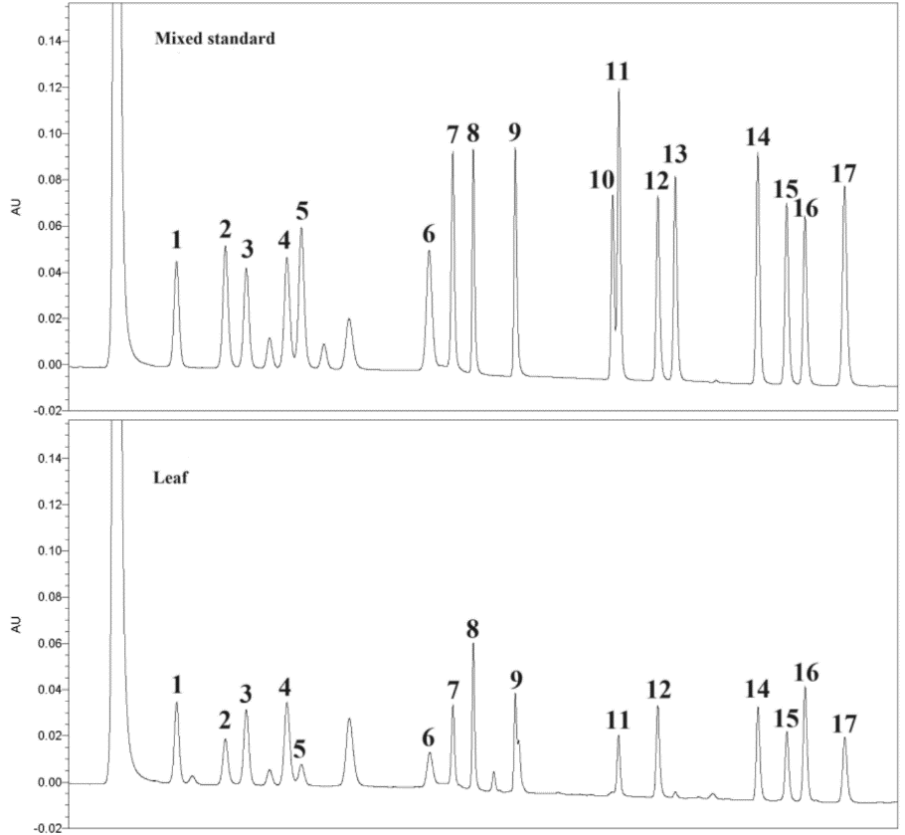
Fig. S1 Amino acid determination chromatogram (1: Asp; 2:Ser; 3: Glu; 4: Gly; 5: His; 6: Arg; 7: Thr; 8: Ala; 9: Pro; 10: Cys; 11: Tyr; 12: Val; 13: Met; 14: Lys; 15: Ile; 16: Leu; 17: Phe)

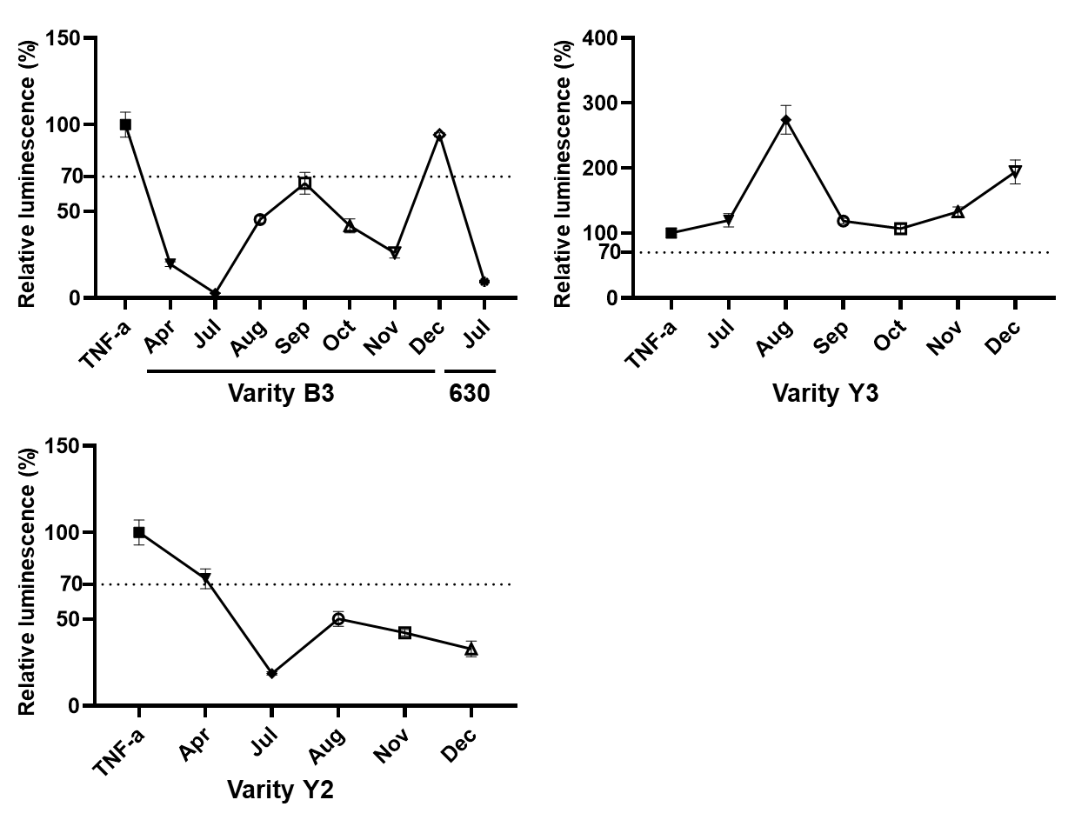
Fig. S2. In vitro validation results of anti-inflammatory activity
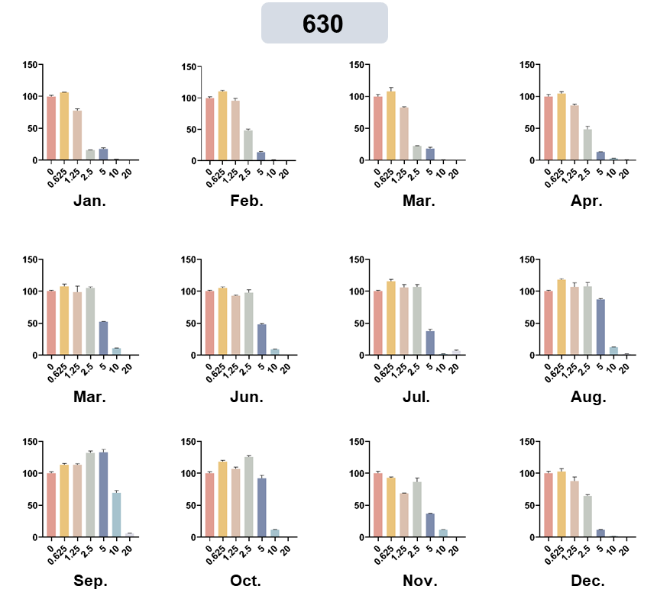
Fig. S3 Effect of variety 630 on the activity of HEK-293T-NFkB cells

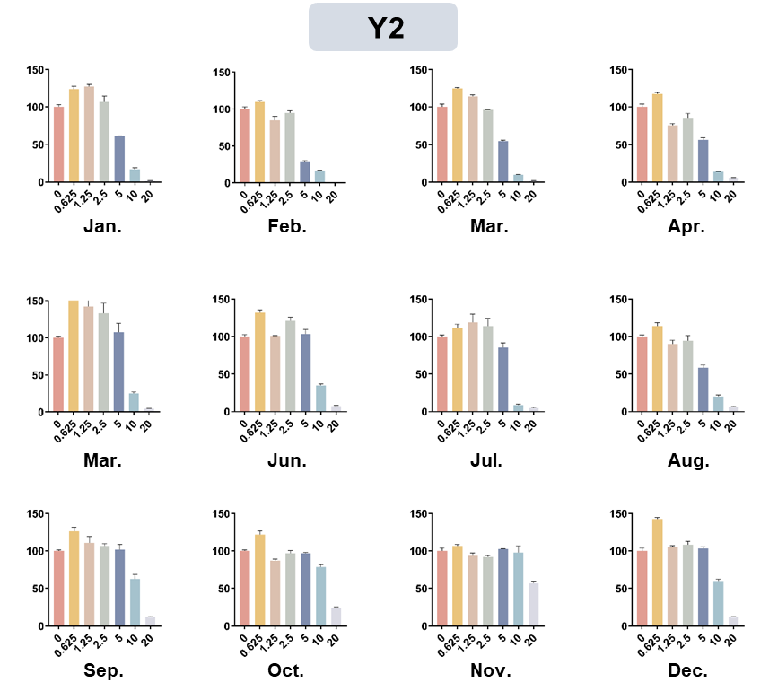
Fig. S4 Effect of variety Y2 on the activity of HEK-293T-NFkB cells

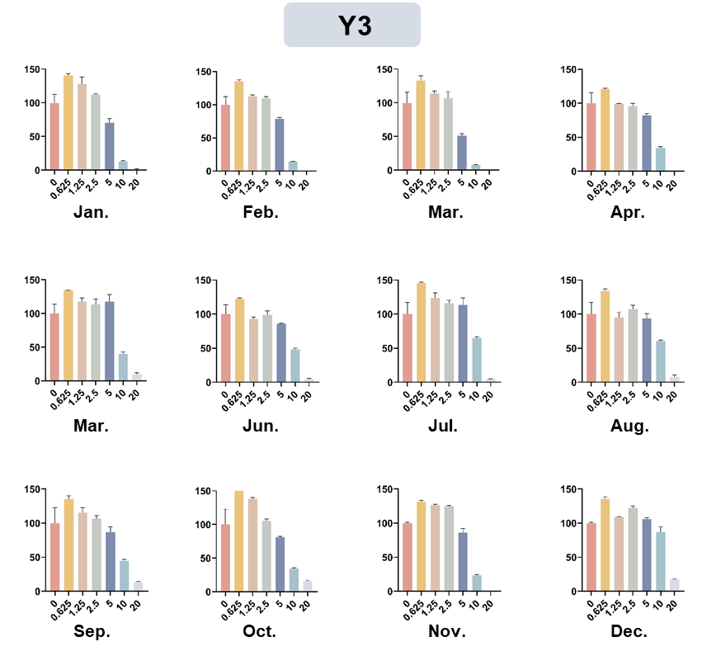
Fig. S5 Effect of variety Y3 on the activity of HEK-293T-NFkB cells

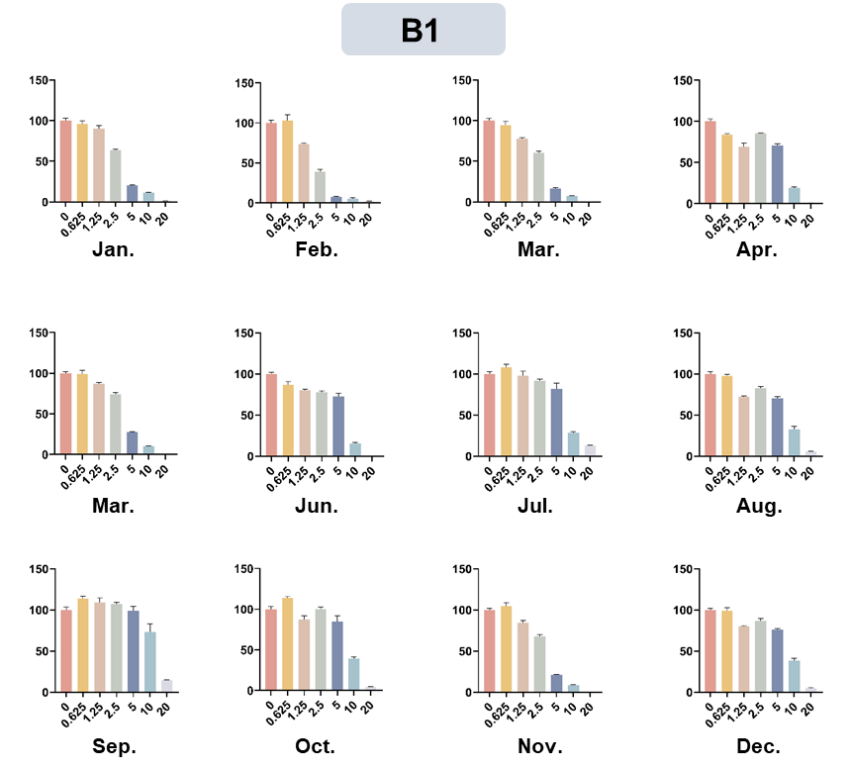
Fig. S6 Effect of variety B1 on the activity of HEK-293T-NFkB cells

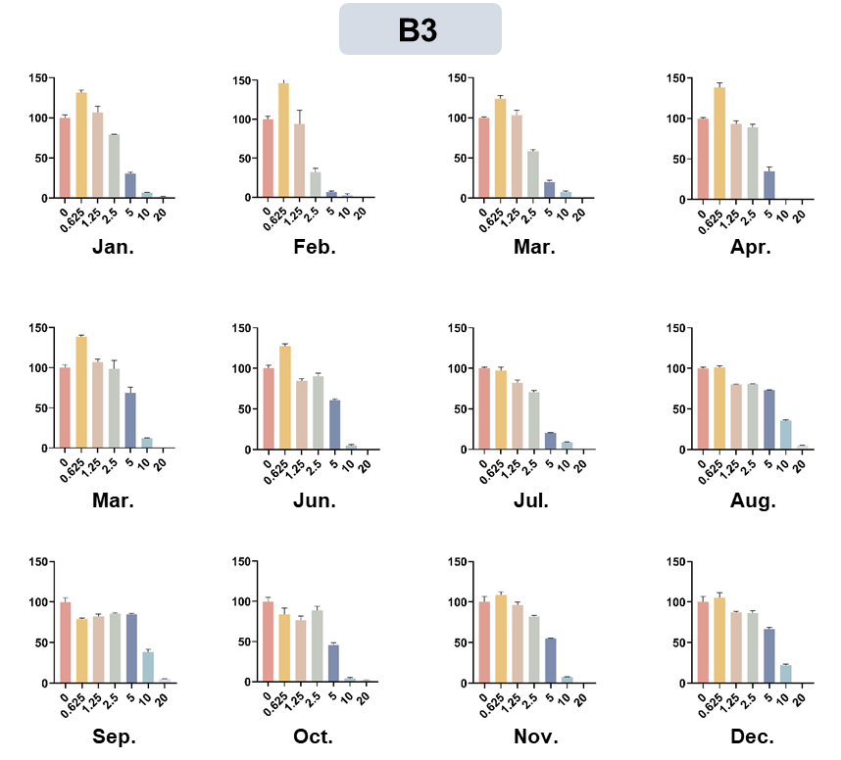
Fig. S7 Effect of variety B3 on the activity of HEK-293T-NFkB cells

