Supplementary Information
Supplementary Fig. 1
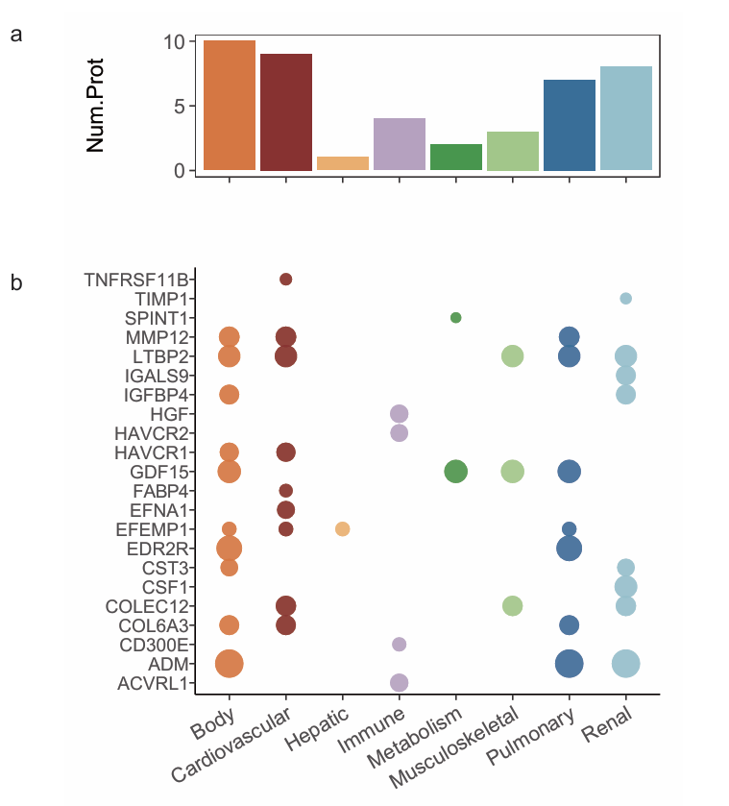
Supplementary Fig. 1 Mortality-Related Proteins (a) Overlap count of mortality-related proteins with the top 50 predictors from each organ. (b) Hazard ratios for the overlapping proteins between mortality-related proteins and the top 50 predictors for each organ; circle size reflects the corresponding HR value.

Supplementary Fig.2
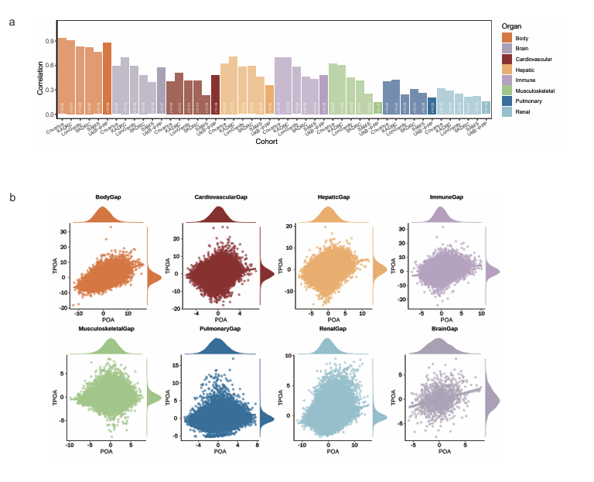
Supplementary Fig. 2 TPOA performance in UKBB cohort. (a) The performance metrics of TPOA models – reconstructed in the UKBB-PPP dataset, evaluation on the UKBB test dataset, contrasted with published statistics by Oh, et al. ¹ (2023) ; (b) Scatterplots comparing actual POA age gaps (x-axis) versus POA age gaps (y-axis) in the UK Biobank-PPP dataset;

Supplementary Fig.3
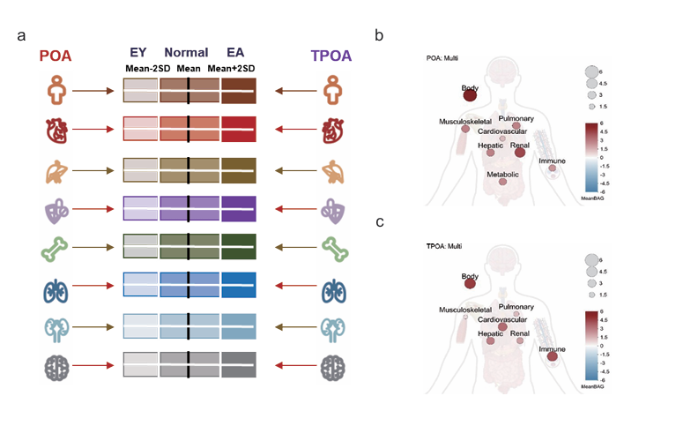
Supplementary Fig. 3 Organ Aging Classification (a) Schematic illustration of the definition of extreme organ aging phenotypes based on POA and TPOA; (b) Mean age gaps for multi-organ agers clusters derived from POA-based analysis; (c) Mean age gaps for multi-organ agers clusters derived from TPOA-based analysis.

Literature Review on previously published Proteome Aging Clock

Journal | Title | Proteomic profiling | Cohort Size | Num.Proteins contained | Performance
ACEL 2018 | Plasma proteomic signature of age in healthy humans² | SomaScan | 240 | 76 | r=0.94
ACEL 2020 | Data mining of human plasma proteins generates a multitude of highly predictive aging clocks that reflect different aspects of aging ³ | SomaScan | 4263 | 491 | r=0.96
NatMed 2019 | Undulating changes in human plasma proteome profiles across the lifespan⁴ | SomaScan | 4263 | 373 | r=0.93
NatMed 2024 | Proteomic aging clock predicts mortality and risk of common age-related diseases in diverse populations ⁵ | Olink | UKB/CKB/Finn | 204 | r=0.94

1. Oh, H.S.-H. et al. Organ aging signatures in the plasma proteome track health and disease. Nature 624, 164-172 (2023).
2. Tanaka, T. et al. Plasma proteomic signature of age in healthy humans. Aging Cell 17, e12799 (2018).
3. Lehallier, B., Shokhirev, M.N., Wyss-Coray, T. & Johnson, A.A. Data mining of human plasma proteins generates a multitude of highly predictive aging clocks that reflect different aspects of aging. Aging Cell 19, e13256 (2020).
4. Lehallier, B. et al. Undulating changes in human plasma proteome profiles across the lifespan. Nat Med 25, 1843-1850 (2019).
5. Argentieri, M.A. et al. Proteomic aging clock predicts mortality and risk of common age-related diseases in diverse populations. Nat Med 30, 2450-2460 (2024).

