Figure legends

Fig.1 Dose dependent effect of PCN-J04 and TOFA induced cell viability after 24 h. A) MCF-7 cells treated with different concentrations of PCN-J04 (6, 12, 25, 50 and 100 µg/ml of final volume of peptide pACC1 containing PCN-J04).B) MCF-7 Cells treated with different concentration of TOFA (6, 12, 25, 50 and 100µg/ml. C) Dose dependent effects of PCN-J04 and TOFA. Values are presented as mean ±SE of three experiments in each group.

Fig.2 Effect of PCN-J04 on intracellular ROS formation as stained by DCFH-DA Photomicrograph showing the oxidative stress effect of upon treatment of PCN-J04 and TOFA.A) Control B) PCN-J04 C) TOFA and D) fluorescent intensity of treated cells showing significant increase in the levels of ROS as compared to control. Values are presented as mean±SE of three experiments in each group ** P&lt; 0.05 vs control.

Fig.3 Apoptotic effect of PCN-J04. A) Photomicrograph showing the effect of PCN-J04 (2.89 µg/ml) and TOFA (4.78 µg/ml) induced apoptotic morphological changes in MCF-7 cells. B) DNA fragmentation of PCN-J04 and TOFA exposed MCF-7 cells for 3, 6 and 12 h. C) Flowcytometric analyses of MCF-7 cells treated with IC₅₀ concentrations of PCN-J04 and TOFA at 3, 6 and 12 h cultures.

Fig.4 Immunoblot analysis of apoptotic marker proteins. Values are presented as mean ±SE of three experiments in each group, ªP<0.05 vs control, ^{n}non-significant vs control.

Fig.5 Immunoblotting of inflammatory marker proteins. Values are presented as mean ±SE of three experiments in each group, ªP<0.05 vs control, ^{n}non-significant vs control.

Fig.6 Inhibition of fatty acid synthesis by PCN-J04.Immunoblot expression of ACC1 and FASN. Values are presented as mean ±SE of three experiments in each group** P<0.05 vs control.

Fig.7 RT-PCR analysis of ACC1 and FASN genes. A) Agarose gel electrophoresis of RT-PCR for ACC1 and FASN genes expression .B) Densitometry values of RT-PCR, ^{ns}non –significant vs control, #P< 0.05 vs control.

Figure- 1
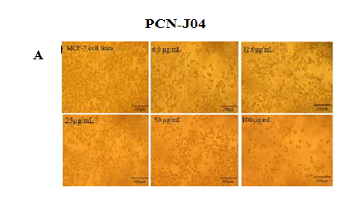
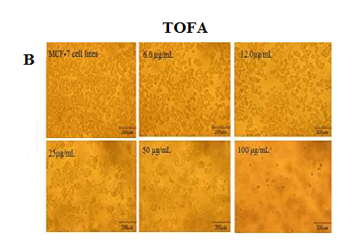

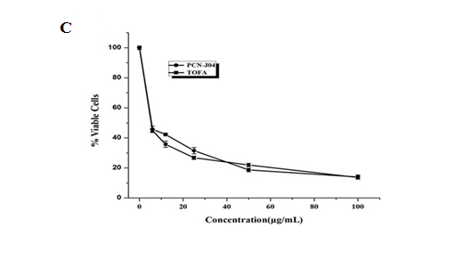

Figure-2
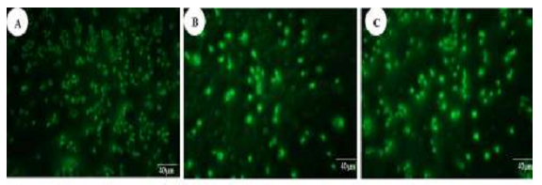
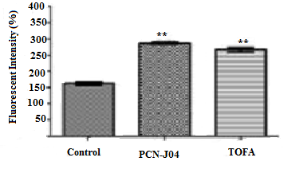
Figure-3

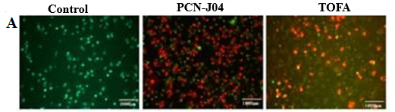

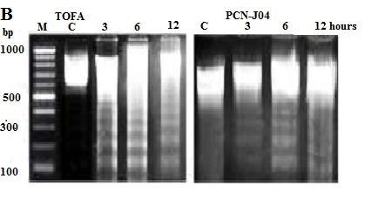

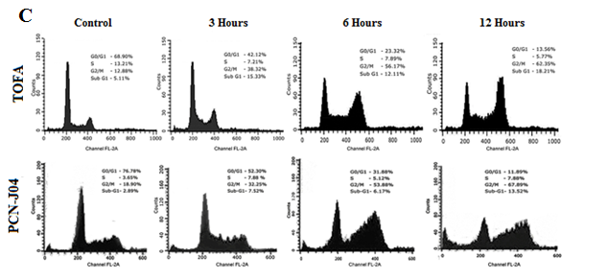

Figure-4
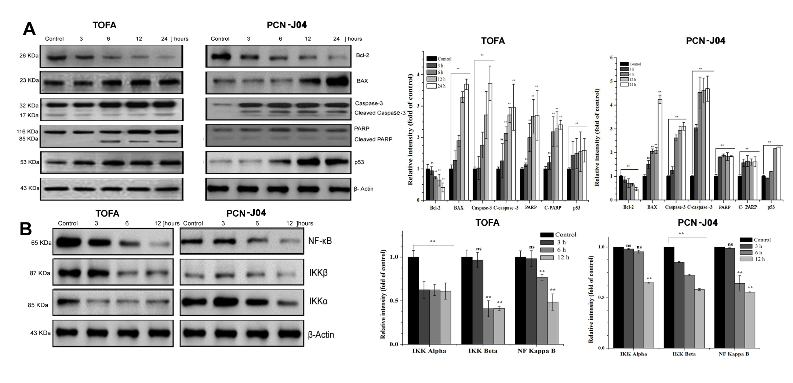

Figure-5

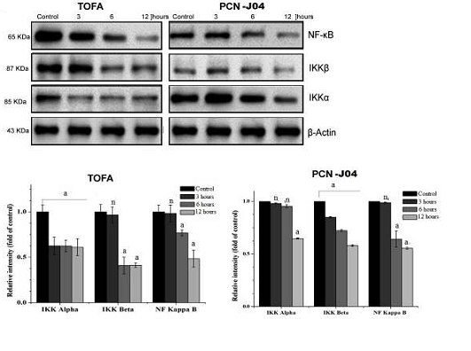

Figure-6
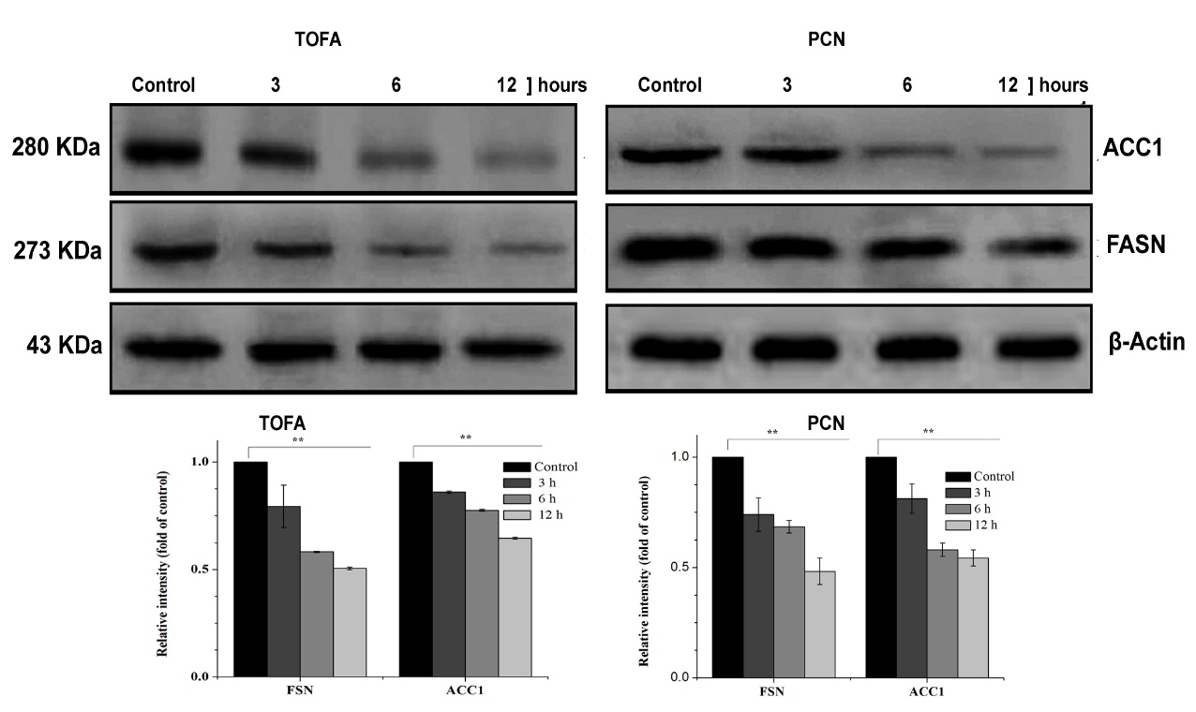

Figure-7
