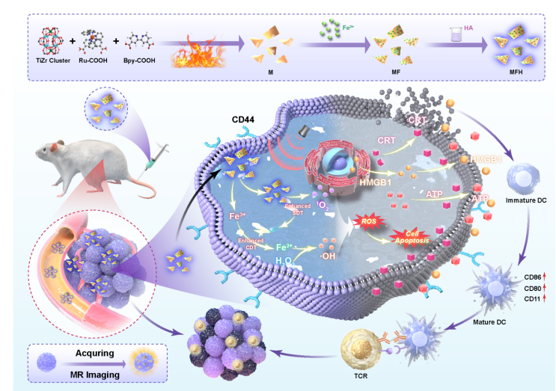
Scheme 1. Schematic illustration of TiZrRuFe-MON@HA (MFH) and synergistic inhibitory mechanism of sono/chemo-dynamic therapies for HCC. A) Schematic diagram of the synthetic process of MFH by hydrothermal-chelation-coating method. B) Synergetic-enhanced ROS generation of MFH for sono/chemo-dynamic therapeutic process under US irradiation against HCC. Under US irradiation, MF is activated, leading to the separation of e⁻/h⁺, which react with O₂ to generate ¹O₂. Additionally, Fe²⁺ reacts with H₂O₂ to produce ·OH and Fe³⁺, which is subsequently reduced back to Fe²⁺ by e⁻, forming a Fe³⁺/Fe²⁺ cycle (CDT). The synergistic effects of SDT and CDT demonstrate potent anti-tumor efficacy.

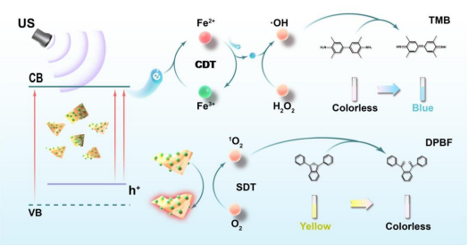
Scheme 2. Schematic representation of the SDT mechanism of MF under US irradiation and ROS generation detected by the probes. The reaction of ·OH with TMB induces a color transition of the solution from colorless to blue, while the interaction of ¹O₂ with DPBF results in a color change from yellow to colorless.

