Supplementary Materials for

Heightened Adaptability Challenges from Extreme Humid Heat Stress for South Asia

Prolay Saha et al.

*Corresponding author. Email: bhupengoswami100@gmail.com

The supplementary file includes:

Figs. S1 to S10

Fig. S1. Time Series of Frequency of Maximum Humidex Exceeding 45°C Over NE.

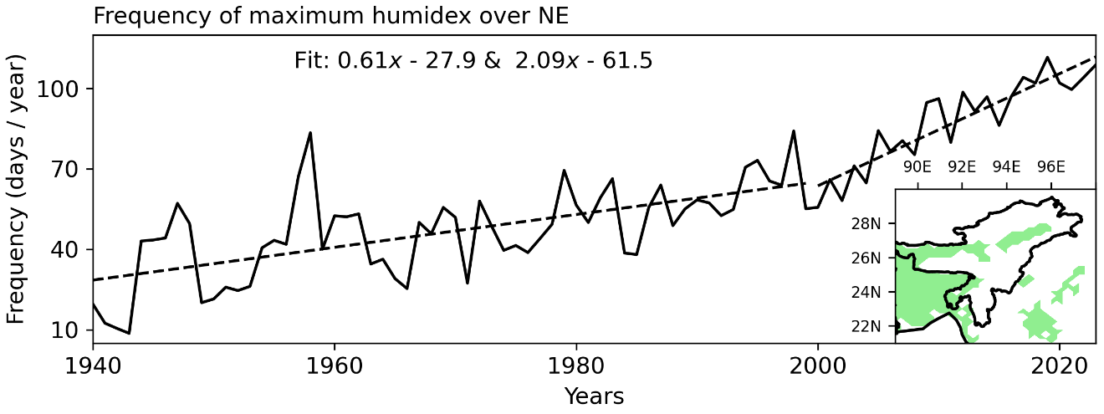

The time series shows the composite frequency (days/year) of maximum Humidex exceeding 45°C over plain locations (elevation < 200 m, as per DEM of SRTM data bilinearly interpolated to 0.25° × 0.25° horizontal resolution) in the Northeast region of the South Asian Monsoon domain during the MJJAS season from 1940 to 2023. The inset map highlights the study region of topographic height ≤ 200 m. The black dashed lines represent the best-linear fit trends for frequency for the periods 1940-1999 and 2000-2023.

Fig. S2. Maximum Daily Humidex for Urban and Rural Locations During MJJAS (2019-2023).

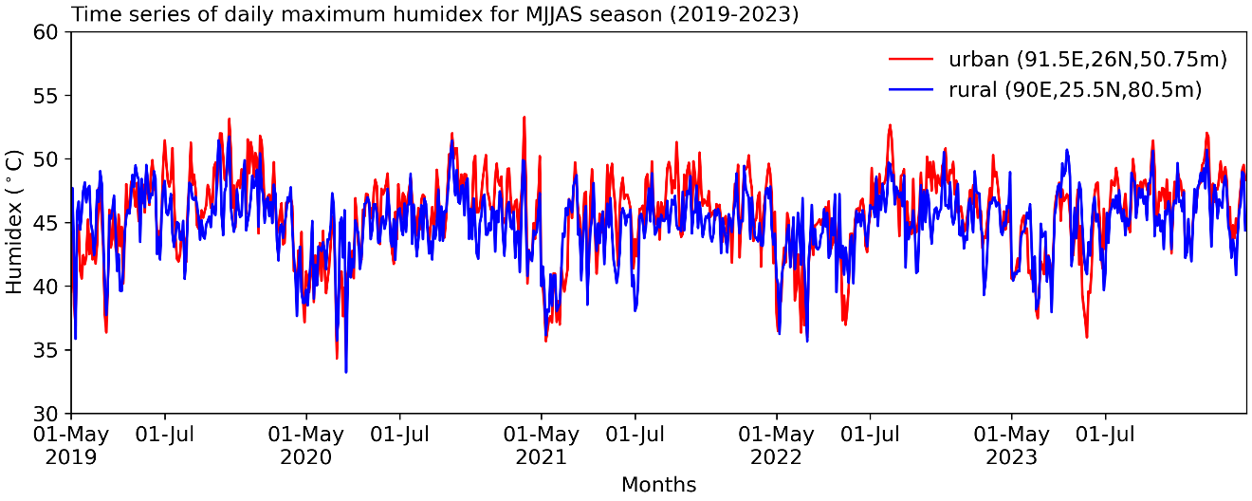
This figure shows the maximum daily Humidex values for the urban location (red) and the rural location (blue) over the five-year period from May to September (MJJAS), covering the years 2019 to 2023.

Fig. S3. Seasonal (MJJAS) timeseries (1940-2023) from ERA5.

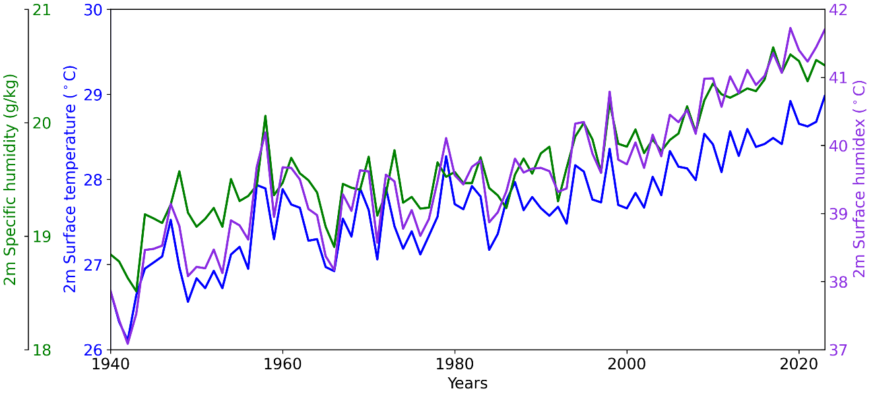
Time series of seasonal (MJJAS) mean 2m surface temp. (0.02⁰K/yr, blue), 2m surface specific humidity (0.02 gm kg⁻¹/yr, green), and 2m surface humidex (0.04⁰K/yr, violet) over NE from 1940-2023. Values in the bracket are the change/year (i.e., final – initial/ Number of years) are computed from linear fitted line.

Fig. S4. Daily Fluctuations and Annual Cycle of Maximum Humidex and Precipitation at an Urban Location Across Eight Decades.

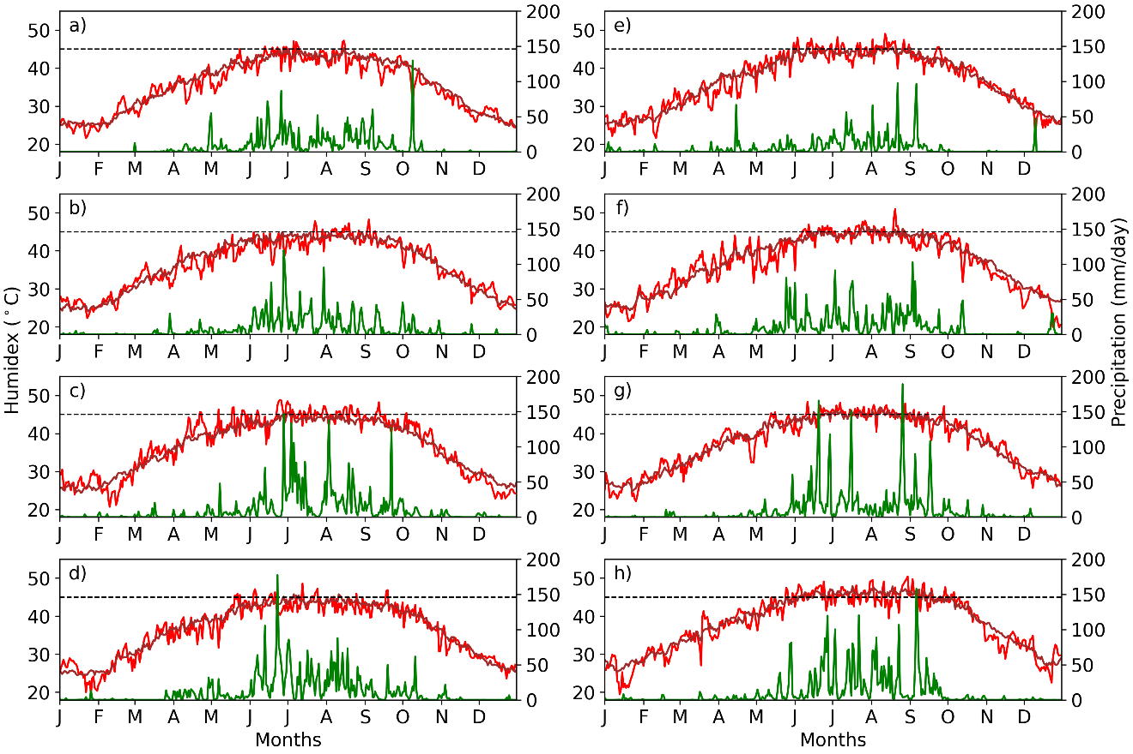

This figure presents the daily fluctuations and annual cycle of the daily maximum Humidex (red, left y-axis) and daily total precipitation (green, right y-axis) at a rural location for the following years across eight decades: a 1941, along with the climatology of maximum Humidex and daily total precipitation from 1940-1949. b 1951, along with the climatology of maximum Humidex and daily total precipitation from 1950-1959. c 1961, along with the climatology of maximum Humidex and daily total precipitation from 1960-1969. d 1971, along with the climatology of maximum Humidex and daily total precipitation from 1970-1979. e 1981, along with the climatology of maximum Humidex and daily total precipitation from 1980-1989. f 1991, along with the climatology of maximum Humidex and daily total precipitation from 1990-1999. g 2001, along with the climatology of maximum Humidex and daily total precipitation from 2000-2009. h 2011, along with the climatology of maximum Humidex and daily total precipitation from 2010-2019.

Fig. S5. Daily Fluctuations and Annual Cycle of Maximum Humidex and Precipitation at a Rural Location Across Eight Decades.

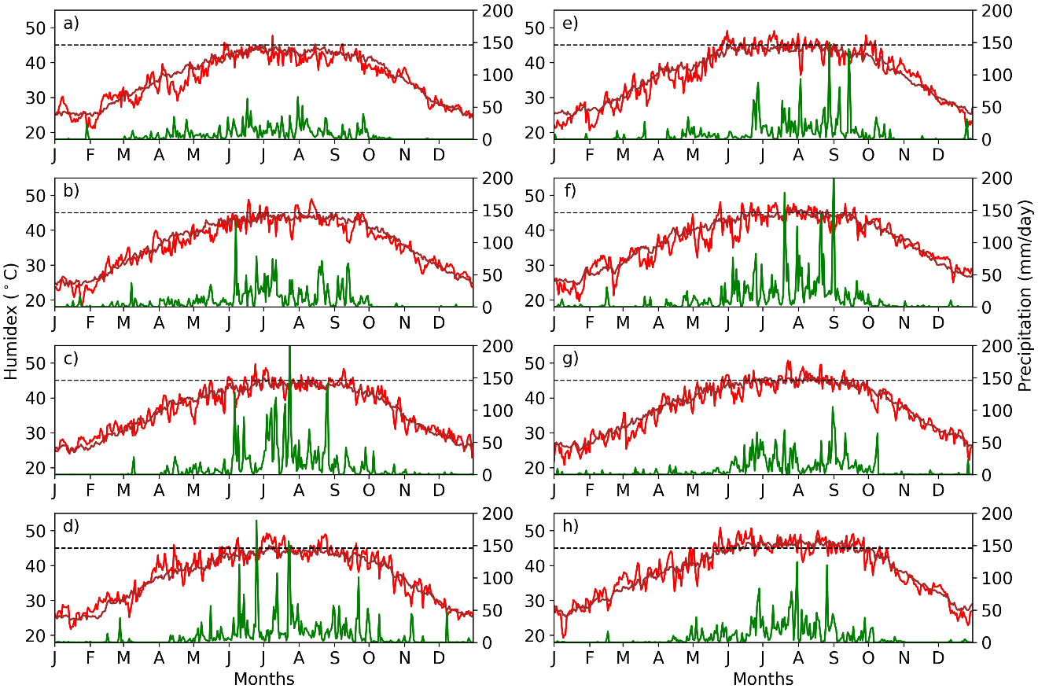

This figure presents the daily fluctuations and annual cycle of the daily maximum Humidex (red, left y-axis) and daily total precipitation (green, right y-axis) at an urban location for the following years across eight decades: a 1943, along with the climatology of maximum Humidex and daily total precipitation from 1940-1949. b 1953, along with the climatology of maximum Humidex and daily total precipitation from 1950-1959. c 1963, along with the climatology of maximum Humidex and daily total precipitation from 1960-1969. d 1973, along with the climatology of maximum Humidex and daily total precipitation from 1970-1979. e 1983, along with the climatology of maximum Humidex and daily total precipitation from 1980-1989. f 1993, along with the climatology of maximum Humidex and daily total precipitation from 1990-1999. g 2003, along with the climatology of maximum Humidex and daily total precipitation from 2000-2009. h 2013, along with the climatology of maximum Humidex and daily total precipitation from 2010-2019.

Fig. S6. Two-Dimensional Time Series of Heat Spell Frequency by Category

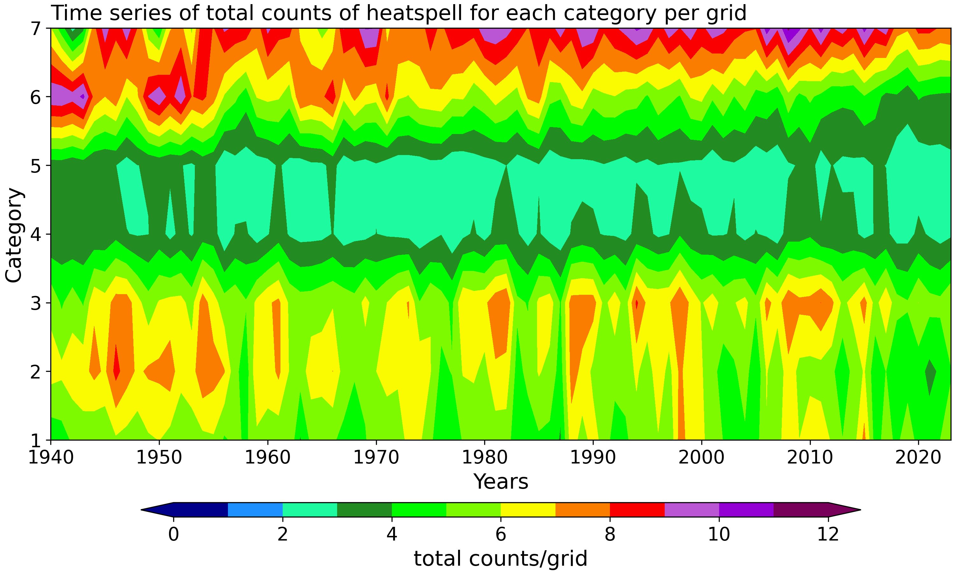

This figure presents a two-dimensional time series showing the frequency of heat spells by category, as defined in Table 1, across the NE. The color scale represents the total number of persistent heat spells per grid, with each category indicating different intensity levels of heat stress over the years from 1940 to 2023.

Fig. S7. Long term Mean Sea Surface Temperature (SST) Over the Tropical Indian Ocean and Western Pacific (1990-2019).
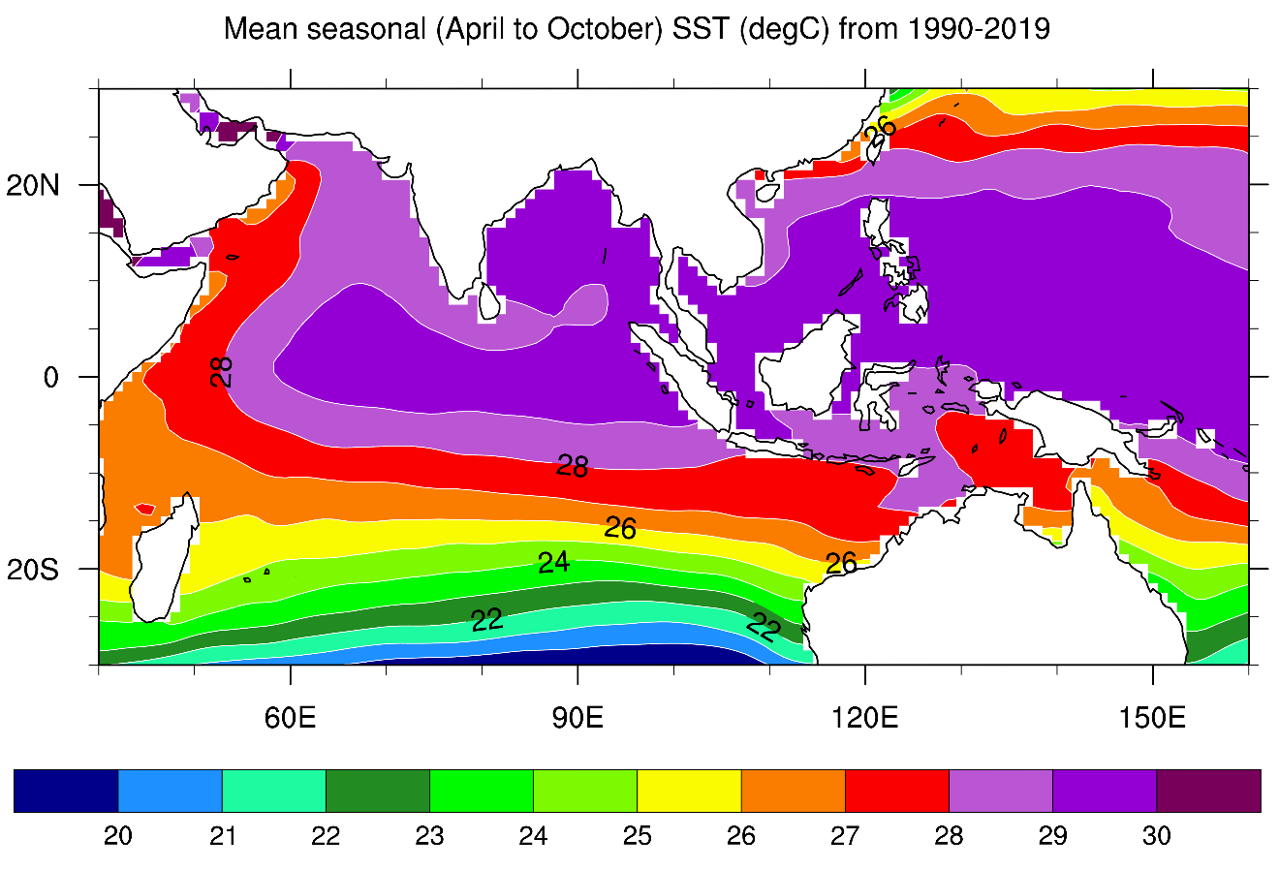This figure shows the climatological mean Sea Surface Temperature (SST) in degrees Celsius (◦C) over the tropical Indian Ocean and Western Pacific (40-130 ◦E, 20 ◦S - 30 ◦N) for the period from April to October, averaged over the years 1990 to 2019

Fig. S8. Annual Cycle of Maximum Humidex and Precipitation.

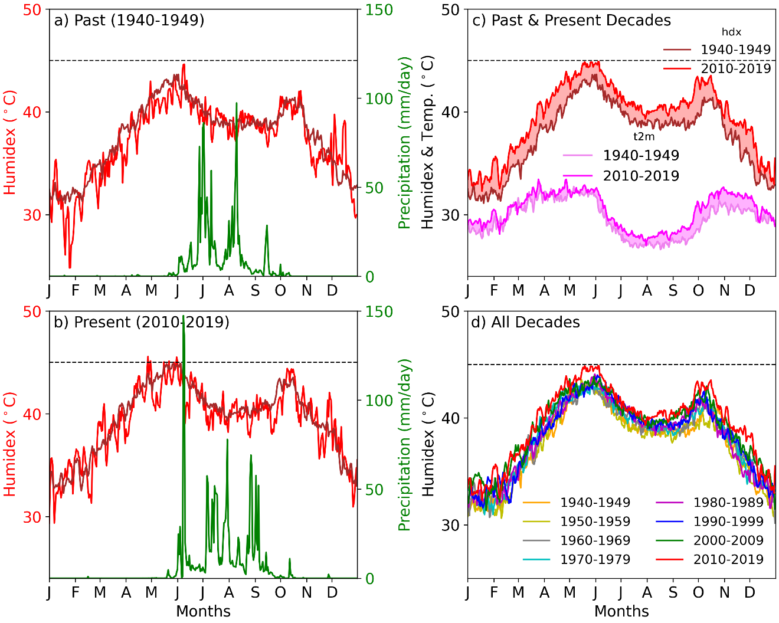

This figure presents the annual cycle of the daily maximum Humidex (red, left y-axis) and daily total precipitation (green, right y-axis) at Mumbai (73E-19N) for the following periods: a The year 1941, along with the climatology of maximum Humidex and daily total precipitation from 1940-1949. b The year 2011 along with daily total precipitation together with climatology of maximum Humidex from 2010-2019. c The difference (shaded red) between the mean annual cycle of maximum Humidex for the past decade (1940-1949) and the present decade (2010-2019), along with the difference in the annuacycle of daily maximum air temperature (pink) at an urban location. d The progression of the climatology of daily maximum Humidex across all eight decades at Mumbai. The dotted horizontal line denotes 45 °C.

Fig. S9. Annual Cycle of Maximum Humidex and Precipitation.
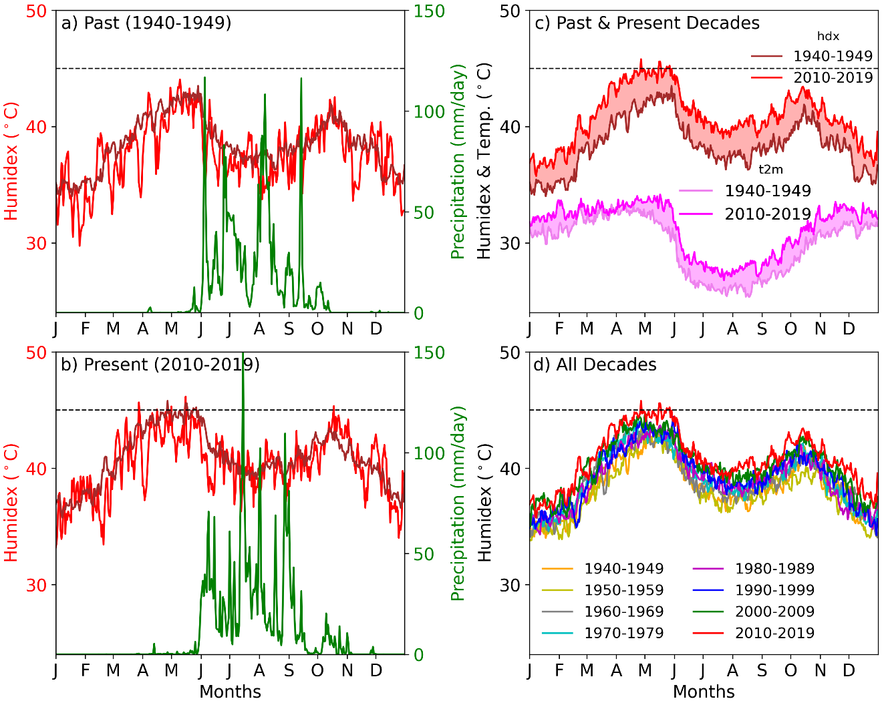

This figure presents the annual cycle of the daily maximum Humidex (red, left y-axis) and daily total precipitation (green, right y-axis) at Panaji (74E-15.5N) for the following periods: a The year 1941, along with the climatology of maximum Humidex and daily total precipitation from 1940-1949. b The year 2011 along with daily total precipitation together with climatology of maximum Humidex from 2010-2019. c The difference (shaded red) between the mean annual cycle of maximum Humidex for the past decade (1940-1949) and the present decade (2010-2019), along with the difference in the annual cycle of daily maximum air temperature (pink) at an urban location. d The progression of the climatology of daily maximum Humidex across all eight decades at Panaji. The dotted horizontal line denotes 45 °C.

Fig. S10. Heatmap of theoretical Humidex index.

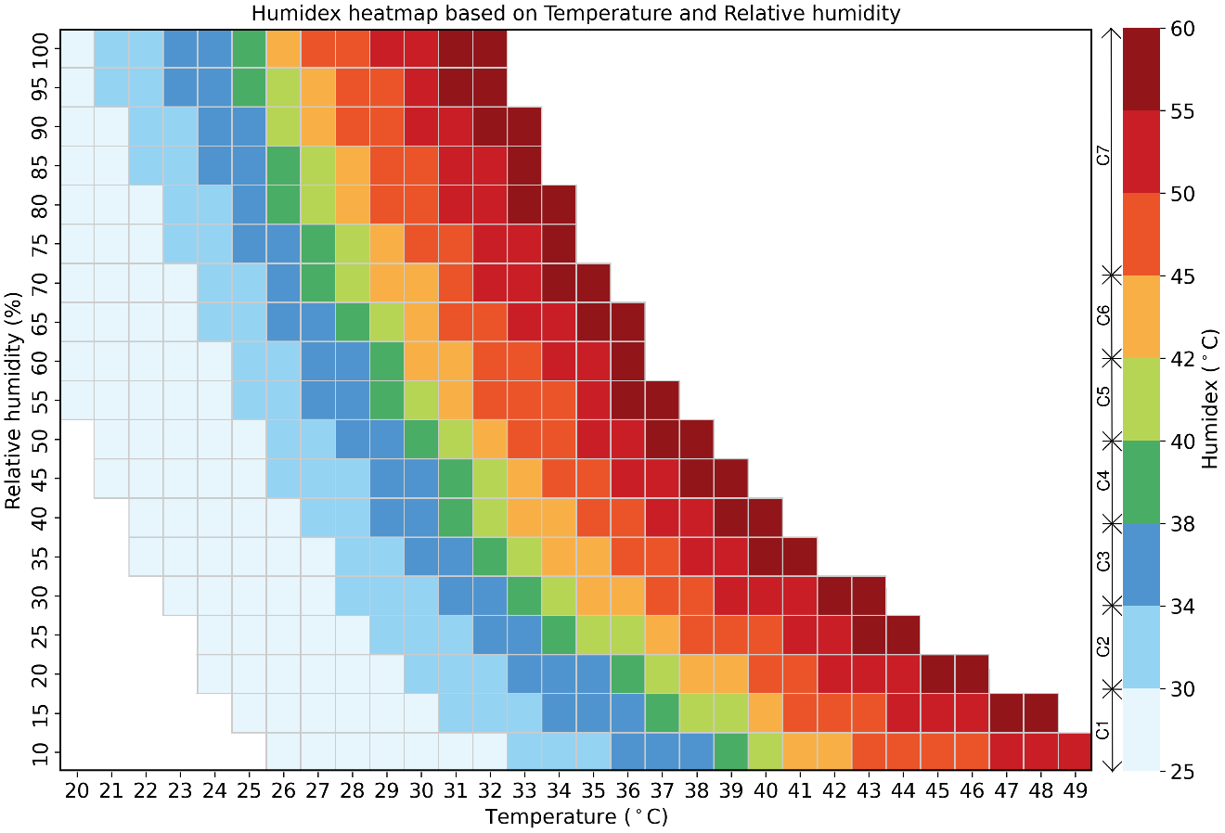

The theoretical Humidex index is calculated based on temperature and relative humidity. The colorbar illustrates the contour of Humidex values in °C, categorized into seven distinct levels as outlined in Table-1 of the main manuscript.

