Figure S1 Diagram for Study Population Selection Process

Exclude:
Twins (n=6)
No available data for birth outcomes or PFAS measurements (n=39)
Mothers-infant pairs in Taiwan Birth Panel study (n = 486)
Mothers-infant pairs in Taiwan Birth Panel study with complete data for exposure and outcomes (n = 431)
Exclude:
Participants without available genotyping data (n=90)
Participants without genotyping results (n=3)
Study population in this study
(n = 338)
Figure S2 Directed acyclic graph
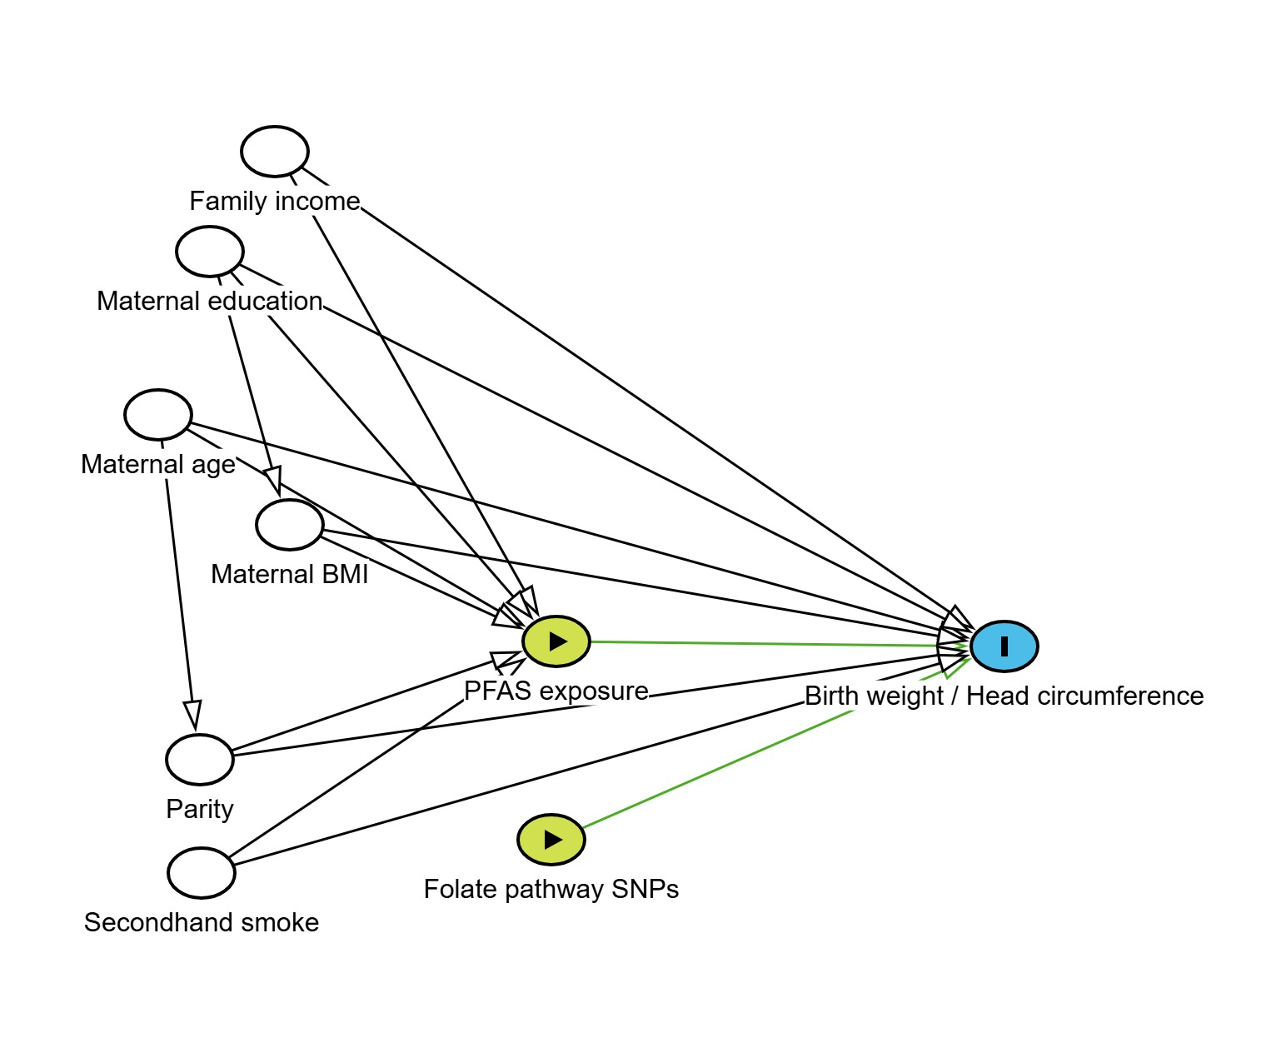
Figure S3 Association Between PFAS Mixture with Birth Weight Across Joint Exposure Quartiles Using Quantile G-Computation
- PFAS mixture-birth weight association
Unadjusted | Adjusted
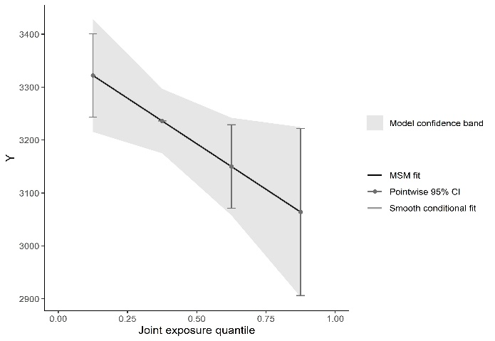 | 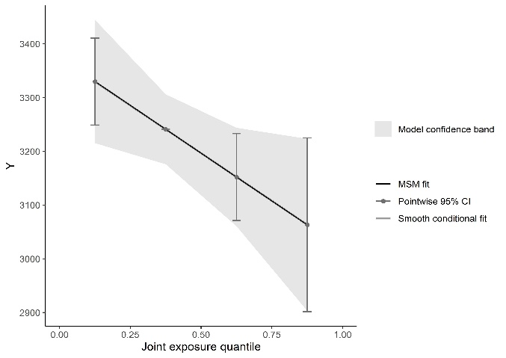
- PFAS mixture-birth weight association, stratified by genotypes
rs1801133 GG genotype | rs1801133, other genotypes (AA/AG)
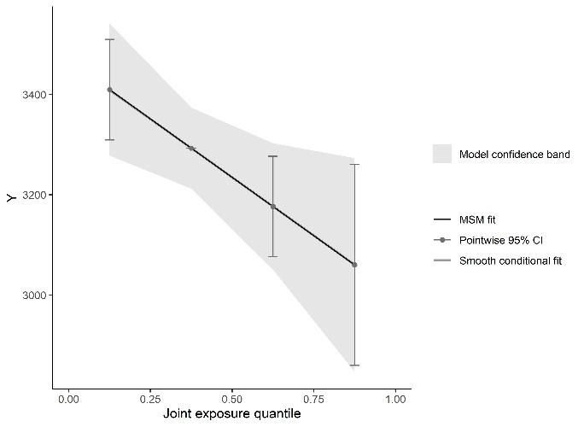 | 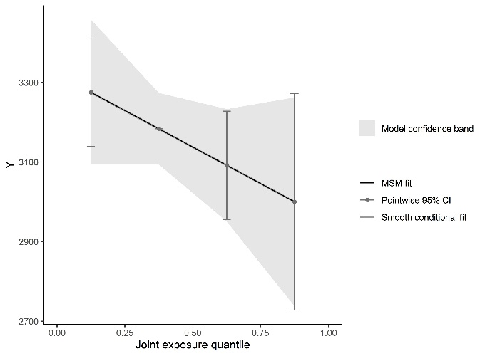
rs2236225 GG genotype | rs2236225, other genotypes (AA/AG)
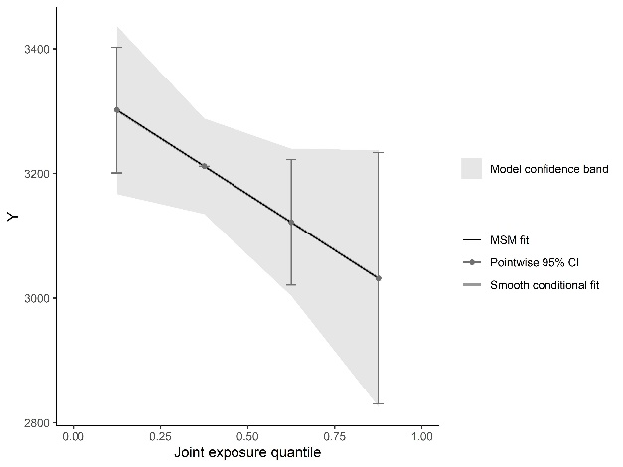 | 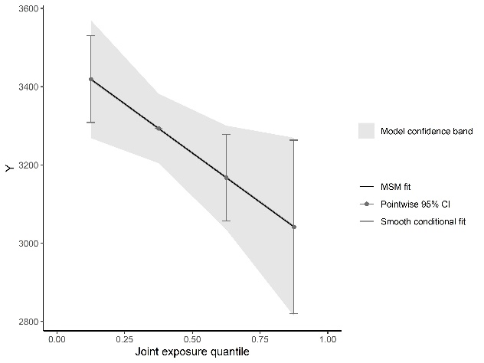
rs1805087 AA genotype | rs1805087, other genotypes (AG/GG)
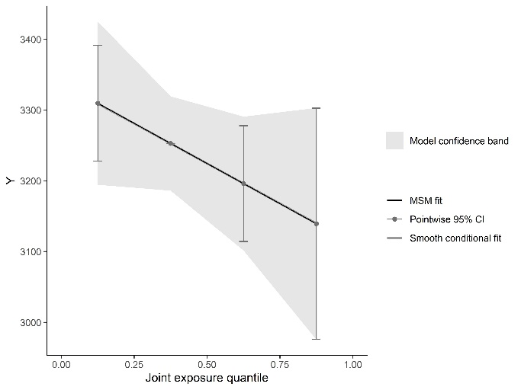 | 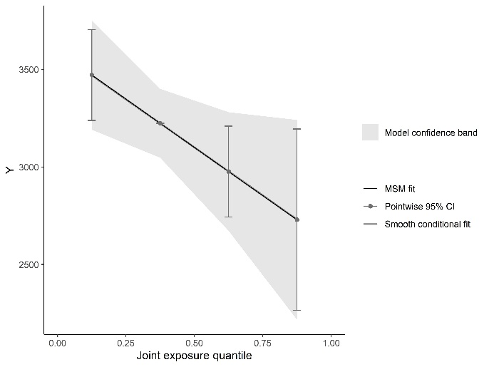
rs1801394 AA genotype | rs1801394, other genotypes (AG/GG)
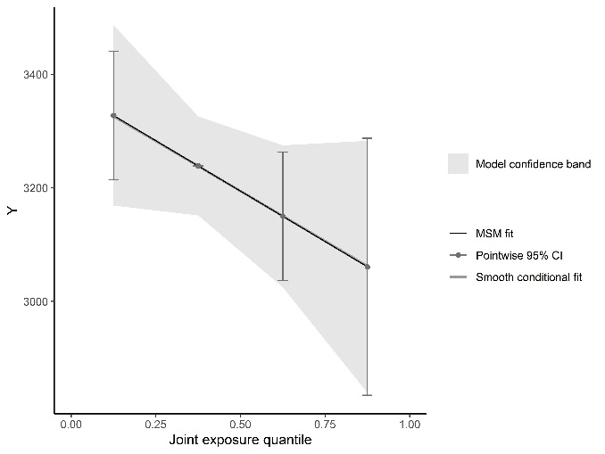 | 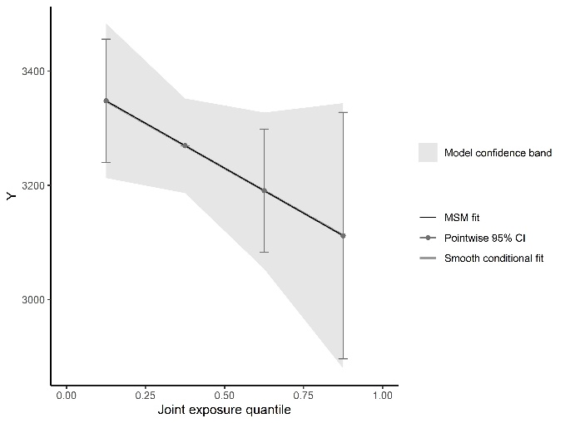
rs234714 CC genotype | rs234714, other genotypes (CT/TT)
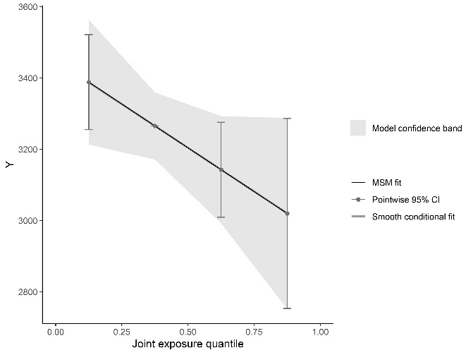 | 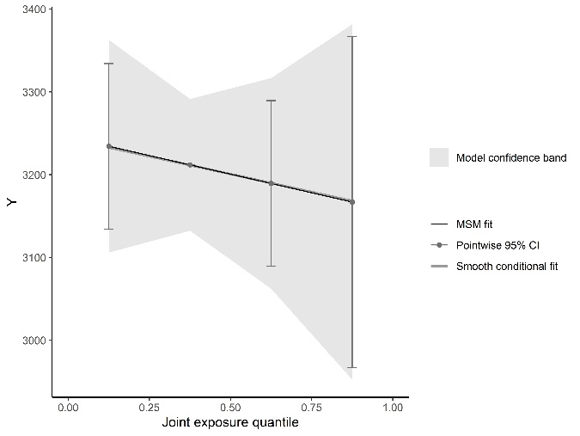
rs10830963 CC genotype | rs10830963, other genotypes (CG/GG)
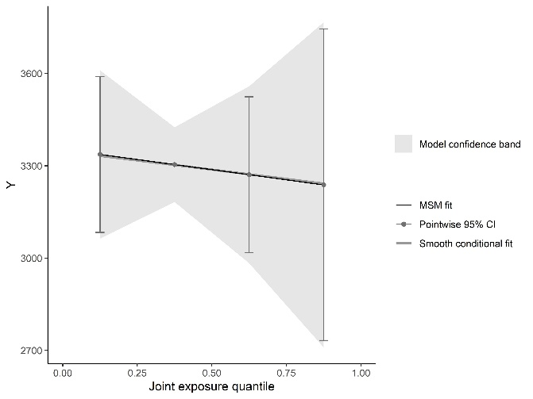 | 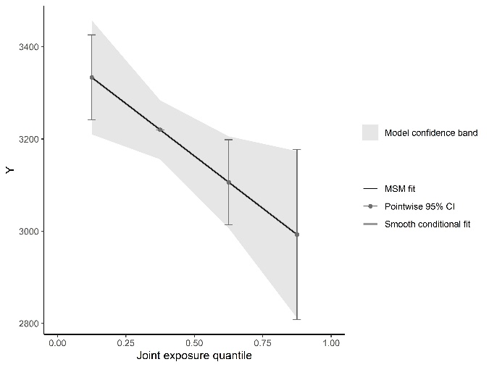
rs1351394 CC genotype | rs1351394, other genotypes (CT/TT)
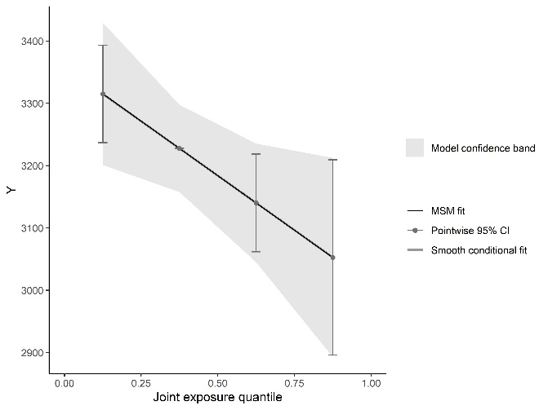 | 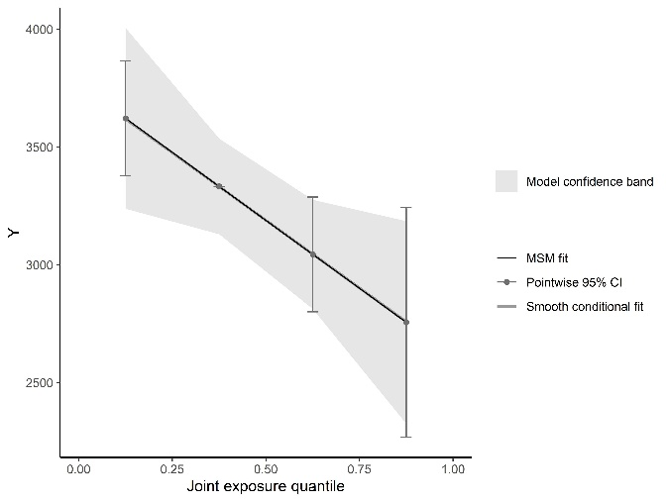
rs1042725 TT genotype | rs1042725, other genotypes (CC/CT)
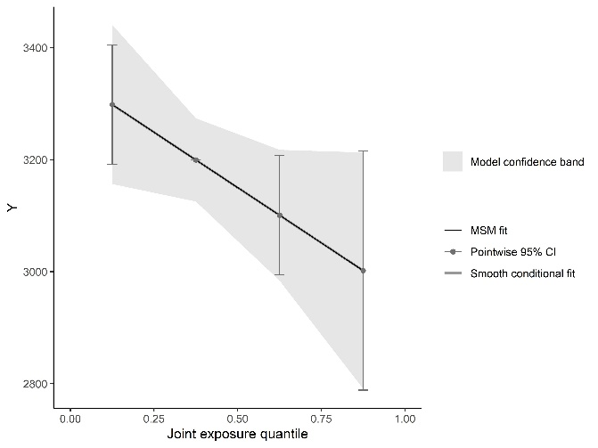 | 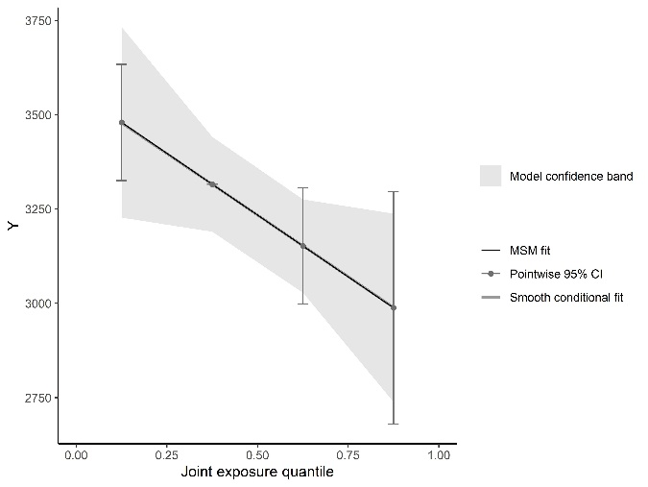

Figure S4 Genotype-Stratified Non-linear Associations Between Individual PFAS Level and Birth Weight
rs1801133 GG genotype | rs1801133, other genotypes
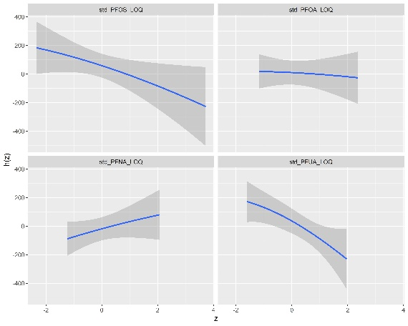 | 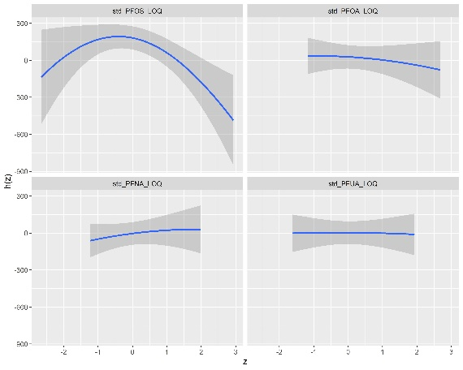
rs2236225 GG genotype | rs2236225, other genotypes
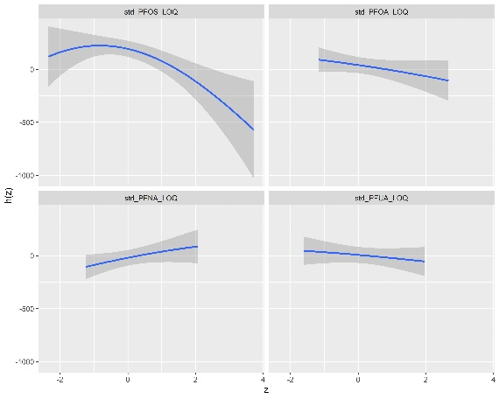 | 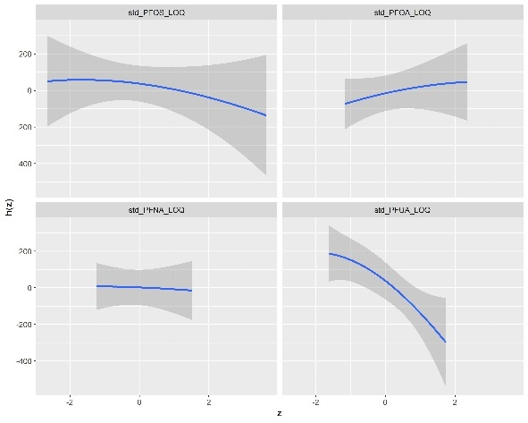
rs1805087 AA genotype | rs1805087, other genotypes
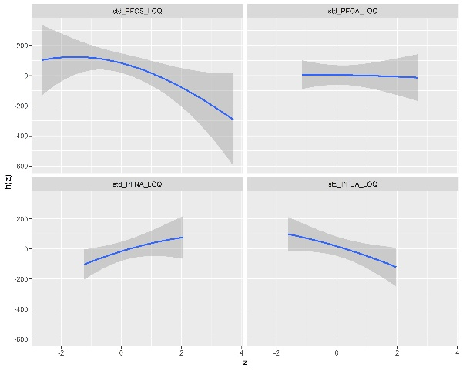 | 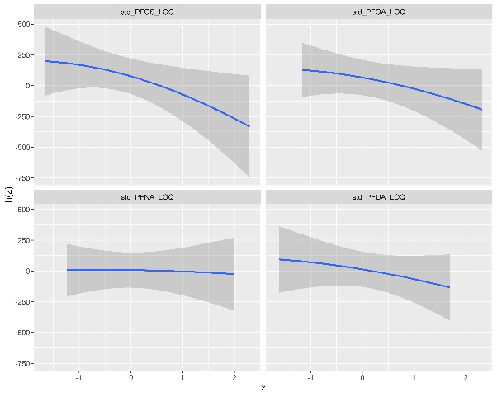
rs1801394 AA genotype | rs1801394, other genotypes
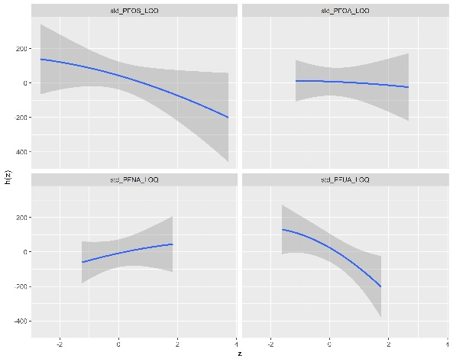 | 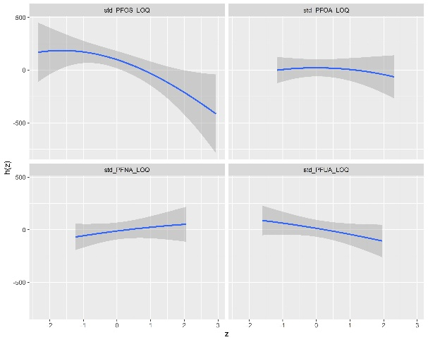
rs234714 CC genotype | rs234714, other genotypes
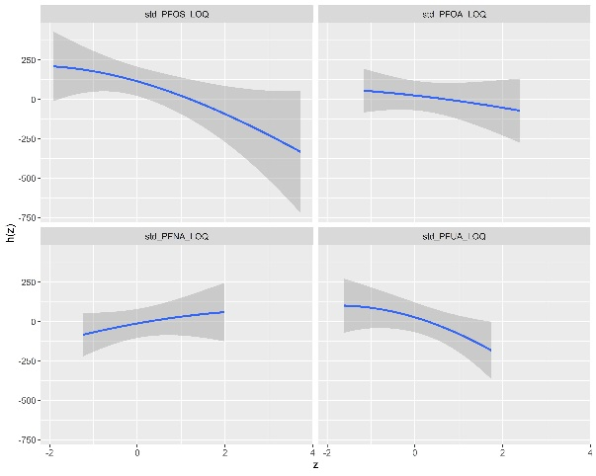 | 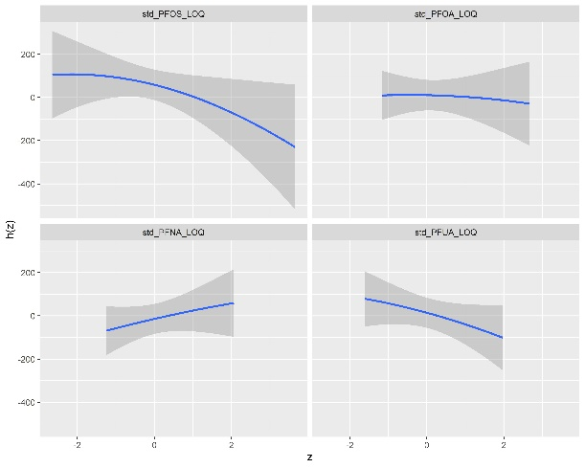
rs10830963 CC genotype | rs10830963, other genotypes
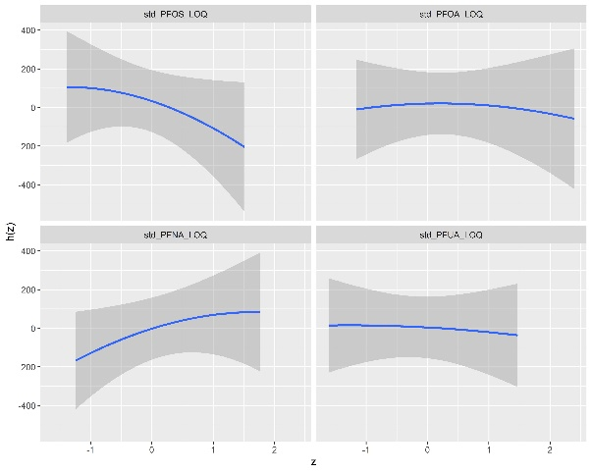 | 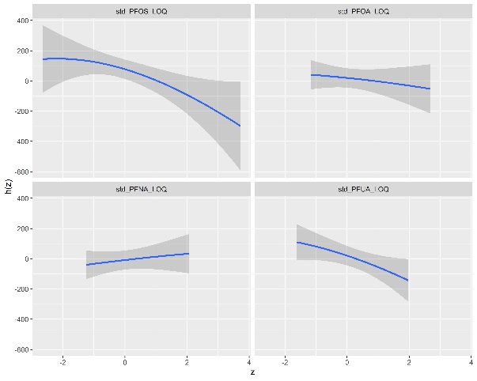
rs1351394 CC genotype | rs1351394, other genotypes
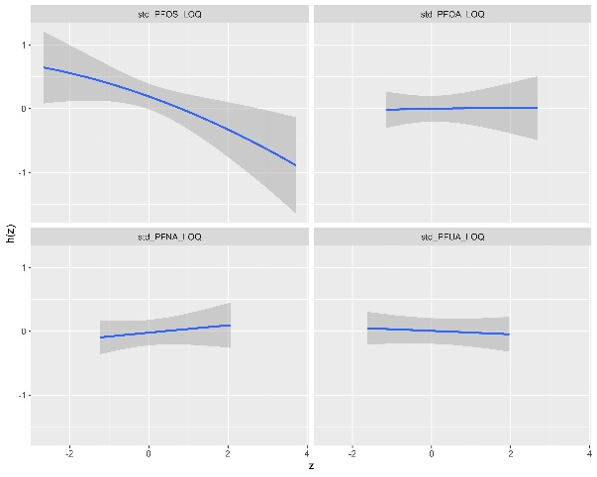 | 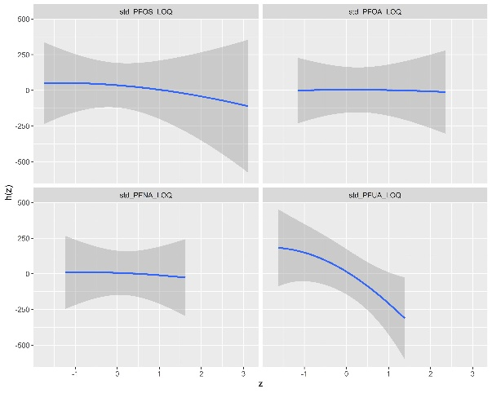
rs1042725 TT genotype | rs1042725, other genotypes
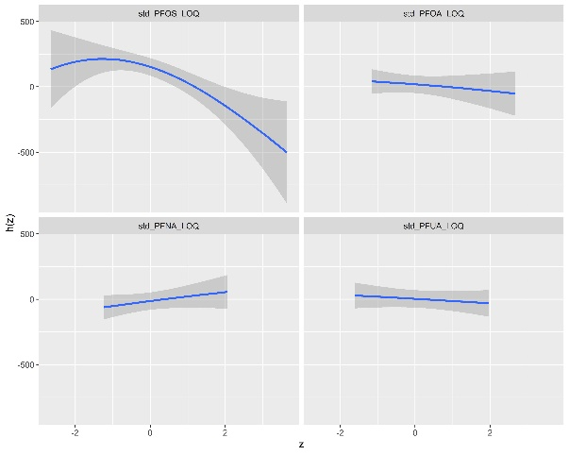 | 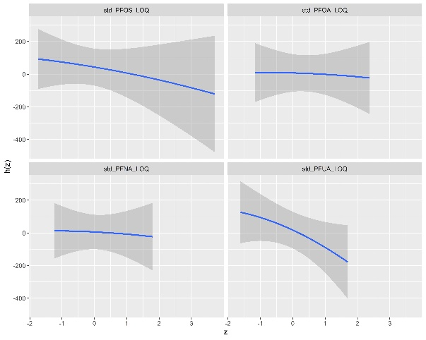

Figure S5 Genotype-Stratified Interactions Between Individual PFAS Within PFAS Mixture on Birth Weight
rs1801133 GG genotype | rs1801133, other genotypes
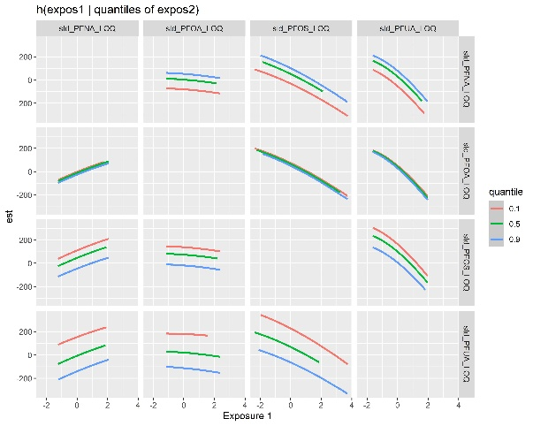 | 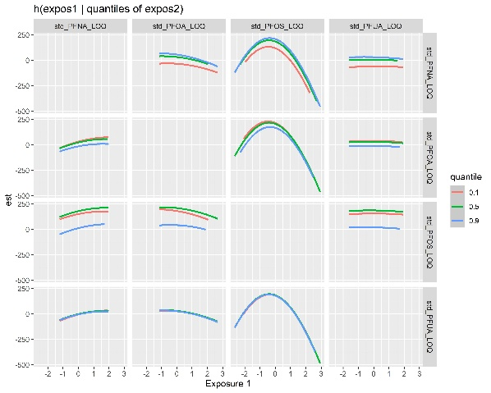
rs2236225 GG genotype | rs2236225, other genotypes
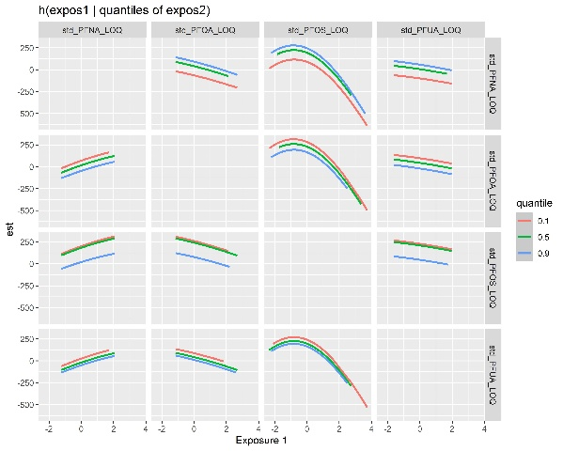 | 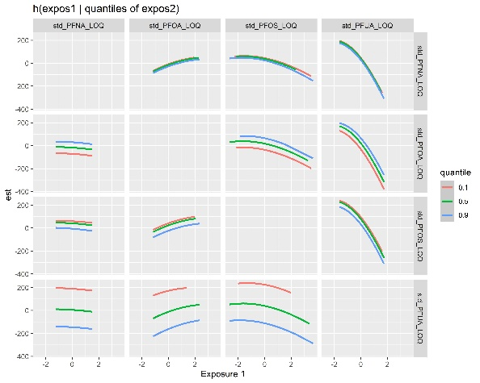
rs1805087 AA genotype | rs1805087, other genotypes
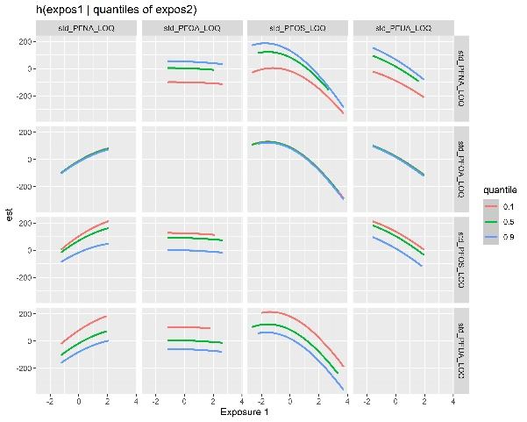 | 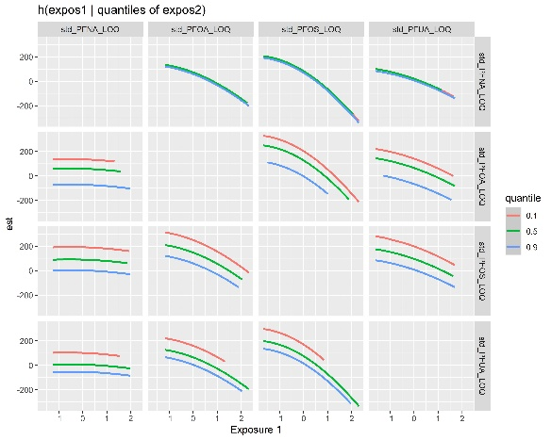
rs1801394 AA genotype | rs1801394, other genotypes
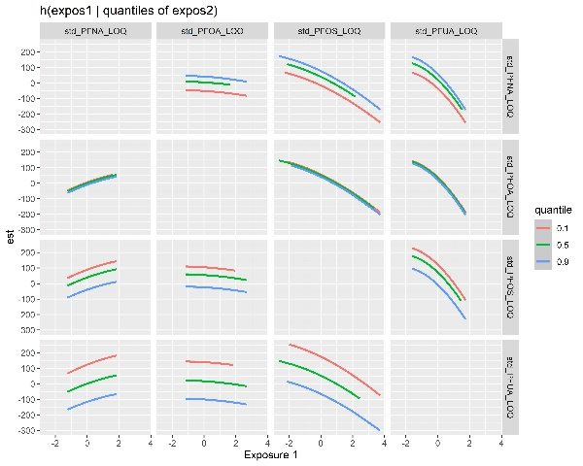 | 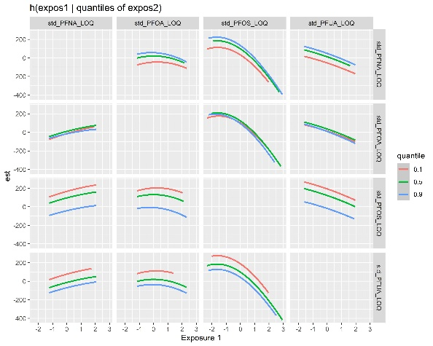
rs234714 CC genotype | rs234714, other genotypes
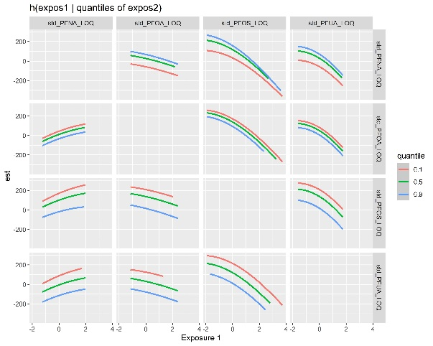 | 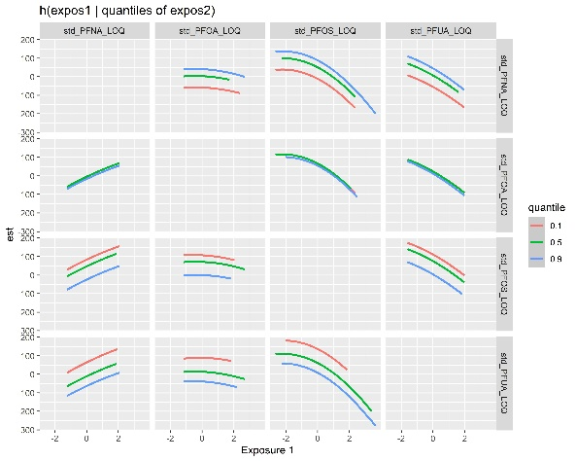
rs10830963 CC genotype | rs10830963, other genotypes
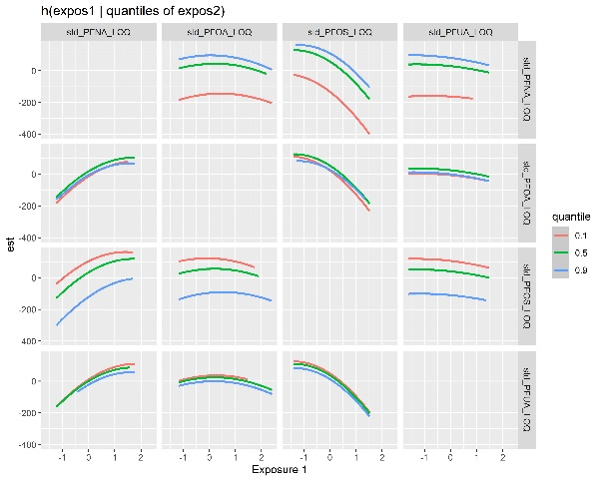 | 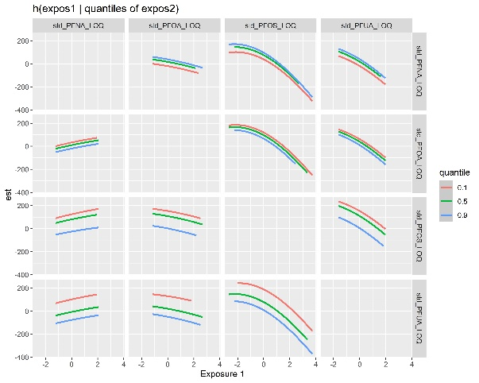
rs1351394 CC genotype | rs1351394, other genotypes
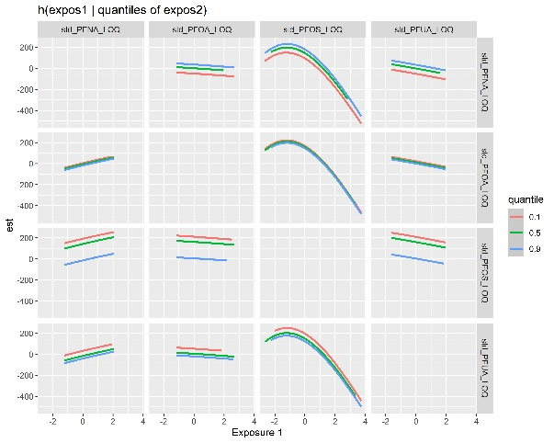 | 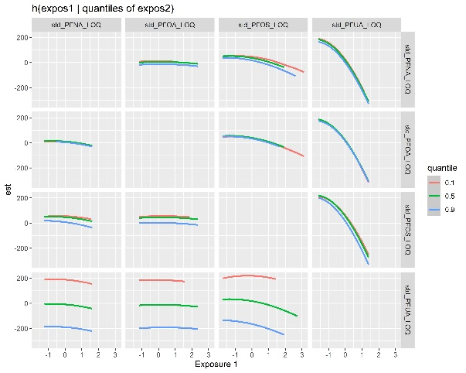
rs1042725 TT genotype | rs1042725, other genotypes
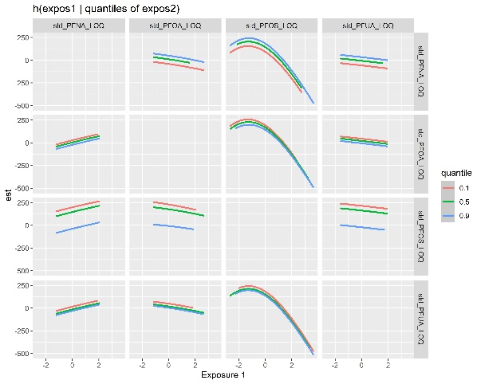 | 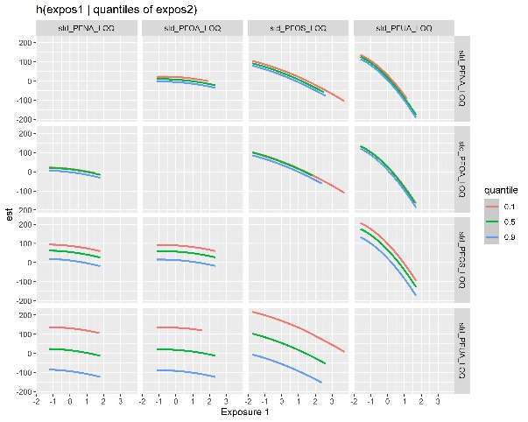

Figure S6 Association Between PFAS Mixture with Head Circumference Across Joint Exposure Quartiles Using Quantile G-Computation
- PFAS mixture-head circumference association
Unadjusted | Adjusted
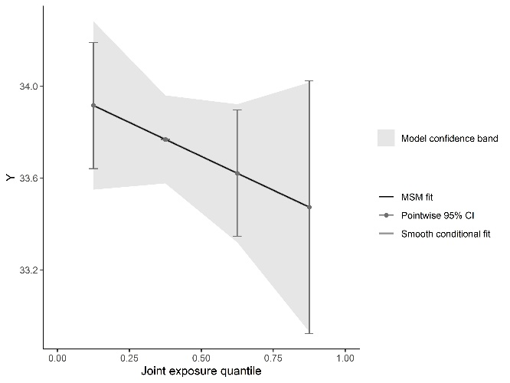 | 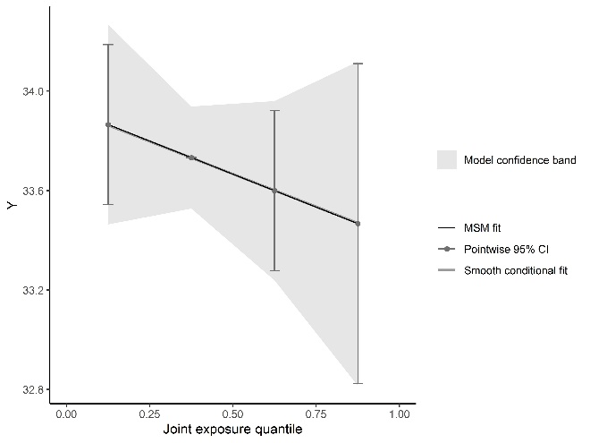
- PFAS mixture- head circumference association, stratified by genotypes
rs1801133 GG genotype | rs1801133, other genotypes
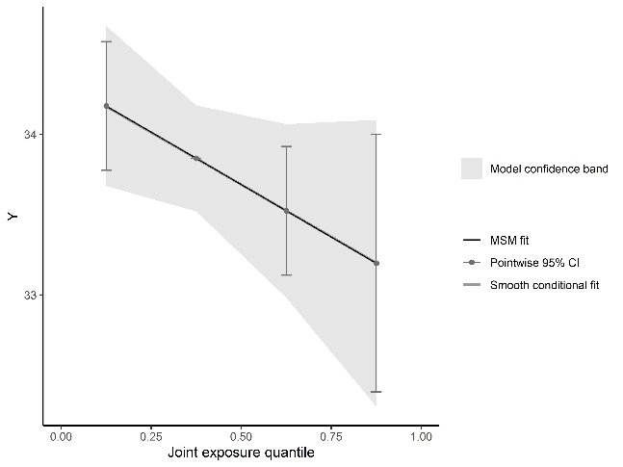 | 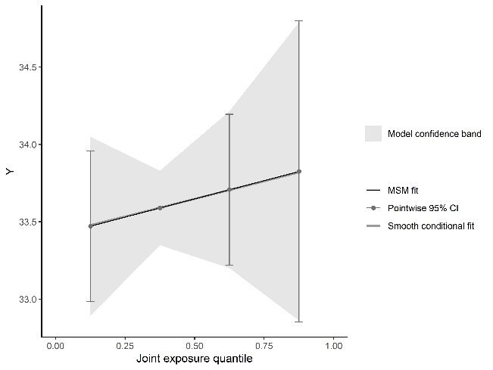
rs2236225 GG genotype | rs2236225, other genotypes
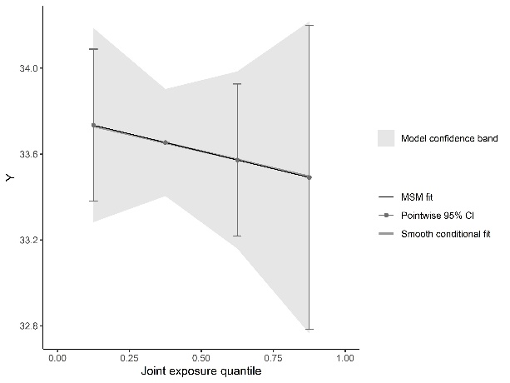 | 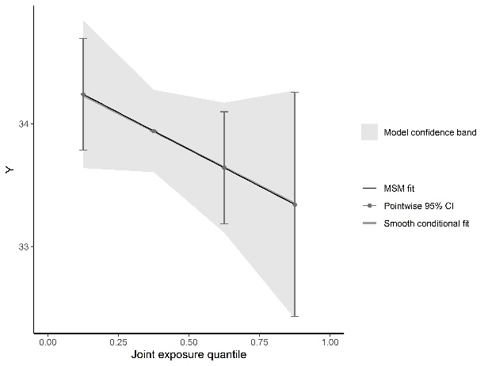
rs1805087 AA genotype | rs1805087, other genotypes
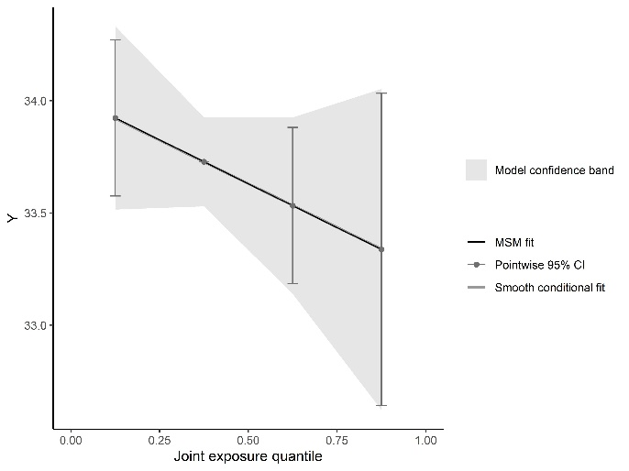 | 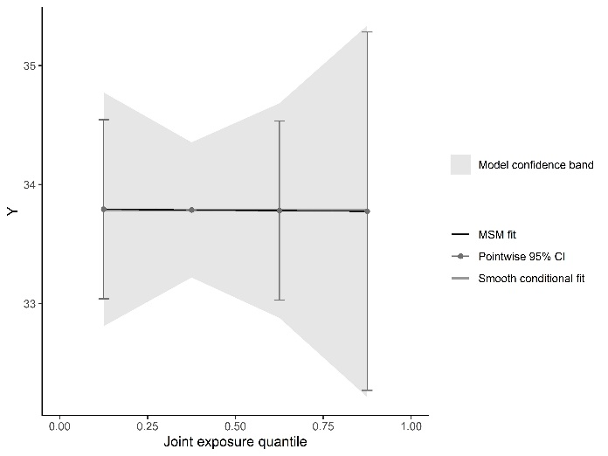
rs1801394 AA genotype | rs1801394, other genotypes
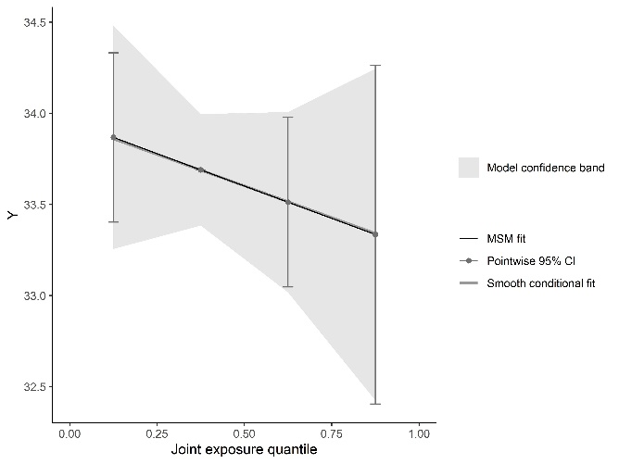 | 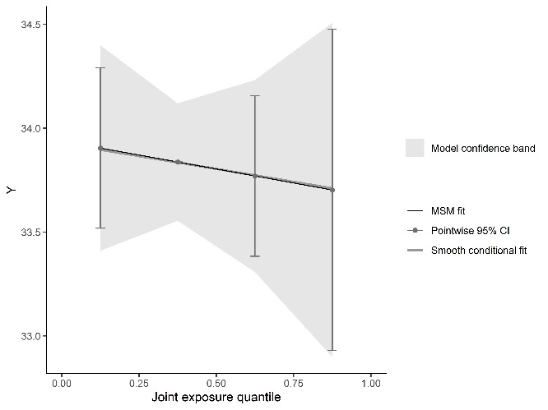
rs234714 CC genotype | rs234714, other genotypes
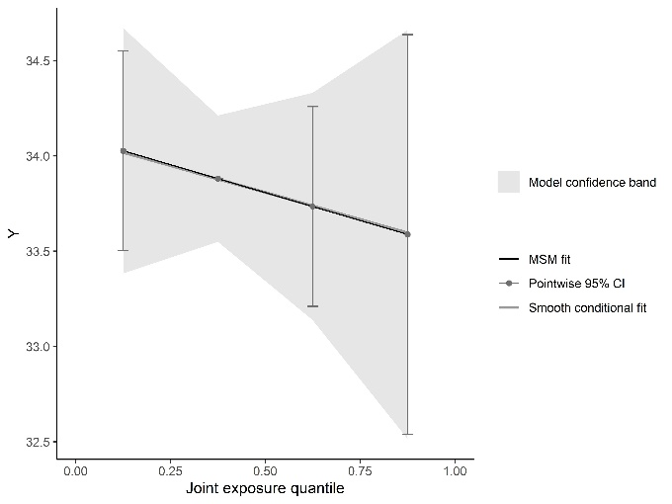 | 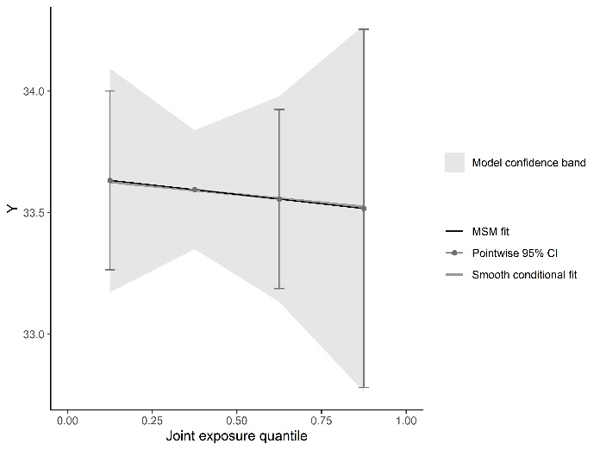
rs10830963 CC genotype | rs10830963, other genotypes
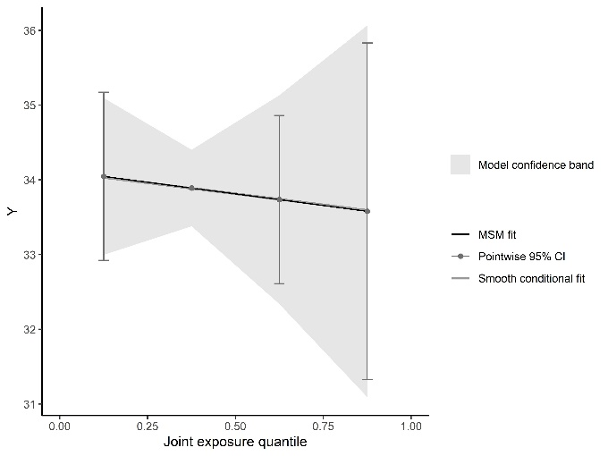 | 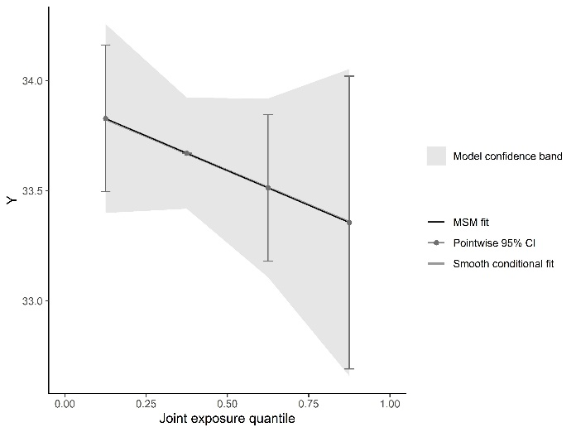
rs1351394 CC genotype | rs1351394, other genotypes
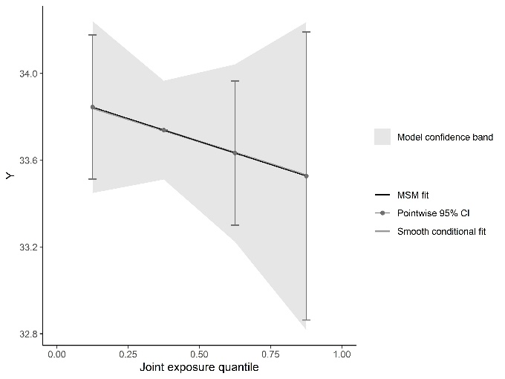 | 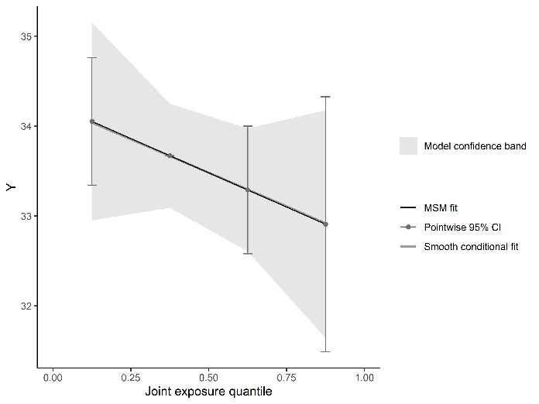
rs1042725 TT genotype | rs1042725, other genotypes
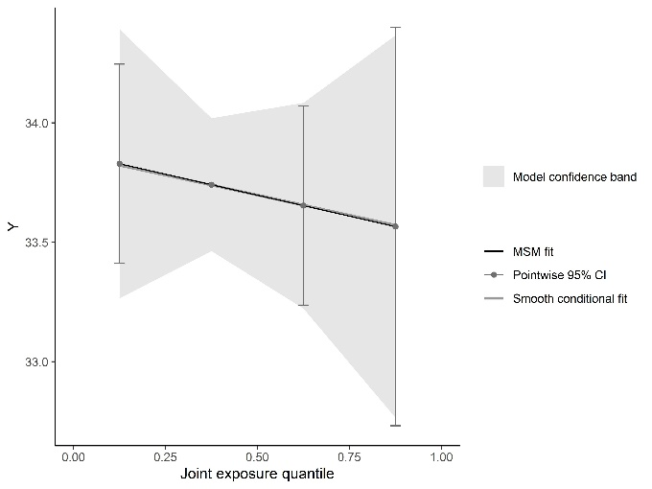 | 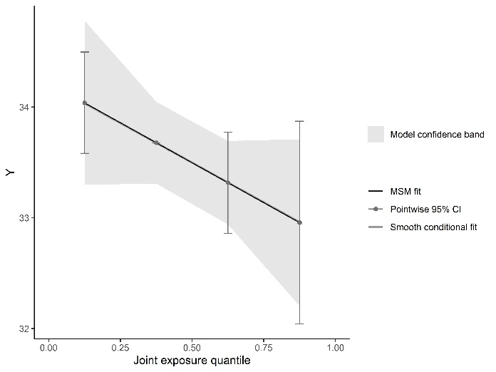

Figure S7 Genotype-Stratified Non-linear Associations Between Individual PFAS Exposure and Head Circumference
rs1801133 GG genotype | rs1801133, other genotypes
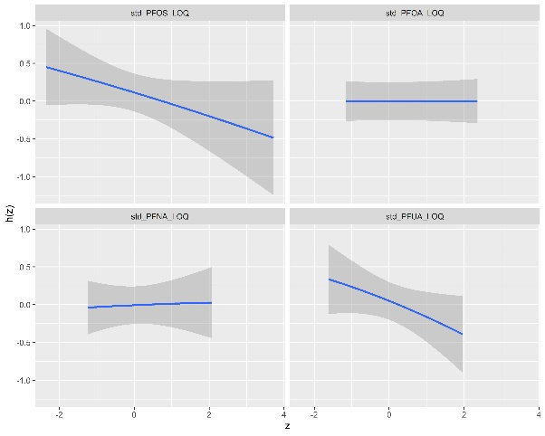 | 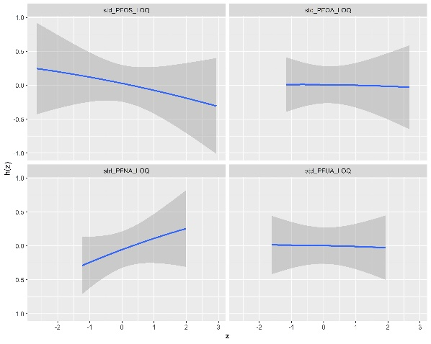
rs2236225 GG genotype | rs2236225, other genotypes
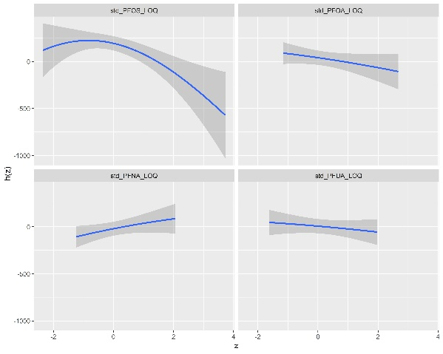 | 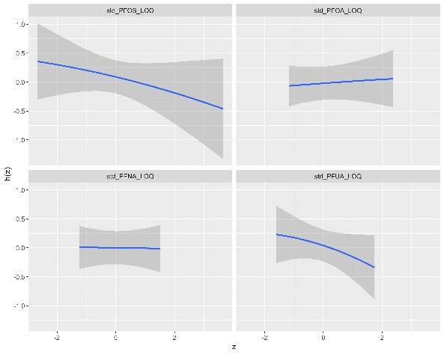
rs1805087 AA genotype | rs1805087, other genotypes
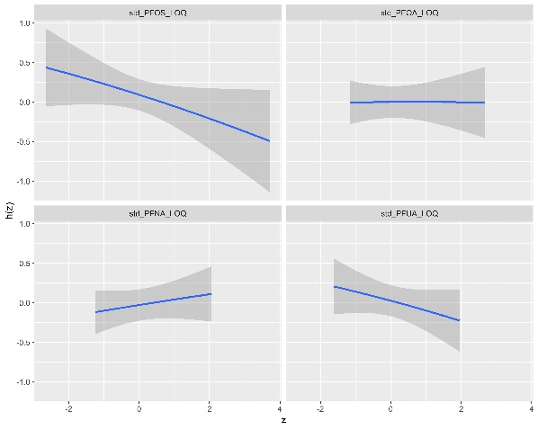 | 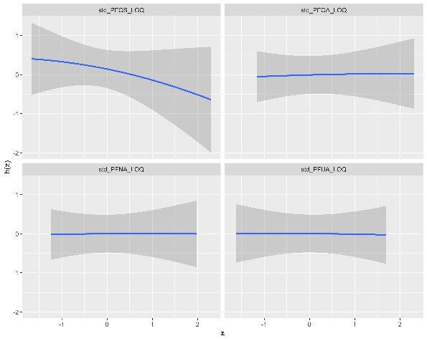
rs1801394 AA genotype | rs1801394, other genotypes
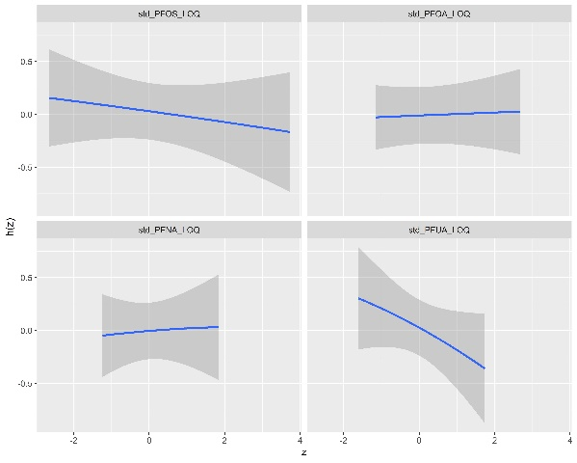 | 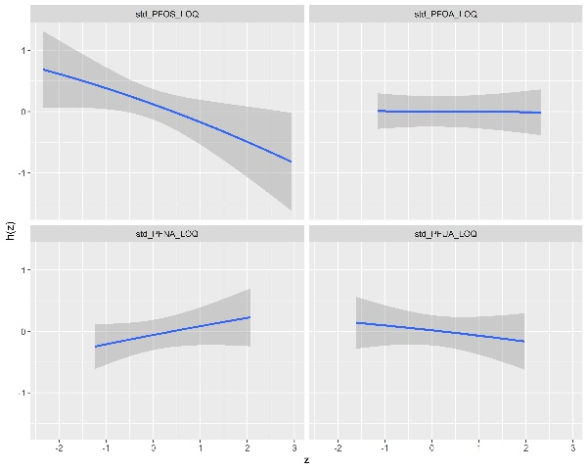
rs234714 CC genotype | rs234714, other genotypes
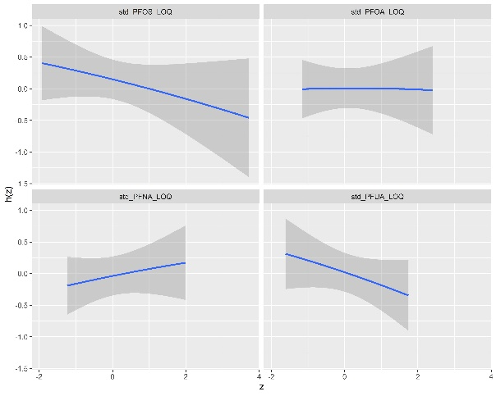 | 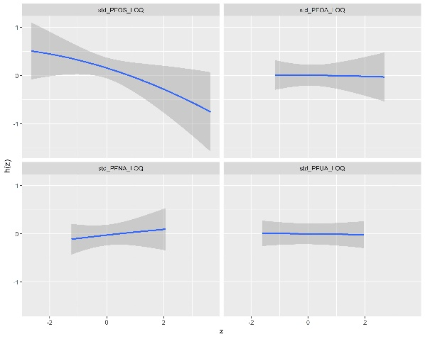
rs10830963 CC genotype | rs10830963, other genotypes
 | 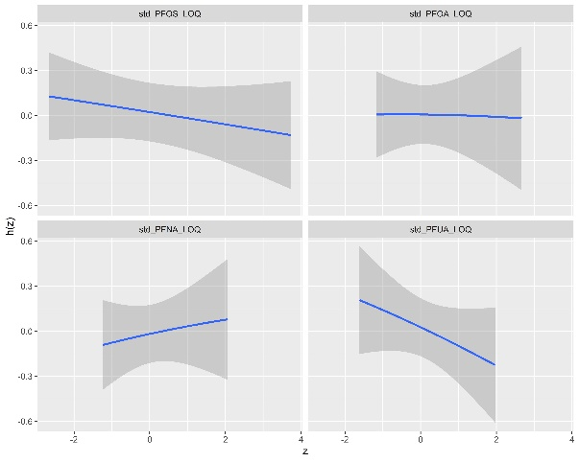
rs1351394 CC genotype | rs1351394, other genotypes
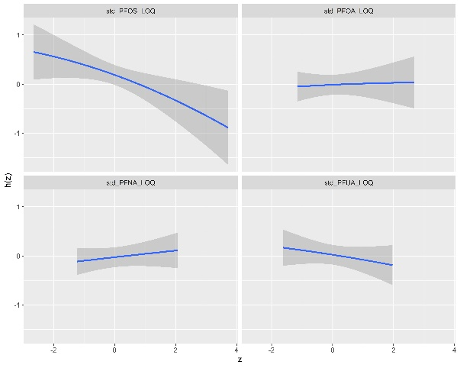 | 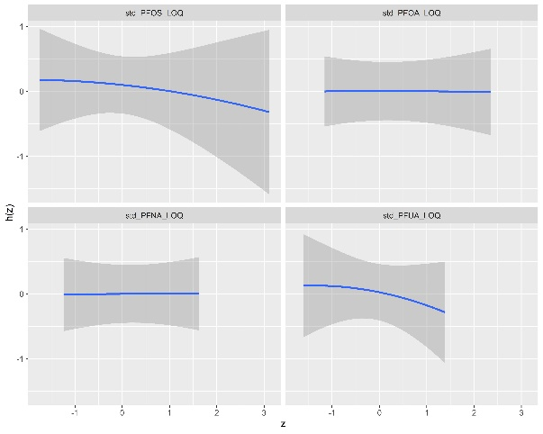
rs1042725 TT genotype | rs1042725, other genotypes
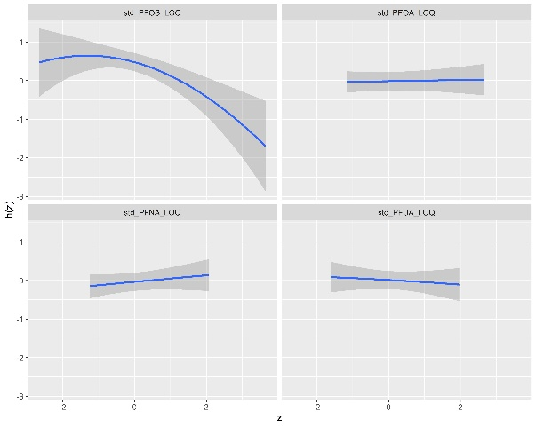 | 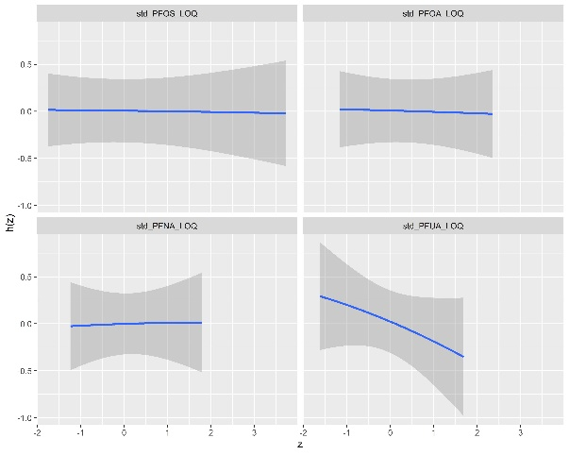

Figure S8 Genotype-Stratified Interactions Between Individual PFAS Within PFAS Mixture on Head Circumference
rs1801133 GG genotype | rs1801133, other genotypes
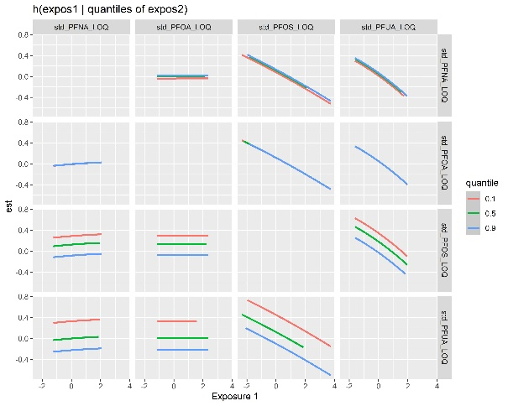 | 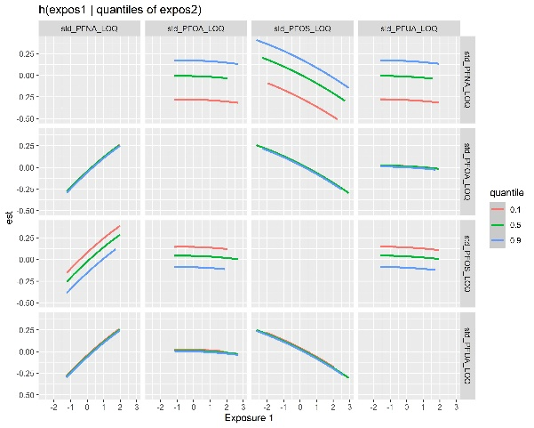
rs2236225 GG genotype | rs2236225, other genotypes
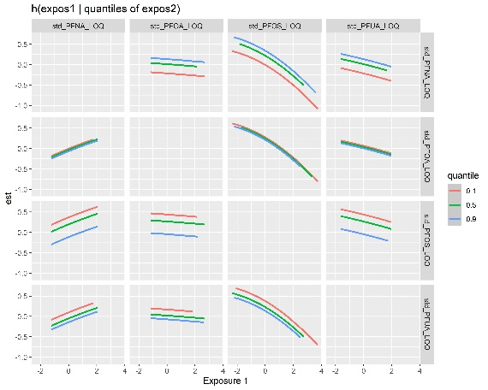 | 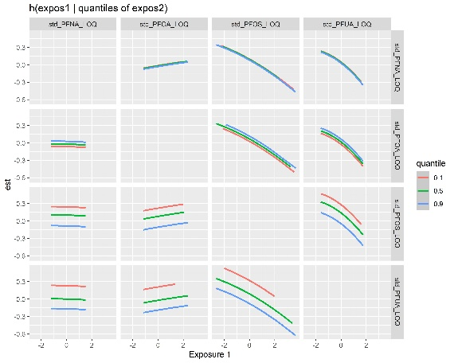
rs1805087 AA genotype | rs1805087, other genotypes
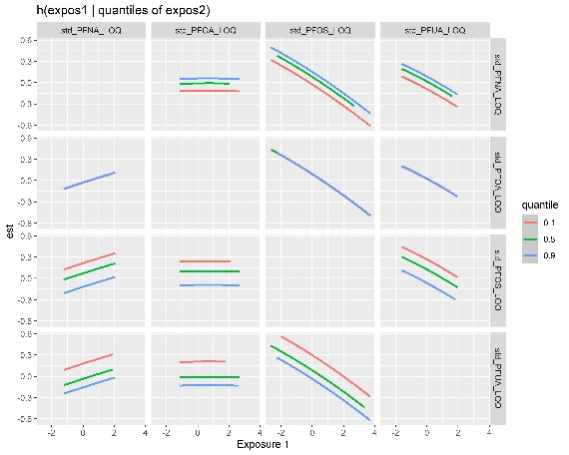 | 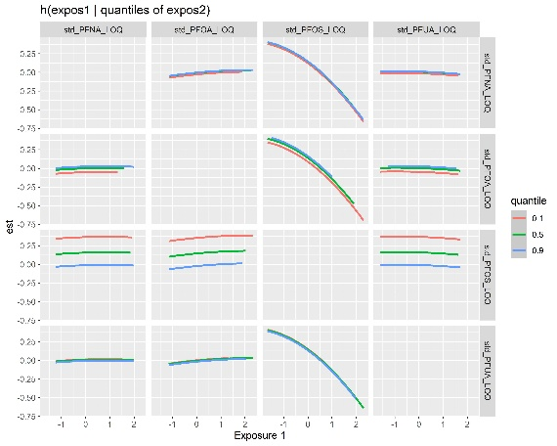
rs1801394 AA genotype | rs1801394, other genotypes
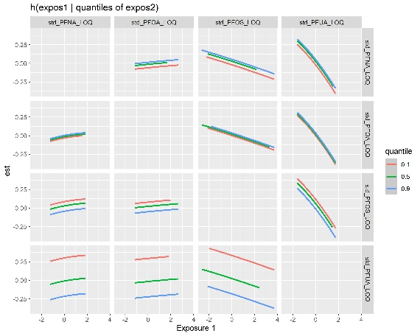 | 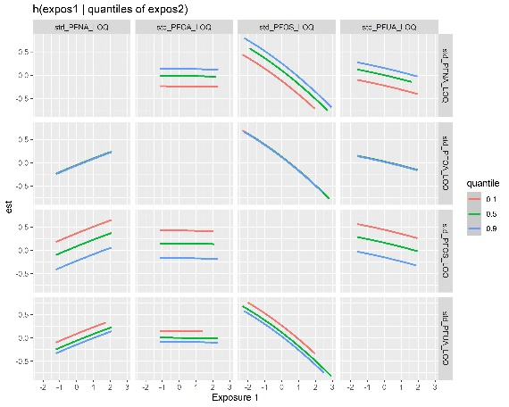
rs234714 CC genotype | rs234714, other genotypes
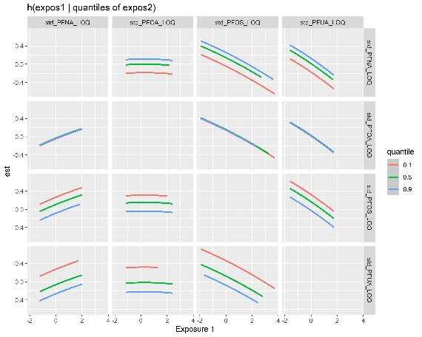 | 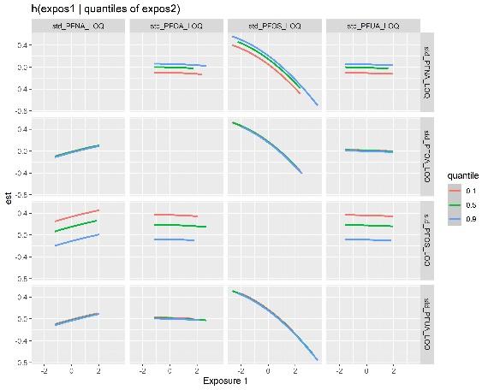
rs10830963 CC genotype | rs10830963, other genotypes
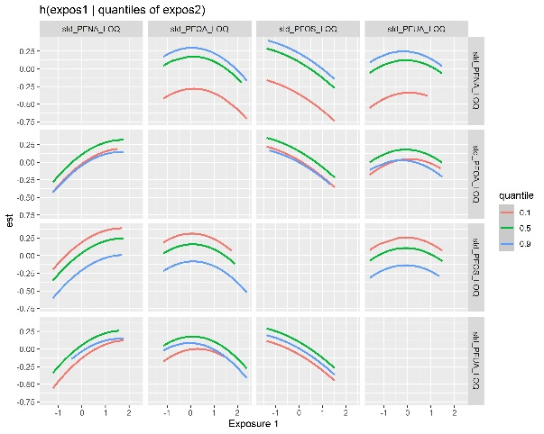 | 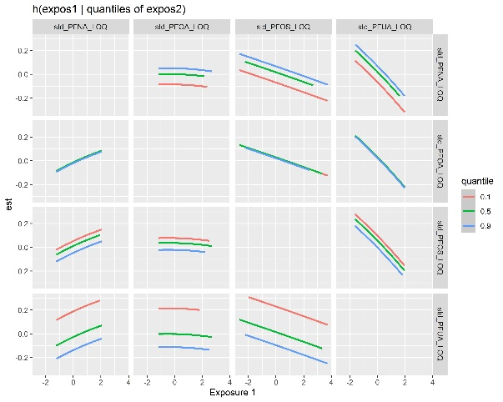
rs1351394 CC genotype | rs1351394, other genotypes
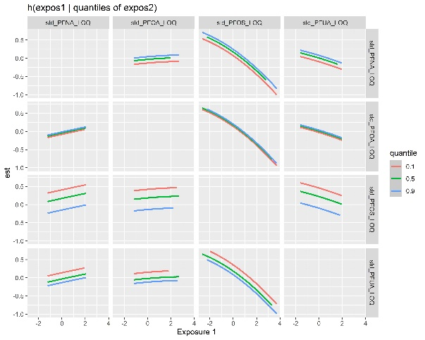 | 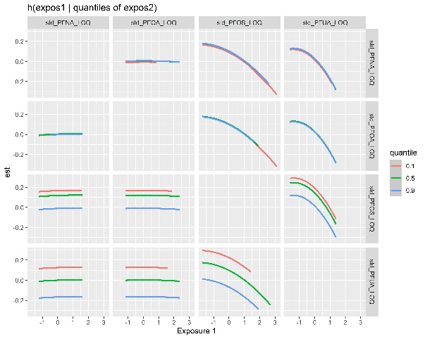
rs1042725 TT genotype | rs1042725, other genotypes
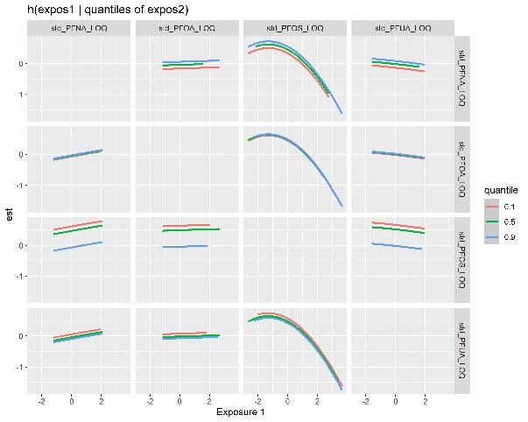 | 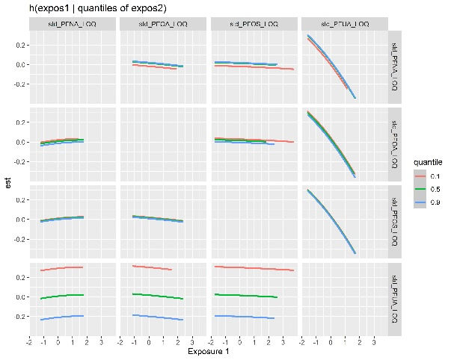

Table S1 Associations of PFAS concentrations and birth weight, stratified by selected genotypes
 | Estimate | 95% confidence interval |  | Estimate | 95% confidence interval |  | P-for-interaction
rs1801133 | GG genotype |  |  | Other genotypes
PFOA | -37.94 | -107.49 | 31.62 | -10.25 | -87.50 | 66.99 | 0.645
PFNA | 11.12 | -59.86 | 82.11 | 7.26 | -68.09 | 82.61 | 0.943
PFOS | -89.51 | -157.14 | -21.87 | -73.25 | -153.16 | 6.65 | 0.923
PFUA | -95.21 | -160.37 | -30.05 | -15.33 | -94.58 | 63.93 | 0.118
Mixture | -122.69 | -226.74 | -18.64 | -82.03 | -217.36 | 53.29 | 0.594
rs2236225 | GG genotype |  |  | Other genotypes
PFOA | -45.37 | -113.86 | 23.12 | 0.30 | -75.39 | 75.99 | 0.350
PFNA | 32.77 | -32.23 | 97.77 | -15.65 | -95.76 | 64.47 | 0.298
PFOS | -104.52 | -173.37 | -35.66 | -47.75 | -120.38 | 24.87 | 0.266
PFUA | -30.15 | -96.23 | 35.93 | -116.98 | -193.08 | -40.87 | 0.059
Mixture | -82.80 | -182.86 | 17.26 | -126.42 | -239.18 | -13.67 | 0.363
rs1805087 | AA genotype |  |  | Other genotypes
PFOA | -0.93 | -57.38 | 55.52 | -125.03 | -248.05 | -2.02 | 0.091
PFNA | 37.72 | -16.59 | 92.04 | -76.27 | -212.37 | 59.83 | 0.076
PFOS | -63.81 | -117.39 | -10.23 | -194.48 | -344.18 | -44.77 | 0.032
PFUA | -48.72 | -102.71 | 5.27 | -139.36 | -274.24 | -4.47 | 0.317
Mixture | -62.66 | -145.96 | 20.63 | -244.89 | -503.69 | 13.92 | 0.021
rs1801394 | AA genotype |  |  | Other genotypes
PFOA | -11.68 | -85.38 | 62.01 | -24.57 | -94.04 | 44.89 | 0.510
PFNA | 11.85 | -58.91 | 82.61 | 14.88 | -54.51 | 84.27 | 0.832
PFOS | -70.17 | -135.88 | -4.47 | -113.95 | -190.87 | -37.04 | 0.531
PFUA | -92.16 | -164.68 | -19.64 | -59.51 | -127.53 | 8.51 | 0.561
Mixture | -98.73 | -209.67 | 12.22 | -68.01 | -175.05 | 39.04 | 0.999
rs234714 | CC genotype |  |  | Other genotypes
PFOA | -57.72 | -138.21 | 22.78 | 4.46 | -61.01 | 69.93 | 0.409
PFNA | 17.41 | -60.95 | 95.77 | 22.41 | -42.89 | 87.72 | 0.771
PFOS | -100.79 | -177.80 | -23.79 | -53.68 | -120.64 | 13.28 | 0.216
PFUA | -83.99 | -164.07 | -3.92 | -41.80 | -104.95 | 21.36 | 0.337
Mixture | -132.28 | -265.27 | 0.71 | -18.63 | -117.17 | 79.91 | 0.367
rs10830963 | CC genotype |  |  | Other genotypes
PFOA | 6.45 | -149.21 | 162.11 | -31.46 | -86.65 | 23.73 | 0.806
PFNA | 133.32 | -16.09 | 282.73 | -7.42 | -61.64 | 46.79 | 0.039
PFOS | -130.53 | -313.17 | 52.11 | -77.65 | -129.86 | -25.44 | 0.867
PFUA | 0.75 | -142.10 | 143.60 | -73.02 | -127.88 | -18.16 | 0.251
Mixture | -5.34 | -269.71 | 259.03 | -116.81 | -208.59 | -25.02 | 0.196
rs1351394 | CC genotype |  |  | Other genotypes
PFOA | -20.82 | -76.64 | 34.99 | -43.32 | -168.93 | 82.30 | 0.061
PFNA | 24.64 | -28.13 | 77.41 | -67.20 | -219.15 | 84.76 | 0.621
PFOS | -98.47 | -151.34 | -45.60 | -61.13 | -207.60 | 85.34 | 0.295
PFUA | -37.64 | -90.72 | 15.44 | -182.66 | -323.59 | -41.72 | 0.272
Mixture | -89.03 | -164.55 | -13.50 | -286.36 | -538.32 | -34.40 | 0.506
rs1042725 | TT genotype |  |  | Other genotypes
PFOA | -28.50 | -88.92 | 31.92 | -38.37 | -133.51 | 56.76 | 0.918
PFNA | 24.14 | -33.02 | 81.31 | -38.51 | -141.93 | 64.91 | 0.404
PFOS | -104.74 | -161.70 | -47.78 | -57.38 | -162.22 | 47.45 | 0.174
PFUA | -37.72 | -95.69 | 20.26 | -101.27 | -201.36 | -1.18 | 0.249
Mixture | -101.74 | -203.35 | -0.13 | -155.78 | -317.68 | 6.12 | 0.974
a. The concentrations were log-transformed and scaled with mean of 0 and standard deviation of 1. Adjusted for maternal age (> 35 years old or not), education (college or above versus others), family income (higher or lower than the average income), environmental tobacco smoke exposure (yes or no), parity, BMI trajectories (underweight, normal, overweight or obesity), and fish intake.

Table S2 Associations of PFAS concentrations and head circumference, stratified by selected genotypes
 | Estimate | 95% confidence interval |  | Estimate | 95% confidence interval |  | P-for-interaction
rs1801133 | GG genotype |  |  | Other genotypes
PFOA | -0.07 | -0.31 | 0.18 | 0.10 | -0.16 | 0.35 | 0.479
PFNA | -0.05 | -0.30 | 0.20 | 0.22 | -0.03 | 0.47 | 0.113
PFOS | -0.30 | -0.53 | -0.06 | -0.11 | -0.38 | 0.15 | 0.385
PFUA | -0.23 | -0.46 | 0.00 | -0.01 | -0.27 | 0.26 | 0.151
Mixture | -0.33 | -0.73 | 0.07 | 0.12 | -0.37 | 0.61 | 0.160
rs2236225 | GG genotype |  |  | Other genotypes
PFOA | -0.04 | -0.28 | 0.19 | 0.04 | -0.21 | 0.29 | 0.571
PFNA | 0.12 | -0.10 | 0.34 | -0.03 | -0.30 | 0.24 | 0.308
PFOS | -0.27 | -0.51 | -0.03 | -0.19 | -0.43 | 0.05 | 0.689
PFUA | -0.12 | -0.34 | 0.11 | -0.16 | -0.43 | 0.10 | 0.518
Mixture | -0.08 | -0.44 | 0.27 | -0.30 | -0.76 | 0.16 | 0.422
rs1805087 | AA genotype |  |  | Other genotypes
PFOA | -0.01 | -0.21 | 0.18 | 0.06 | -0.38 | 0.50 | 0.692
PFNA | 0.09 | -0.10 | 0.27 | 0.04 | -0.43 | 0.52 | 0.979
PFOS | -0.20 | -0.38 | -0.01 | -0.42 | -0.95 | 0.12 | 0.220
PFUA | -0.14 | -0.33 | 0.05 | -0.06 | -0.55 | 0.42 | 0.611
Mixture | -0.20 | -0.54 | 0.15 | -0.01 | -0.76 | 0.75 | 0.665
rs1801394 | AA genotype |  |  | Other genotypes
PFOA | 0.06 | -0.20 | 0.32 | -0.02 | -0.25 | 0.22 | 0.667
PFNA | 0.00 | -0.25 | 0.25 | 0.18 | -0.06 | 0.41 | 0.282
PFOS | -0.20 | -0.43 | 0.03 | -0.34 | -0.61 | -0.08 | 0.457
PFUA | -0.24 | -0.50 | 0.02 | -0.10 | -0.33 | 0.14 | 0.524
Mixture | -0.18 | -0.64 | 0.29 | -0.07 | -0.45 | 0.32 | 0.727
rs234714 | CC genotype |  |  | Other genotypes
PFOA | -0.04 | -0.34 | 0.26 | 0.03 | -0.19 | 0.24 | 0.862
PFNA | 0.13 | -0.16 | 0.42 | 0.07 | -0.14 | 0.28 | 0.826
PFOS | -0.26 | -0.54 | 0.03 | -0.22 | -0.44 | -0.01 | 0.817
PFUA | -0.26 | -0.55 | 0.04 | -0.03 | -0.23 | 0.18 | 0.191
Mixture | -0.15 | -0.67 | 0.38 | -0.04 | -0.41 | 0.33 | 0.927
rs10830963 | CC genotype |  |  | Other genotypes
PFOA | 0.02 | -0.54 | 0.59 | 0.00 | -0.19 | 0.19 | 0.766
PFNA | 0.37 | -0.17 | 0.92 | 0.03 | -0.15 | 0.22 | 0.204
PFOS | -0.29 | -0.96 | 0.37 | -0.23 | -0.41 | -0.05 | 0.955
PFUA | 0.09 | -0.43 | 0.60 | -0.15 | -0.34 | 0.04 | 0.402
Mixture | -0.16 | -1.28 | 0.97 | -0.16 | -0.49 | 0.17 | 0.618
rs1351394 | CC genotype |  |  | Other genotypes
PFOA | 0.03 | -0.18 | 0.23 | -0.05 | -0.42 | 0.31 | 0.547
PFNA | 0.11 | -0.08 | 0.30 | -0.05 | -0.49 | 0.39 | 0.590
PFOS | -0.27 | -0.46 | -0.07 | -0.17 | -0.59 | 0.25 | 0.699
PFUA | -0.10 | -0.29 | 0.09 | -0.19 | -0.62 | 0.24 | 0.671
Mixture | -0.11 | -0.44 | 0.23 | -0.38 | -1.09 | 0.33 | 0.650
rs1042725 | TT genotype |  |  | Other genotypes
PFOA | 0.04 | -0.18 | 0.26 | -0.10 | -0.39 | 0.20 | 0.489
PFNA | 0.12 | -0.09 | 0.32 | -0.02 | -0.34 | 0.30 | 0.580
PFOS | -0.32 | -0.53 | -0.11 | -0.06 | -0.39 | 0.27 | 0.177
PFUA | -0.07 | -0.29 | 0.14 | -0.25 | -0.57 | 0.06 | 0.377
Mixture | -0.09 | -0.51 | 0.33 | -0.36 | -0.82 | 0.10 | 0.681
a. The concentrations were log-transformed and scaled with mean of 0 and standard deviation of 1. Adjusted for maternal age (> 35 years old or not), education (college or above versus others), family income (higher or lower than the average income), environmental tobacco smoke exposure (yes or no), parity, BMI trajectories (underweight, normal, overweight or obesity), and fish intake.

Table S3 Baseline characteristics and birth outcomes of participants included in the study and the TBPS I singleton population (Presented in mean ± SD or n (%))
 |  |  |  | Total (N=480) |  | Selected (N=338) |  |  | Others (N=142) |  |  | p-value
Maternal conditions
Maternal age (years) |  |  |  | 30.9 ± 4.6 |  | 30.5 ± 4.6 |  |  | 31.8 ± 4.5 |  |  | 0.006
Maternal weight (kg) |  |  |  | 53.2 ± 8.1 |  | 53.4 ± 8.1 |  |  | 52.5 ± 8.1 |  |  | 0.231
Maternal body mass index before pregnancy |  |  |  |  |  |  |  |  |  |  |  | 0.135
< 18.5 kg/m² |  |  |  | 77 (16.0%) |  | 47 (13.9%) |  |  | 30 (21.1%)
18.5-24 kg/m² |  |  |  | 371 (77.3%) |  | 267 (79.0%) |  |  | 104 (73.2%)
> 24 kg/m² |  |  |  | 32 (6.7%) |  | 24 (7.1%) |  |  | 8 (5.6%)
Family income above 100 thousand new Taiwan dollar |  |  |  | 194 (40.4%) |  | 130 (38.5%) |  |  | 64 (45.1%) |  |  | 0.178
Maternal smoking |  |  |  | 26 (5.4%) |  | 21 (6.2%) |  |  | 5 (3.5%) |  |  | 0.234
Secondhand smoke exposure |  |  |  | 137 (28.5%) |  | 99 (29.3%) |  |  | 38 (26.8%) |  |  | 0.575
Maternal alcohol consumption |  |  |  | 21 (4.4%) |  | 15 (4.4%) |  |  | 6 (4.2%) |  |  | 0.917
Vitamin supplementation |  |  |  | 286 (59.6%) |  | 197 (58.3%) |  |  | 89 (62.7%) |  |  | 0.371
Folic acid supplementation |  |  |  | 52 (10.8%) |  | 38 (11.2%) |  |  | 14 (9.9%) |  |  | 0.656
Maternal education above college level |  |  |  | 213 (44.4%) |  | 142 (42.0%) |  |  | 71 (50.0%) |  |  | 0.108
Birth conditions
Female |  |  |  | 238 (49.6%) |  | 167 (49.4%) |  |  | 71 (50.0%) |  |  | 0.906
First born |  |  |  | 230 (47.9%) |  | 164 (48.5%) |  |  | 66 (46.5%) |  |  | 0.683
Cesarean section |  |  |  | 188 (39.2%) |  | 128 (37.9%) |  |  | 60 (42.3%) |  |  | 0.369
Table S4 Unadjusted and adjusted associations between PFAS concentration and candidate SNPs ª
Name of PFAS | Candidate SNP | Unadjusted |  |  |  |  |  | Adjusted
Name of PFAS | Candidate SNP | Estimate | 95% confidence interval |  |  |  | p-value | Estimate |  | 95% confidence interval |  |  | p-value
PFOA | rs1801133 | 0.11 | -0.10 |  | 0.32 |  | 0.315 | 0.13 |  | -0.09 | 0.34 |  | 0.245
PFOA | rs2236225 | -0.11 | -0.33 |  | 0.11 |  | 0.338 | -0.09 |  | -0.31 | 0.13 |  | 0.431
PFOA | rs1805087 | 0.07 | -0.20 |  | 0.35 |  | 0.605 | 0.00 |  | -0.28 | 0.28 |  | 0.985
PFOA | rs1801394 | -0.06 | -0.28 |  | 0.15 |  | 0.560 | -0.06 |  | -0.27 | 0.16 |  | 0.603
PFOA | rs234714 | 0.00 | -0.21 |  | 0.21 |  | 0.993 | -0.03 |  | -0.24 | 0.19 |  | 0.807
PFOA | rs10830963 | -0.09 | -0.37 |  | 0.20 |  | 0.553 | -0.11 |  | -0.39 | 0.18 |  | 0.460
PFOA | rs1351394 | 0.14 | -0.14 |  | 0.42 |  | 0.335 | 0.11 |  | -0.17 | 0.38 |  | 0.458
PFOA | rs1042725 | 0.20 | -0.03 |  | 0.44 |  | 0.090 | 0.17 |  | -0.07 | 0.40 |  | 0.165
PFNA | rs1801133 | 0.02 | -0.19 |  | 0.23 |  | 0.860 | 0.01 |  | -0.21 | 0.23 |  | 0.907
PFNA | rs2236225 | -0.04 | -0.26 |  | 0.19 |  | 0.749 | -0.03 |  | -0.25 | 0.20 |  | 0.819
PFNA | rs1805087 | -0.08 | -0.35 |  | 0.20 |  | 0.594 | -0.10 |  | -0.38 | 0.19 |  | 0.499
PFNA | rs1801394 | 0.10 | -0.12 |  | 0.31 |  | 0.377 | 0.10 |  | -0.12 | 0.31 |  | 0.387
PFNA | rs234714 | -0.02 | -0.24 |  | 0.19 |  | 0.845 | 0.00 |  | -0.22 | 0.22 |  | 0.979
PFNA | rs10830963 | -0.06 | -0.35 |  | 0.22 |  | 0.668 | -0.08 |  | -0.37 | 0.21 |  | 0.594
PFNA | rs1351394 | 0.21 | -0.07 |  | 0.49 |  | 0.137 | 0.22 |  | -0.07 | 0.50 |  | 0.134
PFNA | rs1042725 | 0.15 | -0.09 |  | 0.38 |  | 0.218 | 0.16 |  | -0.07 | 0.40 |  | 0.179
PFOS | rs1801133 | 0.08 | -0.13 |  | 0.29 |  | 0.469 | 0.09 |  | -0.13 | 0.30 |  | 0.436
PFOS | rs2236225 | -0.07 | -0.29 |  | 0.15 |  | 0.548 | -0.08 |  | -0.30 | 0.14 |  | 0.493
PFOS | rs1805087 | -0.19 | -0.47 |  | 0.08 |  | 0.173 | -0.17 |  | -0.45 | 0.11 |  | 0.228
PFOS | rs1801394 | -0.15 | -0.37 |  | 0.06 |  | 0.161 | -0.16 |  | -0.38 | 0.05 |  | 0.132
PFOS | rs234714 | -0.15 | -0.37 |  | 0.06 |  | 0.156 | -0.12 |  | -0.34 | 0.10 |  | 0.278
PFOS | rs10830963 | 0.05 | -0.23 |  | 0.34 |  | 0.709 | 0.06 |  | -0.23 | 0.34 |  | 0.701
PFOS | rs1351394 | -0.08 | -0.36 |  | 0.20 |  | 0.585 | -0.06 |  | -0.34 | 0.21 |  | 0.651
PFOS | rs1042725 | -0.12 | -0.35 |  | 0.12 |  | 0.334 | -0.10 |  | -0.33 | 0.14 |  | 0.425
PFUA | rs1801133 | 0.01 | -0.21 |  | 0.22 |  | 0.956 | 0.00 |  | -0.22 | 0.21 |  | 0.965
PFUA | rs2236225 | -0.09 | -0.31 |  | 0.14 |  | 0.441 | -0.09 |  | -0.31 | 0.14 |  | 0.452
PFUA | rs1805087 | 0.02 | -0.25 |  | 0.30 |  | 0.871 | 0.00 |  | -0.28 | 0.28 |  | 0.996
PFUA | rs1801394 | 0.07 | -0.14 |  | 0.29 |  | 0.504 | 0.08 |  | -0.13 | 0.30 |  | 0.450
PFUA | rs234714 | -0.03 | -0.25 |  | 0.18 |  | 0.769 | 0.00 |  | -0.22 | 0.22 |  | 0.984
PFUA | rs10830963 | 0.27 | -0.01 |  | 0.55 |  | 0.062 | 0.27 |  | -0.02 | 0.55 |  | 0.067
PFUA | rs1351394 | -0.09 | -0.37 |  | 0.19 |  | 0.516 | -0.11 |  | -0.39 | 0.17 |  | 0.450
PFUA | rs1042725 | -0.13 | -0.37 |  | 0.11 |  | 0.279 | -0.14 |  | -0.38 | 0.09 |  | 0.237
a. The concentrations were log-transformed and scaled with mean of 0 and standard deviation of 1. Models are adjusted with maternal age (> 35 years old or not), education (college or above versus others), family income (higher or lower than the average income), environmental tobacco smoke exposure (yes or no), parity, and BMI trajectories (underweight, normal, overweight or obesity).
Abbreviations: PFOA, perfluorooctanoic acid; PFNA, perfluorononanoic acid; PFOS, perfluorooctane sulfonate; PFUA, perfluoroundecanoic acid; SNP, single nucleotide polymorphism.

Table S5 Unadjusted and adjusted associations of PFAS concentrations with birth weight and head circumference, after additional adjustment for fish intake ª
 | Unadjusted |  |  |  | Adjusted
 | Estimate | 95% confidence interval |  | p-value | Estimate | 95% confidence interval |  | p-value
Birth weight (g)
PFOA | -25.05 | -75.39 | 25.29 | 0.330 | -23.53 | -73.98 | 26.92 | 0.361
PFNA | 13.23 | -37.16 | 63.63 | 0.607 | 18.25 | -31.42 | 67.91 | 0.472
PFOS | -75.02 | -124.79 | -25.25 | 0.003 | -87.04 | -136.71 | -37.37 | 0.001
PFUA | -58.84 | -108.86 | -8.82 | 0.022 | -58.34 | -107.91 | -8.78 | 0.022
Mixture | -88.83 | -168.42 | -9.24 | 0.029 | -89.58 | -170.84 | -8.32 | 0.031
Head circumference (cm)
PFOA | 0.04 | -0.14 | 0.22 | 0.655 | 0.00 | -0.17 | 0.18 | 0.990
PFNA | 0.05 | -0.13 | 0.23 | 0.565 | 0.09 | -0.08 | 0.26 | 0.314
PFOS | -0.26 | -0.44 | -0.09 | 0.004 | -0.25 | -0.42 | -0.08 | 0.005
PFUA | -0.14 | -0.31 | 0.04 | 0.134 | -0.12 | -0.29 | 0.05 | 0.176
Mixture | -0.15 | -0.45 | 0.14 | 0.301 | -0.13 | -0.47 | 0.20 | 0.437
a. The concentrations were log-transformed and scaled with mean of 0 and standard deviation of 1.
b. Adjusted for maternal age (> 35 years old or not), education (college or above versus others), family income (higher or lower than the average income), environmental tobacco smoke exposure (yes or no), parity, BMI trajectories (underweight, normal, overweight or obesity), and fish intake.

Table S6 Associations of PFAS concentrations and birth weight, stratified by selected genotypes
 | Estimate | 95% confidence interval |  | Estimate | 95% confidence interval |  | P-for-interaction
rs1801133 | GG genotype |  |  | Other genotypes
PFOA | -35.10 | -104.33 | 34.12 | -7.61 | -83.54 | 68.32 | 0.681
PFNA | 9.91 | -60.65 | 80.47 | 15.87 | -58.42 | 90.16 | 0.912
PFOS | -92.76 | -159.94 | -25.59 | -76.30 | -154.73 | 2.12 | 0.886
PFUA | -100.48 | -165.23 | -35.72 | 3.56 | -75.76 | 82.87 | 0.043
Mixture | -122.69 | -226.74 | -18.64 | -82.03 | -217.36 | 53.29 | 0.465
rs2236225 | GG genotype |  |  | Other genotypes
PFOA | -45.51 | -112.45 | 21.42 | 1.98 | -74.01 | 77.97 | 0.324
PFNA | 46.01 | -17.83 | 109.85 | -20.96 | -102.29 | 60.36 | 0.143
PFOS | -116.42 | -183.62 | -49.23 | -47.36 | -120.15 | 25.44 | 0.172
PFUA | -29.69 | -94.28 | 34.90 | -115.17 | -192.05 | -38.30 | 0.073
Mixture | -82.80 | -182.86 | 17.26 | -126.42 | -239.18 | -13.67 | 0.307
rs1805087 | AA genotype |  |  | Other genotypes
PFOA | -0.73 | -56.39 | 54.92 | -124.05 | -248.01 | -0.09 | 0.113
PFNA | 35.44 | -18.15 | 89.03 | -71.01 | -214.52 | 72.50 | 0.135
PFOS | -70.43 | -123.28 | -17.58 | -191.89 | -344.18 | -39.61 | 0.046
PFUA | -44.12 | -97.49 | 9.25 | -145.05 | -281.18 | -8.92 | 0.232
Mixture | -62.66 | -145.96 | 20.63 | -244.89 | -503.69 | 13.92 | 0.058
rs1801394 | AA genotype |  |  | Other genotypes
PFOA | -11.06 | -84.32 | 62.20 | -20.47 | -89.34 | 48.39 | 0.579
PFNA | 12.85 | -57.49 | 83.19 | 18.20 | -50.49 | 86.90 | 0.822
PFOS | -76.41 | -141.85 | -10.96 | -110.99 | -187.19 | -34.79 | 0.611
PFUA | -90.94 | -163.06 | -18.83 | -54.02 | -121.63 | 13.60 | 0.513
Mixture | -98.73 | -209.67 | 12.22 | -68.01 | -175.05 | 39.04 | 0.810
rs234714 | CC genotype |  |  | Other genotypes
PFOA | -56.23 | -135.41 | 22.94 | 7.09 | -57.99 | 72.17 | 0.359
PFNA | 22.09 | -55.03 | 99.20 | 22.74 | -42.12 | 87.60 | 0.808
PFOS | -119.02 | -195.00 | -43.04 | -50.97 | -117.59 | 15.65 | 0.121
PFUA | -81.29 | -160.10 | -2.48 | -38.73 | -101.60 | 24.13 | 0.311
Mixture | -132.28 | -265.27 | 0.71 | -18.63 | -117.17 | 79.91 | 0.307
rs10830963 | CC genotype |  |  | Other genotypes
PFOA | 7.96 | -146.98 | 162.89 | -30.63 | -85.20 | 23.94 | 0.695
PFNA | 142.38 | -6.07 | 290.82 | -6.81 | -60.41 | 46.79 | 0.030
PFOS | -154.79 | -337.79 | 28.20 | -79.67 | -131.24 | -28.10 | 0.714
PFUA | 11.44 | -131.73 | 154.62 | -73.07 | -127.28 | -18.85 | 0.178
Mixture | -5.34 | -269.71 | 259.03 | -116.81 | -208.59 | -25.02 | 0.180
rs1351394 | CC genotype |  |  | Other genotypes
PFOA | -18.12 | -73.24 | 37.01 | -44.99 | -171.06 | 81.09 | 0.584
PFNA | 26.94 | -25.14 | 79.02 | -67.57 | -220.04 | 84.90 | 0.257
PFOS | -100.28 | -152.38 | -48.18 | -70.86 | -218.97 | 77.24 | 0.345
PFUA | -37.59 | -89.97 | 14.79 | -177.66 | -323.13 | -32.18 | 0.102
Mixture | -89.03 | -164.55 | -13.50 | -286.36 | -538.32 | -34.40 | 0.543
rs1042725 | TT genotype |  |  | Other genotypes
PFOA | -26.48 | -86.29 | 33.32 | -33.54 | -128.20 | 61.11 | 0.948
PFNA | 25.51 | -31.04 | 82.07 | -34.75 | -137.51 | 68.01 | 0.417
PFOS | -108.88 | -165.14 | -52.62 | -58.64 | -162.60 | 45.32 | 0.176
PFUA | -35.57 | -92.97 | 21.83 | -96.26 | -195.94 | 3.42 | 0.275
Mixture | -101.74 | -203.35 | -0.13 | -155.78 | -317.68 | 6.12 | 0.937
a. The concentrations were log-transformed and scaled with mean of 0 and standard deviation of 1. Adjusted for maternal age (> 35 years old or not), education (college or above versus others), family income (higher or lower than the average income), environmental tobacco smoke exposure (yes or no), parity, BMI trajectories (underweight, normal, overweight or obesity), and fish intake.

Table S7 Associations of PFAS concentrations and head circumference, stratified by selected genotypes
 | Estimate | 95% confidence interval |  | Estimate | 95% confidence interval |  | P-for-interaction
rs1801133 | GG genotype |  |  | Other genotypes
PFOA | -0.06 | -0.30 | 0.19 | 0.10 | -0.15 | 0.36 | 0.501
PFNA | -0.06 | -0.30 | 0.19 | 0.24 | -0.01 | 0.48 | 0.084
PFOS | -0.31 | -0.54 | -0.07 | -0.12 | -0.39 | 0.15 | 0.365
PFUA | -0.25 | -0.48 | -0.02 | 0.02 | -0.24 | 0.29 | 0.078
Mixture | -0.35 | -0.76 | 0.05 | 0.13 | -0.33 | 0.60 | 0.101
rs2236225 | GG genotype |  |  | Other genotypes
PFOA | -0.04 | -0.27 | 0.18 | 0.04 | -0.22 | 0.29 | 0.550
PFNA | 0.16 | -0.06 | 0.38 | -0.02 | -0.30 | 0.25 | 0.190
PFOS | -0.30 | -0.54 | -0.07 | -0.19 | -0.43 | 0.05 | 0.571
PFUA | -0.12 | -0.34 | 0.10 | -0.17 | -0.44 | 0.10 | 0.572
Mixture | -0.06 | -0.41 | 0.29 | -0.30 | -0.77 | 0.18 | 0.363
rs1805087 | AA genotype |  |  | Other genotypes
PFOA | -0.01 | -0.21 | 0.18 | 0.07 | -0.37 | 0.51 | 0.625
PFNA | 0.08 | -0.10 | 0.27 | 0.12 | -0.37 | 0.62 | 0.848
PFOS | -0.21 | -0.40 | -0.03 | -0.39 | -0.93 | 0.15 | 0.270
PFUA | -0.13 | -0.32 | 0.05 | -0.09 | -0.57 | 0.39 | 0.702
Mixture | -0.21 | -0.56 | 0.14 | 0.07 | -0.77 | 0.91 | 0.520
rs1801394 | AA genotype |  |  | Other genotypes
PFOA | 0.06 | -0.20 | 0.32 | -0.01 | -0.25 | 0.23 | 0.725
PFNA | 0.00 | -0.25 | 0.25 | 0.18 | -0.06 | 0.42 | 0.276
PFOS | -0.22 | -0.46 | 0.01 | -0.34 | -0.61 | -0.07 | 0.510
PFUA | -0.24 | -0.49 | 0.02 | -0.09 | -0.32 | 0.15 | 0.492
Mixture | -0.22 | -0.67 | 0.24 | -0.05 | -0.45 | 0.34 | 0.643
rs234714 | CC genotype |  |  | Other genotypes
PFOA | -0.03 | -0.32 | 0.26 | 0.03 | -0.18 | 0.24 | 0.815
PFNA | 0.15 | -0.13 | 0.43 | 0.07 | -0.14 | 0.29 | 0.795
PFOS | -0.32 | -0.61 | -0.04 | -0.22 | -0.43 | 0.00 | 0.656
PFUA | -0.25 | -0.54 | 0.04 | -0.02 | -0.23 | 0.18 | 0.179
Mixture | -0.18 | -0.69 | 0.33 | -0.03 | -0.45 | 0.38 | 0.873
rs10830963 | CC genotype |  |  | Other genotypes
PFOA | 0.03 | -0.52 | 0.58 | 0.00 | -0.19 | 0.19 | 0.844
PFNA | 0.42 | -0.12 | 0.95 | 0.03 | -0.15 | 0.22 | 0.182
PFOS | -0.40 | -1.06 | 0.26 | -0.23 | -0.41 | -0.05 | 0.936
PFUA | 0.14 | -0.37 | 0.65 | -0.15 | -0.34 | 0.04 | 0.331
Mixture | -0.04 | -1.18 | 1.09 | -0.16 | -0.51 | 0.18 | 0.536
rs1351394 | CC genotype |  |  | Other genotypes
PFOA | 0.03 | -0.17 | 0.23 | -0.06 | -0.42 | 0.30 | 0.522
PFNA | 0.11 | -0.08 | 0.30 | -0.05 | -0.48 | 0.39 | 0.554
PFOS | -0.27 | -0.46 | -0.08 | -0.22 | -0.64 | 0.20 | 0.789
PFUA | -0.10 | -0.29 | 0.09 | -0.13 | -0.56 | 0.31 | 0.812
Mixture | -0.11 | -0.44 | 0.22 | -0.36 | -1.03 | 0.31 | 0.655
rs1042725 | TT genotype |  |  | Other genotypes
PFOA | 0.05 | -0.17 | 0.27 | -0.08 | -0.37 | 0.21 | 0.505
PFNA | 0.12 | -0.09 | 0.33 | -0.01 | -0.32 | 0.31 | 0.594
PFOS | -0.33 | -0.54 | -0.12 | -0.07 | -0.39 | 0.25 | 0.180
PFUA | -0.07 | -0.28 | 0.14 | -0.23 | -0.54 | 0.07 | 0.404
Mixture | -0.09 | -0.46 | 0.27 | -0.33 | -0.82 | 0.17 | 0.718
a. The concentrations were log-transformed and scaled with mean of 0 and standard deviation of 1. Adjusted for maternal age (> 35 years old or not), education (college or above versus others), family income (higher or lower than the average income), environmental tobacco smoke exposure (yes or no), parity, BMI trajectories (underweight, normal, overweight or obesity), and fish intake.

Table S8 Unadjusted and adjusted associations of PFAS concentrations with birth weight and head circumference, additionally adjusted for vitamin use ª
 | Unadjusted |  |  |  | Adjusted
 | Estimate | 95% confidence interval |  | p-value | Estimate | 95% confidence interval |  | p-value
Birth weight (g)
PFOA | -25.05 | -75.39 | 25.29 | 0.330 | -26.21 | -77.24 | 24.83 | 0.315
PFNA | 13.23 | -37.16 | 63.63 | 0.607 | 17.10 | -33.18 | 67.39 | 0.505
PFOS | -75.02 | -124.79 | -25.25 | 0.003 | -81.32 | -131.92 | -30.73 | 0.002
PFUA | -58.84 | -108.86 | -8.82 | 0.022 | -59.73 | -110.01 | -9.45 | 0.021
Mixture | -84.78 | -167.06 | -2.50 | 0.044 | -87.05 | -160.62 | -13.48 | 0.021
Head circumference (cm)
PFOA | 0.04 | -0.14 | 0.22 | 0.655 | -0.01 | -0.18 | 0.17 | 0.954
PFNA | 0.05 | -0.13 | 0.23 | 0.565 | 0.08 | -0.09 | 0.26 | 0.338
PFOS | -0.26 | -0.44 | -0.09 | 0.004 | -0.24 | -0.41 | -0.06 | 0.008
PFUA | -0.14 | -0.31 | 0.04 | 0.134 | -0.13 | -0.30 | 0.05 | 0.158
Mixture | -0.14 | -0.43 | 0.15 | 0.345 | -0.13 | -0.43 | 0.17 | 0.389
a. The concentrations were log-transformed and scaled with mean of 0 and standard deviation of 1.
b. Adjusted for maternal age (> 35 years old or not), education (college or above versus others), family income (higher or lower than the average income), environmental tobacco smoke exposure (yes or no), parity, BMI trajectories (underweight, normal, overweight or obesity), and vitamin supplementation during pregnancy.

Table S9 Associations of PFAS concentrations and birth weight with additional adjustment of vitamin use, stratified by selected genotypes
 | Estimate | 95% confidence interval |  | Estimate | 95% confidence interval |  | P-for-interaction
rs1801133 | GG genotype |  |  | Other genotypes
PFOA | -37.86 | -107.55 | 31.83 | -10.98 | -88.35 | 66.39 | 0.653
PFNA | 10.18 | -61.02 | 81.38 | 11.02 | -64.97 | 87.01 | 0.988
PFOS | -88.69 | -156.58 | -20.80 | -70.04 | -151.02 | 10.94 | 0.892
PFUA | -94.98 | -160.28 | -29.68 | -10.68 | -91.04 | 69.68 | 0.103
Mixture | -116.41 | -215.15 | -17.66 | -86.43 | -228.84 | 55.98 | 0.566
rs2236225 | GG genotype |  |  | Other genotypes
PFOA | -44.85 | -113.37 | 23.67 | -0.63 | -76.54 | 75.28 | 0.366
PFNA | 35.29 | -29.89 | 100.46 | -17.36 | -97.78 | 63.06 | 0.264
PFOS | -102.79 | -171.85 | -33.74 | -44.67 | -118.54 | 29.20 | 0.247
PFUA | -29.16 | -95.30 | 36.97 | -116.01 | -194.09 | -37.93 | 0.069
Mixture | -86.73 | -191.70 | 18.25 | -126.41 | -255.99 | 3.17 | 0.366
rs1805087 | AA genotype |  |  | Other genotypes
PFOA | -0.10 | -56.45 | 56.25 | -121.54 | -247.05 | 3.98 | 0.081
PFNA | 38.90 | -15.31 | 93.11 | -74.11 | -211.27 | 63.06 | 0.074
PFOS | -59.30 | -113.43 | -5.17 | -191.06 | -343.05 | -39.07 | 0.026
PFUA | -45.50 | -99.64 | 8.65 | -140.42 | -276.00 | -4.84 | 0.308
Mixture | -51.71 | -129.11 | 25.69 | -250.38 | -478.11 | -22.65 | 0.027
rs1801394 | AA genotype |  |  | Other genotypes
PFOA | -14.65 | -88.36 | 59.06 | -23.37 | -93.04 | 46.30 | 0.542
PFNA | 15.03 | -55.77 | 85.84 | 13.78 | -55.80 | 83.35 | 0.872
PFOS | -65.52 | -131.91 | 0.87 | -113.19 | -190.28 | -36.09 | 0.514
PFUA | -88.42 | -161.29 | -15.55 | -58.10 | -126.41 | 10.21 | 0.572
Mixture | -83.24 | -205.83 | 39.34 | -78.64 | -191.70 | 34.42 | 0.975
rs234714 | CC genotype |  |  | Other genotypes
PFOA | -58.19 | -138.96 | 22.58 | 3.86 | -61.66 | 69.37 | 0.418
PFNA | 17.94 | -60.71 | 96.59 | 21.88 | -43.47 | 87.24 | 0.805
PFOS | -100.46 | -177.76 | -23.15 | -50.84 | -118.31 | 16.62 | 0.204
PFUA | -83.49 | -163.99 | -2.99 | -39.75 | -103.17 | 23.67 | 0.343
Mixture | -122.30 | -266.77 | 22.17 | -21.18 | -131.85 | 89.50 | 0.398
rs10830963 | CC genotype |  |  | Other genotypes
PFOA | 6.79 | -150.55 | 164.12 | -31.69 | -86.82 | 23.43 | 0.804
PFNA | 136.78 | -15.14 | 288.71 | -6.13 | -60.32 | 48.07 | 0.042
PFOS | -132.77 | -317.92 | 52.38 | -75.12 | -127.54 | -22.69 | 0.879
PFUA | -0.78 | -146.61 | 145.04 | -70.95 | -125.90 | -16.00 | 0.245
Mixture | -31.50 | -292.96 | 229.96 | -110.55 | -198.05 | -23.06 | 0.152
rs1351394 | CC genotype |  |  | Other genotypes
PFOA | -21.00 | -76.87 | 34.87 | -43.22 | -170.12 | 83.69 | 0.627
PFNA | 25.73 | -27.15 | 78.61 | -67.70 | -222.72 | 87.33 | 0.269
PFOS | -97.53 | -150.63 | -44.42 | -64.71 | -215.43 | 86.01 | 0.257
PFUA | -36.22 | -89.57 | 17.13 | -182.77 | -325.10 | -40.44 | 0.059
Mixture | -86.07 | -170.74 | -1.39 | -288.49 | -540.62 | -36.36 | 0.578
rs1042725 | TT genotype |  |  | Other genotypes
PFOA | -29.01 | -89.54 | 31.52 | -37.09 | -132.58 | 58.41 | 0.954
PFNA | 25.03 | -32.29 | 82.36 | -40.54 | -144.35 | 63.27 | 0.385
PFOS | -104.16 | -161.52 | -46.81 | -53.75 | -159.64 | 52.14 | 0.176
PFUA | -36.62 | -94.91 | 21.66 | -99.58 | -200.15 | 1.00 | 0.247
Mixture | -97.72 | -190.09 | -5.34 | -162.06 | -309.12 | -15.00 | 0.968
a. The concentrations were log-transformed and scaled with mean of 0 and standard deviation of 1. Adjusted for maternal age (> 35 years old or not), education (college or above versus others), family income (higher or lower than the average income), environmental tobacco smoke exposure (yes or no), parity, BMI trajectories (underweight, normal, overweight or obesity), and vitamin supplementation during pregnancy.

Table S10 Associations of PFAS concentrations and head circumference with additional adjustment of vitamin use, stratified by selected genotypes
 | Estimate | 95% confidence interval |  | Estimate | 95% confidence interval |  | P-for-interaction
rs1801133 | GG genotype |  |  | Other genotypes
PFOA | -0.07 | -0.32 | 0.18 | 0.10 | -0.16 | 0.35 | 0.482
PFNA | -0.05 | -0.30 | 0.20 | 0.23 | -0.02 | 0.48 | 0.106
PFOS | -0.30 | -0.53 | -0.06 | -0.11 | -0.38 | 0.16 | 0.383
PFUA | -0.23 | -0.46 | 0.00 | 0.00 | -0.26 | 0.27 | 0.146
Mixture | -0.33 | -0.71 | 0.05 | 0.13 | -0.32 | 0.58 | 0.127
rs2236225 | GG genotype |  |  | Other genotypes
PFOA | -0.04 | -0.28 | 0.19 | 0.04 | -0.22 | 0.29 | 0.580
PFNA | 0.12 | -0.10 | 0.34 | -0.03 | -0.31 | 0.24 | 0.293
PFOS | -0.27 | -0.51 | -0.03 | -0.19 | -0.44 | 0.06 | 0.680
PFUA | -0.12 | -0.34 | 0.11 | -0.16 | -0.43 | 0.11 | 0.536
Mixture | -0.08 | -0.45 | 0.30 | -0.31 | -0.74 | 0.13 | 0.346
rs1805087 | AA genotype |  |  | Other genotypes
PFOA | -0.01 | -0.21 | 0.18 | 0.05 | -0.40 | 0.50 | 0.703
PFNA | 0.09 | -0.10 | 0.28 | 0.04 | -0.44 | 0.52 | 0.976
PFOS | -0.20 | -0.39 | -0.01 | -0.44 | -0.98 | 0.11 | 0.217
PFUA | -0.14 | -0.33 | 0.05 | -0.06 | -0.55 | 0.43 | 0.615
Mixture | -0.20 | -0.54 | 0.14 | -0.05 | -0.78 | 0.67 | 0.665
rs1801394 | AA genotype |  |  | Other genotypes
PFOA | 0.06 | -0.20 | 0.32 | -0.01 | -0.25 | 0.23 | 0.679
PFNA | 0.00 | -0.25 | 0.25 | 0.17 | -0.06 | 0.41 | 0.289
PFOS | -0.20 | -0.44 | 0.03 | -0.34 | -0.61 | -0.07 | 0.456
PFUA | -0.24 | -0.50 | 0.02 | -0.09 | -0.33 | 0.15 | 0.527
Mixture | -0.19 | -0.63 | 0.25 | -0.07 | -0.43 | 0.29 | 0.745
rs234714 | CC genotype |  |  | Other genotypes
PFOA | -0.04 | -0.34 | 0.26 | 0.03 | -0.19 | 0.24 | 0.867
PFNA | 0.13 | -0.16 | 0.42 | 0.07 | -0.14 | 0.29 | 0.813
PFOS | -0.26 | -0.54 | 0.03 | -0.22 | -0.44 | -0.01 | 0.813
PFUA | -0.26 | -0.55 | 0.04 | -0.03 | -0.23 | 0.18 | 0.193
Mixture | -0.14 | -0.68 | 0.39 | -0.04 | -0.39 | 0.31 | 0.921
rs10830963 | CC genotype |  |  | Other genotypes
PFOA | 0.03 | -0.53 | 0.59 | 0.00 | -0.19 | 0.19 | 0.767
PFNA | 0.42 | -0.13 | 0.96 | 0.04 | -0.15 | 0.22 | 0.209
PFOS | -0.33 | -0.99 | 0.34 | -0.22 | -0.40 | -0.04 | 0.954
PFUA | 0.05 | -0.47 | 0.57 | -0.15 | -0.34 | 0.04 | 0.401
Mixture | -0.14 | -1.22 | 0.95 | -0.15 | -0.49 | 0.19 | 0.625
rs1351394 | CC genotype |  |  | Other genotypes
PFOA | 0.03 | -0.18 | 0.23 | -0.05 | -0.41 | 0.31 | 0.549
PFNA | 0.11 | -0.08 | 0.30 | -0.02 | -0.47 | 0.43 | 0.577
PFOS | -0.26 | -0.46 | -0.07 | -0.21 | -0.64 | 0.22 | 0.697
PFUA | -0.10 | -0.29 | 0.10 | -0.19 | -0.62 | 0.24 | 0.669
Mixture | -0.10 | -0.49 | 0.28 | -0.38 | -1.06 | 0.30 | 0.677
rs1042725 | TT genotype |  |  | Other genotypes
PFOA | 0.04 | -0.18 | 0.26 | -0.10 | -0.39 | 0.20 | 0.498
PFNA | 0.12 | -0.09 | 0.33 | -0.03 | -0.35 | 0.30 | 0.572
PFOS | -0.32 | -0.54 | -0.11 | -0.06 | -0.39 | 0.27 | 0.178
PFUA | -0.07 | -0.29 | 0.14 | -0.25 | -0.57 | 0.06 | 0.377
Mixture | -0.09 | -0.46 | 0.29 | -0.36 | -0.76 | 0.04 | 0.691
a. The concentrations were log-transformed and scaled with mean of 0 and standard deviation of 1. Adjusted for maternal age (> 35 years old or not), education (college or above versus others), family income (higher or lower than the average income), environmental tobacco smoke exposure (yes or no), parity, BMI trajectories (underweight, normal, overweight or obesity), and vitamin supplementation during pregnancy.

