This is a paper version formatted for readability. The actual questionnaire will be via Qualtrics – sample via this link: https://unsw.au1.qualtrics.com/jfe/preview/previewId/8f457edc-8ba2-426b-a381-2b275cde4f95/SV_6m3CvHFxMCPRiAe?Q_CHL=preview&Q_SurveyVersionID=current

Artificial Intelligence Virtual Patient (AIVP) Questionnaire

We invite you to comment on the AIVP trial you recently participated in. This is completely voluntary. Submission of your completed questionnaire constitutes your consent for your responses to be used in the research study.

Please rate your agreement with the following:

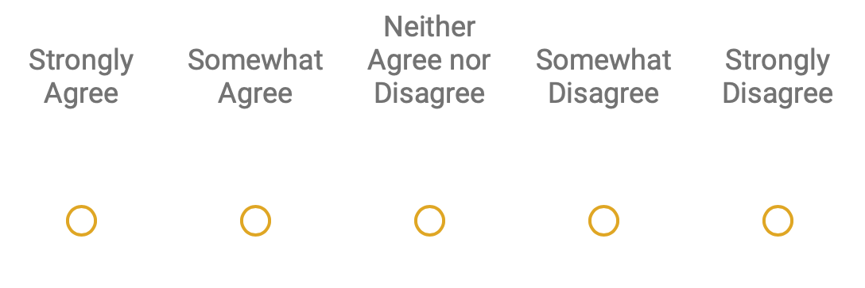

Participating in the AIVP trial:

Increased my confidence in my ability to take a history from a patient.
Improved my ability to ask appropriate questions in a medical history.
Improved my ability to communicate effectively with a patient.
Improved my ability to discuss a likely diagnosis / differential diagnosis with a patient.
Improved my ability to discuss next steps in assessment and management with a patient

The AIVP:

Had realistic personality/ies
Answered questions in a natural manner
Stayed in the role of the patient the whole time
Coped well with any errors or mistakes
Provided answers that were sufficient to allow me to formulate a differential diagnosis
Provided me with useful feedback on my performance at the end of the interaction
Delivered me with feedback in a style that was conducive to my learning

Overall, the use of the AIVP:

Was a valuable learning experience
Did not require a high level of technological skill
Provided a learning opportunity not met by other aspects of the course
Is a tool that should be used more widely in my medical education

Please provide any free-text comments to the following:

What were the strengths of the AIVP as an educational tool?

How could the AIVP, in its role as a virtual patient, be improved?

How could the AIVP, in its role in giving feedback, be improved?

Overall, what elements of the AIVP most contributed to your excitement and/or engagement as a learner?

Are there any other comments you wish to share with us?

