Aerobic Atom Transfer Radical Polymerization by Using Surfactant-GOx: Overcoming the Challenges of Hydrophobicity

¹Henan Key Laboratory of Green Chemistry, Collaborative Innovation Center of Henan Province for Green Manufacturing of Fine Chemicals, Key Laboratory of Green Chemical Media and Reactions, Ministry of Education, School of Chemistry and Chemical Engineering, Henan Normal University, Xinxiang, 453007
²School of Chemical Science and Engineering, Tongji University, Shanghai, 200092
*Corresponding author. Email: luchunna@htu.edu.cn
Characterization
All monomer conversion and organic products were analyzed using ¹H NMR and ¹³C NMR spectra in CDCl₃ and DMSO-d₆ at 25 ℃ with an AVANCE NEO 400 MHz spectrometer. The SEC system used was operated at 35 ºC in N,N-dimethylformamide solution, with a flow rate of 1.0 mL min⁻¹. It was equipped with a Pu300A pump and an RI-1000 differential refractometer. The molecular weight was measured on a shodex single chromatography column. Linear polysterene was used as the standard. Before analysis, the samples were diluted in N,N-dimethylformamide and filtered through a neutral aluminum oxide column to cupric bromide, then filtered through a 0.22 μm nylon (NY) membrane filter, and finally injected into the SEC chromatography column The injection volume was 50 μL. All the activity of surfactant-GOx was tested at 25 ℃ by using a cary 10 UV-VIS spectrophotometer (UV-3600Plus), with PBS buffer solution as the solvent, at a concentration of 3 mg/mL. GOD reagent from the glucose oxidase kit was added to the solution at 10 μL for testing. The secondary structure of all surfactant-GOx was determined using a chiras circular dichroism spectrometer from applied photophysics (UK). An hour before testing, the surfactant-GOx (20 μM) was dissolved in 1 mL of HPLC-grade methanol, insoluble substances were removed by centrifugation, and the solution was tested in a 1 cuvette. The light source was a xenon lamp, the wavelength range was 205 nm-260 nm, and the measurement was made a nitrogen atmosphere. The number-averaged particle size of the polymer particles was measured by using dynamic light scattering (DLS, NanoZS, Malvern Instruments, UK) and cryo-TEM (Cryo ARM 300, JEOL). The samples were diluted with ultra-pure water and dispersed by ultrasound before testing. The hydrophilicity and hydrophobicity of the S-GOx were tested by contact angle (Theta, Baolin, Finland). And the preparation of the sample was carried out by using S-GOx and potassium bromide, 15:1, pressing into a tablet. MALDI-TOF-MS (autboflex speed, Bruker) spectra, a reflection mode was used, trans-2-[3-(4-tert-butylphenyl)-2-methyl-2-propenyl]malononitrile (DCTB) was used as the matrix, and the solution was prepared at a concentration of 20.0 mg/mL, sodium trifluoroacetate was used as the ionization reagent, and the solution was prepared at a concentration of 10 mg/mL, and the polymer concentration was 10 mg/mL. The commonly used solvent was tetrahydrofuran, and the volume ratio of the matrix: sodium salt: polymer was 10:1:2, and the mixture was mixed evenly. A pipette took about 2 μL of the mixed solution and added it to the sample plate, and the test could be carried out after natural drying.
Preparation of non-ionic surfactant glucitol-based 1-glutamic acid dioleate (S)
The synthetic route of the non-ionic surfactant glucose-based-1-glutamic acid dioctyl ester is shown in Scheme S1. L-glutamic acid, higher alcohols, and p-toluenesulfonic acid were refluxed in a toluene for 4 hours. Then, toluene was removed under reduced pressure, and the reaction mixture was dissolved in chloroform, washed with 5% bicarbonate aqueous solution and deionized water. After removing chloroform under reduced pressure, a small amount of hydrochloric acid was added to the to form a salt. The salt, glucose lactone, and triethylamine in ethanol were refluxed for 2 hours. The solvent was removed under reduced, and the crude product was recrystallized in acetone. The synthetic methods of other non-ionic surfactants are similar to that of glucose-1-glutamic acid dioctyl ester, with the corresponding glucose replaced by other higher alcohols. The synthesis methods of other non-ionic surfactants are similar to that of glucose-1-glutamic acid dioctyl ester, with the corresponding higher alcohols replaced by decanol, tetradecanol or octadecanol.
Scheme S1. The synthesis route of non-ionic surfactant glucitol-based l-glutamic acid dioleate
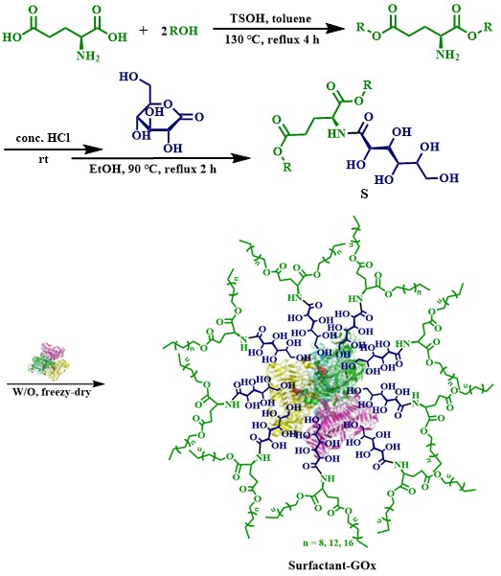
Synthesis of non-ionic surfactant-GOx complexes (S-GOx)
The preparation method of non-ionic surfactant-GOx complexes is as follows (shown in Scheme S1): GOx was dissolved in 1 mL of aqueous solution (100 mM potassium phosphate buffer) at a concentration of 1 g L⁻¹. The surfactant (10 mM) was dissolved in toluene (3 mL). Mixed the aqueous phase and the organic phase at 15,00 rpm for 3 minutes. freeze-dry the stable O/W emulsion in liquid nitrogen for 24 hours by using a freeze-drying device to obtain a white solid, which is the complex of the non-ionic surfactant and GOx. The synthesis methods of other non-ionic surfactant-GOx complexes are similar to the synthesis route of glucose-based 1-glutamic acid dioleate-GOx (S-GOx), except that the alocohol is replaced with other higher alcohols.
General procedure for Aerobic ICAR-ATRP reaction of hydrophobic monomer methyl acrylate in water (example)
The route as shown in Scheme S2, methyl acrylate (MA, 10 mmol, 0.86 g), 2-bromoethyl isutyrate (0.03 mmol, 0.0058 g), cupric bromide (0.2 mmol, 0.0046 g), VA-044 (0.2 mmol, 0.0640 g), TPMA (0.08 mmol, 0.0232 g), and S-GOx (0.08 mmol, 0.0840 g) were placed in a 5 mL round-bottomed flask, using PBS solution (2.5 g) as the solvent. The flask was sealed with a glass stopper and wrapped with sealing film to keep the entire system closed. The reaction was stirred at 45 ℃ for 12 h. After the reaction, a small amount of sample was taken to calculate the monomer conversion rate. The structure of the polymer was characterized by ¹H NMR and the molecular weight and dispersity of the polymer characterized by SEC.
Scheme S2. The general reaction route of GOx-assisted ICAR-ATRP polymerization in water
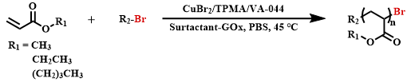
Synthesis of the Tris(2-pyridylmethyl)amine (TPMA)
Experimental procedure:
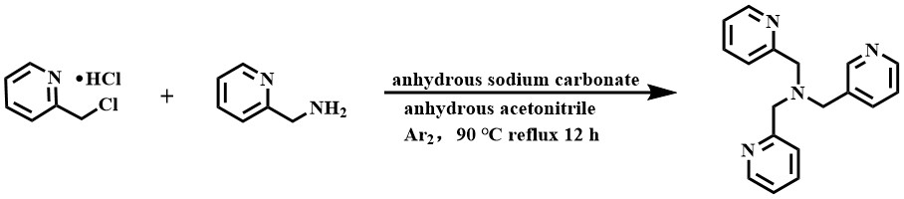
Figure S1: Synthesis route of TPMA.
Experimental steps:
To synthesize the tris(2-pyridylmethyl)amine (TPMA)¹, a 250 mL round-bottomed flask was charged with 2-(chloromethyl)pyridine hydrochloride (30.6 mmol, 5.02 g), anhydrous sodium carbonate (300.2 mmol, 31.83 g), and anhydrous acetonitre (100 mL). The mixture was sealed with a rubber stopper. Then, 2-(aminomethyl)pyridine (15 mmol 1.63 g) was dissolved in 50 mL of anhydrous acetonitrile and slowly added to the reaction flask under an2 atmosphere. The reaction mixture was stirred under Ar₂ for 30 minutes at room temperature, then heated to 90 ºC and refluxed for 12 hours under Ar₂. After the reaction was complete, the mixture was filtered to remove the white precipitate, and the filtrate was concentrated by rotary aporation to remove the acetonitrile. The resulting solid was extracted three times with 60 mL of dichloromethane, and the organic phase were dried over anhydrous magnesium sulfate. The solvent was then removed by rotary evaporation, and the residue was recrystallized from hot acet to yield a yellow solid. The structure of the product was characterized by ¹H NMR, as shown in Figure S2.
Characterization of the product：

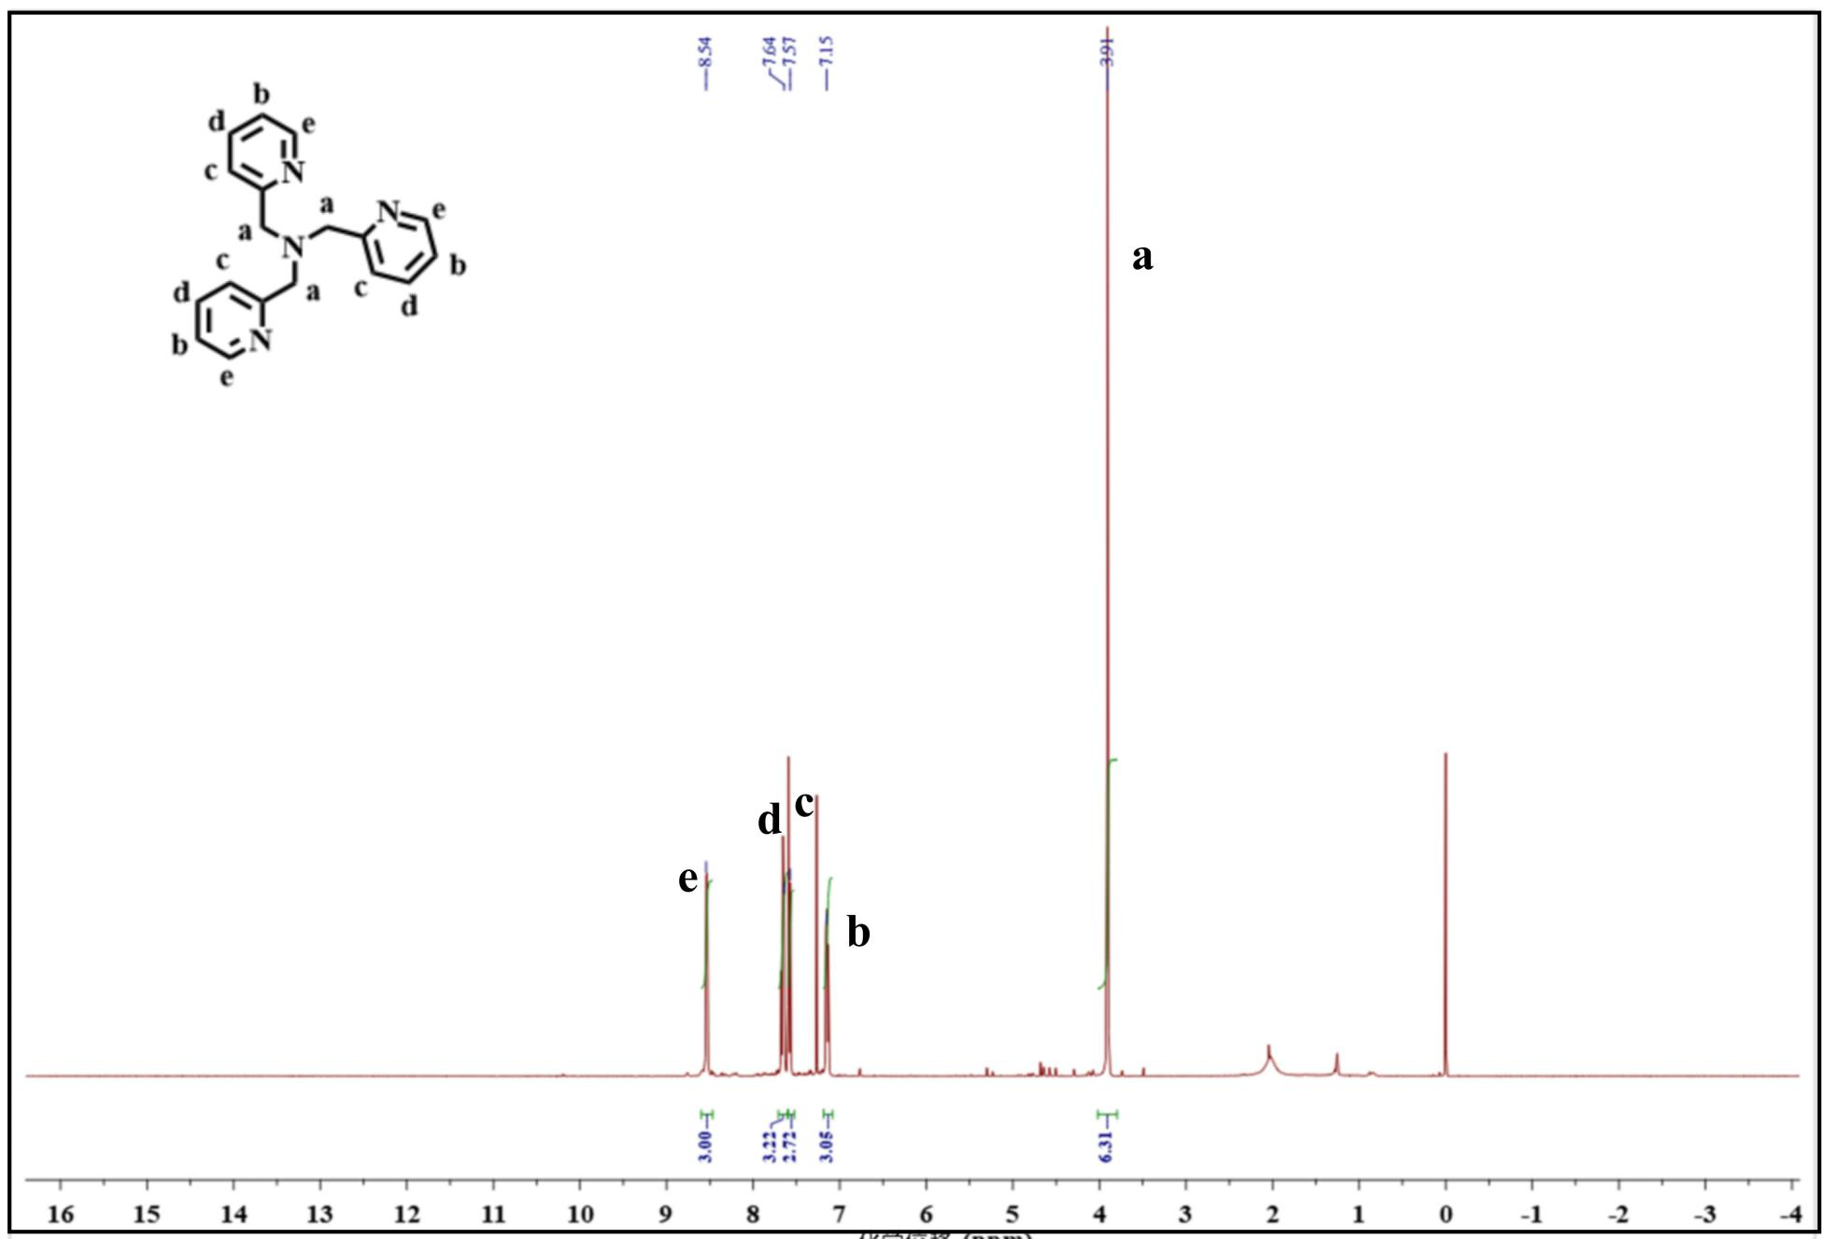
Figure S2: The ¹H NMR spectra of TPMA in CDCl_{3.}
- The Synthesis of L-Glutamic Dioctyl Ester 1
Experimental procedure:
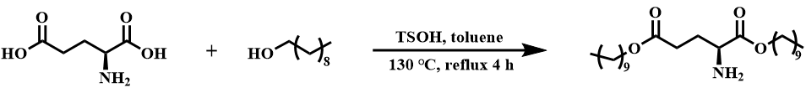
Figure S3: Synthesis route of l-glutamic acid dioctyl ester 1.
Experimental steps:
The synthetic route of the l-Glutamic dioctyl ester 1 is shown in Figure S3 and as literature². A mixture of L-glutamic acid (10.0 mmol, 1.47 g), n-decanol (22.4 mmol, 3.50 g), and p-toluenesulfonic acid (12.5 mmol, 2.39 g) was refluxed in toluene (40 mL) at 120 °C for 4 h. Then, it was cooled to room temperature, and toluene was removed under reduced pressure. The reaction mixture was neutralized with 10% sodium bicarbonate solution. The aqueous phase was extracted with ethyl acetate, and the organic phase was washed with 10% sodium bicarbonate solution and saturated sodium chloride solution. After the extraction, a large amount of anhydrous magnesium sulfate was added for drying. The white solid was removed by suction filtration through a Buchner funnel, and the filtrate was concentrated under reduced pressure. The residue was purified by silica gel column chromatography. First, the unreacted n-decanol was eluted with DCM, then the column was washed twice with DCM:MeOH=60:1, and finally, the product was eluted with DCM:MeOH=30:1. The eluent was concentrated under vacuum to give a pale yellow liquid.
Characterization of the product：
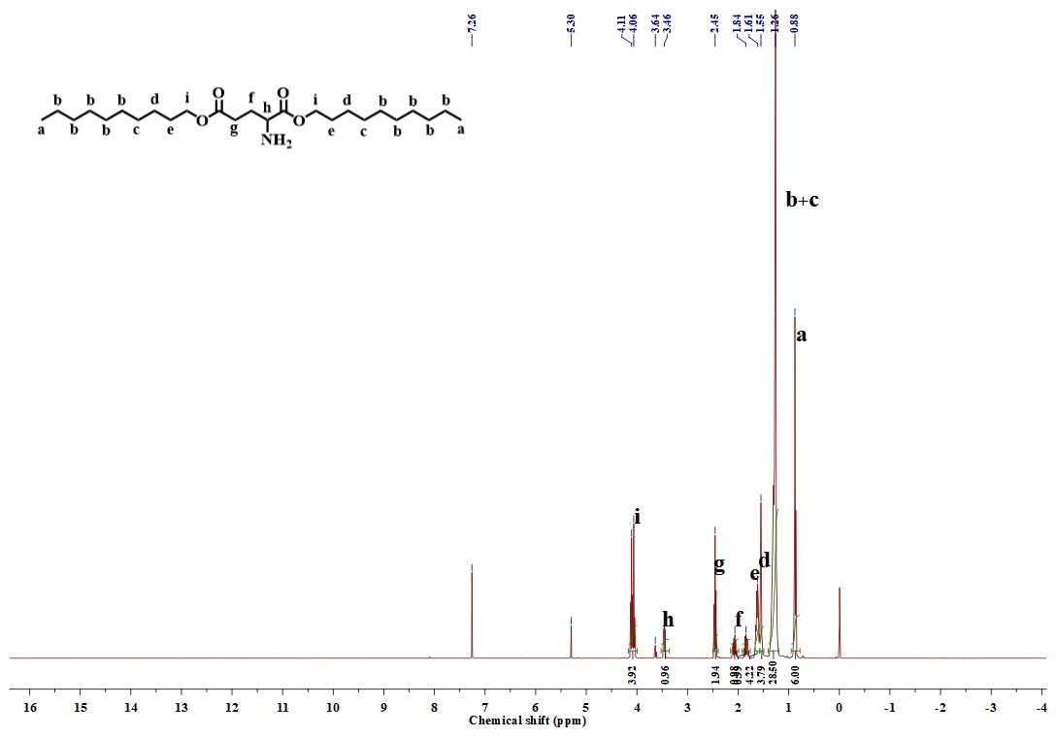
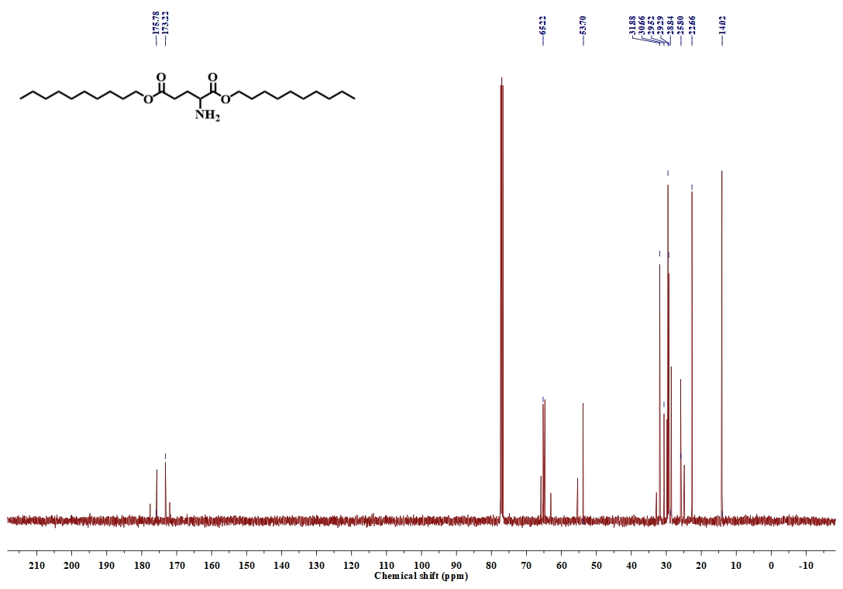
Figure S4: The NMR spectra of l-glutamic dioctyl ester 1 in CDCl₃ (up) ¹H NMR; (down) ¹³C NMR.

The Synthesis of L-Glutamic Dioctyl Ester 2

Experimental procedure:
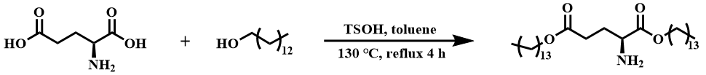

Figure S5: Synthesis route of l-glutamic acid dioctyl ester 2.
Experimental steps：
The synthetic route of the l-Glutamic dioctyl ester 2 is shown in Figure S5 and similar to literature². L-glutamic acid (10.0 mmol, 1.47 g), tetradecanol (22.4 mmol, 4.80 g), and p-toluenesulfonic acid (12.5 mmol, 2.39 g) were refluxed in toluene solution at 120 °C for 4 hours. Then, it was cooled to room temperature, toluene was removed under reduced pressure, and the reaction mixture was neutralized with 10% sodium bicarbonate solution. The water phase was then extracted with ethyl acetate, and the organic phase was extracted with 10% sodium bicarbonate and saturated sodium chloride solutions. After the extraction, a large amount of anhydrous magnesium sulfate was added for drying. The white solid was removed by suction filtration with a Buchner funnel, and the filtrate was concentrated under reduced pressure. The product was purified by silica gel column chromatography, first eluting the raw material n-decanol with DCM, then eluting the column twice with DCM:MeOH=60:1, and finally eluting the product with DCM:MeOH=30:1. The product was concentrated under vacuum to yield a pale yellow liquid.
Characterization of the product ：
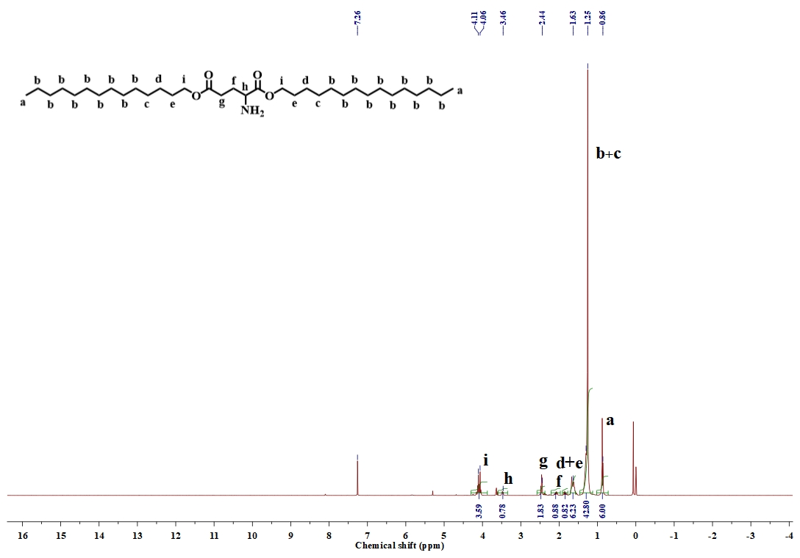
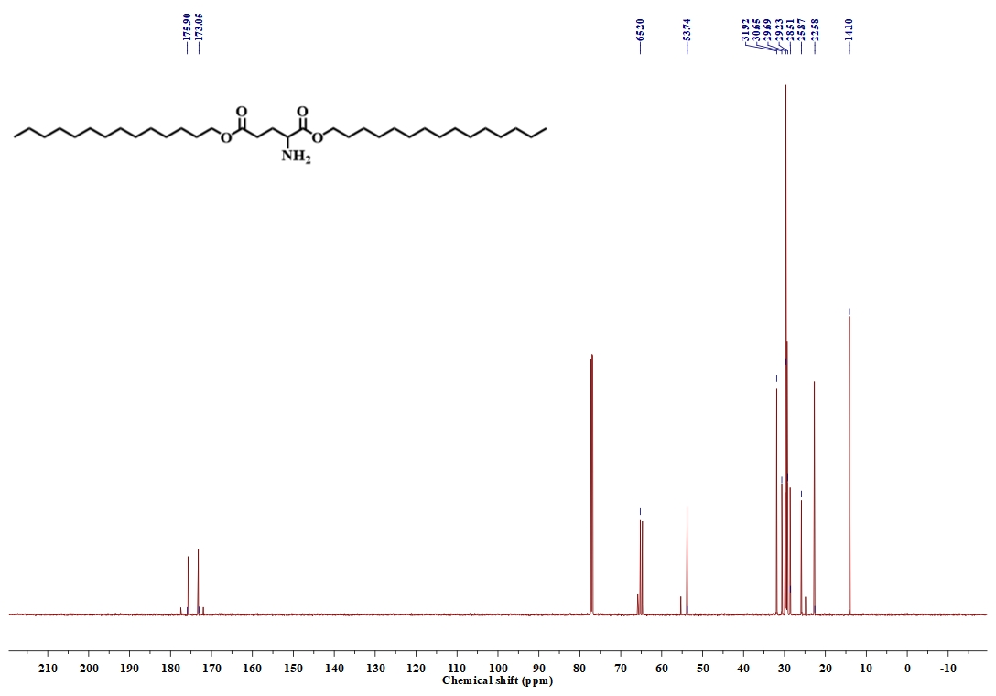
Figure S6: The NMR spectra of l-glutamic dioctyl ester 2 in CDCl₃ (up) ¹H NMR; (down) ¹³C NMR.

The Synthesis of L-Glutamic Dioctyl Ester 3
Experimental procedure:
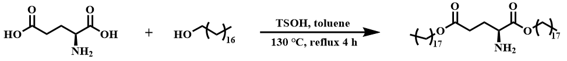

Figure S7: Synthesis route of l-glutamic acid dioctyl ester 3.
Experimental steps：
The synthetic route of the l-Glutamic dioctyl ester 3 is shown in Figure S7 similar to literature². The mixture of L-glutamic acid (10.0 mmol, 1.47 g), octadecanol (22.4 mmol, 3.02 g), and p-toluenesulfonic acid (12.5 mmol, 2.39 g) was refluxed in toluene solution at 120 °C for 4 hours. Then, it was cooled to room temperature, and toene was removed under reduced pressure. The reaction mixture was neutralized with 10% sodium bicarbonate solution. Next, the aqueous phase was extracted with ethyl acetate, and the organic phase was extracted with 10% sodium bicarbonate and saturated sodium chloride solutions. After the extraction, a large amount ofhydrous magnesium sulfate was added for drying. The white solid was removed by suction filtration through a Buchner funnel, and the filtrate was concentrated under reduced. The product was purified by silica gel column chromatography. First, the raw material octadecanol was eluted with DCM, then the column was twice with DCM:MeOH=60:1, and finally, the product was eluted with DCM:MeOH=30:1 The eluent was concentrated under vacuum to yield a pale yellow liquid.

Characterization of the product ：
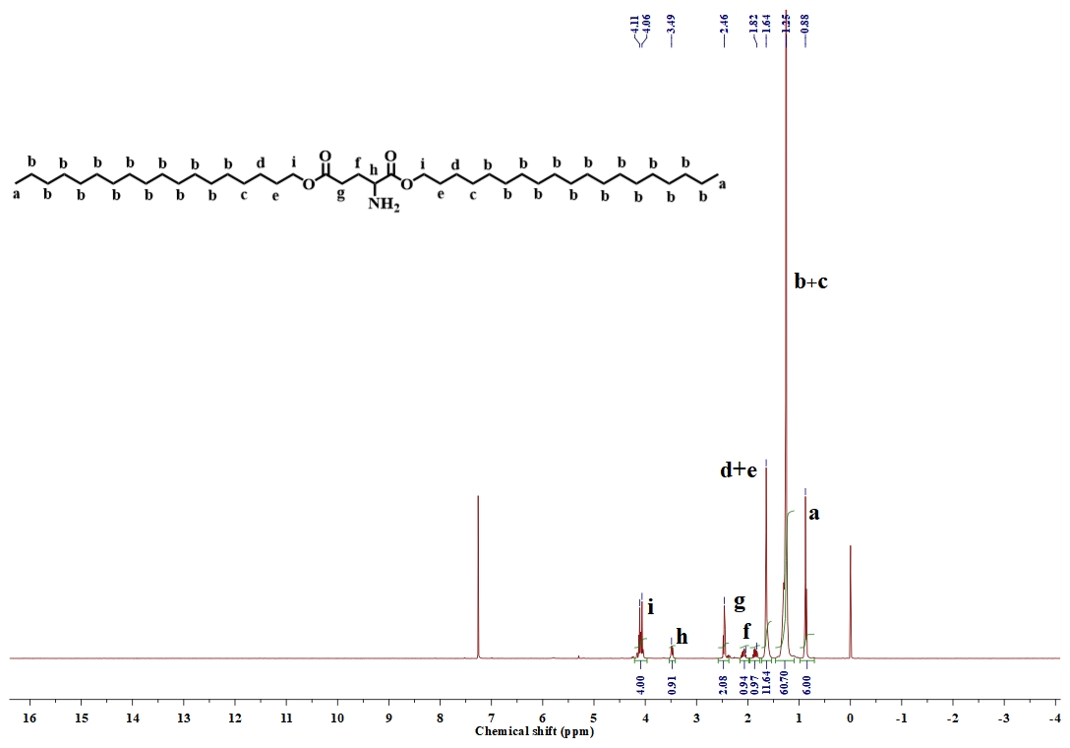
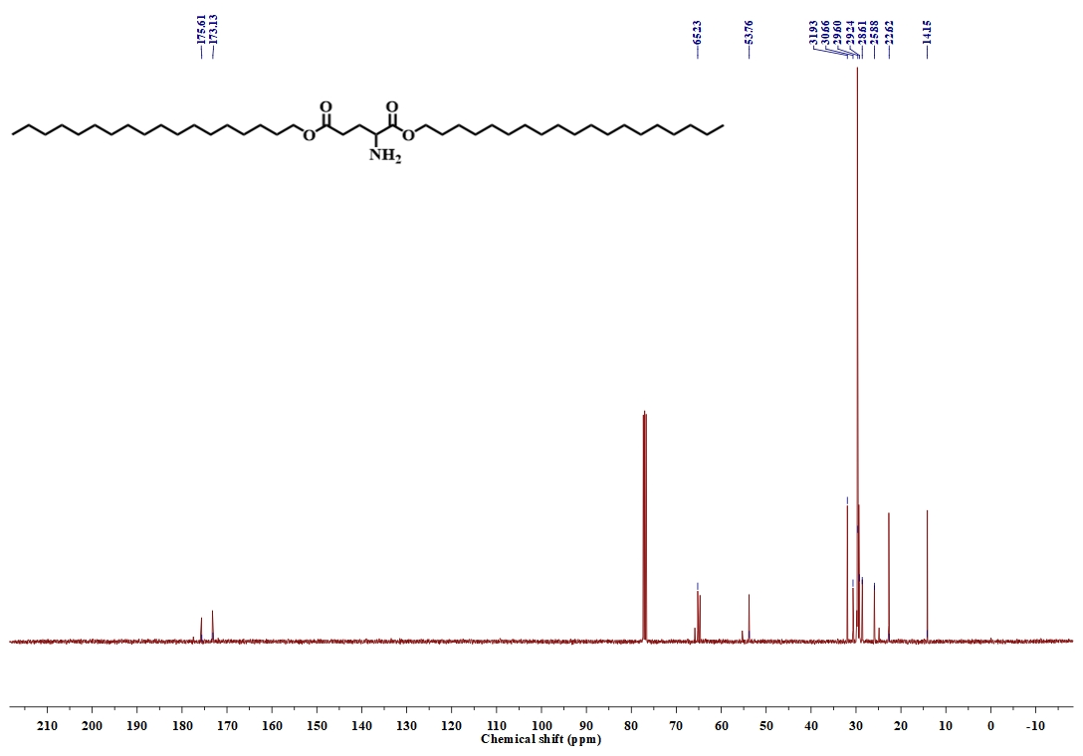
Figure S8: The NMR spectra of l-glutamic dioctyl ester 3 in CDCl₃ (up) ¹H NMR; (down) ¹³C NMR.

The Synthesis of non-ionic surfactant glucitol-based L-glutamic acid dioctyl ester (S₁)
Experimental procedure ：
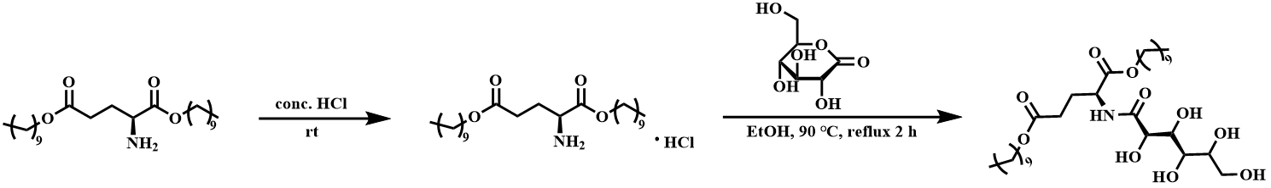
Figure S9: Synthesis route of non-ionic surfactant glucitol-based L-glutamic acid dioctyl ester (S₁)
Experimental steps：
The synthetic route of the non-ionic surfactant S₁, glucose alcohol-based 1-glutamic acid dioleate derivative, is shown Figure S9 as literature³. Hydrochloric acid (0.5 mmol, 0.13 g) was added to the light yellow liquid from step 1 to form a salt (white viscous solid), which was then crystallized in acetone to yield a white solid. Subsequently, the solid salt , glucose lactone (0.5 mmol, 0.09 g), and triethylamine (0.5 mmol, 0.07 g) were refluxed in ethanol (5 mL) for 2 hours. The solvent was removed under reduced pressure, and the crude product was recrystallized in acetone.
Characterization of the product ：
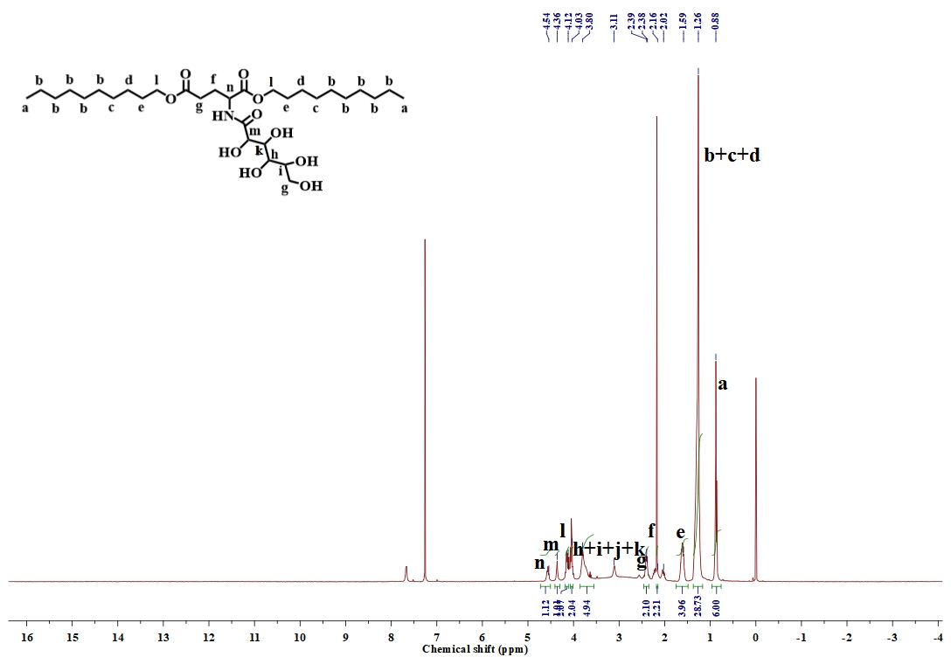
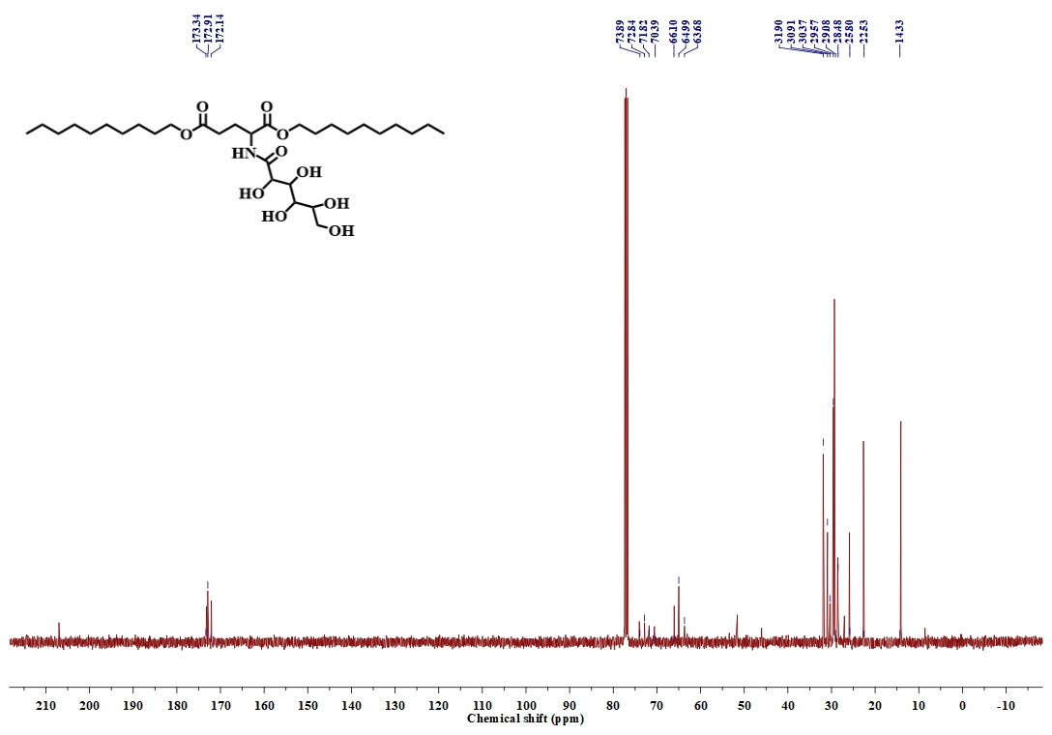
Figure S10: The NMR spectra of non-ionic surfactant glucitol-based l-glutamic acid dioctyl ester (S₁) in CDCl₃ (up）¹H NMR; (down) ¹³C NMR.

The Synthesis of non-ionic surfactant glucitol-based L-glutamic acid dioctyl ester (S₂)
Experimental procedure:
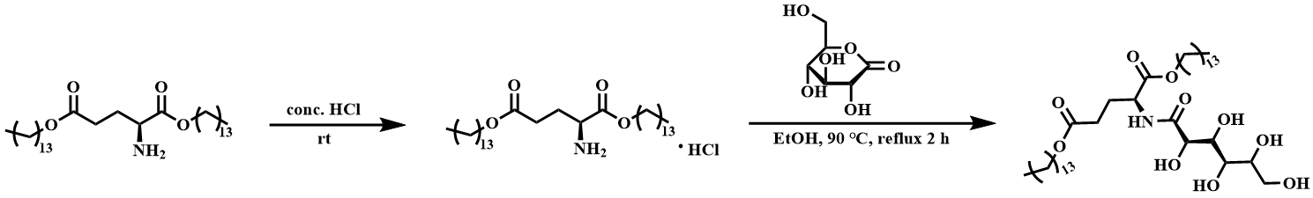
Figure S11: Synthesis route of non-ionic surfactant glucitol-based l-glutamic acid dioctyl ester (S₂)
Experimental steps：
The synthetic route of the non-ionic surfactant S₂, glucose alcohol-based 1-glutamic acid dioleate derivative, is shown Figure S10 and similar to literature³. Hydrochloric acid (0.5 mmol, 0.29 g) was added to the light yellow liquid from step 1 to form a salt (white viscous solid), which was then crystallized in acetone to yield a white solid. Subsequently, the solid salt , glucose lactone (0.5 mmol, 0.09 g), and triethylamine (0.5 mmol, 0.07 g) were refluxed for 2 hours. The solvent was removed under reduced pressure, and the crude product was recrystallized in acetone.
Characterization of the product ：
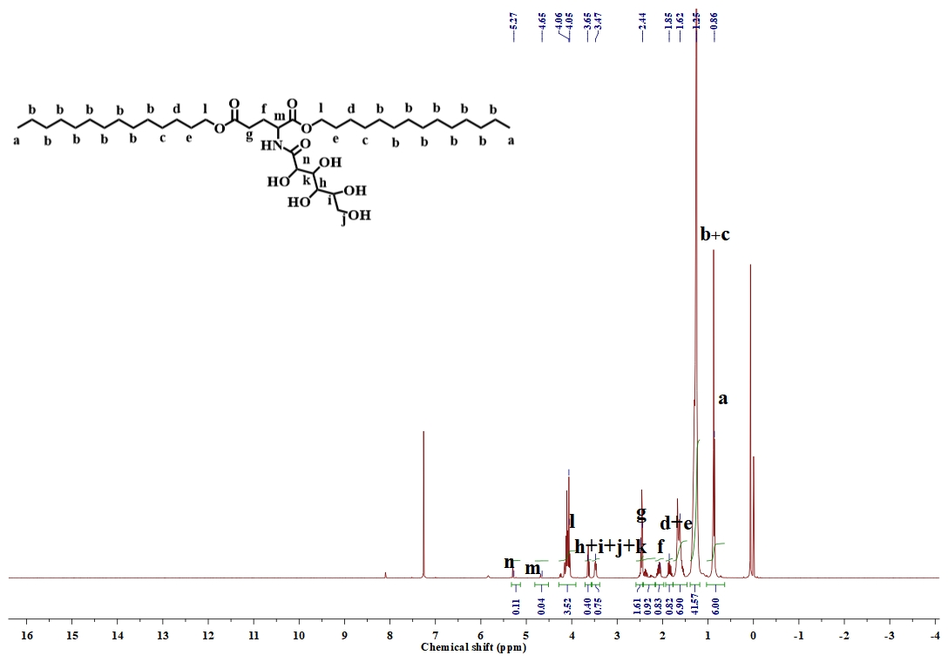
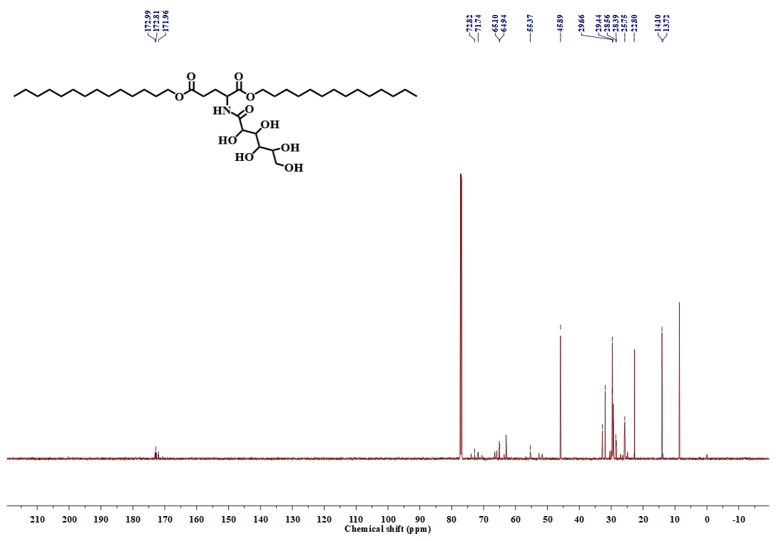
Figure S12: The NMR spectra of non-ionic surfactant glucitol-based l-glutamic acid dioctyl ester (S₂) in CDCl₃ (up) ¹H NMR; (down) ¹³C NMR.

The Synthesis of non-ionic surfactant glucitol-based L-glutamic acid dioctyl ester (S₃)
Experimental procedure:
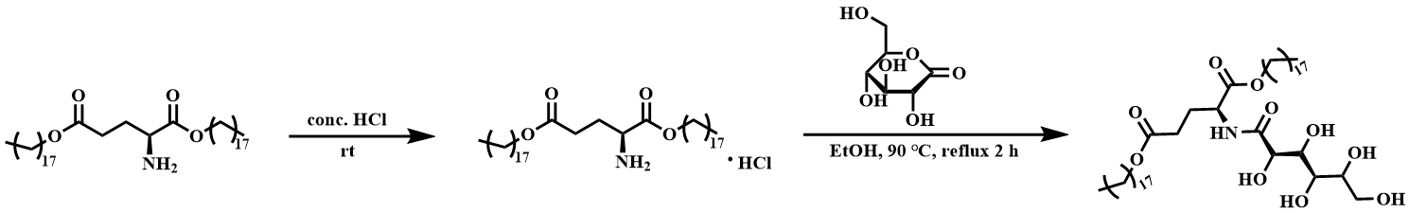
Figure S13: Synthesis route of non-ionic surfactant glucitol-based l-glutamic acid dioctyl ester (S₃)
Experimental steps：
The synthetic route of the non-ionic surfactant S₃, glucose alcohol-based 1-glutamic acid dioleate derivative, is shown Figure S12 and similar to literature³. Hydrochloric acid (0.5 mmol, 0.34 g) was added to the light yellow liquid from step 1 to form a salt (white viscous solid), which was then crystallized in acetone to yield a white solid. Subsequently, the solid salt , glucose lactone (0.5 mmol, 0.09 g), and triethylamine (0.5 mmol, 0.07 g) were refluxed for 2 hours. The solvent was removed under reduced pressure, and the crude product was recrystallized in acetone.
Characterization of the product ：
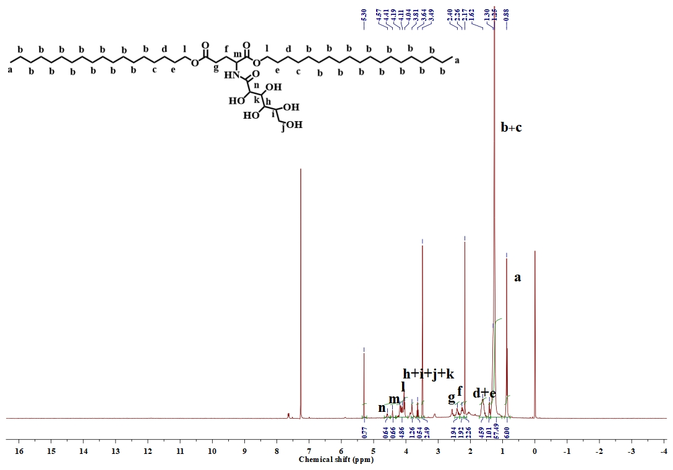
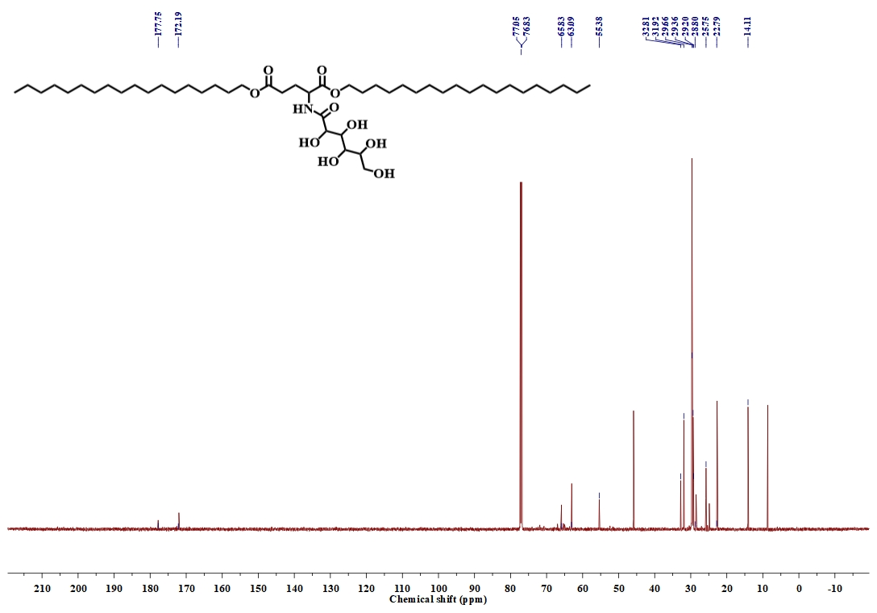
Figure S14: The NMR spectra of non-ionic surfactant glucitol-based l-glutamic acid dioctyl ester (S₃) in CDCl₃ (up) ¹H NMR; (down) ¹³C NMR.

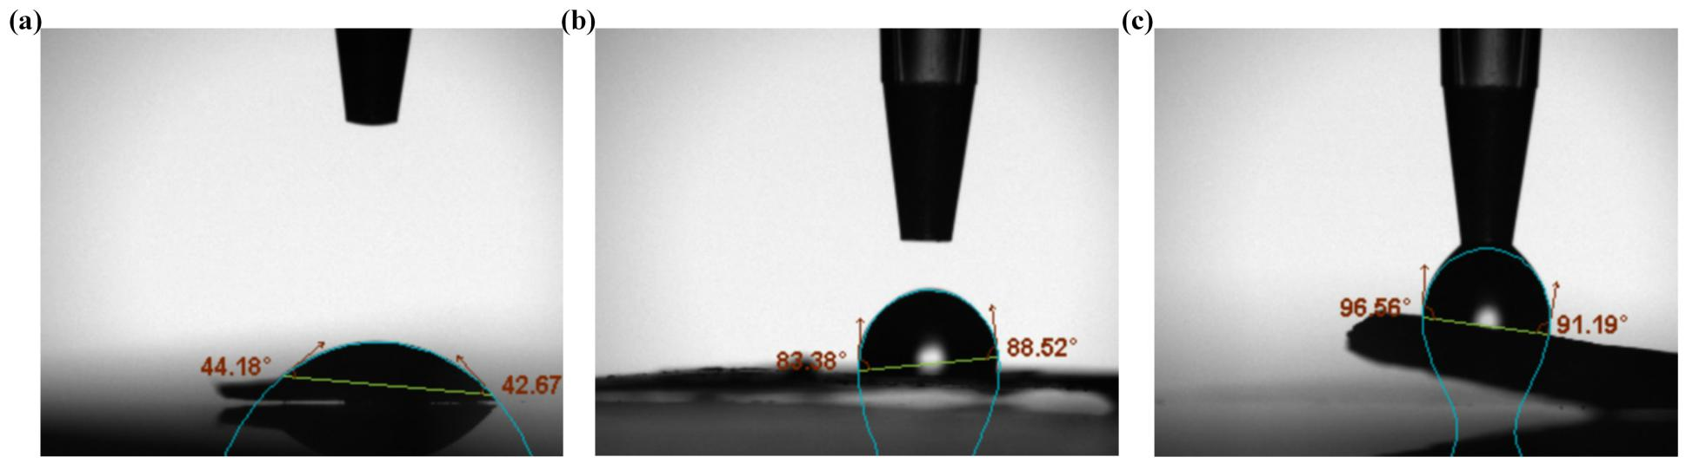
Figure S15: The contact angle image of non-ionic surfactant-GOx: (a) S₁-GOx; (b) S₂-GOx; (c) S₃-GOx.

Table S1. Chain extension of MA by using S₃-GOx in water
Entryª | [M]/[EBiB]/[CuBr₂]/[TPMA]/[VA-044]/[S₃-GOx] | Time (h) | Conv. (%)^{b} | M_{n,th}^{c} | M_{n,SEC}^{d} | M_{w}/M_{n}^{d}
1 | PMA₅₀  PMA₅₀-b-PMA₃₀₀ | 12 | 90  ＞99 | 3900  29500 | 7100  53900 | 1.04  1.47
2 | PMA₅₀  PMA₅₀-b-PEA₃₀₀ | 12 | 90  ＞99 | 3900  33600 | 7700  47800 | 1.04  1.55

ª Reaction conditions: [Monomer]/[EBiB]/[CuBr₂]/[TPMA]/[VA-044]/[S₃-GOx] = x/1/0.6/2.4/0.6/2, in PBS solution at 45 ºC without degassing. ^{b} Determined by ¹H NMR spectroscopy. ^{c} Calculated on the basis of conversion (that is, M_{n,th} = M_{EBiB} + DP × Conversion × M_{MA} ). ^{d} Determined by SEC in DMF, based on linear PMMA calibration standards.
Table S2. Polymerization of various DP of MA by using S₁-GOx in water
Entryª | [M]/[EBiB]/[CuBr₂]/[TPMA]/[VA-044]/[S₁-GOx] | Time (h) | Conv. (%)^{b} | M_{n,th}^{c} | M_{n,SEC}^{d} | M_{w}/M_{n}^{d}
1 | 50/1/0.6/2.4/0.6/2 | 12 | 70 | 3300 | 11300 | 1.27
2 | 100/1/0.6/2.4//0.6/2 | 12 | 85 | 7600 | 15700 | 1.40
3 | 200/1/0.6/2.4/0.6/2 | 12 | 65 | 12000 | 23400 | 1.74
4 | 400/1/0.6/2.4/0.6/2 | 12 | 60 | 21000 | 29000 | 1.66

ª Reaction conditions: [MA]/[EBiB]/[CuBr₂]/[TPMA]/[VA-044]/[S₁-GOx] = x/1/0.6/2.4/0.6/2, in PBS solution at 45 ºC without degassing. ^{b} Determined by ¹H NMR spectroscopy. ^{c} Calculated on the basis of conversion (that is, M_{n,th} = M_{EBiB} + DP × Conversion × M_{MA} ). ^{d} Determined by SEC in DMF, based on linear PMMA calibration standards.

Table S3. Polymerization of various DP of MA by using S₂-GOx in water

Entryª | [M]/[EBiB]/[CuBr₂]/[TPMA]/[VA-044]/[S₂-GOx] | Time (h) | Conv. (%)^{b} | M_{n,th}^{c} | M_{n,SEC}^{d} | M_{w}/M_{n}^{d}
1 | 50/1/0.6/2.4/0.6/2 | 12 | 50 | 2300 | 11600 | 1.24
2 | 100/1/0.6/2.4/0.6/2 | 12 | 72 | 6400 | 14300 | 1.44
3 | 200/1/0.6/2.4/0.6/2 | 12 | 54 | 9500 | 24800 | 1.82
4 | 400/1/0.6/2.4/0.6/2 | 12 | 35 | 13000 | 8500 | 1.24

ª Reaction conditions: [MA]/[EBiB]/[CuBr₂]/[TPMA]/[VA-044]/[S₂-GOx] = x/1/0.6/2.4/0.6/2, in PBS solution at 45 ºC without degassing. ^{b} Determined by ¹H NMR spectroscopy. ^{c} Calculated on the basis of conversion (that is, M_{n,th} = M_{EBiB} + DP × Conversion × M_{MA} ). ^{d} Determined by SEC in DMF, based on linear PMMA calibration standards.

Table S4. Polymerization of various DP of MA by using S₃-GOx in water
Entryª | [M]/[EBiB]/[CuBr₂]/[TPMA]/[VA-044]/[S₃-GOx] | Time (h) | Conv. (%)^{b} | M_{n,th}^{c} | M_{n,SEC}^{d} | M_{w}/M_{n}^{d}
1 | 50/1/0.6/2.4/0.6/2 | 12 | ＞99 | 4500 | 13000 | 1.35
2 | 100/1/0.6/2.4/0.6/2 | 12 | 90 | 8000 | 14400 | 1.41
3 | 200/1/0.6/2.4/0.6/2 | 12 | 82 | 15000 | 24700 | 1.10
4 | 400/1/0.6/2.4/0.6/2 | 12 | 40 | 14000 | 56000 | 1.53

ª Reaction conditions: [MA]/[EBiB]/[CuBr₂]/[TPMA]/[VA-044]/[S₃-GOx] = x/1/0.6/2.4/0.6/2, in PBS solution at 45 ºC without degassing. ^{b} Determined by ¹H NMR spectroscopy. ^{c} Calculated on the basis of conversion (that is, M_{n,th} = M_{EBiB} + DP × Conversion × M_{MA} ). ^{d} Determined by SEC in DMF, based on linear PMMA calibration standards.
The bioactivity of S-GOx
UV-Vis Spectrum
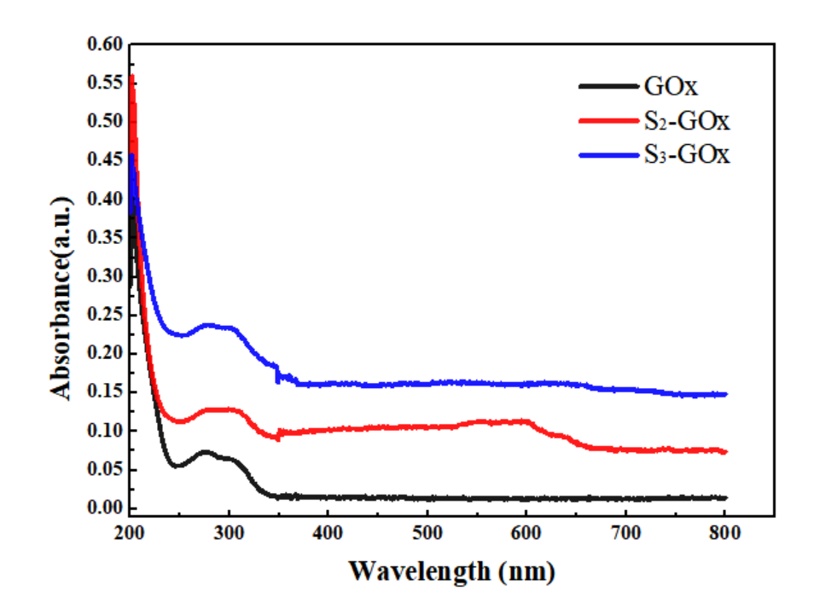
Figure S16. UV-Vis spectra of S-GOx in the PBS solution .
CD Spectrum
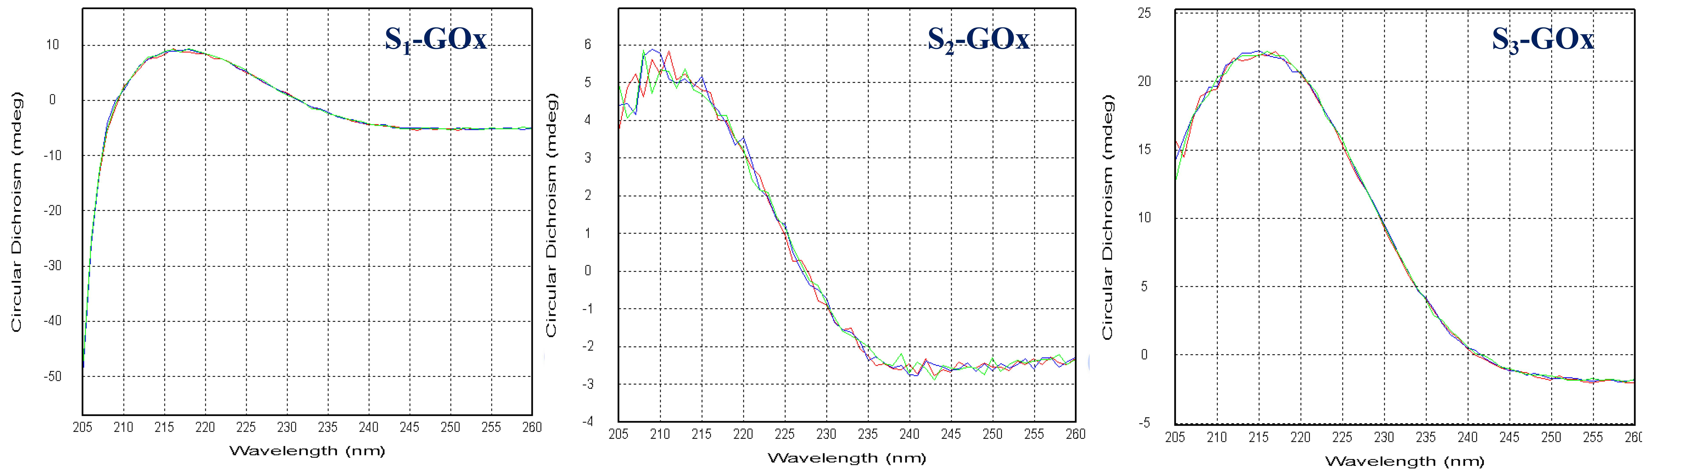
Figure S17. CD spectra of S-GOx in the ethanol solution.
REFERENCES
- Li, L.; Tek, A. T.; Wojtecki, R. J.; Braslau, R. Internal Plasticization of Poly(vinyl) Chloride Using Glutamic Acid as a Branched Linker to Incorporate Four Plasticizers Per Anchor Point. Polym. Chem. 2019, 57, 1821–1835.
(2) Lei, L.; Chen, Y.; Feng, Z.; Deng, C.; Xiao, Y. Bioinspired Manganese Complex for Room-Temperature Oxidation of Primary Amines to Imines by t-butyl Hydroperoxide. Inorg. Chim. Acta. 2021, 519, 120282.

