Supplementary

Estimation of lysimeter sampling time after in situ irrigation
The Green-Ampt model was parameterised using values corresponding to the fine-textured loam soil present at the site (Saxton & Rawls, 2006). The initial soil water deficit (Δθ) was set at 0.3. Saturated hydraulic conductivity (K_{s}) was prescribed at 5 mm h⁻¹, while the initial soil water potential (Ψ) was defined as 1000 mm. Simulations ran for 5 hours, using a timestep (Δt) of 1 second. Cumulative infiltration (F) was iteratively calculated using an implicit form of the Green-Ampt equation (Green & Ampt, 1911). Subsequently, the wetting front depth (L) was estimated from the cumulative infiltration and initial soil water deficit (Figure S1). Simulations were conducted in MATLAB version 24.1.0.2689473 (R2024a) Update 6 (The Mathworks, Inc., 2024).
Green-Ampt equation:
Ft= Kst+ΨΔθln1+FtΨΔθ (S1)
Wetting front depth:
Lt=F(t)Δθ (S2)
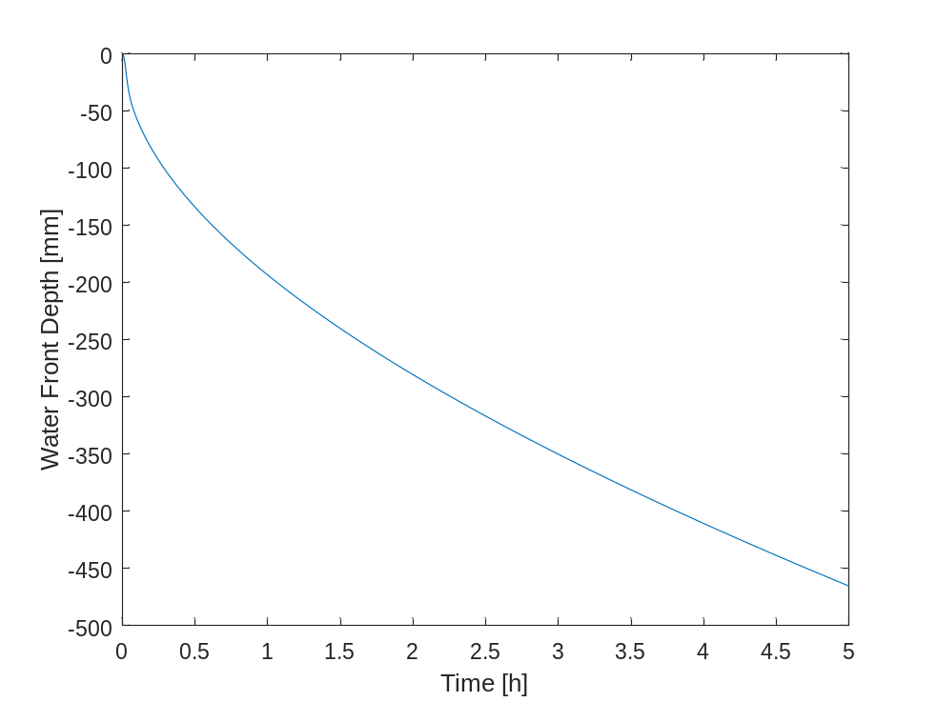
Figure S1. Time taken for the waterfront to reach a specific soil depth following the addition of 20 L water based on the Green-Ampt equation.

Determination of centrifugation time interval
Soil samples from October 2023 were sub-sampled for gravimetric soil moisture, which was determined at 65 °C (DeAngelis, 2007). Soil samples (n = 6) were then centrifuged using the method described in the primary methods section 2. The supernatant was removed at two-minute intervals, and its volume was measured. The centrifuging continued at two-minute intervals until no further supernatant could be sufficiently extracted to perform additional analyses, such as acidimetric titration.
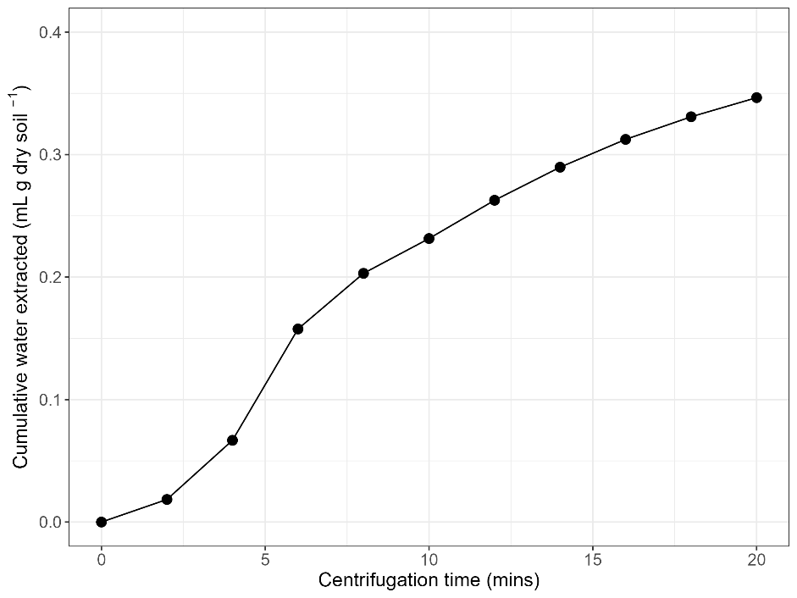
Figure S2: Cumulative pore water extracted per g of dry soil at two-minute timesteps via the centrifugation extraction method. Gravimetric soil moisture (GSM) = 29.6%.

Irrigation water chemistry
A one-tailed t-test evaluated differences in TA between irrigation water sources. Water source A displayed 1400% higher TA than ultra-pure water (t = 15.12, p < 0.01).
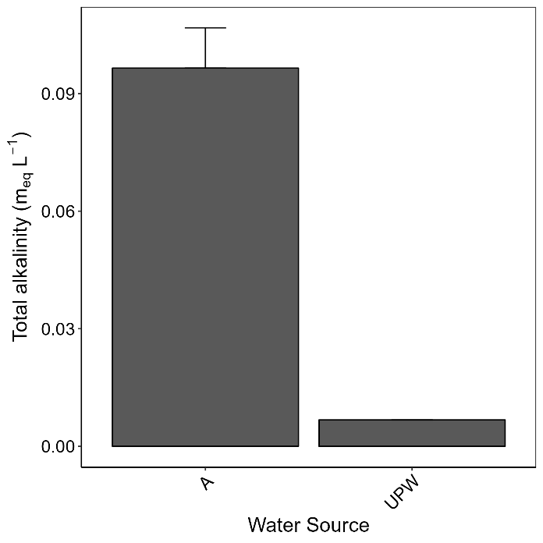
Figure S3: On-site aquifer total alkalinity (mean + standard error). The water source represents the on-site water sources from which water was extracted. UPW denotes ultra-pure water, which was used as a control.
A two-way ANOVA was conducted to examine the differences in cation concentrations among on-site water sources and ultra-pure water, which was used as a control, with water source and sampling date treated as additive factors. The results revealed significant differences among the water sources for Mg: F(1,10) = 4.21, p = 0.07, Ca: F(1,12) = 5.67, p < 0.05, Na: F(1,12) = 6.18, p < 0.05, K: F(1,12) = 7.13, p < 0.05, Sr: F(1,10) = 28.9, p = 0.23 (Figure S4). B within ultra-pure water is not displayed as concentrations were below the detection limits of ICP-OES.
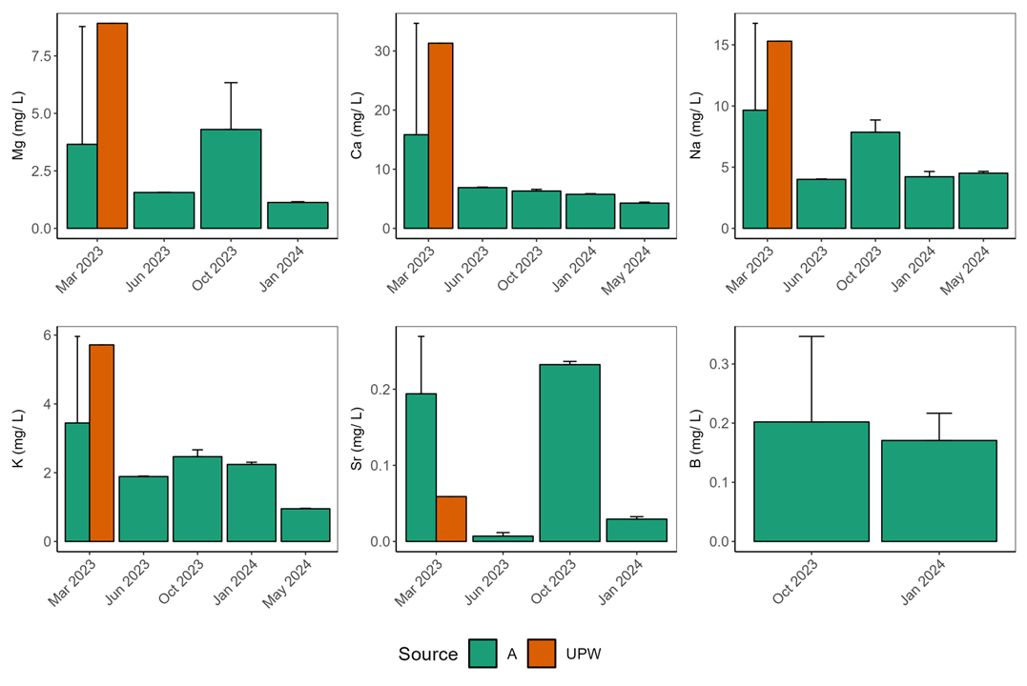
Figure S4: On-site aquifer water cation concentrations (mean + standard error) (a-f) across sampling dates. The water source represents the site at which water was extracted. UPW denotes ultra-pure water, which is used as a control.

Mechanical basalt dissolution and its total alkalinity release
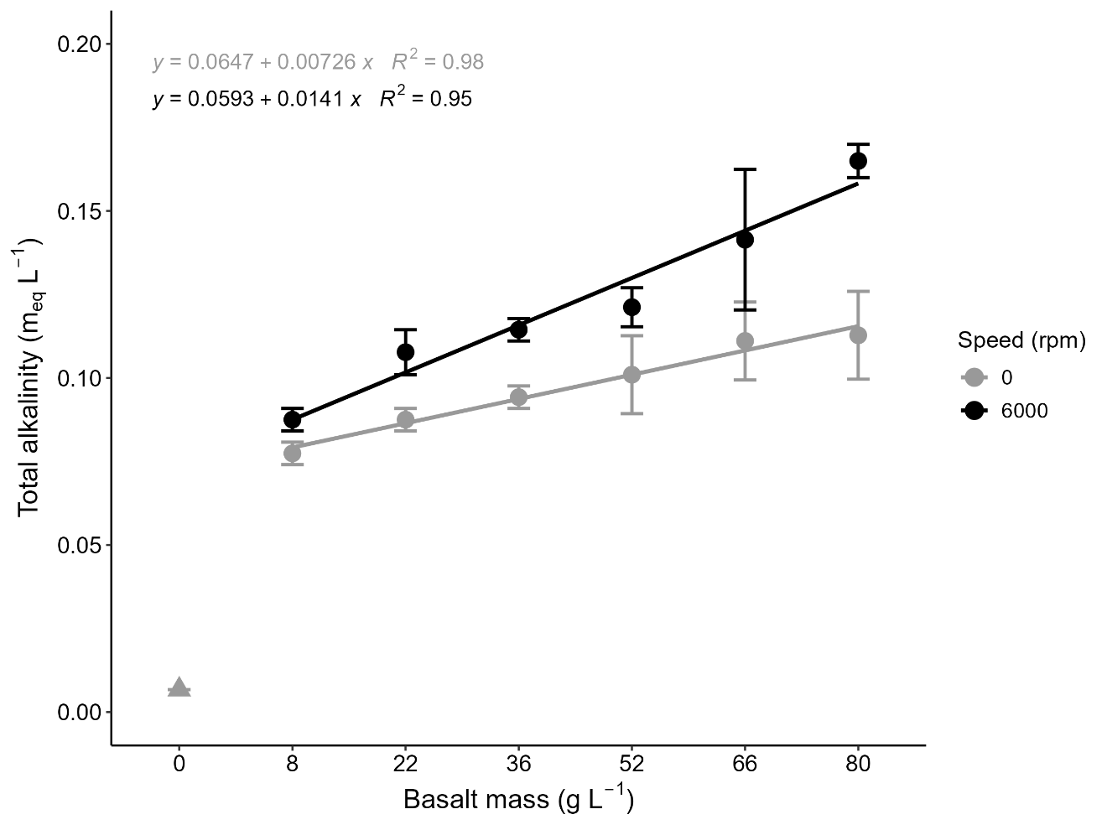
Figure S5: Comparison of increasing masses of basalt in ultra-pure water (UPW) subjected to the maximum centrifugation speed (6000 rpm; black points) versus a positive control group (0 rpm; grey points) in comparison to UPW alone (represented by the grey triangular point) and the influence on total alkalinity (TA) (mean ± standard error).

Extraction coefficient derivation

5.1. Extraction coefficient for samples without basalt
To calculate the impact of mechanical disruption of centrifugation on soil and its associated influence on pore water alkalinity ($C_{e,mech}$), two sets of soil samples without basalt were saturated with ultra-pure water. We derived extraction coefficients by accounting for the dilution effect of adding ultra-pure water to samples to reach saturation. This allowed for a greater yield of analysable supernatant following centrifugation.
The soils were divided into two sub-samples: one was centrifuged, and one was not, denoted by the subscripts c and nc. This yields two treatment groups (note that soils used in this experiment do not contain basalt, signified by the subscript nb), for example:
- ${TA}_{nc,nb}$ for the measured TA of samples with no centrifugation
- ${TA}_{c,nb}$ for the measured TA of samples with centrifugation
Here, we refer to $X_{c,nb}$ and $X_{nc,nb}$ as sets of measurements (X) from the same soil sample without basalt but have either been centrifuged/ not centrifuged and have different initial soil water volumes.
The measured total alkalinity (TA_{nb}; m_{eq} L⁻¹) can be described as:
TAnc,nb= Mnc,nbVnc,nb (S3)
TAc,nb= Mc,nbVc,nb (S4)
Where the alkaline load (M) in the unit of m_{eq} is the product of total alkalinity in the unit of m_{eq} L⁻¹, TA and the total soil water volume (V) after saturation in the unit of L.
The alkaline load of centrifuged/ non-centrifuged soil samples following the addition of ultra-pure water alkaline load ($M_{UPW}$; m_{eq}) to the initial alkaline load of soil pore water ($M_{soil}$; m_{eq}) can be determined as:
Mnc,nb= Msoil,nc,nb+MUPW,nc,nb (S5)
$$M_{c,nb}= M_{soil,c,nb}+M_{UPW,c,nb} (S6)$$
For centrifugation and non-centrifugation treatments, the alkaline load of ultra-pure water ($M_{UPW}$; m_{eq}) can be calculated as:
$M_{UPW}= {TA}_{UPW} . V_{add} (S7)$
Where, ${TA}_{UPW}$ is the measured TA (m_{eq} L⁻¹) of ultra-pure water and $V_{add}$ (L) the volume of ultra-pure water added for the sample to reach saturation. Therefore, the total alkalinity of soil pore water (${TA}_{soil}$; m_{eq} L⁻¹) can be determined as:
$${TA}_{soil,nc,nb} = \frac{{TA}_{nc,nb} . \left(V_{soil,nc,nb}+ V_{add,nc,nb}\right)- {TA}_{UPW} . V_{add,nc,nb}}{{ V}_{soil,nc,nb}} (S8)$$
$${TA}_{soil,c,nb} = \frac{{TA}_{c,nb} . \left(V_{soil,c,nb}+ V_{add,c,nb}\right)- {TA}_{UPW} . V_{add,c,nb}}{{ V}_{soil,c,nb}} (S9)$$
In which and $V_{soil}$ (L) denotes the initial soil water volumes of each sample. Consequently, the mechanical effects of centrifugation on soil disaggregation and its potential influence on pore water TA is estimated with the ratio of TA and soil water volumes within samples which have/ have not been centrifuged ($\frac{{TA}_{soil,c,nb}}{{TA}_{soil,nc,nb}}$; $C_{e,mech}$), derived from equations S8-9:
$$C_{e,mech}= \frac{{TA}_{c,nb} . \left(V_{soil,c,nb}+V_{add,c,nb}\right)- {TA}_{UPW} . V_{add,c,nb}}{{TA}_{nc,nb} . \left(V_{soil,nc,nb}+V_{add,nc,nb}\right)- {TA}_{UPW} . V_{add,nc,nb}} . \frac{{ V}_{soil,nc,nb}}{{ V}_{soil,c,nb}} (S10)$$
Since the TA of the ultra-pure water is negligible (${TA}_{UPW}≅0$) compared to the soil pore water, and no water will be added to the centrifugation samples when applying the extraction coefficient, its minor influence ($- {TA}_{UPW} . V_{add}$) is not significant enough to be represented in the final extraction coefficient equation.
$$C_{e,mech}= \frac{{TA}_{c,nb} . { V}_{soil,nc,nb} . (V_{soil,c,nb}+V_{add,c,nb})}{{TA}_{nc,nb} . { V}_{soil,c,nb} . (V_{soil,nc,nb}+V_{add,nc,nb})} (S11)$$

5.2. Extraction coefficient for samples with basalt
In our sub-experiment, soil samples containing basalt were saturated with ultra-pure water to calculate the combined mechanical impact of centrifugation on pore water alkalinity from soil disturbance and centrifuge-induced basalt dissolution ($C_{e, mech,diss}$). The soils were then divided into two sub-samples: one is centrifuged, and one is not, denoted by the subscripts c and nc. This yields two treatment groups (note that soils used in this experiment contain basalt, signified by the subscript b). Consequently , the extraction coefficient for samples containing basalt ($C_{e,mech,diss}$) can be determined using the same process presented in supplementary section 5.1:
$$C_{e,mech,diss}= \frac{{TA}_{c,b} . { V}_{soil,nc,b} . (V_{soil,c,b}+V_{add,c,b})}{{TA}_{nc,b} . { V}_{soil,c,b} . (V_{soil,nc,b}+V_{add,nc,b})} (S12)$$

5.3 Extraction coefficient comparison
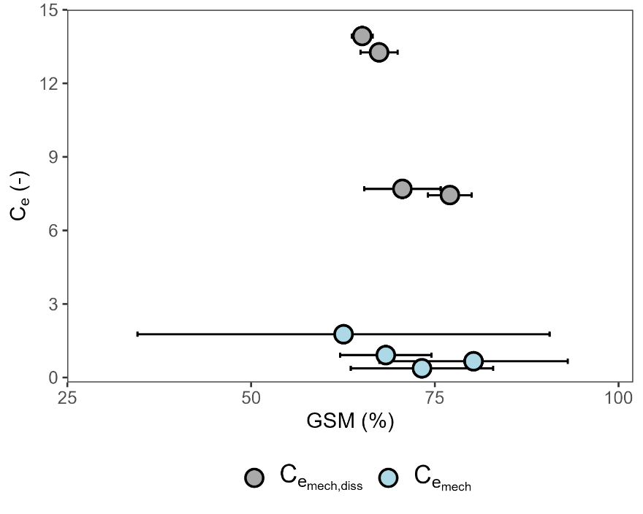
Figure S6: Comparison of extraction coefficient (C_{e}) values with respect to gravimetric soil moisture (GSM) (mean ± one standard deviation) across samples from basalt (C_{e,mech,diss}) / non-basalt (C_{e,mech}) treatments.
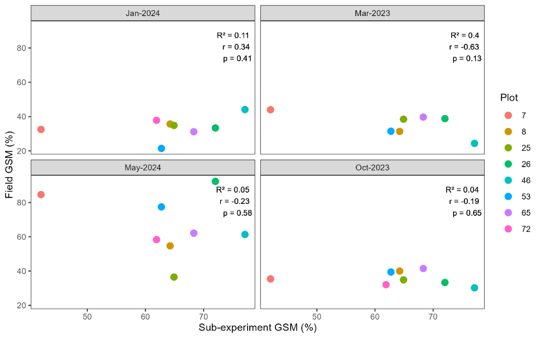
Figure S7: Association between gravimetric soil moisture (GSM) of samples used for the sub-experiment to determine extraction coefficient values and GSM values of field samples the extraction coefficient s were applied to, separated by sampling date. Different coloured points represent the sampled plots.

Depth effects on pore water total alkalinity
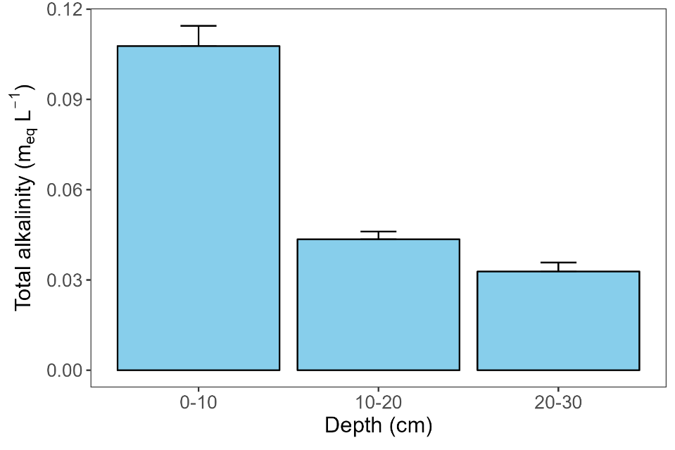
Figure S8: Pore water total alkalinity at different soil depths obtained via the centrifugation extraction approach from a non-basalt plot.

Centrifugation pore water cation concentrations
Table S1: Summary statistics and effect sizes of pore water cation concentrations following one-tailed t-tests on centrifugation and lysimeter extraction approaches that have not been coefficient-transformed, and basalt application as the independent variable. Outliers were removed using the Bonferroni outlier and Cook’s distance tests. Effect sizes are presented as the percentage change of mean pore water cation concentrations in basalt treatments compared to those without basalt. Bold p-values correspond to significant treatment effects (p < 0.05).
Extraction approach | Cation | t-value | Degrees of freedom | p-value | Effect size (%)
Lysimeter | Mg | 0.13 | 54 | 0.44 | - 15.2
 | Ca | 0.80 | 48 | 0.21 | + 7.6
 | Na | -0.89 | 66 | 0.81 | +7.16
 | K | -0.07 | 66 | 0.52 | - 1.6
 | Sr | -0.11 | 50 | 0.46 | + 11.7
 | B | -1.43 | 26 | 0.92 | + 420.6
Centrifugation | Mg | -0.52 | 54 | 0.70 | - 16.4
 | Ca | 2.97 | 57 | 0.002 | + 48.6
 | Na | -1.45 | 55 | 0.92 | - 18.6
 | K | 0.44 | 58 | 0.33 | + 10.3
 | Sr | 0.63 | 47 | 0.26 | - 4.4
 | B | -2.36 | 20 | 0.99 | + 28.2

