Supplementary material
---

Supplementary Figure 1. Histogram of the minimal number of SNPs between maternal and neonatal isolates within mother-neonate pairs sharing at least one common bacterial species.
Pairs where a transmission event was identified in the phylogenetic tree are shown in red, while those without a transmission event are shown in blue.
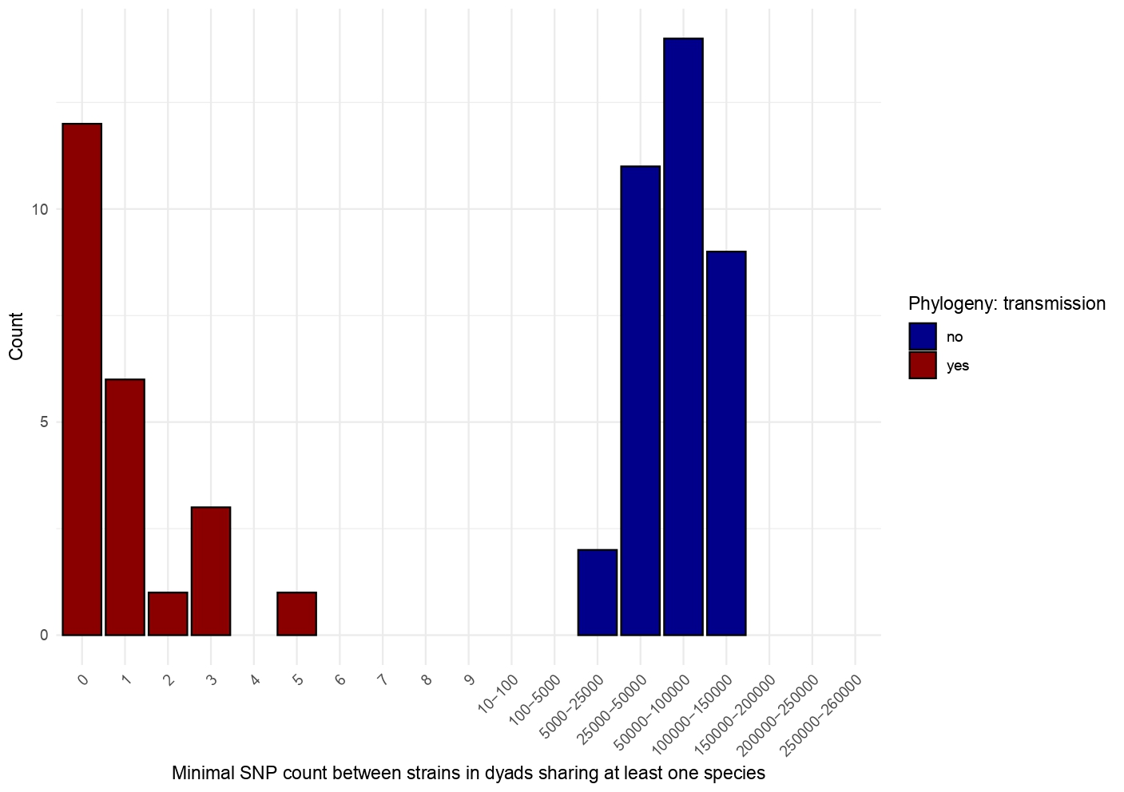
Supplementary Figure 2. Antibiotic susceptibility testing (AST) results (disc diffusion method), divided in four categories by country and origin.
For quinolone, CIPROFLOXACIN has been tested for all subcategories except for Cambodian neonates, for which a MOXIFLOXACIN disc was used, due to technical constraints.
Acronyms:S: susceptible, I: intermediate, R: resistant according to EUCAST 2018 cut-offs. NA: missing data. Camb: Cambodia, Mada: Madagascar. 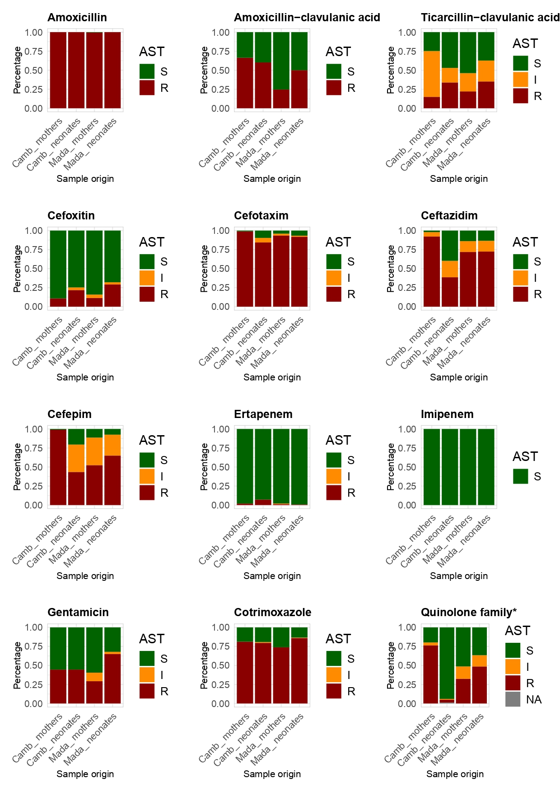

Supplementary Figure 3. Genome-based phylogenetic classification of the isolates belonging to the genus Escherichia.
Minimum evolution midpoint-rooted phylogenetic tree displaying all the isolates belonging to a mother-neonate pair both colonized by an Escherichia species. Cambodian (blue) and Madagasy (green) isolate names start with C and M prefixes, respectively, whereas M and B suffixes correspond to mother and neonate, respectively. Three Escherichia and four Shigella type strain genomes (red) were added to identify the species of the different ESBL-PE strains, as well as the genomes of the representative strains (orange) of the 14 E. coli phylogroups (Abram et al. 2021, doi:10.1038/s42003-020-01626-5) in order to illustrate the diversity of the sampled ESBL-PE isolates within the E. coli population structure. Neonatal acquisitions from maternal source (highlighted in sand color) are assessed by a mother-neonate cherry. Bar, 0.025 nucleotide substitutions per character.
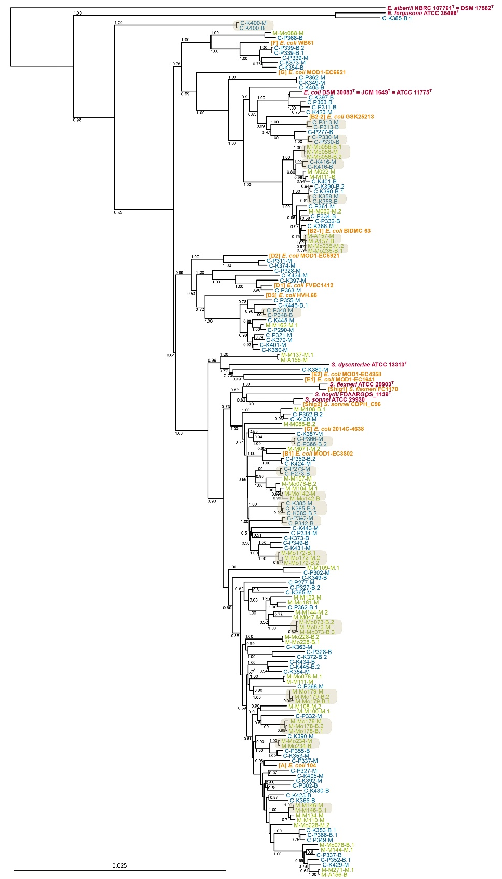

Supplementary Figure 4. Histogram of the frequency of the 15 most common resistance genes identified by AMRFinder, stratified by maternal and neonatal strains.
Statistical significance between maternal and neonatal strains was assessed using a chi-squared test with Bonferroni correction (p-value cutoff: < 0.003), with stars indicating significant differences.

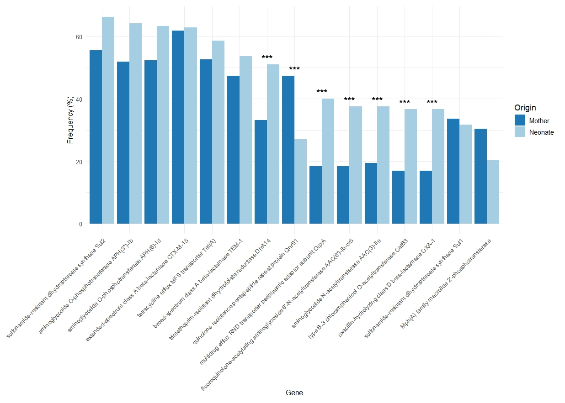

Supplementary Figure 5. Schematic illustration of key terms.
In this study, "acquisition" refers to the neonatal colonization by an ESBL-PE. The figure illustrates four possible scenarios for a colonized neonate: (1) sharing an identical strain with the mother; (2) sharing an ESBL-gene-carrying plasmid with the mother; (3) no shared strain or plasmid; (4) mother not colonized. Cases 1 and 2 are classified as maternal-source acquisitions, while cases 3 and 4 indicate acquisition from another source.
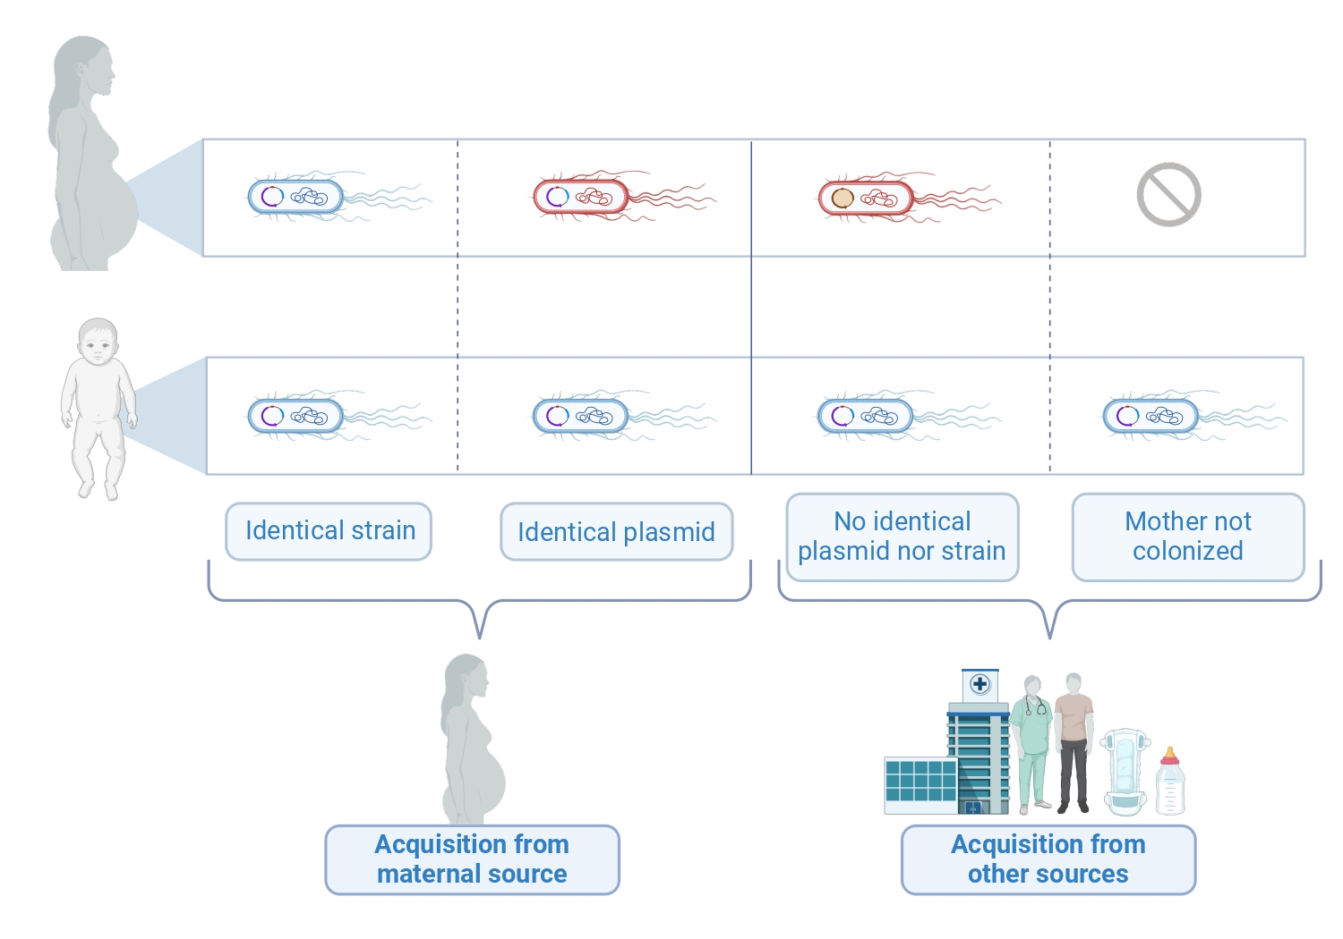
Supplementary Figure 6. Genome-based phylogenetic classification of the isolates belonging to the genus Klebsiella.
Minimum evolution midpoint-rooted phylogenetic tree displaying all the isolates belonging to a mother-neonate pair both colonized by a Klebsiella species. Cambodian (blue) and Madagasy (green) isolate names start with C and M prefixes, respectively, whereas M and B suffixes correspond to mother and neonate, respectively. A total of 16 Klebsiella type strain genomes (red) were added to identify the species of the different ESBL-PE isolates. The type strains belonging to the Klebsiella pneumoniae complex are also labeled using their Kp1-Kp7 standard phylogroups identifiers (e.g. Rodrigues et al. 2019, doi:10.1016/j.resmic.2019.02.003). Neonatal acquisitions from maternal source (highlighted in sand) are assessed by a mother-neonate cherry. Bar, 0.025 nucleotide substitutions per character.
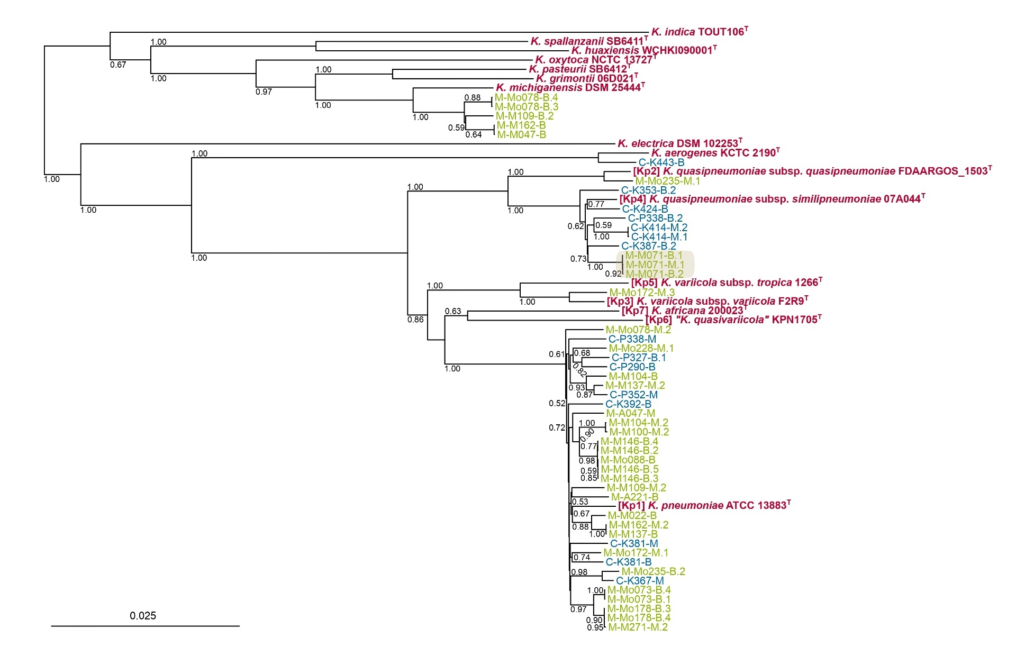
Supplementary Figure 7. Genome-based phylogenetic classification of the isolates belonging to the genus Enterobacter.
Minimum evolution midpoint-rooted phylogenetic tree displaying all the isolates belonging to a mother-neonate pair both colonized by an Enterobacter species. Cambodian (blue) and Malagasy (green) isolate names start with C and M prefixes, respectively, whereas M and B suffixes correspond to mother and neonate, respectively. A total of 28 Enterobacter type strain genomes (red) were added to identify the species of the different ESBL-PE isolates. Neonatal acquisitions from maternal source (highlighted in sand color) are assessed by a mother-neonate cherry. Bar, 0.025 nucleotide substitutions per character.
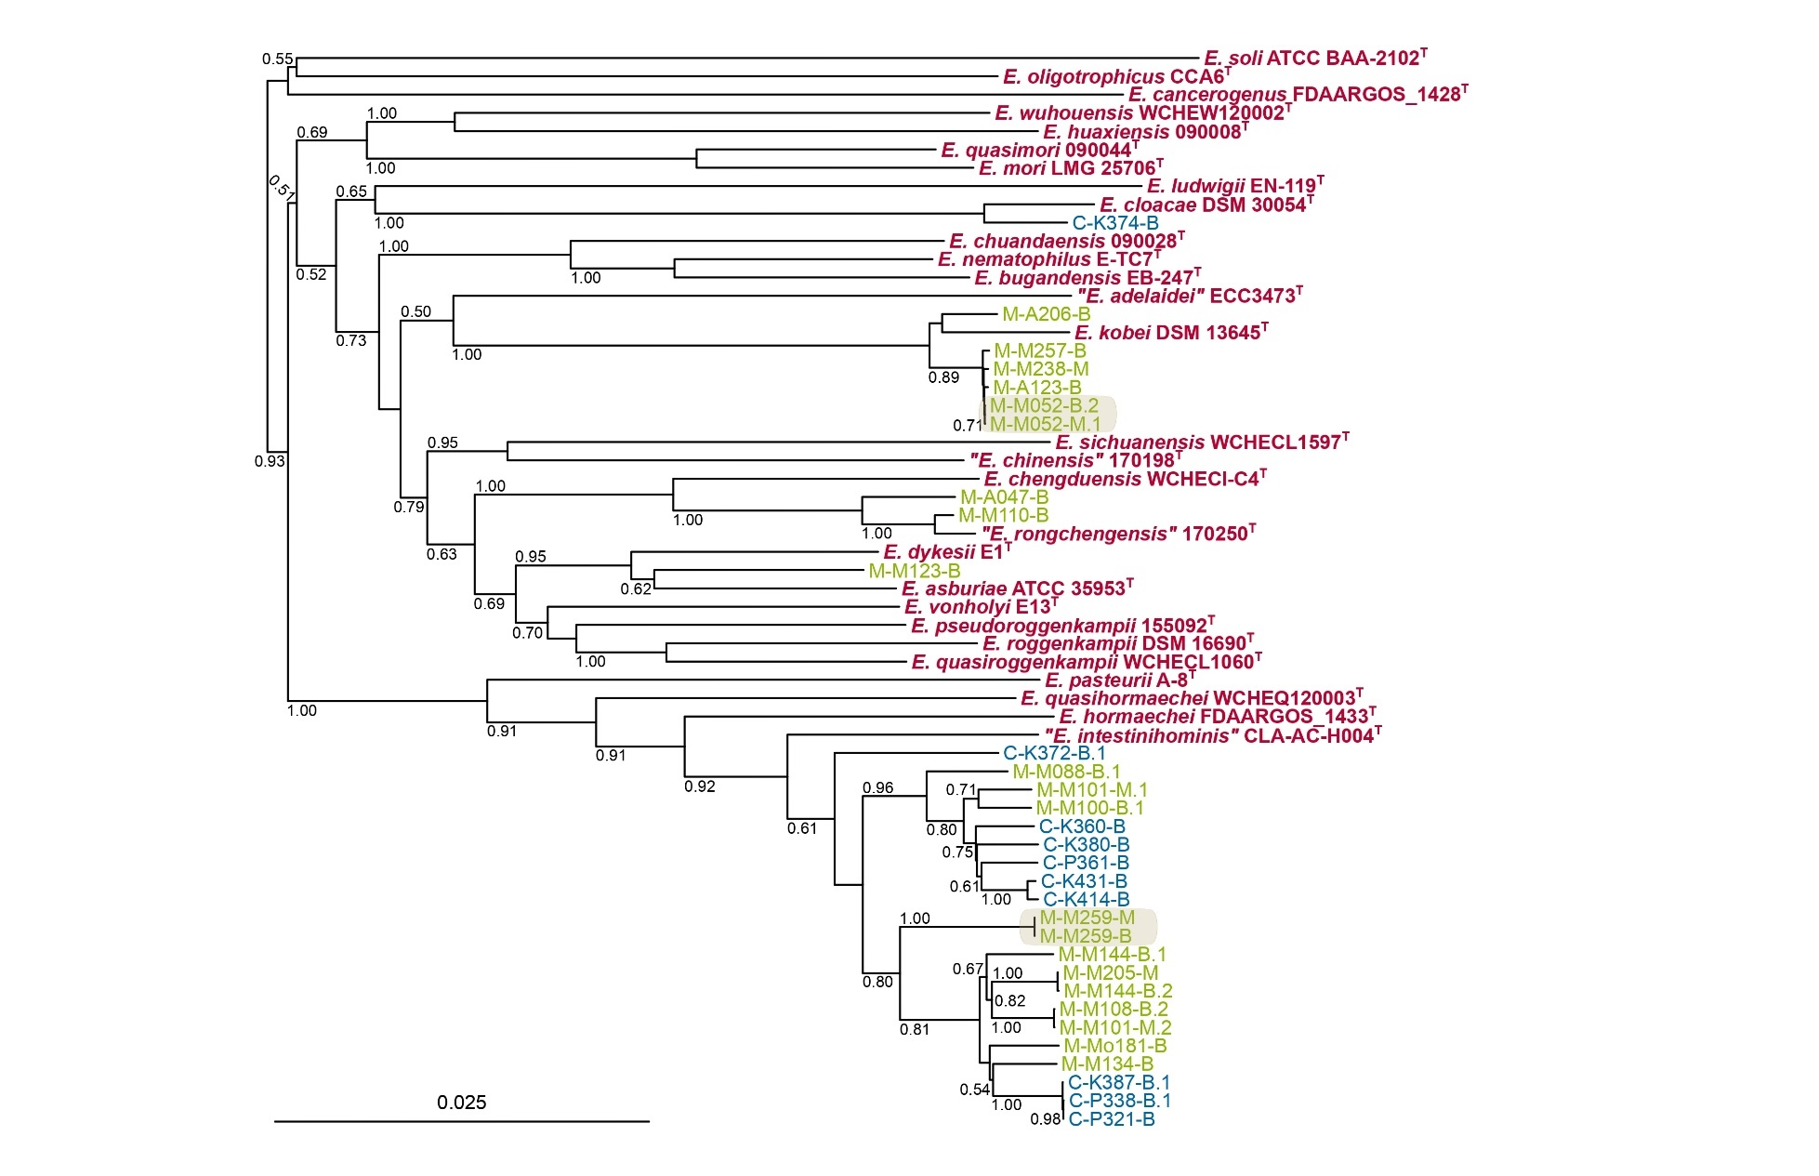

Supplementary Table 1. Results of multinomial regression models from imputed datasets.
This table presents the adjusted odds ratios from multinomial regression models computed on 10 imputed datasets, where missing data were handled using the Predictive Mean Matching (PMM) method from the mice package.
 | Model Estimates
Variable | Model m1 | Model m2 | Model m3 | Model m4 | Model m5 | Model m6 | Model m7 | Model m8 | Model m9 | Model m10
Outcome Level: ESBL-PE acquisition from maternal source
(Intercept) | 0.06 [0.02-0.18], p=0 | 0.06 [0.02-0.19], p=0 | 0.06 [0.02-0.18], p=0 | 0.06 [0.02-0.18], p=0 | 0.06 [0.02-0.18], p=0 | 0.06 [0.02-0.19], p=0 | 0.06 [0.02-0.18], p=0 | 0.06 [0.02-0.18], p=0 | 0.06 [0.02-0.19], p=0 | 0.06 [0.02-0.19], p=0
Study site: Madagascar (BIRDY 2019-20) | 0.16 [0.06-0.47], p=0 | 0.16 [0.06-0.47], p=0 | 0.16 [0.06-0.47], p=0 | 0.16 [0.06-0.47], p=0 | 0.16 [0.06-0.47], p=0 | 0.16 [0.06-0.47], p=0 | 0.16 [0.06-0.47], p=0 | 0.16 [0.06-0.47], p=0 | 0.16 [0.06-0.47], p=0 | 0.16 [0.06-0.47], p=0
Study site: Madagascar (NeoLIC 2021-22) | 1.28 [0.45-3.63], p=0.64 | 1.29 [0.45-3.64], p=0.64 | 1.28 [0.45-3.63], p=0.64 | 1.28 [0.45-3.63], p=0.64 | 1.28 [0.45-3.63], p=0.64 | 1.29 [0.45-3.64], p=0.64 | 1.28 [0.45-3.63], p=0.64 | 1.28 [0.45-3.63], p=0.64 | 1.29 [0.45-3.64], p=0.64 | 1.29 [0.45-3.64], p=0.64
Primigravidae | 2.51 [1.1-5.74], p=0.03 | 2.52 [1.1-5.76], p=0.03 | 2.51 [1.1-5.74], p=0.03 | 2.51 [1.1-5.74], p=0.03 | 2.51 [1.1-5.74], p=0.03 | 2.52 [1.1-5.76], p=0.03 | 2.51 [1.1-5.74], p=0.03 | 2.51 [1.1-5.74], p=0.03 | 2.52 [1.1-5.76], p=0.03 | 2.52 [1.1-5.76], p=0.03
Cesarean section | 2.12 [0.54-8.28], p=0.28 | 2.1 [0.54-8.21], p=0.29 | 2.12 [0.54-8.28], p=0.28 | 2.12 [0.54-8.28], p=0.28 | 2.12 [0.54-8.28], p=0.28 | 2.1 [0.54-8.21], p=0.29 | 2.12 [0.54-8.28], p=0.28 | 2.12 [0.54-8.28], p=0.28 | 2.1 [0.54-8.21], p=0.29 | 2.1 [0.54-8.21], p=0.29
Neonatal resuscitation | 1.92 [0.62-5.93], p=0.25 | 1.84 [0.6-5.65], p=0.29 | 1.92 [0.62-5.93], p=0.25 | 1.92 [0.62-5.93], p=0.25 | 1.92 [0.62-5.93], p=0.25 | 1.84 [0.6-5.65], p=0.29 | 1.92 [0.62-5.93], p=0.25 | 1.92 [0.62-5.93], p=0.25 | 1.84 [0.6-5.65], p=0.29 | 1.84 [0.6-5.65], p=0.29
Season: Wet | 2.31 [0.94-5.68], p=0.07 | 2.3 [0.94-5.64], p=0.07 | 2.31 [0.94-5.68], p=0.07 | 2.31 [0.94-5.68], p=0.07 | 2.31 [0.94-5.68], p=0.07 | 2.3 [0.94-5.64], p=0.07 | 2.31 [0.94-5.68], p=0.07 | 2.31 [0.94-5.68], p=0.07 | 2.3 [0.94-5.64], p=0.07 | 2.3 [0.94-5.64], p=0.07
Outcome Level: ESBL-PE acquisition from other sources
(Intercept) | 0.55 [0.32-0.92], p=0.02 | 0.55 [0.33-0.93], p=0.03 | 0.55 [0.32-0.92], p=0.02 | 0.55 [0.32-0.92], p=0.02 | 0.55 [0.32-0.92], p=0.02 | 0.55 [0.33-0.93], p=0.03 | 0.55 [0.32-0.92], p=0.02 | 0.55 [0.32-0.92], p=0.02 | 0.55 [0.33-0.93], p=0.03 | 0.55 [0.33-0.93], p=0.03
Study site: Madagascar (BIRDY 2019-20) | 0.38 [0.23-0.62], p=0 | 0.38 [0.23-0.62], p=0 | 0.38 [0.23-0.62], p=0 | 0.38 [0.23-0.62], p=0 | 0.38 [0.23-0.62], p=0 | 0.38 [0.23-0.62], p=0 | 0.38 [0.23-0.62], p=0 | 0.38 [0.23-0.62], p=0 | 0.38 [0.23-0.62], p=0 | 0.38 [0.23-0.62], p=0
Study site: Madagascar (NeoLIC 2021-22) | 0.36 [0.17-0.78], p=0.01 | 0.37 [0.17-0.79], p=0.01 | 0.36 [0.17-0.78], p=0.01 | 0.36 [0.17-0.78], p=0.01 | 0.36 [0.17-0.78], p=0.01 | 0.37 [0.17-0.79], p=0.01 | 0.36 [0.17-0.78], p=0.01 | 0.36 [0.17-0.78], p=0.01 | 0.37 [0.17-0.79], p=0.01 | 0.37 [0.17-0.79], p=0.01
Primigravidae | 0.84 [0.54-1.32], p=0.46 | 0.85 [0.54-1.32], p=0.46 | 0.84 [0.54-1.32], p=0.46 | 0.84 [0.54-1.32], p=0.46 | 0.84 [0.54-1.32], p=0.46 | 0.85 [0.54-1.32], p=0.46 | 0.84 [0.54-1.32], p=0.46 | 0.84 [0.54-1.32], p=0.46 | 0.85 [0.54-1.32], p=0.46 | 0.85 [0.54-1.32], p=0.46
Cesarean section | 3.64 [1.92-6.89], p=0 | 3.6 [1.9-6.82], p=0 | 3.64 [1.92-6.89], p=0 | 3.64 [1.92-6.89], p=0 | 3.64 [1.92-6.89], p=0 | 3.6 [1.9-6.82], p=0 | 3.64 [1.92-6.89], p=0 | 3.64 [1.92-6.89], p=0 | 3.6 [1.9-6.82], p=0 | 3.6 [1.9-6.82], p=0
Neonatal resuscitation | 2.23 [1.2-4.13], p=0.01 | 2.09 [1.13-3.87], p=0.02 | 2.23 [1.2-4.13], p=0.01 | 2.23 [1.2-4.13], p=0.01 | 2.23 [1.2-4.13], p=0.01 | 2.09 [1.13-3.87], p=0.02 | 2.23 [1.2-4.13], p=0.01 | 2.23 [1.2-4.13], p=0.01 | 2.09 [1.13-3.87], p=0.02 | 2.09 [1.13-3.87], p=0.02
Season: Wet | 1.68 [1.08-2.63], p=0.02 | 1.67 [1.07-2.6], p=0.02 | 1.68 [1.08-2.63], p=0.02 | 1.68 [1.08-2.63], p=0.02 | 1.68 [1.08-2.63], p=0.02 | 1.67 [1.07-2.6], p=0.02 | 1.68 [1.08-2.63], p=0.02 | 1.68 [1.08-2.63], p=0.02 | 1.67 [1.07-2.6], p=0.02 | 1.67 [1.07-2.6], p=0.02

Supplementary Table 2. Strain accession numbers and main characteristics.
See separate xlsx sheet.

