S1 Figure. Two-step antibody validation for ChIP-Seq.
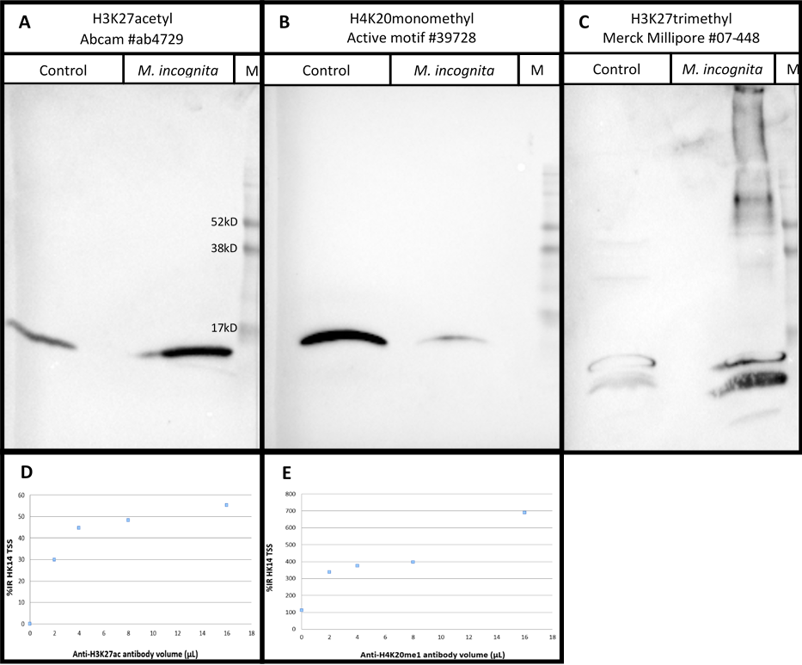
S1 Table. Antibodies selected and tested for ChIP-seq analysis on M. incognita.
Epitope | Supplier | Catalog # | Batch # | Clonality | Western Blot | ChIP-qPCR | Antibody amount
H4K20monomethyl | Active Motif | 39728 | #21115004 | Monoclonal | Yes | No | Not validated
H4K20trimethyl | Active Motif | 39672 | #25815004 | Monoclonal | Yes | No | Not validated
H3K9acetyl | Active Motif | 61664 | #04415001 | Monoclonal | Yes | No | Not validated
H3K56acetyl | Active Motif | 61062 | #09811001 | Monoclonal | Yes | No | Not validated
H3K4dimethyl | Abcam | ab32356 | #GR84714-4 | Monoclonal | Yes | No | Not validated
H4K20trimethyl | Abcam | ab9053 | #GR86824-1 | Polyclonal | Yes | No | Not validated
H3K27acetyl | Abcam | ab4729 | #GR150367-2 | Polyclonal | Yes | Yes | 4µL
H3K27trimethyl | Epigentek | A-4039 | #503019 | Polyclonal | Yes | Yes | 4µL
H3K4trimethyl | Merck Millipore | 04-745 | #2392291 and #2452485 | Monoclonal | Yes | Yes | 8µL
H3K9trimethyl | Abcam | ab8898 | #GR306402-2 | Polyclonal | Yes | Yes | 8µL
H4K20monomethyl | Abcam | ab9051 | #GR158874-1 | Polyclonal | Yes | Yes | 8µL
H3K36trimethyl | Abcam | ab9050 | #GR300387-1 | Polyclonal | No | No | Not validated
H3K27monomethyl | Merck Millipore | 07-448 | #JBC1361682 | Polyclonal | No | No | Not validated
H3K27acetyl | Millipore | 07-360 | #Q2209321 | Polyclonal | No | No | Not validated
H3K27acetyl | Active Motif | 39134 | #1613007 | Polyclonal | No | No | Not validated
H3K9acetyl | Merck Millipore | 07-352 | #3089126 | Polyclonal | No | No | Not validated

S2 Figure. H3K4me3, H3K9me3, H3K27ac, H27me3 and H4K20me1 histone modifications on the M. incognita genome.
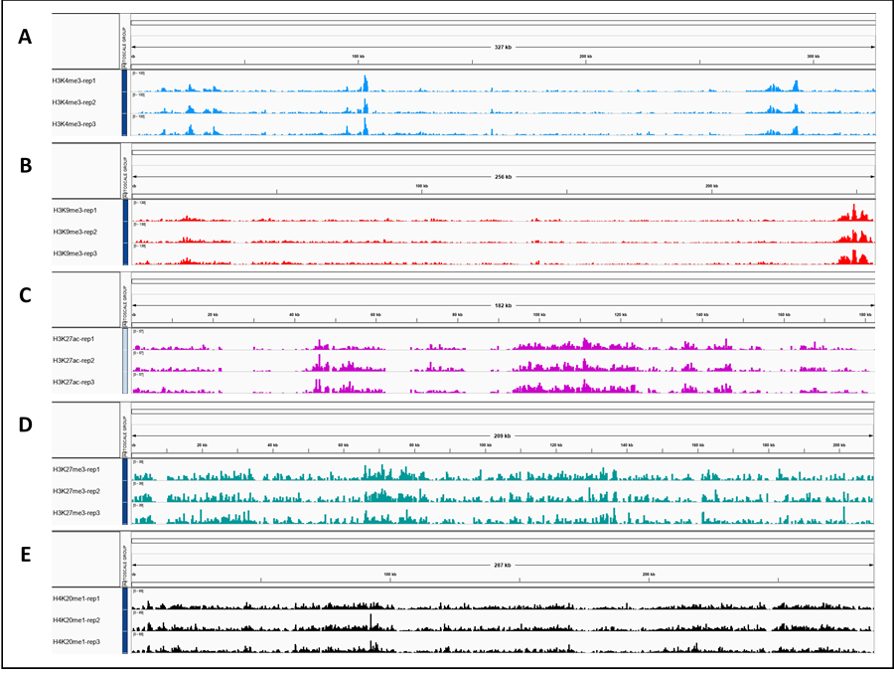

S3 Figure. Genome wide distribution of histone modifications, J2 samples, in relation to annotations for the M. incognita genome.
S4 Figure. Distinct epigenetic landscapes at the transposable element (TE) and protein coding-gene annotations in M. incognita.
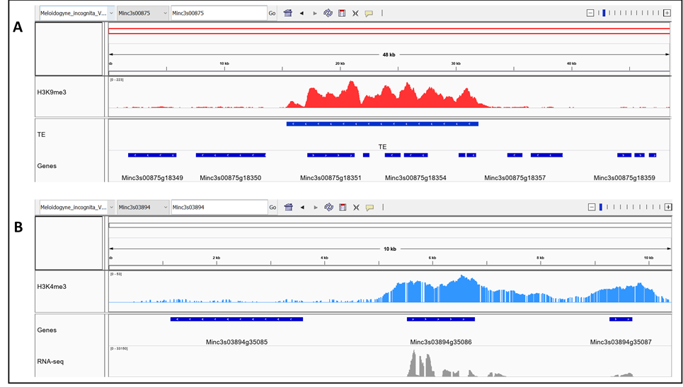
Gene_ID | GO_ID | Cele_ortholog | PANTHER_Family_Subfamily | PANTHER_Protein_Class
Minc3s00022g01429 | GO:0042302 | - | - | -
Minc3s00024g01555 | GO:0005515 | - | - | -
Minc3s00059g03033 | GO:0008270 | - | - | -
Minc3s00122g05254 | GO:0005515 | - | - | -
Minc3s00175g06764 | GO:0006470,GO:0004725 | - | - | -
Minc3s00228g08060 | GO:0005515 | - | - | -
Minc3s00235g08214 | GO:0005921 | - | - | -
Minc3s00270g09053 | GO:0006334,GO:0005634,GO:0000786,GO:0003677,GO:0046982 | - | - | -
Minc3s00496g13313 | GO:0042302 | - | - | -
Minc3s00617g15162 | GO:0006508,GO:0008237,GO:0008270,GO:0004222 | - | - | -
Minc3s00743g16779 | GO:0006468,GO:0004672,GO:0005524,GO:0004674,GO:0004713,GO:0016772 | - | - | -
Minc3s00778g17229 | GO:0005921 | - | - | -
Minc3s00778g17230 | GO:0005921 | - | - | -
Minc3s00948g19200 | GO:0046872 | - | - | -
Minc3s01033g20041 | GO:0005921 | - | - | -
Minc3s01509g24378 | GO:0003677 | - | - | -
Minc3s02210g28873 | GO:0003677 | - | - | -
Minc3s02531g30493 | GO:0006334,GO:0000786,GO:0003677,GO:0046982 | - | - | -
Minc3s03074g32677 | GO:0005488 | - | - | -
Minc3s03635g34388 | GO:0005921 | - | - | -
Minc3s04120g35526 | GO:0006468,GO:0004672,GO:0005524,GO:0004674,GO:0004713,GO:0016772 | - | - | -
Minc3s04120g35527 | GO:0005515,GO:0008270 | - | - | -
Minc3s06804g40340 | GO:0005515 | - | - | -
Minc3s07231g40874 | GO:0006334,GO:0000786,GO:0003677,GO:0046982 | - | - | -
Minc3s09509g43272 | GO:0006334,GO:0005634,GO:0000786,GO:0003677,GO:0046982 | - | - | -
Minc3s11337g44818 | GO:0006355,GO:0003700,GO:0043565,GO:0003677 | - | - | -
Minc3s00781g17277 | GO:0005524,GO:0008026,GO:0003676,GO:0004386 | A0FLQ6 | DNA POLYMERASE THETA (PTHR10133:SF41) | DNA-directed DNA polymerase(PC00018)
Minc3s01717g25828 | GO:0006260,GO:0006139,GO:0000166,GO:0003677,GO:0003887,GO:0003676 | C7IVS4 | DNA POLYMERASE ALPHA CATALYTIC SUBUNIT (PTHR45861:SF1) | DNA metabolism protein(PC00009)
Minc3s00307g09837 | GO:0000910,GO:0000226,GO:0008017 | G5ED58 | FASCETTO-RELATED (PTHR19321:SF0) | non-motor microtubule binding protein(PC00166)
S2 Table. M. incognita Egg-overexpressed genes orthologs in C. elegans. (30 first rows only).
S3 Table. M. incognita J2-overexpressed genes orthologs in C. elegans. (30 first rows only)
Gene_ID | GO_ID | Cele_ortholog | PANTHER_Family_Subfamily | PANTHER_Protein_Class
Minc3s00019g01229 | GO:0006355,GO:0003700 | - | - | -
Minc3s00043g02384 | GO:0035023,GO:0005089,GO:0005515 | - | - | -
Minc3s00061g03127 | GO:0008270,GO:0005515 | - | - | -
Minc3s00069g03459 | GO:0006355,GO:0007179,GO:0005622,GO:0005667,GO:0005515,GO:0003700 | - | - | -
Minc3s00077g03765 | GO:0005509 | - | - | -
Minc3s00088g04180 | GO:0003676,GO:0046872 | - | - | -
Minc3s00096g04404 | GO:0055085,GO:0016021 | - | - | -
Minc3s00097g04473 | GO:0071805,GO:0016020,GO:0005267 | - | - | -
Minc3s00130g05555 | GO:0006355,GO:0003700 | - | - | -
Minc3s00140g05827 | GO:0007186,GO:0016021,GO:0004930 | - | - | -
Minc3s00164g06502 | GO:0006355,GO:0005634,GO:0043565,GO:0003677,GO:0003700,GO:0008270 | - | - | -
Minc3s00221g07904 | GO:0006355,GO:0043401,GO:0005634,GO:0003707,GO:0003700 | - | - | -
Minc3s00288g09480 | GO:0016021 | - | - | -
Minc3s00326g10264 | GO:0005515 | - | - | -
Minc3s00354g10848 | GO:0006355,GO:0007179,GO:0005622,GO:0005667,GO:0005515,GO:0003700 | - | - | -
Minc3s00398g11622 | GO:0005634,GO:0043565 | - | - | -
Minc3s00457g12628 | GO:0008270,GO:0005515 | - | - | -
Minc3s00491g13226 | GO:0005515 | - | - | -
Minc3s00492g13244 | GO:0006979,GO:0055114,GO:0004602 | - | - | -
Minc3s00510g13525 | GO:0008270,GO:0003676 | - | - | -
Minc3s00570g14437 | GO:2001070,GO:0030246 | - | - | -
Minc3s00662g15772 | GO:0055085,GO:0016021 | - | - | -
Minc3s00692g16166 | GO:0005576,GO:0005184 | - | - | -
Minc3s00716g16468 | GO:0006836,GO:0016021,GO:0005328 | - | - | -
Minc3s00840g17971 | GO:0006508,GO:0031012,GO:0008237,GO:0008270,GO:0004222 | - | - | -
Minc3s00939g19096 | GO:0055114,GO:0009055,GO:0016705,GO:0020037,GO:0005506 | - | - | -
Minc3s00956g19273 | GO:0007165,GO:0000159,GO:0008601,GO:0005488 | - | - | -
Minc3s00956g19274 | GO:0007165,GO:0000159,GO:0008601,GO:0005488 | - | - | -
Minc3s00972g19447 | GO:0006355,GO:0005634,GO:0043565,GO:0003700 | - | - | -

S4 Table Transcriptional regulation of known subventral glands (SvG) effector genes.
Gene numbers according to Da Rocha et al., 2021 | Gene names according to literature | Log2(Fold-change J2s/Eggs) | Gene | HPTM_eggs | HPTM_J2s
Effector genes associated with a similar expression level during eggs-to-J2s transition
1 | 16D10 | NS | NA | [] | []
4 | 2G06B (CM1) | NS | NA | [] | []
11 | 5G06 (msp26) | NS | Minc3s00664g15812 | [] | []
12 | 6D09B (CM1, CM2, 2G06B) | NS | NA | [] | []
16 | 8H11 (msp10, 10A08) | NS | Minc3s01802g26418 | [] | []
19 | CL321Contig1_1-EST | NS | Minc3s00011g00761 | [] | []
20 | CL480Contig2_1-EST | NS | Minc3s00475g12970 | [] | []
34 | Minc03314 | NS | Minc3s00020g01281 | [] | []
36 | Minc03328 | NS | Minc3s00020g01299 | [] | []
38 | Minc04584 | NS | NA | [] | []
41 | Minc10418 (Minc08073) | NS | Minc3s01112g20831 | [] | []
44 | Minc15401 | NS | Minc3s06052g39242 | [] | []
45 | Minc18033 (16E05, msp17) | NS | Minc3s03024g32468 | [] | []
28 | Mi-PNF3 (Profilin3) | NS | Minc3s00239g08307 | [] | []
30 | Mi-Xyl1 | NS | Minc3s00084g04025 | [] | []
32 | Minc00469 | NS | Minc3s00013g00811 | [] | [H3K27me3]
40 | Minc08146 | NS | Minc3s00234g08205 | [] | [H3K27me3]
42 | Minc12024 | NS | NA | [] | [H3K27me3+H3K9me3+H4K20me1]
15 | 8E10B (msp40) | NS | Minc3s05895g38985 | [] | [H3K4me3]
9 | 4D01 (msp3) | NS | Minc3s01472g24105 | [] | [H3K9me3]
46 | Minc18636 (MiEFF18) | NS | Minc3s01525g24488 | [] | [H3K9me3]
22 | HM1 | NS | Minc3s00001g00021 | [H3K27ac] | [H3K27ac]
39 | Minc08073 (Minc10418) | NS | Minc3s00371g11166 | [H3K27ac] | [H3K27ac]
5 | 30G11 (msp21) | NS | Minc3s00271g09100 | [H3K4me3] | [H3K4me3]
17 | CL2552Contig1_1-EST | NS | Minc3s01149g21190 | [H3K4me3] | [H3K4me3]
31 | Minc00344 (Minc04584) | NS | Minc3s00056g02915 | [H4K20me1] | [H4K20me1]
Effector genes associated with a differential expression level during eggs-to-J2s transition
7 | 31H06 (msp22) | 3.57 | Minc3s00376g11251 | [] | []
47 | SXP-RAL2=Mi-SXP-1 | 4.08 | Minc3s00381g11354 | [] | []
27 | Mi-PG1 | 5.59 | Minc3s00007g00481 | [] | []
2 | 2B02B (Mi-PEL2) | 6.12 | Minc3s00094g04359 | [] | []
26 | Mi-PEL2 | 6.40 | Minc3s00566g14364 | [] | []
35 | Minc03325 | 7.55 | Minc3s00020g01295 | [] | []
21 | CL5Contig2_1-EST (Sec-2) | 2.30 | Minc3s00113g04971 | [H3K4me3] | [H3K4me3]
33 | Minc01696 | 4.48 | Minc3s00036g02098 | [H3K9me3] | [H3K9me3]
Effector genes associated with both a histone modification dynamic and a differential expression level during eggs-to-J2s transition
25 | Mi-GSTS1 | 2.14 | Minc3s00365g11068 | [] | [H3K4me3]
6 | 30H07 (msp20) | 2.95 | Minc3s05190g37766 | [] | [H3K27ac+H3K27me3+H4K20me1]
13 | 8D05 (msp9) | 3.20 | Minc3s01244g22037 | [] | [H3K9me3]
18 | CL312Contig1_1-EST | 3.90 | Minc3s00070g03486 | [H3K4me3+H4K20me1] | [H3K4me3]
3 | 2G02 (msp2) | 3.96 | Minc3s00855g18130 | [] | [H4K20me1]
14 | 8E08B (Eng4) | 5.04 | Minc3s00139g05823 | [] | [H3K9me3]
48 | Mi-PEL1 | 6.09 | Minc3s00441g12378 | [] | [H3K27me3]
8 | 34C04 (Mi-PL1) | 6.14 | Minc3s01107g20785 | [H4K20me1] | [H3K27me3]
29 | Mi-VAP2 | 6.33 | Minc3s01051g20218 | [] | [H3K27ac+H3K27me3+H4K20me1]
23 | Mi-CBP1 (42G06) | 6.51 | Minc3s00139g05824 | [H3K27me3] | [H3K9me3]
43 | Minc13292 | 6.99 | Minc3s00083g03979 | [H3K9me3] | []
10 | 5A12B (ENG1, ENG3) | 8.51 | Minc3s03138g32920 | [] | [H3K27ac+H3K27me3+H4K20me1]
24 | Mi-ENG1 (1C11B) | 8.53 | Minc3s03136g32914 | [] | [H3K27me3+H4K20me1]
37 | Minc03866 | 8.67 | Minc3s00066g03327 | [H3K27me3+H3K9me3+H4K20me1] | [H3K9me3]

S5 Table. Transcriptional regulation of known dorsal gland (DG) effector genes.
Gene numbers according to Da Rocha et al., 2021 | Gene names according to literature | Log2(Fold-change J2s/Eggs) | Gene | HPTM_egg | HPTM_juvenile
Effector genes associated with a similar expression level during eggs-to-J2s transition
1 | 10G02 (msp29) | NS | Minc3s00046g02513 | [] | []
2 | 12H03 (msp13) | NS | NA | [] | []
3 | 13A12 (2E07, 11A01, msp14) | NS | Minc3s00111g04880 | [] | []
4 | 17H02 (msp18) | NS | NA | [] | []
6 | 1C05B (msp36) | NS | Minc3s01204g21688 | [] | []
7 | 1D08B (msp37) | NS | NA | [] | []
8 | 21E02 (14E06, msp19) | NS | NA | [] | []
10 | 2G10 (msp27) | NS | NA | [] | []
11 | 34D01 (msp23) | NS | NA | [] | []
13 | 35F03 (msp30) | NS | NA | [] | []
14 | 4D03 (msp28) | NS | Minc3s00043g02427 | [] | []
19 | 7E12 (14E06, msp7) | NS | NA | [] | []
20 | 7H08 (msp8) | NS | NA | [] | []
21 | 9H10 (msp11) | NS | Minc3s00709g16396 | [] | []
27 | Minc11817 (Minc18861) | NS | NA | [] | []
29 | Minc12754 | NS | Minc3s00905g18741 | [] | []
30 | Minc17611 | NS | NA | [] | []
31 | Minc17998 | NS | Minc3s01352g23040 | [] | []
32 | Minc18876 | NS | Minc3s00086g04105 | [] | []
33 | 28B04 | NS | NA | NA | NA
5 | 19F07 (35E04, msp32) | NS | Minc3s00381g11350 | [H3K27me3] | [H3K27me3]
15 | 5C03B (msp39) | NS | Minc3s00989g19628 | [H3K9me3] | [H3K4me3]
17 | 6G07 (msp5) | NS | NA | [] | [H3K27me3+H4K20me1]
18 | 7A01 (msp6) | NS | Minc3s00173g06739 | [] | [H3K9me3]
22 | HM12 | NS | Minc3s01504g24329 | [] | [H3K4me3]
24 | Minc00108 | NS | Minc3s00001g00012 | [] | [H3K27ac+H4K20me1]
34 | 4F05B | NS | NA | [H3K4me3] | [H3K4me3]
Effector genes associated with a differential expression level during eggs-to-J2s transition
28 | Minc12639 | 3.18 | Minc3s00340g10545 | [] | []
25 | Minc01595 | 3.90 | Minc3s01184g21493 | [H3K27me3+H4K20me1] | [H3K27me3+H4K20me1]
Effector genes associated with both a histone modification dynamic and a differential expression level during eggs-to-J2s transition
12 | 34F06 (msp24) | 2.68 | Minc3s00321g10151 | [H3K27me3] | [H3K27me3+H3K9me3]
26 | Minc02097 (35A02, msp25) | 4.80 | Minc3s00202g07465 | [] | [H3K27me3]
9 | 25B10 (msp33) | 4.99 | Minc3s03649g34419 | [] | [H3K9me3]
16 | 6F06 (msp4) | 5.65 | Minc3s02324g29465 | [H3K9me3] | []
23 | Mi-14-3-3 | -3.43 | Minc3s00122g05244 | [] | [H3K27me3]

