SUPPLEMENTARY INFORMATION

MEMS-based chip scale spatial-bandwidth product enhanced image sensor

Rongbo Xie¹, Xiaoqin Liu¹, Haiyang Zhan¹, Guozhe Xuan¹, Fan Zhang²,
Bingbai Li¹, Ziqi Mei¹, Enze Zhou¹, Rui Ma¹, Zheng You^{1, 3, 4, *}, Fei Xing^{1, 3, 4, *}
& Xiaoguang Zhao^{1, 3, 4, *}

¹Department of Precision Instrument, Tsinghua University, Beijing, China.
²School of Instrument Science and Opto-electronics Engineering, Beijing Information Science and Technology University, Beijing, China.
³State Key Laboratory of Precision Measurement Technology and Instruments, Tsinghua University, Beijing, China.
⁴Beijing Advanced Innovation Center for Integrated Circuits, Tsinghua University, Beijing, China.
*e-mail: yz-dpi@mail.tsinghua.edu.cn; xingfei@mail.tsinghua.edu.cn; zhaoxg@mail.tsinghua.edu.cn

Table of contents

Supplementary Notes

Supplementary Note. 1 Derivation of the image degradation model

Supplementary Note. 2 Derivation of the space-modulated sampling model

Supplementary Figures

Supplementary Fig. 1 Characterization of the MEMS actuator

Supplementary Fig. 2 Illustration of twist-free scanning enabled by four independent comb structures.

Supplementary Fig. 3 Fabrication process flow of the MEMS actuator.

Supplementary Fig. 4 Integration of MEMS actuator and DIS device.

Supplementary Fig. 5 Experimental setup of MSEIS characterization.

Supplementary Fig. 6 Additional experimental results demonstrate the MSEIS’s accuracy improvement in positioning of the point-like targets.

Supplementary Fig. 7 Schematic diagram of the degradation and sampling process in frequency domain.

Supplementary Note. 1 Derivation of the image degradation model
In classical imaging theory, we consider a two-dimensional time-invariant illuminated image I(x,y). The ideal sampling process of the digital image sensor (DIS) is considered to be
$$\begin{aligned}I_{s}\left(x,y\right)=\sum_{n=0}^{N}{\sum_{m=0}^{M}{δ\left(x-np_{x},y-mp_{y}\right)I\left(x,y\right),}}\#(1) \end{aligned}$$
where the N and M is the total number of pixels in x- and y-direction, n and m are the pixel label in x- and y-direction, respectively. The δ(x,y) is the two-dimensional Dirac function defined as
$$\begin{aligned}δ\left(x,y\right)=\left\{\begin{aligned}+∞, x=y=0 \\ 0,others\end{aligned}\right.,\#(2) \end{aligned}$$
and possesses the following properties
$$\begin{aligned}\int_{-∞}^{+∞}{\int_{-∞}^{+∞}{δ\left(x,y\right)dxdy=1}}.\#(3) \end{aligned}$$
We consider an image detector with pixel size p and number of pixels N in both x- and y- directions. The ideal sampling Equation (1) can then be simplified to following representation
$$\begin{aligned}I_{s}\left(x,y\right)=\sum_{n=0}^{N}{\sum_{m=0}^{N}{δ\left(x-np,y-mp\right)I\left(x,y\right)}}\#(4) \end{aligned}$$
However, due to the finite area of the active pixel photosensitive regions, which cannot be infinitely small, the practical sampling function can be further described as
$$\begin{aligned}I_{sd}\left(x,y\right)=\sum_{n=0}^{N}{\sum_{m=0}^{N}{δ\left(x-np,y-mp\right)\int_{x-\frac{ap}{2}}^{x+\frac{ap}{2}}{\int_{y-\frac{ap}{2}}^{y+\frac{ap}{2}}{\frac{I\left(α,β\right)}{a^{2}p^{2}}} dαdβ}}},\#(5) \end{aligned}$$
where the a is the fill factor of the DIS. The integral in equation (5) describes the averaging effect of the finite active pixel size of the image sensor on the illuminated image, similar to a moving average process. To decouple the averaging effect introduced by the pixel from the sampling process, we define an intermediate variable called the degraded image I_{d}(x,y). The degraded image I_{d}(x,y) represents the image that can be sampled in actual imaging, under the influence of averaging effects in DIS and can be represented as a degradation process of the illuminated image I(x,y):
$$\begin{aligned}I_{d}\left(x,y\right)=\int_{-\frac{ap}{2}}^{\frac{ap}{2}}{\int_{-\frac{ap}{2}}^{\frac{ap}{2}}{\frac{I\left(x+α,y+β\right)}{a^{2}p^{2}}} dαdβ}. \#\left(6\right)\end{aligned}$$
Solving for the illuminated image I(x,y) from a degraded image I_{d}(x,y) means calculation of the integrand from a definite integral function, which is a highly ill-posed inverse problem, yielding the loss of information¹.
Below, we will demonstrate that the degree of degradation depends on the edge length of the active pixel ap. When using the degraded image as an estimate for the illuminated image, the resulting point estimation error can be expressed as
$$\begin{aligned}E\left(x,y\right)=\left|I\left(x,y\right)-I_{d}\left(x,y\right)\right|.\#\left(7\right)\end{aligned}$$
For a practical illuminated image, we assume that the image distribution is smooth and continuously differentiable up to the second order in space. Therefore, the illuminated image at any point within its domain, according to Taylor's theorem (considering terms up to the second order), can be expressed as:
$$I\left(x,y\right)=I\left(x_{0},y_{0}\right)+I_{x}\left(x_{0},y_{0}\right)\left(x-x_{0}\right)+I_{y}\left(x_{0},y_{0}\right)\left(y-y_{0}\right)+\frac{1}{2}\left[I_{xx}\left(x_{0},y_{0}\right){\left(x-x_{0}\right)}^{2}+2I_{xy}\left(x_{0},y_{0}\right)\left(x-x_{0}\right)\left(y{-y}_{0}\right)+I_{yy}\left(x_{0},y_{0}\right){\left(y-y_{0}\right)}^{2}\right]+R_{2}\left(x,y\right),$$
$$(8)$$
where R₂(x,y) represents the remainder term of the Taylor expansion, representing the sum of terms from third order and above.
Substituting the above expression (8) into definition of the degraded image (6) yields:
$$I_{d}\left(x,y\right)=\frac{1}{a^{2}p^{2}}\int_{x-\frac{ap}{2}}^{x+\frac{ap}{2}}{\int_{y-\frac{ap}{2}}^{y+\frac{ap}{2}}{\left\{I\left(x,y\right)+I_{x}\left(x,y\right)\left(α-x\right)+I_{y}\left(x,y\right)\left(β-y\right)+\frac{1}{2}\left[I_{xx}\left(x,y\right){\left(α-x\right)}^{2}+2I_{xy}\left(x,y\right)\left(α-x\right)\left(β-y\right)+I_{yy}\left(x,y\right){\left(β-y\right)}^{2}\right]+R_{2}\left(α,β\right)\right\}} dαdβ.}$$
$$(9)$$
Considering the symmetry of the integration interval, the linear terms (i.e., those containing (x-x₀) and (y-y₀) integrate to zero over symmetric intervals. Therefore, only the constant and quadratic terms need to be considered:
$$I_{d}\left(x,y\right)=\frac{1}{a^{2}p^{2}}\int_{x-\frac{ap}{2}}^{x+\frac{ap}{2}}{\int_{y-\frac{ap}{2}}^{y+\frac{ap}{2}}{\left\{I\left(x,y\right)+\frac{1}{2}\left[I_{xx}\left(x,y\right){\left(α-x\right)}^{2}+2I_{xy}\left(x,y\right)\left(α-x\right)\left(β-y\right)+I_{yy}\left(x,y\right){\left(β-y\right)}^{2}\right]+R_{2}\left(α,β\right)\right\}} dαdβ.}$$
$$(10)$$
Further calculation of the integral yields:
$$\begin{aligned}I_{d}\left(x,y\right)=I\left(x,y\right)+\frac{ap}{24}\left[I_{xx}\left(x,y\right)+I_{yy}\left(x,y\right)\right]+\frac{1}{a^{2}p^{2}}\int_{x-\frac{ap}{2}}^{x+\frac{ap}{2}}{\int_{y-\frac{ap}{2}}^{y+\frac{ap}{2}}{R_{2}\left(α,β\right)}dαdβ}.\#\left(11\right)\end{aligned}$$
Substituting the above expression (10) into definition of the estimation error (7), we can derive an expression for the upper bound of the estimation error as bellow:
$$E\left(x,y\right)=\left|\frac{ap}{24}\left[I_{xx}(x,y)+I_{yy}(x,y)\right]+\frac{1}{a^{2}p^{2}}\int_{x-\frac{ap}{2}}^{x+\frac{ap}{2}}{\int_{y-\frac{ap}{2}}^{y+\frac{ap}{2}}{R_{2}\left(α,β\right)}dαdβ}\right|≤\frac{ap}{24}\left[\left|I_{xx}\left(x,y\right)\right|+\left|I_{xx}\left(x,y\right)\right|\right]+O\left(a^{2}p^{2}\right).$$
$$(12)$$
Equation (12) demonstrate that, when using a degraded image I_{d}(x,y) to estimate the illumination image I(x,y), the upper bound of the estimation error decreases linearly as the active pixel size $ap$ decreases. This estimation error is solely limited by the active pixel size $ap$ and cannot be reduced by modulating the spatial position of the image sensor.
To more intuitively describe the loss of image information during the degradation process, we further analyze the degradation process in the frequency domain. Based on Fourier optics theory² the Equation (11) can be rewritten with the convolution operators $⊗$:
$$\begin{aligned}I_{d}\left(x,y\right)=\frac{1}{a^{2}p^{2}}I\left(x,y\right)⊗rect\left(\frac{x}{ap},\frac{y}{ap}\right),\#\left(13\right)\end{aligned}$$
where the rect represents the two-dimensional rectangular window function defined as follows:
$$\begin{aligned}rect\left(x,y\right)=\left\{\begin{aligned}1, -0.5≤x≤0.5 and -0.5≤y≤0.5 \\ 0,others\end{aligned}\right..\#\left(14\right)\end{aligned}$$
Taking the Fourier transform of both sides of Equation (13) yields:
$$\begin{aligned}F\left\{I_{d}\left(x,y\right)\right\}=F\left\{I\left(x,y\right)\right\}sinc\left({apf}_{x}\right)sinc\left({apf}_{y}\right).\#\left(15\right)\end{aligned}$$
According to Equation (15), the averaging effect modulates the spectrum of the illuminated image with a sinc function in the frequency domain. This causes rapid attenuation of high-frequency information and the complete loss of signal information at frequencies i/2ap (i = 1, 2, 3…), resulting in the reduced high-frequency signal signal-to-noise ratio (SNR) and decreased measurement accuracy. When the fill factor a decreases while the pixel size remains constant, the width of the sinc function increases, indicating less attenuation of high-frequency signals and the improvement of the degradation process.

Supplementary Note. 2 Derivation of the space-modulated sampling model
The MSEIP’s improvement in imaging performance lies in the enhancement of the SBP, meaning a higher spatial sampling frequency of the degraded image. The SBP of the image senor can be defined as:
$$\begin{aligned}SBP=N^{2}p^{2}×f_{xmax}f_{ymax},\#(16) \end{aligned}$$
where the N²p² represents the area of the image sensor and the f_{xmax}f_{ymax} corresponds to the product of the maximum sampling frequencies in the x-direction and y-direction. According to the Nyquist-Shannon sampling theorem, the maximum sampling frequency can be described as:
$$\begin{aligned}f_{xmax}=f_{ymax}=\frac{1}{2p},\#\left(17\right)\end{aligned}$$
where the p_{x} and p_{y} relate to the sampling period in x- and y-direction, respectively. In classical imaging theory, both the sampling rate and image degradation are limited by the pixel size p. Since the sampling interval equals the pixel size, the accuracy of image estimation and the sampling cutoff frequency are both proportional to 1/p, according to the Equation (12) and (17). However, with the use of the proposed MSEIS, the maximum sampling frequencies can be decoupled from the pixel size and the maximum sampling frequency becomes:
$$\begin{aligned}f_{xmax}=f_{ymax}=\frac{k}{2p},\#\left(18\right)\end{aligned}$$
where the k is the expansion factor and represents the number of samples taken in a certain dimension within a single pixel. Substituting Equation (18) into Equation (16) yields:
$$\begin{aligned}SBP=\frac{{N^{2}k}^{2}}{4},\#\left(19\right)\end{aligned}$$
The equation (19) indicates that the higher expansion factor k result in higher SBP, since the area of the image sensor remains constant while the sampling period decreases.
With the SBP enhanced sampling process, the high-sampled degraded image in Equation (5) become:
$$\begin{aligned}I_{hsd}\left(x,y\right)=\sum_{n=0}^{kN}{\sum_{m=0}^{kN}{δ\left(x-\frac{np}{k},y-\frac{mp}{k}\right)I_{d}(x,y)}},\#(20) \end{aligned}$$
By applying the Fourier transform to Equation (20), we obtain the expression for the high-sampled degraded image in the frequency domain as follows:
$$\begin{aligned}F\left\{I_{hsd}\left(x,y\right)\right\}= \sum_{n=-\frac{kN}{2}}^{\frac{kN}{2}}{\sum_{m=-\frac{kN}{2}}^{\frac{kN}{2}}{δ\left(f_{x}-\frac{n}{Np},f_{y}-\frac{m}{Np}\right)}}F\left\{I\left(x,y\right)\right\}sinc\left({apf}_{x}\right)sinc\left({apf}_{y}\right)\end{aligned}$$
$$(21)$$
Based on the above derivation, we can give an extension to the classical imaging theory described by Equation (4). The extended imaging theory (neglecting noise) comprises two main steps: first, the image information degrades due to the average effect of the active pixel area as described by Equation (6) and Equation (13); second, the degraded image is sampled as described by Equation (20) and Equation (21) in spatial and frequency domain, respectively.
According to the Equation (21), for a DIS with a fill factor a=0.5, the maximum sampling frequency in static sampling is 1/2p. At this frequency, the degradation caused by averaging effects is minimal and can be ignored. In contrast, during spatial modulation-based sampling, the maximum sampling frequency (marked by black dashed line) increases as the expansion factor k increases. This increase allows more high-frequency information to be captured, leading to improved image quality.
However, the attenuation of high-frequency signals due to averaging effects becomes significant. The intensity of high-frequency information decreases rapidly with increasing spatial frequency, which limits the improvement of image quality by space-modulated imaging process. According to Equation (15), reducing the fill factor can significantly suppress the attenuation of high-frequency signal strength. Therefore, spatial modulation-based imaging has greater potential when applied to image sensors with smaller fill factors, such as multidimensional sensing applications.
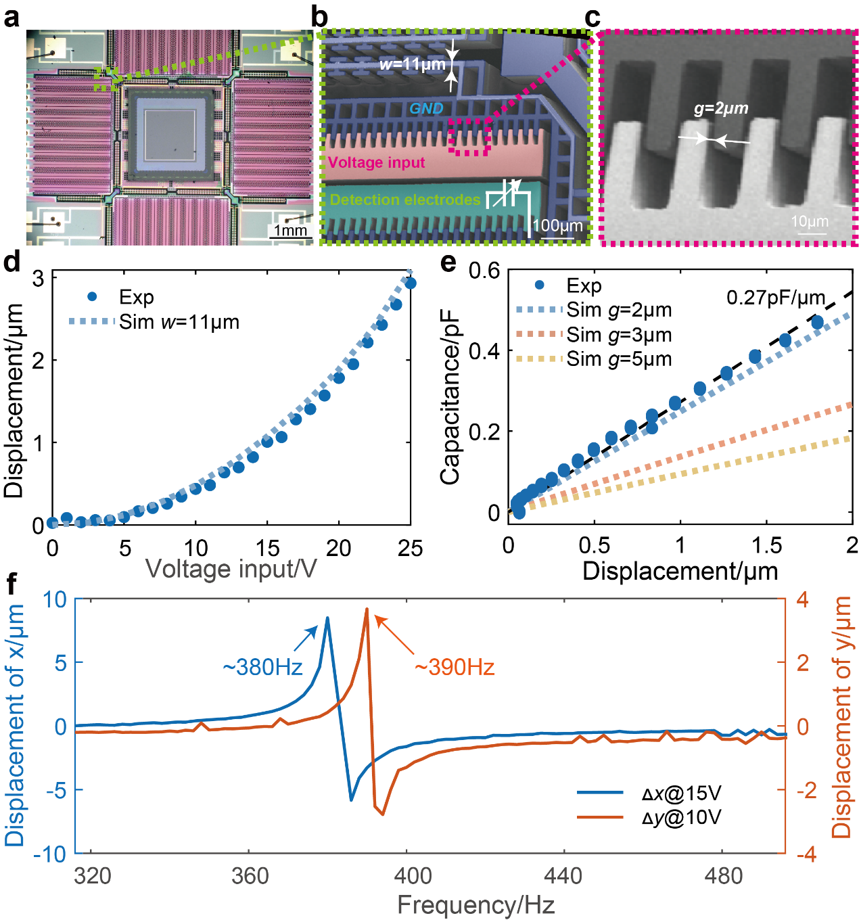
Supplementary Fig. 1 Characterization of the MEMS actuator. (a) The optical microscope image of a MSEIS. (b-c) SEM images of the comb structure and the gap of comb finger structure. When operating, the movable structures (blue area) are grounded, and the driving voltage is applied to the drive combs (red area). Displacement information is obtained by measuring the capacitance between the detection comb finger electrodes (green area) and ground (blue area). The two key parameters in the MEMS structure design, the folded beam width w (b) and the air gap of the comb finger structure g (c), are 11μm and 2μm, respectively. (d-e) Comparison of the simulated and experimental voltage-displacement and displacement-capacitance characteristic curves of the MSEIS. The experimental results show good agreement with the simulation results with w=11μm and g=2μm, validating the reliability of our MEMS design. The fitted displacement capacitance curve (black dashed line) demonstrates a displacement capacitance sensitivity of 0.27pF/μm. (f) Mechanical resonance characteristics of MSEIS measured by the white light interferometer. Excitation voltages of 15V and 10V are applied to x-direction and y-direction, respectively. The slight resonance frequency difference between the x-direction (380 Hz) and y-direction (390 Hz) is attributed to asymmetries introduced by the fabrication process.
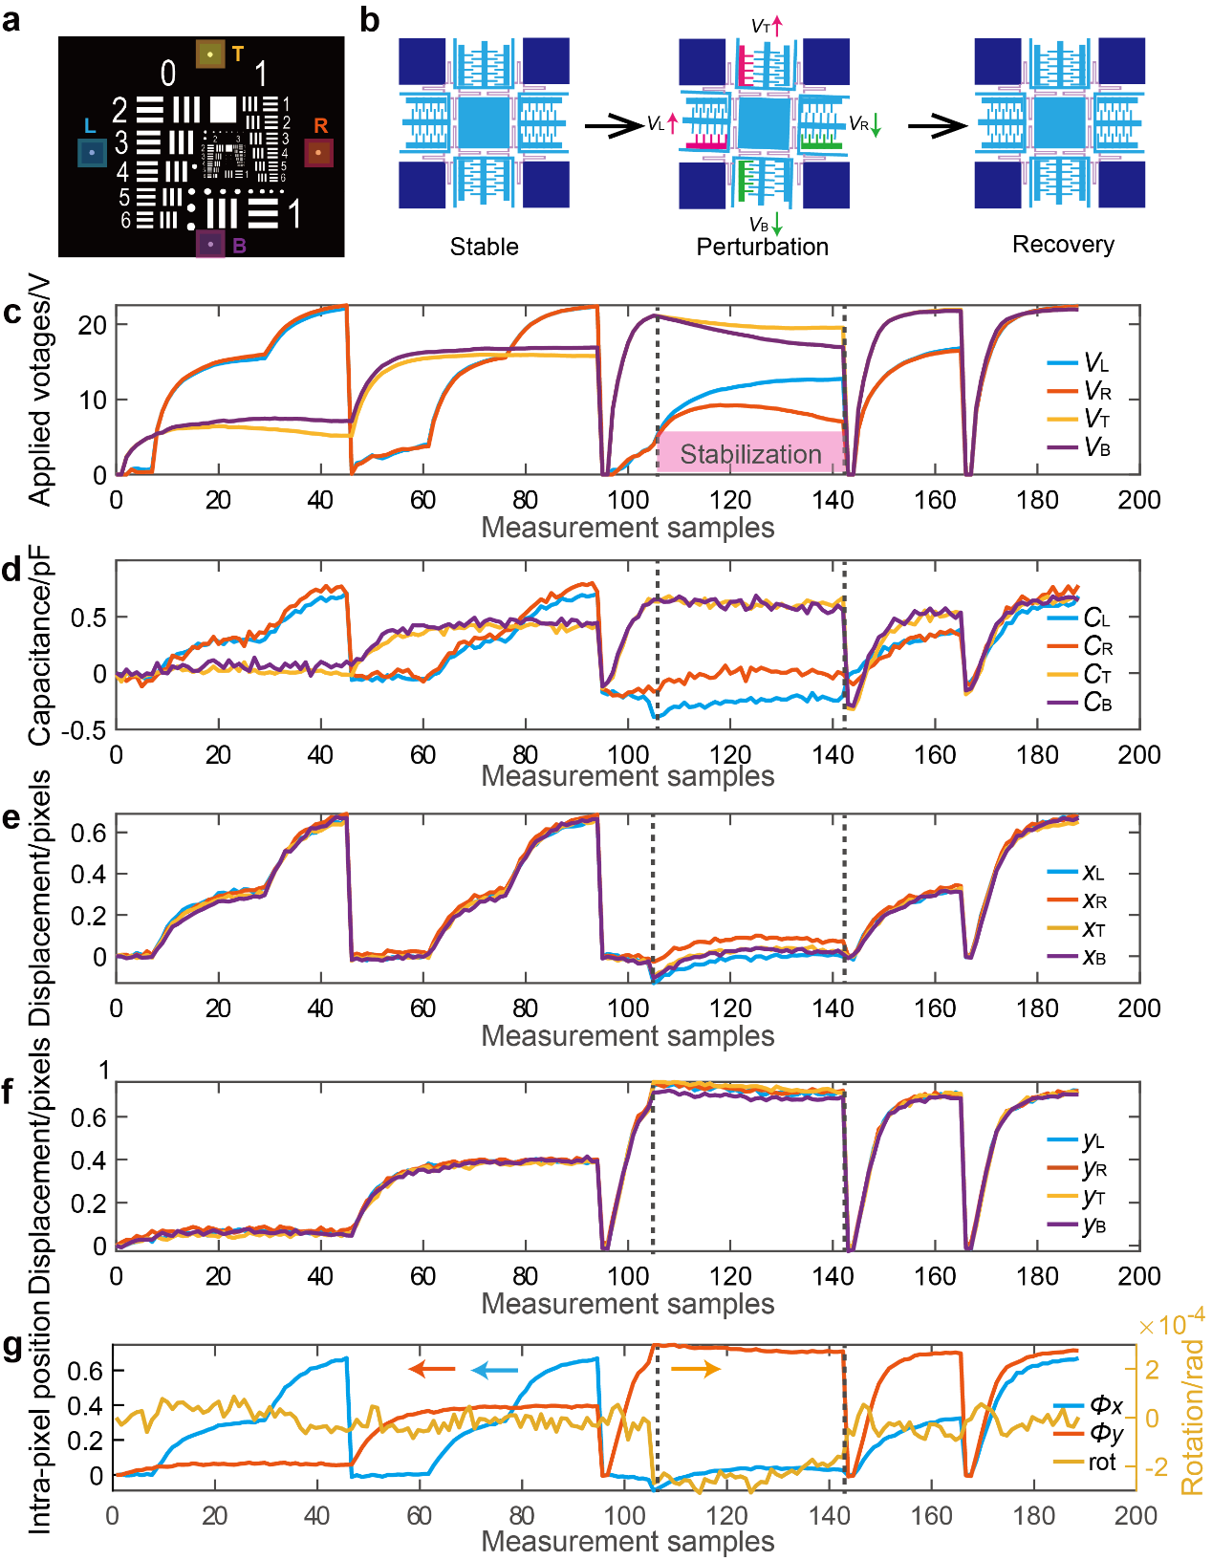
Supplementary Fig. 2 Illustration of twist-free scanning enabled by four independent comb structures. V_{L}, V_{R}, V_{T} and V_{B} correspond to the applied voltages, the C_{L}, C_{R}, C_{T} and C_{B} correspond to the detected capacitances of the left (L), right (R), top (T), and bottom (B) comb finger structures. (a) The illustration of the four measurement points. The displacements are measured by calculating the centroid within a 14x14 pixel region around each measurement point. (b) The schematic of how MSEIS recovered from perturbation. The increase of V_{R} and V_{B} cause the DIS to rotate clockwise, while the increase of the V_{L} and V_{T} cause the DIS to rotate counterclockwise. When a clockwise perturbation occurs, the V_{L} and V_{T} increase and the V_{R} and V_{B} decrease to make the MSEIS recovered from the perturbation. (c-d) The applied voltages (c) and the detected capacitances (d) of the MSEIS in an image process with k=3. A clockwise torsional disturbance occurs at sample 105 (black dashed line), after which the V_{L} and V_{T} increase and the V_{R} and V_{B} decrease and finally recovered from the disturbance at sample 143 (black dashed line). (e-f) The displacements of the four measurement points in x (e) and y (f) directions. (g) The intra-pixel position and the rotation angles calculated from four measurement points. During the stabilization period from sample 105 to sample 143, the intra-pixel position remains stable while the rotation angle gradually decreases, indicating the successful implementation of torsional compensation.
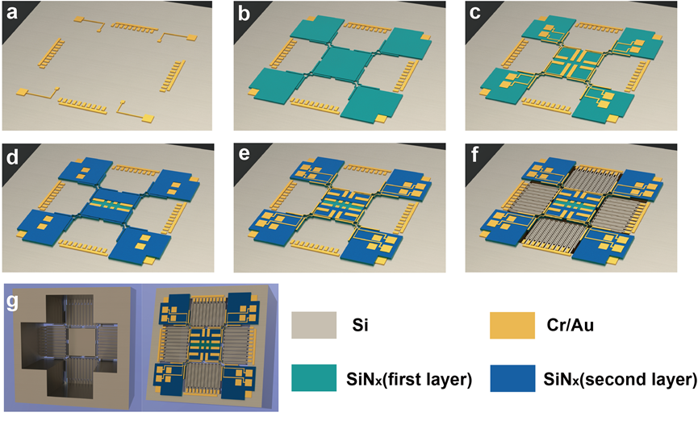
Supplementary Fig. 3 Fabrication process flow of the MEMS actuator. (a) MEMS electrodes patterning on a commercial SOI wafer. (b) Patterning of the first insulation layer in the RDL. (c) Patterning of the first metal layer in the RDL. (d) Patterning of the second insulation layer in the RDL. (e) Patterning of the second metal layer in the RDL. (f) Etching of the silicon MEMS device layer. (g) Back-side etching of the silicon handle layer and silicon oxide box layer to release the MEMS structure.
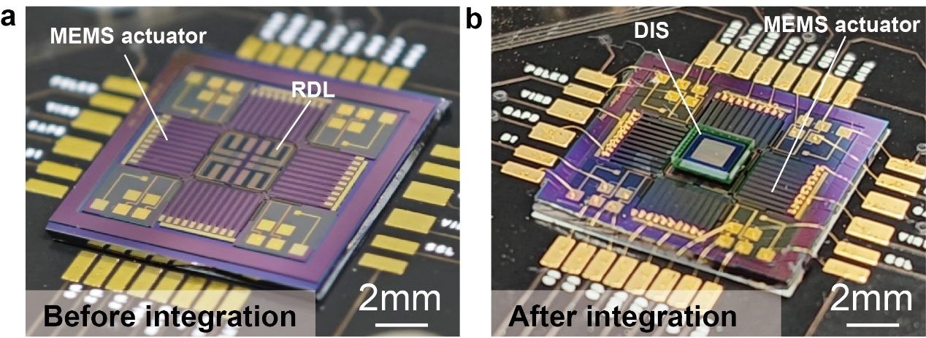
Supplementary Fig. 4 Integration of MEMS actuator and DIS device. The optical images of MSEIS before (a) and after (b) flip-chip bonding integration. The DIS signals are connected to the RDL via bumps. The MEMS control signal and DIS signal are linked to the printed circuit board through wire bonding.
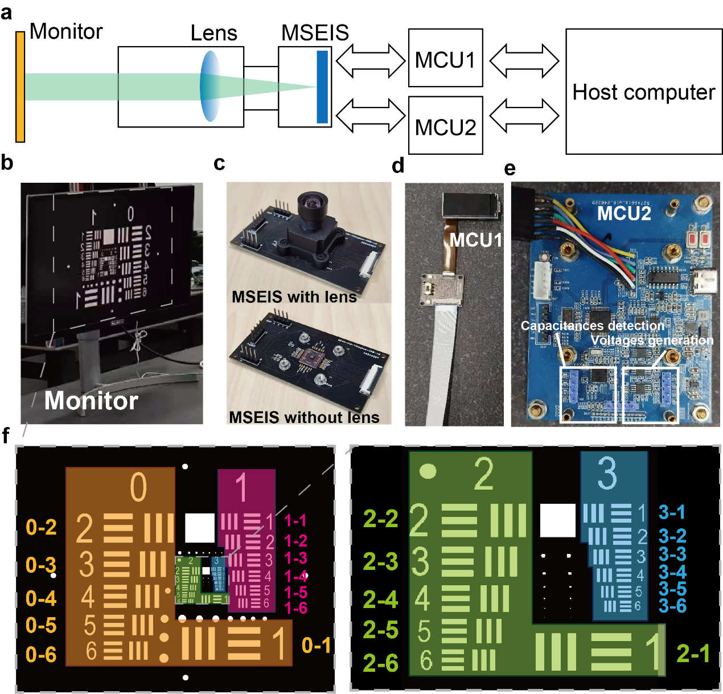
Supplementary Fig. 5 Experimental setup of MSEIS characterization. (a) Schematic of the experimental set-up for the MSEIS characterization. The test chart displayed on the monitor is imaged onto the MSEIS through the lens of the MSEIS camera. The MSEIS connects to the host computer via two microcontroller units (MCUs), MCU1 for image decoding, and MCU2 for closed loop control. (b) The optical image of the monitor used for showing the test chart. (c) The optical images of the MSEIS with and without lens. (d-e) The optical images of the MCU1 (d) and MCU2 (e), which is based on the RP2040 and STM32F103, respectively. (f) The dotted USAF-1951 test pattern consists of multiple groups of line pairs with varying line widths and spacings, arranged from 0-1 to 3-6. The numbers corresponding to the line pairs are labeled in the figure. Group 0-1 has the largest line width and spacing, while group 3-6 has the smallest.
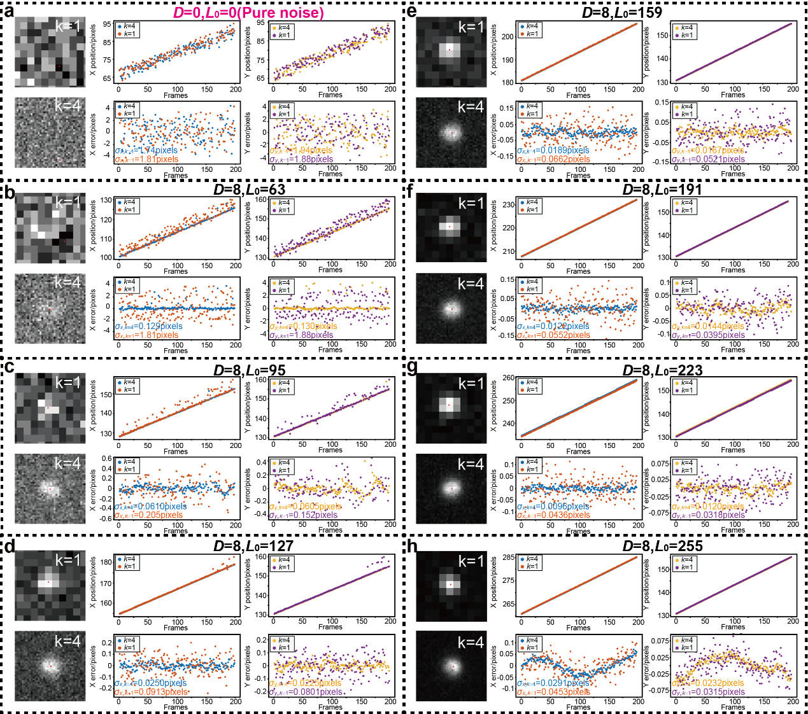
Supplementary Fig. 6 Additional experimental results demonstrate the MSEIS’s accuracy improvement in positioning of the point-like targets. (a) ROI of the pure noise target at k=1 and k=4 with position curves and error curves in the x-direction and y-direction. The correlation between position and frame number under pure noise conditions is because the center of the ROI window shifting with each frame. Experimental error curves show the accuracy of measurement of σ_{x,noise}≈1.8 pixels and σ_{y,noise}≈1.9pixels under pure noise conditions. (b-h) ROI, position curves and error curves of the point-like target in the x-direction and y-direction at k=1 and k=4 with D=8 and L₀=63 (b), L₀=95 (c), L₀=127 (d), L₀=159 (e), L₀=191 (f), L₀=225 (g), and L₀=255 (h). The results in (b-d) show that some point-like targets which are unmeasurable (pure noise like) under k=1 become successfully measured under k=4. As the brightness L₀ increases from 63 to 223, the standard deviation of the measurement at k=1 and k=4 improves from ~1.8 pixels to 0.4 pixels and from 0.13 pixels to 0.01 pixels, respectively. At L₀=255, the ROI at k=4 exhibits a center's offset due to the non-ideal PSF introduced by the optical system, and causing an abnormal increase in standard deviation. The consistency between the k=1 and k=4 measurement results also suggests that the abnormal increase in standard deviation is not caused by the MSEIS.
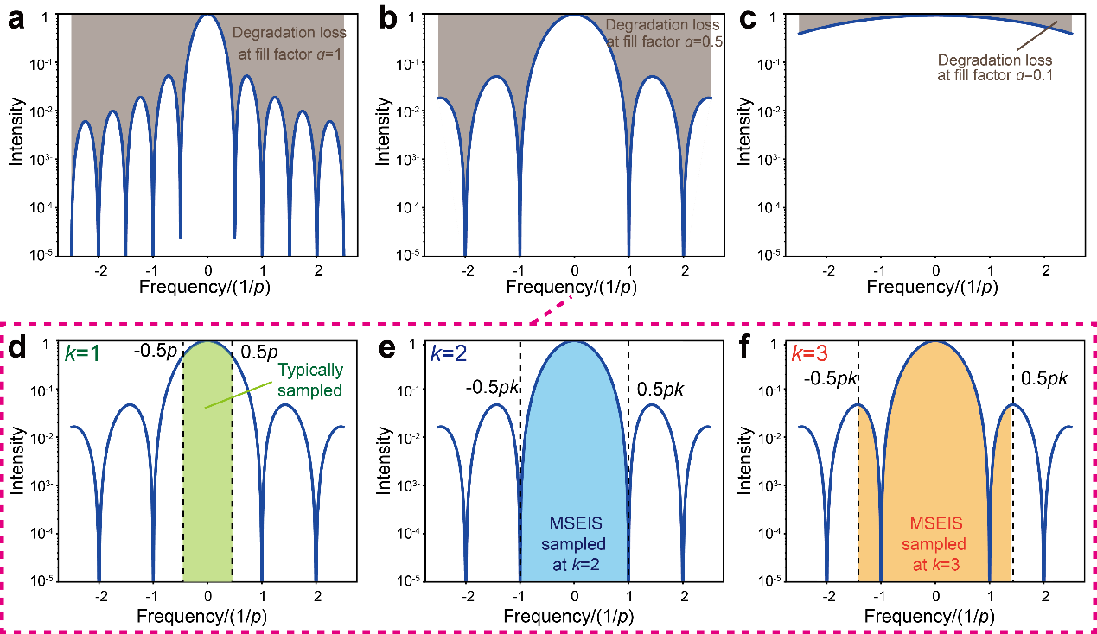
Supplementary Fig. 7 Schematic diagram of the degradation and sampling process in frequency domain. (a-c) Loss of image information in frequency domain due to image degradation at a=1(a), a=0.5(b), and a=0.1(c), respectively. At spatial frequencies of i/2ap (i=1, 2, 3, …), the information of the image is completely lost. (d) Spatial frequency information of the image (marked by green area) sampled under traditional static sampling (k=1) in an DIS with a=0.5, with the black dashed lines marking the maximum of sampling frequency calculated by Nyquist sampling theorem. (e-f) Spatial frequency information of the image (marked by blue and orange area) sampled by the MSEIP at k=2 (e) and k=3 (f), respectively, demonstrating that as k increases, the MSEIS can capture more spatial frequency information of the image.

References:
1 Farsiu, S., Robinson, D., Elad, M. & Milanfar, P. Robust shift and add approach to super-resolution In Conference on Applications of Digital Image Processing XXVI. 121-130 (2003).
2 Goodman, J. W. Introduction to Fourier optics.edn 3rd, (Roberts and Company publishers, 2005).

