Table 1. Components, standards for scoring (caloric densities) and corresponding point values of the Planetary Health Diet Index and the Planetary Health Diet Index adapted for children

- Planetary Health Diet Index (PHDI), adapted from Cacau et al, 2021

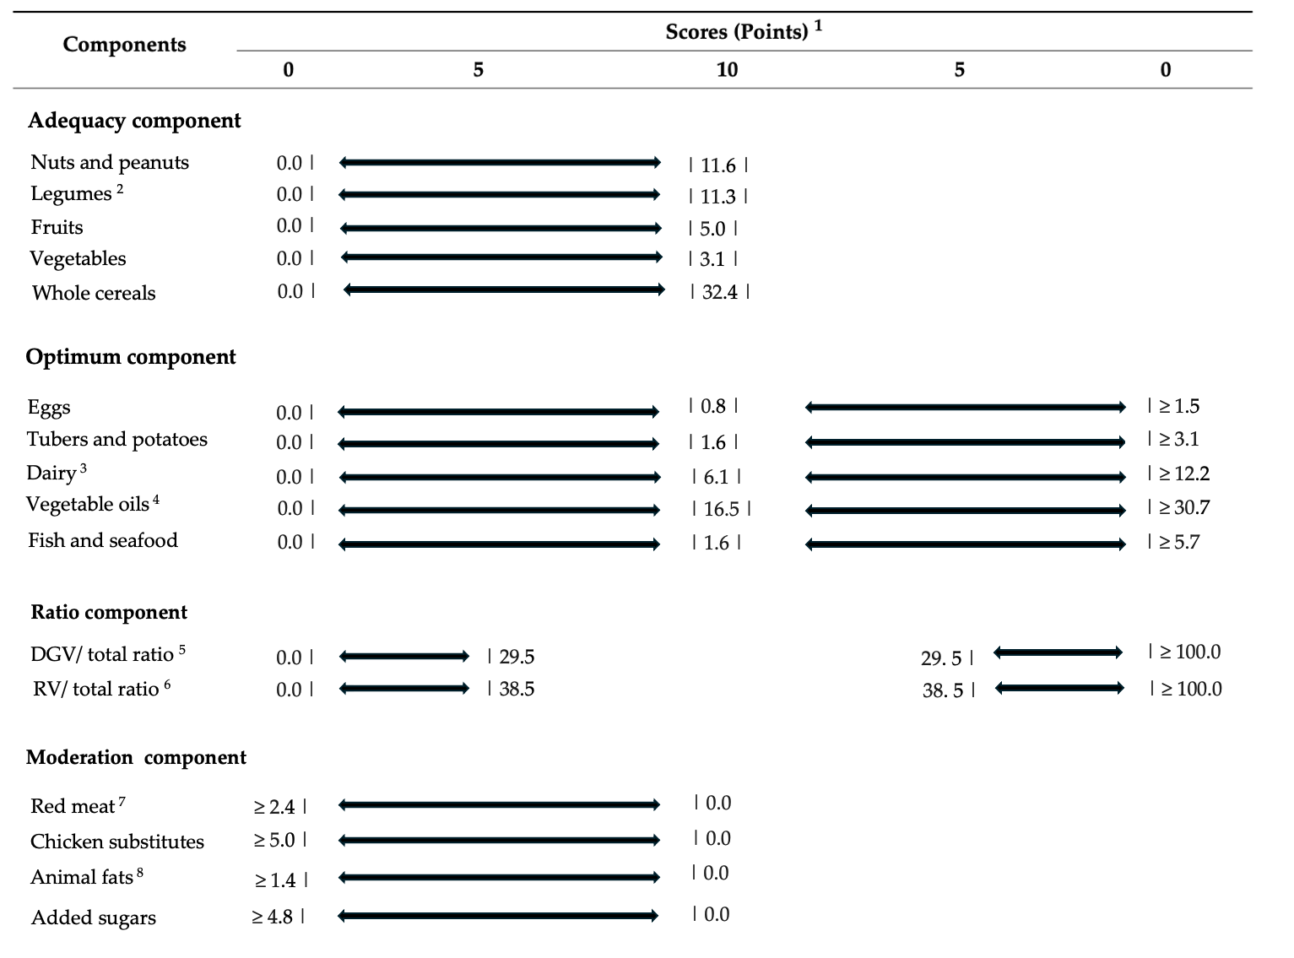

Table 1. (continued)

- Planetary Health Diet Index adapted to children (PHDI-C), adapted from Venegas Hargous et al, 2023
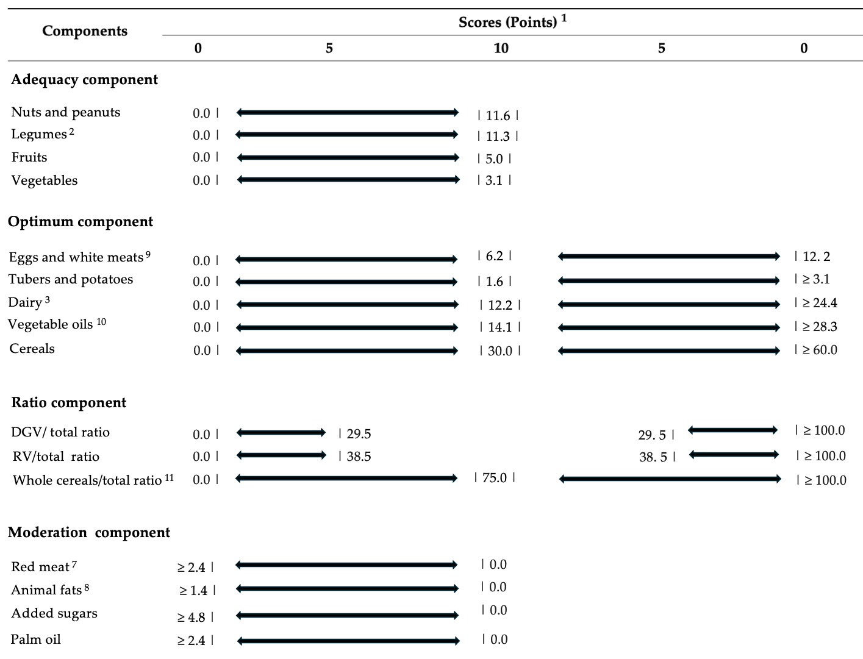

1 All values expressed as caloric densities from the reference diet proposed by the EAT-Lancet Commission. The bars represent the limits; 2 Legumes: beans, lentils and soy; 3 Dairy: excluding dairy fats; 4 Unsaturated oils (includes palm oil); 5 DGV ratio: ratio between the energy intake of dark green vegetables and the total of vegetables; 6 RV ratio: ratio between the energy intake of red and Orange vegetables and the total of vegetables; 7 Red meat: beef, Lamb, and pork; 8 Animal fat: lard, tallow and dairy fats; 9 Eggs and white meats: includes eggs, fish, seafood and chicken; 10 Unsaturated oils (does not include palm oil)

