Supplementary Fig. S1 Results of the genetic score test associated with diabetes in the Thai population. (A) ROC curve of PGS000804 in multiple logistic regression models: (black) PRS only, (blue) age + sex + BMI, and (red) age + sex + BMI + genetic score. AUC for black, red, and blue = 0.6245, 0.7819, and 0.8072, respectively. (B) Distribution of PGS000804 in T2D patients and control groups. (C) Odds ratio at different deciles of PGS000804 using Fisher’s exact test. Statistical significance is indicated by * (p < 0.05) and ** (p < 0.01).

Supplementary Fig. S2 Logistic regression analysis between allele counts at positions in PGS000804 and PGS003402 and type 2 diabetes (T2D). (A) Association tests between positions and T2D (red) and between positions and age at diagnosis (blue). (B) Comparison of beta-estimations between models for age at diagnosis and T2D. Blue indicates opposite directions, red indicates the same direction. Dark red circles represent positions with FDR < 0.05.
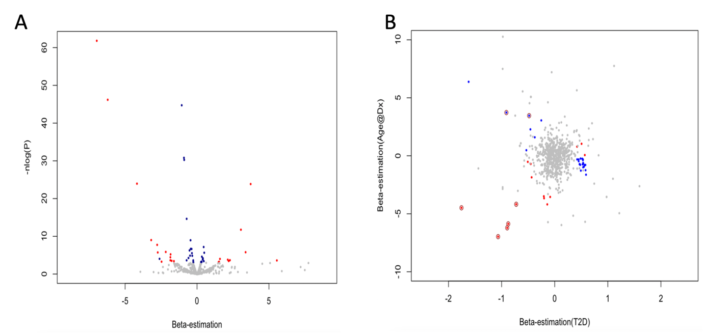

Supplementary Table S1 Odds ratios and p values for different deciles of PGS000804 in the Thai population, comparing T2D cases and controls.
Docile | Case | Control | p value | Odds ratio
D1 | 41 | 30 | 0.001** | 0.41 (0.24,0.7)
D2 | 50 | 22 | 0.25 | 0.72 (0.42,1.3)
D3 | 46 | 26 | 0.03* | 0.55 (0.32,0.95)
D4 | 57 | 15 | 0.473 | 1.28 (0.69,2.51)
D5 | 55 | 17 | 0.886 | 1.07 (0.59,2.03)
D6 | 54 | 18 | 1 | 0.99 (0.55,1.84)
D7 | 57 | 15 | 0.473 | 1.28 (0.69,2.51)
D8 | 54 | 18 | 1 | 0.99 (0.55,1.84)
D9 | 63 | 9 | 0.009* | 2.48 (1.19,5.79)
D10 | 63 | 8 | 0.005* | 2.8 (1.3,6.92)

Supplementary Table S2 SNP and risk allele associated with type 2 diabetes and age at diagnosis
SNP | Direction |  | Risk allele for T2D | Risk allele for AaD
SNP | T2D | AaD | Risk allele for T2D | Risk allele for AaD
rs2216063(G/A) | - | ++ | G | G
rs9358356(T/C) | - | + | T | T
rs9472138(C/T) | -- | +++ | C | C
rs6479591(G/A) | - | -- | G | A
rs10818763(C/T) | - | -- | C | T
rs189339(A/G) | - | -- | A | G
rs4382480(G/A) | -- | - | G | A
rs3132469(A/G) | --- | -- | A | G
Abbreviations AaD, age at diagnosis; T2D, type 2 diabetes

Supplementary Table S3 Frequency of homozygous GTC at rs2216063, rs9358356, and rs9472138 in type 2 diabetes patients across different clusters
Cluster | G-T-C: 194 | Others: 277 | G-T-C Freq | χ² | p value
MARD | 24 | 187 | 0.11 | 125.92 | <0.001
MOD | 78 | 40 | 0.66 | 12.237 | 0.0004684
MSD | 3 | 50 | 0.06 | 41.679 | <0.001
SIDD | 89 | 0 | 1.00 | 89 | <0.001
Abbreviations MARD, mild age-related diabetes; MOD, mild obesity-related diabetes; MSD, metabolic syndrome diabetes; SIDD, severe insulin-deficient diabetes

