Supporting information file
Fig. S1. Visible transmission of alumina with different sintering aids.
Fig. S2. Cross-sectional FESEM images of alumina with different sintering aids: (a) without sintering aid, (b) 100 ppm MgO, (c) 100 ppm MgO + 100 ppm La₂O₃, (d) 100 ppm MgO + 300 ppm ZrO₂. Red arrows indicate porosity.
Figure S3: Light microscopic images of Vickers impact points and cracks observed for the 100M-100L-300Z (Z) sample: (a) impact point; (b) crack observed at higher magnification.
Figure S4: FESEM images of indentation impact points and crack length measurements for samples with varying amounts of sintering aids.

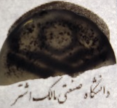
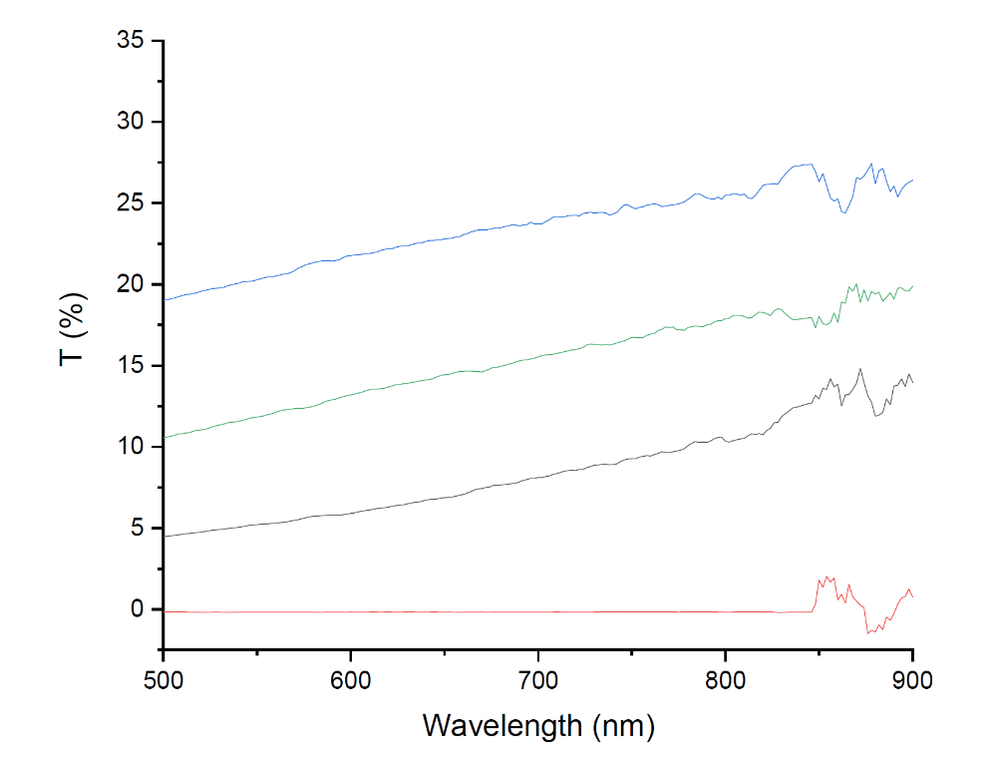
100ppm MgO 300 ppm ZrO₂

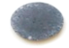
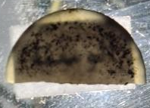
100 ppm MgO
Without sintering aid
100ppm MgO 100 ppm La₂O₃
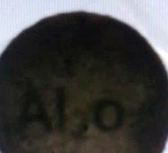

Fig. S1.

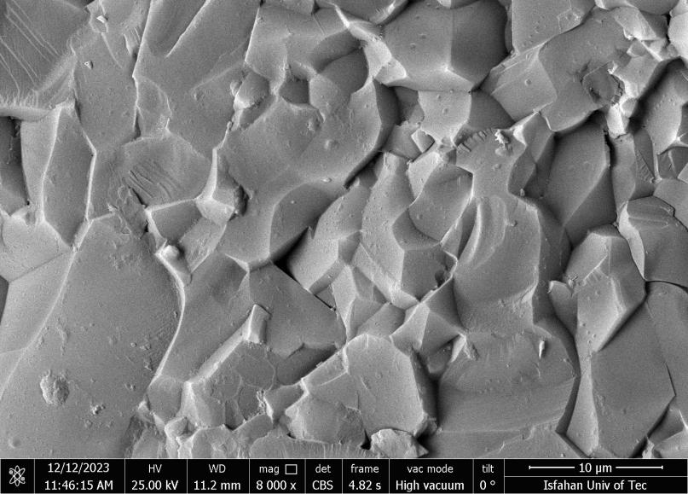
(a)
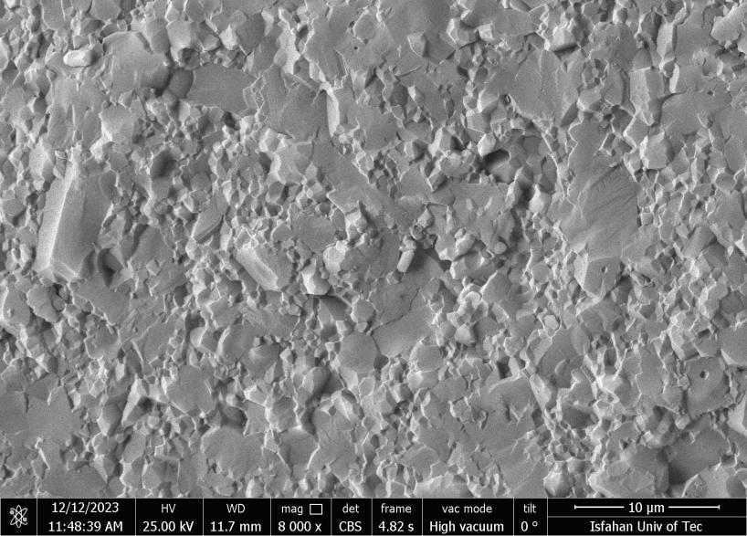
(b)
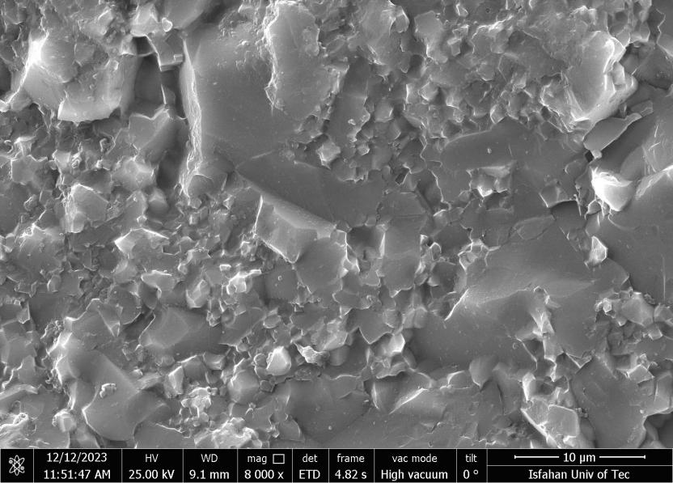
(c )
Alumina/1wt.% Si₃N₄
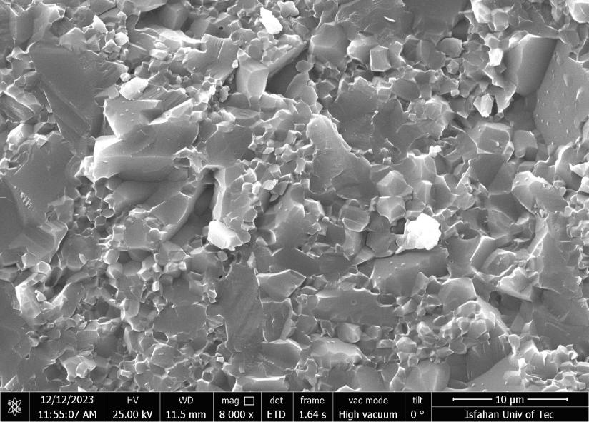
(d )
Fig. S2.

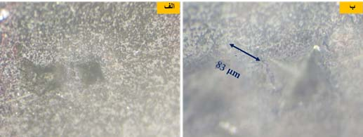
b
a
Crack

Figure S3.

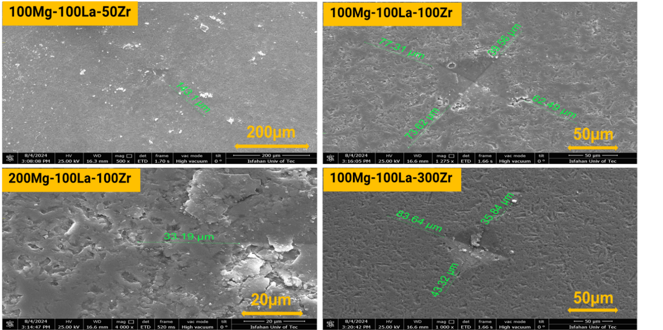
100M100L50Z
100M100L100Z
100M100L300Z
200M100L100Z
Figure S4.

