Supplementary Information
Is Global Crop Yield Enhancement and Emissions Mitigation by Biochar Application Feasible from a Biochar Resource Availability Perspective?
Wucheng Zhaoª, Ondřej Mašek^{b}, Zhixin Liª, Yufei Liª, Feng Zhang^{a*}
a State Key Laboratory of Grassland Agro-ecosystems, College of Ecology, Lanzhou University, Lanzhou, Gansu 730000, China
b UK Biochar Research Centre, School of Geosciences, University of Edinburgh, Crew Building, Alexander Crum Brown Road, Edinburgh EH9 3FF, UK
Corresponding author’s Email address: zhangfeng@lzu.edu.cn

1.1 Supplementary results and discussion

1.1.1 Crop yield and GHG emission results
According to the biochar management factors (Fig. S9), among the various biochar types, manure biochar increased yield by 98%, which was higher than for woody (28%) and other biochar (9%). Also, different BA rate significantly affected yield, 20-30t/ha (27%) resulted in a higher yield than for 0-10 t/ha (24%) and 10-20t/ha (20%). In biochar pyrolysis temperature subgroup, the effect size of increasing yield gradually decreased with the increase of pyrolysis temperature. Compared to biochar of particle size less than 3mm, the biochar of particle size bigger than 3mm can significantly increase yield by 31% (95%CI: 2-52%). Among the various BA methods, rotary tiller increased yield by 33% (95%CI: 15-55%), which was higher than for mix (15%), ploughing (13%), and surface broadcast (6%). Also, compared to topsoil 20cm application, deep application in subsoil 50 can significantly increase crop yield by 14% (95%CI: 0-30%). In N fertilizer management subgroup, manure and no fertilizer (no base fertilizer application) can significantly increase crop yield by 20% (95%CI: 3-41%) and 20% (95%CI: 10-31%), respectively. Also, different N management cycles significantly affected yield, 2-times (26%) resulted in a higher yield than for 3-times (24%) and 0-times (20%).
All biochar types and BA rates had no inhibiting impact on N₂O emission (Fig. S7 (A)). However, there had promoting effects N₂O emission when BA rate was greater than 30 t/ha (2%) and biochar pyrolysis temperature was 600-800℃ (27%). No matter what’s the particle size of biochar, which could decrease N₂O emission no significantly. The depth of BA also had no significant effect on N₂O emission. In BA method subgroup, rotary tiller can significantly reduce N₂O emission by 29% (95%CI: -46 to -6%). Among various N fertilizer managements, manure (-29%), compost (-6%), and no fertilizer (-18%) inhibited N₂O emission, but not significant. Among all N fertilizer management times, only 5 times can significantly inhibited N₂O emission 73% (95%CI: -89 to -33%).
In terms of effect of feedstock of biochar on CO₂ (Fig. S7 (B)), But these categorizations (manure biochar (15%), other biochar (17%), application rate 20-30t/ha (15%), and N management cycle 2 times (8%)) can inhibit CO₂ emission. And another categorizations (woody biochar (15%), pyrolysis temperature 200-400℃ (17%), compound fertilizer (15%), and N management cycle 3 times (8%)) can promote CO₂ emission.
Straw and woody biochar can inhibit CH₄ emission by 12%, 37%, and 12%, respectively, but manure biochar can promote CH₄ emission by 19%. The effect size of BA inhibiting CH₄ emission increased with the increase of BA application rate, but when it reaches 30t/ha, its emission was promoted. Compared to biochar particle size bigger than 3mm, biochar particle size less than 3mm is more conducive to inhibiting CH₄ emission. Topsoil 20cm application and rotary tiller method significantly inhibited CH₄ emissions by 23% and 49%. In the case of the BA, application of urea and compost, and 2 times N fertilizer management cycle significantly inhibited CH₄ emissions by 18%, 15% and 41%.

1.1.2 GHG emission discussion
The inhibiting effect of biochar on N₂O emission decreased with the increase of precipitation. BA significantly decreased N₂O emission by 27% in regions with mean annual temperatures less than 15 °C. Our results had different conclusions with some individual experiments, which found BA can increase N₂O emission (Bruun et al., 2011 , Saarnio et al., 2013 , SÃ¡nchez-GarcÃ­a et al., 2014). When the data quantity is large enough, the positive results will be overwritten by the negative because of heterogeneity (Shakoor et al., 2021).

1.2 Data categorization and Meta-analysis
The model variables had aridity index (AI), bulk density (BD), cation exchange capacity (CEC), soil clay content, soil sand content, soil silt content, elevation, evapotranspiration (ET), mean annual temperature (MAT), mean annual precipitation (MAP), nitrogen deposition (ND) nitrogen input (NI), total nitrogen (TN), power of hydrogen (pH), soil organic carbon (SOC), soil temperature (ST), and soil water content (SWC), the ln R of crop yield and GHG emissions under BA as response variables. The download URL for these variables are World Climate (https://www.worldclim.org/), Soil Grid (https://soilgrids.org/), and some literature (Wei et al., 2024 , Zomer et al., 2022).
According to extracted data structure and previous categorization (Zhang et al., 2022 , Wei et al., 2022), some subgroup variables categorizations were represented at below. Mean annual precipitation was grouped into 0-500, 500-1000, 1000-1500, >1500, mean annual temperature was grouped into cool (<15℃) and warm region (>15℃), N management cycle was divided into 0, 1, 2, 3, 4, BA rate was divided into 0-10, 10-20, 20-30, >30 t/ha, pyrolysis temperature was divided into 200-400, 400-600, 600-800, 800-1000. And other categorization catalogue were crop type (rice, wheat, maize, soybean, vegetable, grassland, forest, and other), ecosystem type (upland, paddy field, grassland, and forest), biochar type (straw biochar, woody biochar, manure biochar, other), biochar particle size (less than 3 and bigger than 3), BA method (surface broadcast, ploughing, mix, and rotary tiller), BA depth (topsoil 20 and subsoil 50), N Fertilizer management (urea, compound fertilizer, manure, compost, and no fertilizer), N management cycle (0, 1, 2, 3, 4, and 5), and irrigation (yes and no). N Fertilizer management was base fertilizer in our analysis. N Fertilizer management cycle is the times of N fertilizer application while the total amount was same in 1 year. Other crops include sugarcane, barley, switchgrass, Jerusalem artichoke, chestnut, moso bamboo, peanut in crop type catalogue. Other biochar types include rice-husk biochar, cottonseed husk biochar, poultry litter biochar, corncob biochar, and sludge-derived biochar in biochar type catalogue. In general, the set of paired comparisons (2140) satisfactorily covered the different types of soils, biochar and experimental conditions.
The basic Meta-analysis calculation showed below.
lnR=$\frac{{lnX}_{t}}{lnX_{c}}=lnX_{t}-lnX_{c}$ (1)
V (ln R) =$\frac{S_{et}2}{N_{et}×{X_{e}}^{2}}+\frac{S_{ec}2}{N_{ec}×{X_{c}}^{2}}$ (2)
Where Xt and Xc are the mean values of the biochar applications and control groups, respectively. Set and Sec are the corresponding SDs, and Net and Nec are the corresponding numbers of replicates.
When the 95% confidence interval did not overlap with 0, the effect of biochar on variables was significant. When the 95% confidence interval overlapped with 0, it was non-significant.
In this study, Biochar potential production considered the plant sources and animal manure source material, which included all kinds of livestock (pigs, cattle, sheep, goats, chickens and ducks) feces and all kinds of crop straw (wheat, maize, rice, bean, potato, cotton, sugarcane, and rape straw) and forest above-ground biomass. After searching reference, we refer to the manure yield of each livestock, the biochar yield of manure and straw, and the water conversion ratio of straw, tree and manure, as well as the maximum conversion ratio as shown in Table S4 (Shen et al., 2020 , Bai et al., 2020 , Xu et al., 2020 , Touray et al., 2014). The final result is achieved using the following formula.
Biochar potential production=$\sum{ manure biochar+plant residues}biochar$

1.3 Model simulation
To select optimal simulation model, firstly, four classical and efficient machine learning algorithms, including support vector machine (SVM), multi-layer perceptron (MLP), random forest (RF) and gradient boosting machine (GBM) were used. Some relevant auxiliary variables were collected when use machine learning model simulate yield and GHG emissions globally.
The loop statement was applied to find the best accuracy with 10-fold cross validation, and then tested model with the remaining 30% of data (Fig.4 (EFGH)). The performances of ML models were used with the regression coefficient (R²) and root mean squared error (RMSE). The formulas were shown as following:
$R^{2}= \left(\frac{\sum_{i=1}^{N}{(Y_{i}^{sim}-\overline{Y_{i}^{mea}})(Y_{i}^{sim}-\overline{Y_{i}^{sim}})}}{\sqrt{\sum_{i=1}^{N}{{(Y_{i}^{mea}-\overline{Y_{i}^{mea}})}^{2}}}\sqrt{\sum_{i=1}^{N}{{(Y_{i}^{sim}-\overline{Y_{i}^{sim}})}^{2}}}}\right)$ (3)
$RMSE= \sqrt{\frac{1}{N}\sum_{i=1}^{N}{(Y_{i}^{mea}-{Y_{i}^{sim})}^{2}}}$ (4)
Where N is number of data series,$Y_{i}^{sim}, Y_{i}^{mea}, \overline{Y_{i}^{sim}}$ and $\overline{Y_{i}^{mea}}$ are simulated values from models, measured values, mean simulated value and mean measured value, respectively.
RF was finally chose as the optimal model to simulate global crop yield and GHG emissions under BA through the performances comparison (highest R² and lowest RMSE) of four ML models (Table S2). The R² and RMSE were calculated with training set and verification set. The SVM, MLP, RF and GBM are implemented using Python algorithms, and the code is detailed in the Supplementary Information.

1.4 Statistical analysis
A model selection analysis was performed to calculate the relative importance of all predictive variables affecting the effect size of CH4, CO2, N2O, and yield using the “glmulti” package in R (Chen et al., 2020). The whole factors model involved not only environmental factors but also biochar management factors, and biochar factors only involved biochar management factors. Principal component analysis (PCA) was used to construct a multivariate index representing the four type factors, which were biochar peculiarity, biochar management, soil and environmental factor, respectively (Delgado-Baquerizo et al., 2017 , Wang et al., 2017). Then used them to elucidate relative changes in GHG emissions and crop yield under BA in SEM. The Principal Component Analysis (PCA) was carried out using Origin 2021 and SEM using the “lavaan” package in R 4.2.2. While biochar type, biochar application method, irrigation, and nitrogen fertilizer management were categorical variables, thus considered as regular numeric covariates in model selection analysis and structural equation modeling (Zhang et al., 2015).

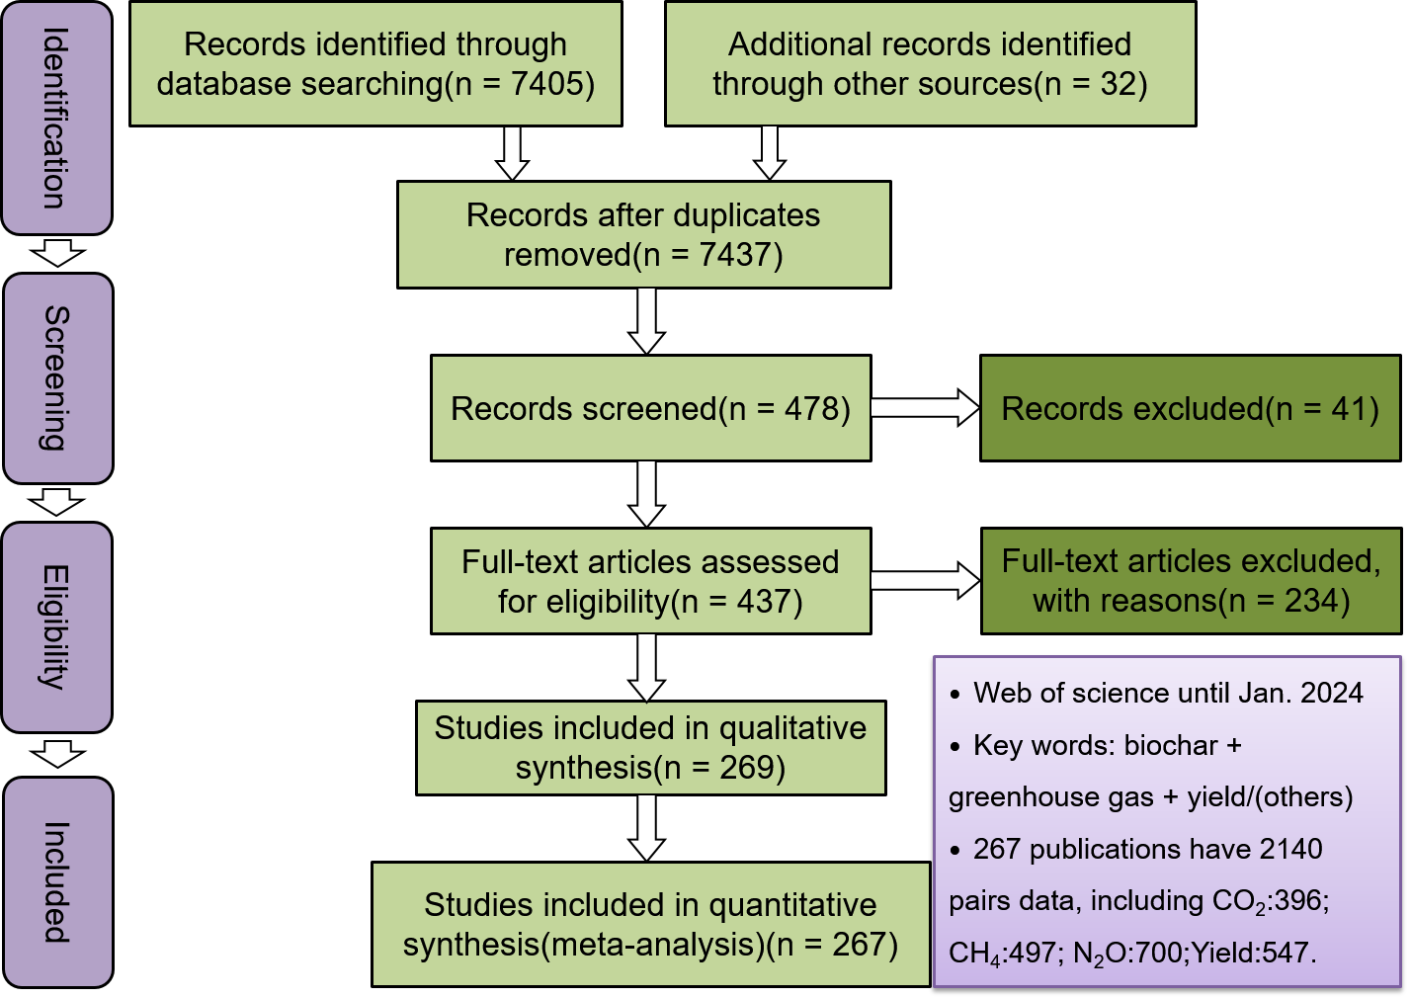
Fig. S1. The PRISMAP procedures and quantities of literatures screening (PRISMAP: Preferred Reporting Items for Systematic Reviews and Meta-Analyses)

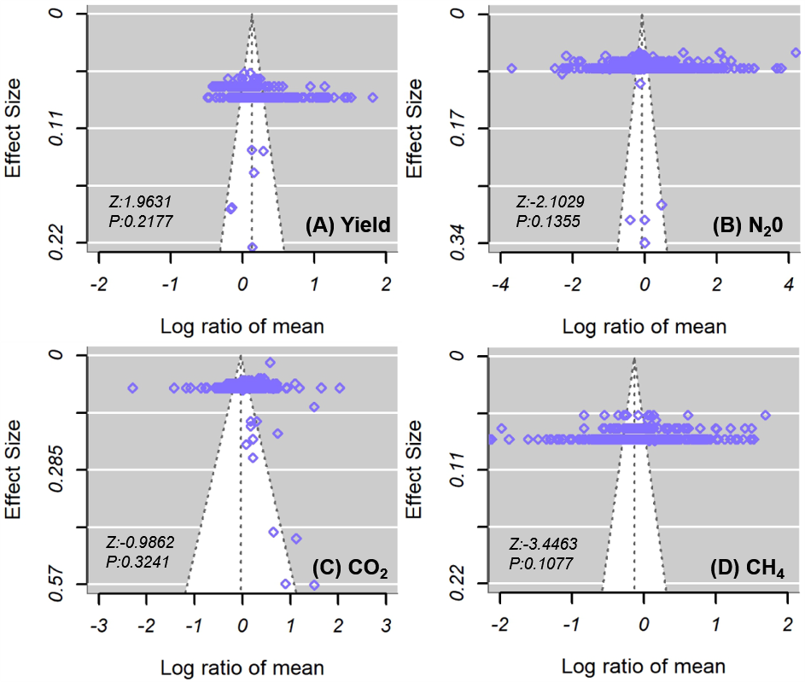
Fig. S2. Funnel plot of yield and GHG emissions dataset under biochar application (raw data: trim-and-fill method was not applied)

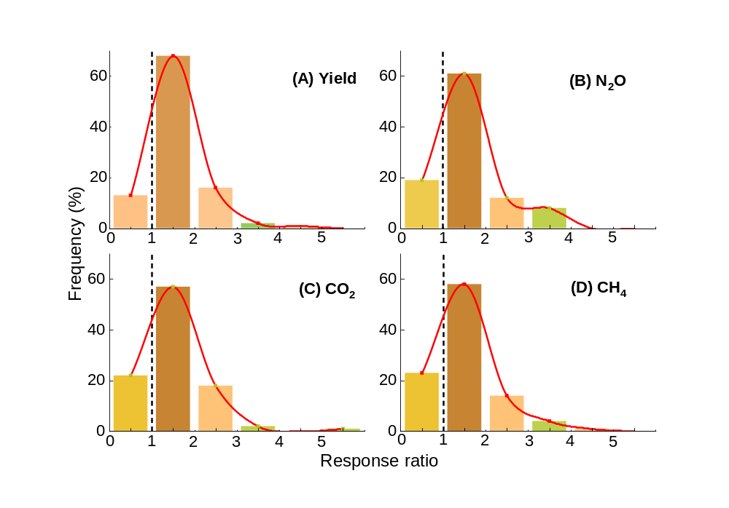
Fig. S3. Frequency distribution of the response ratios of crop yield (A), N₂O emissions (B), CO₂ emissions (C) and CH₄ emissions (D). The red solid lines are fitted normal (Gaussian) distributions to frequency datasets

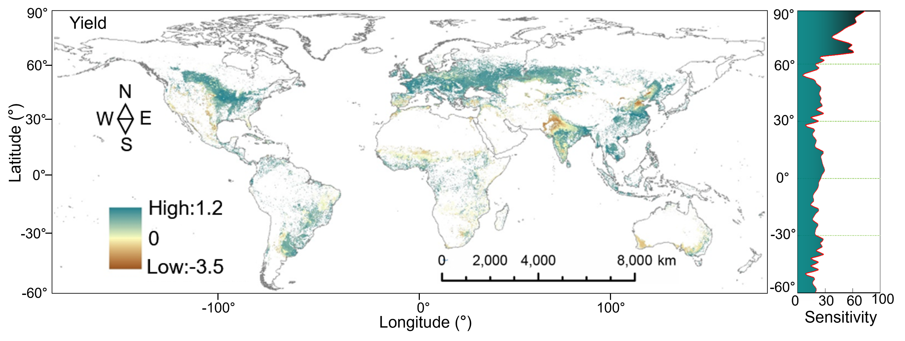
Fig. S4. Uncertainties of global crop yield simulation under biochar application conditions

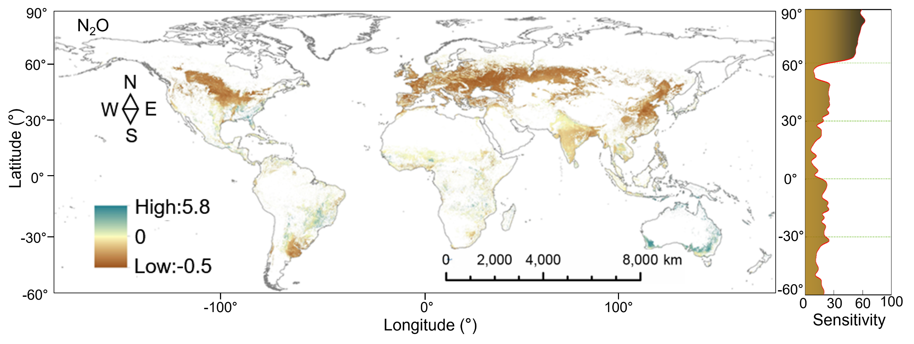
Fig. S5. Uncertainties of global N₂O emissions simulation under biochar application conditions.

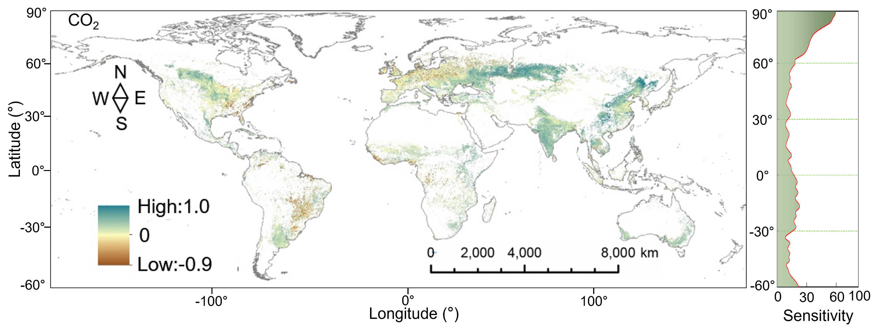Fig. S6. Uncertainties of global CO₂ emissions simulation under biochar application conditions.

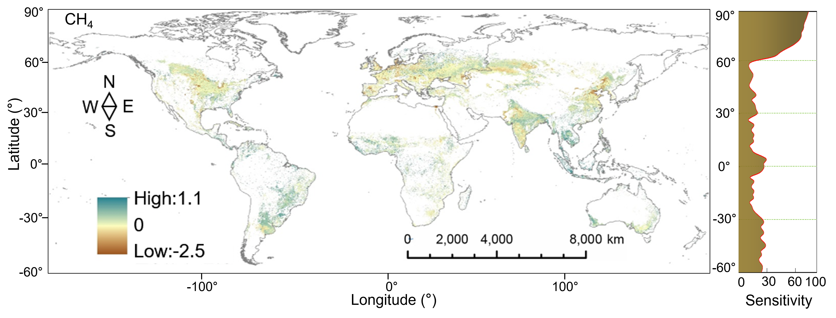
Fig. S7. Uncertainties of global CH₄ emissions simulation under biochar application conditions.

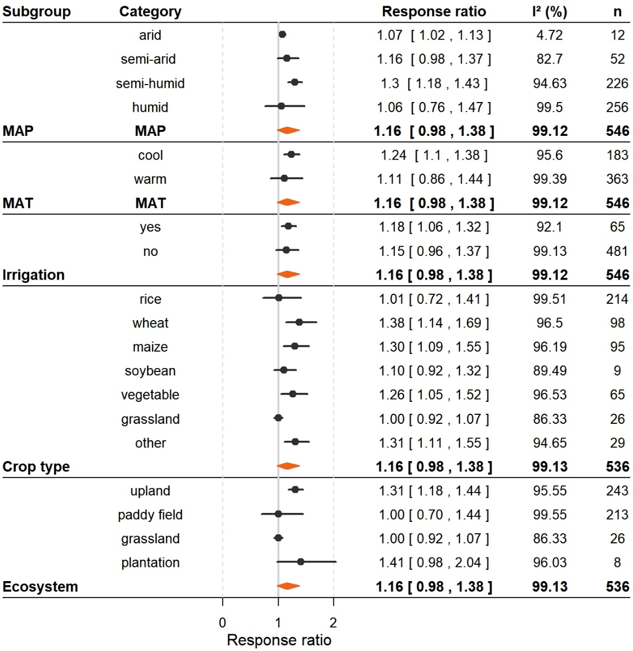
Fig. S8. The effects of the size of environmental factors on crop yield under biochar application.
The plot shows the mean value (black circle) with error bars representing a 95% confidence interval (CI). The mean effect size and its 95% CI in square brackets are presented next to the plot. The orange diamond represents the summary effect. A ratio > 1 indicates that the response from the treatment is higher than the corresponding response from the control group. I²: total heterogeneity; n: number of observations. MAP: mean annual precipitation. MAT: mean annual temperature. Cool represents regions with an average annual temperature of less than 15 degrees, and warm represents regions with an average annual temperature of more than 15 degrees. In crop type category, others include chestnut, barley, ryegrass, bamboo, sorghum, and plantation. Because the number of each category is small and there is no standard classification basis, it is listed as another. Same as below.
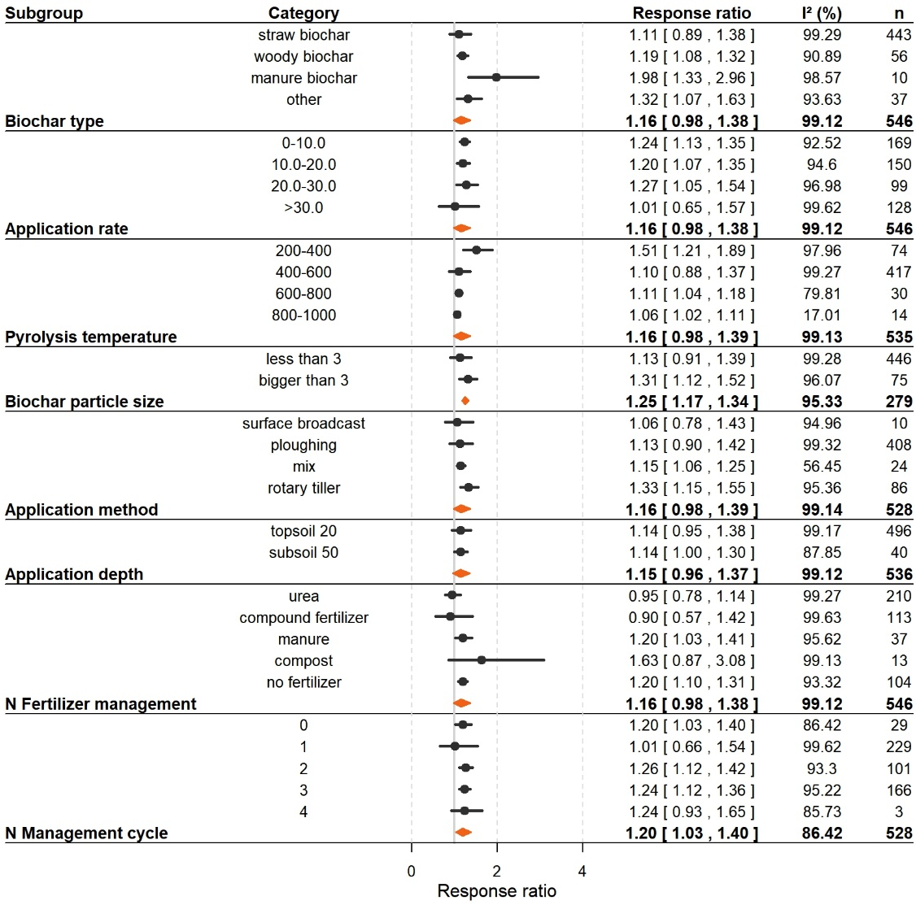
Fig. S9. The effects size of biochar management factors on crop yield under biochar application.
In crop biochar category, “other” includes bamboo leaf, switchgrass, cereal husks, rice husks, palm shell, corncob, poultry litter, cottonseed husk, and rice hull biochar.

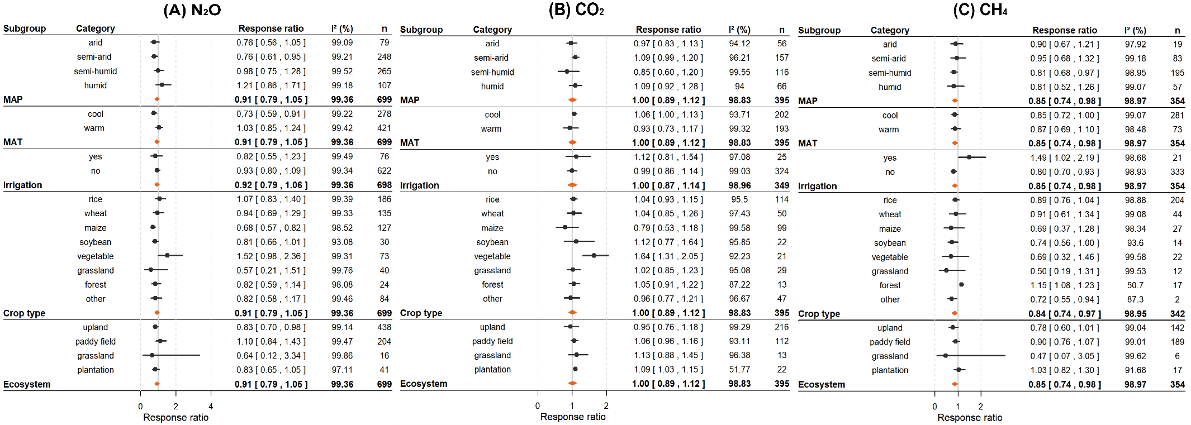
Fig. S10. The effects size of environmental factors on GHG emissions under biochar application.

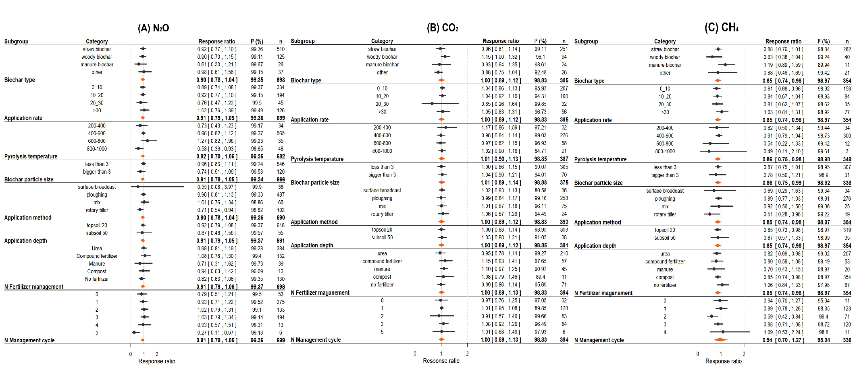
Fig. S11. The effects size of biochar management factors on GHG emissions under biochar application.

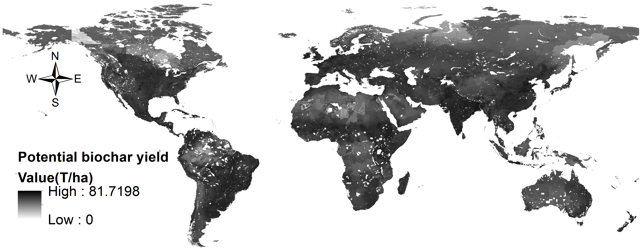
Fig. S12. Global biochar potential yield distribution: animal manure and crop residues are considered

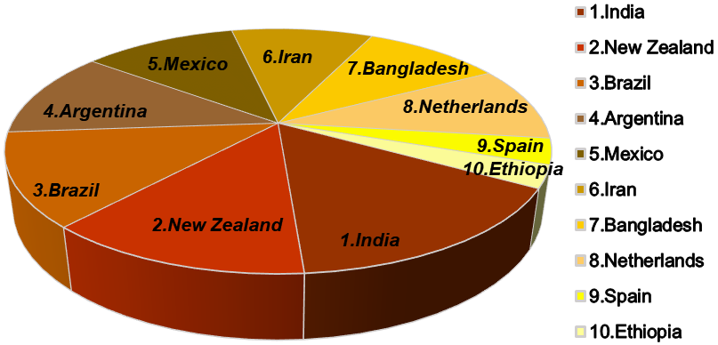
Fig. S13. Top 10 countries with surplus biochar availability

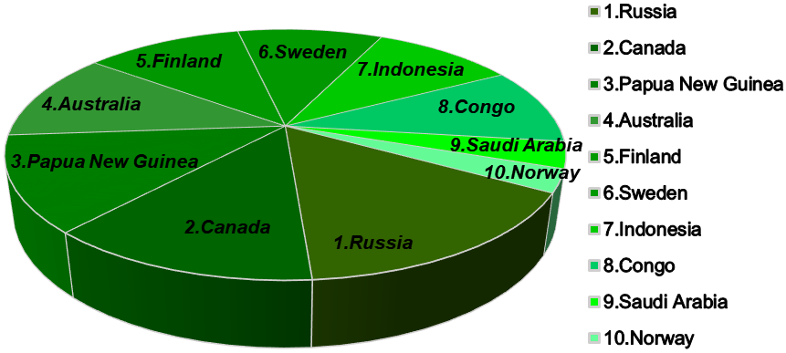
Fig. S14. Top 10 countries with biochar availability deficits

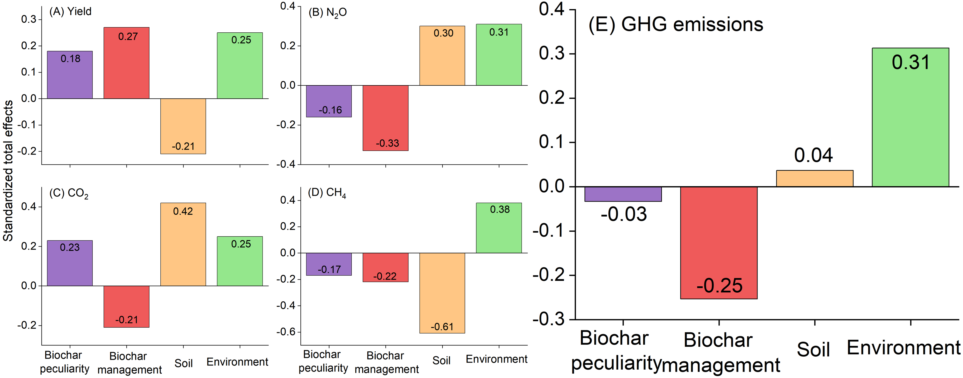
Fig. S15. Standardized effects (sum of both direct and indirect effects) of biochar management, environment factors, biochar peculiarity, and soil factors on crop yield and GHG emissions in SEM.

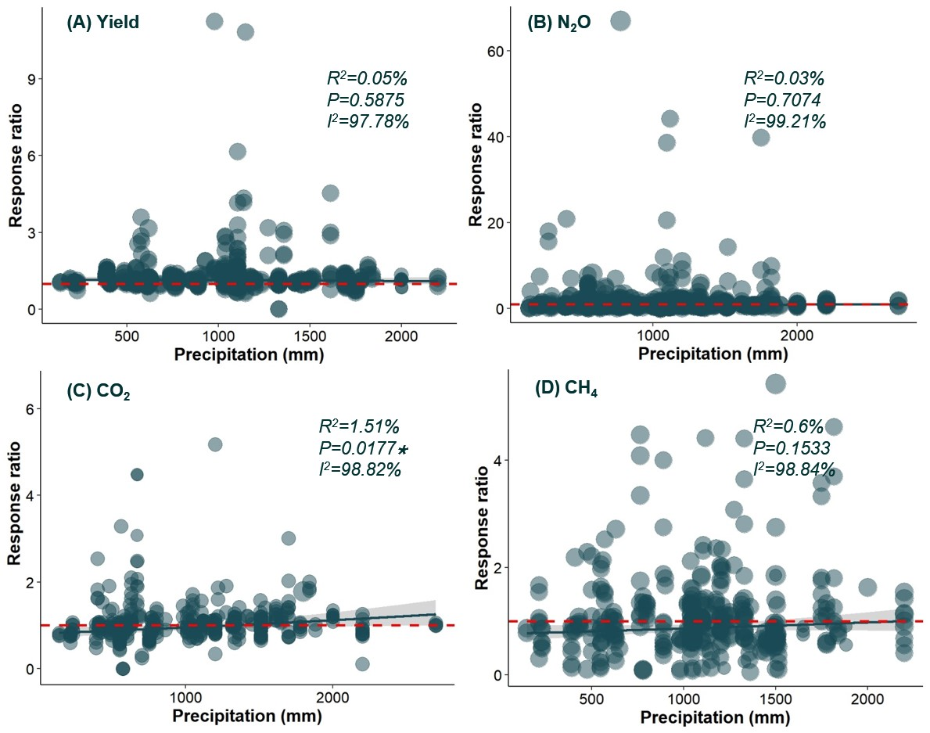
Fig. S16. Responses of crop yield (A), N₂O (B), CO₂ (C), and CH₄ (D) emissions to mean annual precipitation under biochar application.
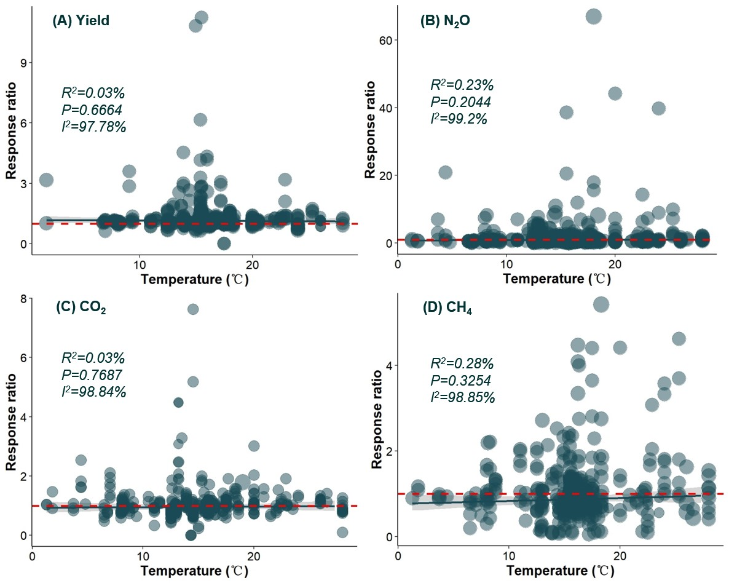
Fig. S17. Responses of crop yield (A), N₂O (B), CO₂ (C), and CH₄ (D) emissions to mean annual temperature under biochar application.

Table S1 Data structure and categorization information
Categorization | Indicators | Range
Basic information | Experiment conduct year | 1990-2023
Basic information | Soil texture | -
Basic information | Country | -
Basic information | Location | -
Basic information | Longitude | -31.55~67.13
Basic information | Latitude | -150.66~153.42
Basic information | Annual precipitation | 35~2700 mm
Basic information | Annual temperature | 1.3~28 ℃
Experiment information | Soil pH | 4.13~9.7
Experiment information | Bulk density | 0.59~1.73 g/cm³
Experiment information | Soil organic carbon | 4.4~14.6 g/kg
Experiment information | Crop type | -
Experiment information | Ecosystem | -
Biochar management practices | Biochar type | -
Biochar management practices | Biochar application rate | 0.25~128 t/ha
Biochar management practices | Biochar application method | -
Biochar management practices | Application depth | 0-50
Biochar management practices | Pyrolysis temperature | 350~1000 ℃
Biochar management practices | Biochar partial size | 0.3~10mm
Biochar management practices | Nitrogen fertilizer | -
Biochar management practices | Nitrogen application rate | 0-1000
Biochar management practices | Nitrogen application cycle | 0-5
Biochar management practices | Irrigation | -

Table S2 Accuracy comparison of machine learning models
Items | RF | GBM | SVM | MLP
R² | 0.72 | 0.57 | 0.49 | 0.41
RMSE | 8.78 | 15.46 | 29.48 | 27.62
Note: random forest (RF), gradient boosting machine (GBM), support vector machine (SVM), and multi-layer perceptron (MLP).

Table S3. Information on the global spatial layers source of the model.
Variable | Units | Source | Origin Spatial Resolution
MAT | °C | WorldClim2 | 1 km
MAP | mm | WorldClim2 | 1 km
AI |  | CGIAR-CSI | 1 km
ST | °C | ERA5-Land | 1 km
SWC | % | ERA5-Land | 1 km
SOC | % | SoilGrids2 (Shangguan et al., 2014) | 1 km
Sand | % | SoilGrids2 (Shangguan et al., 2014) | 1 km
Silt | % | SoilGrids2 (Shangguan et al., 2014) | 1 km
Clay | % | SoilGrids2 (Shangguan et al., 2014) | 1 km
BD | g cm⁻³ | SoilGrids2 (Shangguan et al., 2014) | 1 km
MAT: mean annual temperature, MAP: mean annual precipitation, AI: aridity index, SOC: soil organic carbon, TN: soil total nitrogen, Sand: soil sand content, Silt: soil silt content, Clay: soil clay content, BD: soil bulk density, SWC: soil water content.

Table S4 conversion ratio of biochar potential production
Items | ratio
Straw maximum conversion ratio | 0.45
Manure maximum conversion ratio | 0.6
Wood maximum conversion ratio | 0.55
Straw biochar yield ratio | 0.3
Manure biochar yield ratio | 0.45
Wood biochar yield ratio | 0.55
Pig manure yield | 0.55t/y
Cattle manure yield | 5.475t/y
Sheep manure yield | 0.365t/y
Goats manure yield | 0.55t/y
Chickens manure yield | 0.003t/y
Ducks manure yield | 0.008t/y

Table S5 Summary of the Egger regression after trim-and-fill method for crop yield and GHG emissions dataset under biochar application.
Response variable | Egger regression
Response variable | Z | p
CO₂ | -0.9862 | 0.3048
CH₄ | -2.0446 | 0.1017
N₂O | -2.1029 | 0.1394
Yield | 1.9631 | 0.2035
Z: the intercept of egger regression; p < 0.05 represents has publication bias.

References collected in the research:
Aamer, M., Hassan, M.U., Shaaban, M., Rasul, F., Haiying, T., Qiaoying, M., Batool, M., Rasheed, A., Chuan, Z., Qitao, S., Guoqin, H., 2021. Rice straw biochar mitigates N₂O emissions under alternate wetting and drying conditions in paddy soil. Journal of Saudi Chemical Society 25.
Abagandura, G.O., Bansal, S., Karsteter, A., Kumar, S., 2021. Soil greenhouse gas emissions, organic carbon and crop yield following pinewood biochar and biochar–manure applications at eroded and depositional landscape positions: A field trial in South Dakota, USA. Soil Use and Management 38, 487-502.
Abagandura, G.O., Chintala, R., Sandhu, S.S., Kumar, S., Schumacher, T.E., 2019. Effects of biochar and manure applications on soil carbon dioxide, methane, and nitrous oxide fluxes from two different soils. Journal of Environmental Quality 48, 1664-1674.
Abbas, A., Naveed, M., Azeem, M., Yaseen, M., Ullah, R., Alamri, S., Ain Farooq, Q.u., Siddiqui, M.H., 2020. Efficiency of wheat straw biochar in combination with compost and biogas slurry for enhancing nutritional status and productivity of soil and plant. Plants 9.
Agegnehu, G., Bass, A.M., Nelson, P.N., Bird, M.I., 2016. Benefits of biochar, compost and biochar–compost for soil quality, maize yield and greenhouse gas emissions in a tropical agricultural soil. Science of The Total Environment 543, 295-306.
Agegnehu, G., Bass, A.M., Nelson, P.N., Muirhead, B., Wright, G., Bird, M.I., 2015. Biochar and biochar-compost as soil amendments: Effects on peanut yield, soil properties and greenhouse gas emissions in tropical North Queensland, Australia. Agriculture, Ecosystems & Environment 213, 72-85.
Ali, A., Ali, M.F., Javed, T., Abidi, S.H., Syed, Q., Zulfiqar, U., Alotaibi, S.S., Siuta, D., Adamski, R., Wolny, P., 2022. Mitigating ammonia and greenhouse gaseous emission from arable land by co-application of zeolite and biochar. Frontiers in Plant Science 13.
Ali, M.A., Hoque, M.A., Kim, P.J., 2012. Mitigating global warming potentials of Methane and nitrous oxide gases from rice paddies under different irrigation regimes. Ambio 42, 357-368.
Angst, T.E., Six, J., Reay, D.S., Sohi, S.P., 2014. Impact of pine chip biochar on trace greenhouse gas emissions and soil nutrient dynamics in an annual ryegrass system in California. Agriculture, Ecosystems & Environment 191, 17-26.
Atinafu, D.G., Yeol Yun, B., Uk Kim, Y., Wi, S., Kim, S., 2021. Introduction of eicosane into biochar derived from softwood and wheat straw: Influence of porous structure and surface chemistry. Chemical Engineering Journal 415.
Ayaz, M., Feizienė, D., Tilvikienė, V., Feiza, V., Baltrėnaitė-Gedienė, E., Ullah, S., 2023. Biochar with inorganic nitrogen Fertilizer reduces direct greenhouse gas emission flux from soil. Plants 12.
Bai, J., Song, J., Chen, D., Zhang, Z., Yu, Q., Ren, G., Han, X., Wang, X., Ren, C., Yang, G., Wang, X., Feng, Y., 2023. Biochar combined with N fertilization and straw return in wheat-maize agroecosystem: Key practices to enhance crop yields and minimize carbon and nitrogen footprints. Agriculture, Ecosystems & Environment 347.
Bai, N., Zhang, H., Li, S., Zheng, X., Zhang, J., Zhang, H., Zhou, S., Sun, H., Lv, W., 2019. Long-term effects of straw and straw-derived biochar on soil aggregation and fungal community in a rice-wheat rotation system. PeerJ 6.
Bamminger, C., Poll, C., Marhan, S., 2017. Offsetting global warming-induced elevated greenhouse gas emissions from an arable soil by biochar application. Global Change Biology 24.
Basalirwa, D., Sudo, S., Wacal, C., Akae, F., Oo, A.Z., Koyama, S., Sasagawa, D., Yamamoto, S., Masunaga, T., Nishihara, E., 2020. Assessment of crop residue and palm shell biochar incorporation on greenhouse gas emissions during the fallow and crop growing seasons of broccoli (Brassica oleracea var. italica). Soil and Tillage Research 196.
Basalirwa, D., Sudo, S., Wacal, C., Oo, A.Z., Sasagawa, D., Yamamoto, S., Masunaga, T., Nishihara, E., 2019. Impact of fresh and aged palm shell biochar on N₂O emissions, soil properties, nutrient content and yield of Komatsuna (Brassica rapa var. perviridis ) under sandy soil conditions. Soil Science and Plant Nutrition 66, 328-343.
Bi, R., Zhang, Q., Zhan, L., Xu, X., Zhang, X., Dong, Y., Yan, X., Xiong, Z., 2022. Biochar and organic substitution improved net ecosystem economic benefit in intensive vegetable production. Biochar 4.
Bovsun, M.A., Castaldi, S., Nesterova, O.V., Semal, V.A., Sakara, N.A., Brikmans, A.V., Khokhlova, A.I., Karpenko, T.Y., 2021. Effect of biochar on soil CO₂ fluxes from agricultural field experiments in Russian far East. Agronomy 11.
Butphu, S., Kaewpradit, W., 2022. Impacts of eucalyptus biochar application on greenhouse gas emission from an upland rice-sugarcane cropping system on sandy soil. Experimental Agriculture 58.
Cao, Y., Shan, Y., Wu, P., Zhang, P., Zhang, Z., Zhao, F., Zhu, T., 2021. Mitigating the global warming potential of rice paddy fields by straw and straw-derived biochar amendments. Geoderma 396.
Case, S.D.C., McNamara, N.P., Reay, D.S., Whitaker, J., 2013. Can biochar reduce soil greenhouse gas emissions from a Miscanthus bioenergy crop? GCB Bioenergy 6, 76-89.
Castaldi, S., Riondino, M., Baronti, S., Esposito, F.R., Marzaioli, R., Rutigliano, F.A., Vaccari, F.P., Miglietta, F., 2011. Impact of biochar application to a Mediterranean wheat crop on soil microbial activity and greenhouse gas fluxes. Chemosphere 85, 1464-1471.
Chang, R., Yao, Y., Cao, W., Wang, J., Wang, X., Chen, Q., 2019. Effects of composting and carbon based materials on carbon and nitrogen loss in the arable land utilization of cow manure and corn stalks. Journal of Environmental Management 233, 283-290.
Chen, D., Wang, C., Shen, J., Li, Y., Wu, J., 2018a. Response of CH₄ emissions to straw and biochar applications in double-rice cropping systems: Insights from observations and modeling. Environmental Pollution 235, 95-103.
Chen, G., Zhang, Z., Zhang, Z., Zhang, R., 2018b. Redox-active reactions in denitrification provided by biochars pyrolyzed at different temperatures. Science of The Total Environment 615, 1547-1556.
Chen, T., Liu, C., Zhang, F., Han, H., Wang, Z., Yi, B., Tang, L., Meng, J., Chi, D., Wilson, L.T., Chen, W., 2022a. Acid-modified biochar increases grain yield and reduces reactive gaseous N losses and N-related global warming potential in alternate wetting and drying paddy production system. Journal of Cleaner Production 377.
Chen, X., Yang, S.-H., Jiang, Z.-W., Ding, J., Sun, X., 2021. Biochar as a tool to reduce environmental impacts of nitrogen loss in water-saving irrigation paddy field. Journal of Cleaner Production 290.
Chen, Y., Wang, L., Tong, L., Hao, X., Wu, X., Ding, R., Kang, S., Li, S., 2023. Effects of biochar addition and deficit irrigation with brackish water on yield-scaled N₂O emissions under drip irrigation with mulching. Agricultural Water Management 277.
Chen, Z., Huang, G., Li, Y., Zhang, X., Xiong, Y., Huang, Q., Jin, S., 2022b. Effects of the lignite bioorganic fertilizer on greenhouse gas emissions and pathways of nitrogen and carbon cycling in saline-sodic farmlands at Northwest China. Journal of Cleaner Production 334.
Cui, Y.F., Meng, J., Wang, Q.X., Zhang, W.M., Cheng, X.Y., Chen, W.F., 2017. Effects of straw and biochar addition on soil nitrogen, carbon, and super rice yield in cold waterlogged paddy soils of North China. Journal of Integrative Agriculture 16, 1064-1074.
Dash, P.K., Padhy, S.R., Bhattacharyya, P., Nandy, U., Nayak, A.K., Das, M., Satapathy, B.S., 2021. Mitigation of greenhouse gases emission through value-added straw amendments in rice-green gram system. International Journal of Environmental Science and Technology 20, 1019-1036.
Dawar, K., Khan, H., Zaman, M., Muller, C., Alam, S.S., Fahad, S., Alwahibi, M.S., Alkahtani, J., Saeed, B., Saud, S., Hammad, H.M., Nasim, W., 2021a. The effect of biochar and Nitrogen Inhibitor on ammonia and nitrous oxide emissions and wheat productivity. Journal of Plant Growth Regulation 40, 2465-2475.
Dawar, K., Saif ur, R., Fahad, S., Alam, S.S., Khan, S.A., Dawar, A., Younis, U., Danish, S., Datta, R., Dick, R.P., 2021b. Influence of variable biochar concentration on yield-scaled nitrous oxide emissions, Wheat yield and nitrogen use efficiency. Scientific Reports 11.
Ding, W., Chang, N., Zhang, J., Li, G., Zhang, J., Ju, X., Zhang, G., Li, H., 2022. Optimized fertigation mitigates N₂O and NO emissions and enhances NH₃ volatilizations in an intensified greenhouse vegetable system. Agricultural Water Management 272.
Dong, D., Li, J., Ying, S., Wu, J., Han, X., Teng, Y., Zhou, M., Ren, Y., Jiang, P., 2021. Mitigation of methane emission in a rice paddy field amended with biochar-based slow-release fertilizer. Science of The Total Environment 792.
Dong, D., Yang, M., Wang, C., Wang, H., Li, Y., Luo, J., Wu, W., 2013. Responses of methane emissions and rice yield to applications of biochar and straw in a paddy field. Journal of Soils and Sediments 13, 1450-1460.
Duan, M., Wu, F., Jia, Z., Wang, S., Cai, Y., Chang, S.X., 2020. Wheat straw and its biochar differently affect soil properties and field-based greenhouse gas emission in a Chernozemic soil. Biology and Fertility of Soils 56, 1023-1036.
Duan, P., Zhang, Q., Zhang, X., Xiong, Z., 2019. Mechanisms of mitigating nitrous oxide emissions from vegetable soil varied with manure, biochar and nitrification inhibitors. Agricultural and Forest Meteorology 278.
Edwards, J.D., Pittelkow, C.M., Kent, A.D., Yang, W.H., 2018. Dynamic biochar effects on soil nitrous oxide emissions and underlying microbial processes during the maize growing season. Soil Biology and Biochemistry 122, 81-90.
Fan, C., Leng, Y., Zhang, Q., Zhao, X., Gao, W., Duan, P., Li, Z., Luo, G., Zhang, W., Chen, M., Li, Q., 2022a. Synergistically mitigating nitric oxide emission by co-applications of biochar and nitrification inhibitor in a tropical agricultural soil. Environmental Research 214.
Fan, D., Cao, C., Li, C., 2022b. Integrated organic-inorganic nitrogen fertilization mitigates nitrous oxide emissions by regulating ammonia-oxidizing bacteria in purple caitai fields. Agriculture 12.
Fan, R., Zhang, B., Li, J., Zhang, Z., Liang, A., 2020. Straw-derived biochar mitigates CO₂ emission through changes in soil pore structure in a wheat-rice rotation system. Chemosphere 243.
Fang, B., Lee, X., Zhang, J., Li, Y., Zhang, L., Cheng, J., Wang, B., Cheng, H., 2016. Impacts of straw biochar additions on agricultural soil quality and greenhouse gas fluxes in karst area, Southwest China. Soil Science and Plant Nutrition 62, 526-533.
Feng, Y., Xu, Y., Yu, Y., Xie, Z., Lin, X., 2012. Mechanisms of biochar decreasing methane emission from Chinese paddy soils. Soil Biology and Biochemistry 46, 80-88.
Fidel, R., Laird, D., Parkin, T., 2019. Effect of biochar on soil greenhouse gas emissions at the laboratory and field scales. Soil Systems 3.
Fungo, B., Lehmann, J., Kalbitz, K., Tenywa, M., Thionģo, M., Neufeldt, H., 2017. Emissions intensity and carbon stocks of a tropical Ultisol after amendment with Tithonia green manure, urea and biochar. Field Crops Research 209, 179-188.
Fungo, B., Lehmann, J., Kalbitz, K., Thionģo, M., Tenywa, M., Okeyo, I., Neufeldt, H., 2019. Ammonia and nitrous oxide emissions from a field Ultisol amended with tithonia green manure, urea, and biochar. Biology and Fertility of Soils 55, 135-148.
Gao, J., Zhao, Y., Zhang, W., Sui, Y., Jin, D., Xin, W., Yi, J., He, D., 2019. Biochar prepared at different pyrolysis temperatures affects urea-nitrogen immobilization and N2O emissions in paddy fields. PeerJ 7.
Geethathanuja, K., Karthikeyan, S., 2022. Application of soil amendments to enhance soil carbon and biological properties in a paddy field under elevated CO₂ conditions. Archives of Agronomy and Soil Science 69, 1860-1877.
Ghorbani, M., Amirahmadi, E., Zamanian, K., 2021. In‐situ biochar production associated with paddies: Direct involvement of farmers in greenhouse gases reduction policies besides increasing nutrients availability and rice production. Land Degradation & Development 32, 3893-3904.
Ginebra, M., Muñoz, C., Calvelo-Pereira, R., Doussoulin, M., Zagal, E., 2022a. Biochar impacts on soil chemical properties, greenhouse gas emissions and forage productivity: A field experiment. Science of The Total Environment 806.
Ginebra, M., Muñoz, C., Zagal, E., 2022b. Carbon stability and soil N₂O emissions. pyrolyzed or unpyrolyzed manure? Journal of Environmental Management 322.
Grau‐Andrés, R., Pingree, M.R.A., Öquist, M.G., Wardle, D.A., Nilsson, M.C., Gundale, M.J., 2021. Biochar increases tree biomass in a managed boreal forest, but does not alter N₂O, CH₄, and CO₂ emissions. GCB Bioenergy 13, 1329-1342.
Gross, C.D., Bork, E.W., Carlyle, C.N., Chang, S.X., 2022. Biochar and its manure-based feedstock have divergent effects on soil organic carbon and greenhouse gas emissions in croplands. Science of The Total Environment 806.
Hamad, A.A.A., Ni, L., Shaghaleh, H., Elsadek, E., Hamoud, Y.A., 2023. Effect of Carbon Content in Wheat Straw Biochar on N₂O and CO₂ Emissions and Pakchoi Productivity Under Different Soil Moisture Conditions. Sustainability 15.
Hammond, J., Shackley, S., Prendergast-Miller, M., Cook, J., Buckingham, S., Pappa, V.A., 2014. Biochar field testing in the UK: outcomes and implications for use. Carbon Management 4, 159-170.
Han, X., Sun, X., Wang, C., Wu, M., Dong, D., Zhong, T., Thies, J.E., Wu, W., 2016. Mitigating methane emission from paddy soil with rice-straw biochar amendment under projected climate change. Scientific Reports 6.
Han, Z., Wang, J., Xu, P., Li, Z., Liu, S., Zou, J., 2021. Differential responses of soil nitrogen‐oxide emissions to organic substitution for synthetic fertilizer and biochar amendment in a subtropical tea plantation. GCB Bioenergy 13, 1260-1274.
He, F., Hu, W., He, F., Wang, P., Pi, B., Zhao, M., 2023. An appraisal of the utility of biochar in a rotation involving tobacco-rice in southern China. GCB Bioenergy 15, 979-993.
He, L., Xu, Y., Li, J., Zhang, Y., Liu, Y., Lyu, H., Wang, Y., Tang, X., Wang, S., Zhao, X., Yang, S., 2022. Biochar mitigated more N-related global warming potential in rice season than that in wheat season: An investigation from ten-year biochar-amended rice-wheat cropping system of China. Science of The Total Environment 821.
He, T., Liu, D., Yuan, J., Luo, J., Lindsey, S., Bolan, N., Ding, W., 2018. Effects of application of inhibitors and biochar to fertilizer on gaseous nitrogen emissions from an intensively managed wheat field. Science of The Total Environment 628-629, 121-130.
He, T., Yuan, J., Luo, J., Lindsey, S., Xiang, J., Lin, Y., Liu, D., Chen, Z., Ding, W., 2020. Combined application of biochar with urease and nitrification inhibitors have synergistic effects on mitigating CH₄ emissions in rice field: A three-year study. Science of The Total Environment 743.
He, T., Yuan, J., Luo, J., Wang, W., Fan, J., Liu, D., Ding, W., 2019. Organic fertilizers have divergent effects on soil N₂O emissions. Biology and Fertility of Soils 55, 685-699.
He, T., Yun, F., Liu, T., Jin, J., Yang, Y., Fu, Y., Wang, J., 2021. Differentiated mechanisms of biochar- and straw-induced greenhouse gas emissions in tobacco fields. Applied Soil Ecology 166.
Horák, J., Kondrlová, E., Igaz, D., Šimanský, V., Felber, R., Lukac, M., Balashov, E.V., Buchkina, N.P., Rizhiya, E.Y., Jankowski, M., 2017. Biochar and biochar with N-fertilizer affect soil N₂O emission in Haplic Luvisol. Biologia 72, 995-1001.
Horák, J., Šimanský, V., Igaz, D., Juriga, M., Aydin, E., Lukac, M., 2020. Biochar: an important component ameliorating the productivity of intensively used soils. Polish Journal of Environmental Studies 29, 2995-3001.
Hou, R., Li, T., Fu, Q., Liu, D., Li, M., Zhou, Z., Li, Q., Zhao, H., Yu, P., Yan, J., 2020. Effects of biochar and straw on greenhouse gas emission and its response mechanism in seasonally frozen farmland ecosystems. Catena 194.
Hu, S., Deng, Q., Hui, D., Wang, J., Iwuozo, S., Yu, C.-L., Jima, T., Smart, D., Reddy, C., Dennis, S., 2015. Corn yield and soil nitrous oxide emission under different fertilizer and soil management: a three-year field experiment in Middle Tennessee. Plos One 10.
Hu, Y., Thomsen, T.P., Fenton, O., Sommer, S.G., Shi, W., Cui, W., 2023. Effects of dairy processing sludge and derived biochar on greenhouse gas emissions from Danish and Irish soils. Environmental Research 216.
Huang, R., Wang, Y., Liu, J., Li, J., Xu, G., Luo, M., Xu, C., Ci, E., Gao, M., 2019a. Variation in N₂O emission and N₂O related microbial functional genes in straw-and biochar-amended and non-amended soils. Applied Soil Ecology 137, 57-68.
Huang, Y., Wang, C., Lin, C., Zhang, Y., Chen, X., Tang, L., Liu, C., Chen, Q., Onwuka, M.I., Song, T., 2019b. Methane and nitrous oxide flux after biochar application in subtropical acidic paddy soils under tobacco-rice rotation. Scientific Reports 9.
Hui, D., Yi, Q., Tang, S., Fan, X., Zhang, M., Pang, Y., Huang, X., Huang, Q., 2017. Effects of nitrogen application rate, nitrogen synergist and biochar on nitrous oxide emissions from vegetable field in south China. Plos One 12.
Hui, D., Yu, C.-L., Deng, Q., Saini, P., Collins, K., Koff, J., 2018. Weak effects of biochar and nitrogen fertilization on switchgrass photosynthesis, biomass, and soil respiration. Agriculture 8.
Hüppi, R., Felber, R., Neftel, A., Six, J., Leifeld, J., 2015. Effect of biochar and liming on soil nitrous oxide emissions from a temperate maize cropping system. Soil 1, 707-717.
Hüppi, R., Neftel, A., Lehmann, M.F., Krauss, M., Six, J., Leifeld, J., 2016. N use efficiencies and N₂O emissions in two contrasting, biochar amended soils under winter wheat-cover crop-sorghum rotation. Environmental Research Letters 11.
Ibrahim, M., Li, G., Khan, S., Chi, Q., Xu, Y., 2017. Biochars mitigate greenhouse gas emissions and bioaccumulation of potentially toxic elements and arsenic speciation in Phaseolus vulgaris L. Environmental Science and Pollution Research 24, 19524-19534.
Ibrahim, M.M., Guo, L., Wu, F., Liu, D., Zhang, H., Zou, S., Xing, S., Mao, Y., 2022. Field-applied biochar-based MgO and sepiolite composites possess CO₂ capture potential and alter organic C mineralization and C-cycling bacterial structure in fertilized soils. Science of The Total Environment 813.
Ji, C., Li, S., Geng, Y., Yuan, Y., Zhi, J., Yu, K., Han, Z., Wu, S., Liu, S., Zou, J., 2020. Decreased N2O and NO emissions associated with stimulated denitrification following biochar amendment in subtropical tea plantations. Geoderma 365.
Jia, J., Li, B., Chen, Z., Xie, Z., Xiong, Z., 2012. Effects of biochar application on vegetable production and emissions of N₂O and CH₄. Soil Science and Plant Nutrition 58, 503-509.
Jiang, R.W., Galo, M., Oelbermann, M., Naeth, M.A., 2022a. Soybean and soil responses to biochar amendment in controlled environments with elevated temperature and carbon dioxide. Canadian Journal of Soil Science 102, 65-76.
Jiang, R.W., Mechler, M.A.A., Oelbermann, M., Naeth, M.A., 2022b. Softwood biochar and greenhouse gas emissions: a field study over three growing seasons on a temperate agricultural soil. Canadian Journal of Soil Science 102, 197-211.
Jiang, Z., Yang, S., Pang, Q., Xu, Y., Chen, X., Sun, X., Qi, S., Yu, W., 2021. Biochar improved soil health and mitigated greenhouse gas emission from controlled irrigation paddy field: Insights into microbial diversity. Journal of Cleaner Production 318.
Kammann, C.I., Linsel, S., Gößling, J.W., Koyro, H.W., 2011. Influence of biochar on drought tolerance of Chenopodium quinoa Willd and on soil-plant relations. Plant and Soil 345, 195-210.
Kang, S.-W., Cheong, Y.H., Yun, J.-J., Park, J.-H., Park, J.-H., Seo, D.-C., Cho, J.-S., 2021a. Effect of biochar application on nitrogen use efficiency for sustainable and productive agriculture under different field crops. Journal of Plant Nutrition 44, 2849-2862.
Kang, S.-W., Kim, S.-H., Park, J.-H., Seo, D.-C., Ok, Y.S., Cho, J.-S., 2018. Effect of biochar derived from barley straw on soil physicochemical properties, crop growth, and nitrous oxide emission in an upland field in South Korea. Environmental Science and Pollution Research 25, 25813-25821.
Kang, S.-W., Yun, J.-J., Park, J.-H., Cheong, Y.H., Park, J.-H., Seo, D.-C., Cho, J.-S., 2021b. Effects of biochar and barley straw application on the rice productivity and greenhouse gas emissions of paddy field. Applied Biological Chemistry 64.
Kang, S.-W., Yun, J.-J., Park, J.-H., Cho, J.-S., 2021c. Exploring Suitable Biochar Application Rates with Compost to Improve Upland Field Environment. Agronomy 11.
Karhu, K., Mattila, T., Bergström, I., Regina, K., 2011. Biochar addition to agricultural soil increased CH₄ uptake and water holding capacity-Results from a short-term pilot field study. Agriculture, Ecosystems & Environment 140, 309-313.
Keith, A., Singh, B., Dijkstra, F.A., van Ogtrop, F., 2016. Biochar field study: greenhouse gas emissions, productivity, and nutrients in two soils. Agronomy Journal 108, 1805-1815.
Kimani, S.M., Bimantara, P.O., Hattori, S., Tawaraya, K., Sudo, S., Xu, X., Cheng, W., 2020. Co-application of poultry-litter biochar with Azolla has synergistic effects on CH₄ and N₂O emissions from rice paddy soils. Heliyon 6.
Koga, N., Shimoda, S., Iwata, Y., 2017. Biochar impacts on crop productivity and greenhouse gas emissions from an andosol. Journal of Environmental Quality 46, 27-35.
Kotuš, T., Šimanský, V., Drgoňová, K., Illéš, M., Wójcik-Gront, E., Balashov, E., Buchkina, N., Aydın, E., Horák, J., 2022. Combination of biochar with N-fertilizer affects properties of soil and N₂O emissions in maize crop. Agronomy 12.
Kulmala, L., Peltokangas, K., Heinonsalo, J., Pihlatie, M., Laurila, T., Liski, J., Lohila, A., 2022. Effects of biochar and ligneous soil amendments on greenhouse gas exchange during extremely dry growing season in a Finnish cropland. Frontiers in Sustainable Food Systems 6.
La Rosa, J.M., Rosado, M., Paneque, M., Miller, A.Z., Knicker, H., 2018. Effects of aging under field conditions on biochar structure and composition: Implications for biochar stability in soils. Science of The Total Environment 613-614, 969-976.
Lagomarsino, A., Valagussa, M., Scotti, C., Borrelli, L., Becagli, C., Tosca, A., 2022. Mitigation of GHG emissions from soils fertilized with livestock chain residues. Agronomy 12.
Lan, Z.M., Chen, C.R., Rezaei Rashti, M., Yang, H., Zhang, D.K., 2019. Linking feedstock and application rate of biochars to N₂O emission in a sandy loam soil: Potential mechanisms. Geoderma 337, 880-892.
Lehman, R.M., Chen, J., Kim, H., Yoo, G., 2015. Effects of biochar addition on CO₂ and N₂O emissions following fertilizer application to a cultivated grassland soil. Plos One 10.
Li, B., Bi, Z., Xiong, Z., 2016. Dynamic responses of nitrous oxide emission and nitrogen use efficiency to nitrogen and biochar amendment in an intensified vegetable field in southeastern China. GCB Bioenergy 9, 400-413.
Li, B., Fan, C.H., Xiong, Z.Q., Li, Q.L., Zhang, M., 2015a. The combined effects of nitrification inhibitor and biochar incorporation on yield-scaled N₂O emissions from an intensively managed vegetable field in southeastern China. Biogeosciences 12, 2003-2017.
Li, B., Fan, C.H., Zhang, H., Chen, Z.Z., Sun, L.Y., Xiong, Z.Q., 2015b. Combined effects of nitrogen fertilization and biochar on the net global warming potential, greenhouse gas intensity and net ecosystem economic budget in intensive vegetable agriculture in southeastern China. Atmospheric Environment 100, 10-19.
Li, B., Huang, W., Elsgaard, L., Yang, B., Li, Z., Yang, H., Lu, Y., 2020. Optimal biochar amendment rate reduced the yield-scaled N₂O emissions from Ultisols in an intensive vegetable field in South China. Science of The Total Environment 723.
Li, D., He, H., Zhou, G., He, Q., Yang, S., 2023. Rice Yield and Greenhouse Gas Emissions Due to Biochar and Straw Application under Optimal Reduced N Fertilizers in a Double Season Rice Cropping System. Agronomy 13.
Li, S., Ma, Q., Zhou, C., Yu, W., Shangguan, Z., 2021. Applying biochar under topsoil facilitates soil carbon sequestration: A case study in a dryland agricultural system on the Loess Plateau. Geoderma 403.
Li, W., Xie, H., Ren, Z., Li, T., Wen, X., Han, J., Liao, Y., 2022. Response of N₂O emissions to N fertilizer reduction combined with biochar application in a rain-fed winter wheat ecosystem. Agriculture, Ecosystems & Environment 333.
Liao, X., Chen, Y., Ruan, H., Malghani, S., 2021a. Incapability of biochar to mitigate biogas slurry induced N₂O emissions: Field investigations after 7 years of biochar application in a poplar plantation. Science of The Total Environment 794.
Liao, X., Liu, D., Niu, Y., Chen, Z., He, T., Ding, W., 2021b. Effect of field-aged biochar on fertilizer N retention and N₂O emissions: A field microplot experiment with 15N-labeled urea. Science of The Total Environment 773.
Liao, X., Niu, Y., Liu, D., Chen, Z., He, T., Luo, J., Lindsey, S., Ding, W., 2020. Four-year continuous residual effects of biochar application to a sandy loam soil on crop yield and N2O and NO emissions under maize-wheat rotation. Agriculture, Ecosystems & Environment 302.
Lima Barizão, A.C., Oliveira Gomes, L.E., Brandão, L.L., Sampaio, I.C.F., Moura, I.V.L., Gonçalves, R.F., Oliveira, J.P., Cassini, S.T., 2023. Microalgae as tertiary wastewater treatment: Energy production, carbon neutrality, and high-value products. Algal Research 72.
Lin, S., Yin, X., Yang, X., Wang, W., Wang, C., Sardans, J., Tariq, A., Zeng, F., Alrefaei, A.F., Peñuelas, J., 2022. Effects of combined applications of straw with industrial and agricultural wastes on greenhouse gases emissions, temperature sensitivity, and rice yield in a subtropical paddy field. Science of The Total Environment 840.
Liu, H., Li, H., Zhang, A., Rahaman, M.A., Yang, Z., 2020. Inhibited effect of biochar application on N₂O emissions is amount and time-dependent by regulating denitrification in a wheat-maize rotation system in North China. Science of The Total Environment 721.
Liu, J., Shen, J., Li, Y., Su, Y., Ge, T., Jones, D.L., Wu, J., 2014. Effects of biochar amendment on the net greenhouse gas emission and greenhouse gas intensity in a Chinese double rice cropping system. European Journal of Soil Biology 65, 30-39.
Liu, Q., Liu, B., Ambus, P., Zhang, Y., Hansen, V., Lin, Z., Shen, D., Liu, G., Bei, Q., Zhu, J., Wang, X., Ma, J., Lin, X., Yu, Y., Zhu, C., Xie, Z., 2015. Carbon footprint of rice production under biochar amendment-a case study in a Chinese rice cropping system. GCB Bioenergy 8, 148-159.
Liu, Q., Liu, B., Zhang, Y., Lin, Z., Zhu, T., Sun, R., Wang, X., Ma, J., Bei, Q., Liu, G., Lin, X., Xie, Z., 2017. Can biochar alleviate soil compaction stress on wheat growth and mitigate soil N₂O emissions? Soil Biology and Biochemistry 104, 8-17.
Liu, X., Ren, J., Zhang, Q., Liu, C., 2019a. Long-term effects of biochar addition and straw return on N₂O fluxes and the related functional gene abundances under wheat-maize rotation system in the North China Plain. Applied Soil Ecology 135, 44-55.
Liu, X., Tang, Z., Zhang, Q., Kong, W., 2021. The contrasting effects of biochar and straw on N₂O emissions in the maize season in intensively farmed soil. Environmental Science and Pollution Research 28, 29806-29819.
Liu, X., Zheng, J., Zhang, D., Cheng, K., Zhou, H., Zhang, A., Li, L., Joseph, S., Smith, P., Crowley, D., Kuzyakov, Y., Pan, G., 2016. Biochar has no effect on soil respiration across Chinese agricultural soils. Science of The Total Environment 554-555, 259-265.
Liu, X., Zhou, J., Chi, Z., Zheng, J., Li, L., Zhang, X., Zheng, J., Cheng, K., Bian, R., Pan, G., 2019b. Biochar provided limited benefits for rice yield and greenhouse gas mitigation six years following an amendment in a fertile rice paddy. Catena 179, 20-28.
Liu, Y., Bi, Y., Xie, Y., Zhao, X., He, D., Wang, S., Wang, C., Guo, T., Xing, G., 2019c. Successive straw biochar amendments reduce nitrous oxide emissions but do not improve the net ecosystem economic benefit in an alkaline sandy loam under a wheat-maize cropping system. Land Degradation & Development 31, 868-883.
Liu, Y., Shi, M., Chen, Z., Tang, Z., Tan, J., Tian, J., Elsgaard, L., Lu, Y., Li, B., 2023. Nonlinear effects of biochar on greenhouse gas emissions and soil microbial community composition under intensive vegetable production in South China. Applied Soil Ecology 189.
Liu, Z., Li, Z., Huang, F., Wang, B., Zhao, C., Zhang, P., Jia, Z., 2022a. Plastic film mulching and biochar amendment enhance maize yield and nitrogen fertilizer use efficiency by reducing gaseous nitrogen losses. Field Crops Research 289.
Liu, Z., Wang, B., Li, Z., Huang, F., Zhao, C., Zhang, P., Jia, Z., 2022b. Plastic film mulch combined with adding biochar improved soil carbon budget, carbon footprint, and maize yield in a rainfed region. Field Crops Research 284.
Lu, X., Li, Y., Wang, H., Singh, B.P., Hu, S., Luo, Y., Li, J., Xiao, Y., Cai, X., Li, Y., 2019. Responses of soil greenhouse gas emissions to different application rates of biochar in a subtropical Chinese chestnut plantation. Agricultural and Forest Meteorology 271, 168-179.
Lu, Y., Silveira, M.L., Cavigelli, M., O'Connor, G.A., Vendramini, J.M.B., Erickson, J.E., Li, Y.C., 2020. Biochar impacts on nutrient dynamics in a subtropical grassland soil: 2. Greenhouse gas emissions. Journal of Environmental Quality 49, 1421-1434.
Ludwig, B., Song, X., Gunina, A., Greenberg, I., Dippold, M.A., Piepho, H.P., 2021. Importance of sources of variability, scales and experimental design: A case study about the effects of biochar and slurry application on soil properties in agricultural silty loam soils. European Journal of Soil Science 72, 1954-1968.
Ma, X., Lv, M., Huang, F., Zhang, P., Cai, T., Jia, Z., 2022. Effects of biochar application on soil hydrothermal environment, carbon emissions, and crop yield in wheat fields under ridge-furrow rainwater harvesting planting mode. Agriculture 12.
Ma, Y., Liu, D.L., Schwenke, G., Yang, B., 2019. The global warming potential of straw-return can be reduced by application of straw-decomposing microbial inoculants and biochar in rice-wheat production systems. Environmental Pollution 252, 835-845.
Maier, R., Soja, G., Friesl-Hanl, W., Zechmeister-Boltenstern, S., Michel, K., Tatzber, M., Kitzler, B., 2022. Biochar-compost additions have strong short-term effects on carbon and nitrogen emissions from an agricultural soil. Agronomy 12.
Mechler, M.A.A., Jiang, R.W., Silverthorn, T.K., Oelbermann, M., 2018. Impact of biochar on soil characteristics and temporal greenhouse gas emissions: A field study from southern Canada. Biomass and Bioenergy 118, 154-162.
Michel, K., Tatzber, M., Kitzler, B., 2022. Increased N₂ emissions from an arable soil four years after biochar application. Journal of Plant Nutrition and Soil Science 185, 202-208.
Mikhael, J.E.R., Wang, J.J., Dodla, S., Scaglia, G., Dattamudi, S., 2022. Effects of biochar and N-stabilizers on greenhouse gas emissions from a subtropical pasture field applied with organic and inorganic nitrogen fertilizers. Journal of Environmental Management 306.
Mosharrof, M., Uddin, M.K., Mia, S., Sulaiman, M.F., Shamsuzzaman, S.M., Haque, A.N.A., 2022. Influence of rice husk biochar and lime in reducing phosphorus application rate in acid soil: A field trial with maize. Sustainability 14.
Nan, Q., Fang, C., Cheng, L., Hao, W., Wu, W., 2022. Elevation of NO³⁻-N from biochar amendment facilitates mitigating paddy CH₄ emission stably over seven years. Environmental Pollution 295.
Nan, Q., Wang, C., Wang, H., Yi, Q., Wu, W., 2020. Mitigating methane emission via annual biochar amendment pyrolyzed with rice straw from the same paddy field. Science of The Total Environment 746.
Nguyen, B.T., Trinh, N.N., Bach, Q.-V., 2020. Methane emissions and associated microbial activities from paddy salt-affected soil as influenced by biochar and cow manure addition. Applied Soil Ecology 152.
Niu, Y., Chen, Z., Müller, C., Zaman, M.M., Kim, D., Yu, H., Ding, W., 2017. Yield-scaled N 2 O emissions were effectively reduced by biochar amendment of sandy loam soil under maize - wheat rotation in the North China Plain. Atmospheric Environment 170, 58-70.
Niu, Y., Luo, J., Liu, D., Müller, C., Zaman, M., Lindsey, S., Ding, W., 2018. Effect of biochar and nitrapyrin on nitrous oxide and nitric oxide emissions from a sandy loam soil cropped to maize. Biology and Fertility of Soils 54, 645-658.
Oladele, S.O., Adetunji, A.T., 2021. Agro-residue biochar and N fertilizer addition mitigates CO2-C emission and stabilized soil organic carbon pools in a rain-fed agricultural cropland. International Soil and Water Conservation Research 9, 76-86.
Olaniyan, J.O., Isimikalu, T.O., Raji, B.A., Affinnih, K.O., Alasinrin, S.Y., Ajala, O.N., 2020. An investigation of the effect of biochar application rates on CO₂ emissions in soils under upland rice production in southern Guinea Savannah of Nigeria. Heliyon 6.
Oomori, S., Toma, Y., Nagata, O., Ueno, H., 2016. Effects of bamboo biochar application on global warming in paddy fields in Ehime prefecture, Southern Japan. Soil Science and Plant Nutrition 62, 553-560.
Palviainen, M., Berninger, F., Bruckman, V.J., Köster, K., de Assumpção, C.R.M., Aaltonen, H., Makita, N., Mishra, A., Kulmala, L., Adamczyk, B., Zhou, X., Heinonsalo, J., Köster, E., Pumpanen, J., 2018. Effects of biochar on carbon and nitrogen fluxes in boreal forest soil. Plant and Soil 425, 71-85.
Pandey, A., Mai, V.T., Vu, D.Q., Bui, T.P.L., Mai, T.L.A., Jensen, L.S., de Neergaard, A., 2014. Organic matter and water management strategies to reduce methane and nitrous oxide emissions from rice paddies in Vietnam. Agriculture, Ecosystems & Environment 196, 137-146.
Park, J.-H., Yun, J.-J., Park, J.-H., Acharya, B.S., Han, K.J., Cho, J.-S., Kang, S.-W., 2023. Three years of biochar and straw application could reduce greenhouse gas and improve rice productivity. Soil Science and Plant Nutrition 70, 2-10.
Petter, F.A., Borges de Lima, L., Marimon Júnior, B.H., Alves de Morais, L., Marimon, B.S., 2016. Impact of biochar on nitrous oxide emissions from upland rice. Journal of Environmental Management 169, 27-33.
Pokharel, P., Chang, S.X., 2019. Manure pellet, woodchip and their biochars differently affect wheat yield and carbon dioxide emission from bulk and rhizosphere soils. Science of The Total Environment 659, 463-472.
Pokharel, P., Qi, L., Chang, S.X., 2021. Manure-based biochar decreases heterotrophic respiration and increases gross nitrification rates in rhizosphere soil. Soil Biology and Biochemistry 154.
Polifka, S., Wiedner, K., Glaser, B., 2018. Increased CO₂ fluxes from a sandy cambisol under agricultural use in the Wendland region, Northern Germany, three years after biochar substrates application. GCB Bioenergy 10, 432-443.
Qi, L., Ma, Z., Chang, S.X., Zhou, P., Huang, R., Wang, Y., Wang, Z., Gao, M., 2021. Biochar decreases methanogenic archaea abundance and methane emissions in a flooded paddy soil. Science of The Total Environment 752.
Qi, L., Pokharel, P., Chang, S.X., Zhou, P., Niu, H., He, X., Wang, Z., Gao, M., 2020. Biochar application increased methane emission, soil carbon storage and net ecosystem carbon budget in a 2-year vegetable-rice rotation. Agriculture, Ecosystems & Environment 292.
Qin, X., Li, Y.e., Wang, H., Liu, C., Li, J., Wan, Y., Gao, Q., Fan, F., Liao, Y., 2016. Long-term effect of biochar application on yield-scaled greenhouse gas emissions in a rice paddy cropping system: A four-year case study in south China. Science of The Total Environment 569-570, 1390-1401.
Ramlow, M., Foster, E.J., Del Grosso, S.J., Cotrufo, M.F., 2019. Broadcast woody biochar provides limited benefits to deficit irrigation maize in Colorado. Agriculture, Ecosystems & Environment 269, 71-81.
Riaz, M., Bin Yousaf, M.T., Nawaz, M.F., Yasin, G., Cheng, H., Ahmed, I., Gul, S., Rizwan, M., Rehim, A., Xuebin, Q., Ur Rahman, S., 2022. Determining the appropriate level of farmyard manure biochar application in saline soils for three selected farm tree species. Plos One 17.
Ribas, A., Mattana, S., Llurba, R., Debouk, H., Sebastià, M.T., Domene, X., 2019. Biochar application and summer temperatures reduce N₂O and enhance CH₄ emissions in a Mediterranean agroecosystem: Role of biologically-induced anoxic microsites. Science of The Total Environment 685, 1075-1086.
Rose, T.J., Keen, B., Morris, S.G., Quin, P., Rust, J., Kearney, L., Kimber, S., Van Zwieten, L., 2016. Application of woody biochar and woody mulch to mitigate nitrous oxide emissions from a poultry litter-amended soil in the subtropics. Agriculture, Ecosystems & Environment 228, 1-8.
Sánchez-García, M., Sánchez-Monedero, M.A., Cayuela, M.L., 2020. N₂O emissions during Brassica oleracea cultivation: Interaction of biochar with mineral and organic fertilization. European Journal of Agronomy 115.
Scheer, C., Grace, P.R., Rowlings, D.W., Kimber, S., Van Zwieten, L., 2011. Effect of biochar amendment on the soil-atmosphere exchange of greenhouse gases from an intensive subtropical pasture in northern New South Wales, Australia. Plant and Soil 345, 47-58.
Schimmelpfennig, S., Müller, C., Grünhage, L., Koch, C., Kammann, C., 2014. Biochar, hydrochar and uncarbonized feedstock application to permanent grassland-Effects on greenhouse gas emissions and plant growth. Agriculture, Ecosystems & Environment 191, 39-52.
Scotti, C., Bertora, C., Valagussa, M., Borrelli, L., Cabassi, G., Tosca, A., 2022. Agroenvironmental Performances of Biochar Application in the Mineral and Organic Fertilization Strategies of a Maize-Ryegrass Forage System. Agriculture 12.
Seki, M., Sugihara, S., Miyazaki, H., Jegadeesan, M., Kannan, P., Bertrand, I., Tanaka, H., 2022. Impact of biochar and manure application on in situ carbon dioxide flux, microbial activity, and carbon budget in degraded cropland soil of southern India. Land Degradation & Development 33, 1626-1636.
Shao, Q., Ju, Y., Guo, W., Xia, X., Bian, R., Li, L., Li, W., Liu, X., Zheng, J., Pan, G., 2019. Pyrolyzed municipal sewage sludge ensured safe grain production while reduced C emissions in a paddy soil under rice and wheat rotation. Environmental Science and Pollution Research 26, 9244-9256.
Shen, J., Tang, H., Liu, J., Wang, C., Li, Y., Ge, T., Jones, D.L., Wu, J., 2014. Contrasting effects of straw and straw-derived biochar amendments on greenhouse gas emissions within double rice cropping systems. Agriculture, Ecosystems & Environment 188, 264-274.
Shen, Y., Zhu, L., Cheng, H., Yue, S., Li, S., 2017. Effects of biochar application on CO₂ emissions from a cultivated soil under semiarid climate conditions in Northwest China. Sustainability 9.
Shi, W., Bian, R., Li, L., Lian, W., Liu, X., Zheng, J., Cheng, K., Zhang, X., Drosos, M., Joseph, S., Pan, G., 2021. Assessing the impacts of biochar-blended urea on nitrogen use efficiency and soil retention in wheat production. GCB Bioenergy 14, 65-83.
Shi, Y., Liu, X., Zhang, Q., Li, G., Wang, P., 2022a. Biochar rather than organic fertilizer mitigated the global warming potential in a saline-alkali farmland. Soil and Tillage Research 219.
Shi, Y., Liu, X., Zhang, Q., Li, Y., 2022b. Contrasting effects of biochar- and organic fertilizer-amendment on community compositions of nitrifiers and denitrifiers in a wheat-maize rotation system. Applied Soil Ecology 171.
Shin, J., Park, D., Hong, S., Jeong, C., Kim, H., Chung, W., 2021. Influence of activated biochar pellet fertilizer application on greenhouse gas emissions and carbon sequestration in rice (Oryza sativa L.) production. Environmental Pollution 285.
Song, Y., Li, Y., Cai, Y., Fu, S., Luo, Y., Wang, H., Liang, C., Lin, Z., Hu, S., Li, Y., Chang, S.X., 2019. Biochar decreases soil N₂O emissions in Moso bamboo plantations through decreasing labile N concentrations, N-cycling enzyme activities and nitrification/denitrification rates. Geoderma 348, 135-145.
Sriphirom, P., Chidthaisong, A., Yagi, K., Boonapatcharoen, N., Tripetchkul, S., Towprayoon, S., 2020. Effects of Biochar Particle Size on Methane Emissions from Rice Cultivation. Journal of Renewable Materials 8, 1199-1214.
Sriphirom, P., Chidthaisong, A., Yagi, K., Tripetchkul, S., Boonapatcharoen, N., Towprayoon, S., 2021. Effects of biochar on methane emission, grain yield, and soil in rice cultivation in Thailand. Carbon Management 12, 109-121.
Sriphirom, P., Chidthaisong, A., Yagi, K., Tripetchkul, S., Towprayoon, S., 2019. Evaluation of biochar applications combined with alternate wetting and drying (AWD) water management in rice field as a methane mitigation option for farmers’ adoption. Soil Science and Plant Nutrition 66, 235-246.
Suddick, E.C., Six, J., 2013. An estimation of annual nitrous oxide emissions and soil quality following the amendment of high temperature walnut shell biochar and compost to a small scale vegetable crop rotation. Science of The Total Environment 465, 298-307.
Sui, Y., Gao, J., Liu, C., Zhang, W., Lan, Y., Li, S., Meng, J., Xu, Z., Tang, L., 2016. Interactive effects of straw-derived biochar and N fertilization on soil C storage and rice productivity in rice paddies of Northeast China. Science of The Total Environment 544, 203-210.
Sun, H., Lu, H., Feng, Y., 2018. Greenhouse gas emissions vary in response to different biochar amendments: an assessment based on two consecutive rice growth cycles. Environmental Science and Pollution Research 26, 749-758.
Sun, H., Yi, Z., Jeyakumar, P., Xia, C., Feng, Y., Lam, S.S., Sonne, C., Wang, H., Shi, W., 2022. Citric acid modified biochar application at a low dosage can synchronically mitigate the nitrogenous gas pollutants emission from rice paddy soils. Environmental Pollution 312.
Sun, H., Zhang, H., Min, J., Feng, Y., Shi, W., 2015. Controlled-release fertilizer, floating duckweed, and biochar affect ammonia volatilization and nitrous oxide emission from rice paddy fields irrigated with nitrogen-rich wastewater. Paddy and Water Environment 14, 105-111.
Sun, L., Deng, J., Fan, C., Li, J., Liu, Y., 2020. Combined effects of nitrogen fertilizer and biochar on greenhouse gas emissions and net ecosystem economic budget from a coastal saline rice field in southeastern China. Environmental Science and Pollution Research 27, 17013-17022.
Sun, Z., Sänger, A., Rebensburg, P., Lentzsch, P., Wirth, S., Kaupenjohann, M., Meyer-Aurich, A., 2017. Contrasting effects of biochar on N₂O emission and N uptake at different N fertilizer levels on a temperate sandy loam. Science of The Total Environment 578, 557-565.
Tan, G., Wang, H., Xu, N., Junaid, M., Liu, H., Zhai, L., 2019. Effects of biochar application with fertilizer on soil microbial biomass and greenhouse gas emissions in a peanut cropping system. Environmental Technology 42, 9-19.
Tan, G., Wang, H., Xu, N., Liu, H., Zhai, L., 2018. Biochar amendment with fertilizers increases peanut N uptake, alleviates soil N₂O emissions without affecting NH₃ volatilization in field experiments. Environmental Science and Pollution Research 25, 8817-8826.
Tang, Y., Gao, W., Cai, K., Chen, Y., Li, C., Lee, X., Cheng, H., Zhang, Q., Cheng, J., 2021. Effects of biochar amendment on soil carbon dioxide emission and carbon budget in the karst region of southwest China. Geoderma 385.
Tang, Y., Gao, W., Chen, Y., Zhang, Q., Cheng, J., 2023. Effects of biochar amendment on nitrous oxide emission, bacterial and fungal community composition in a tobacco-planting soil. Journal of Soil Science and Plant Nutrition 23, 3106-3119.
Thers, H., Abalos, D., Dörsch, P., Elsgaard, L., 2020. Nitrous oxide emissions from oilseed rape cultivation were unaffected by flash pyrolysis biochar of different type, rate and field ageing. Science of The Total Environment 724.
Trinh, M.V., Tesfai, M., Borrell, A., Nagothu, U.S., Bui, T.P.L., Quynh, V.D., Thanh, L.Q., 2016. Effect of organic, inorganic and slow-release urea fertilisers on CH₄ and N₂O emissions from rice paddy fields. Paddy and Water Environment 15, 317-330.
Van Zwieten, L., Kimber, S.W.L., Morris, S.G., Singh, B.P., Grace, P.R., Scheer, C., Rust, J., Downie, A.E., Cowie, A.L., 2013. Pyrolysing poultry litter reduces N₂O and CO₂ fluxes. Science of The Total Environment 465, 279-287.
Ventura, M., Alberti, G., Panzacchi, P., Vedove, G.D., Miglietta, F., Tonon, G., 2018. Biochar mineralization and priming effect in a poplar short rotation coppice from a 3-year field experiment. Biology and Fertility of Soils 55, 67-78.
Verhoeven, E., Six, J., 2014. Biochar does not mitigate field-scale N₂O emissions in a northern california vineyard: an assessment across two years. Agriculture, Ecosystems & Environment 191, 27-38.
Virk, A.L., Kan, Z.-R., Liu, B.-Y., Qi, J.-Y., He, C., Liu, Q.-Y., Zhao, X., Zhang, H.-L., 2021. Impact of biochar water extract addition on soil organic carbon mineralization and C fractions in different tillage systems. Environmental Technology & Innovation 21.
Wang, C., Liu, J., Shen, J., Chen, D., Li, Y., Jiang, B., Wu, J., 2018a. Effects of biochar amendment on net greenhouse gas emissions and soil fertility in a double rice cropping system: A 4-year field experiment. Agriculture, Ecosystems & Environment 262, 83-96.
Wang, C., Shen, J., Liu, J., Qin, H., Yuan, Q., Fan, F., Hu, Y., Wang, J., Wei, W., Li, Y., Wu, J., 2019a. Microbial mechanisms in the reduction of CH₄ emission from double rice cropping system amended by biochar: A four-year study. Soil Biology and Biochemistry 135, 251-263.
Wang, C., Sun, H., Zhang, X., Zhang, J., Zhou, S., 2023. Optimal straw retention strategies for low-carbon rice production: 5 year results of an in situ trial in Eastern China. Agronomy 13.
Wang, C., Wang, W., Sardans, J., Singla, A., Zeng, C., Lai, D.Y.F., Peñuelas, J., 2018b. Effects of steel slag and biochar amendments on CO₂, CH₄, and N₂O flux, and rice productivity in a subtropical Chinese paddy field. Environmental Geochemistry and Health 41, 1419-1431.
Wang, E., Yuan, N., Lv, S., Tang, X., Wang, G., Wu, L., Zhou, Y., Zhou, G., Shi, Y., Xu, L., 2022a. Biochar-based fertilizer decreased soil N₂O emission and increased soil CH₄ uptake in a subtropical typical bamboo plantation. Forests 13.
Wang, J., Pan, X., Liu, Y., Zhang, X., Xiong, Z., 2012. Effects of biochar amendment in two soils on greenhouse gas emissions and crop production. Plant and Soil 360, 287-298.
Wang, M., Lan, X., Xu, X., Fang, Y., Singh, B.P., Sardans, J., Romero, E., Peñuelas, J., Wang, W., 2020. Steel slag and biochar amendments decreased CO₂ emissions by altering soil chemical properties and bacterial community structure over two-year in a subtropical paddy field. Science of The Total Environment 740.
Wang, M., Wang, C., Lan, X., Abid, A.A., Xu, X., Singla, A., Sardans, J., Llusià, J., Peñuelas, J., Wang, W., 2019b. Coupled steel slag and biochar amendment correlated with higher methanotrophic abundance and lower CH₄ emission in subtropical paddies. Environmental Geochemistry and Health 42, 483-497.
Wang, Q., Yuan, J., Yang, X., Han, X., Lan, Y., Cao, D., Sun, Q., Cui, X., Meng, J., Chen, W., 2022b. Responses of soil respiration and C sequestration efficiency to biochar amendment in maize field of Northeast China. Soil and Tillage Research 223.
Wang, S., Ma, S., Shan, J., Xia, Y., Lin, J., Yan, X., 2019c. A 2-year study on the effect of biochar on methane and nitrous oxide emissions in an intensive rice-wheat cropping system. Biochar 1, 177-186.
Wang, S., Xia, G., Zheng, J., Wang, Y., Chen, T., Chi, D., Bolan, N.S., Chang, S.X., Wang, T., Ok, Y.S., 2022c. Mulched drip irrigation and biochar application reduce gaseous nitrogen emissions, but increase nitrogen uptake and peanut yield. Science of The Total Environment 830.
Wang, W., Neogi, S., Lai, D.Y.F., Zeng, C., Wang, C., Zeng, D., 2017a. Effects of industrial and agricultural waste amendment on soil greenhouse gas production in a paddy field in Southeastern China. Atmospheric Environment 164, 239-249.
Wang, W., Zeng, C., Sardans, J., Zeng, D., Wang, C., Bartrons, M., PeÑUelas, J., 2017b. Industrial and agricultural wastes decreased greenhouse-gas emissions and increased rice grain yield in a subtropical paddy field. Experimental Agriculture 54, 623-640.
Wang, X., Lu, P., Yang, P., Ren, S., 2021. Effects of fertilizer and biochar applications on the relationship among soil moisture, temperature, and N₂O emissions in farmland. PeerJ 9.
Wang, Y., Liu, Y., Liu, R., Zhang, A., Yang, S., Liu, H., Zhou, Y., Yang, Z., 2017c. Biochar amendment reduces paddy soil nitrogen leaching but increases net global warming potential in Ningxia irrigation, China. Scientific Reports 7.
Wang, Z., Li, Y., Chang, S.X., Zhang, J., Jiang, P., Zhou, G., Shen, Z., 2014. Contrasting effects of bamboo leaf and its biochar on soil CO₂ efflux and labile organic carbon in an intensively managed Chinese chestnut plantation. Biology and Fertility of Soils 50, 1109-1119.
Watanabe, A., Ikeya, K., Kanazaki, N., Makabe, S., Sugiura, Y., Shibata, A., 2014. Five crop seasons' records of greenhouse gas fluxes from upland fields with repetitive applications of biochar and cattle manure. Journal of Environmental Management 144, 168-175.
Wei, C., Li, F., Yang, P., Ren, S., Wang, S., Wang, Y., Xu, Z., Xu, Y., Wei, R., Zhang, Y., 2019. Effects of irrigation water salinity on soil properties, N₂O emission and yield of spring maize under mulched drip irrigation. Water 11.
Wei, W., Yang, H., Fan, M., Chen, H., Guo, D., Cao, J., Kuzyakov, Y., 2020. Biochar effects on crop yields and nitrogen loss depending on fertilization. Science of The Total Environment 702.
Wei, X., Fan, L., Li, Y., Wang, W., Zhu, Z., Zhran, M., Shen, J., Kim, P.J., Wu, J., Ge, T., Dorodnikov, M., 2021. Subsurface methane dynamics of a paddy field under long-term fertilization: ¹³C-evidence from in-situ belowground labeling. Journal of Cleaner Production 325.
Westermann, M., Brackin, R., Robinson, N., Salazar Cajas, M., Buckley, S., Bailey, T., Redding, M., Kochanek, J., Hill, J., Guillou, S., Freitas, J.C.M., Wang, W., Pratt, C., Fujinuma, R., Schmidt, S., 2021. Organic wastes amended with sorbents reduce N₂O emissions from sugarcane cropping. Environments 8.
Wu, F., Jia, Z., Wang, S., Chang, S.X., Startsev, A., 2012. Contrasting effects of wheat straw and its biochar on greenhouse gas emissions and enzyme activities in a Chernozemic soil. Biology and Fertility of Soils 49, 555-565.
Wu, J., Guo, W., Feng, J., Li, L., Yang, H., Wang, X., Bian, X., 2014. Greenhouse gas emissions from cotton field under different irrigation methods and fertilization regimes in Arid Northwestern China. The Scientific World Journal 2014, 1-10.
Wu, Y., Li, F., Zheng, H., Hong, M., Hu, Y., Zhao, B., De, H., 2019a. Effects of three types of soil amendments on yield and soil nitrogen balance of maize-wheat rotation system in the Hetao Irrigation Area, China. Journal of Arid Land 11, 904-915.
Wu, Y., Li, Y., Wang, H., Wang, Z., Fu, X., Shen, J., Wang, Y., Liu, X., Meng, L., Wu, J., 2021. Response of N₂O emissions to biochar amendment on a tea field soil in subtropical central China: A three-year field experiment. Agriculture, Ecosystems & Environment 318.
Wu, Z., Dong, Y., Zhang, X., Xu, X., Xiong, Z., 2023. Biochar single application and reapplication decreased soil greenhouse gas and nitrogen oxide emissions from rice-wheat rotation: A three-year field observation. Geoderma 435.
Wu, Z., Zhang, X., Dong, Y., Li, B., Xiong, Z., 2019b. Biochar amendment reduced greenhouse gas intensities in the rice-wheat rotation system: six-year field observation and meta-analysis. Agricultural and Forest Meteorology 278.
Wu, Z., Zhang, X., Dong, Y., Xu, X., Xiong, Z., 2018. Microbial explanations for field-aged biochar mitigating greenhouse gas emissions during a rice-growing season. Environmental Science and Pollution Research 25, 31307-31317.
Xiang, J., Liu, D., Ding, W., Yuan, J., Lin, Y., 2015. Effects of biochar on nitrous oxide and nitric oxide emissions from paddy field during the wheat growth season. Journal of Cleaner Production 104, 52-58.
Xiao, L., Bao, L., Ren, L., Xie, Y., Wang, H., Wang, X., Wang, J., Qiao, C., Xiao, X., 2022. Appropriate irrigation and fertilization regime restrain indigenous soil key ammonia-oxidizing archaeal and bacterial consortia to mitigate greenhouse gas emissions. Sustainability 14.
Xiao, Y., Yang, S., Xu, J., Ding, J., Sun, X., Jiang, Z., 2018. Effect of biochar amendment on methane emissions from paddy field under water-saving irrigation. Sustainability 10.
Xie, Y., Dong, C., Chen, Z., Liu, Y., Zhang, Y., Gou, P., Zhao, X., Ma, D., Kang, G., Wang, C., Zhu, Y., Guo, T., 2021. Successive biochar amendment affected crop yield by regulating soil nitrogen functional microbes in wheat-maize rotation farmland. Environmental Research 194.
Xie, Y., Yang, C., Ma, E., Tan, H., Zhu, T., Müller, C., 2020. Biochar stimulates NH⁴⁺ turnover while decreasing NO³⁻ production and N₂O emissions in soils under long-term vegetable cultivation. Science of The Total Environment 737.
Xie, Z., Xu, Y., Liu, G., Liu, Q., Zhu, J., Tu, C., Amonette, J.E., Cadisch, G., Yong, J.W.H., Hu, S., 2013. Impact of biochar application on nitrogen nutrition of rice, greenhouse-gas emissions and soil organic carbon dynamics in two paddy soils of China. Plant and Soil 370, 527-540.
Xu, L., Fang, H., Deng, X., Ying, J., Lv, W., Shi, Y., Zhou, G., Zhou, Y., 2020. Biochar application increased ecosystem carbon sequestration capacity in a Moso bamboo forest. Forest Ecology and Management 475.
Xu, X., Wu, Z., Dong, Y., Zhou, Z., Xiong, Z., 2016. Effects of nitrogen and biochar amendment on soil methane concentration profiles and diffusion in a rice-wheat annual rotation system. Scientific Reports 6.
Yamamoto, A., Akiyama, H., Kojima, M., Osaki, A., 2019. Nitrous oxide emissions from an Andosol upland field amended with four different types of biochars. Nutrient Cycling in Agroecosystems 113, 323-335.
Yang, S., Jiang, Z., Sun, X., Ding, J., Xu, J., 2018. Effects of biochar amendment on CO₂ emissions from paddy fields under water-saving irrigation. International Journal of Environmental Research and Public Health 15.
Yang, S., Liu, X., Liu, X., Xu, J., 2017a. Effect of water management on soil respiration and NEE of paddy fields in Southeast China. Paddy and Water Environment 15, 787-796.
Yang, S., Sun, X., Ding, J., Jiang, Z., Liu, X., Xu, J., 2020a. Effect of biochar addition on CO₂ exchange in paddy fields under water-saving irrigation in Southeast China. Journal of Environmental Management 271.
Yang, S., Sun, X., Ding, J., Jiang, Z., Xu, J., 2019a. Effects of biochar addition on the NEE and soil organic carbon content of paddy fields under water-saving irrigation. Environmental Science and Pollution Research 26, 8303-8311.
Yang, s., Xiao, Y.n., Sun, X., Ding, J., Jiang, Z., Xu, J., 2019b. Biochar improved rice yield and mitigated CH₄ and N₂O emissions from paddy field under controlled irrigation in the Taihu Lake Region of China. Atmospheric Environment 200, 69-77.
Yang, T., Yang, Z., Xu, C., Li, F., Fang, F., Feng, J., 2023. Greenhouse gas emissions from double-season rice field under different tillage practices and fertilization managements in Southeast China. Agronomy 13.
Yang, W., Feng, G., Miles, D., Gao, L., Jia, Y., Li, C., Qu, Z., 2020b. Impact of biochar on greenhouse gas emissions and soil carbon sequestration in corn grown under drip irrigation with mulching. Science of The Total Environment 729.
Yang, X., Lan, Y., Meng, J., Chen, W., Huang, Y., Cheng, X., He, T., Cao, T., Liu, Z., Jiang, L., Gao, J., 2017b. Effects of maize stover and its derived biochar on greenhouse gases emissions and C-budget of brown earth in Northeast China. Environmental Science and Pollution Research 24, 8200-8209.
Yang, X., Sun, Q., Yuan, J., Fu, S., Lan, Y., Jiang, X., Meng, J., Han, X., Chen, W., 2022a. Successive corn stover and biochar applications mitigate N₂O emissions by altering soil physicochemical properties and N-cycling-related enzyme activities: A five-year field study in Northeast China. Agriculture, Ecosystems & Environment 340.
Yang, X., Vancov, T., Peñuelas, J., Sardans, J., Singla, A., Alrefaei, A.F., Song, X., Fang, Y., Wang, W., 2022b. Optimal biochar application rates for mitigating global warming and increasing rice yield in a subtropical paddy field. Experimental Agriculture 57, 283-299.
Yang, X., Wang, W., Chen, X., Sardans, J., Wang, C., Vancov, T., Fang, Y., Wang, S., Yuan, X., Llusià, J., Tariq, A., Zeng, F., Alrefaei, A.F., Peñuelas, J., 2022c. Effects of N-enriched biochar on ecosystem greenhouse gas emissions, rice yield, and bacterial community diversity in subtropical rice paddy soils. European Journal of Soil Biology 113.
Yang, Z., Yu, Y., Hu, R., Xu, X., Xian, J., Yang, Y., Liu, L., Cheng, Z., 2020c. Effect of rice straw and swine manure biochar on N₂O emission from paddy soil. Scientific Reports 10.
Yeboah, S., Jun, W., Liqun, C., Oteng-Darko, P., Narteh Tetteh, E., Renzhi, Z., 2021. Nitrous oxide, methane emissions and grain yield in rainfed wheat grown under nitrogen enriched biochar and straw in a semiarid environment. PeerJ 9.
Yin, X., Peñuelas, J., Sardans, J., Xu, X., Chen, Y., Fang, Y., Wu, L., Singh, B.P., Tavakkoli, E., Wang, W., 2021. Effects of nitrogen-enriched biochar on rice growth and yield, iron dynamics, and soil carbon storage and emissions: A tool to improve sustainable rice cultivation. Environmental Pollution 287.
Yoo, G., Lee, Y.O., Won, T.J., Hyun, J.G., Ding, W., 2018. Variable effects of biochar application to soils on nitrification-mediated N₂O emissions. Science of The Total Environment 626, 603-611.
Yun, J.-J., Park, J.-H., Acharya, B.S., Park, J.-H., Cho, J.-S., Kang, S.-W., 2022. Production of pelleted biochar and Its application as an amendment in paddy condition for reducing methane fluxes. Agriculture 12.
Zhang, A., Bian, R., Hussain, Q., Li, L., Pan, G., Zheng, J., Zhang, X., Zheng, J., 2013. Change in net global warming potential of a rice-wheat cropping system with biochar soil amendment in a rice paddy from China. Agriculture, Ecosystems & Environment 173, 37-45.
Zhang, A., Bian, R., Li, L., Wang, X., Zhao, Y., Hussain, Q., Pan, G., 2015. Enhanced rice production but greatly reduced carbon emission following biochar amendment in a metal-polluted rice paddy. Environmental Science and Pollution Research 22, 18977-18986.
Zhang, A., Bian, R., Pan, G., Cui, L., Hussain, Q., Li, L., Zheng, J., Zheng, J., Zhang, X., Han, X., Yu, X., 2012. Effects of biochar amendment on soil quality, crop yield and greenhouse gas emission in a Chinese rice paddy: A field study of 2 consecutive rice growing cycles. Field Crops Research 127, 153-160.
Zhang, A., Cheng, G., Hussain, Q., Zhang, M., Feng, H., Dyck, M., Sun, B., Zhao, Y., Chen, H., Chen, J., Wang, X., 2017. Contrasting effects of straw and straw-derived biochar application on net global warming potential in the Loess Plateau of China. Field Crops Research 205, 45-54.
Zhang, A., Cui, L., Pan, G., Li, L., Hussain, Q., Zhang, X., Zheng, J., Crowley, D., 2010. Effect of biochar amendment on yield and methane and nitrous oxide emissions from a rice paddy from Tai Lake plain, China. Agriculture, Ecosystems & Environment 139, 469-475.
Zhang, A., Liu, Y., Pan, G., Hussain, Q., Li, L., Zheng, J., Zhang, X., 2011. Effect of biochar amendment on maize yield and greenhouse gas emissions from a soil organic carbon poor calcareous loamy soil from Central China Plain. Plant and Soil 351, 263-275.
Zhang, D., Pan, G., Wu, G., Kibue, G.W., Li, L., Zhang, X., Zheng, J., Zheng, J., Cheng, K., Joseph, S., Liu, X., 2016a. Biochar helps enhance maize productivity and reduce greenhouse gas emissions under balanced fertilization in a rainfed low fertility inceptisol. Chemosphere 142, 106-113.
Zhang, H., Liang, S., Wang, Y., Liu, S., Sun, H., 2020a. Greenhouse gas emissions of rice straw return varies with return depth and soil type in paddy systems of Northeast China. Archives of Agronomy and Soil Science 67, 1591-1602.
Zhang, H., Sun, H., Zhou, S., Bai, N., Zheng, X., Li, S., Zhang, J., Lv, W., 2019. Effect of straw and straw biochar on the community structure and diversity of ammonia-oxidizing bacteria and archaea in rice-wheat rotation ecosystems. Scientific Reports 9.
Zhang, J., Sun, H., Ma, J., Zhang, X., Wang, C., Zhou, S., 2023a. Effect of straw biochar application on soil carbon, greenhouse gas emissions and nitrogen leaching: A vegetable crop rotation field experiment. Soil Use and Management 39, 729-741.
Zhang, M., Hou, R., Li, T., Fu, Q., Zhang, S., Su, A., Xue, P., Yang, X., 2022a. Study of soil nitrogen cycling processes based on the ¹⁵N isotope tracking technique in the black soil areas. Journal of Cleaner Production 375.
Zhang, P., Zhang, Z., Liu, X., Fan, T., Wang, D., 2023b. Effect of mulching and biochar addition on the distribution and emission characteristics of N₂O from furrow-ridge tillage soils. Journal of Environmental Management 345.
Zhang, Q., Wu, Z., Zhang, X., Duan, P., Shen, H., Gunina, A., Yan, X., Xiong, Z., 2021a. Biochar amendment mitigated N₂O emissions from paddy field during the wheat growing season. Environmental Pollution 281.
Zhang, S., Zhou, J., Chen, J., Ge, T., Cai, Y., Yu, B., Wang, H., White, J.C., Li, Y., 2023c. Changes in soil CO₂ and N₂O emissions in response to urea and biochar-based urea in a subtropical Moso bamboo forest. Soil and Tillage Research 228.
Zhang, X., Qu, J., Li, H., La, S., Tian, Y., Gao, L., 2020b. Biochar addition combined with daily fertigation improves overall soil quality and enhances water-fertilizer productivity of cucumber in alkaline soils of a semi-arid region. Geoderma 363.
Zhang, X., Zhang, Q., Xu, X., Dong, Y., Xiong, Z., 2022b. Biochar mitigated yield-scaled N₂O and NO emissions and ensured vegetable quality and soil fertility: a 3-year greenhouse field observation. Agronomy 12.
Zhang, Y., Hwarari, D., Yang, Y., Huo, A., Wang, J., Yang, L., 2022c. Biochar-induced mitigation potential of greenhouse gas emissions was enhanced under high soil nitrogen availability in intensively-irrigated vegetable cropping systems. Agronomy 12.
Zhang, Y., Lin, F., Wang, X., Zou, J., Liu, S., 2016b. Annual accounting of net greenhouse gas balance response to biochar addition in a coastal saline bioenergy cropping system in China. Soil and Tillage Research 158, 39-48.
Zhang, Y., Yan, J., Rong, X., Han, Y., Yang, Z., Hou, K., Zhao, H., Hu, W., 2021b. Responses of maize yield, nitrogen and phosphorus runoff losses and soil properties to biochar and organic fertilizer application in a light-loamy fluvo-aquic soil. Agriculture, Ecosystems & Environment 314.
Zhao, Y., Jiang, H., Gao, J., Feng, Y., Yan, B., Li, K., Lan, Y., Zhang, W., 2023. Effects of nitrogen co-application by different biochar materials on rice production potential and greenhouse gas emissions in paddy fields in northern China. Environmental Technology & Innovation 32.
Zhao, Y., Lin, S., Lv, H., Wang, Y., Hu, J., Li, G., Butterbach-Bahl, K., 2022. Increasing the environmental sustainability of greenhouse vegetable production by combining biochar application and drip fertigation-effects on soil N₂O emissions and carbon sequestrations. Agronomy 12.
Zhou, J., Qu, T., Li, Y., Van Zwieten, L., Wang, H., Chen, J., Song, X., Lin, Z., Zhang, X., Luo, Y., Cai, Y., Zhong, Z., 2021. Biochar-based fertilizer decreased while chemical fertilizer increased soil N₂O emissions in a subtropical Moso bamboo plantation. Catena 202.
Zhou, Y., Berruti, F., Greenhalf, C., Tian, X., Henry, H.A.L., 2017. Increased retention of soil nitrogen over winter by biochar application: Implications of biochar pyrolysis temperature for plant nitrogen availability. Agriculture, Ecosystems & Environment 236, 61-68.
Zhou, Z., Xu, X., Bi, Z., Li, L., Li, B., Xiong, Z., 2016. Soil concentration profiles and diffusion and emission of nitrous oxide influenced by the application of biochar in a rice-wheat annual rotation system. Environmental Science and Pollution Research 23, 7949-7961.
References
[1] Bai, T., Qu, W., Yan, Y., et al. Influence of pyrolysis temperature on the properties and environmental safety of heavy metals in chicken manure-derived biochars[J]. J Environ Sci Health B. 2020, 55(11): 941-950.
[2] Bruun, E W., Müller-Stöver, D., Ambus, P., et al. Application of biochar to soil and N₂O emissions: potential effects of blending fast-pyrolysis biochar with anaerobically digested slurry[J]. European Journal of Soil Science. 2011, 62(4): 581-589.
[3] Chen, J., Elsgaard, L., van Groenigen, K J., et al. Soil carbon loss with warming: New evidence from carbon‐degrading enzymes[J]. Global Change Biology. 2020, 26(4): 1944-1952.
[4] Delgado-Baquerizo, M., Eldridge, D J., Ochoa, V., et al. Soil microbial communities drive the resistance of ecosystem multifunctionality to global change in drylands across the globe[J]. Ecology Letters. 2017, 20(10): 1295-1305.
[5] SÃ¡nchez-GarcÃ­a, M a., Roig, A n., SÃ¡nchez-Monedero, M A., et al. Biochar increases soil N₂O emissions produced by nitrification-mediated pathways[J]. Frontiers in Environmental Science. 2014, 2.
[6] Saarnio, S., Heimonen, K, Kettunen, R. Biochar addition indirectly affects N₂O emissions via soil moisture and plant N uptake[J]. Soil Biology and Biochemistry. 2013, 58: 99-106.
[7] Shakoor, A., Arif, M S., Shahzad, S M., et al. Does biochar accelerate the mitigation of greenhouse gaseous emissions from agricultural soil? - A global meta-analysis[J]. Environmental Research. 2021, 202.
[8] Shangguan, W., Dai, Y J., Duan, Q Y., et al. A global soil data set for earth system modeling[J]. Journal of Advances in Modeling Earth Systems. 2014, 6(1): 249-263.
[9] Shen, X., Zeng, J., Zhang, D., et al. Effect of pyrolysis temperature on characteristics, chemical speciation and environmental risk of Cr, Mn, Cu, and Zn in biochars derived from pig manure[J]. Sci Total Environ. 2020, 704: 135283.
[10] Touray, N., Tsai, W-T., Chen, H-R., et al. Thermochemical and pore properties of goat-manure-derived biochars prepared from different pyrolysis temperatures[J]. Journal of Analytical and Applied Pyrolysis. 2014, 109: 116-122.
[11] Wang, J., Sun, J., Xia, J., et al. Soil and vegetation carbon turnover times from tropical to boreal forests[J]. Functional Ecology. 2017, 32(1): 71-82.
[12] Wei, H., Zhang, F., Zhang, K., et al. Effects of soil mulching on staple crop yield and greenhouse gas emissions in China: A meta-analysis[J]. Field Crops Research. 2022, 284.
[13] Wei, H., Zhang, K., Chai, N., et al. Exploring low-carbon mulching strategies for maize and wheat on-farm: Spatial responses, factors and mitigation potential[J]. Science of The Total Environment. 2024, 906.
[14] Xu, Y., Bai, T., Yan, Y., et al. Influence of sodium hydroxide addition on characteristics and environmental risk of heavy metals in biochars derived from swine manure[J]. Waste Manag. 2020, 105: 511-519.
[15] Zhang, K., Li, Y., Wei, H., et al. Conservation tillage or plastic film mulching? A comprehensive global meta-analysis based on maize yield and nitrogen use efficiency[J]. Science of The Total Environment. 2022, 831.
[16] Zhang, Y., Chen, H Y H, Coomes, D. Individual size inequality links forest diversity and above‐ground biomass[J]. Journal of Ecology. 2015, 103(5): 1245-1252.
[17] Zomer, R J., Xu, J, Trabucco, A. Version 3 of the Global Aridity Index and Potential Evapotranspiration Database[J]. Scientific Data. 2022, 9(1).

