Methods
Synthesis of one-unit-cell n-type ZnIn₂S₄ (n-ZIS) nanosheet arrays. Fluorine-doped tin oxide glass (FTO) conductive substrates were cleaned by continuous ultrasonication in acetone, ethanol, and deionized water for 30 min and then dried for use. In the synthetic process, 0.6 mmol ZnCl₂, 1.2 mmol InCl₃·4H2O, 2.4 mmol CH₄N₂S, and 60 mL deionized water were mixed under constant magnetic stirring for 20 minutes. Afterward, the substrates were placed in Teflon-lined stainless steel autoclaves with 5 mL of the reaction solution, and then they were maintained at 160 °C for 6 h. After naturally cooling down to room temperature, yellow two-dimensional n-ZIS nanosheet arrays were formed on FTO substrates, which were rinsed thoroughly with ethanol and dried in vacuum at 60 °C.
Synthesis of one-unit-cell P-doped n-type ZnIn₂S₄ (n-ZIS-P) nanosheet arrays. The n-ZIS electrodes were heated to 400 °C in a tube furnace with flowing argon (Ar) atmosphere at a heating rate of 10 °C·min⁻¹. When the temperature reached 400 °C, PH₃ flow started to fill the system, and both the time for filling with PH₃ and the dwell time at 400 °C were 1 min. The total flow rate of Ar and PH₃ was kept at 100 mL·min⁻¹, and the flow rate ratios of PH₃/(PH₃+Ar) were 1%, 3%, 5%, 7%, and 9%. After naturally cooling down to room temperature, the n-ZIS-P electrodes were carefully taken out for further measurements.
Photodeposition experiment. 20 μM H₂PtCl₆, 20 μM AgNO₃, 0.4 mM MnCl₂, and 0.4 mM CoSO₄ were used as metal precursors for Pt, Ag, MnOx, and CoO_{x} photodeposition, respectively. The sample with FTO was immersed in 50 mL aqueous solution mixed with a metal precursor. The system was evacuated for 30 minutes to completely remove the dissolved air. Then, it was irradiated with a 300 W Xe lamp equipped with a 420 nm cut-off filter (λ ≥ 420 nm) for 5 minutes. After irradiation, the sample was thoroughly washed with ethanol and deionized water, and finally dried at 60 °C under vacuum.
Characterization. The morphology and structure of the samples were examined by field emission scanning electron microscopy (FESEM; JEOL-7800F) and transmission electron microscopy (TEM; FEI Talos F200X). Energy dispersive X-ray spectroscopy (EDS) elemental mapping was conducted under the TEM with an annular dark-field (ADF) detector. The thickness of samples was measured by atomic force microscopy (AFM, MFP-3D-BIO, Asylum Research Inc, USA). An X-ray photoelectron spectrometer (XPS) with an ESCALAB 250Xi from Thermo Fisher Scientific using monochromatic Al Kα radiation (225 W, 15 mA, 15 kV), a powder X-ray diffractometer (XRD, PANalytical X’Pert Powder with Cu Kα radiation), and a Raman spectrometer equipped with an argon (532 nm) laser to cover the wavenumber range of 100-2000 cm⁻¹ (Horiba LabRAM HR Evolution) were adopted to characterize the as-prepared samples. The absorption spectra was collected on an ultraviolet-visible (UV-vis) spectrophotometer (UV-3600, SHIMADU, Japan). Elemental analysis was conducted on an inductively coupled plasma emission spectrometer (ICP, Thermo Scientific, iCAP 6300 Duo). Ultraviolet photoemission spectroscopy (UPS) measurements were carried out on an ESCA LAB 250 Xi spectrometer with He I resonance lines (21.22 eV). The steady-state photoluminescence (PL) spectra (excited by 330 nm illumination) and the time-resolved transient photoluminescence decay (TRPL) spectra were recorded on a spectrofluorometer (FLS1000, Edinburgh Instruments) equipped with both continuous (450 W) and pulsed xenon lamps. The surface photovoltaic properties (SPV) of samples were tested by a surface photovoltage test system (CEL-SPS1000).
Photoelectrochemical measurements. The photoelectrocatalytic activities of the samples were investigated via a controllable reaction system (CEL-PAEM-D8, CEAULight, China) with a volume of approximately 150 mL. A commercial solar simulator (S500RE7, CEAULight, China) was used for irradiation of the photoanode with a light intensity (1 sun at AM1.5G) of 100 mW cm⁻², where AM1.5G stands for air mass 1.5 global. All the measurements were carried out in an electrolyte containing 0.5 M Na₂SO₃ (pH ≈ 9.8) under a three electrode system on an electrochemical workstation (CHI 760E, CH Instruments). The as-prepared samples were used as the working electrodes (photoanode), Pt wire as the counter electrode, and saturated Ag/AgCl electrode as the reference electrode, respectively. The photocurrent-voltage (J-V) curves were tested under simulated solar light and the curves were recorded by scanning the potential from the negative to the positive direction with a scan rate of 0.01 V s⁻¹. Electrochemical impedance spectra (EIS) were collected on the workstation at an open-circuit voltage under light illumination, with the frequency ranging from 0.1 Hz to 100 kHz. Mott-Schottky plots were obtained at an AC frequency of 1.0 kHz with amplitude of 0.01 V in the dark. The measured potentials were converted to the reversible hydrogen electrode (RHE) scale according to the Nernst equation: E_{RHE} = E_{Ag/AgCl} + 0.059pH + Eº_{Ag/AgCl}, where Eº_{Ag/AgCl} = 0.1976 V at 25 °C and E_{Ag/AgCl} is the experimentally measured potential versus the Ag/AgCl reference. HC-STH values for the fabricated photoanodes were determined from the Jp–E curves by using the following equation: HC-STH (%) = J_{p} × (1.23-V_{RHE}) × (100/P), where J_{p} (mA cm⁻²) is the photoanode photocurrent density, V is the electrode potential versus RHE, and P is the intensity of the simulated solar light (1 sun at AM1.5G = 100 mW cm⁻²). The incident photon to current efficiency (IPCE) was measured under monochromatic irradiation from a Xe lamp equipped with bandpass filters. The IPCE at each wavelength was calculated from the equation: IPCE = (1240J)/(λI_{light}) × 100%, in which λ corresponds to the incident light wavelength (nm), J is the photocurrent density (mA cm⁻²) at wavelength λ under illumination, and I_{light} is the incident light irradiance intensity (mW cm⁻²). Gas production was measured using a gas chromatograph (Aulight GC-7920) equipped with a thermal conductivity detector (TCD) and a flame ionization detector (FID).
Computational details. First-principles density functional theory (DFT) calculations were performed using VASP version 5.4.4^{1,2}. The projector augmented wave (PAW) method³ was used, and the 3s3p orbitals of P, 3s3p orbitals of S, 3d4s orbitals of Zn and 4d5s5p orbitals of In are treated as valence electron orbitals. The Perdew-Burke-Ernzerhof (PBE)⁴ exchange correlation functional was chosen. The Hubbard corrected DFT (DFT+U( method^{5,6} was applied with the Hubbard U for Zn 3d and In 4d set at 4.5 and 4.8 eV, respectively, to correct for the self-interaction among localized d electrons. The U value for Zn was set according to the previously tested value for Zn in ZnO⁷, and the U value for In was set to be the same as that for Sn in Cu₂ZnSnS₄⁸ because of their similar closed shell electronic configurations. The optimized bulk ZnIn₂S₄ crystal has lattice constants of a = b = 3.884 Å and c = 12.512 Å, in close agreement with the experimental lattice constants of a = b = 3.850 Å and c = 12.340 Å⁹. A (4×4) (0001) ZnIn₂S₄ slab model of seven atomic layers thick was built from the optimized crystal structure, which consists of 112 atoms along with a vacuum layer 15 Å thick. For structures with defects, S vacancies were introduced by removing two S atoms from the top layer. P dopants were introduced by replacing two S atoms at the bottom layer by P atoms. To keep the two defects apart from each other, the vacancies or dopants were positioned at the corner and the center of the atomic layer, respectively. These S vacancies at the top and P dopants at the bottom configuration were found to be 4.55 eV lower in total energy compared to the opposite arrangement with S vacancies at the bottom and P dopants at the top. Atomic positions were fully relaxed with a 2×2×1 k-point mesh and a 400 eV kinetic energy cut-off. Gaussian smearing was chosen with a smearing parameter of 0.1 eV. Self-consistent electronic steps converge when the total energy difference between two steps is less than 1×10⁻⁵ eV. The force convergence criterion was 0.025 eV/Å on each atom. For electronic structure calculations, a denser k-point grid of 4×4×1 was implemented, and the tetrahedral smearing method was used. The charge density difference was calculated by subtracting the total density of pure ZIS from the doped structure and ensuring a proper atomic balance by adding or subtracting S or P atoms. For example, the density difference for the ZIS in the P doping case was calculated by ρ_{P:ZIS} – ρ_{pure ZIS} – ρ_{P} + ρ_{S}.

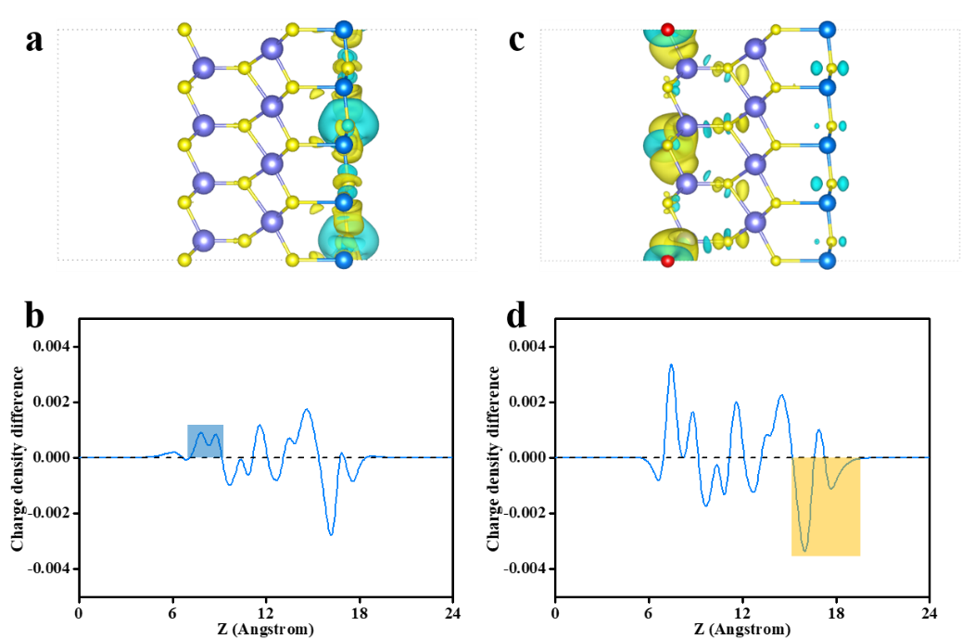
Supplementary Figure 1 | Charge density difference and planar-averaged electron density difference ∆ρ(z) of a, b) ZIS with an S vacancy in the top layer, and c, d) ZIS with P doping in the bottom layer. The blue isosurface represents electron loss, while the yellow isosurface represents electron gain. The isosurface value is 0.0015 e/Bohr³.
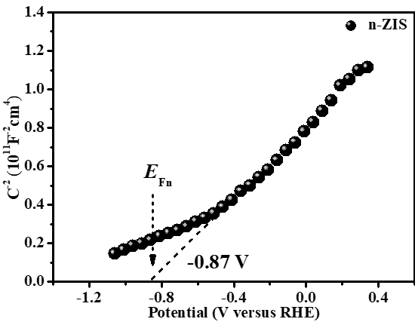

Supplementary Figure 2 | Mott-Schottky plot for n-ZIS. Notably, only the positive slope of the Mott-Schottky plot was found, demonstrating its n-type characteristic, which was due to some S vacancies in n-ZIS^{10,11}.
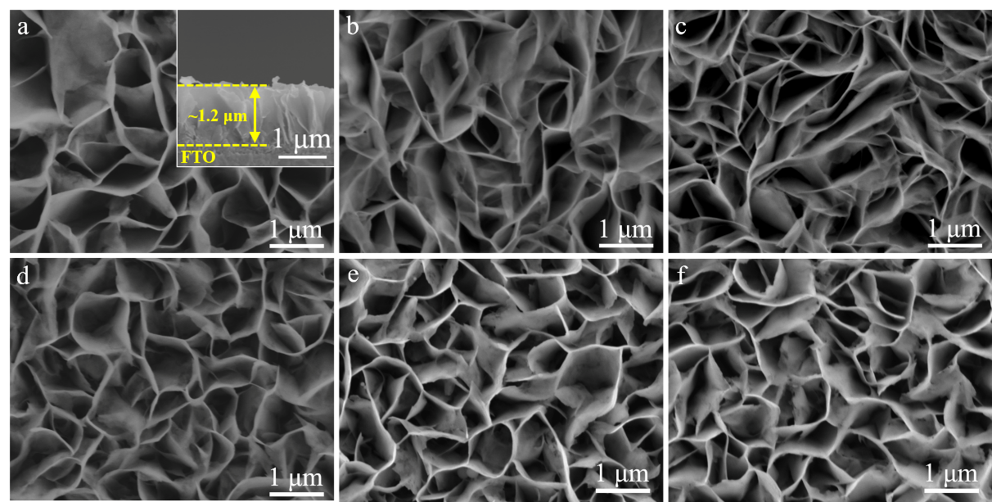
Supplementary Figure 3 | SEM images of a) n-ZIS, with cross-section shown in inset, and b-f) n-ZIS-P nanosheet arrays on FTO substrate, heat-treated at 400 ℃ for 1 min with different flow rate ratios of PH₃/(PH₃+Ar): b) 1%, c) 3%, d) 5%, e) 7%, f) 9%.
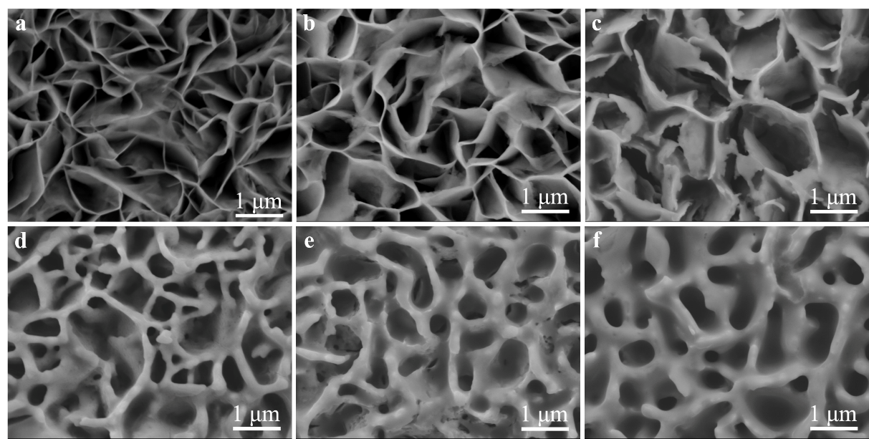

Supplementary Figure 4 | SEM images of the samples prepared at a temperature of 400 ℃ with different reaction times: a) 1 min, b) 10 min, c) 30 min, d) 60 min, e) 120 min, f) 240 min.

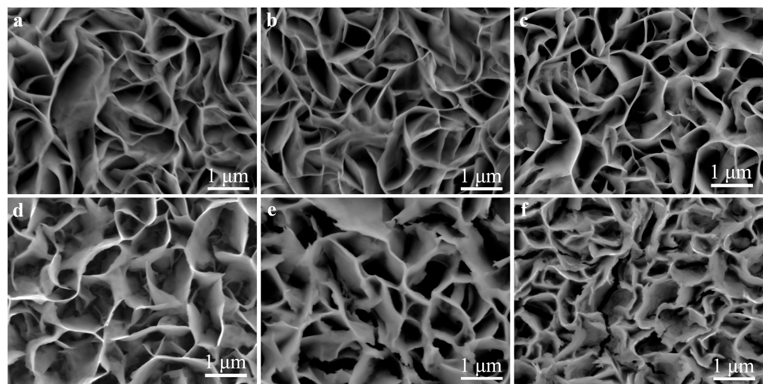
Supplementary Figure 5 | SEM images of the resulting samples prepared with different reaction temperatures: a) 350 ℃, b) 400 ℃, c) 450 ℃, d) 500 ℃, e) 550 ℃, f) 600 ℃.
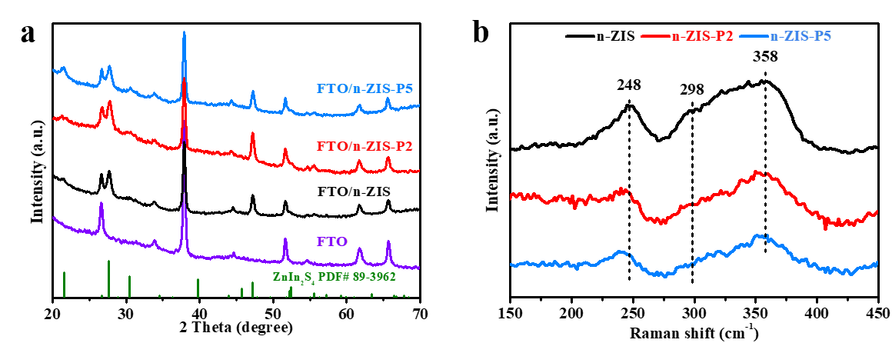

Supplementary Figure 6 | a) XRD patterns and b) Raman spectra of n-ZIS, n-ZIS-P2, and n-ZIS-P5. The Raman spectra of all the samples are characterized by three Raman bands around 248, 298, and 358 cm⁻¹, which could be assigned to the longitudinal optical mode (LO1), transverse optical mode (TO2), and longitudinal optical mode (LO2) of crystalline ZIS respectively. These results are in good agreement with the previous report on ZIS^{12,13}.
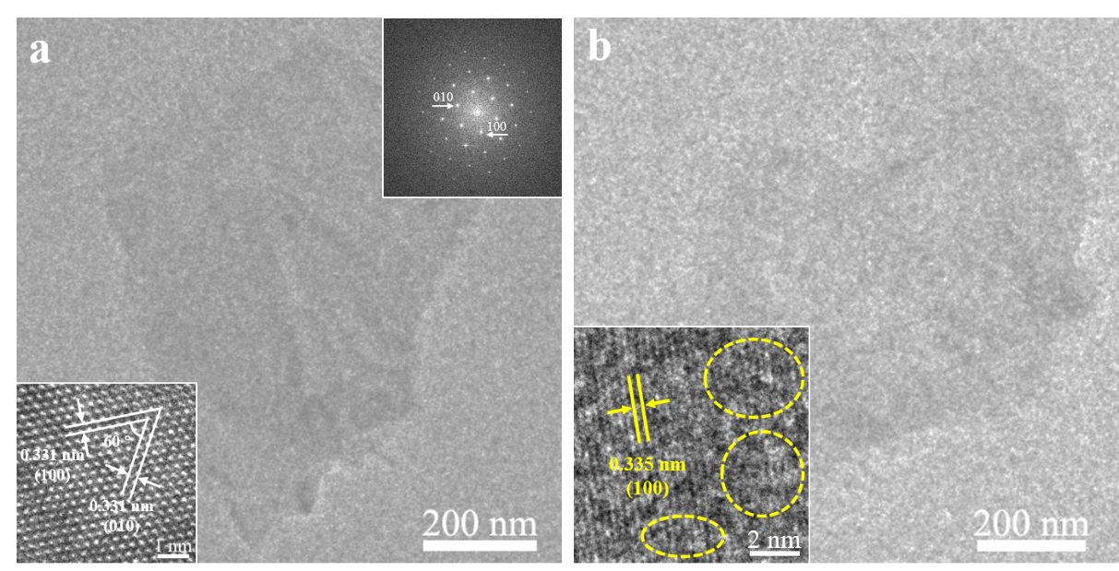
Supplementary Figure 7 | TEM images and HRTEM images (lower left insets) of a) the n-ZIS nanosheets, with FFT pattern in upper right inset, and b) the n-ZIS-P5 nanosheets. The HRTEM image of n-ZIS presents relatively intact crystal fringes with interlayer distance (d) of around 0.331 nm, matching the d₁₀₀ (~0.333 nm) of the ZIS structure, suggesting that the n-ZIS nanosheets with some S vacancies could retain their pristine crystal structure. It is obvious that the HRTEM image of the n-ZIS-P5 nanosheets shows discontinuous crystal fringes (indicated by the dashed circles) with interlayer distance of about 0.335 nm, corresponding to the (100) planes of the ZIS structure, indicating the presence of some amount of structural distortion in the n-ZIS-P5 nanosheets¹⁴.
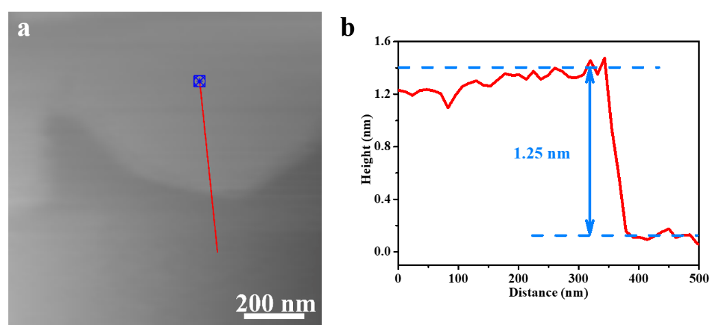

Supplementary Figure 8 | AFM image of the ultrathin n-ZIS-P2 nanosheets and corresponding height profile.

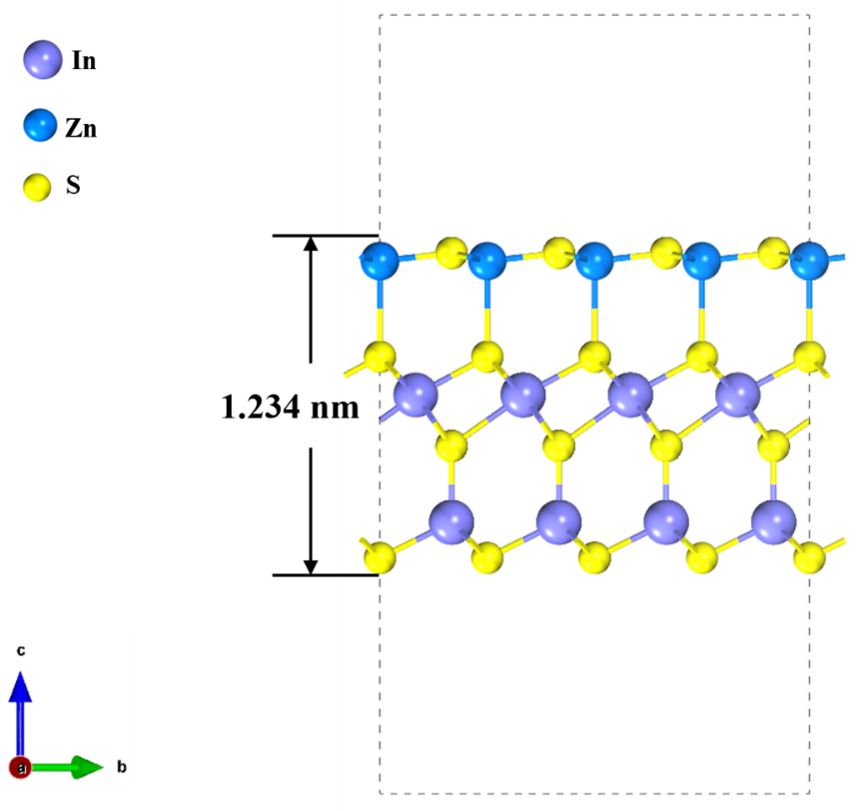
Supplementary Figure 9 | The structural model of perfect ZIS nanosheets (Zn blue, In purple, S yellow).

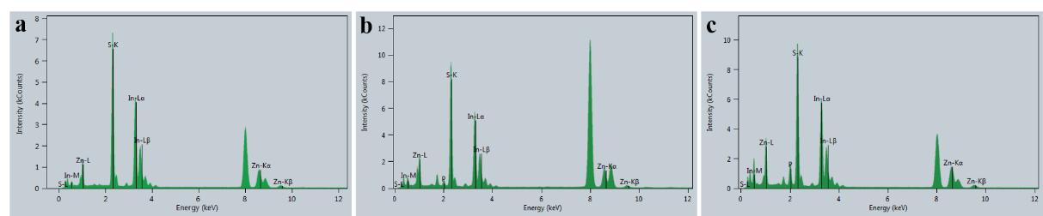
Supplementary Figure 10 | EDX spectrum of a) n-ZIS, b) n-ZIS-P2, and c) n-ZIS-P5.

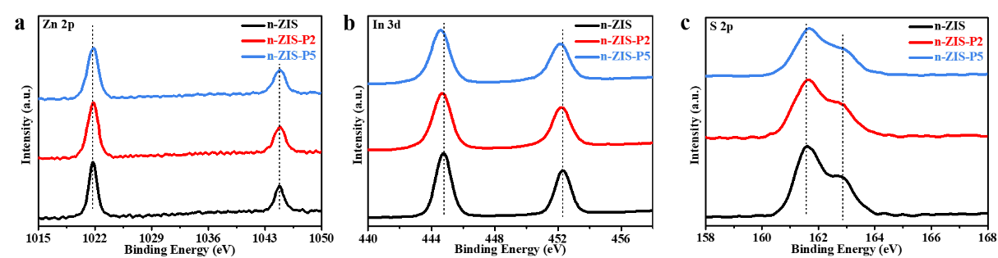
Supplementary Figure 11 | High-resolution XPS spectra of a) Zn 2p, b) In 3d, and c) S 2p for n-ZIS, n-ZIS-P2, and n-ZIS-P5.

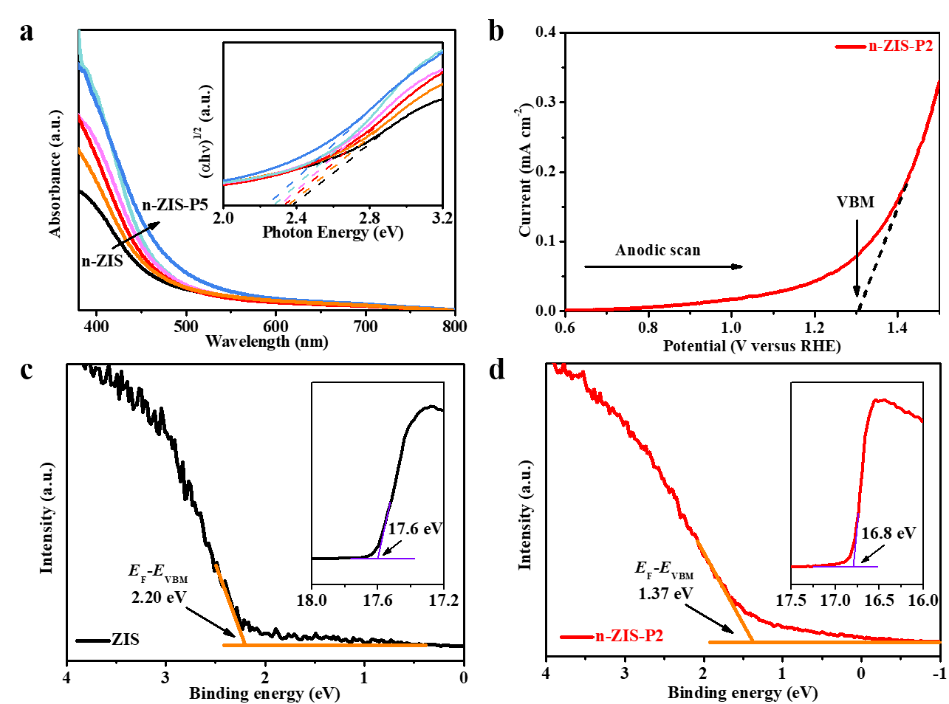
Supplementary Figure 12 | a) Ultraviolet-visible DRS of n-ZIS and n-ZIS-P. The inset presents the corresponding Tauc plots of (αhv)^{1/2} versus photon energy. b) Anodic scan for determining the valence band maximum (VBM) of n-ZIS-P2 at 5 mV s⁻¹. UPS spectra of c) n-ZIS and d) n-ZIS-P2, with enlargements in the insets).

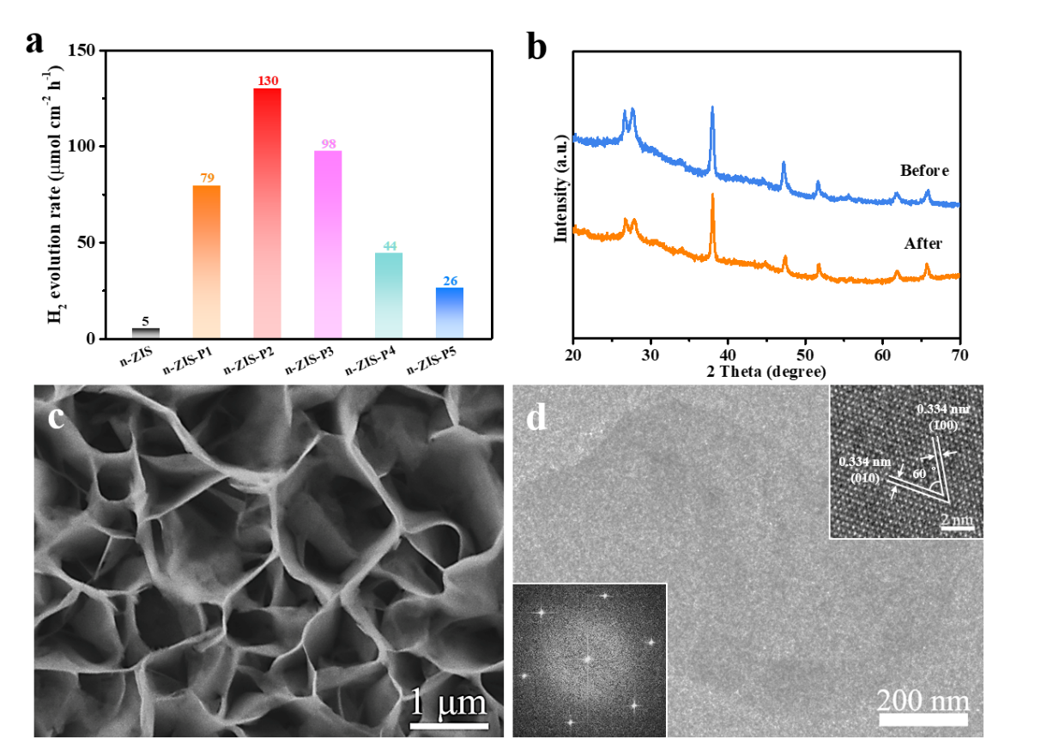
Supplementary Figure 13 | a) H₂ evolution rate in an eight-hour-reaction, b) XRD patterns, c) SEM image d) TEM and HRTEM (upper right inset) images of the n-ZIS-P2 nanosheets after the tests of photoelectrocatalytic H₂ evolution, with the corresponding FFT pattern in the lower left inset).
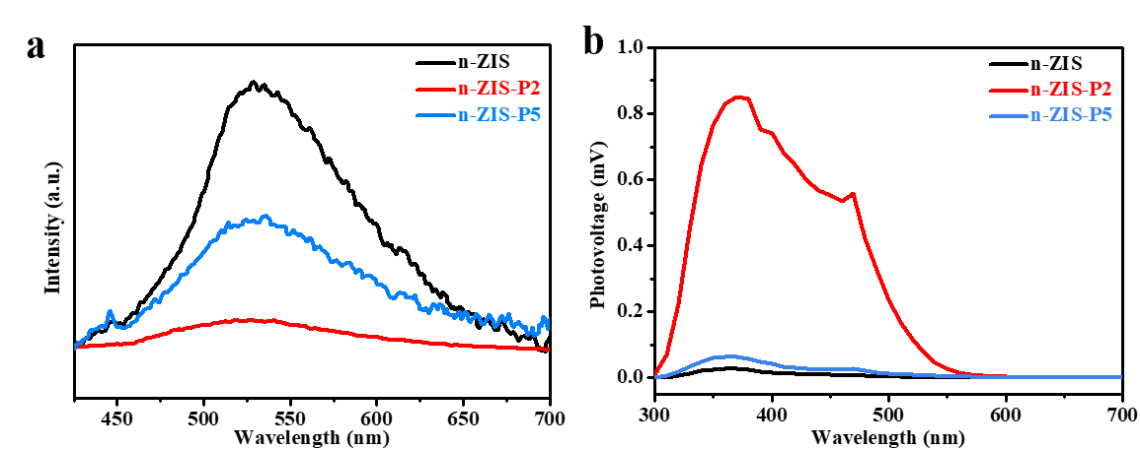

Supplementary Figure 14 | a) Steady-state PL spectra, and b) SPV spectra of n-ZIS, n-ZIS-P2, and n-ZIS-P5

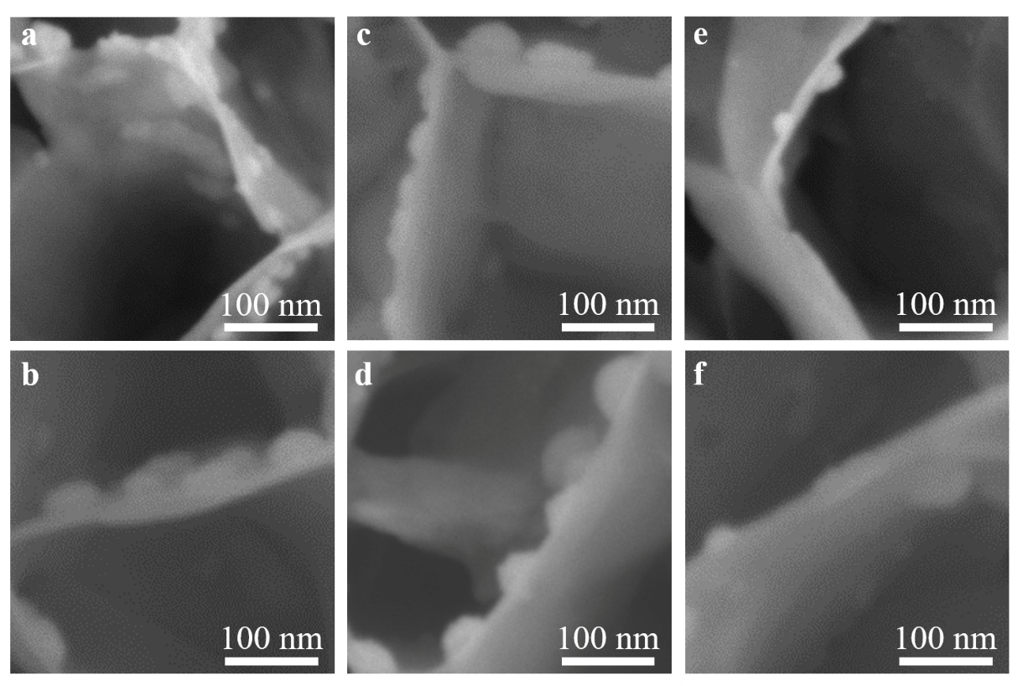
Supplementary Figure 15 | SEM images of the sample arrays with photoreduction deposition of noble metals and the photooxidation deposition of metal oxides: a) Pt/n-ZIS-P2, b) Ag/n-ZIS-P2, c) CoO_{x}/n-ZIS-P2, d) MnO_{x}/n-ZIS-P2, e) Pt/n-ZIS, f) Ag/n-ZIS.
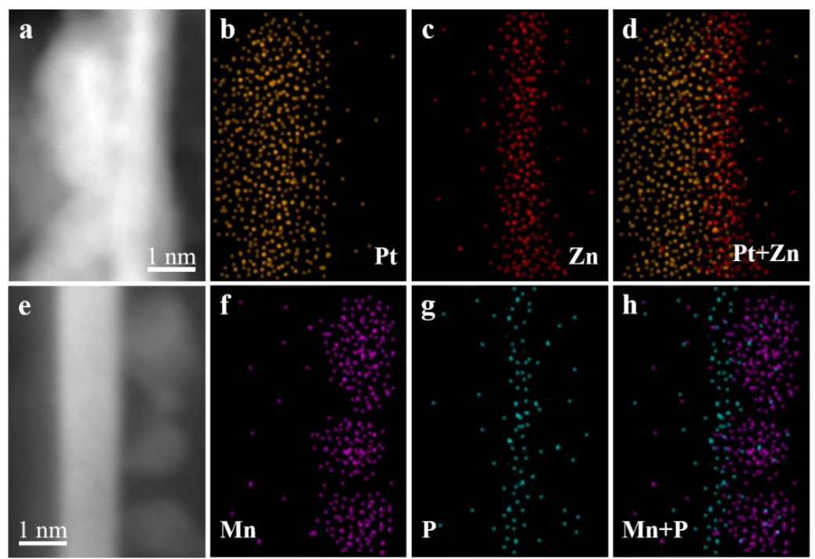

Supplementary Figure 16 | High-angle annular dark field ‒ scanning TEM (HAADF-STEM) images and the corresponding elemental mapping images of n-ZIS-P2 photodeposited with a-d) Pt and e-h) MnO_{x}.
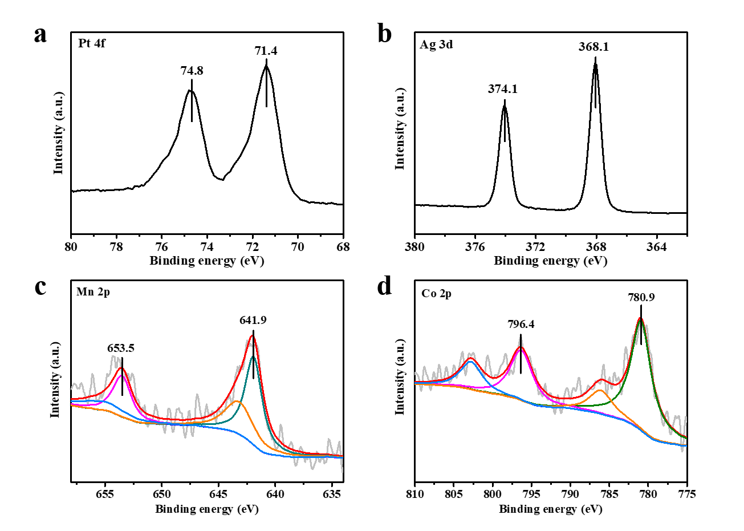
Supplementary Figure 17 | XPS peaks of nanoparticles of a) Pt, b) Ag, c) Mn, and d) Co species photodeposited on the samples. The peaks of Pt 4f_{7/2} and Pt 4f_{5/2} located at 71.4 eV and 74.8 eV indicate that the Pt is in its metallic form. Similarly, the formation of metallic Ag after photodeposition can be confirmed, based on its binding energies. The binding energies of Mn 2p were 641.9 eV and 653.5 eV, which infers the presence of Mn³⁺ and Mn⁴⁺ species, that is, MnO_{x} (1.5 < x < 2) has been formed. The Co 2p_{3/2} and Co 2p_{1/2} peaks located at 780.9 eV and 796.5 eV, indicating that the species is Co₃O₄. Compared to their corresponding metal precursors, these results confirm that Pt and Ag were deposited via the photoreduction reaction, while MnO_{x} and CoO_{x} were deposited through the photooxidation reaction¹⁵⁻¹⁷.

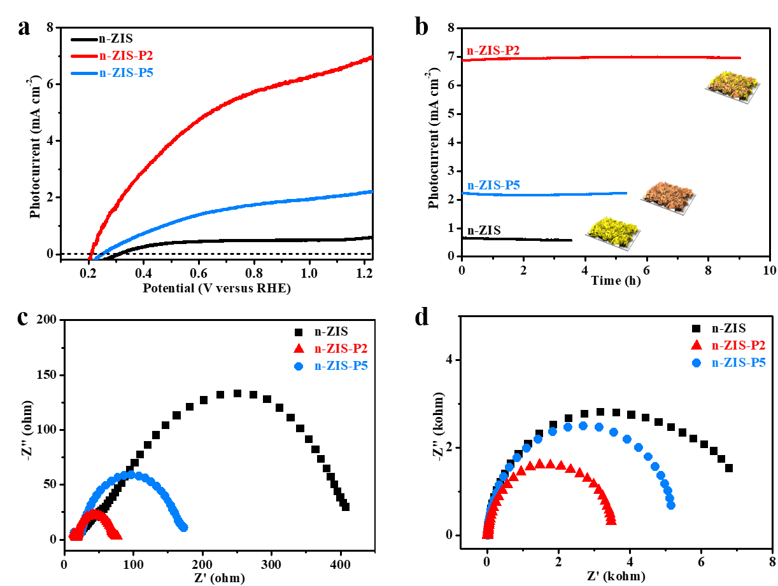
Supplementary Figure 18 | a) J-V curves under light irradiation. b) Long-term photocurrent-time curves for n-ZIS, n-ZIS-P2, and n-ZIS-P5 at 1.23 V versus RHE. EIS Nyquist plots of photoanodes c) under illumination, d) in the dark.

Supplementary Table 1 | ICP elemental analysis of various samples.

 | Zn (mg L⁻¹) | In (mg L⁻¹) | S (mg L⁻¹) | P (mg L⁻¹)
n-ZIS | 5.23 | 18.45 | 9.79
n-ZIS-P1 | 5.23 | 18.44 | 9.57 | 0.20
n-ZIS-P2 | 5.22 | 18.44 | 9.40 | 0.37
n-ZIS-P3 | 5.21 | 18.45 | 9.20 | 0.54
n-ZIS-P4 | 5.22 | 18.43 | 9.04 | 0.67
n-ZIS-P5 | 5.23 | 18.44 | 8.93 | 0.79

Supplementary Table 2 | Comparison of PEC water splitting performance of the reported ZIS-based, ultrathin sheets-based and other photoanodes.

Photoanode^{[a]} | Electrolyte | Photocurrent  [mA cm⁻²] | Potential [V]^{[b]} | IPCE | STH efficiency | H₂ [µmol cm⁻² h⁻¹] | Ref.
One-unit-cell p-n ZnIn₂S₄ (n-ZIS-P2) | 0.5 M Na₂SO₃ | 6.98 | 1.23 | 78% at 365 nm | 3% | 130 | This work
CoPi/ZnIn₂S₄/Pt | 0.25 M Na₂SO₃ /0.35 M Na₂S | 0.91 | 1.23 | 11% at 370 nm | - - | - - | ¹⁸
CVD ZnIn₂S₄ | 0.1 M K₃PO₄ | ~ 0.31 | 2.1 (vs. SHE) | - - | - - | - - | ¹⁹
Hexagonal phase ZnIn₂S₄ | 0.25 M Na₂S | 0.27 | 0.5 (vs. Ag/AgCl) | - - | - - | - - | ²⁰
Cu-doped ZnIn₂S₄ | 0.5 M K₂SO₄ | 1.15 | 1.0 (vs. Ag/AgCl) | - - | - - | - - | ²¹
Ni-doped ZnIn₂S₄ | 0.2 M Na₂SO₄ | ~ 0.24 | 0.9 (vs. Ag/AgCl) | - - | - - | - - | ²²
Tremella-like ZnIn₂S₄/graphene | 0.1 M Na₂SO₄ | ~ 0.0045 | 0 (vs. Ag/AgCl) | - - | - - | - - | ²³
Zn₁₀In₁₆S₃₄ | 0.5 M Na₂SO₃ | 4.63 | 1.23 | - - | - - | - - | ²⁴
Co-doped In₂S₃ | 1 M KOH | 1.17 | 1.5 | 46% at 450 nm | - - | - - | ²⁵
Four-layered WO₃ | 0.5 M Na₂SO₄ | 2.81 | 1.23 | - - | - - | - - | ²⁶
Pore-rich ultrathin WO₃ | 0.5 M Na₂SO₄ | 2.14 | 1.0 (vs. Ag/AgCl) | - - | - - | - - | ²⁷
Few-layered InSe | 0.2 M KOH | ~ 0.0004 | 0.5 (vs. Ag/AgCl) | - - | - - | - - | ²⁸
Au/CdSe | 0.5 M Na₂S /0.5 M K₂SO₃ | 1.3 | 0.4 | 35% at 1150 nm | 2.38% | 45.3 | ²⁹
FeCoO_{x}/  BiVO₄ | 1 M potassium borate | 4.82 | 1.23 | 86% at 420 nm | - - | 86.5 | ³⁰
Co-Pi/Ag/Fe₂O₃ | 1 M NaOH | 4.68 | 1.23 | 80% at 320 nm | 0.55% | 100 | ³¹
CoPi/GaN/  Ta₃N₅ | 0.5 M KPi | 8 | 1.2 | - - | 1.5% | 106.6 | ³²
Fe foam | 1 M NaOH | 2.29 | 1.23 | 42% at 400 nm | - - | 31.3 | ³³
NiFeO_{x}/Ta₃N₅/GaN/Al₂O₃ | 0.2 M potassium phosphate | 6.3 | 1.23 | 66% at 400 nm | 1.15% | 39 | ³⁴
CoOx/C₃N₄/Ba-TaON | 1 M NaOH | 4.57 | 1.23 | 62% at 400 nm | - - | 52 | ³⁵
FeOOH/  NiOOH/ Mo:BiVO₄/LBR | Na₂SO₃/  Na₂SO₄ | 5.25 | 1.23 | - - | - - | 90 | ³⁶
CdS inverse opal | 0.25 MNa₂S/0.35 M Na₂SO₃ | 5.68 | 0 | 75% at 470 nm | - - | 98 | ³⁷
Ta/Ta₃N₅/  FeNiO_{x} | 0.5 M K₂HPO₄/KOH | 9.95 | 1.05 | 87% at 380 nm | 2.72% | 164.9 | ³⁸
Ta₃N₅:Mg+Zr | 0.1 M Na₂SO₄/  NaOH | 2.3 | 1.23 | 35% at 400 nm | 0.59% | - - | ³⁹
[a] deposited on a conductive substrate photoanode. [b] vs. RHE unless stated otherwise.

References
1. Kresse, G. & Furthmuller, J. Efficient iterative schemes for ab initio total-energy calculations using a plane-wave basis set. Phys. Rev. B 54, 11169-11186 (1996).
2. Kresse, G. & Furthmuller, J. Efficiency of ab-initio total energy calculations for metals and semiconductors using a plane-wave basis set. Comput. Mater. Sci. 6, 15-50 (1996).
3. Blochl, P. E. Projector augmented-wave method. Phys. Rev. B 50, 17953-17979 (1994).
4. Perdew, J. P., Burke, K. & Ernzerhof, M. Generalized Gradient Approximation Made Simple. Phys. Rev. Lett. 77, 3865-3868 (1996).
5. Liechtenstein, A. I., Anisimov, V. I. & Zaanen, J. Density-functional theory and strong-interactions -orbital ordering in mott-hubbard insulators. Phys. Rev. B 52 (1995).
6. Dudarev, S. L., Botton, G. A., Savrasov, S. Y., Humphreys, C. J. & Sutton, A. P. Electron-energy-loss spectra and the structural stability of nickel oxide : An LSDA+U study. Phys. Rev. B 57, 1505-1509 (1998).
7. Yu, K. & Carter, E. A. Communication: comparing ab initio methods of obtaining effective U parameters for closed-shell materials. J. Chem. Phys. 140, 121105 (2014).
8. Yu, K. & Carter, E. A. A Strategy to Stabilize Kesterite CZTS for High-Performance Solar Cells. Chem. Mater. 27, 2920-2927 (2015).
9. Radautsa.Si, Donika, F. G., Kyosse, G. A. & Mustya, I. G. Polytypism of Ternary Phases in the System ZnInS. Phys. Status Solidi 37, K123-& (1970).
10. Liu, G. et al. In Situ Bond Modulation of Graphitic Carbon Nitride to Construct p–n Homojunctions for Enhanced Photocatalytic Hydrogen Production. Adv. Funct. Mater. 26, 6822-6829 (2016).
11. Gong, Y. et al. Spatially controlled doping of two-dimensional SnS₂ through intercalation for electronics. Nat. Nanotechnol. 13, 294-299 (2018).
12. Xu, B. et al. A 1D/2D Helical CdS/ZnIn₂S₄ Nano‐Heterostructure. Angew. Chem., Int. Ed. 53, 2339-2343 (2014).
13. Wang, P. et al. Atomic Insights for Optimum and Excess Doping in Photocatalysis: A Case Study of Few‐Layer Cu‐ZnIn₂S₄. Adv. Funct. Mater. 29, 1807013 (2019).
14. Yang, W. et al. Enhanced Photoexcited Carrier Separation in Oxygen‐Doped ZnIn₂S₄ Nanosheets for Hydrogen Evolution. Angew. Chem., Int. Ed. 55, 6716-6720 (2016).
15. Li, R. et al. Spatial separation of photogenerated electrons and holes among {010} and {110} crystal facets of BiVO₄. Nat. Commun. 4, 1432 (2013).
16. Meng, C. et al. Atomically and Electronically Coupled Pt and CoO Hybrid Nanocatalysts for Enhanced Electrocatalytic Performance. Adv. Mater. 29, 1604607 (2017).
17. Li, Z. et al. Surface‐Polarity‐Induced Spatial Charge Separation Boosts Photocatalytic Overall Water Splitting on GaN Nanorod Arrays. Angew. Chem., Int. Ed. 59, 935-942 (2020).
18. Zhou, M. et al. Hybrid 0D/2D edamame shaped ZnIn₂S₄ photoanode modified by Co-Pi and Pt for charge management towards efficient photoelectrochemical water splitting. Appl. Catal., B 244, 188-196 (2019).
19. Yang, W. et al. Layered crystalline ZnIn₂S₄ nanosheets: CVD synthesis and photo-electrochemical properties. Nanoscale 8, 18197-18203 (2016).
20. Xie, Y. et al. Facile solution-based fabrication of ZnIn₂S₄ nanocrystalline thin films and their photoelectrochemical properties. J. Power Sources 265, 62-66 (2014).
21. Cheng, K. et al. Photoelectrochemical performance of Cu-doped ZnIn₂S₄ electrodes created using chemical bath deposition. Sol. Energy Mater. Sol. Cells 95, 1940-1948 (2011).
22. Fan, B., Chen, Z., Liu, Q., Zhang, Z. & Fang, X. One-pot hydrothermal synthesis of Ni-doped ZnIn₂S₄ nanostructured film photoelectrodes with enhanced photoelectrochemical performance. Appl. Surf. Sci. 370, 252-259 (2016).
23. Ye, H., Wang, H., Zhang, B., Zhao, F. & Zeng, B. Tremella-like ZnIn₂S₄/graphene composite based photoelectrochemical sensor for sensitive detection of dopamine. Talanta 186, 459-466 (2018).
24. Meng, L. et al. Simultaneous Manipulation of O‐Doping and Metal Vacancy in Atomically Thin Zn₁₀In₁₆S₃₄ Nanosheet Arrays toward Improved Photoelectrochemical Performance. Angew. Chem., Int. Ed. 57, 16882-16887 (2018).
25. Lei, F. et al. Atomic-Layer-Confined Doping for Atomic-Level Insights into Visible-Light Water Splitting. Angew. Chem., Int. Ed. 54, 9266-9270 (2015).
26. Ma, M. et al. Dual Oxygen and Tungsten Vacancies on a WO₃ Photoanode for Enhanced Water Oxidation. Angew. Chem., Int. Ed. 55, 11819-11823 (2016).
27. Liu, Y. et al. Promoting Photogenerated Holes Utilization in Pore-Rich WO₃ Ultrathin Nanosheets for Efficient Oxygen-Evolving Photoanode. Adv. Energy Mater. 6, 1600437 (2016).
28. Li, Z. et al. High‐Performance Photo‐Electrochemical Photodetector Based on Liquid‐Exfoliated Few‐Layered InSe Nanosheets with Enhanced Stability. Adv. Funct. Mater. 28, 1705237 (2018).
29. Wang, H. et al. Efficient Plasmonic Au/CdSe Nanodumbbell for Photoelectrochemical Hydrogen Generation beyond Visible Region. Adv. Energy Mater. 9, 1803889 (2019).
30. Wang, S. et al. New Iron‐Cobalt Oxide Catalysts Promoting BiVO₄ Films for Photoelectrochemical Water Splitting. Adv. Funct. Mater. 28, 1802685 (2018).
31. Peerakiatkhajohn, P. et al. Stable Hematite Nanosheet Photoanodes for Enhanced Photoelectrochemical Water Splitting. Adv. Mater. 28, 6405-6410 (2016).
32. Zhong, M. et al. Highly Active GaN‐Stabilized Ta₃N₅ Thin‐Film Photoanode for Solar Water Oxidation. Angew. Chem., Int. Ed. 56, 4739-4743 (2017).
33. Kang, J. S. et al. Iron Oxide Photoelectrode with Multidimensional Architecture for Highly Efficient Photoelectrochemical Water Splitting. Angew. Chem., Int. Ed. 56, 6583-6588 (2017).
34. Higashi, T. et al. Transparent Ta₃N₅ Photoanodes for Efficient Oxygen Evolution toward the Development of Tandem Cells. Angew. Chem., Int. Ed. 58, 2300-2304 (2018).
35. Hou, J., Cheng, H., Takeda, O. & Zhu, H. Unique 3D heterojunction photoanode design to harness charge transfer for efficient and stable photoelectrochemical water splitting. Energy Environ. Sci. 8, 1348-1357 (2015).
36. Choi, D., Nam, S. K., Kim, K. & Moon, J. H. Enhanced Photoelectrochemical Water Splitting through Bismuth Vanadate with a Photon Upconversion Luminescent Reflector. Angew. Chem., Int. Ed. 58, 6891-6895 (2019).
37. Zheng, X. et al. Strongly Coupled Nafion Molecules and Ordered Porous CdS Networks for Enhanced Visible-Light Photoelectrochemical Hydrogen Evolution. Adv. Mater. 28, 4935-4942 (2016).
38. Pihosh, Y. et al. Ta₃N₅-Nanorods enabling highly efficient water oxidation via advantageous light harvesting and charge collection. Energy Environ. Sci. 13, 1519-1530 (2020).
39. Seo, J. et al. Mg–Zr Cosubstituted Ta₃N₅ Photoanode for Lower-Onset-Potential Solar-Driven Photoelectrochemical Water Splitting. J. Am. Chem. Soc. 137, 12780-12783 (2015).

