Groups | M0 | M100 | M300 | M500 | M700
Day 1 | 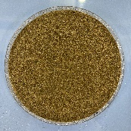 | 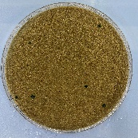 | 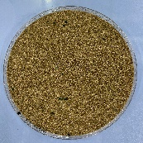 | 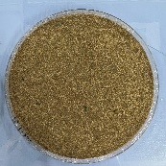 | 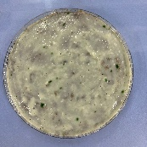
Day 5 | 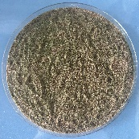 | 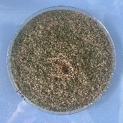 | 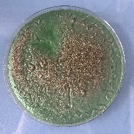 | 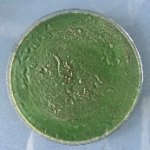 | 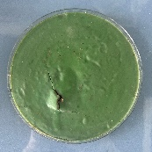
Day 9 | 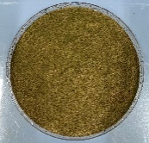 | 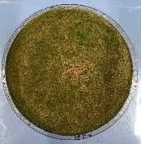 | 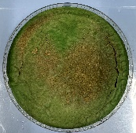 | 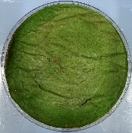 | 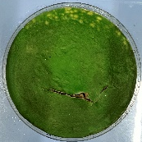
Day 14 | 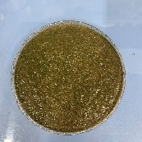 | 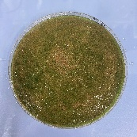 | 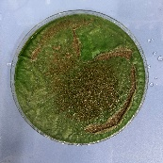 | 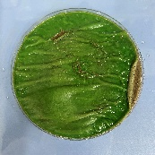 | 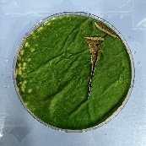
Day 19 | 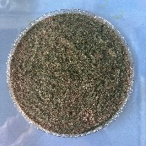 | 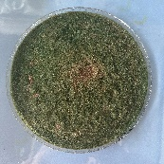 | 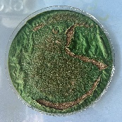 | 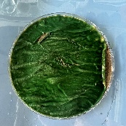 | 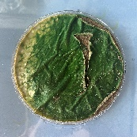
Day 36 | 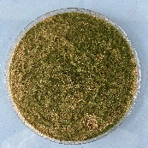 | 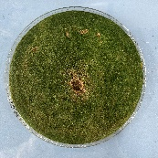 | 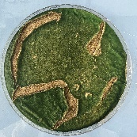 | 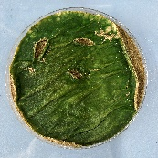 | 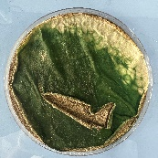
Day 44 | 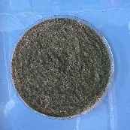 | 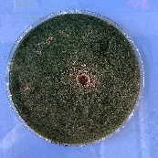 | 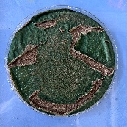 | 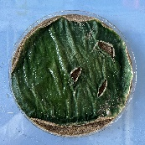 | 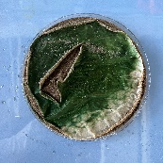
Day 62 | 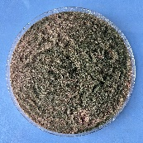 | 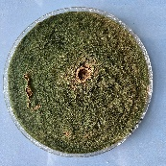 | 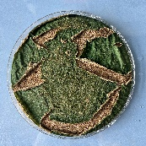 | 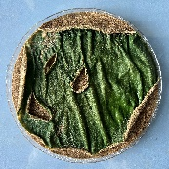 | 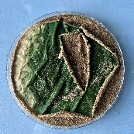
Fig. S1 Photos of ACBs samples in 5 treatments imaged with 5 times

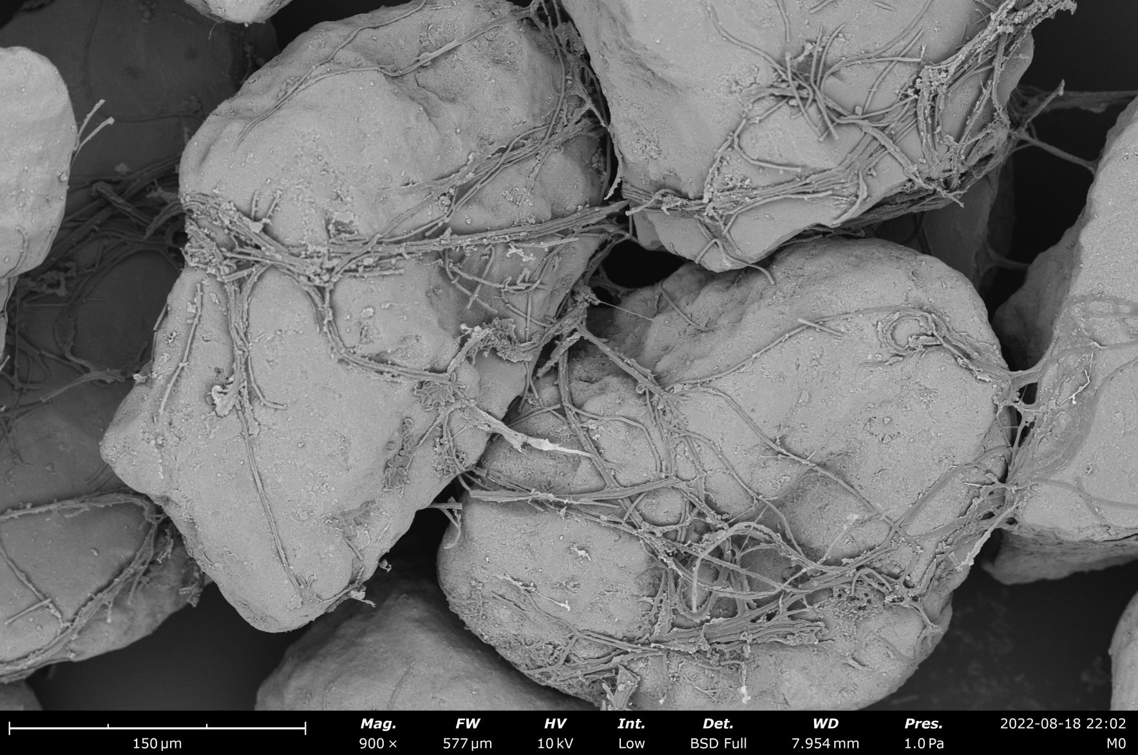
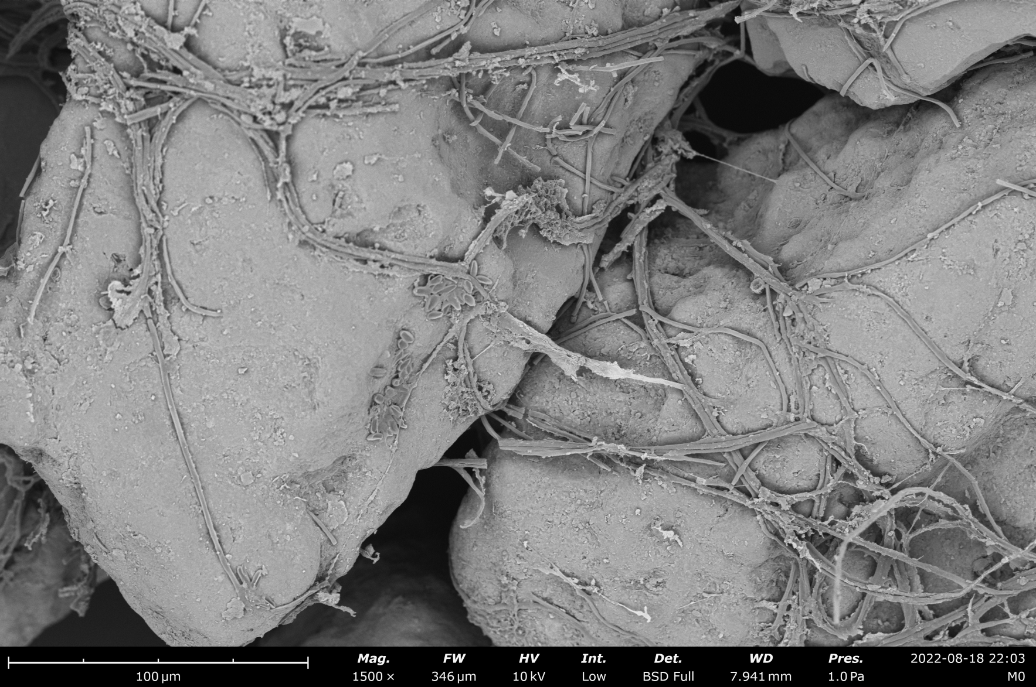
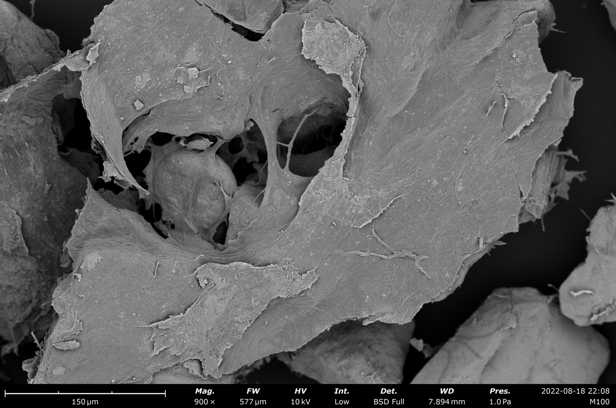
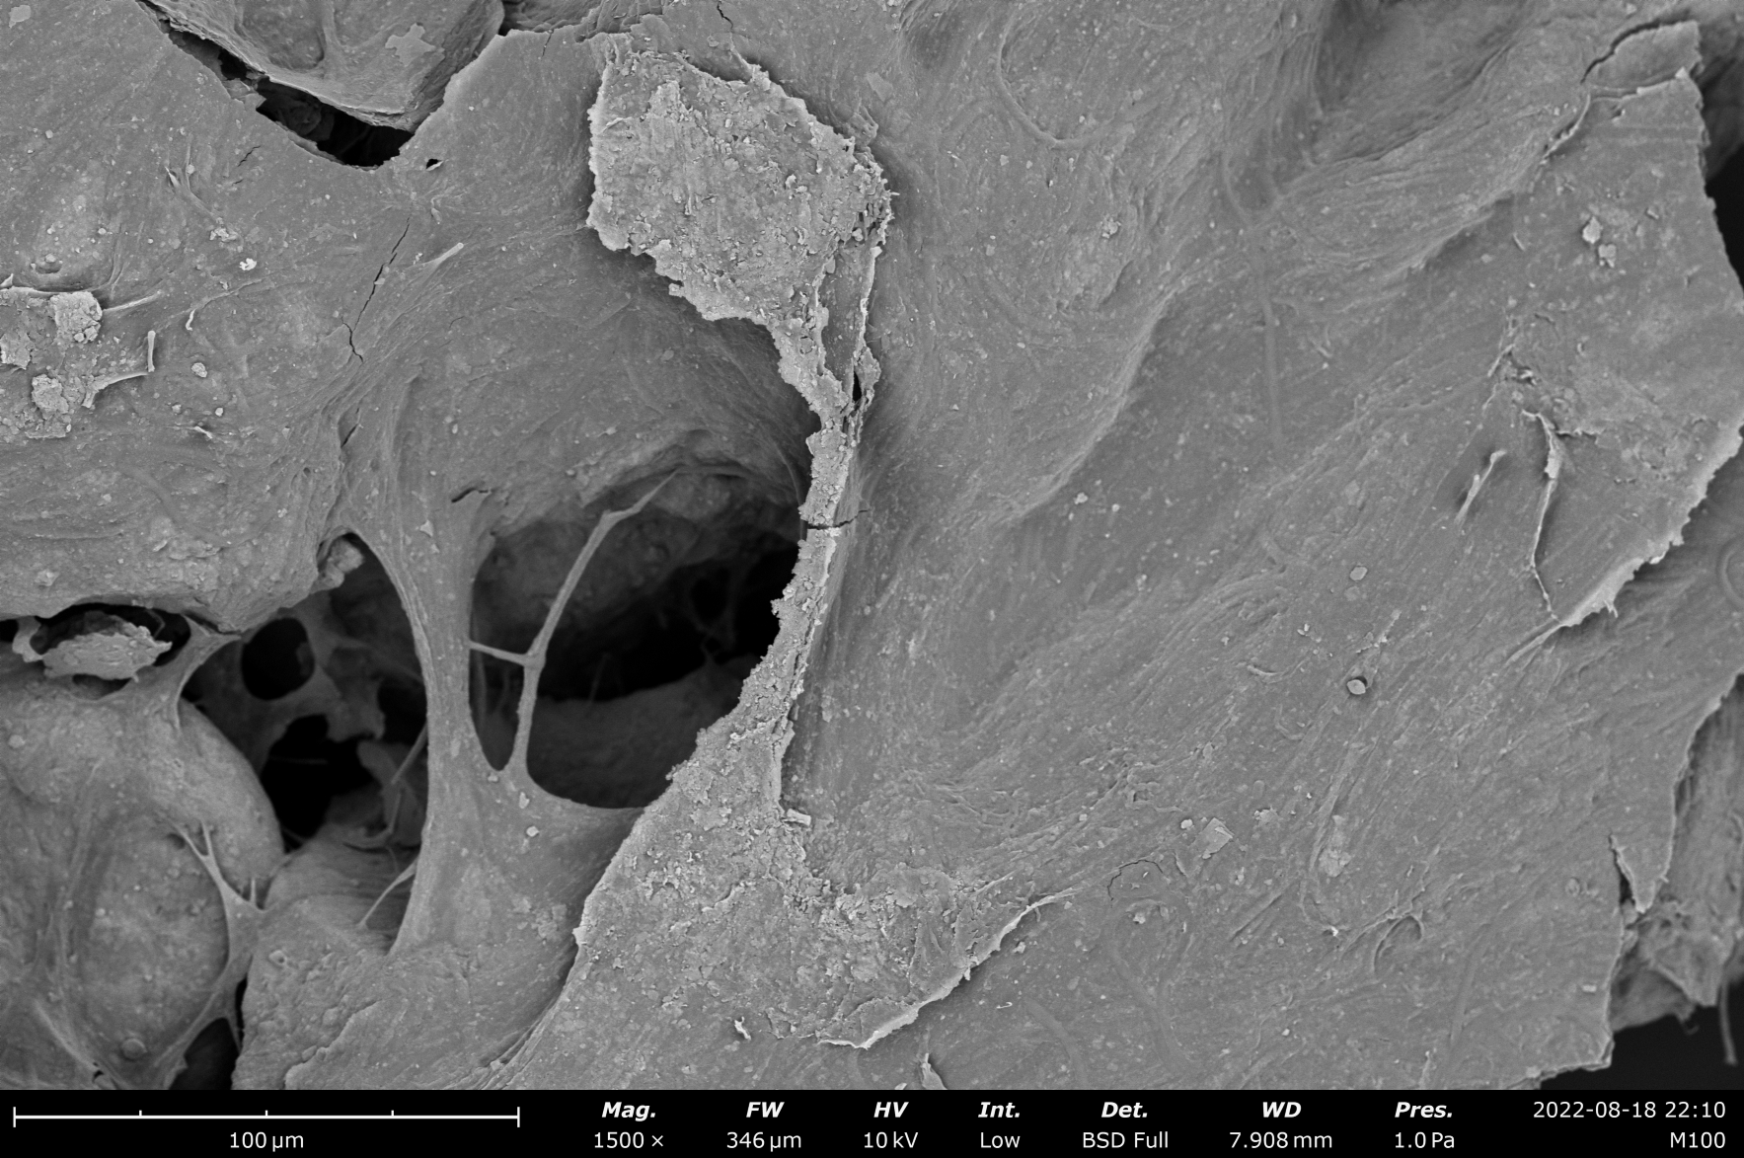
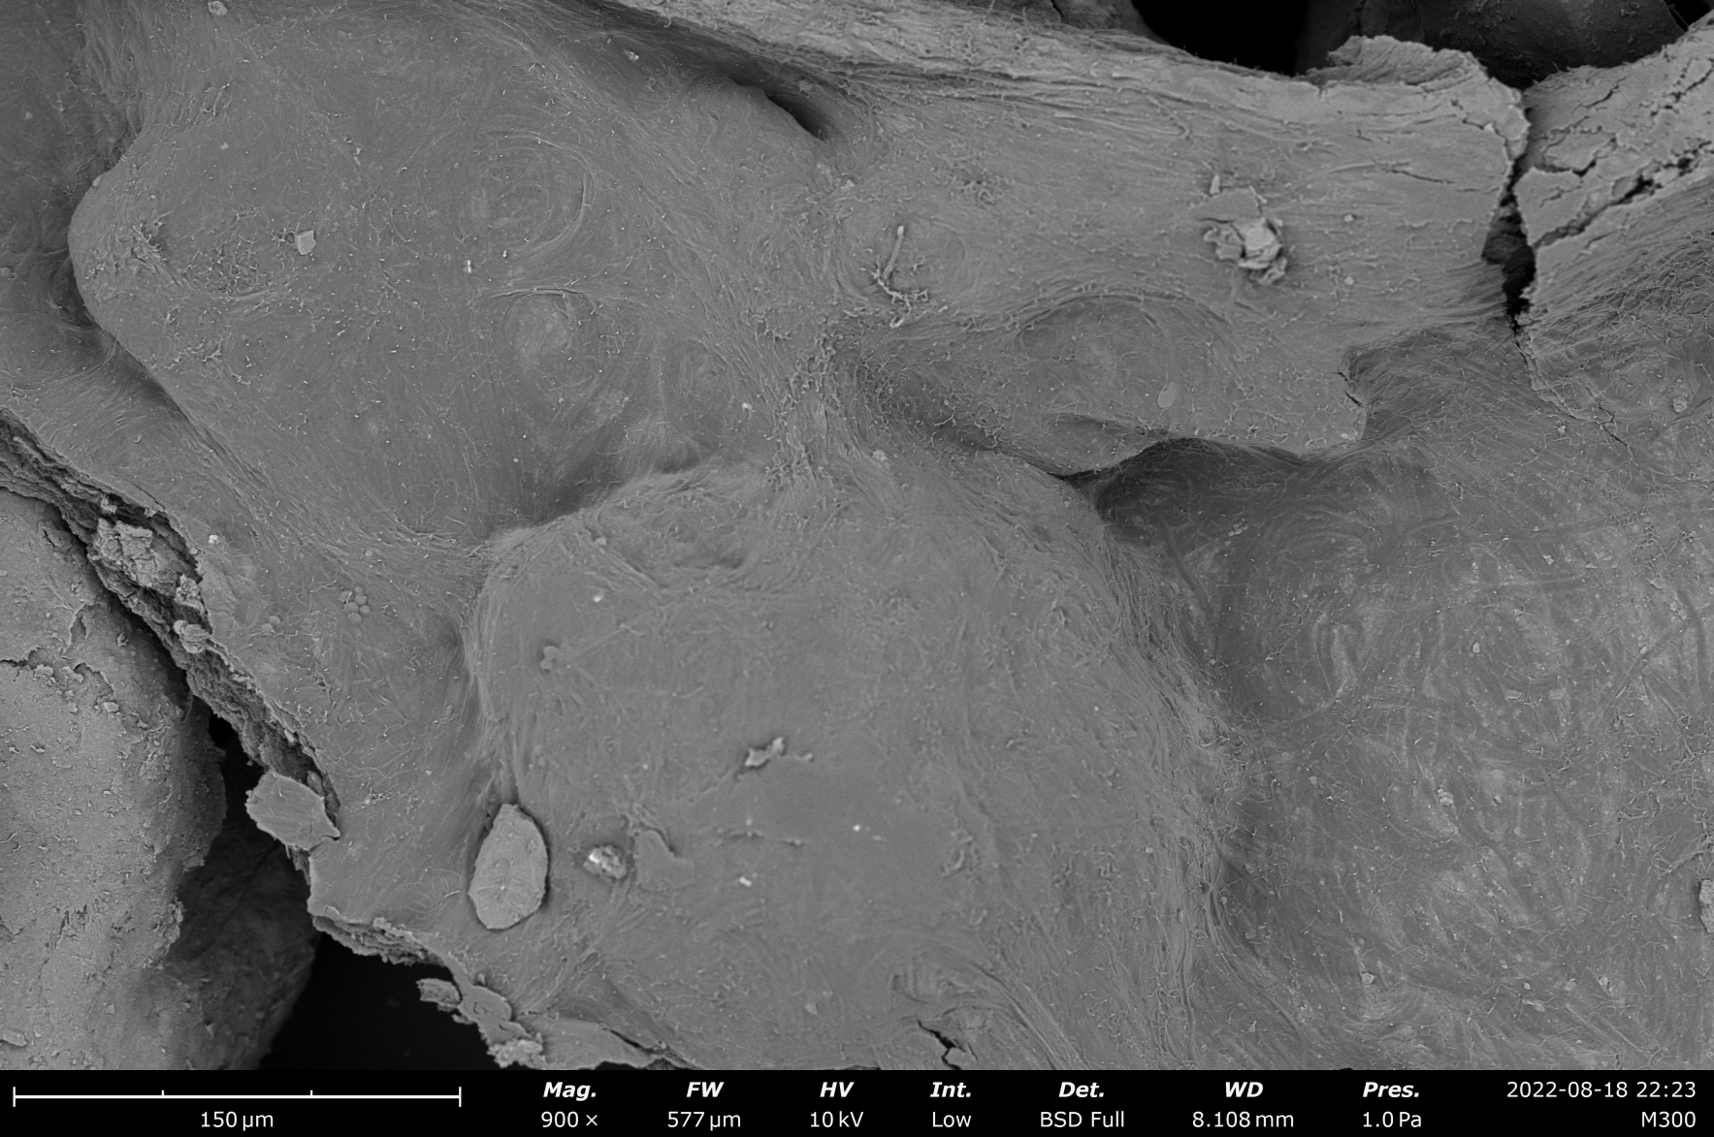
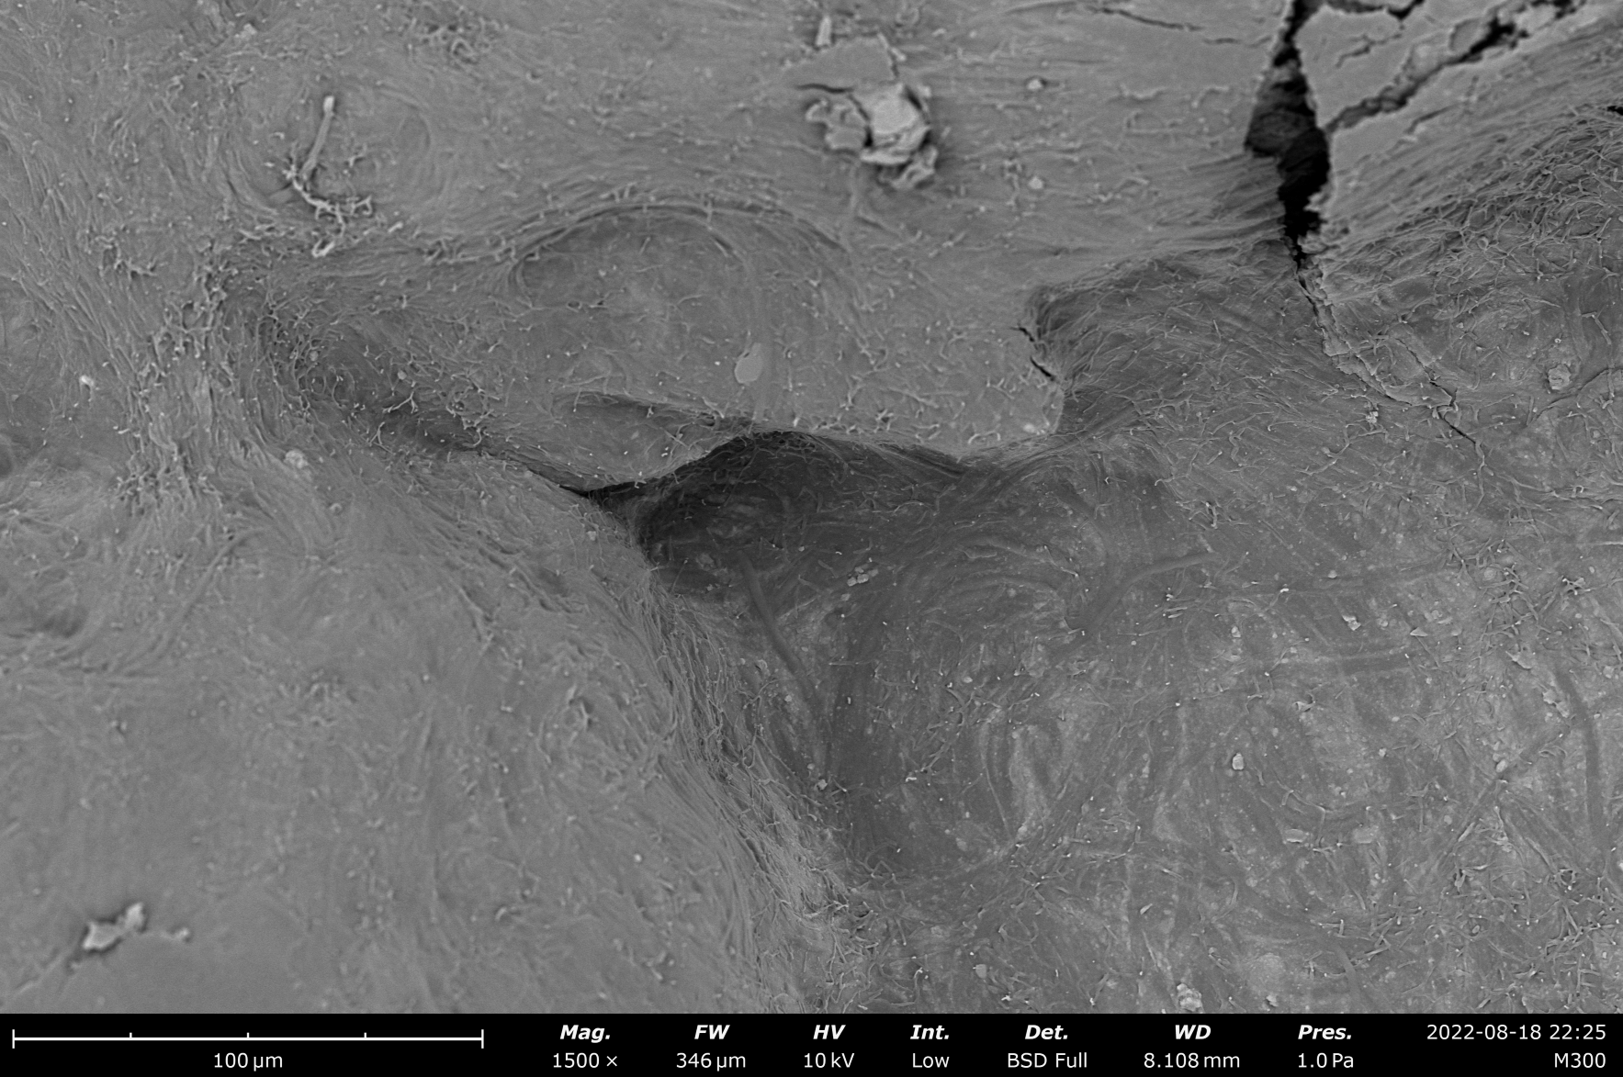
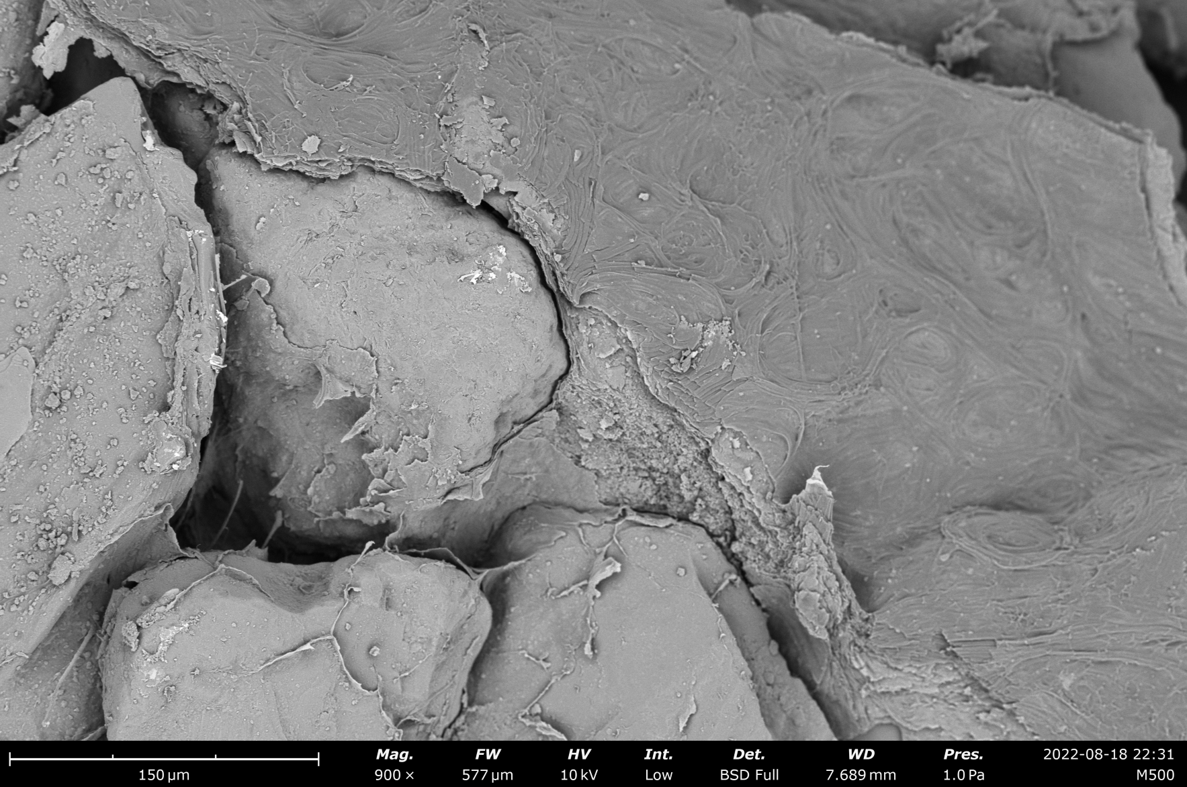
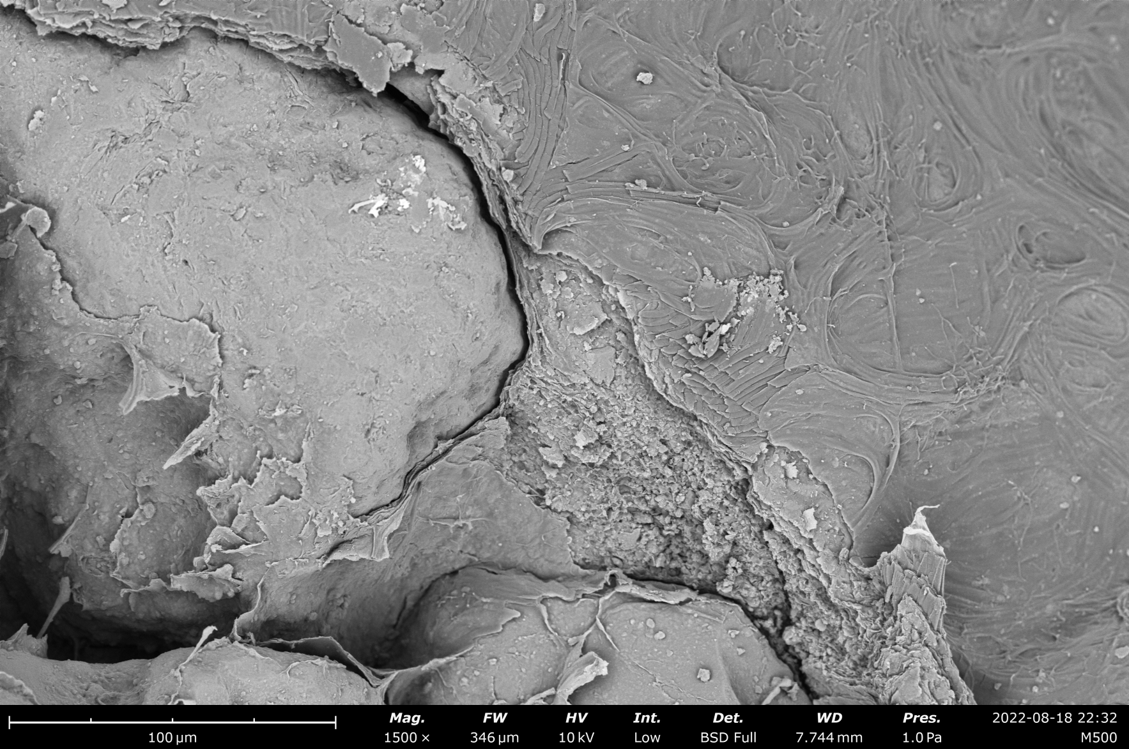
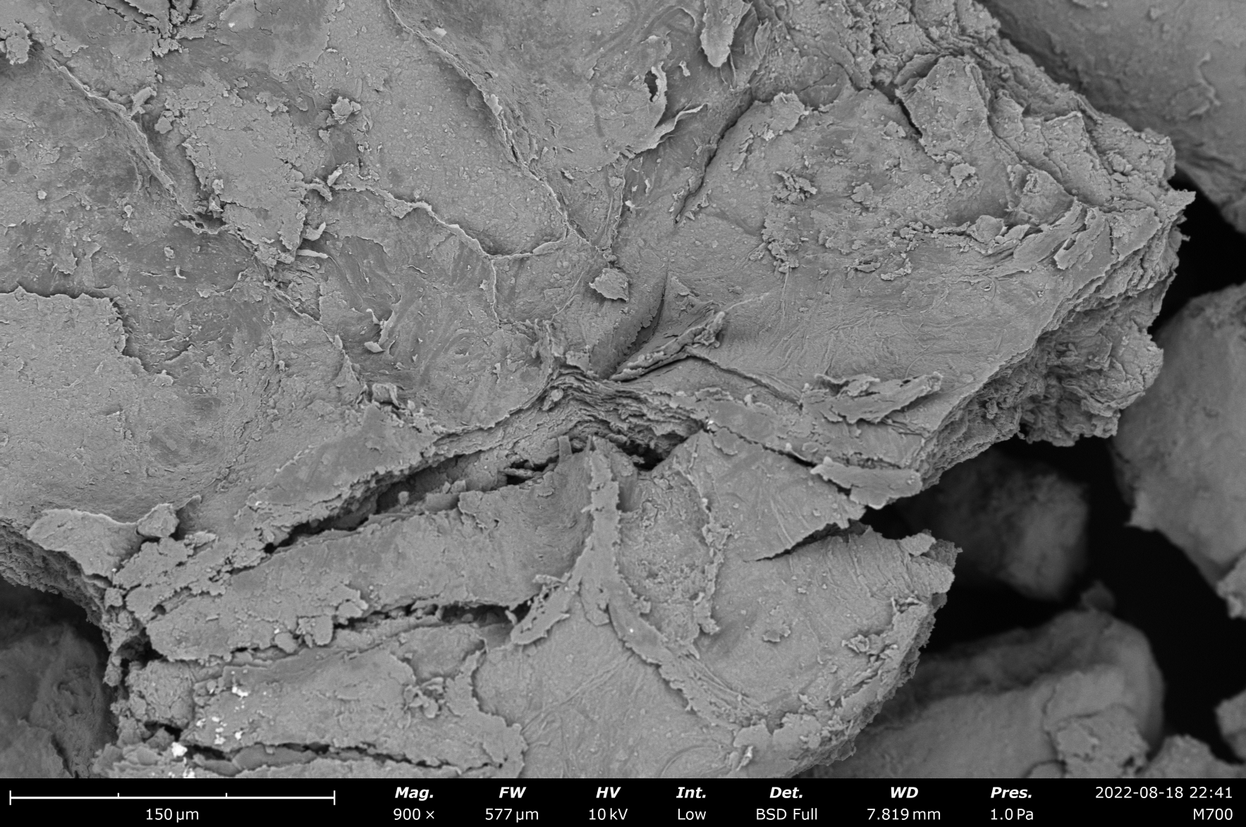
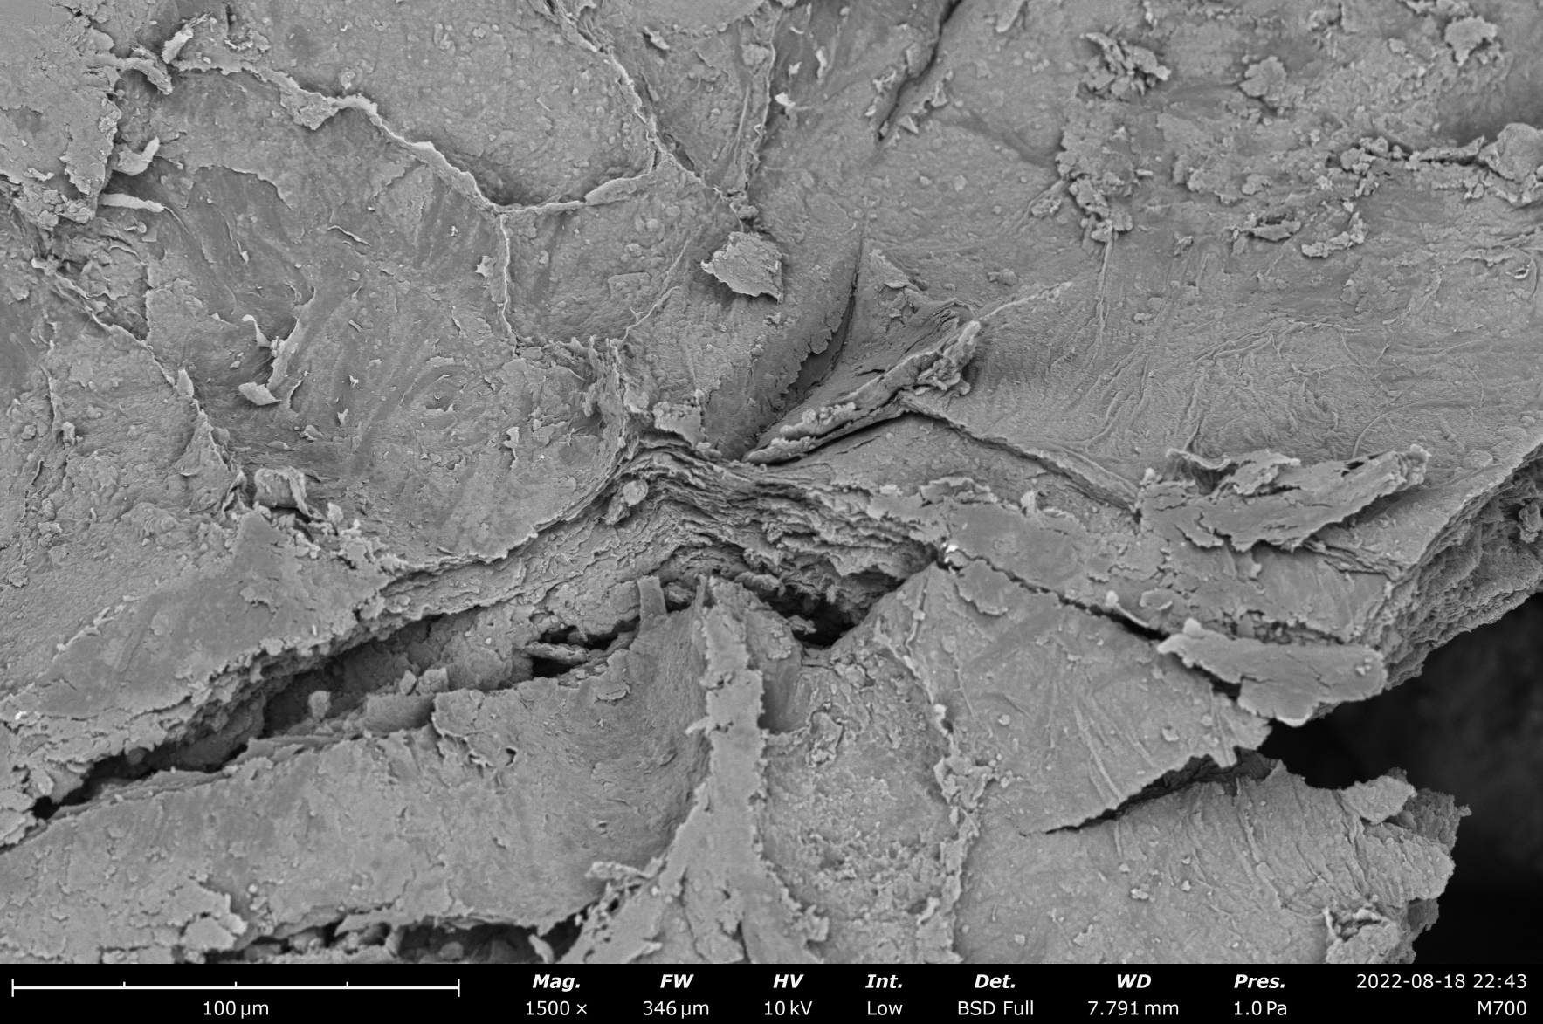
Fig. S2 SEM images of ACBs samples in 5 treatments on day 62 at 900 and 1500 magnification levels
M0
M100
M300
M500
M700
×900
×1500
Fig. S3 pH with 5 treatments at day 62.

Table S1 Changes in the characteristic absorption peaks of 4 bio-parts before and after Pb(II) loading and their corresponding functional groups
Treatments | Before Pb(II) loaded (cm⁻¹) | After Pb(II) loaded (cm⁻¹) | Change | Functional groups
M0_{UL} | none | 873 | appear | C-O
M0_{UL} | none | 1035 | appear | C-C/C-O
M0_{UL} | 1097 | 1080 | -17 | PO-2
M0_{UL} | none | 1170 | appear | PO-2
M0_{UL} | none | 1385 | appear | C-O
M0_{UL} | none | 1419 | appear | C-O
M0_{UL} | none | 3618 | appear | -OH
M0_{LL} | none | 873 | appear | C-O
M0_{LL} | 1097 | 1083 | -14 | PO-2
M0_{LL} | none | 1170 | appear | PO-2
M0_{LL} | none | 1424 | appear | C-O
M0_{LL} | none | 3621 | appear | -OH
M500_{UL} | none | 873 | appear | C-O
M500_{UL} | none | 916 | appear | Al-OH
M500_{UL} | none | 1037 | appear | C-C/C-O
M500_{UL} | 1097 | 1087 | -10 | PO-2
M500_{UL} | none | 1457 | appear | C-O
M500_{UL} | 1626 | 1644 | ﹢18 | N-H
M500_{UL} | none | 3618 | appear | -OH
M500_{LL} | none | 873 | appear | C-O
M500_{LL} | none | 1037 | appear | C-C/C-O
M500_{LL} | 1097 | 1087 | -10 | PO-2
M500_{LL} | none | 1170 | appear | PO-2
M500_{LL} | none | 1428 | appear | C-O
M500_{LL} | none | 3617 | appear | -OH

Fig. S4 CK and M500 for relative abundance of the top ten species at the phylum level at 62 days post inoculation

