Supplementary File 1 –
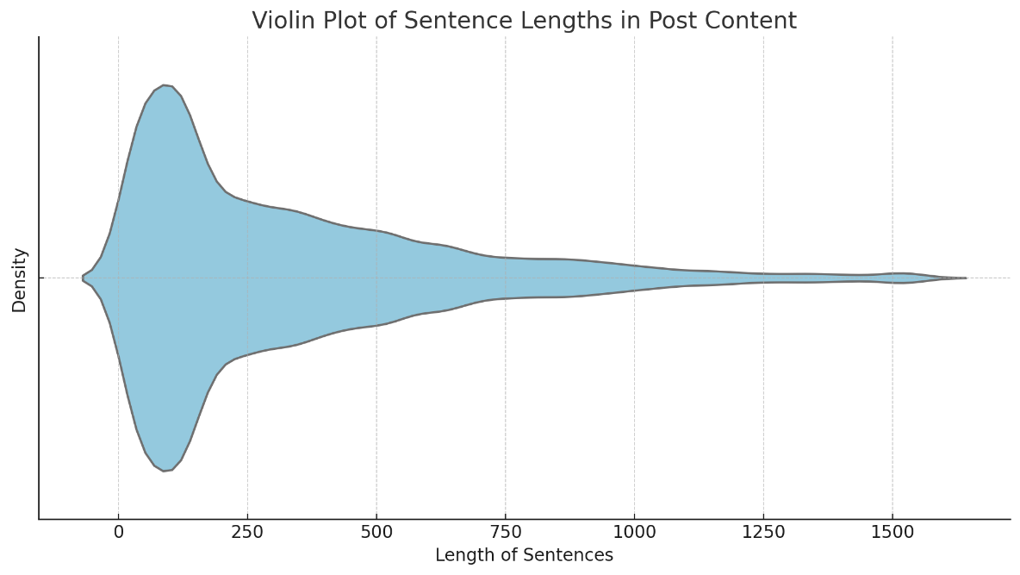
Distribution of Sentence Lengths (in Characters) in Post-Content: This violin plot illustrates the density distribution of sentence lengths in CWF-related posts on Meta platforms. The plot highlights that most sentences are concise, falling below 300 characters, with a tapering density for longer sentences, reflecting social media content's informal and concise nature.

Supplementary File 2 –
Sample of Posts showing positive, negative and neutral emotions about CWF on Facebook and Instagram (Meta).
This table presents a sample of Facebook and Instagram posts reflecting positive, negative, and neutral sentiments about community water fluoridation (CWF), categorized using sentiment polarity scores (+1 to -1).
- Positive Posts: Highlight CWF’s public health benefits, reduced dental decay, and community well-being.
- Negative Posts: Express concerns about safety, government control, and lack of consent.
- Neutral Posts: Indicate uncertainty, mixed views, or lack of strong opinion on fluoridation.

Opinion | Post | Sentiment Polarity Score (Range +1 to -1)
Positive | "Absolutely love how our community is protecting our teeth by fluoridating the water. It's a no-brainer for better dental health! 🦷💧 #HealthFirst" | +0.9
Positive | "Fluoridation in water is a win for public health! It's reassuring to know our kids are getting extra protection. 💪✨ #HealthySmiles" | +0.8
Positive | "Finally, a decision to fluoridate our water! This is a huge step toward reducing cavities and improving overall dental health. Proud of my city! 😁 #OralHealth" | +0.85
Positive | "Grateful for water fluoridation! Knowing it's helping prevent tooth decay for everyone, especially those who can't afford dental care, is just awesome. 🙌 #CommunityHealth" | +0.75
Positive | "Fluoridated water has been a game-changer for my family’s dental health. Fewer cavities, stronger teeth! Thanks, science! 🧪🌟 #FluorideWorks" | +0.8
Positive | "I’ve seen firsthand how fluoridated water has helped reduce cavities in kids where I work. It’s an essential public health measure. 👏 #PublicHealth" | +0.7
Positive | "Thrilled that our town is keeping fluoridation in the water. It’s such a simple way to help so many. 😊 #DentalCare" | +0.75
Positive | "When people complain about water fluoridation, I can’t help but wonder if they realize how much it helps with dental care. Super grateful for it! 🦷💙 #HealthyCommunities" | +0.65
Positive | "Fluoridation is a proven method to improve dental health. I’m so glad our city supports it. More smiles, less decay! 😄 #SupportFluoride" | +0.7
Positive | "If you care about public health, you should care about fluoridation. It’s made a massive difference in reducing tooth decay. Proud to support this! 🏥💧 #OralHealthMatters" | +0.9
Negative | "I can’t believe they’re still pushing water fluoridation. It feels like we’re being forced to ingest chemicals without our consent. 😠 #FluorideFree" | -0.8
Negative | "Adding fluoride to our water is just another way the government tries to control us. I don’t trust it, and I don’t want it. 😤 #SayNoToFluoride" | -0.85
Negative | "Why are we still using fluoride in our water? It’s outdated and unnecessary. We deserve the choice not to consume it. 😒 #FluorideFree" | -0.7
Negative | "Fluoride in water? No thanks! I don’t need the government deciding what’s best for my health. Feels like a violation of my rights. 🚫 #StopFluoridation" | -0.75
Negative | "Water fluoridation is just mass medication without consent. It’s wrong on so many levels, and I’m furious that it's still happening. 😡 #FluorideIsToxic" | -0.9
Negative | "It’s crazy how people just accept water fluoridation like it’s normal. It’s not! We shouldn’t be forced to consume chemicals. 😠 #AntiFluoride" | -0.7
Negative | "I’m deeply concerned about the long-term effects of fluoride in our water. Why are we being treated like lab rats? 🧪 #FluorideFreeFuture" | -0.8
Negative | "Fluoride in the water is nothing but a big experiment on the public. We deserve better than this! 😡 #NoToFluoride" | -0.85
Negative | "I feel betrayed knowing our water is fluoridated without proper public consultation. It’s not right. 😞 #FluorideFree" | -0.75
Negative | "Fluoride in water is dangerous and unnecessary. We need to put a stop to this practice now before it’s too late. ⚠️ #FluorideIsPoison" | -0.9
Neutral | "Fluoridation has been around for years, but I’m still not sure what to think about it. There are pros and cons to both sides. 🤔 #OnTheFence" | 0.0
Neutral | "Honestly, I don’t have a strong opinion on water fluoridation. I guess it’s good for some, but I see why others might oppose it. 🤷‍♂️ #NeutralThoughts" | 0.0
Neutral | "I’ve heard a lot about water fluoridation, but I’m still undecided. Both sides make valid points. 🤨 #FluorideDebate" | 0.0
Neutral | "Not sure what to believe about fluoride in water. Seems like everyone has a different opinion, and it’s hard to know who’s right. 😕 #Confused" | 0.0
Neutral | "Water fluoridation isn’t something I think about often. It’s just part of life, I guess. 🤷‍♀️ #Whatever" | 0.0
Neutral | "There’s a lot of debate about water fluoridation, but I’m still on the fence. It’s hard to say what’s really best. 😐 #FluorideDiscussion" | 0.0
Neutral | "I don’t really have a stance on fluoridation. I can see both sides, so I’m just staying neutral. 🤷 #NoStrongFeelings" | 0.0
Neutral | "I’ve read arguments for and against water fluoridation. Honestly, I’m not convinced either way. Just seems like another debate. 😬 #Undecided" | 0.0
Neutral | "It’s interesting to see how divided people are over water fluoridation. I don’t have a strong opinion myself. 🤔 #FluorideTalk" | 0.0
Neutral | "Water fluoridation is one of those things I just don’t think about much. People seem passionate, though. 🤷‍♂️ #Neutral" | 0.0

