Supplementary Information

SI1. Renewable energy heatmaps
The heatmaps developed by the Australian National University RE100 Group [1] visually represent the most favourable locations for solar and wind farms across Australia by evaluating and categorizing potential sites based on their indicative cost of electricity production. This cost comprises the energy cost from a solar/wind farm and the associated powerline connecting the solar/wind farm to the existing and planned high-voltage transmission network:
Equation S1
$$\text{Indicative cost (AUD}\text{/}\text{MWh)}=\frac{\frac{\text{Transmission CAPEX}×\text{Distance}}{\text{PV(Discount rate, lifetime)}}+\frac{\text{Solar}\text{/}\text{Wind CAPEX}}{\text{PV(Discount rate, lifetime)}}+\text{Solar}\text{/}\text{Wind OPEX}+\text{Transmission OPEX}×\text{Distance}}{1×8760×\text{Capacity Factor}×\left(1-\text{Transmission loss}×\text{Distance}\right)}$$
Where:
- Transmission CAPEX: Capital expenditures of the transmission line (AUD/MW-km)
- Transmission OPEX: Operating expenses of the transmission line (AUD/MW-km p.a.)
- Solar/Wind CAPEX: Capital expenditures of the solar/wind farm (AUD/MW)
- Solar/Wind OPEX: Operating expenses of the solar/wind farm (AUD/MW p.a.)
- Distance: Distance from the pixel to the high-voltage transmission network (km)
- Capacity Factor: Capacity factor of the solar/wind farm (%)
- Transmission loss: Transmission loss of the transmission line (% per km)
- PV (Discount rate, lifetime): Present value factor with a given discount rate and lifetime
Costs are categorized into five bands (A to E), ranging from below $40/MWh to above $70/MWh, with bands B, C, and D incrementing by $10/MWh, enabling users to quantify and compare the potential for renewable energy development across different regions using Equation S2:
Equation S2
$$\text{Class A Potential}=\sum_{i=1}^{n}{{\text{Area}}_{i}}×\text{Land use factor},\text{ where Indicative }{\text{cost}}_{i}<AUD 40/MWh$$
Where:
- Class A Potential: The total Class A solar/wind potential (GW) within the specified area. Class B - E potential can be calculated in the same way by setting different ranges for the indicative cost.
- $n$: The total number of pixels in the area being analysed
- ${\text{Area}}_{i}$​: The area of the $i_{th}$ pixel (1 km² for solar, 62,500 m² for wind)
- Land use factor: 0.15 GW/km² for solar (according to 5B [2]), 7.2 MW/km² for wind (based on Vestas V162-6.8 MW turbine [3])
- $\text{Indicative }{\text{cost}}_{i}$​: The indicative cost for the $i_{th}$ pixel
The heatmaps are useful for identifying promising sites for solar PV and wind based on the existing and planned high-voltage transmission network. However, they do not provide guidance on where to build new transmission, especially when the existing network is saturated due to rising demand. This project aims to address that gap. The heatmaps were used to quantify the low-cost renewable resource potential enabled by candidate HVAC routes, as discussed in Section 3.1.3 of the manuscript.
The cost assumptions used to develop the heatmaps are summarized below.
 | CAPEX | OPEX | Lifetime | Source
Transmission | $2,065/MW-km | 1% of CAPEX p.a. | 30 years | AEMO Transmission Cost Database [4]
Solar PV | $946/kW | $17/kW p.a. | 30 years | GenCost 2022-23 [5]
Wind onshore | $1,756/kW | $25/kW p.a. | 25 years | GenCost 2022-23 [5]
Discount rate | 5.99% |  |  | GenCost 2022-23 [5]

SI2. Top HVAC routes for each state

New South Wales
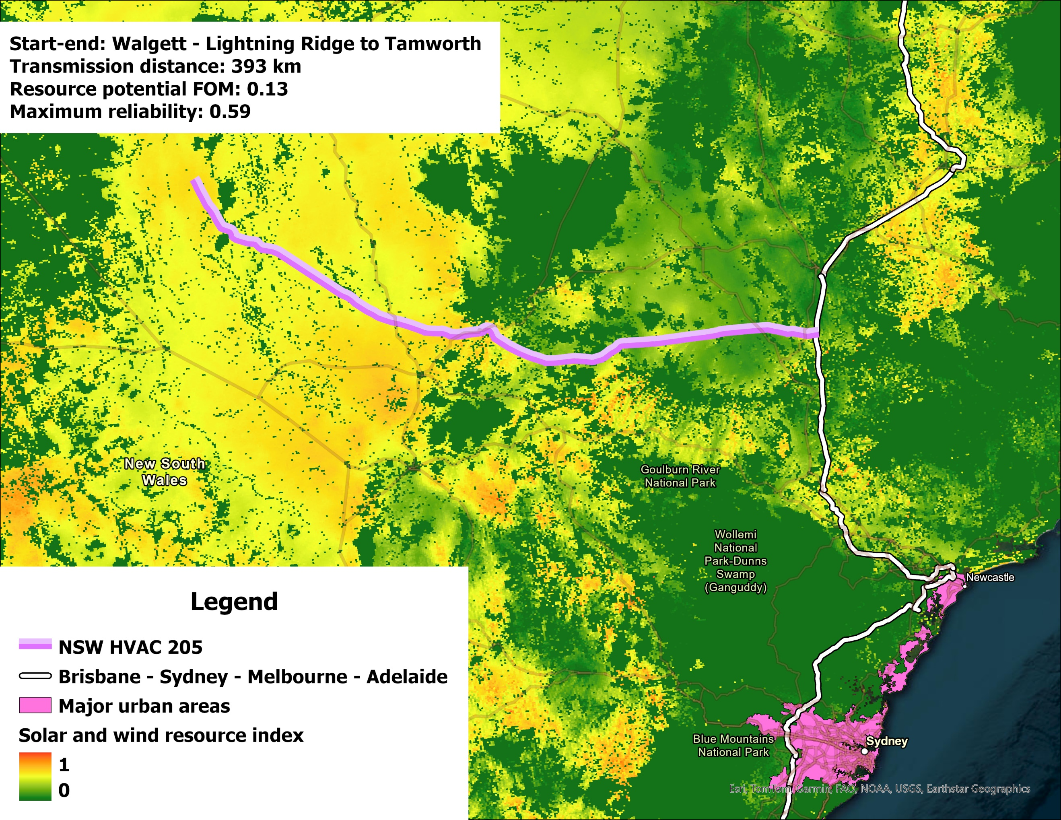
Figure SI2.1: NSW HVAC Route 205
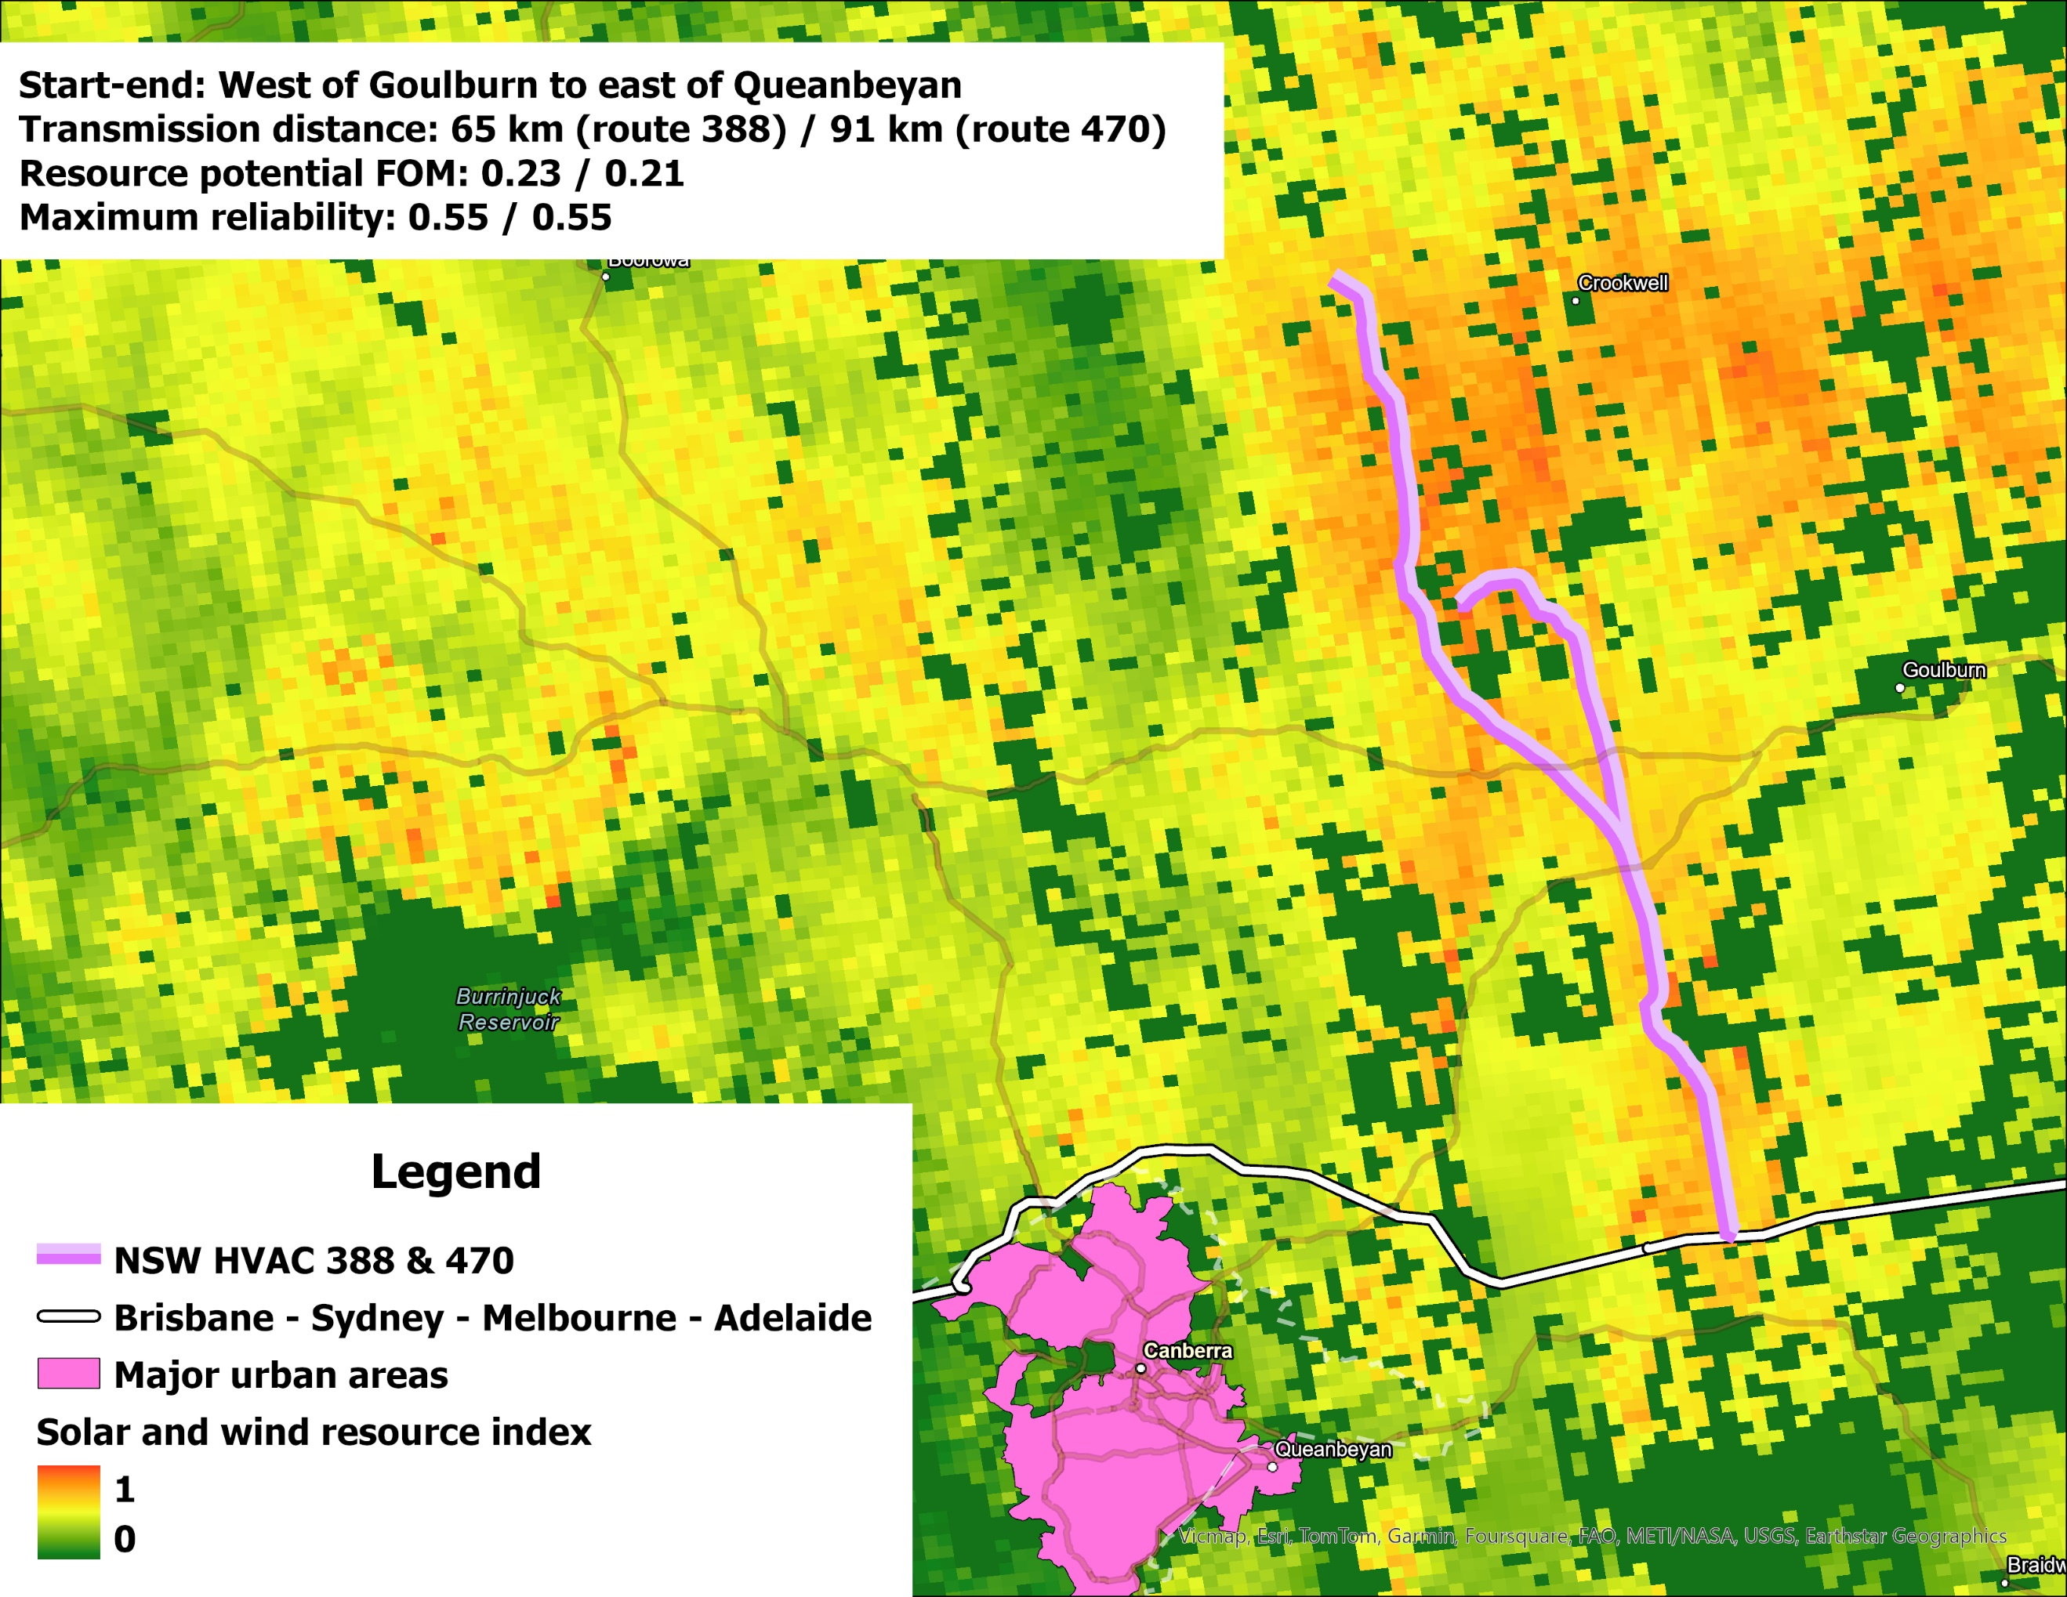
Figure SI2.2: NSW HVAC Route 388 & Route 470

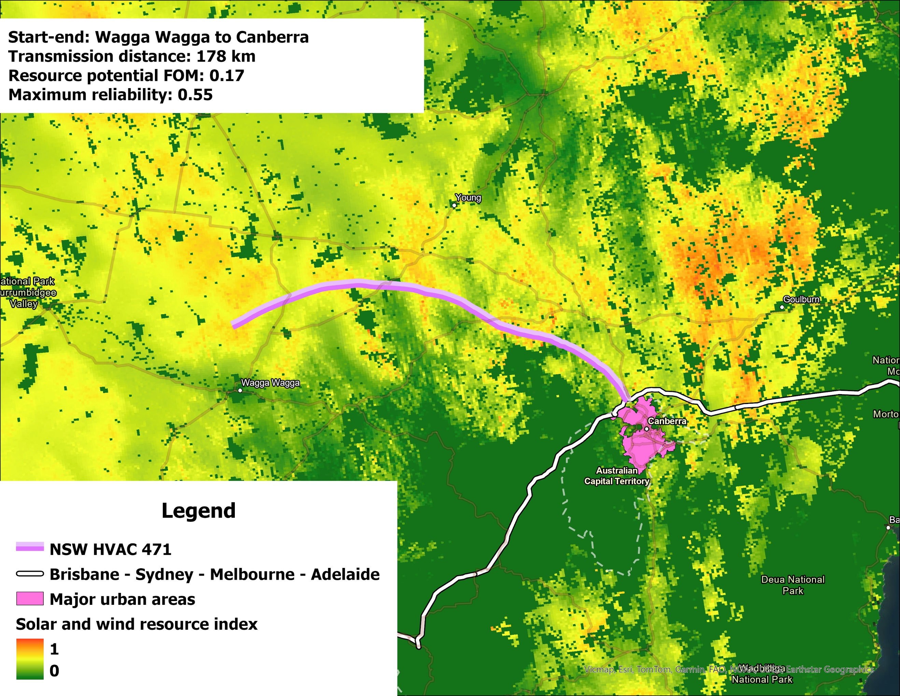
Figure SI2.3: NSW HVAC Route 471

Queensland
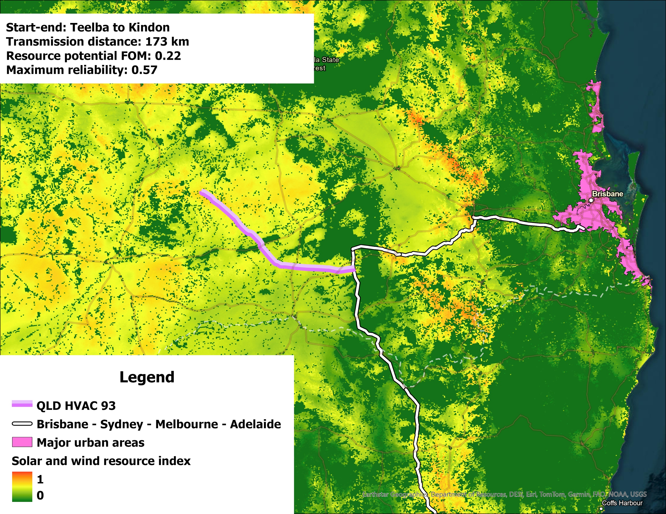
Figure SI2.4: QLD HVAC Route 93
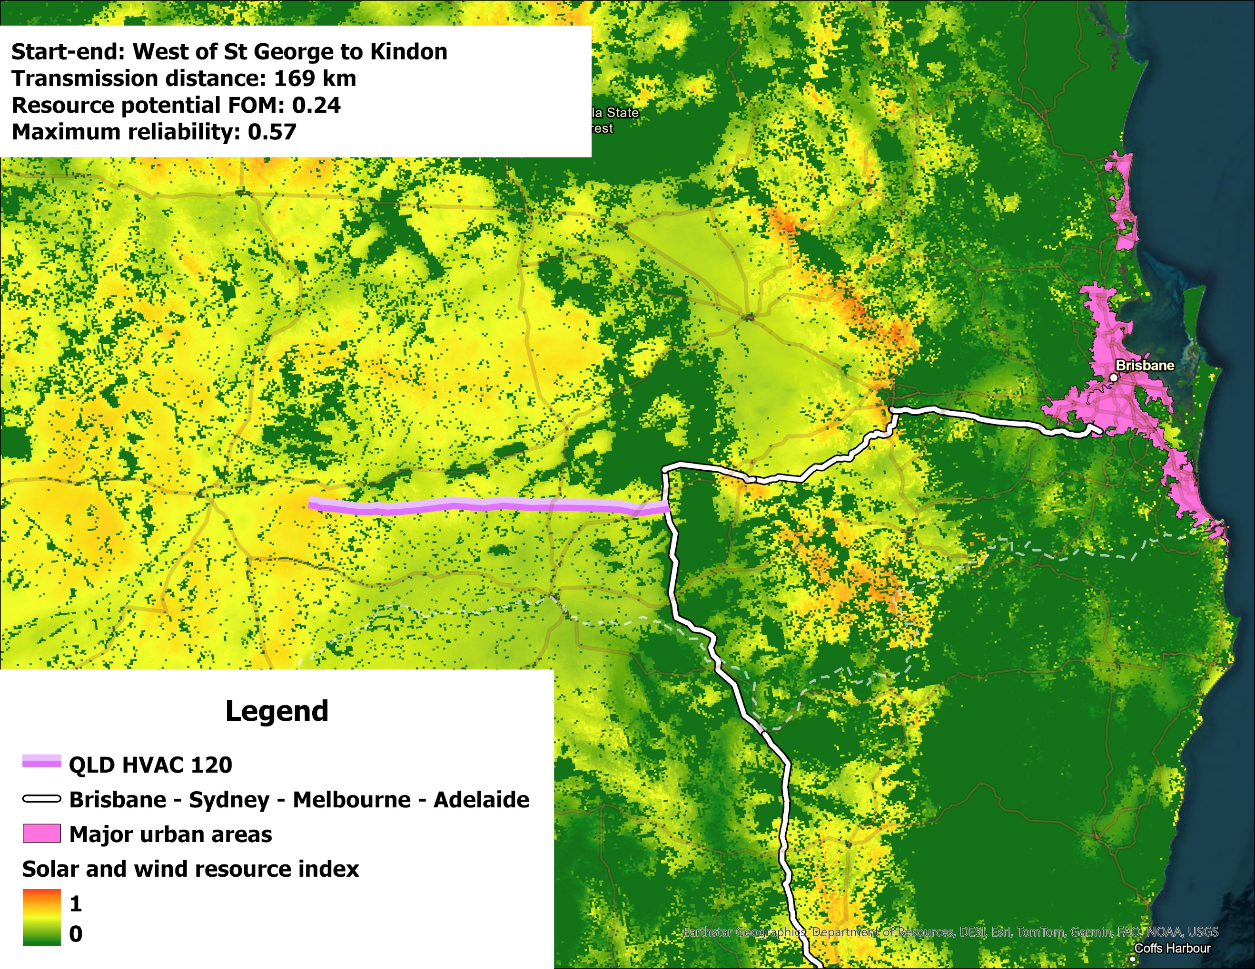
Figure SI2.5: QLD HVAC Route 120
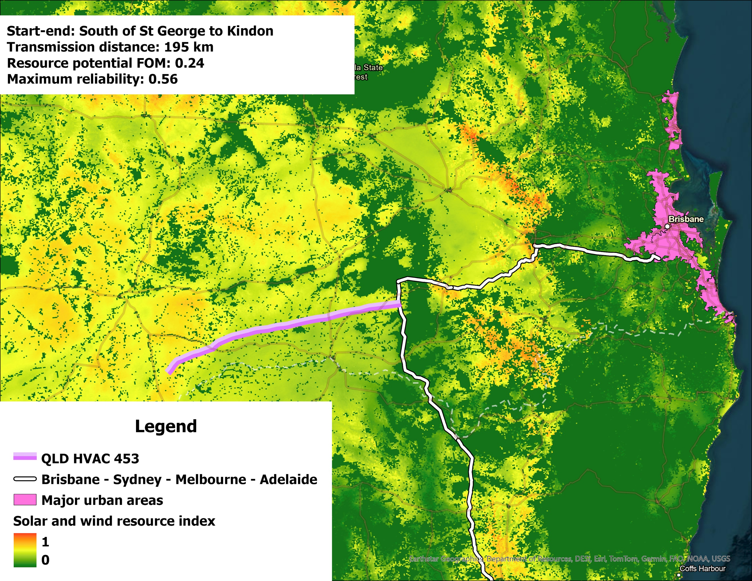
Figure SI2.6: QLD HVAC Route 453

South Australia
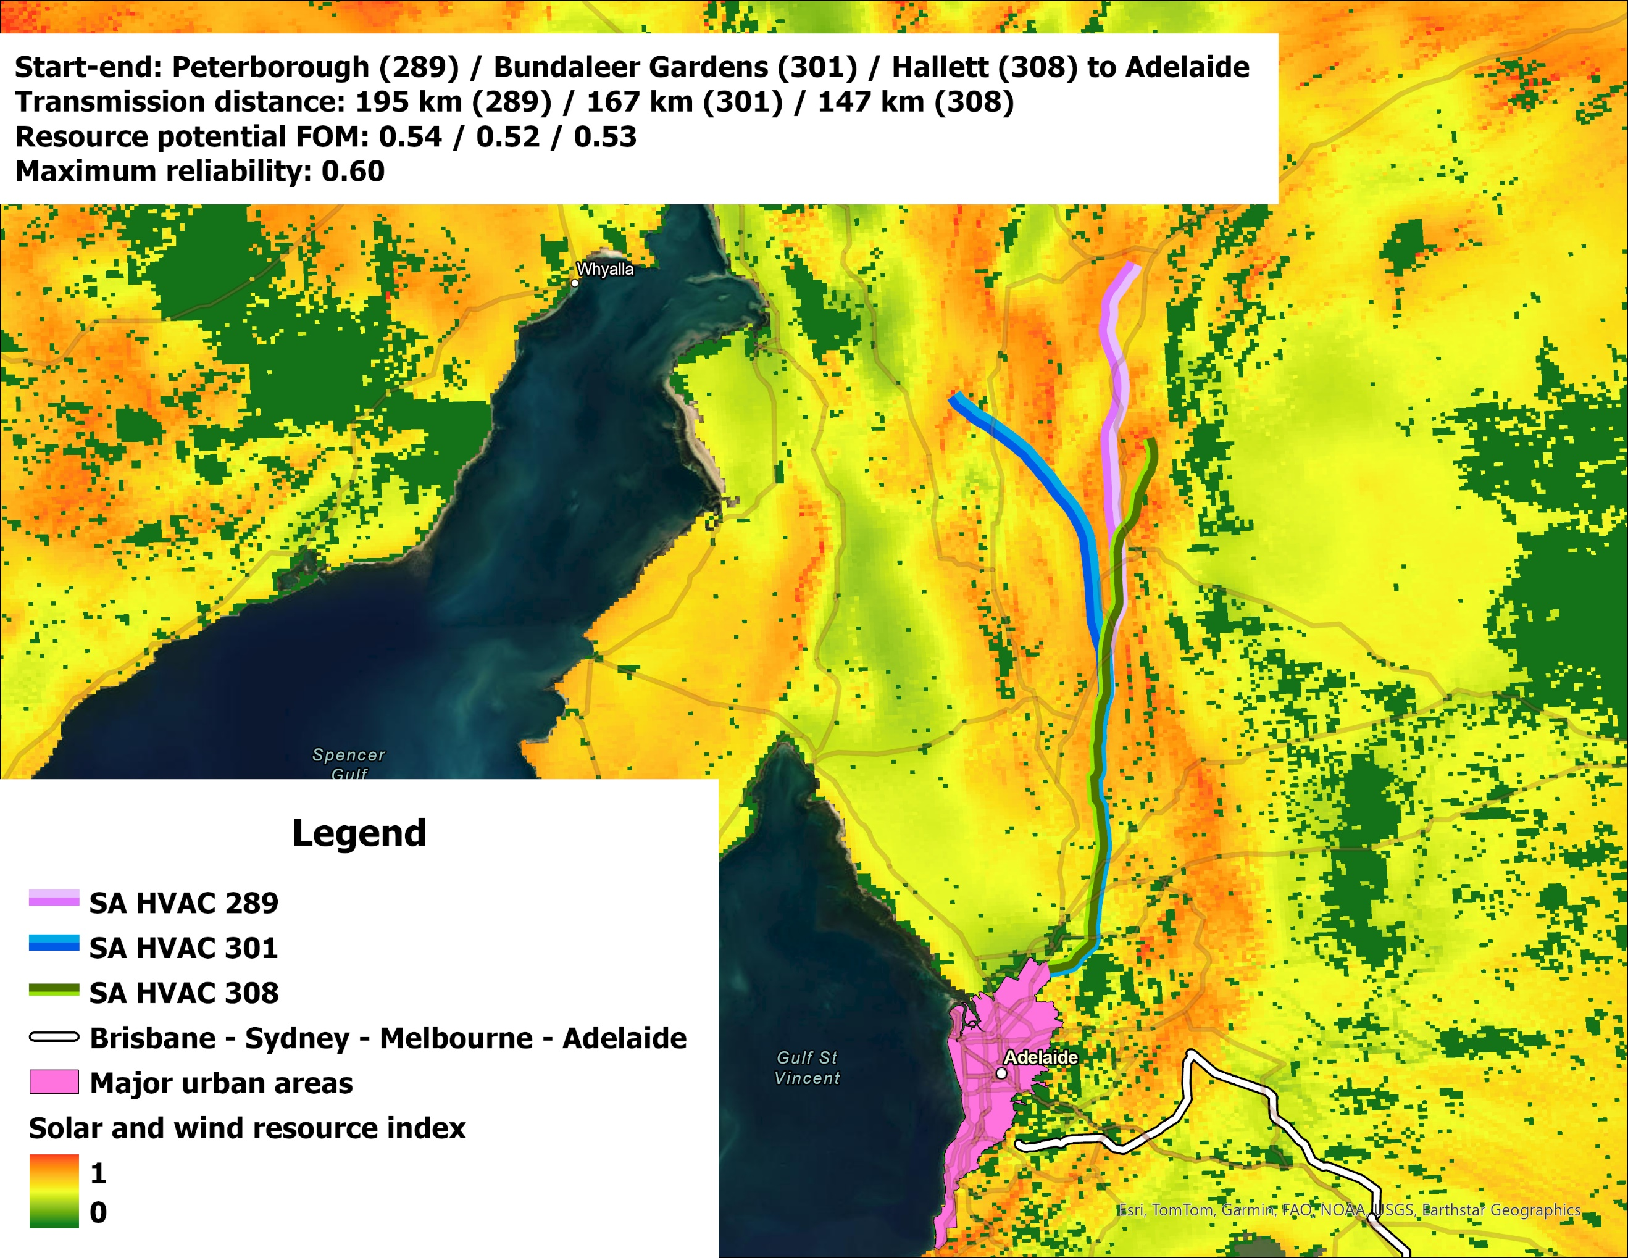
Figure SI2.7: SA HVAC Route 289 & Route 301 & Route 308
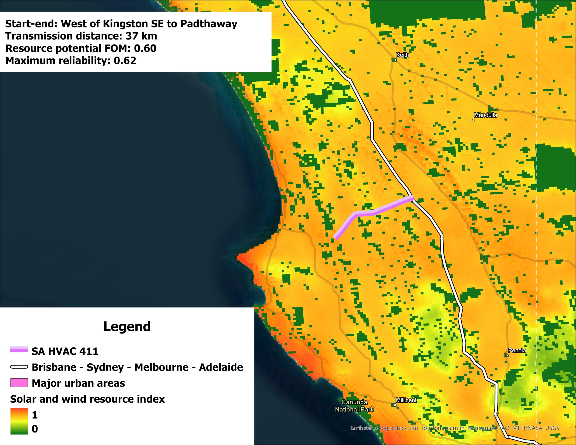
Figure SI2.8: SA HVAC Route 411
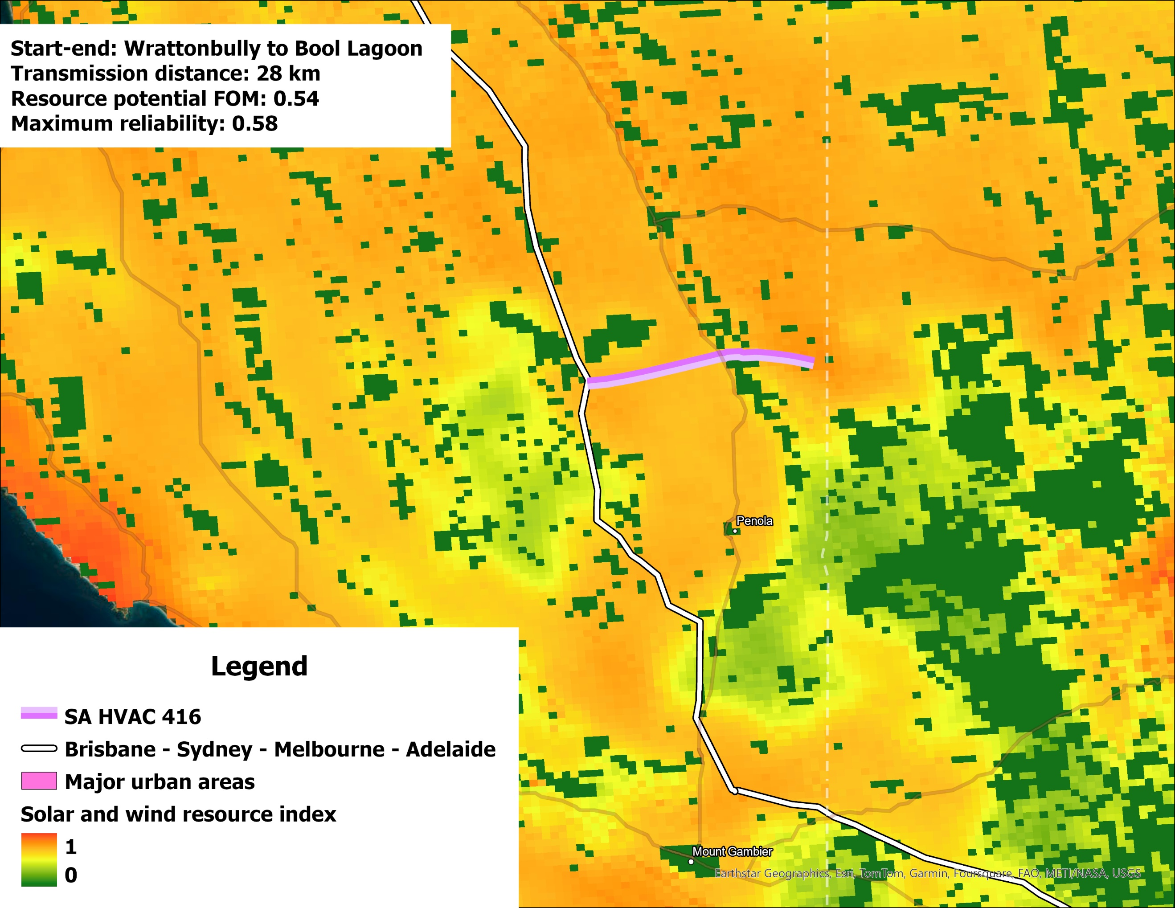
Figure SI2.9: SA HVAC Route 416

Victoria
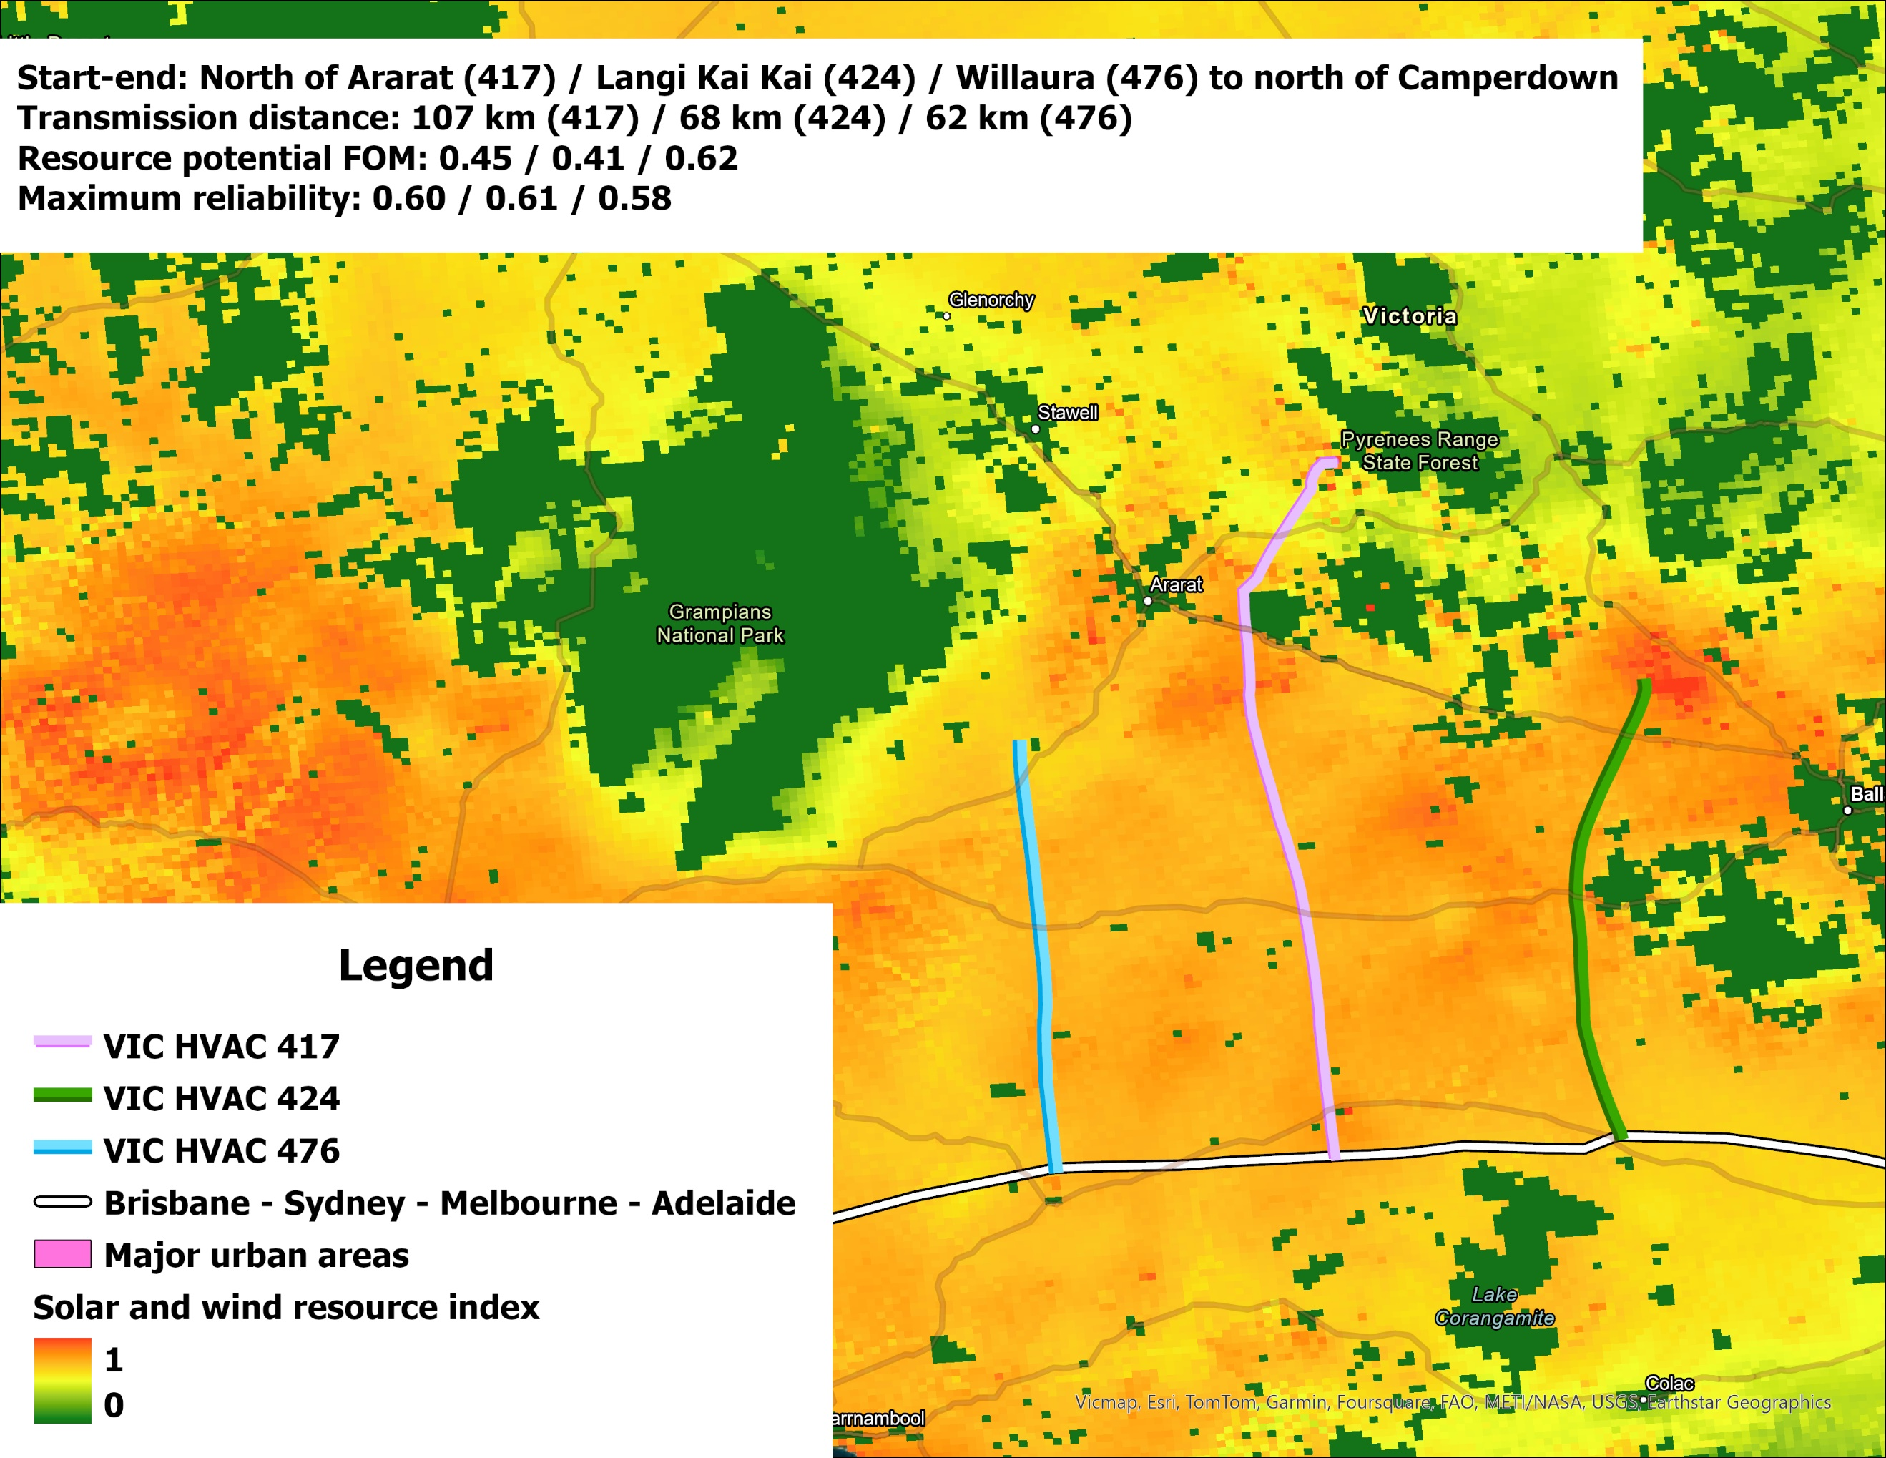
Figure SI2.10: VIC HVAC Route 417 & Route 424 & Route 476
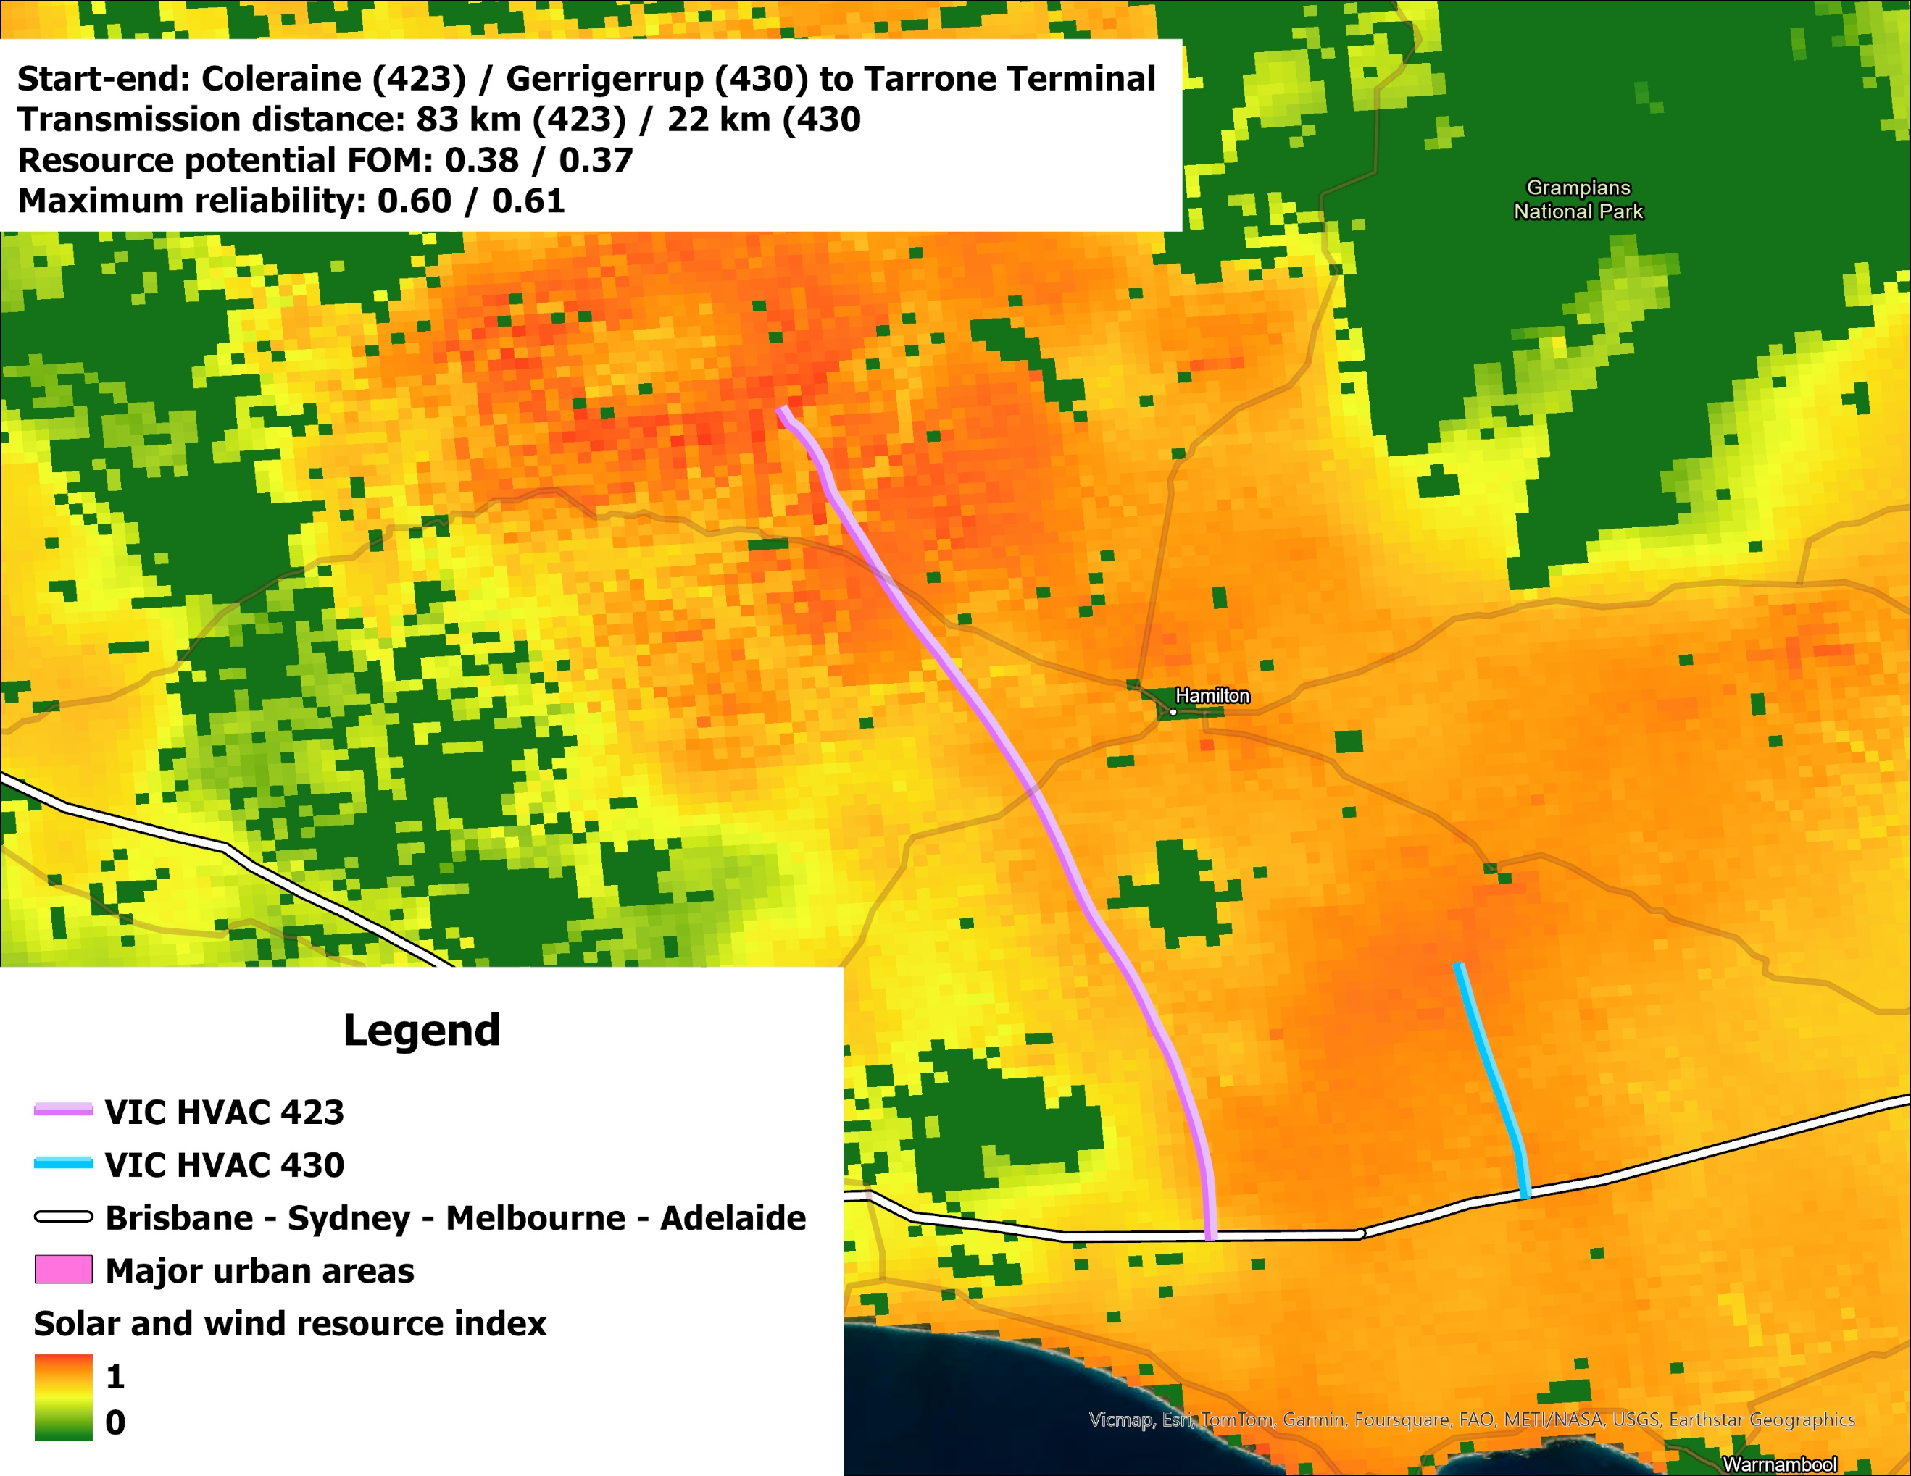
Figure SI2.11: VIC HVAC Route 423 & Route 430
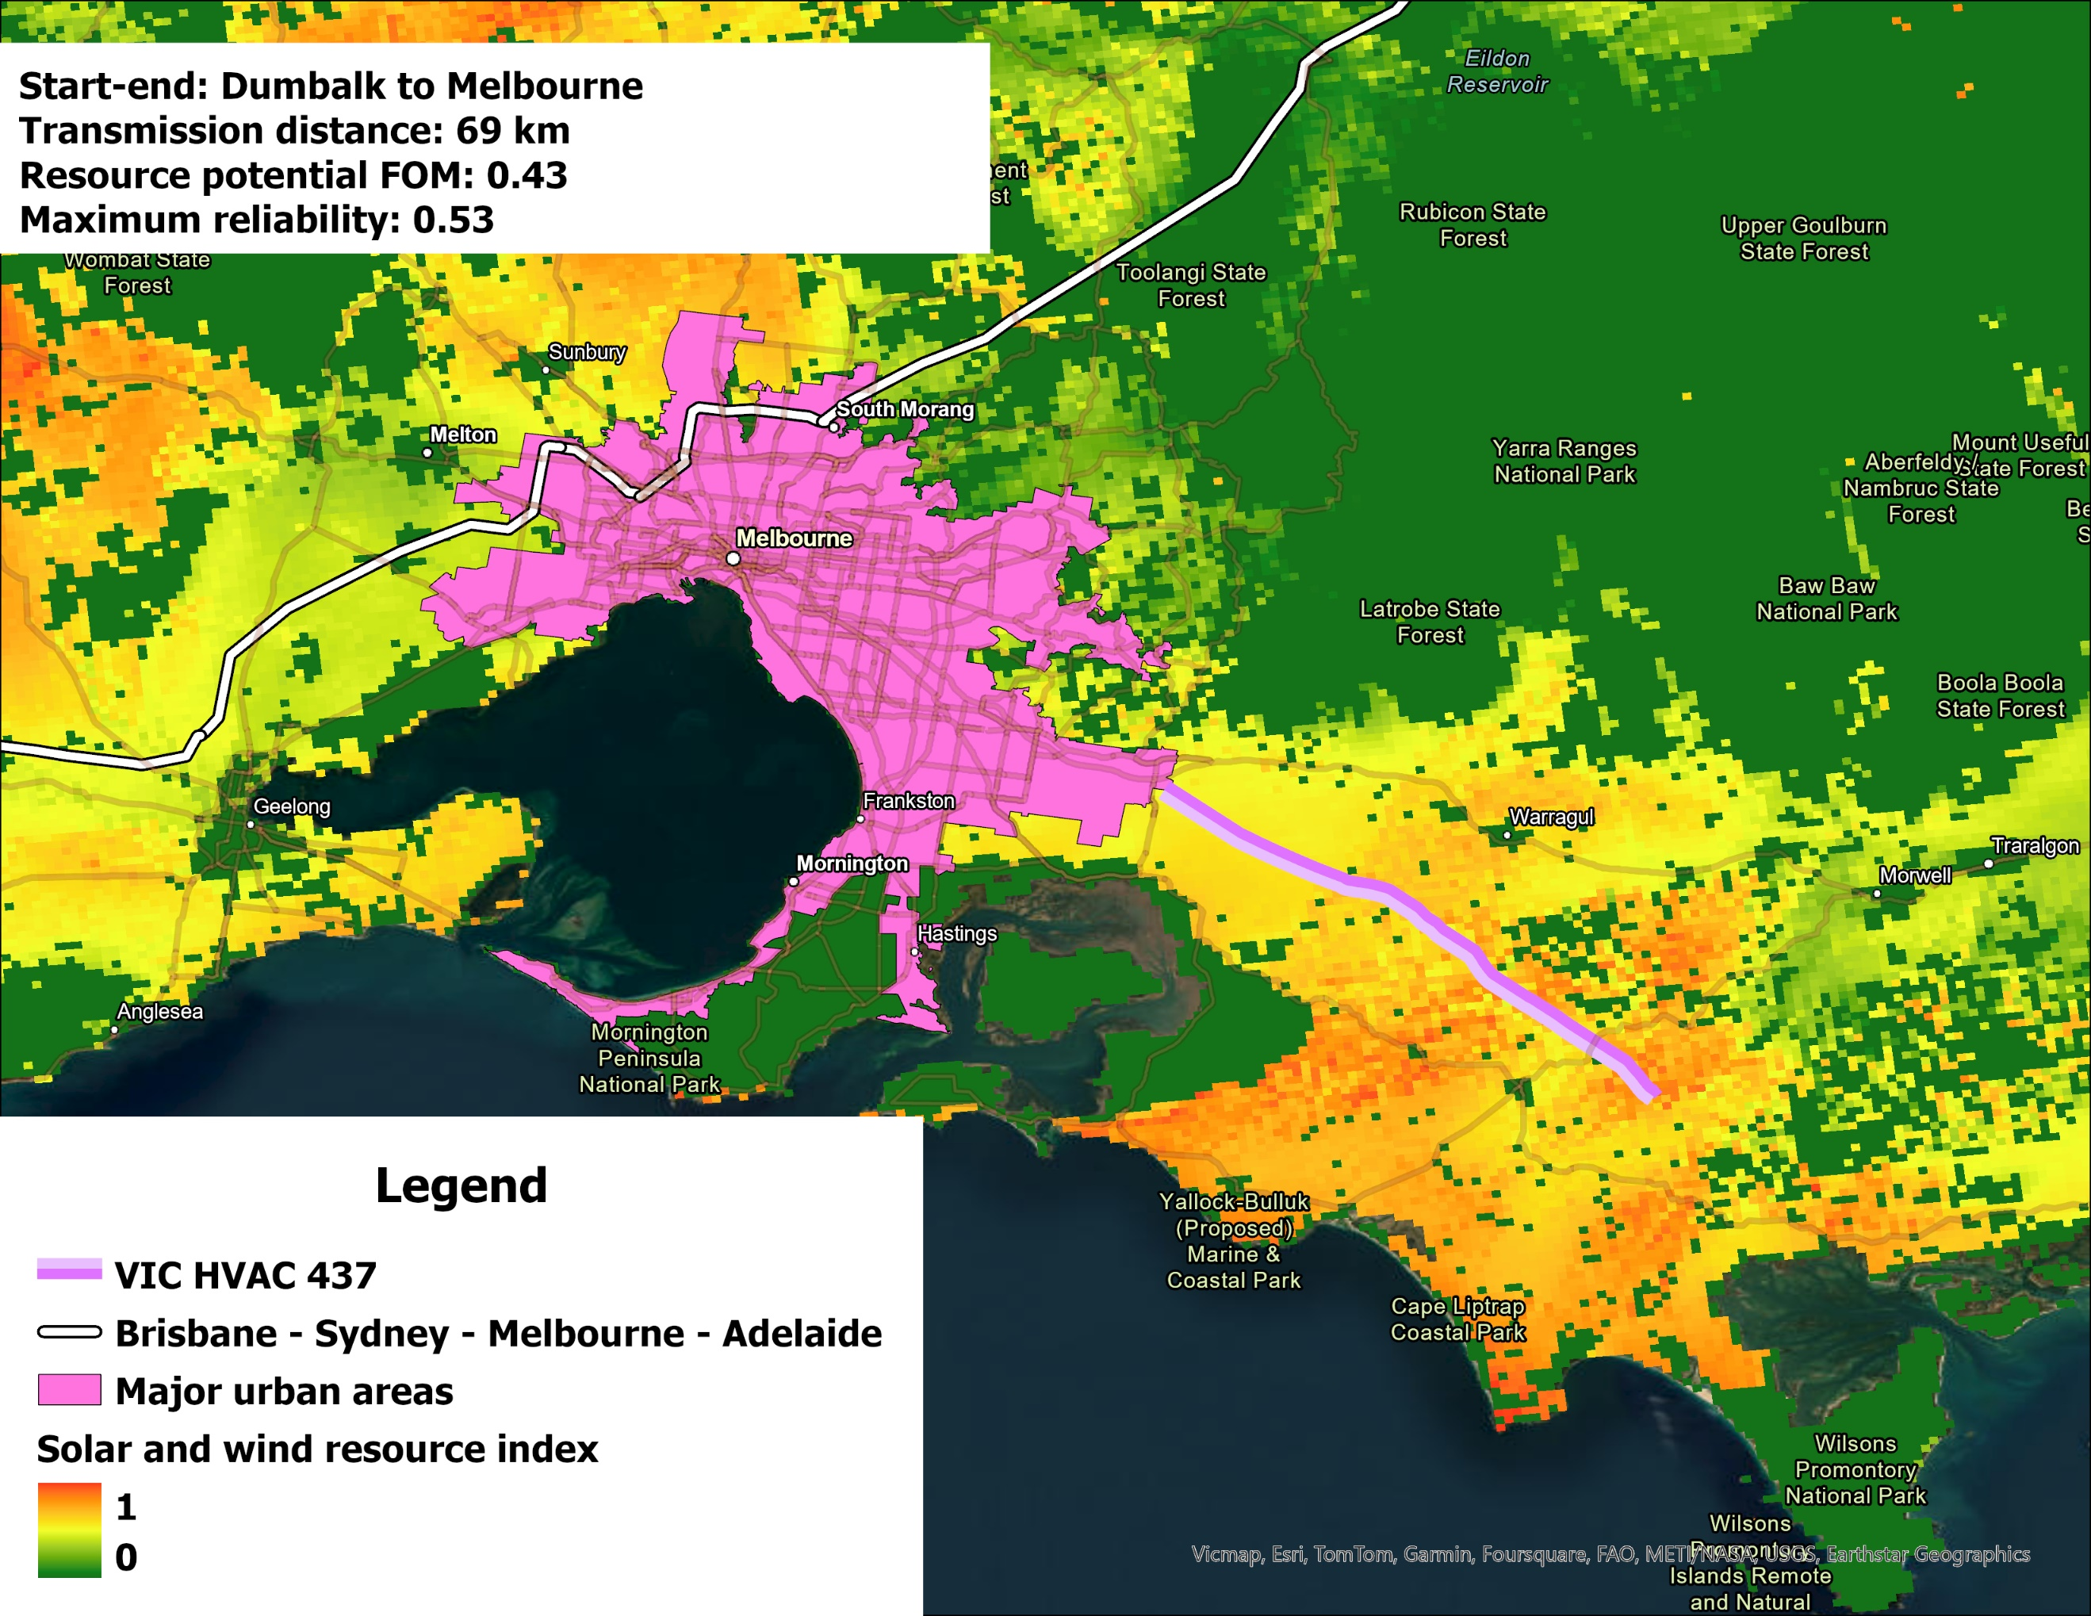
Figure SI2.12: VIC HVAC Route 437

Western Australia
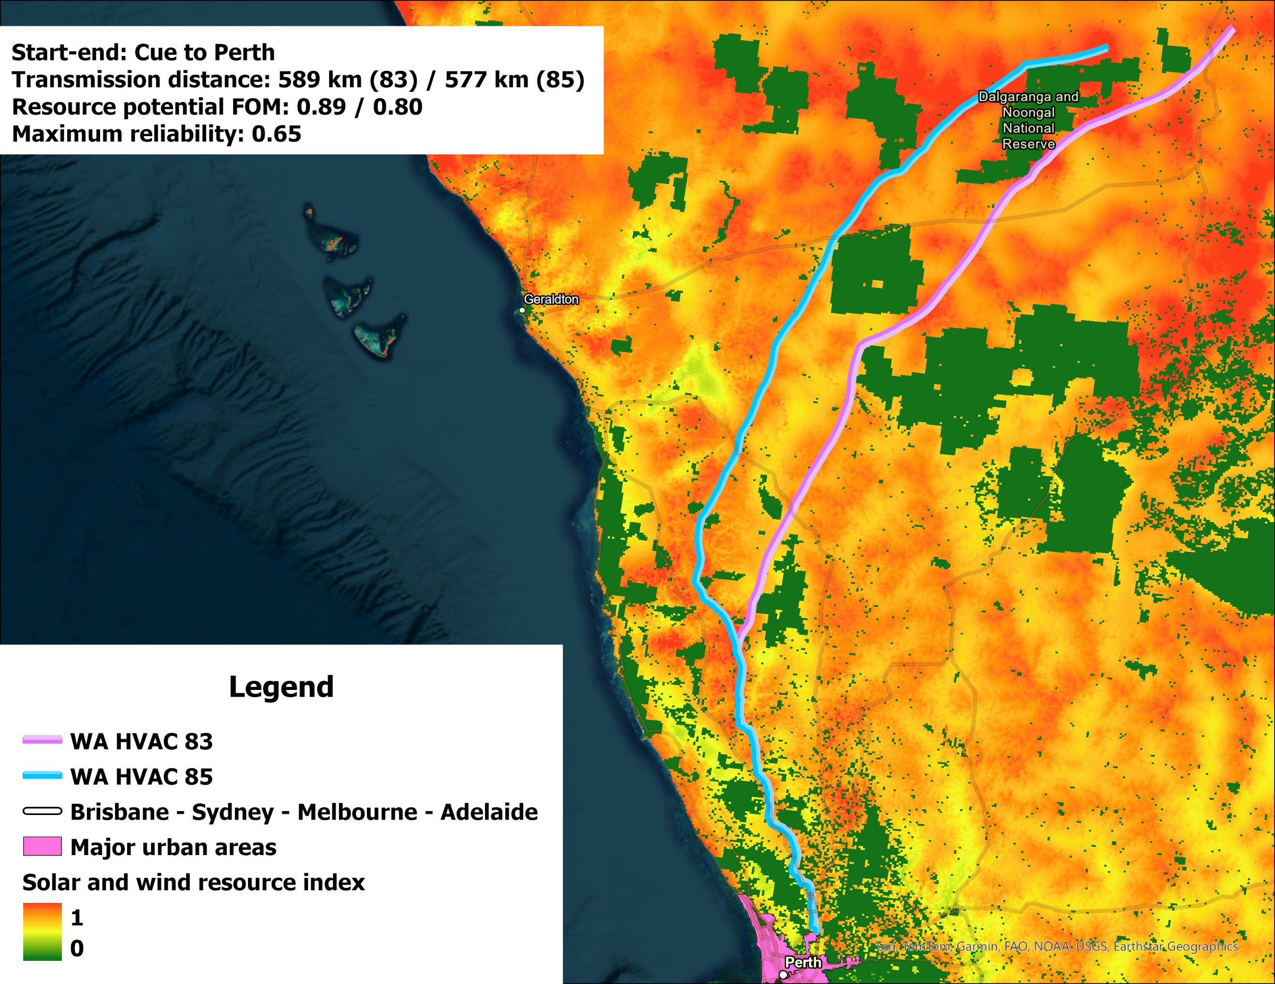
Figure SI2.13: WA HVAC Route 83 & Route 85
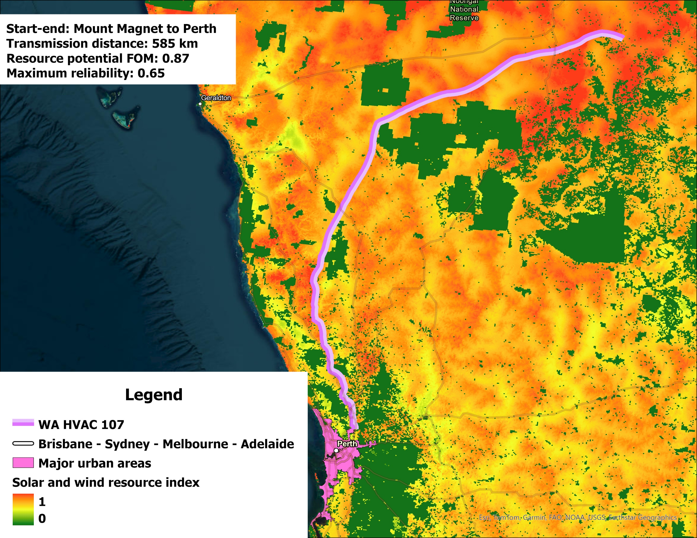
Figure SI2.14: WA HVAC Route 107
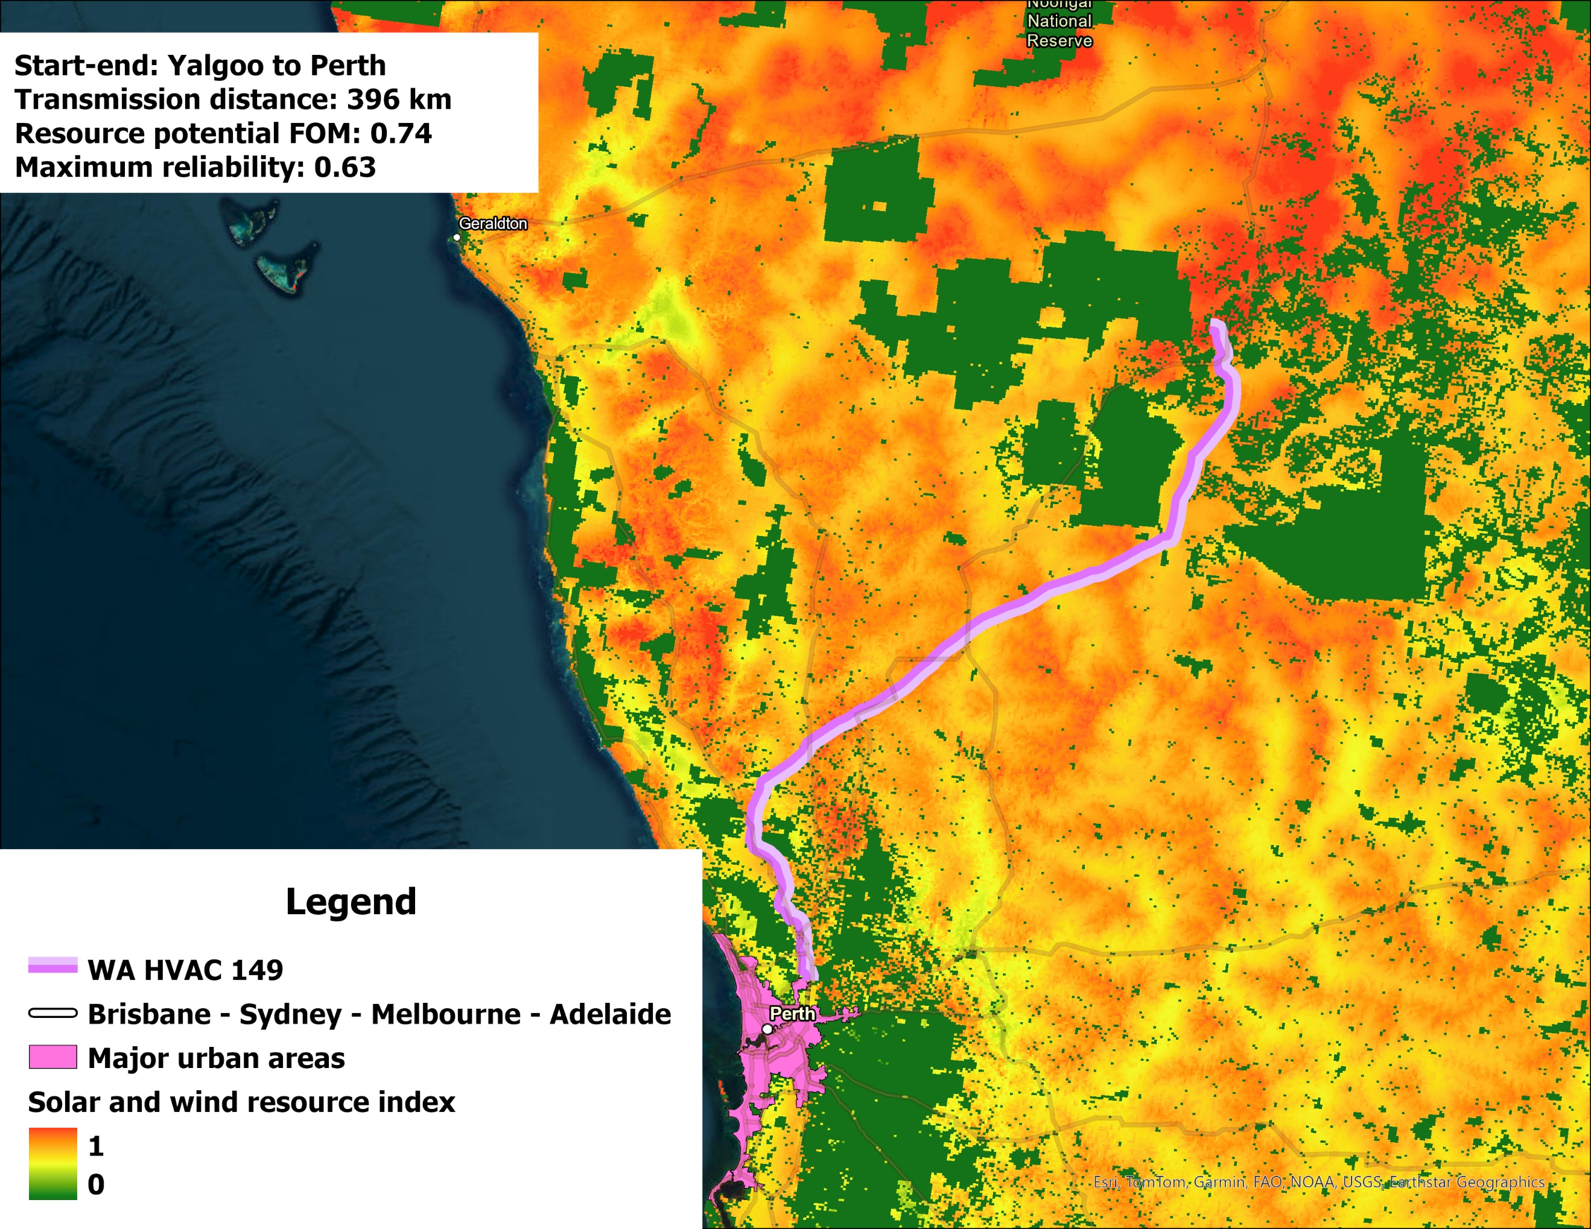
Figure SI2.15: WA HVAC Route 149

SI3. Winter maps for solar PV and wind
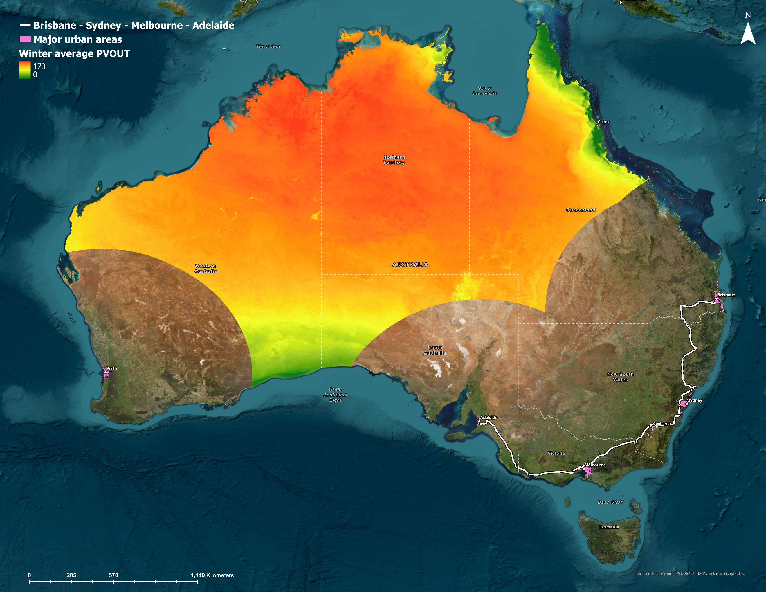
Figure SI3.1: Winter average PVOUT. Source data: Global Solar Atlas [6].
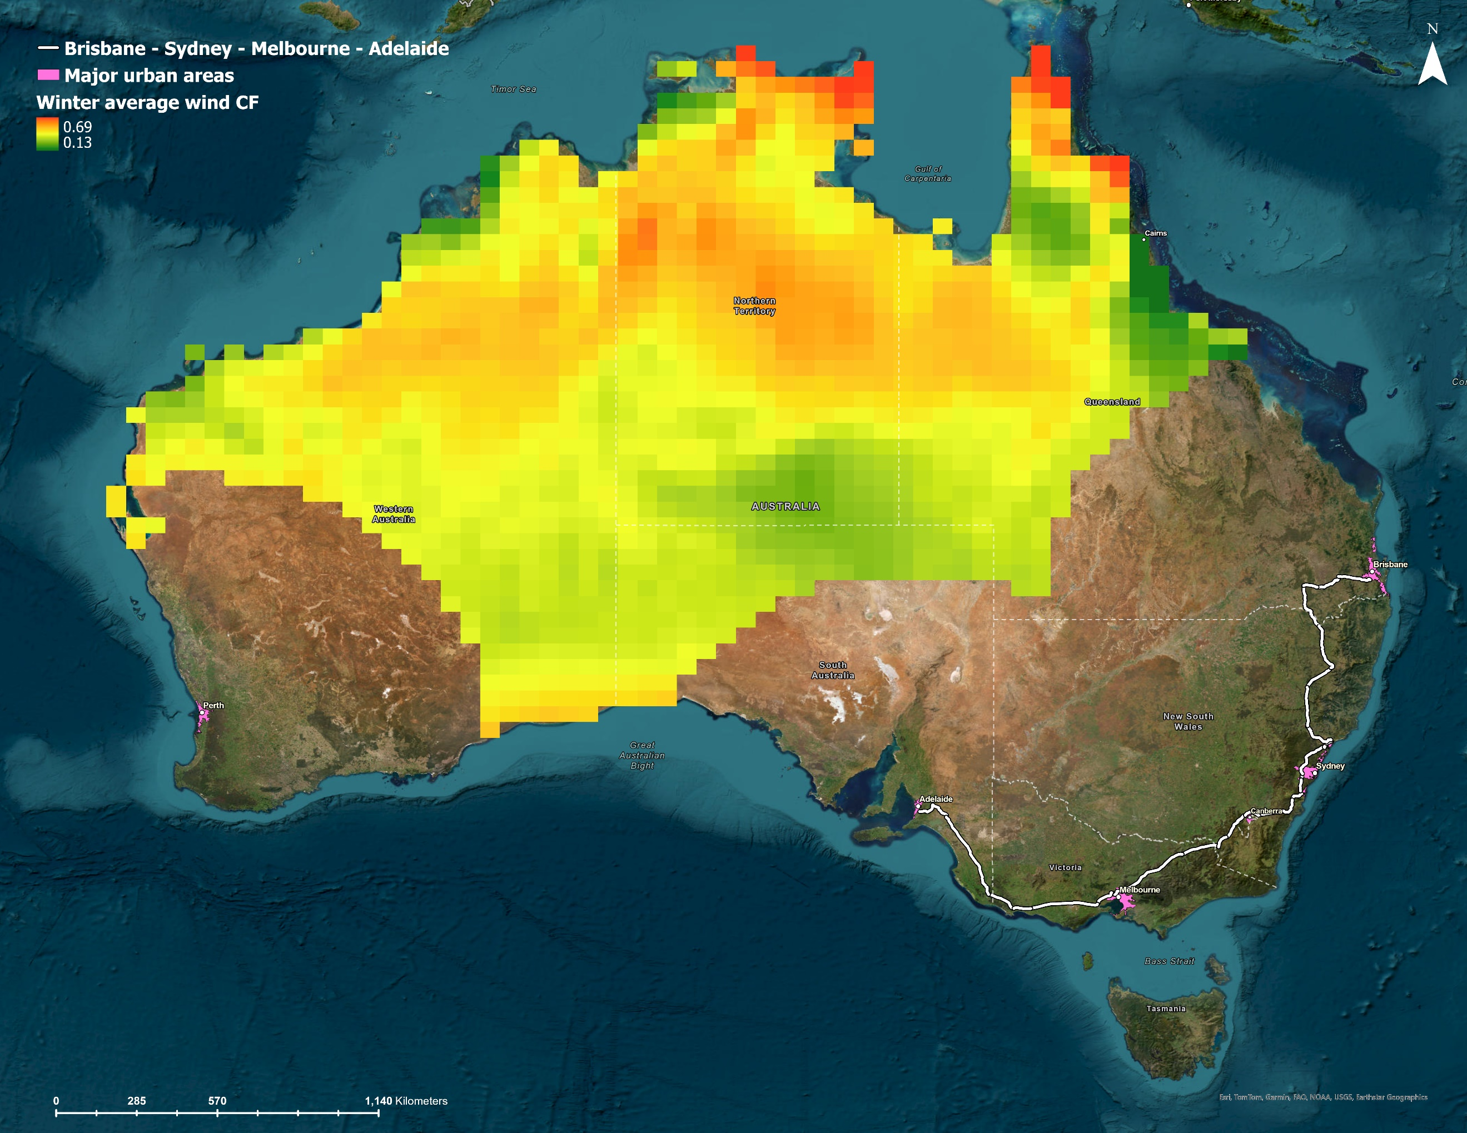
Figure 14: Winter average wind capacity factor. Source data: Renewables.ninja [7].

SI4. Net load and energy balance over the “worst week”
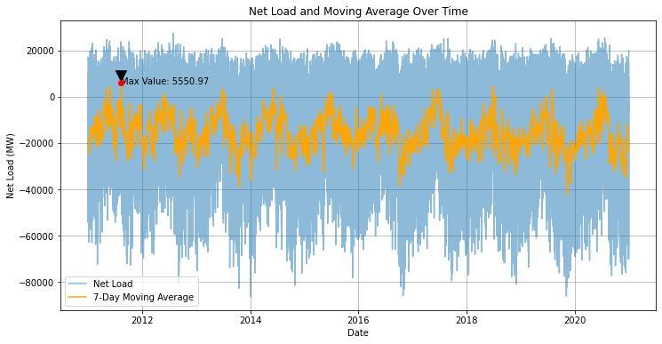
Figure SI4.1: Hourly net load and 7-day moving average for the NEM (baseline)
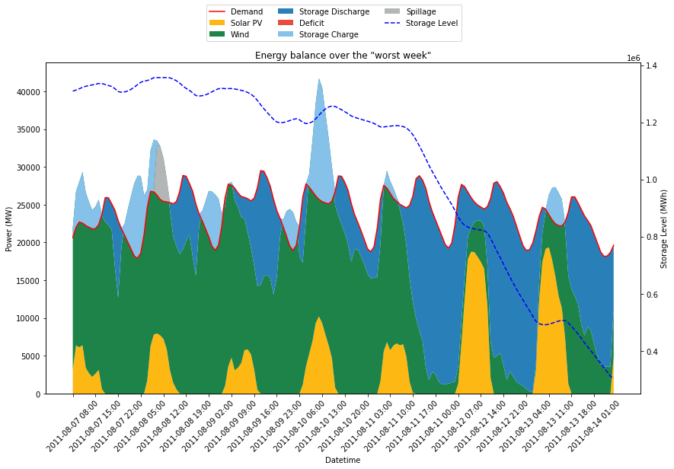
Figure SI4.2: Energy balance over the “worst week” for the NEM (baseline)
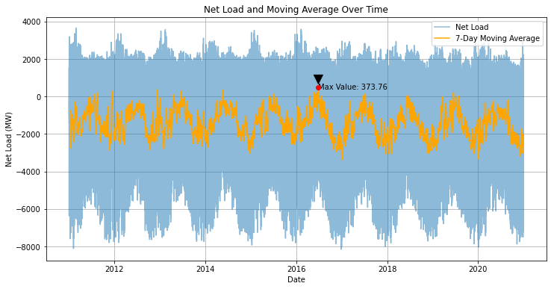
Figure SI4.3: Hourly net load and 7-day moving average for the SWIS (baseline)
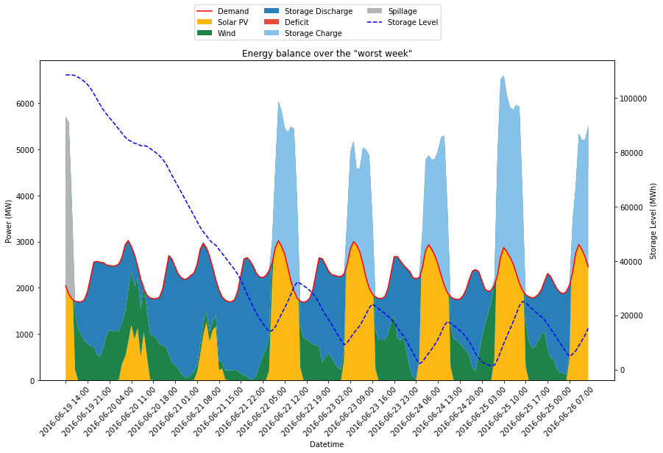
Figure SI4.4: Energy balance over the “worst week” for the SWIS (baseline)

SI5. HVDC modelling results for the SWIS
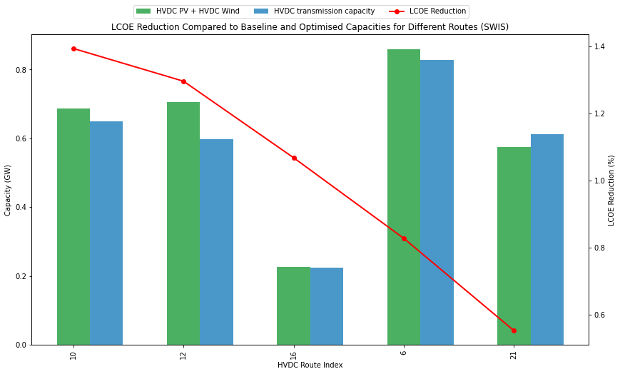
Figure SI5.1: Modelling results for the top 5 candidate HVDC routes in the SWIS

SI6. Comparison with AEMO Transmission Expansion Options
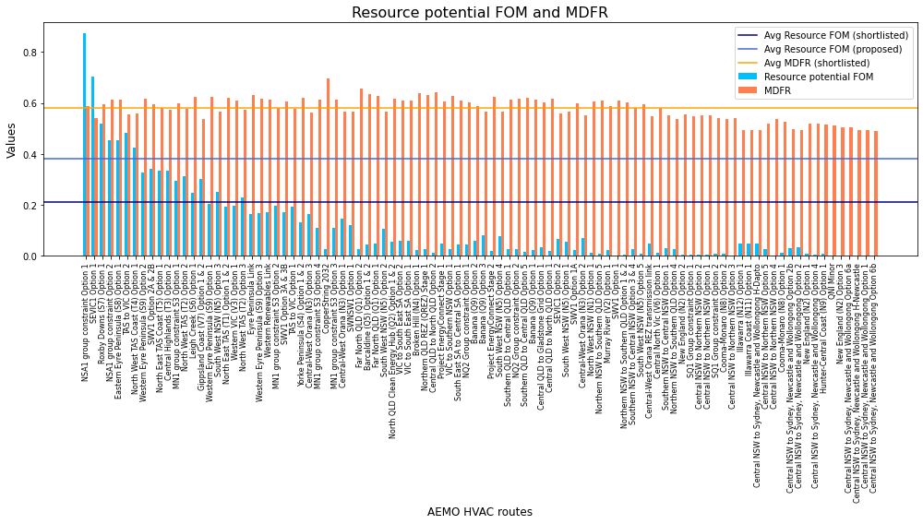
Figure SI6.1: Resource potential FOM and MDFR for AEMO HVAC options. The average resource potential FOM for the shortlisted (127 excluding 20 in WA) and proposed (3 per state) HVAC routes in this study are also plotted for comparison. MDFR for the shortlisted and proposed HVAC routes are identical: 0.58.
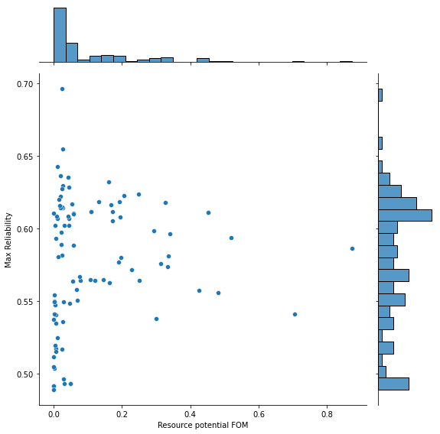
Figure SI6.2: Scatter plot with marginal histograms for AEMO HVAC options.
The average resource potential FOM for the 127 shortlisted HVAC routes in this study (excluding the 20 routes in WA) is 0.21 (dark blue line in SI6.1), while the proposed 12 routes (top 3 per state, as shown in the Supplementary Information 2) yield an average of 0.38 (light blue line in Figure SI6.1). Both values are higher than those of most routes proposed by AEMO, justifying the higher cost-effectiveness for the HVAC routes identified in this study, although this does not imply that AEMO’s routes fail to unlock sufficient renewable potential. As shown in Figure SI6.2, most AEMO-proposed routes have a resource potential FOM below 0.2. The two notable exceptions are “NSA1 group constraint Option 1” and “SEVIC1 Option 1”, which are short routes located in resource-rich regions (Figure SI6.3).
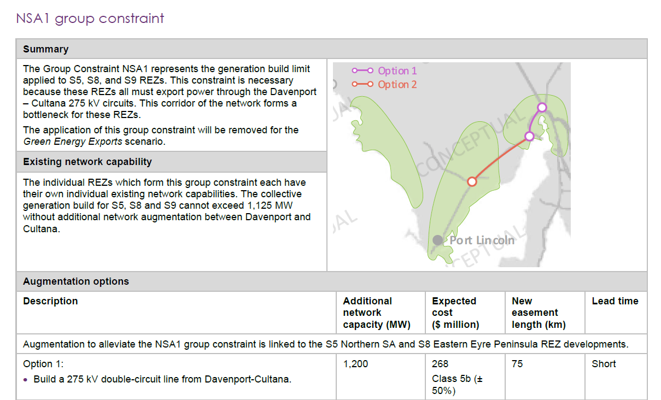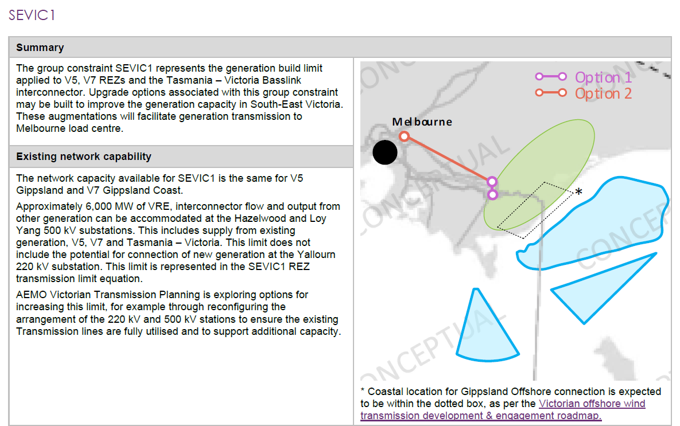
Figure S16.3: “NSA1 group constraint Option 1” and “SEVIC1 Option 1”. Source: AEMO Transmission Expansion Options report [8].
Regarding the MDFR, the average value across both the shortlisted and proposed HVAC routes is 0.58, which is consistent with the levels observed for the AEMO routes. AEMO’s routes display a more uniform distribution of MDFR, with a noticeable concentration around the 0.6 mark, indicating a common MDFR threshold for many routes.
It is important to note that the criteria used are designed to evaluate new routes under the assumption that the existing network is saturated. Therefore, it is not appropriate to critique AEMO’s routes based solely on their performance in this context.

References (Supplementary Information)
[1] ANU RE100 Group, “Australian Solar PV and Wind Heat Maps.” [Online]. Available: https://re100.eng.anu.edu.au/heatmaps/.
[2] 5B, “Solutions for EPCs | 5B - Solar Reinvented.” [Online]. Available: https://5b.co/solutions.
[3] Vestas Wind Systems A/S, “Vestas introduces the V162-6.8 MW, expanding the EnVentus platform’s power output and market applicability,” 2021. [Online]. Available: https://www.vestas.com/en/media/company-news/2021/vestas-introduces-the-v162-6-8-mw--expanding-the-envent-c3458514.
[4] AEMO, “Transmission Cost Database,” 2023.
[5] P. Graham, J. Hayward, J. Foster, and L. Havas, “GenCost 2022-23 Final report,” 2023.
[6] Solargis, “Global Solar Atlas,” 2019. [Online]. Available: https://globalsolaratlas.info/?c=43.866218,86.828145,4.
[7] S. Pfenninger and I. Staffell, “Renewables.ninja,” 2016. [Online]. Available: https://www.renewables.ninja/about.
[8] Australian Energy Market Operator, “2023 Transmission Expansion Options Report,” 2023.

