Additional file 1

Figure S1 iCWPs are ignited by IAV-infected cells, related to Fig. 1
(a) MDCK/O-GECO cells were exposed to PR8, fixed using 3% paraformaldehyde (PFA) at the indicated time points, and subjected to an immunofluorescence-based infection assay. The percentage of infected cells was plotted. Data are presented as mean (n > 10,000 cells from three independent experiments). The solid line is the Hill curve generated by fitting the data set.
(b) MDCK/O-GECO cells were seeded in 35-mm glass-based dishes carved with a grid, exposed to PR8 at an MOI of 0.01 PFU/cell, and subjected to time-laps microscopic observation at 24 hpi. Cells were then fixed, stained with Hoechst 33342, and subjected to immunofluorescence using anti-NP and Alexa Fluor 488–conjugated secondary antibodies. Using grid coordinates as a guide, time-lapse images were aligned with post-acquisition immunofluorescence images. Representative merged images at the time points indicated at the bottom right of O-GECO (red), Alexa Fluor 488 (green), and Hoechst 33342 (blue) are shown. Scale bar, 50 μm.

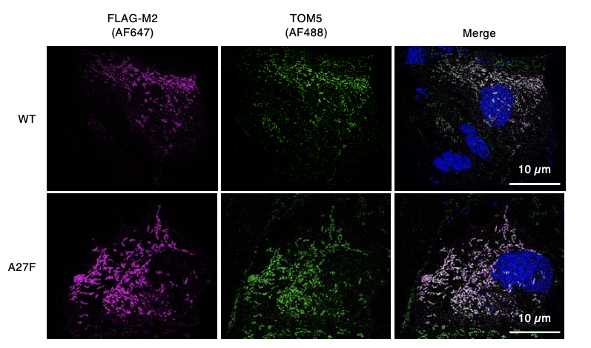

Figure S2 Wild-type and mutant IAV M2 are localized to mitochondria, related to Fig. 3
MDCK cells expressing FLAG-tagged wild-type form (WT) or ion channel activity-deficient mutant form (A27F) of M2 were fixed, stained with Hoechst 33342, and subjected to immunofluorescence using primary antibodies against FLAG and TOM5, which were visualized using Alexa Fluor 647 (AF647)– and Alexa Fluor 488 (AF488)–conjugated secondary antibodies, respectively. Cells were observed using a super-resolution microscope. Representative images of FLAG-M2 (magenta) and TOM5 (green), and their merged images with Hoechst 33342 (blue) are shown. Scale bar, 10 μm.

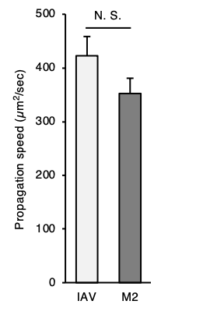

Figure S3 The spread rate of iCWPs induced by M2 is comparable to that induced by IAV infection, related to Fig. 3
Epithelial monolayer-forming MDCK/O-GECO cells were infected with PR8 at an MOI of 0.01 PFU/cell for 24 h (IAV). Alternatively, cells were transfected with the expression vectors for PR8 M2 for 24 h (M2). The spread rate of iCWPs was determined using a fluorescence microscope. Data are presented as mean + SEM (n = 3). p = 0.2594. N.S., not significant, as calculated using Student’s t-test.

Figure S4 Sustained elevation of Ca²⁺ concentration in M2-expressing cells initiates iCWP, related to Fig. 4
(a) Confluent MDCK/O-GECO cells in 35-mm glass-based dishes were pretreated with 10 µM BPTU, 10 µM venetoclax (ven), or DMSO ([-]) for 1 h, then incubated with 50 µM NPE-caged ADP for 10 min, and subjected to time-laps microscopic observation. The uncage of NPE-caged ADP was induced by ultraviolet (UV) light irradiation (385 nm, 1 mW). The average O-GECO fluorescence in each cell for 10 min after illumination was normalized by the pre-illumination value and plotted. Data are presented as mean + SEM (n > 10,000 cells from three independent experiments). *p < 0.0001 (one-way ANOVA with Dunnett’s post hoc test).
(b) MDCK/O-GECO cells were transfected with the control vector, expression vector for wild-type form (WT) of PR8 M2, or that for ion channel activity-deficient mutant form (A27F) of M2. Fluorescence intensities of O-GECO in cells positive for bicistronically expressed EGFP in the presence (ven) or absence ([-]) of venetoclax were quantified and plotted. Data are presented as mean + SEM (n > 10,000 cells from three independent experiments). *p < 0.0001 (one-way ANOVA with Dunnett’s post hoc test).
(c) MDCK cells were treated with BPTU at indicated concentrations for 24 h, and the number of living cells was determined by trypan blue exclusion assay. The viability of BPTU-treated cells relative to that of untreated cells was calculated and plotted. Data are presented as mean + SEM (n = 3). N.S., not significant, as calculated by one-way ANOVA.
(d) MDCK/O-GECO cells expressing PR8 M2 or transfected with the control vector (Vector) were incubated with BPTU or left untreated ([-]) for 1 h, and the frequency of iCWPs was quantified and plotted. Data are presented as mean + SEM (n = 12 fields of view from three independent experiments). *p = 0.0004 (one-way ANOVA with Dunnett’s post hoc test).
(e) MDCK/O-GECO cells were exposed to PR8 at an MOI of 0.01 PFU/cell (IAV infected) or mock-infected (MOCK) for 23 h and treated with BAPTA-AM, BPTU, diltiazem, or sialidase or left untreated ([-]) for 1 h. The frequency of iCWPs was quantified and plotted. Data are presented as mean + SEM (n = 12 fields of view from three independent experiments). *p < 0.03 (one-way ANOVA with Dunnett’s post hoc test).

Figure S5 M2-induced ICWP facilitates IAV infection in surroundings through enhanced endocytosis, related to Fig. 5
(a, b) MDCK cells pretreated with BPTU or DMSO (Control) were exposed to PR8 at an MOI of 0.01 PFU/cell for 1 h, fixed with 3% PFA at 30 hpi, stained with Hoechst 33342, and subjected to immunofluorescence with anti-NP and Alexa Fluor 488–conjugated secondary antibodies. Representative merged images of NP (green) and Hoechst 33342 (blue) are shown (a). Bar, 500 µm. The distance between centers of gravity of the nuclei of infected cells was quantified, and frequencies of the distance were plotted on histograms. Dashed lines indicate the median values (b). *p < 0.0001 vs. the calculated values (Student’s t-test).
(c) MDCK cells transfected with either control vector ([-]) or expression vector for PR8 M2 were incubated with Alexa Fluor 488–labeled dextran for 15 min and observed using a fluorescence microscope. The total fluorescence intensity of Alexa Fluor 488 within M2-expressing cells relative to that in vector-transfected cells was plotted. Data are presented as mean + SEM (n > 10,000 cells from three independent experiments). *p < 0.0001 vs. the intensity of cells transfected with the control vector (Student’s t-test).

Additional file 2

Movie S1 iCWPs in IAV-infected cells, related to Fig. 1a
An epithelial monolayer formed by MDCK/O-GECO cells was exposed to PR8 at an MOI of 0.01 PFU/cell. After 24 hours postinfection (hpi), cells were subjected to fluorescence microscopic observation.

Movie S2 iCWPs in MOCK-infected cells, related to Fig. 1b
An epithelial monolayer formed by MDCK/O-GECO cells was treated with PBS. After 24 hpi, cells were subjected to fluorescence microscopic observation.

Movie S3 iCWPs in IAV-infected cells, as visualized by AMATERAS, related to Fig. 2a
An epithelial monolayer formed by MDCK/O-GECO cells was exposed to PR8 at an MOI of 0.01 PFU/cell and imaged using AMATERAS-1 after 24 hpi.

Movie S4 iCWPs in MOCK-infected cells, as visualized by AMATERAS, related to Fig. 2b
An epithelial monolayer formed by MDCK/O-GECO cells was treated with PBS and imaged using AMATERAS-1 after 24 hpi.

Movie S5 iCWPs in M2-transfected cells, related to Fig. 3a
PR8 M2-expressing MDCK/O-GECO cells were observed using a fluorescence microscope. M2-expressing cells were identified using fluorescence signals of bicistronically expressed EGFP.

